PENNSYLVANIA
PUBLIC UTILITY COMMISSION
Harrisburg, PA 17105-3265

 | Public Meeting held December 20, 2018
Commissioners Present:

Gladys M. Brown, Chairman, Statement
Andrew G. Place, Vice Chairman
Norman J. Kennard
David W. Sweet
John F. Coleman, Jr.

Pennsylvania Public Utility Commission  Office of Consumer Advocate  Office of Small Business Advocate  Philadelphia Area Industrial Energy Users Group  v.  PECO Energy Company – Electric Division | R-2018-3000164  C-2018-3001112  C-2018-3001043  C-2018-3001471

OPINION AND ORDER

Contents

I. History of the Proceeding 2
II. Introduction 7
A. Legal Standards 8
1. Justness and Reasonableness of Rates 8
2. Burden of Proof 11
3. Settlements Must Serve the Public Interest 13
III. The Joint Petition for Partial Settlement 15
A. Terms and Conditions of the Partial Settlement 15
B. Statements in Support of the Partial Settlement 25
C. ALJs’ Recommendation 26
D. Disposition of the Partial Settlement 28
IV. Contested Issue 30
A. NRG’s Proposal to Re-allocate Indirect Costs 30
1. Background 30
2. Positions of the Parties 34
B. ALJs’ Recommendation 48
C. Exceptions and Replies 51
1. Did the ALJs err in concluding that PECO carried its burden of proving that it is just and reasonable to allocate all indirect costs to residential distribution service while allocating no indirect costs to residential default service? (NRG Exception No. 1) 51
2. Did the ALJs improperly conclude that PECO’s PTC recovers all costs of providing default service? (NRG Exception No. 2) 57
3. Did the ALJs erroneously disregard the Commission’s standard for unbundling? (NRG Exception No. 3) 59
4. Did the ALJ err in relying on an avoided cost theory? (NRG Exception No. 4) 63
D. Disposition 66
V. Conclusion 75

BY THE COMMISSION:

Before the Pennsylvania Public Utility Commission (Commission) for consideration and disposition are the Exceptions filed on October 29, 2018, by NRG Energy, Inc. (NRG) to the Recommended Decision (R.D.) of Deputy Chief Administrative Law Judge (ALJ) Christopher P. Pell and Administrative Law Judge F. Joseph Brady (the ALJs), which was issued on October 18, 2018, in the above-captioned proceeding. The ALJs recommended granting, without modification, the Joint Petition for Partial Settlement of Rate Investigation (Joint Petition or Partial Settlement) filed on August 28, 2018, by PECO Energy Company – Electric Division (PECO or the Company), the Commission’s Bureau of Investigation and Enforcement (I&E), the Office of Consumer Advocate (OCA), the Office of Small Business Advocate (OSBA), the Coalition for Affordable Utility Services and Energy Efficiency in Pennsylvania (CAUSE PA), the Community Action Association of Pennsylvania (CAAP), ChargePoint, Inc. (ChargePoint), the Philadelphia Area Industrial Energy Users Group (PAIEUG), the Tenant Union Representative Network and Action Alliance of Senior Citizens of Greater Philadelphia (TURN et al.), Tesla, Inc. (Tesla) and Wal-Mart Stores East, LP and Sam’s East, Inc. Walmart) (collectively, the Joint Petitioners). Replies to Exceptions were filed by PECO and the OCA on November 5, 2018. With regard to the one outstanding issue that was reserved for litigation and not included in the Partial Settlement, the ALJs recommended that NRG’s proposed modification to the allocation costs between distribution service and default service be denied. The Exceptions and Replies to Exceptions pertain exclusively to the sole issue preserved as a separate matter for litigation that was unresolved by the Partial Settlement, i.e., the allocation of costs between distribution service and default service. For the reasons stated, infra, we shall deny NRG’s Exceptions and adopt the ALJs’ Recommended Decision that grants the Joint Petition, and therefore, approves the Joint Settlement, without modification, consistent with this Opinion and Order.

As discussed below, the genesis of this proceeding involved a general rate increase in which PECO proposed a base rate change that would have increased its annual distribution revenue by $142.5 million, or 11.6% on a distribution revenue basis, based on a fully projected future test year (FPFTY) ending December 31, 2019. PECO Exh. BSY-1, Sch. A-1. Our approval of the Joint Petition, which embodies a so-called “black box” settlement, permits PECO to file new tariff rates designed to provide an overall distribution base rate increase of $85.5 million, or 7.0% on a distribution revenue basis. Joint Petition, Appendix B. Additionally, the monthly residential and residential heating customer charge will increase from $8.45 to $10.00, in lieu of the Company’s proposed $12.50 charge.

History of the Proceeding

On March 29, 2018, PECO filed proposed Tariff Electric – Pa. P.U.C. No. 6 (Tariff No. 6) to become effective May 28, 2018, that contained proposed changes to rates, designed to produce a net increase in PECO’s annual distribution revenue of approximately $81.9 million, or 6.7% above existing distribution revenues. The proposed tariff increase, as filed, represented a 2.2% increase over the Company’s total Pennsylvania jurisdictional operating revenue, including distribution, transmission, and generation revenues.

On April 4, 2018, I&E entered its Notice of Appearance in this matter. A Formal Complaint was filed by the OSBA at Docket No. C-2018-3001043 on April 9, 2018. A Petition to Intervene was filed by CAUSE-PA on April 10, 2018. A Formal Complaint at Docket No. C-2018-3001112, in addition to a Public Statement and a Notice of Appearance, was filed by the OCA on April 12, 2018. On April 17, 2018, the International Brotherhood of Electric Workers, Local 614 (IBEW) filed a Petition to Intervene in this proceeding.

On April 19, 2018, the Commission entered an Order suspending Tariff No. 6 until December 28, 2018, pursuant to Section 1308(d) of the Public Utility Code (Code), 66 Pa. C.S. § 1308(d), and initiated an investigation into the lawfulness, justness and reasonableness of the proposed rate increase, as well as PECO’s existing rates, rules and regulations. PECO’s filing was subsequently assigned to ALJs Christopher P. Pell and F. Joseph Brady.

A Petition to Intervene was filed by CAAP on April 23, 2018. On April 26, 2018, PAIEUG filed a Formal Complaint at Docket No. C-2018-3001471. On April 27, 2018, the Delaware Valley Regional Planning Commission (DVRPC) filed a Petition to Intervene. A Formal Complaint was filed by the Trustees of the University of Pennsylvania (UPenn) on May 2, 2018 and was docketed at C-2018-3001636.

On May 3, 2018, TURN et al., Tesla, and Walmart filed separate Petitions to Intervene. On May 4, NRG and the Retail Energy Supply Association (RESA) filed separate Petitions to Intervene.

A Prehearing Conference was held on May 8, 2018, at which time a schedule was established for the submission of testimony and the conduct of hearings. Additionally, hearing no opposition to the Petitions to Intervene filed by Walmart, Tesla, TURN et al., IBEW, CAUSE-PA, and CAAP, their Petitions were granted during the Prehearing Conference, which was memorialized in Prehearing Order No. 1.

By Hearing Notice dated May 17, 2018, five in-person Public Input Hearings were scheduled as follows, in order to allow PECO’s customers the opportunity to express their concerns or opinions regarding the pending rate increase request:

June 6, 2018, at 6 p.m. in Media, PA;
June 7, 2018, at 6 p.m. in Norristown, PA;
June 12, 2018, at 6 p.m. in Newtown, PA;
June 14, 2018, at 10 a.m. in Philadelphia, PA; and
June 14, 2018, at 6 p.m. in Philadelphia, PA.

On May 18, 2018, the Laborers International Union of North America, Local 57 (LIUNA) filed a Petition to Intervene in this proceeding. On May 24, 2018, Calpine Energy Solutions, LLC (Calpine) and ArcelorMittal USA, LLC (ArcelorMittal) filed their respective Petitions to Intervene in this proceeding.

By Hearing Notice dated June 11, 2018, an additional Public Input Hearing was scheduled for June 18, 2018 at 6 p.m. in Oxford, PA.

On June 12, 2018, PECO submitted Supplemental Direct Testimony.

On June 26, 2018, West Norriton Township filed a Formal Complaint docketed at C-2018-3003149.

The following Parties submitted direct testimony on June 26, 2018: the OCA; I&E; CAUSE-PA; Walmart; TURN et al.; PAIEUG; Tesla; NRG; the OSBA; ArcelorMittal; and LIUNA.

On July 3, 2018, ChargePoint filed a Petition to Intervene. Separately on that date, Reizdan B. Moore, Esq., on behalf of ChargePoint, filed a Motion for Admission Pro Hac Vice, pursuant to 52 Pa. Code §§ 1.22 and 1.23 and Pa. B.A.R. 301(a), on behalf of Scott Dunbar, Esq., requesting that he be admitted for purposes of representing ChargePoint in this proceeding.

Rebuttal testimony was submitted on July 24, 2018, by the following parties: PECO; TURN et al.; CAAP; the OSBA; ChargPoint; PAIEUG; and the OCA. Surrebuttal testimony was submitted on August 8, 2018, by the following parties: PECO; NRG; the OCA; I&E; CAUSE-PA; PAIEUG; and TURN et al.

On August 15, 2018, PECO communicated to the ALJs that a Partial Settlement in principle had been reached. As a result of settlement discussions, the Joint Petitioners were successful at resolving all but one issue in this proceeding prior to the scheduled evidentiary hearings. As noted, the issue reserved for litigation was NRG’s opposition to PECO’s allocation of certain costs to residential distribution service and the effect of re-allocating those costs to residential default service, with a commensurate reduction in the level of residential distribution charges. Consequently, except for PECO and NRG, the parties in this proceeding waived cross-examination of witnesses. Furthermore, PECO advised that the parties anticipated that only one hearing day would be necessary and requested that the hearing be held on August 21, 2018.

An evidentiary hearing was held, as scheduled, on August 21, 2018, at which time the Joint Petitioners’ pre-filed testimony and exhibits were admitted into the record. PECO witness Alan B. Cohn presented rejoinder testimony and was cross-examined by counsel for NRG with respect to the issue reserved for litigation. Likewise, NRG witness Chris Peterson, who prepared NRG’s proposal, was cross-examined by counsel for PECO.

On August 28, 2018, the Joint Petition was filed by the Joint Petitioners. The Joint Petitioners’ Statements in Support of the Partial Settlement were attached to the Joint Petition as appendices. Although ArcelorMittal, Calpine and IBEW did not sign the Partial Settlement, the Joint Petitioners indicated in the Partial Settlement that ArcelorMittal, Calpine and IBEW authorized them to state their non-opposition to the Partial Settlement.

On September 7, 2018, Main Briefs were filed by PECO, NRG, and the OCA. Reply Briefs were filed by PECO, NRG, and the OCA on September 17, 2018.

By Recommended Decision issued October 18, 2018, the ALJs recommended that the Joint Petition be adopted without modification and that NRG’s proposal be rejected in its entirety. R.D. at 74 and 124. With regard to the one remaining contested issue, the ALJs specifically concluded that PECO properly allocates costs for default service and recommended that PECO continue to allocate its price-to-compare (PTC) as previously approved by the Commission in prior default service and base rate proceedings as set out in PECO’s proposed tariff. R.D. at 124 and 130.

As noted, Exceptions were filed by NRG on October 29, 2018, and Replies to Exceptions were filed by PECO and the OCA on November 5, 2018.

Introduction

As a preliminary matter, we note that any issue that we do not specifically delineate shall be deemed to have been duly considered and denied without further discussion. The Commission is not required to consider expressly or at length each contention or argument raised by the parties. Consolidated Rail Corp. v. Pa. PUC, 625 A.2d 741 (Pa. Cmwlth. 1993); also see, generally, University of Pennsylvania v. Pa. PUC, 485 A.2d 1217 (Pa. Cmwlth. 1984).

In their Recommended Decision, the ALJs made thirty-seven Findings of Fact and reached six Conclusions of Law. R.D. at 8-13, 130-31. The Findings of Fact and Conclusions of Law are incorporated herein by reference and are adopted without comment unless they are either expressly or by necessary implication rejected or modified by this Opinion and Order.

Legal Standards

1. Justness and Reasonableness of Rates

The purpose of this investigation is to establish distribution rates, rules and regulations for PECO’s customers that are just and reasonable and otherwise lawful. See 66 Pa. C.S. § 1301. The Commission applies certain principles in deciding any general rate increase case brought under Section 1308(d) of the Code, 66 Pa. C.S. § 1308(d), as discussed generally below.

Section 523 of the Code requires the Commission “when determining just and reasonable rates,” to consider “in addition to all other relevant evidence of the record, the efficiency, effectiveness and adequacy of service of each utility. . ..” 66 Pa. C.S. § 523. Additionally, Section 526 of the Code permits the Commission to reject a proposed rate increase, in whole or in part, if the Commission finds “that the service rendered by the public utility is inadequate. . ..” 66 Pa. C.S. § 526(a).

In exchange for the utility’s provision of safe, adequate and reasonable service, we have previously stated the following with respect to the types of costs that may be recovered by the utility through the rates that customers will pay:

[I]n exchange for the utility’s provision of safe, adequate and reasonable service, the ratepayers are obligated to pay rates which cover the cost of service which includes reasonable operation and maintenance expenses, depreciation, taxes and a fair rate of return for the utility’s investors . . . In return for providing safe and adequate service, the utility is entitled to recover, through rates, these enumerated costs.

Pa. PUC v. Pennsylvania Gas & Water Co., 61 Pa. PUC 409, 415-16 (1986). Thus, in determining a utility’s allowed revenue requirement to be used to establish customer rates, typically the focus of review is upon: the reasonable and prudently incurred operating expenses of the utility; depreciation expense; taxes; the used and useful investments of the utility for providing service to customers, or the utility’s rate base; and, the overall rate of return, which is comprised of the return on equity and cost of capital, to be applied to the utility’s rate base. See generally Pa. PUC et al. v. PPL Electric Utilities Corporation, Docket Nos. R-2015-2469275 et al. (Order entered November 19, 2015), adopting the Recommended Decision of ALJ Susan D. Colwell (Issued October 5, 2015) (Pa. PUC v. PPL Electric). Additionally, the appropriate allocation of the utility’s revenue requirement among its various customer rate classes is a significant part of the review to ensure that the rates established for customers are not unduly discriminatory. See Id.; see also 66 Pa. C.S. § 1304.

A public utility seeking a general rate increase is entitled to an opportunity to earn a fair rate of return on the value of the property dedicated to public service. Pennsylvania Gas and Water Co. v. Pa. PUC, 341 A.2d 239 (Pa. Cmwlth. 1975); Bluefield Water Works and Improvement Co. v. Public Service Comm’n of West Virginia, 262 U.S. 679 (1923) (Bluefield). In determining what constitutes a fair rate of return, the Commission is guided by the criteria set forth in Bluefield, supra, and Federal Power Comm’n v. Hope Natural Gas Co., 320 U.S. 591 (1944). In Bluefield, the United States Supreme Court stated:

A public utility is entitled to such rates as will permit it to earn a return on the value of the property which it employs for the convenience of the public equal to that generally being made at the same time and in the same general part of the country on investments in other business undertakings which are attended by corresponding risks and uncertainties; but it has no constitutional right to profits such as are realized or anticipated in highly profitable enterprises or speculative ventures. The return should be reasonably sufficient to assure confidence in the financial soundness of the utility and should be adequate, under efficient and economical management, to maintain and support its credit and enable it to raise the money necessary for the proper discharge of its public duties. A rate of return may be too high or too low by changes affecting opportunities for investment, the money market and business conditions generally.

Bluefield, 262 U.S. at 692-93.

In determining the rate of return to be applied to the utility’s rate base, typically the Commission will examine the calculations presented by the parties to the proceeding of the utility’s capital structure and the cost of capital during the period in issue. The Commission is granted wide discretion, because of its administrative expertise, in determining the cost of capital. Equitable Gas Co. v. Pa. PUC, 405 A.2d 1055, 1059 (Pa. Cmwlth. 1979) (determination of cost of capital is basically a matter of judgment which should be left to the regulatory agency and not disturbed absent an abuse of discretion); see also Pa. Pub. Util. Comm’n, et al. v. PPL Electric Utilities Corporation, R-2015-2290597 (Order entered December 28, 2012).

2. Burden of Proof

Typically, in proceedings before the Commission, the public utility has the burden to establish the justness and reasonableness of every element of its rate increase in all proceedings conducted under Section 1308(d) of the Code, 66 Pa. C.S. § 1308(d). The standard of proof which a public utility must meet, as discussed above, is set forth in Section 315(a) of the Code, as follows:

- Reasonableness of rates. — In any proceeding upon the motion of the commission, involving any proposed or existing rate of any public utility, or in any proceedings upon complaint involving any proposed increase in rates, the burden of proof to show that the rate involved is just and reasonable shall be upon the public utility. The commission shall give to the hearing and decision of any such proceeding preference over all other proceedings, and decide the same as speedily as possible.

66 Pa. C.S. § 315(a).

The Commonwealth Court has upheld this standard of proof and has applied it in base rate proceedings:

Section 315(a) of the Public Utility Code, 66 Pa. C.S. § 315(a), places the burden of proving the justness and reasonableness of a proposed rate hike squarely on the utility. It is well-established that the evidence adduced by a utility to meet this burden must be substantial.

Lower Frederick Twp. v. Pa. PUC, 409 A.2d 505, 507 (Pa. Cmwlth. 1980).

As the Pennsylvania Supreme Court has stated, “the burden of proof is met when the elements of that cause of action are proven with substantial evidence which enables the party asserting the cause of action to prevail, precluding all reasonable inferences to the contrary.” Burleson v. Pa. PUC, 461 A.2d 1234, 1236 (Pa. 1983). Furthermore, it is well-established that the “degree of proof before administrative tribunals…is satisfied by establishing a preponderance of the evidence.” See Lansberry, Inc. v. Pa. PUC, 578 A.2d 600, 602 (Pa. Cmwlth. 1990), alloc. denied, 529 Pa. 654, 602 A.2d 863 (1992). That is, the evidence must be substantial and legally credible, and cannot be mere “suspicion” or a “scintilla” of evidence. See Id. The evidence must be more convincing, by even the smallest amount, than that presented by the other party. See Se-Ling Hosiery, Inc. v. Margulies, 70 A.2d 854, 856 (Pa. 1950).

Indeed, the Pennsylvania Supreme Court has held that the burden of proof does not shift to the other parties to justify a proposed adjustment to a utility’s general rate filing:
[T]he appellants did not have the burden of proving that the plant additions were improper, unnecessary or too costly; on the contrary, that burden is, by statute, on the utility to demonstrate the reasonable necessity and cost of the
installations, and that is the burden which the utility patently failed to carry.

Berner v. Pa. PUC, 116 A.2d 738, 744 (Pa. 1955).

However, as the Commonwealth Court has explained: “While it is axiomatic that a utility has the burden of proving the justness and reasonableness of its proposed rates, it cannot be called upon to account for every action absent prior notice that such action is to be challenged.” See Allegheny Center Assocs. v. Pa. PUC, 570 A.2d 149, 153 (Pa.Cmwlth. 1990) (citing Central Maine Power Co. v. Public Utilities Commission, 405 A.2d 153, 185 (Me. 1979)). Therefore, while the statutory burden of proof does not shift from the public utility in a general rate proceeding, a party proposing an adjustment to a ratemaking claim bears the burden of presenting some evidence or analysis, during the reception of evidence in the proceeding, tending to demonstrate the reasonableness of the adjustment. See Id.; See, e.g., Pa. PUC v. PECO, Docket No. R-891364 et al., 1990 Pa. PUC Lexis 155 (Order entered May 16, 1990); see also Pa. PUC v. Breezewood Telephone Company, Docket No. 901666, 74 Pa. PUC 431 (Order entered February 15, 1991).

Moreover, the statutory burden of proof placed on the utility under Section 315(a) of the Code, 66 Pa.C.S. § 315(a), cannot reasonably be read to place the burden of proof on the utility with respect to an issue that the utility did not propose in its general rate case filing, and which, frequently, the utility would oppose. Inasmuch as the Legislature is not presumed to intend an absurd result in interpretation of its enactments, see, 1 Pa. C.S. § 1922(1), PA Financial Responsibility Assigned Claims Plan v. English, 541 Pa. 424, 430-431, 64 A.2d 84, 87 (1995), the statutory burden placed on a proponent of a rule or order under Section 332(a) does not shift to the utility simply because such rule or order is proposed within the context of the utility’s 1308(d) general base rate proceeding. See 66 Pa. C.S. 332(a) (“Except as may be otherwise provided in section 315…or other provisions of this part…the proponent of a rule or order has the burden of proof.”); see generally Pa. PUC v. PPL Electric; Pa. PUC. et al. v. West Penn Power Company, Docket Nos. R-2014-2428742 et al. (Order entered April 9, 2015), adopting the Recommended Decision of ALJs Dennis J. Buckley and Katrina L. Dunderdale (Issued March 9, 2015); and Pa. PUC v. Metropolitan Edison Company, et al., Docket Nos. R-00061366 et al., 2007 Pa. PUC LEXIS 5 *111 (Order entered January 11, 2007).

3. Settlements Must Serve the Public Interest

The policy of the Commission is to encourage settlements, and the Commission has stated that settlement rates are often preferable to those achieved at the conclusion of a fully litigated proceeding. 52 Pa. Code §§ 5.231, 69.401. A full settlement of all the issues in a proceeding eliminates the time, effort and expense that otherwise would have been used in litigating the proceeding, while a partial settlement may significantly reduce the time, effort and expense of litigating a case. A settlement, whether whole or partial, benefits not only the named parties directly, but, indirectly, all customers of the public utility involved in the case.

The Partial Settlement, in this case, is a “black box” settlement. This means that the parties were not able to agree on each and every element of the revenue requirement calculation. The Commission has recognized that “black box” settlements can serve an important purpose in reaching consensus in rate cases:

We have historically permitted the use of “black box” settlements as a means of promoting settlement among the parties in contentious base rate proceedings. Settlement of rate cases saves a significant amount of time and expense for customers, companies, and the Commission and often results in alternatives that may not have been realized during the litigation process. Determining a company’s revenue requirement is a calculation involving many complex and interrelated adjustments that affect expenses, depreciation, rate base, taxes and the company’s cost of capital. Reaching an agreement between various parties on each component of a rate increase can be difficult and impractical in many cases.

Pa. PUC v. Peoples TWP LLC, Docket No. R-2013-2355886 (Order entered December 19, 2013), at 28 (citations omitted).

Rate increase proceedings are expensive to litigate, and the reasonable cost of such litigation is an operating expense recovered in the rates approved by the Commission. Partial or full settlements allow the parties to avoid the substantial costs of preparing and serving testimony and the cross-examination of witnesses in lengthy hearings, the preparation and service of briefs, reply briefs, exceptions and replies to exceptions, together with the briefs and reply briefs necessitated by any appeal of the Commission’s decision, yielding significant expense savings for the company’s customers. For this and other sound reasons, settlements are encouraged by long-standing Commission policy.

Despite the policy favoring settlements, the Commission does not simply rubber stamp settlements without further inquiry. In order to accept a settlement such as those proposed here, the Commission must determine that the proposed terms and conditions are in the public interest. Pa. PUC v. York Water Co., Docket No. R-00049165 (Order entered October 4, 2004); Pa. PUC v. C. S. Water and Sewer Assoc., 74 Pa. P.U.C. 767 (1991). The focus of the inquiry for determining whether a proposed settlement should be approved by the Commission is whether the proposed terms and conditions foster, promote and serve the public interest. Pa. PUC, et al. v. City of Lancaster – Bureau of Water, Docket Nos. R-2010-2179103, et al. (Order entered July 14, 2011), citing Warner v. GTE North, Inc., Docket No. C-00902815 (Order entered April 1, 1996) and CS Water and Sewer. Because the Joint Petitioners request the Commission enter an order in this proceeding approving the Partial Settlement without modification, they share the burden of proof to show that the terms and conditions of the Partial Settlement are in the public interest. See 66 Pa. C.S. § 332(a) (“Except as may be otherwise provided in section 315…or other provisions of this part . . . the proponent of a rule or order has the burden of proof.”)

The Joint Petition for Partial Settlement

Terms and Conditions of the Partial Settlement

As noted the Joint Petitioners agreed to the Partial Settlement addressing all but one issue (i.e., NRG’s claim regarding PECO’s allocation of certain costs to residential distribution service instead of residential default service). Partial Settlement at ¶ 12.

As previously indicated, the Partial Settlement is a “black box” agreement, which does not specifically identify the resolution of certain disputed issues. Instead, the Partial Settlement indicates that the Joint Petitioners have agreed to a net increase of $24.9 million in annual distribution revenues and the Parties retain the rights to further challenge all issues in subsequent proceedings.

The $24.9 million net increase in distribution revenues, or approximately 2.0% (0.7% increase over PECO’s total Pennsylvania jurisdictional operating revenue), resulting from the Partial Settlement, is $57 million less than the $81.9 million net increase, or approximately 6.7% (2.2% increase over PECO’s total Pennsylvania jurisdictional operating revenue), originally proposed by PECO. The Joint Petitioners have agreed to a base rate increase, an allocation of that revenue increase to the rate classes, a rate design for each rate class, residential and low-income service matters, the impact of Act 40, which added Section 1301.1 to the Code, on the revenue requirement, the establishment of an Electric Vehicle Direct Current Fast Charger (EV-FC) Rider, the calculation of the Federal Tax Adjustment Credit (FTAC) resulting from the TCJA and the manner of flow-through of the 2018 TCJA tax savings to customers, a revision to the Rate HT high voltage discount, as well as various reporting requirements.

The Joint Petitioners stated that the Partial Settlement was achieved after conducting discovery and engaging in in-depth discussions over several weeks. They further stated that the Settlement terms and conditions constitute a carefully crafted package representing reasonable negotiated compromises on the issues addressed therein. Partial Settlement ¶ 34 at 14. They also stated that the Partial Settlement is in the public interest for several reasons including: the reduced base rate increase, the reduced administrative burden and the reasonable revenue allocation. Id.

The Joint Petition contains the terms and conditions of the Partial Settlement along with Appendices A through E and Statements A through K. Appendix A to the Settlement presents the Proposed Tariff at Settlement rates. Appendix B presents the Proof of Revenues which contains a comparison of present and proposed rates for all of the affected services. Appendix C sets forth the issues concerning residential and low-income customers. Appendix D sets out the baseline of gross plant balances to be achieved in order to restart charges under the Company’s DSIC. Appendix E sets out the rate effects for typical customers in each major class. Statements A through K represent the Statements in Support filed by PECO, I&E, the OCA, the OSBA, PAIEUG, CAUSE-PA, TURN et al., CAAP, Tesla, ChargePoint, and Walmart, respectively.

The essential terms and conditions of the Partial Settlement are set forth in Paragraphs 15 through 32 of the Joint Petition, and are repeated verbatim below as follows:

- Revenue Requirement

15. PECO will be permitted to charge, effective for service rendered on and after January 1, 2019, the Settlement Rates set forth in Appendix A. The Settlement Rates are designed to produce an annual increase in electric operating revenues of $85.5 million, which is reduced to $14.9 million following the application of 2019 tax savings related to TCJA. The revenue requirement is further adjusted to account for the roll-in of Distribution System Improvement Surcharge (“DSIC”) revenue for a net revenue increase of $24.9 million as shown in the proof of revenues provided as Appendix B. The revenue requirement agreed upon above reflects a reduction to rate base for the excess Accumulated Deferred Income Taxes (“ADIT”) amount (regulatory liability related to TCJA) as of the end of the FPFTY. The Company agrees to continue such treatment in future base rate filings until the entire amount has been refunded in future years.

- Revenue Allocation And Rate Design

16. The Settlement Rates reflect the allocation of the annual net increase in electric operating revenue to each rate class agreed to by the Joint Petitioners, as set forth below:

Rate | Net Revenue
 | Increase | % Increase
Residential | $14,716,454 | 2.2%
Residential Heating | $4,016,155 | 2.9%
General Service | $3,031,316 | 1.3%
Primary Distribution | $146,143 | 1.8%
High Tension | $2,414,390 | 1.6%
Electric Propulsion | $220,575 | 3.1%
Lighting | $358,992 | 1.8%
Total | $24,904,024 | 2.0%

17. The Settlement Rates reflect the agreement among the Joint Petitioners with respect to PECO’s monthly Fixed Distribution Service (Customer) Charges for Rates R, RH and HT, as follows:

Rates R and RH | $10.00
Rate HT | $354.00

For Rates R, RH and HT, the Variable Distribution Charges were scaled back to produce the class revenues shown in the table in Paragraph 16, above. For all other rate classes, the Fixed Distribution Service Charges under the Settlement Rates were adjusted, and the Variable Distribution Charges were scaled back, to produce the class revenues shown in the table in Paragraph 16, above.

- Residential And Low-Income Customer Issues

18. The terms of the Joint Petitioner’s agreement on issues concerning residential customers and low-income customers are set forth in Appendix C to this Joint Petition.

- FPFTY Reports

19. PECO will provide the Commission’s Bureau of Technical Utility Services (“TUS”), I&E, OCA, and OSBA with an update to PECO Exhibit BSY-2, Sch. C-2, no later than April 1, 2019, which should include actual capital expenditures, plant additions, and retirements by month from January 1, 2018 through December 31, 2018. Then, no later than April 1, 2020, another update of PECO Exhibit BSY-1, Sch. C-2 should be submitted showing actuals from January 1, 2019 through December 31, 2019. In PECO’ s next base rate proceeding, the Company will prepare a comparison of its actual expenses and rate base additions for the twelve months ended December 31, 2019 to its projections in this case.

- Quarterly Earnings Reports

20. The Joint Petitioners acknowledge the issue raised by I&E in I&E Statement No. 3, pages 54-68, regarding the manner in which utilities should present financial results of operations adjusted on a ratemaking basis for future plant additions in their Quarterly Earnings Reports (the “QER Issue”) but do not agree on the substantive issue or relevance to this proceeding. In the event the Commission issues a final order that adopts the I&E position on the QER Issue in any proceeding in which the Commission states that the I&E position will be applied to all regulated utilities or via a secretarial letter after notice to PECO and an opportunity to be heard, PECO will not appeal the Commission’s determination with respect to the QER Issue.

- DSIC

21. PECO will not implement a DSIC during the calendar year ending December 31, 2019. The first DSIC in 2020 will be effective no earlier than April 1, 2020 based on DSIC-eligible expenditures during January and February 2020. In any event, the Company will not begin to impose a DSIC until the total aggregate gross plant costs (before depreciation or amortization) associated with the eligible property that has been placed in service exceed the following total aggregate plant costs claimed by the Company in the FPFTY: $7,193.6 million, shown in detail in Appendix D.

22. In compliance with the Supplemental Implementation Order entered on September 21, 2016 at Docket No. M-2012-2293611, the amounts shown in Appendix D constitute the baseline of gross plant balances to be achieved in order to restart charges under the Company’s DSIC. This provision relates solely to the calculation of the DSIC during the time that the Settlement Rates are in effect and is not determinative for future ratemaking purposes of the projected plant additions to be included in rate base in a fully projected future test year filing.

23. For all DSIC-related purposes, PECO’s DSIC rate shall apply to the qualifying revenues set forth in the following table. The Nuclear Decommissioning Charge will be removed from base rates for the DSIC calculation. Additionally, the Non-Bypassable Transmission Charge, the State Tax Adjustment Surcharge (“STAS”) and the FTAC will not be included in the DSIC calculation.
Qualifying Revenues for DSIC Rate
Qualifying Charges  (Included in the DSIC) | Non-Qualifying Charges  (Excluded from the DSIC)
Fixed Charge | Nuclear Decommissioning Cost  (will be removed from base rates for the DSIC calculation)
Variable Distribution Charge | Non-Bypassable Transmission Charge
High Voltage Discount | State Tax Adjustment
Applicable Riders | FTAC
Consumer Education

24. PECO will charge the DSIC to Kimberly-Clark (“K-C”), a member of the Philadelphia Area Industrial Users Group, according to the following terms and conditions:
- K-C’s responsibility to pay the DSIC will be capped at a DSIC rate of 1.5% (of qualifying revenues set forth above in the Qualifying Revenues for DSIC Rate table) for K-C’s Rate HT account.

- If PECO’s DSIC goes above 1.5% while K-C is capped at 1.5%, PECO will forego surcharge recovery of amounts that would otherwise be charged to K-C, i.e. those amounts would not be recovered from other ratepayers through the DSIC. However, PECO would only forego surcharge recovery from K-C for amounts that exceed the cap (the DSIC rate of 1.5%). The full amount of PECO’s DSIC-eligible plant investment will be rolled into base rates in the Company’s next base rate case proceeding.

- The 1.5% cap for K-C will remain in effect until the implementation of new rates following PECO’s next electric distribution base rate case proceeding.

- Additionally, the Joint Petitioners agree that the issue of whether or not any PECO customer(s) should be granted an exemption from DSIC charges under the transmission voltage provisions in the Commission’s Final Implementation Order may be fully addressed, without prejudice, in PECO’s next base rate case proceeding.

- Act 40 of 2016 (“Act 40)

25. Section 1301.1(a), 66 Pa.C.S. § 1301.1(a), which was added to the Public Utility Code by Act 40 of 2016, provides, in relevant part, that a utility’s federal income tax expense shall be calculated on a stand-alone basis for ratemaking purposes. As a consequence, consolidated tax adjustments would no longer be reflected in calculating income tax expense for ratemaking purposes. Section 1301.1(b), 66 Pa.C.S. § 1301.1(b), deals with the use of amounts representing a “differential” calculated by reference to Section 1301.1(a). The level of revenue requirement included in this Settlement reflects the resolution of the Joint Petitioners’ positions regarding 66 Pa.C.S. § 1301.1 for this case. The Company submitted a calculation of what its consolidated tax adjustment would have been absent the enactment of Act 40 of 2016 in PECO Exhibit BSY-1, Schedule D-18, p. 3. The Company will continue to submit this calculation in future rate filings submitted with a test year that ends on or before December 31, 2025. The amount calculated by PECO was not contested by any party in this case.

- Pilot Electric Vehicle Direct Current Fast Charger (“EV-FC”) Rider

26. The Company will revise the EV-FC Rider to: (1) provide that the demand credit will be available for a 36-month term or until the Pilot concludes, whichever comes first; and (2) remove the following Rider provision: “The DCFC does not limit its compatibility to an exclusive subset of EVs via the use of proprietary charging networks or technology, including but not limited to communication protocols, connectors, or ports. (Exceptions will be made for DCFCs dedicated solely to workplace fleet charging.)”

27. The Joint Petitioners agree that Pilot participants will be required to provide data for all DCFCs connected to the PECO system and not separately metered in order to allow PECO to investigate the development of future DCFC rates. This data will include, for each DCFC: the number installed, the number of charging ports, the nameplate capacity (in kW), hourly and monthly usage (kWh), and the hourly and monthly demand (kW).

I. FTAC

28. The Company will revise the FTAC to refund the 2018 estimated TCJA savings of $68 million, which includes 2018 tax expense savings and the 2018 protected and unprotected Excess Deferred Income Taxes (“EDIT”) consistent with the Company’s proposed amortization periods, to customers on a bills-rendered basis beginning January 1, 2019. The amount of TCJA savings for each class will be determined based on the ratio of the estimated 2018 annual distribution revenues for each class multiplied by the $68 million total TCJA savings. The FTAC will be calculated for the residential, small commercial and streetlighting rate classes (Rates R, RH, GS, SLS, POL, AL, TLCL, SLE) to refund the 2018 TCJA savings over a one-month period in January of 2019, subject to reconciliation of revenues credited under the FTAC and the Company’s actual 2018 TCJA savings after the end of the refund period. For the industrial classes (Rates HT, PD, EP), the FTAC will be calculated to refund the 2018 TCJA savings over a one-year period starting in January 2019, subject to reconciliation of revenues credited under the FTAC and the Company’s actual 2018 TCJA savings after the end of the refund period. The amount being refunded to all rate classes will include interest accrued in 2018 using the residential mortgage lending rate specified by the Secretary of Banking in accordance with the Loan Interest Protection Law (41 P.S. §§ 101, et. seq.). No interest will be paid to customers on any amount of TCJA savings held by the Company in 2019 and refunded to customers.

- Rate HT High Voltage Discount

29. PECO’s increase in the Rate HT high voltage discount, as scaled back pursuant to the rate allocation agreed to in this proceeding, is adopted. PAIEUG’s proposal to remove the demand caps on the Rate HT high voltage discount is adopted.

- Capacity Reservation Rider (“CRR”) Reporting

30. In the next base rate case, for each CRR customer added, the Company agrees to:

- Provide schedules showing the class, usage and billing details of that customer and a breakdown of the revenue received from that customer.

- Show the cost of the capacity being reserved and indicate the basis for determining the cost as either a system average or specific costs to serve each customer.

31. PECO will treat this information as highly confidential and will provide it pursuant to the terms of a Protective Order.

- Vegetation Management Reporting

32. The Company agrees to submit annual reports to TUS, I&E, OCA, and OSBA that detail the number of ash trees removed per year and average cost per ash tree by year, along
with a total breakdown of vegetation management expense by year. Yearly reporting will be submitted no later than April 1 of the following year until the next rate case is filed.

Joint Petition at 6-13.

The Partial Settlement is conditioned upon the Commission’s approval of the terms and conditions contained therein without modification. The Joint Petitioners agreed that if the Commission disapproves the Partial Settlement or modifies any terms and conditions therein, then any Joint Petitioner may elect to withdraw from the Joint Petition and may proceed with litigation and, in such event, the Partial Settlement shall be void and of no force and effect. The Joint Petitioners acknowledged and agreed that the Partial Settlement is presented without prejudice to any position which any of the Joint Petitioners may have advanced and without prejudice to the position any of the Joint Petitioners may advance in the future on the merits of the issues in future proceedings. Id. at 15.

The Joint Petitioners agreed that if the Commission does not approve the Partial Settlement and the proceedings continue, the Joint Petitioners reserve their respective rights to fully litigate this case, including, but not limited to, presentation of witnesses, cross-examination and legal argument through submission of Briefs, Exceptions and Replies to Exceptions. Id. at 15-16.

The Joint Petitioners acknowledged that the Partial Settlement reflects a compromise of competing positions and does not necessarily reflect any Joint Petitioner’s position with respect to any issues raised in this proceeding. They also acknowledged and agreed that this Partial Settlement, if approved, shall have the same force and effect as if the Joint Petitioners had fully litigated these proceedings. Finally, they agreed that if the ALJs recommend that the Commission adopt the Partial Settlement without modification, the Joint Petitioners would waive their right to file Exceptions with respect to any issues addressed by the Partial Settlement. Id. at 15-16.

Statements in Support of the Partial Settlement

As previously mentioned, each of the eleven Joint Petitioners filed individual Statements in Support of the Partial Settlement. Each of the Joint Petitioners submitted that the Partial Settlement is in the best interest of the Company and its customers, that the Partial Settlement is in the public interest and that the Partial Settlement should be approved without modification. In its Statement in Support, PECO stated that the Partial Settlement was reached after a comprehensive investigation of the Company’s operations and finances, which included extensive discovery, submission of multiple rounds of testimony by the active Parties, public input hearings, and extensive negotiations among the Joint Petitioners as to the appropriate revenue level, rate structure, rate design, and other matters, as set forth in detail in the Joint Petition. PECO claimed that because the Partial Settlement was achieved among parties representing a wide array of stakeholder interests, including residential, commercial, and industrial customers; organizations representing the interests of low-income customers; and developers of electric vehicles (EV) and EV charging networks, the Partial Settlement represents a reasonable resolution and is in the public interest. PECO Statement in Support at 2.

In their Recommended Decision, the ALJs provided an extensive summary and analysis of the various Statements in Support and that discussion will not be repeated here. For a detailed summary of each Parties’ positions on the settled issues please refer to the ALJs’ Recommended Decision at pages 32 through 73.

ALJs’ Recommendation

As noted, supra, in their Recommended Decision, the ALJs provided an extensive discussion of the issues addressed by the terms and conditions of the Partial Settlement, as well as the positions of the Joint Petitioners regarding the Partial Settlement, as set forth in the individual Statements in Support of the Settlement. R.D. at 32-76. The ALJs concluded that the proposed Partial Settlement is just and reasonable and in the public interest. As such, they recommended approval of the Partial Settlement without modification. R.D. at 76. The ALJs stated that the Partial Settlement represents a just and fair compromise of the issues raised in this proceeding. The ALJs further noted that this Partial Settlement represents a “black box” settlement meaning that the Parties could not agree as to every element of the revenue requirement calculations. R.D. at 74.

The ALJs were of the opinion that the reduction in proposed revenue requirement increase, together with the revenue allocation, the reduction in the proposed residential customer charge, and all of the other terms and conditions of the Partial Settlement represent a fair and reasonable compromise. Id. at 75. According to the ALJs, the mitigation of the increase in the revenue requirement and the residential customer charge through the Partial Settlement, combined with the “Residential and Low-Income Customer Issues” portion of the Partial Settlement offer a reasonable resolution to address residential and low-income customer issues raised by the parties during this proceeding as well as the concerns raised by those who testified at the Public Input Hearings. Id.

The ALJs opined that resolution of this proceeding by negotiated settlement removes the uncertainties of litigation. In addition, they asserted that all Parties obviously benefit by the reduction in rate case expense and the conservation of resources made possible by adoption of the proposed Partial Settlement in lieu of litigation. Specifically, the ALJs pointed out that acceptance of the Partial Settlement will negate the need for participation at in-person hearings or the filing of main and reply briefs on the issues contained in the Partial Settlement, exceptions and reply exceptions, and potential appeals. Id. at 75-76. According to the ALJs, this savings in rate case expense serves the interests of PECO and its ratepayers, as well as the Parties themselves. Id. at 76.

Importantly, the ALJs indicated that the Partial Settlement found support from a broad range of Parties with diverse interests. They noted that the public advocates – I&E, the OCA, and the OSBA – each maintained that the interests of their respective constituencies have been adequately protected and that the terms of the Partial Settlement are in the public interest. Also, the ALJs noted that other interested parties, including public interest groups representing low-income customers (CAUSE-PA, TURN et al., and CAAP), large volume electricity users (PAIEUG and Walmart), and electric vehicle charging station operators (Tesla and ChargePoint), were also represented and supported the Partial Settlement. According to the ALJs, the Joint Petitioners have reached agreement on a broad array of issues, demonstrating that the Partial Settlement is in the public interest and should be approved. R.D. at 75.

Disposition of the Partial Settlement

Based on our review of the Partial Settlement, including the settlement rates, we find it to be fair, just, reasonable, non-discriminatory, lawful and in the public interest and therefore, should be approved. As indicated by PECO in its Statement in Support of the Partial Settlement, the Partial Settlement in this case was reached after an extensive and thorough investigation of the Company’s operation and finances by the Parties through: (1) extensive discovery; (2) submission of direct, supplemental direct, rebuttal, surrebuttal, and oral rejoinder testimony covering a wide range of issues; (3) informal discovery; (4) negotiations among the Joint Petitioners as to the appropriate revenue level, rate structure, rate design, and other matters, as set forth in detail in the Joint Petition. PECO Statement in Support at 2.

We find that there are a number of settled issues within the Partial Settlement that are particularly beneficial to customers. Among those provisions are: (1) the reduced distribution rate increase of $85.5 million or about 60% ($85.5 million/$142.5 million) of the originally requested increase in rates; (2) the timely refund of the 2018 TCJA savings to customers via a negative surcharge; (3) the agreement to a revenue allocation that is within the range of revenue allocations proposed by the Joint Petitioners; (4) the agreement that the monthly residential customer charge will increase from $8.45 to $10.00 (15.5%) in lieu of PECO’s proposal to increase the monthly residential customer charge to $12.00 (48%); (5) the agreement that PECO will not implement a DSIC during the calendar year ending December 31, 2019, and that the first DSIC will be effective no earlier than April 1, 2020, based on DSIC-eligible expenditures during January and February 2020, (6) the agreement by PECO to provide the Parties with updates to PECO Exhibit BSY-2, Sch. C-2, which will include actual capital expenditures, plant additions, and retirements by month for the twelve months ending December 31, 2018, and December 31, 2019; (7) the agreed-upon impact of Act 40 of 2016 on the revenue requirement in this proceeding; (8) certain provisions regarding Rate HT, which include ensuring that customers served on Rate HT receive a net revenue increase of approximately $2.4 million (1.6%), establishing that Rate HT customers’ monthly customer charge will be $354, and removing the demand caps on the Rate HT high voltage discount; (9) the initiation by PECO to establish an EV-FC Rider as a means to encourage the development of EV charging with revisions to the Company’s proposal that fully addressed the concerns expressed by the OCA, the OSBA, Tesla, and ChargePoint; (10) PECO’s agreements concerning the CRR and vegetation management reporting; and (11) several agreed-upon adjustments to universal service programs, helping low income customers mitigate the impact of the increase.

Appendix C of the Joint Petition details the resolution of several significant residential and low-income customer issues, including: (1) the enrollment process for PECO’s customer assistance program (CAP) and CAP credit maximums used by the Company; (2) the budget for PECO’s Low Income Usage Reduction Program (LIURP) and how LIURP funds should be targeted; (3) the process for determining low-income status for the purpose of winter termination protections; (4) the use of budget billing; (5) the process for ensuring the low-income customers are not assessed a security deposit; and (6) a language assessment of residents of PECO’s service territory and development of a written policy regarding service to customers with limited English proficiency.

We find that these many beneficial aspects within the Partial Settlement all support a finding that the Joint Petition for Partial Settlement is in the public interest. The Partial Settlement resolves the majority of the issues impacting residential consumers, small business, large business customers and the public interest at large. The benefits of the Partial Settlement are numerous and will result in significant savings of time and expenses for all Parties involved by avoiding the necessity of further administrative proceedings, as well as possible appellate court proceedings. For the reasons stated herein and in the Joint Petitioners’ Statements in Support, we agree with the ALJs’ conclusion that the Joint Petition for Partial Settlement is in the public interest. Accordingly, we shall adopt the ALJs’ recommendation to grant the Joint Petition for Partial Settlement and approve the Partial Settlement without modification.

Contested Issue

NRG’s Proposal to Re-allocate Indirect Costs

1. Background

Historically, local electric utility companies were responsible for generating or purchasing and delivering electricity to customers’ premises. The Electric Generation Customer Choice and Competition Act (Competition Act), which added Chapter 28 to the Code, required electric distribution companies (EDCs) to unbundle transmission, distribution, and generation rates for retail customers. 66 Pa. C.S. §§ 2801, et seq. Specifically, the Competition Act provided all customers in Pennsylvania with the opportunity to purchase supply from Electric Generation Suppliers (EGSs). 66 Pa. C.S. § 2806(a). Of specific relevance, Section 2807 required each EDC to act as the default service provider for its non-shopping customers in accordance with the Commission’s Regulations. The Commission adopted Regulations governing the default service obligation in 52 Pa. Code §§ 54.181-189, as required by 66 Pa. C.S. § 2807(e) (relating to the duties of EDCs).

PECO set forth its proposal for unbundling its rates through its restructuring plan, which was addressed by the Commission in 1997. Application of PECO Energy Company and Approval of Restructuring Plan Under Section 2806 of the Public Utility Code and Joint Petition for Partial Settlement, Docket No. R-00973953 (Order entered December 23, 1997) (1997 Restructuring Order).

Building upon the foundation of the Competition Act, the General Assembly passed Act 129 in October of 2008 (Act 129). Act 129, inter alia, set forth the obligation of default service providers to bring the benefits of competitive generation prices in the wholesale market to all customers, and to procure supply at the least cost over time, through a mix of default supplies, for all customers. Act 129 sets forth the obligation of the default service provider in Section 2807(e)(3.1) of the Code as follows:

(3.1) Following the expiration of an electric distribution company’s obligation to provide electric generation supply service to retail customers at capped rates, if a customer contracts for electric generation supply service and the chosen electric generation supplier does not provide the service or if a customer does not choose an alternative electric generation supplier, the default service provider shall provide electric generation supply service to that customer pursuant to a commission-approved competitive procurement plan. The electric power acquired shall be procured through competitive procurement processes and shall include one or more of the following:

66 Pa. C.S. § 2807(e)(3.1) (emphasis added).

As a default service provider, PECO is required to file a default service plan with the Commission that sets forth how PECO will meet its default service obligations, including a strategy for procuring generation supply and a rate design to recover the costs of providing default service. 66 Pa. C.S. § 2807(e)(3.6). Pursuant to the Commission’s default service Regulations, PECO’s default service plan must include, inter alia: (1) a default service procurement plan that sets forth PECO’s strategy for procuring generation supply and complying with Pennsylvania’s Alternative Energy Portfolio Standards Act, 73 P.S. § 1643.1 et seq. (AEPS Act); (2) an implementation plan identifying the schedule and other details of PECO’s proposed competitive procurements for default supply, with forms of supplier documents and agreements and an associated contingency plan; and (3) a rate design plan to recover all reasonable costs of default service.
As indicated in PECO’s Main Brief, the Company conducts competitive procurements and enters into wholesale power contracts and associated services for three different default service customer classes: Residential, Small Commercial (up to 100 KW annual peak demand and lighting customers), and Medium/Large Commercial (greater than 100 kW annual peak demand). PECO M.B. at 7. PECO recovers the default service costs for each customer class through a class-specific generation supply adjustment (GSA) charge and a transmission service charge (TSC) set forth in its electric tariff. PECO St. No. 9-R at 4. PECO recovers all of the costs of the wholesale power contracts in the PTC as well as default service administrative costs (including the cost of an independent evaluator to oversee the procurement process), working capital, information technology costs, and regulatory and litigation costs associated with PECO’s default service plan. PECO St. No. 9-R at 5-6. In accordance with the Commission’s Regulations, PECO is prohibited from recovering costs of default service in distribution rates, and its PTC is audited annually by the Commission.

The Commission reviews PECO’s default service plans and approves a plan if it is consistent with the Public Utility Code and the Commission’s Regulations. To date, the Commission has approved four PECO default service plans, with the current plan in effect until May 31, 2021.

In a Policy Statement regarding default service and retail electric markets, the Commission identified the types of costs that should be recovered from default service customers as follows:

- The PTC should be designed to recover all generation, transmission and other related costs of default service. These cost elements include:

- Wholesale energy, capacity, ancillary, applicable RTO or ISO administrative and transmission costs.

- Congestion costs will ultimately be recovered from ratepayers. Congestion costs should be reflected in the fixed price bids submitted by wholesale energy suppliers.

- Supply management costs, including supply bidding, contracting, hedging, risk management costs, any scheduling and forecasting services provided exclusively for default service by the EDC, and applicable administrative and general expenses related to these activities.

- Administrative costs, including billing, collection, education, regulatory, litigation, tariff filings, working capital, information system and associated administrative and general expenses related to default service.

- Applicable taxes, excluding Sales Tax.

- Costs for alternative energy portfolio standard compliance.

52 Pa. Code § 69.1808(a).

2. Positions of the Parties

Description of NRG’s Proposal

It is NRG’s contention that PECO is charging distribution rates that are too high and charging a PTC for default service that is too low, due to the Company’s flawed cost allocation approach. According to NRG, despite previous attempts to unbundle costs from PECO’s distribution rates, the Company’s proposed rates in the instant base rate proceeding continue to reflect PECO’s improper allocation of all indirect costs associated with serving the residential classes to residential distribution service. Specifically, NRG recommends that this misallocation could be rectified by re-allocating $196,616,182 in expenses that PECO allocates entirely to residential distribution service. PECO’s allocation of this expense amount was included in NRG Exhibit CP-5 and reprinted below:

Expense Category |  | Amount PECO Allocates Entirely to Residential Distribution Service
Operation & Maintenance
Customer Service
Customer Assistance |  | $9,926,000
Information Advertisement |  | $796,000
Miscellaneous Customer Service |  | $134,000
Total Customer Service |  | $10,857,163
Sales
Demonstrating & Selling |  | $793,507
Administrative & General
Administrative Salaries |  | $28,894,762
Office Supplies & Expense |  | $6,150,333
Outside Services Employed |  | $55,985,671
Property Insurance |  | $115,070
Injuries & Damages |  | $7,033,486
Employee Pension & Benefits |  | $23,164,009
Regulatory Commission |  | $8,972,145
Duplicate Charges – Credit |  | ($1,058,508)
Miscellaneous General |  | $2,131,290
Maintenance of General Plant |  | $4,662,907
Total Administrative & General |  | $136,051,164
Depreciation & Amortization
Intangible Plant |  | $12,689,664
General Plant |  | $11,629,436
Common Plant |  | $24,595,247
TOTAL |  | $196,616,182

NRG Exh. CP-5; NRG Exh. CP-6.

NRG’s witness, Chris Peterson, claimed that PECO improperly allocated approximately $101 million of the $196.6 million of indirect expenses shown above and proposed to re-allocate these indirect costs from distribution service to default service. The result of NRG’s recommendation is to reduce the distribution expense allocated to Residential (R) and Residential Heating (RH) classes, accompanied by a concomitant increase in the cost of default service purchased by customers in those classes. Mr. Peterson, proposed that these indirect expenses be reallocated such that: (1) the distribution rate to residential customers should be decreased by 0.76 cents per kWh on average; a customer using 1,000 kWh per month would see a decrease in distribution charges of $7.64 per month, or $91.68 over the course of a year; and (2) the PTC for residential default service customers should be increased by 1.25 cents per kWh, or 15%, to reflect the costs incurred by PECO to provide default service. NRG M.B. at 2.

Mr. Peterson’s assertion rests primarily on his claim that a “significant portion” of PECO’s expenses “reasonably support” residential default service since PECO provides default service to approximately sixty-six percent of its residential customers and those costs would be incurred if default service was provided through a division of PECO separate from its distribution operations. NRG St No. 1 at 17-18. The remainder of Mr. Peterson’s direct testimony (and the “utility rate study” he attaches to his testimony) largely consist of his re-allocation of the aforementioned distribution expenses in PECO’s fully projected future test year (FPFTY) to default customers using three different cost allocation models: (1) the ratio of PECO’s projected FPFTY residential default service revenues to its total residential distribution service revenues (43%) (Methodology A); (2) the ratio of the number of residential customers Mr. Peterson believes will be receiving default service in 2019 to the total number of projected residential customers (66%) (Methodology B); and (3) a hybrid of the revenue-based and customer-based ratios, in which either 43% or 66% is used depending upon the selected cost being re-allocated (Methodology C). NRG St. No. 1 at 25-30. The results of the three allocation methods are shown in NRG Exhibit CP-7.

After considering the results of his calculations, Mr. Peterson concluded that Methodology C was preferable and that the resulting 1.25 cents per kWh increase in the price of default service from the $101 million in costs re-allocated to customers receiving default service will assist PECO customers in making “apples-to-apples” decisions in shopping for electricity. NRG St. No. 1 at 34.

Of the total aforementioned expenses of $196,616,182, which NRG proposed be re-allocated, Mr. Peterson estimated that $101,191,549 should be reallocated to residential default service (51.5% of the total) in the following manner:

NRG’s
Proposed Re-Allocation
Expense Category |  | PECO’s Allocation to Residential Distribution Service |  | Residential Default Service (PTC) | Residential Distribution Service
Operation & Maintenance
Customer Service |  | $10,857,163 |  | $7,165,728 | $3,691,435
Sales |  | $793,507 |  | $523,715 | $269,792
Administrative & General |  | $136,051,164 |  | $61,218,637 | $74,832,527
Depr. & Amortization
Intangible Plant |  | $12,689,664 |  | $8,375,178 | $4,314,486
General Plant |  | $11,629,436 |  | $7,675,428 | $3,954,008
Common Plant |  | $24,595,247 |  | $16,232,863 | $8,362,384
TOTAL |  | $196,616,182 |  | $101,191,549 | $95,424,633

NRG St. No. 1 at 30; NRG Exhibit CP-7.

NRG devoted large portions of its discussion to the history of Pennsylvania’s electricity markets and incorporating Mr. Peterson’s testimony regarding his cost allocation, offering several arguments with regard to the flaws in PECO’s approach and the reasonableness of Mr. Peterson’s proposal.

- PECO Allocates All Indirect Costs to Distribution Service, Giving PECO a Discriminatory Cost Advantage in The Provision of Energy Supply.

NRG pointed to Section 69.1808(a)(4) of the Commission’s Policy Statement, indicating that the PTC “should be designed to recover all generation, transmission and other related costs of default service, including “administrative costs, including billing, collection, education, regulatory, litigation, tariff filings, working capital, information systems and associated administrative and general expenses related to default service.” Citing to PECO Statement No. 9-R, NRG asserted that PECO only includes “administrative costs that are associated with the wholesale power supply contracts,” while not including administrative costs more broadly related to the provision of default service. NRG M.B. at 36-37 (citing PECO St. No. 9-R at 6).

NRG contended that it is unreasonable not to allocate over $100 million of indirect expenses to residential distribution customers receiving default service in light of PECO’s projected default service revenues in excess of $637 million and the provision of default service to a projected 66% of residential distribution customers. NRG M.B. at 1. NRG argued that PECO’s cost allocation analysis has fallen short by terminating the process at the customer class level without considering the need to allocate indirect costs within the residential classes as they relate to the provision of distribution service and default service. Id. at 28.

By way of example, NRG highlighted information technology (IT) costs and additional regulatory and litigation costs it believes PECO incurs related to the provision of default service. NRG argued that it is unfathomable to accept the notion that PECO incurs no IT costs to provide essential electric services to two-thirds of its residential distribution customers. NRG M.B. at 38; NRG R.B. at 12. As to the inclusion of zero IT costs in the current PTC, PECO’s witness Mr. Cohn testified that only when IT costs relate specifically to implementation of the default service plan have they been included in the PTC. PECO St. No. 9-R at 6. NRG asserted that the standard, as explained by Mr. Cohn, is not consistent with the Policy Statement, which identifies IT costs for inclusion in the PTC and does not limit the inclusion of such costs to only IT upgrades necessary to implement the default service plan. NRG supported Mr. Peterson’s view that a reasonable portion of PECO’s IT costs should be included in the PTC since it would be impossible for PECO to provide default service to over one million customers without incurring IT costs. NRG M.B. at 38-39. With respect to regulatory and litigation costs, Mr. Cohn’s rebuttal testimony indicated that only those costs “associated with PECO’s default service plans are recovered through the PTC,” and identified no other regulatory and litigation costs associated with the provision of default service. PECO St. No. 9-R at 6. NRG responded, stating that by including only regulatory costs and litigation costs that are associated with PECO’s default service plans in its current PTC, PECO is overlooking the fact that it incurs other regulatory and litigation costs related to the provision of default service. For instance, PECO files comments with the Commission related to proposed retail market enhancements, including comments urging the Commission to keep EDCs in the default service role and opposing an EGS proposal to implement supplier consolidated billing. Both sets of comments related specifically to PECO’s functions as a default service provider. NRG M.B. at 39.

It is NRG’s contention that without an appropriate allocation of costs to default service, customers who avail themselves of shopping opportunities are then forced to subsidize the costs of the customers who stay on default service, creating a framework where customers are not able to compare prices and services on a uniform basis, or to make apples-to-apples comparisons. NRG argued that permitting PECO to continue operating with an artificially low PTC also enables it to attract and retain default service customers. Mr. Cohn testified that because PECO makes no profit from providing default service, it is not an area in which PECO seeks to “compete” with EGSs. However, NRG contended that if PECO is not seeking to compete with EGSs to provide generation service, it would seem that PECO would be indifferent to NRG’s proposals to ensure that the PTC more accurately reflects the costs of providing default service. NRG further contends that providing default service positions PECO to provide additional services for which it can seek ratepayer funding that not only includes recovery of costs but the potential to earn a return on investment. For example, by offering a pre-pay product or a microgrid pilot, PECO has the opportunity to recover the costs of the program from all ratepayers. To make such proposals palatable, PECO is incentivized to both deepen and continue to build its long-term relationship with customers and to position itself as “the energy company.” Therefore, portraying itself as the dominant provider of generation service (through default service) enables PECO to continue down the path of offering more and more ancillary services for which it can seek ratepayer recovery plus a return on investment. NRG M.B. at 33-35.

- The Provision of Default Service Should Be Treated As a Separate Operating Division of PECO For The Purposes of Cost Allocation.

Although utilities, including PECO, that offer default service do not typically treat the default service business as a separate business unit, NRG’s consultant, Mr. Peterson, contended that they should. Mr. Peterson explained that his allocation of between 43% and 66% of various indirect costs to customers receiving default service is appropriate because PECO would “necessarily incur these types of expenses” if it “were to operate a separate functional division that provides default service.” NRG St. No. 1-SR (Rev) at 3. Assuming that PECO would incur $100 million in various costs if it were to operate a separate division providing default service, Mr. Peterson argued that PECO’s distribution operations and its provision of default service should be treated as “separate operating divisions” to support his proposal. NRG M.B. at 45.

NRG averred that allocation of shared costs to different businesses or business units is not a novel concept and is consistent with cost causation principles by closely tracking the way that costs are incurred to run each portion of the business. NRG St. No. 1-SR (Rev) at 17. Using PECO’s actual indirect expenses for specified cost categories that any business would need to incur and widely-accepted allocators to re-allocate these shared or common costs across PECO’s two business lines, Mr. Peterson allocated these costs between distribution and default service. As Mr. Peterson testified, “[t]o determine if costs should be allocated to certain business units, one only has to consider whether the business could sustain itself with its current cost structure if it were operated on a stand-alone basis. Clearly, PECO’s default service business could not operate even a single day under its current cost structure if it were operated on a stand-alone basis.” NRG St. No. 1-SR (Rev) at 17.

In support of Mr. Peterson’s contention that the provision of default service must be treated as a separate division of PECO, he relied on the Commission’s 1997 Restructuring Order, in which the Commission agreed with the OCA that PECO’s administrative expenses should be allocated as if PECO were to separate its generation and distribution business into “functionally separate divisions.” NRG M.B. at 18-19 (citing 1997 Restructuring Order at 58).

PECO and the OCA

Both PECO and the OCA submitted that NRG entirely failed to demonstrate that Mr. Peterson’s reallocation of $100 million in distribution system costs to residential distribution system customers receiving default service is reasonable or consistent with Pennsylvania law or established utility principles of cost causation. Accordingly, PECO and the OCA advocated that the Partial Settlement without the modifications requested by NRG should be approved. PECO R.B. at 2-3; OCA R.B. at 3.

Preliminarily, both PECO and the OCA address Mr. Peterson’s qualifications, or lack thereof. The OCA noted that Mr. Peterson proposed a re-allocation of $101 million of what he characterizes as indirect expense to default service generation, despite not having ever allocated public utility costs for ratemaking purposes. OCA M.B. at 10. The OCA cited to Mr. Peterson’s admissions during cross-examination that he has “not done other cost allocations for utility companies” and that he relied on counsel to explain the following: the Commission’s 1997 Restructuring Order, what costs the PTC is intended to recover, the Commission’s default service regulations, the Commission’s statements on wholesale market price signals, PECO’s comments in other proceedings on retail market enhancements, PECO’s micro-grid proposal referenced by Mr. Peterson’s testimony, and PECO’s prepaid pilot referenced by Mr. Peterson’s testimony. Id.

PECO asserted in its Main Brief that Mr. Peterson failed to meet the legal requirement that he must have specialized knowledge of the matter at issue which, in this case, involves utility rates, utility cost causation, and the provision of default service. PECO M.B. at 10 (citing Manes v. PECO Energy Company, Docket No. C-20015803 (Order entered June 14, 2002)). According to PECO, Mr. Peterson lacks any relevant utility experience as well as both personal and specialized knowledge to support his opinions, and his inability to provide any evidence that utilities allocate expenses as he has proposed further undermines the application of his “widely accepted” theories to PECO. PECO M.B. at 10-12. Moreover, PECO stated that Mr. Peterson’s lack of expert ratemaking knowledge and experience was further demonstrated by his incorrect assertion that PECO earns a return on distribution charges, as well as by his acknowledgement on cross-examination that he was unaware of the standard practice of utilities in allocating indirect costs. PECO asserted that because it does not earn a return on expenses, no weight should be given to Mr. Peterson’s. In this regard, PECO cited to Mr. Cohn’s explanation during cross-examination that PECO earns a return on its investment on rate base in distribution service, not on indirect costs of distribution service. PECO M.B. at 11 (citing Tr. at 445-446, 473 & 517-518).

In support of their positions, PECO and the OCA have advanced arguments that can be broken down into two main points. First, their core contention is that NRG’s proposed re-allocation is fundamentally flawed in that it ignores PECO’s role as a default service provider, is inconsistent with principles of utility cost allocation and re-allocates costs that are not avoidable. PECO M.B. at 13-15; OCA M.B. at 8-12. Second, the 1997 Restructuring Order does not create a basis to consider default service as a separate “operating division” of PECO, nor is NRG’s proposal supported by Commission policy or Pennsylvania law. PECO M.B. at 16-18; OCA M.B. at 14-18.

- NRG’s Proposal Ignores PECO’s Role as a Default Service Provider and Does Not Adhere to Cost Causation Principles.

OCA witness Mr. Johnson explained that Act 129 subjects PECO to certain requirements as follows:

In its role as default service provider, PECO must be prepared to meet the requirements of serving 100% of residential customers at any time. As such, PECO’s costs are not avoidable as PECO must stand ready to serve at all times.

In addition, the default service provider acquires power through open auctions, is required to procure a diverse set of long and short-term power, may not advertise default service or include value added services, or earn a profit on providing the service. PECO does not own or operate the generation which provides default service, but instead acquires power through Commission approved solicitations. The law permits PECO to recover its reasonable costs of providing default service.

OCA St. No. 3R at 3-4.

PECO echoed the OCA’s contention that none of the costs identified by NRG are avoidable and should not be reallocated to default service because default service exists for all customers, both shopping and non-shopping. Therefore, PECO must stand ready to provide default service to even those customers that receive electric generation supply, if an EGS abruptly ceases to provide service or if an EGS customer suddenly elects to return to default service. OCA M.B. at 8-9; OCA R.B. at 4, 6; PECO R.B. at 5.

PECO witness Jiang Ding described the uncontested principles PECO applied in developing its cost of service study and selecting allocation factors for distribution system costs:

The central element in performing a COS study is the determination of allocation factors based on causal relationships between, on the one hand, customer demands, load profiles and usage characteristics, and, on the other hand, the costs incurred by the Company to meet customers’ service requirements imposed by those demands, load profiles and usage characteristics. The primary goals in selecting allocation factors are:

- The appropriate recognition of cost causality;

2. The stability of study methods and their consistent application over time, so that trends in the direction of class revenues relative to cost of service can properly be discerned from case to case; and

3. Completeness, such that the COS study captures all of the costs that each class imposes on the distribution system.

PECO St. No. 6 at 6-7.

PECO argued that Mr. Peterson’s proposed re-allocation fails to meet these bedrock principles for two major reasons. First, Mr. Peterson’s allocations reflect no assessment of the actual costs of PECO’s provision of default service. Second, Mr. Peterson’s choice of default service-based ratios for the allocation of such costs as PECO’s physical buildings and employee salaries does not correspond with cost causality. Mr. Cohn described how Mr. Peterson’s allocations would lead to PECO losing money as more customers shop, since PECO would continue to incur the costs that Mr. Peterson proposed to allocate to default service customers. PECO M.B. at 14-15.

Mr. Cohn stated that the “primary goal in cost allocation is appropriate recognition of cost causality” and that Mr. Peterson “has not shown that the costs he allocates are caused by or even vary with his chosen allocators.” Tr. at 442. Therefore, the OCA averred that NRG’s proposed allocation is inconsistent with the structure of PECO’s class cost of service study and the cost of service study classification of indirect costs. OCA M.B. at 13-14.

Mr. Cohn explained that virtually all (90%) of the amounts recovered through the residential PTC are paid directly to wholesale suppliers by PECO’s Energy Acquisition (EA) team. EA manages all the accounting and administrative functions associated with the continuous delivery of electric energy from wholesale energy markets operated by PJM Interconnection, Inc. to PECO’s electric distribution system customers, whether they shop with an EGS or receive default service. PECO M.B. at 8-9. PECO explained that the costs of the EA team are included in distribution rates because the work performed by the EA team supports both shopping and non-shopping customers. Id. at 9.

- Neither the 1997 Restructuring Order nor Any Commission Policy or Pennsylvania Law support NRG’s Proposed Re-allocation of Distribution System Costs.

Prefatorily, PECO noted Mr. Peterson’s failure to identify any utility in the United States that operates default service as a “separate division,” nor any utility that allocates indirect expenses as he has proposed. PECO M.B. at 15.

Both PECO witness Mr. Cohn and OCA witness Mr. Johnson argued that Mr. Peterson’s reliance on the 1997 Restructuring Order is entirely misplaced because the 1997 decision involved a very different company, with two distinct business groups. PECO St. No. 9R at 12; OCA St. 3R at 7. PECO explained that at that time, the generation business had thousands of employees and significant income on a standalone basis. The 1997 Restructuring Order makes clear that “references to generation [] mean that sector of PECO’s operations related to the production of energy.” PECO M.B. at 16-17; PECO R.B. at 12 (citing 1997 Restructuring Order at 49). PECO added that the Commission approved allocation of administrative expenses between generation and distribution based upon a labor allocator in 1997, therefore, that decision provides no support for allocation of administrative expenses based on default service revenues or the number of customers served as Mr. Peterson advocates. PECO M.B. at 17.

Although NRG contends that changes to PECO’s business since restructuring are “of no consequence” and that the cost allocation discussion in the 1997 Restructuring Order is “as valid today as [it was] over twenty years ago, PECO maintained that its operations as a default service provider today are clearly not analogous to its prior operations related to the production of energy. PECO R.B. at 12-13.

The OCA contended that even if the 1997 Restructuring Order was related to NRG’s proposal, it would not support NRG’s proposal. Namely, the OCA pointed out that the 1997 Restructuring Order established distribution only rates. OCA R.B. at 7 (citing 1997 Restructuring Order at 65-66). Accordingly, there are no costs of default service improperly included in distribution rates as NRG suggested. As PECO witness Cohn testified, all of the Company’s costs related to default service, including those identified in the Commission’s policy statement at 52 Pa. Code § 69.1808, are properly in the PTC. OCA R.B. at 8.

PECO and the OCA asserted that Pennsylvania law and the Commission’s Regulations prescribe the manner in which PECO may recover its default service costs. OCA noted Mr. Cohn’s discussion of the Commission’s Policy Statement regarding default service and retail electric markets. PECO witness Cohn explained that, in this Policy Statement, the Commission identified the types of costs that should be recovered from a default service customer. PECO witness Mr. Cohn further explained that PECO’s PTC includes each of these types of costs identified in the policy statement. OCA MB at 17 (citing PECO St. No. 9R at 5-8).
123

In addition, PECO witness Mr. Cohn testified that the costs Mr. Peterson proposed to reallocate were “properly functionalized and assigned to distribution customers.” PECO St. No. 9R at 14. The OCA agreed with PECO that “all PECO customers – whether they receive electric generation supply from EGSs or from PECO – are distribution customers, and [the] responsibility for distribution business costs should not vary based upon receipt of default service.” OCA M.B. at 17-18 (citing PECO St. No. 9R at 14). PECO witness Cohn noted that Mr. Peterson’s allocation inflates the PTC by allocating hypothetical costs to default service generation. PECO St. No. 9R at 14-15. The OCA noted that an increased PTC will likely result in increased EGS prices, thereby harming both non-shopping and shopping customers. OCA M.B. at 17-18; OCA R.B. at 10.

ALJs’ Recommendation

In their Recommended Decision, the ALJs found, based on review of the record evidence established in this proceeding, that PECO is properly allocating costs for the provision of default service and should continue to calculate its PTC as previously approved by the Commission in prior default service and base rate proceedings and as set forth in its proposed tariff. R.D. at 124, 130. Hence, the ALJs denied NRG’s proposed modification to the allocation of costs between distribution services and default service. The basis of the ALJs’ recommendation lies in the ALJs’ discussion and deduction, as follows:

1. Default service exists for all customers, both shopping and non-shopping, and as noted by both PECO and the OCA, the Code requires PECO to stand ready to serve 100% of customers’ power needs on a moment’s notice. 66 Pa. C.S. § 2807(a). R.D. at 124.

2. The types of costs that should be recovered from default service customers have been identified in the Commission’s Policy Statement at 52 Pa. Code § 69.1808(a)(1-6). PECO witness Cohn testified that PECO’s PTC includes each of these types of costs as follows:

All of the costs of the wholesale power supply contracts I have described, including the costs of energy, transmission, congestion, and AEPS compliance are included in the PTC in accordance with 52 Pa. Code §69.1808(a)(1), (2), (5), and (6).

* * *

Supply procurement and administrative costs that are associated with the wholesale power supply contracts, which include the costs of a default service independent evaluator to oversee the procurement process and a charge for working capital, are also included in the PTC as permitted by Section 69.1808(a)(3) and (4). Regulatory costs and litigation costs associated with PECO’s default service plans are also recovered through the PTC.

R.D. at 126

3. Although prior approval of PECO’s PTC is not conclusive to a determination in this proceeding as to whether the PTC is lawful, just and reasonable, the ALJs found that the Commission’s approval of PECO’s PTC computation in four previous default service plans to be persuasive. R.D. at 128.

4. The ALJs agreed that the only avoidable costs, which are those cost that PECO avoids when a customer switches to an alternative supplier, are properly allocated to its PTC. They found PECO witness Cohn was particularly convincing on this point:

Under Mr. Peterson’s allocation method, if all customers became default service customers, large amounts of PECO distribution system costs (including depreciation and amortization for general, common and intangible plant) would need to be recovered from those customers. Alternatively, if all of PECO’s customers decide to shop (which they are free to do), PECO would not recover any distribution business expenses under Mr. Peterson’s allocation method that are allocated to default service even though all the costs would still remain with PECO. PECO St. 9R at 17.

R.D. at 127-128.

5. The ALJs agreed with PECO witness Cohn that the primary goal in cost allocation is appropriate recognition of cost causality, and that Mr. Peterson has not shown that the costs he has proposed reallocating to default service are caused by, or even vary with, his chosen allocators. The costs that Mr. Peterson proposes reallocating are not caused by customers being default service customers, but rather, by them being distribution customers, which all default customers are as well. Tr. at 442, R.D. at 129.

6. PECO’s Cost of Service Study is based on fully allocated costs, and PECO provides default service to commercial and industrial customers in addition to the residential class. However, as noted by OCA’s witness Mr. Johnson, Mr. Peterson’s allocation recommendation is limited to only PECO rate R and rate RH classes, yet he provides no explanation for why he proposes reallocating costs to only PECO’s residential customers. OCA St. 3R at 5, R.D. at 129.

7. Based on the purpose of the 1997 unbundling proceeding, the ALJs agreed with PECO and the OCA that NRG’s reliance on the 1997 Restructuring Order is misplaced. R.D. at 129-130.

Exceptions and Replies

NRG’s Exception Nos. 1 through 4 address interrelated matters. Each issue is presented separately below in sections IV.C.1 through IV.C.4 of this Opinion and Order. However, we shall dispose of these issues simultaneously in section IV.D.

1. Did the ALJs err in concluding that PECO carried its burden of proving that it is just and reasonable to allocate all indirect costs to residential distribution service while allocating no indirect costs to residential default service? (NRG Exception No. 1)

NRG Exceptions

In its first Exception, NRG submits that the ALJs correctly stated that PECO bears the burden of proving that its proposed rates are just and reasonable in this proceeding. However, NRG contends that because the ALJs did not direct PECO to reallocate some of its indirect costs to distribution customers that receive default service, the ALJs erred in determining that PECO successfully met its burden of proof. NRG reemphasizes that PECO allocates all of its indirect costs that are assigned to its residential customer classes to residential distribution service and allocates zero indirect costs to residential default service. NRG restates its position that because PECO provides default service to approximately sixty-six percent of the residential customers in its service area, a reasonable portion of indirect costs must be allocated to support these default service operations. NRG highlights that the provision of distribution service and the provision of default service are wholly separate and distinct functions and that our Regulations at 52 Pa. Code § 54.183(b)-(d) provide for the possibility of an entity other than an EDC serving the default service provider role. Further, NRG points out that an EDC’s distribution rates are established in a general rate base proceeding while its default service rates are determined in a separate default service proceeding. According to NRG, this underscores the separate and distinct functions that EDCs and default service providers fulfill. Thus, NRG asserts that the ALJs erred by failing to explain why they did not view these functions as separate businesses operated by PECO. NRG Exc. at 7-10.

NRG remains of the opinion that its own proposal, outlined, supra, should be adopted because, as a Party proposing an adjustment to PECO’s ratemaking claim, it presented evidence and analysis that tends to demonstrate that its proposal is reasonable. Citing to the 1997 Restructuring Order, NRG points out that the Commission has expressed a desire to correctly allocate costs such that EDCs are recovering default service costs through the PTC and not through distribution rates. NRG argues that its proposal is consistent with this goal. Further, NRG submits that through the adoption of its proposal, the information received by residential customers will allow for more meaningful comparisons between PECO’s PTC and the prices offered by EGSs, as required by Section 2807(d)(2) of the Code. NRG elaborates that although this will not result in a “perfect apples-to-apples comparison,” the adoption of its proposal will, nonetheless, permit customers to compare prices and services on a more uniform basis and enhance their ability to make informed choices regarding the purchase of electricity services. NRG postulates that this will also reduce the subsidization of default service by distribution service customers and improve the overall functioning of the electric retail competitive market. NRG Exc. at 11-17.

NRG submits that the ALJs failed to give proper weight to its proposal and instead summarily dismissed it after a cursory analysis which was primarily focused on recommending the adoption of PECO’s position. Specifically, NRG objects to the ALJs’ finding that NRG’s witness Mr. Peterson acknowledged that he has never allocated public utility costs for ratemaking purposes. According to NRG this is immaterial given Mr. Peterson’s experience in performing analyses across a variety of industries as to the proper way to allocate costs across different segments or lines of a business. NRG Exc. at 14-15.

NRG also claims that the ALJs mischaracterized NRG’s proposal when they described it as involving a reallocation of a portion of PECO’s fixed costs from residential distribution service to residential default service. According to NRG, while it identified indirect costs as common or shared costs across operation segments, which may vary by volume, fixed costs do not vary with volume. Rather, NRG submits that the costs identified by the ALJs for reallocation from distribution to default service, although characterized as fixed costs, are clearly indirect costs. NRG contends that the ALJs failed to discuss the widely accepted accounting principles that are routinely followed by businesses and organizations to allocate indirect costs to all segments of their operations. NRG asserts that PECO failed to demonstrate that its approach of allocating no indirect costs to residential default service is reasonable. Accordingly, NRG claims that there is no basis on which to support the ALJs’ finding that a public utility can meet its burden of proving its rates are just and reasonable when it fails to account for an entire segment of its business in allocating indirect costs. NRG Exc. at 10-11.

Finally, NRG disagrees with the ALJs’ finding that its proposal is limited to the residential classes. NRG argues that although the focus of the testimony of its witness Mr. Peterson was on PECO’s distribution and default service for the residential and residential heating classes, his analysis could easily be applied to PECO’s other customer classes with similar outcomes. As such, NRG submits that the ALJs’ criticism is not a valid basis upon which to reject NRG’s proposal. NRG Exc. at 17.

PECO Replies to Exceptions

In its Reply Exceptions, PECO retorts that the ALJs correctly found that the rates produced by the Partial Settlement are just and reasonable and that PECO properly allocates both distribution service costs and default service costs. PECO submits that, under the Code, it has an obligation to be ready to serve all distribution customers with default generation supply service, regardless of whether or not the customers currently shop for their electricity generation. PECO emphasizes that this includes being ready to provide default service to those customers who return to default service after being served by an EGS that becomes unable or unwilling to serve them. Therefore, PECO rejects NRG’s claim that the ALJs failed to explain why they did not view default service and distribution service as “separate businesses” operated by PECO. To the contrary, PECO submits that the ALJs clearly concluded that default service exists for all customers, both shopping and non-shopping, and that the Code requires PECO to stand ready to service 100% of any customer’s power needs on a moment’s notice. PECO R. Exc. at 3, 5-6.

PECO refutes NRG’s argument that the ALJs summarily dismissed NRG’s proposal after giving it only a cursory analysis. PECO points out that the ALJs devoted more than fifty pages of the Recommended Decision to a summary and analysis of NRG’s proposal and the counterarguments of PECO and the OCA and made recommendations that include specific findings regarding the flaws of the testimony and proposed cost allocation of NRG’s witness Mr. Peterson. Namely, PECO asserts that the ALJs properly concluded that NRG’s proposal is inconsistent with principles of cost causation because NRG has failed to demonstrate that the costs it proposed to be reallocated to default service are driven by, or even vary with, default service revenue or the number of default service customers. PECO R. Exc. at 3, 8-9.

PECO also refutes NRG’s contention that the ALJs mischaracterized NRG’s proposal by describing it as involving a reallocation of a portion of PECO’s fixed costs from residential distribution service to residential default service, rather than a reallocation of indirect costs. Citing to Fixed Utility Distribution Rates Policy Statement, Docket No. M-2015-2518883 (Order entered May 23, 2018) PECO reasons that because NRG is seeking to reallocate distribution costs, the ALJs’ reference to such costs as “fixed” is consistent with the Commission’s view of such costs. PECO R. Exc. at 5, n.17.

Additionally, PECO contends that NRG failed to provide a reasonable basis to conclude that distribution service and default service should be treated as distinct functions for purposes of allocating indirect costs. For example, PECO notes that although NRG’s witness Mr. Peterson claimed that his proposed allocations reflect “widely accepted principles,” he also stated that he was unaware of any other utility that actually allocates indirect costs in such a manner. PECO further points out that it manages its interactions with wholesale electric markets to support both default service and electric choice through its EA team, which is responsible for matching each distribution customer’s load responsibility to its retail provider, regardless of whether the customer receives generation from an EGS or from PECO as the default service provider. PECO reasons that because the EA team supports both shopping and default customers, the ALJs correctly found that PECO properly included the costs of the EA team in its distribution rates. Therefore, PECO submits that because NRG failed to demonstrate that the ALJs erred in concluding that PECO properly allocates its indirect costs, NRG’s argument that a higher PTC based on costs would be in the interest of customers and permit “apples to apples” comparisons must also fail. PECO R. Exc. at 6-8.

OCA Replies to Exceptions

In its Reply Exceptions, the OCA, likewise, avers that the ALJs correctly determined that PECO met its burden of proving that its current cost allocation method is appropriate, and that the costs NRG seeks to reallocate are already properly allocated to distribution service. The OCA emphasizes that because all PECO customers are distribution customers, regardless of whether they receive electric generation supply from PECO or an EGS, PECO’s provision of default service is not a separate operating division of PECO. The OCA asserts that NRG identified only unavoidable costs, none of which can be reallocated to default service, when it should have identified avoidable costs of providing default service that are improperly recovered from customers of competitive EGS providers. OCA R. Exc. at 3-4.

Additionally, the OCA contends that NRG’s reallocation proposal reflects a misunderstanding of default service. In this regard, the OCA echoes PECO’s position that the distribution business costs NRG proposed to allocate to default service customers are not a function of the number of distribution customers that receive default service or the amount such customers pay for default service. Therefore, the OCA reasons that NRG’s proposal would result in the allocation of fixed costs to default service in a manner that would result in PECO losing money as more people shop for power. The OCA elaborates that if all of PECO’s customers decide to shop, PECO would be unable to recover any distribution business expenses even though it would retain all the associated costs. OCA R. Exc. at 4.

2. Did the ALJs improperly conclude that PECO’s PTC recovers all costs of providing default service? (NRG Exception No. 2)

NRG Exceptions

In its second Exception, NRG submits that although the Commission’s Regulations require an EDC to recover all default service costs incurred in serving the average member of a customer class through the PTC, and not through distribution rates, PECO’s PTC methodology is flawed because it does not include all such costs and that the ALJs erred in finding to the contrary. Namely, NRG alleges that PECO has excluded numerous indirect expenses incurred to operate a business, including certain administrative costs, in the calculation of its PTC. According to NRG, by only including administrative costs that are directly associated with the procurement of wholesale power supply for non-shopping customers, PECO inappropriately excludes administrative costs that are more broadly related to the provision of default service. NRG Exc. at 17-20.

NRG restates that PECO’s most recent PTC does not include any IT, regulatory, or education costs, which is inconsistent with the Commission’s Policy Statement. NRG also highlights that this PTC reflects a negative administrative and general expense and that PECO offered no testimony to explain this. In NRG’s view, it is not realistic for PECO to provide default service to over one million customers without incurring such costs. NRG elaborates that IT costs are an integral part of the ability of PECO to provide default service. Similarly, NRG reiterates that by not including any regulatory costs and litigation costs beyond those associated with PECO’s default service plans in its current PTC, PECO disregards the fact that it incurs other regulatory and litigation costs related to the provision of default service, including the filing of comments with the Commission on this matter. Additionally, NRG notes that the Policy Statement clearly provides that education costs should be, not may be, recovered through the PTC. NRG Exc. at 21-23.

Further, NRG notes that although PECO uses an EA team to perform functions necessary to support electric and gas customer choice, PECO recovers the associated costs through distribution rates. NRG contends that the acquisition of energy supplies is clearly related to default supply service under traditional ratemaking principles of cost causation. In NRG’s view, the fact that PECO does not allocate any of these costs to default service represents further evidence that it allocates a disproportionate amount of costs to distribution service. NRG Exc. at 23-24.

PECO Replies to Exceptions

In its Reply Exceptions, PECO asserts that in accordance with its Commission approved default service plans, it conducts competitive procurements and enters into wholesale power contracts and associated services for three different default service customer classes. PECO states that consistent with Commission requirements, it recovers all of the costs of the wholesale power contracts in the PTC as well as default service administrative costs, working capital, IT costs, and regulatory and litigation costs associated with PECO’s default service plan and that it recovers only its actual cost to furnish default service. PECO points out that the Commission audits its PTC annually to ensure compliance. PECO further submits that although NRG claims it is not realistic to exclude certain costs from PECO’s PTC, NRG never investigated whether the additional costs it wants to allocate to the PTC were actually caused by any default service function. PECO R. Exc. at 9-11. PECO also criticizes the credibility of NRG’s witness, Mr. Peterson, whom it claims lacked personal knowledge of the PECO programs that he claimed are related to PECO’s provision of default service. Id. at 11, n.42. Finally, PECO submits that although NRG sets forth arguments regarding a negative expense in the administrative component of PECO’s PTC, NRG fails to acknowledge the correct application of retail market enhancements resulting in a credit to the PTC. Id. at 11-12.

OCA Replies to Exceptions

In its Reply Exceptions, the OCA submits that the ALJs correctly determined that PECO properly quantifies and collects the direct expense of providing default service from its default service customers. According to the OCA, most of the default service cost is simply a pass through of purchased power. The OCA reiterates its position that NRG failed to identify any avoidable costs of providing default service which are improperly recovered from customers of competitive EGS providers. Further, the OCA submits that although PECO is permitted under the Customer Choice Act to recover all reasonable costs incurred in the provision of default service on a full and current basis, PECO is not permitted to earn a profit for such provision. The OCA stresses that NRG’s proposed allocation would inflate the PTC by allocating hypothetical costs to default service generation, and that this would likely result in increases in EGS prices to the harm of both shopping and non-shopping customers. OCA R. Exc. at 4-6.

3. Did the ALJs erroneously disregard the Commission’s standard for unbundling? (NRG Exception No. 3)

NRG Exceptions

In its third Exception, NRG submits that due to a fundamental misunderstanding of the purpose of the 1997 restructuring proceeding and the associated 1997 Restructuring Order, the ALJs disregarded the standard developed by the Commission, which considers how PECO’s costs would be allocated if it were to functionally separate itself into two distinct divisions to provide distribution services and generation services. NRG Exc. at 24. NRG references the 1997 Restructuring Order in which the Commission reduced PECO’s transmission and distribution rates based on the OCA’s argument that PECO misallocated costs among the three unbundled services by improperly allocating certain general costs, including A&G expenses. NRG notes that the Commission emphasized that as functions continued to be unbundled, PECO’s rates may be reexamined to determine if they provide for charges which encompass generation or other unbundled services. Id. at 25-26 (citing 1997 Restructuring Order at 53-62).

NRG also submits that since 1997, the Commission has continued to express the need for further unbundling of commodity costs from distribution rates. For example, NRG cites to Investigation of Pennsylvania’s Retail Electricity Market: End State of Default Service, Docket No. I-2011-2237952 (Order entered February 15, 2013), in which it avers that the Commission addressed comments suggesting further unbundling of commodity costs from distribution rates and noted. NRG further avers that the Commission agreed with this concept and committed to address the further unbundling of commodity costs and distribution rates in other future distribution rate case proceedings. NRG Exc. at 34.
NRG reiterates its position that the standard the Commission adopted in the 1997 Restructuring Order’s for the unbundling of charges for generation, transmission, and distribution services is identical to the issue NRG raised in its proposal in this present matter. NRG asserts that in the discussion in the 1997 Restructuring Order, which NRG has relied upon in this proceeding, the Commission explained that it was reviewing the unbundling of PECO’s rates which entails breaking the existing and approved single rate that encompasses all of PECO’s services into its separate components of generation, transmission, and distribution. According to NRG, the ALJs’ misunderstanding of the purpose of the 1997 restructuring proceeding resulted in their failure to even discuss NRG’s position that PECO’s costs should be allocated in a way that resembles how they would be incurred if PECO operated a separate default service division. In this regard, NRG also takes issue with the ALJs’ characterization of NRG’s proposal as a “hypothetical separation of functions that PECO performs as a distribution Company.” NRG Exc. at 27-33.

NRG takes the position that although PECO previously generated and sold electricity and now procures and sells electricity, this difference does not alter the fundamental concept endorsed by the Commission in 1997 that the supply side of the business would necessarily incur A&G expenses to operate and that PECO should examine whether any of these costs support its default service business. NRG submits that it is clear that PECO performs significant additional services for distribution customers who receive default service as opposed to customers who shop for their supply. NRG claims that without the services that PECO performs for non-shopping customers, no electricity would even be available to deliver to them. As such, NRG maintains that the Commission treats default service as its own separate function by requiring EDCs to submit default service plans and imposing the obligation on EDCs to serve in the default service provider role. NRG Exc. at 33-34.

PECO Replies to Exceptions

In its Reply Exceptions, PECO refutes NRG’s contention that the cost allocation issues in this proceeding mirror those addressed in the 1997 Restructuring Order. In this regard, PECO asserts that the 1997 restructuring proceeding and the associated 1997 Restructuring Order took place in a different context and addressed different issues. In the 1997 Restructuring Order, PECO avers that the Commission implemented the unbundling of generation rates from distribution and transmission rates as mandated by the Competition Act, and therefore, had to address the actual separation of PECO’s generation business and consider how total-Company administrative costs should be allocated between PECO’s operations related to the production of energy and its distribution operations. As such, PECO submits that the 1997 Restructuring Order does not apply to the allocation of costs between distribution and default service functions and that the ALJs correctly focused on the default service statutes and regulations and the principles of cost causation to assess whether PECO has properly allocated distribution and default service costs. PECO R. Exc. at 12-13

PECO maintains its position that its operations as a default service provider clearly are not analogous to its prior ownership and operation of generation facilities that were used in the production of electricity. PECO submits that it does not generate any of the electricity it delivers to its customers and only solicits and manages the contracts in which wholesale suppliers procure and provide default service supply to customers. PECO further points out that NRG never identified any instances in the default service context in which the Commission applied the “standard” NRG claims established in the 1997 Restructuring Order; nor has it identified any utility in the United States that operates a separate default service division. PECO highlights that the functional separation that resulted from the 1997 Restructuring Order was followed by the physical separation of PECO’s generating assets in 2001, when PECO’s entire generation operations, including all of its generating assets and associated employees, were transferred to a separate corporate entity pursuant to a detailed corporate restructuring plan approved by the Commission. PECO R. Exc. at 13-15.

OCA Replies to Exceptions

In its Replies to Exceptions, the OCA echoes PECO’s position that the 1997 Restructuring Order is not related to NRG’s proposal in this proceeding. More specifically, the OCA contends that contrary to NRG’s assertions, the OCA’s testimony that the Commission adopted in the 1997 Restructuring Order, is not applicable to the instant proceeding because the 1997 Restructuring Order addressed the actual separation of PECO’s generation business. In contrast, the OCA submits that in the instant case, there is no “separate and distinct” distribution service for default service customers and EGS customers. Rather, the OCA points to the testimony of PECO’s witness, Mr. Cohn, that PECO customers are distribution customers who may or may not receive default service. Accordingly, the OCA contends that it is not appropriate to rely on the 1997 Restructuring Order to argue that distribution service to default service customers should be separated from distribution service to EGS customers. OCA R. Exc. at 6-11.

4. Did the ALJ err in relying on an avoided cost theory? (NRG Exception No. 4)

NRG Exceptions

In its Exception No. 4, NRG submits that the ALJs improperly concluded that the costs NRG seeks to allocate to default service are unavoidable costs. According to NRG, for purposes of ratemaking and cost allocation, the Commission does not consider what costs would be avoided if a utility did not perform certain functions. NRG points out that the Commission already rejected this avoided cost theory in the 1997 Restructuring Order. NRG notes that in that proceeding, PECO contended that if the costs could not be avoided as a result of the transition to competition and still would be incurred by the future EDC, they should be recovered through distribution rates. NRG also notes that the Commission rejected this rationale, noting that it must ensure that there is an appropriate allocation of costs among generation, transmission, and distribution and that unbundling costs should produce results that should look like what functional costs could be if PECO were to separate itself into functionally separate divisions. NRG Exc. at 34-35 (citing 1997 Restructuring Order at 55-58).

NRG objects to the ALJs’ conclusion that if its proposal were adopted, then PECO would be in danger of not being reimbursed for costs it incurs as the customers’ distribution company. In this regard, NRG clarifies that it is not proposing that PECO be denied the opportunity to recover the $101 million that NRG asserts is misallocated to distribution service; rather, PECO should be directed to adjust its PTC at the next quarterly adjustment following the issuance of an order in this proceeding to reflect the reallocation of these costs from distribution service to default service. NRG reasons that this is appropriate given the number of customers that currently are shopping in PECO’s territory and that PECO would be free to propose modifications if the number of shopping customers changes. NRG Exc. at 36-37.

NRG remains of the opinion that given PECO’s decision to allocate all indirect costs to one segment of its business, PECO has deviated from widely accepted accounting principles and common business standards across a variety of industries, under which indirect costs are allocated across all segments of the business. NRG restates that in contrast to PECO’s approach, NRG’s proposed approach for allocating indirect costs is designed to more closely track the way that costs are incurred to run each portion of the business. NRG points out that because they cannot be linked to a particular function, indirect costs cannot be evaluated precisely in a cost causation matter. Nonetheless, NRG asserts that its witness Mr. Peterson considered the types of expenses he was reallocating from the perspective of whether they would be incurred to provide default service. As such, NRG believes that its approach is far superior to PECO’s position and should be approved given the purpose of cost allocation as an attempt to establish rates that reflect the way in which costs were incurred. NRG Exc. at 38-40.

PECO Replies to Exceptions

In its Reply Exceptions, PECO rebuts that the ALJs’ reference to “avoidable costs” does not mean that the ALJs ignored sound cost-causation principles. Rather, PECO asserts that the ALJs properly applied generally accepted principles of cost causation that the Commission regularly uses to allocate utility costs. PECO notes the ALJs’ finding that the costs NRG proposes to reallocate are caused by PECO’s customers being distribution customers, and not by them being default service customers. PECO emphasizes that NRG’s proposal was developed before any discovery was conducted and before it could investigate how PECO actually provides default service to distribution customers or what costs PECO actually incurs in this provision of default service. PECO asseverates that each of the cost categories identified by NRG was properly functionalized and assigned to distribution customers. PECO R. Exc. at 15-16.

PECO also asserts that NRG failed to consider the extent of the losses that could arise from its proposed reallocation method. According to PECO, NRG’s contention that PECO could seek recourse from the Commission to address such losses highlights NRG’s failure to demonstrate the reasonableness of its proposal. PECO maintains that NRG’s proposed allocation method would create a significant risk that PECO would not be able to recover its actual fixed costs of providing distribution service to all of its customers. PECO R. Exc. at 17.

OCA Replies to Exceptions

In its Replies to Exceptions, the OCA insists that NRG’s contention that the Commission has rejected the avoided cost theory is based on a flawed reading of the 1997 Restructuring Order. According to the OCA, the Commission concluded in the 1997 Restructuring Order that the unbundling of generation and distribution costs should result in what functional costs would be if PECO were to separate itself into functionally separate divisions. OCA R. Exc. at 11 (citing 1997 Restructuring Order at 58). The OCA restates its position that this conclusion is not applicable in the instant case. The OCA asserts that in the 1997 Restructuring Order the Commission separated two functions – generation and distribution; but in the present matter, it is the distribution function which was already separated from any generation function that NRG is seeking to reallocate. OCA R. Exc. at 11.

The OCA asserts that only the costs that are not incurred by the default service provider when a customer shops can be properly allocated to the PTC. Thus, the OCA maintains that NRG failed to identify any avoidable costs of providing default service which are not properly recovered from customers of competitive EGS providers. The OCA contrasts this with PECO’s obligation to act as a Provider of Last Resort (POLR). More specifically, the OCA points out that PECO’s costs are designed to meet its obligation to serve 100% of its customers’ power needs and service needs on a moment’s notice. Therefore, the OCA asserts that because PECO’s default service costs remain with PECO, regardless of whether its customers shop for generation, PECO’s default service costs are unavoidable. OCA R. Exc. at 11.

The OCA also alleges that with respect to cost causation, NRG attempts to allocate costs to default service that are not associated with default service. According to the OCA, NRG’s witness Mr. Peterson never attempted to determine whether the costs he proposed to allocate were actually caused by any default service function and that he testified that requesting information regarding the different default service functions performed by PECO employees would not be within the scope of his proposal. Accordingly, the OCA takes the position that NRG’s reallocation proposal does not reflect cost causality. OCA R. Exc. at 12.

Disposition

NRG, PECO, and the OCA concur that, in the context of a base rate proceeding, the affirmative burden of proving the justness and reasonableness of the tariff provisions, including rates and charges for electric service, remains on the utility, i.e. PECO. However, a party proposing an adjustment to a ratemaking claim bears the burden of presenting some evidence or analysis tending to demonstrate the reasonableness of the adjustment.

Here, NRG’s proposal is partially based on its claim that PECO’s improper allocation of certain costs to distribution service, as opposed to its PTC, is inconsistent with, and in violation of, the Commission’s Policy Statement at 52 Pa. Code § 69.1808(a). In order to address its claim regarding PECO’s cost allocation practices that allegedly are in violation of our Policy Statement, NRG has proposed adjustments to the Company’s cost of service claim for the Commission to adopt under Section 523(a) of the Code, 66 Pa. C.S. § 523(a). Looking at it through this lens, the issue to be examined is PECO’s alleged wrongful practice. On this aspect of NRG’s argument, the burden of proof is properly placed with NRG under Section 332(a) of the Code, and not with PECO under Section 315(a) of the Code. Accordingly, the Company has the burden of proving entitlement to its own cost allocation proposal while the burden of proving that changes should be made to PECO’s current cost allocation methodology rests on NRG.

We further note that the Joint Petitioners have presented a Partial Settlement for our approval in this proceeding that establishes, within the context of a “black box” settlement, PECO’s overall allowed revenue requirement and the rates that will go into effect for customers following the Commission’s order in this proceeding. As previously indicated, this “black box” agreement includes a rate increase that is forty percent lower than that originally requested by PECO. Therefore, it is not known with certainty what costs are included in base rates, under the Partial Settlement, regarding the particular “indirect costs” which NRG proposed be re-allocated.

Nevertheless, upon our review of the record evidence, the Recommended Decision, the Exceptions and Replies, thereto, in this proceeding, we are persuaded by the parallel positions of PECO and the OCA and the finding of the ALJs that (1) the Company has carried its burden of proof regarding the justness and reasonableness of its underlying cost allocations, as presented in its cost of service study, which is used as a guide in allocating the final revenue increase among the various customer classes; (2) NRG has not carried it’s burden of proof to re-allocate to default service certain administrative costs as proposed in this proceeding; and (3) the 1997 restructuring proceeding does not support NRG’s proposal.

We recognize the validity of the concerns of both PECO and NRG. Concerning the contested issue in this proceeding, PECO and NRG have seemingly opposing interests; PECO is concerned about lost revenues (due to the proposed reallocation effects on revenue as customer migrate to alternative suppliers) and NRG is concerned with maintaining a level playing field to compete against the default service provider’s PTC.

The types of costs that should be recognized in a default service provider’s PTC is a complicated issue that was first considered in each EDC’s restructuring filings. Through our Policy Statement at 52 Pa. Code § 69.1808(a), we endeavored to fairly identify those costs that should be recovered from default service customers through the PTC, the rate the utility charges for a service which is also available in the competitive market. The PTC does not determine the level of costs that would equal an EGS’s costs for like services.

The public interest is served by both the appropriate allocation of costs among customers and the recovery of those costs through the correct rates. 66 Pa. C.S. §§ 1301, 1304. As indicated by the ALJs, we note and acknowledge the persuasive nature of the Commission’s prior scrutiny and approval of both PECO’s base rates and its PTC computations. The full provision of our Policy Statement makes clear:

- EDC rates should be scrutinized for generation related costs that remain embedded in distribution rates. This review should occur no later than the next distribution rate case for each EDC filed after September 15, 2007. The Commission may initiate a cost allocation case for an EDC on its own motion if such a case is not initiated by December 31, 2007. Changes to rates resulting from the examination would take effect after the expiration of Commission-approved rate caps.

52 Pa. Code § 69.1808(b). Consistent with our Policy Statement, the Commission has reviewed PECO’s distribution rates twice – once in 2010 and again in 2015 – and determined that those distribution rates were just and reasonable. In addition, the Commission has considered PECO’s default rate design (including the costs that would be recovered in the PTC) four separate times in approvals of PECO’s default service programs.

The question in this base rate proceeding is not whether suppliers’ cost structure is the same as the Company’s; it is whether PECO incurs a cost and whether those costs are accurately recovered in its revenue requirement. An alternative electric supplier’s cost structure is irrelevant to this proceeding. The only costs in question here are the costs that PECO seeks to recover in its revenue requirement. Thus, as it relates to the re-allocation of certain indirect costs that NRG raises, the question is not whether the alternative suppliers’ cost structure is the same as the Company’s, but whether PECO incurs a cost that should be recovered from all customers.

After reviewing the testimony and exhibits submitted by PECO that support the proposed unbundled rates, we find that NRG has failed to justify its alternative allocation of default service costs. Additionally, we note Mr. Cohn’s testimony that Mr. Peterson’s proposal would leave PECO at risk for not recovering its costs of providing distribution service should a greater percentage of customers choose to receive generation service form an EGS in the future. R.D. at 128-129 (citing PECO St. No. 9R at 17). On this point, NRG does not recommend any type of recovery mechanism for lost revenues, other than simply suggesting that PECO increase its PTC during its quarterly adjustments as necessary to recover the re-allocated indirect costs. NRG’s suggestion, therefore, implies that under a hypothetical scenario (absent a base rate proceeding) where the level of residential shopping increases to 90% in PECO’s service area in the next two years, the $101.1 million proposed by Mr. Peterson to be re-allocated and recovered from 66% of PECO’s residential customers will then effectively be recovered from only 10% of residential customers. While under the Code, PECO is entitled to recover all actual costs to provide default service on a dollar-for-dollar basis, NRG has failed to provide sufficient empirical support for any actual known and measurable costs that are not being recovered through the existing PTC.

Regarding Mr. Peterson’s cost allocation methodology, NRG notes that the method is based on principles of cost causation, but it seems clear that these principles are significantly different from those traditionally used in utility ratemaking. PECO’s embedded cost of service study used a traditional approach, where costs are allocated to functions which caused the costs to be incurred. The cost causation principles used by Mr. Peterson were guided by two assertions: that (1) PECO operates two “separate and distinct” businesses providing distribution service and default service that requires the allocation of PECO’s indirect expenses between distribution customers who receive default service and those who shop with an EGS; and (2) the allocation of those indirect expenses should be based upon PECO’s default service revenues and the number of customers receiving default service.

We find that the 1997 restructuring proceeding, which concluded with the 1997 Restructuring Order, is unrelated to NRG’s proposal. The 1997 restructuring proceeding addressed numerous issues, as well as POLR obligations, requiring EDCs to divest their ownership of generation assets and unbundle the full costs of its generation plants for stranded cost determination and an eventual transfer to an unregulated affiliate. This transitioned PECO from its role as the monopoly provider to its current role as the POLR. Therefore, PECO is no longer in the generation business. As such, we agree with the ALJs’ findings and concur that the unbundling proceeding addressed “a very different company, with two distinct groups,” generation and distribution. As PECO witness Mr. Cohn explained, in the unbundling proceeding, “the Commission was addressing the actual separation of PECO’s generation business which had thousands of employees and generated significant income on a stand-alone basis and the distribution business, not a hypothetical separation of functions PECO performs as a distribution Company.” Tr. at 443; OCA M.B. at 14. As there is no “separate and distinct” distribution service for default service customers and EGS customers, it is not appropriate to rely on the unbundling proceeding to argue that distribution service to default service customers should be separated from distribution service to EGS customers.

In this proceeding, Mr. Peterson could not identify specific additional costs related to providing default service, having done no analysis of the costs that PECO actually incurs to provide default service. Rather, Mr. Peterson merely indicated that a “significant portion” of PECO’s expenses “reasonably support” residential default service since PECO provides default service to approximately sixty-six percent of its residential customers and those costs would be incurred if default service was provided through a division of PECO separate from its distribution operations. Therefore, we agree with the ALJs and PECO witness Cohn that the primary goal of cost allocation is appropriate recognition of cost causality, and that Mr. Peterson has not shown that the costs that he proposed to be reallocated to default service are caused by, or even vary with, his chosen allocators. Thus, we are of the opinion that the record in this case does not support the quantification of the unbundled rates that results from the application of Mr. Peterson’s methodology. Accordingly, NRG has not sustained its burden.

Furthermore, we find Mr. Peterson’s proposal to be inconsistent with the structure of PECO’s class cost of service study. PECO’s cost of service study follows three basic steps: (1) costs are functionalized into generation, transmission or distribution; distribution costs are then sub-functionalized; (2) costs are classified as demand, customer or energy-related or an internal composition of factors; and (3) costs are allocated among the rate classes. The testimony of OCA witness Mr. Johnson is particularly convincing on this point:

Administrative & General (A&G) expense is the largest component of indirect cost which Mr. Peterson re-allocates to default service. A&G expense, by definition, is not directly allocable to any particular corporate function. A&G includes upper management salary, general consulting and legal costs, pension and benefits, injuries and damages, and regulatory activities. Most of the A&G expense accounts are classified by PECO’s CCOSS as salary and wage (S&W) related, and are therefore, allocated on the basis of salary and wages incurred for direct activities within the CCOSS. For example, A&G costs are assigned to customer accounting based on customer accounting salaries as a percent of total direct wage and salary expense. The A&G costs assigned in this manner to customer accounting are then allocated on the customer accounting allocation factor (i.e., customer allocation). Mr. Peterson reallocates A&G expense to residential default service without any consideration of the classification of the A&G costs as S&W-related. Based on the logic of PECO’s CCOSS, any allocation of this A&G expense to the generation function should follow S&W incurred for the direct costs of providing default service. Because the bulk of direct costs of acquiring default power consists of actual power expense and consultant expense, it is not clear that any direct S&W expense is incurred in the provision of default service,[] meaning that no S&W-related A&G expense is allocable to the default service program function. Moreover, Mr. Peterson’s procedure for re-allocating A&G expense based on customers or revenues assumes a fixed allocation to Rate R and RH which is unaffected by the change in allocation basis. If Mr. Peterson seeks to replace the S&W classification with a hybrid customers-revenue classification, the amount of A&G expense allocated to each customer class should change—but it does not under his method.

OCA St. No. 3R at 5-6.

A theory that underlies NRG’s proposal is that the categories of costs incorporated in alternative energy suppliers’ charges to their customers should be the same as the categories of costs incorporated in PECO’s PTC. However, rate design is governed by the principle of cost causation. The principle requires that the cost of supplying public utility services is allocated to those who cause the costs to be incurred.

NRG’s consultant, Mr. Peterson identified certain accounts that he believed might contain costs that should not be included in distribution rates and allocated these accounts based on either revenue or number of customers. Mr. Peterson assumed a problem existed within the cost allocation of these accounts, assumed that he can locate where that problem resided and assumed that the problem has a clear correlation with either the number of distribution customers that receive default service or the amount such customers pay for default service. This is not a sound basis on which to determine rate responsibility. Indeed, customers move from shopping to default service and back again, but all customers use the distribution services of the Company in essentially the same way. The distinction that NRG wishes to draw between shopping and non-shopping customers is not a definable classification. PECO’s witness Mr. Cohn has underscored NRG’s misunderstanding of default service in his rebuttal testimony:

In discussing his re-allocation of administrative employee salary expense based on default service revenues, Mr. Peterson asserts (p. 29) that this re-allocation is proper because “administrative employees are clearly needed to maintain the levels of revenue achieved by both default service and distribution service operating divisions,” and therefore “percentage of revenues is an appropriate way to allocate these costs.” But this assertion underscores Mr. Peterson’s apparent misunderstanding of default service: PECO is not seeking to “maintain” the levels of default service “achieved,” has no “default service” operating division, and passes virtually all of the revenue received from default service customers to wholesale suppliers under contract with PECO who deliver their energy directly to PJM. In comparison, thousands of PECO employees and contractors are employed in providing distribution service using significant capital assets. Under Mr. Peterson’s revenue allocation approach, however, there
would be a 45% re-allocation of the associated administrative and general expense of those employees and operations to default service customers.

PECO St. No. 9R at 15-16 (emphasis added). Given that most of the default service cost is a pure pass-through of purchased power, the magnitude of this re-allocation appears to be unreasonable.

We find that NRG has presented no persuasive or compelling evidence demonstrating that the current allocations are unfair, or that its proposed re-allocations are a more equitable result than PECO’s proposed rates. Therefore, we shall deny Exceptions Nos. 1 through 4 submitted by NRG and adopt the ALJs’ recommendation.

Conclusion

Based on the review of the record in this proceeding, and consistent with the foregoing discussion we shall: (1) deny the Exceptions filed by NRG on October 29, 2018; (2) adopt the ALJs’ Recommended Decision, consistent with this Opinion and Order; (3) approve the Joint Petition for Partial Settlement, without modification; (4) and mark the Formal Complaints of the OCA, the OSBA, and the PAIEUG as satisfied, consistent with this Opinion and Order; THEREFORE:

IT IS ORDERED:

- That the Exceptions filed by NRG Energy, Inc. on October 29, 2018, to the Recommended Decision of Deputy Chief Administrative Law Judge Christopher P. Pell and Administrative Law Judge F. Joseph Brady are denied, consistent with this Opinion and Order.

- That the Recommended Decision of Deputy Chief Administrative Law Judge Christopher P. Pell and Administrative Law Judge F. Joseph Brady, issued on October 18, 2018, is adopted, consistent with this Opinion and Order.

- That the Joint Petition for Partial Settlement of Rate Investigation filed on August 28, 2018, by PECO Energy Company – Electric Division, the Commission’s Bureau of Investigation and Enforcement, the Office of Consumer Advocate, the Office of Small Business Advocate, the Coalition for Affordable Utility Services and Energy Efficiency in Pennsylvania, the Community Action Association of Pennsylvania, ChargePoint, Inc., the Philadelphia Area Industrial Energy Users Group, the Tenant Union Representative Network and Action Alliance of Senior Citizens of Greater Philadelphia, Tesla, Inc. and Wal-Mart Stores East, LP and Sam’s East, Inc., is granted, and the Partial Settlement is hereby approved, without modification, consistent with this Opinion and Order.

- That NRG Energy, Inc.’s proposed modification to the allocation of costs between distribution service and default service is denied.

- That PECO Energy Company – Electric Division shall not place into effect the rates, rules, and regulations contained in Tariff Electric – Pa. P.U.C. No. 6 regarding its cost recovery base rates for electric service revenues within its service territory.

- That PECO Energy Company – Electric Division shall be permitted to file a tariff supplement incorporating the terms of the Joint Petition for Partial Settlement of Rate Investigation and changes to rates, rules and regulations as set forth in Appendix A, which is attached to the Joint Petition for Partial Settlement of Rate Investigation, to become effective on at least one (1) days’ notice after the entry date of this Opinion and Order, for service rendered on and after January 1, 2019, which tariff supplement increases PECO Energy Company – Electric Division’s rates so as to produce an annual increase in base rate operating revenues not in excess of $85.5 million, which is reduced to $14.9 million following the application of 2019 tax savings related to the Tax Cuts and Jobs Act. The revenue requirement is further adjusted to account for the roll-in of Distribution System Improvement Charge revenue for a net revenue increase of $24.9 million as shown in the proof of revenues provided in Appendix B of the Joint Petition for Partial Settlement of Rate Investigation.

- That the Formal Complaint filed by the Office of Consumer Advocate at Docket No. C-2018-3001112 be deemed satisfied and marked closed.

- That the Formal Complaint filed by the Office of Small Business Advocate at Docket No. C-2018-3001043 be deemed satisfied and marked closed.

- That the Formal Complaint filed by the Philadelphia Area Industrial Energy Users Group at Docket No. C-2018-3001471 be deemed satisfied and marked closed.

- That upon Commission approval of the tariff supplement filed by PECO Energy Company – Electric Division in compliance with the Commission’s Order, the investigation at Docket No. R-2018-3000164, be marked closed.

BY THE COMMISSION,

Rosemary Chiavetta
Secretary

(SEAL)

ORDER ADOPTED: December 20, 2018

ORDER ENTERED: December 20, 2018
ATTACHMENTS
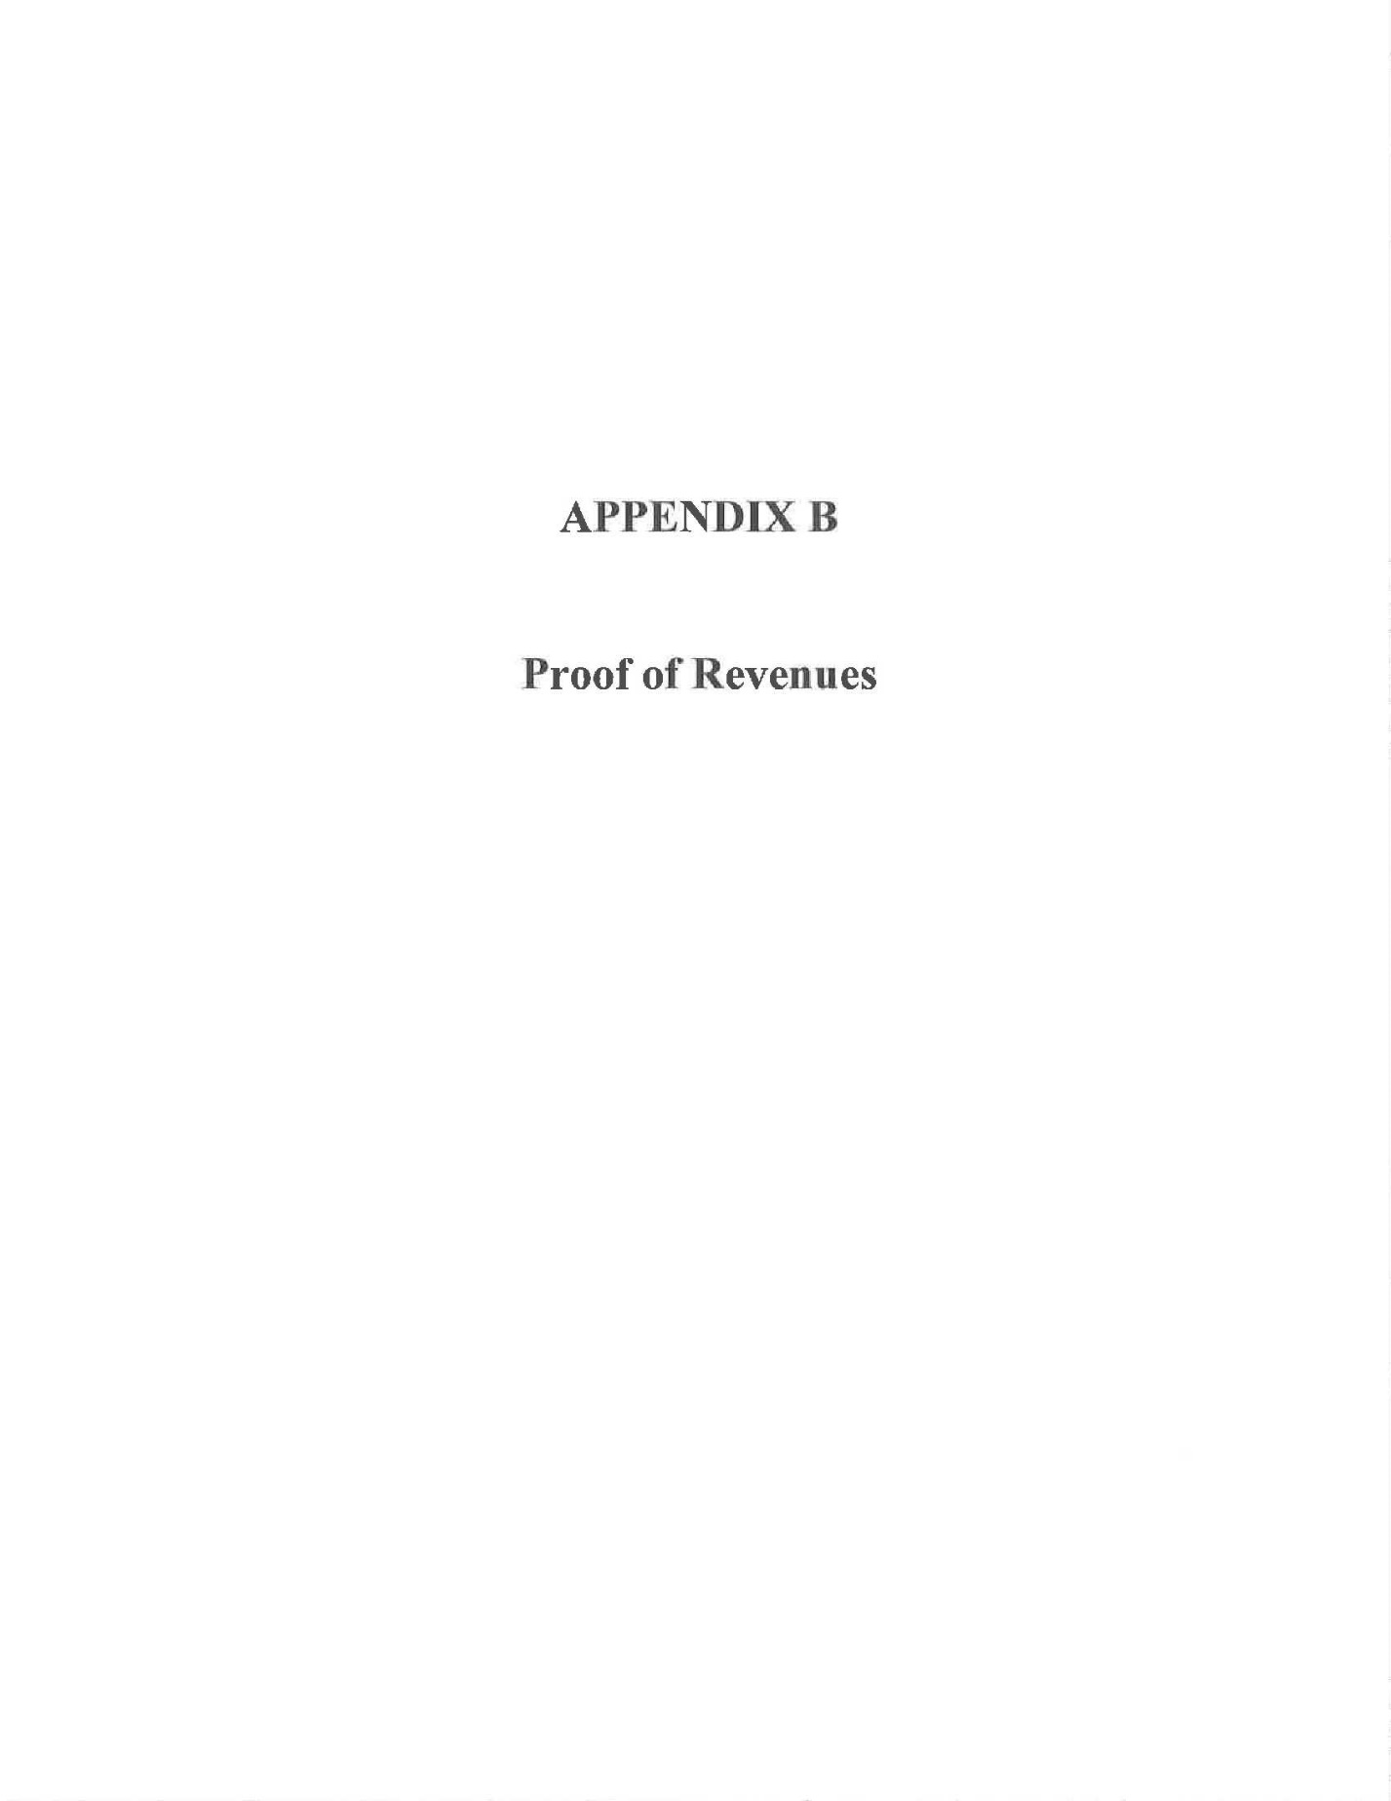

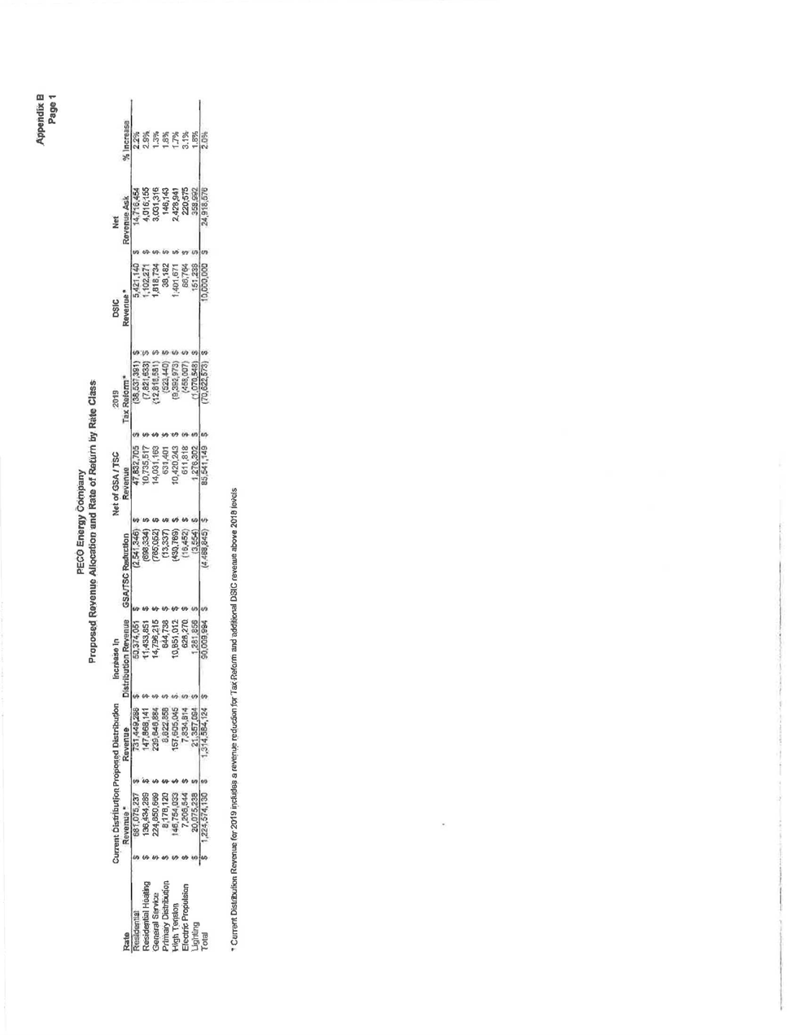
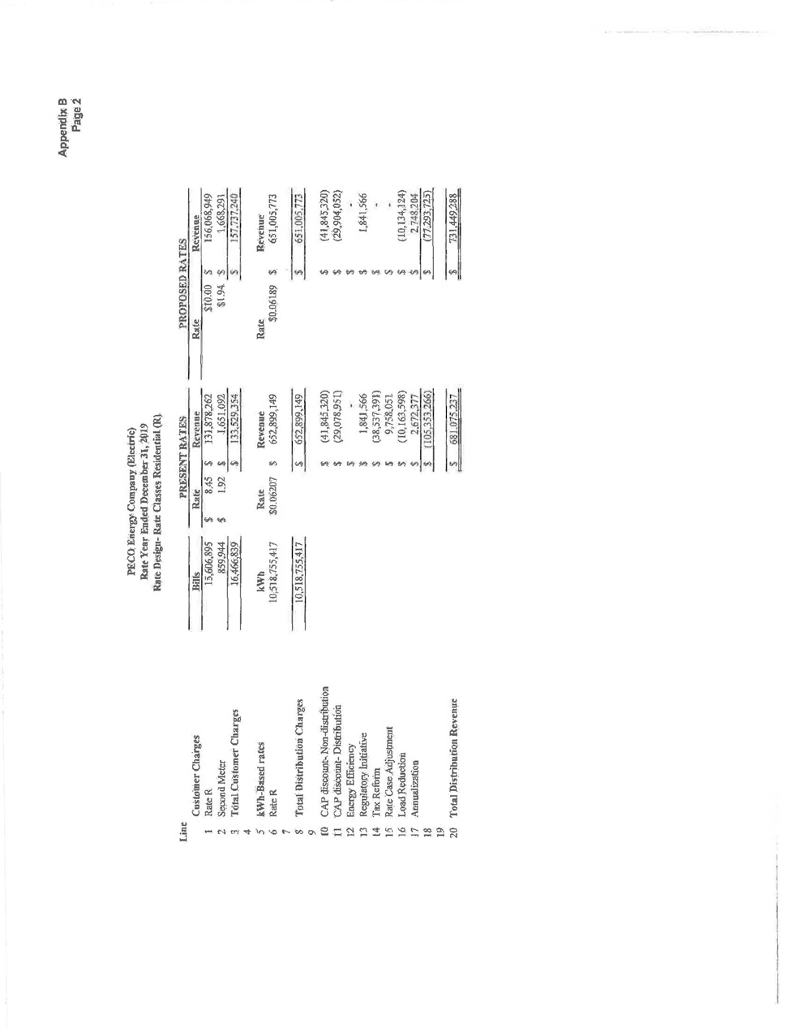
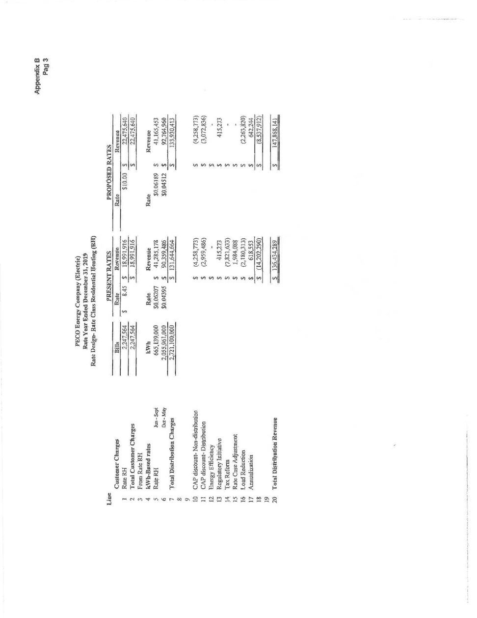

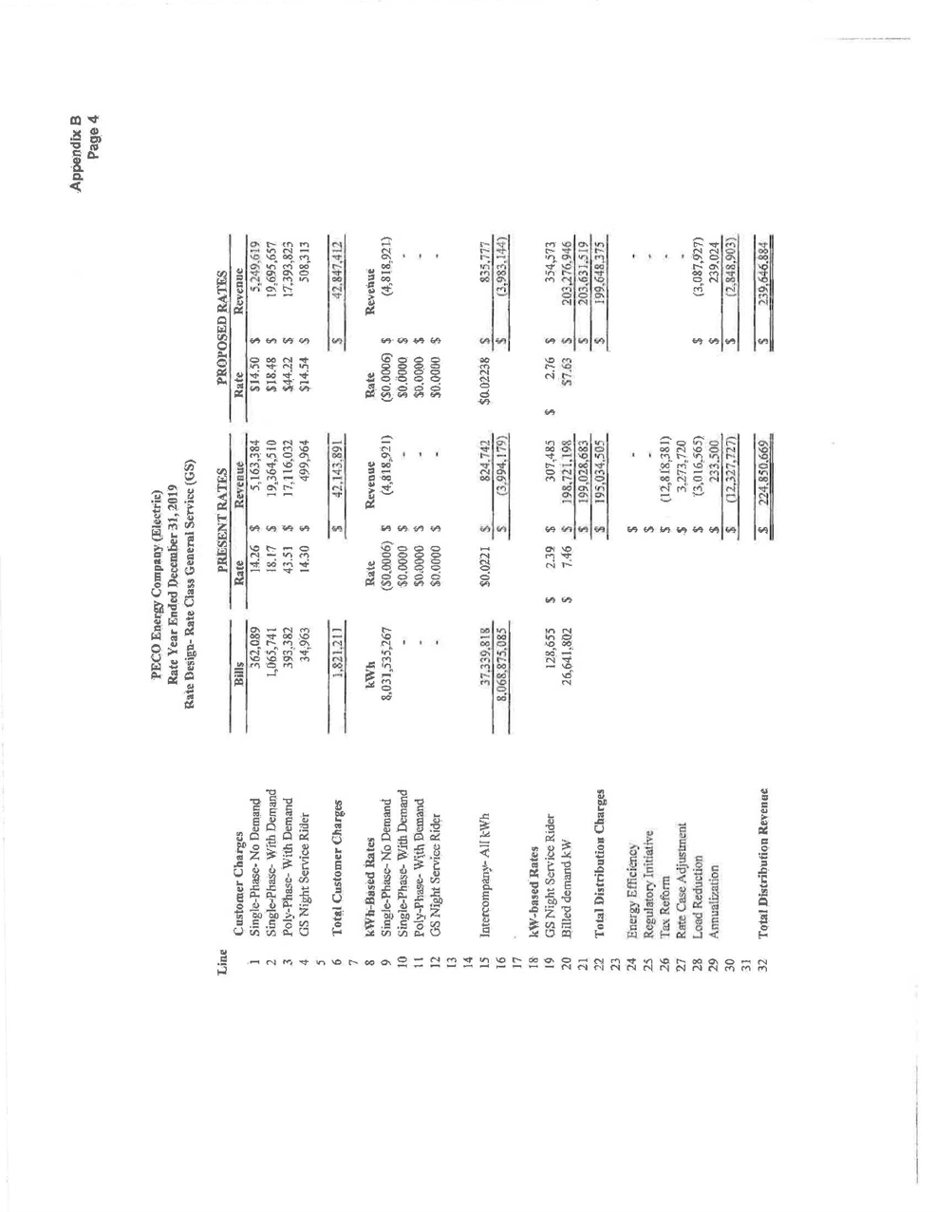
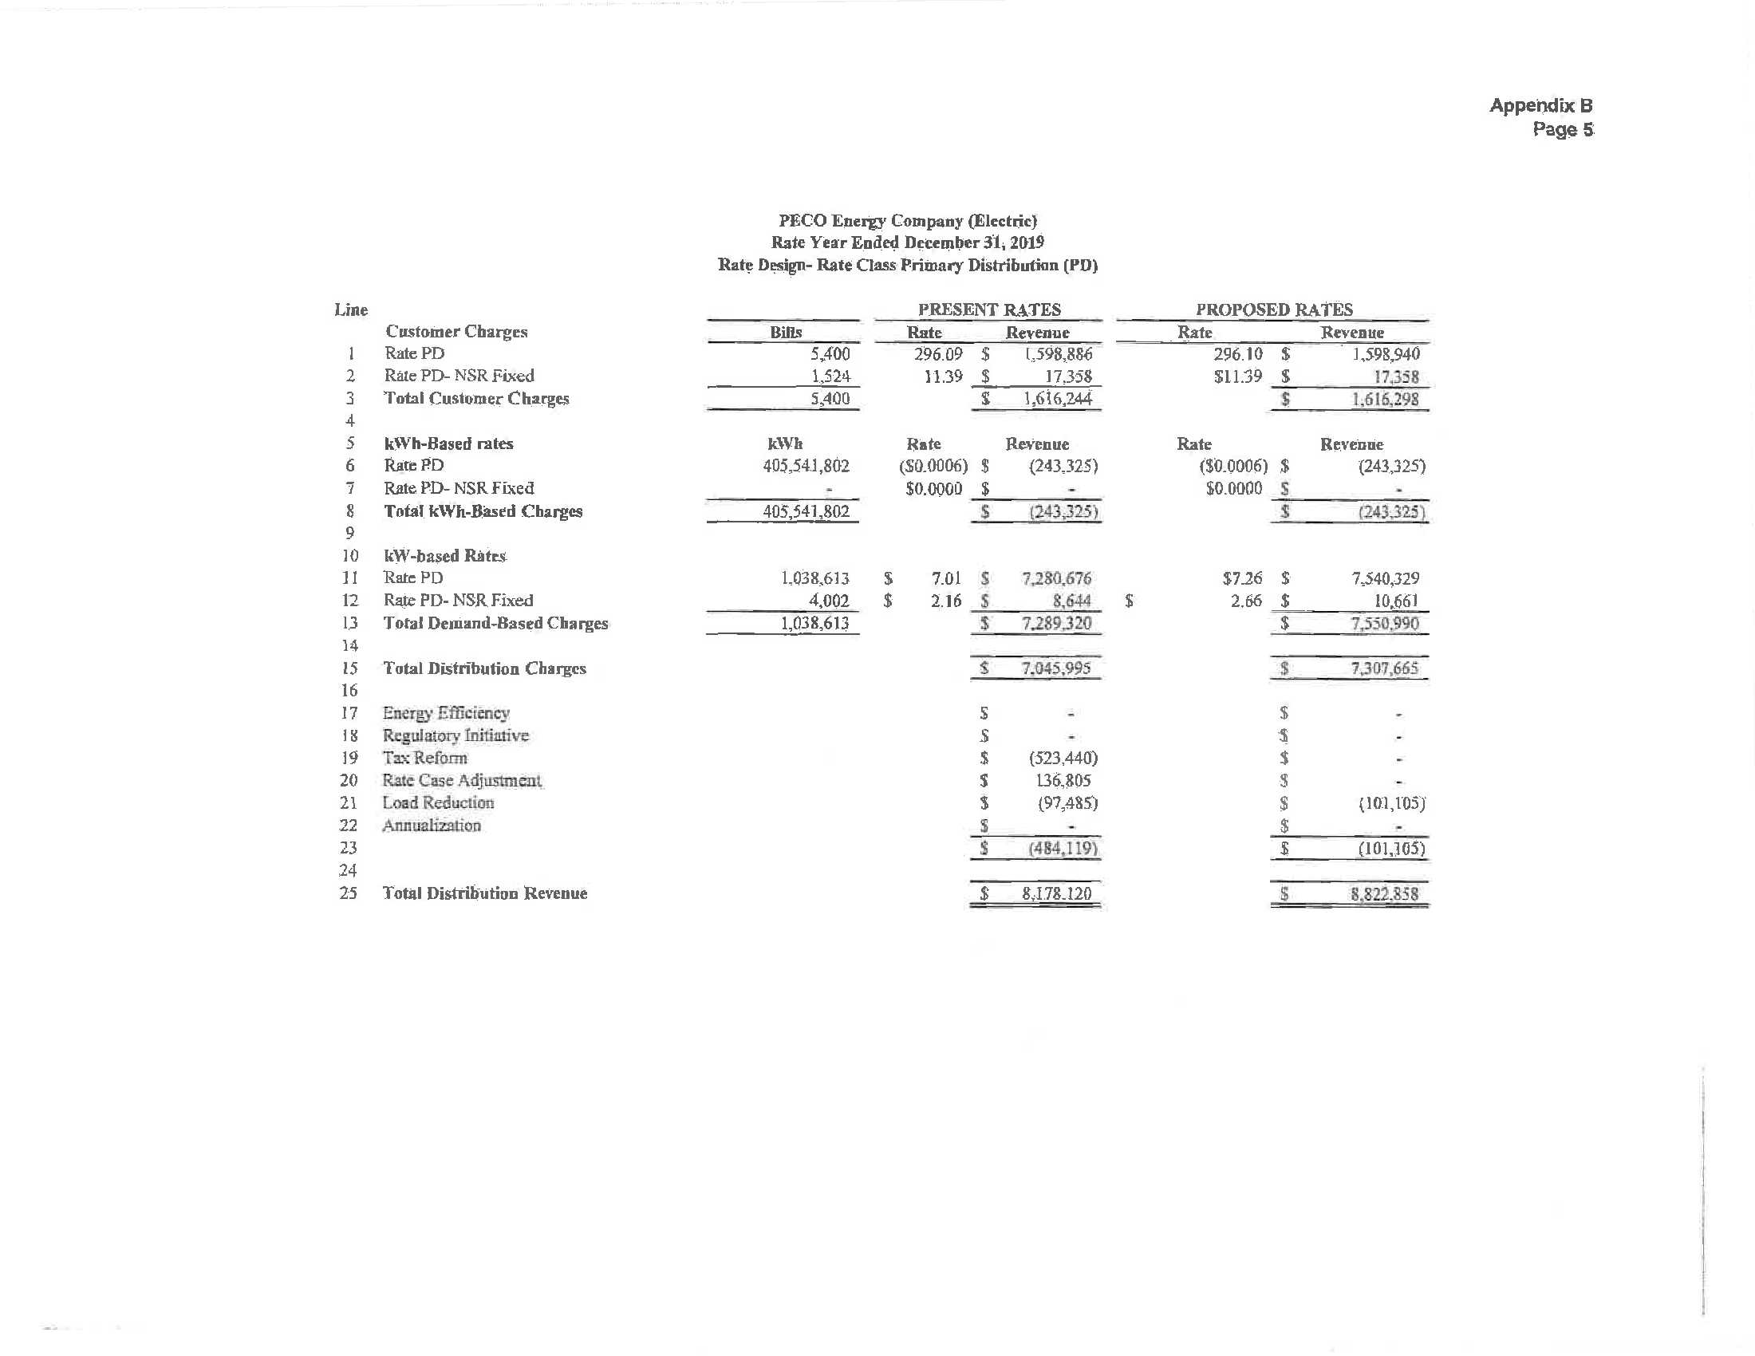

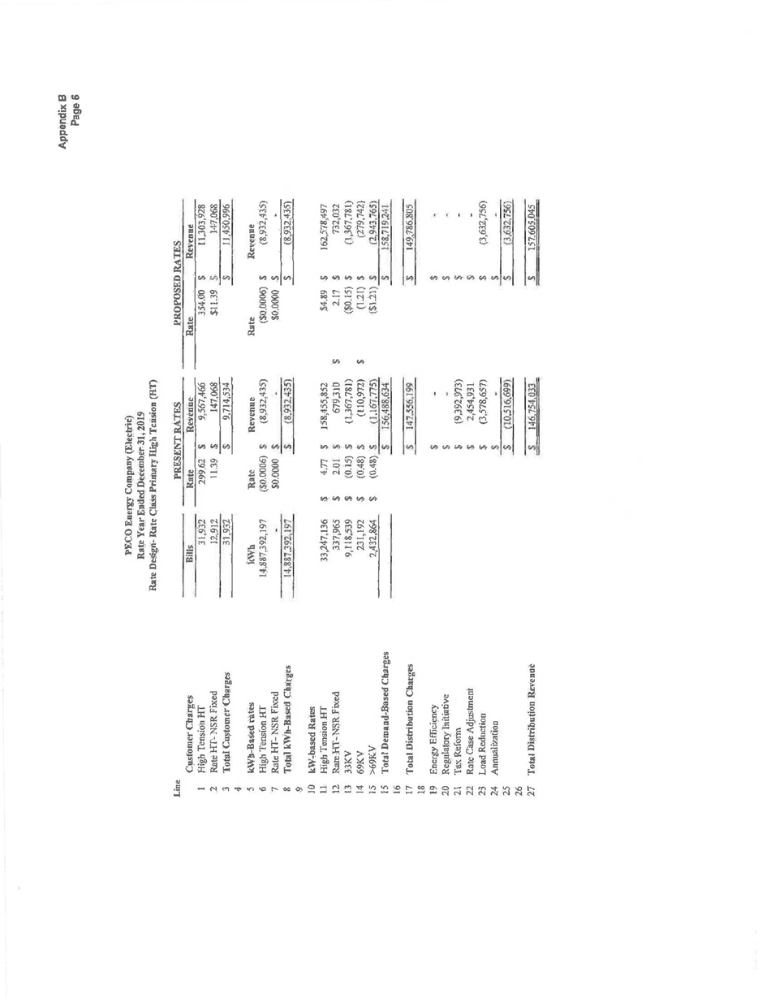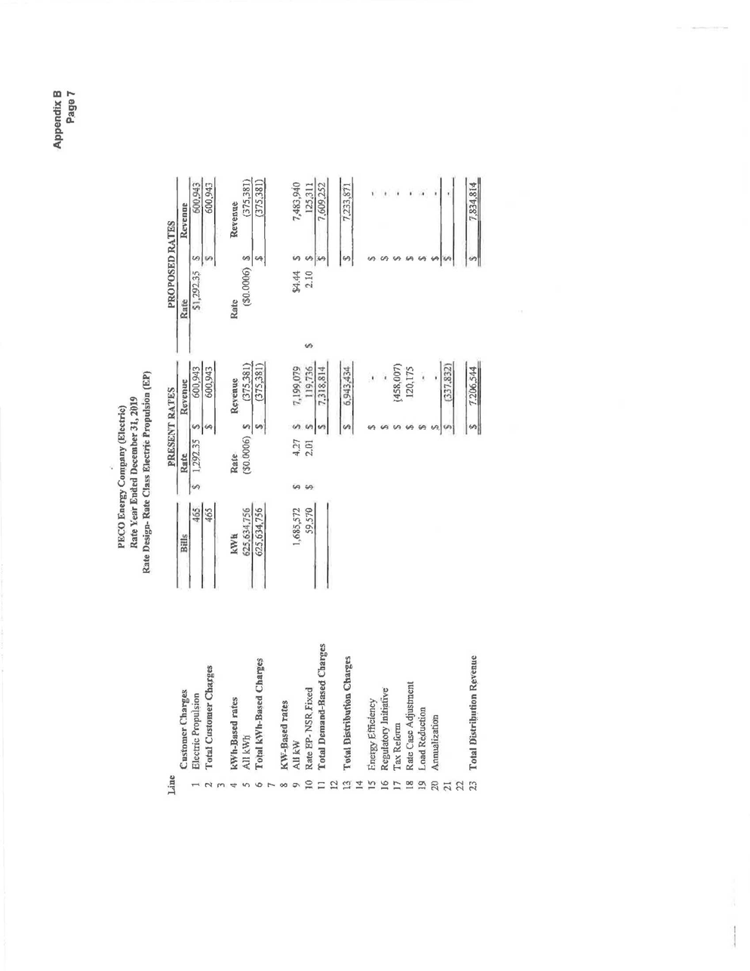
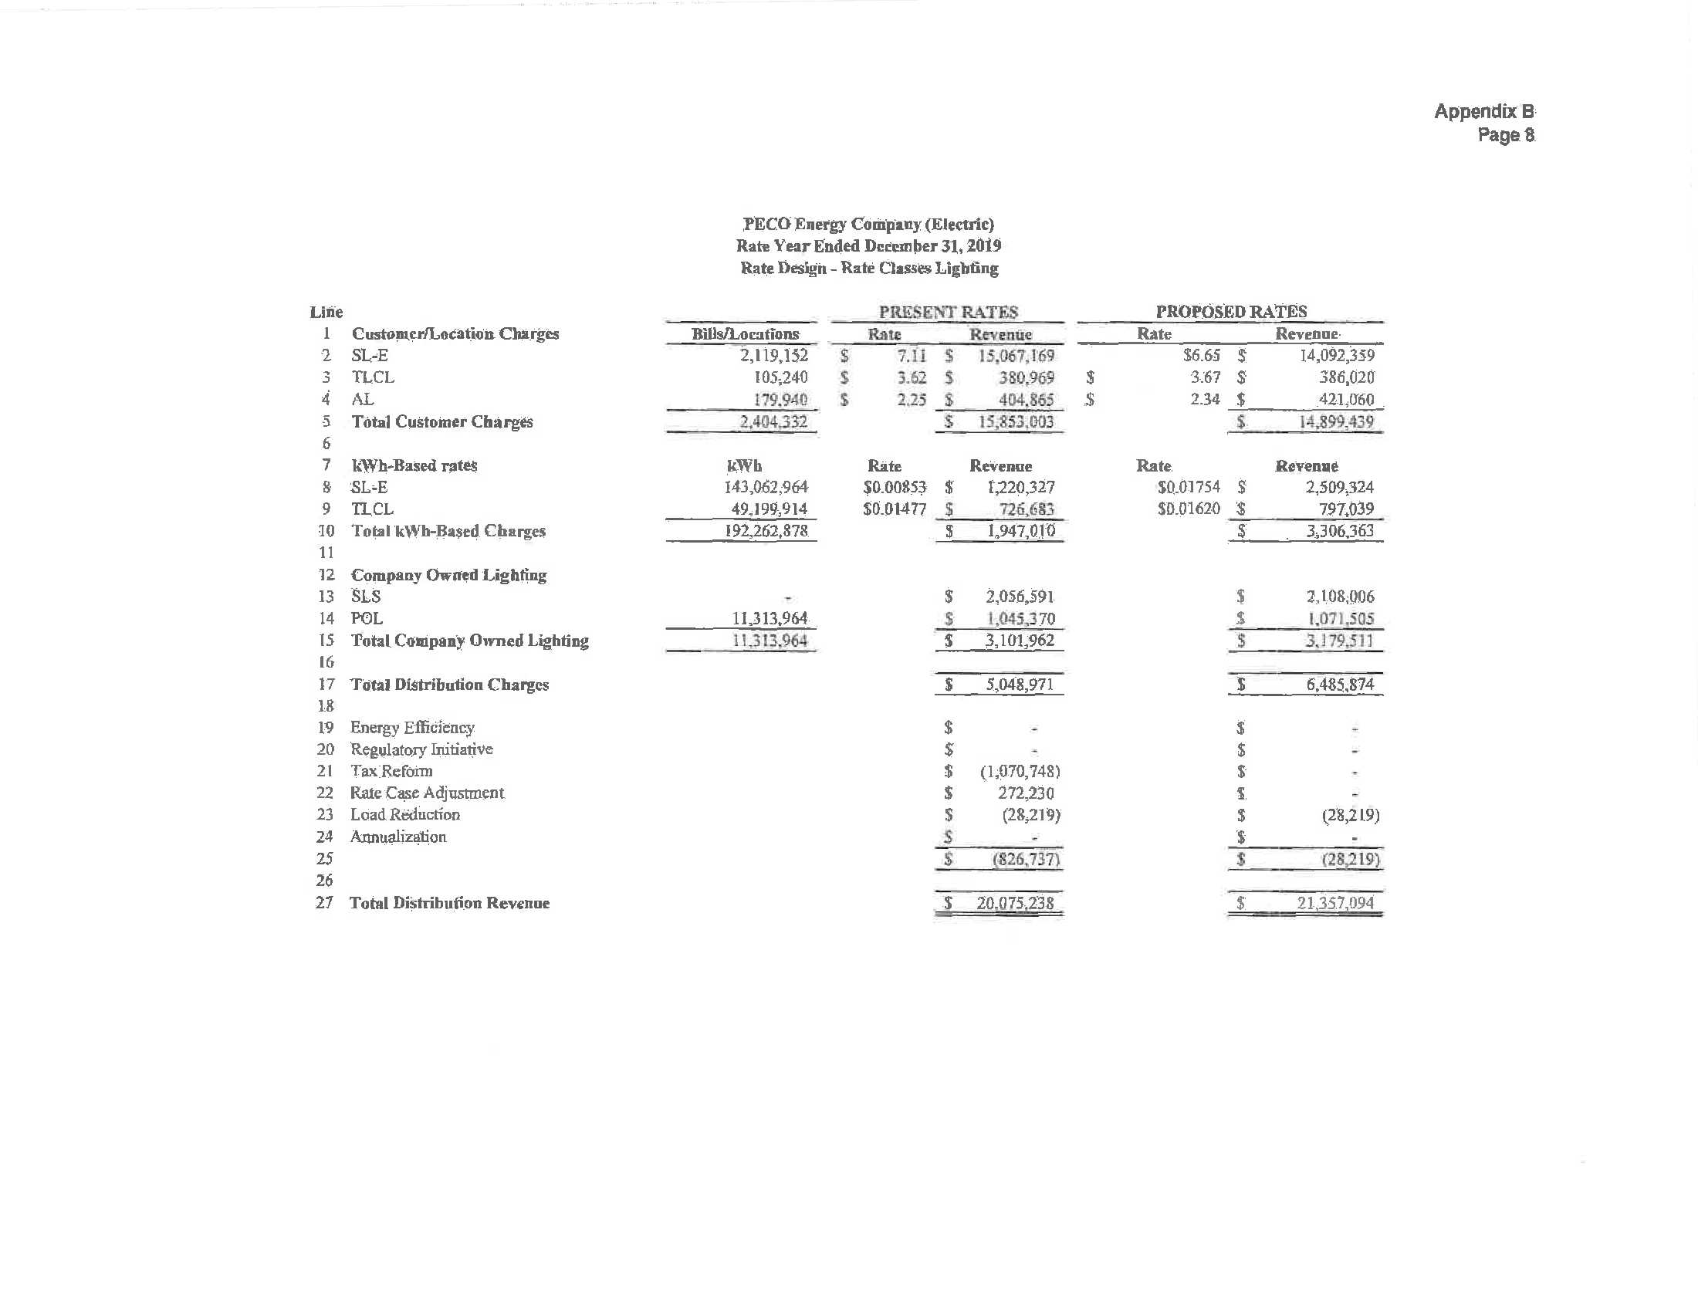

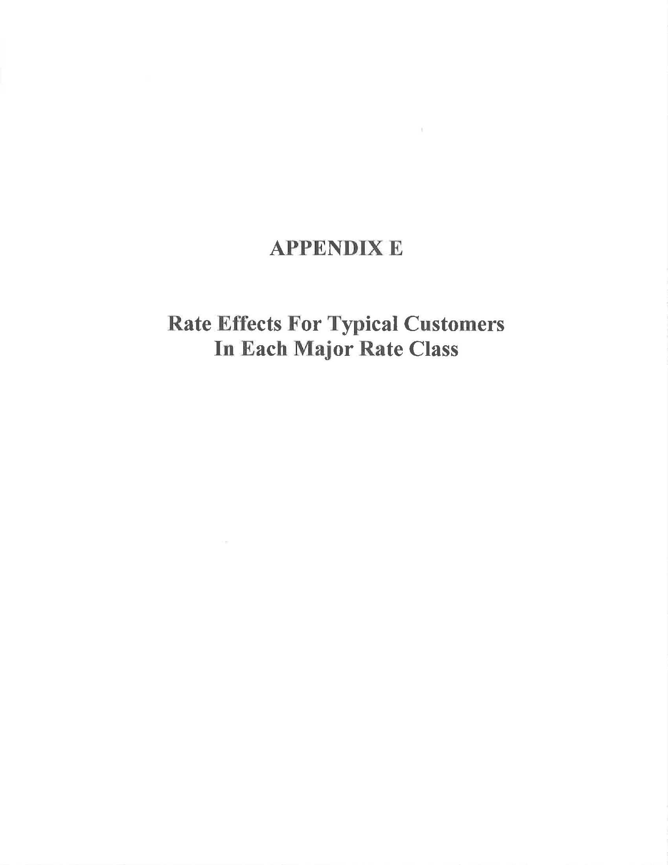

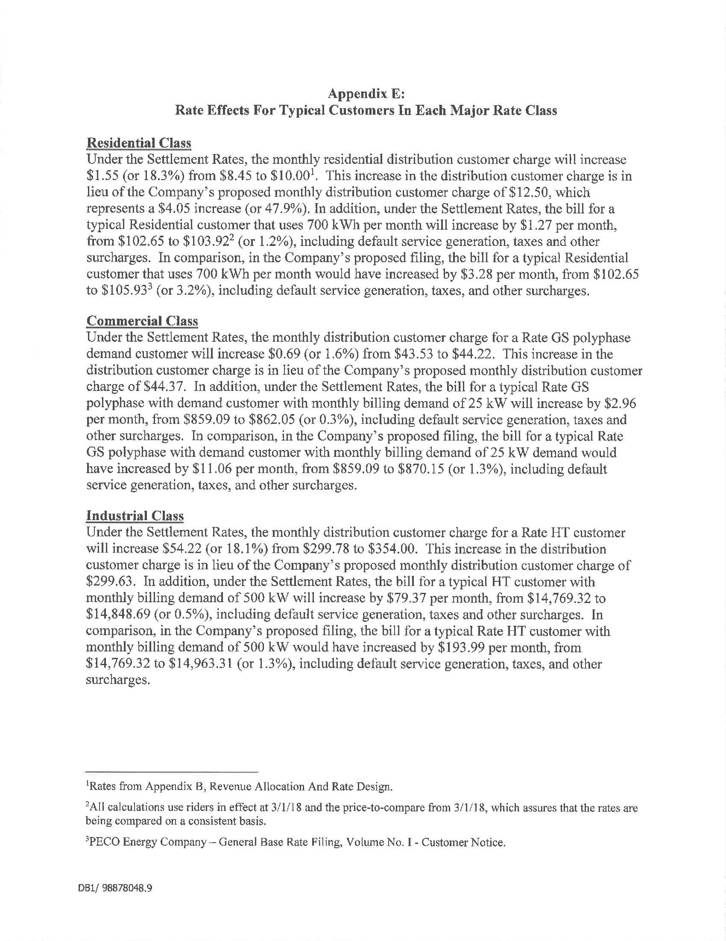

PECO’s proposed increase in annual operating revenues was approximately $142.5 million. PECO St. No. 3 at 13. However, that figure was adjusted to reflect $71 million savings in 2019 from changes in federal income tax law made by the Tax Cuts and Jobs Act (TCJA), which became effective on January 1, 2018. The $142.5 million increase was further adjusted for the roll-in of $10 million of additional 2019 Distribution System Improvement Charge (DSIC) revenue. The savings of $71 million in 2019 is the net effect of the TCJA’s reduction in the federal income tax rate from 35% to 21%, the amortization of a regulatory asset established to reflect excess accumulated deferred income taxes created by the tax rate reduction, and the elimination of bonus depreciation for public utilities. Partial Settlement at 2.
On May 16, 2018, the DVRPC filed a Petition for Leave to Withdraw, which was granted by Initial Decision dated July 3, 2018 and issued on July 25, 2018.
On June 20, 2018, UPenn filed a Petition for Leave to Withdraw, which was granted by Initial Decision dated July 3, 2018 and issued on July 25, 2018.
On May 16, 2018, PECO filed Answers to the Petitions to Intervene of NRG and RESA. On May 23, 2018, NRG filed a Response to PECO’s Answer. On May 24, 2018, RESA filed a Response to PECO’s Answer. On June 1, 2018, the ALJs granted the Petitions to Intervene in Prehearing Order No. 2. On July 17, 2018, RESA filed a Petition for Leave to Withdraw, which was granted by Initial Decision dated August 3, 2018, and issued on August 9, 2018.
On August 15, 2018, LIUNA filed a Petition for Leave to Withdraw, which was granted by Initial Decision dated September 17, 2018, and issued on September 27, 2018.
A total of forty-eight PECO customers gave sworn testimony during the six scheduled Public Input Hearings.
PECO also filed a Motion for Leave to File the Supplemental Direct Testimony of Richard A. Schlesinger on this date. On June 26, 2018, PECO’s Motion was granted in Prehearing Order No. 3.
On July 18, 2018, West Norriton Township filed a Petition for Leave to Withdraw, which was granted by Initial Decision dated August 3, 2018, and issued on August 9, 2018.
Pursuant to Paragraph No. 5 of Prehearing Order No. 1 issued on May 10, 2018, ChargePoint’s Petition to Intervene was deemed granted as there were no objections to its Petition within three calendar days of filing.
By Order dated July 24, 2018, the ALJs granted the Motion for Admission Pro Hac Vice.
Pa. PUC v. Peoples TWP LLC, Docket No. R-2013-2355886 (Order entered December 19, 2013), at 28 (citations omitted).
The Partial Settlement will allow PECO to file new tariff rates designed to provide an overall distribution base rate increase of $85.5 million, which is reduced to $14.9 million following the application of 2019 tax savings related to TCJA. The revenue requirement is further adjusted to account for the roll-in of DSIC revenue for a net revenue increase of $24.9 million. Partial Settlement at ¶ 15.
A copy of Appendix B, Proof of Revenues, is attached to this Opinion and Order.
A copy of Appendix E, Rate Effects for Typical Customers in Each Major Rate Class, is attached to this Opinion and Order.
Net Revenue increases include a revenue reduction related to the TCJA and additional DSIC revenue above 2018 levels. This footnote appears as footnote 10 in the Joint Petition.
Paragraphs 16 and 17 describe the principal elements of the rate structure and rate design incorporated in the Settlement Rates. While every effort has been made to ensure that the description is accurate, if any inconsistency is perceived between that description and the specific rates set forth in Appendix A, the latter shall take precedence. This footnote appears as footnote 11 in the Joint Petition.
Includes the Capacity Reservation Rider Charges, Customer Assistance Program (CAP) Rider, Commercial and Industrial Direct Load Control Rider, Economic Development Rider, Investment Guarantee Rider Charges, Residential Direct Load Control Rider, Night Service Rider (GS, PD and HT rates), and Pilot Electric Vehicle Direct Current Fast Charge Rider. This footnote appears as footnote 12 in the Joint Petition.
Additional provisions regarding the implementation of a DSIC include: (1) the agreement that the Nuclear Decommissioning Charge, the Non-Bypassable Transmission Charge, the STAS; (2) and the FTAC will be removed from base rates for the DSIC calculation, and that a 1.5% cap on the DSIC that applies to K-C, a member of PAIEUG will be implemented and will remain in effect until the implementation of new rates following PECO’s next electric distribution base rate proceeding.
52 Pa. Code § 54.181 et seq.
52 Pa. Code § 54.185.
52 Pa. Code § 54.187(e) & (f); 66 Pa. C.S. § 1307(d).
Petition of PECO Energy Company for Approval of its Default Service Program for the Period from June 1, 2017 through May 31, 2021, Docket No. P-2016-2534980 (Order entered December 8, 2016).
Customer Service sub-accounts show rounded values based on values in PECO Exhibit JD-2 – Electric Class Cost of Service Study.
Based on its Proposed Ordering Paragraphs included with its Main Brief, NRG appears to have included with its proposal a request to scale-back its proposed re-allocation based upon the final revenue requirement approved by the Commission in this proceeding. However, NRG did not present any explanation of its scale-back proposal. NRG M.B., Proposed Ordering Paragraph No. 1.
NRG St No. 1, Exhibit CP-3.
NRG M.B. at 36-37 (quoting 52 Pa. Code § 69.1808(a)(4)).
The full citation from PECO Statement No. 9-R at 6 is as follows: “Supply procurement and administrative costs that are associated with the wholesale power supply contracts, which include the costs of a default service independent evaluator to oversee the procurement process and a charge for working capital, are also included in the PTC as permitted by Section 69.1808(a)(3) and (4). Regulatory costs and litigation costs associated with PECO’s default service plans are also recovered through the PTC.”
Investigation of Pennsylvania’s Retail Electricity Market: End State of Default Service, Docket No. I-2011-2237952 (PECO Comments filed December 10, 2012).
Petition of NRG Energy, Inc. for Implementation of Electric Generation Supplier Consolidated Billing, Docket No. P-2016-2579249 (PECO Comments and Answer filed January 23, 2017).
PECO St. No. 9-R at 9-10.
NRG M.B. at 44.
PECO St. No. 9R at 5-6.
PECO St. No. 9R at 17.
Application of PECO Energy Co. for Approval of its Restructuring Plan Under Section 2806 of the Public Utility Code, Docket No. P-00971265, 1997 Pa. PUC LEXIS 51 (Order entered December 22, 1997).
NRG R.B. at 3.
PECO witness Jiang Ding explained in her direct testimony how each of the costs, identified in Mr. Peterson’s re-allocation proposal, was properly functionalized and assigned to distribution customers. PECO St. No. 6 at 14-25.
R.D. at 76-95.
PECO M.B. at 17; OCA R.B. at 7.
Tr. at 497.
NRG St. No. 1 at 17-18.
R.D. at 129.
OCA St. No. 3R at 6 (citing PECO Petition to Provide Default Service Program (June 2017 – May 2019) (DSP-IV), Docket No. P-2016-2534980; and PECO St. No. 5, Ex. ABC-5).

