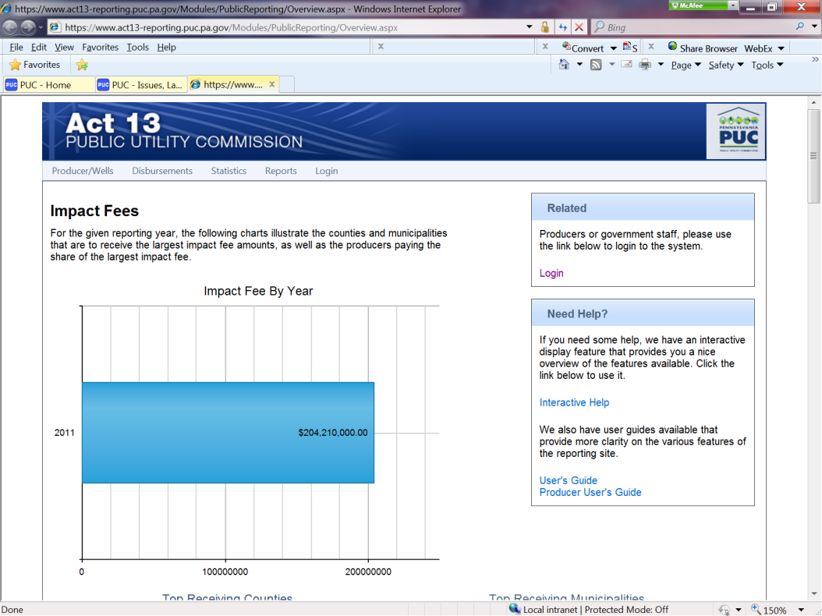
Enter the site at https://www.act13-reporting.puc.pa.gov. The home page will appear as

NOTE: Once a menu bar item is selected, you must use the back browser button to
return to the previous page

You can choose the following items from the Menu bar:
- Producer/Wells
  - Producer Details
  - Producer List

- Disbursements
  - Fee Schedule

- Statistics
  - Overview (this is the default home page of the site)
  - County / Municipality Reporting

- Reports (no drop down, just click on Reports)

- Login (for producers only)

Producer/Wells
Producer List - Provides an alphabetical listing of Producers, along with the number of horizontal and vertical wells.
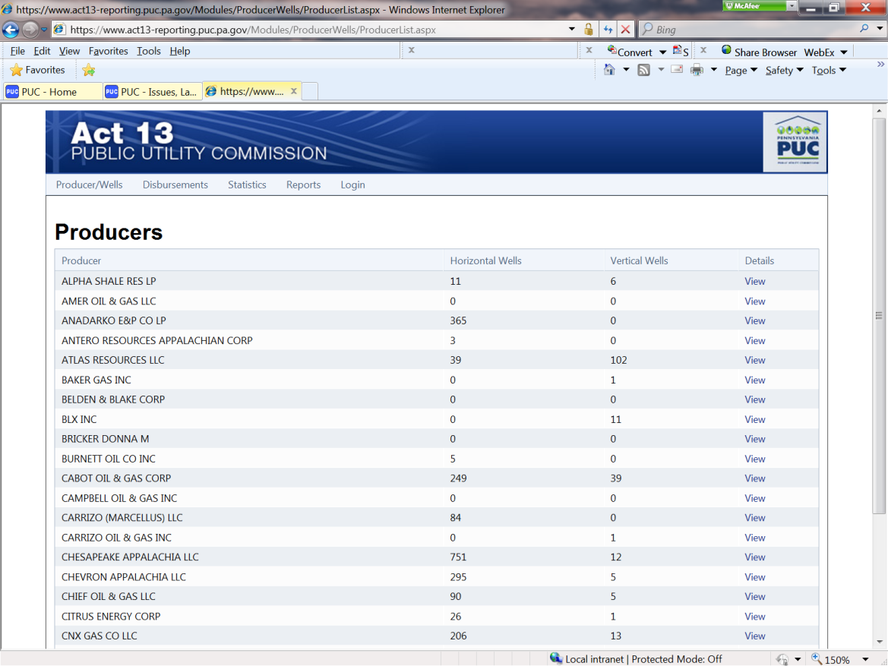

Producer Details – Displays interactive listing of Producers. For details select View beside the appropriate producer

A screen with the Producer’s information will appear
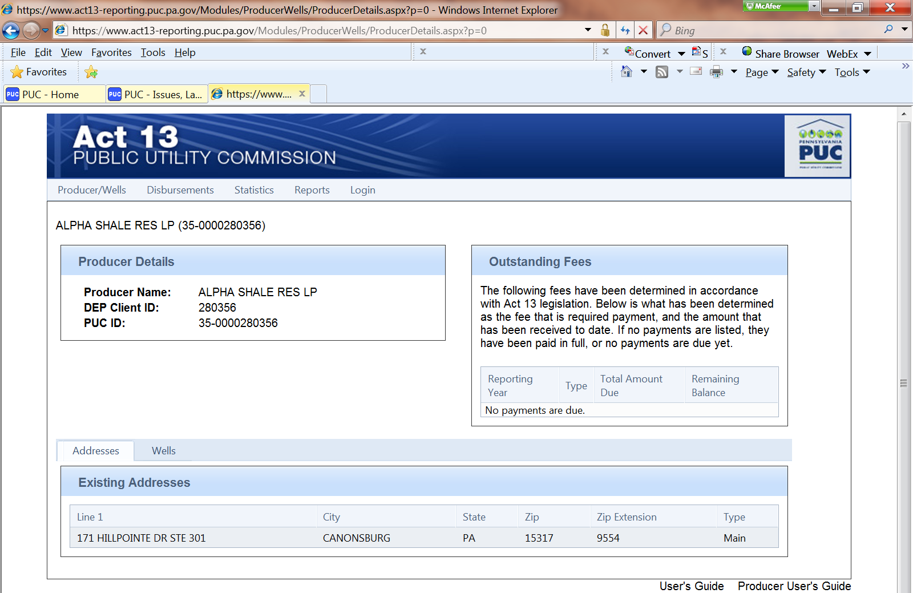

In addition to this screen, you can choose the Wells tab

This will display a list of the producers’ wells and fee information
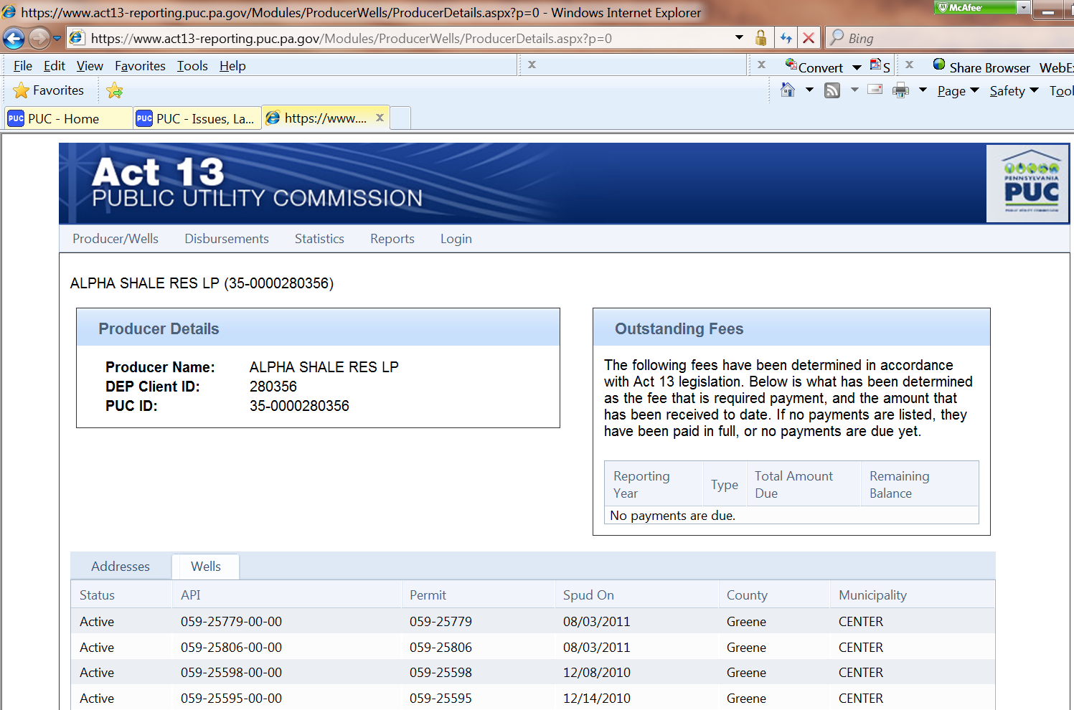

Disbursements
Fee Schedule – displays the amount due for well for selected Reporting Year
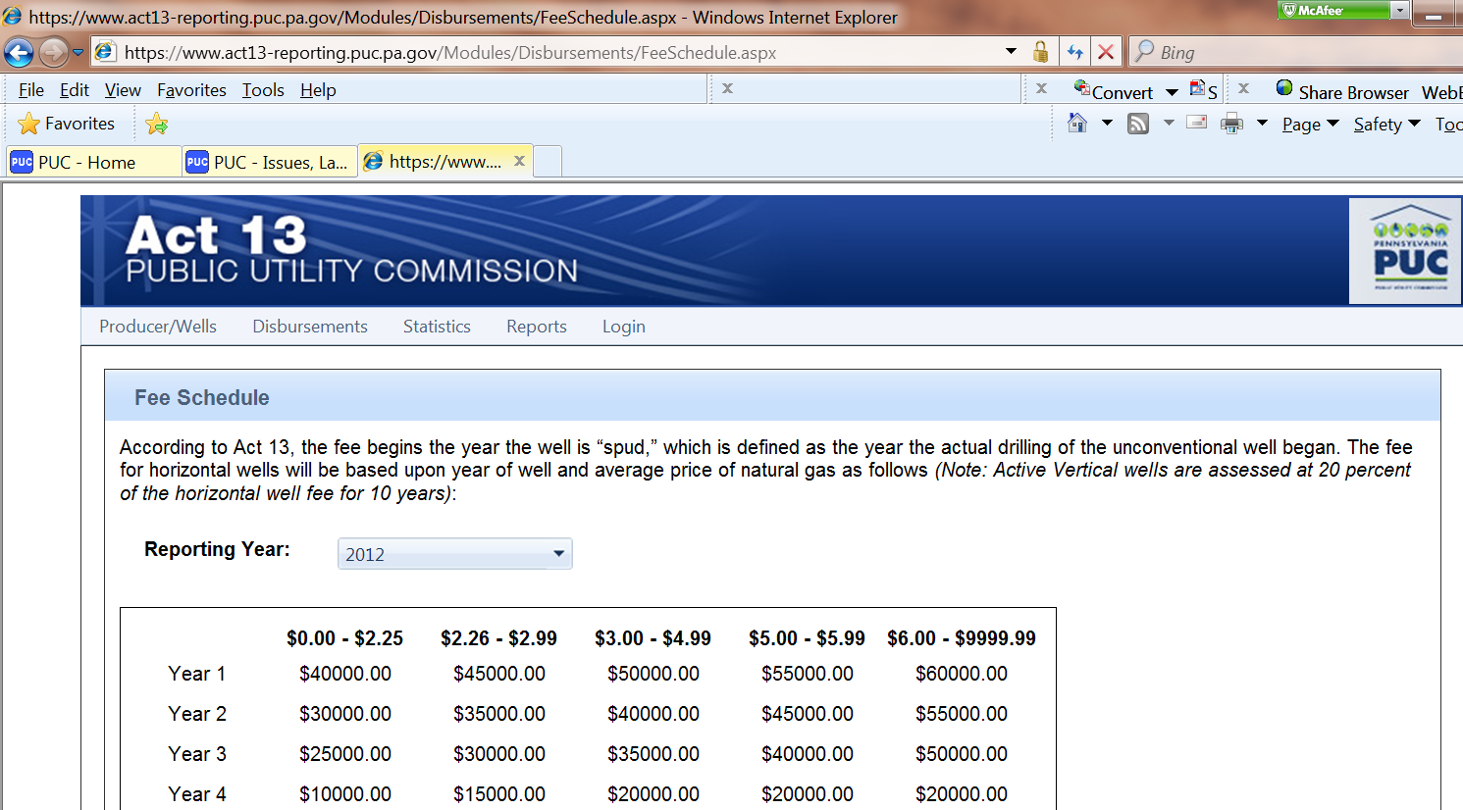

Statistics
Overview – displays a general overview of the Impact Fees
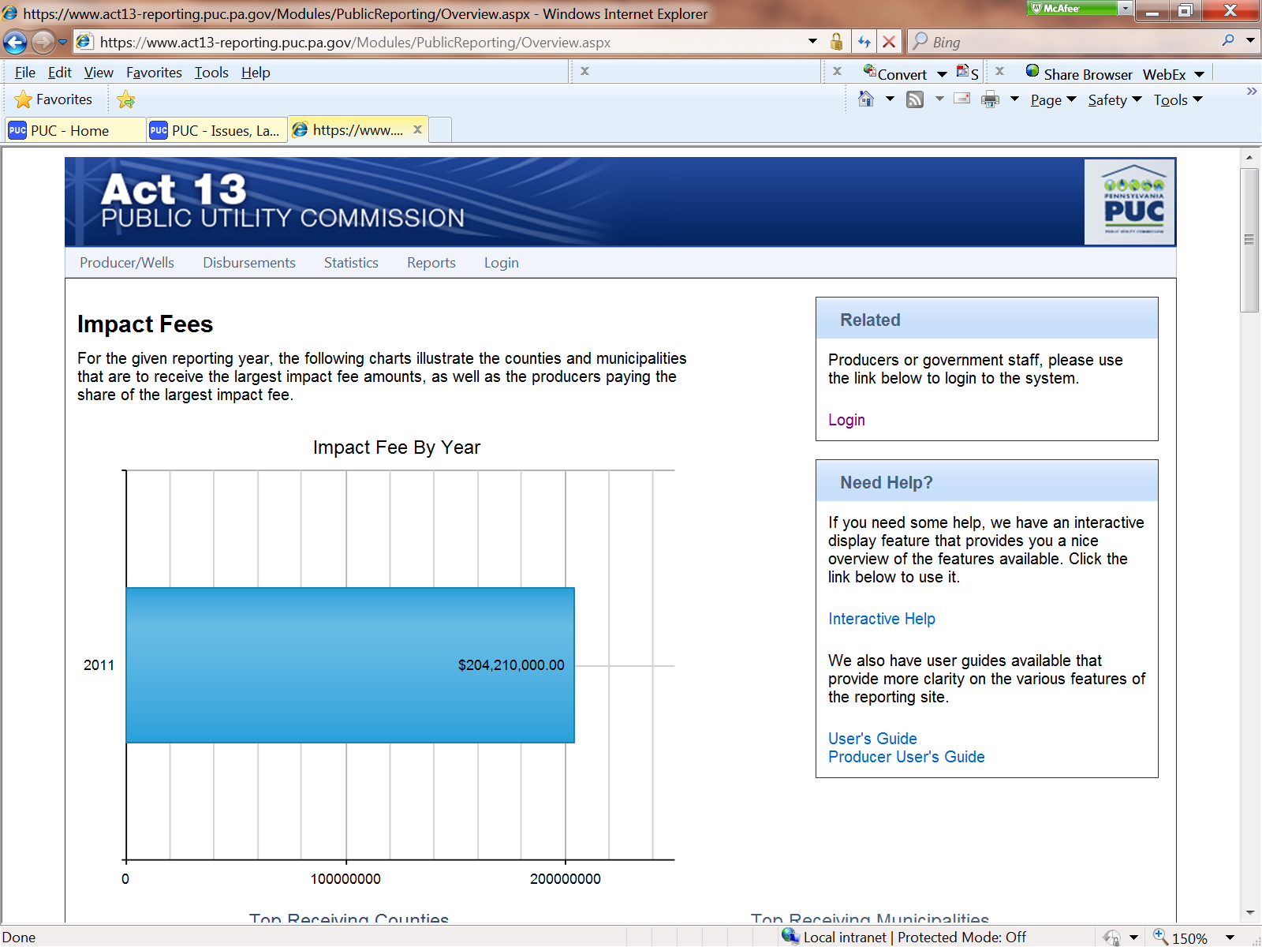

County/Municipality Reporting – displays an interactive map of all counties within the Commonwealth
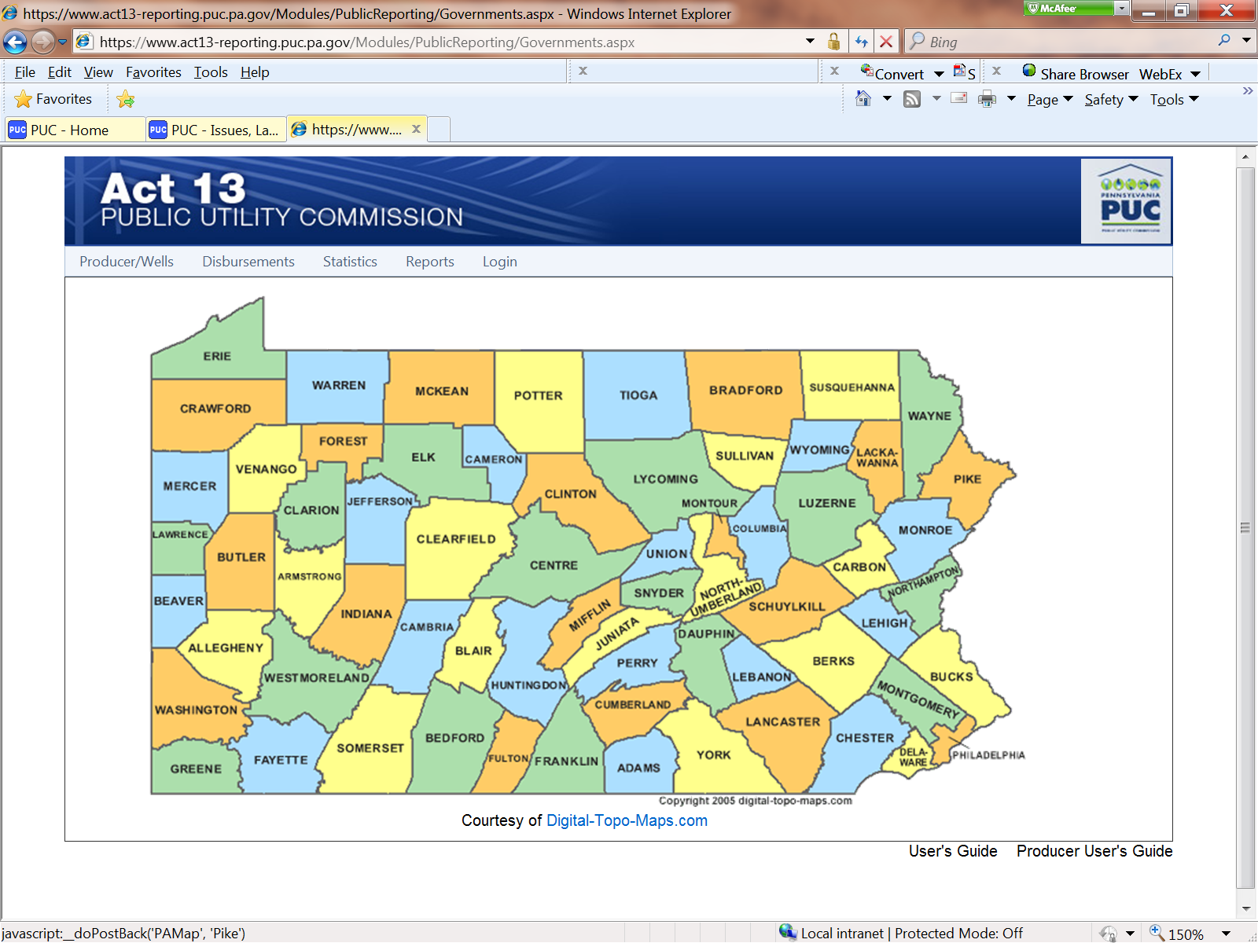

Select the county of interest to view the details of the county

This will display the County demographics, well information, and list its’municipalities
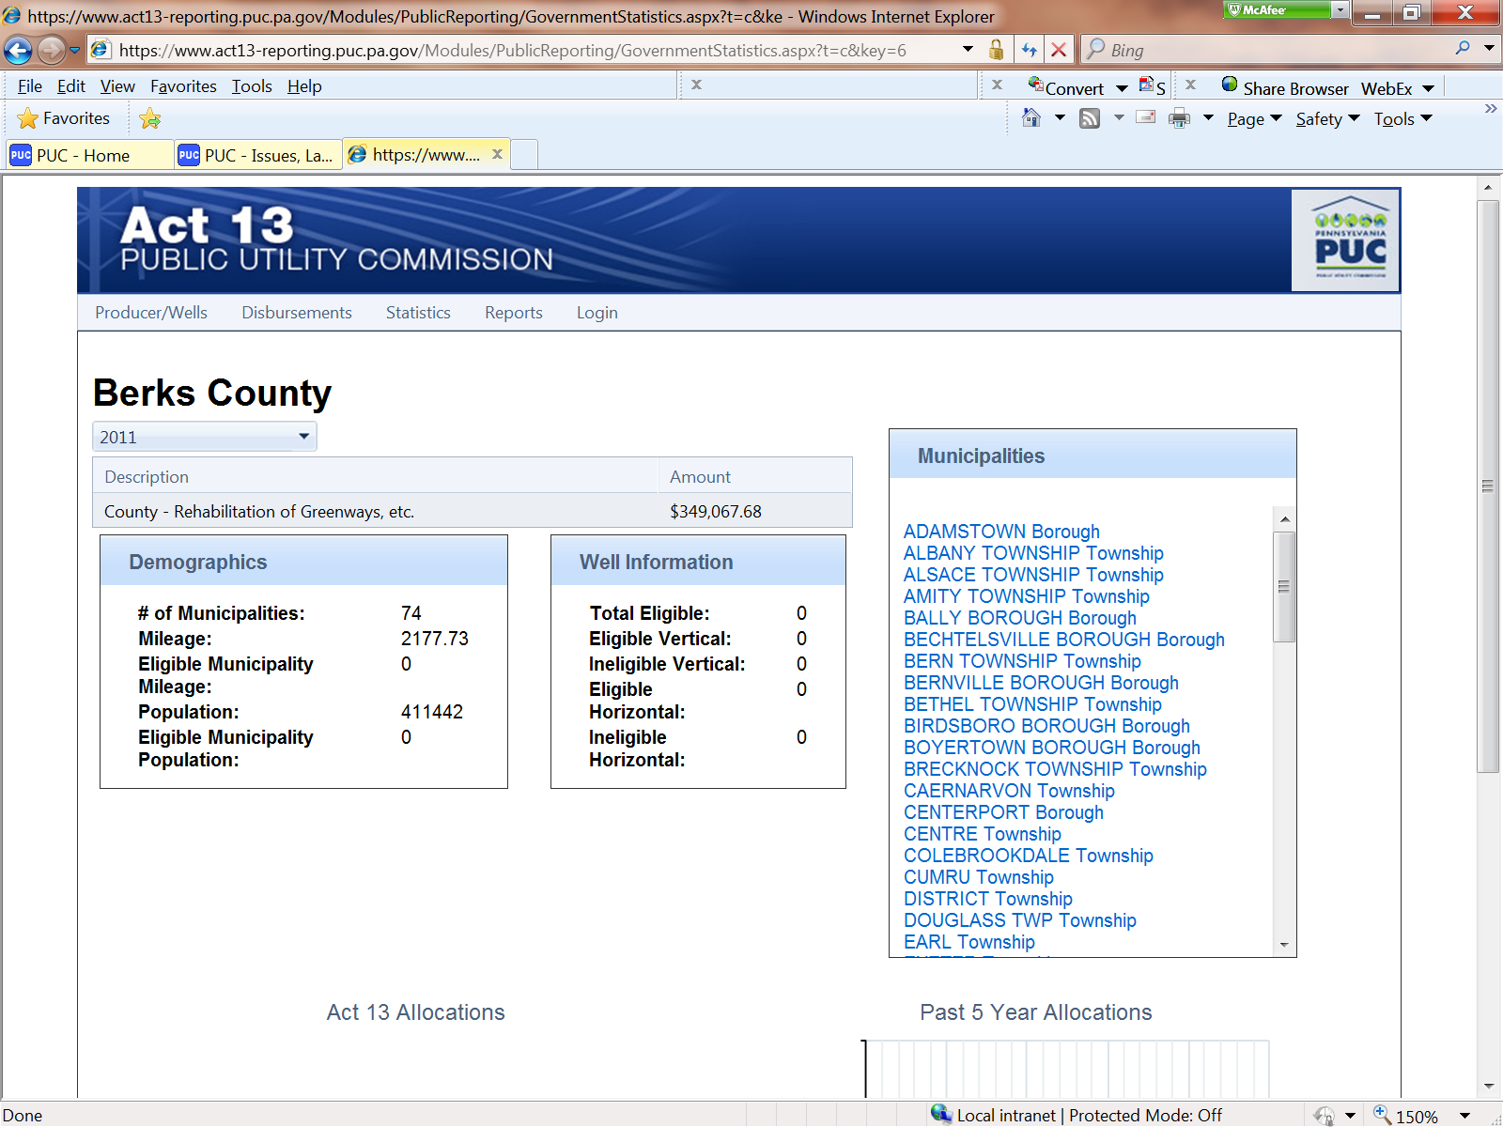

Select the municipality on the right to see specific details of that municipality

This will display the demographics of the municipality chosen
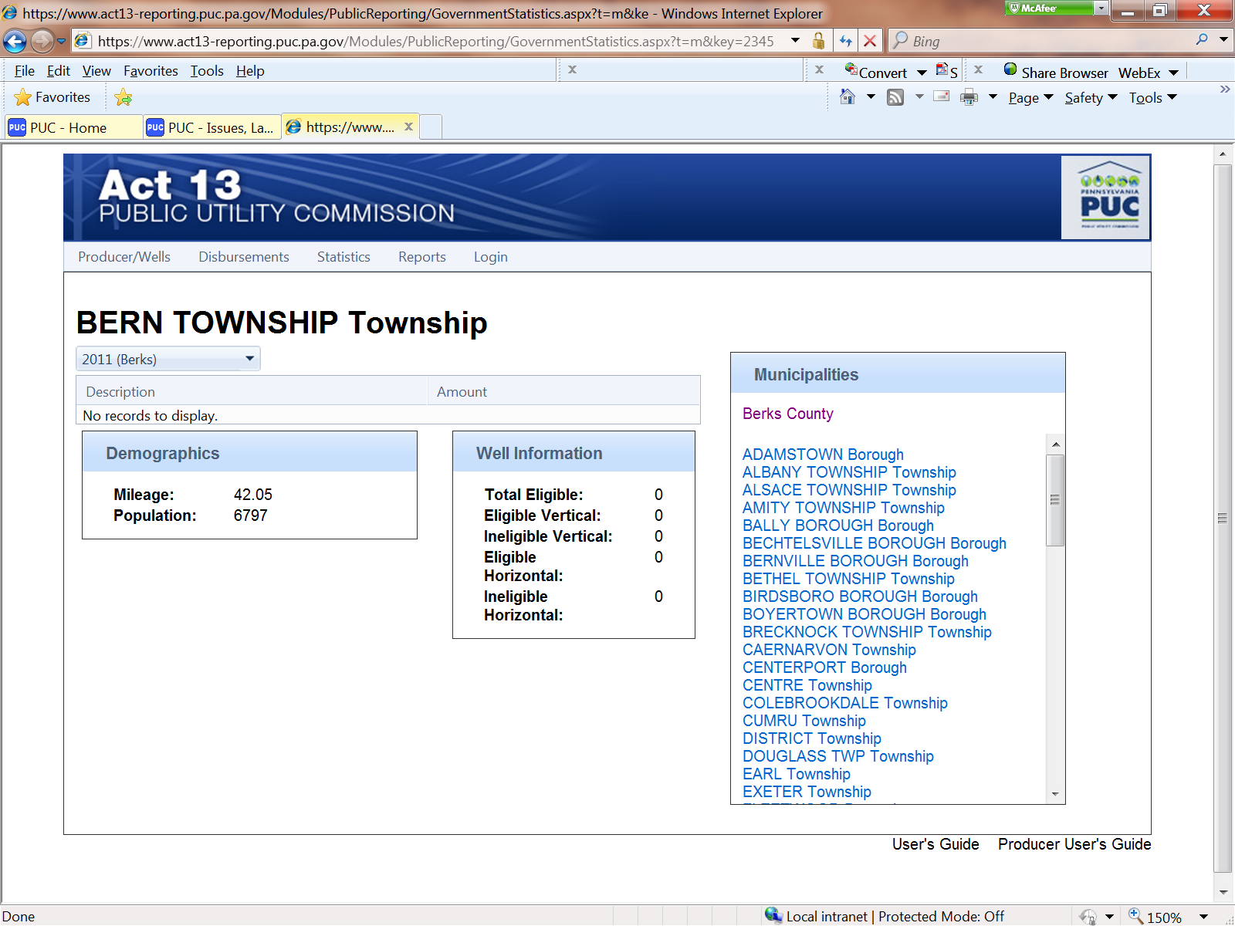

Reports

County and Municipality Disbursement - select the Reporting Year, then select View Report

This displays an alphabetical listing of all county /municipality disbursement amounts for the selected year
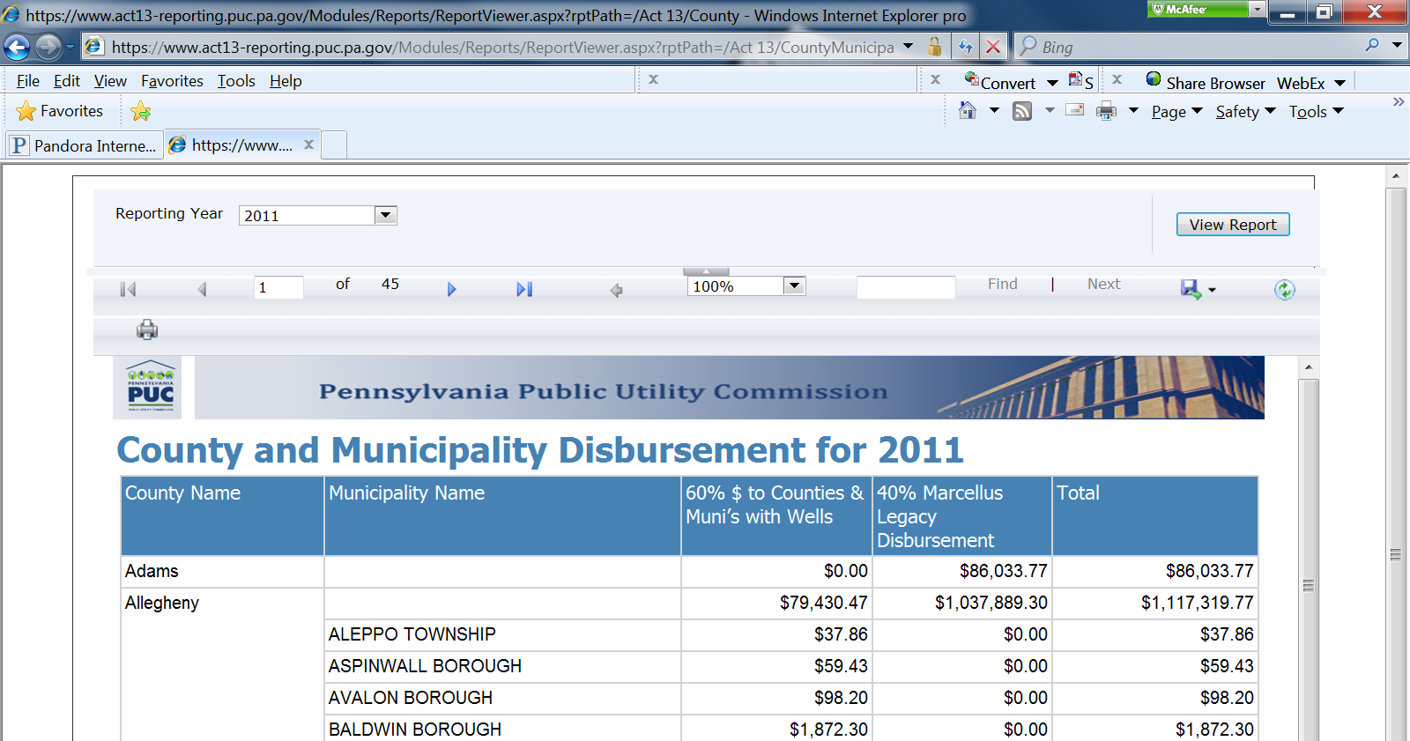

County Report – select the appropriate Reporting Year and County, then select View Report

This will display the distribution details for the funds received by the county
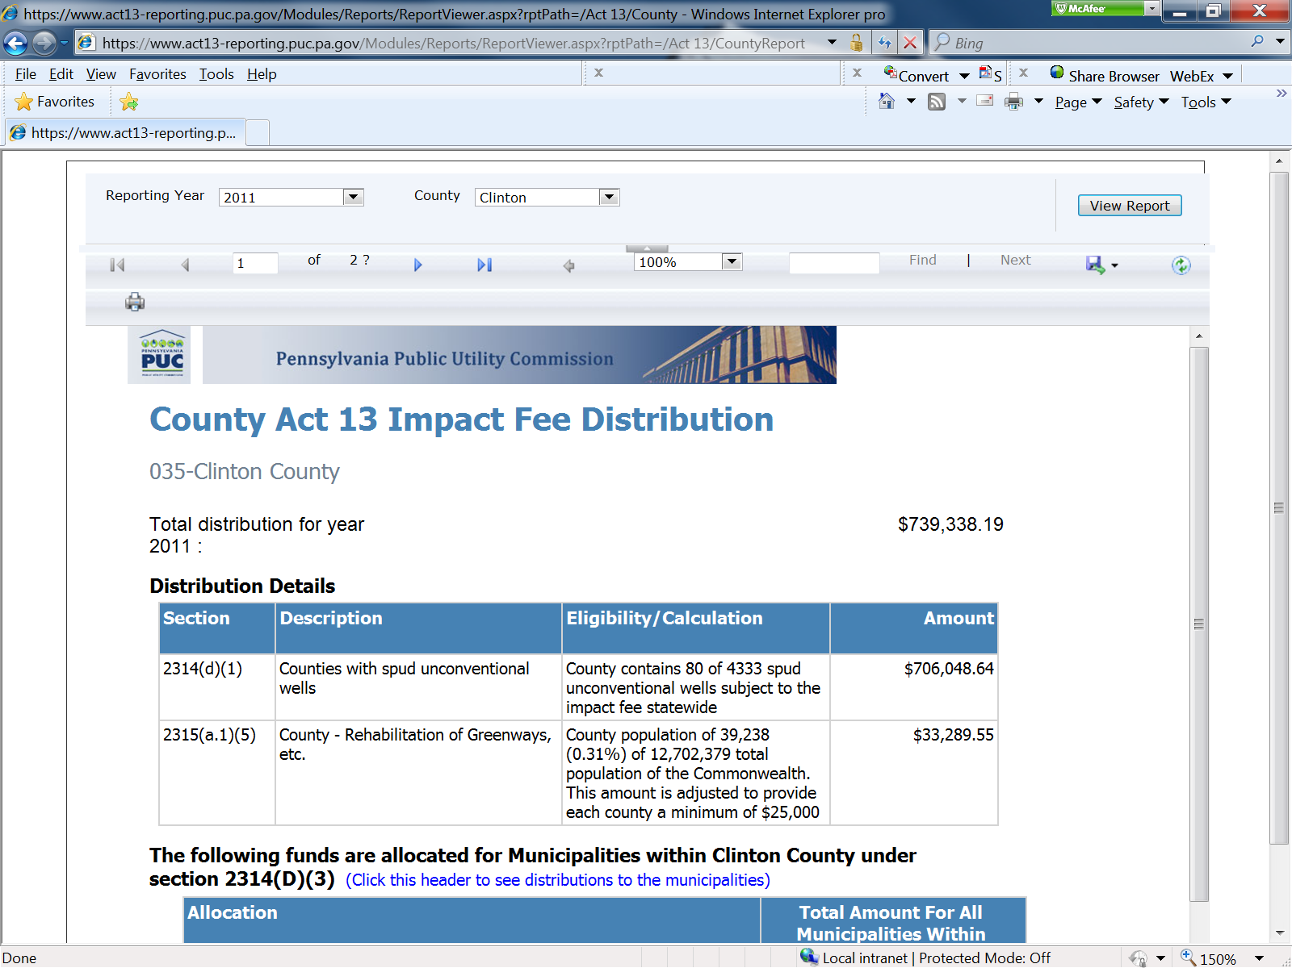

Disbursements Report – select the Year, then select View Report

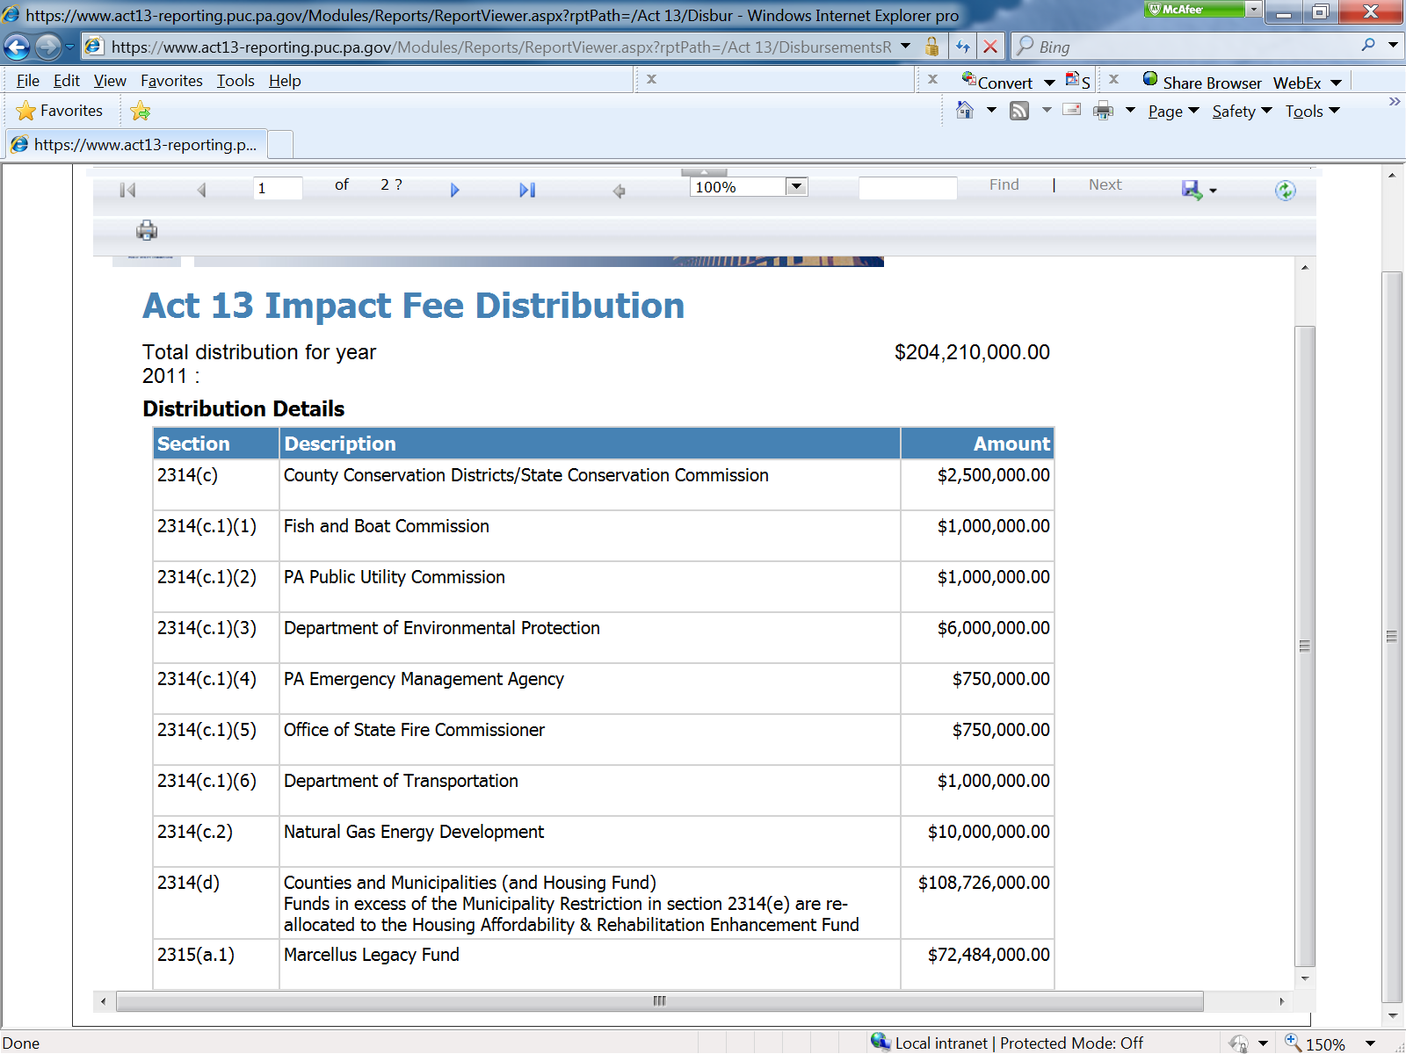
This displays the distribution details of the Impact Fee for the selected year

Selecting Page 2 will bring up additional information on disbursements

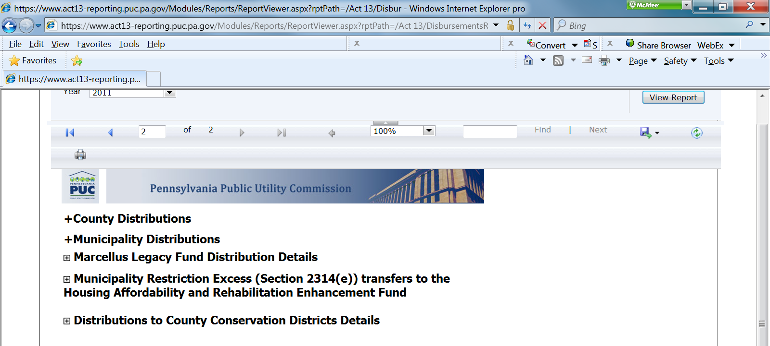

Municipality Report – select appropriate Reporting Year and County

Select the appropriate Municipality, then select View Report
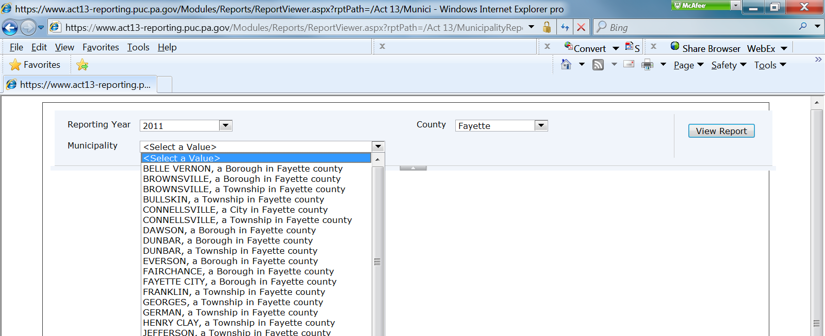
This will display the distribution details of the Impact Fee for the chosen municipality
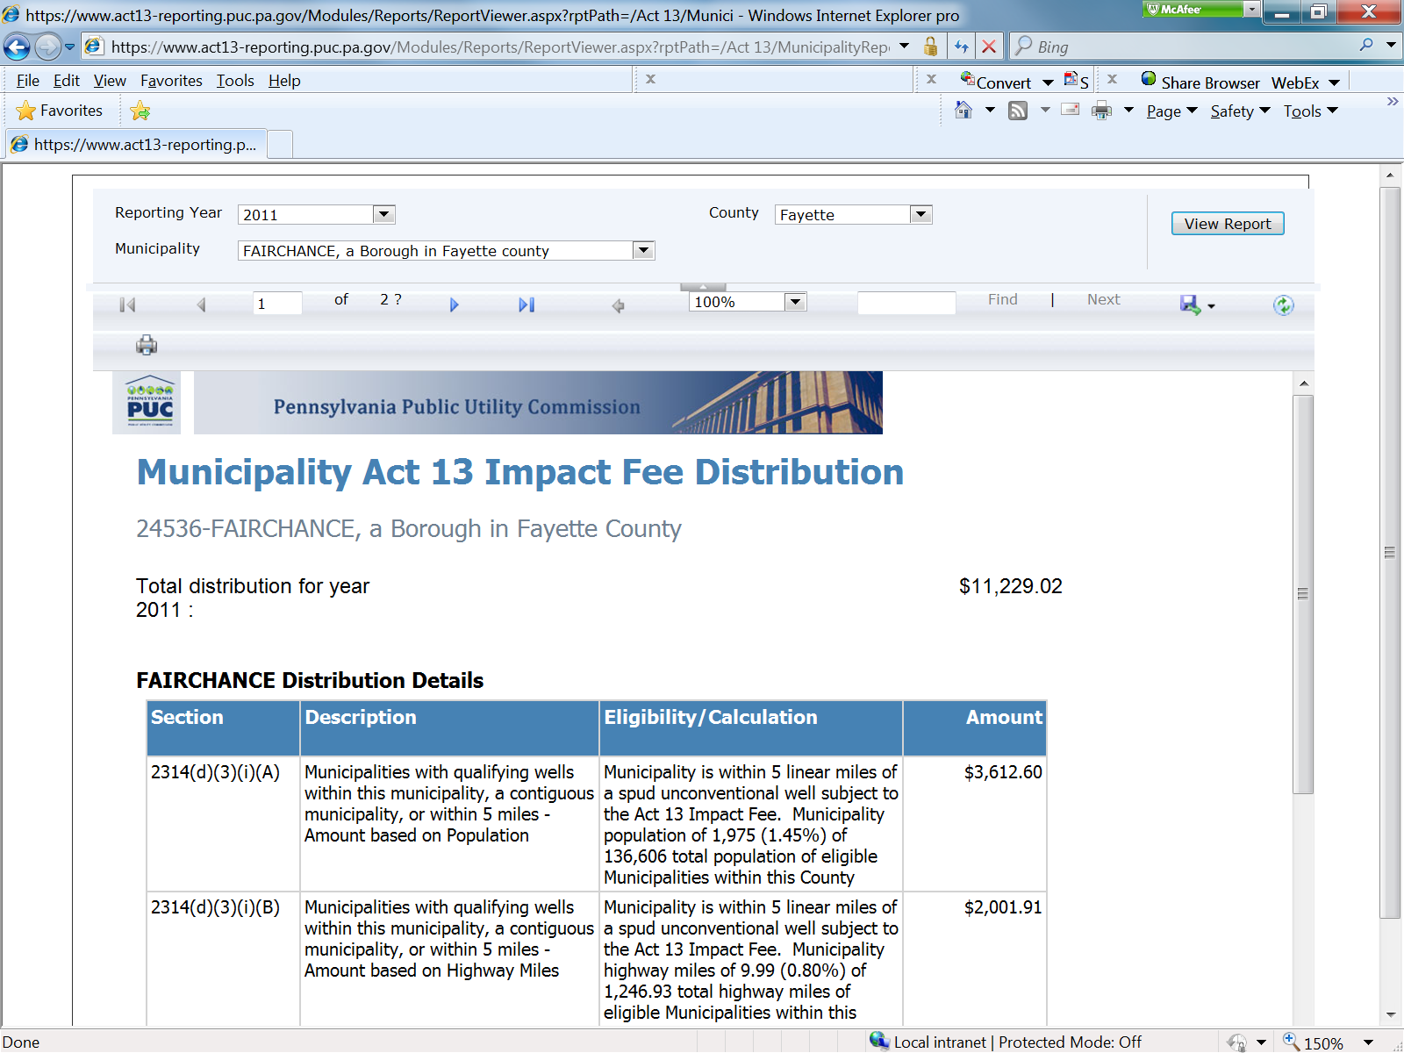

Login – This menu bar is for producers only.

