EDEWG Change Request #140

This EDEWG Change Request can be found on the PUC website at http://www.puc.state.pa.us/electric/electric_edewg_download.aspx

Requester’s Name:  Brandon Siegel | EDC/EGS Name:  Intelometry / Regional Transaction Set Owner | Phone #:  412-817-8004
Date of Request:  2/15/2018 | Affected EDI Transaction Set #(s):  814E, 867HU, 867HIU | E-Mail Address:  brandon.siegel@intelometry.com
Requested Priority (emergency/high/low): Low | Requested Implementation Date:  N/A – Admin Only | Status:  APPROVED / Implemented into multiple IGs (see EDEWG notes below)

Brief Explanation (This will be copied into the description in the Change Control Summary Spreadsheet):
Remove utility specific implementation dates in PA Use gray box for REF*KY in 814E & 867HU/HIU.

Detail Explanation (Exactly what change is required? To which EDEWG Standards? Why?):
The gray box notes for PA Use under the REF*KY segment in the EDI 814 Enrollment, 867 Historical Usage & 867 Historical Interval Usage require an update. Perform the following administrative changes…
814E, 867HU & 867HIU: Remove PA utility specific implementation timelines in PA Use gray box since the REF*KY is live.
814C/R: No changes necessary, the PA Use gray box for REF*KY is correct.

Redline changes on p2-3 of this change request.

For Change Control Manager Use Only:
Date of EDEWG Discussion:  3/1/18 | Expected Implementation Date:  N/A – Admin Only

EDEWG Discussion and Resolution:
2/15/2018 – Brandon Siegel: Drafted change, assigned #140 & placed on March 2018 agenda.
3/1/2018 – Brandon Siegel: EDEWG approved without revision.
3/2/2018 – Brandon Siegel: Incorporated into IG814Ev6-4.docx, IG867HUv6-4.docx & IG867HIv6-3.docx

Priority Classifications

Emergency Priority | Implemented within 10 days or otherwise directed by EDEWG
High Priority | Changes / Enhancements implemented with 30 days. The next release, or as otherwise directed by EDEWG
Low Priority | Changes / Enhancements implemented no earlier than 90 days, Future Release, or as otherwise directed by EDEWG

Please submit this form via e-mail to both jmccracken@pa.gov and lyalcin@pa.gov
at the PUC and to the
Change Control Manager, Brandon Siegel at brandon.siegel@intelometry.com

Your request will be evaluated and prioritized at an upcoming EDEWG meeting or conference call.
814 Enrollment
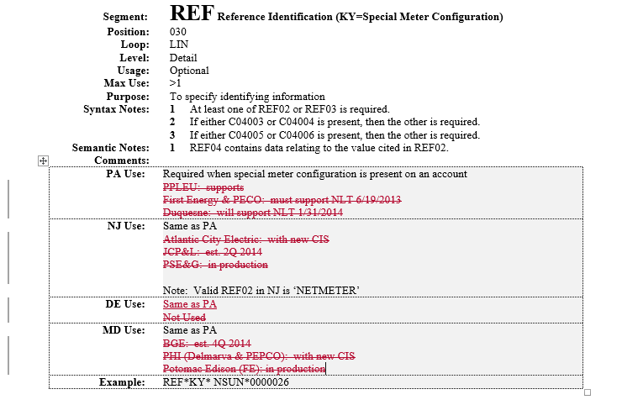
867 Historical Usage
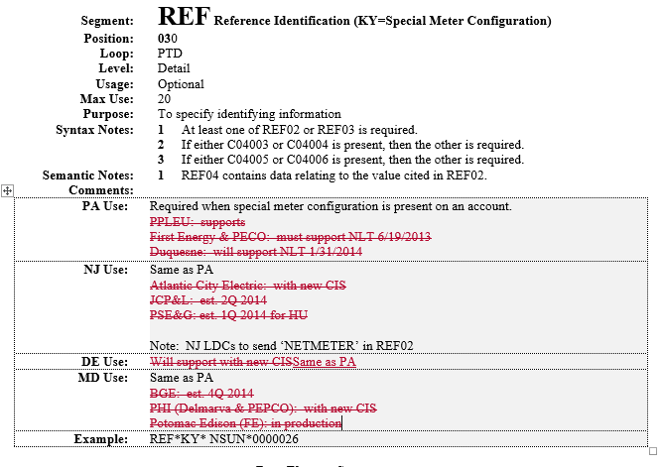
867 Historical Interval Usage
