 | COMMONWEALTH OF PENNSYLVANIA  PENNSYLVANIA PUBLIC UTILITY COMMISSION  P.O. BOX 3265, HARRISBURG, PA 17105-3265 | IN REPLY PLEASE REFER TO OUR FILE  M-2012-2289411
May 8, 2012
TO ALL INTERESTED PARTIES:

Re: Release of the Act 129 Pennsylvania Statewide Electric End Use and Saturation Studies and Stakeholders’ Meeting Announcement
Docket No. M-2012-2289411

The Commission was charged by the Pennsylvania General Assembly with establishing an energy efficiency and conservation program. The energy efficiency and conservation program requires each electric distribution company (EDC) with at least 100,000 customers to adopt a plan to reduce energy demand and consumption within its service territory. 66 Pa. C.S. § 2806.1. The Commission was also charged with the responsibility to evaluate the costs and benefits of the energy efficiency and conservation program by November 30, 2013 and every five years thereafter. 66 Pa. C.S. § 280.1(c)(3).

To assist in accomplishing this task, the Commission directed the Act 129 Statewide Evaluator to conduct electric baseline studies to establish baseline energy characteristics for the residential, and commercial and industrial sectors. With this Secretarial Letter, the Commission is releasing the 2012 Pennsylvania Statewide Residential End-Use and Saturation Study and the 2012 Pennsylvania Statewide Commercial & Industrial End Use & Saturation Study under the above-referenced docket. Both studies will be published immediately on the Commission’s website at http://www.puc.state.pa.us/electric/Act_129_info.aspx.

The Commission would also like to provide notice of an Act 129 Stakeholders’ Meeting on Tuesday, June 5, 2012, at 1:00 P.M. in Hearing Room 1 of the Commonwealth Keystone Building, 400 North Street, Harrisburg, Pennsylvania, 17120. The purpose of the meeting is to provide stakeholders with the opportunity to participate in a question and answer session with the Commission’s Act 129 Statewide Evaluator on the topics of the baseline studies cited above and the soon to be released Market Potential Study for Phase II planning. This meeting is being
scheduled in response to comments the Commission received to its March 1, 2012 Secretarial Letter. The Commission will accept comments on these studies during the comment period following the forthcoming Tentative Implementation Order at the above-referenced docket.
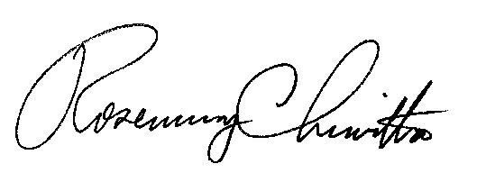
Sincerely,

Rosemary Chiavetta
Secretary
cc: Chairman’s Office
Vice Chairman’s Office
Commissioners’ Office
Jan Freeman, Executive Director
Karen Oill Moury, Director of Regulatory Operations
Bohdan R. Pankiw, Chief Counsel
Robert F. Young, Deputy Chief Counsel
Paul T. Diskin, Director, Technical Utility Services
Darren D. Gill, Deputy Director, Technical Utility Services

