PENNSYLVANIA

PUBLIC UTILITY COMMISSION

Harrisburg, PA 17105-3265

Public Meeting held January 12, 2012

Commissioners Present:

Robert F. Powelson, Chairman
John F. Coleman, Jr., Vice Chairman
Wayne E. Gardner
James H. Cawley
Pamela A. Witmer

Pennsylvania Telecommunications Relay M-00900239
Service Advisory Board

OPINION AND ORDER

BY THE COMMISSION:

The Pennsylvania Telecommunications Relay Service (TRS) is a communications service that offers persons who are hearing, deaf, and hearing or speech impaired three ways to connect to the service using various means: Traditional Telephone Relay, Video Relay and Internet Relay. Users who access TRS by telephone simply dial 7-1-1 to connect to a skillfully-trained Communications Assistant, or CA, who follows a strict code of ethics and confidentiality for telephone TRS communications. The CA then relays messages to the other person. TRS is available twenty-four hours a day, seven days a week.

By Order entered May 29, 1990, the Commission established the Telecommunications Relay Service Advisory Board (Board) for the purpose of reviewing the success of TRS in Pennsylvania. The Board was also assigned the task of identifying any additional improvements which might need to be implemented to ensure the continued success of the TRS program. The Board is comprised of representatives from the following: AT&T, the Pennsylvania Telephone Association, the Commission, the Pennsylvania Department of Labor and Industry’s Office for the Deaf & Hard of Hearing, and from the community of persons who are, or who have experience with people who are deaf or hard of hearing, or those with language and speech disorders. The Board meets quarterly in Harrisburg and functions as a user group providing guidance in such areas as problem solving and future enhancements. The normal term of a TRS Board member is two years.

The nominee for the TRS Board for the two-year term ending
March 30, 2014, is Stephen H. Schultz, Government Affairs Chairperson for the Pennsylvania Chapter of the Hearing Loss Association of the Capital Region (an affiliate of the Hearing Loss Association of America (HLAA)). The HLAA is the largest consumer organization in the country for people with hearing loss, providing support, education, advocacy and self-help. Mr. Schultz’s expertise and input could prove to be beneficial to the TRS Board; THEREFORE,

IT IS ORDERED:

1. That the nomination of Stephen H. Schultz of the Hearing Loss Association of the Capital Region to the Telecommunications Relay Service Advisory Board for the two-year term ending March 30, 2014, is approved.

2. That Mr. Stephen S. Schultz shall be served with a copy of this Opinion and Order.

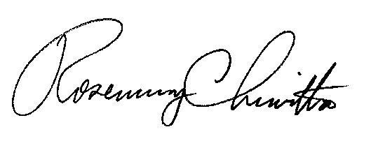
BY THE COMMISSION,

Rosemary Chiavetta
Secretary

(SEAL)
ORDER ADOPTED: January 12, 2012
ORDER ENTERED: January 12, 2012

