 | COMMONWEALTH OF PENNSYLVANIA  PENNSYLVANIA PUBLIC UTILITY COMMISSION  P.O. BOX 3265, HARRISBURG, PA 17105-3265 | IN REPLY PLEASE REFER TO OUR FILE

March 9, 2012
Docket No. L-00060182

ANDREW P WACHTER
VICE PRESIDENT – FINANCE AND RATES
PEOPLES TWP LLC
205 NORTH MAIN STREET
BUTLER PA 16001

Re: Proposed Supplement No. 13 to Peoples TWP LLC Tariff Gas-Pa. P.U.C. No. 7, Tariff changes requirement as a result of the Revised Final Rulemaking Order entered June 13, 2011

Dear Mr. Wachter:

On December 23, 2011, Peoples TWP LLC (Company) filed Supplement No. 13 to Tariff Gas-Pa. P.U.C. No. 7 to become effective on February 19, 2012. Supplement No. 13 reflects the changes the Company deems necessary under the terms of the Commission’s Order and Annex A thereto.

Commission Staff has reviewed the tariff revisions and found that suspension or further investigation does not appear warranted at this time. Therefore, in accordance with 52 Pa. Code, Supplement No. 13 to Tariff Gas-Pa. P.U.C. No. 7 is effective by operation of law according to the effective dates contained on each page of the supplement. However, this does not constitute a determination that the revisions are just, lawful and reasonable, but only that suspension or further investigation does not appear warranted at this time, and is without prejudice to any formal complaints timely filed against said tariff revision.

If you have any questions in this matter, please contact J. Elaine McDonald, Bureau of Technical Utility Services, at 717-787-1869 or jmcdonald@pa.gov.

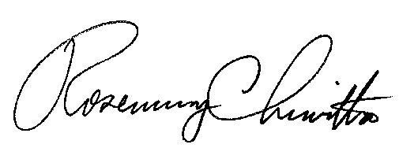
Sincerely

Rosemary Chiavetta
Secretary

cc: J. Elaine McDonald, Bureau of Technical Utility Services

