 | COMMONWEALTH OF PENNSYLVANIA  PENNSYLVANIA PUBLIC UTILITY COMMISSION  P.O. BOX 3265, HARRISBURG, PA 17105-3265 | IN REPLY PLEASE REFER TO OUR FILE

March 9, 2012
Docket No. L-00060182

RICHARD A D’ANGELO
MANAGER OF RATES & REGULATORY AFFAIRS - PA
PENNSYLVANIA ELECTRIC COMPANY
P O BOX 16001
READING PA 19612-6001

Re: Pennsylvania Electric Company
Supplement No. 16 to Tariff Electric-Pa. P.U.C. No. 80
Rulemaking to Amend the Provisions of 52 Pa. Code, Chapter 56

Dear Mr. D’Angelo:

On January 6, 2012, Pennsylvania Electric Company (Company) filed Supplement No. 16 to Tariff Electric-Pa. P.U.C. No. 80 to become effective on March 2, 2012. Supplement No. 16 reflects tariff changes in compliance with the Rulemaking to Amend the Provisions of 52 Pa. Code, Chapter 56 at the above docket.

Commission Staff has reviewed the tariff revisions and found that suspension or further investigation does not appear warranted at this time. Therefore, in accordance with 52 Pa. Code, Supplement No. 16 to Tariff Electric-Pa. P.U.C. No. 80 is effective by operation of law according to the effective dates contained on each page of the supplement. However, this does not constitute a determination that the revisions are just, lawful and reasonable, but only that suspension or further investigation does not appear warranted at this time, and is without prejudice to any formal complaints timely filed against said tariff revision.

If you have any questions in this matter, please contact J. Elaine McDonald, Bureau of Technical Utility Services, at 717-787-1869 or jmcdonald@pa.gov.
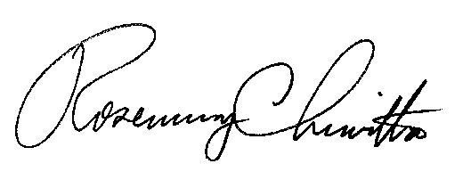

Sincerely

Rosemary Chiavetta
Secretary

cc: J. Elaine McDonald, Bureau of Technical Utility Services

