 | COMMONWEALTH OF PENNSYLVANIA  PENNSYLVANIA PUBLIC UTILITY COMMISSION  P.O. BOX 3265, HARRISBURG, PA 17105-3265 | IN REPLY PLEASE REFER TO OUR FILE  M-2012-2289411/  M-2008-2069887  M-2012-2300653/  M-2009-2108601

June 29, 2012

Donna M.J. Clark, Esquire
Energy Association of Pennsylvania
800 North Third Street, Suite 205
Harrisburg, PA 17102

Re: Request for Extension of Time to File Reply Comments to Act 129 Tentative
Orders: Implementation Phase II and Total Resource Cost (TRC) Test – 2012
Phase II

Dear Ms. Clark:

This letter is in response to your letter of June 26, 2012 in the above referenced matters.

The due date for the filing of Reply Comments with respect to the Tentative Implementation Order is hereby extended until July 9, 2012. This extension applies to all parties and commenters.

The due date for the filing of Reply Comments to the Tentative Order regarding the Total Resource Cost Test remains July 9, 2012.

We encourage the use of the Commission’s eFiling system for the filing of reply comments. In addition, all commenters are directed to email copies of their submittals to Megan Good (megagood@pa.gov) and Kriss Brown (kribrown@pa.gov).

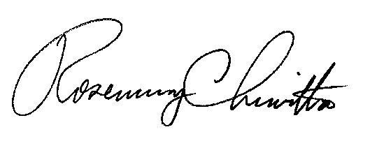
Sincerely,

Rosemary Chiavetta
Secretary

cc: All Parties and Commentors

