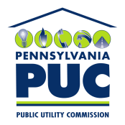 | COMMONWEALTH OF PENNSYLVANIA  PENNSYLVANIA PUBLIC UTILITY COMMISSION  P.O. BOX 3265, HARRISBURG, PA 17105-3265 | IN REPLY PLEASE REFER TO OUR FILE  M-2012-2289411

October 17, 2012
TO ALL INTERESTED PARTIES:

Re: Energy Efficiency and Conservation Program On-Bill Financing Stakeholders’ Meeting
Docket No. M-2012-2289411

To initiate the creation of the energy efficiency and conservation program On-Bill Financing Working Group, the Commission will hold an in-person On-Bill Financing Stakeholders’ Meeting on Friday, November 16, 2012, from 1:00 P.M. to 3:00 P.M. in Hearing Room 1 of the Commonwealth Keystone Building, 400 North Street, Harrisburg, Pennsylvania, 17120. The purpose of the meeting is to identify the primary issues relevant to the potential implementation of on-bill financing for energy efficiency and conservation project purchase and installation expenses. The attached Appendix provides an agenda for the meeting.

On August 2, 2012, the Pennsylvania Public Utility Commission (Commission) adopted the Phase II Energy Efficiency and Conservation (EE&C) program Implementation Order. In the Implementation Order, the Commission noted that it does not have enough information to prescribe the implementation of on-bill financing of EE&C measures. The Commission further noted that the benefits of on-bill financing programs warrant further consideration.

The Commission directed the Bureaus of Consumer Services and Technical Utility Services to initiate a working group “to investigate best practices from other states and identify working models of on-bill financing and on-bill repayment that address the concerns of the [utilities], consumer interest groups and other interested stakeholders.” The Commission further directed that “[t]he goal of the working group will be to determine the feasibility of the inclusion of on-bill financing and on-bill repayment programs and to identify potential options for customers to obtain low-cost financing for energy efficiency projects to meet the needs of Pennsylvania consumers.”

With this Secretarial Letter and the November 16, 2012 Stakeholders’ meeting, the Bureaus of Consumer Services and Technical Utility Services are initiating the On-Bill Financing working group. Any questions regarding this stakeholder meeting should be directed to Sarah Dewey at 717-705-4029 or sdewey@pa.gov.

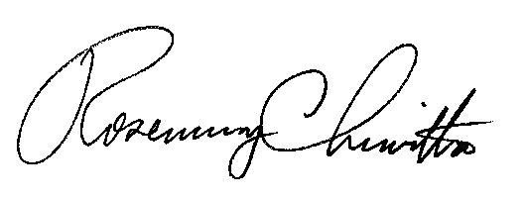
Sincerely,

Rosemary Chiavetta
Secretary

cc: Chairman’s Office
Vice Chairman’s Office
Commissioners’ Offices
Jan Freeman, Executive Director
Karen Oill Moury, Director of Regulatory Operations
Bohdan R. Pankiw, Chief Counsel
Robert F. Young, Deputy Chief Counsel
Paul T. Diskin, Director, Technical Utility Services
Darren D. Gill, Deputy Director, Technical Utility Services
Sarah Dewey, Consumer Policy Analyst, Bureau of Consumer Services

 | COMMONWEALTH OF PENNSYLVANIA  PENNSYLVANIA PUBLIC UTILITY COMMISSION  P.O. BOX 3265, HARRISBURG, PA 17105-3265 | IN REPLY PLEASE REFER TO OUR FILE  M-2012-2289411

ACT 129 ON-BILL FINANCING STAKEHOLDERS’ MEETING

COMMONWEALTH KEYSTONE BUILDING
HEARING ROOM 1
400 NORTH STREET
HARRISBURG, PA 17120
NOVEMBER 16, 2012
1:00 – 3:00 P.M.

AGENDA

- WELCOME
- INTRODUCTIONS & OPENING REMARKS
- PURPOSE OF OBF WORKING GROUP
- DISCUSSION OF ISSUES RELEVANT TO OBF IN PENNSYLVANIA
  - Legal/Regulatory Issues
  - Sources of Funding
  - Payment Terms & Obligations
  - Customer Groups
  - Qualifying Energy Efficiency & Conservation Projects

- IDENTIFYING BEST PRACTICES IN OTHER STATES
- NEXT STEPS
- CLOSING REMARKS

See Energy Efficiency and Conservation Program, Implementation Order at Docket Nos. M-2012-2289411 and M-2008-2069887, entered on August 3, 2012 (Implementation Order).
Implementation Order at 51.
Id.

