 | COMMONWEALTH OF PENNSYLVANIA  PENNSYLVANIA PUBLIC UTILITY COMMISSION  P.O. BOX 3265, HARRISBURG, PA 17105-3265 | IN REPLY PLEASE REFER TO OUR FILE

December 14, 2012
Docket No. M-2009-2123945

ANTHONY D KANAGY
POST & SCHELL
17 NORTH SECOND STREET
12TH FLOOR
HARRISBURG PA 17101-1601

Re: Petition of PPL Electric Utilities Corporation for Approval to Modify its Smart Meter Technology Procurement and Installation Plan

Dear Mr. Kanagy:

On August 1, 2012, PPL Electric Utilities Corporation (PPL Electric) filed its Smart Meter Rider (SMR) charges to become effective January 1, 2013. The annual filing reflects changes in the SMR charges for the Residential, Commercial and Industrial customer classes pursuant to the Commission’s Order at Docket No. M-2009-2123945, entered June 24, 2010. PPL Electric also filed Supplement No. 121 to Tariff Electric -Pa. P.U.C. No. 201.

Commission Staff has reviewed the annual filing and tariff revisions and found that suspension or further investigation does not appear warranted at this time. Therefore, in accordance with 52 Pa. Code, the changes in the SMR rates for the Residential, Commercial and Industrial customer classes are approved to become effective January 1, 2013, and Supplement No. 121 to Tariff Electric -Pa. P.U.C. No. 201 is effective by operation of law according to the effective dates contained on each page of the supplement. However, this does not constitute a determination that the revisions are just, lawful and reasonable, but only that suspension or further investigation does not appear warranted at this time, and is without prejudice to any formal complaints timely filed against said tariff revisions.

If you have any questions in this matter, please contact Marissa Boyle, Bureau of Technical Utility Services, at 717-787-7237 or maboyle@pa.gov.

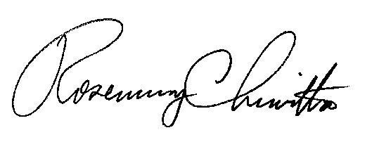
Sincerely

Rosemary Chiavetta
Secretary

