 | COMMONWEALTH OF PENNSYLVANIA  PENNSYLVANIA PUBLIC UTILITY COMMISSION  P.O. BOX 3265, HARRISBURG, PA 17105-3265 | IN REPLY PLEASE REFER TO OUR FILE

January 11, 2013

Docket No. R-2012-2290597
M-2012-2337090
M-2009-2123945

JOSEPH M KLEHA
PPL ELECTRIC UTILITIES CORPORATION
TWO NORTH NINTH STREET
ALLENTOWN PA 18101-1179

Re: Supplement No. 125 to Tariff – Electric Pa. P.U.C. No. 201

Dear Mr. Kleha:

At Public Meeting held December 5, 2012, the Commission authorized PPL Electric Utilities Corporation (Company) to file tariffs, tariff supplements and/or tariff revisions, on less than statutory notice, and pursuant to the provisions of 52 Pa. Code §§ 53.1, et seq., and 53.101, in regards to the rate investigation at Docket No. R-2012-2290597. On December 31, 2012, the Company filed Supplement No. 125 to Tariff – Electric Pa. P.U.C. No. 201 designed to produce an annual distribution rate revenue increase of approximately $71.030 million, to become effective for service rendered on and after January 1, 2013. The Company also incorporated into Supplement No. 125 to Tariff – Electric Pa. P.U.C. No. 201 the changes in the Smart Meter Rider charges pursuant to the Commission’s Order at Docket No. M-2009-2123945, entered June 24, 2010, and the Universal Service Rider rate of $0.00393 per kWh, approved by the Commission at the Public Meeting on December 20, 2012.

Commission Staff has reviewed the tariff revisions and found that suspension or further investigation does not appear warranted at this time. Therefore, in accordance with 52 Pa. Code, Supplement No. 125 to Tariff – Electric Pa. P.U.C. No. 201 is effective by operation of law according to the effective dates contained on each page of the supplement. However, this is without prejudice to any formal complaints timely filed against said tariff revision.

If you have any questions in this matter, please contact Marissa Boyle, Bureau of Technical Utility Services, at 717-787-7237 or maboyle@pa.gov.

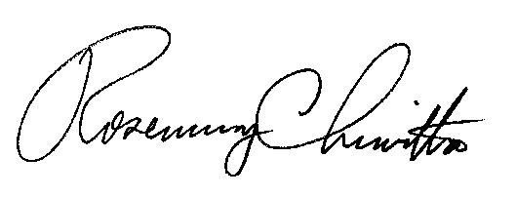

Sincerely,

Rosemary Chiavetta
Secretary

