PENNSYLVANIA
PUBLIC UTILITY COMMISSION
Harrisburg, PA 17105-3265

 | Public Meeting held June 5, 2014
Commissioners Present:

Robert F. Powelson, Chairman
John F. Coleman, Jr., Vice Chairman
James H. Cawley, Joint Statement
Pamela A. Witmer, Joint Statement
Gladys M. Brown

Pennsylvania Public Utility Commission, Bureau of Investigation and Enforcement  v.  Columbia Gas of Pennsylvania, Inc. | M-2014-2306076
OPINION AND ORDER

BY THE COMMISSION:

Before the Pennsylvania Public Utility Commission (Commission) for consideration and disposition is a Settlement Agreement (Settlement) filed on February 6, 2014, by the Commission’s Bureau of Investigation and Enforcement (I&E) and Columbia Gas of Pennsylvania, Inc. (Columbia Gas or Company) (collectively, Parties). Each Party also filed a Statement in Support of the Settlement.
History of the Proceeding

This matter concerns an informal investigation initiated by I&E at the request of the I&E Gas Safety Division (GSD). The GSD’s initial investigation involved separate investigations of various incidents, including those relating to valve inspection procedures; excessive pipeline pressures and related Company protocols; excavation damage and related Company response protocols; and lack of pressure regulation devices. The GSD’s initial investigation suggested that a further investigation was warranted to determine whether the actions of Columbia Gas or its third-party contractor (Contractor) violated state regulations, federal regulations, and/or the Company’s operating procedures. I&E consolidated the various matters into a single docket for purposes of the informal investigation.

By letters dated August 30, 2012, and January 30, 2013, I&E requested that Columbia Gas provide responses to various data requests. Based on its investigation, I&E concluded that sufficient data had been gathered to substantiate allegations of violations of the Public Utility Code (Code), 66 Pa. C.S. §§ 101 et seq., and state and federal gas safety regulations.

The Parties entered into negotiations and agreed to resolve this matter in accordance with the Commission’s policy to promote settlements at 52 Pa. Code § 5.231. The Parties filed the instant Settlement on February 6, 2014.

Background

1. Operating Valves P-2913 and P-2914

On December 19, 2011, an excavator was installing a water line to a barn at 280 Old Hickory Ridge Road in Chartiers Township, Pennsylvania. At approximately
3:20 p.m., the excavator’s trackhoe hit a Columbia Gas two-inch plastic gas main operating at 40 psig. Upon puncturing the gas main, the operator got off the trackhoe, and the gas ignited. The trackhoe was destroyed by the ensuing fire. Columbia Gas was notified of the incident at 3:25 p.m., and a Columbia Gas employee arrived at the incident site at 3:49 p.m. A Columbia Gas supervisor called gas measurement personnel to the site to start the pipeline shut down process.

Columbia Gas service personnel determined that closing the four valves that are inspected annually for the safe operation of the system at issue (the emergency valves) would have impacted the service provided to 207 Columbia Gas customers. Columbia Gas service personnel decided to close Valves P-2913 and P-2914, rather than the four designated emergency valves, in order to limit the number of customers out of service to twenty-eight customers. Settlement at 5. Columbia shut down approximately 9,000 feet of pipe at 6:35 p.m. According to available records, Valves P-2913 and P-2914 had not been inspected since 1993. Id. at 6.

As a result of this incident, I&E averred that the valves in question were not checked and serviced at intervals not exceeding fifteen months, or at least once each calendar year. I&E alleged that, if proven, this would constitute a violation of 49 C.F.R. § 192.747(a). Settlement at 6.

2. Pipeline D-1810 (Overpressure)

Pipeline D-1810 is a Columbia Gas steel transmission pipeline located in Allegheny County. Documentation reviewed during a May 2, 2011 integrity management inspection indicated that, on December 10, 2003, Columbia Gas listed the operating pressure for Pipeline D-1810 at 506 psig. Id. Pipeline D-1810 has a listed maximum allowable operating pressure (MAOP) of 500 psig based on the highest operating pressure for the five-year period from July 1, 1965, to July 1, 1970. Id. at 7.
I&E alleged that Columbia Gas operated Pipeline D-1810 at a pressure that exceeded the MAOP, and if proven, this would be a violation of 49 C.F.R. § 192.619(c). Settlement at 7.

3. Operating Pressure Violation in Somerset County (New Enterprise)

On March 2, 2011, Columbia Gas discovered that the New Enterprise
system in Somerset County, Pennsylvania (New Enterprise system) was operating at
a pressure of 74 psig. Id. The New Enterprise system has a MAOP of 60 psig based on the pressure test of the pipeline after installation. The Regulator Station 4189 that controls the gas pressure into the New Enterprise system was found to have a leaking bypass valve, allowing high pressure gas to bleed into the 60 psig system. There was no recording gauge at this station to monitor when the pressure increase occurred. Id. at 8.

I&E alleged that Columbia Gas operated the New Enterprise system at a pressure that exceeded the plastic pipe test pressure divided by a factor of 1.5, which, if proven, would be a violation of 49 C.F.R. § 192.619(a)(2)(i). I&E also alleged that Columbia Gas did not have pressure regulation devices that prevent accidental over-pressuring due to a bypass valve leaking through at the regulator station that controlled the gas pressure into the New Enterprise system. I&E indicated that, if proven, this would be a violation of 49 C.F.R. § 192.195(b)(1) and (2). I&E further alleged that, if proven that the New Enterprise system was operating at a pressure of 74 psig, this would be a violation 49 C.F.R. § 192.201(a)(2)(i), because pressure relieving and limiting stations for pipelines that have a MAOP of 60 psig must be set to operate at a maximum pressure of 66 psig. Settlement at 8.

4. Operating Pressure Violation in Washington County (Scenery Hill)

On April 11 and 12, 2011, Columbia Gas discovered that the Scenery Hill high pressure distribution system in Washington County, Pennsylvania (Scenery Hill system) was operating at pressures of 12 psig and 11 psig, respectively. The documented MAOP for the Scenery Hill system based on the highest operating pressure for the five year period from July 1, 1965 to July 1, 1970, is 7 psig. The cause of this overpressure was determined to be debris found in the control and monitor regulator at Regulator Station 4062.

I&E averred that Columbia Gas did not have pressure regulation devices to prevent accidental over-pressuring due to debris in the gas, which caused the regulator station that controlled the gas pressure into the Scenery Hill distribution system to malfunction and exceed the set points. I&E alleged that, if proven, this would be a violation of 49 C.F.R. § 192.195(b)(1) and (2). I&E stated that Columbia Gas did not have pressure regulation devices designed and installed at the regulator station to prevent a single occurrence, such as debris in the gas, from affecting the gas pressure into the Scenery Hill distribution system. I&E indicated that, if proven, this would be a violation of 49 C.F.R. § 192.199(g). Settlement at 9. According to I&E, pressure relieving and limiting stations for pipelines that have a MAOP of 7 psig must be set to operate at a maximum pressure of 10.5 psig. I&E contended that, if proven that the Scenery Hill system was operating at pressures of 11 and 12 psig, this would be a violation 49 C.F.R. § 192.201(a)(2). Settlement at 10.

5. Overpressure of the Downstream Pipelines at the Carson Street Regulator
Station 4135 in Connellsville.

On July 21, 2012, Columbia Gas was notified of a gas odor at the Carson Street Regulator Station 4135. The Company service personnel discovered gas blowing from the regulator and turned the matter over to the Company’s Gas Measurement and Regulation personnel. The Columbia Gas Measurement and Regulation personnel discovered that the downstream pressure of the regulator station reached 20 psig. The MAOP for the downstream pipeline system is 5 psig. The Columbia Gas Measurement and Regulation personnel found that the bypass valve had leaked high pressure gas into the 5 psig system. I&E alleged that there was inadequate relief to prevent the system pressure from reaching 20 psig. The Columbia Gas Measurement and Regulation personnel repaired the bypass valve and tested and checked the regulator equipment. I&E averred that the Company reset the station pressure and did not report the overpressure condition to anyone before leaving the site. Id.

On July 23, 2012, the Columbia Gas Measurement and Regulation personnel advised the acting Operations Center Manager of the overpressure found and corrected two days earlier. The acting Operations Center Manager began an immediate leak survey of the affected downstream system as well as an investigation of the communications delay. A Class 1 leak was identified at 1415 Carson Street on the customer service line, and the service line was shut off immediately.

The two involved Columbia Gas Measurement and Regulation personnel had been employed in that capacity since January 2, 2011. Both employees had completed training regarding “NiSource Operator Qualification OQ-M-4 Inspect & Test Pressure Limit Stations, Relief Devices & Pressure Regulating Stations” on May 26, 2011. I&E concluded that neither Company employee met the definition of “Qualified” as set forth in 49 C.F.R. § 192.803, because neither recognized nor properly reacted to the overpressure of the downstream piping at the Carson Street Regulator 4135. I&E explained that NiSource Distribution Operations Gas Standard number GS1150, “Response to Overpressure” states as follows: “If the distribution system pressure is found to exceed the normal system operating pressure parameters or exceeds the maximum allowable operating pressure, notify the dispatcher immediately.” Settlement at 11. I&E alleged that the Columbia Gas personnel did not report this overpressure to the dispatcher until July 23, 2012, and that this delayed the Company’s required response to leak survey the pipelines that were over-pressured. Id. at 11-12. According to I&E, the Columbia Gas personnel responding to this overpressure held their positions since January 2, 2011, and both completed the NiSource Operator Qualification Inspect & Test Pressure Limit Stations, Relief Devices & Pressure Regulating Stations, OQ TASK CDOQM4 on May 26, 2011, by OQ Test Passed-Written Exam, but the Company failed to maintain records to indicate that the employees in question answered the abnormal operating condition questions correctly. I&E contended that Columbia Gas neither retains individual test results for each person, nor measures retention rates upon providing the correct answers to missed questions. Id. at 12.

I&E averred that Columbia Gas had a regulator station design that allowed a bypass valve leak to create an overpressure condition in the downstream system on July 21, 2012. I&E indicated that the MAOP of the main and service pipelines is 5 psig, and, on that particular date, the pressure was 20 psig. I&E alleged that, if proven, this would be a violation of 49 C.F.R. § 192.195(b)(2). I&E stated that the Columbia Gas personnel who discovered the overpressure at the Carson Street regulator station did not follow the NiSource Distribution Operations Gas Standard number GS1150 Response to Overpressure, which delayed the Company’s required response to leak survey the pipelines that were over-pressured. Settlement at 12. I&E contended that, if proven, this would be a violation of 49 C.F.R. § 192.13(c). I&E additionally alleged that Columbia Gas failed to ensure through evaluation that individuals performing covered tasks were qualified, and if proven, this would be a violation of 49 C.F.R. § 192.805(b). Settlement at 13.

6. Excavation Damage of Pipeline D-1810 in Collier Township

On July 21, 2012, at 1:13 p.m., Columbia Gas was notified by Allegheny County 911 of excavation damage at 1273 Washington Pike in Collier Township, Pennsylvania, which was caused by a third party installing guard rail posts. Pipeline D-1810 operates at 170 psig in the area of the damaged pipe. According to I&E, Columbia Gas personnel were unable to immediately shut down the damaged section of Pipeline D-1810 because the valve that controls the flow of gas to the pipeline would not turn. The pipeline was shut down using a stopple fitting at 7 p.m., and the repairs to the pipeline were completed by 2 a.m. on July 22, 2012. Id.

Columbia Gas had received seven PA One Call notices from the third-party guard rail installer from April 12, 2012, to July 11, 2012, and the Company responded to six of the notices that the facilities were marked. The Columbia Gas locating personnel located Pipeline D-1810 at both ends of the notices and found the pipe in the street. I&E contended that the Company personnel knew the third-party contractor was installing guard rail posts in the area behind the curb but did not locate Pipeline D-1810 near the excavation site. I&E also contended that the Company’s locate personnel failed to locate Pipeline D-1810 between the intersections to determine if the buried pipeline would be in the area of excavation. I&E further contended that, before leaving the site, none of the Columbia Gas personnel reviewed the locate request or verified that the markings were adequate and matched the records. Id. at 14.

I&E indicated that none of the Columbia Gas personnel met the definition of “Qualified” in 49 C.F.R. § 192.803, because they did not recognize or react to the abnormal operating condition of no marks for Pipeline D-1810 through the entire locate request. Settlement at 14. I&E explained that the Company’s “NiSource Distribution Operations Gas Standard number GS1100.010(PA), Locating Facilities,” Section 2.3.4 titled “Marking” states, “[M]ark all facilities and paint valve box covers within the scope of the locate request. Extend marks at least [twenty-five] feet beyond established work zone ([fifty] feet preferred).” Section 2.3.5 titled “Prior to Leaving the Site” states, “[B]efore leaving the site, be sure to review the locate request and verify that any markings are adequate and match the records.” I&E stated that the Company’s three employees that provided locates for Pipeline D-1810 along Washington Pike (SR 50) between Winstein Street and Steen Road in Collier Township had varying experience levels and all completed NiSource Operator Qualification Locate and Mark Underground Facilities OQ TASK CDOQM2 at different times. Settlement at 15.

I&E averred that there were no records maintained by the Company to indicate that the employees in question answered the abnormal operating condition questions correctly. I&E indicated that Columbia Gas neither retains individual test results for each person, nor measures retention rates upon providing the correct answers to missed questions. I&E also averred that no marks are an abnormal operating condition for this task and if any of the Company locate personnel recognized that there were no marks within the scope of the locate request, they could have prevented the resulting damage. Id.

I&E alleged that Columbia Gas personnel failed to provide for temporary marking of buried Pipeline D-1810 along Washington Pike (SR 50) between Winstein Street and Steen Road in Collier Township in the area of the excavation activity and, if proven, this would be a violation of 49 C.F.R. § 192.614(c)(5). Settlement at 15-16. I&E stated that Columbia Gas personnel responding to the pipeline locates failed to mark Pipeline D-1810 within the scope of the locate request and, if proven, this would be a violation of 49 C.F.R. § 192.805. I&E indicated that Columbia Gas failed to ensure through evaluation that individuals performing covered tasks were qualified. I&E contended that, if proven, this would be a violation of 49 C.F.R. § 192.805(b). Settlement at 16.

7. Overpressure of the Downstream Pipelines at Regulator Station 4853
near West Newton

On June 24, 2013, the Columbia Gas Company Chart for Regulator Station 4853 indicated a spike in pressure from 49 psig at approximately 11 a.m. to 85 psig at approximately 12 p.m. The pressure began to drop until it reached the MAOP of the system at 60 psig at 3 a.m. on June 29, 2013. Columbia Gas personnel did not discover the over-pressure of 25 psig until the chart was removed on July 15, 2013. When the over-pressure was discovered, an investigation into the cause of this issue began and revealed that Columbia Gas Transmission personnel turned a gas well owned by Viking Energy into Columbia Gas Company’s system without monitoring the pressure to determine if the MAOP would be exceeded. Id. Columbia Gas Transmission personnel contacted the responsible Columbia Gas supervisor and told him they were putting this well on line. The Columbia Gas supervisor did not notify anyone of Columbia Gas Transmission’s intentions. Id. at 17.

I&E alleged that, according to the chart, the 60 psig MAOP was exceeded for four days and fifteen hours. If proven, this would be a violation of 49 C.F.R. §§ 192.13(c), 192.195, 192.605(b)(5) and 192.619(a). Settlement at 17.

8. Overpressure of the Downstream Pipelines at Regulator Station 4092 in
Dunbar Township

On June 25, 2013, Columbia Gas Measurement & Regulation Technicians arrived at Regulator Station 4092 in Dunbar Township to inspect the station. When the gauge was installed on the downstream side of the regulator station, it registered 12 psig. The MAOP is 4 psig for this system. The regulator station cuts the high pressure gas to 4 psig into the system that services the customers. The pressure was lowered and the regulators were tested and found to be operating properly. The bypass valve was greased and operated. Id. The station was put back in service, operating at 3.9 psig. An ERX was installed to monitor the pressure. The pipe was scheduled for replacement so that the regulator station could be removed. Id. at 18.

I&E alleged that the 4 psig MAOP was exceeded for an undetermined amount of time, and if proven, this would be a violation 49 C.F.R. §§ 192.195(b)(2) and 192.619(a). Settlement at 18.

9. Overpressure of the Downstream Pipelines at Penn State Grad Lab Building Regulator at University Park

On July 11, 2013, Columbia Gas performed a routine inspection on the regulators to Penn State University's Grad Lab Building located at University Park, Pennsylvania. The technician found that the system pressure upstream of the regulators was 31 psig, and the downstream pressure was 26.5 psig. When functioning properly, the correct outlet pressure would be 5 psig. Despite having monitor overpressure protection, the MAOP was exceeded by 21.5 psig. The regulator and monitor overpressure protection were inspected and found to be functioning properly. Columbia determined that the source of the failure was a leaking bypass valve that allowed gas to bypass the regulators and build up pressure downstream of the regulator and the overpressure protection. Id.

I&E alleged that the 5 psig MAOP was exceeded by 21.5 psig, and, if proven, this overpressure would be a violation of 49 C.F.R. §§ 192.13(c) and 192.619(a). Settlement at 19.

I&E contended that all of the above allegations resulted in an increased danger to the public in violation of Section 1501 of the Code, 66 Pa. C.S. § 1501. Settlement at 19.

While Columbia Gas may dispute or disagree with some or all of the alleged violations, the Company fully acknowledges the seriousness of the allegations. Id.

Terms of the Settlement Agreement

The Parties entered into the Settlement to resolve this matter fully and completely without litigation in a formal proceeding. The Parties have agreed to the following Settlement terms:

a. Pursuant to 66 Pa. C.S. § 3301(c), Columbia Gas will pay a civil penalty of one hundred ten thousand ($110,000) dollars. Said payment shall be made by certified check payable to “Commonwealth of Pennsylvania” and forwarded to the Commission through the prosecuting attorney within thirty (30) days of the date of the Order approving this Settlement.

b. Columbia Gas has taken corrective action and implemented revisions to its operating procedures which will act as safeguards against similar incidents occurring in the future. The pertinent actions taken by Columbia Gas are briefly described as follows:

Columbia Gas will take the following corrective action:

i. Columbia Gas shall provide a district regulator station at the connection of D-1810 in Allegheny County to Columbia Transmission 1570 pipeline to prevent operating D-1810 at a pressure higher than the maximum allowable operating pressure;

ii. Columbia Gas shall provide a list of all single feed district regulator stations for Columbia Gas that do not have a recording gauge at this time;

iii. Columbia Gas shall install recording gauges at all identified stations at a rate of 80 (eighty) units per year, beginning July 1, 2013, until all the stations identified above have had gauges installed. Further, Columbia Gas shall, at [six] month intervals, conduct twice annual meetings with the Gas Safety Division to review the status of the installation program and the remaining installation priorities;

iv. Columbia Gas shall provide a list of all single feed district regulator stations for Columbia Gas that do not have a relief valve on the outlet side with no flow conditions for any [twenty-four] hour period;

v. Columbia Gas shall provide a list of all district regulator stations for Columbia [Gas] that are supplied from production gas either whole or in part;

vi. Columbia Gas shall provide and implement a design for the identified regulator stations to prevent accidental over-pressure at the rate of 80 (eighty) units per year, beginning July 1, 2013, until all the stations identified above have had additional over-pressure installed. Further, Columbia Gas shall begin this program by addressing the single feed, low pressure systems that do not currently have additional over-pressure protection. Further, Columbia Gas shall, at [six] month intervals, conduct twice annual meetings with the Gas Safety Division to review the status of the installation program and the remaining installation priorities;

vii. Columbia Gas shall provide a process for evaluating operating personnel for determining abnormal operating conditions and provide a record for this process;

viii. Columbia Gas shall adopt as its baseline OQ Training and Testing methodology the “Virginia Enhanced OQ Training and Testing Protocol” as the covered tasks in that protocol become available to the industry, with the exception that Columbia Gas shall not be required to include construction covered tasks in its baseline OQ Training and Testing methodology. In consultation with the Gas Safety Division, Columbia Gas may amend its baseline OQ Training and Testing methodology to address issues that are unique to Pennsylvania and/or Columbia Gas. Using this new process, Columbia will qualify its new employees and new contractor employees to this new standard as they are hired, and current employees and contract employees as their existing qualifications expire; and

ix. Columbia Gas shall perform annual inspections of any distribution system valve used to close the system in a natural gas emergency that was not designated a necessary or emergency valve at the time of the emergency (and therefore was not a valve that was inspected annually.) After six (6) annual inspections, if the valve has not again been used in an emergency, the annual inspections may cease. If during that six year period the valve has been used again to close the system in an emergency, Columbia Gas will reclassify that valve as an emergency valve and conduct an inspection once every calendar year, not to exceed fifteen (15) months.

Settlement at 20-22.

In addition to the civil penalty and operational modifications described above, Columbia Gas has agreed to resolve a master meter issue, referred to herein as the “Delong Farm Tap.” The Parties indicate that the Delong Farm Tap is a “master meter system” located at Fullerton Road in Bradford, Pennsylvania, which is owned and operated by Ms. Casey Delong and served by Columbia Gas. The system is a “farm tap” arrangement whereby Ms. Delong is served by a private gas line connected directly to the distribution facilities, and the private gas line from its connection to the distribution facilities to the premises belongs to Ms. Delong. According to the Parties, eight customers are currently connected to and taking gas from the Delong Farm Tap. Columbia Gas facilities serving the Delong line consist of a tap off of an interstate pipeline owned and operated by Columbia Gas Transmission, LLC and a meter that measures consumption on the customer-owned system. Neither Columbia Gas nor any related company owns any facilities downstream of Columbia Gas’s meter. There are privately-owned meters at each of the eight premises served by the Delong line. Ms. Delong is billed by Columbia Gas for the usage on the Delong line as measured at Columbia Gas’s meter, and, then, Ms. Delong is responsible for collecting payment from each of the premises on the system based on the usage measured on the private meters at each premise. As customers on the Delong line continued to receive the gas but failed to contribute to the payment for the gas, Ms. Delong sought the assistance of the GSD. Id. at 22.

I&E and Columbia Gas indicated that they have held numerous meetings and discussions in an effort to resolve Ms. Delong’s concerns. Id. I&E’s GSD wanted Columbia Gas to take over the Delong line so that Ms. Delong and the other customers on the line would be served and individually billed by Columbia Gas. Columbia Gas advised that it would need to install new facilities in order to provide such service. Columbia Gas averred that, due to the estimated cost to install new facilities, it would be impractical to assume that the customers would be willing to pay the difference between the maximum allowable investment to serve them and the capital expenditure necessary for the installation. Id. at 23.

In order to resolve the GSD’s concerns, the Parties agreed to a lesser monetary civil penalty than originally sought by I&E regarding the alleged over-pressure violations, and Columbia Gas agreed to install facilities that would replace the Delong Farm Tap facilities and to serve and bill the customers currently connected to the Delong line who intended to continue to be served by Columbia Gas. Columbia Gas expects to invest approximately $200,000 in new facilities to replace the Delong Farm Tap. As such, the Parties have agreed that “Columbia Gas will not be precluded from recovering its reasonable costs related to this facilities investment, to a maximum recovery of $200,000.” Id.

In consideration of the Company’s agreement to pay a civil penalty and other non-monetary relief, as set forth in the Settlement, I&E agrees to forebear from instituting any formal complaint that relates to the matters described in the Settlement and the related conduct of the Company, its employees, and its Contractor’s employees, as described in the Settlement. The Parties state that nothing contained in the Settlement shall adversely affect the Commission’s authority to receive and resolve any informal or formal complaints filed by any affected party with respect to the alleged incidents, except that no further sanctions may be imposed by the Commission for any actions identified in the Settlement. Id. Additionally, none of the provisions of the Settlement or the statements in the Settlement shall be considered an admission of any fact or culpability. Id. at 25. As the Settlement does not make any findings of fact or conclusions of law, the Parties intend that the Settlement and the Statements in Support thereof not be admitted as evidence in any potential civil proceeding involving this matter. Id. at 26.

The Settlement is conditioned upon the Commission’s approval of its terms and conditions, without modification. The Parties reserve the right to withdraw from the Settlement if it is modified. Id. at 25.

Discussion

We note that, consistent with Section 5.231 of our Regulations, 52 Pa. Code § 5.231, it is our policy to promote settlements. However, before taking final action on the proposed Settlement, we must first seek public comment pursuant to Section 3.113(b)(3) of our Regulations, 52 Pa. Code § 3.113(b)(3).

Conclusion

Before issuing a decision on the merits of the proposed Settlement, consistent with Section 3.113(b)(3) of our Regulations, 52 Pa. Code § 3.113(b)(3), we are providing an opportunity for interested parties to file comments; THEREFORE,

IT IS ORDERED:

1. That this Opinion and Order, together with the attached Settlement Agreement and the Statements in Support thereof, shall hereby be entered for comments.

2. That a copy of this Opinion and Order, together with the attached Settlement Agreement and the Statements in Support thereof, shall be served on the Office of Consumer Advocate, the Office of Small Business Advocate, and the Bureau of Investigation and Enforcement.

3. That comments to this Opinion and Order, together with the Settlement Agreement and the Statements in Support thereof, will be considered timely if filed within twenty (20) days of the date of entry of this Opinion and Order.

4. That, subsequent to the Commission’s review of the comments filed in this proceeding, a final Opinion and Order will be issued.

BY THE COMMISSION,

Rosemary Chiavetta
Secretary

(SEAL)

ORDER ADOPTED: June 5, 2014

ORDER ENTERED: June 5, 2014

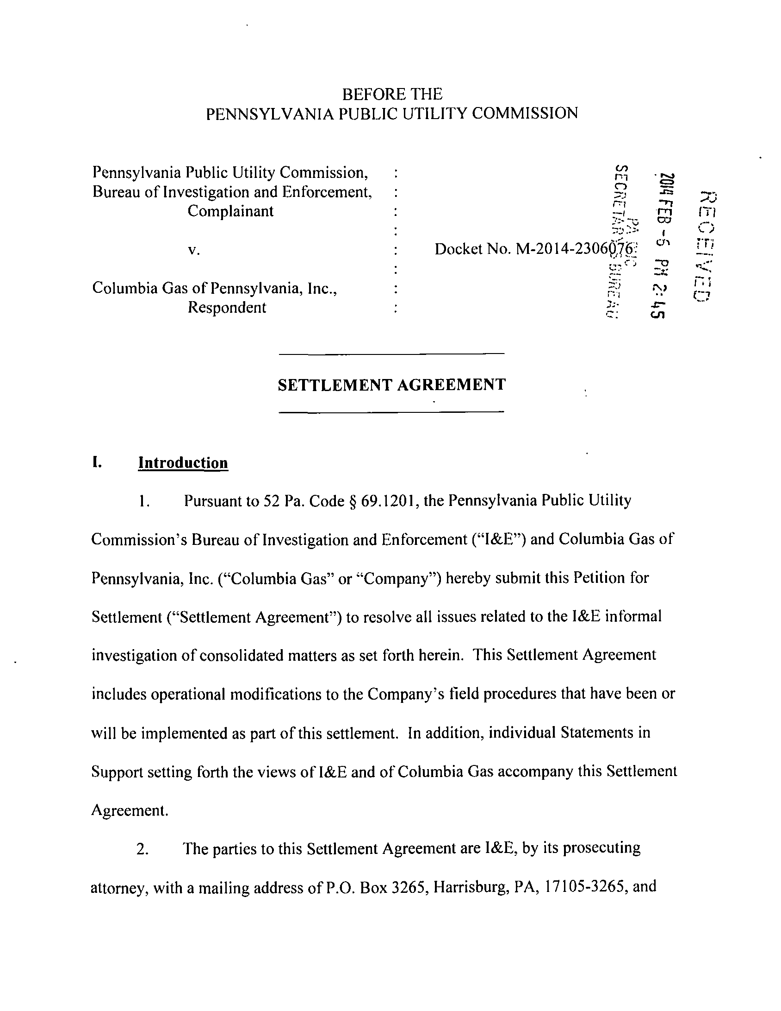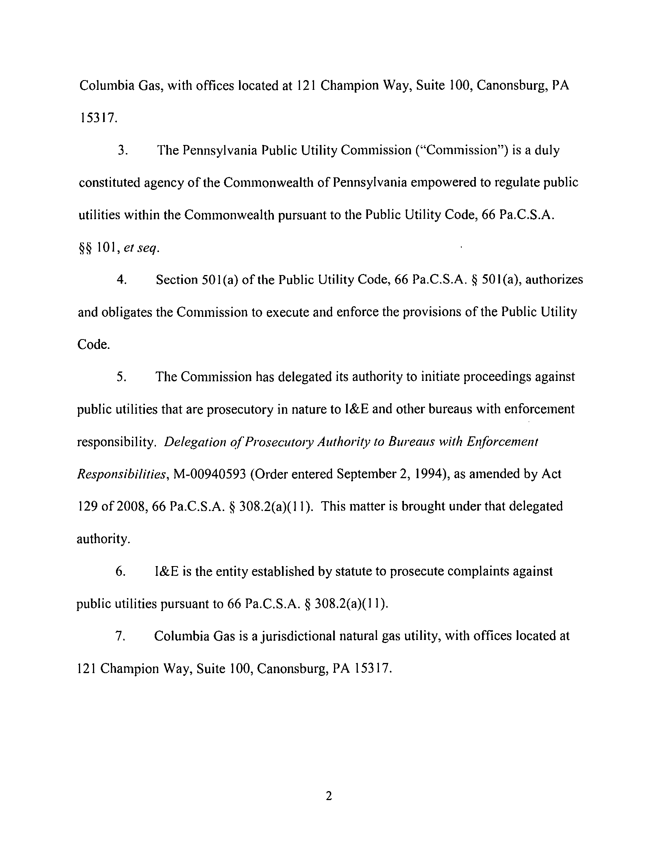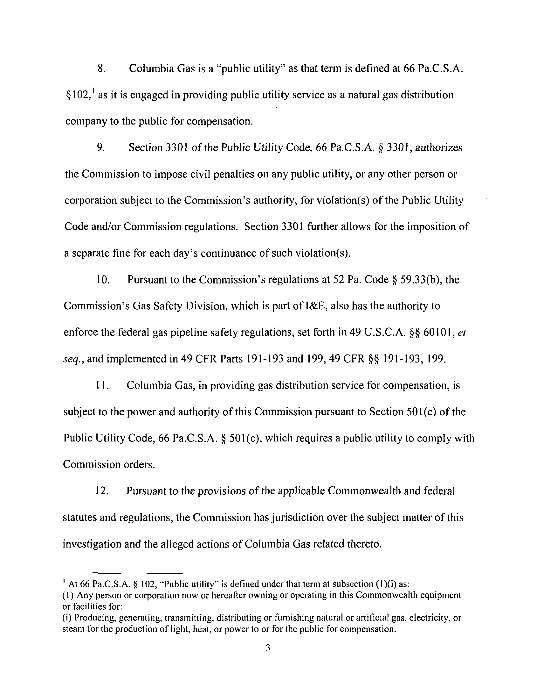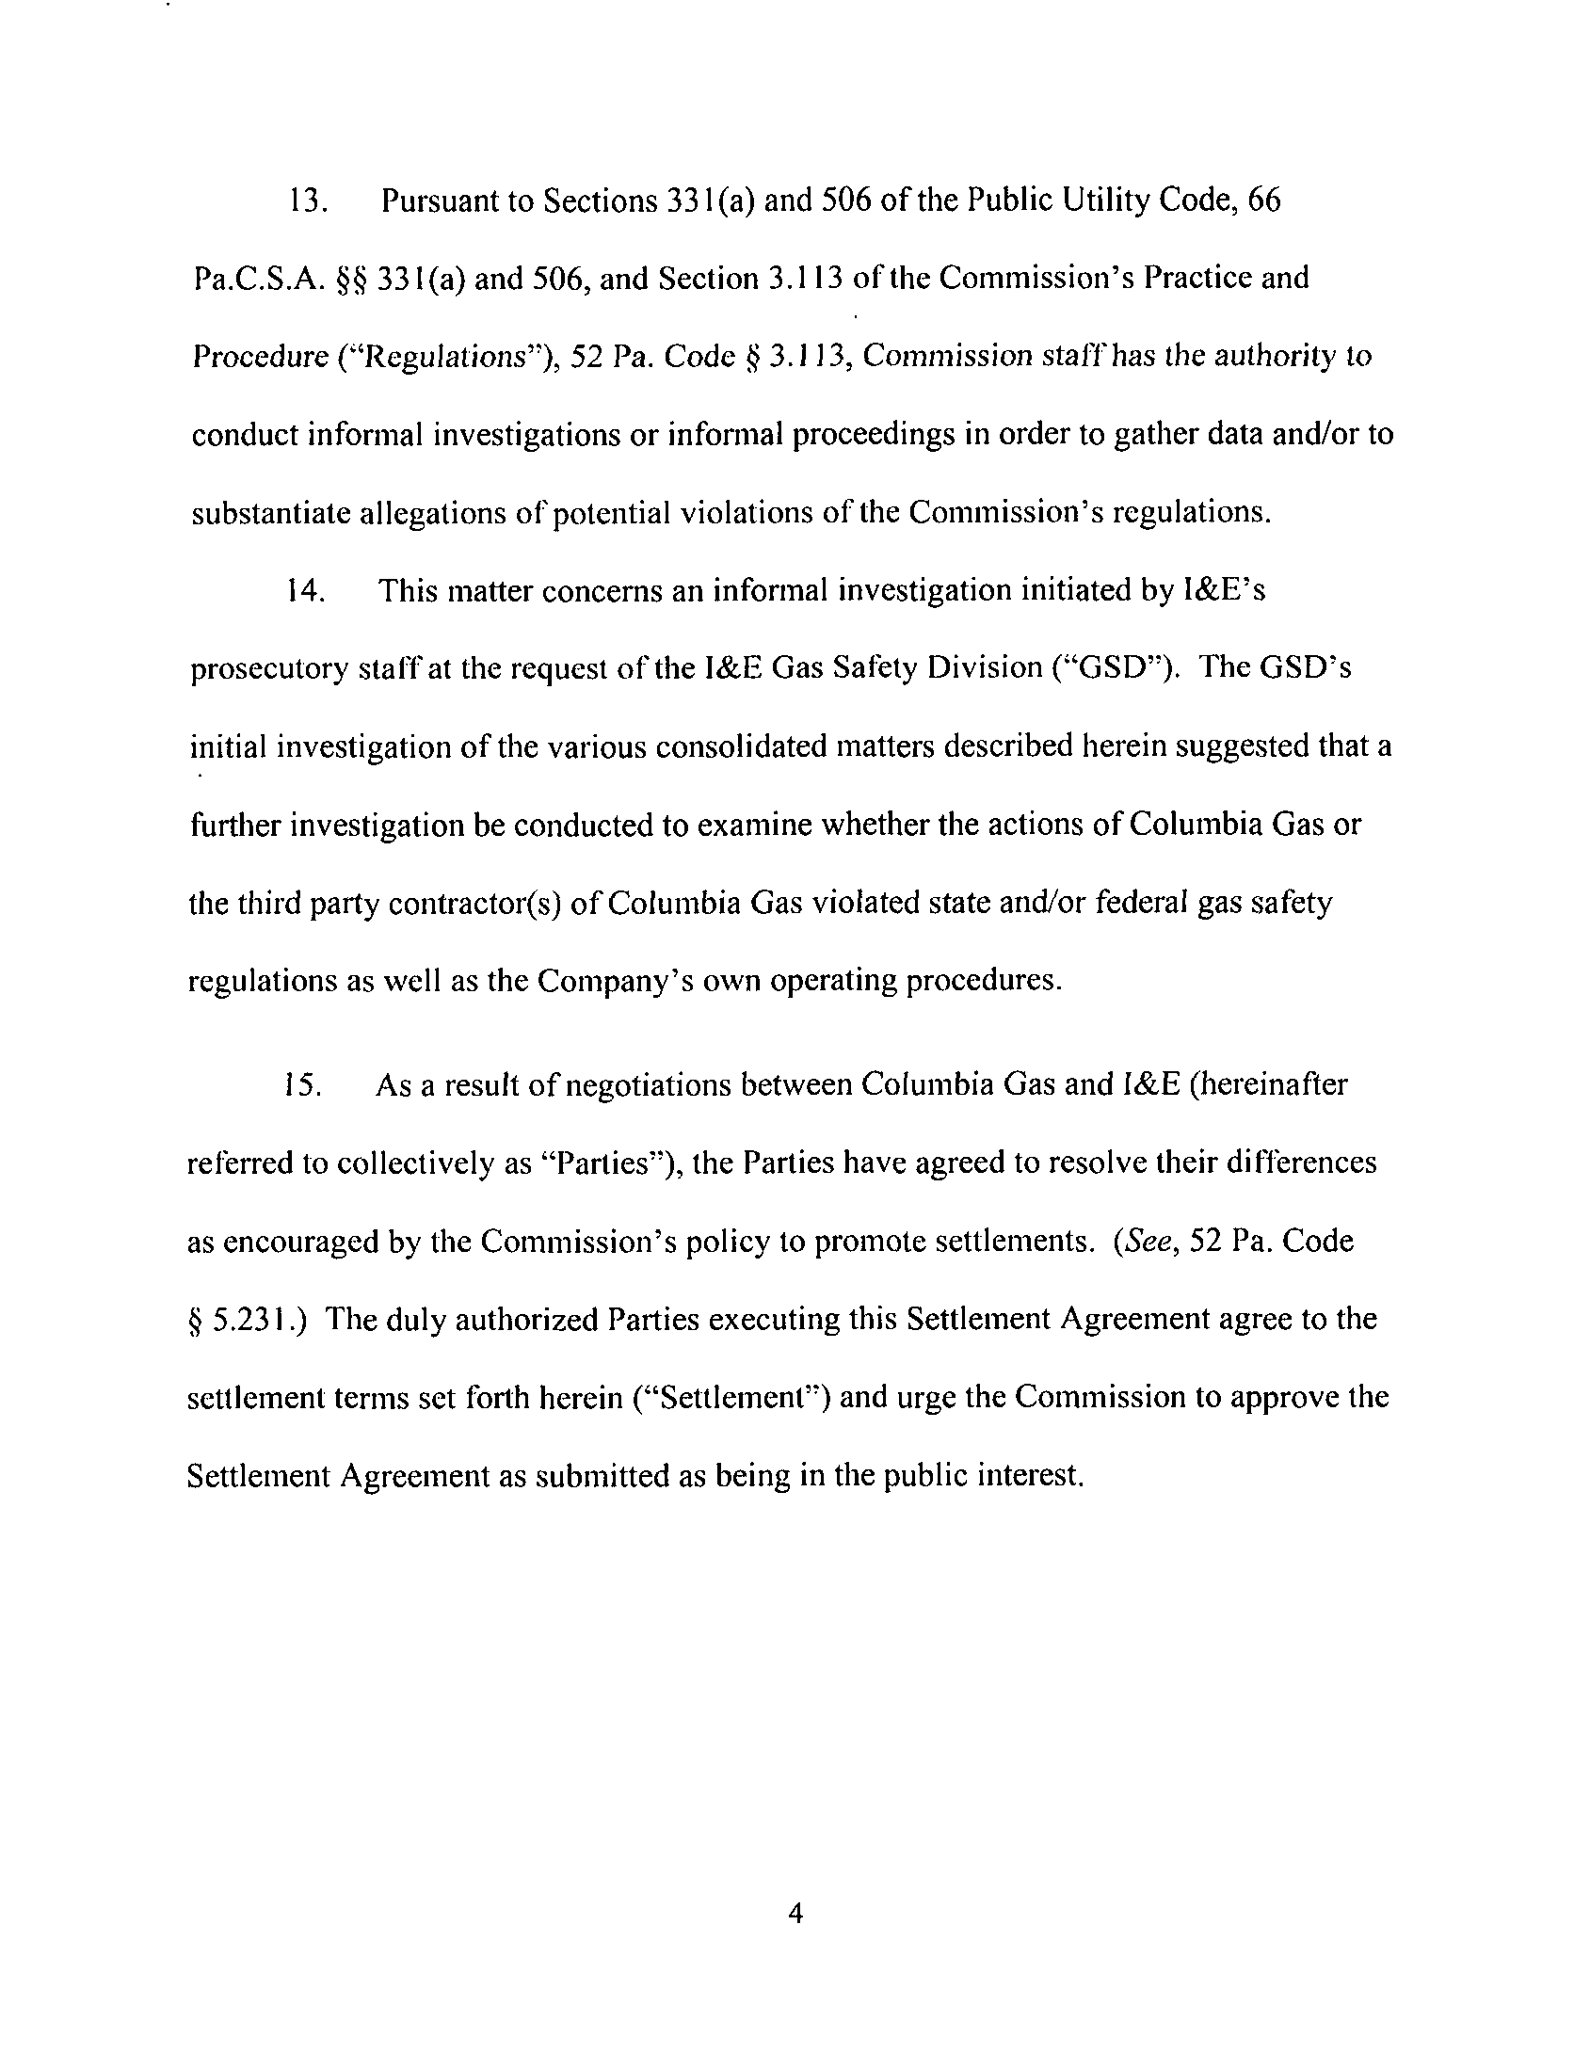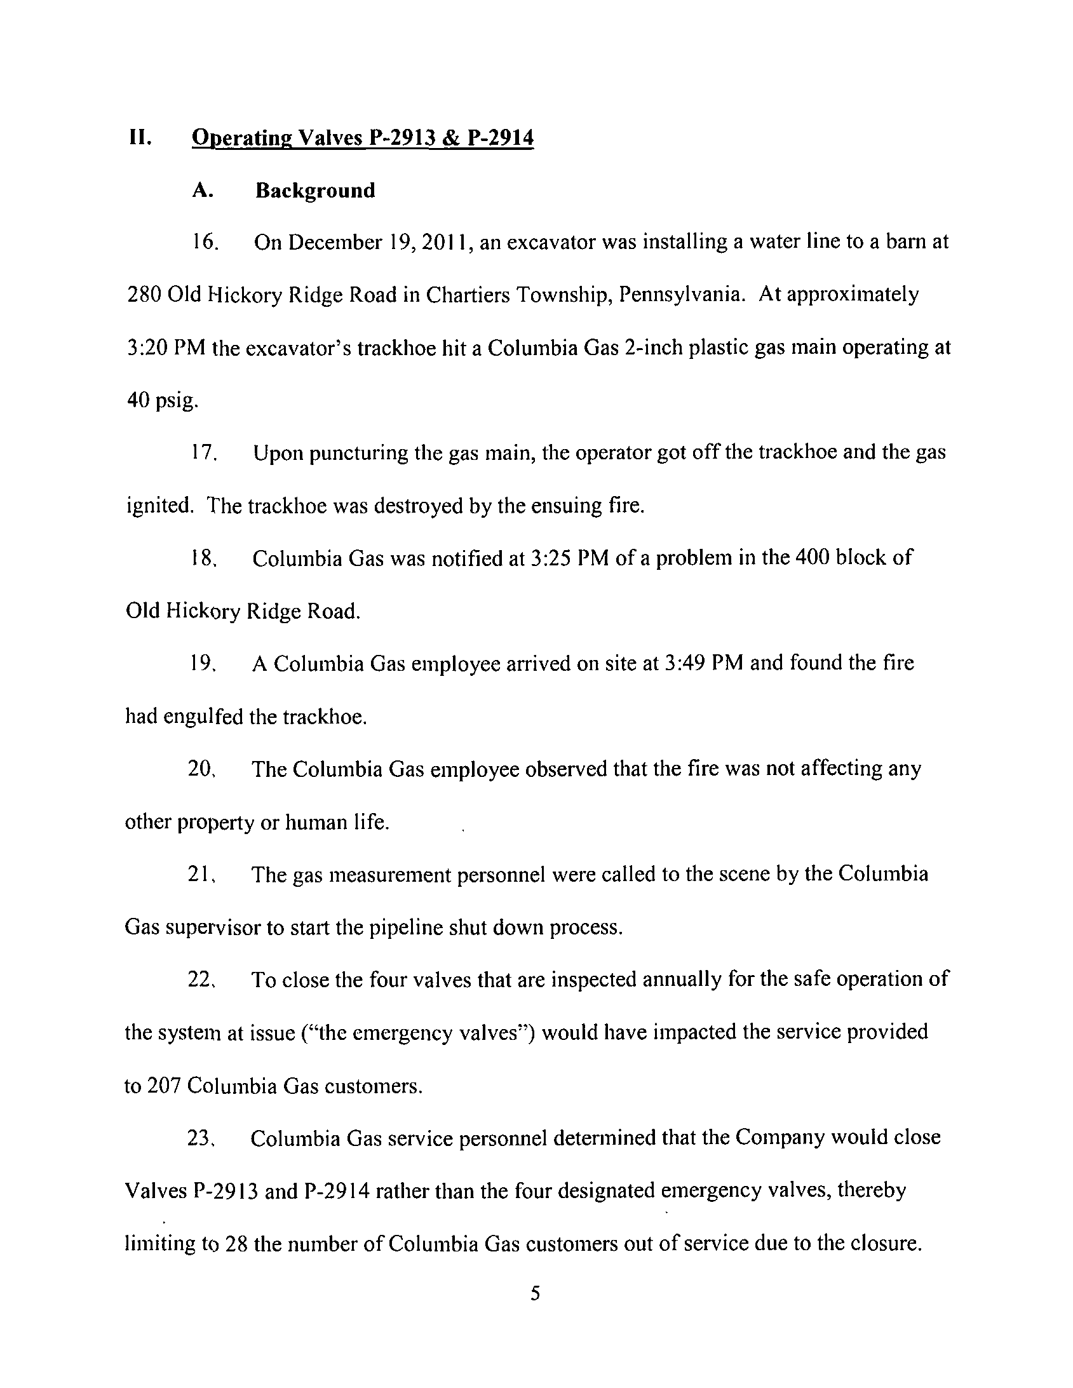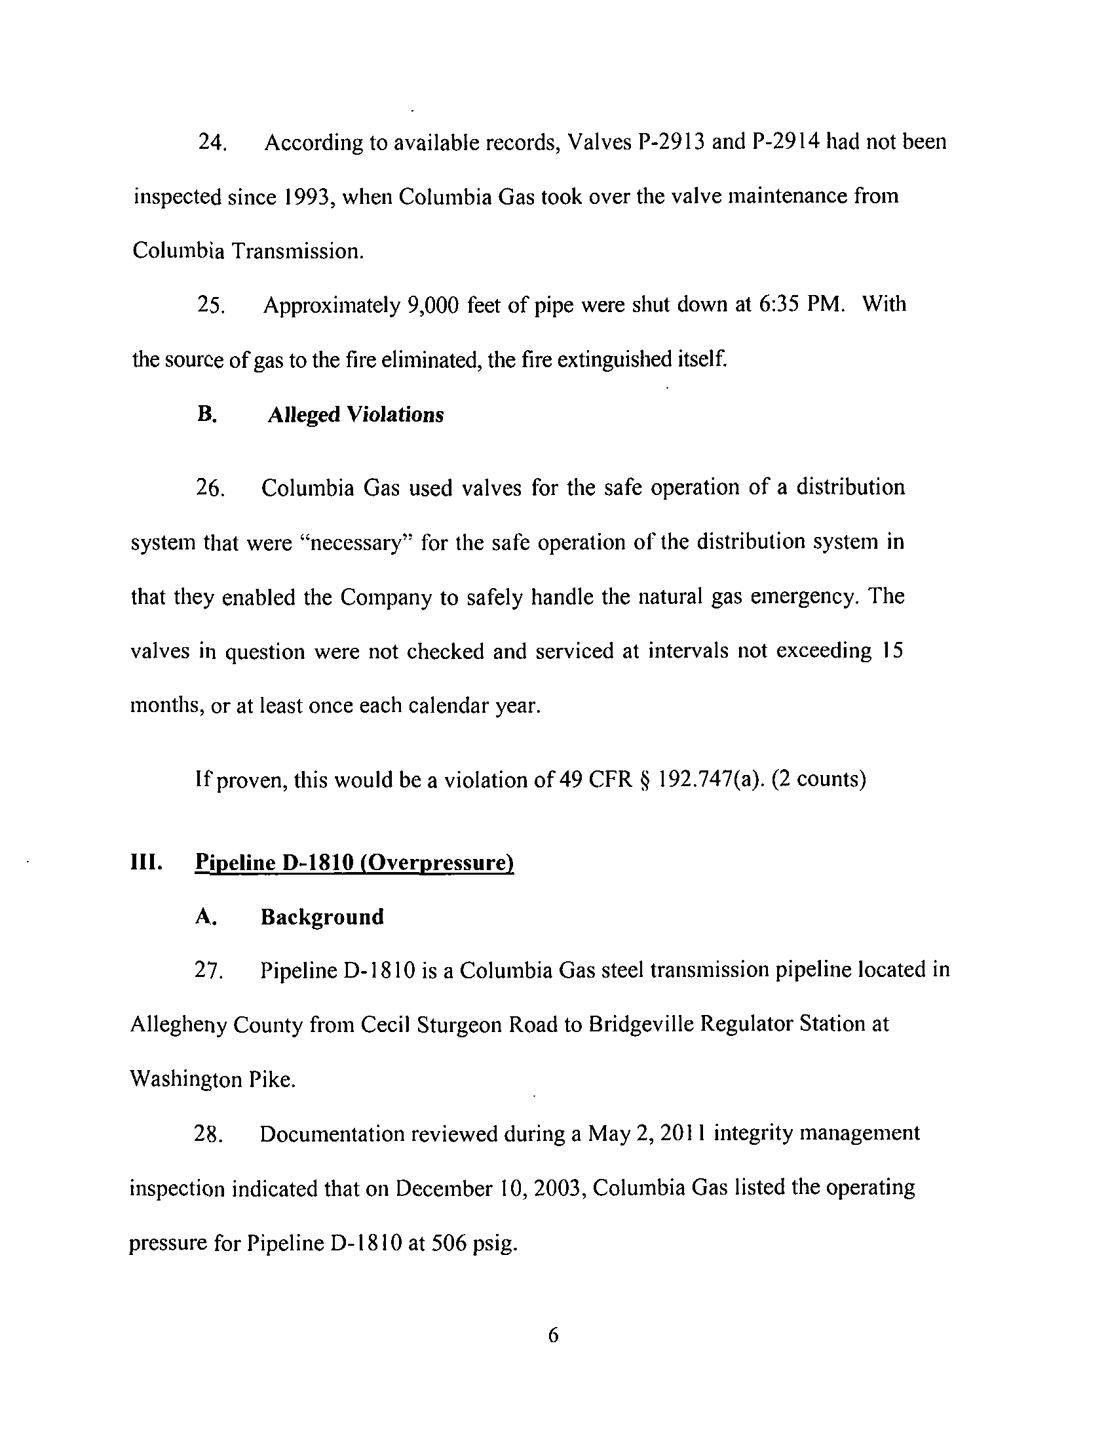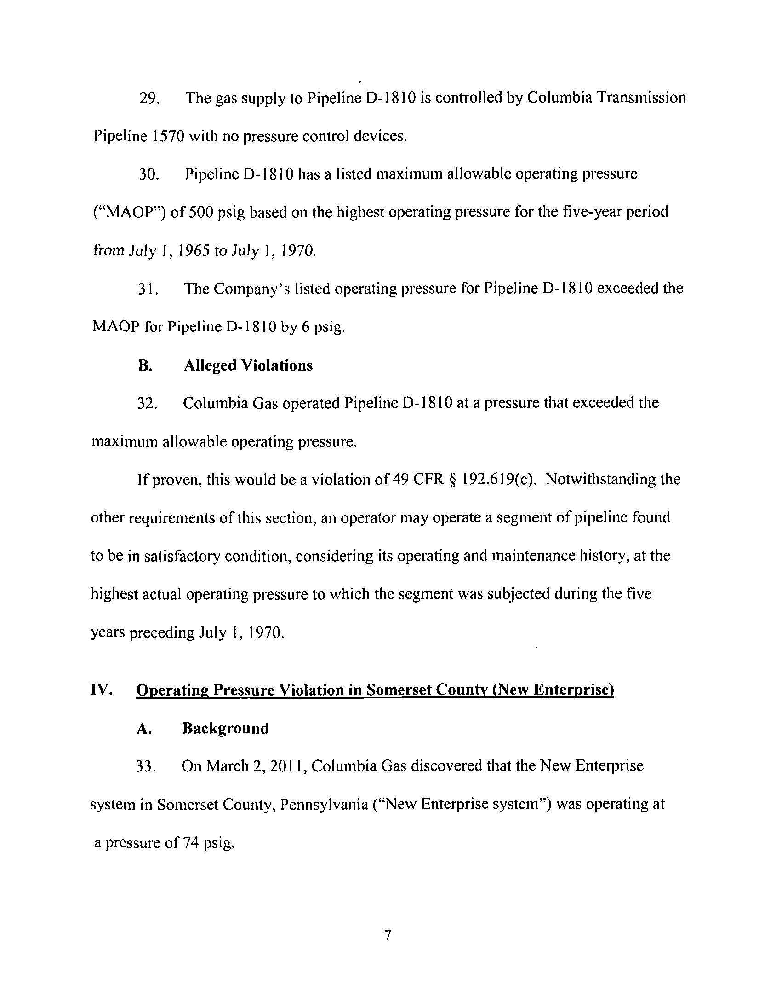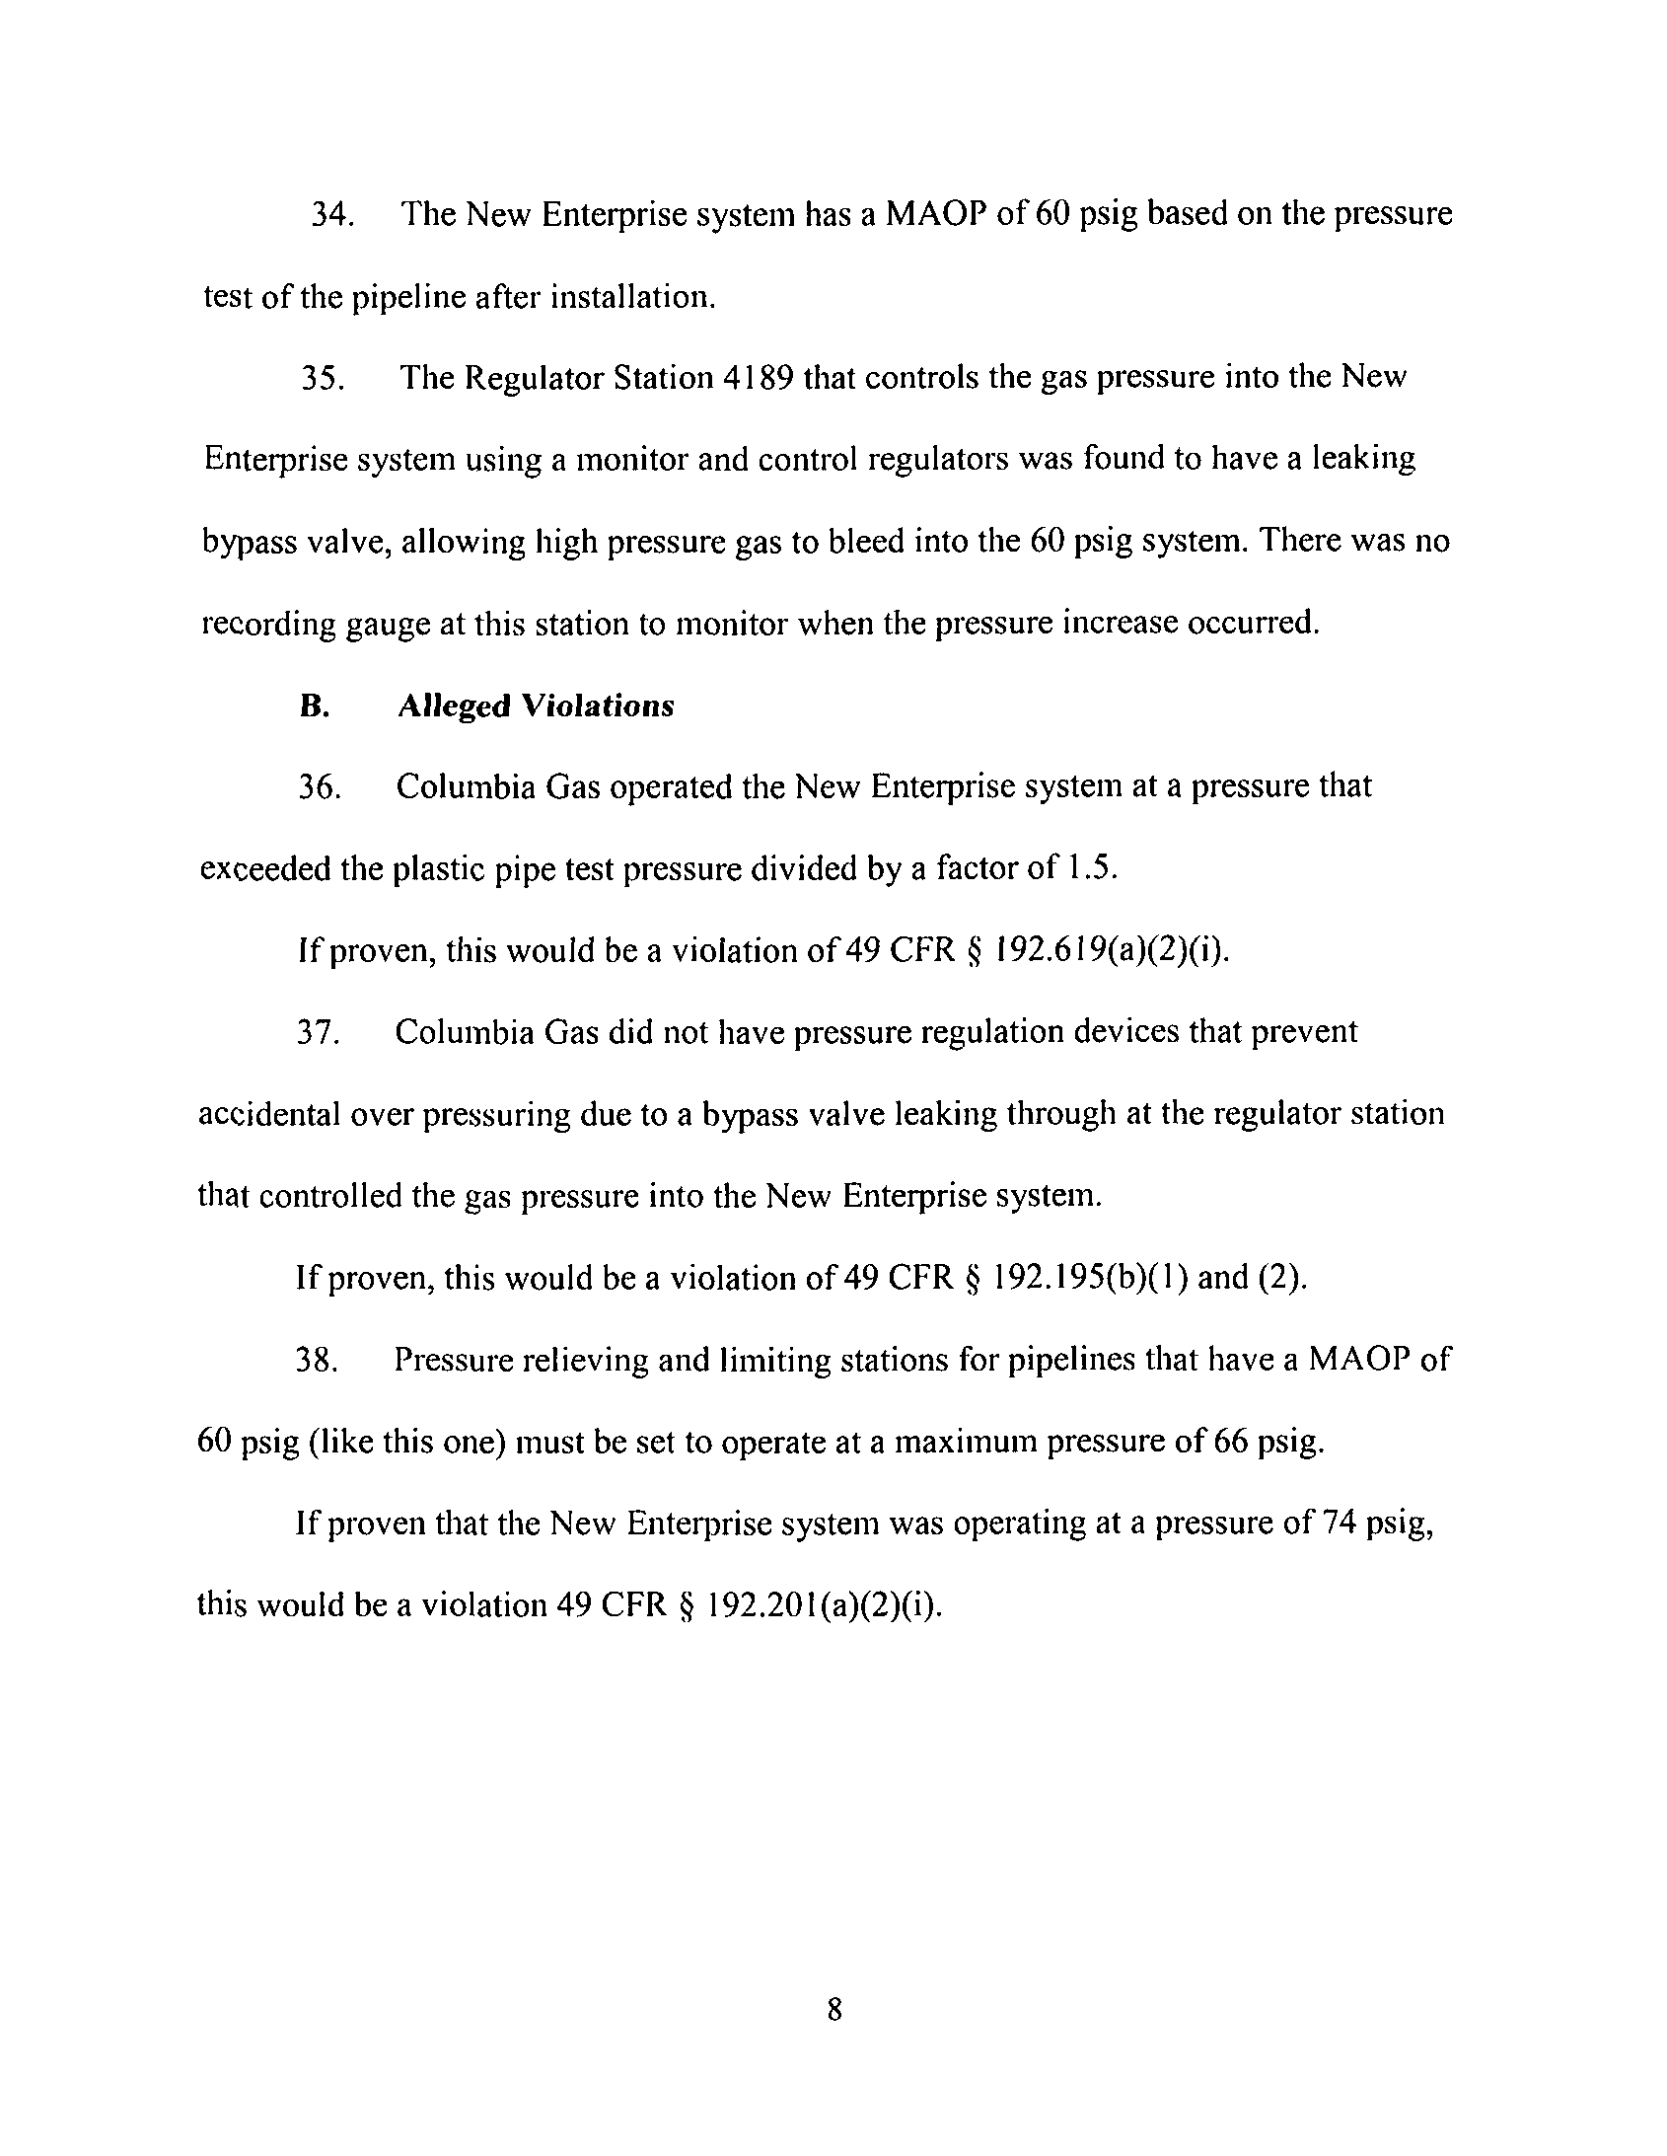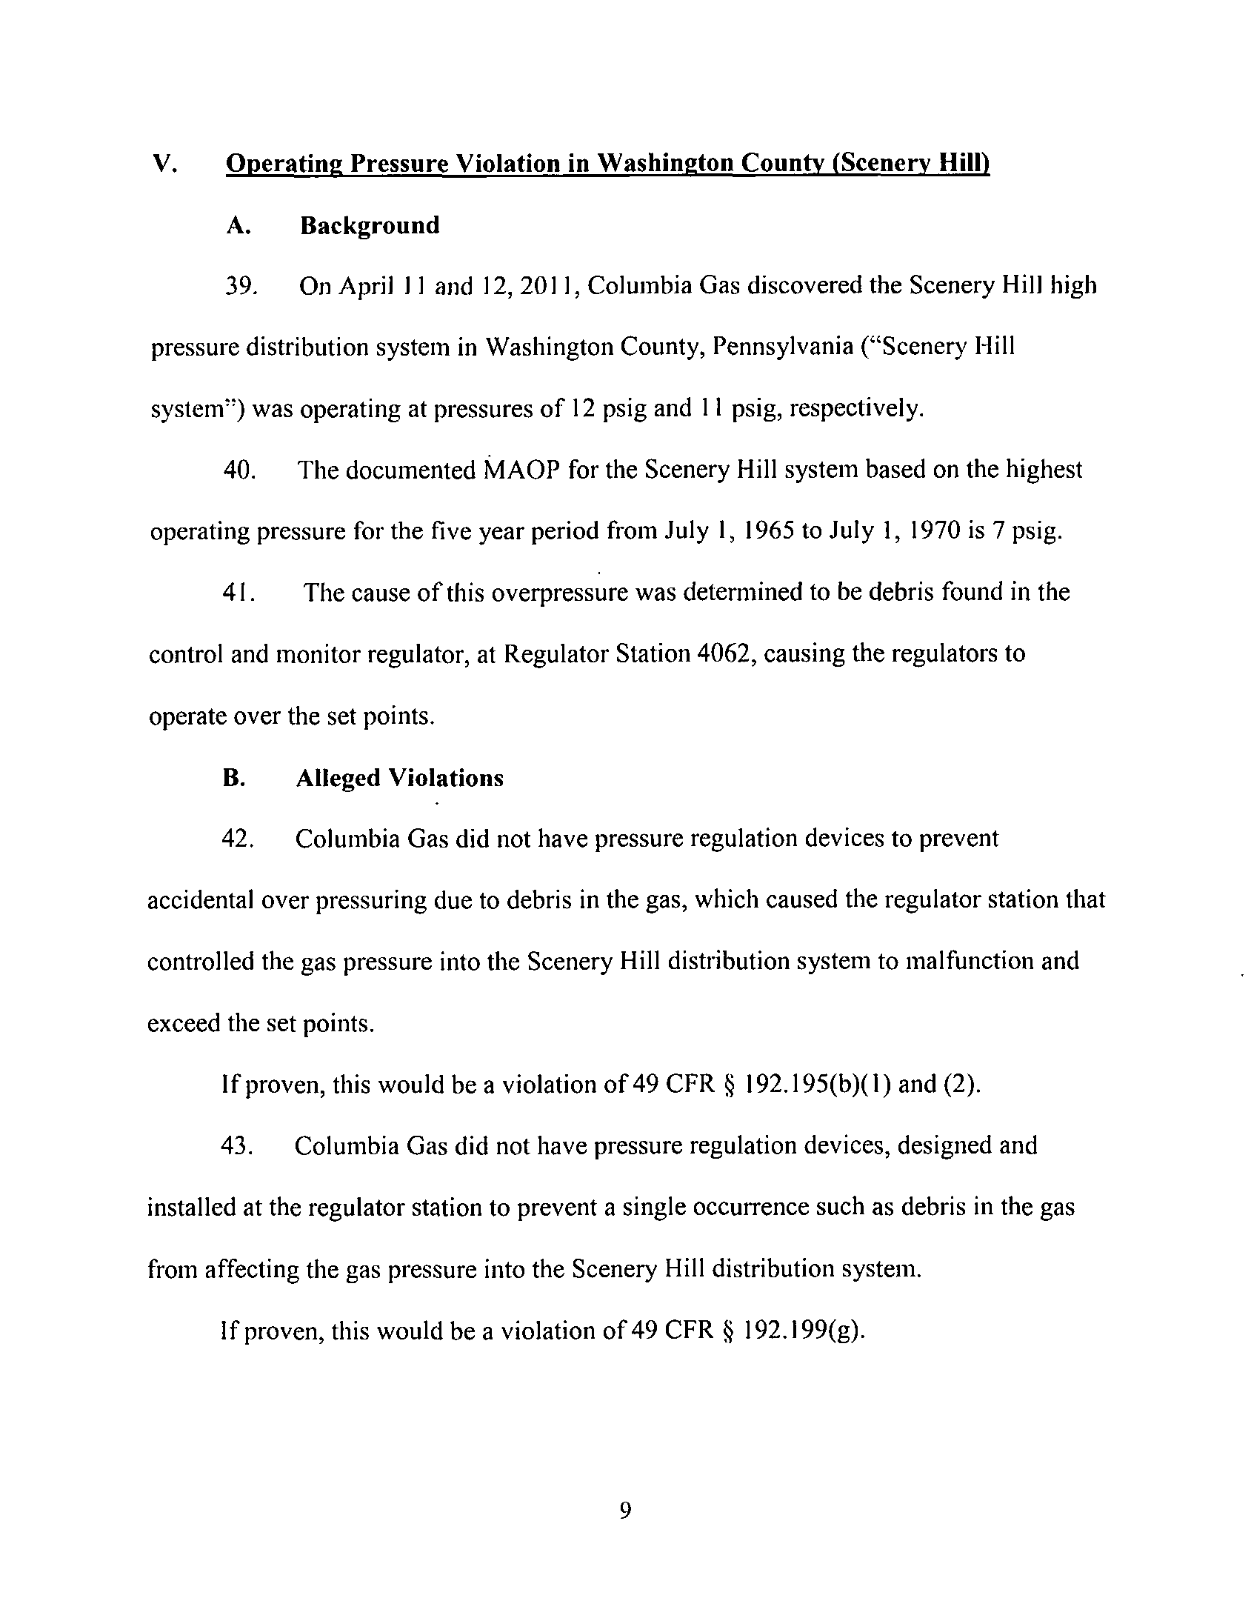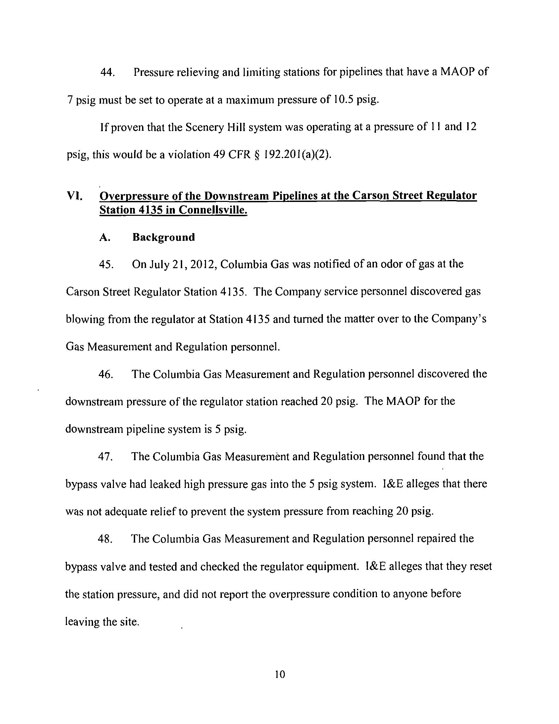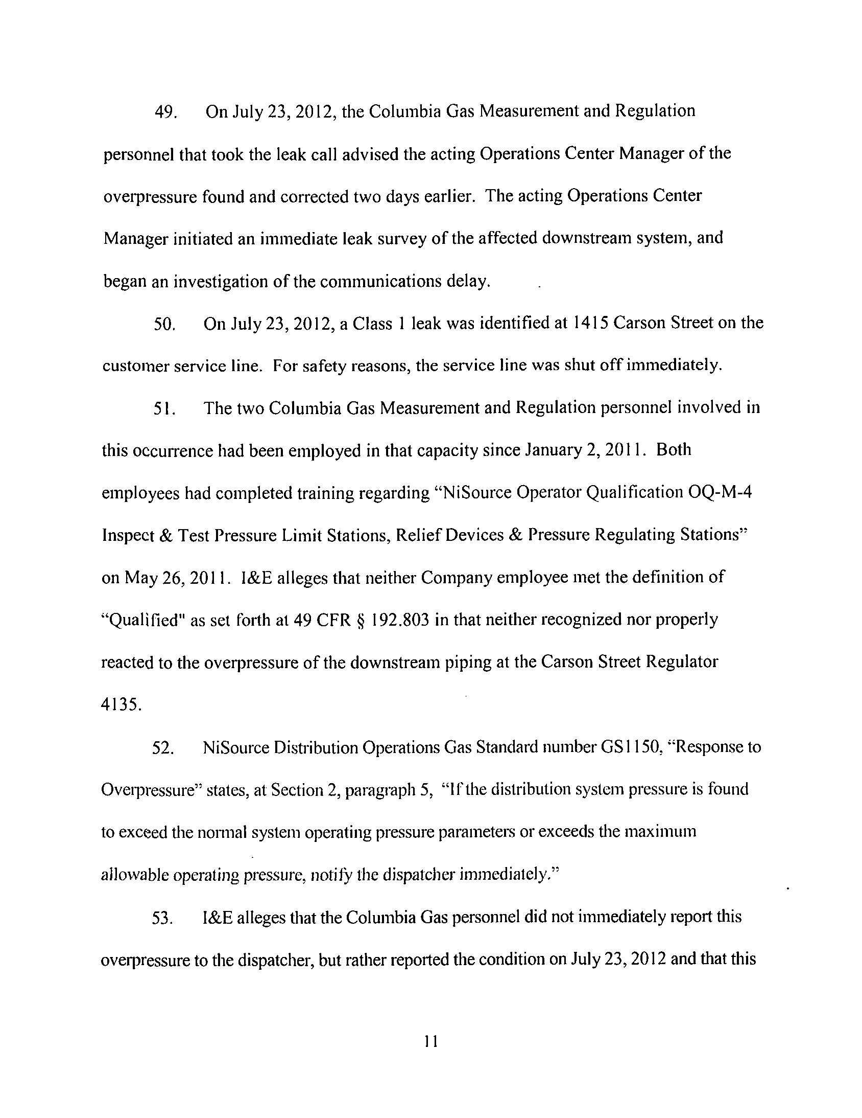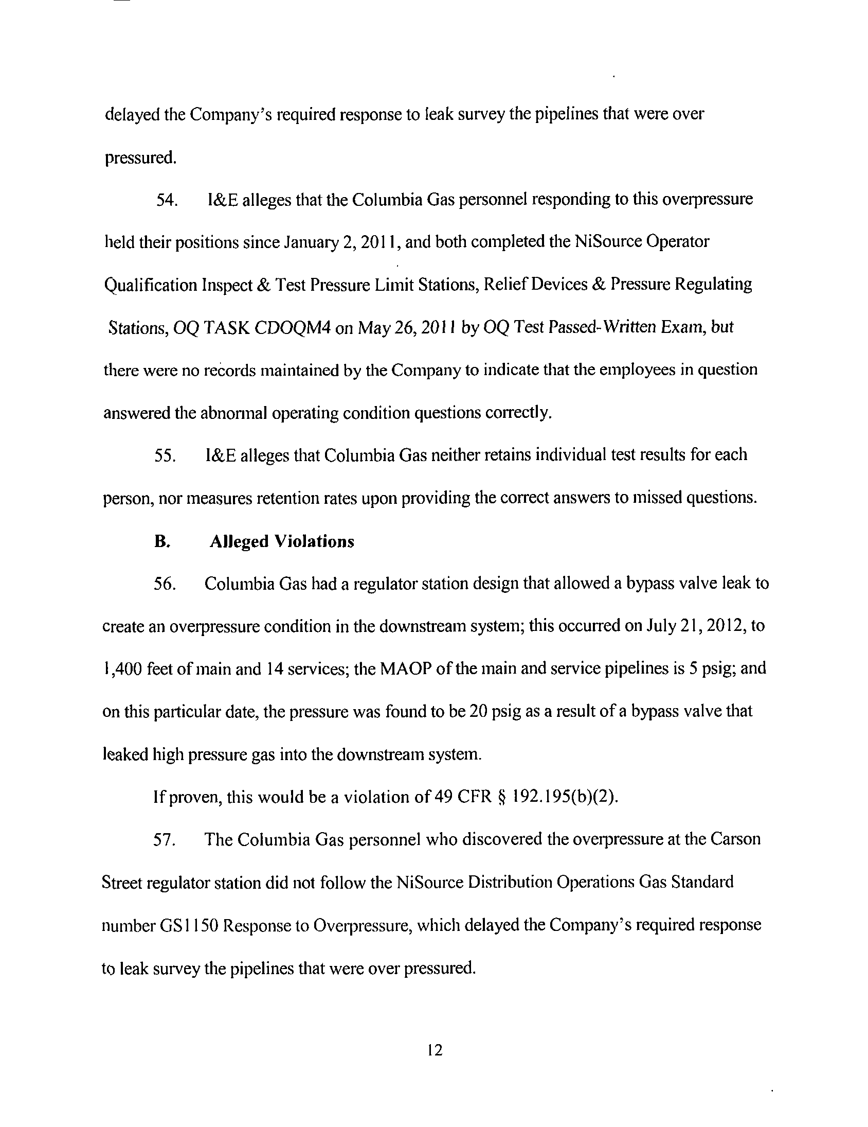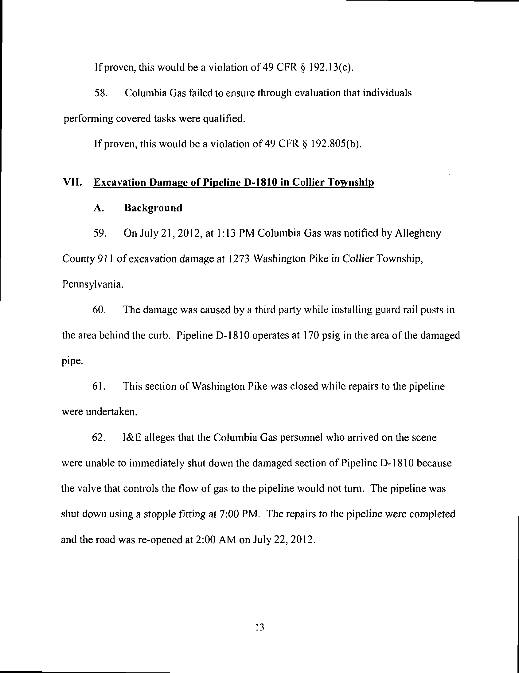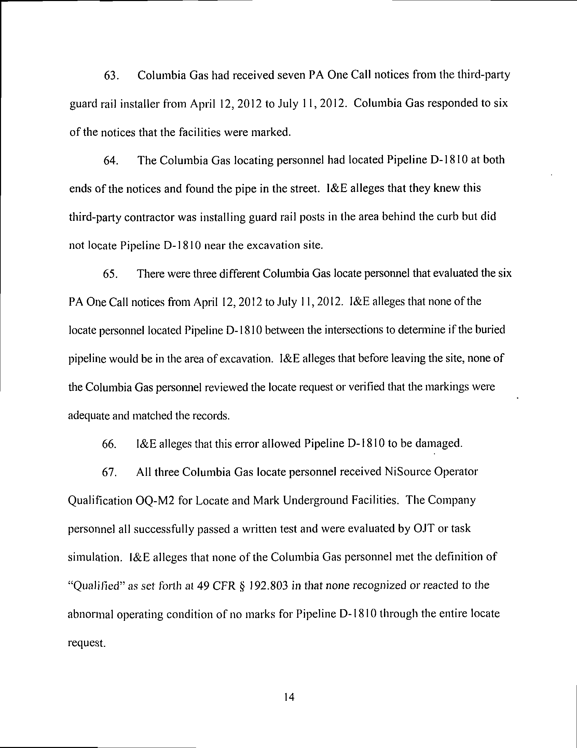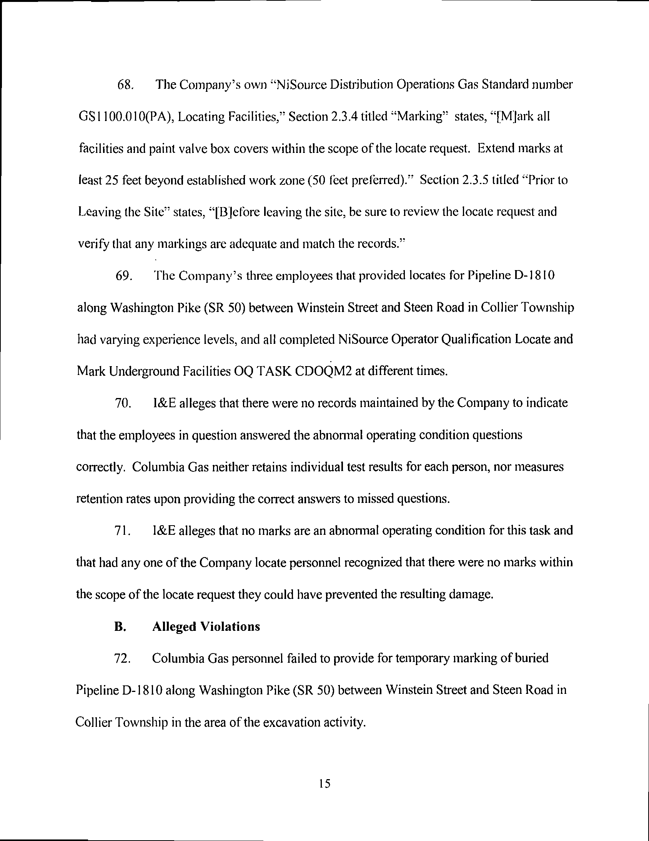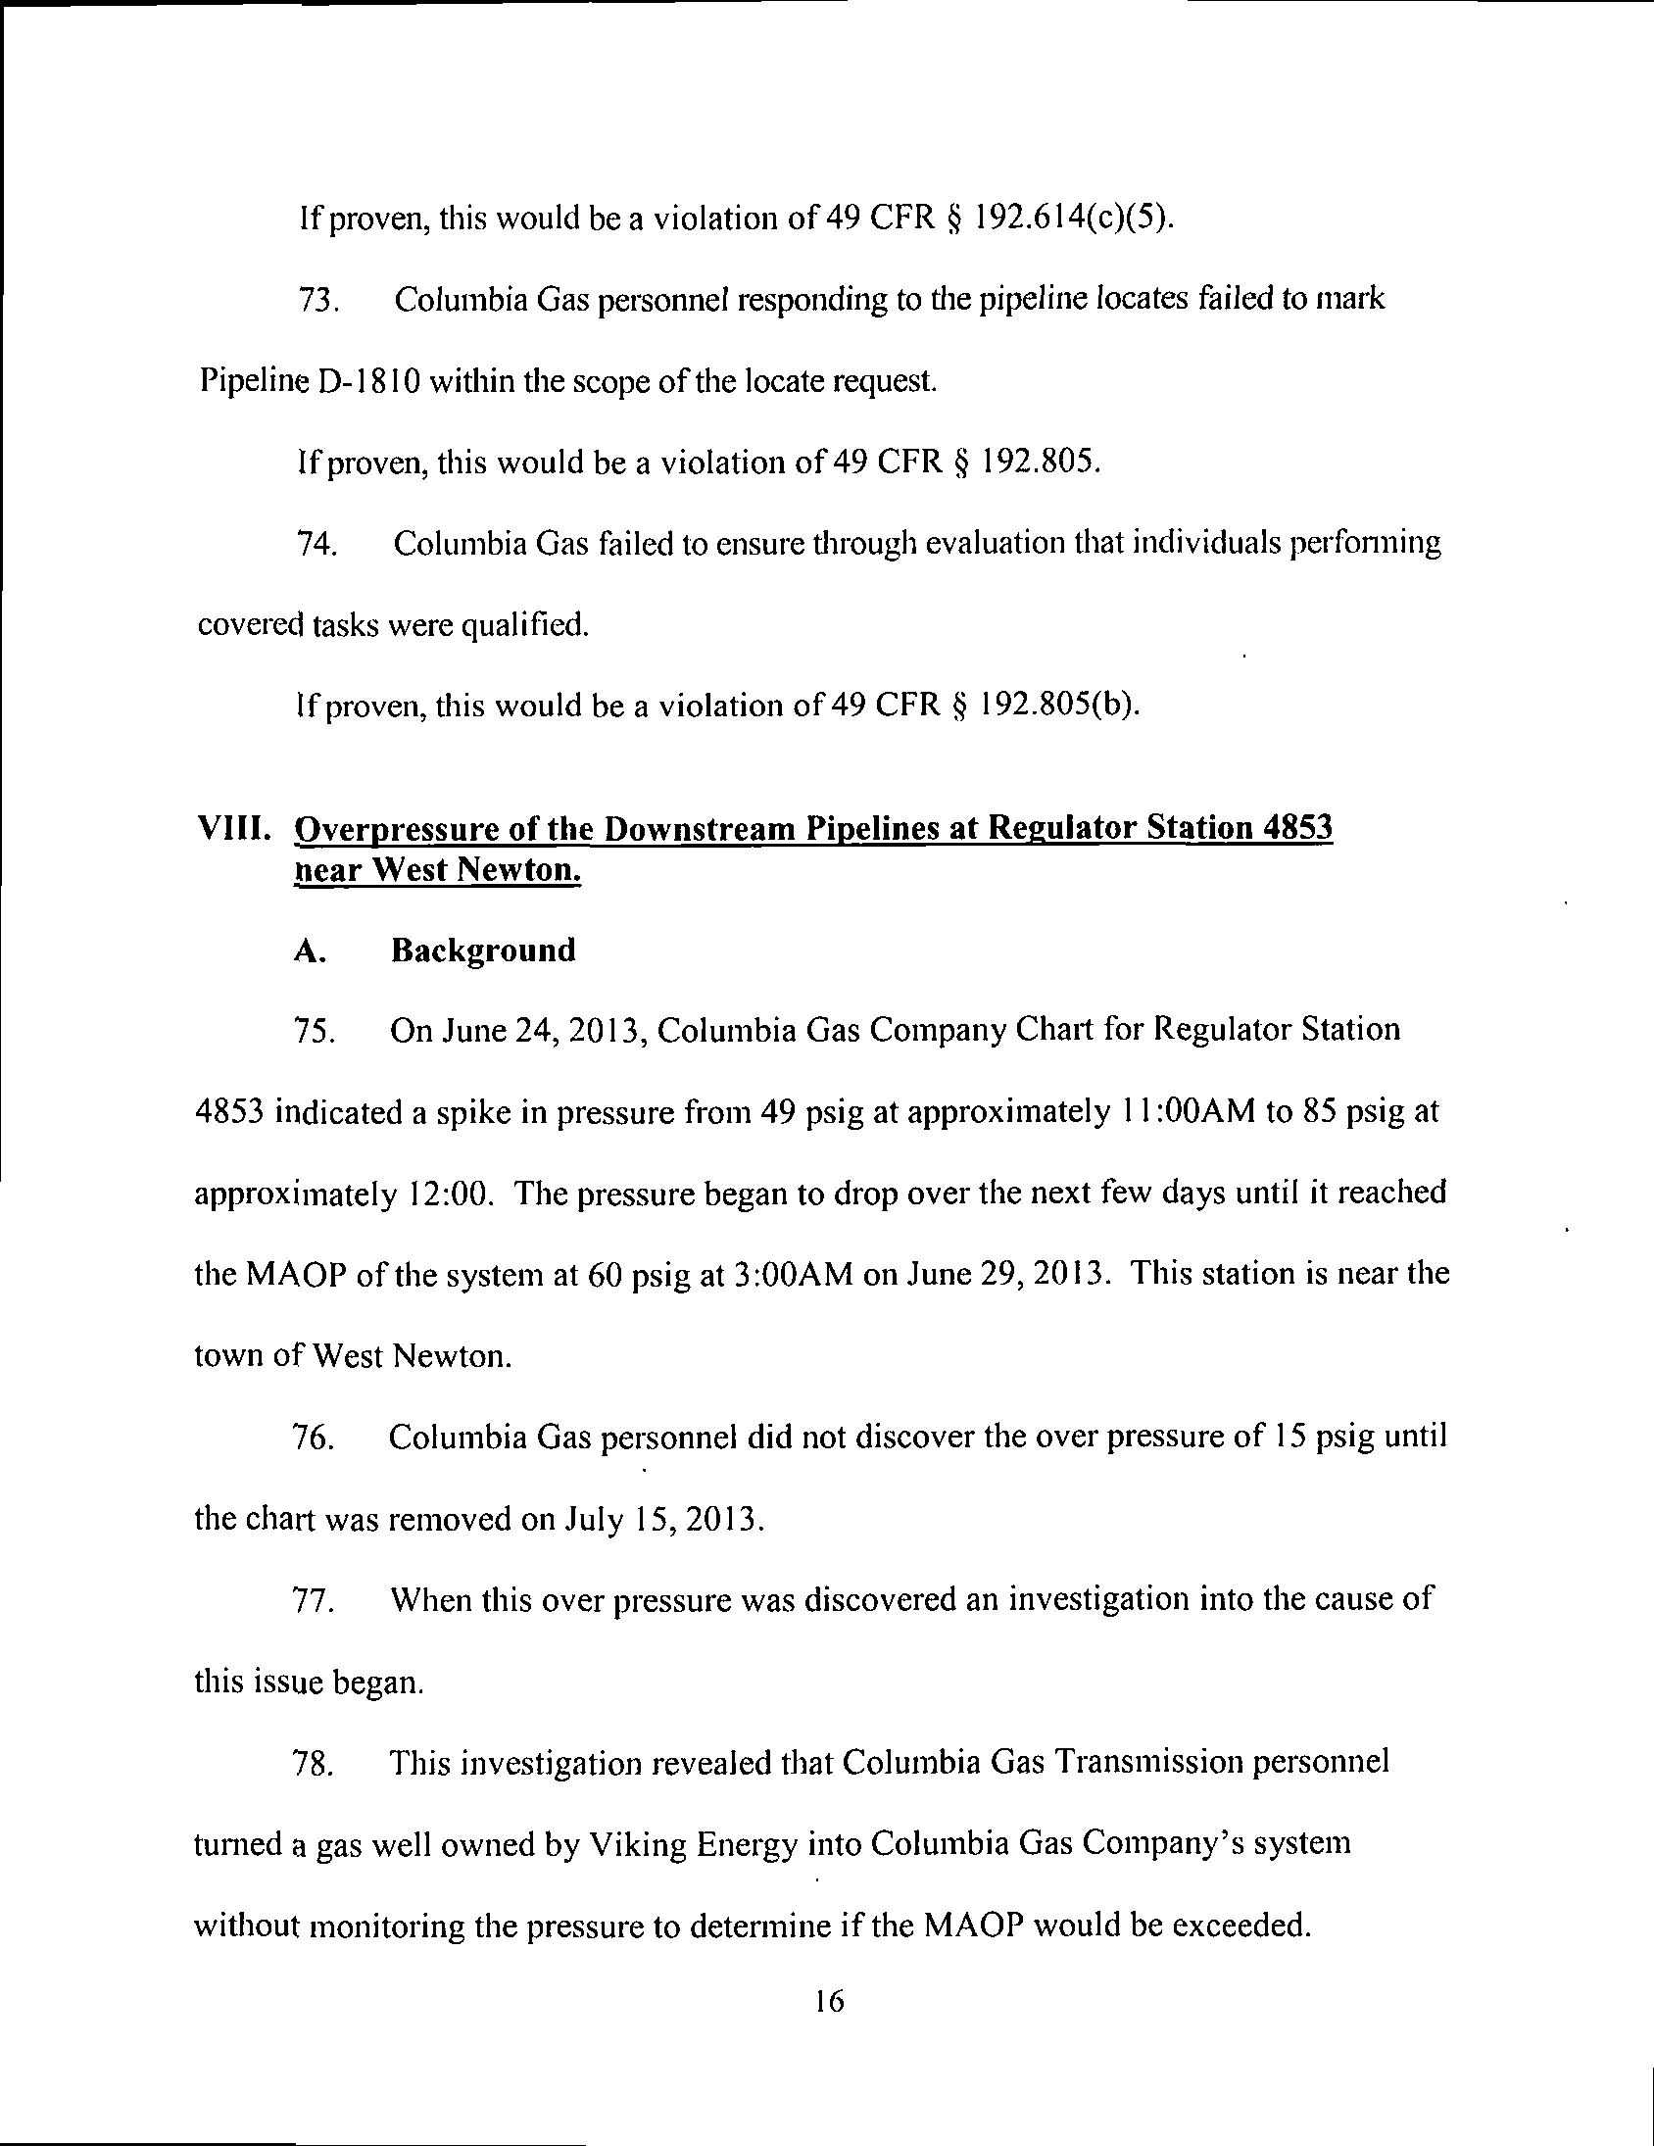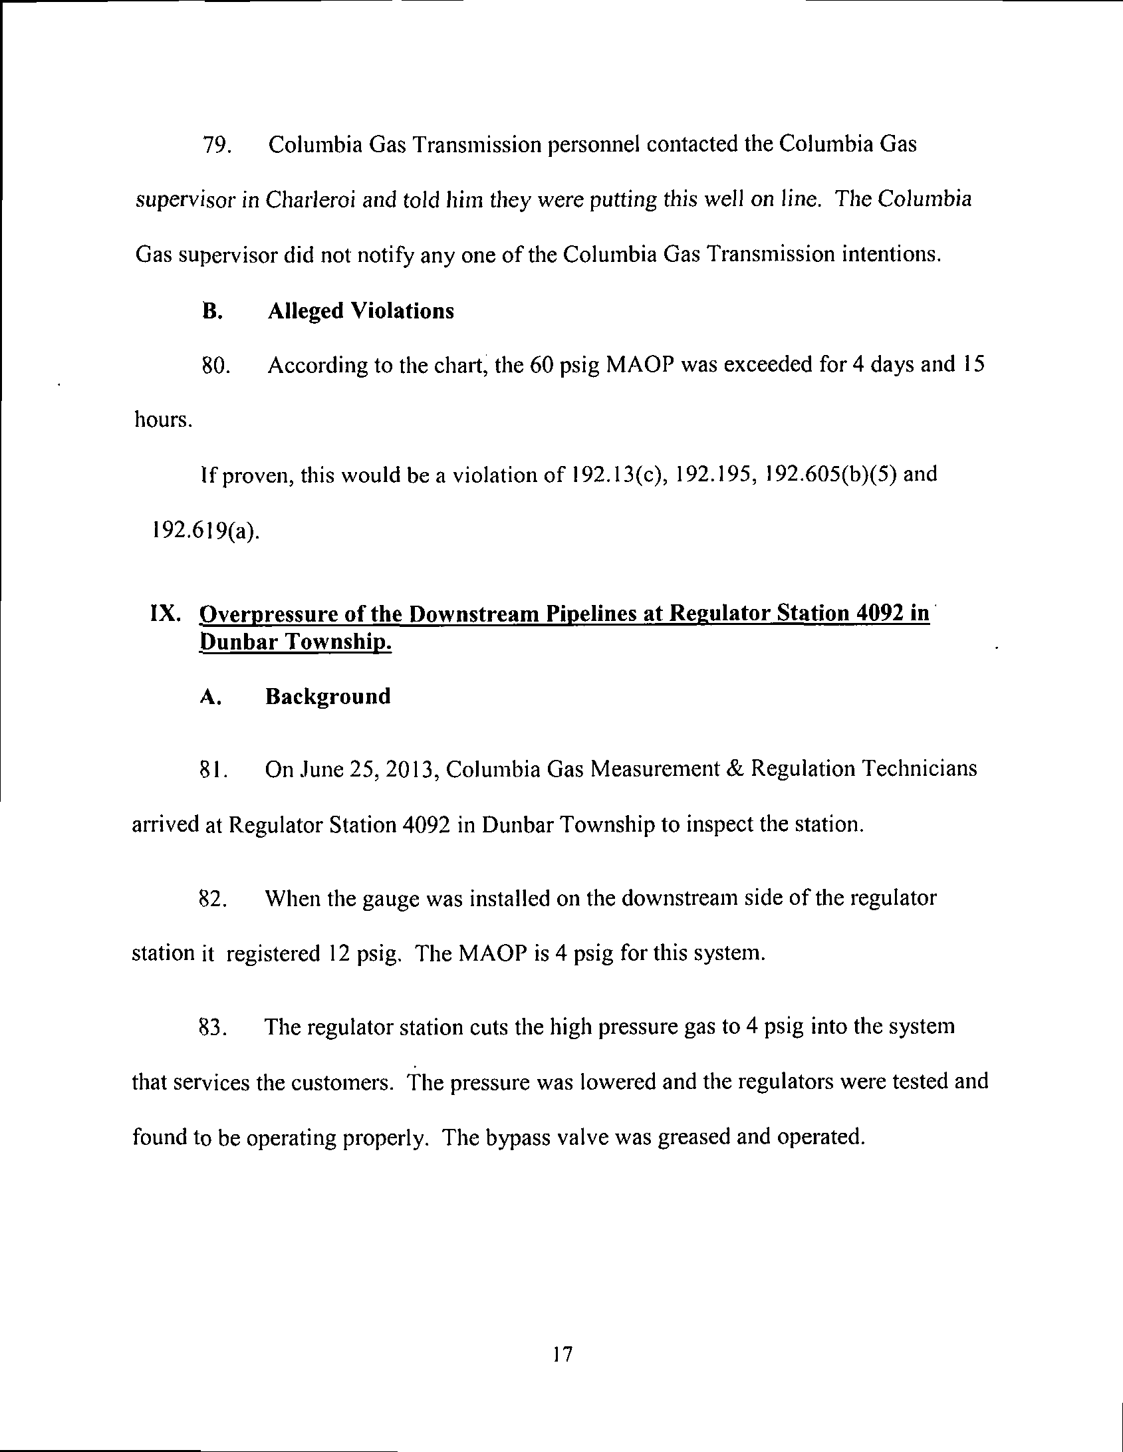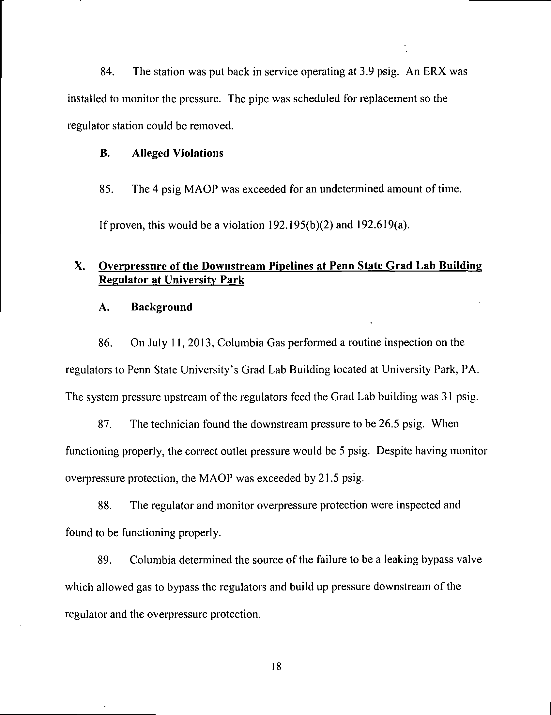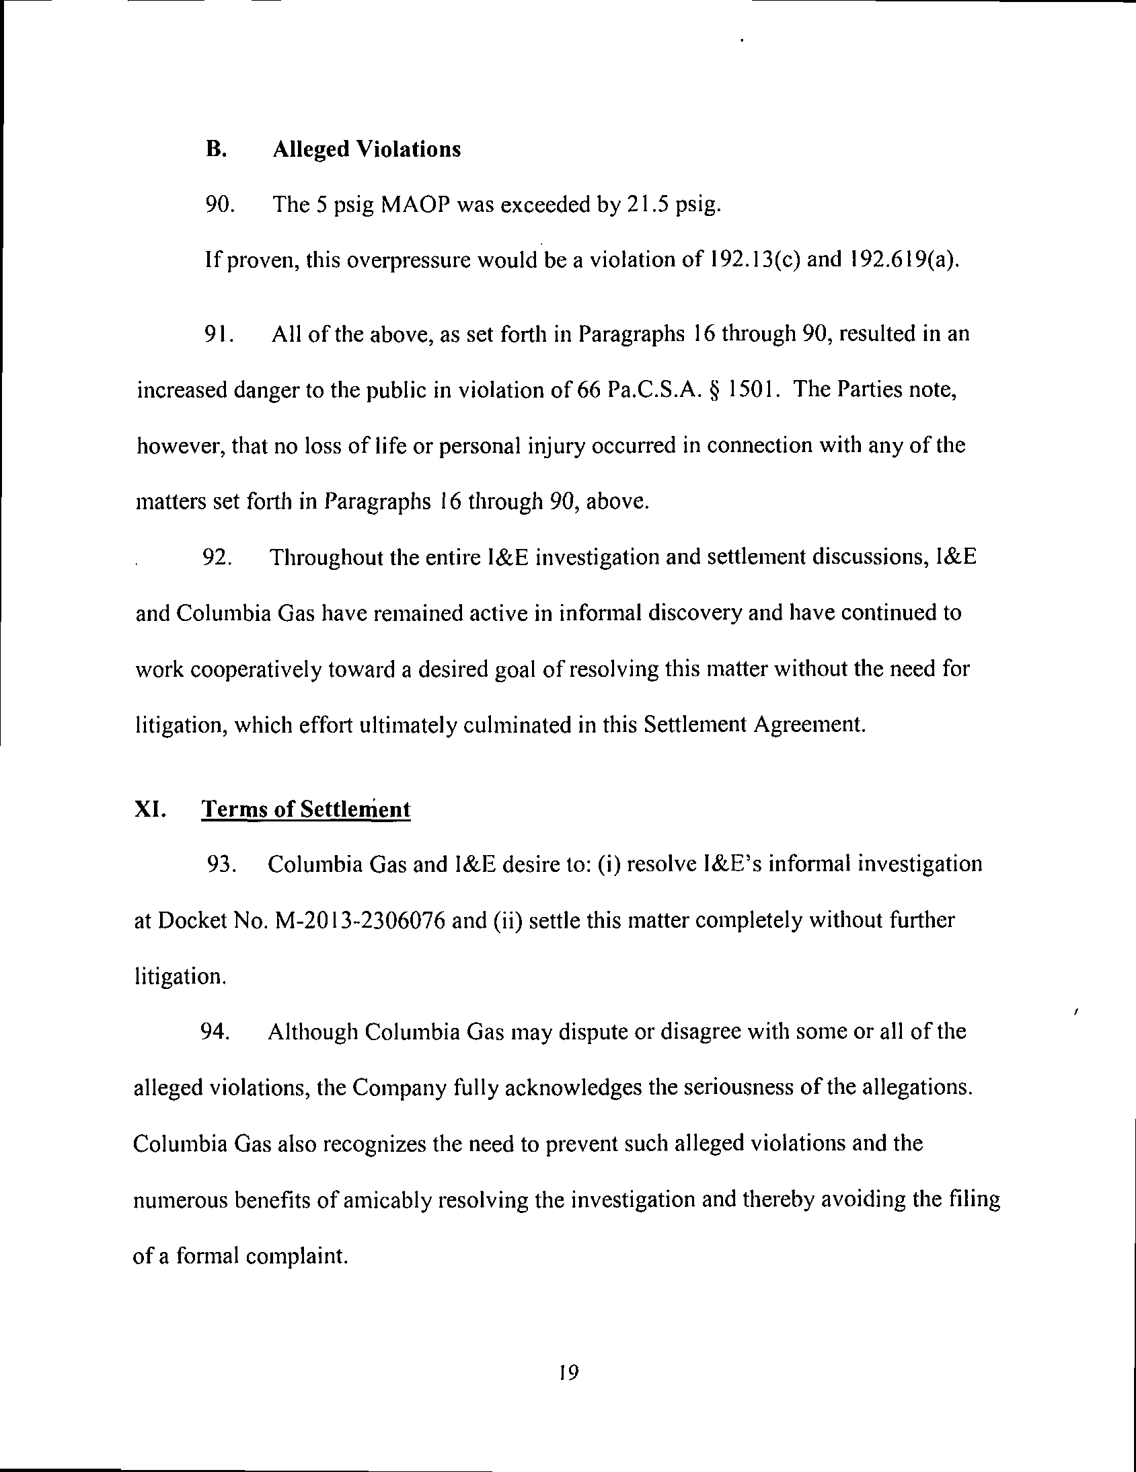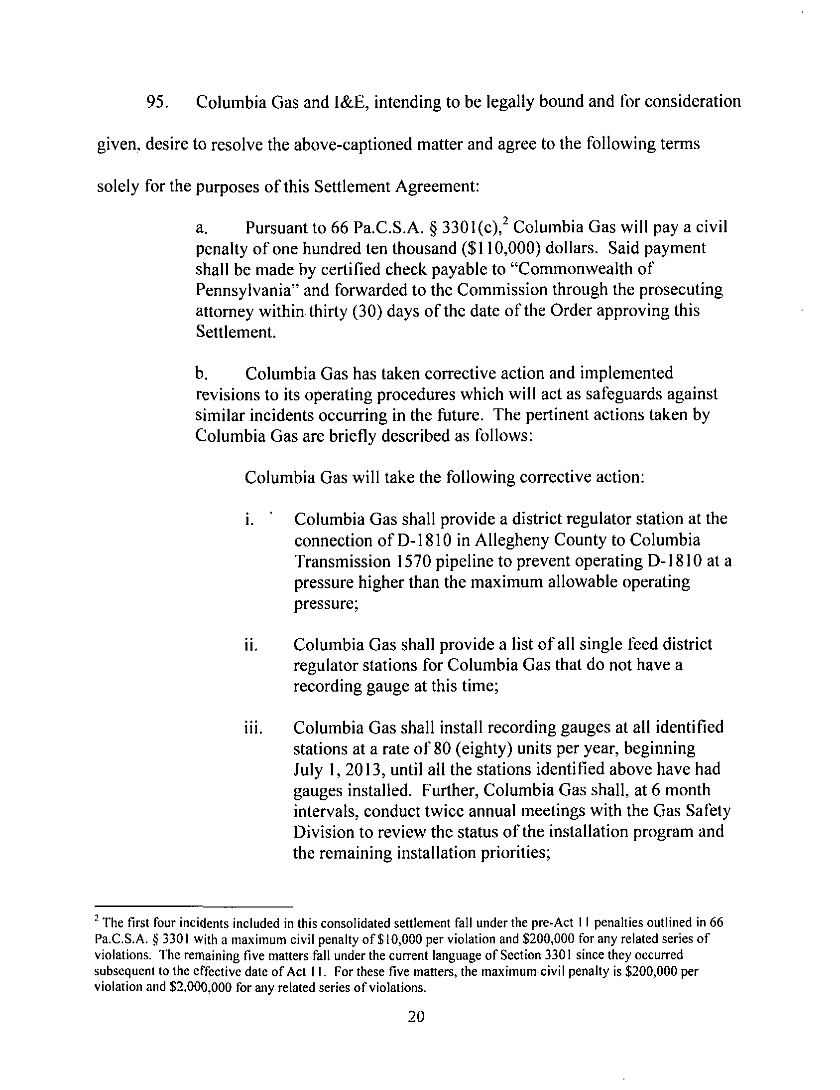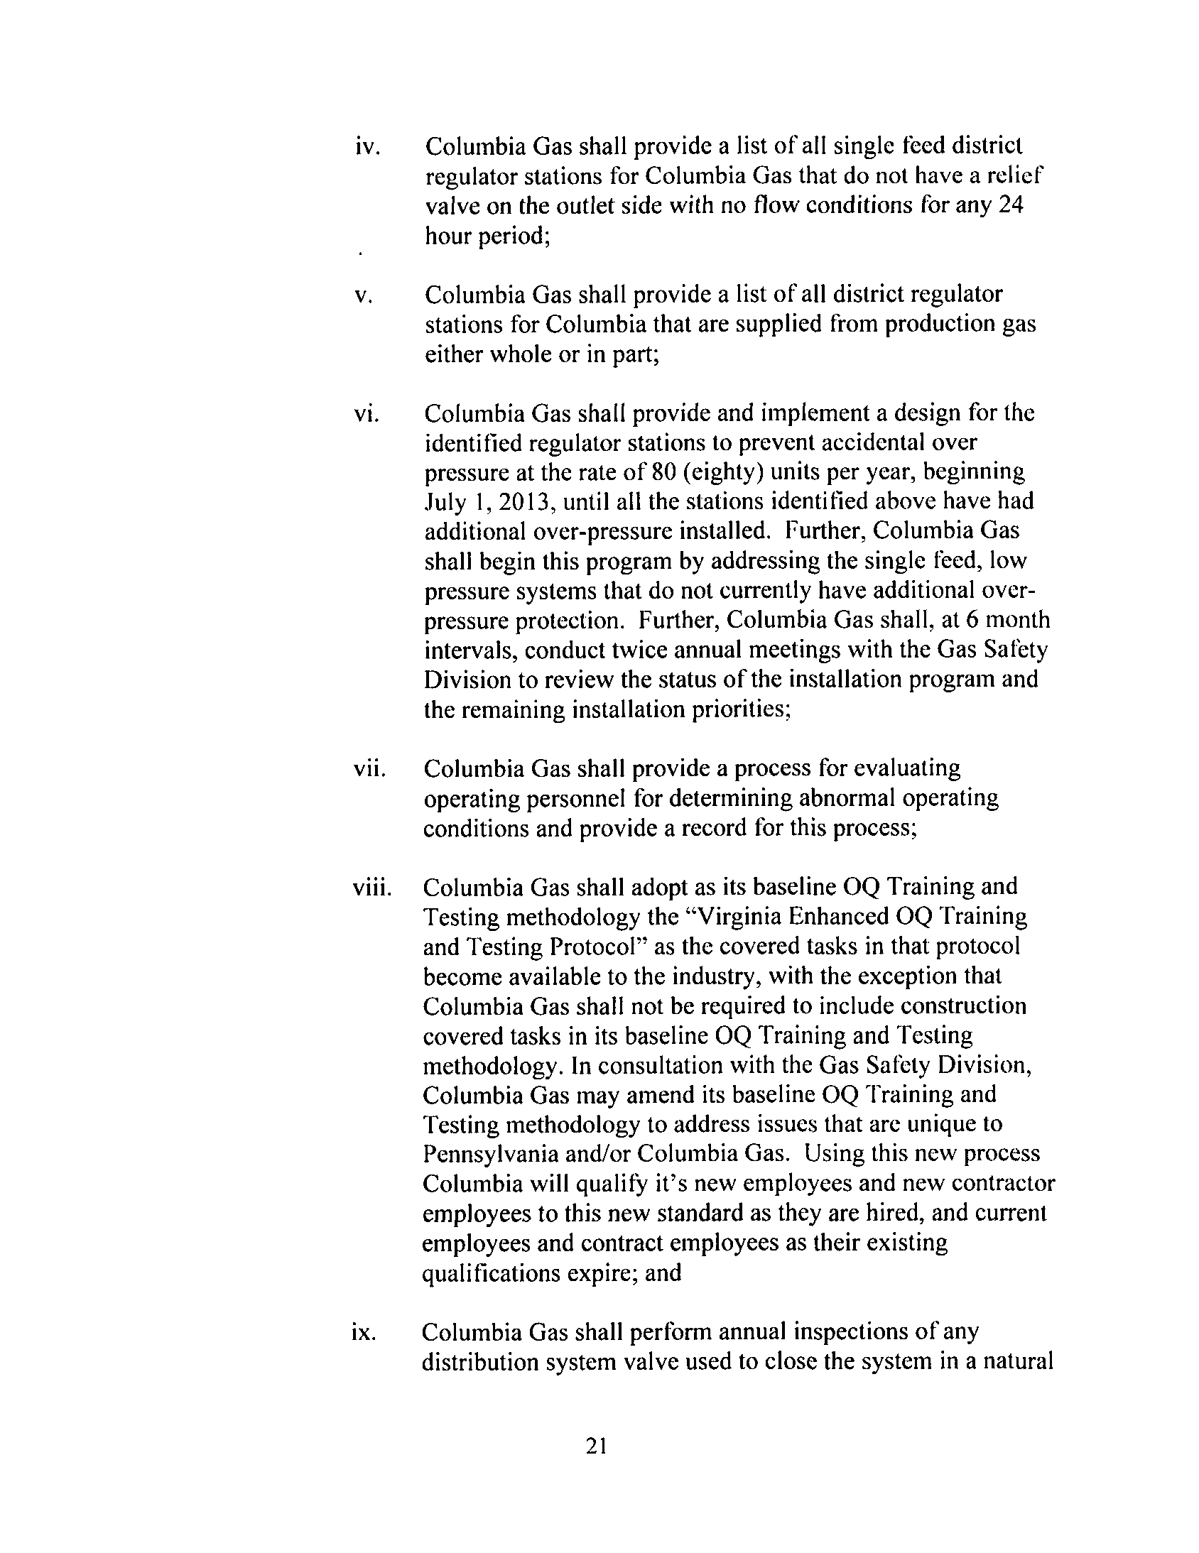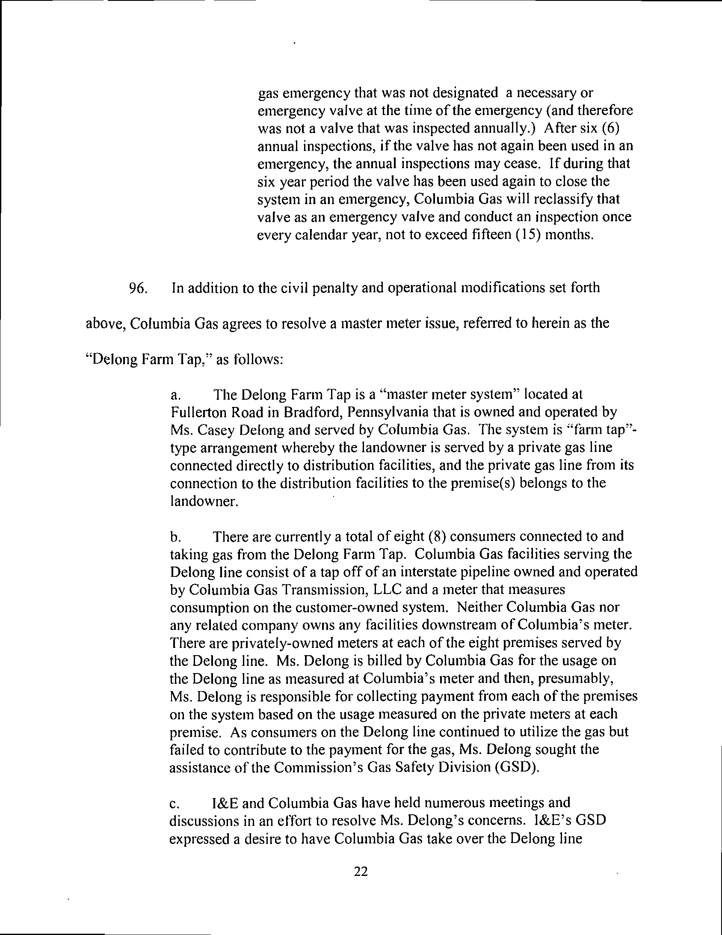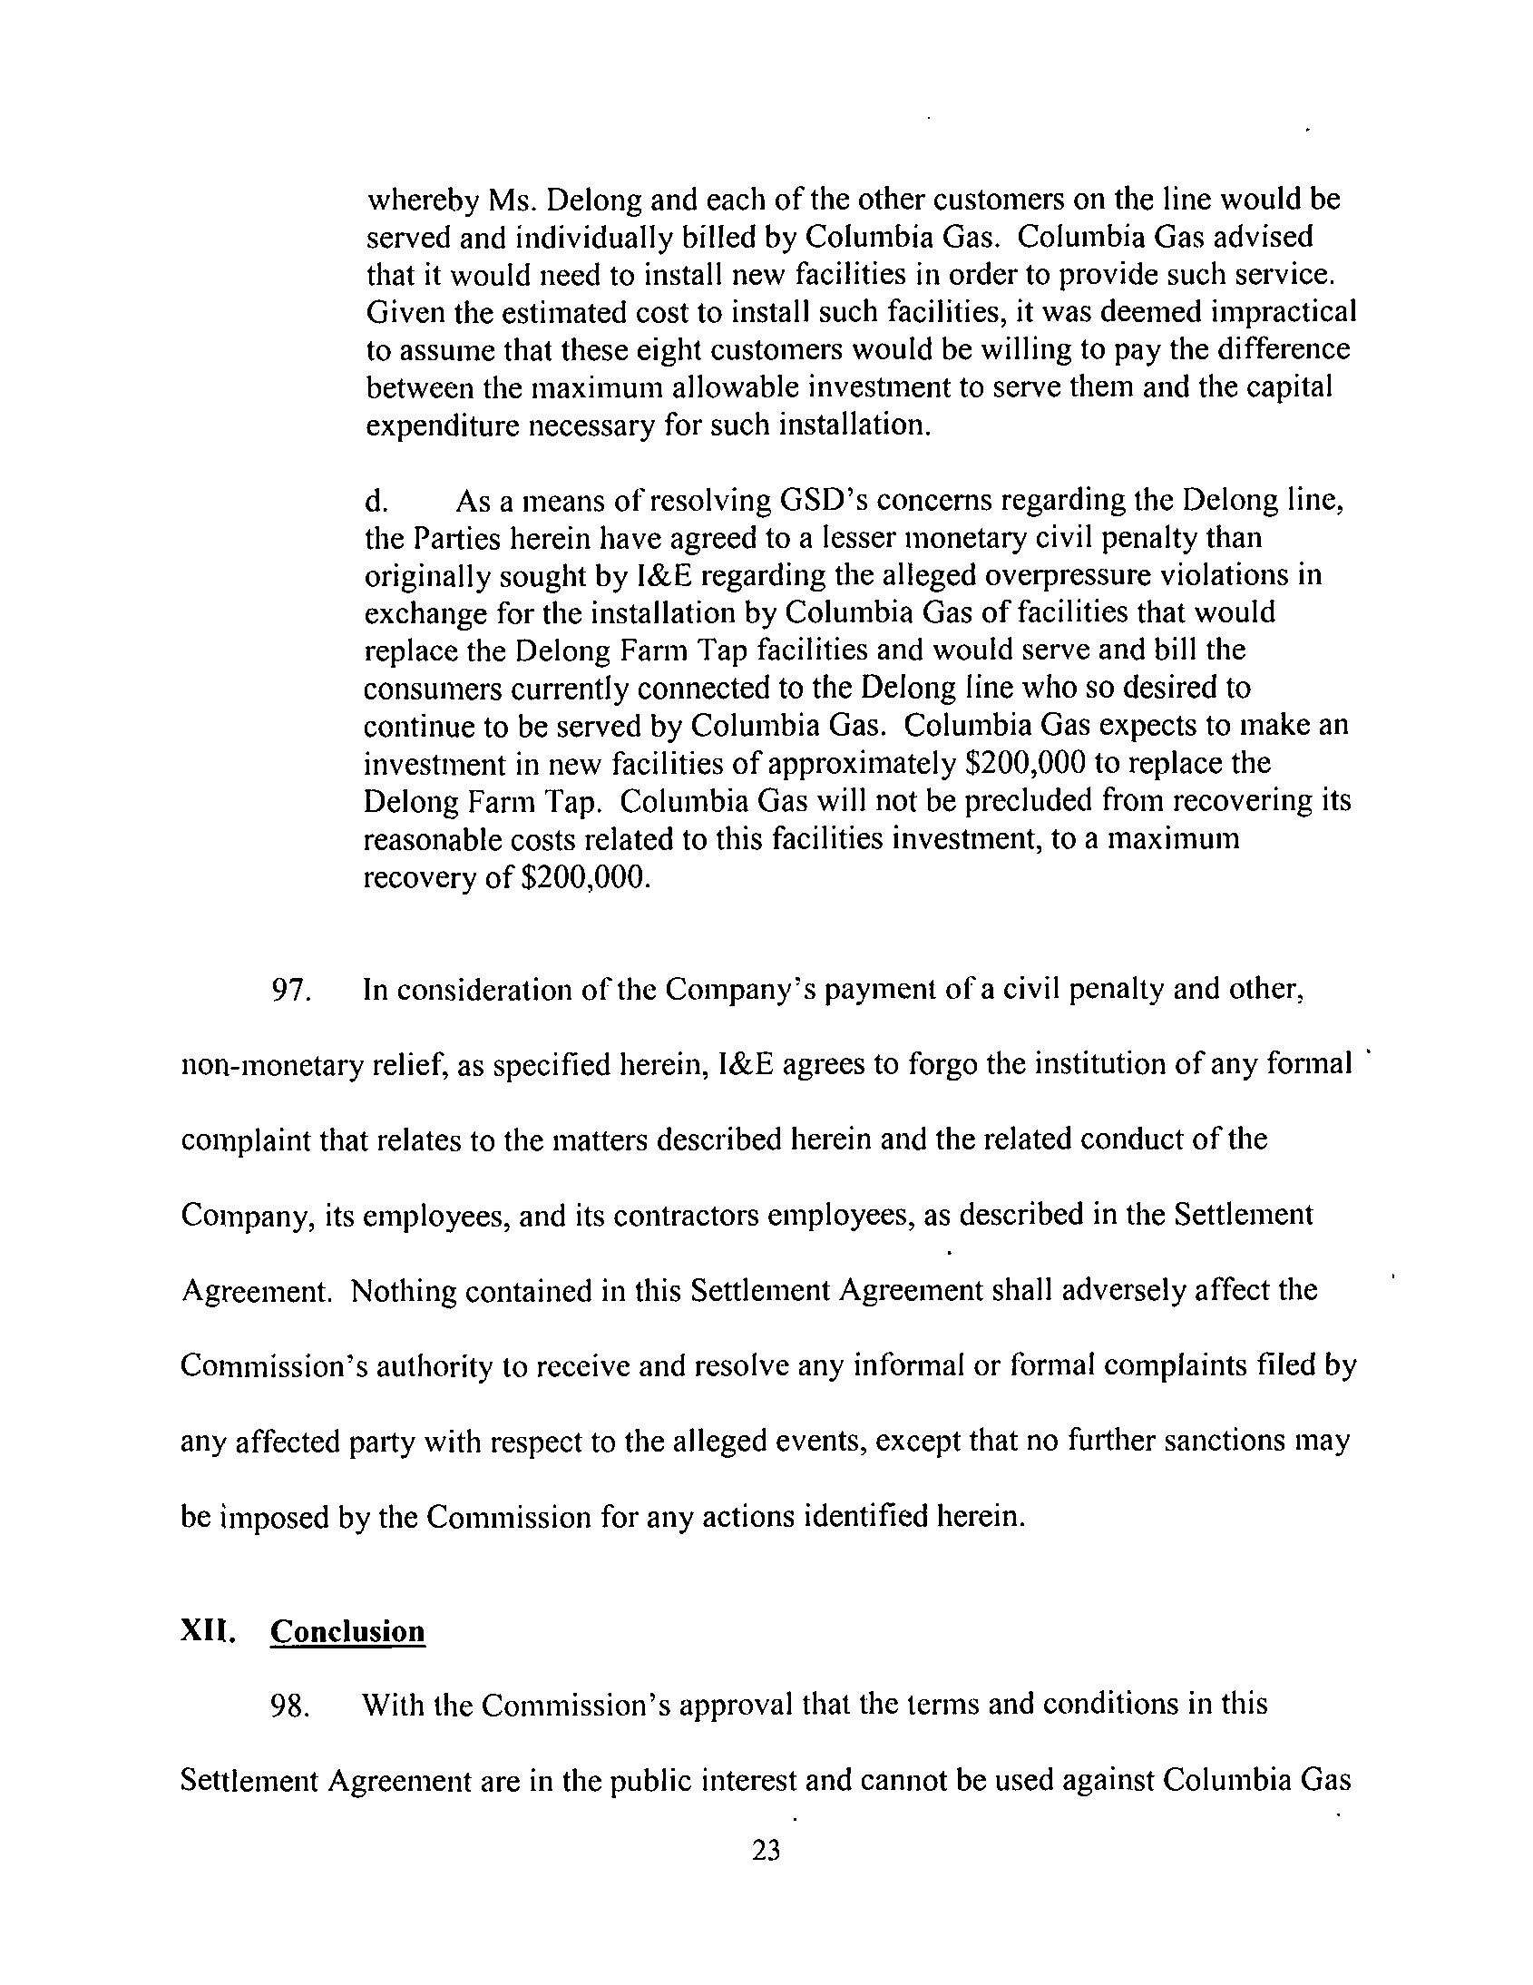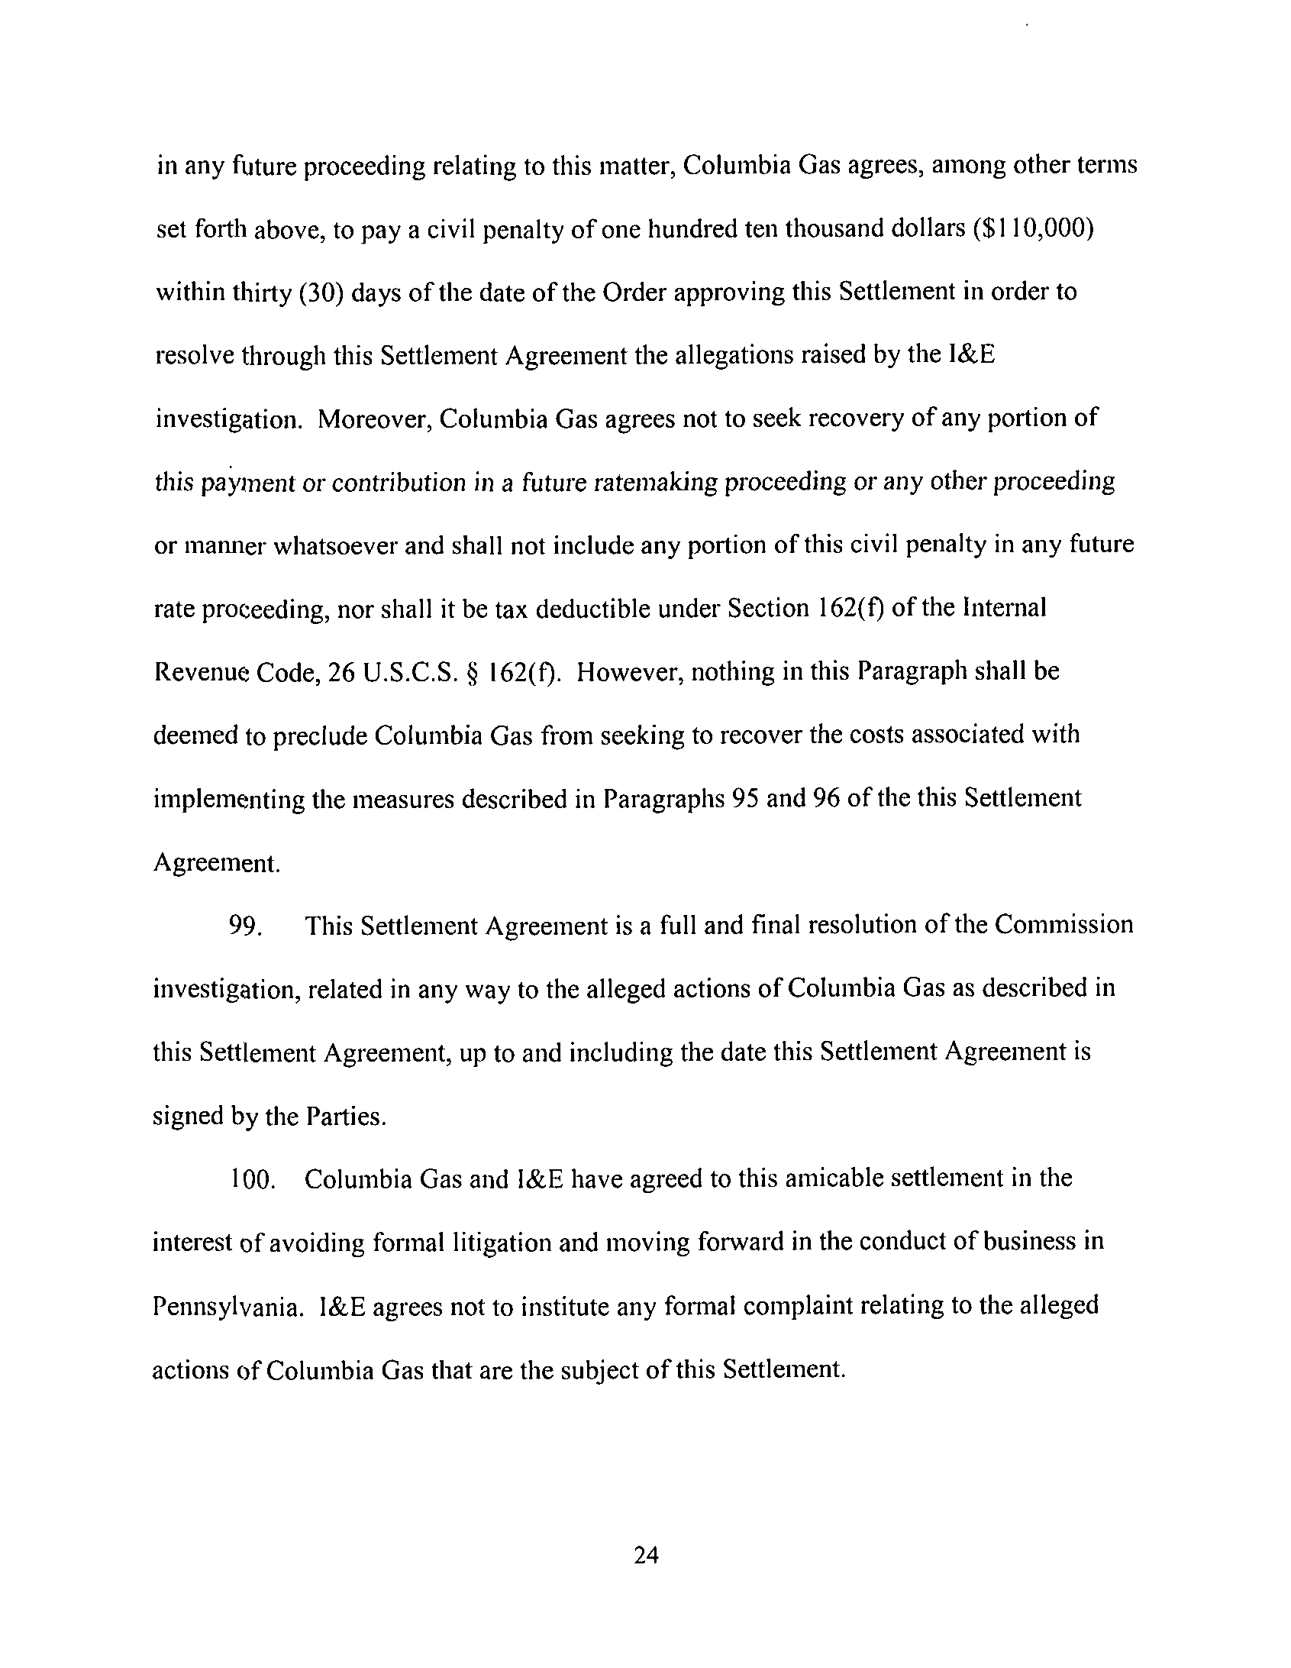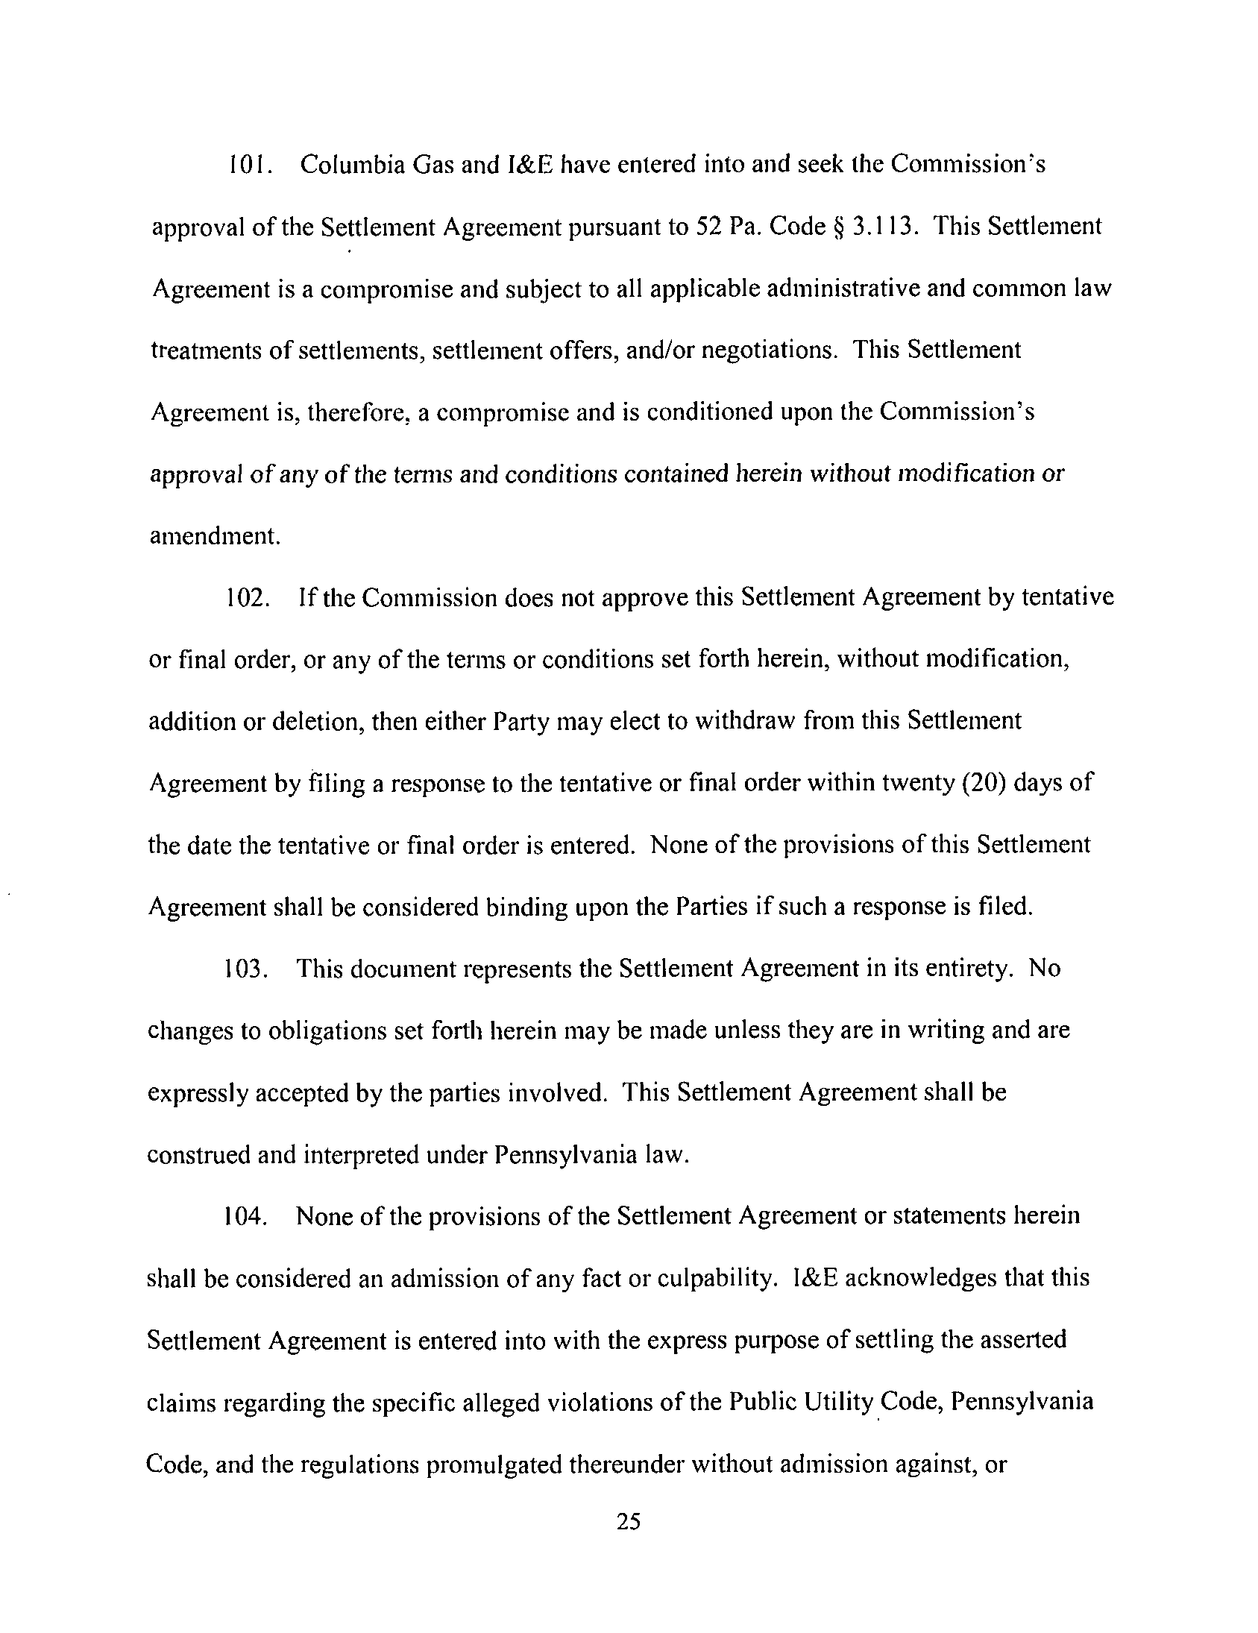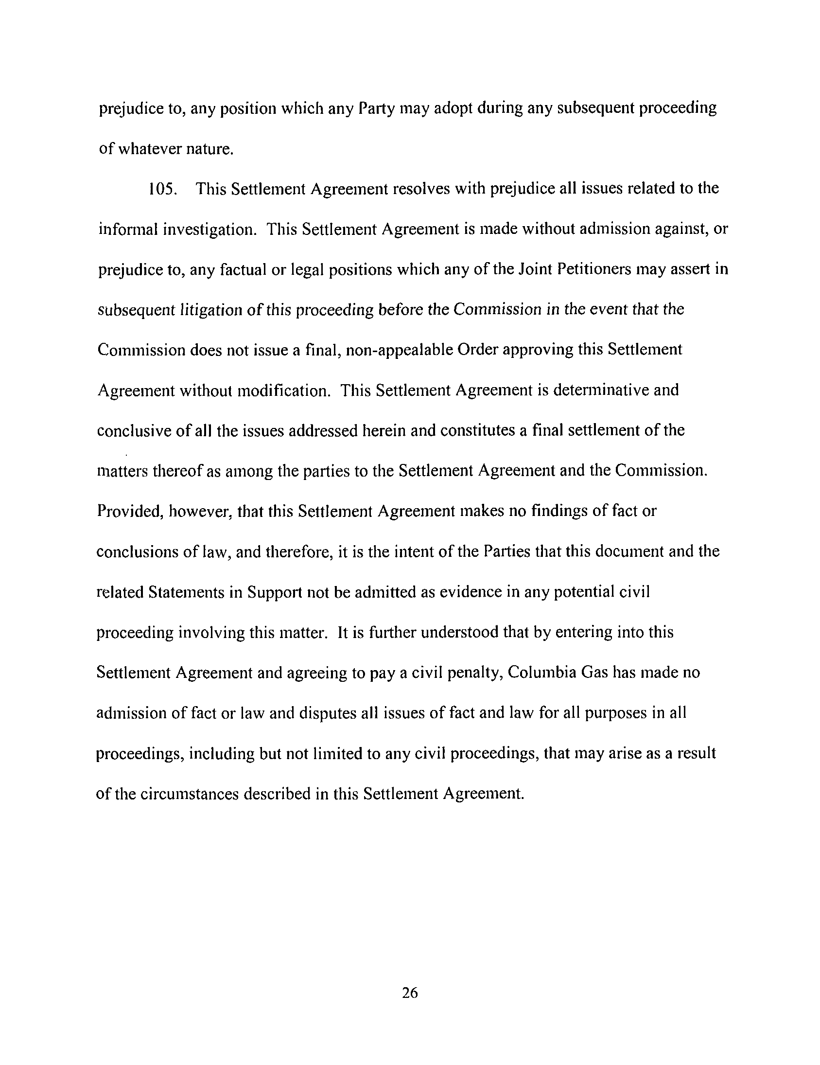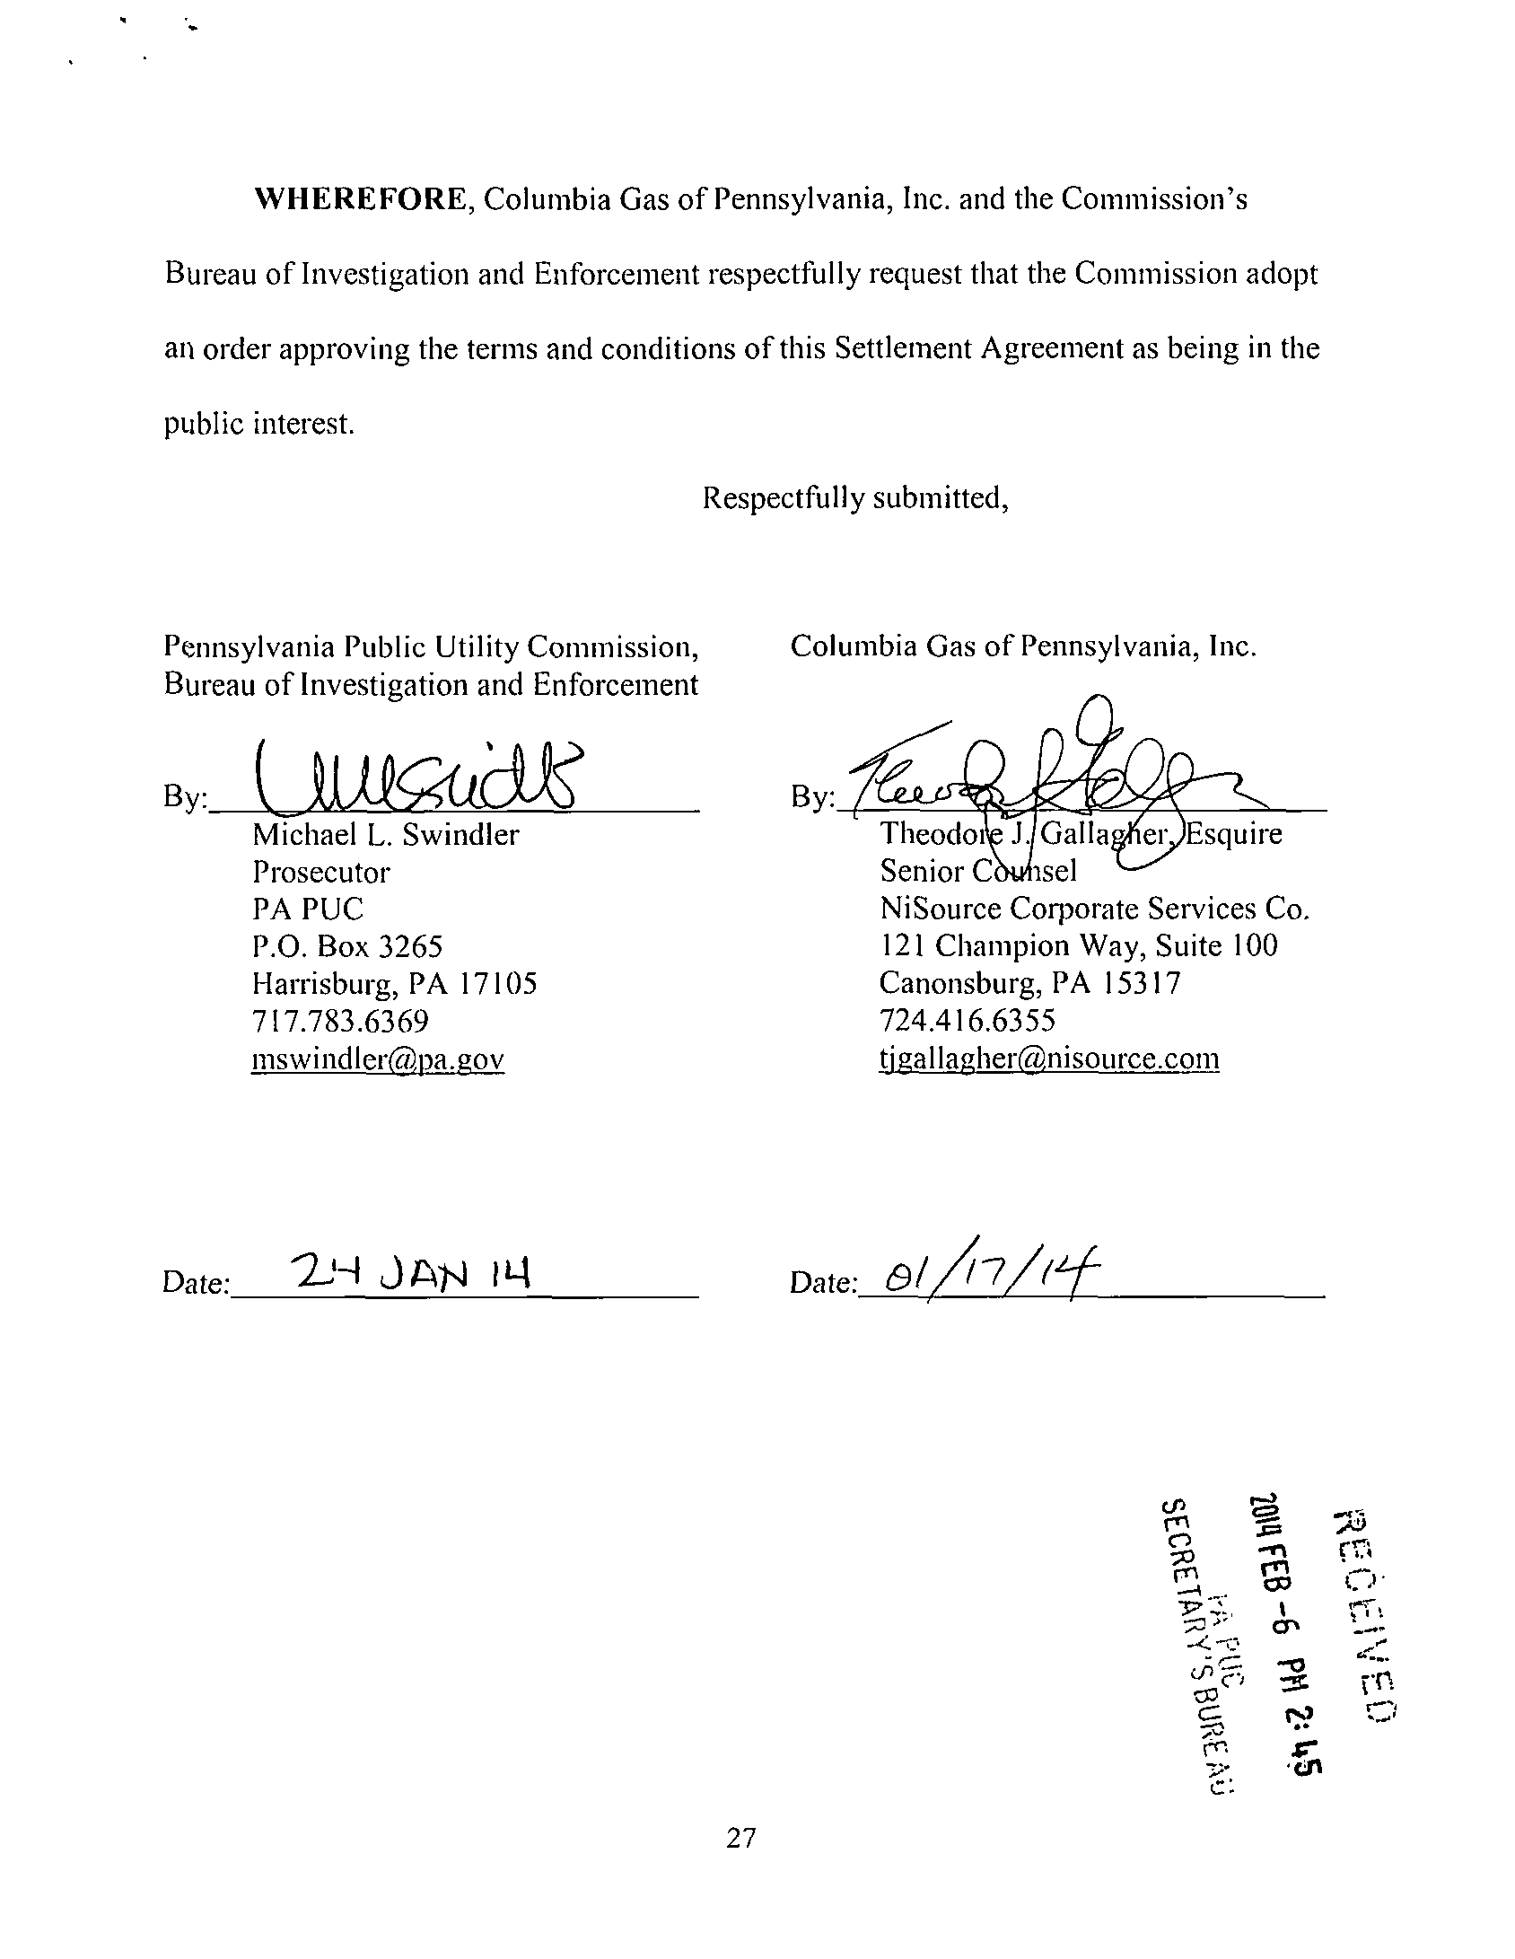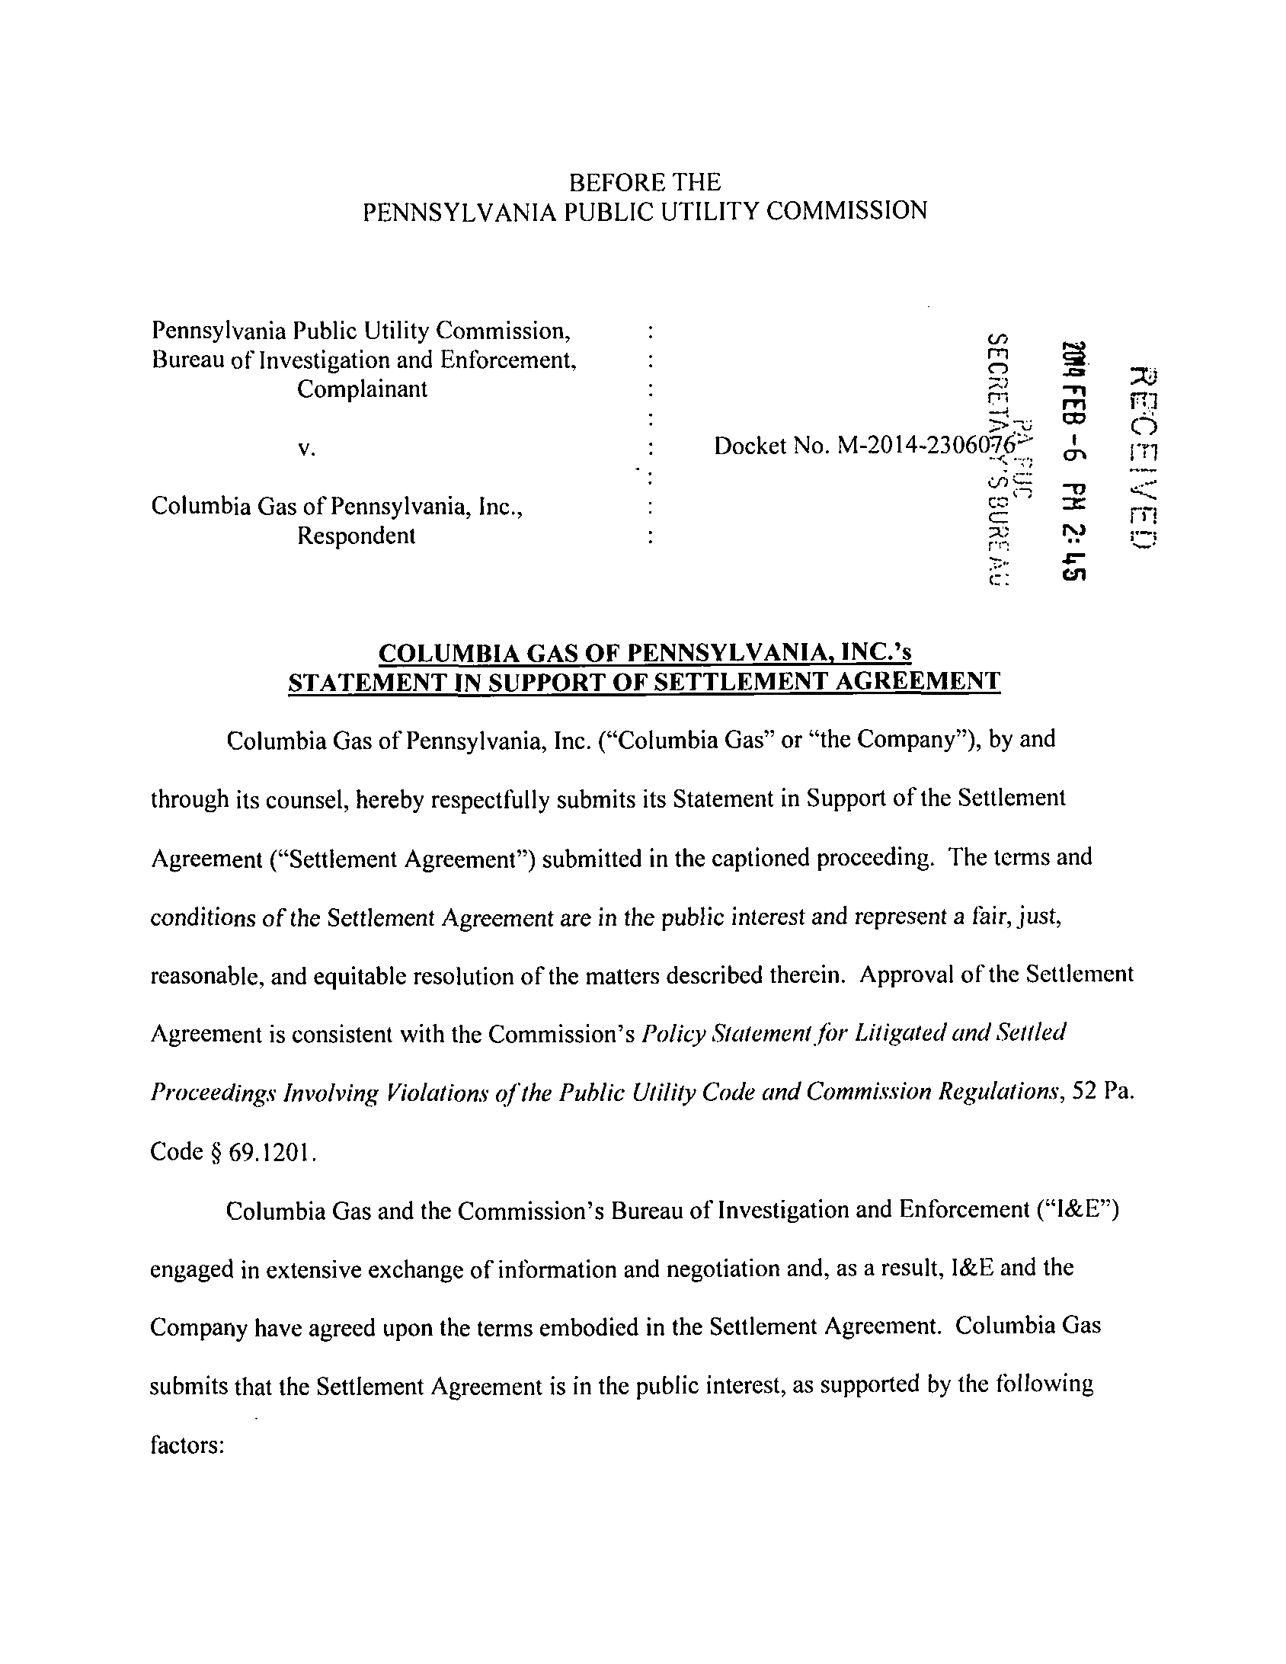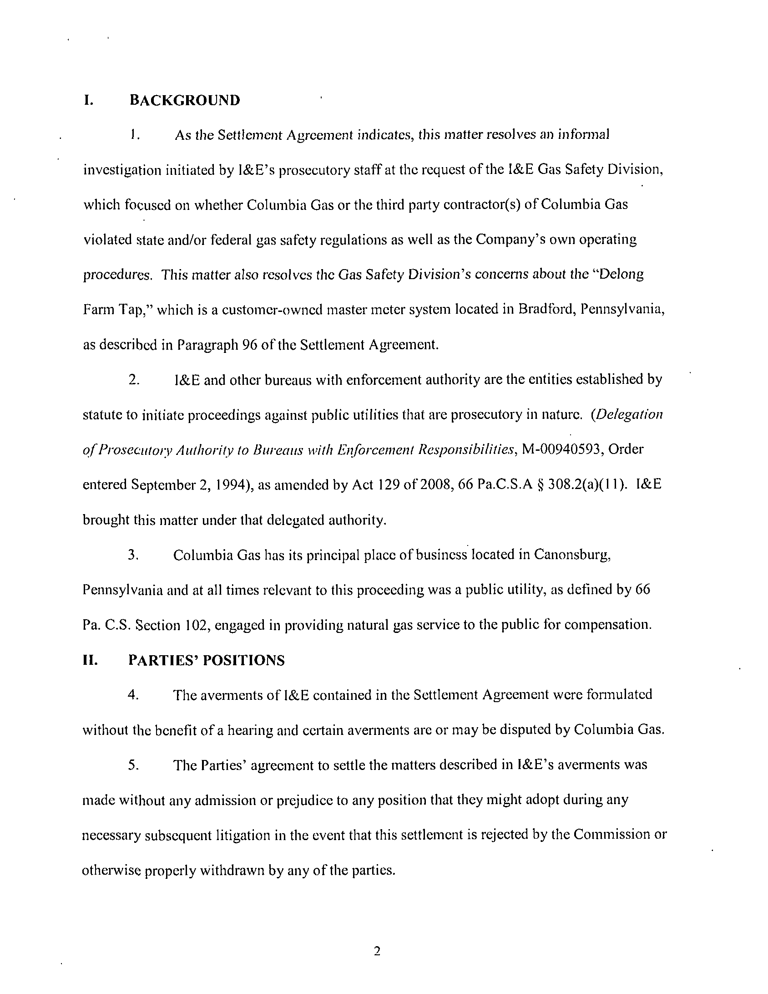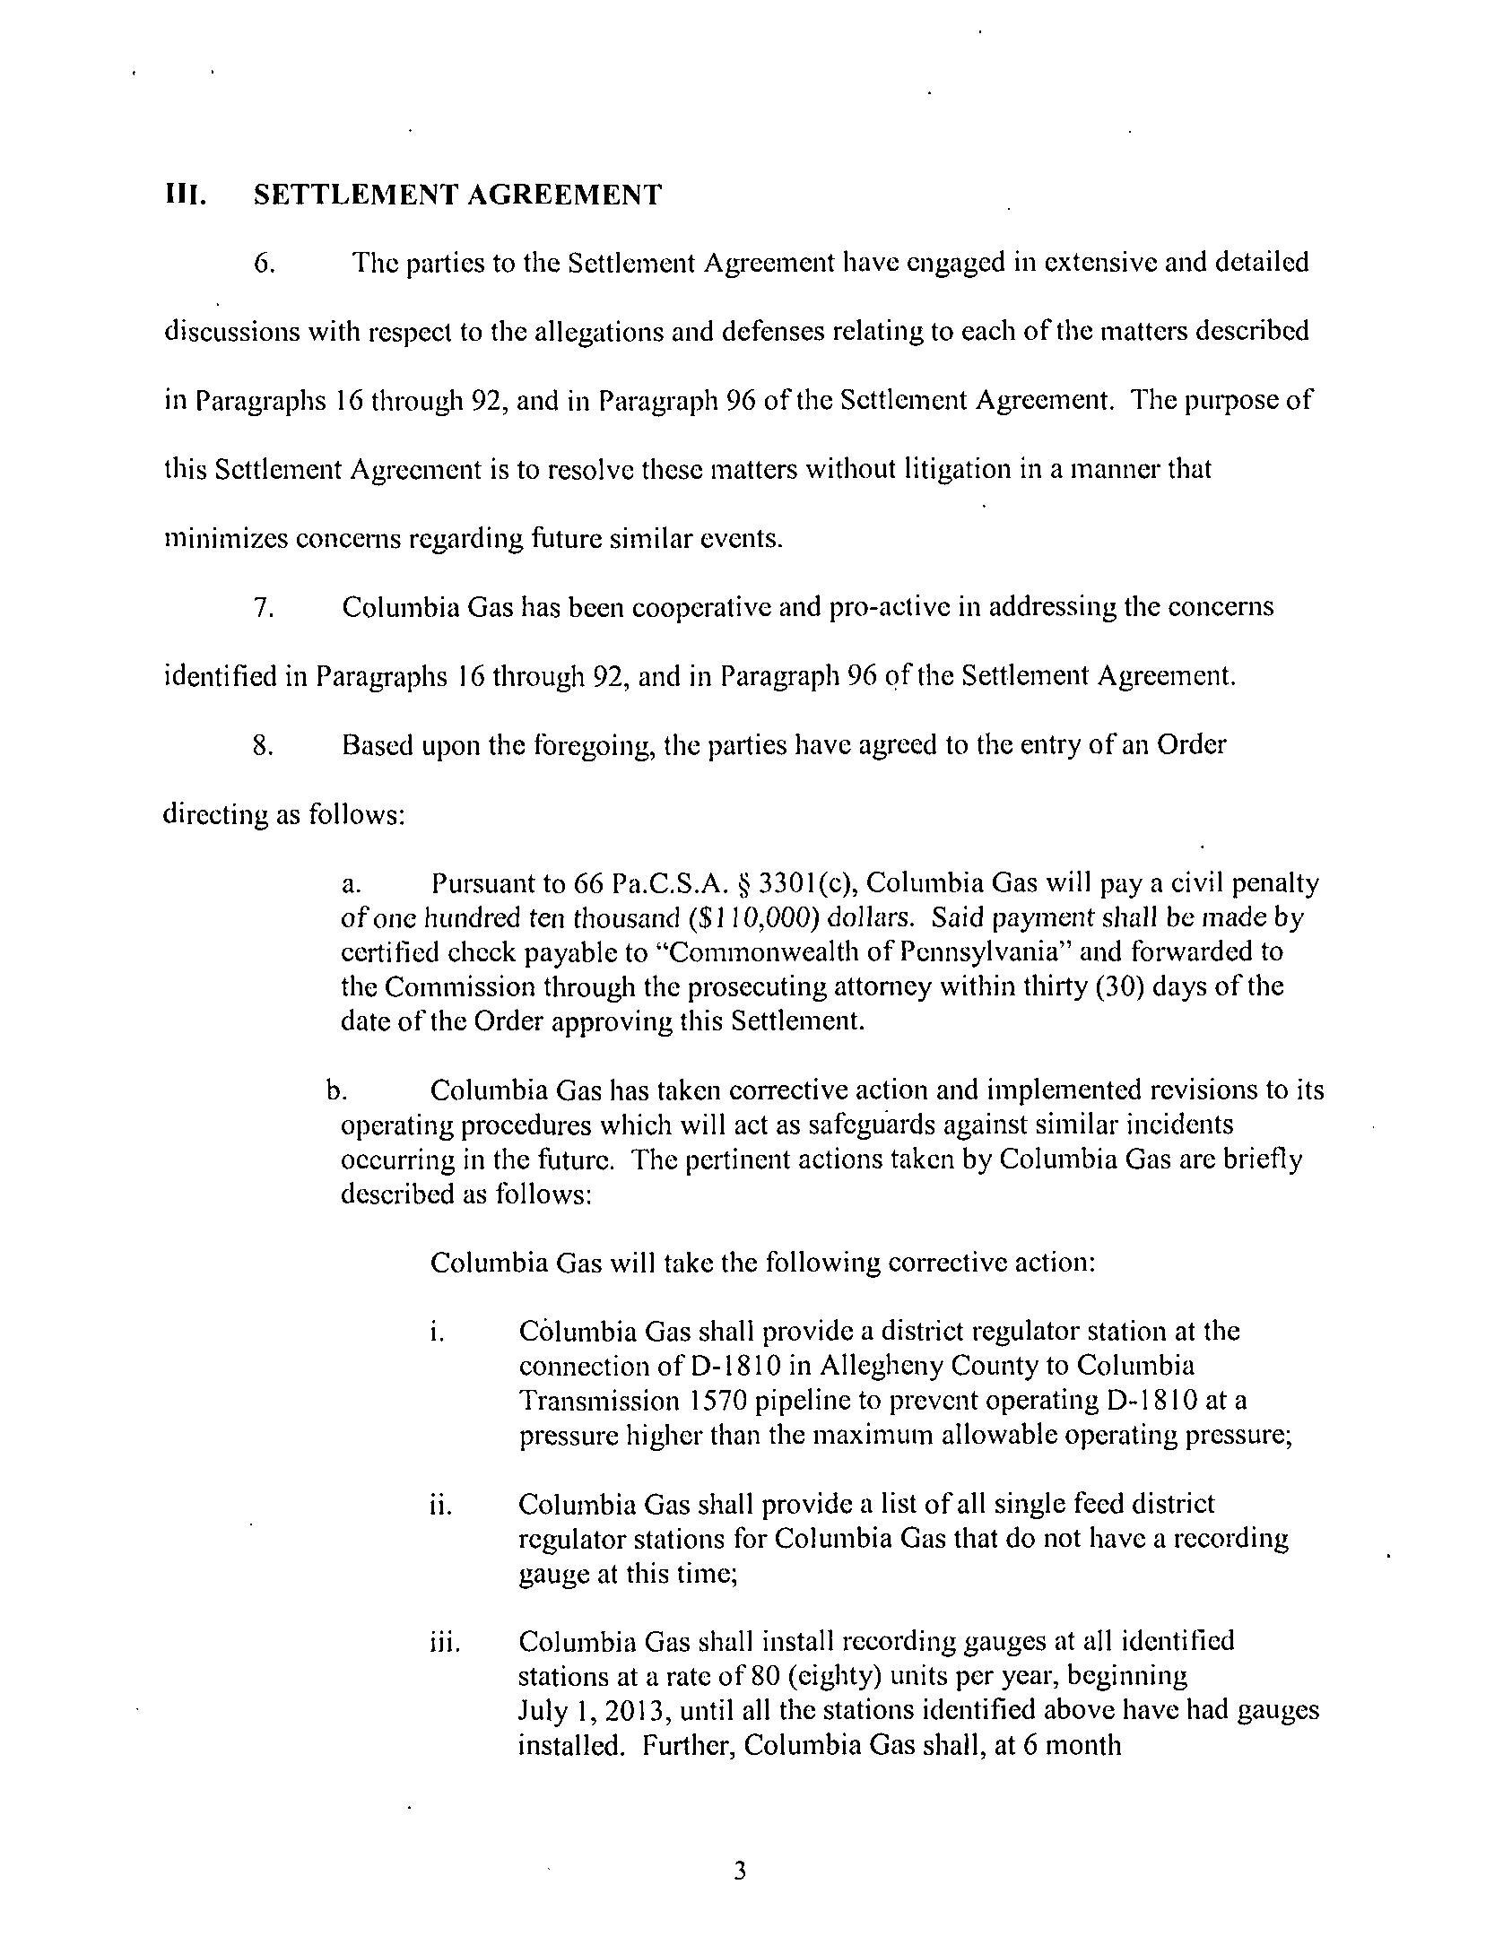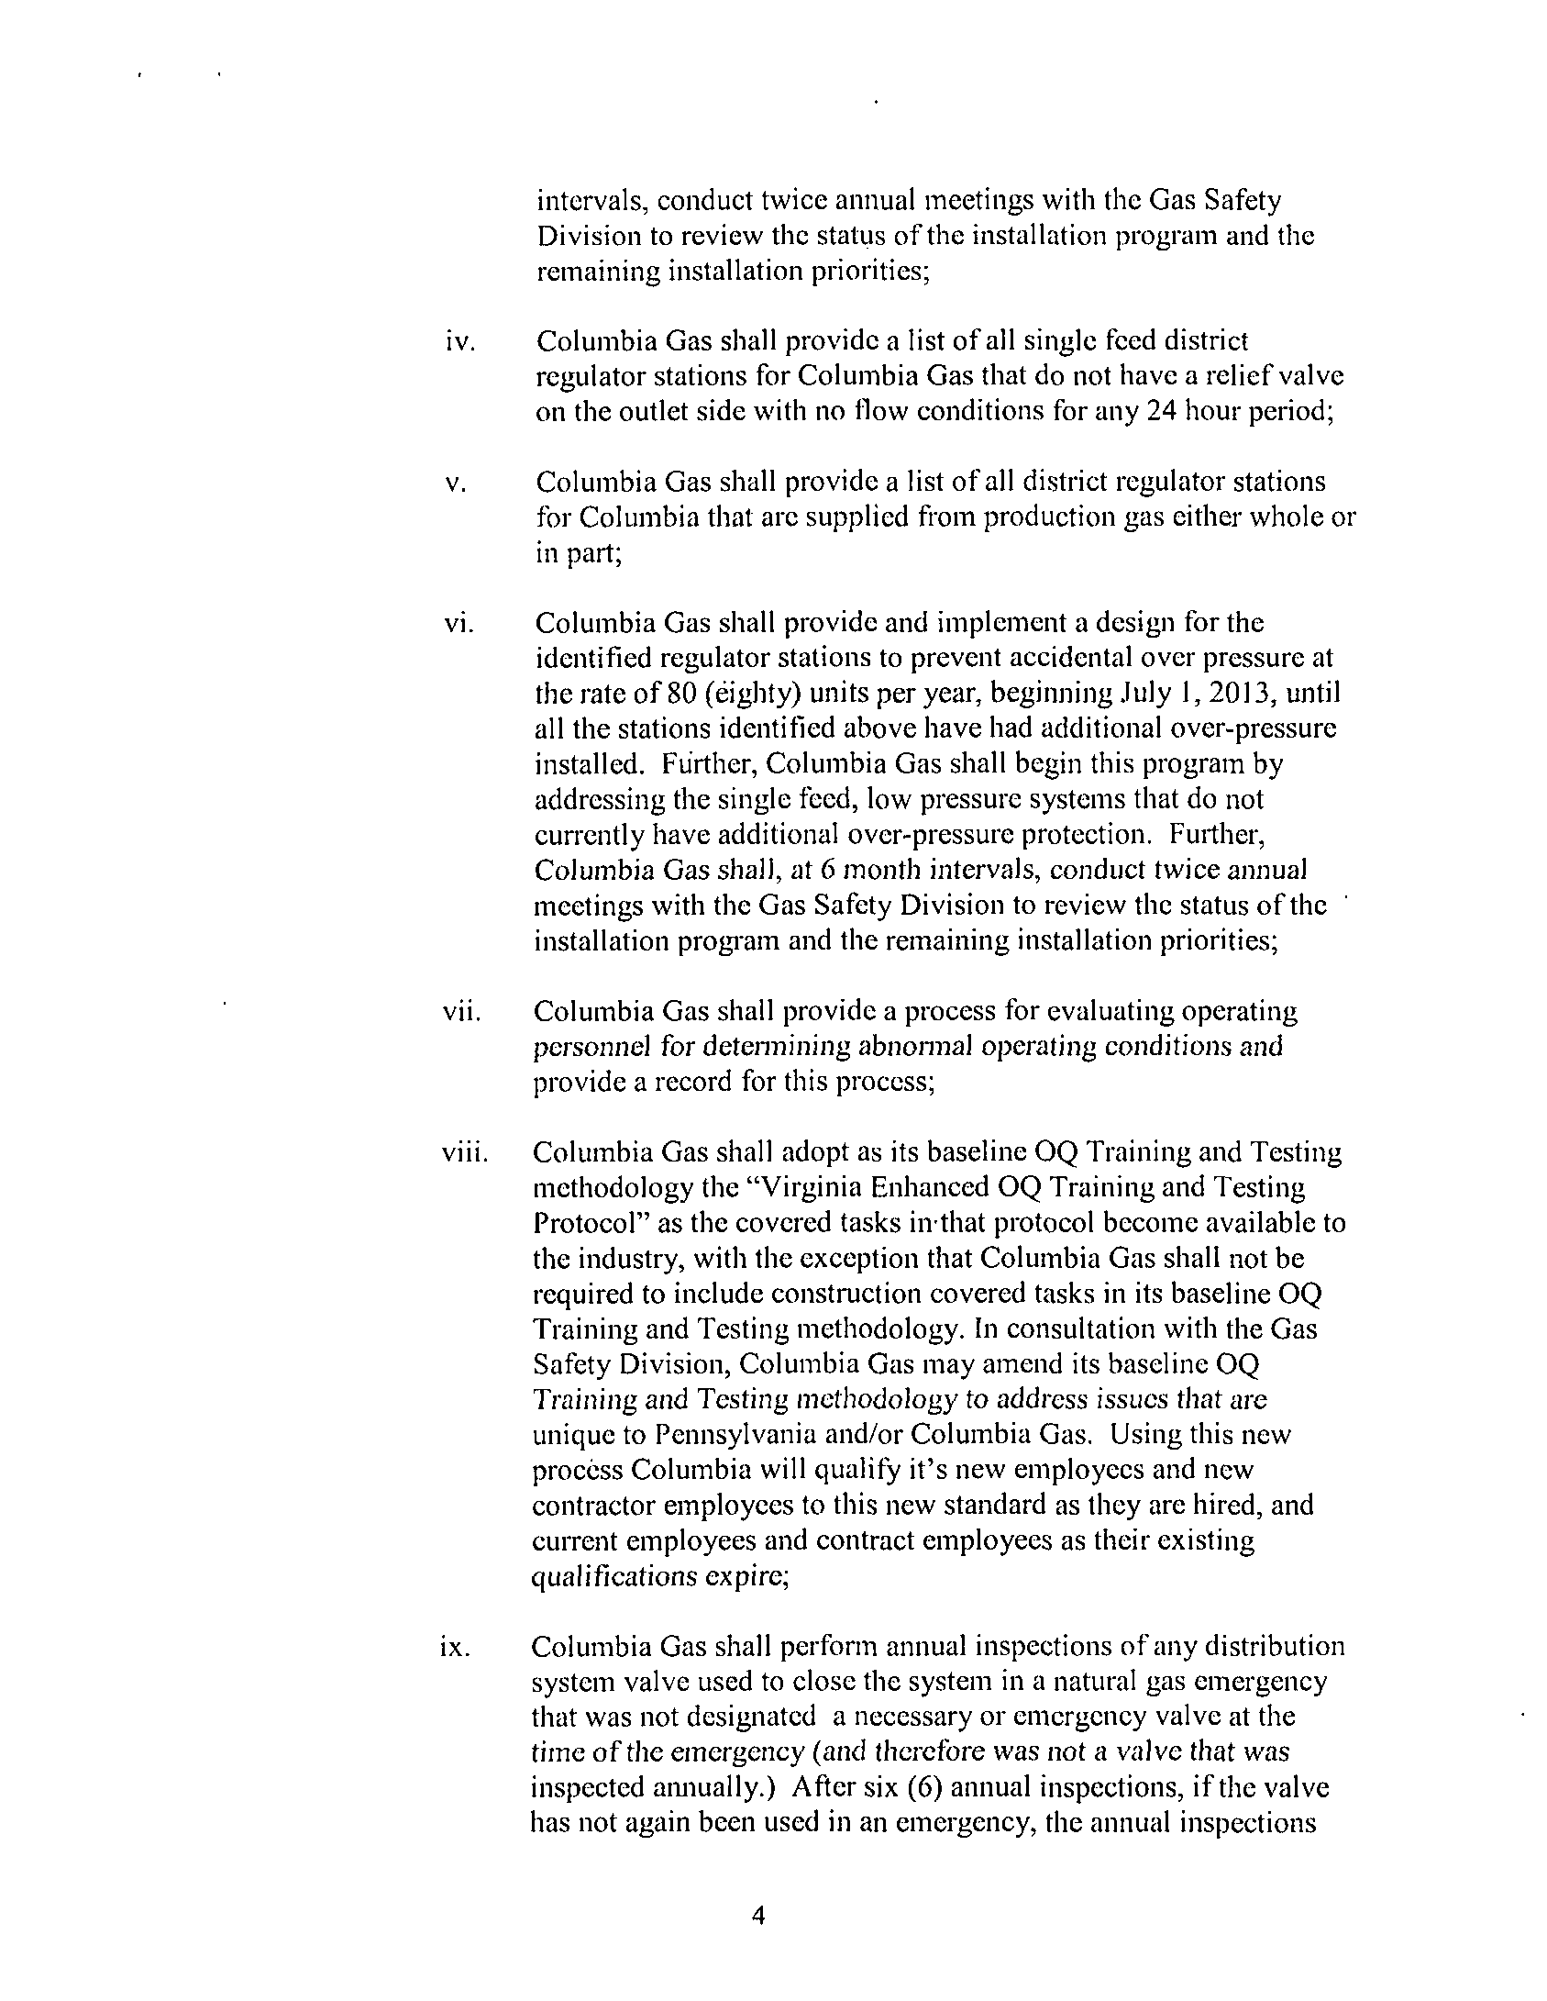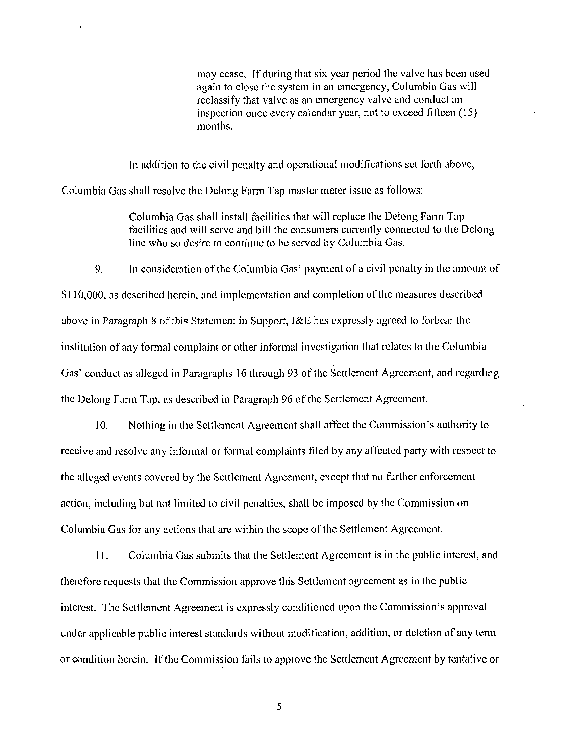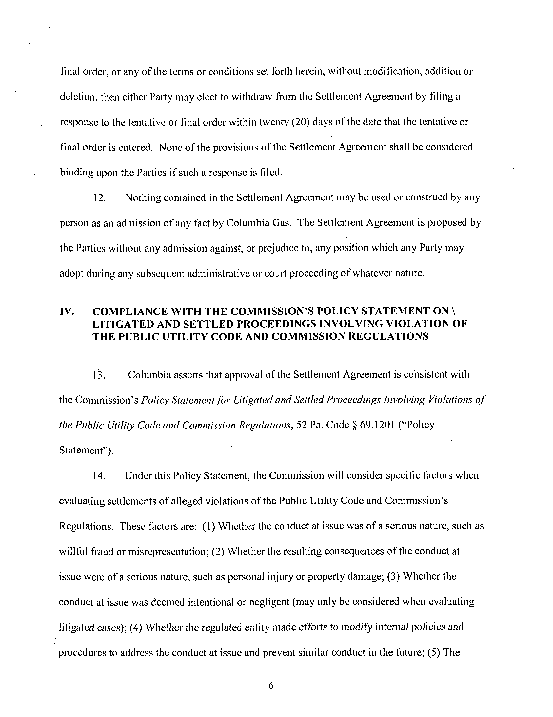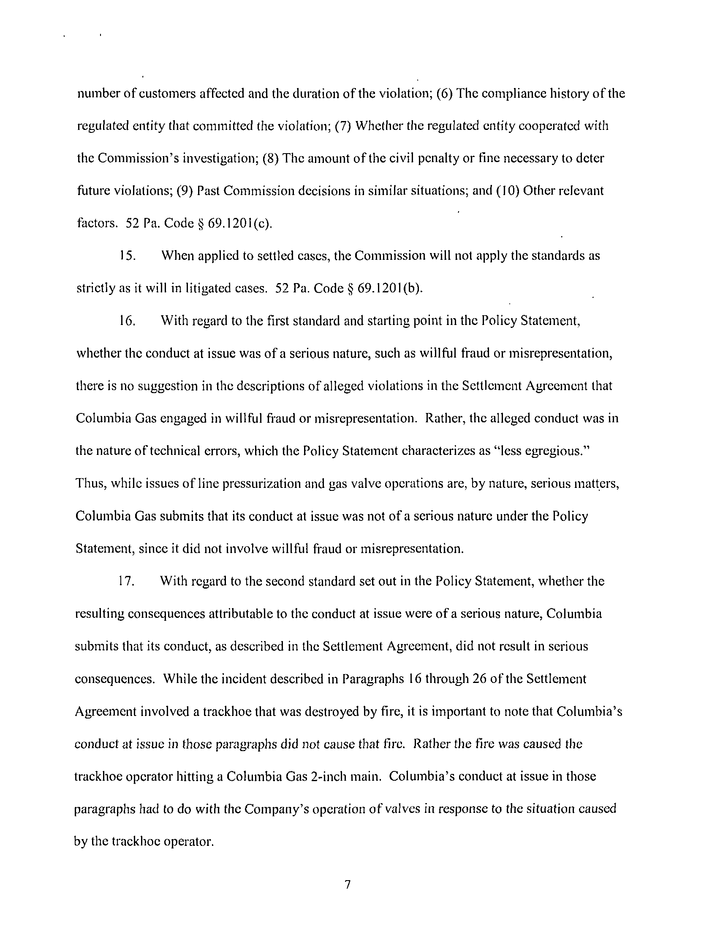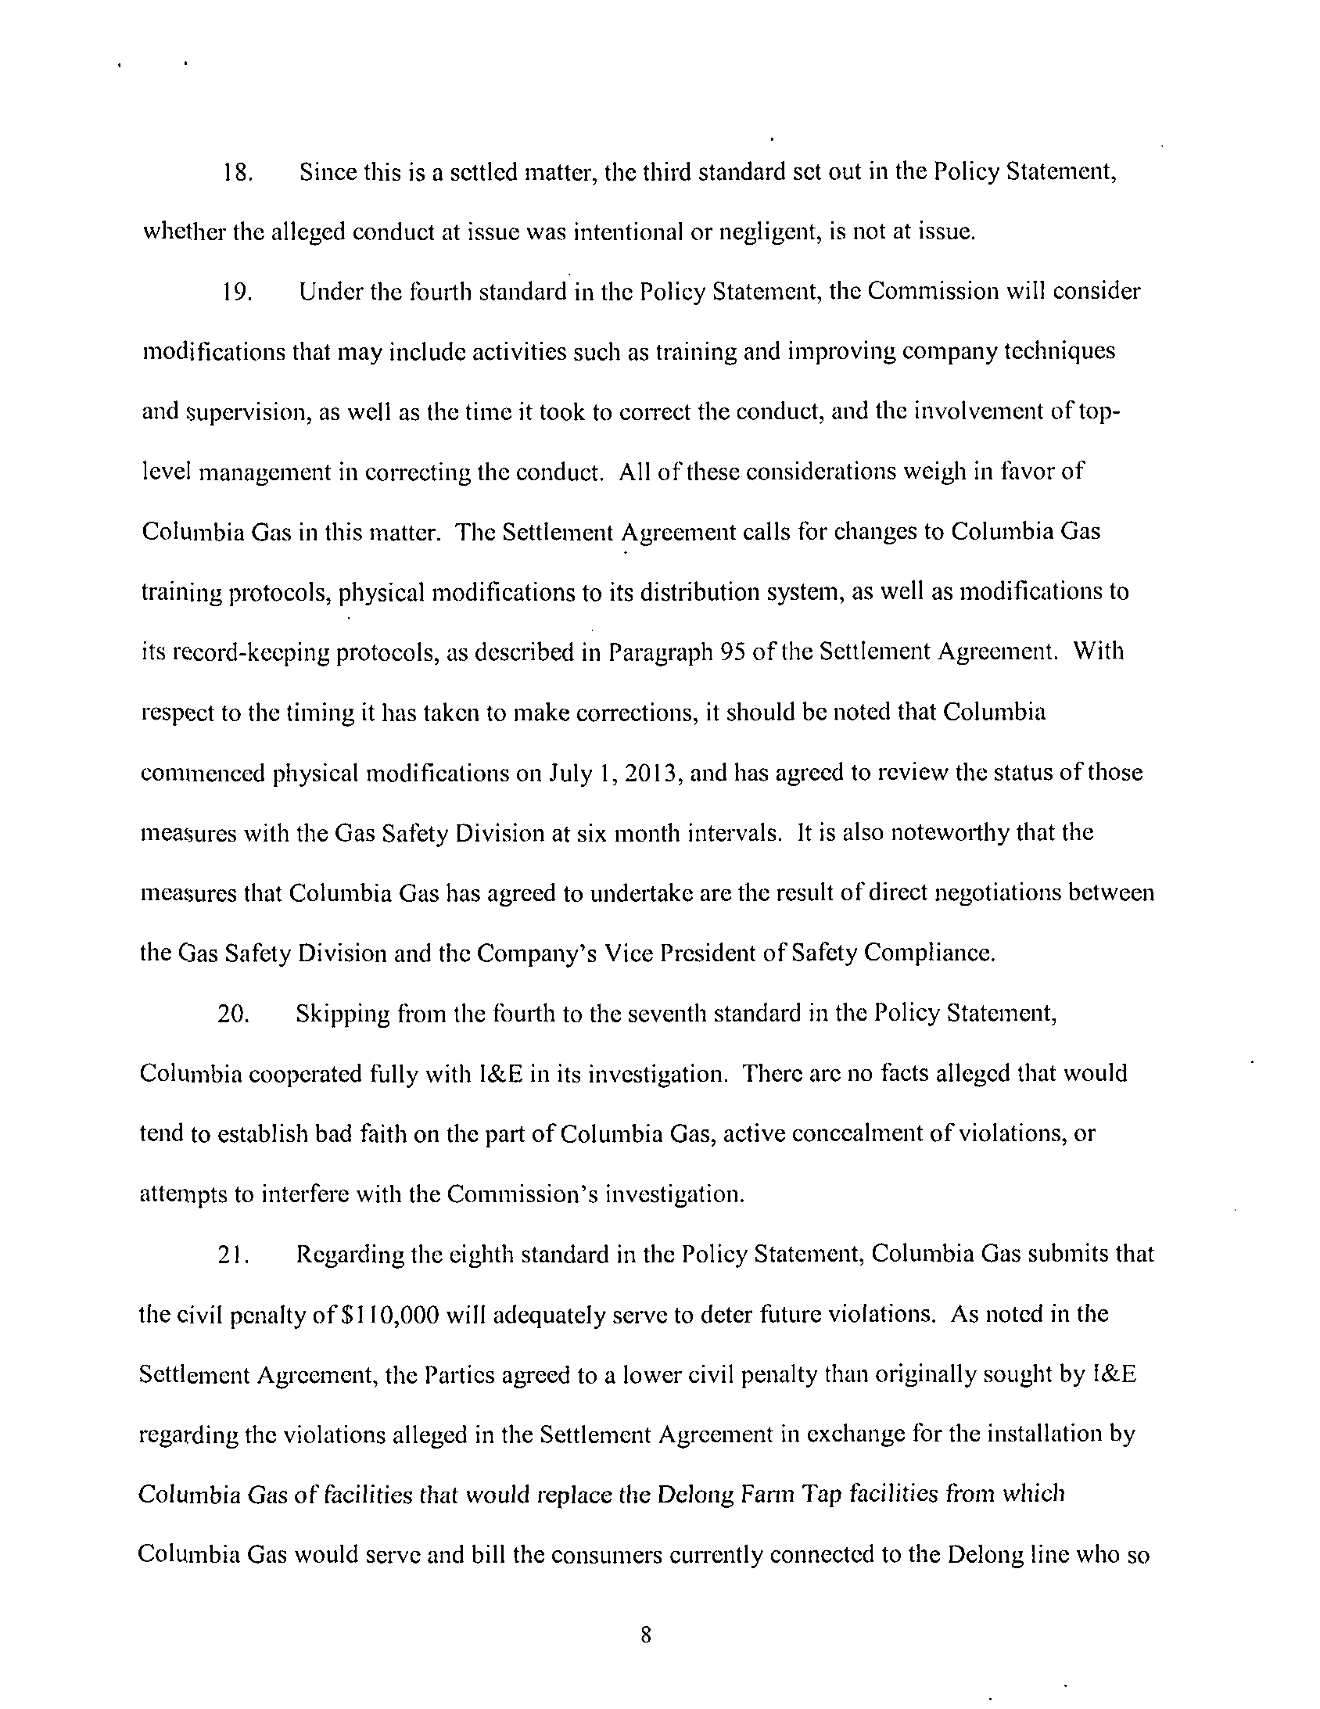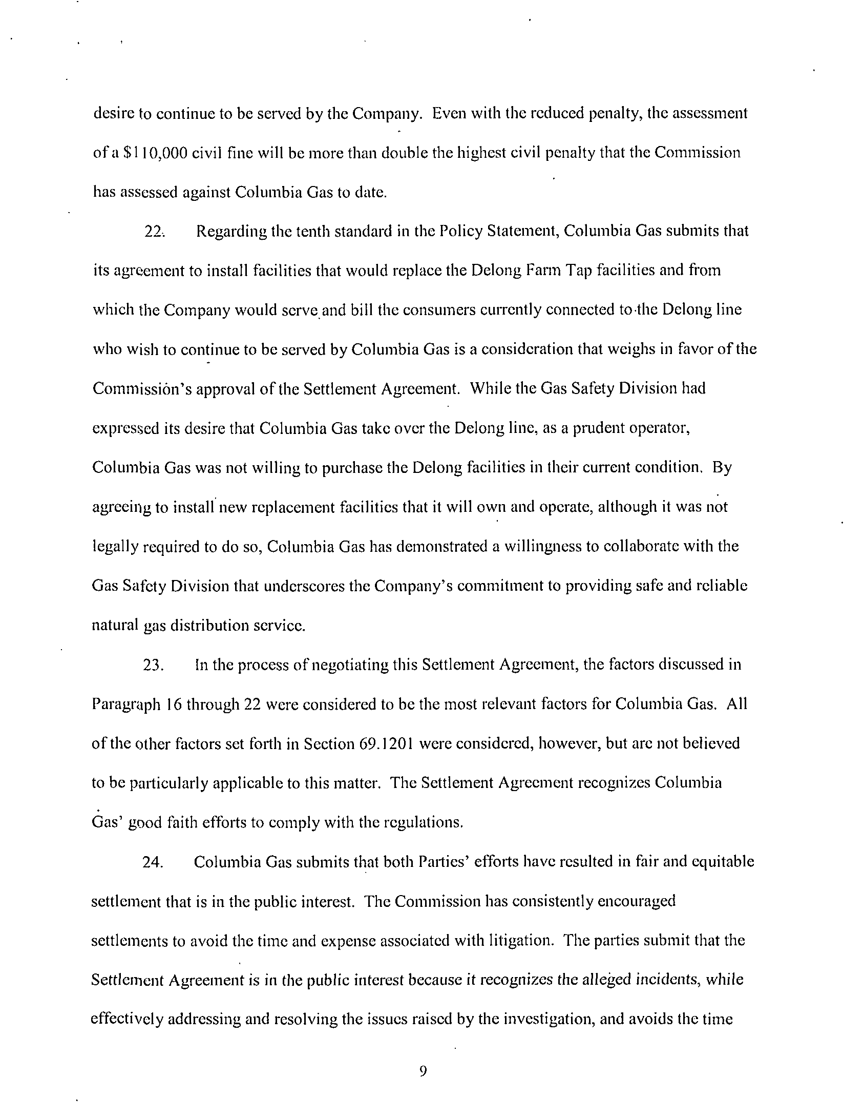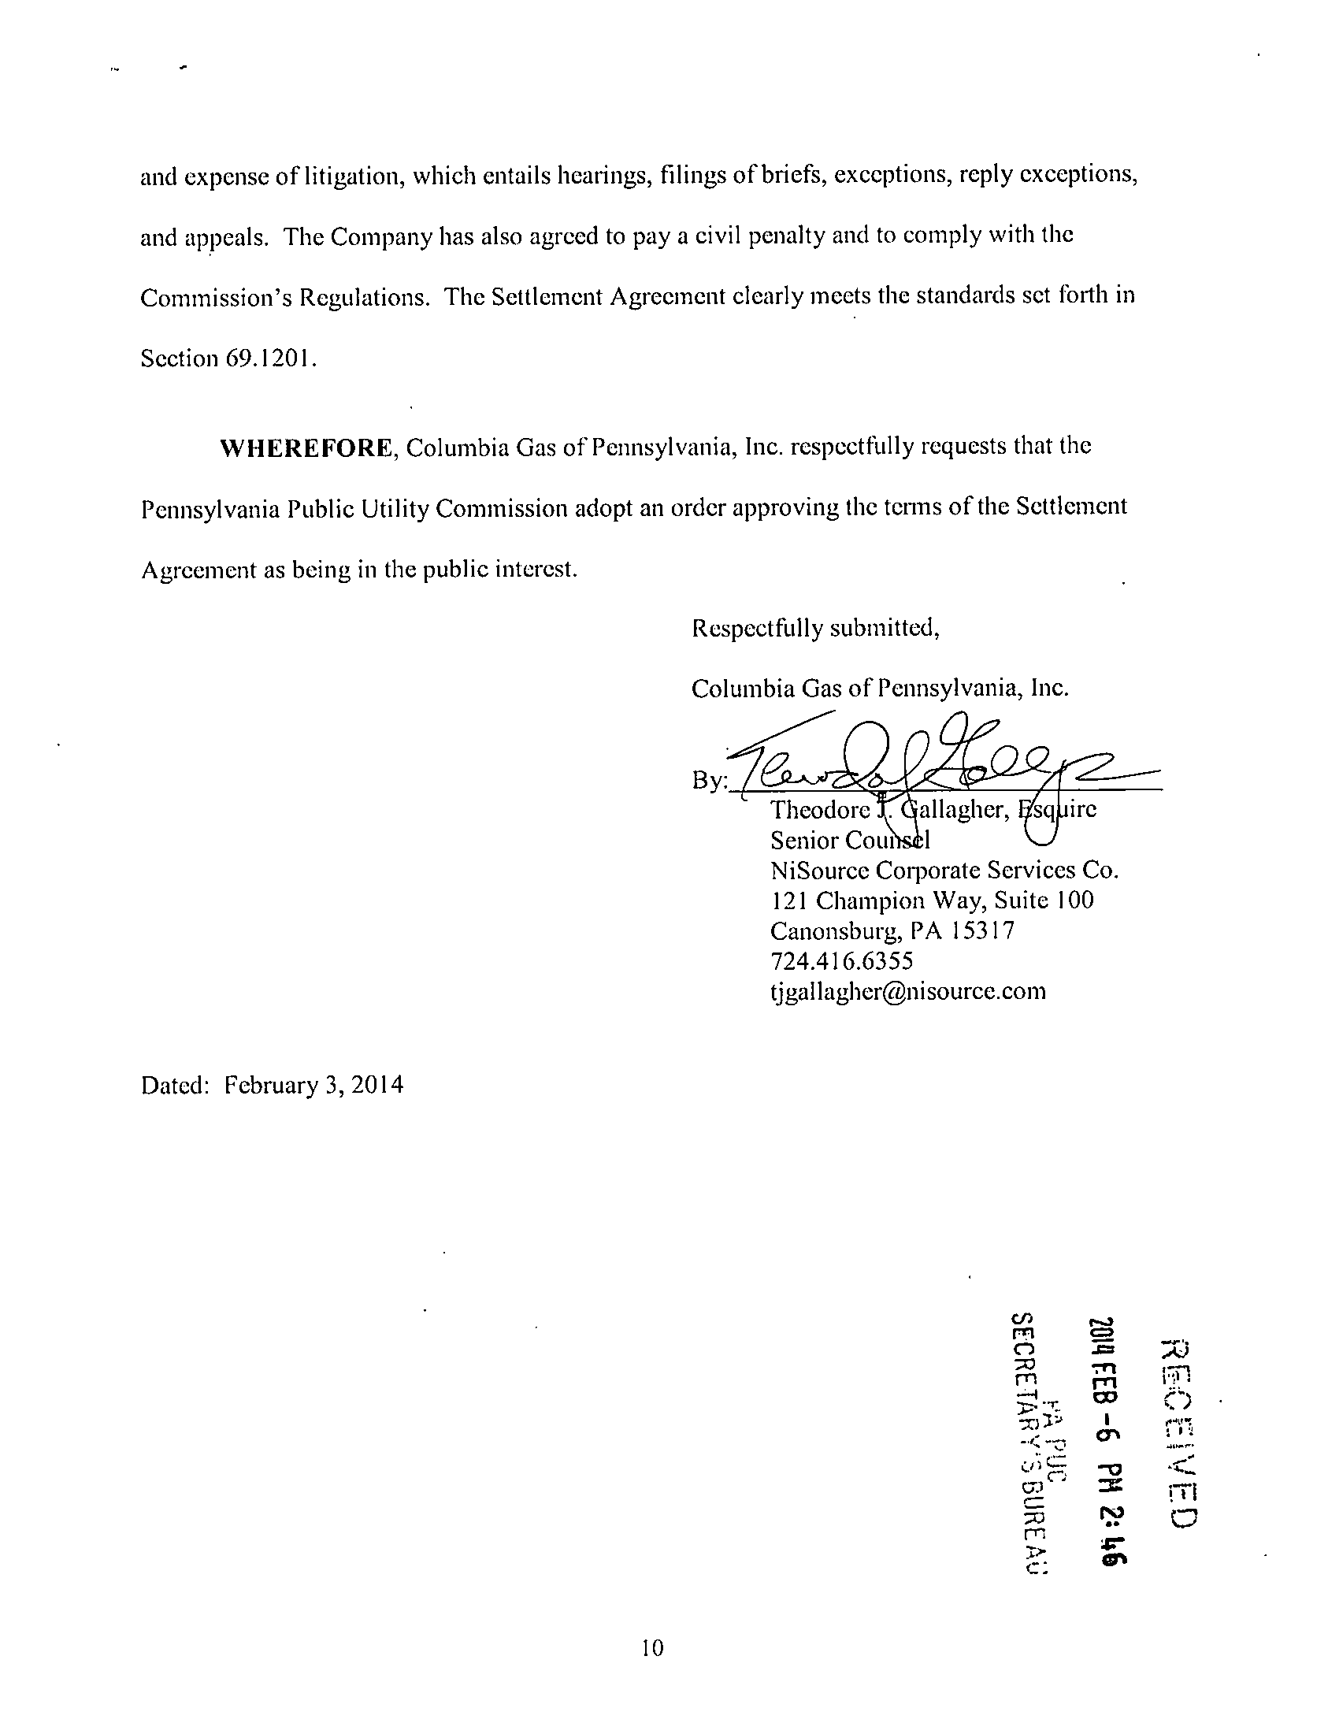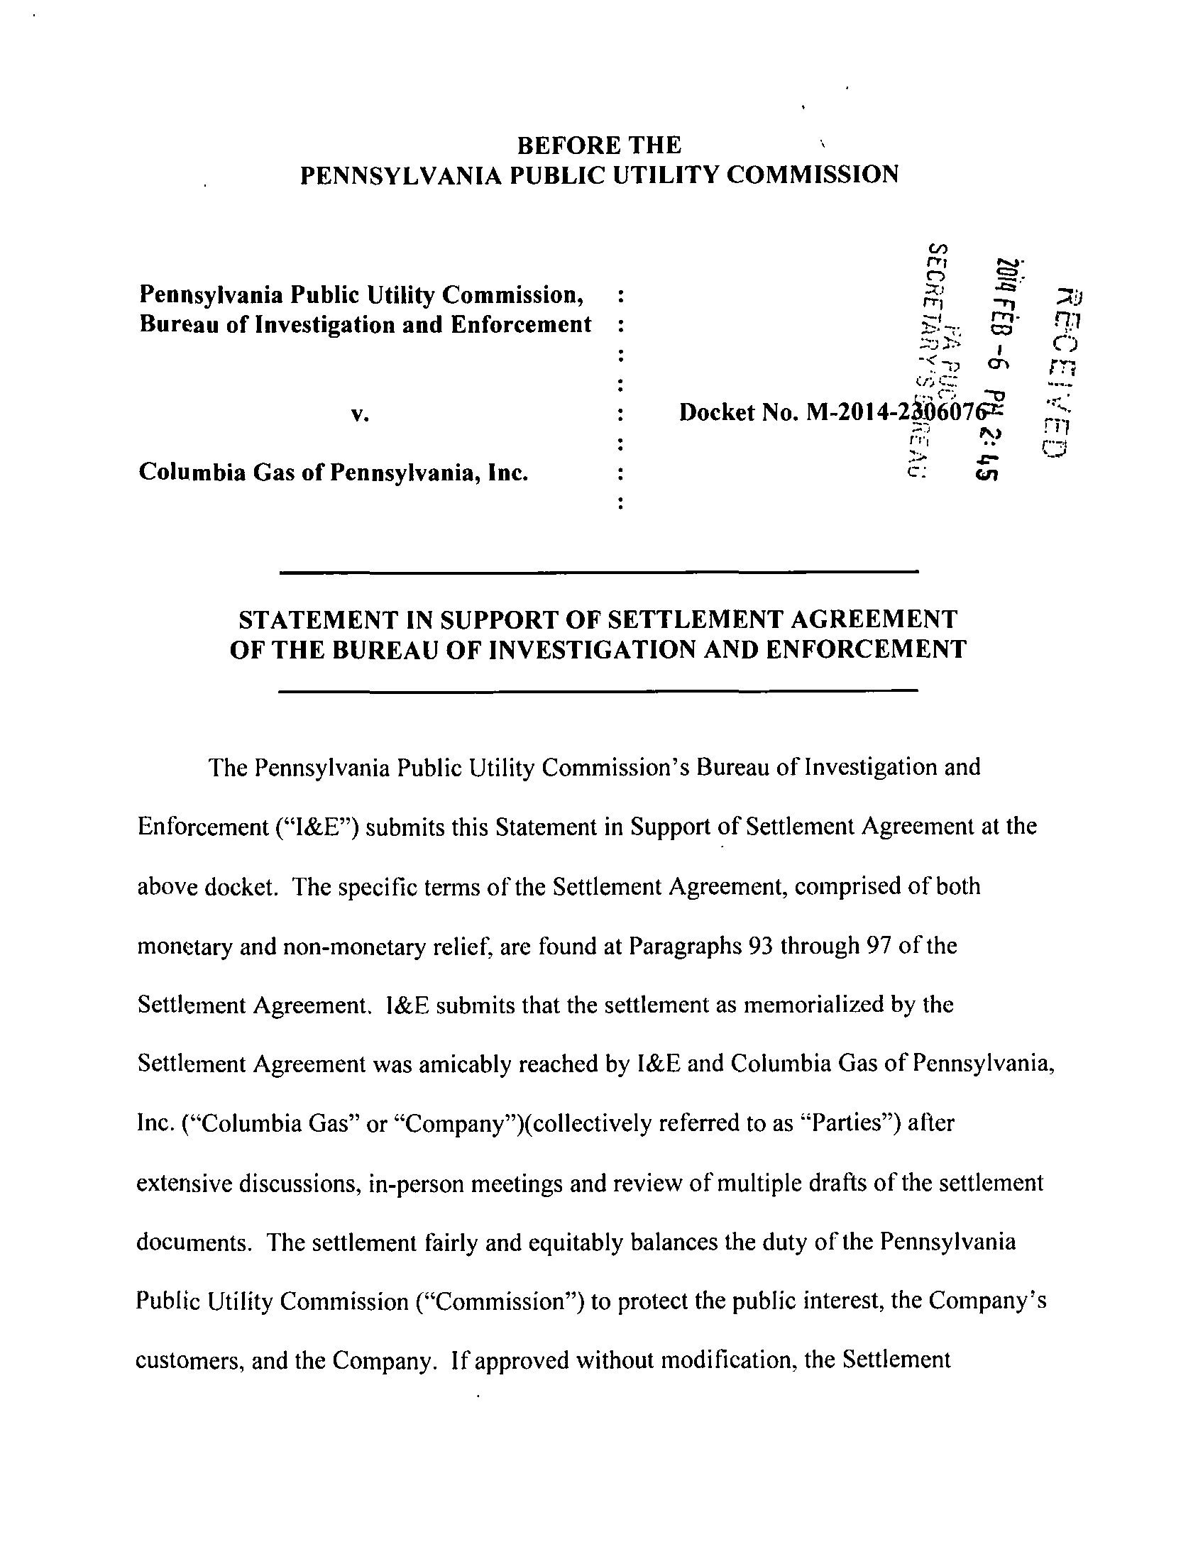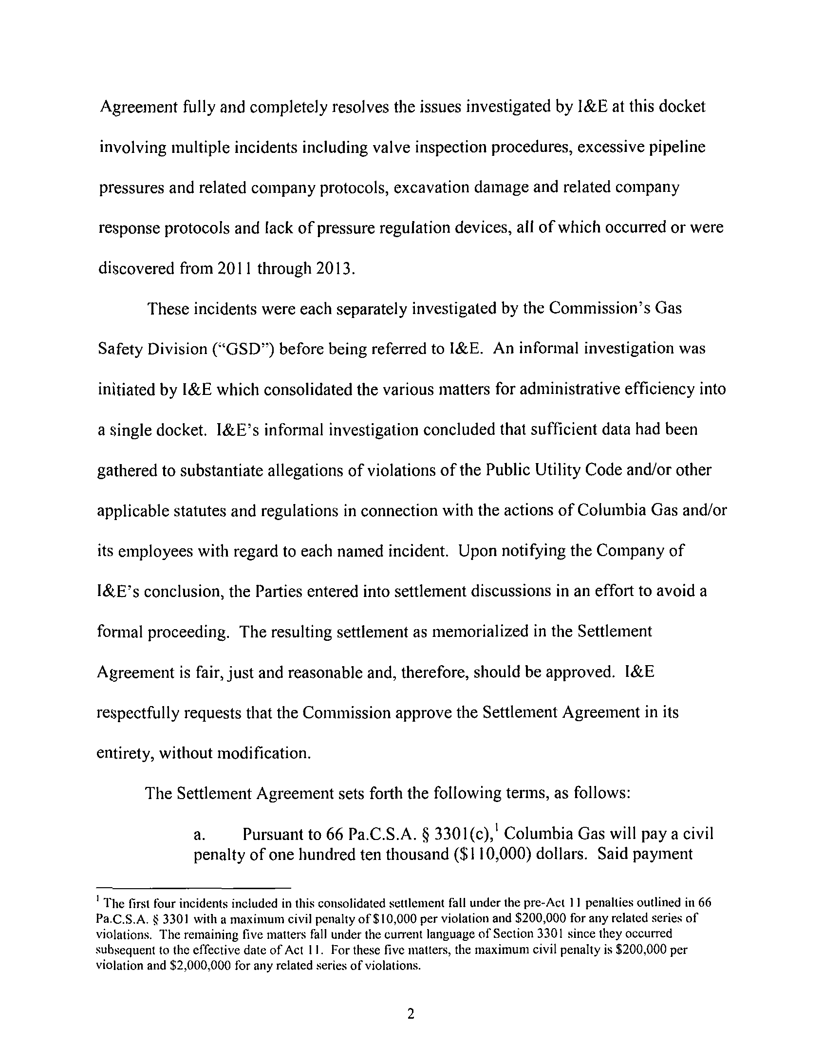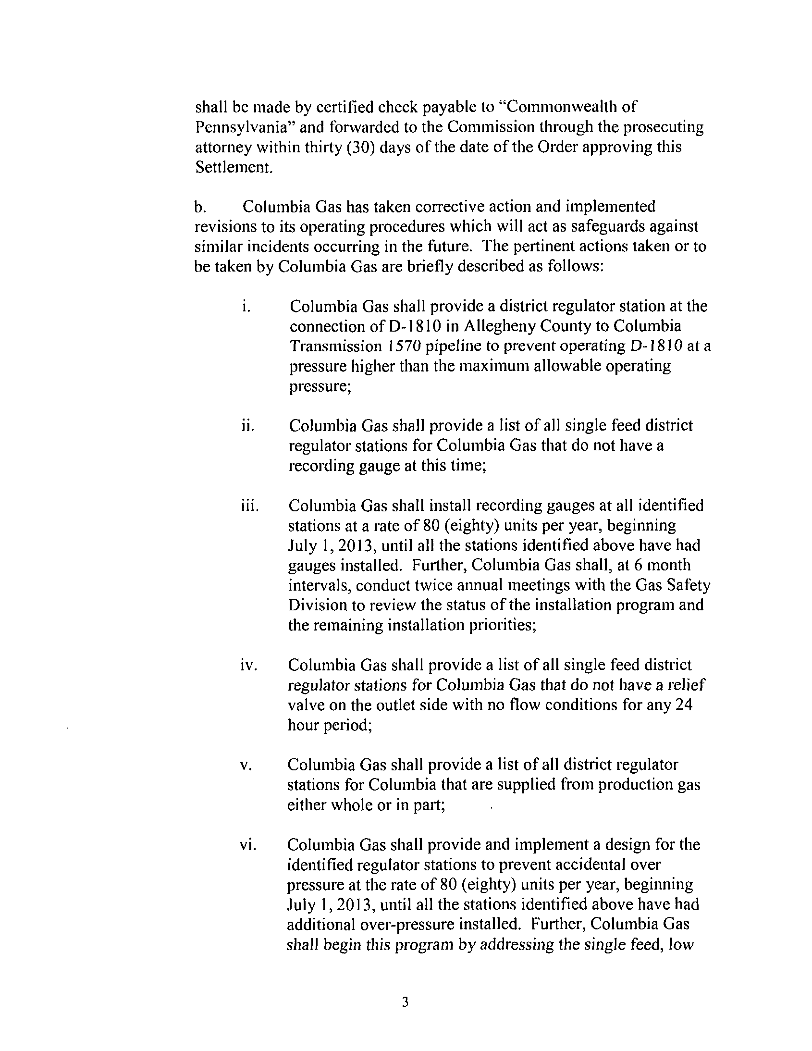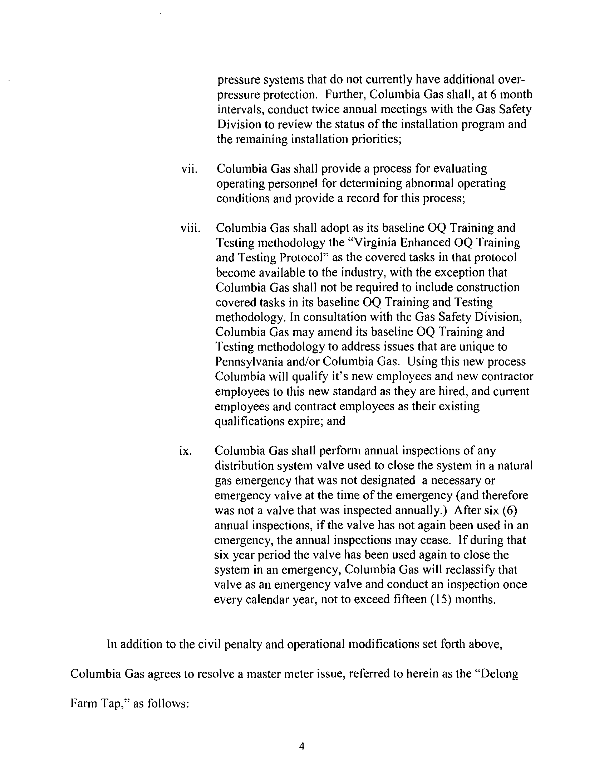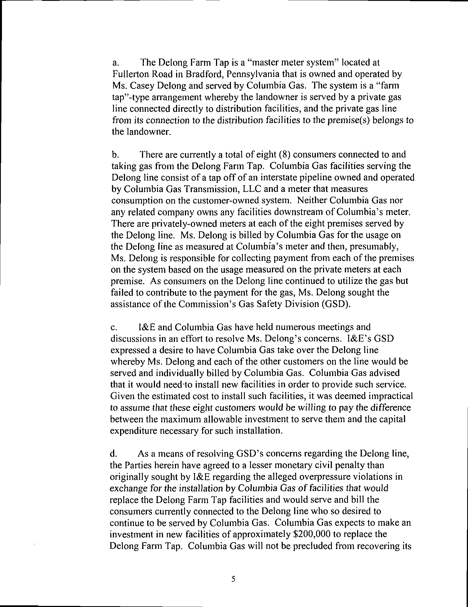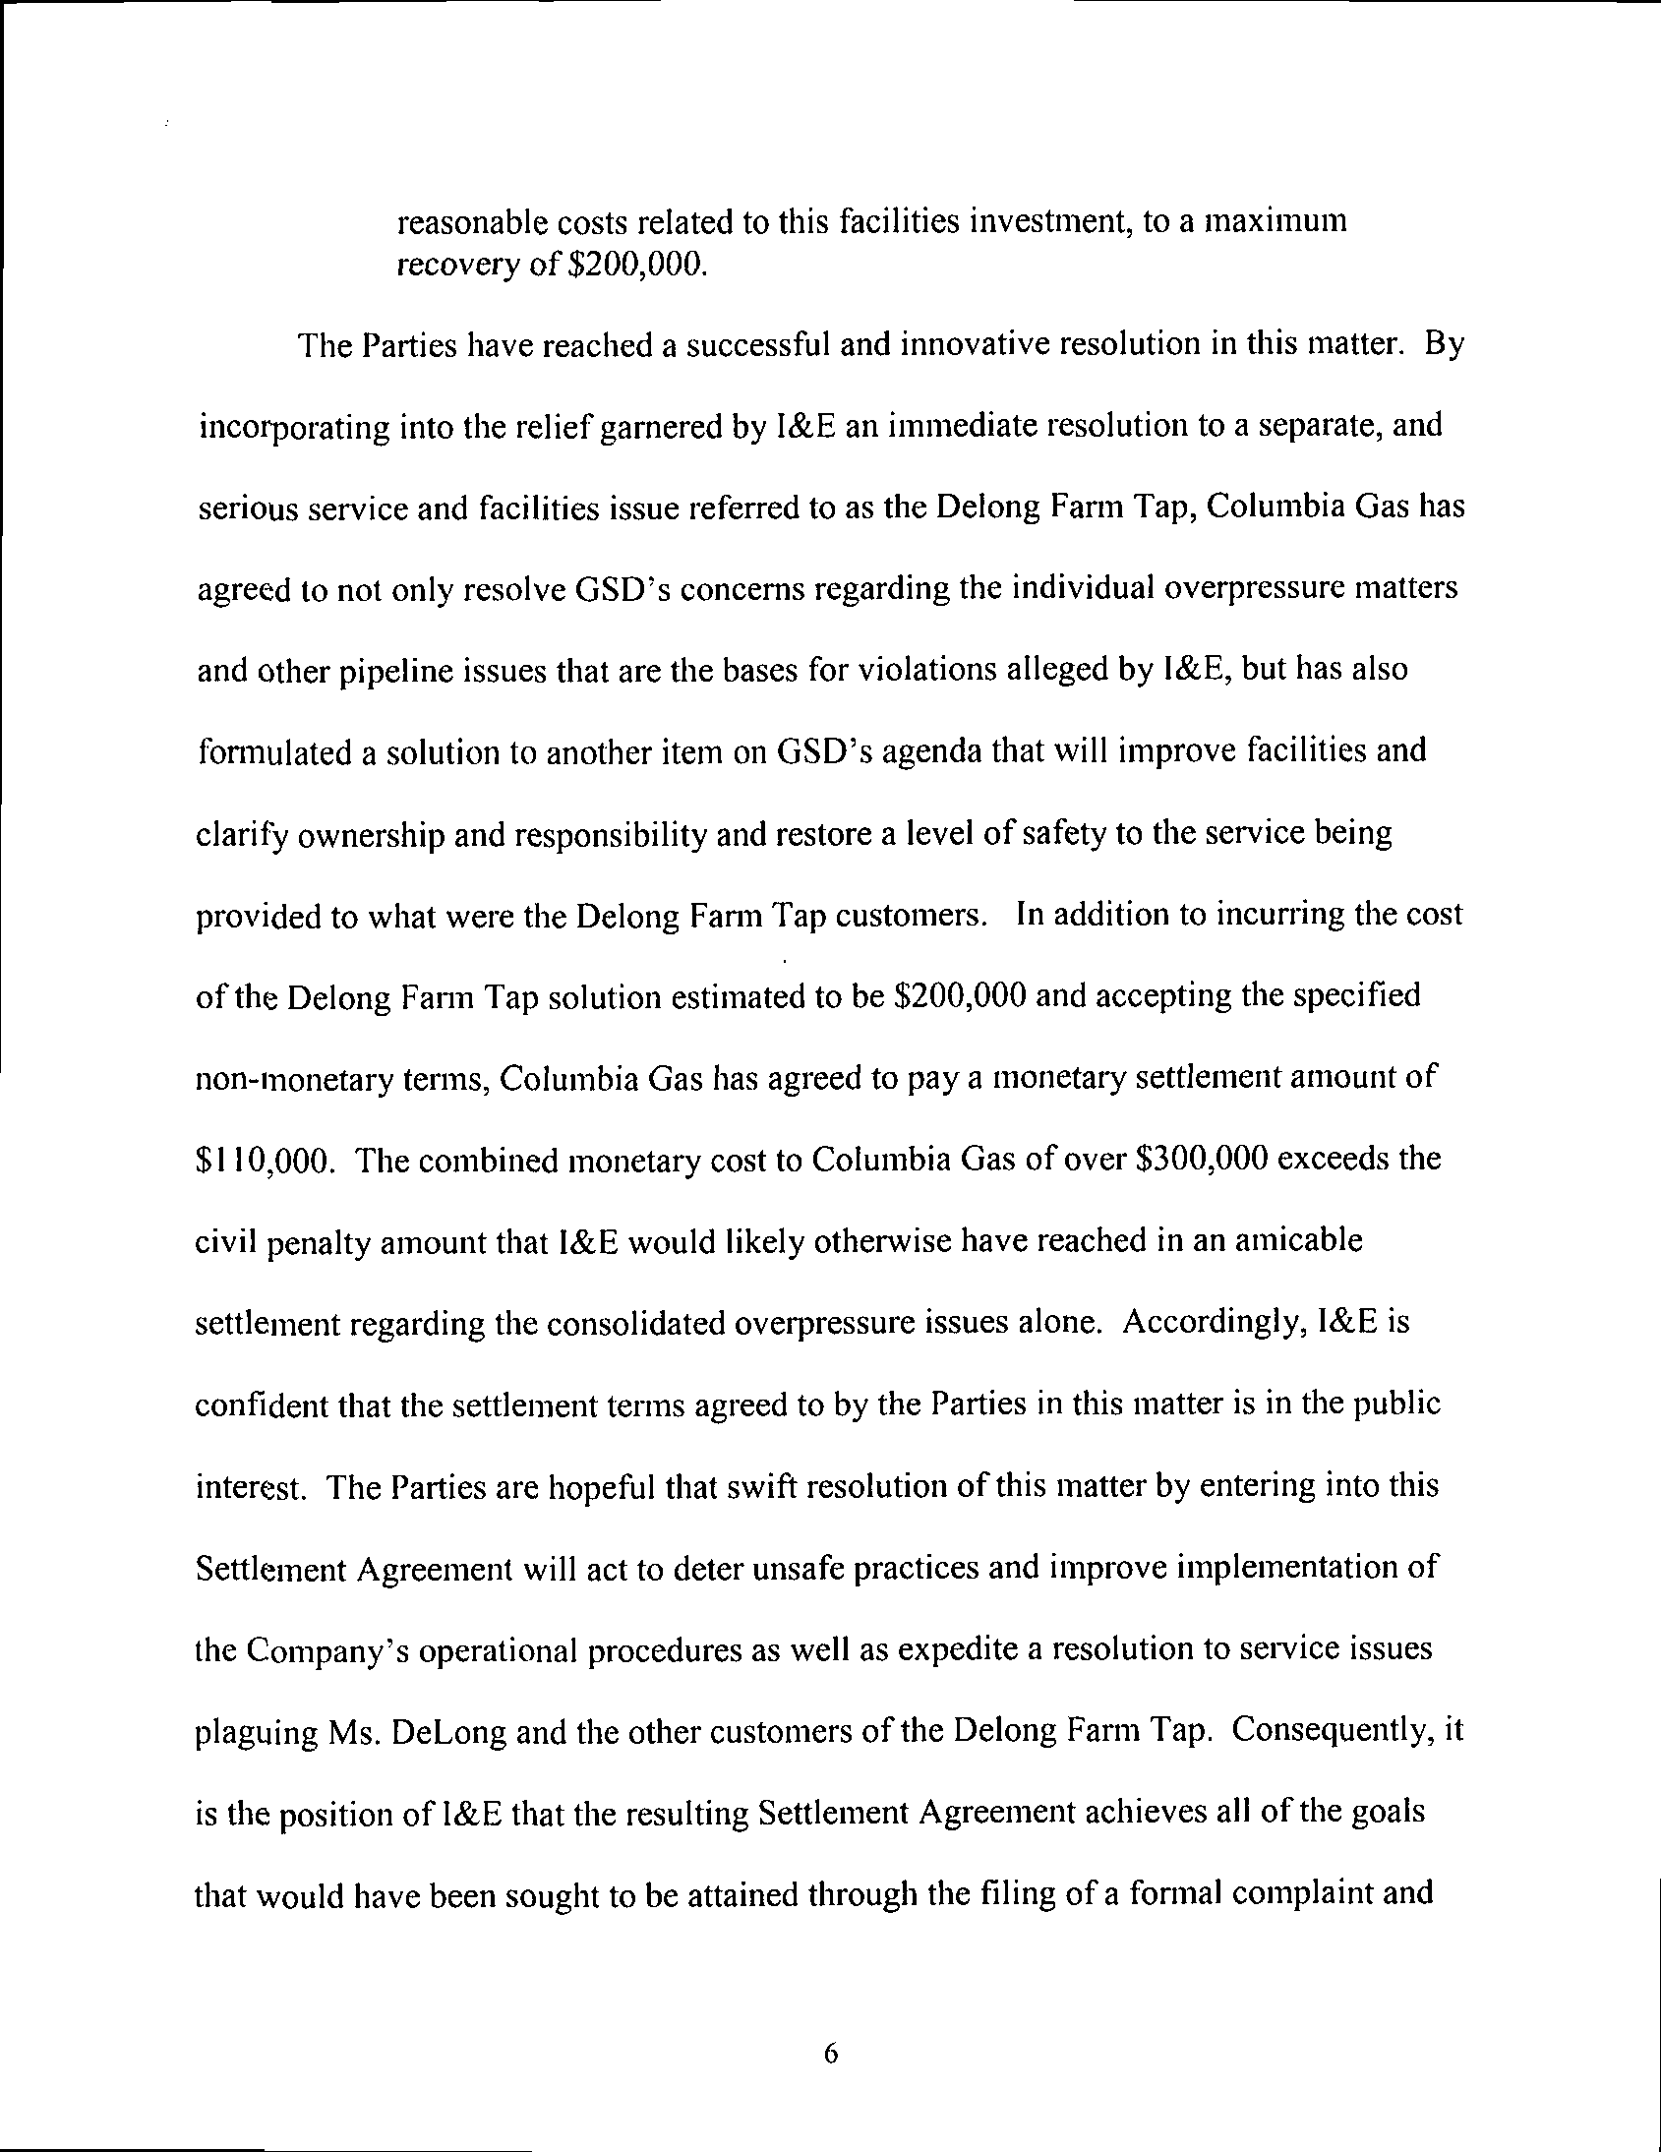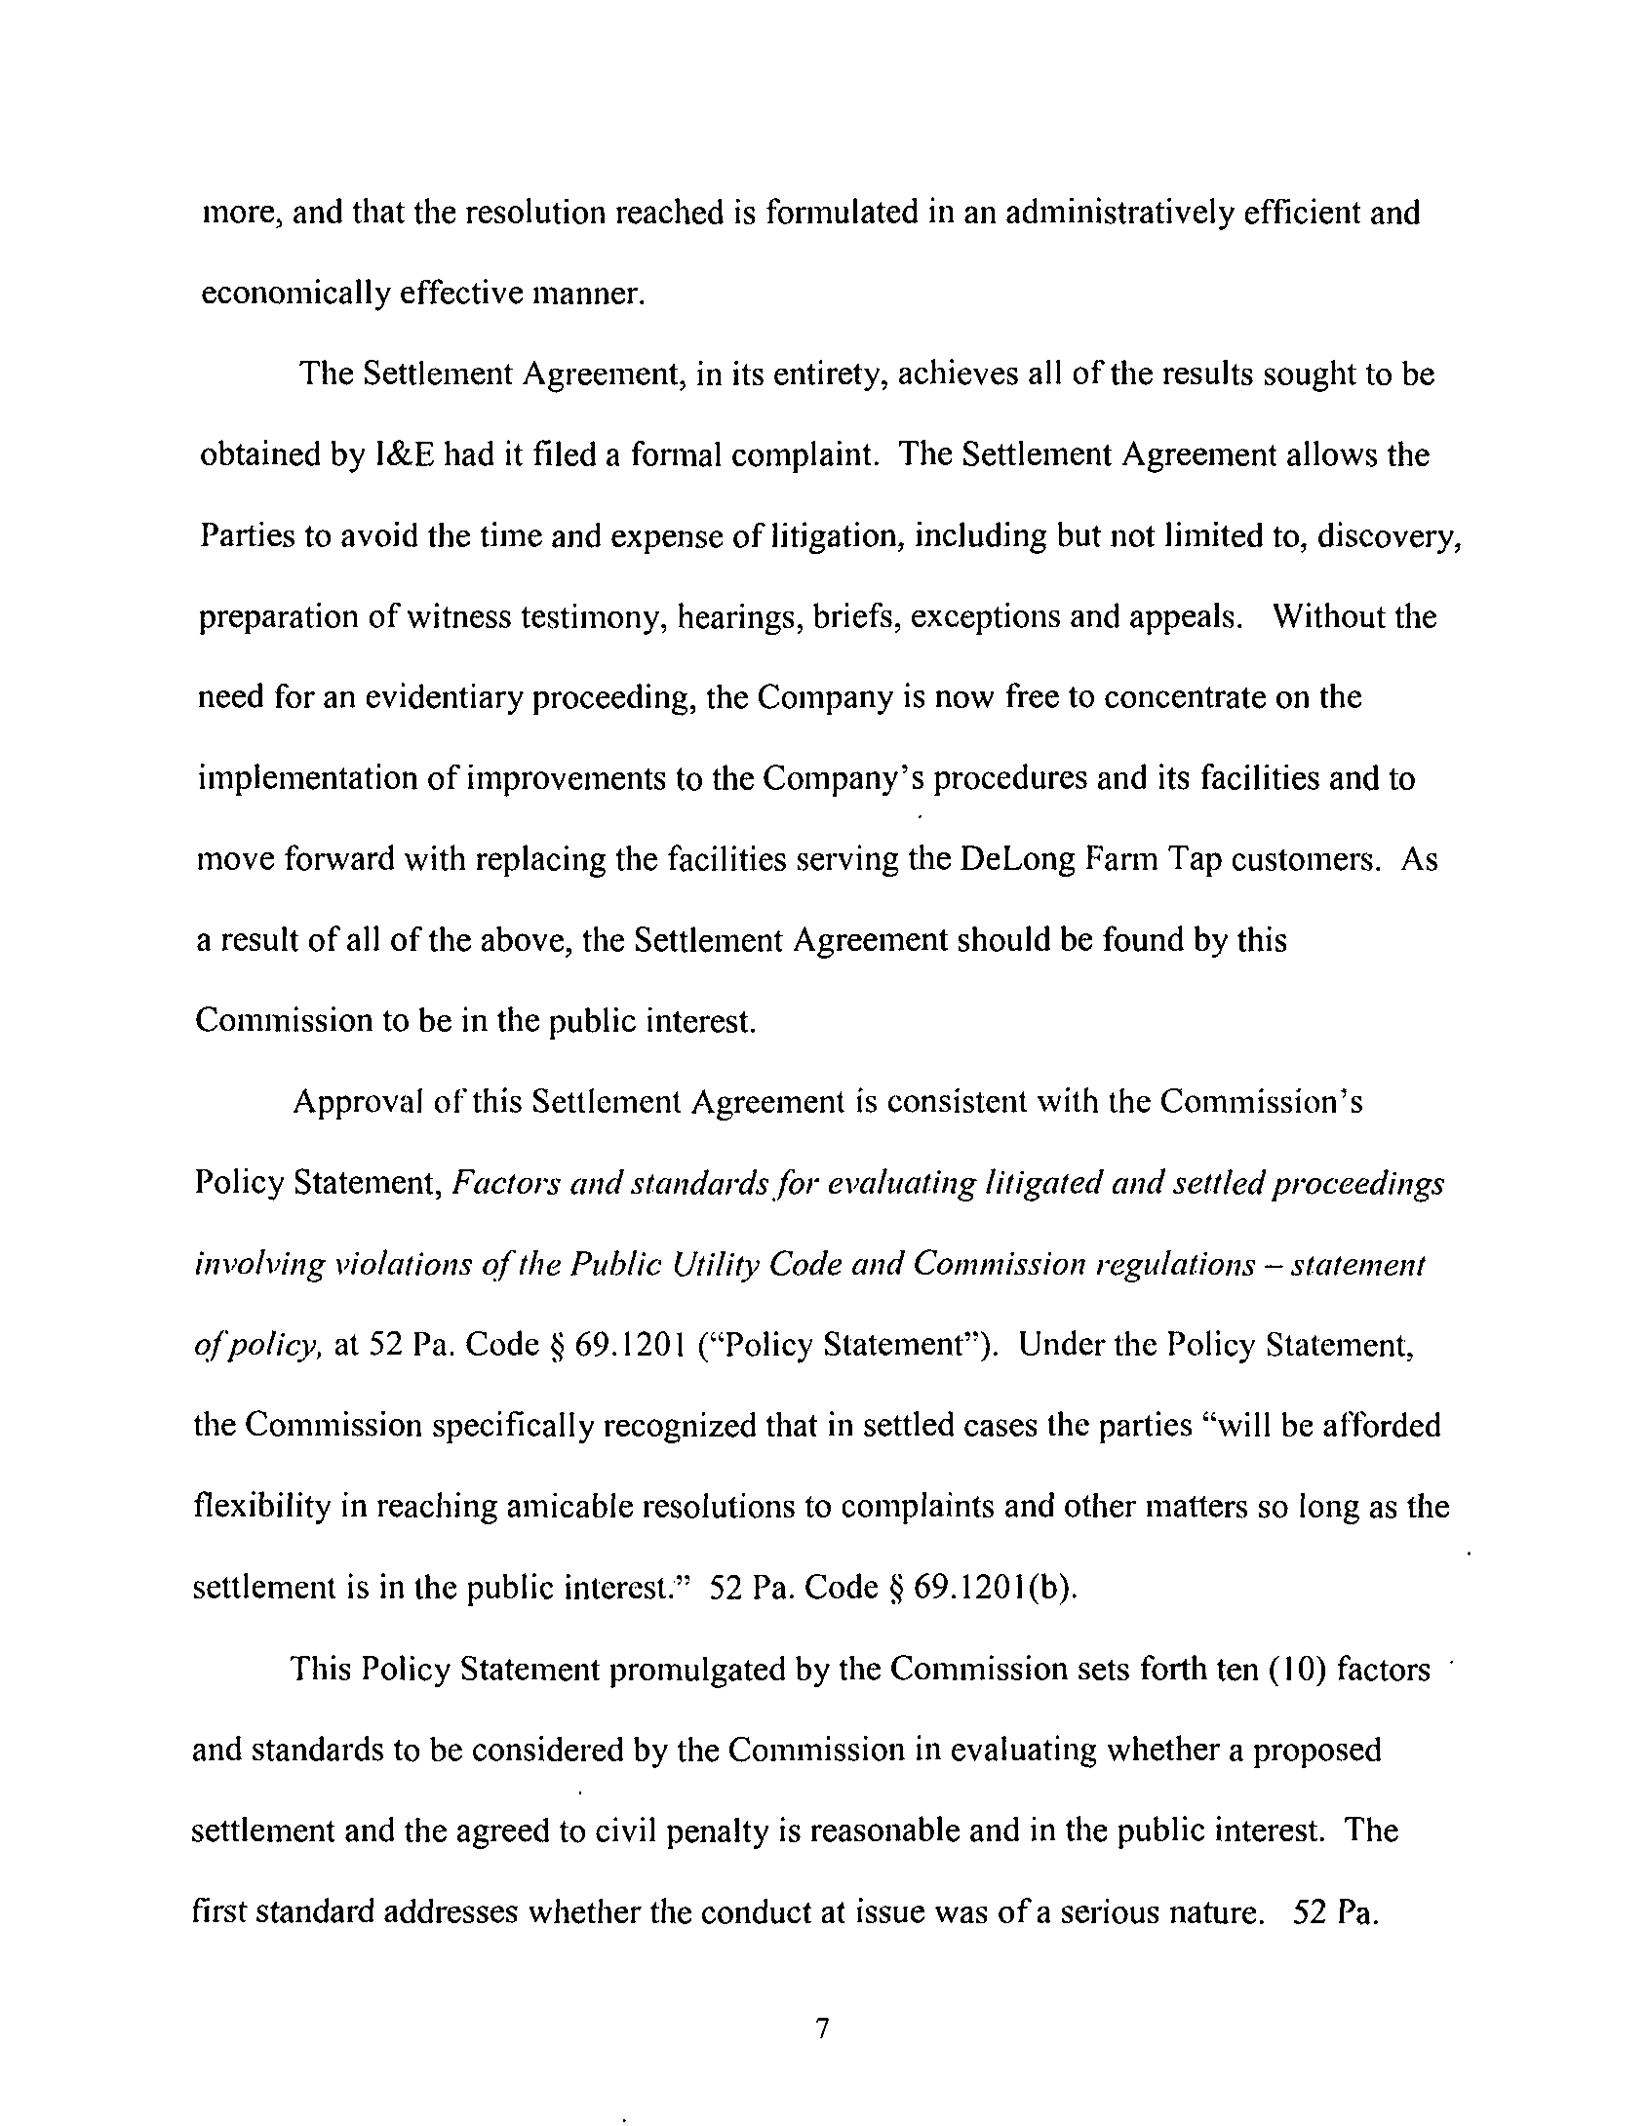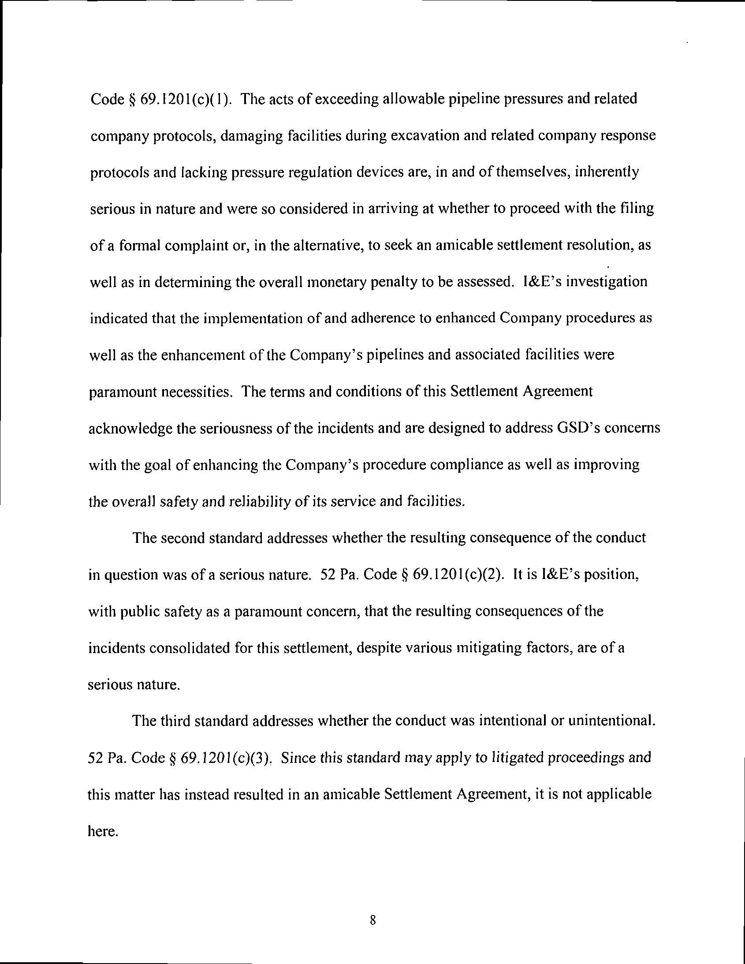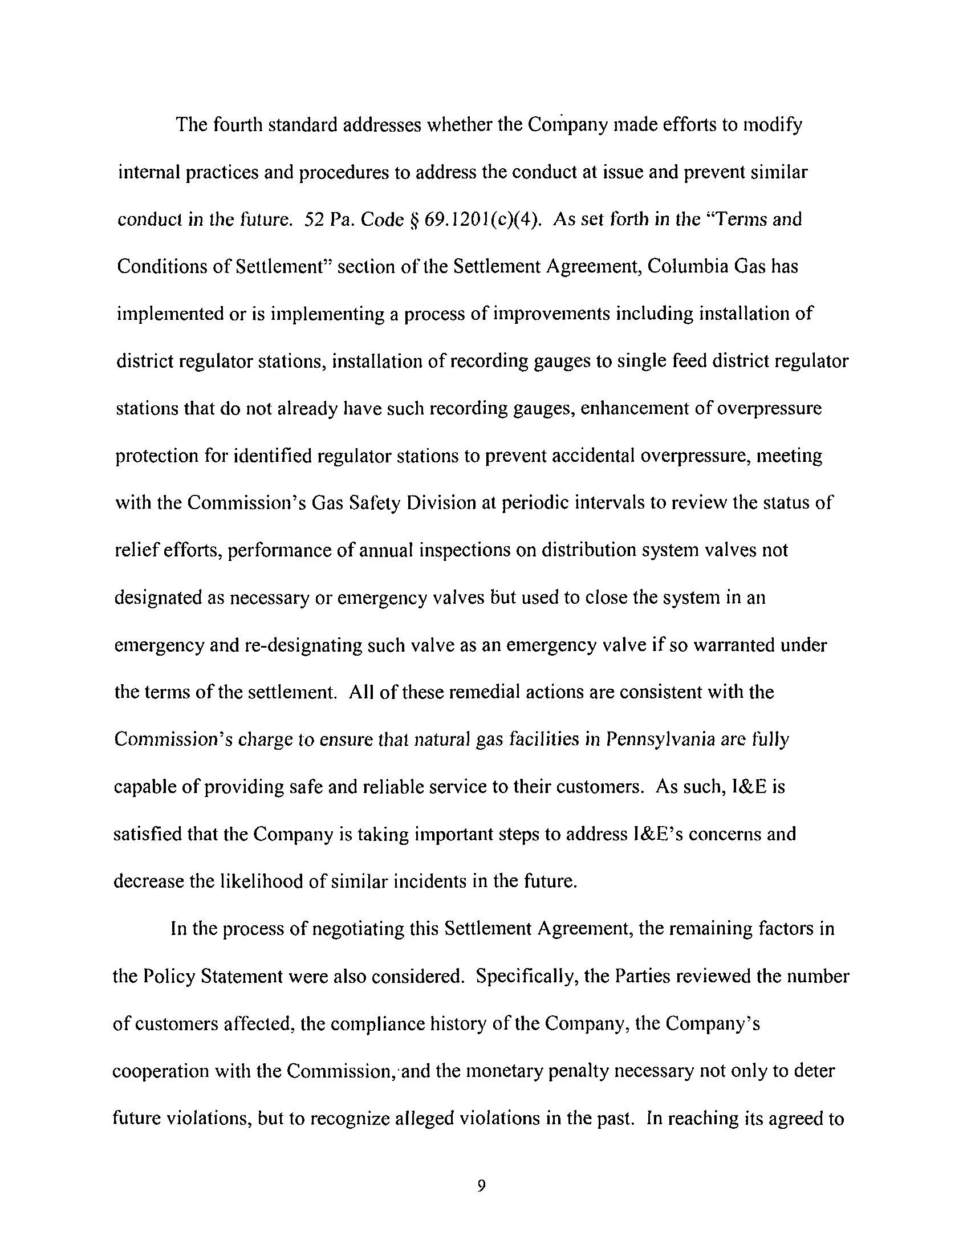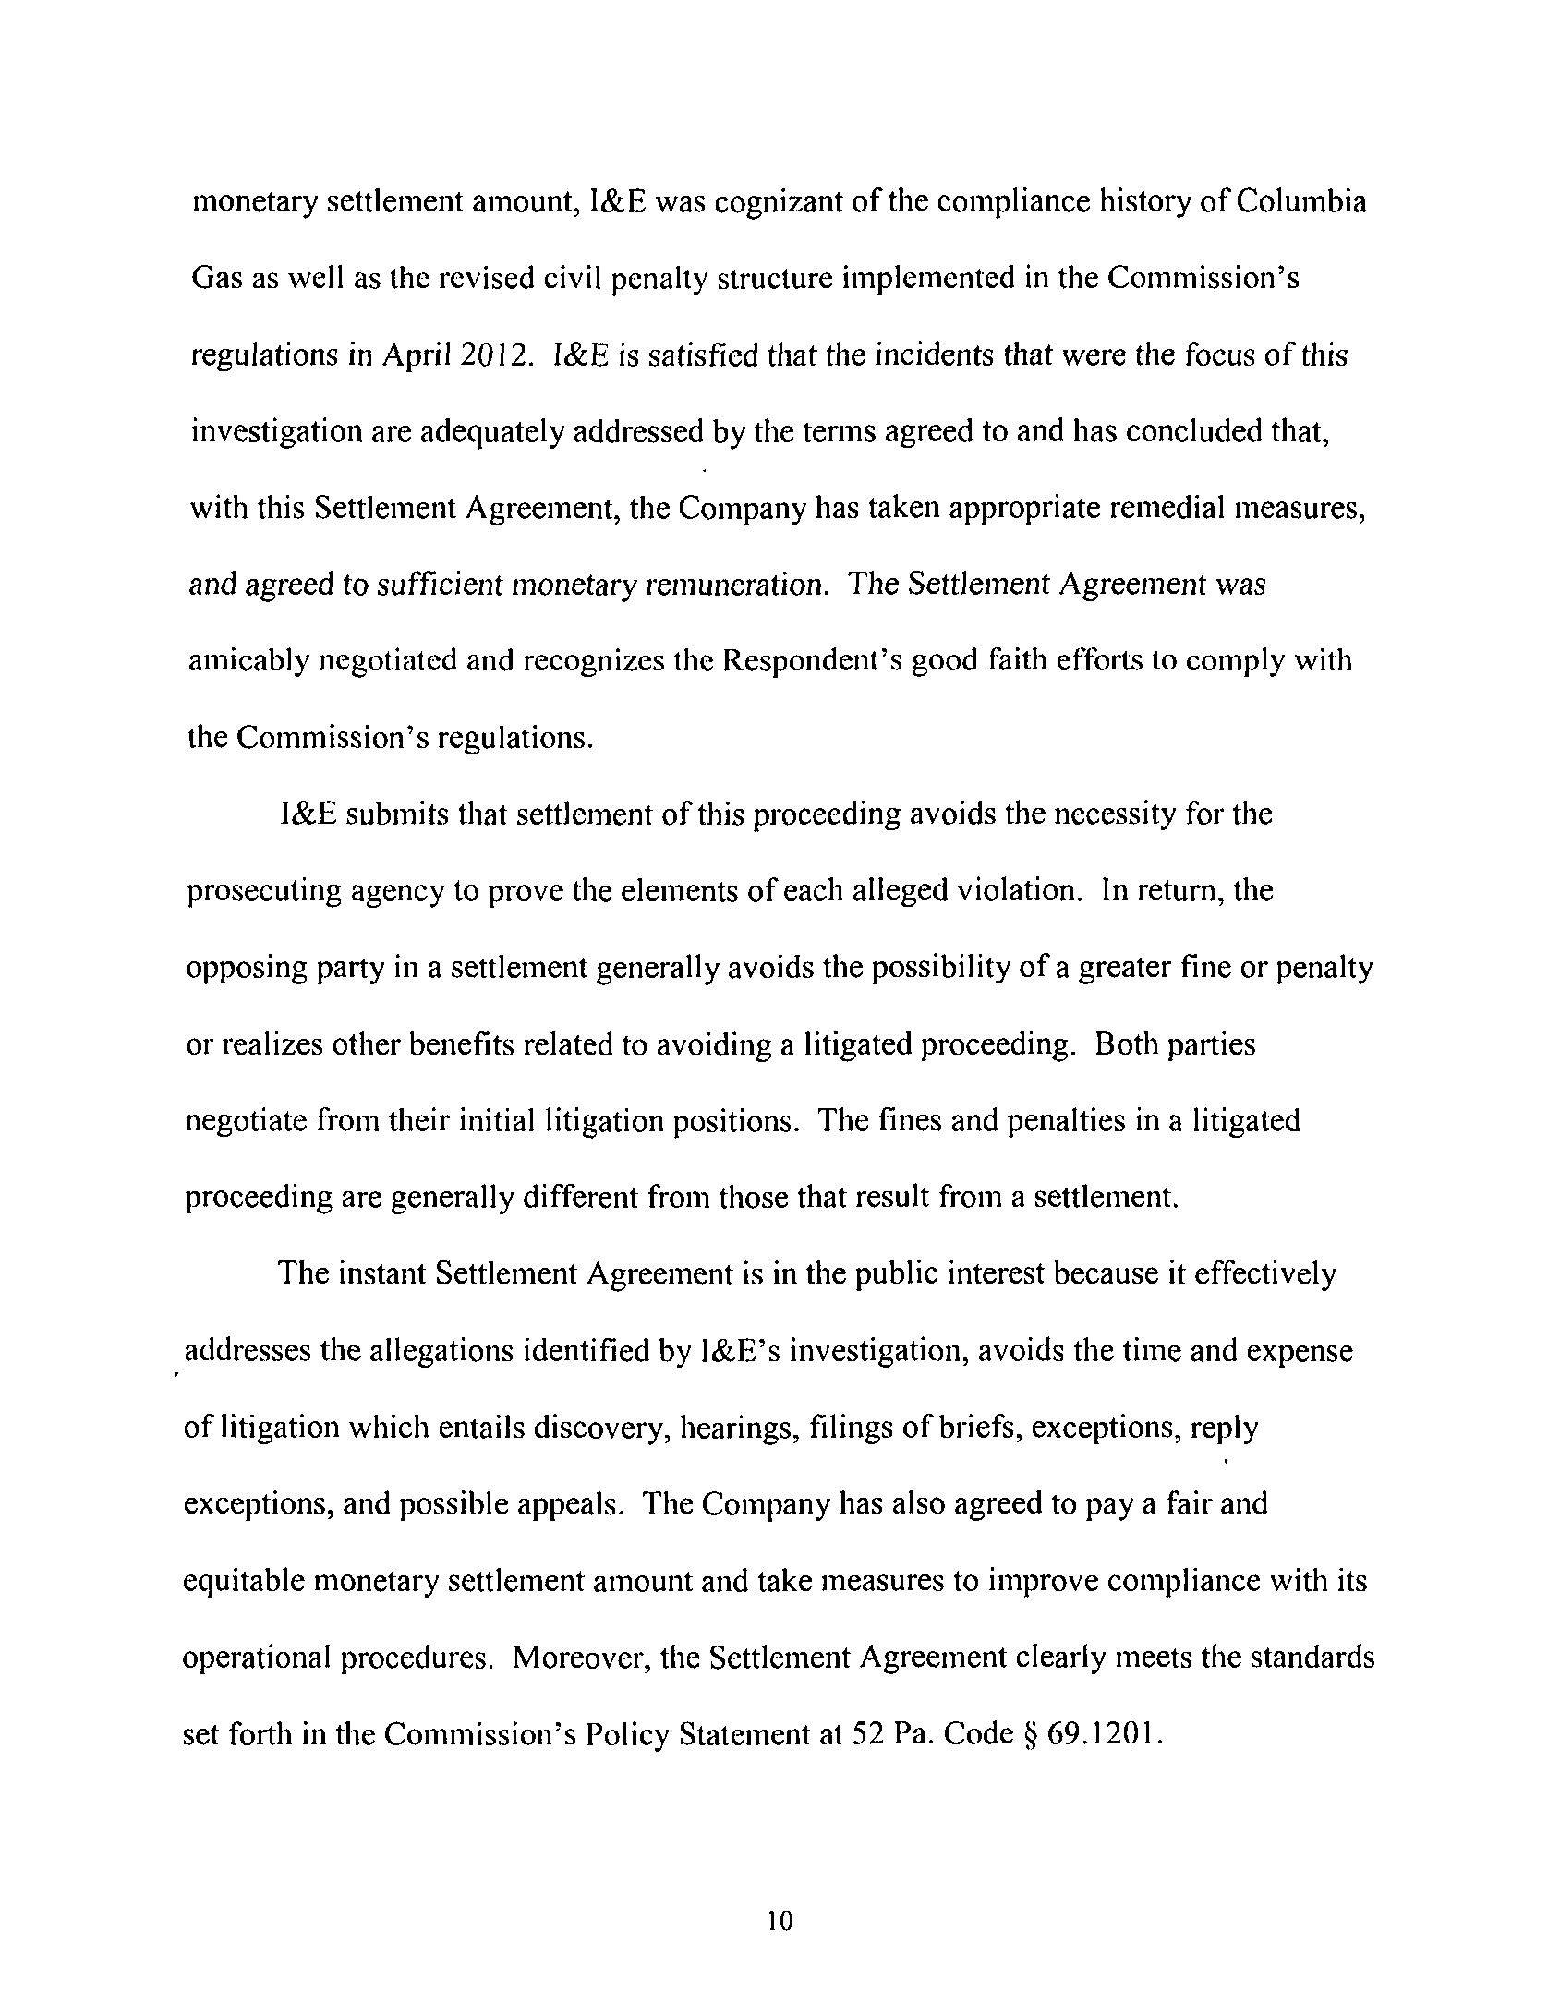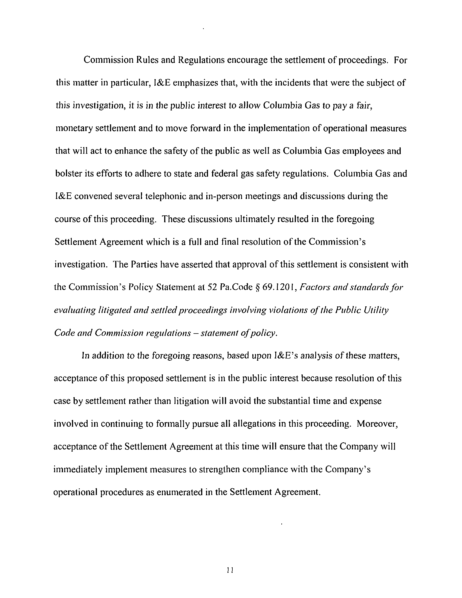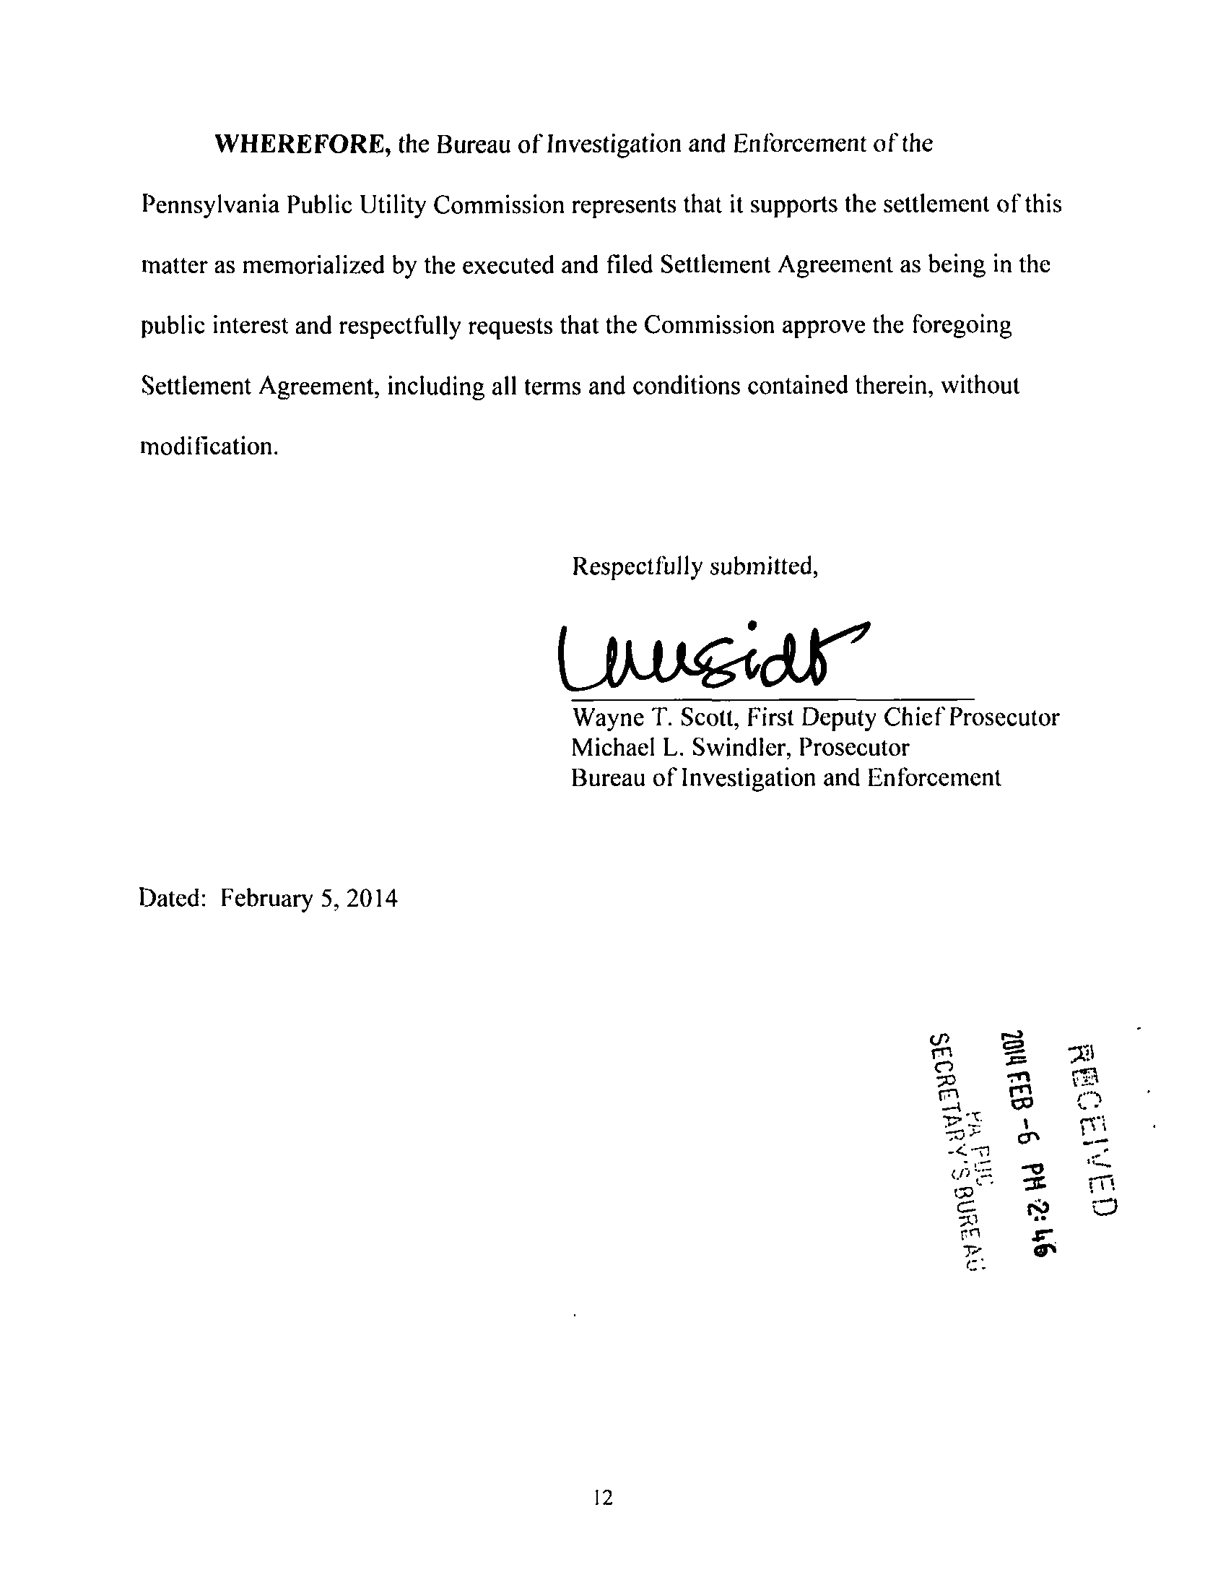

The Parties have agreed that Columbia Gas will not seek recovery of any portion of this civil penalty amount in any future ratemaking proceeding, and that it will not be tax deductible under Section 162(f) of the Internal Revenue Code, 26 U.S.C.S. § 162(f). Settlement at 24.

