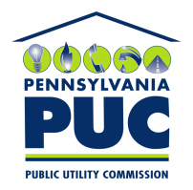 | COMMONWEALTH OF PENNSYLVANIA  PENNSYLVANIA PUBLIC UTILITY COMMISSION  400 NORTH STREET, HARRISBURG, PA 17120 | IN REPLY PLEASE REFER TO OUR FILE

February 18, 2016

Mr. Sloan Auchincloss
919 Green Street
Harrisburg, Pennsylvania 17102

Dear Mr. Auchincloss:

Thank you for your letter dated February 15, 2016 to Chairman Gladys Brown of the Pennsylvania Public Utility Commission, regarding your opposition to the rate increase proposal filed by UGI Utilities at Docket Number R-2015-2518438.

Since this matter is now a contested on the record proceeding that has been assigned to the Commission’s Office of Administrative Law Judge for further hearings and decision, the Commissioners are prohibited from responding to outside correspondence due to the statutory prohibition on ex-parte communications at 66 Pa. C.S. Section 334(c). Please know that your letter of opposition will be placed on the record at this docket.
Sincerely,

Rosemary Chiavetta
Secretary of the Commission

