PENNSYLVANIA PUBLIC UTILITY COMMISSION

NOTICE TO BE PUBLISHED

Petition of NRG Energy Inc for Implementation of Electric Generation Supplier Consolidated Billing.
Docket Number: P-2016-2579249
________________________________________________

Formal comments and reply comments must be filed in accordance with Title 52 of the Pennsylvania Code. Answers and any comments must be filed by January 23, 2017 and Reply Comments by February 22, 2017. All filings must be made with the Secretary of the Pennsylvania Public Utility Commission, 400 North Street, Harrisburg, PA 17120, with a copy served on the Petitioner. The documents filed in support of the Petition are available for inspection and copying at the Office of the Secretary between the hours of 8:00 a.m. and 4:30 p.m., Monday through Friday, at the Commission’s website at www.puc.pa.gov , and at the Petitioner's business address.

Petitioner:

NRG Energy, Inc.

Through and By Counsel:

Karen O. Moury
Sarah C. Stoner
Eckert, Seamans, Cherin & Mellott, LLC
213 Market Street, Eighth Floor
Harrisburg, Pa 17101

BY THE COMMISSION
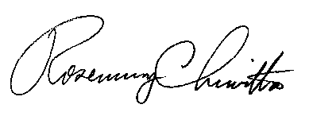 Rosemary Chiavetta
Secretary

