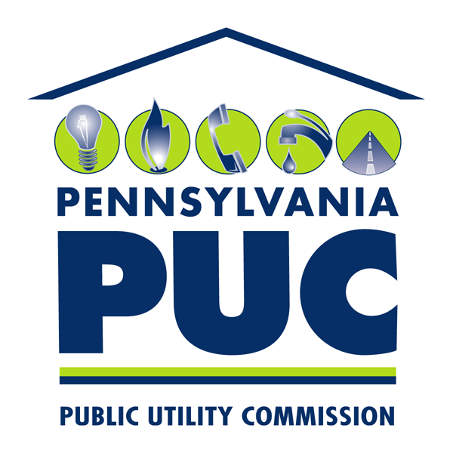 | COMMONWEALTH OF PENNSYLVANIA  PENNSYLVANIA PUBLIC UTILITY COMMISSION  400 NORTH ST, HARRISBURG, PA 17120 | IN REPLY PLEASE REFER TO OUR FILE

August 4, 2017
A-2015-2517036

THOMAS J. SNISCAK, ATTORNEY
HAWKE MCKEON & SNISCAK LLP
100 NORTH TENTH ST
HARRISBURG, PA 17101

Re: Pike County Light and Power Company Compliance Filing Letter Requesting Contractor Approval

Dear Mr. Sniscak:

On Jul 25, 2017, Pike County Light and Power Company (Pike) filed a Compliance Filing Letter Requesting Contractor Approval in compliance with Paragraph 36(h) of the Joint Petition for Settlement. Pike has requested that the Commission issue a Secretarial Letter within 10 days approving the use of certain contractors.

Based on a review of the information provided by Pike and its current needs of operation, it appears the contractor staffing request is reasonable for the manner stated in the compliance filing and is hereby approved as written.

We also advise Pike to perform a review of hired contractors to determine if they meet the definition of an affiliated interest under 66 Pa. C.S. § 2101, and if necessary, submit a filing in accordance with 66 Pa. C.S. § 2102, Relations with Affiliated Interests.

If you are dissatisfied with the resolution of this matter, you may appeal this decision, as set forth in 52 Pa. Code §5.44, file a petition with the Commission within 10 days of the date of this letter.

Sincerely,

Rosemary Chiavetta Secretary

Cc Paul Diskin, TUS

Daniel Searfoorce, TUS

The Petition for Settlement was approved by Commission Order dated August 11, 2016, at Docket No. A-2015-2517036.

