BEFORE THE
PENNSYLVANIA PUBLIC UTILITY COMMISSION

Pennsylvania Public Utility Commission : R-2017-2618332
Office of Consumer Advocate : C-2017-2629498
:
v. :
:
Pine-Roe Natural Gas Company, Inc. :

SECOND INTERIM ORDER
ADMITTING JOINT PETITION FOR SETTLEMENT
OF RATE INVESTIGATION INTO THE RECORD,
CONSOLIDATING COMPLAINT WITH RATE FILING AND CLOSING THE RECORD

AND NOW, a Joint Petition for Settlement of Rate Investigation (Settlement Petition) having been filed on January 31, 2018, by the Parties, the Bureau of Investigation and Enforcement of the Pennsylvania Public Utility Commission, the Office of Consumer Advocate and Pine-Roe Natural Gas Company, Inc., together with Appendices A through C; and the Office of Consumer Advocate having filed a Complaint against the rate filing at Docket No. C-2017-2629498, and a Recommended Decision, which shall address the Settlement Petition in this case is being prepared for issuance,

THEREFORE,

IT IS ORDERED:

- That the Joint Petition for Settlement of Rate Investigation together with Appendices A through C filed on January 31, 2018, by the Parties, the Bureau of Investigation and Enforcement of the Pennsylvania Public Utility Commission, the Office of Consumer Advocate and Pine-Roe Natural Gas Company, Inc., at Docket No. R-2017-2618332 is admitted into the record.

- That the Complaint of the Office of Consumer Advocate against Pine-Roe Natural Gas Company, Inc. at Docket No. C-2017-2629498 is consolidate with the rate filing at Docket No. R-2017-2618332

- That the record at Docket No. No. R-2017-2618332 is closed.
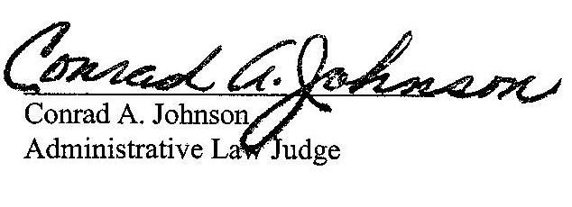

February 2, 2018

R-2017-2618332; C-2017-2629498 - Pennsylvania Public Utility Commission; OFFICE OF CONSUMER ADVOCATE v. pine-roe natural gas company, inc.

Revised 2/2/18

PAULINE M GRIEBEL, APPLICANT
PINE-ROE NATURAL GAS COMPANY INC
p o Box 146
clarion PA 16214
accepts E-service
814-745-3902

*DARRYL A LAWRENCE Esquire
HAYLEY E DUNN ESQUIRE
OFFICE OF CONSUMER ADVOCATE
555 WALNUT STREET
5TH FLOOR FORUM PLACE
HARRISBURG PA 17101-1923
*accepts E-service
717-783-5048

erika mclain Esquire
PENNSYLVANIA PUBLIC UTILITY COMMISSION
BUREAU OF INVESTIGATION & ENFORCEMENT
PO BOX 3265
HARRISBURG PA 17105-3265
accepts E-service
717-783-6170

steven c gray esquire
office of small business advocate
300 north second street suite 202
harrisburg pa 17101
717-783-2525

