PENNSYLVANIA
PUBLIC UTILITY COMMISSION
Harrisburg, PA 17105-3265

Public Meeting held December 6, 2018

Commissioners Present:

Gladys M. Brown, Chairman, Statement
Andrew G. Place, Vice Chairman
Norman J. Kennard
David W. Sweet
John F. Coleman, Jr.

Pennsylvania Public Utility Commission  Office of Consumer Advocate  Office of Small Business Advocate  Patricia Southorn  The Pennsylvania State University  Columbia Industrial Intervenors  G. Blair Bauer  Philip L. Bloch  Robin A. Harrison  v.  Columbia Gas of Pennsylvania, Inc.  Petition of Columbia Gas of Pennsylvania,  Inc. For Authorization to Defer, For  Accounting Purposes, Certain Costs,  Associated With a Prepayment to the  NiSource, Inc. Pension Trust | R-2018-2647577  C-2018-3000582  C-2018-3000773  C-2018-3000779  C-2018-3001034  C-2018-3001047  C-2018-3001319  C-2018-3001634  C-2018-3002595  P-2018-2641257

OPINION AND ORDER

BY THE COMMISSION:

Before the Pennsylvania Public Utility Commission (Commission) for consideration and disposition are the Joint Exceptions filed on October 15, 2018, by Shipley Choice, LLC, Dominion Retail, Inc., and Interstate Gas Supply, Inc. (hereinafter collectively referred to as the NGS Parties) to the Recommended Decision (R.D.) of Administrative Law Judge (ALJ) Jeffrey A. Watson, issued on September 28, 2018, in the above-captioned proceedings wherein he recommended adoption, without modification, of the terms and conditions of the Joint Petition for Partial Settlement (Joint Petition or Partial Settlement) filed by the Joint Petitioners on August 31, 2018. The Partial Settlement proposes to resolve all issues related to the rate proceeding and preserves as a separate matter, a claim against Columbia for an alleged violation of Section 1502 of the Code, 66 Pa.C.S. § 1502 (Code). The ALJ further recommends denial of the claim by the NGS Parties that Columbia discriminates in provision of service regarding billing in violation of Section 1502 of the Code. Replies to Exceptions were filed by Columbia and the Office of Consumer Advocate (OCA) on October 25, 2018. The Exceptions and Replies to Exceptions pertain exclusively to the sole issue preserved as a separate matter for litigation that was unresolved by the Partial Settlement, i.e., the claim raised by the NGS Parties that a Columbia billing practice violates the prohibition on discrimination in provision of service under Section 1502 of the Code.

For the reasons stated, infra, we shall grant, in part, the Exceptions of the NGS Parties pertaining to the sole issue left unresolved by the terms of the Partial Settlement and adopt the ALJ’s Recommended Decision, as modified, to approve the terms and conditions of the Joint Petition for Partial Settlement resolving all issues pertaining to the rate proceeding without modification, consistent with this Opinion and Order. Accordingly, as discussed infra, we conclude that Columbia’s billing practice offering third parties “on billing” for non-commodity service provided by third parties is subject to the Commission’s jurisdiction under Section 1502 of the Code, which prohibits discrimination in the provision of service, and we shall therefore require Columbia to take action to conform its billing practice in accordance with Section 1502.

I. Background

Columbia is a public utility and natural gas distribution company (NGDC) as those terms are defined in Sections 102 and 2202 of the Code, 66 Pa. C.S. §§ 102, 2202. Columbia provides natural gas distribution, sales, transportation, and/or supplier of last resort services to approximately 426,000 retail customers in portions of 26 counties of Pennsylvania.

Columbia originally sought an increase to its annual operating revenues of approximately $46.9 million. Under the Partial Settlement, the Joint Petitioners have agreed upon a lesser increase in rates designed to produce an additional $26.0 million in annual base rate operating revenues which equates to an increase in Columbia’s existing base rate operating revenues of approximately 4.52%, instead of the 8.16% increase originally sought. Similarly, the monthly bill of a typical residential customer using 70 therms of gas per month will increase by $4.11, from $91.63 to $95.74, or by 4.49%, rather than the originally proposed increase of $8.25, from $91.63 to $99.88 per month, or 9%.

Columbia’s Accounting Deferral Petition at Docket No. P-2018-2641257, also resolved by the Partial Settlement, sought Commission approval to defer, for accounting and financial reporting purposes only, the Company’s prepayment of $8.45 Million to the NiSource, Inc. Pension Plan, made on January 5, 2017.

II. History of Proceeding

The following history of the proceeding has been gleaned from the Partial Settlement.

On March 15, 2018, the Pennsylvania Public Utility Commission (Commission) issued an order at Docket No. M-2018-2641242, establishing the then-current rates of certain public utilities as temporary rates, in response to the Tax Cuts and Jobs Act of 2017, Pub. L. No. 115-97, 131 Stat. 2054 (TCJA).

On March 16, 2018, Columbia Gas of Pennsylvania, Inc. filed Supplement No. 267 to its Tariff Gas – Pa. P.U.C. No. 9 (Supplement No. 267) with the Commission to become effective on May 15, 2018. In Supplement No. 267, the Company proposed to increase rates to produce approximately $46.9 million in additional annual operating revenues, or an 8.16% increase in annual operating revenues based upon a pro forma fully projected future test year (FPFTY) ending December 31, 2019.

On March 20, 2018, the OCA filed a formal complaint in opposition to the Company’s proposed rate increase at Docket No. C-2018-3000582. On March 22, 2018, I&E filed a Notice of Appearance in this matter. On March 28, 2018, the OSBA filed a formal complaint at Docket No. C-2018-3000773. On March 28, 2018, Patricia Southorn also filed a formal complaint at Docket No. C-2018-3000779. On March 30, 2018, the NGS Parties filed a Petition to Intervene. On April 4, 2018, CAAP also filed a Petition to Intervene. On April 6, 2018, PSU filed a formal complaint at Docket No. C-2018-3001034. On April 9, 2018, CII filed a formal complaint at Docket No. C-2018-3001047. On April 10, 2018, CAUSE-PA filed a Petition to Intervene. On April 16, 2018, the Direct Energy Companies also filed a Petition to Intervene.

On April 5, 2018, the Commission entered an Order suspending Supplement No. 267 until December 16, 2018, pursuant to Section 1308(d) of the Code, 66 Pa. C.S. § 1308(d), and initiated an investigation into the lawfulness, justness, and reasonableness of the proposed and existing rates, rules, and regulations. The Company’s filing was assigned to the Office of Administrative Law Judge (OALJ) which assigned ALJ Jeffrey A. Watson as presiding officer.

On April 10, 2018, a Call-In Telephone Hearing Notice was issued to schedule the Prehearing Conference in this proceeding for April 18, 2018, at 9:00 a.m. A Prehearing Conference Order was entered on April 10, 2018, which required the Parties, inter alia, to submit prehearing memoranda. Prehearing memoranda were submitted by the Company, I&E, the OCA, the OSBA, the NGS Parties, CAUSE-PA, CII, the Direct Energy Companies, and PSU prior to the Prehearing Conference in this proceeding.

A Prehearing Conference was held on April 18, 2018, as scheduled. Counsel for the Company, I&E, the OCA, the OSBA, the NGS Parties, CAUSE-PA, CII, the Direct Energy Companies, and PSU attended the conference.

On April 19, 2018, Columbia filed Supplement No. 274 to Tariff Gas Pa. PUC No. 9, suspending Columbia’s Supplement No. 267 until December 16, 2018. Joint Petition at 5.

On April 20, 2018, Columbia filed supplemental direct testimony, which calculated the effect of the TCJA on Columbia’s 2018 tax liability. Columbia’s original rate filing had included the prospective effect of the TCJA in calculating Columbia’s proposed revenue requirement. Joint Petition at 4.

On May 1, 2018, ALJ Watson issued a Prehearing Order that confirmed the litigation schedule established at the Prehearing Conference. The Prehearing Order also consolidated the Company’s Accounting Deferral Petition into the Company’s Base Rate Filing at the present docket.

By way of background, on January 5, 2018, at Docket No. P-2018-2641257, Columbia filed its Accounting Deferral Petition, requesting Commission approval to defer, for accounting and financial reporting purposes only, the Company’s prepayment of $8.45 Million to the NiSource, Inc. Pension Plan, made on January 5, 2017. In its Accounting Deferral Petition, Columbia sought permission to defer the pension prepayment on its books of account pending a determination of recoverability in Columbia’s next base rate case. Columbia sought only permission to defer the prepayment for accounting purposes and did not seek a determination as to rate recovery of the prepayment. The case was assigned to Administrative Law Judge Dunderdale. On April 6, 2018, the Company filed a motion to consolidate the Accounting Deferral Petition with the base rate proceeding filed at this docket, Docket No. R-2018-2647577.

ALJ Watson’s Prehearing Order also consolidated several formal complaints with the present base rate proceeding, including: the OCA’s formal complaint at Docket No. C-2018-3000582; the OSBA’s formal complaint at Docket No. C-2018-3000773; Patria Southorn’s formal complaint at Docket No. C-2018-3000779; PSU’s formal complaint at Docket No. C-2018-3001034; and CII’s formal complaint at Docket No. C-2018-3001047.

On May 2, 2018, Columbia filed a Motion for a Protective Order. ALJ Watson granted Columbia’s Motion and issued the Protective Order on May 9, 2018.

On May 14, 2018, a Public Input Hearing Notice was issued that scheduled a public input hearing at the Courthouse Square Building, 100 West Beau Street, Washington, Pennsylvania, for June 21, 2018 beginning at 6:00 p.m. The public input hearing was held as scheduled.

On May 17, 2018, at Docket No. M-2018-2641242, the Commission issued a further order directing certain utilities to establish temporary rates in the form of a negative surcharge effective July 1, 2018. In that Order, the Commission exempted Columbia from filing a negative surcharge because of Columbia’s pending base rate case. The Commission further stated:

Accordingly, the Commission expects the public utility and the parties in each such proceeding to address the effects of the federal tax reduction on the justness and reasonableness of the consumer rates charged during the term of the suspension period, and, in particular, whether a retroactive surcharge or other measure is necessary to account for the tax rate changes that became effective on January 1, 2018.

May 17, 2018 Order at 20-21; Joint Petition at 4-5.

On June 11, 2018, a Hearing Notice was issued that scheduled the evidentiary hearing in this proceeding for July 25-27, 2018, and August 6, 2018, beginning at 10:00 a.m. each day in Harrisburg, Pennsylvania.

An Interim Order was entered on June 21, 2018 amending the Prehearing Order entered on May 1, 2018, to set July 17, 2018, as the deadline for surrebuttal testimony, except for OCA witness Roger D. Colton, whose surrebuttal testimony was due on July 19, 2018.

Subsequent to the Prehearing Conference, but prior to the commencement of the evidentiary hearing, additional complaints were filed by four individual customers of Columbia, docketed respectively as follows: (1) the formal complaint of G. Blair Bauer, filed on April 19, 2018, at Docket No. C-2018-3001319; (2) the formal complaint of Philip L. Bloch, filed on May 1, 2018, at Docket No. C-2018-3001634; and (3) the formal complaint of Robin A. Harrison filed on June 7, 2018, at Docket No. C-2018-3002595; and (4) the formal complaint of Patricia Southorn filed on March 28, 2018, at Docket No. C-2018-3000779.

The evidentiary hearing was held on July 26, 2018, at 10:00 a.m., at which time the Joint Petitioners’ pre-filed testimony and exhibits were admitted into the record. Counsel for the Company, I&E, the OCA, the OSBA, the NGS Parties, CAUSE-PA, CII, the Direct Energy Companies, and PSU attended the hearing. At the hearing, Counsel for the Company represented that the Parties had settled in principal all issues related to the rate proceeding and agreed to preserve, as a separate matter for litigation, the claim raised by the NGS Parties that a Columbia billing practice violates Section 1502 of the Code. Further, the Parties represented they had reached an agreement regarding the admission of evidence and the waiver of cross examination at the hearing. Evidence was received, and the hearing was concluded on July 26, 2018.

On July 27, 2018, an Interim Order was entered consolidating the formal complaints filed by G. Blair Bauer, at Docket No. C-2018-3001319; by Philip L. Bloch, at Docket No. C-2018-3001634; and by Robin A. Harrison at Docket No. C-2018-3002595. In addition, the hearings scheduled for July 27, 2018, and August 6, 2018, were cancelled.

On August 16, 2018, Main Briefs were filed by Columbia, the Direct Energy Companies, the NGS Parties and the OCA on the sole issue preserved for litigation – the claim by the NGS Parties that a Columbia billing practice violates Section 1502 of the Code.

On August 31, 2018, Reply Briefs were filed by Columbia, the NGS Parties and the OCA.

On August 31, 2018, the Joint Petitioners filed a Joint Petition for Partial Settlement (Partial Settlement) in which it requested that the Commission approve the terms and conditions of the Partial Settlement in its entirety without modification. The Partial Settlement included the tariff supplements and statements in support of the Partial Settlement filed by I&E, the OCA, the OSBA, CII, the NGS Parties, the Direct Energy Companies, CAUSE-PA, CAAP, PSU and Columbia. These documents were attached to the Partial Settlement as Appendices A through M (Appendices A and B, pertaining to Increase by Rate Class and Allocation of Proposed Annual Revenues by Rate Schedule Based on Revenue Requirement are reproduced and attached hereto). All of the active Parties in the rate proceeding agreed with the terms and conditions in the Partial Settlement.

On September 4, 2018, written notice was provided to Complainants G. Blair Bauer, Philip L. Bloch, Robin A. Harrison and Patricia Southorn (individual Columbia customers) by ALJ Watson acknowledging that they were listed on the certificate of service attached to the Joint Petition. The notice advised the individual Complainants to carefully review the Joint Petition for Partial Settlement that was filed on August 31, 2018. The individual Complainants were advised that they must file any objection to the proposed Partial Settlement in writing with the Secretary of the Commission and that all objections must be received by all Parties listed on the service list and the Presiding Officer no later than 4:30 p.m. on Wednesday, September 12, 2018. The individual Complainants were advised that any objection received after that time would not be considered.

On September 14, 2018, an Interim Order was issued which admitted the Joint Petition for Partial Settlement into the record along with the attached Appendices marked as A through M and closed the record.

No objection was received by ALJ Watson from Complainants G. Blair Bauer, Philip L. Bloch, Robin A. Harrison and Patricia Southorn on or before September 12, 2018.

On September 28, 2018, ALJ Watson issued his Recommended Decision in which he: (1) recommended that the terms and conditions of the Partial Settlement be adopted, without modification; (2) found, as matter of law, that Columbia’s billing practice of including on its bills, a separate line item charge for non-commodity services offered by third parties, is not subject to the Commission jurisdiction under Section 1502 of the Code (prohibiting discrimination in provision of service); and (3) found, as matter of fact, that Columbia’s billing practice was not discriminatory against the NGS Parties.

As noted, Joint Exceptions to the Recommended Decision were filed on October 15, 2018, by the NGS Parties. Replies to Exceptions were filed by Columbia and the OCA on October 25, 2018.

III. Legal Standards

In deciding this or any other general rate increase case brought under Section 1308(d) of the Code, 66 Pa. C.S. § 1308(d), certain general principles always apply. A public utility is entitled to an opportunity to earn a fair rate of return on the value of the property dedicated to public service. Pa. PUC v. Pennsylvania Gas and Water Co. 341 A.2d 239, 251 (Pa. Cmwlth. 1975). In determining a fair rate of return, the Commission is guided by the criteria provided by the United States Supreme Court in the landmark cases of Bluefield Water Works and Improvement Co. v. Public Service Comm’n of West Virginia, 262 U.S. 679 (1923) (Bluefield) and Federal Power Comm’n v. Hope Natural Gas Co.,
320 U.S. 591 (1944). In Bluefield, the Court stated:

A public utility is entitled to such rates as will permit it to earn a return on the value of the property which it employs for the convenience of the public equal to that generally being made at the same time and in the same general part of the country on investments in other business undertakings which are attended by corresponding risks and uncertainties; but it has no constitutional right to profits such as are realized or anticipated in highly profitable enterprises or speculative ventures. The return should be reasonably sufficient to assure confidence in the financial soundness of the utility and should be adequate, under efficient and economical management, to maintain and support its credit and enable it to raise the money necessary for the proper discharge of its public duties. A rate of return may be too high or too low by changes affecting opportunities for investment, the money market and business conditions generally.

Bluefield, 262 U.S. at 692-693.

The burden of proof to establish the justness and reasonableness of every element of a public utility’s rate increase request rests solely upon the public utility in all proceedings filed under Section 1308(d) of the Code. The standard to be met by the public utility is set forth in Section 315(a) of the Code, 66 Pa. C.S. § 315(a), as follows:

Reasonableness of rates. – In any proceeding upon the motion of the commission, involving any proposed or existing rate of any public utility, or in any proceedings upon complaint involving any proposed increase in rates, the burden of proof to show that the rate involved is just and reasonable shall be upon the public utility.

In reviewing Section 315(a) of the Code, the Pennsylvania Commonwealth Court interpreted a public utility’s burden of proof in a rate proceeding as follows:

Section 315(a) of the Public Utility Code, 66 Pa. C.S. § 315(a), places the burden of proving the justness and reasonableness of a proposed rate hike squarely on the public utility. It is well-established that the evidence adduced by a utility to meet this burden must be substantial.

Lower Frederick Twp. Water Co. v. Pa. PUC, 409 A.2d 505, 507 (Pa. Cmwlth. 1980) (emphasis added). See also, Brockway Glass Co. v. Pa. PUC, 437 A.2d 1067 (Pa. Cmwlth. 1981).

In general rate increase proceedings, it is well established that the burden of proof does not shift to parties challenging a requested rate increase. Rather, the utility’s burden of establishing the justness and reasonableness of every component of its rate request is an affirmative one, and that burden remains with the public utility throughout the course of the rate proceeding. There is no similar burden placed on parties to justify a proposed adjustment to the Company’s filing. The Pennsylvania Supreme Court has held:

[T]he appellants did not have the burden of proving that the plant additions were improper, unnecessary or too costly; on the contrary, that burden is, by statute, on the utility to demonstrate the reasonable necessity and cost of the installations, and that is the burden which the utility patently failed to carry.

Berner v. Pa. PUC, 382 Pa. 622, 631, 116 A.2d 738, 744 (1955).

This does not mean, however, that in proving that its proposed rates are just and reasonable, a public utility must affirmatively defend every claim it has made in its filing, even those which no other party has questioned. As the Pennsylvania Commonwealth Court has held:

While it is axiomatic that a utility has the burden of proving the justness and reasonableness of its proposed rates, it cannot be called upon to account for every action absent prior notice that such action is to be challenged.

Allegheny Center Assocs. v. Pa. PUC, 570 A.2d 149, 153 (Pa. Cmwlth. 1990) (citation omitted). See also, Pa. PUC v. Equitable Gas Co., 73 Pa. P.U.C. 310, 359-360 (1990).

Additionally, Section 315(a) of the Code, 66 Pa. C.S. § 315(a), cannot reasonably be read to place the burden of proof on the utility with respect to an issue the utility did not include in its general rate case filing and which, frequently, the utility would oppose. Inasmuch as the legislature is not presumed to intend an absurd result in interpretation of its enactments, the burden of proof must be on the party who proposes a rate increase beyond that sought by the utility. The mere rejection of evidence contrary to that adduced by the public utility is not an impermissible shifting of the evidentiary burden. United States Steel Corp. v. Pa. PUC, 456 A.2d 686 (Pa. Cmwlth. 1983).

Where, as here, the matter is resolved by settlement, the Commission must first determine that the proposed settlement terms and conditions are in the public interest before approving and adopting terms. Pa. Pub. Util. Comm’n v. York Water Co., Docket No. R-00049165 (Order entered October 4, 2004); Pa. Pub. Util. Comm’n v. CS Water and Sewer Assoc., 74 Pa. PUC 767 (1991).

In this case, the Partial Settlement is a “Black Box” agreement which does not specifically identify the resolution of certain disputed issues. Instead, an overall increase to base rates is negotiated and agreed upon as in the best interest of all Parties concerned and the Joint Petitioners forego challenges in the present proceeding while retaining the right to further challenge all issues in subsequent proceedings. A “Black Box” settlement benefits ratepayers as it allows for the resolution of a proceeding on favorable terms in a timely manner while avoiding significant additional expenses.

In analyzing a proposed general rate increase, the Commission determines a rate of return to be applied to a rate base measured by the aggregate value of all the utility’s property used and useful in the public service. The Commission determines a proper rate of return by calculating the utility’s capital structure and the cost of the different types of capital during the period in issue. The Commission is granted wide discretion, because of its administrative expertise, in determining the cost of capital. Equitable Gas Co. v. Pa. PUC, 405 A.2d 1055, 1059 (Pa. Cmwlth. 1979) (determination of cost of capital is basically a matter of judgment which should be left to the regulatory agency and not disturbed absent an abuse of discretion).

As we proceed in our review of the various positions of the Parties in this proceeding, we note that any issue or Exception not specifically addressed shall be deemed to have been duly considered and denied without further discussion. It is well settled that the Commission is not required to consider expressly or at length each contention or argument raised by the parties. Consolidated Rail Corp. v. Pa. PUC, 625 A.2d 741 (Pa. Cmwlth. 1993); also see, generally, University of Pennsylvania v. Pa. PUC, 485 A.2d 1217 (Pa. Cmwlth. 1984).

IV. Partial Settlement

By the terms and conditions set forth in the Partial Settlement and which are set forth and addressed by the ALJ in his Recommended Decision, the Joint Petitioners have resolved all of the issues related to Columbia’s 2018 Base Rate Filing through mutual agreement, but have preserved, as a separate matter for litigation, the claim raised by the NGS Parties that a Columbia billing practice violates Section 1502 of the Code regarding nondiscrimination in provision of service. R.D. at 14-27, Joint Petition at ⁋⁋26-78.

The Joint Petitioners agreed to a base rate increase, an allocation of that revenue increase to the rate classes and a rate design for all rate classes to recover the portion of the rate increase allocated to each class. In compliance with the Commission’s directive, the Joint Petitioners agreed to a mechanism to return to customers the 2018 income tax differential resulting from the TCJA. All other issues presented in the proceeding, except for the billing of non-commodity products and services, were resolved by the Partial Settlement. Id.

As a term of the Partial Settlement, the Joint Petitioners proposed that rates be designed to produce an additional $26 million in annual base rate operating revenues based upon the pro forma level of operations for the twelve months ended December 31, 2019, instead of the Company’s filed increase request of approximately $46.9 million. R.D. at 7, Joint Petition at 2. The effective date of the new rates would be December 16, 2018. R.D. at 7, Joint Petition at 2. If the Partial Settlement is approved, Columbia will receive an increase in existing base rate operating revenues of approximately 4.52%, instead of the 8.16% increase originally proposed by Columbia. The monthly bill of a typical residential customer using 70 therms of gas per month will increase by $4.11, from $91.63 to $95.74, or by 4.49%, rather than the originally proposed increase of $8.25, from $91.63 to $99.88 per month, or 9%. R.D. at 7, Joint Petition at 6-7.

The Joint Petitioners maintained that terms and conditions of the Partial Settlement reflect a carefully balanced compromise of the interests of all the Joint Petitioners in this proceeding. The Joint Petitioners unanimously agreed that the Partial Settlement, which resolves all material issues related to Columbia’s 2018 Base Rate Filing is in the public interest. The Joint Petitioners requested that the Commission approve Columbia’s 2018 Base Rate Filing as modified by the Partial Settlement, including those tariff changes contained in Supplement No. 267 which is attached as Appendix “C” of the Joint Petition. R.D. at 14, Joint Petition at 7.

A. Revenue Requirement

The Partial Settlement provides for rates designed to produce an increase in operating revenues of $26 million over Columbia’s current base rates, based upon the pro forma level of operations for the twelve months ended December 31, 2019. Joint Petition at ¶ 26. If approved, the $26 million increase in tariff rates will become effective on December 16, 2018, which is the effective date of rates under the Commission’s April 5, 2018 suspension order. Joint Petition at ¶ 38. The agreed upon rate increase is approximately 55% of Columbia’s original request of $46.9 million. Columbia Exhibit 102, Sch. 3, p. 3. The Joint Petitioners agree that the $26 million revenue increase, although $20.9 million less than that originally requested by the Company, is a just and reasonable increase that will permit the Company to earn a reasonable rate of return while protecting the interests of its customers through the provision of safe, reliable and affordable utility service. R.D. at 42.

The ALJ emphasized that the Joint Petitioners acknowledge that this “Black Box” settlement has been attained through compromise of the Joint Petitioners’ litigation positions on all material issues. Pursuant to the Partial Settlement, apart from a few specified factors, the agreed upon revenue increase of $26 million is a “Black Box” amount. Therefore, under the terms of settlement, the Parties have not calculated the revenue requirement based on specified revenues, expenses and returns that are allowed or disallowed. Instead, the Joint Petitioners achieved a consensus revenue increase amount of $26 million by weighing all factors in favor of, and opposed to, Columbia’s original proposed revenue increase of $46.9 million. R.D. at 42.

The ALJ noted, for example, that Columbia, I&E and the OCA presented extensive testimony on Columbia’s overall revenue requirement and related issues. The Parties acknowledged that extensive litigation would have been required by Columbia’s opposition to virtually all proposed adjustments to the revenue requirement advanced by I&E and the OCA. While supporting their respective litigation positions regarding the revenue requirement, the Joint Petitioners recognized that after extensive litigation, the Commission would likely have accepted some, but not all, of each Joint Petitioner’s proposed adjustments. The Joint Petitioners, therefore, concluded that a revenue increase of $26 million reflects a reasonable compromise of the disparate positions of the Joint Petitioners. R.D. at 43.

The ALJ also noted that Columbia asserted that “Black Box” settlements facilitate agreements, as parties are not required to identify a specific return on equity or identify specific revenues and/or expenses that are allowed or disallowed. R.D. 43. Further, weighing all the competing factors, the Joint Petitioners agree and affirm that the revenue increase of $26 million is just and reasonable in the circumstances. R.D. at 42-43. The Partial Settlement sets forth the basis for the revenue requirement to provide the Company with the increase in revenues necessary to continue to provide safe and reliable service to customers and balances the need of the Company to have an opportunity to earn a reasonable rate of return with its customers’ need for reasonable rates. Upon review of all the terms and conditions, the ALJ concluded the $26 million revenue increase was just and reasonable and in the public interest. R.D. 42-46.

As explained, Columbia’s revenue requirement was a consensus amount determined by weighing all factors in favor of, and opposed to, Columbia’s proposed rate increase, rather than a calculation of itemized allowances, disallowances and returns. However, the Joint Petitioners did specify agreement with respect to the following issues that impact the revenue requirement: Columbia’s accounting of capital expenditures; Columbia’s Return of Income Tax Expense Differential; Tax Repair Allowance and Mixed Service Cost Normalization; and Pension Prepayment Amortization.

As a condition of settlement of the revenue requirement, Columbia has agreed to provide an actual accounting of Columbia’s capital investments. Specifically, Columbia has agreed that on or before April 1, 2019, it will provide the Commission’s Bureau of Technical Utility Services (TUS), I&E, the OCA and the OSBA with an update to Columbia Exhibit No. 108, Schedule 1, including actual capital expenditures, plant additions, and retirements by month for the twelve months ending December 31, 2018. Joint Petition at ¶ 36. On or before April 1, 2020, Columbia will update Exhibit No. 108, Schedule 1 for the twelve months ending December 31, 2019. Joint Petition at ¶ 36. Also, as part of the Company’s next base rate proceeding, the Company will prepare a comparison of its actual revenue, expenses and rate base additions for the twelve months ended December 31, 2019. R.D. at 42, Joint Petition at ¶ 36.

The ALJ noted that the Partial Settlement provides that approximately $23.8 million associated with the TCJA will be refunded to customers in full over an eighteen-month period upon the new rates taking effect on December 16, 2018, to be calculated based on liability booked by the Company in revenues for service rendered from January 1, 2018 through December 15, 2018. Customers will be refunded the approximately $23.8 million via a negative surcharge applied to customers’ bills on a percentage basis with interest, calculated pursuant to rate specified by law, and based on balance of the actual regulatory liability per the terms of the Partial Settlement to ensure customers obtain the total amount of the refund plus interest determined to be owed. R.D. at 43-44, Joint Petition at ¶ 27.

The revenue requirement agreed upon also factors in a reduction to rate base for the excess accumulated deferred income taxes amount as of the end of the FPFTY. The Company agreed to continue such treatment in future base rate filings until the entire amount has been refunded in future years. Joint Petition at ¶ 28. The ALJ concluded that the terms and conditions of the Partial Settlement addressing the federal tax reduction comply with the Commission’s directive in the May 17 Order at Docket No. M-2018-2641242 and are in the public interest. R.D. at 44.

Another factor recognized in the Partial Settlement is that Columbia has completed the amortization of the full amount of the $37.4 million tax refund it previously received. This is consistent with prior Commission-approved settlement agreements which provided that the amortization would be without interest and without a deduction of the unamortized balance from rate base. The Joint Petitioners acknowledged that the full amount of the $37.4 million has been returned to Columbia’s customers. R.D. at 44.

The Joint Petitioners have also agreed that Columbia will continue to use normalization accounting with respect to the tax treatment of Internal Revenue Code Section 263A mixed service costs (MSC). Joint Petition at ¶ 32. The ALJ noted that Columbia’s use of normalization accounting was adopted in the settlement of Columbia’s 2012 rate case at Docket No. R-2012-2321748, and that no party raised opposition to its continued use in this proceeding. Therefore, the Joint Petitioners have agreed to the continued us of normalization accounting with respect to MSC. R.D. at 44-45.

Finally, Columbia’s Petition for Pension Pre-Payment Deferral at Docket No. P-2018-2641257, seeking permission to defer for accounting and financial reporting purposes the one-time prepayment of pension expense of $8,449,772, was consolidated with the present rate proceeding. See, Order Entered May 1, 2018, at this docket; R.D. at 45. The Joint Petitioners agreed that the pension prepayment in the amount of $8,449,772 will be amortized over the longer ten-year period, as recommended by the OCA, rather than the three-year period proposed by the Company, beginning December 16, 2018. The ALJ further noted that any unamortized balance shall not be permitted to be included in rate base in future rate base cases. R.D. 46, Joint Petition at ¶ 33 (ii).

As the ALJ noted, the agreement for amortization of the pension prepayment over ten years is consistent with the number of years the Company has prepaid the pension obligation per actuarial future estimates. See, Columbia Petition for Pension Pre-Payment Deferral at Docket No. P-2018-2641257. R.D. at 46. The ALJ concluded that the ten-year amortization of the pension prepayment serves the public interest both as a factor weighing in favor of settlement and as it allows the Company to recover that cost over the same amount of time that the prepayment savings or benefits are realized. R.D. at 46.

B. Revenue Allocation and Rate Design

Appendices A and B to the Partial Settlement set forth the revenue allocation and rate design to the classes agreed upon by the Parties. Joint Petition at ¶ 47. As the ALJ noted, the revenue allocation and rate design were the subject of extensive litigation and negotiation among the Parties and reflect a compromise of the positions of the Joint Petitioners in this proceeding. While the Joint Petitioners did not agree on a specific class “cost of service” in the Partial Settlement, they did reach agreement on a revenue allocation within the range of the various revenue allocations proposed by the Joint Petitioners. R.D. at 58.

The ALJ noted that the Joint Petitioners disagreed on how to allocate certain costs to the different rate classes and how much movement toward cost of service was appropriate. Therefore, the revenue allocation set forth in the Partial Settlement is based on neither a specific allocation formula, nor any specific cost of service study results. Instead, the Joint Petitioners reached a compromise between the disparate revenue allocation and rate design proposals. (Partial Settlement Appendices “A” and “B”.) Columbia notes that because of the disagreement over cost allocation studies and the “Black Box” nature of the stipulated settlement, it is not possible to precisely calculate the extent to which the stipulated rates move rates closer to the actual cost of service. R.D. at 59.

As illustrated below, the Partial Settlement arrived at a revenue increase of $26 million rather than Columbia’s proposed increase of $46.9 million, and further stipulated to an allocation of revenue increase by class based upon the Joint Petitioners’ consensus, rather than a specific cost allocation study. Again, Columbia points out that the use of the stipulated revenue and cost allocation figures precludes accurate measurement of proximity between rates and cost of service.

Customer Group | As Filed | Percentage of  Proposed  Increase¹⁶ | As Settled | Percentage of  Settled  Increase
Residential (RS/RDS) | $37,712,156 | 79.22% | $18,799,197 | 72.3%
Small General Service (SGSS/SGDS/SCD) | $4,547,224 | 10.81% | $4,198,609 | 16.15%
Small Distribution  Service (SDS/LGSS) | $2,505,422 | 5.34% | $2,002,266 | 7.7%
Large Distribution  Service (LDS/LGSS) | $2,130,154 | 4.54% | $999,929 | 3.85%
Mainline Distribution Service (MLDS/NSS) | $42,270 | 0% | $0 | 0%
Total | $46,937,246 | 100% | $26,000,000 | 100%

However, as a practical matter, the stipulated revenue and allocation serve to lower the rate increase for a typical residential customer as compared to Columbia’s initial proposal. For example, as previously noted, under the terms of the Partial Settlement, a typical residential customer using 70 therms of gas per month will experience a 4.49% increase in their monthly bill, rather than a 9% increase as proposed by the Company in its original filing. Joint Petition at ¶ 23. Specifically, the total monthly bill of a typical Residential customer using 70 therms of gas per month would increase from $91.63 to $99.88 under the Company’s original proposal, whereas the monthly bill of a typical Residential customer using 70 therms of gas per month will increase from $91.63 to $95.74 under the Partial Settlement. Joint Petition at ¶ 23.

The compromise position of the Joint Petitioners is illustrated in the table below that was prepared by the OSBA. The illustration sets out the range of revenue allocation proposals of the Parties, by class as a percentage of the overall revenue increase. (i.e., if a class allocation is $5 million of a system-wide $50 million increase, the class allocation equals ten percent of total revenue increase). The table also includes the Joint Petitioner’s stipulated revenue allocation. As illustrated, the Joint Petitioner’s stipulated revenue allocation lies within the range of the proposals put forth by the Parties.

 | Comparison of Revenue Allocation Proposals
 | Total | R | SGS1 | SGS2 | SDS/LGSS | LDS/LGSS | MDS
Company  Proposal | 100.0% | 80.3% | 5.1% | 4.6% | 5.3% | 4.5% | 0.1%
OSBA Proposal | 100.0% | 78.7% | 7.6% | 0.0% | 6.9% | 6.8% | 0.0%
OSBA 50/50  Alternative | 100.0% | 92.8% | 5.3% | 0.0% | 1.6% | 0.3% | 0.0%
I&E Proposal (Sch 14) | 100.0% | 70.7% | 11.5% | 7.8% | 5.3% | 4.5% | 0.1%
I&E Proposal (Sch 13) | 100.0% | 70.1% | 11.7% | 8.2% | 5.3% | 4.5% | 0.1%
OCA Proposal  Direct | 100.0% | 63.8% | 10.1% | 11.3% | 9.2% | 5.2% | 0.3%
OCA Proposal Surreb. | 100.0% | 63.1% | 10.1% | 10.0% | 9.2% | 7.2% | 0.3%
I&E Scaleback (Sch 15) | 100.0% | 70.6% | 13.4% | 6.0% | 5.3% | 4.5% | 0.1%
Joint Petition | 100.0% | 72.3% | 10.4% | 5.7% | 7.7% | 3.8% | 0.0%

The proposed changes to the rate design for all customer classes, as set forth in Appendix “B” to the Partial Settlement, reflect an accord reached between the Joint Petitioners for the rate design to be used to recover the rate increases allocated to the Company’s customers. The Joint Petitioners have agreed that the Partial Settlement reflects an acceptable compromise of the competing litigation positions of the Joint Petitioners relative to rate design. Further, the Joint Petition provides that the residential customer charge will not be increased and will remain at $16.75 per month, thereby serving the public interest by protecting residential ratepayers while providing Columbia with adequate revenue. R.D. at 60.

The ALJ specifically noted that the Joint Petition resolved several related and contentious cost issues regarding the Weather Normalization Adjustment (WNA) and Revenue Normalization Adjustment (RNA) and the Commercial and Industrial Network (C&I Network). The Partial Settlement provides that the proposed WNA “will continue as a pilot and will include a 3% deadband” to take effect on January 31, 2019, and that the “proposal to exclude the month of October from the operation of the revised WNA is . . . accepted.” Joint Petition at ¶ 40. In addition, the Company’s proposed RNA has been withdrawn. Joint Petition at ¶ 41. The Joint Petition provides that the “C&I Network will not be placed in service in 2019, and no charges will be imposed on customers in this proceeding related to the C&I Network.” R.D. at 60.

As noted by the ALJ, revenue allocation and rate design, and the specific issues addressed by the Joint Petitioners were the subject of extensive litigation and negotiation, and the Partial Settlement reflects a compromise of all the positions of the active Parties to this proceeding. R.D. at 58-62. As such, the Partial Settlement is not based on a formulaic calculation of revenue allocation and rate design, but rather a consensus of all Parties to revenue allocation and rate design which adequately addresses the concerns of each party, and as a practical matter, strikes a balance between the two paramount concerns: adequate revenue for the utility to provide safe and reliable utility service and affordability of utility service for rate payers in the Commonwealth.

C. Universal Service and Conservation

Pursuant to the Partial Settlement, Columbia agrees to adopt certain policies regarding service to low-income customers and universal service which the Joint Petitioners agree are beneficial to the public interest. Specifically, settlement terms provide necessary steps toward remedying issues related to funding of the Company’s Hardship Fund, budget billing enrollment, budget billing outreach, high CAP credits, and Hardship Fund grant eligibility, and ensuring the availability of essential programs to low-income customers.

It was the consensus of the Joint Petitioners that establishing adequate funding for Columbia’s Hardship Fund was necessary to prevent adverse impact on the Company’s low-income population. As the ALJ noted, the Partial Settlement adopts Columbia’s proposal for continued funding for the Hardship Fund. R.D. at 70. Specifically, Columbia will adopt certain practices which will serve to optimize the benefit of the fund, and secure additional funding sources. For example, Columbia may continue the practice of using the residential portion of pipeline penalty credits and refunds as a funding source for the Hardship Fund, while it continues to seek out additional funding from voluntary sources, consistent with the Commission’s Order approving the practice. To measure the Company’s progress, Columbia agreed to report in its next base rate proceeding on policies and practices developed to increase voluntary contributions to the Fund. R.D. at 70, Joint Petition at ⁋48. Columbia also agreed to provide an accounting to measure the effectiveness of the funding proposal, by providing testimony of the exact annual cost impact on an individual customer basis for the average usage customer and a comparison of the residential price-to-compare with and without utilized pipeline credits and refunds. The Joint Petitioners further agreed that all Parties reserve the right to challenge or support the continued use of those funds to support the Hardship Fund. R.D. at 70-71.

The ALJ noted that the Partial Settlement addresses a number of the concerns raised by the Joint Petitioners regarding the Company’s Universal Service Programs, including:

48. Columbia’s proposal to use the residential portion of pipeline credits and refunds as a funding source for the Hardship Fund, while it continues to seek out additional funding from voluntary sources, is approved . . . .

* * *

- The Company will allow year-round rolling enrollment for its budget billing program and shall modify its related tariff language accordingly in its compliance filing and Columbia agrees to further review the budget billing proposals of Mr. Colton and provide an analysis in its next rate case of the costs and timing to adopt further modifications.

- Columbia will promote the budget plan to each customer upon successful completion of a deferred payment plan.

- Columbia agrees to engage in specific budget billing outreach to accounts, both low-income and residential generally, that experience short-term arrears during the Company’s high cost months.

- Columbia agrees to continue to review the list of customers with high CAP credits (over $1,000) from the prior year and prioritize those customers for weatherization when possible. Once this list has been exhausted, Columbia will use the high usage CAP customer list as well as eligible customers requesting weatherization. This prioritization will continue unless and until Columbia evaluates the cost-effectiveness of the prioritization; reviews that evaluation with stakeholders; and all parties agree that the prioritization is not cost-effective.

- Columbia’s proposal to decline to impose a limitation on the eligibility to receive a Hardship Fund grant to households with income between 151% and 200% of Poverty is approved.

R.D. at 71-72, Joint Petition at ¶¶ 48, 52-56.

The ALJ further noted that as a condition of settlement, Columbia agreed to work cooperatively to address issues raised by CAUSE-PA, CAAP and the OCA related to universal service issues which are not addressed in the Partial Settlement. The Parties agreed that they may present these issues to Columbia’s Universal Service Advisory Committee (USAC) for discussion and identification of potential solutions. R.D. at 72, Joint Petition at ¶ 59. Columbia further agreed to undertake several initiatives to mitigate the effects of a rate increase upon low-income customers in response to the OCA’s, CAUSE-PA’s and CAAP’s concerns regarding the effects of a rate increase on low-income customers. R.D. at 73.

The ALJ concluded that the terms and conditions of the Partial Settlement demonstrate the Joint Petitioners’ commitment to policies and practices which serve to support and further the goals of Universal Service and Energy Conservation and thereby benefit the public interest. R.D. at 73.

D. Natural Gas Supplier Issues

The Partial Settlement provides for resolution of concerns articulated by the NGS Parties, and the Direct Energy Companies which are unique to the natural gas suppliers interfacing with Columbia’s system, which carry over from Columbia’s 2016 rate proceeding. The primary issue raised by the NGS Parties and the Direct Energy Companies regarded penalties and imbalance charges for noncompliance with Columbia’s Operational Flow Orders (OFO) and Operational Matching Orders (OMO). R.D. at 73, citing, Direct Energy Statement No. 1 at 56. OMOs and OFOs impose certain requirements and limitations on deliveries to Columbia’s system which Columbia asserts are necessary to maintain a balanced system. R.D. at 73, citing, Columbia Statement No. 16-R, p. 4.

The ALJ noted, in addition to various changes to Columbia’s tariff rules to reduce penalties and imbalance charges, while continuing to maintain provisions to encourage compliance with Columbia’s delivery requirements, Columbia and the natural gas suppliers reached accord on a plan to engage in a collaborative effort to examine the issues presented by transportation customers and their suppliers, including ongoing communication, operations, fiscal and other concerns, to develop consensus on solutions which may then be implemented by a new Tariff proposal. R.D. at 79-81.

The natural gas suppliers’ note that the failure to meet OFO and OMO and the resulting penalties was due largely to the lack of communication of customer usage data from Columbia. A critical component to facilitate communication of that data between Columbia and natural gas suppliers was to be the development of the C&I Network, which was approved to be implemented following the Company’s 2016 base rate proceeding. However, in the present Base Rate Filing, Columbia recommended that due to the level of costs associated with the C&I Network and resulting rate impact on customers receiving the service, it was in the interest of all Parties to explore alternative solutions to issues which the C&I Network intended to address. R.D. at 70, citing, Columbia Statement No. 10 at 26-27.

The ALJ noted, as a factor in encouraging settlement, Columbia has agreed to reduce the penalty multiple for violation of OFOs/OMOs. However, Columbia reserves the right to modify the multiplier if Columbia experiences substantially higher non-compliance with OFO/OMO requirements following implementation of the lower multiplier. R.D. at 81, Joint Petition at ¶ 64.

To resolve the issues associated with OFO/OMO requirements and other issues unique to the natural gas suppliers interfacing with Columbia’s system, the Partial Settlement provides that Columbia shall convene a collaborative (Collaborative-I). Collaborative-I is designed to provide Columbia and interested parties a forum to discuss the concerns raised in this proceeding related to penalties, as well as other issues transportation customers and suppliers may encounter on Columbia’s system. As the ALJ noted, Collaborative-I will also provide interested stakeholders with an opportunity to examine other potentially more cost-effective alternatives to the C&I Network. R.D. at 79. In addition, the Collaborative-I will examine ways to facilitate accurate and timely communication of customer usage data including installing telemetering or equivalent equipment. R.D.at 79, Joint Petition at ¶ 60.

The ALJ also noted that the Joint Petitioners established a time frame for the collaborative efforts to yield proposed changes to Columbia’s tariff. The terms provide that Columbia will file tariff changes within 150 days of convening Collaborative-I, to implement the solutions which reflect the majority consensus of the participants. R.D. at 79. All Parties, however, retain their individual rights to support or oppose the tariff filing. R.D. at 79, Joint Petition at 61. The Partial Settlement also addresses what will happen if Collaborative-I does not result in a tariff filing supported by a consensus of the participants. R.D. at 79-80, Joint Petition at ¶ 62.

Finally, the ALJ noted that the Joint Petitioners planned for ongoing communication to address emerging concerns and facilitate further improvements. Pursuant to the Partial Settlement, Columbia agrees to continue to hold quarterly Collaborative Meetings (Collaborative-II) subsequent to completion of Collaborative-I for a minimum of two years and thereafter as appropriate, to which all Parties to this proceeding, all interested Suppliers and representatives of interstate pipelines shall be invited. R.D. 80. Columbia also agreed to notify participants about any changes it is planning to make in GTS or Choice transportation rules. As a means to identify emerging concerns with system operations, all participants will be kept informed of meeting results via reports of meeting minutes and actions items. R.D. at 80, Joint Petition at ¶ 63.

E. Revenue/Cost Allocation and Rate Justification for Flex Rate Customers

The Partial Settlement addresses concerns raised regarding revenue/cost allocation and competitive alternative analysis for the rate justification of flex rate customers. R.D. 82-83.

Columbia’s tariff allows it to negotiate flex rates for certain customers who can show that they have a competitive alternative to the Company’s gas supply. As the ALJ noted, I&E proposed that Columbia should justify the rate and provide a competitive alternative analysis in its next base rate case for seven flex rate customers who had not had their competitive alternatives updated recently. R.D. at 82.

As a condition of settlement, Columbia agreed to make available for review, subject to an appropriate updated confidentiality agreement, competitive alternative analyses for the seven flex-rate customers identified in I&E Statement No. 3, in its next base rate case, and justify the flex rate granted to each customer. R.D. at 85, Joint Petition at ¶ 45.

With respect to revenue/cost allocation, PSU and the OSBA advocated that the Company segregate flex-rate customers for purposes of revenue and cost of service allocation. As a condition of settlement, Columbia has agreed to segregate flex rate customers into a separate category in each of its cost allocation studies filed in its next base rate proceeding. The Joint Petitioners agree, however, that the Company shall not be required to allocate the revenue shortfall from the flex rate customer class to the regular rate classes as part of its cost allocation analysis. R.D. at 83, Joint Petition at ¶ 46.

F. Disposition of Non-Settling Parties’ Formal Complaints

The ALJ noted that the four individual Columbia customers who filed formal complaints – G. Blair Bauer, at Docket No. C-2018-3001319; Philip L. Bloch, at Docket No. C-2018-3001634; Robin A. Harrison, at Docket No. C-2018-3002595; and Patria Southorn, at Docket No. C-2018-3000779 – did not attend the Prehearing Conference, did not file testimony, and did not otherwise actively participate in the rate proceeding. R.D. at 87-89.

As noted, supra, the inactive Parties were provided a copy of the Joint Petition for Partial Settlement on August 31, 2018, and a written notice from ALJ Watson on September 4, 2018, which apprised each Complainant of their opportunity to file objections to the Joint Petition on or before September 12, 2018. By providing each Complainant the opportunity to be heard, the Complainants’ due process rights have been fully protected. Schneider v. Pa. Pub. Util. Comm’n, 83 Pa.Cmwlth. 306, 479 A. 2d 10 (1984). Each Complainant also was served with a with a copy of the ALJ Watson’s Recommended Decision issued September 28, 2018.

Based upon the Complainants’ having been provided notice and opportunity to be heard and the ALJ’s determination to recommend adoption of the terms and conditions of the Joint Petition for Partial Settlement, the ALJ recommended that the inactive Complainants’ formal complaints be dismissed, and the dockets marked closed.

G. Disposition

It is the policy of the Commission to encourage settlements. The Commission has stated that settlement rates are often preferable to those achieved at the conclusion of a fully litigated proceeding. 52 Pa. Code §§ 5.231; 69.401. A full settlement of all the issues in a proceeding eliminates the time, effort and expense that otherwise would have been used in litigating the proceeding, while a partial settlement may significantly reduce the time, effort and expense of litigating a case. A settlement, whether whole or partial, benefits not only the named parties directly, but, indirectly, all customers of the public utility involved in the case. Pa. PUC, et al. v. Columbia Gas of Pennsylvania, Inc., Docket Nos. R-2015-2468056, et al. (Order entered December 3, 2015) at 6-7.

Rate increase proceedings are expensive to litigate, and the reasonable cost of such litigation is an operating expense recovered in the rates approved by the Commission. Pa. PUC, et al. v. Columbia Gas of Pennsylvania, Inc., supra. Partial or full settlements allow the parties to avoid the substantial costs of preparing and serving testimony and the cross-examination of witnesses in lengthy hearings, the preparation and service of briefs, reply briefs, exceptions and replies to exceptions, together with the briefs and reply briefs necessitated by any appeal of the Commission’s decision, yielding significant expense savings for the company’s customers. For this and other sound reasons, settlements are encouraged by long-standing Commission policy. Id.

Despite the policy favoring settlements, the Commission does not simply rubber stamp settlements without further inquiry. In order to accept a settlement such as those proposed here, the Commission must determine that the proposed terms and conditions are in the public interest. Pa. PUC v. York Water Co., Docket No. R-00049165 (Order entered October 4, 2004); Pa. PUC v. C. S. Water and Sewer Assoc., 74 Pa. P.U.C. 767 (1991).

The Partial Settlement reflects the consensus of the active Parties that the terms and conditions benefit all interested parties, including securing a lower rate increase than might have otherwise resulted from protracted litigation. The Partial Settlement resolves the issues necessary for the ultimate resolution of the rate proceeding. It also removes several potentially contentious issues that would have prolonged or required further litigation or administrative proceedings. The benefits of approving the Partial Settlement are numerous and will result in savings of time and expenses for all Parties involved by avoiding the necessity of further administrative proceedings, as well as possible appellate court proceedings, conserving precious administrative resources. Moreover, the Partial Settlement provides regulatory certainty with respect to the disposition of issues which benefits all parties. We agree with the ALJ’s conclusions that the provisions of the Partial Settlement are in the public interest. We cite, favorably, the essential benefits of the Partial Settlement as set forth by ALJ Watson:

The Settlement provides for rates to be designed to produce an increase in operating revenues of $26 million over current base rates based upon the pro forma level of operations for the twelve months ended December 31, 2019. (Settlement ¶ 26.) The $26 million increase in tariff rates will go into effect on December 16, 2018, which is the effective date of rates under the Commission’s April 5, 2018 suspension order. (Settlement ¶ 38.) The Settlement increase is approximately 55% of Columbia’s original request of $46.9 million. (Columbia Exhibit 102, Sch. 3, p. 3.) The Settling Parties agree that the $26 million increase, although less than that requested by the Company, will enable the Company to continue to provide safe and reliable service to its customers.

In order to provide ongoing information concerning Columbia’s capital investments, Columbia has agreed that on or before April 1, 2019, it will provide the Commission’s Bureau of Technical Utility Services (TUS), I&E, OCA and OSBA with an update to Columbia Exhibit No. 108, Schedule 1, which will include actual capital expenditures, plant additions, and retirements by month for the twelve months ending December 31, 2018. (Settlement ¶ 36.) On or before April 1, 2020, Columbia will update Exhibit No. 108, Schedule 1 for the twelve months ending December 31, 2019. (Settlement ¶ 36.) Also, as part of the Company’s next base rate proceeding, the Company will prepare a comparison of its actual revenue, expenses and rate base additions for the twelve months ended December 31, 2019. (Settlement ¶ 36.) However, it is recognized by the Joint Petitioners that this
black box settlement is a compromise of Joint Petitioners’ positions on various issues.

* * *

The Settlement revenue increase of $26 million reflects a reasonable compromise of Joint Petitioners’ positions in this proceeding. Columbia notes that in its rebuttal testimony, it took issue with virtually all of the proposed adjustments advanced by I&E and OCA. The Joint Petitioners, while supporting their revenue requirement positions for litigation purposes, recognized that the Commission likely would have accepted certain adjustments proposed by Joint Petitioners, but would not have accepted all of the adjustments.

R.D. at 42-43.

Under the Partial Settlement, with only a few select exceptions set forth in the Partial Settlement, the settlement revenue requirement is a “Black Box” amount. Under a “Black Box” settlement, parties do not specifically identify revenues, expenses and returns that are allowed or disallowed. Columbia asserted that “Black Box” settlements facilitate agreements, as parties are not required to identify a specific return on equity or identify specific revenues and/or expenses that are allowed or disallowed.

Accordingly, we shall adopt the ALJ’s recommendation that grants the Joint Petition and thereby approves the terms and conditions of the Partial Settlement, without modification. In addition, based upon our adoption of the terms and conditions of the Partial Settlement, and in view of the fact that the inactive Complainants filed neither objections to the Joint Petition for Partial Settlement nor exceptions to ALJ Watson’s Recommended Decision, we shall also adopt the ALJ’s recommendation to dismiss the Complaints of G. Blair Bauer, at Docket No. C-2018-3001319; Philip L. Bloch, at Docket No. C-2018-3001634; Robin A. Harrison, at Docket No. C-2018-3002595, and Patria Southorn, at Docket No. C-2018-3000779, and mark those dockets closed.

VI. Litigated Issue – Discrimination in Service Claim

As discussed above, the Joint Petitioners preserved, as a separate matter from the rate proceeding, the claim raised by the NGS Parties that Columbia’s billing practice of providing “on bill” billing for non-commodity goods and services offered by third parties, while denying the NGS Parties’ request for the same billing option, constitutes discrimination in provision of service violated Section 1502 of the Code. R.D. at 14, Joint Stipulation at 19.

A. Background

The question presented arises in the context of the practice known as “on bill” billing. “On bill” billing is a utility billing practice of including charges for non-commodity goods and services as a separate line item on the utility bill and including those charges with the total amount due shown on the bill. R.D. at 107. Typically, “on bill” charges may be for non-commodity goods and services offered by the utility itself. However, in the present case, the utility issuing the bill, Columbia, provides “on bill” billing for goods and services offered by non-regulated third parties. R.D. at 106.

Currently, Columbia’s two agreements for the provision of “on bill” billing are with Columbia Service Partners, Inc. (CSP) and Nicor Energy Services Company (Nicor), both former affiliates of Columbia. See Columbia St. No. 18R at 3-5. The agreements between Columbia and both CSP and Nicor are legacy agreements established at a time when CSP and Nicor were still Columbia affiliates. Columbia St. No. 18-R at 3. Neither CSP nor Nicor are natural gas suppliers. Id. at 3-4. The “on bill” billing of third party non-commodity charges are for items such as warranty services covering HVAC systems and gas, water, and/or sewer line protection services. NGS Parties St. No. 2 at 2. Columbia does not currently provide “on bill” billing for non-commodity good and services to any third parties other than CSP and Nicor. Columbia St. No. 18-R at 4-5. Revenues received by Columbia under the contracts with CSP and Nicor are credited as miscellaneous revenues and reflected in computing revenue requirements. Columbia M.B. at 7-8.

Columbia asserts that it provides “on bill” billing to CSP and Nicor because they each purchased various retail service businesses that a Columbia affiliate previously provided to Columbia customers. Columbia entered into the billing arrangements with CSP and Nicor for the convenience of Columbia’s customers who wished to continue purchasing non-commodity products and services from CSP and Nicor and to retain the ability to have these charges included on the monthly gas bill. Columbia does not provide “on bill” billing for any entity other than CSP and Nicor. Columbia M.B. at 8-9.

The NGS Parties request that the Commission compel Columbia to offer the NGS Parties the same “on bill” billing option for non-commodity products offered by the NGS Parties which Columbia provides for the non-commodity services offered by its two former affiliates. NGS Parties M.B. at 4.

B. Position of Parties

The NGS Parties and Direct Energy Companies maintained the position that Columbia’s billing practice of providing “on bill” billing for the non-commodity goods and services offered by third parties, while refusing to provide the same billing service to the NGS Parties, constituted discrimination in provision of service. The NGS Parties’ explained that because Columbia’s billing practice constitutes provision of “service,” as service is defined under 66 Pa. C. S. § 102, Columbia was obligated to provide billing service in a manner which was not discriminatory pursuant to 1502 of the Code, 66 Pa. C.S. § 1502 (prohibiting discrimination in any provision of service by a utility). NGS Parties M.B. at 4-7; Direct Energy M.B. at 6.

The NGS Parties and Direct Energy Companies reasoned that because Columbia’s provision of service included “on bill” billing for non-commodity goods and service offered by third parties, Columbia is required to offer the same option of “on bill” billing for non-commodity goods and services offered by the NGS Parties, otherwise, Columbia’s practice is discriminatory. NGS Parties M.B. at 4-5; Direct Energy M.B. at 4.

The NGS Parties argued that the legislature’s intent that billing be an aspect of the “service” offered by NGDCs such as Columbia, was expressly stated where the legislature authorized NGDCs to design, implement, and render billing services on behalf of NGS or other entities, under 66 Pa. C. S. §2205(c) (3). Further, the NGS Parties noted that the Commonwealth Court has confirmed that utility billing falls within the definition of “service” in Section 102, and, therefore, falls within Commission jurisdiction. Aronson v. Pa. PUC, 740 A.2d 1208 (Pa. Cmwlth. 1999). NGS Parties M.B. at 5.

Therefore, the NGS Parties concluded that Columbia’s billing services are required to comply with both Sections 1502 and 2203 of the Code, prohibiting discrimination and anti-competitive practices. 66 Pa. C.S. §§ 1502, 2203. NGS Parties M.B. at 6. The NGS Parties also argued that Columbia mistakenly claims that it is not required to provide billing services on a non-discriminatory basis. NGS Parties R.B. at 1-2. Both the NGS Parties and the Direct Energy Companies submitted that the record contains substantial evidence to support a finding that Columbia’s current practice of allowing its former affiliates to bill for non-commodity services is discriminatory, in violation of the Code and the Commission’s regulations. NGS Parties M.B. at 6; Direct Energy M.B. at 5.

Finally, both the NGS Parties and the Direct Energy Companies stressed they did not seek to halt Columbia’s billing practice and proposed, rather, that the Commission require Columbia to offer the NGS Parties the same option for “on bill” billing of non-commodity goods and services offered by the NGS Parties. M.B. at 6; NGS Parties at 4.

Columbia asserted that the Commission lacks jurisdiction to regulate the billing practice and that it possesses an unrestricted right to contract with third parties to provide “on bill” billing for non-commodity goods and services offered by the third parties. Columbia M.B. at 9. Columbia argued that the non-discrimination provisions of Sections 1502 and 2203(4) of the Code, 66 Pa. C.S. §§ 1502, 2203(4), do not apply to functions that are not utility service based on the Commonwealth Court’s holding in PPL Electric Utilities Corp. v. Pa. PUC, 912 A.2d 386 (Pa. Cmwlth. 2006) (PPL). Columbia M.B. at 11.

Columbia reasoned that the holding in PPL Electric Utilities Corp. v. Pa. PUC, required the conclusion that because the “on bill” billing practice at issue pertains to non-commodity goods and service which are not utility service, the Commission has no jurisdiction over the practice. Columbia M.B. at 11-13.

Columbia also reasoned that because neither the Code nor the Commission’s regulations expressly state a requirement that Columbia bill for non-commodity products and services provided by third parties, as requested by the NGS Parties, Columbia is under no obligation to do so. Columbia M.B. at 9. As an example, Columbia noted that Commission regulations expressly state that a distribution company’s bill may include charges for non-commodity products and services offered by third parties but including these charges on the utility bill is not expressly required by regulation. Columbia M.B. at 9, citing 52 Pa. Code § 56.13.

Columbia asserted that “on bill” billing for non-commodity services of third parties is limited only by Commission oversight of its regulations for billing and prohibition on termination for nonpayment of non-basic charges, as set forth in 52 Pa. Code §§ 56.13 and 56.83. Columbia M.B. at 9.

Columbia acknowledged it is required to bill for natural gas supply service provided by NGSs in accordance with 66 Pa.C.S. § 2205(c). However, Columbia argued again that, in the absence of an expressly stated requirement to do so, Columbia is not required to bill for non-commodity products and services that NGSs offer. Columbia M.B. at 9.

Columbia argued that the NGS Parties’ assertion that Columbia’s billing practice violates Section 2203(4) of the Code is similarly without merit. NGS Parties St. No. 2 at 5. Columbia asserted its decision to limit “on bill” billing for non-commodity products to the two former affiliates is not in violation of the Natural Gas Choice and Competition Act’s non-discrimination provisions. Columbia M.B. at 12-13.

Columbia reasoned that different treatment between an NGS entity and another non-affiliated entity with respect to non-utility products and services is not prohibited. Columbia asserted that because the two entities authorized to include charges for non-commodity services on Columbia’s bill are not “NGSs” and do not offer “natural gas supply service” as those terms are defined in the Code, 66 Pa.C.S. § 2202, its decision to limit “on bill” billing to the two former affiliates does not favor one NGS over another, does not favor an affiliate over an NGS, and is therefore, not discriminatory pursuant to the Natural Gas Choice and Competition Act. Columbia M.B. at 12-13.

Columbia further asserted that even if a discrimination standard were applied, discrimination must be unreasonable to constitute a violation of Section 1502. Columbia argues that because the Commission has held that some level of discrimination is allowable so long as it is not unduly discriminatory, Columbia could discriminate between its former affiliates and the NGS Parties, so long as the basis for the different treatment is reasonable. Columbia M.B. at 13., citing, Pa. Pub. Util. Comm’n v. Nat’l Fuel Gas Distribution Corp., 2000 Pa. PUC LEXIS 883, *13 (June 29, 2000) citing United Natural Gas Co. v. Pa. Pub. Util. Comm’n, 22 A.2d 752, 757 (Pa. Super. 1943).

Finally, Columbia argued that the factual distinctions between the NGS Parties and its former affiliates justify Columbia’s choice to offer “on bill” billing exclusively to its former affiliates. Columbia noted its former affiliates are non-NGS entities offering clearly defined non-commodity services, i.e. service plans for customer-owned natural gas facilities, pursuant to legacy contracts. Columbia St. No. 18-R at 3. Conversely, the NGS Parties may market products and services unrelated to natural gas service, e.g., products bundled with loyalty rewards and/or home protection which Columbia alleged may be detrimental to customers. NGS Parties St. No. 2 at 4. Columbia concluded it was free to choose to limit the provision of “on bill” billing of non-commodity service to its former affiliates, which Columbia argued, does not rise to the level of unreasonable discrimination. Columbia M.B. at 14.

The OCA raised consumer protection concerns regarding Columbia’s present practice of “on bill’ billing for non-commodity services offered by a third party. OCA M.B. at 7-8. The OCA suggested that the practice required thorough review to ensure consumer protection concerns are adequately addressed. The OCA argued against the NGS Parties’ proposal to be permitted to engage in the same billing practice, while not opposing Columbia’s status quo. OCA M.B. at 8-9.

The OCA also asserted that the record is deficient regarding the actual practice in place by Columbia and questioned how the non-commodity services are marketed to Columbia’s customers. OCA St. No. 5-R at 7. Finally, the OCA questioned whether Columbia has authority to provide “on bill” billing since the practice is not reflected in Columbia’s tariff or approved by a Commission order. OCA St. No. 5-R at 4.

C. Recommended Decision

In his Recommended Decision, ALJ Watson made thirty-four Findings of Fact and reached nineteen Conclusions of Law. R.D. at 9-13; 118-121. The Findings of Fact and Conclusions of Law are incorporated herein by reference and are adopted without comment unless they are either expressly or by necessary implication rejected or modified by this Opinion and Order.

The ALJ concluded that the NGS Parties failed to carry their burden of proof under Pa. Pub. Util. Comm’n v. Metropolitan Edison Company, Docket No. R-00061366, 2007 Pa. PUC LEXIS 5 (January 11, 2007), to establish that Columbia’s billing practice violates the Code’s prohibitions on discrimination in provision of service. R.D. at 93, 118.

The ALJ applied the Commonwealth Court’s holding in PPL Electric Utilities Corp. v. Pa. PUC, to the present facts and concluded that because the non-commodity services are not utility services, Columbia’s billing for non-commodity services did not fall under the Commission’s jurisdiction. The ALJ concluded that the non-discrimination provisions of Sections 1502 and 2203(4) of the Code do not apply to functions that are not utility service.

The ALJ rejected the position of the NGS Parties that because billing falls within the definition of public utility “service” as the term is defined under Section 102 of the Code, Columbia’s billing practice is subject to Commission jurisdiction and the Code’s prohibition on discrimination in service. R.D. at 109-112.

The ALJ agreed with Columbia that its billing practice did not discriminate in any manner in provision of service to customers, to natural gas suppliers, and to the NGS Parties. R.D. at 108-114.

The ALJ noted the concerns for consumer protection expressed by both the OCA and CAUSE-PA concerning Columbia’s billing practice regarding: the consumer’s ability to distinguish payment obligations for utility charges necessary to prevent termination of utility service from non-commodity charges; consumer confusion caused by “on bill” billing; and the protection of confidential customer data. R.D. at 114-117. However, the ALJ was satisfied that any consumer protection concerns were mitigated because Columbia’s billing practice adheres to the Commission’s regulations regarding standards and billing practices for residential utility service which includes separate identification of the charges for non-commodity services and prohibition of termination for non-payment of non-commodity charges. R.D. at 114-117.

The ALJ concluded that no evidence was presented to establish that Columbia’s practice of billing for non-commodity services is unlawful and found Columbia should be permitted to continue its practice. ALJ Watson recommended denial of the NGS Parties’ request that Columbia be required to provide the NGS Parties “on-bill” billing for non-commodity products and services provided by the NGS Parties. R.D. at 118.

D. Exceptions and Replies

In their Exceptions Nos. 1& 2 to the ALJ’s Recommended Decision, the NGS Parties argue that: (1) the Recommended Decision erroneously concludes that the prohibitions on discrimination and anti-competitive practices of the Code do not apply because the non-commodity services are not public utility services; and (2) the Recommended Decision erred in finding that the NGS Parties did not carry their burden of proof. NGS Parties Exc. Nos. 1 & 2 at 2,5.

The NGS Parties assert that the ALJ’s analysis is fundamentally flawed because it failed to conclude that Columbia’s billing practice constitutes provision of utility service under the Code and thus is subject to the Commission’s jurisdiction, including review for compliance with Sections 1502 and 2203(4). NGS Parties Exc. at 2. The NGS Parties also assert that the Recommended Decision erred in applying the holding in PPL Electric Utilities Corp. v. Pa. PUC, to the facts in the present case to conclude that the anti-discrimination provisions of Section 1502 of the Code do not apply where the service complained of is not a public utility service. The NGS Parties submit that the Recommended Decision conflates the billing service which forms the basis of the discrimination claim with the services being billed, i.e., the non-commodity service, to conclude under PPL that the Commission lacks jurisdiction to address a claim based on non-commodity services, which are not utility services. NGS Parties Exc. at 3-5.

In its Replies to the Exceptions, Columbia submits that the Recommended Decision was properly reasoned and should be adopted by the Commission. In Reply to the NGS Exception No. 1, Columbia maintains that the ALJ properly applied the holding in PPL to preclude application of the Public Utility Codes’ anti-discrimination provisions to Columbia’s practice of “on bill” billing for non-commodity services offered by its former affiliates. Columbia asserts that the ALJ properly concluded that Columbia’s “on bill” billing does not constitute provision of service. Columbia R. Exc. at 1-9.

In its Reply to the NGS Parties’ Exception No. 2, Columbia avers that the ALJ correctly concluded that the NGS Parties failed to carry their burden of proof. Columbia argues that its decision to limit the provision of “on bill” billing for non-commodity services for its former affiliates is not unreasonably discriminatory. Columbia R. Exc. at 10-13. Columbia further argues that provisions of the Code authorizing Columbia to provide “on bill” billing do not contain corresponding language that requires Columbia to offer the service to any parties. Columbia R. Exc. at 11. Columbia asserts that the provision of such service to two parties does not give rise to the obligation to provide the same service to other parties. Id.

In its Reply to Exception No. 2 of the NGS Parties, the OCA submits that the NGS Parties failed to demonstrate that their proposal that the Commission compel Columbia to provide the NGS Parties with the same “on bill” billing of non-commodity products and services which Columbia provides to its former affiliates, is a reasonable solution to the serious issues raised by Columbia’s current billing practice. OCA R. Exc. at 3-6. The OCA reiterates its consumer protection concerns raised by “on bill” billing. The OCA submits that in view of the customer confusion concern caused by utility bills which include a line item for non-commodity products and services and include those charges in the balance due on a utility bill, the OCA advocates against granting the NGS Parties’ proposal. OCA R. Exc. at 3-6.

The OCA submits that the record remains questionable regarding the impact of “on bill” billing on consumers. In particular, the OCA notes that Columbia’s current billing practice is not reflected in any Columbia Tariff or Commission order approving the practice. OCA R. Exc. at 3. Given the existing concerns regarding Columbia’s present billing practices, the OCA asserts it would compound the problem to authorize the practice for additional parties, as the NGS Parties request. OCA R. Exc. at 3.

E. Disposition

1. Burden of Proof

Typically, a public utility seeking a general rate increase has the burden of proof to establish the justness and reasonableness of every element of the rate increase request. 66 Pa.C.S. § 315(a); Pa. Pub. Util. Comm’n v. Aqua Pennsylvania, Inc., Docket No. R-00038805, 236 PUR 4th 218, 2004 Pa. PUC LEXIS 39 (Order entered August 5, 2004).

In the present case, the ALJ concluded that the burden of proof shifted to the NGS Parties because they were the proponent of an issue that was not included in the companies’ filings, i.e., whether Columbia is required to offer “on bill” billing to the NGS Parties. R.D. at 91-93, Citing, Pa. Pub. Util. Comm’n v. Metropolitan Edison Company, Docket No. R-00061366, 2007 Pa. PUC LEXIS 5 (January 11, 2007).

2. Discrimination in Provision of Service

The ALJ concluded that the Commission lacks jurisdiction to determine whether the Columbia “on bill” billing practice at issue is discriminatory. As discussed in more detail below, we disagree with the ALJ. We find that Columbia’s billing practice constitutes “service” as the term is defined under Section 102 of the Code, 66 Pa. C.S. § 102, and is subject to the Commission’s jurisdiction to determine whether the practice violates Sections 1502 and 2203(4), 66 Pa. C.S. §§ 1502 and 2203(4) prohibiting discrimination and anti-competitive practices in the provision of service. Further, we find that Columbia’s “on bill” billing practice is unreasonable and discriminatory in this instance.

Columbia’s billing practice related to non-commodity products and services constitutes a public utility service as the term “service” is defined by Section 102 of the Code, 66 Pa.C.S. 102, which provides:

‘Service.’ Used in its broadest and most inclusive sense, includes any and all acts done, rendered, or performed, and any and all things furnished or supplied, and any and all facilities used, furnished, or supplied by public utilities . . .

66 Pa.C.S. § 102.

Similarly, the Commonwealth Court has held that billing falls under the definition of service in Section 102, and therefore falls within the jurisdiction of Commission regulation. Aronson v. Pa. PUC, 740 A.2d 1208 (Pa. Cmwlth. 1999). Therefore, Columbia’s billing practice is subject to the same prohibitions of discriminatory and anti-competitive practice applicable to the provision of service under Sections 1502 and 2203(4) of the Code, 66 Pa.C.S. §§1502 and 2203(4).

The ALJ recommended adoption of Columbia’s position regarding the holding in PPL Electric Utilities Corp. v. Pa. PUC, to conclude that “Section 1502 of the Code does not apply to acts by the utility that are not related to utility service.” R.D. at 111-12, 120. The ALJ reasoned that because the Commonwealth Court determined in PPL that Section 1502 did not apply to a utility’s conduct in referring its customers to a non-regulated affiliate for tax auditing services because tax auditing was not a public utility service, Columbia’s provision of billing for non-commodity services would likewise be excluded from Commission jurisdiction, since the non-commodity services are also not public utility service. R.D. at 111-12.

The ALJ further relied on PPL to conclude that to claim discrimination in provision of service, the NGS Parties were required to show that they were “customers or ratepayers,” or that Columbia’s billing practice discriminated against the NGS as compared to another NGS. R.D. at 112 and 118. Finding that the NGS Parties were not utility “customers or ratepayers” and finding that Columbia’s billing practice was provided to a non-NGS party, rather than another NGS, the ALJ concluded that “ . . . Columbia has not favored one NGS over another.” R.D. at 111 and 118. As a result, the ALJ found that “[n]o evidence was presented to establish that Columbia’s current practice of billing for non-commodity services is unlawful . . . .” R.D. at 118.

The ALJ further concluded that Commission jurisdiction with respect to Columbia’s billing practice is limited to statutory and regulatory provisions which expressly address the specific billing practices at issue. The ALJ concluded that Columbia’s billing practice is not subject to Commission jurisdiction, including review under Sections 1502 and 2203(4) of the Code. However, the fact that the utility billing in the present case involves non-regulated, non-commodity services provided by unaffiliated third parties does not exclude it from Commission jurisdiction in any respect. R.D. at 113-116.

The ALJ interpreted the language of both Sections 1502 and 2203(4) of the Code to exclude Commission review of Columbia’s billing practice. We disagree with the ALJ’s reasoning and conclusion regarding the claim of discrimination in provision of service.

Section 1502 provides:

No public utility shall, as to service, make or grant any unreasonable preference or advantage to any person, corporation, or municipal corporation, or subject any person, corporation or municipal corporation to any unreasonable disadvantage. No public utility shall establish or maintain any unreasonable difference as to service, either as between
localities or as between classes of service, but this section does not prohibit the establishment of reasonable classifications of service.

66 Pa.C.S. § 1502 (emphasis added). The language of Section 1502 establishes a broad prohibition on discrimination in the provision of service by prohibiting the unreasonable preference of one party over any other party. For example, Section 1502 does not require that the discrimination be against the same type of provider, i.e., favoring one NGS over another NGS. Rather, discrimination will be found if any unreasonable preference or difference in the treatment of one party versus another is shown in the provision of service.

Section 2203(4) provides:

Consistent with the provisions of section 2204, the Commission shall require that a natural gas distribution company that owns or operates jurisdictional distribution facilities shall provide distribution service to all retail gas customers in its service territory and to all natural gas suppliers, affiliated or nonaffiliated, on nondiscriminatory rates, terms of access and other conditions.

66 Pa. C.S. § 2203(4) (emphasis added). Section 2203(4) prohibits a natural gas distribution company from discriminating with respect to natural gas distribution service. The language of Section 2204’s prohibition on discrimination includes the NGDC’s “terms of access and conditions, and other” circumstances related to provision of that service to customers and NGSs. Therefore, Section 2203, like Section 1502, broadly prohibits discrimination in the provision of service.

In the present case, Columbia’s billing practice is a term of its provision of service to the NGS Parties. Therefore, Columbia’s billing practice is subject to Commission jurisdiction and governed by the prohibition on discrimination and anti-competitive practice of both Sections 1502 and 2203(4) of the Code.

In this case, Columbia provides a billing service which is beneficial enough for a third party to pay for the benefit of receiving it. Columbia has offered no reasonable justification for offering the benefit of the billing service to certain third parties, while denying the NGS Parties that same billing service. Therefore, the billing practice at issue discriminates by preferential treatment of the third parties, Columbia’s former affiliates, when Columbia affords the option of “on bill” billing for goods and services offered by former affiliated third parties but denies the same billing option to the NGS Parties. We conclude, under the given facts, that Columbia’s billing practice is discriminatory.

Columbia’s remaining argument is that even if the Code’s prohibitions on discrimination are applicable, discrimination must be unreasonable to constitute a violation of Section 1502, pursuant to Pa. Pub. Util. Comm’n v. Nat’l Fuel Gas Distribution Corp., 2000 Pa. PUC LEXIS 883, *13 (June 29, 2000) citing United Natural Gas Co. v. Pa. Pub. Util. Comm’n, 22 A.2d 752, 757 (Pa. Super. 1943). R.D. at 121, Columbia M.B. at 13. In certain cases, the Commission has held that some level of discrimination is allowable so long as it is not undue. Discrimination between classes of customers is permissible, provided that it is reasonable and based on the facts.

In order for the discrimination to be reasonable in the circumstances, the discrimination between the parties must be based on facts which warrant the distinction, and not simply preferential treatment. However, all the reasons Columbia gives for providing its former affiliates “on bill” billing service point to a preferential relationship and weigh against any justifiable distinction between Columbia’s former affiliates and the NGS Parties for billing purposes.

The facts show that Columbia’s practice of “on bill” billing for the former affiliates arose as a special business arrangement between Columbia and the two entities at a time when they were affiliated business interests. For example, while Columbia emphasizes the “arms-length” contract negotiation for the billing service, Columbia also concedes that contracts for billing are “legacy contracts” originally between Columbia and its affiliates, under terms which were mutually beneficial to the affiliated parties at that time. R.D. at 106-107. Now that the companies are no longer affiliated, Columbia continues the arrangement to the mutual benefit of both Columbia and the former affiliates, even if negotiated at “arms-length.”

Columbia has stated it derives a dual benefit of convenience for its customers who wish to purchase the third-parties’ services, and Columbia receives revenue via compensation received from the former affiliates for provision of the “on bill” billing service. R.D. at 107. The former affiliates pay what the parties agree to be a reasonable fee for the value of “on bill” billing service Columbia provides, which the former affiliates find beneficial to their own business interests. R.D. at 107.

Columbia’s own assertion that “on bill” billing would imply Columbia’s endorsement of the NGS Parties goods and services, arguably establishes Columbia’s present practice is preferential treatment for its former affiliates. See, R.D. at 97, Columbia M.B. at 15. An endorsement granted by Columbia of the former affiliates’ services is a clear benefit, i.e., the benefit of the association in the consumer’s mind of Columbia with the former affiliates’ service, by inclusion on Columbia’s utility bill. For example, Columbia expressly argues that inclusion of NGS goods and services on Columbia’s bill would be “forcing Columbia to associate with products and services against its will.” Columbia MB at 6 and 15. If requiring inclusion of a third party’s products and services on Columbia’s bill equals forcing Columbia’s association with those products and services, then Columbia concedes that inclusion of its former affiliates’ services on Columbia’s utility bill equals “Columbia’s association with those services.” Arguably, Columbia concedes its billing practice constitutes preferential treatment of the former affiliates.

Further, a third party’s ability to have its products and services associated with the Columbia “brand” in the Commonwealth is arguably a business advantage, albeit an intangible one. Columbia occupies the uniquely powerful market position of one of the most recognized utility names in the Commonwealth, serving hundreds of thousands of consumers, spanning twenty-six counties, with a history dating back to the Company’s founding in the Commonwealth in 1885. Columbia’s implied endorsement by its current “on bill” billing policy is, itself, a business benefit Columbia presently bestows only to two former affiliates.

We find that Columbia’s billing practice, as presently implemented, is discriminatory, unreasonable and not justified in the given circumstances. Therefore, we conclude that Columbia’s billing practice, as implemented, violates the prohibition on discrimination in provision of service under both Sections 1502 and 2204 of the Code. Notwithstanding this determination, we agree with the OCA’s Reply Exception that it would not be a reasonable solution in these circumstances for the Commission to compel Columbia to provide the NGS Parties “on bill” billing service for non-commodity goods and services offered by the NGS Parties. Columbia must comply with Section 1502 of the Code and provide its “on bill” billing policy in a way that is nondiscriminatory. In other words, Columbia must either provide such a service to all entities that provide such non-basic services or must discontinue the “on bill” billing policy. Columbia may not continue to provide this ability to only the two entities referenced in this case. Should Columbia provide the service to all entities providing non-basic services, we recognize the potential need for reasonable limitations, such as a requirement that the entities be able to provide information to Columbia in a manner that conforms to Columbia’s billing practices, spacing and technologies. As such, we shall require Columbia to report to this Commission’s Bureau of Technical Utility Services, within 60 days of the entry day of this Opinion and Order, its methodology for coming into compliance with Section 1502 of the Code. We reiterate the requirements of 52 Pa. Code § 56.83(3) which directs that a customer’s service may not be terminated for nonpayment of such nonbasic charges.

V. Conclusion

We have reviewed the record as developed in this proceeding, including the ALJ’s Recommended Decision, the Exceptions and Replies filed thereto. Based upon our review, evaluation and analysis of the record evidence, we shall grant, in part, and deny, in part, the Exceptions filed by the NGS Parties, and adopt the ALJ’s Recommended Decision as modified, consistent with this Opinion and Order; THEREFORE,

IT IS ORDERED:

1. That the Joint Exceptions filed on October 15, 2018, by Shipley Choice, LLC, Dominion Retail, Inc., and Interstate Gas Supply, Inc., to the Recommended Decision of Administrative Law Judge Jeffrey A. Watson, that was served on September 28, 2018, are granted, in part, and denied, in part, consistent with this Opinion and Order.

2. That the Recommended Decision of Administrative Law Judge Jeffrey A. Watson, that was issued on September 28, 2018, is adopted as modified, consistent with this Opinion and Order.

3. That the Joint Petition for Partial Settlement filed on August 31, 2018, the by the Bureau of Investigation and Enforcement, the Office of Consumer Advocate, the Office of Small Business Advocate, Columbia Industrial Intervenors, Dominion Retail, Inc., Shipley Choice, LLC, Interstate Gas Supply, Inc., Direct Energy Business, LLC, Direct Energy Services, LLC, Direct Energy Business Marketing, LLC, Coalition for Affordable Utility Services and Energy Efficiency in Pennsylvania, Community Action Association of Pennsylvania, Pennsylvania State University, and Columbia Gas of Pennsylvania, Inc., in the above-captioned case, is granted, and the terms and conditions of the Partial Settlement are hereby approved and adopted, without modification.

4. That Columbia Gas of Pennsylvania, Inc., shall file tariff supplements, to become effective for service rendered on and after December 16, 2018, on at least one-day’s notice to the Commission, consistent with the terms and conditions of the Partial Settlement.

5. That Columbia Gas of Pennsylvania, Inc., the Bureau of Investigation and Enforcement, the Office of Consumer Advocate, the Office of Small Business Advocate, Columbia Industrial Intervenors, Dominion Retail, Inc., Shipley Choice, LLC, Interstate Gas Supply, Inc., Direct Energy Business, LLC, Direct Energy Services, LLC, Direct Energy Business Marketing, LLC, Coalition for Affordable Utility Services and Energy Efficiency in Pennsylvania, Community Action Association of Pennsylvania, and Pennsylvania State University shall comply with the terms and conditions of the Partial Settlement submitted in this proceeding as though each term and condition stated therein had been subject of an individual ordering paragraph.

6. That upon Columbia Gas of Pennsylvania, Inc.’s filing of tariff supplements acceptable to the Commission as conforming with this Opinion and Order and terms and conditions of the Partial Settlement adopted herein, the rates established therein shall become effective for service rendered on and after December 16, 2018.

7. That the Formal Complaint filed by the Office of Small Business Advocate in this proceeding, at Docket No. C-2018-3000773, be deemed satisfied and marked closed.

8. That the Formal Complaint filed by the Office of Consumer Advocate in this proceeding, at Docket No. C-2018-3000582, be deemed satisfied and marked closed.

9. That the Formal Complaint filed by Patricia Southorn in this proceeding, at Docket No. C-2018-3000779, be dismissed and the docket marked closed.

10. That the Formal Complaint filed by G. Blair Bauer, at Docket No.
C-2018-3001319, be dismissed and the docket marked closed.

11. That the Formal Complaint filed by Philip L. Bloch, at Docket No. C-2018-3001634, be dismissed and the docket marked closed.

12. That the Formal Complaint filed by Robin A. Harrison, at Docket No. C-2018-3002595, be dismissed and the docket marked closed.

13. That the Formal Complaint filed by the Columbia Industrial Intervenors, at Docket No. C-2018-3001047, be deemed satisfied and marked closed.

14. That the Formal Complaint filed by Pennsylvania State University, at Docket No. C-2018-3001034, be deemed satisfied and marked closed.

15. That Columbia Gas of Pennsylvania, Inc.’s billing practice of offering separate line item billing for the non-commodity service provided by third parties is subject to Commission jurisdiction of provision of service and such practice must comply with Sections 1502 and 2203(4) of the Public Utility Code, 66 Pa. C.S. §§ 1502, 2203(4).

16. That Columbia Gas of Pennsylvania, Inc. submit to this Commission’s Bureau of Technical Utility Services, within 60 days of the entry date of this Opinion and Order, a report detailing its compliance with Sections 1502 and 2203(4) of the Public Utility Code, 66 Pa. C.S. §§ 1502, 2203(4).

17. That upon acceptance and approval by the Commission of the tariff supplement and supporting data filed by Columbia Gas of Pennsylvania, Inc. as being consistent with this Opinion and Order and the terms and conditions of the Joint Petition
for Partial Settlement adopted herein, the inquiry and investigation at Docket No. R-2018-2647577 shall be terminated and the docket marked closed.

BY THE COMMISSION,

Rosemary Chiavetta
Secretary

(SEAL)

ORDER ADOPTED: December 6, 2018

ORDER ENTERED: December 6, 2018

Pennsylvania Public Utility Commission, et al.,

v.

Columbia Gas of Pennsylvania, Inc.
Docket No. R-2018-2647577

Appendix A:
Increase by Rate Class for the
12 month period ending December 31, 2019

Appendix B:
Allocation of Proposed Annual Revenues by Rate Schedule Based on Revenue Requirement for the
12 month period ending December 31, 2019

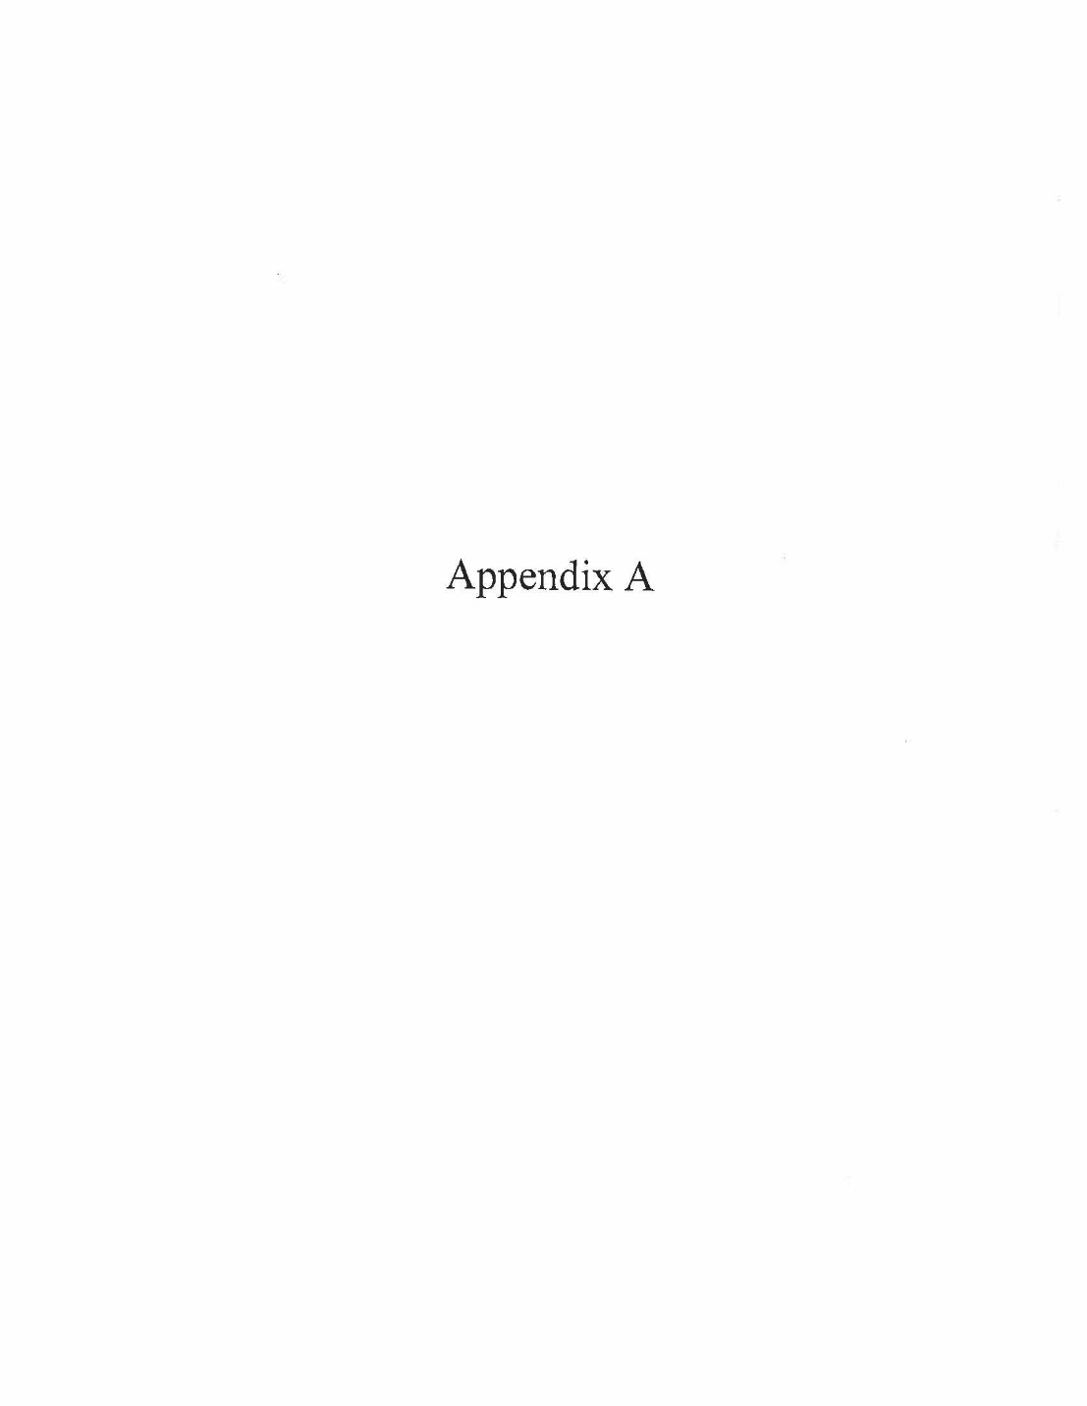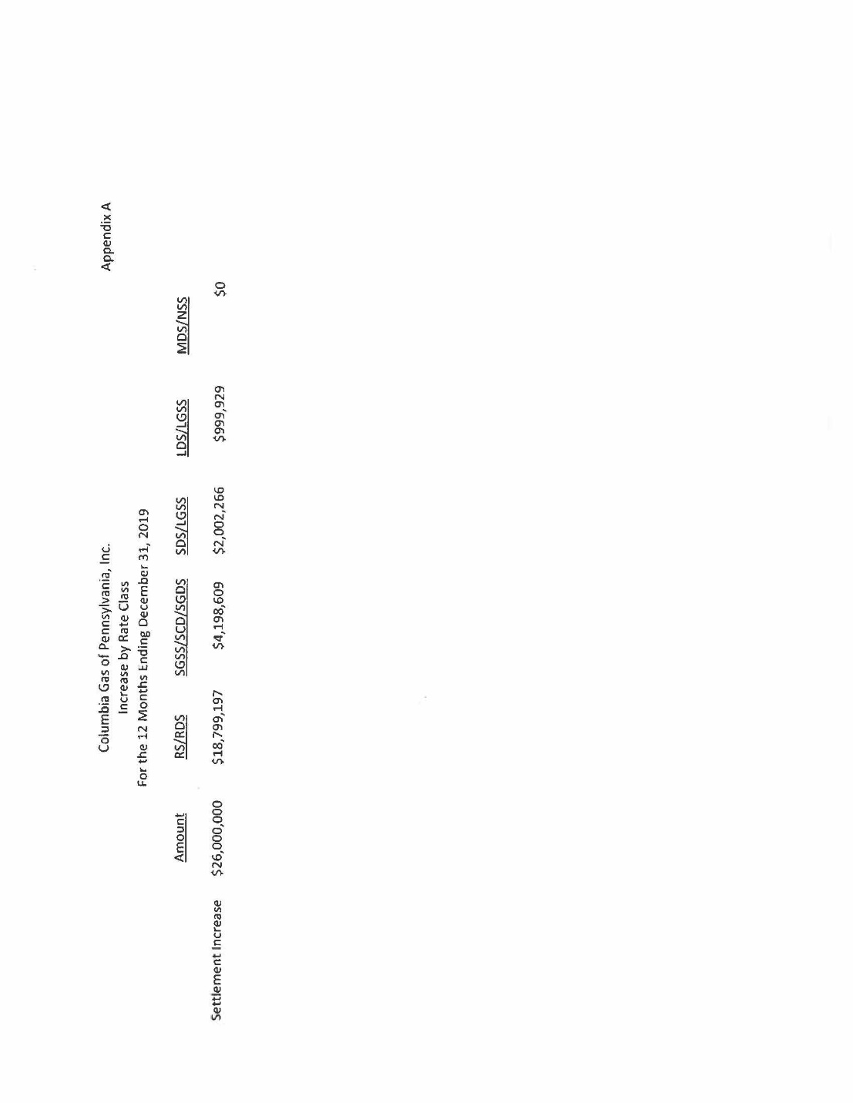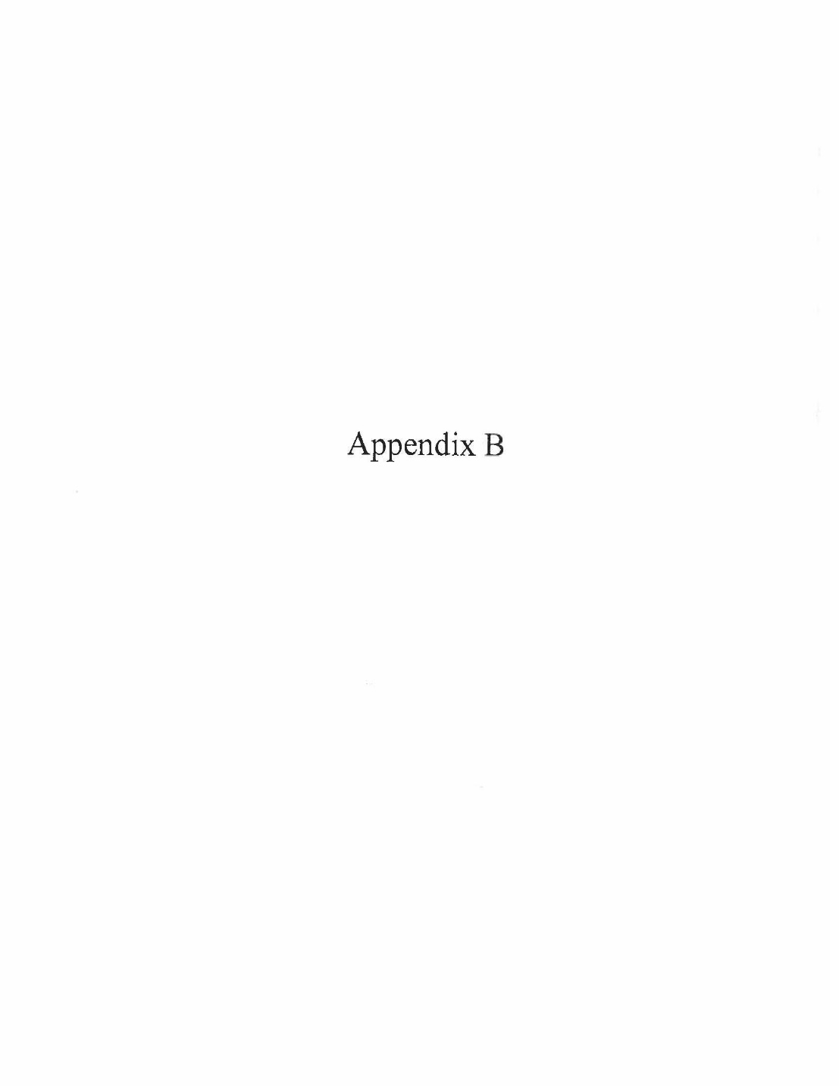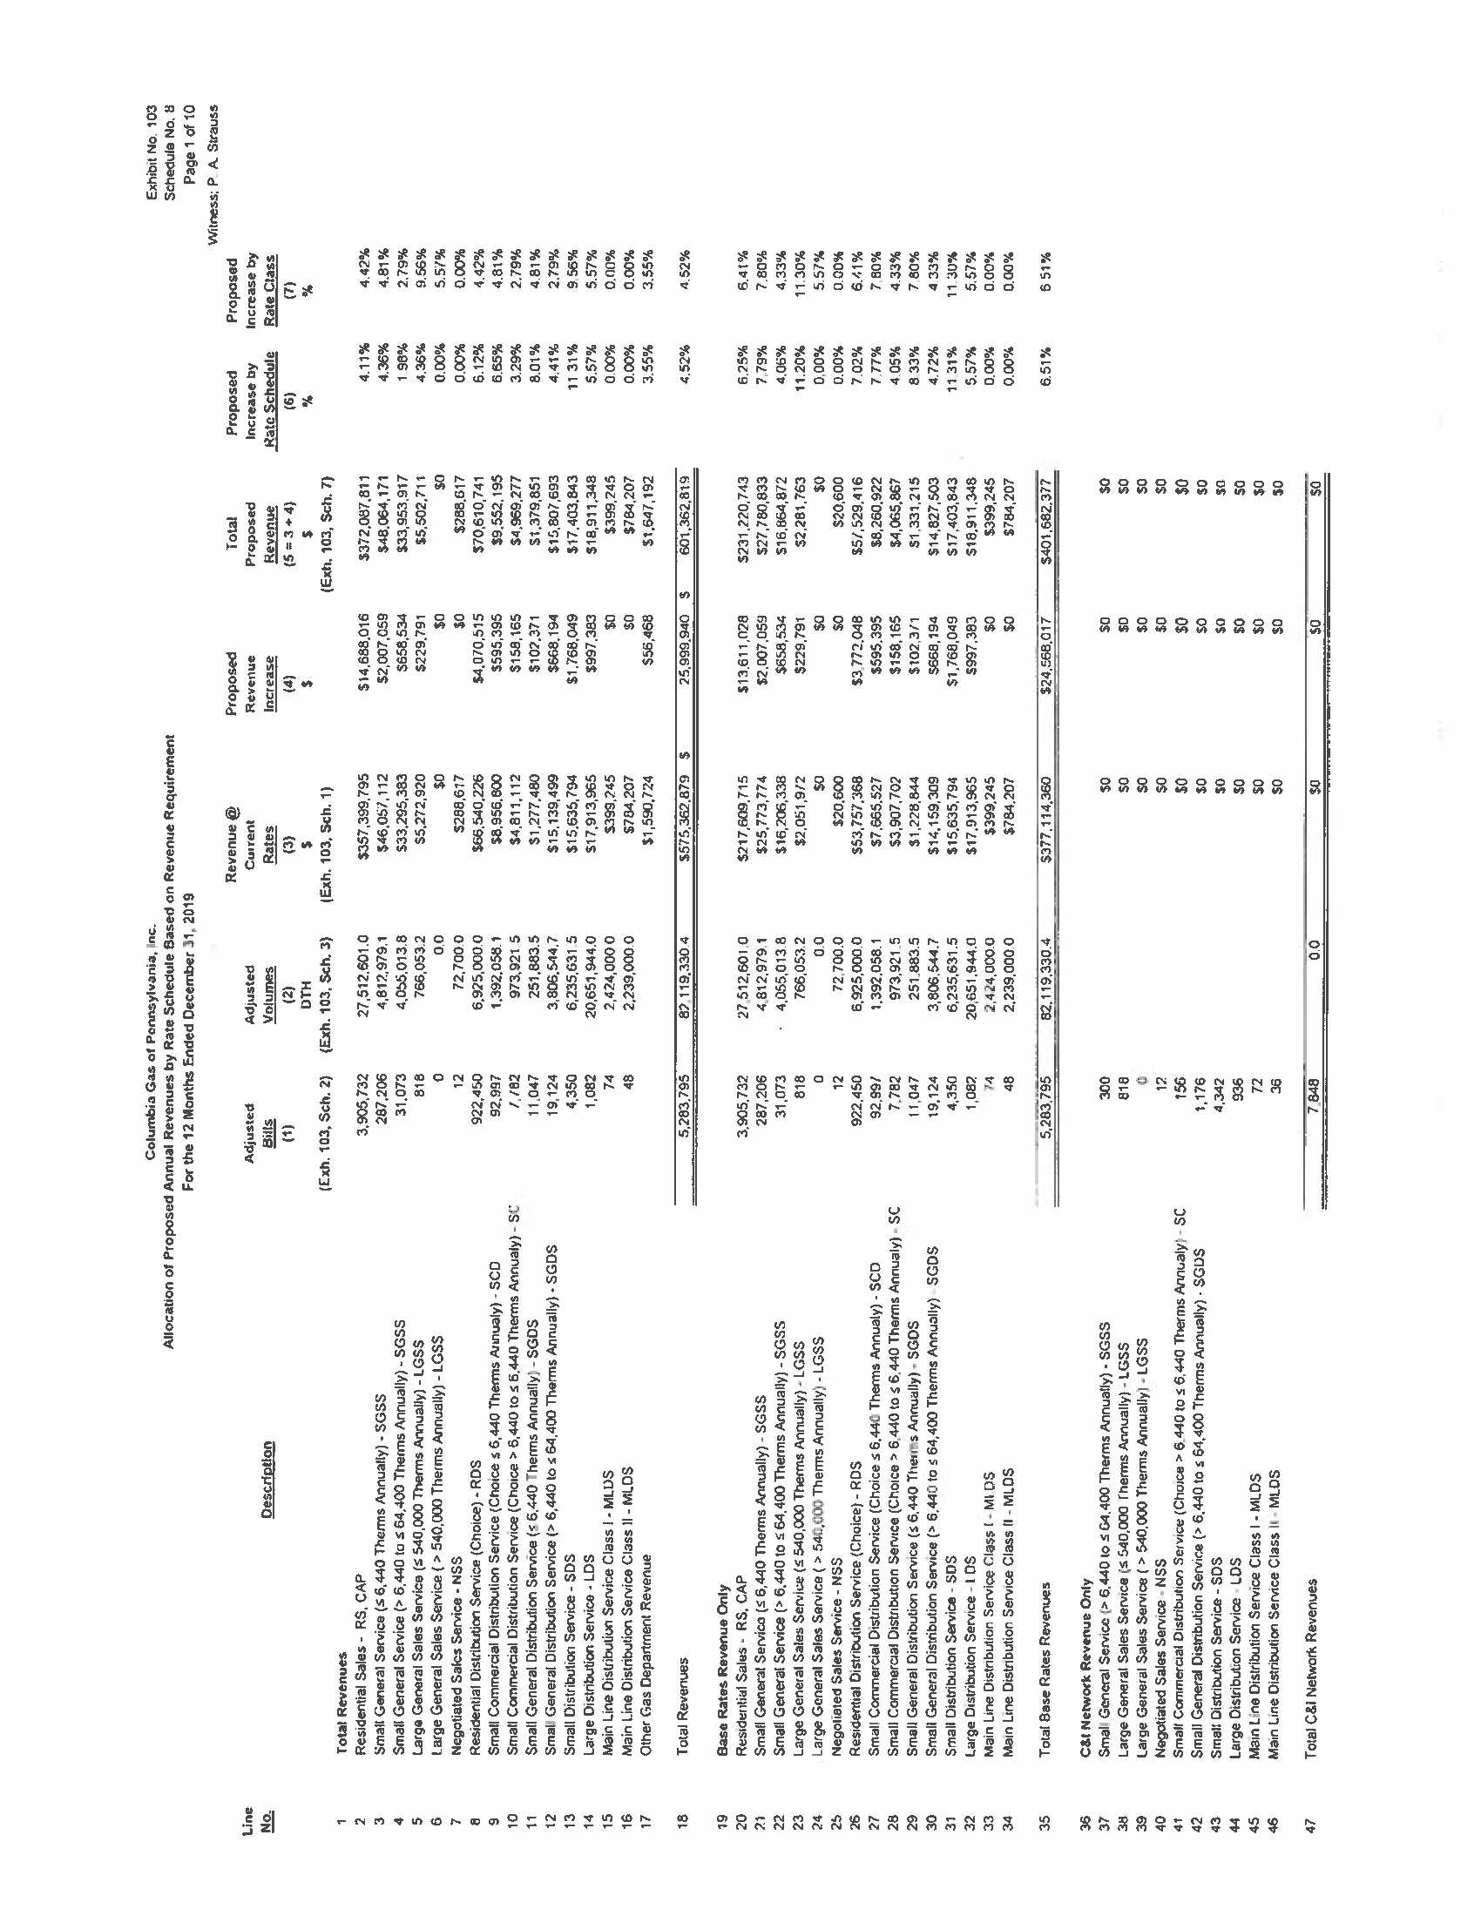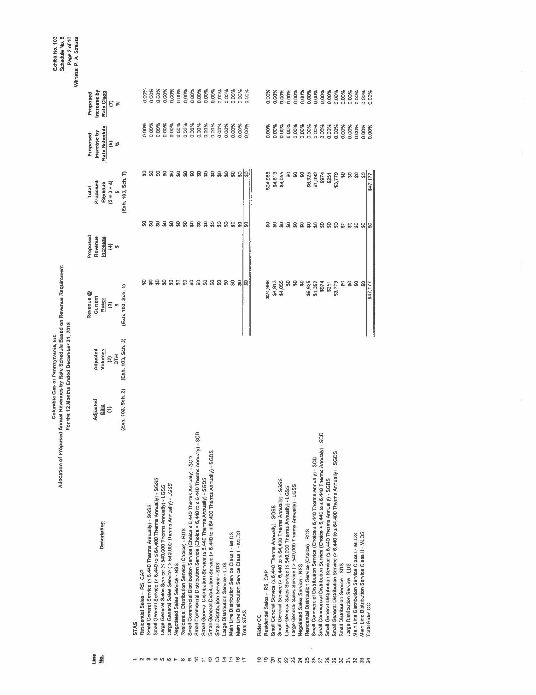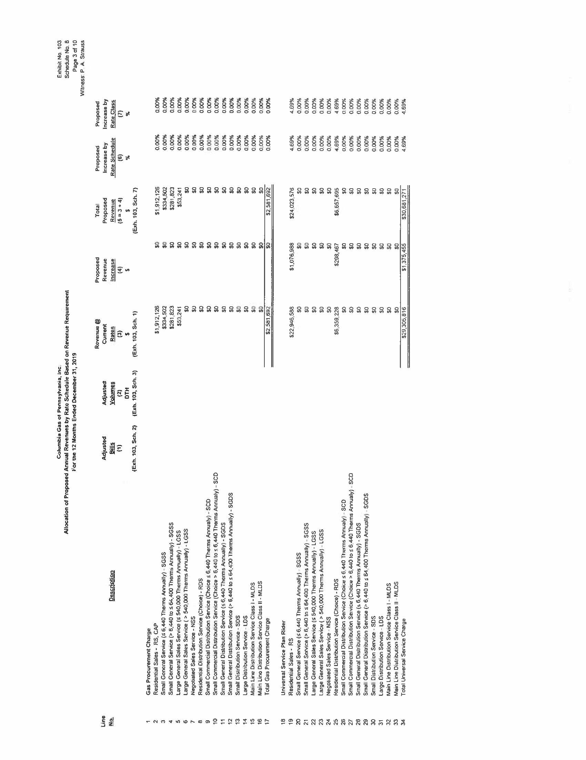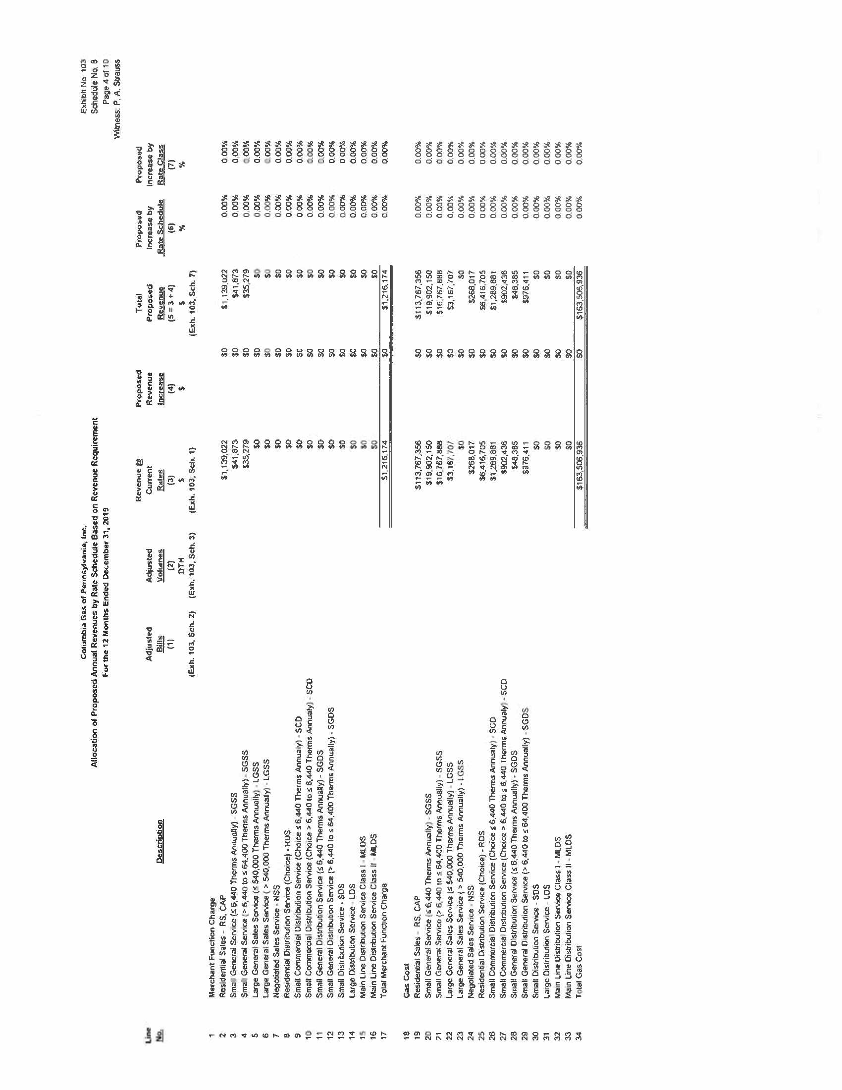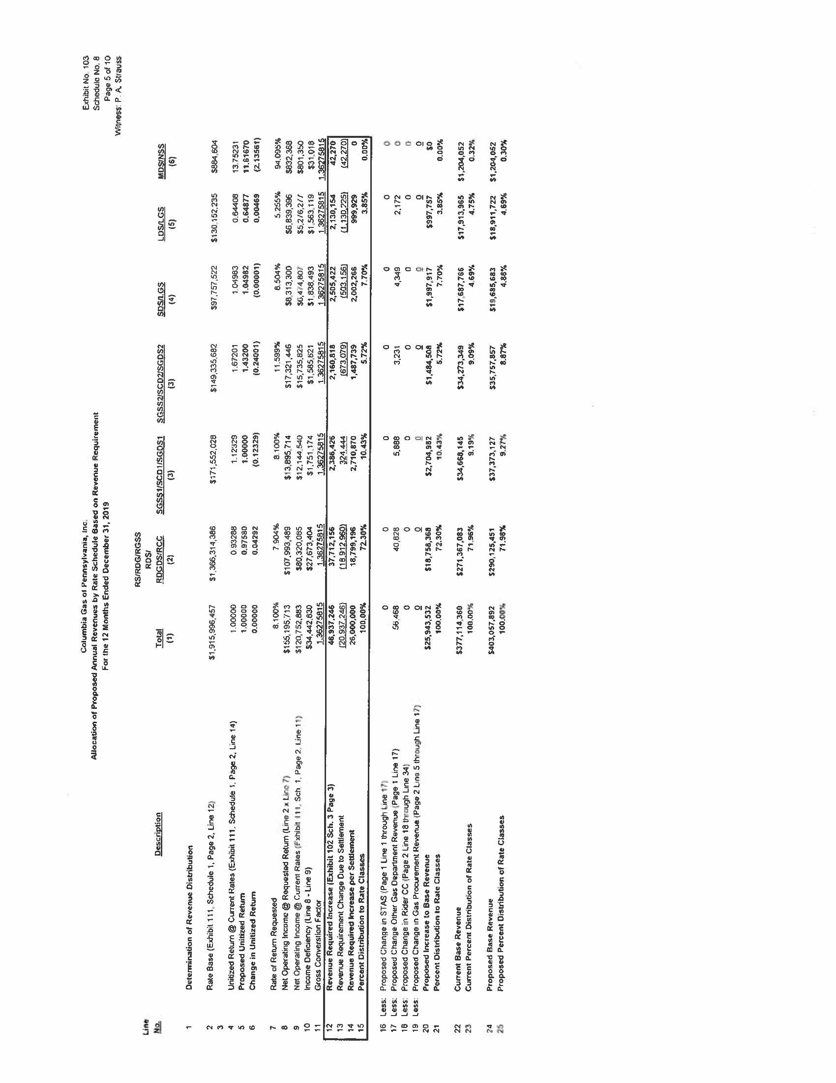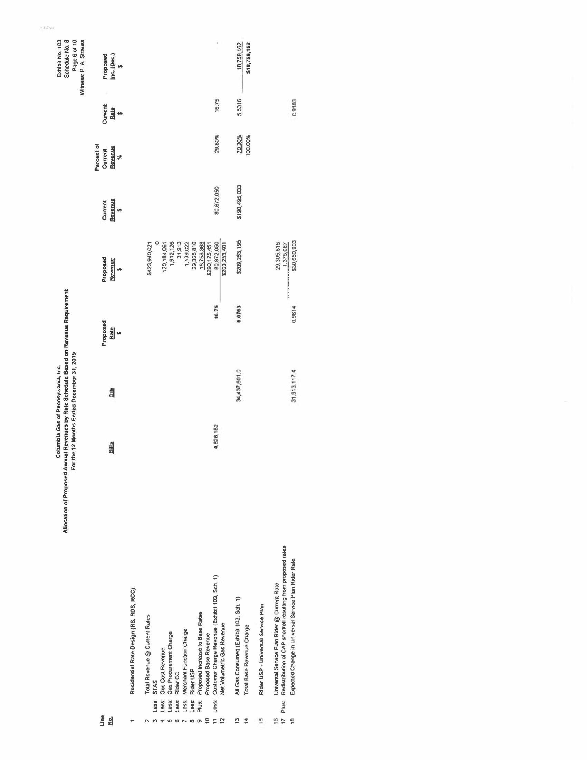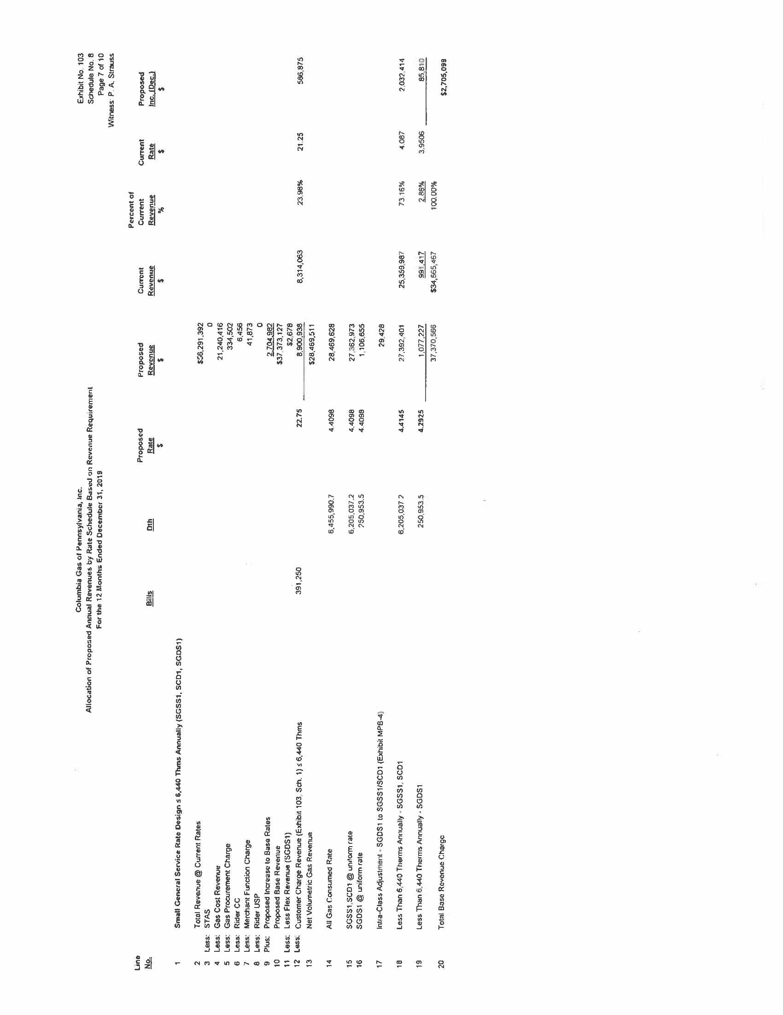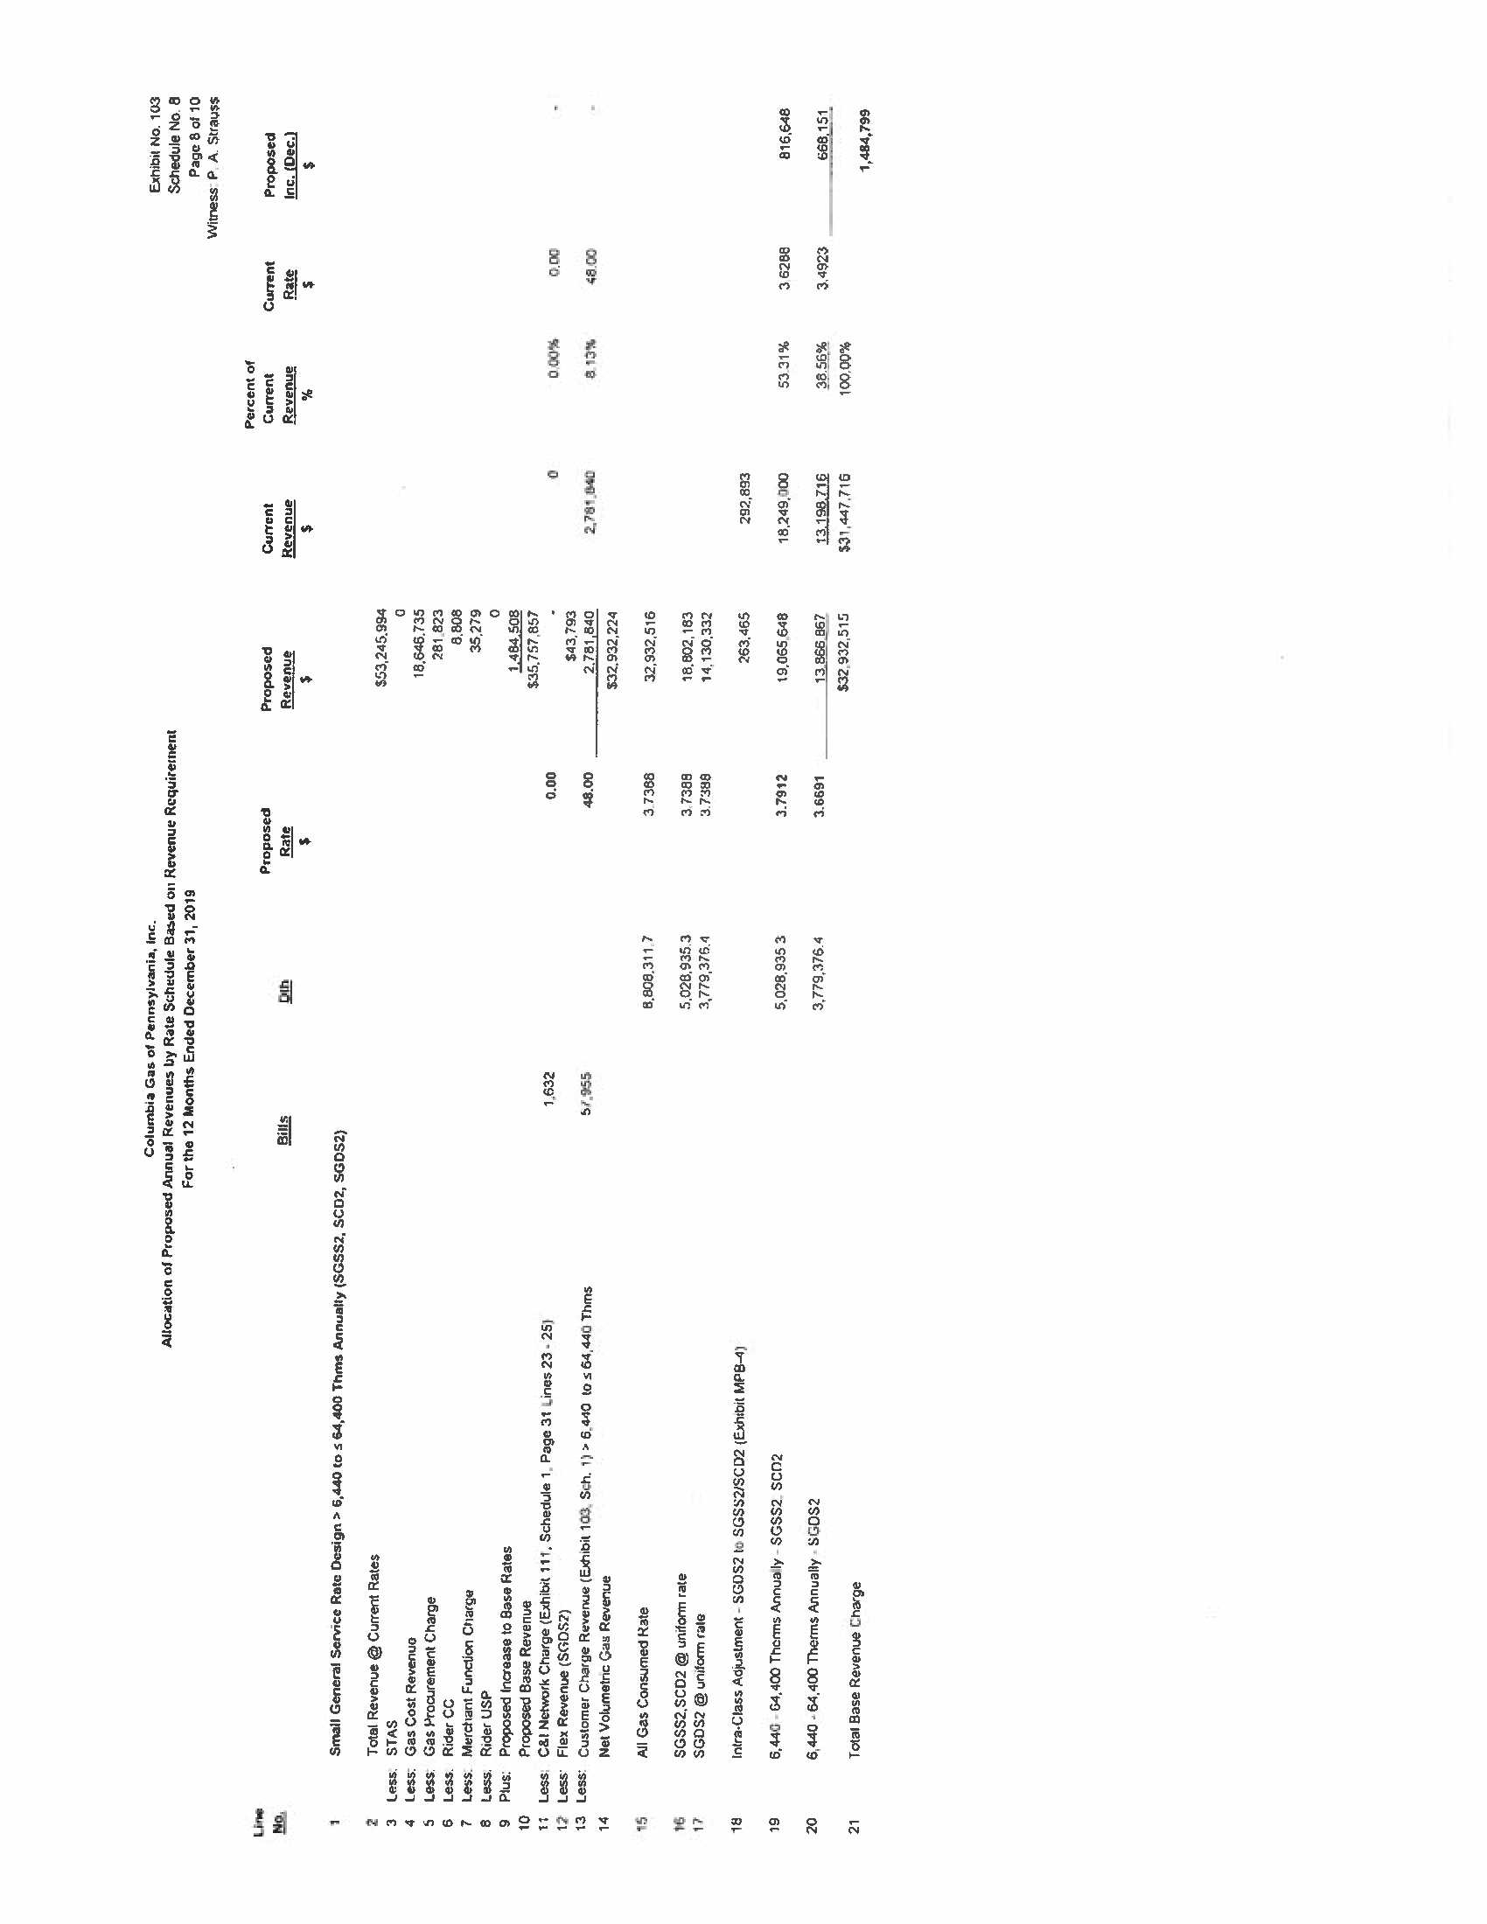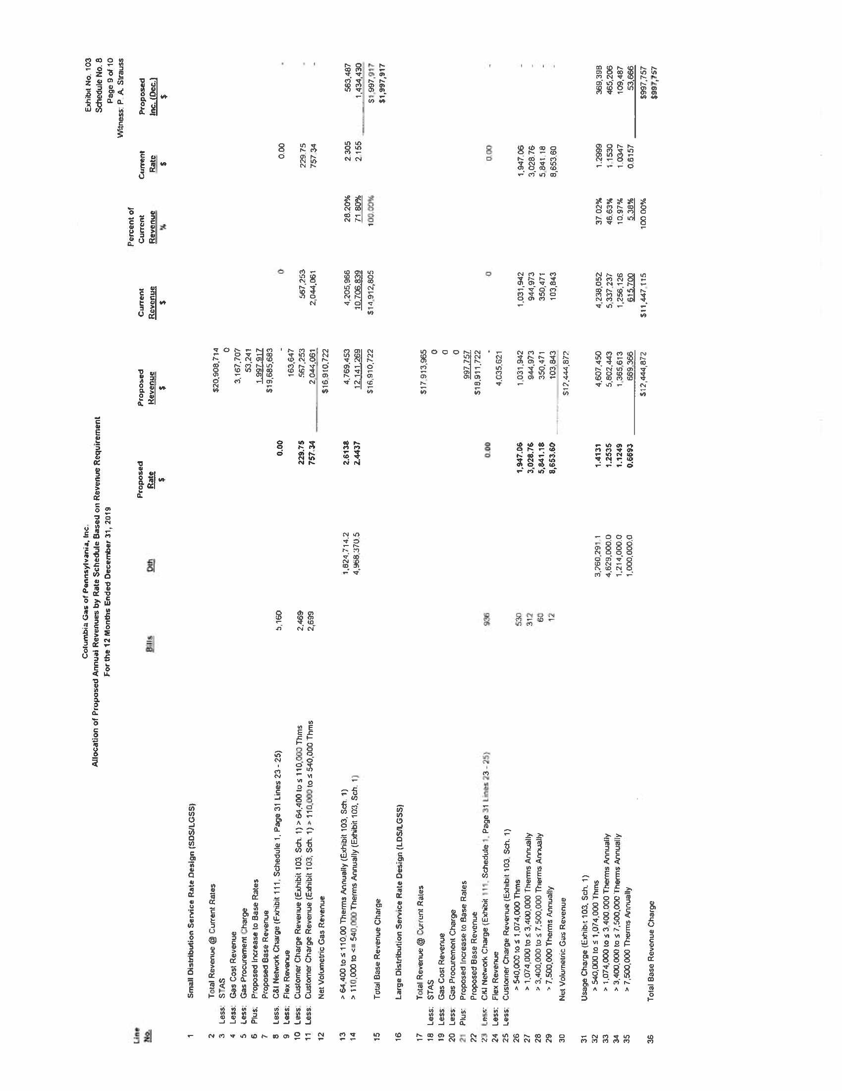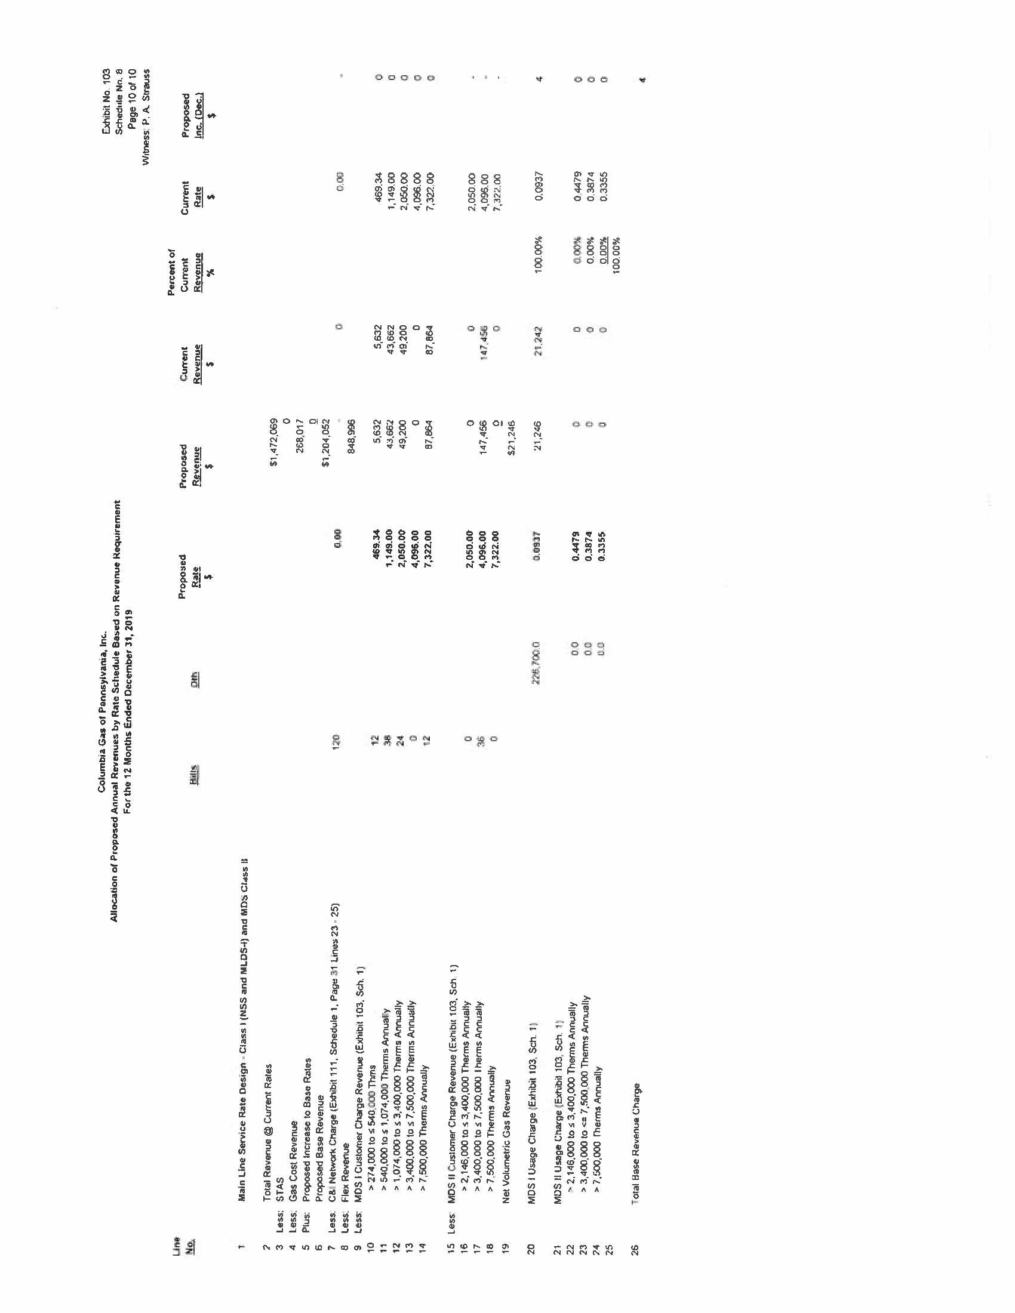

The Joint Petitioners who proposed the Partial Settlement involve all active Parties in the proceeding as follows: the Commission’s Bureau of Investigation and Enforcement (I&E), the OCA, the Office of Small Business Advocate (OSBA), Columbia Industrial Intervenors (CII), the NGS Parties, Direct Energy Business, LLC, Direct Energy Services, LLC, and Direct Energy Business Marketing, LLC (herein collectively referred to as the Direct Energy Companies), the Coalition for Affordable Utility Service and Energy Efficiency in Pennsylvania (CAUSE-PA), the Community Action Association of Pennsylvania (CAAP), Penn State University (PSU) and Columbia (hereinafter collectively referred to as the Joint Petitioners).
See also, Tax Cuts and Jobs Act of 2017 Temporary Rates Order, Docket No. M-2018-2641242, at 15 (Order entered May 17, 2018).
The four individual Columbia customers who had filed formal complaints – G. Blair Bauer, at Docket No. C-2018-3001319; Philip L. Bloch, at Docket No. C-2018-3001634; Robin A. Harrison, at Docket No. C-2018-3002595; and Patricia Southorn, at Docket No. C-2018-3000779 – did not attend the Prehearing Conference, did not file testimony, and did not otherwise actively participate in the rate proceeding. These four inactive Parties were provided notice and opportunity to be heard; however, they declined to participate. As indicated on the Certificate of Service, Columbia served a copy of the proposed Settlement on the four inactive Complainants.
1 Pa. C.S. § 1922(1), PA Financial Responsibility Assigned Claims Plan v. English, 541 Pa. 424, 430-431, 64 A.2d 84, 87 (1995).
OSBA Statement in Support at 8.
A 3% deadband means that a billing adjustment will only occur if the variation of actual heating degree days is lower than 97% or higher than 103% of the normal heating degree days for an individual billing cycle.
Petition of Columbia Gas of Pennsylvania, Inc. For Approval to use Penalty Credit and Refund Proceeds for its Residential Hardship Fund, Docket No. P-2018-3000160 (Order entered June 14, 2018).

