COMMONWEALTH OF PENNSYLVANIA
PENNSYLVANIA PUBLIC UTILITY COMMISSION
400 NORTH STREET, HARRISBURG PA 17120
Formal Complaint
Docket #: C-2019-3008081
Date Served: February 27,2019

THOMAS T NIESEN
THOMAS NIESEN & THOMAS LLC
212 LOCUST STREET SUITE 302
HARRISBURG PA 17101

RE: PA PUC vs BUCK HILL WATER COMPANY
Rate Case Docket #: R-2019-3007103

Dear Sir:

A Formal Complaint has been filed against you in the above-captioned matter before the Pennsylvania Public Utility Commission by Office of Small Business Advocate.

This true and correct copy of the complaint has been filed of record with the Pennsylvania Public Utility Commission. Both the Pennsylvania Public Utility Code, 66 Pa. C.S. and the Commission’s regulations at 52 Pa. Code Section 1.53, requires the Commission to serve on each party named in a Formal Complaint a copy of the complaint.

Within ten (10) days from the above date of service, you may either satisfy or answer this complaint in accordance with the provisions of 52 Pa Code, §5.61(d).

When filing your answer to the Formal Complaint, please reference the “Formal Complaint Docket Number” located in the upper-right hand corner of this Notice.

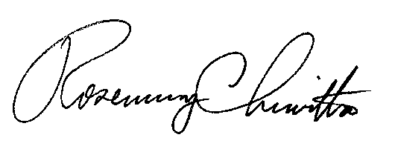
Very Truly Yours,

Rosemary Chiavetta
Secretary

RC:Jbs

(SEAL)

Certified Mail
Return Receipt Requested

