PENNSYLVANIA
PUBLIC UTILITY COMMISSION
Harrisburg, PA 17105-3265

Public Meeting held March 28, 2019

Commissioners Present:

Gladys M. Brown, Chairman
David W. Sweet, Vice Chairman
Norman J. Kennard
Andrew G. Place
John F. Coleman, Jr.

Pennsylvania Public Utility Commission,  Bureau of Investigation and Enforcement  v.  Great American Power, LLC |  | M-2018-2617335

Opinion and Order

BY THE COMMISSION:

Before the Pennsylvania Public Utility Commission (Commission) for consideration and disposition is a proposed Settlement Agreement (Settlement) filed on October 29, 2018, by the Commission’s Bureau of Investigation and Enforcement (I&E) and Great American Power, LLC (Great American or Company) (collectively, the Parties), with respect to an informal investigation conducted by I&E regarding alleged marketing and sales practices by Great American, an electric generation supplier (EGS) in Pennsylvania. The investigation was initiated in response to allegations that during the period from October 2015 through June 2017, sales agents on behalf of Great American were going door-to-door attempting to sell electricity, without the required solicitation permits and without properly notifying the Commission’s Bureau of Consumer Services. Such activities occurred in Millersburg, Dauphin County, PA; Mount Joy, Lancaster County, PA; Cumru Township, Berks County, PA; and Lower Milford Township, Lehigh County, PA. Both Parties submitted Statements in Support of the Settlement. I&E submits that the terms of the proposed Settlement reflect a carefully balanced compromise of the interests of the Parties in the proceeding and in the public interest. Great American submits that it agreed to all of the terms and conditions of the Settlement Agreement, including the monetary penalty amount and that approval of the Settlement is in the public interest. We will issue the Settlement for comments.

Background

On June 27, 2017, the Commission’s Bureau of Consumer Services became aware of a Facebook post by the Millersburg Borough Police Department (MBPD) regarding multiple residents who complained that two sales agents were going door-to-door attempting to sell electricity in Millersburg, PA (hereinafter referred to as “Millersburg incident”). When questioned, the agents told MBPD Officers that they were working for Great American. The officers issued citations to both agents for conducting door-to-door marketing in Millersburg without the required solicitation permits. Settlement at 4.

On June 29, 2017, BCS contacted Great American regarding the Millersburg incident and requested that the Company review its sales force and practices in Millersburg to determine if the agents in question did in fact work for Great American. BCS also informed Great American that it had no record of being notified by Great American about its door-to-door marketing and sales activities as required by Section 111.4(a) of the Commission’s Regulations, 52 Pa. Code § 111.14(a). Settlement at 4-5.

Great American responded to BCS that upon its investigation determined that those agents, who were obtained through a third-party vendor, had been working on door-to-door marketing campaigns on behalf of the Company. However, since its third-party vendor provides agents to other EGSs, Great American could not confirm that the agents in question were marketing on behalf of Great America during the day of the Millersburg incident. Great American alleged that Millersburg was not a targeted area for its June 2017 door-to-door marketing campaign and did not find any such activity in Millersburg during that time period. Settlement at 5. Great American also agreed to begin notifying BCS of its door-to-door marketing activities on a monthly basis. Settlement at 5.

Subsequently, BCS referred this matter to I&E for an investigation whereupon I&E instituted an informal investigation of Great American based on the information provide by BCS I&E determined that the BCS allegations warranted further investigation to examine whether the actions of Great American or the agents of Great American violated any Commission Regulations and Orders. Accordingly, I&E submitted data requests to Great American related to the Millersburg incident.

Based on the Great American’s responses to I&E’s several sets of data requests, I&E determined that the Company actually began its door-to-door marketing in October 2015 and had conducted seventeen door-to-door marketing and sales campaigns in Millersburg as well as other areas of the state between October 2015 to June 2017. Great American confirmed that the marketing and sales campaign were conducted without notifying BCS and local distribution companies (LDCs) of those activities. Settlement at 5.

I&E also determined that the Millersburg incident was not the only incident where agents were found engaging in door-to-door marketing on behalf of Great American without the proper solicitation permits for a particular area. I&E discovered that in January 2017, Great American’s third-party vendor received a complaint from Mount Joy, Lancaster County, PA regarding agents engaging in door-to-door marketing on behalf of Great American without the required solicitation permits for that area. Additionally, in June 2017, Great American received two similar complaints from Lower Milford Township, Lehigh County, PA and Cumru Township, Berks County, PA. Settlement at 6.

I&E’s investigation concluded that Great American acknowledged it conducted internal investigations into all five incidents where agents were found engaging in door-to-door marketing on behalf of Great American without the proper solicitation permits, but that the Company did not produce any formal written investigative report regarding these incidents. Great American claimed that it cannot provide the exact number of agents who were found engaging in door-to-door marketing on behalf of Great American in Mount Joy, Lower Milford Township, and Cumru Township, Pennsylvania. Great American resumed door-to-door marketing and began notifying BCS and LDCs about its door-to-door marketing and sales activities on a monthly basis. Id.

I&E concluded from its investigation that the third-party agents acting on behalf of Great American violated provisions of Chapter 111 of the Commission’s Regulations concerning the Marketing and Sales Practices for the Retail Residential Energy Market. I&E was prepared to contend by the filing of a formal complaint that Great American’s conduct violated (1) Section 111.9 of the Commission’s Regulations, 52 Pa. Code § 111.9 on five counts because Great American failed to comply with local ordinances while conducting door-to-door marketing and sales activities. In addition, I&E, and (2) Section 111.14(a)-(b) on seventeen counts because Great American failed to notify BCS and the LDCs about the scheduled door-to-door marketing and sales activities. Great American acknowledges its errors and has put into effect appropriate measures that have been approved by I&E to ensure such oversight is not likely to reoccur. I&E Statement in Support at 4.

Thereafter, the Parties entered into negotiations and agreed to resolve the matter in accordance with the Commission’s policy to promote settlements at 52 Pa. Code § 5.231. The Parties filed the instant Settlement on October 29, 2018.

Terms of the Settlement

Pursuant to the proposed Settlement, Great American will pay a civil penalty of $13,500, within thirty days of the Commission’s final order approving the Settlement, to resolve all allegations of unauthorized door-to-door marketing and sales practices and to fully and finally settle all possible liability and claims of alleged violation of the Commission’s Regulations arising from, or related to, the unauthorized door-to-door marketing and sales practices. The Company will not recover any portion of the civil penalty payment from Pennsylvania consumers.

The Settlement acknowledges that the Company has since taken corrective action and revised its marketing practices and implemented revisions to its operating procedures which will act as safeguards against future unauthorized EGS marketing and sales practices by its employees, agents and the Company’s third-party vendors. The settlement recites the Company’s modified procedures as follows:

i. Great American shall continue notifying BCS and LDCs of the Company’s door-to-door marketing and sales activities on a monthly basis, which shall include general, non-proprietary information about the activity, the period involved, and a general description of the geographical area in accordance with 52 Pa. Code § 111.14(a)-(b), respectively;

ii. In addition to Great American’s initial training of its internal marketing and sales representatives and third-party marketing and sales agents, the Company shall revise its Code of Conduct for Agents, Quality Assurance Program, and any and all training materials to require subsequent refresher training on current Commission regulations, statutes, policies, and orders on at least a quarterly basis;

iii. Great American shall revise its Code of Conduct for Agents, Quality Assurance Program, and any and all training materials provided to its internal marketing and sales representatives and third-party marketing and sales agents to emphasize compliance with local ordinances regarding door-to-door marketing and sales activities to ensure that the Company and its representatives and third-party agents properly adhere to 52 Pa. Code § 111.9(a);

iv. Great American shall self-report [footnote omitted] to the Commission any instance where the Company receives notice that anyone acting or purporting to act on its behalf receives a citation from law enforcement or a complaint, notification, report, or warning from a local municipality or township regarding the Company’s and/or agent’s failure to comply with local ordinances regarding door-to-door marketing and sales activities;

v. If Great American and/or its internal or third-party marketing and sales agent, acting on behalf of the Company, receives a citation from law enforcement or a complaint, notification, report, or warning from a local municipality or township regarding the Company’s and/or agent’s failure to comply with local ordinances regarding door-to-door marketing and sales activities, Great American shall conduct its own internal investigation and prepare a formal written investigative report, which shall include the Company’s findings, conclusions, and all corrective measures taken by the Company in response to the incident.

vi. Great American shall employ additional quality control measures for the Company and its third-party vendors to ensure that the Company and its third-party marketing and sales agents, acting on the Company’s behalf, comply with local ordinances regarding door-to-door marketing and sales activities. Those quality control measures shall include, but are not limited to, keeping records, in compliance with Great American’s records retention policy, of the locations where Great American and/or third-party vendors have obtained the required solicitation permits for door-to-door marketing and sales activities and comparing the locations of enrollments and sales to the Company’s records reflecting the locations where the Company and/or third-party vendors have acquired the necessary solicitation permits.

Settlement at 11-13.

In exchange for the actions taken by Great American, as described above, I&E agrees to forbear from initiating any formal complaint relating to the unauthorized door-to-door marketing and sales activities that are the subject of the proposed Settlement. The Settlement will not, however, affect the Commission’s authority to receive and resolve any formal or informal complaints filed by any affected party regarding the subject of the allegations of I&E’s informal investigation, except that no penalties beyond the $13,500 civil penalty amount agreed here may be imposed by the Commission for any action identified in the Settlement. Id. at 13.

The proposed Settlement is conditioned on the Commission’s approval without modification of any of its terms or conditions. If the Commission modifies the proposed Settlement, either Party may elect to withdraw from the Settlement and may proceed with litigation and, in such event the settlement agreement shall be void and of no effect. Such election to withdraw must be made in writing, filed with the Secretary of the Commission and served upon all parties within twenty business days after entry of an Order modifying the Settlement. Settlement at 14.

Discussion

Pursuant to our Regulations at 52 Pa. Code § 5.231, it is the Commission’s policy to promote settlements. The Commission must, however, review proposed settlements to determine whether the terms are in the public interest. Pa. PUC v. Philadelphia Gas Works, Docket No. M-00031768 (Order entered January 7, 2004).

Conclusion

Before issuing a decision on the merits of the proposed Settlement, and consistent with the requirement of 52 Pa. Code § 3.113(b)(3), we are providing an opportunity for interested parties to file comments regarding the proposed Settlement; THEREFORE,

IT IS ORDERED:

1. That this Opinion and Order, together with the attached Settlement Agreement, proposed Ordering Paragraph and Statements in Support thereof, shall be issued for comments by any interested party.

2. That a copy of this Opinion and Order, together with the attached Settlement Agreement, proposed Ordering Paragraph and the Statements in Support thereof, shall be served on the Office of Consumer Advocate and the Office of Small Business Advocate.

3. That within twenty (20) days from the date of entry of this Opinion and Order, interested parties may file comments concerning the proposed Settlement Agreement. Comments to the proposed Settlement Agreement may be filed either through eFiling for those parties who have an eFiling user account with the Pennsylvania Public Utility Commission or by paper copy. Paper copies shall be filed with the Secretary’s Bureau at the following address:

Rosemary Chiavetta, Secretary
Pennsylvania Public Utility Commission
Commonwealth Keystone Building
400 North Street
Harrisburg, PA, 17120

4. That, subsequent to the Commission’s review of comments filed in this proceeding, an Opinion and Order will be issued.

BY THE COMMISSION,

Rosemary Chiavetta
Secretary

(SEAL)

ORDER ADOPTED: March 28, 2019

ORDER ENTERED: March 28, 2019

ATTACHMENT
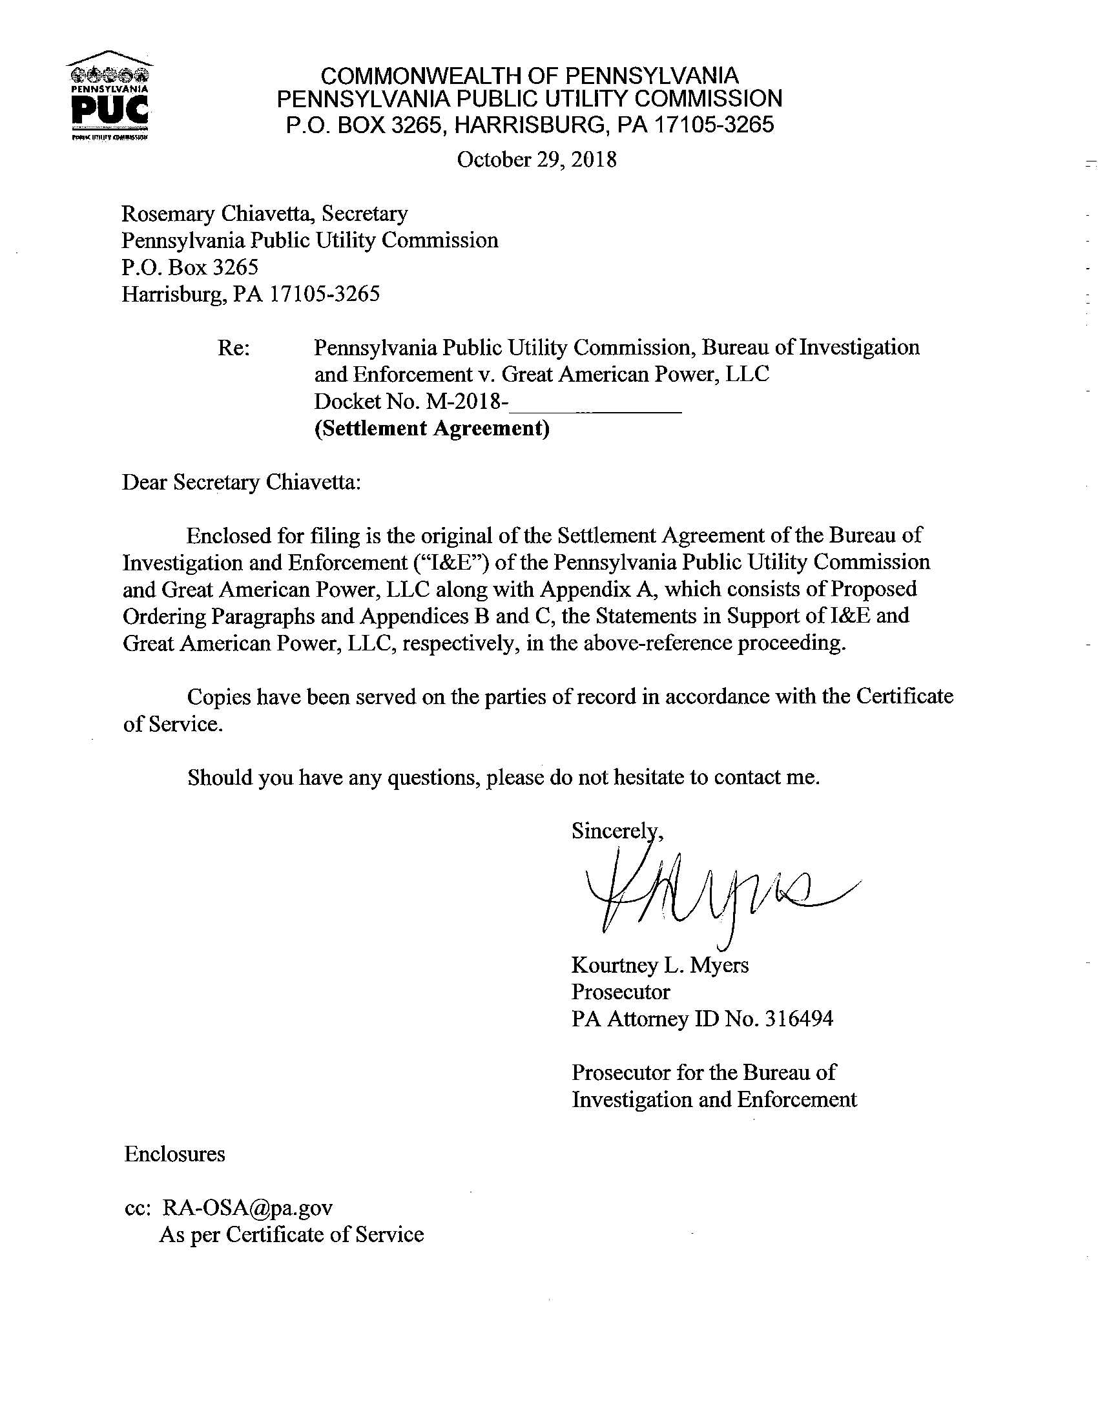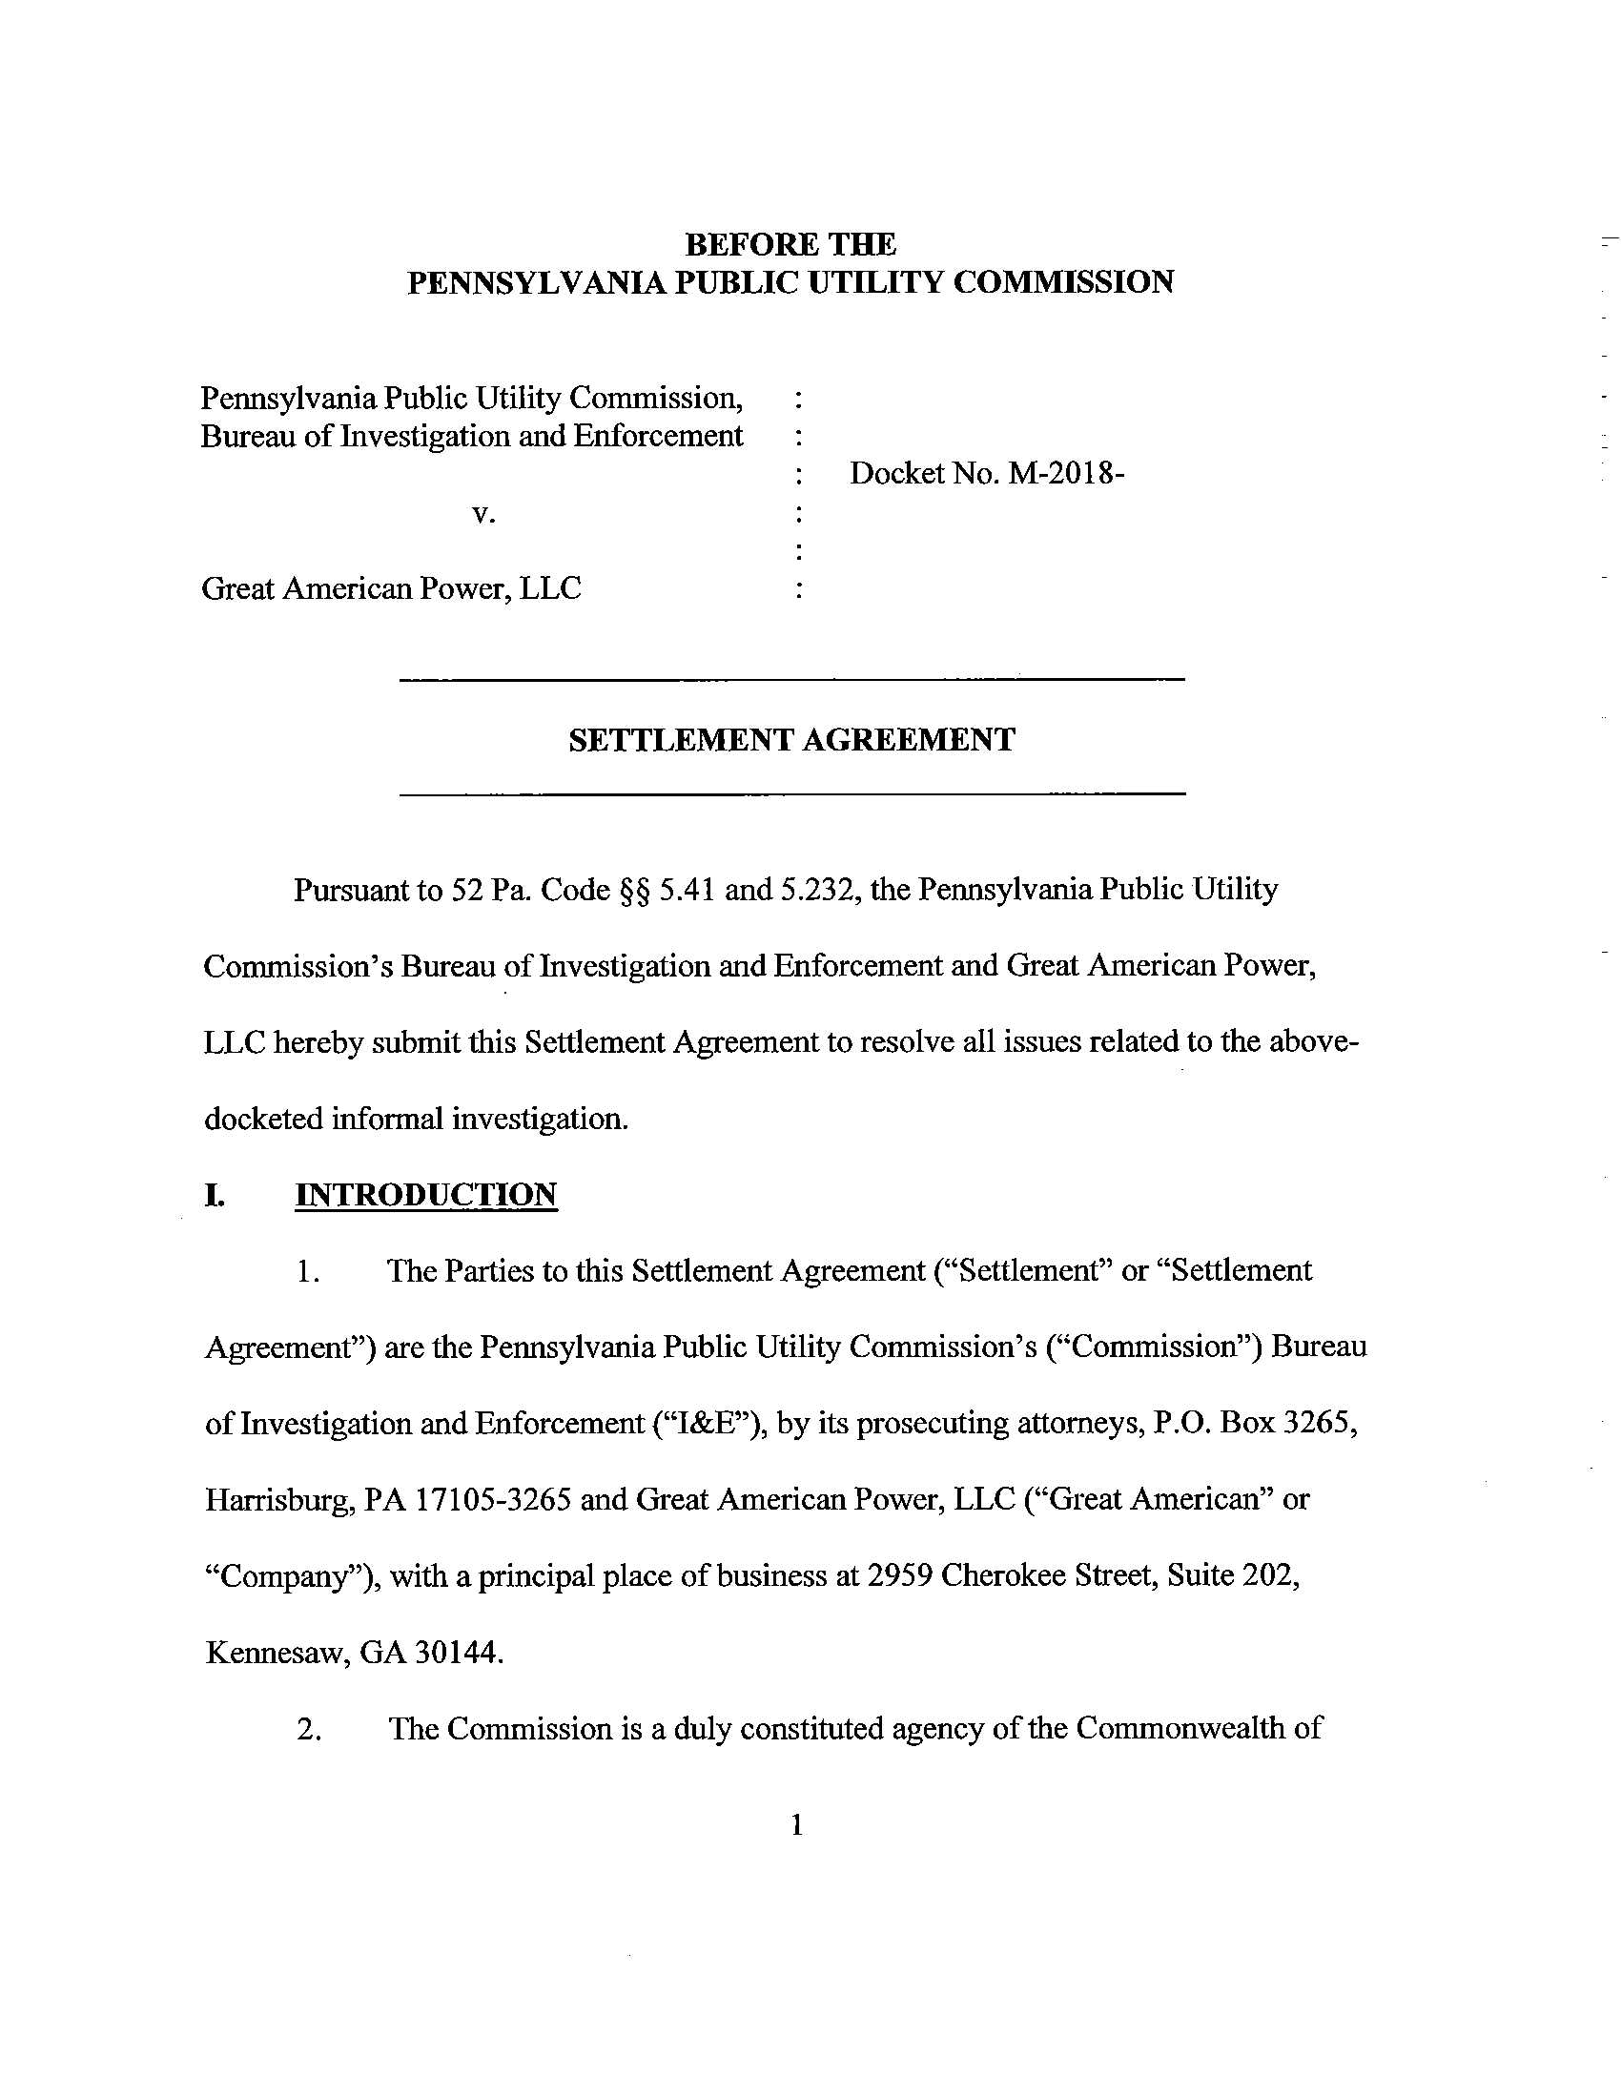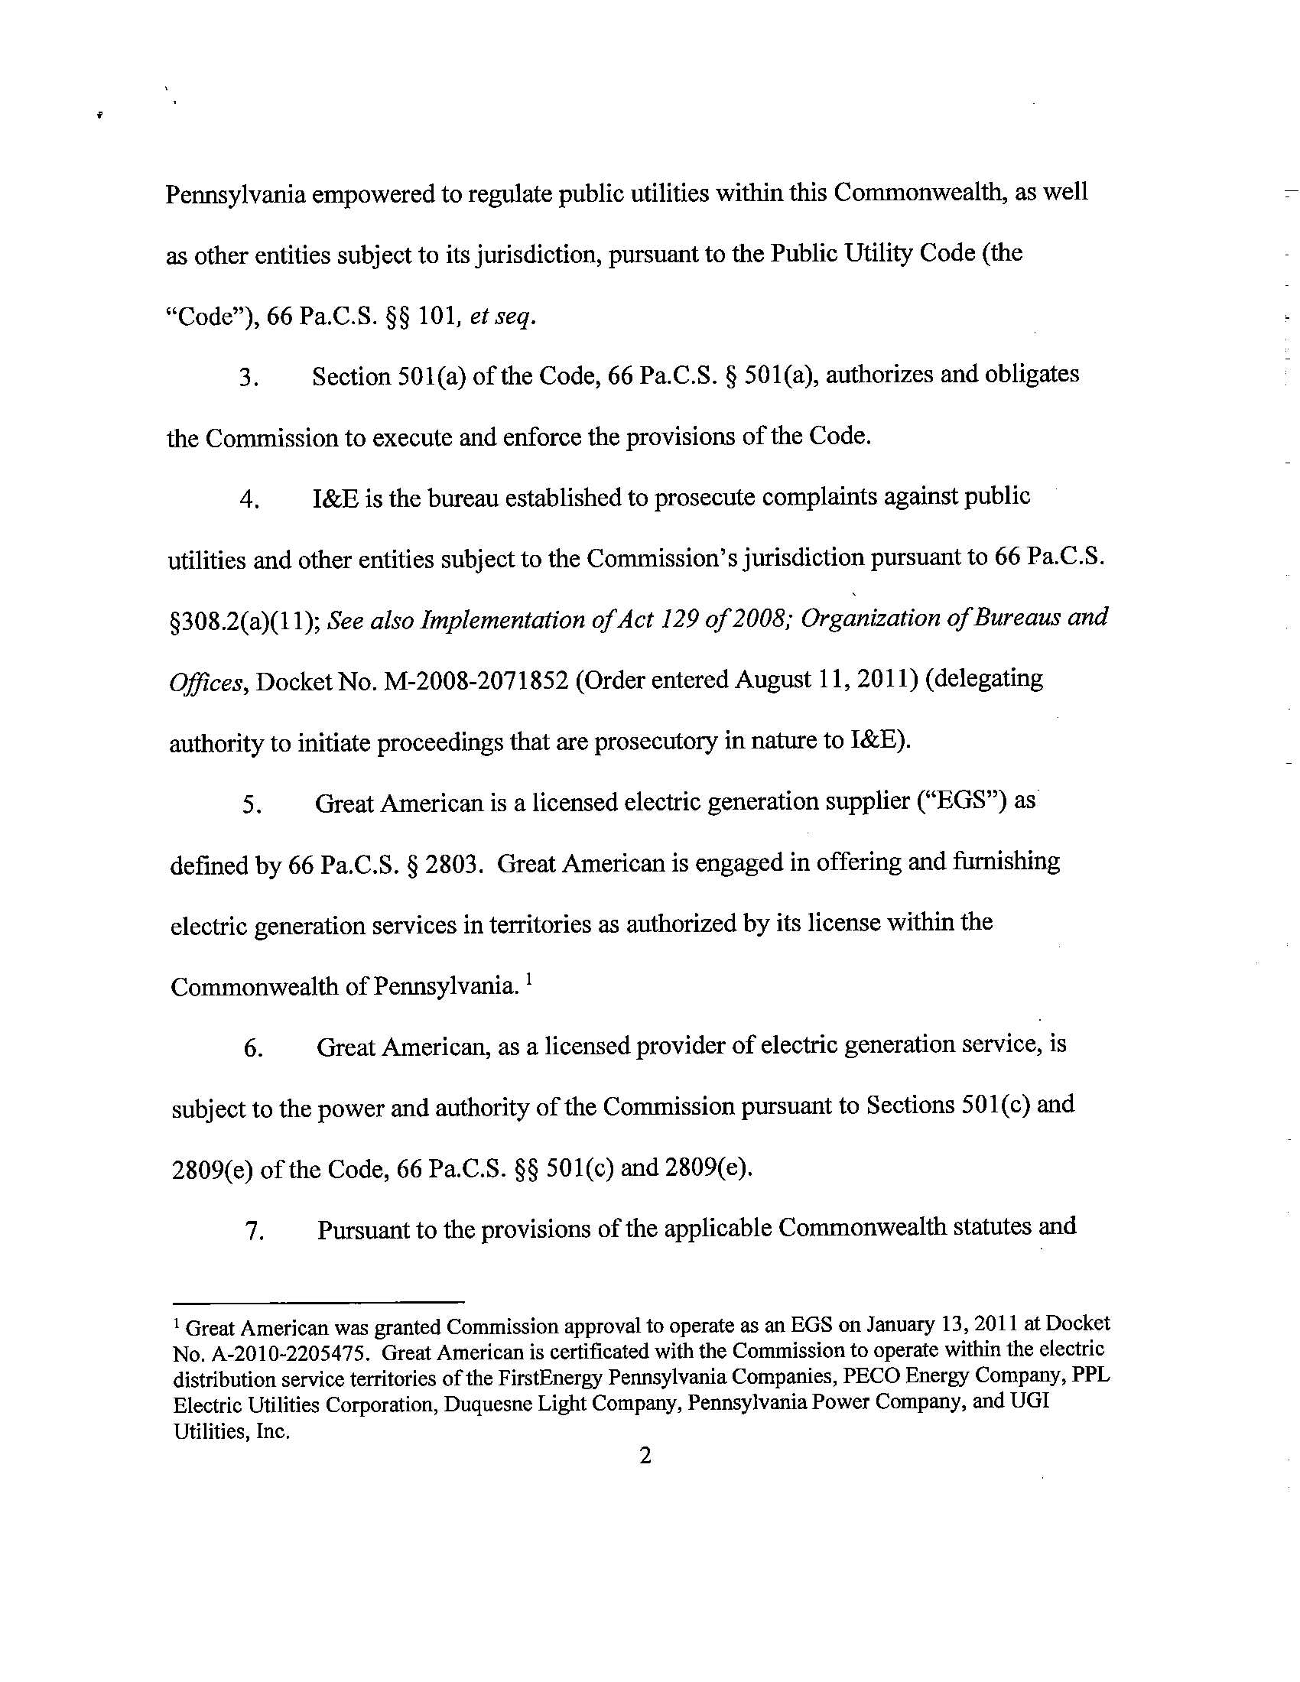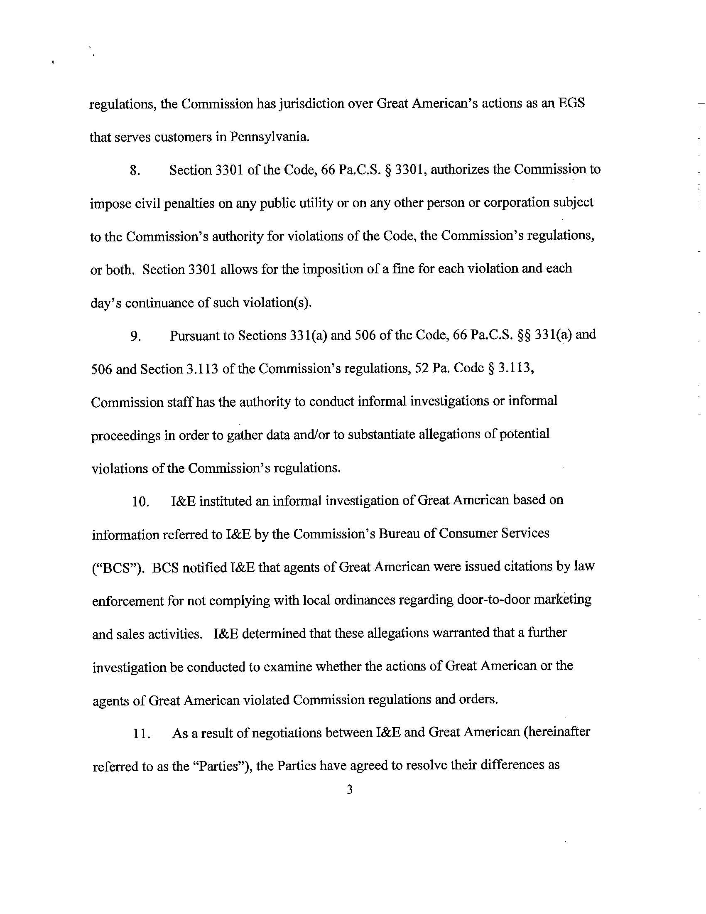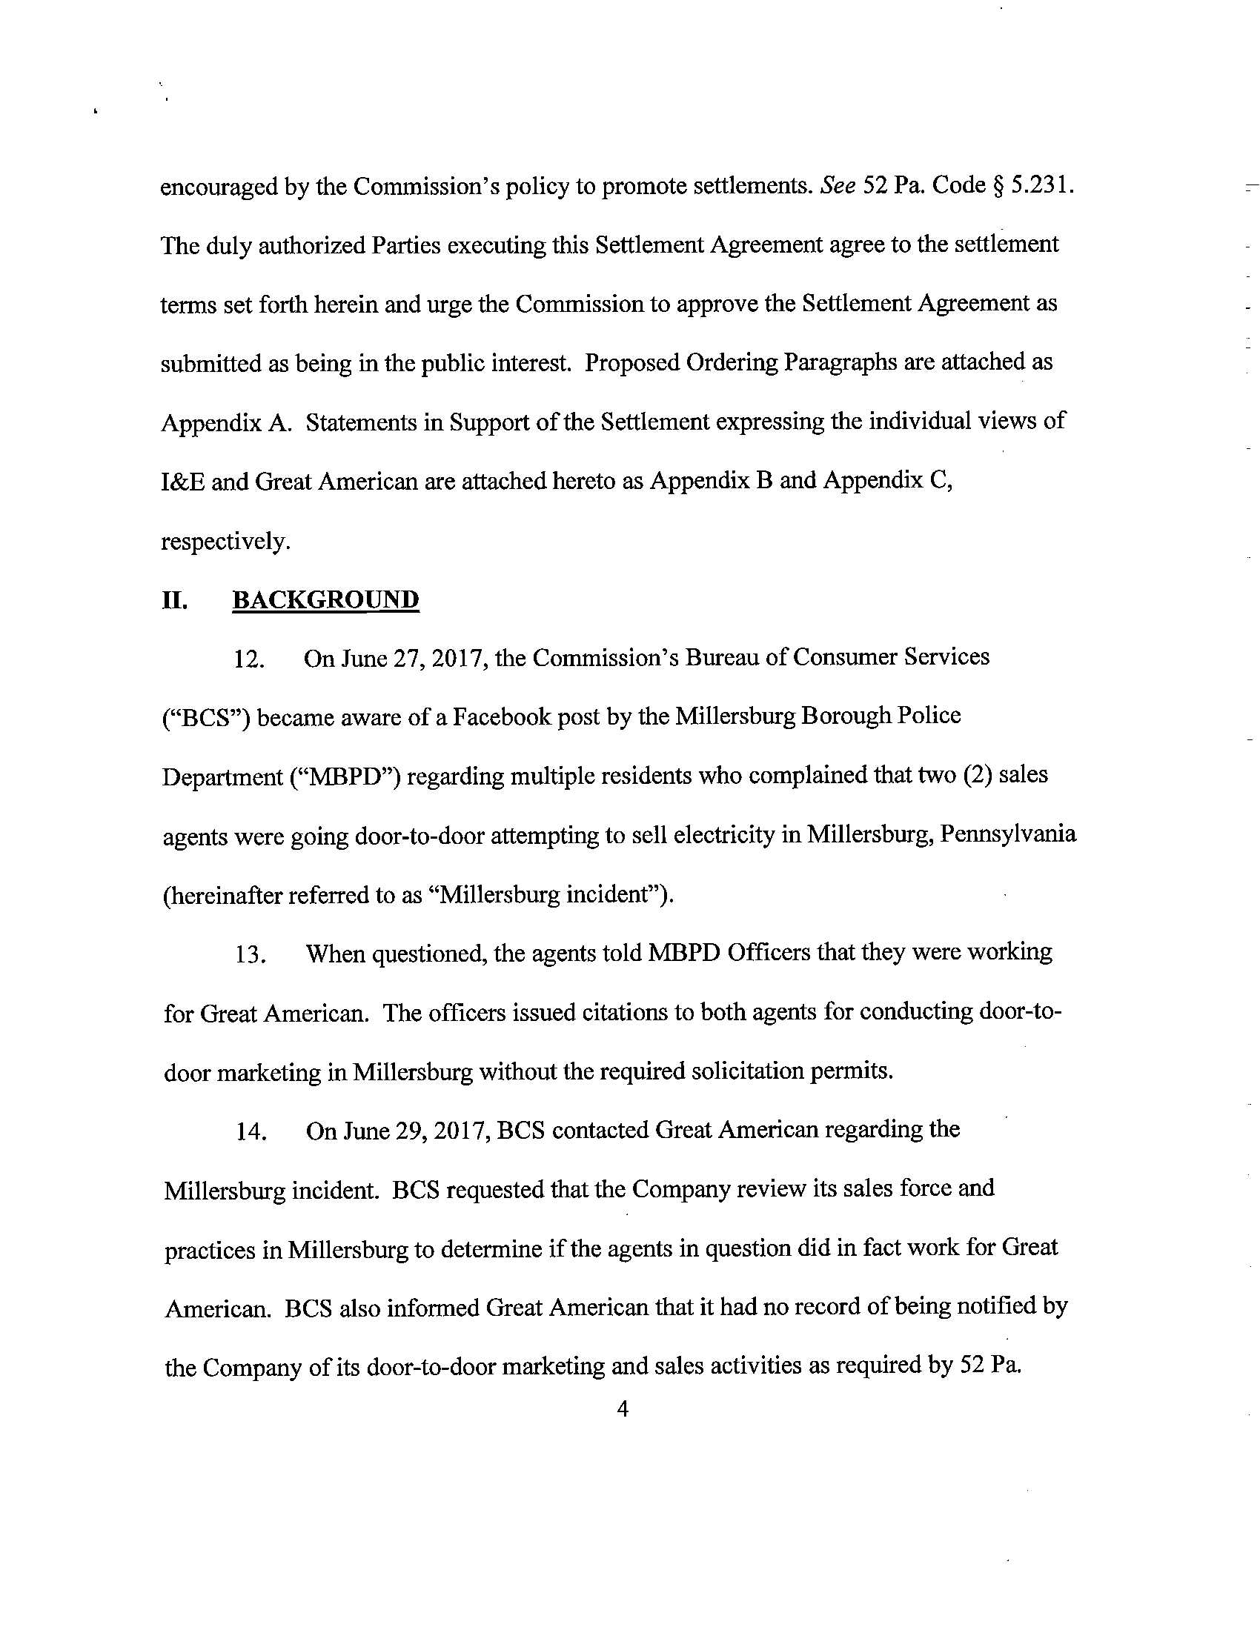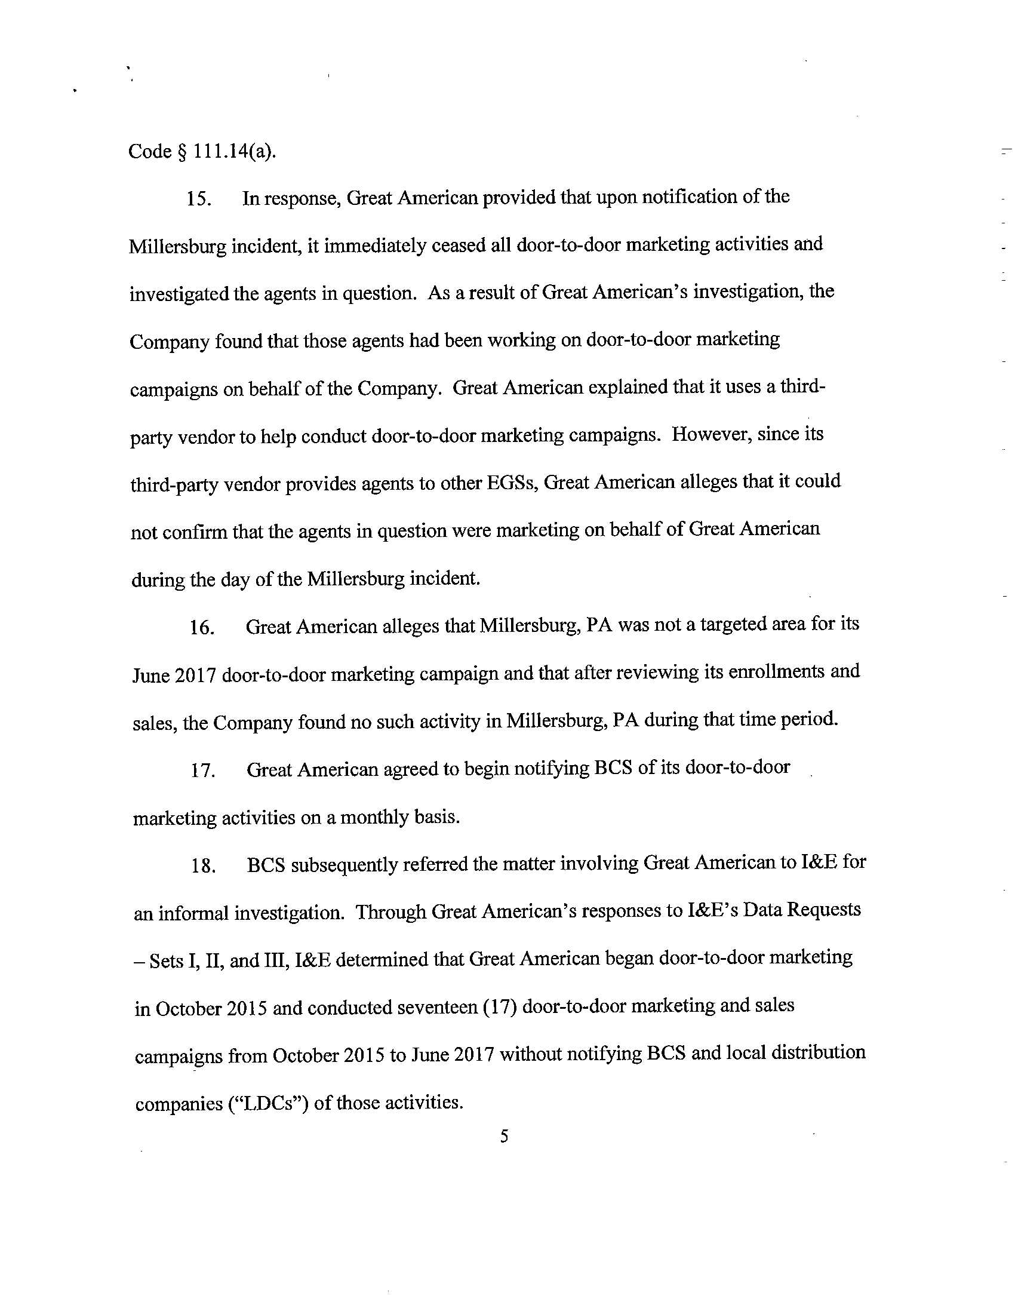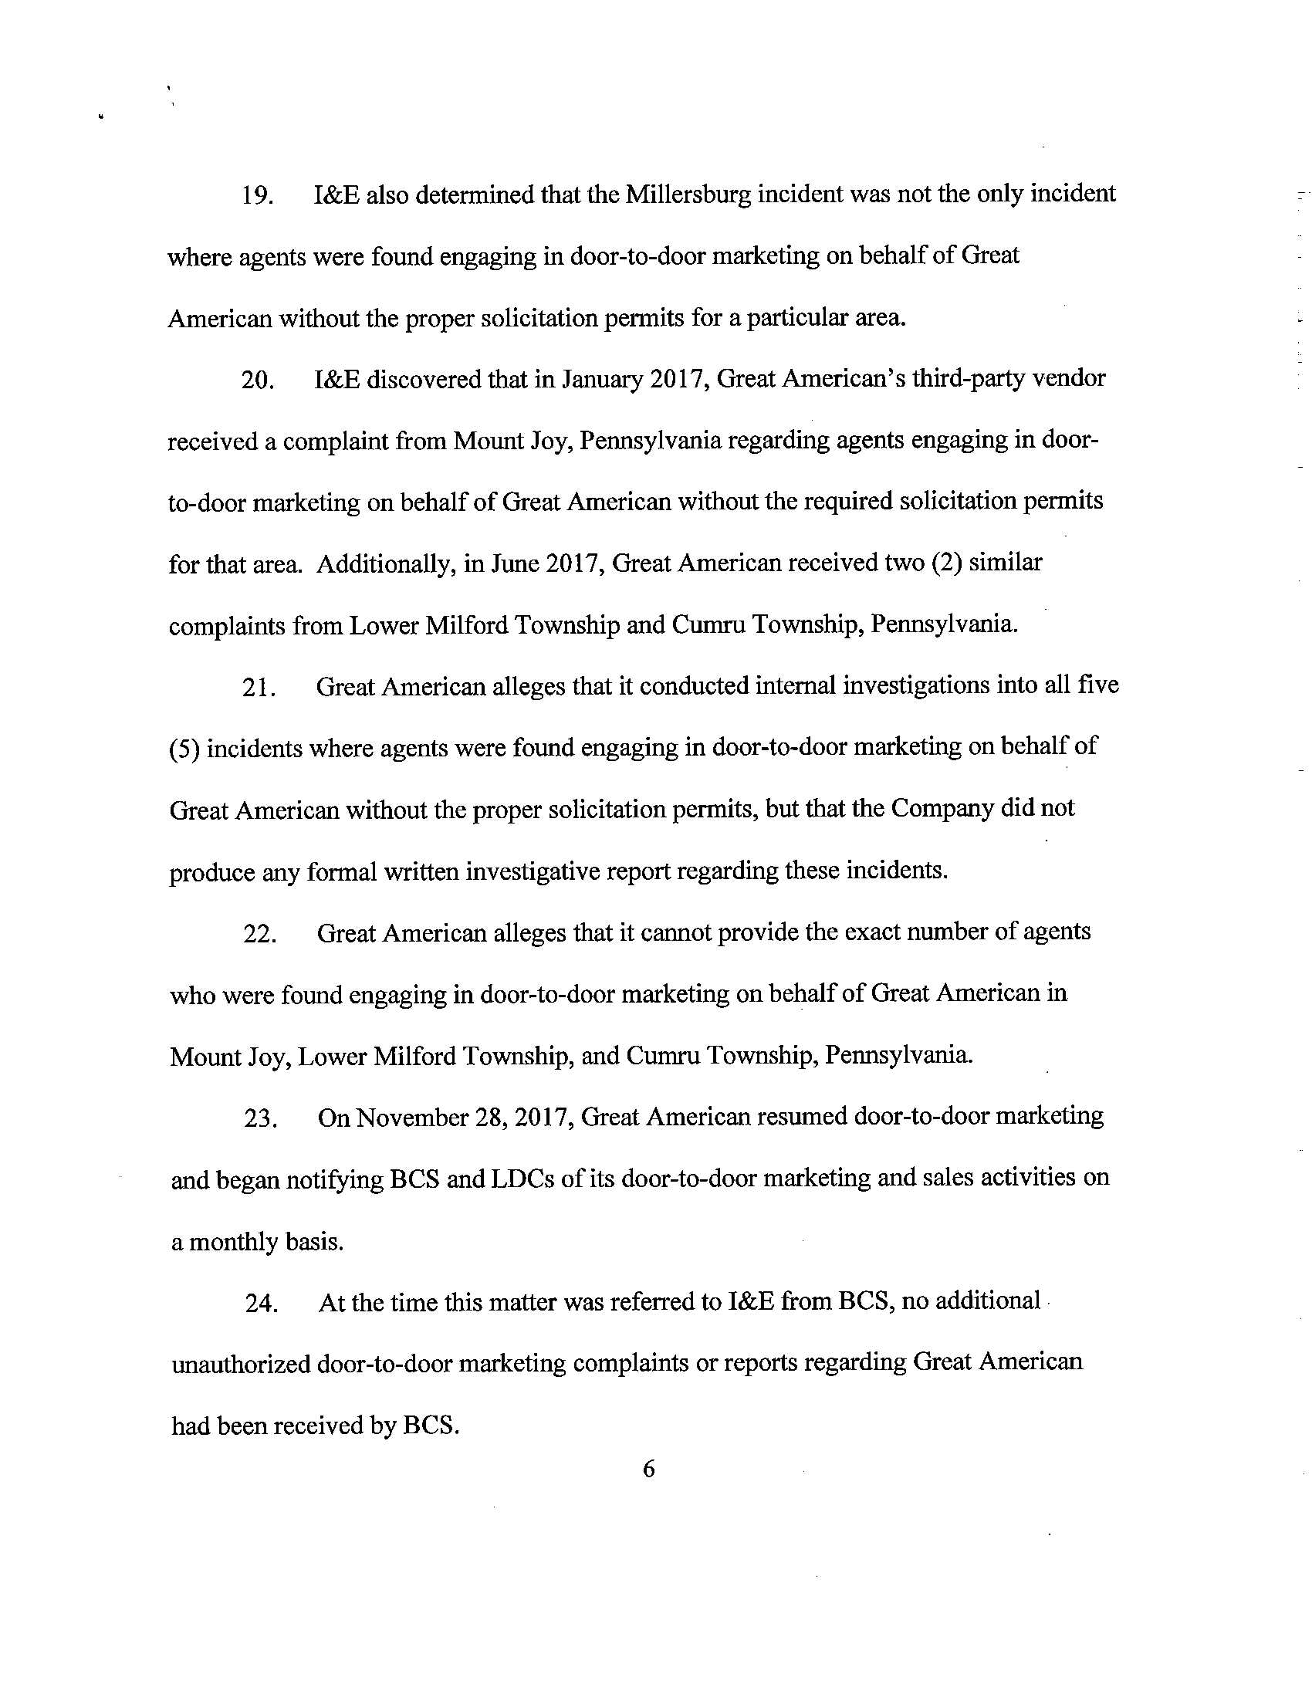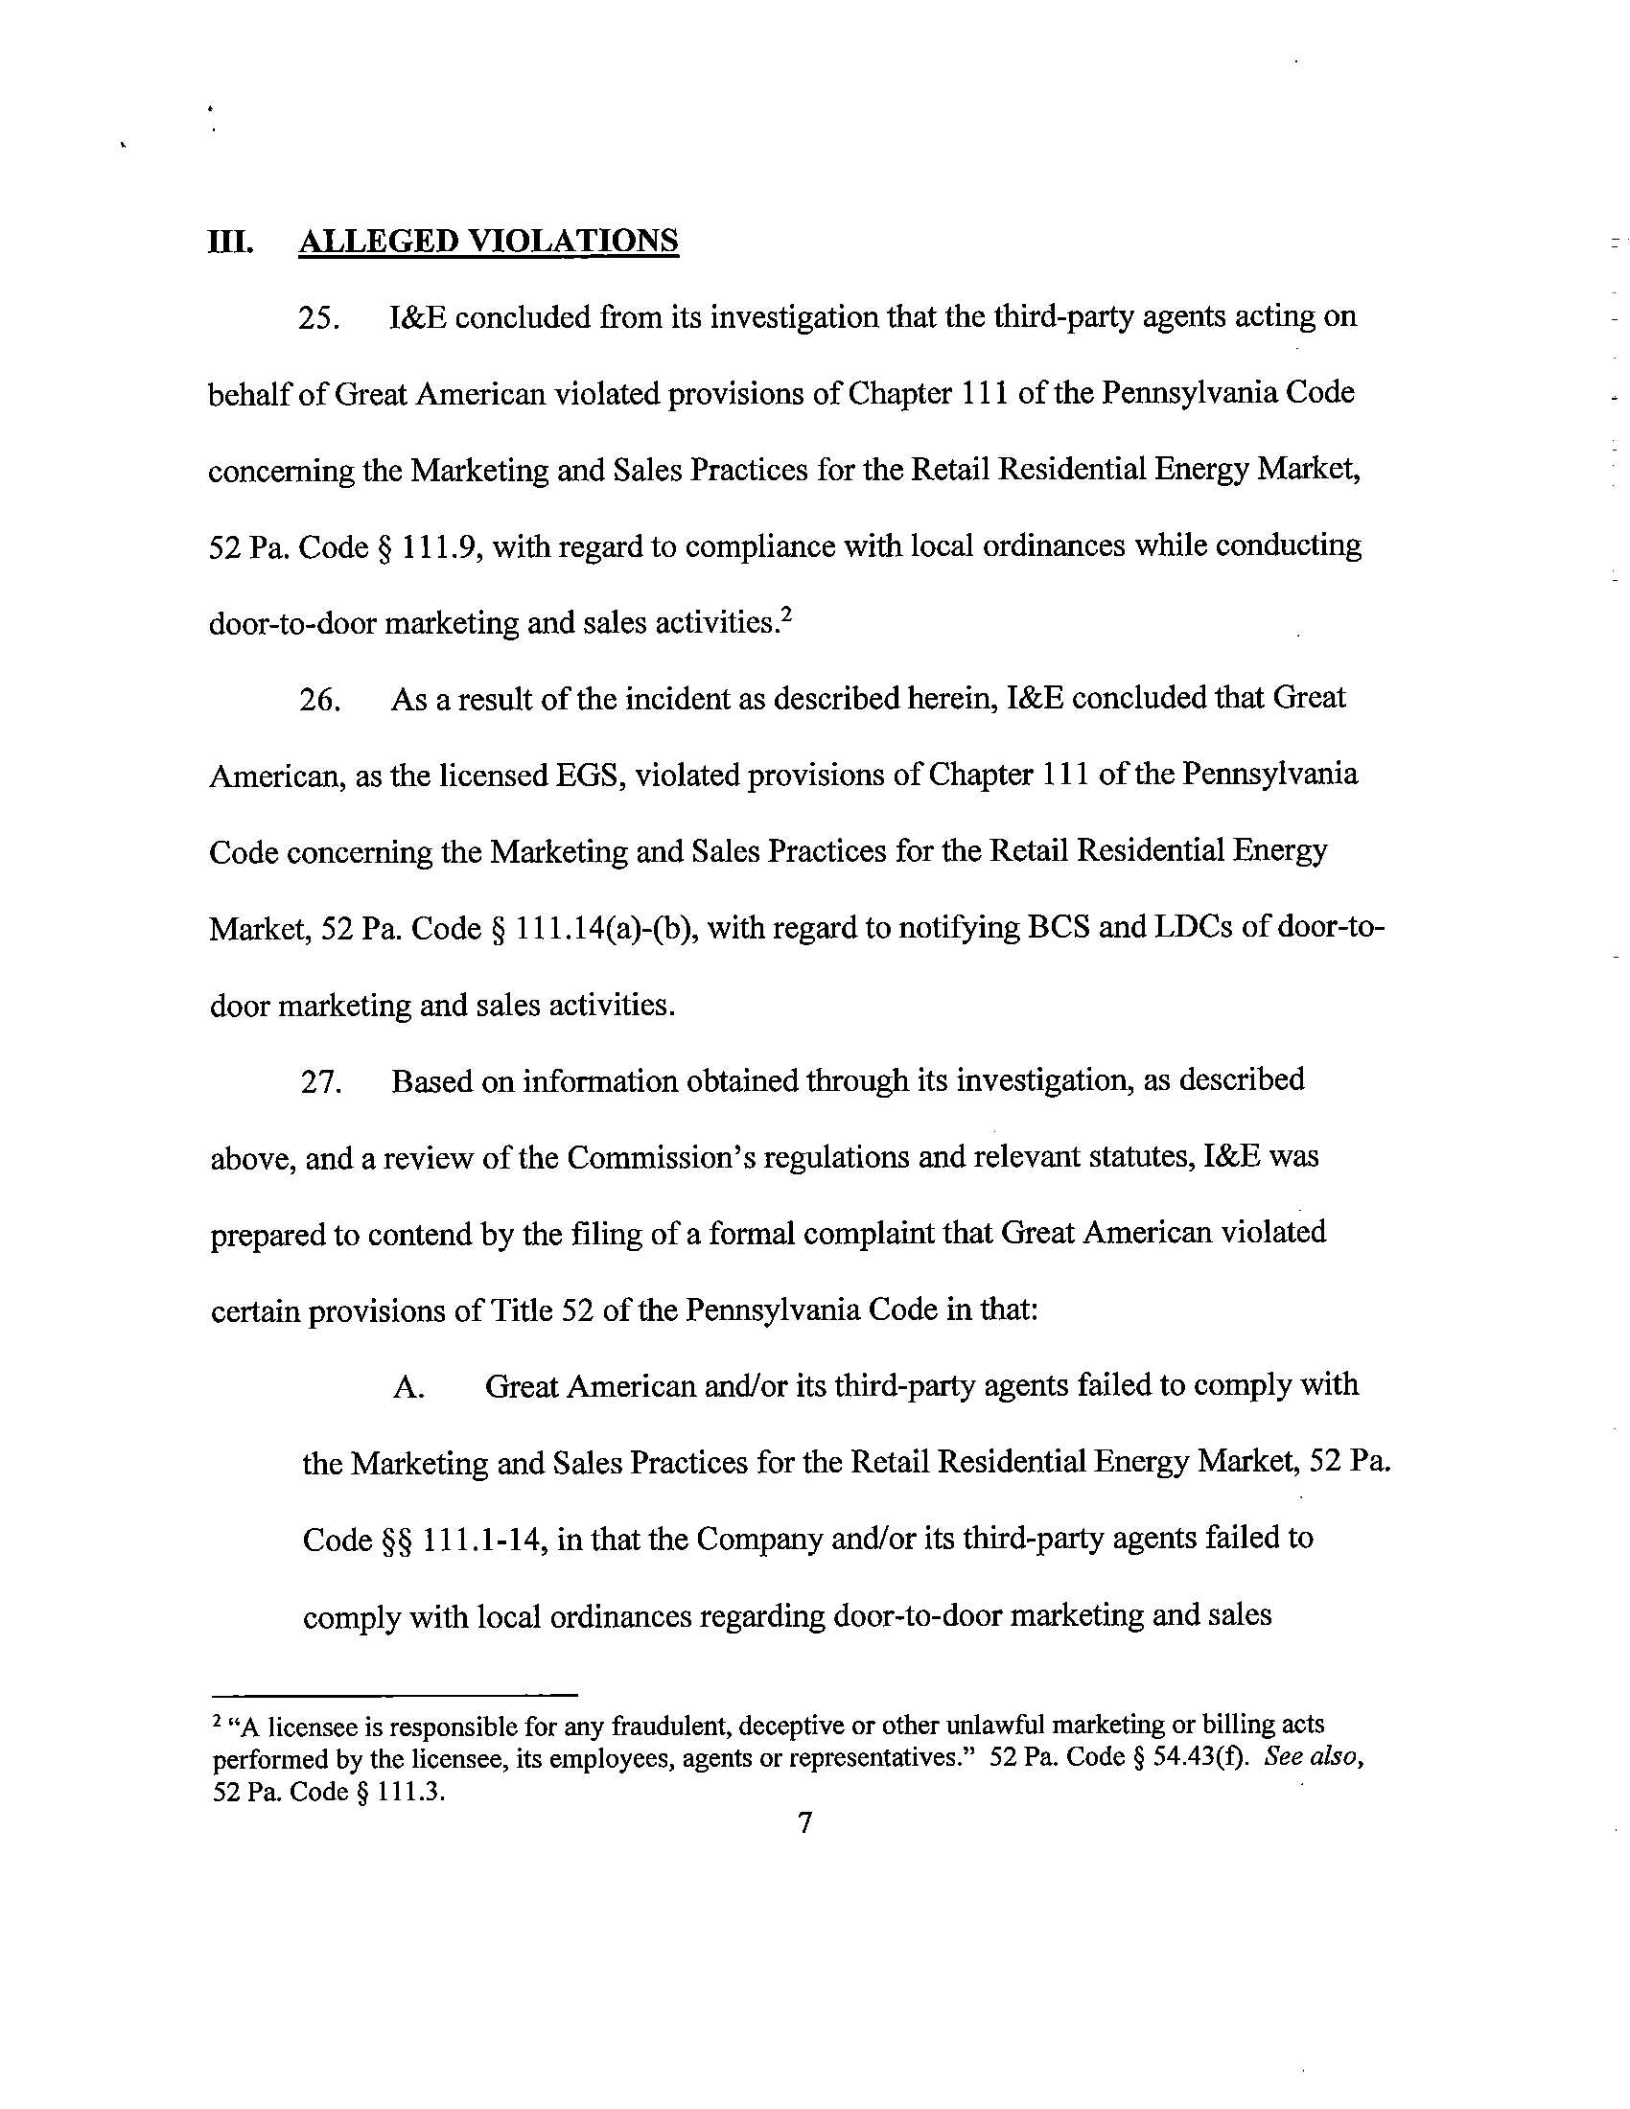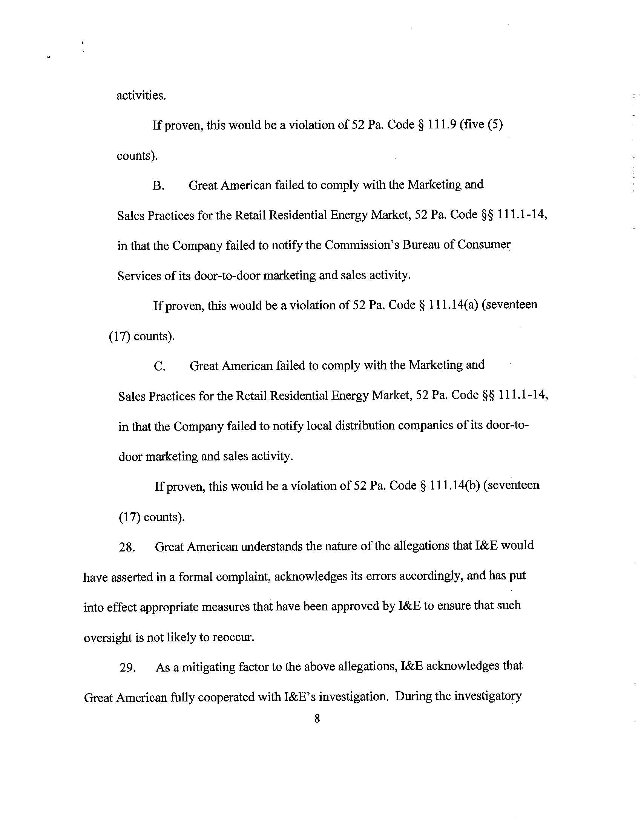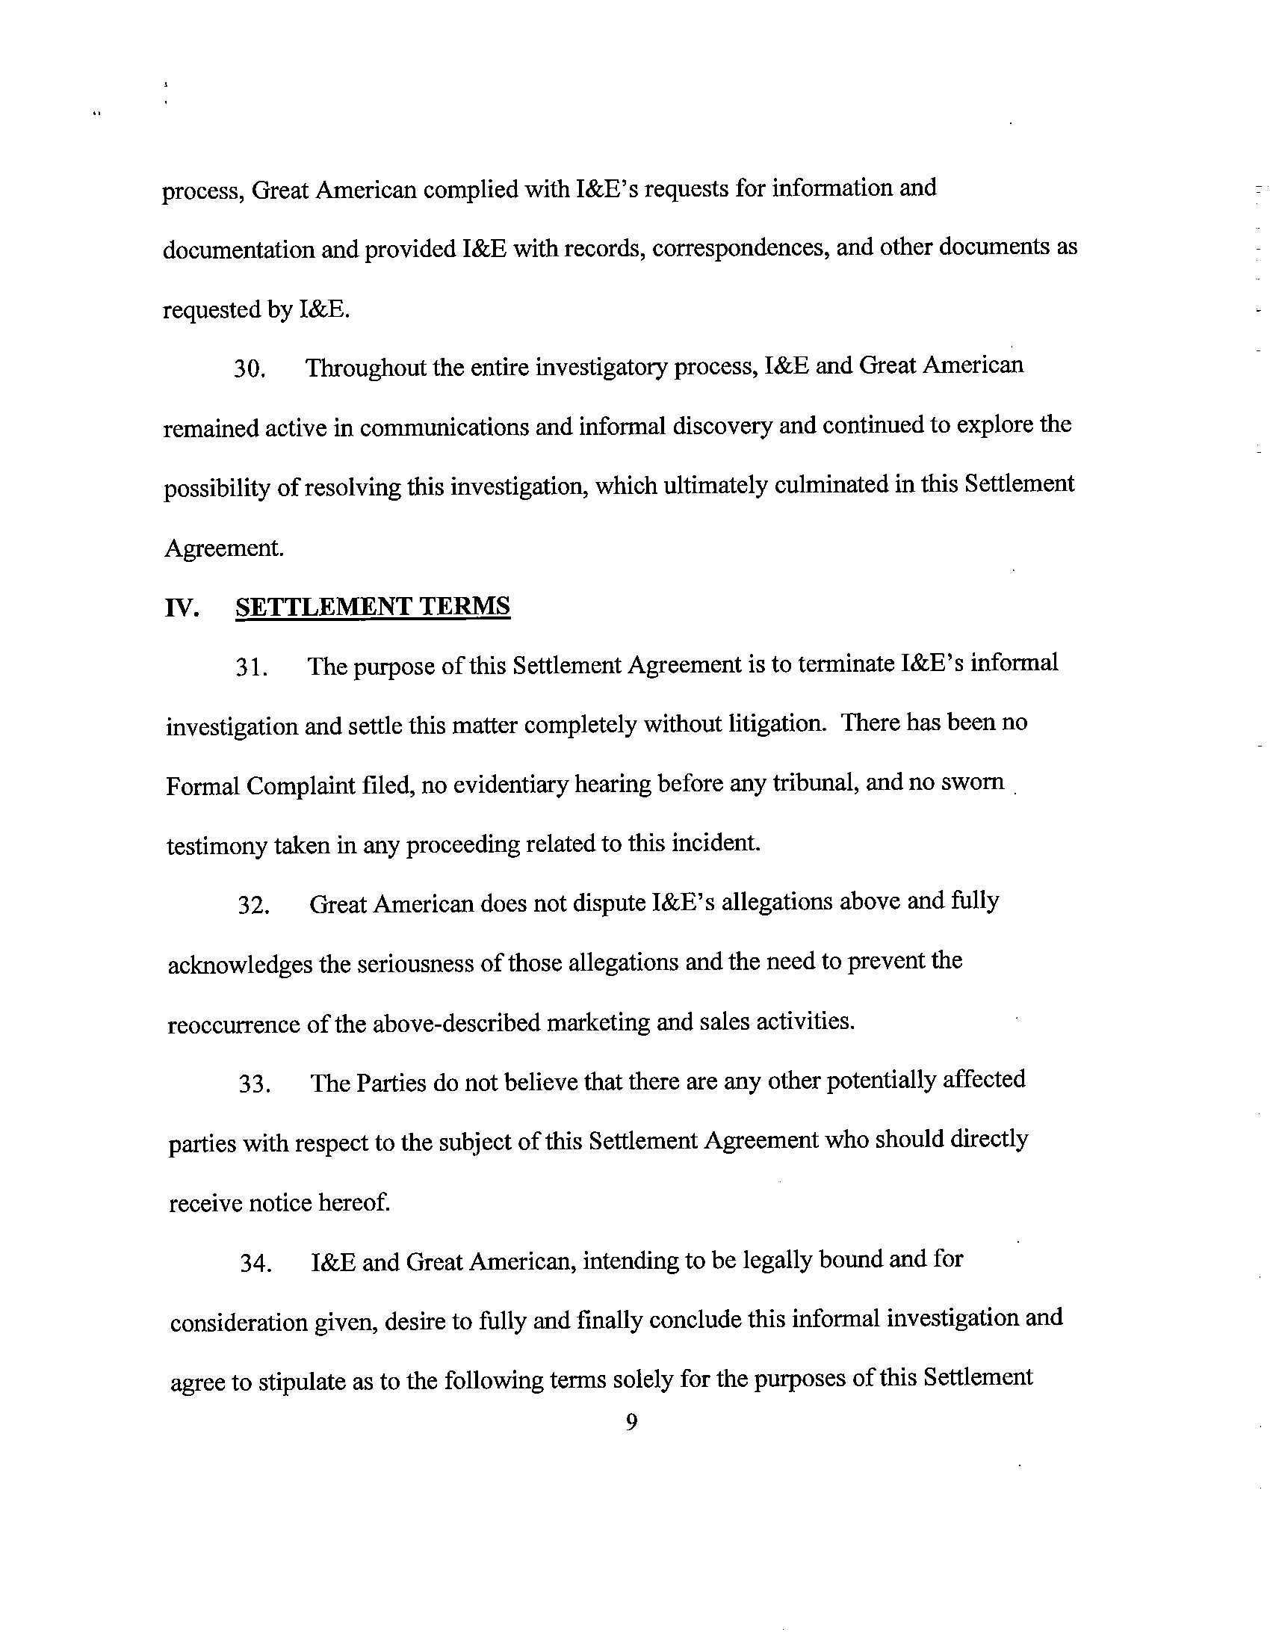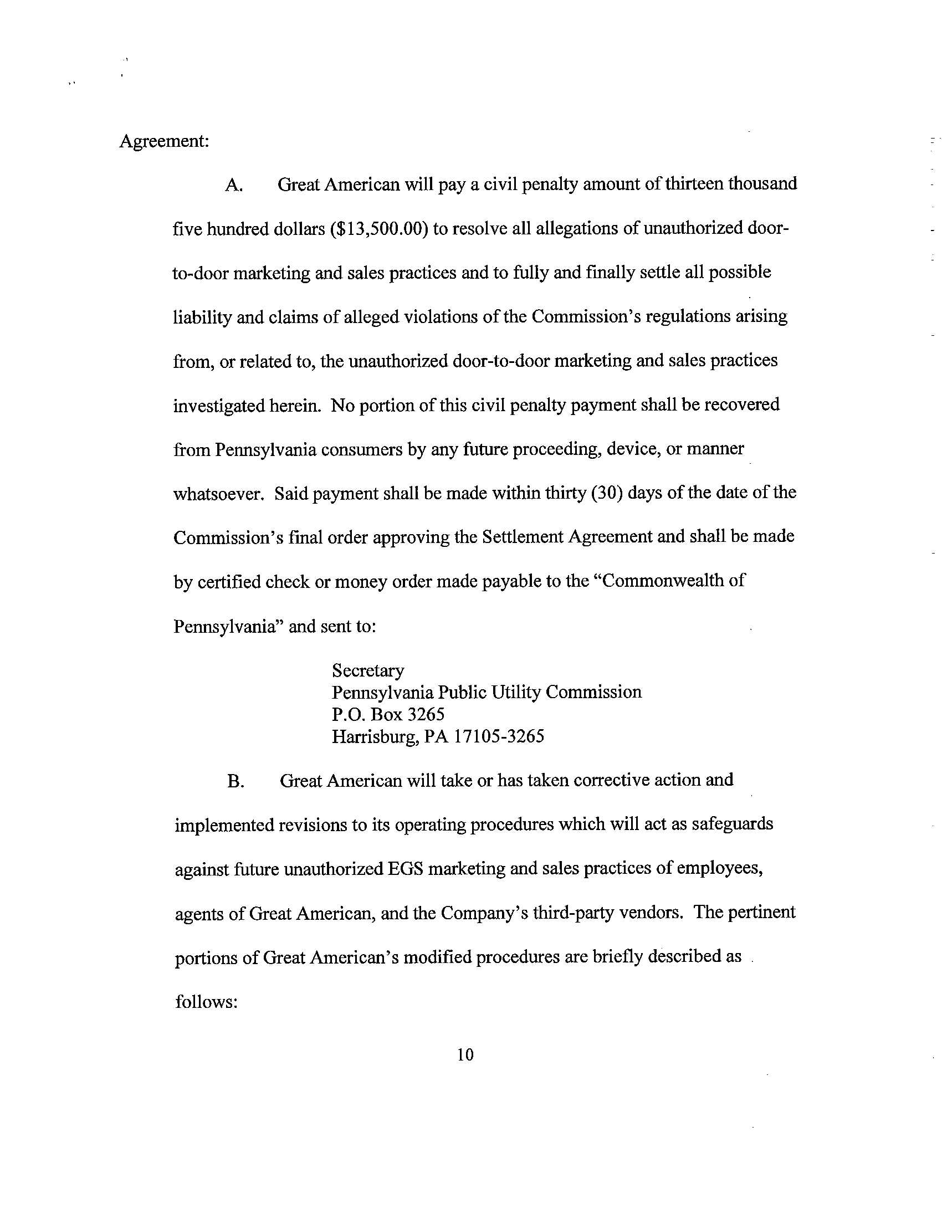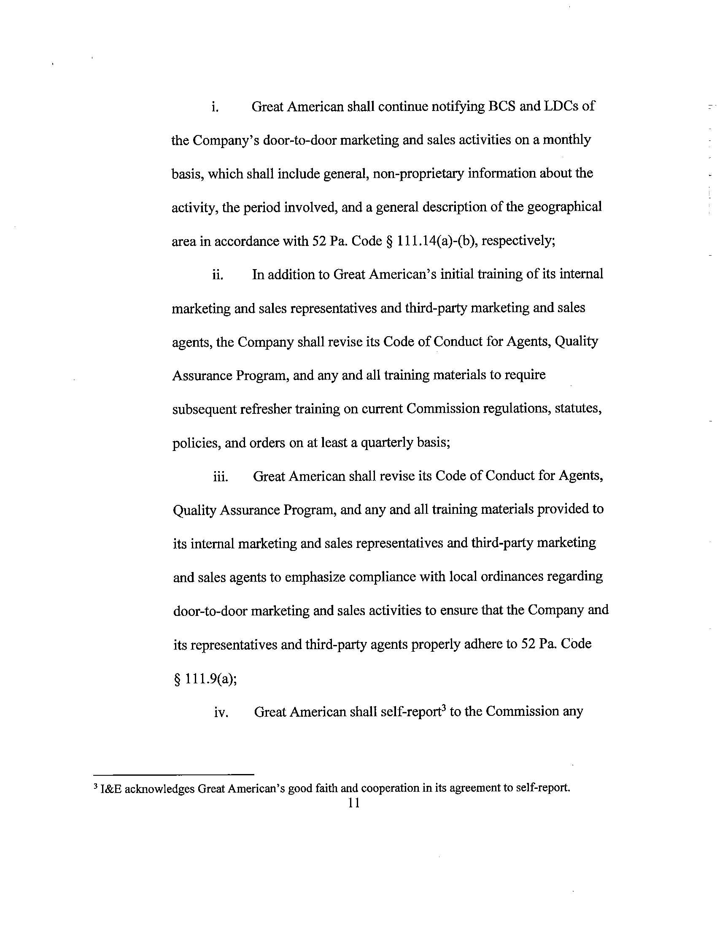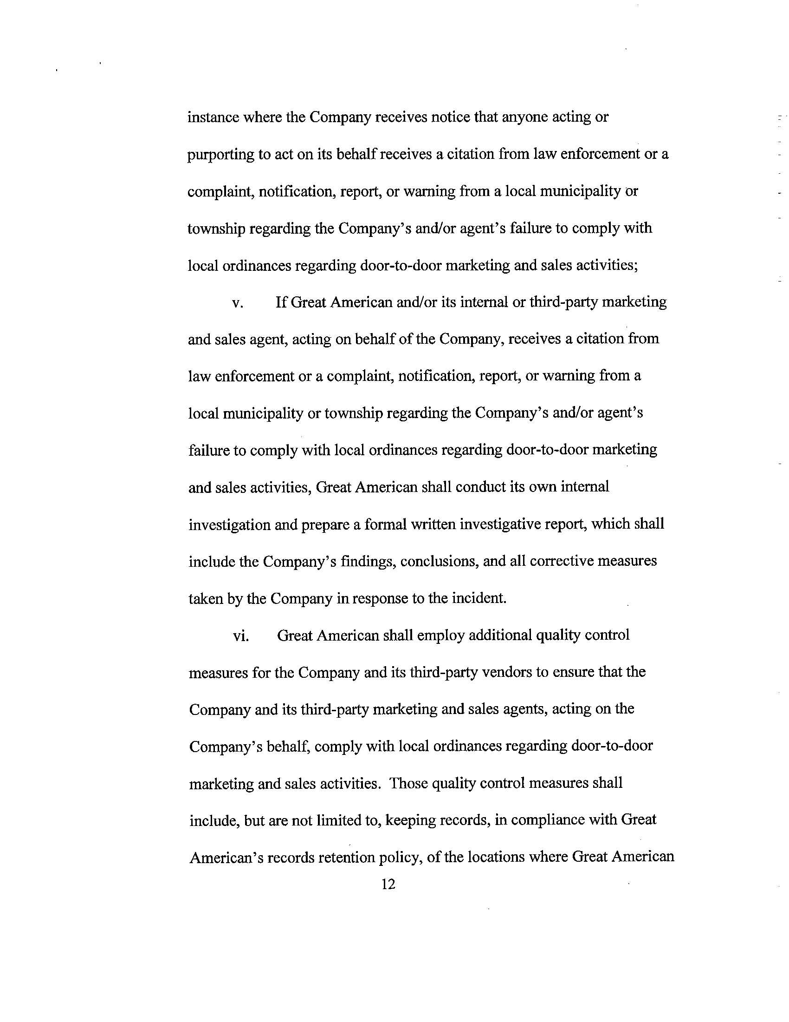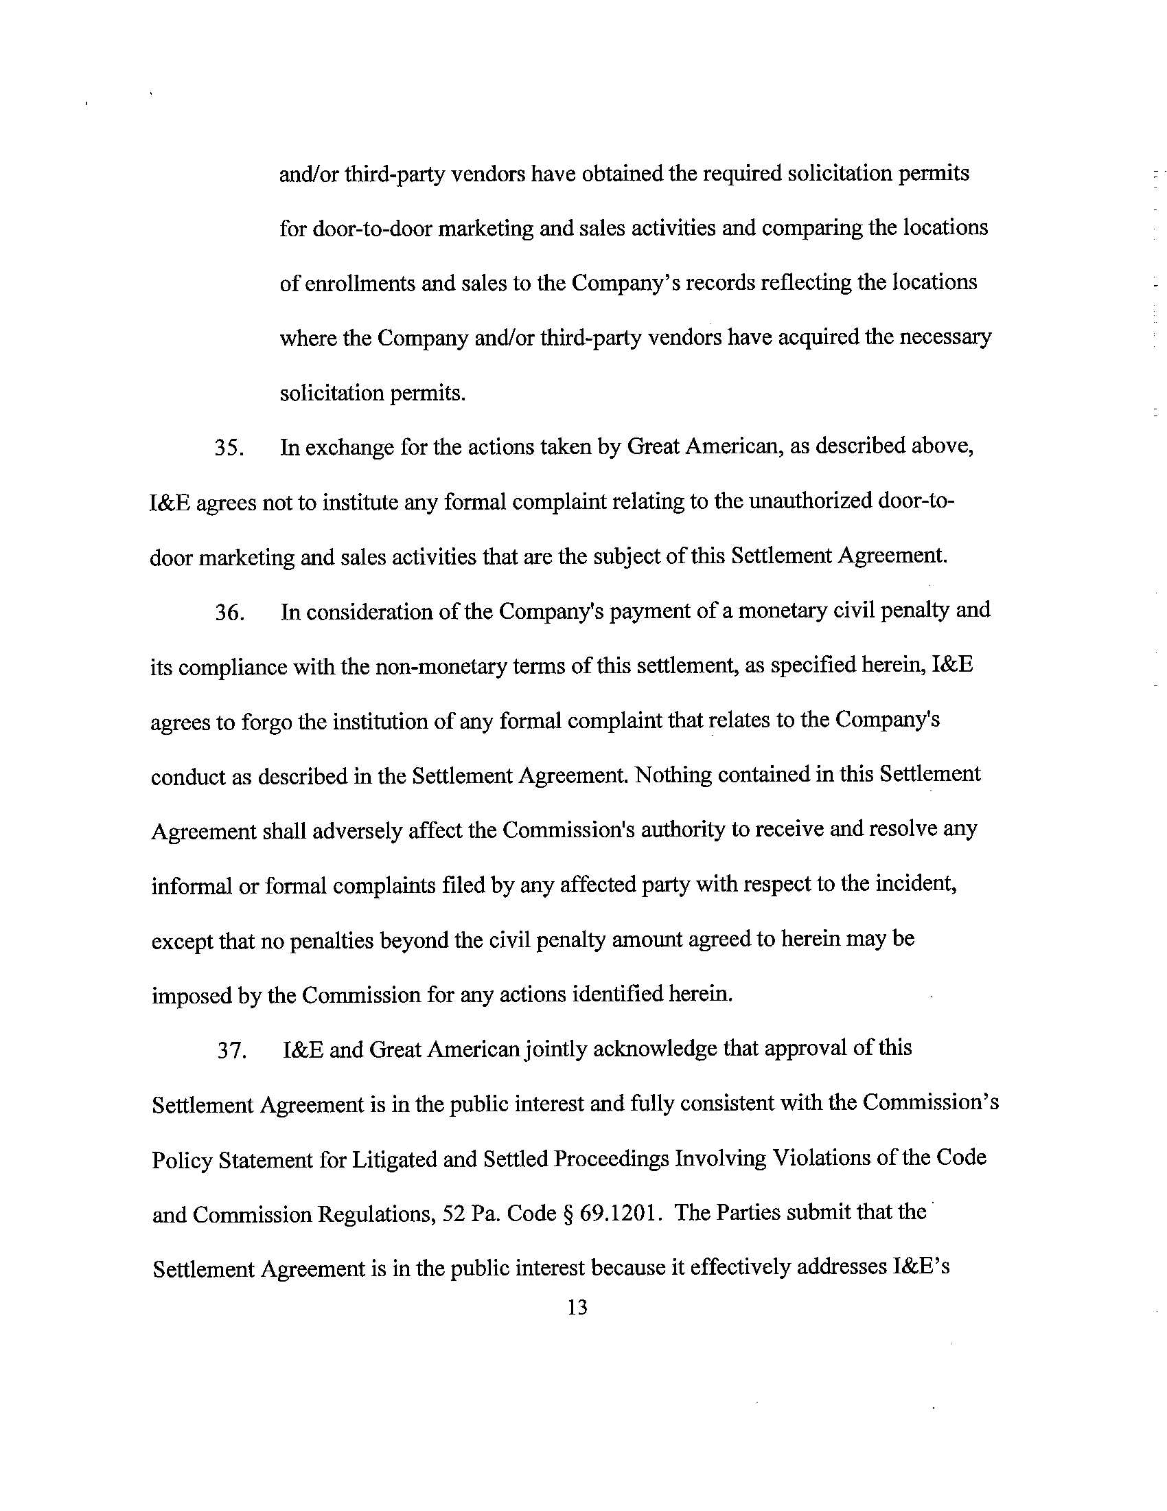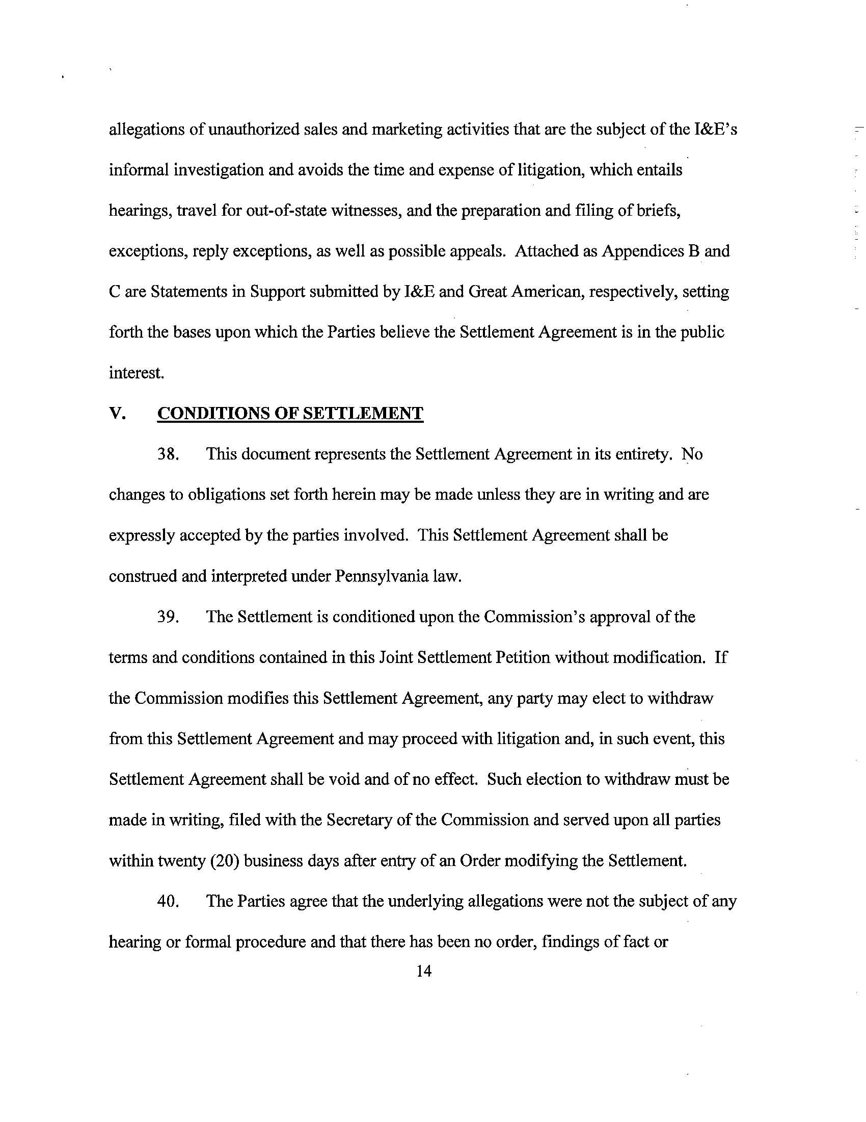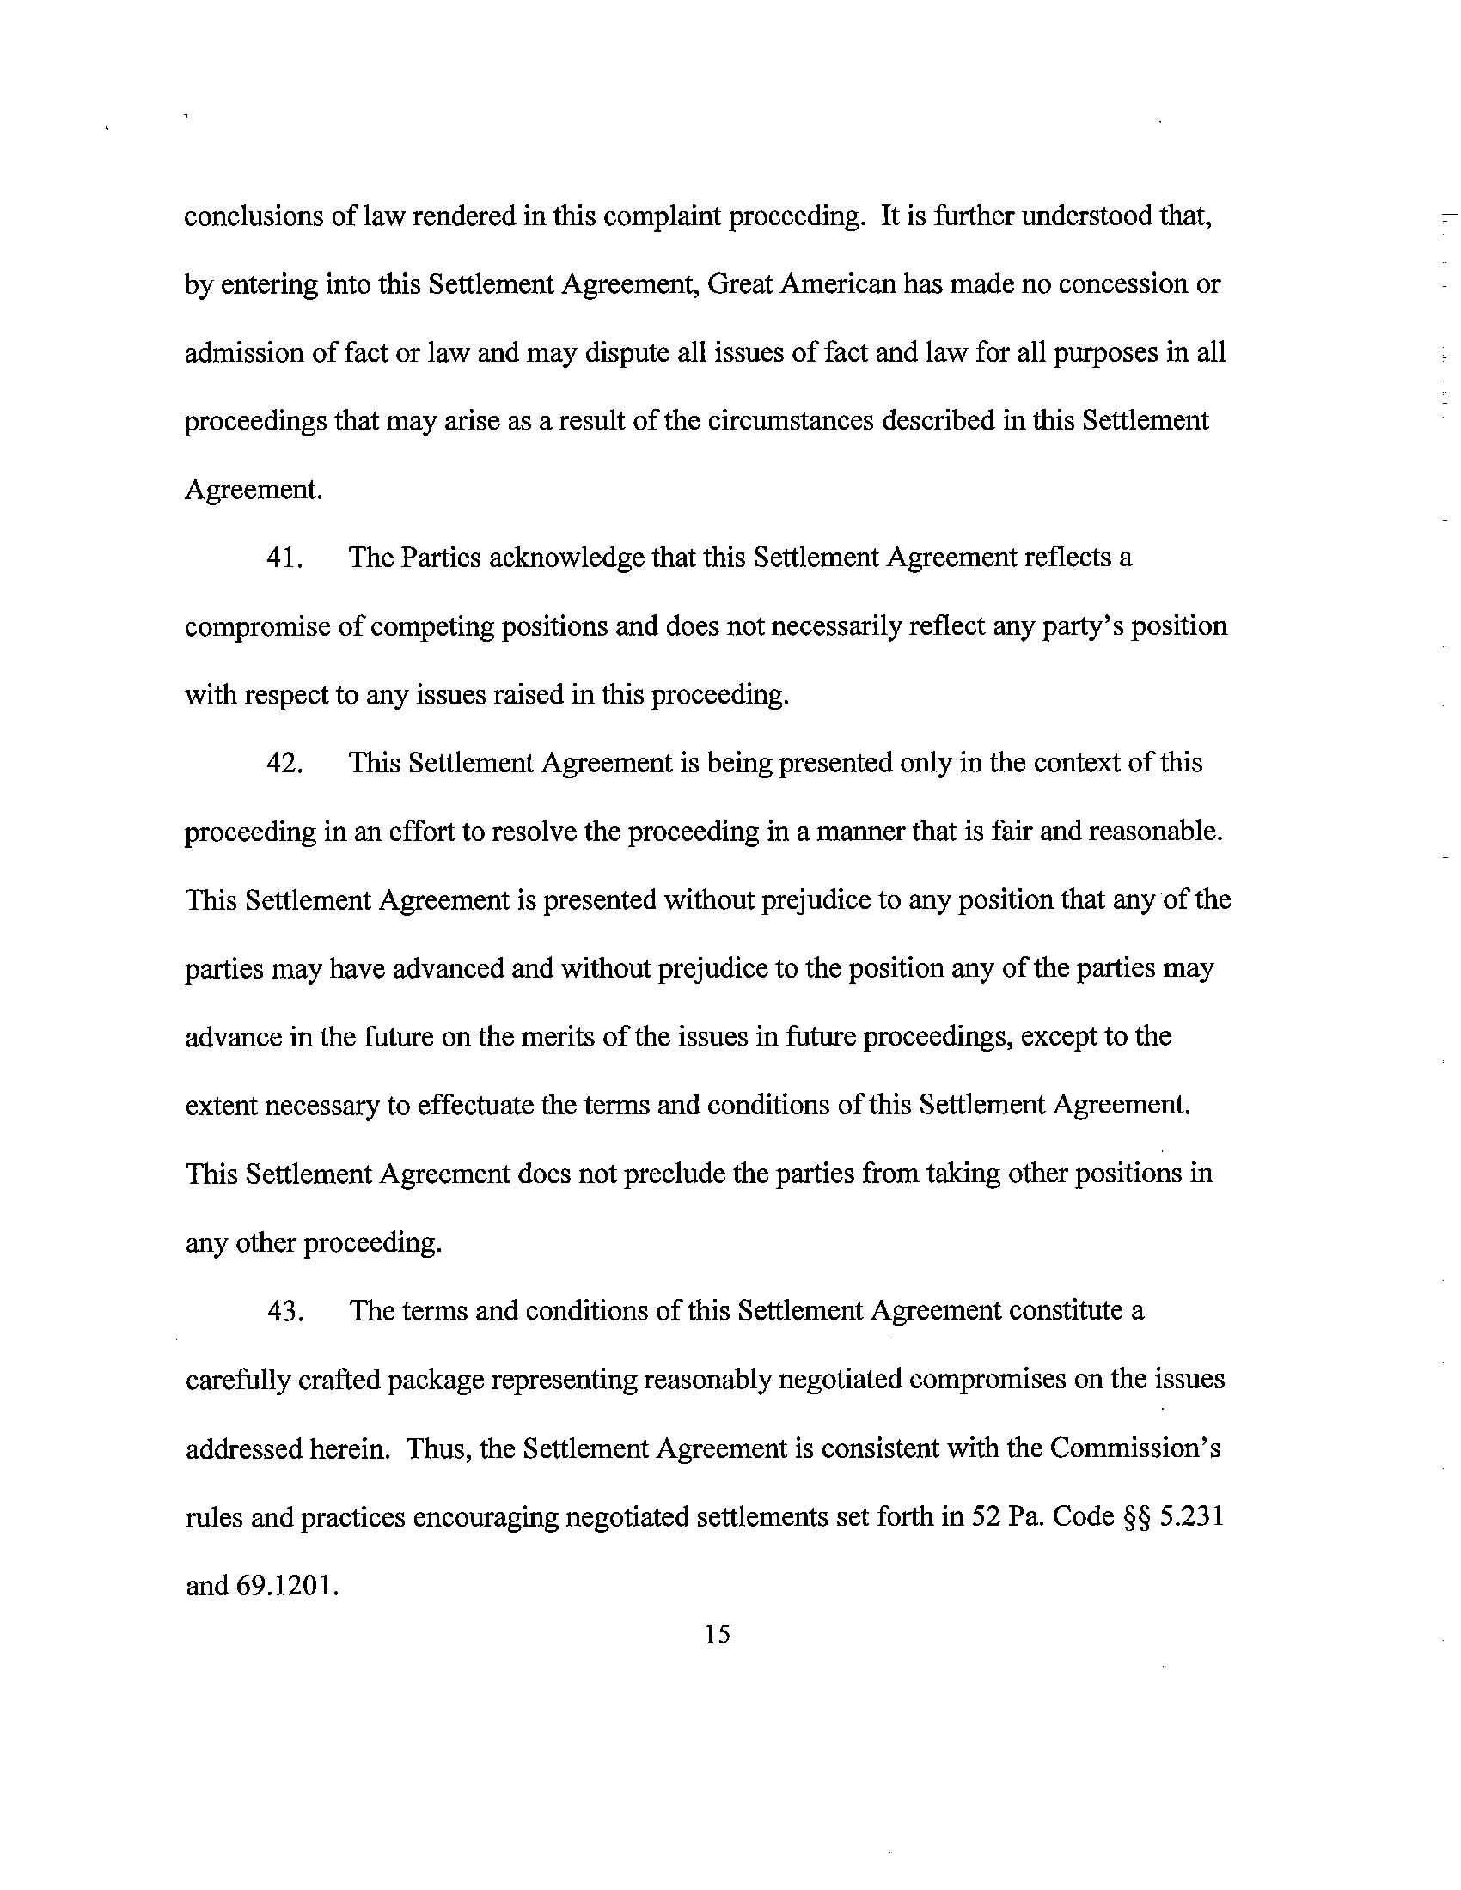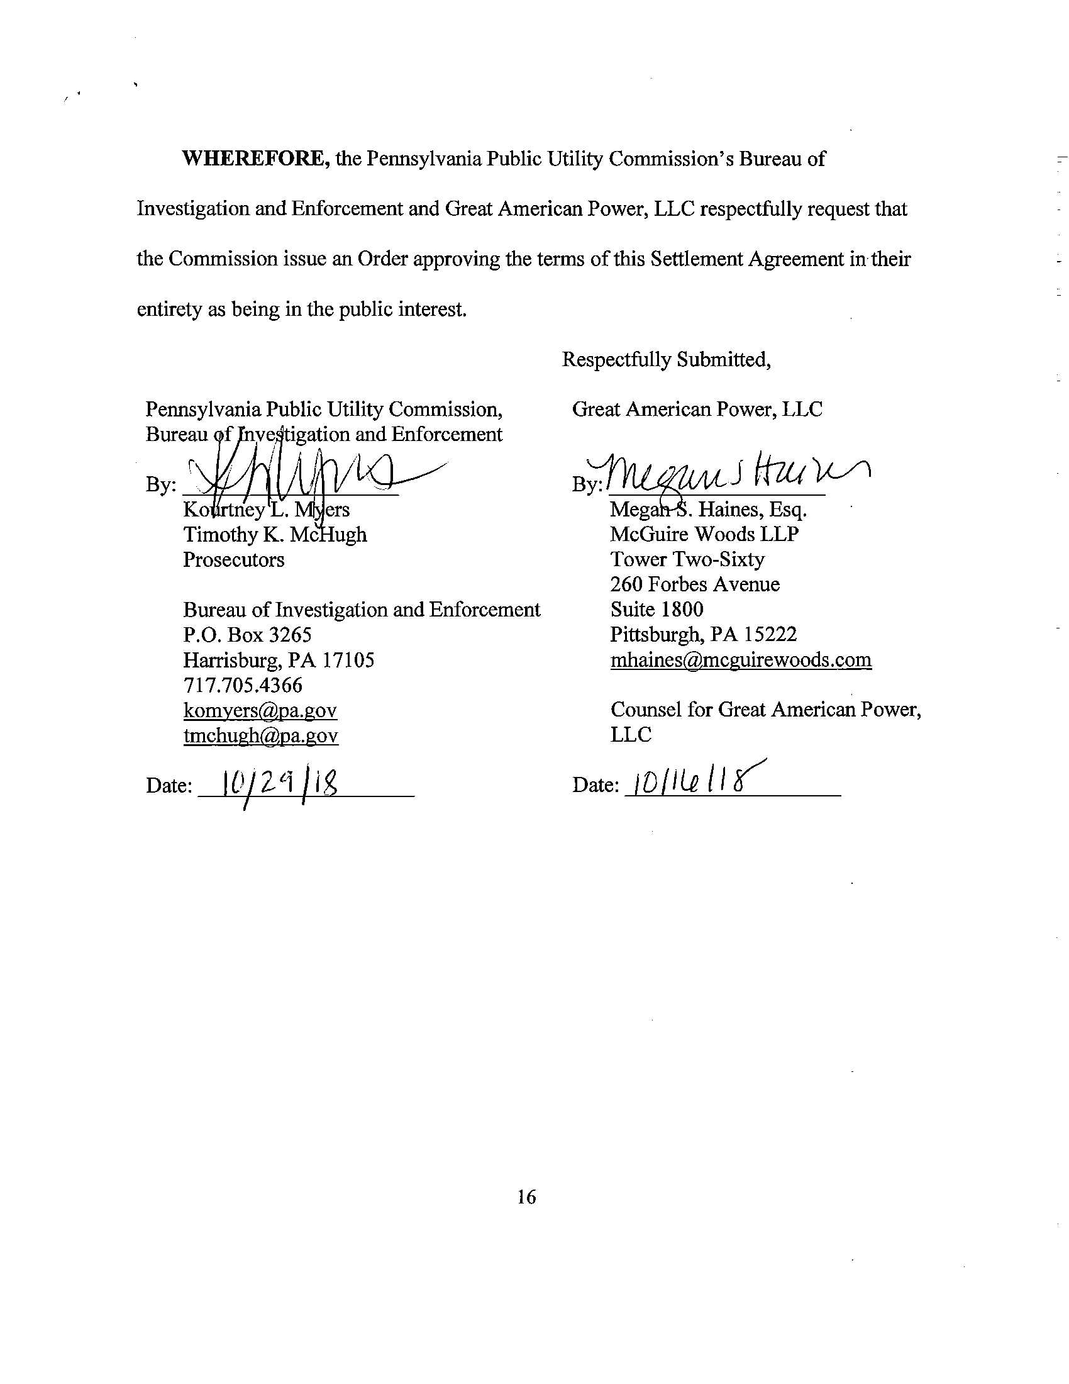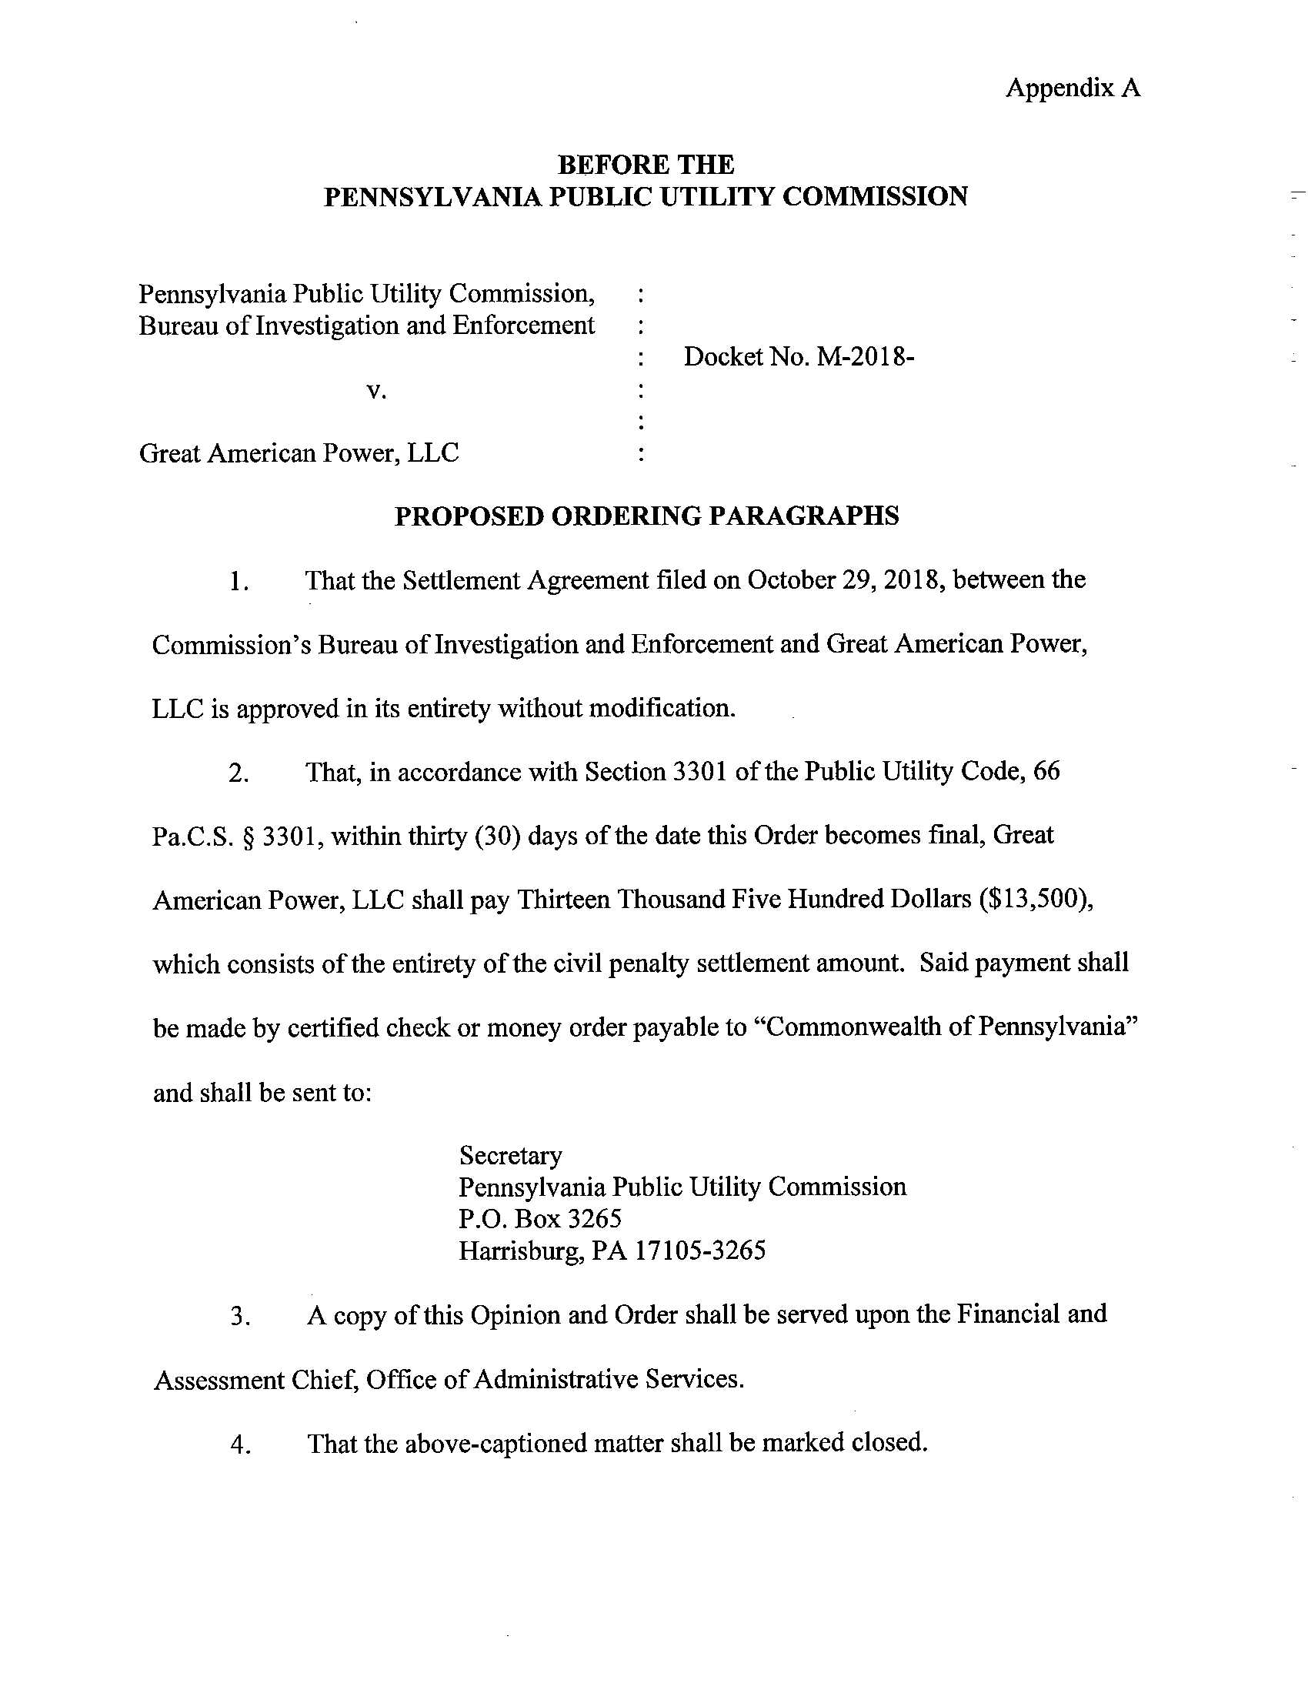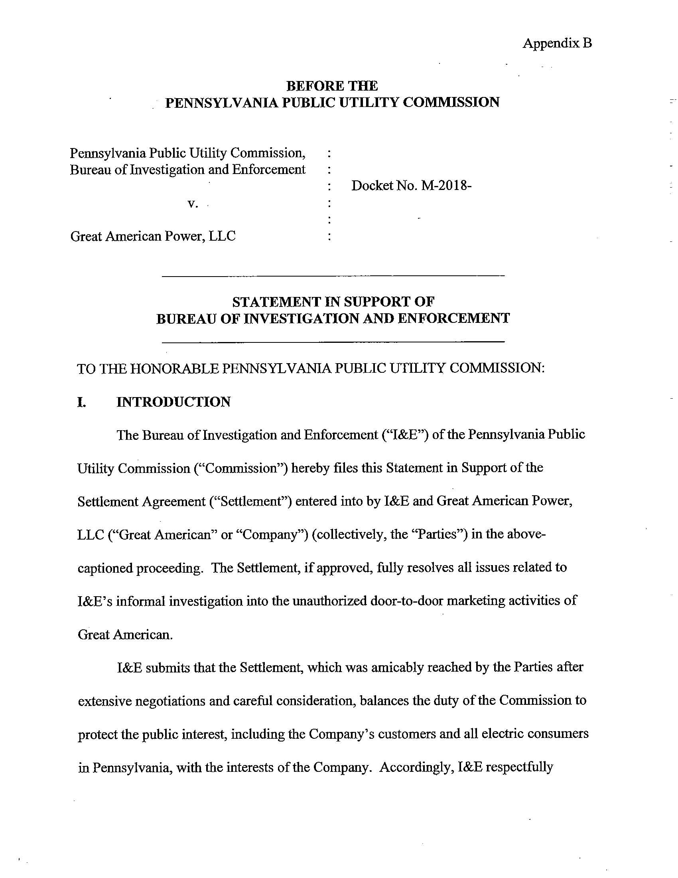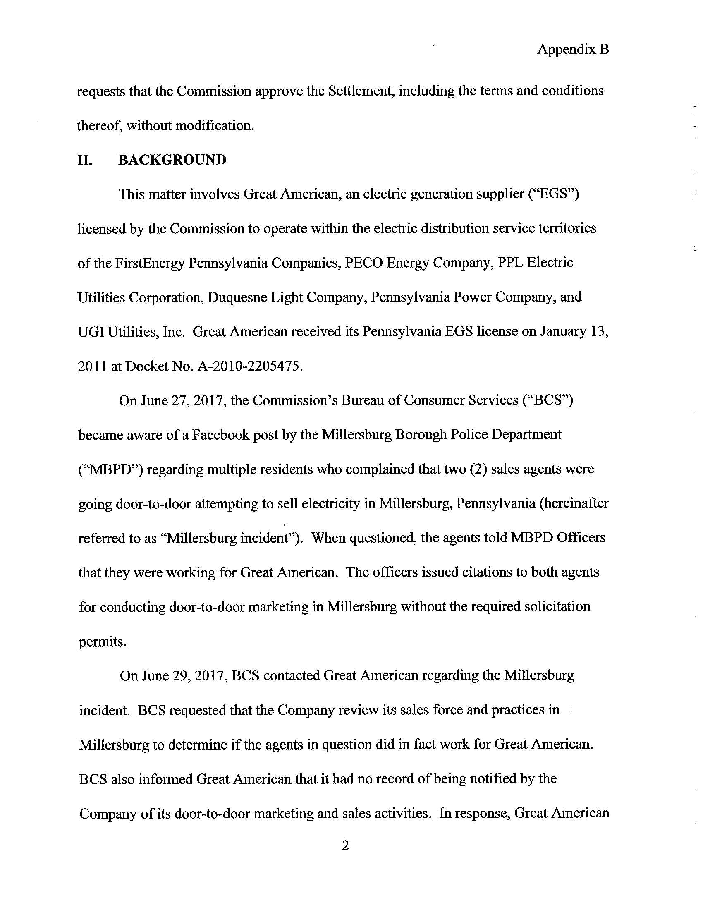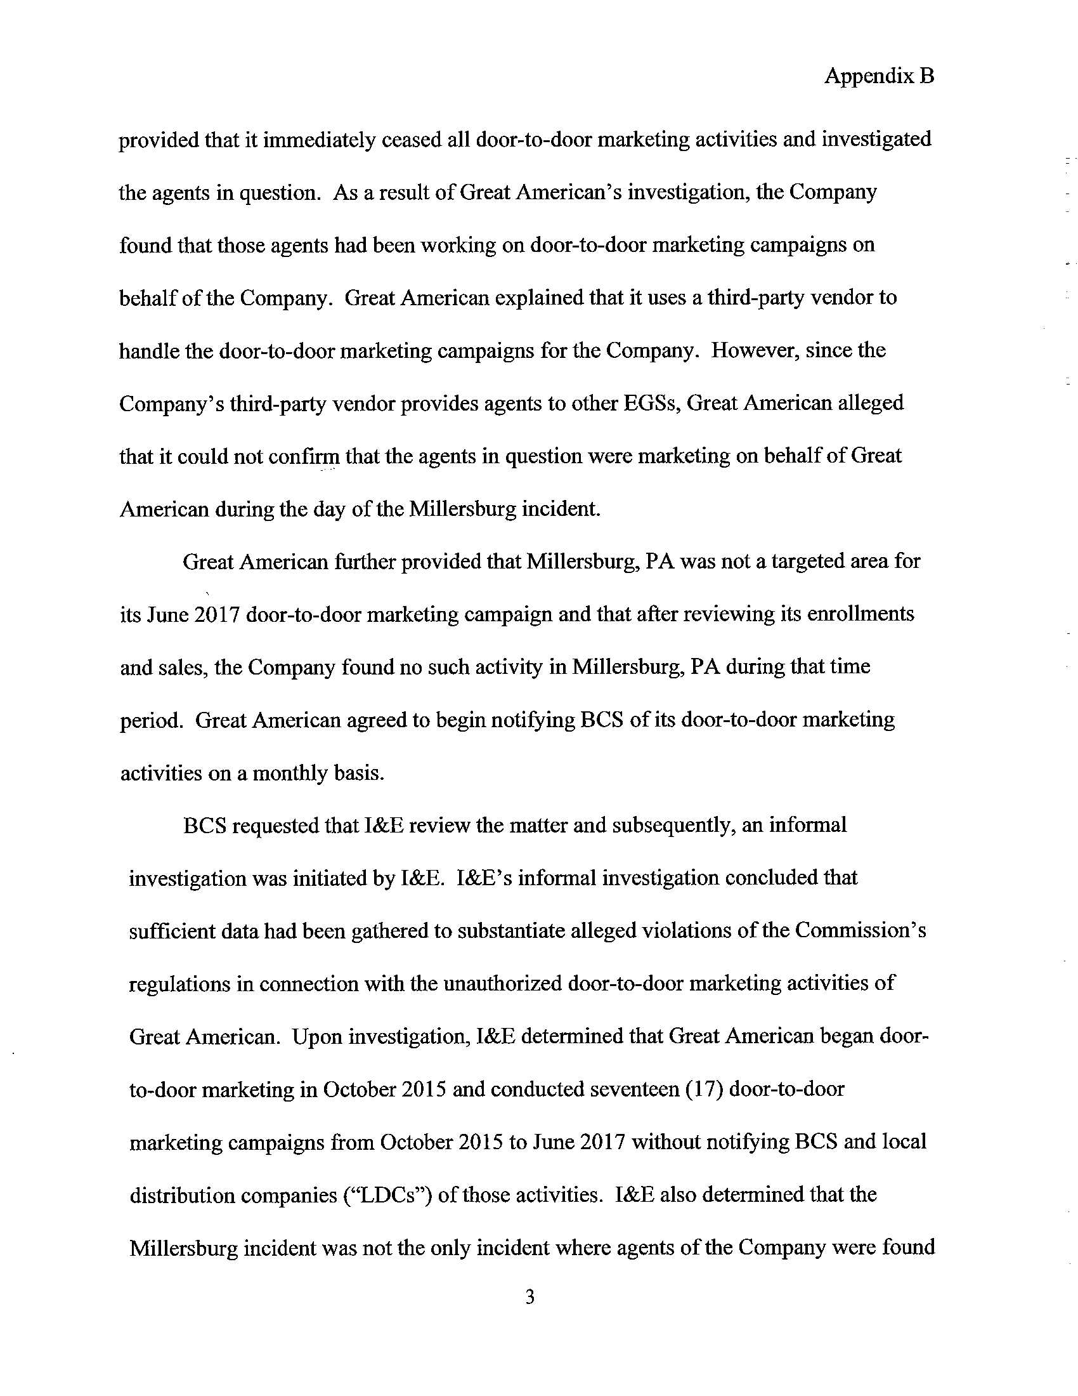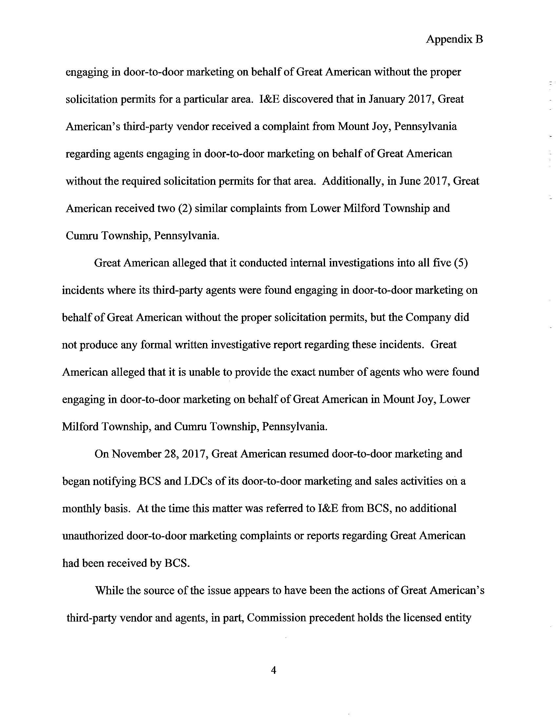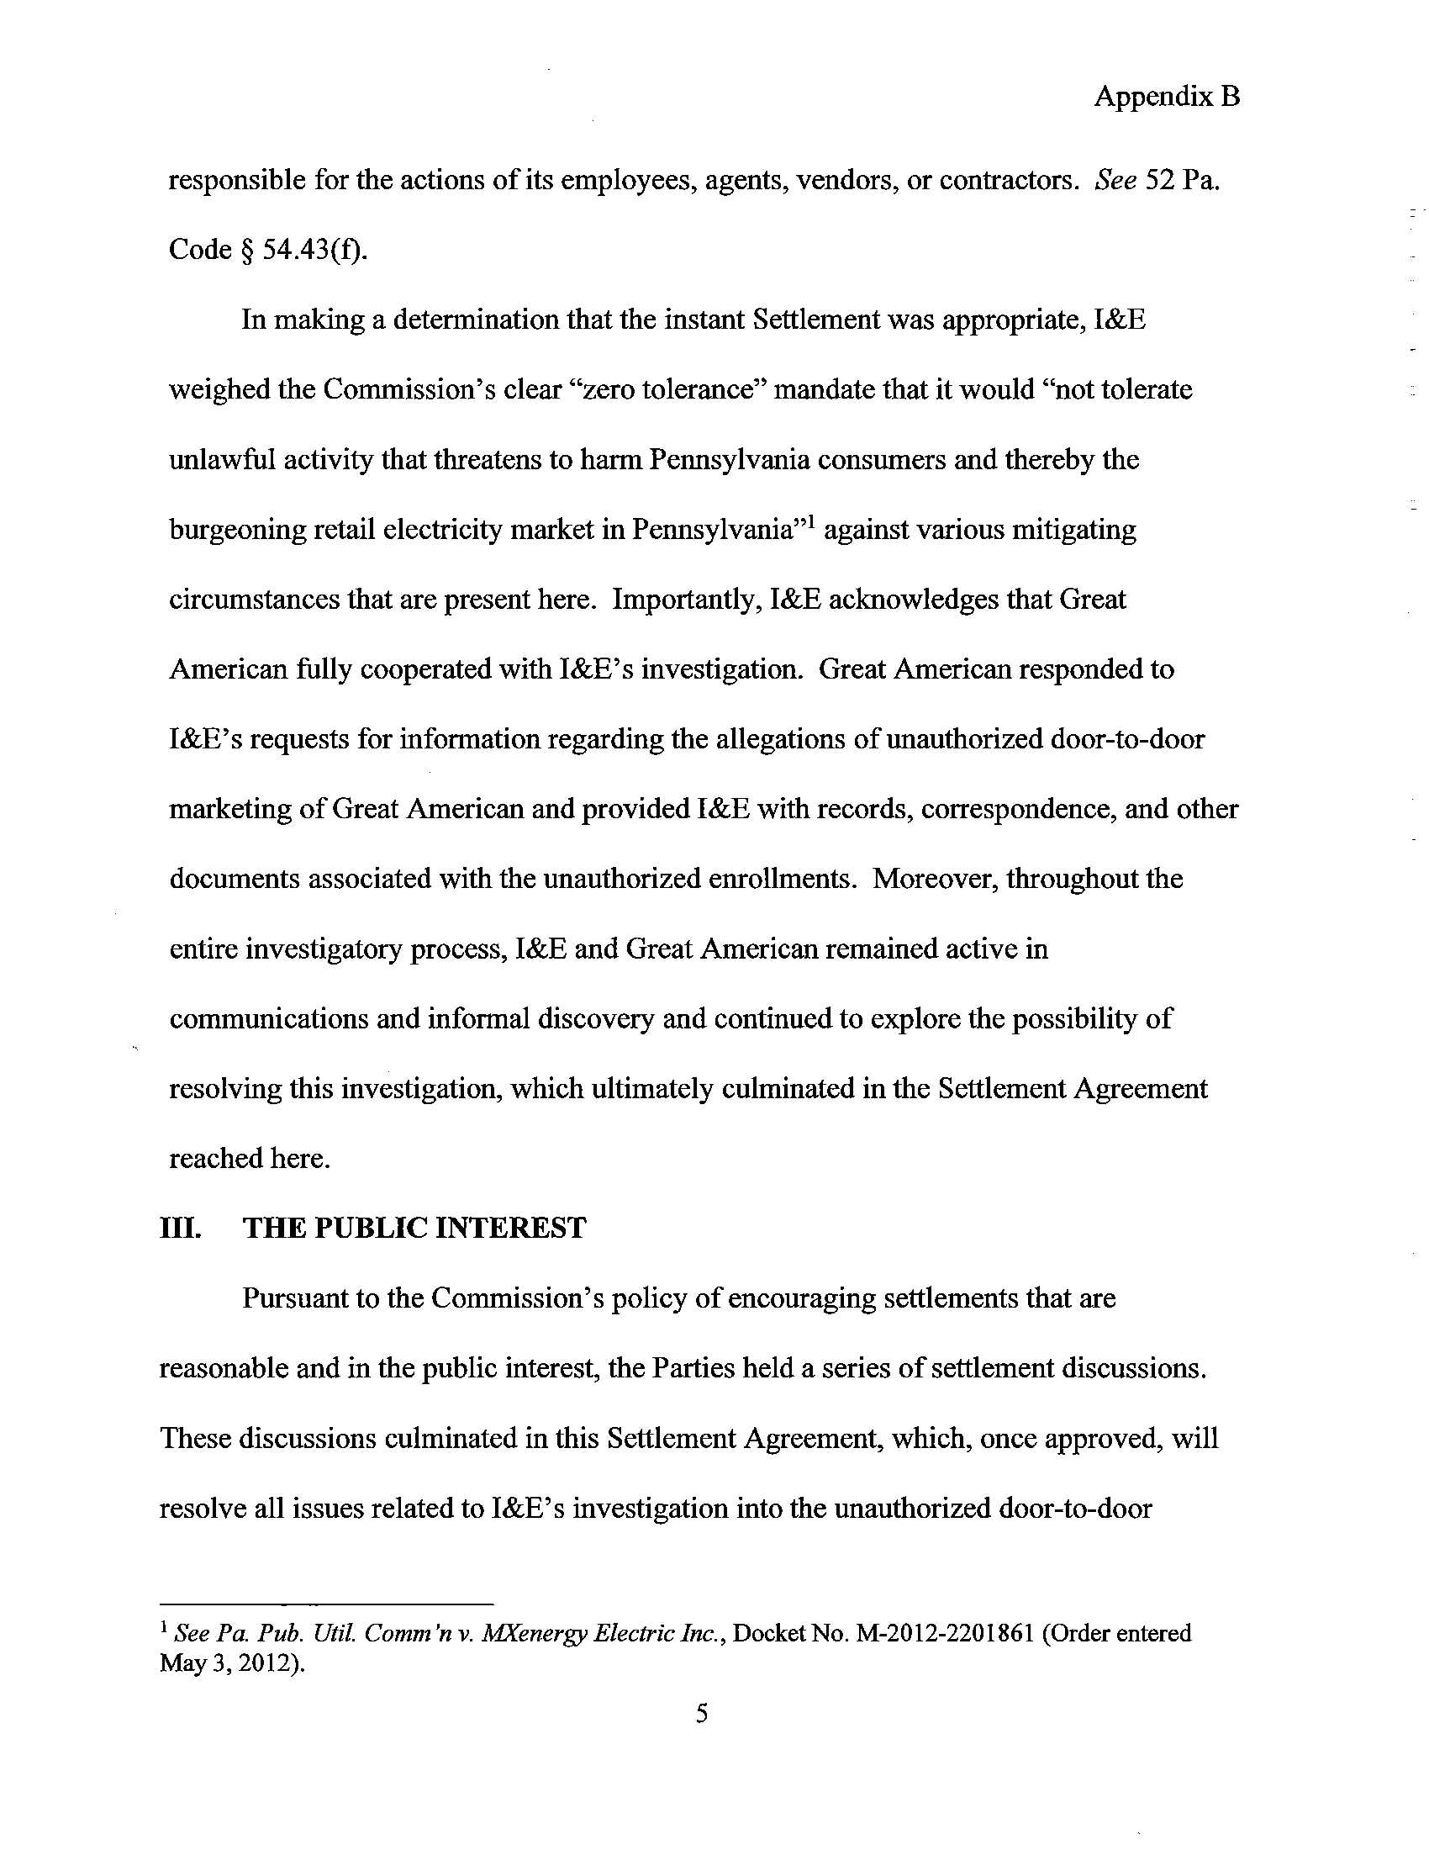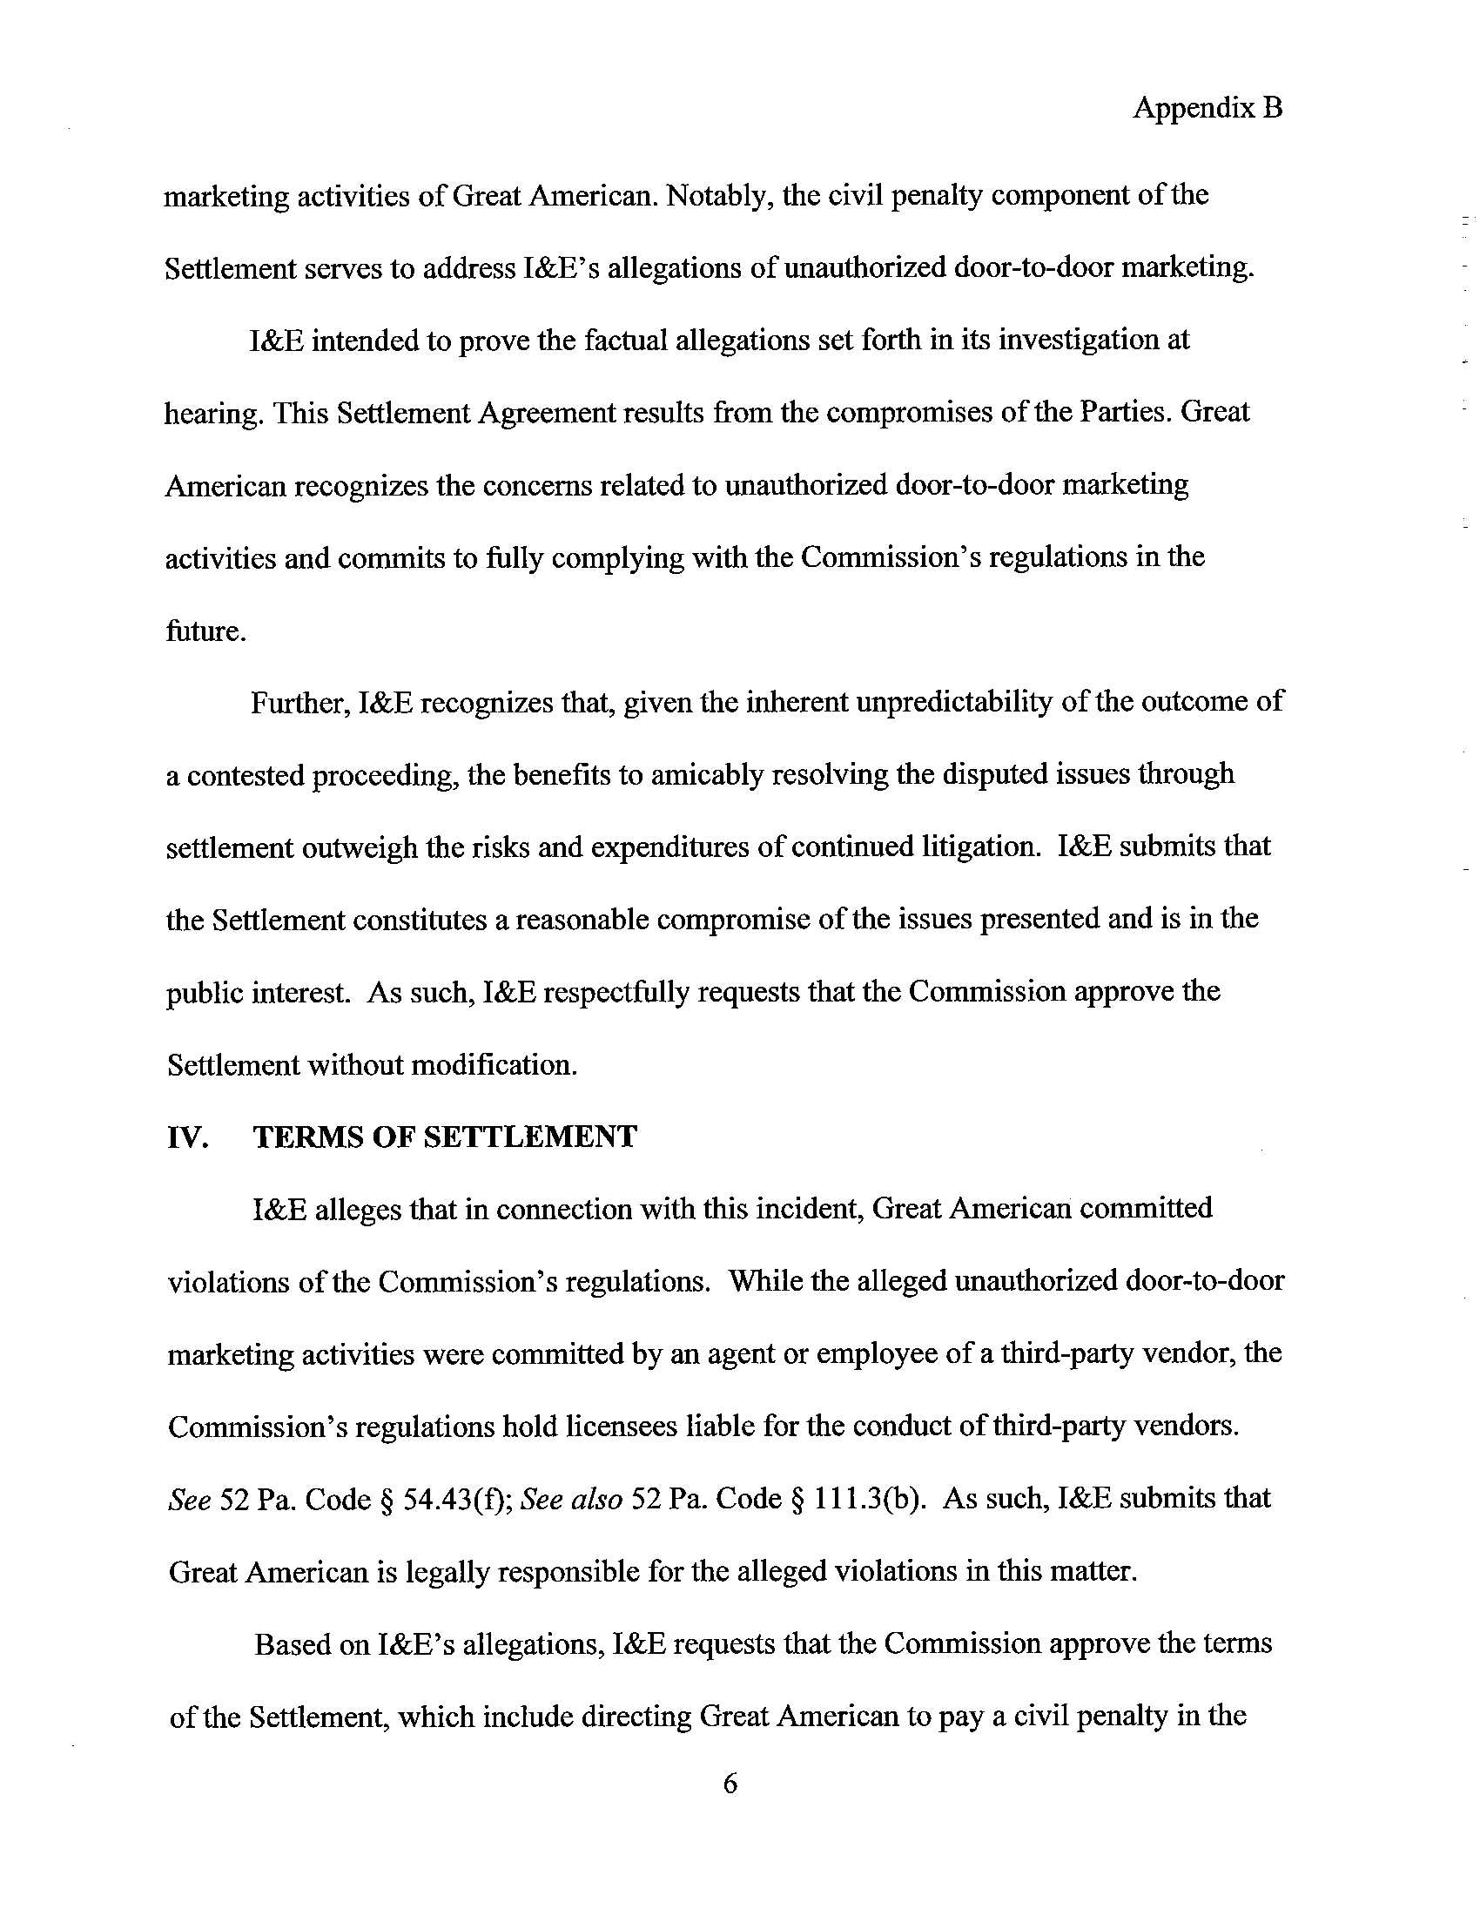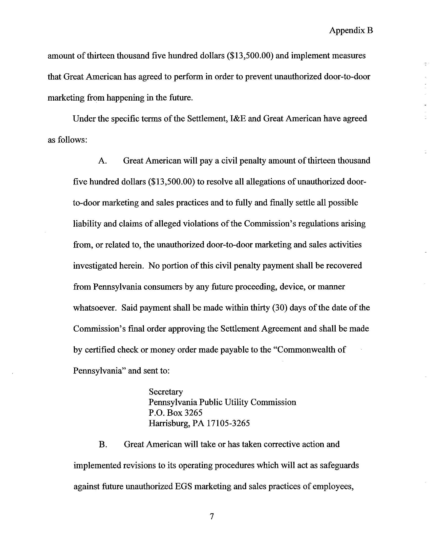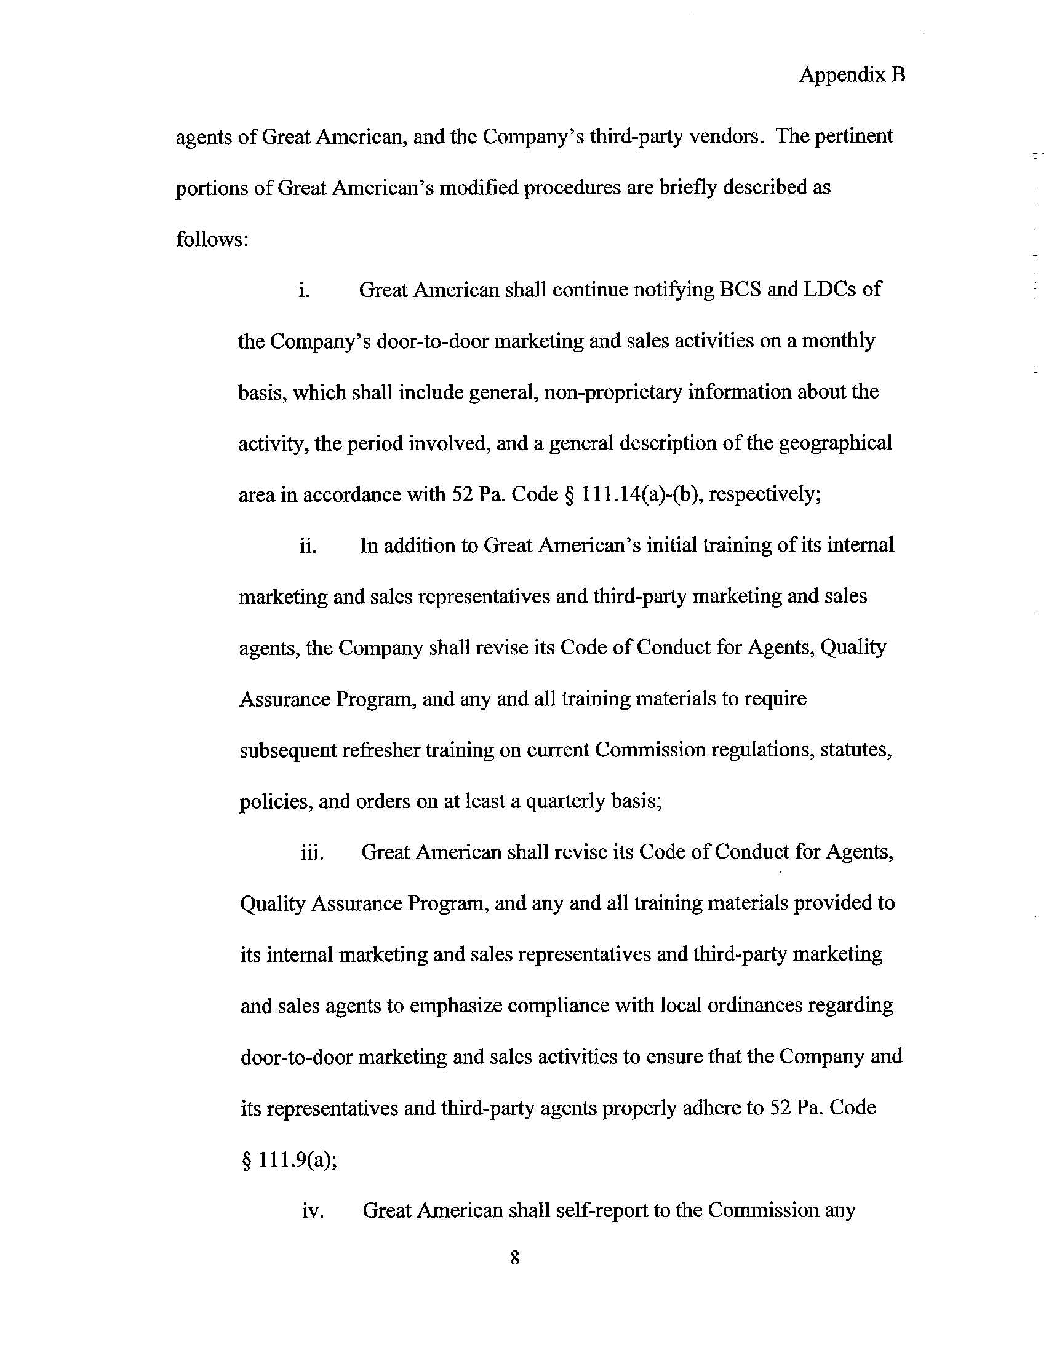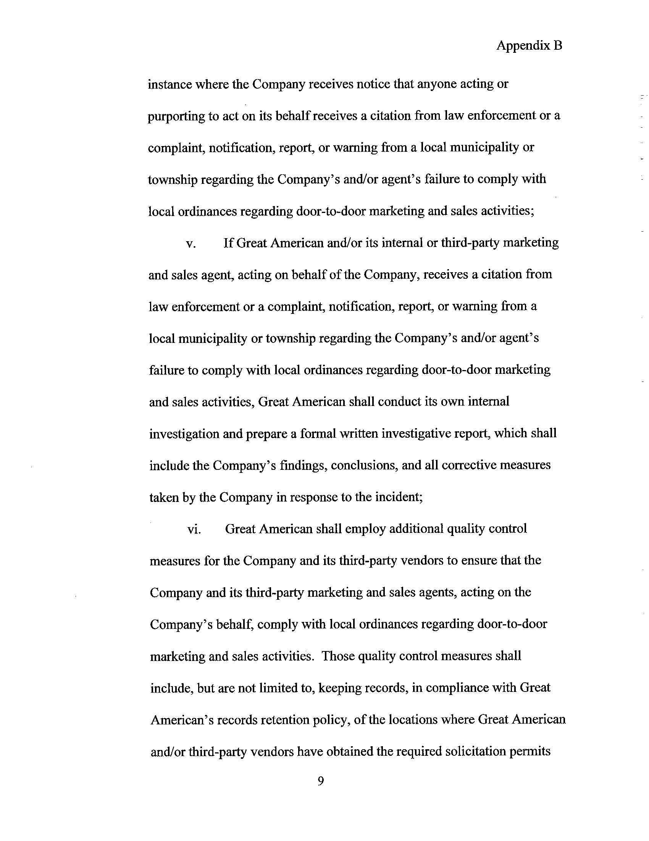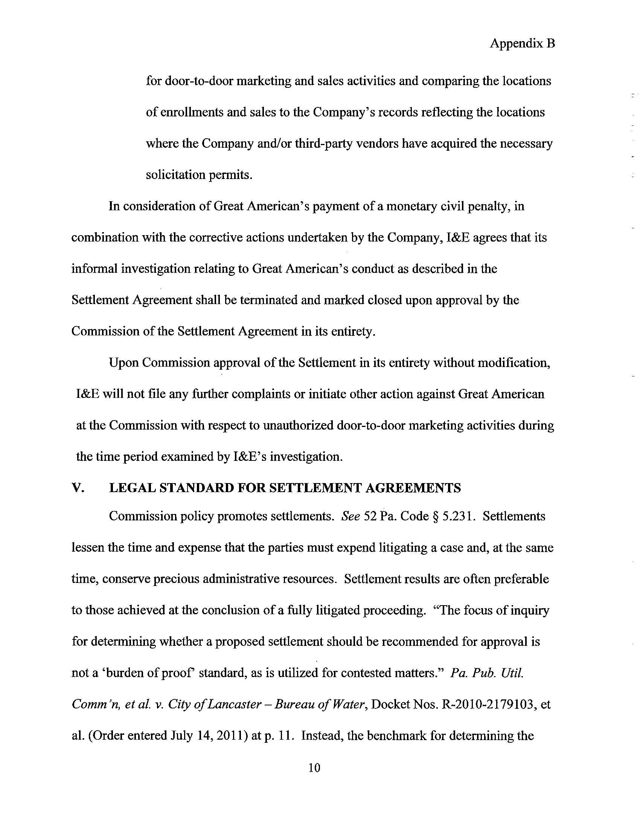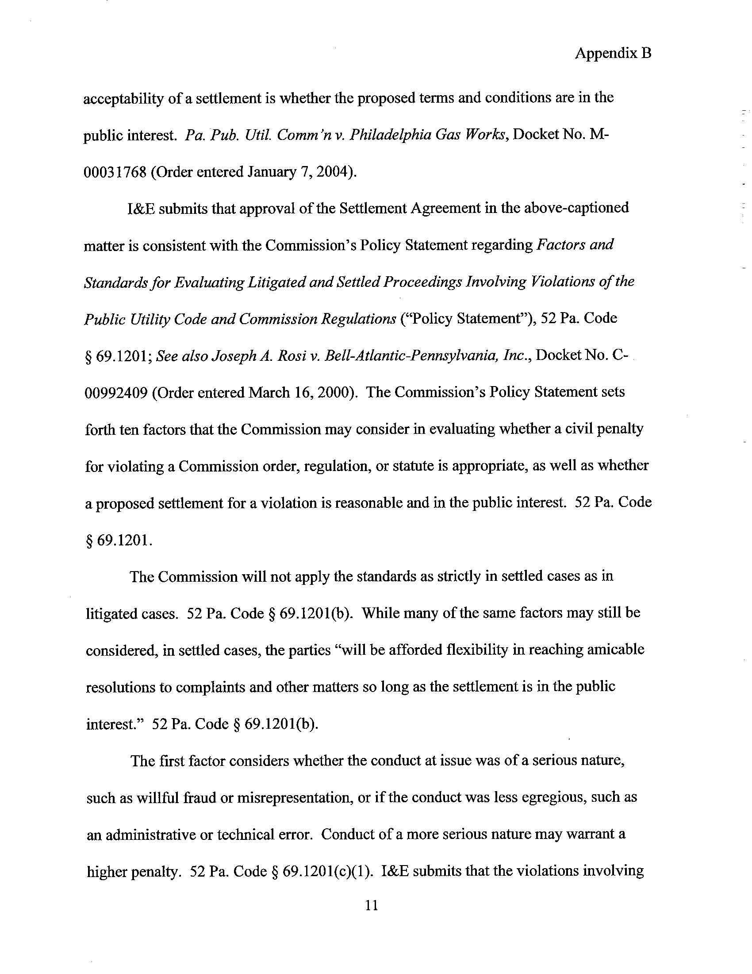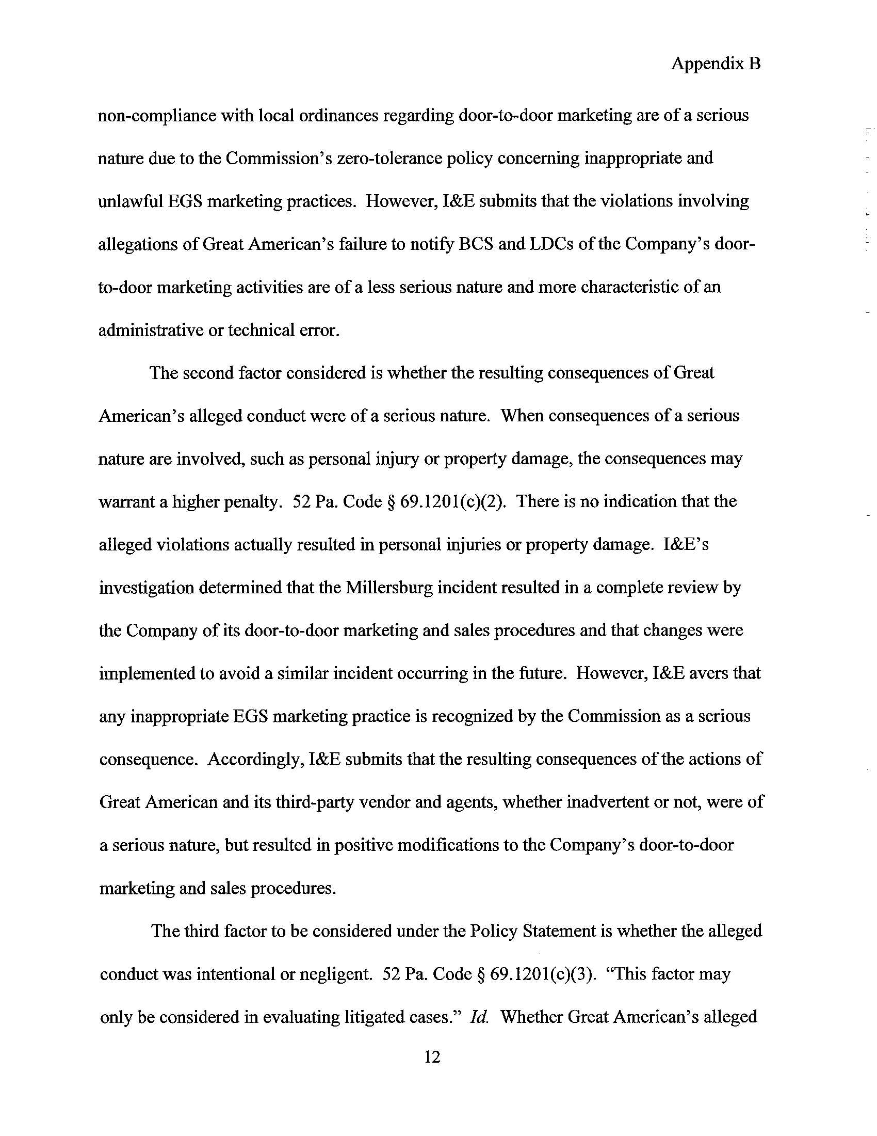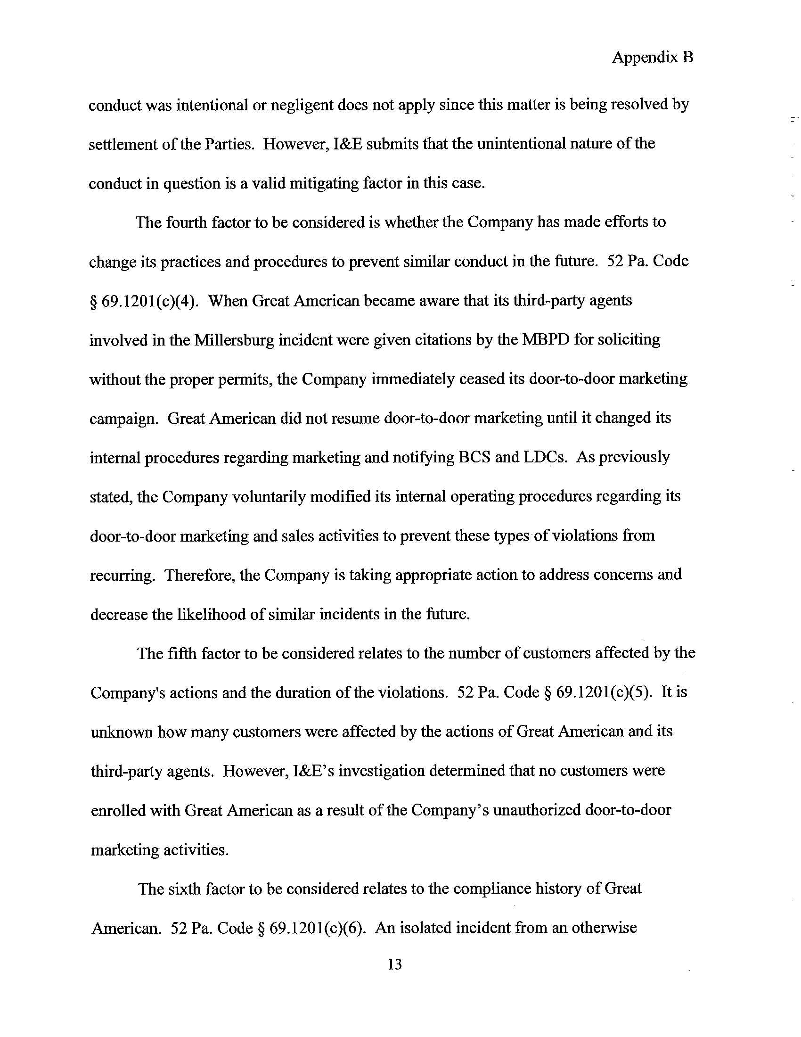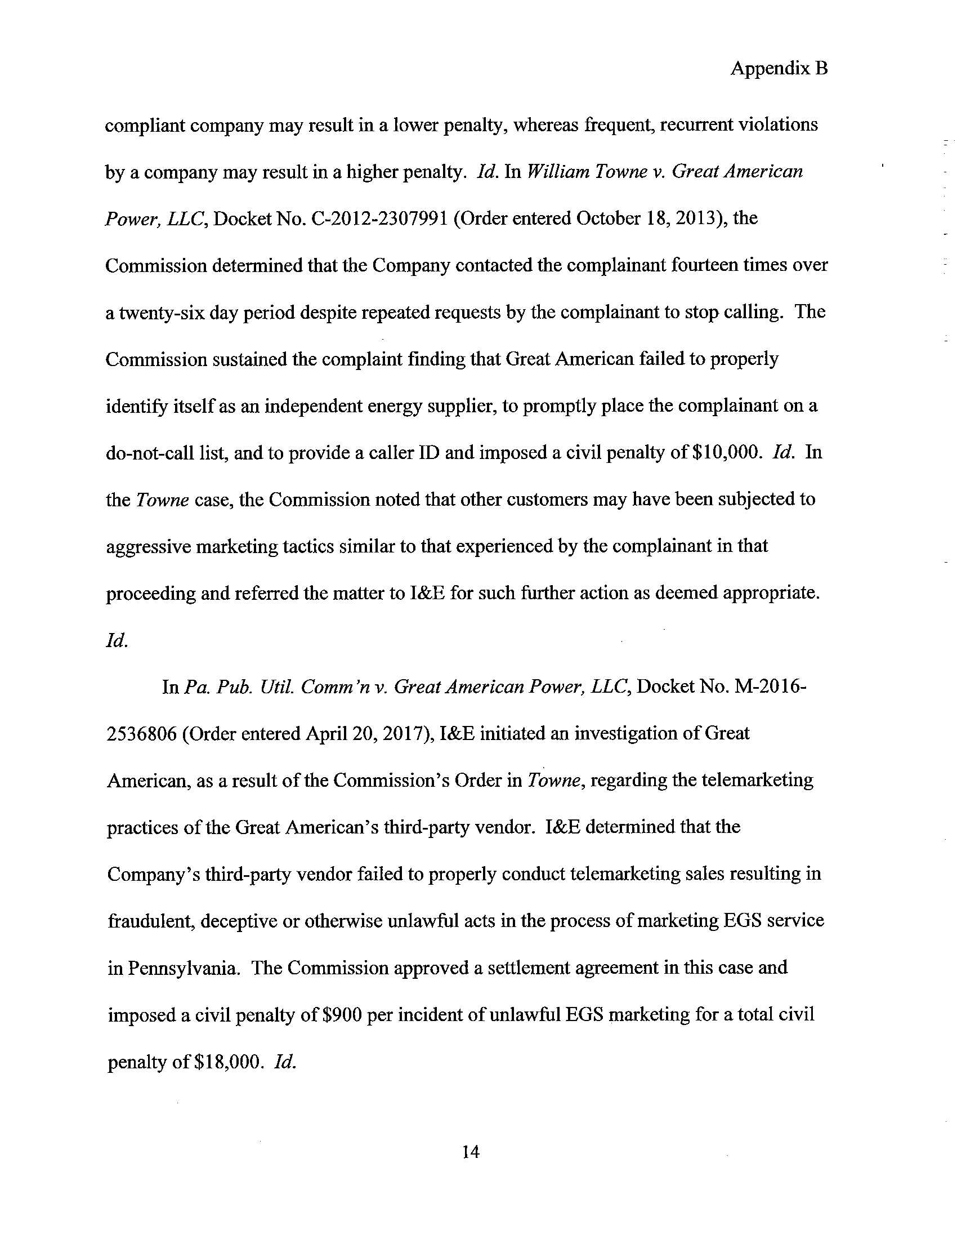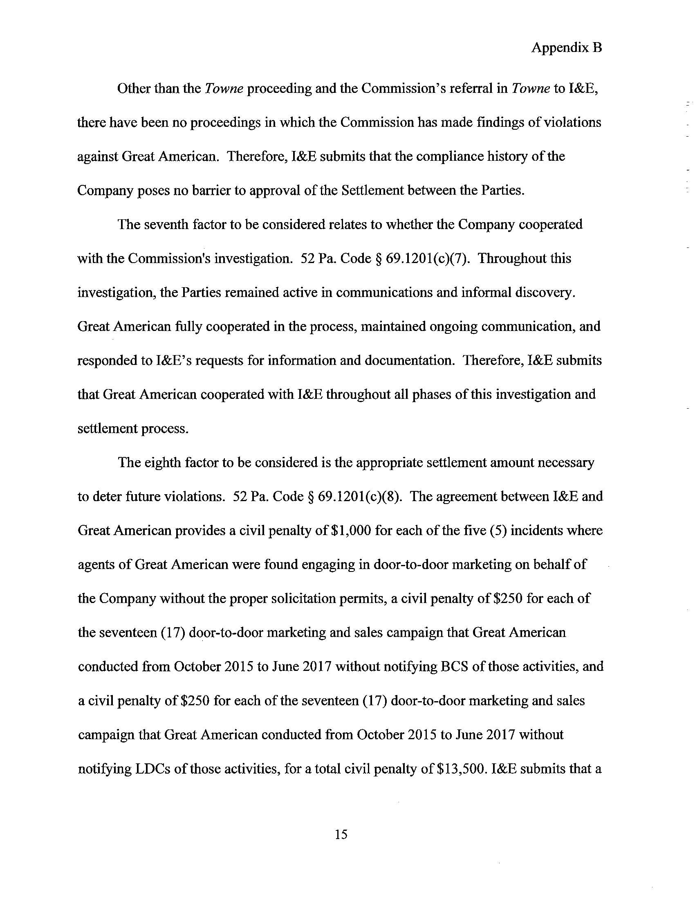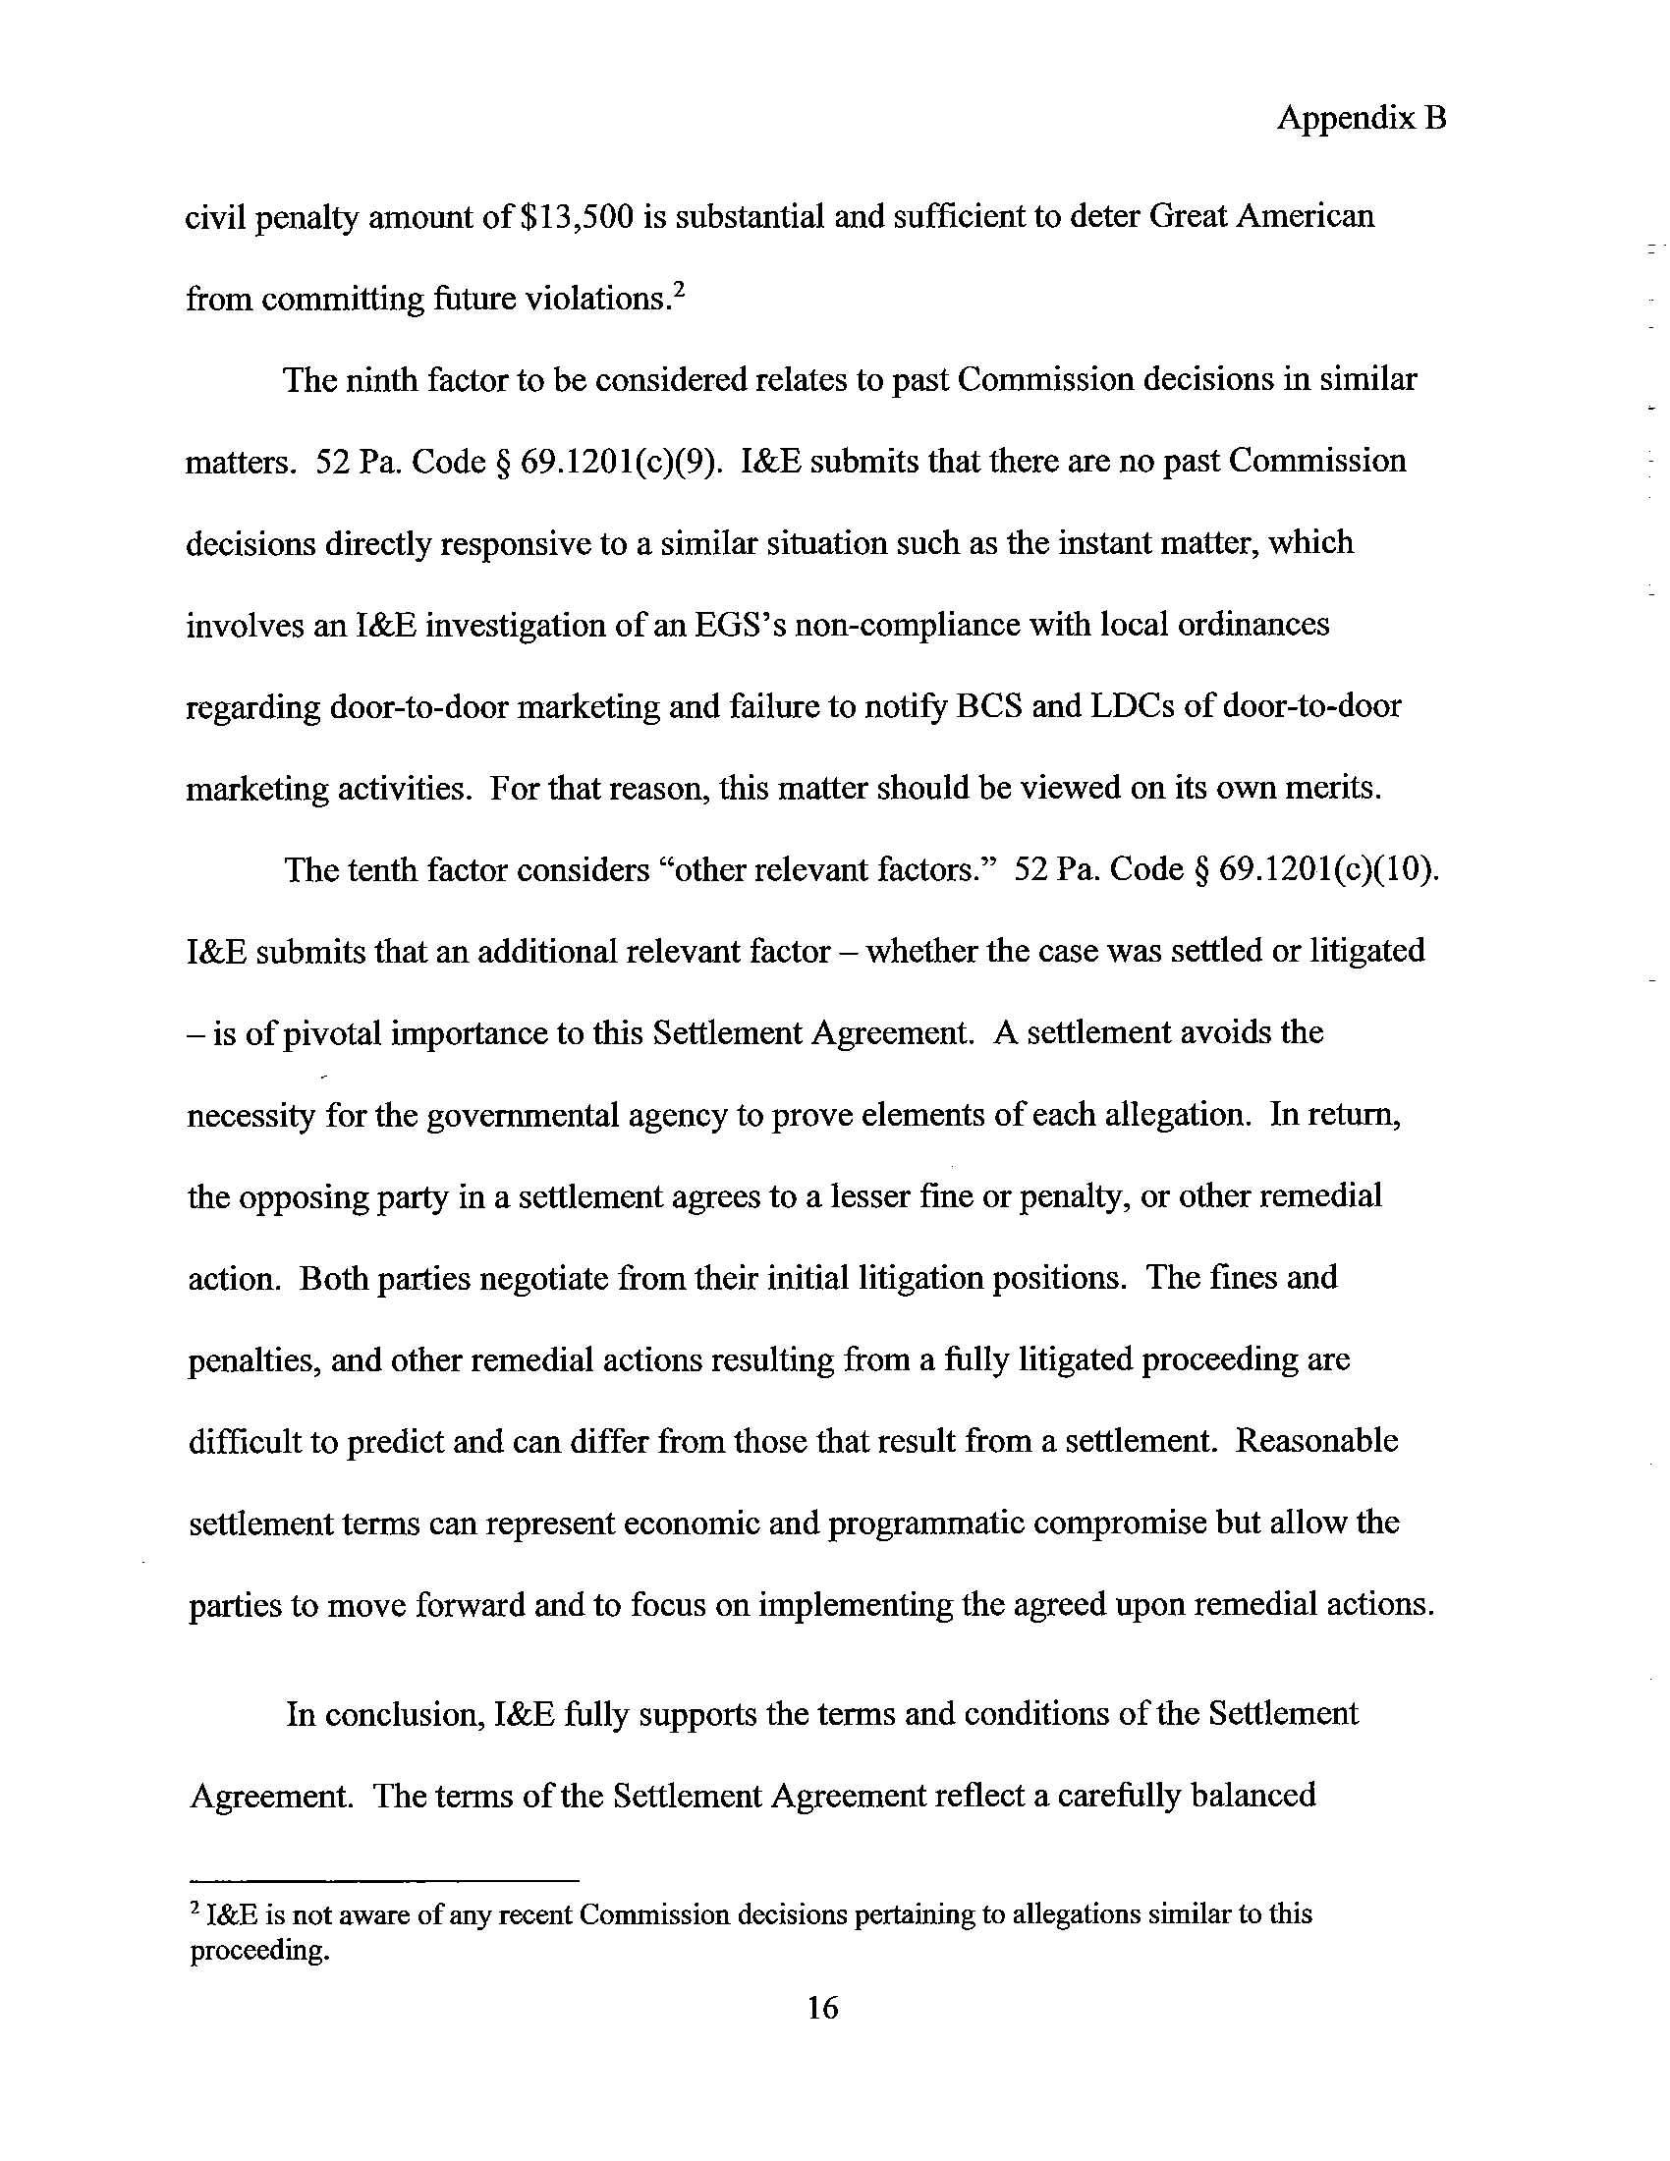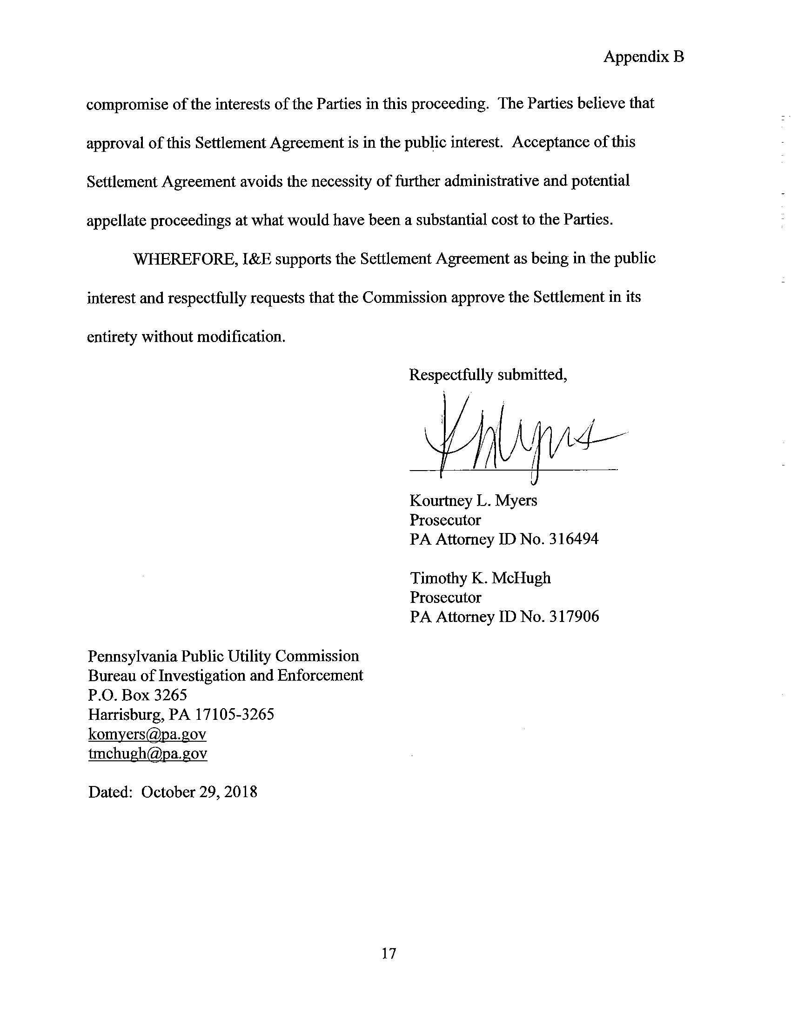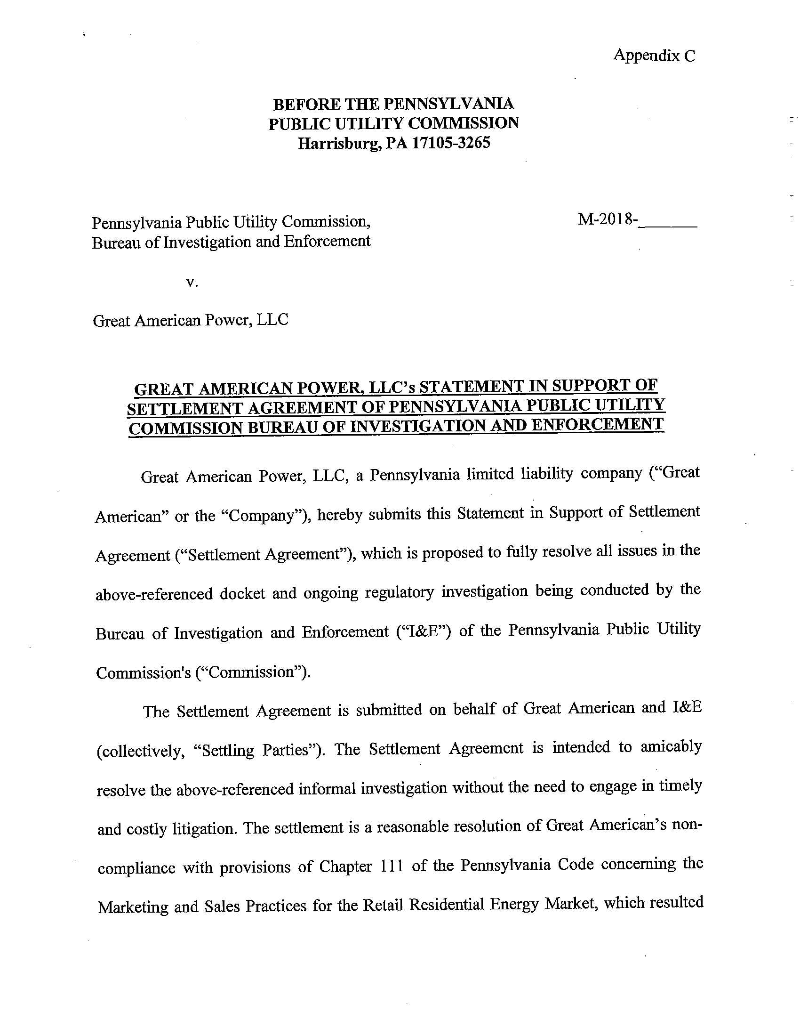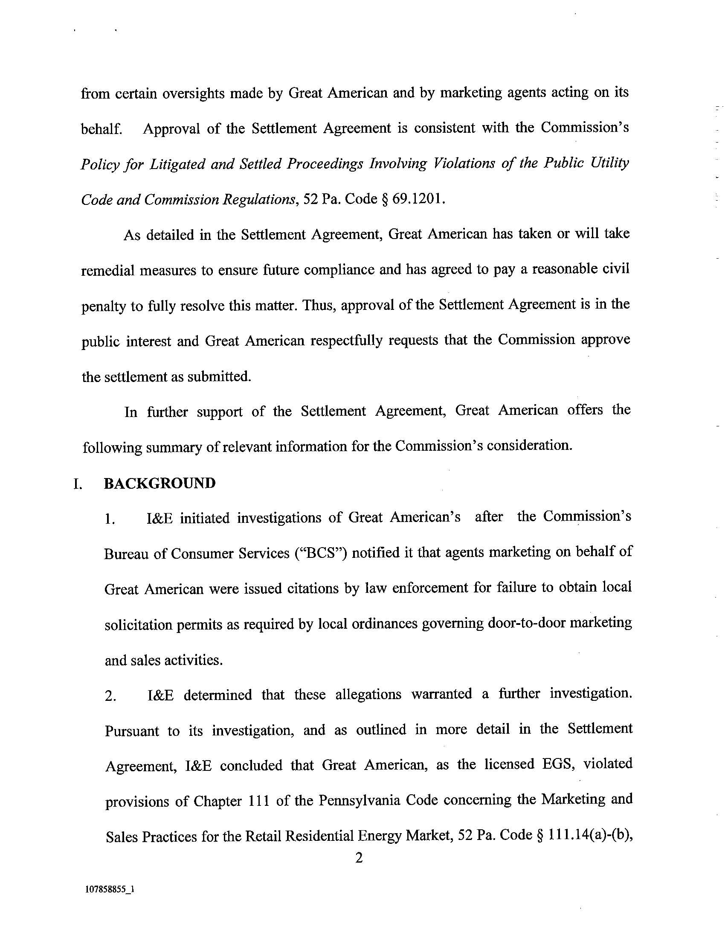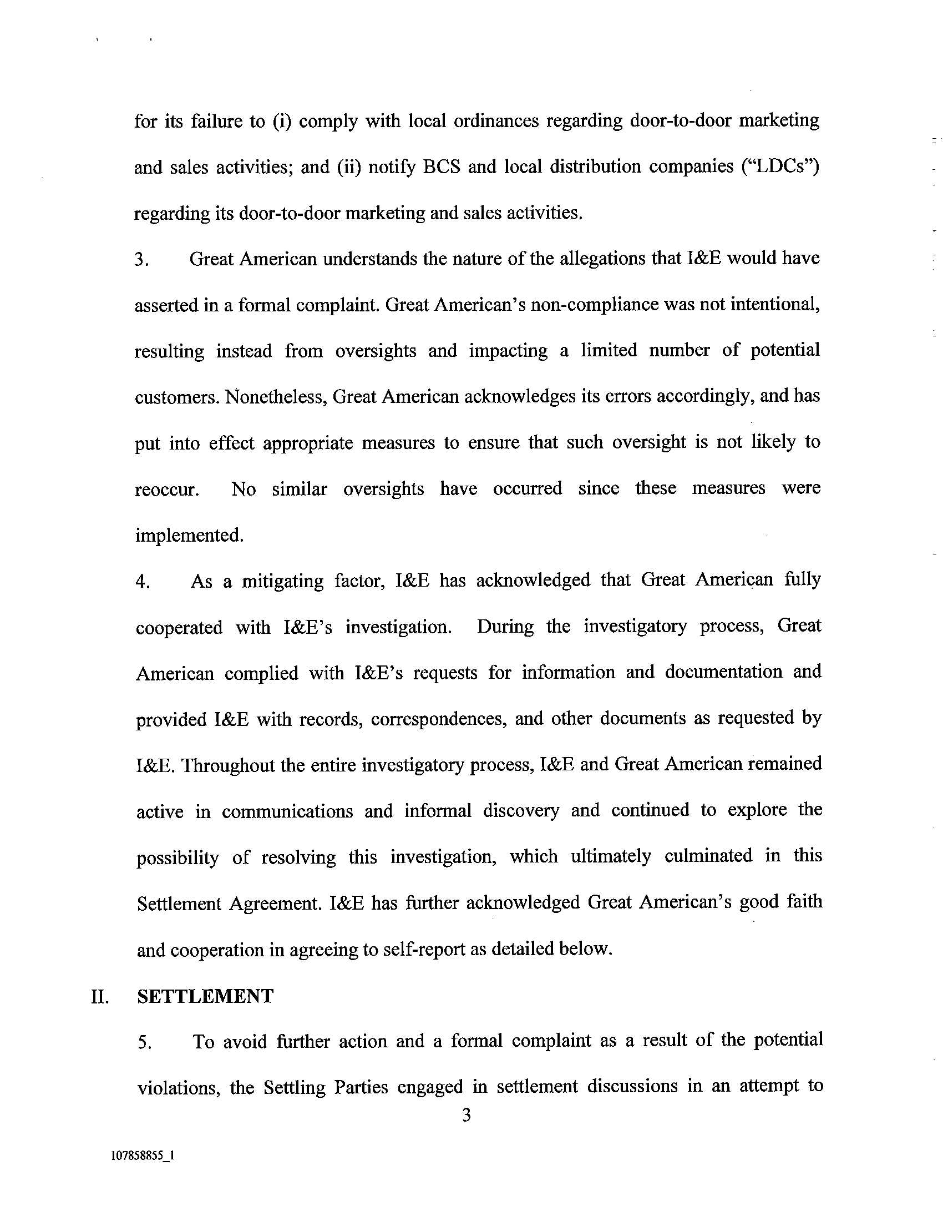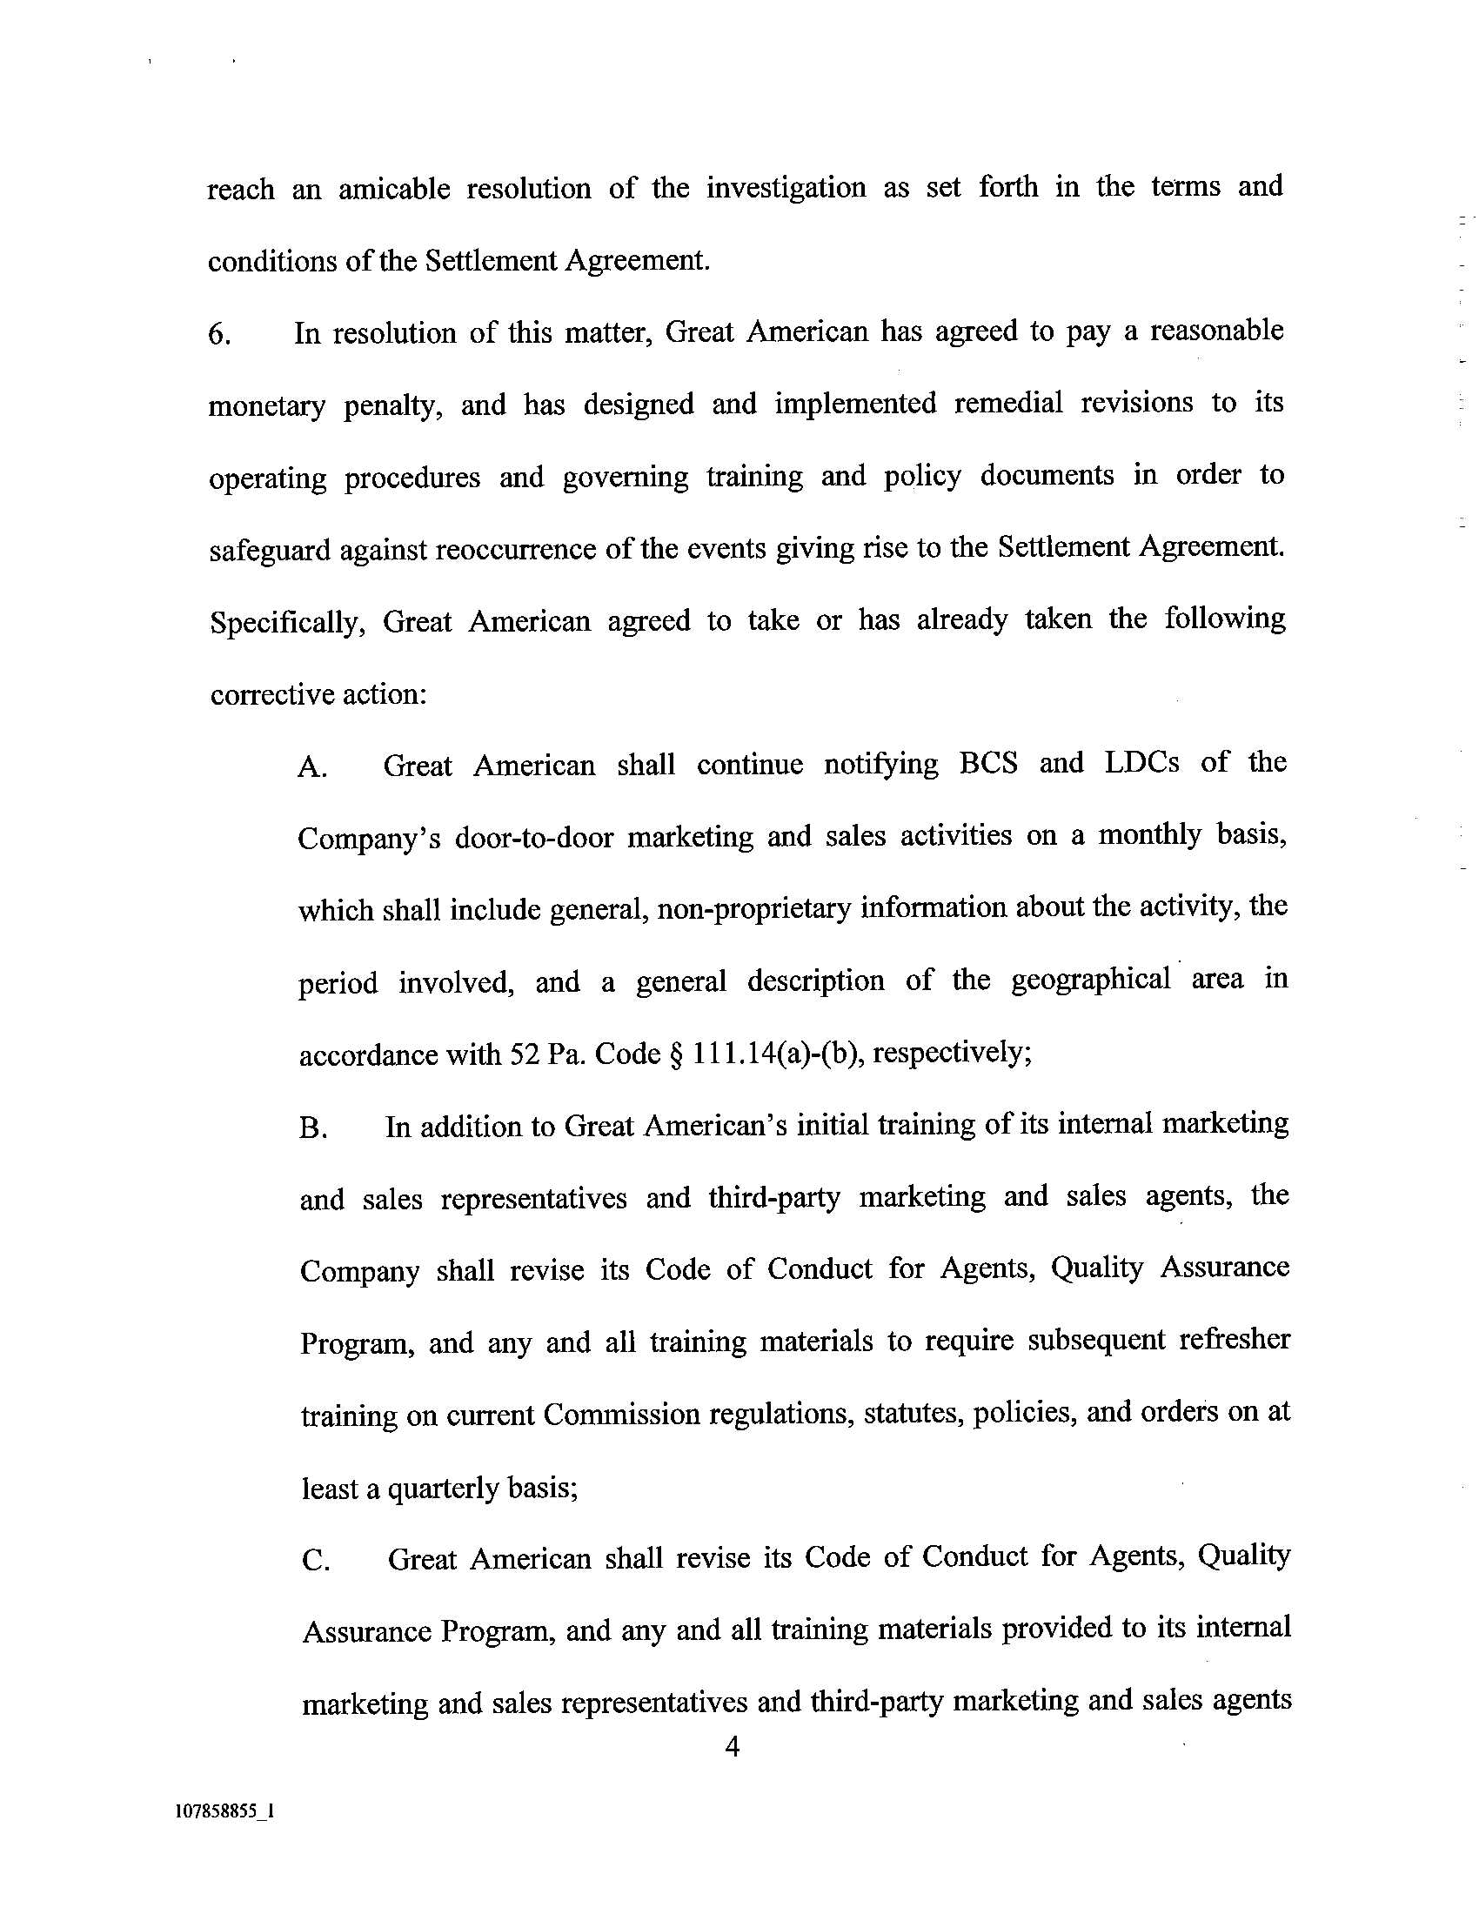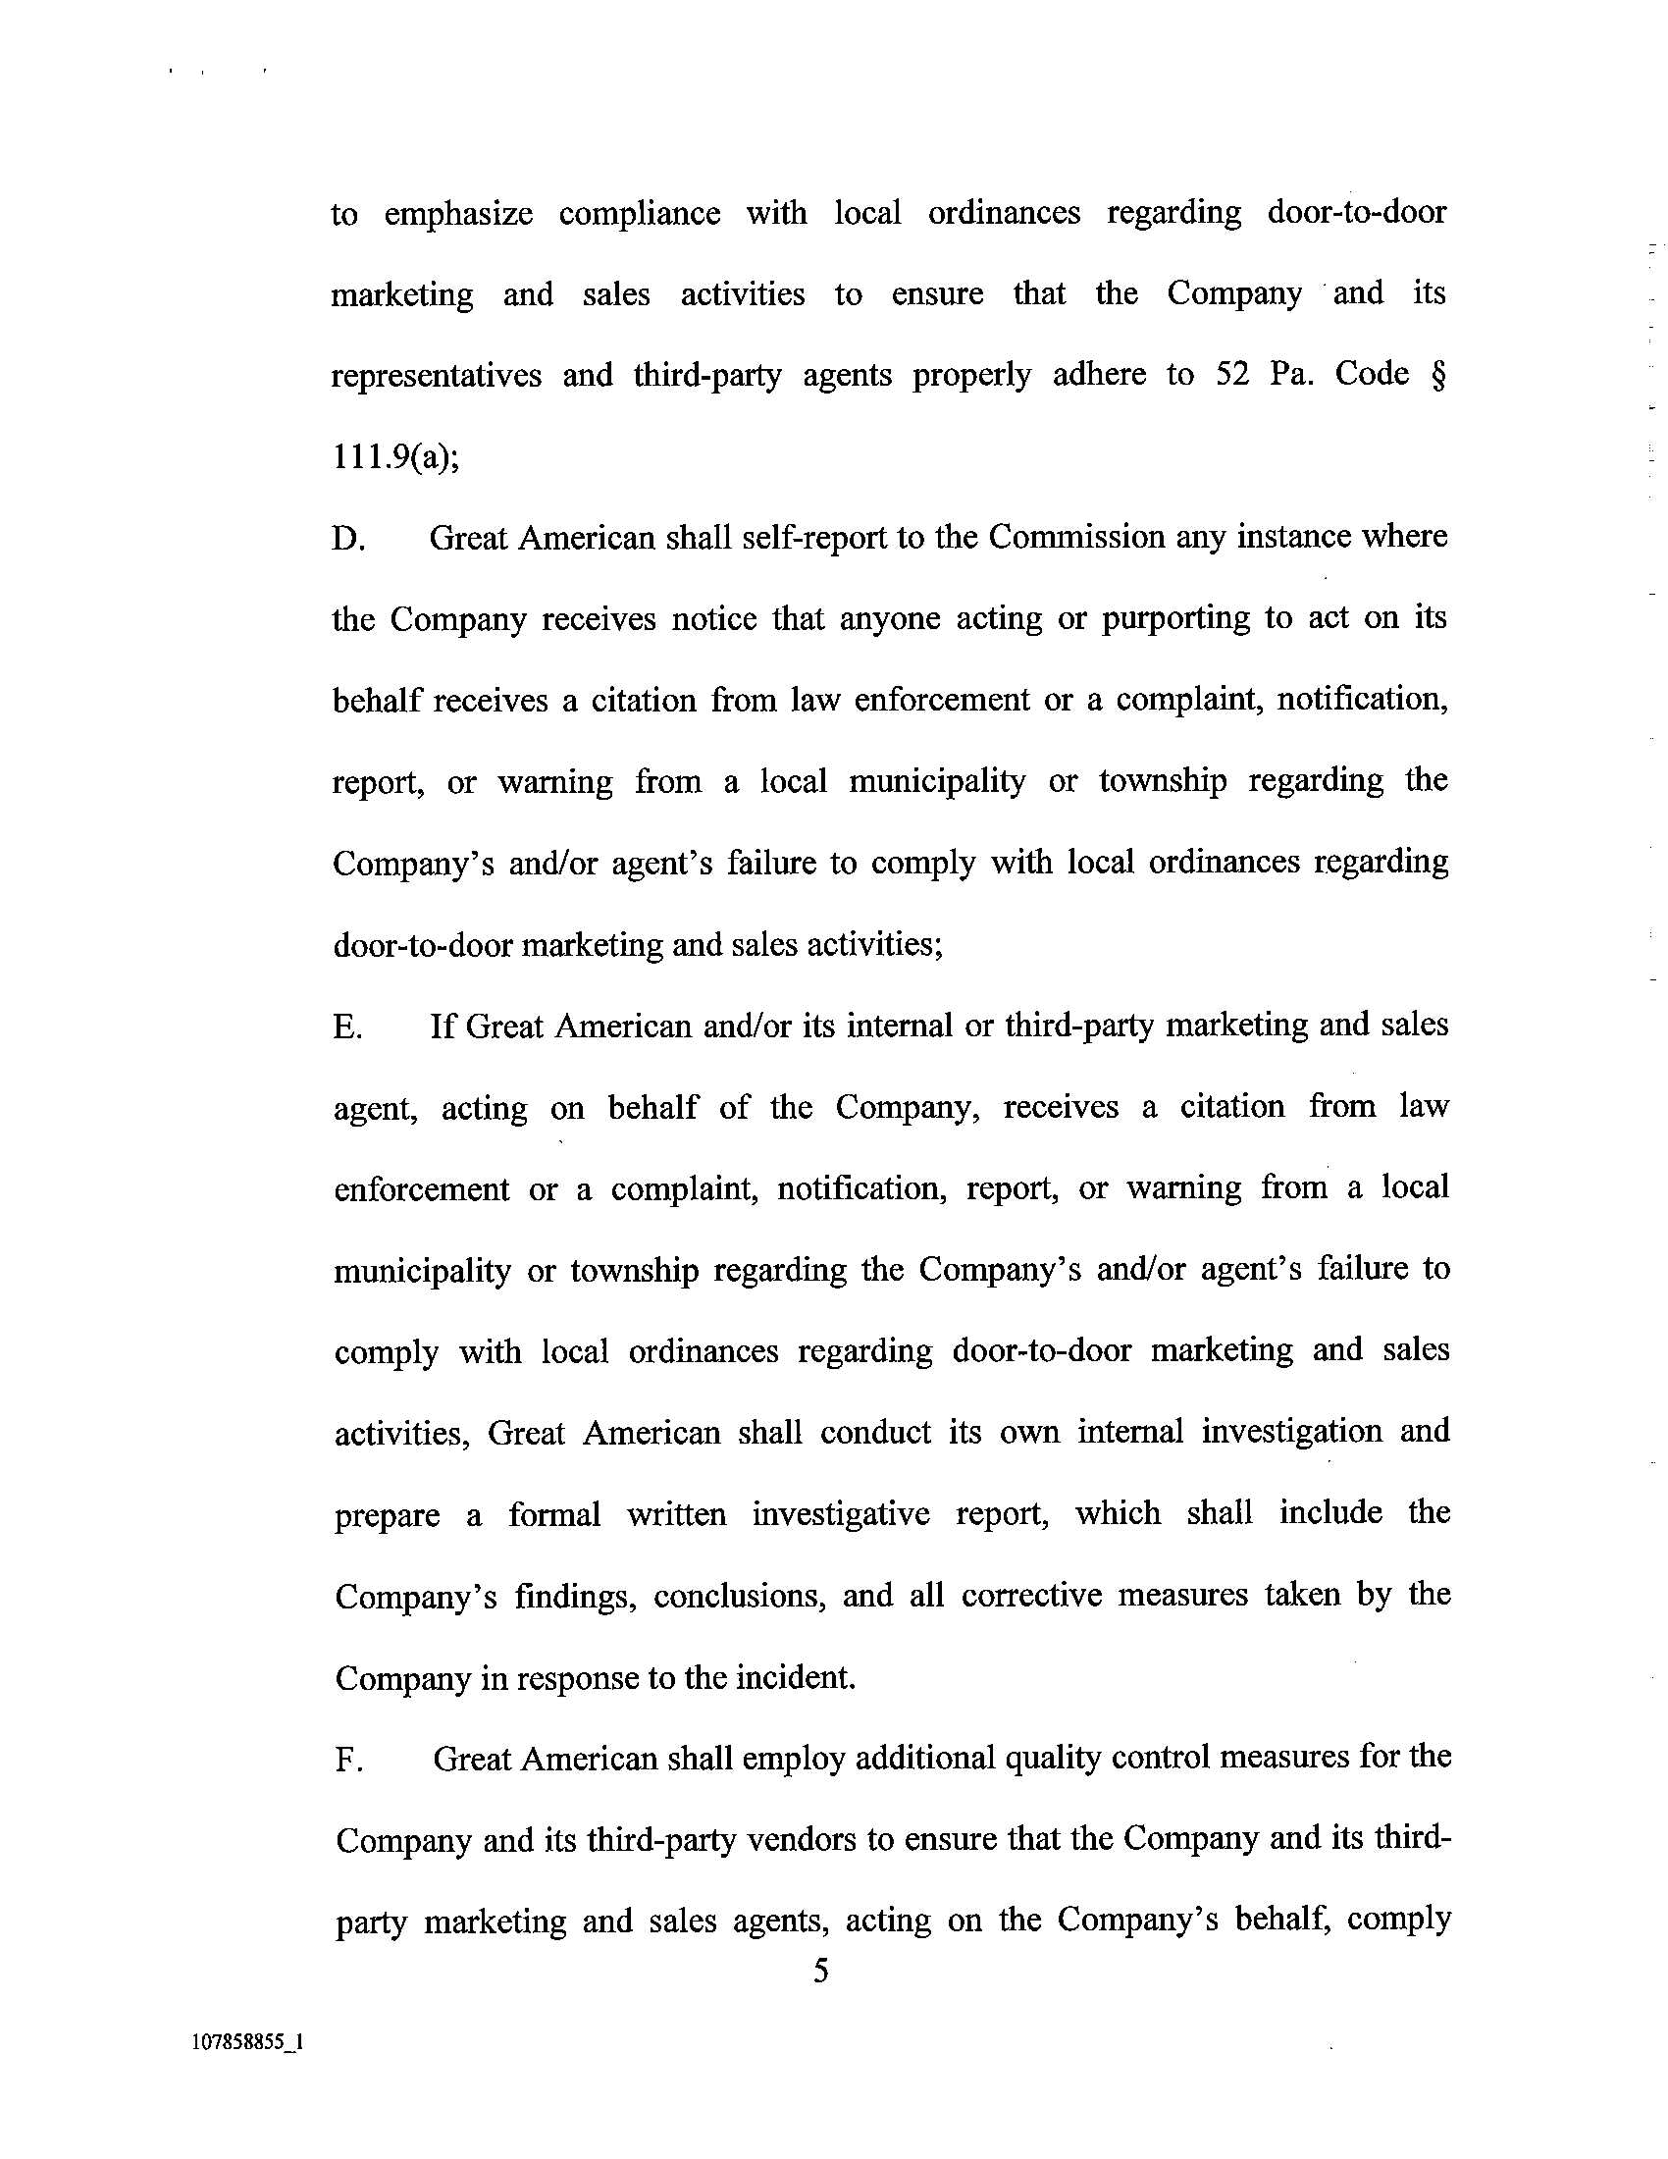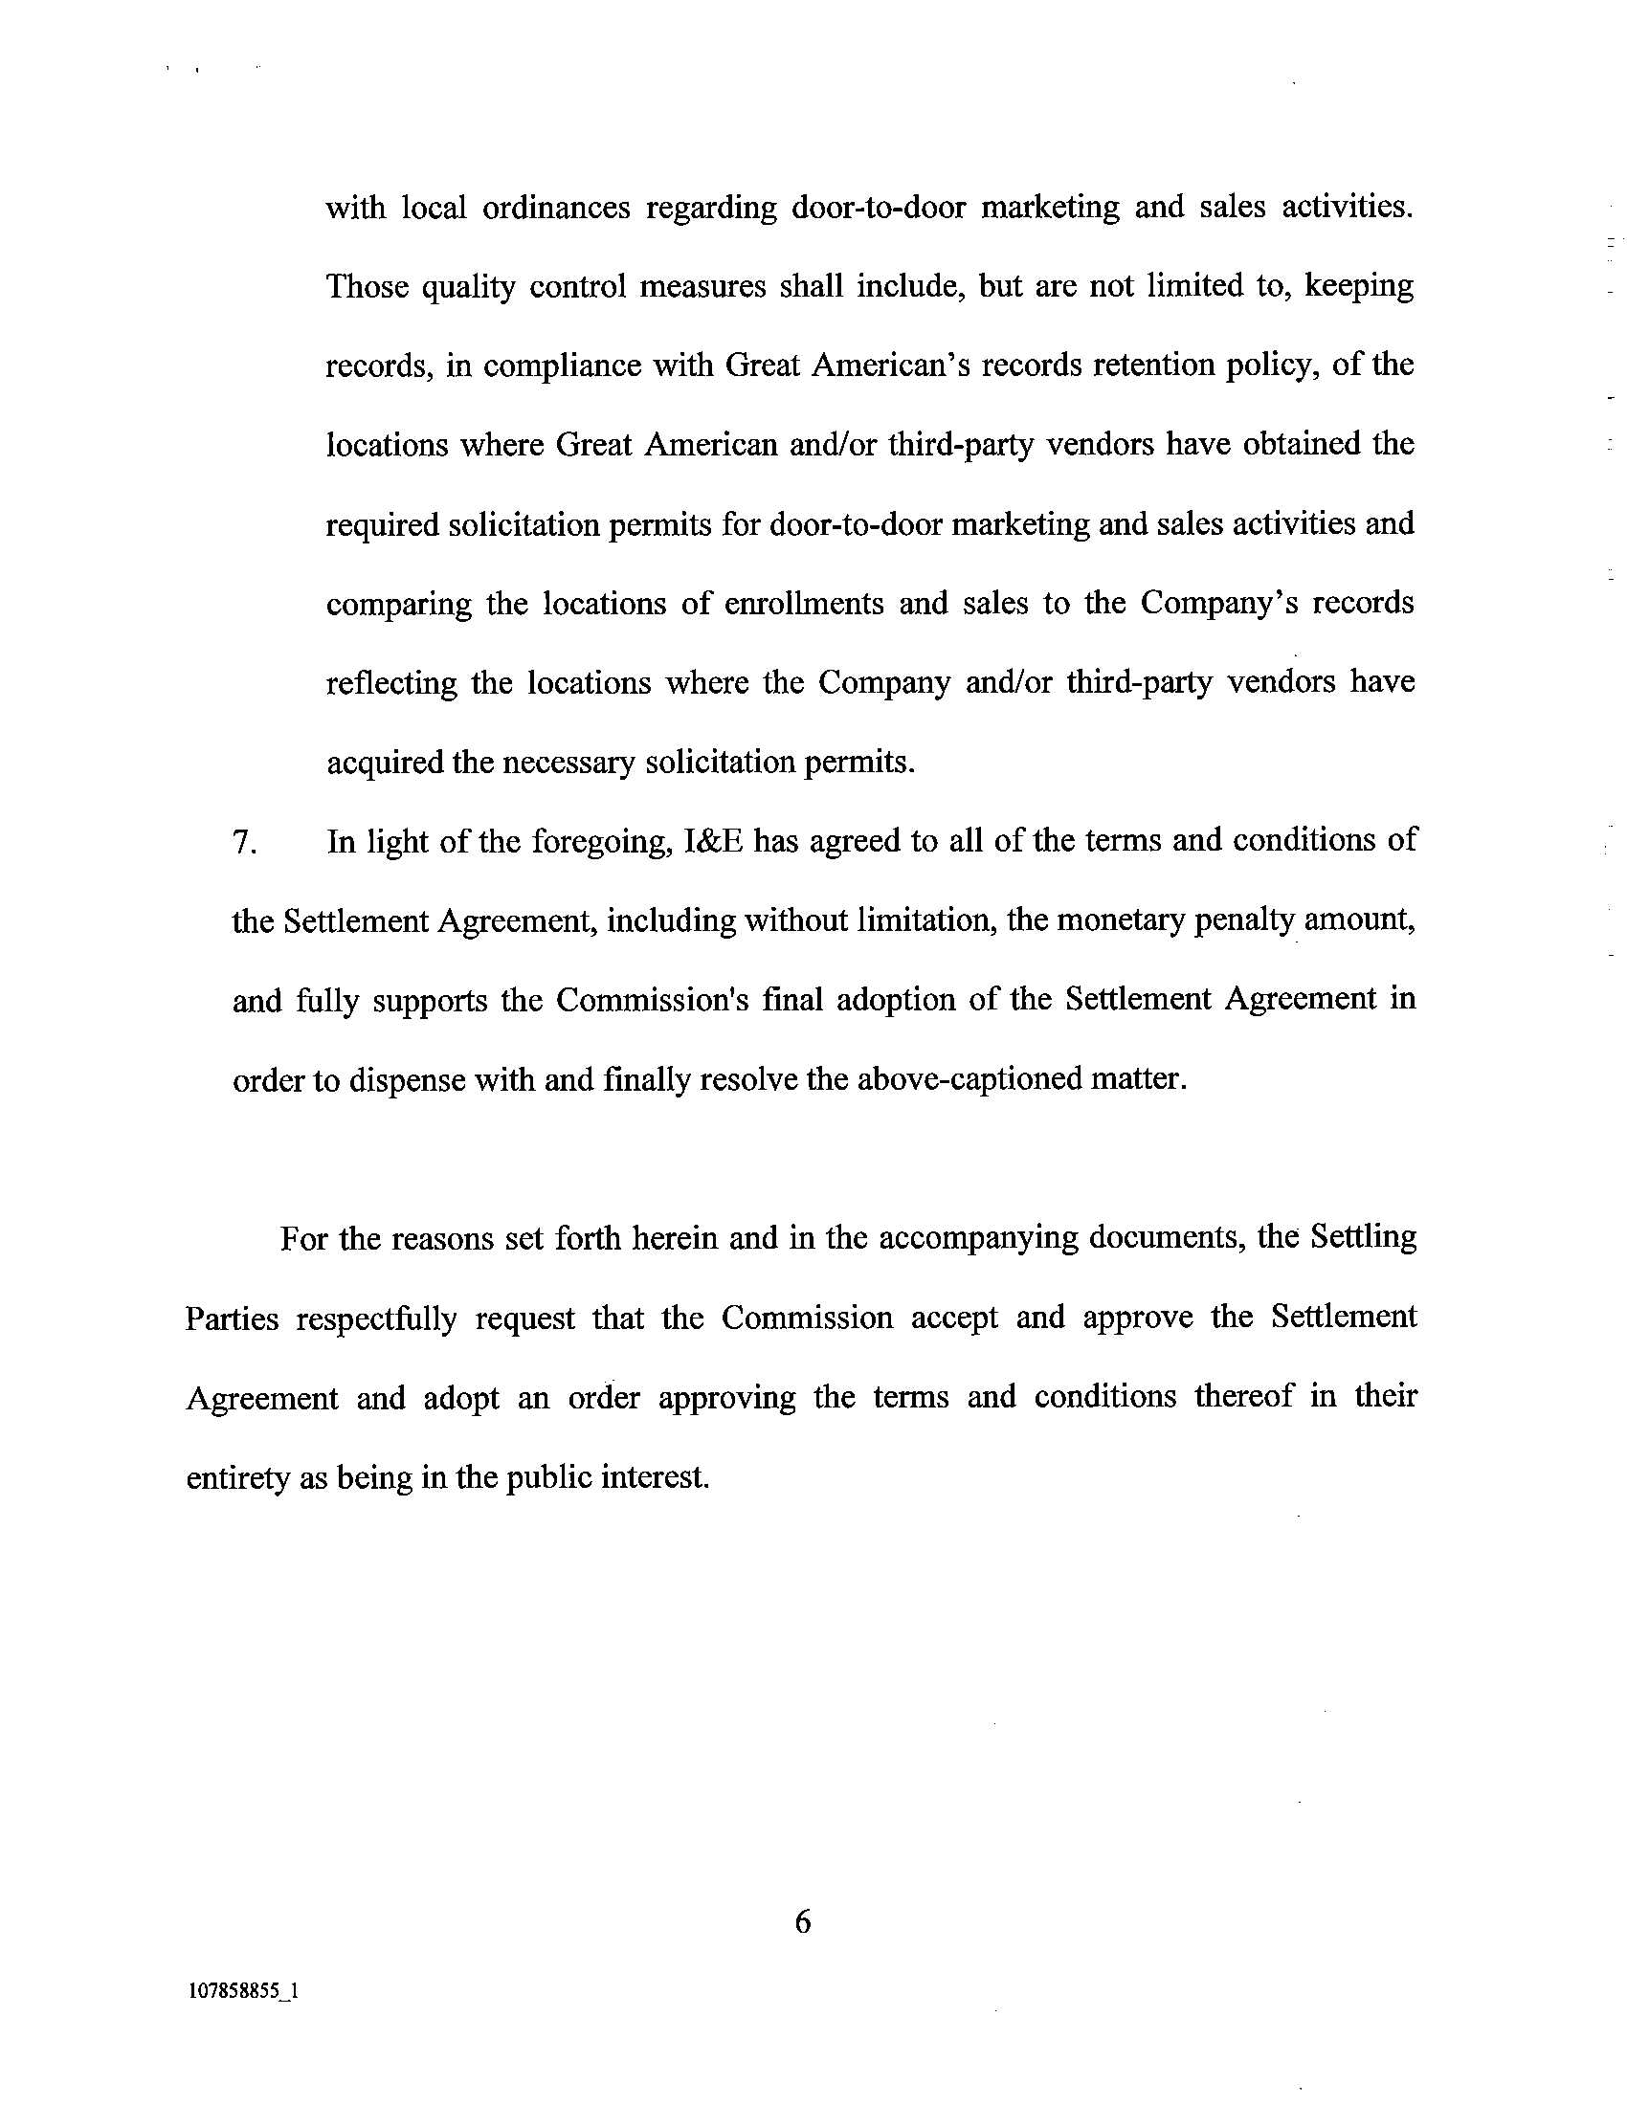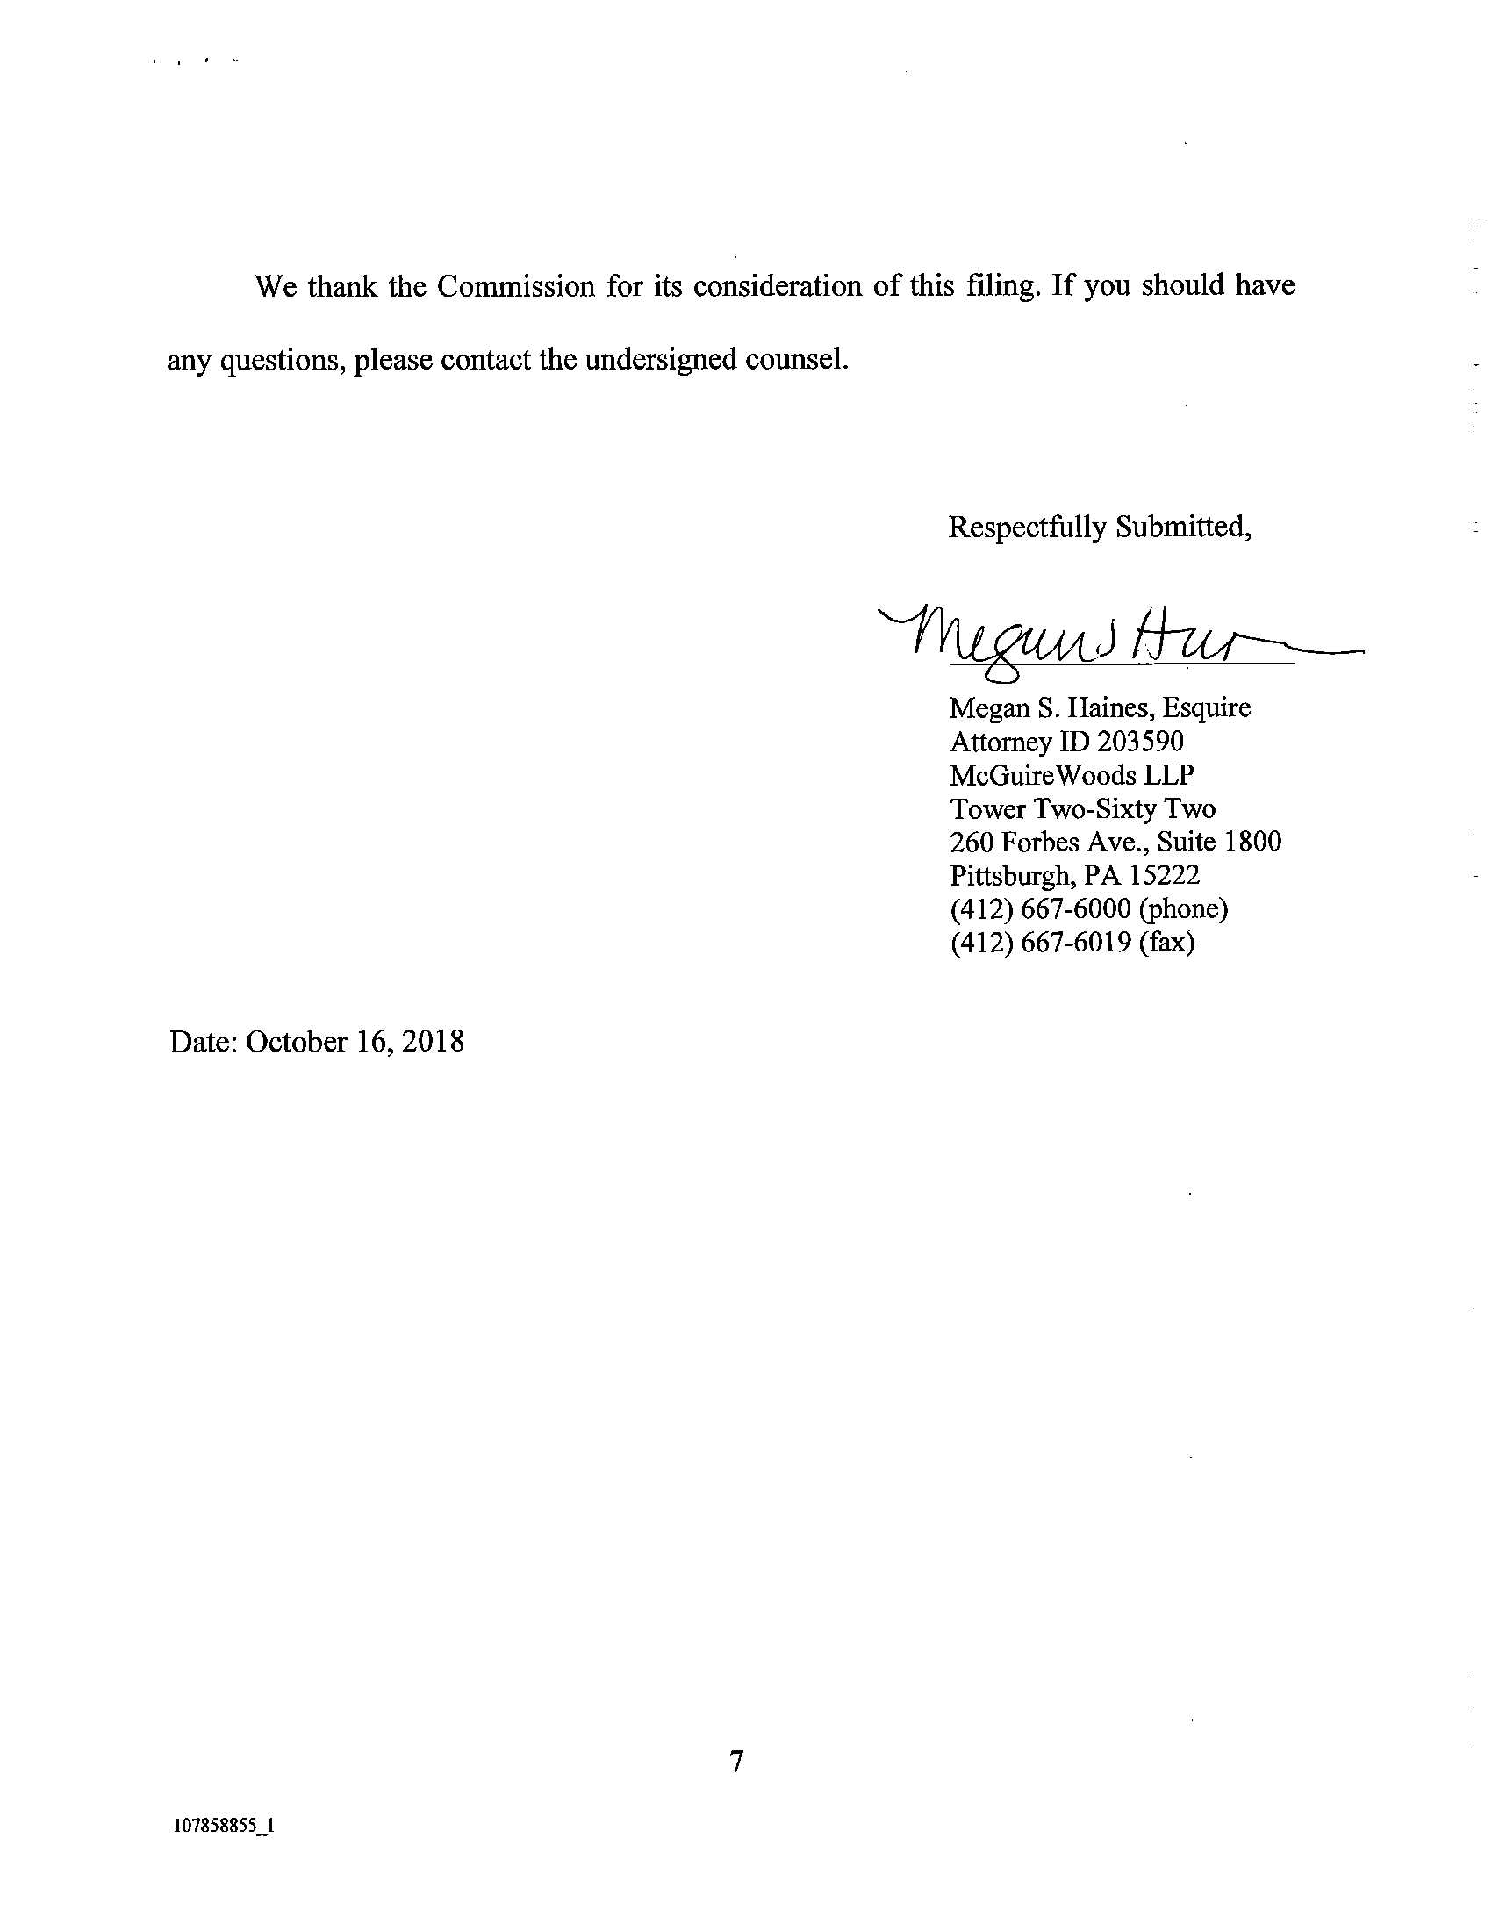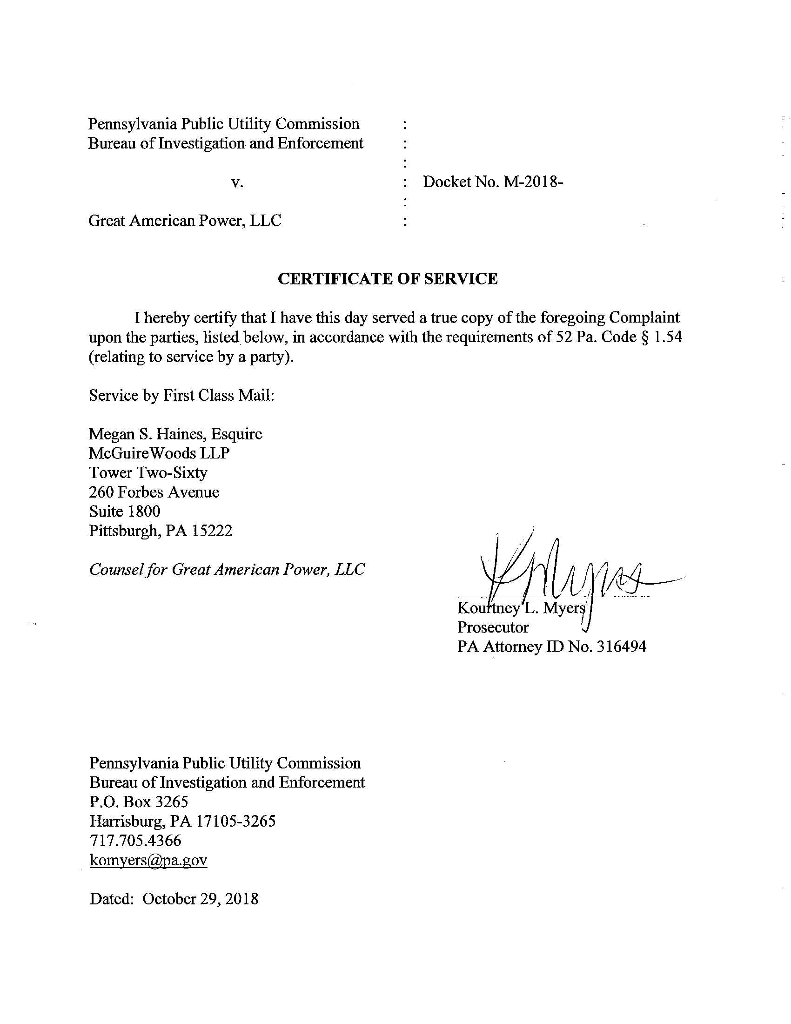

Great American is a jurisdictional Electric Generation Supplier (EGS) licensed by the Commission to operate within the service territories of PPL Electric Utilities “Corporation, PECO Energy Company, Metropolitan Edison Company and Duquesne Light Company.
See Appendix B to Settlement, Statement In support of Bureau of Investigation and Enforcement; and Appendix C, Great American Power, LLC’s Statement in Support of Settlement Agreement of Pennsylvania Public Utility Commission Bureau of Investigation and Enforcement.

