PENNSYLVANIA
PUBLIC UTILITY COMMISSION
Harrisburg, PA 17105-3265

Public Meeting held April 11, 2019

Commissioners Present:

Gladys M. Brown, Chairman
David W. Sweet, Vice Chairman
Norman J. Kennard
Andrew G. Place
John F. Coleman, Jr.

Pennsylvania Public Utility Commission,  Bureau of Investigation and Enforcement  v.  Vista Energy Marketing, L.P. |  | M-2019-2633094

Opinion and Order

BY THE COMMISSION:

Before the Pennsylvania Public Utility Commission (Commission) for consideration and disposition is a proposed Settlement Agreement of the Bureau of Investigation and Enforcement and Vista Energy Marketing, L.P. (Settlement) filed on February 28, 2019, by the Commission’s Bureau of Investigation and Enforcement (I&E) and Vista Energy Marketing, L.P. (Vista or Company) (collectively, the Parties), with respect to an Informal Investigation conducted by I&E. Vista is an electric generation supplier licensed by the Commission to operate in the Duquesne Light, PPL, UGI Utilities, and First Energy Pennsylvania Companies (First Energy) service territories. Both Parties submitted Statements in Support of the Settlement. The Parties submit that the proposed Settlement is in the public interest and is consistent with the Commission’s Policy Statement at 52 Pa. Code § 69.1201, Factors and standards for evaluating litigated and settled proceedings involving violations of the Public Utility Code and Commission regulations—statement of policy. Settlement at 13-14. We will issue the Settlement for comment.

History of the Proceeding

This matter involves an informal investigation initiated by I&E consistent with Sections 331(a) and 506 of the Public Utility Code (the Code) and Section 3.113 of the Commission’s regulations, 52 Pa. Code § 3.113. The informal investigation focused on allegations of slamming raised in five informal complaints received by the Commission’s Bureau of Consumer Services (BCS) and a sixth informal complaint that alleged that Vista’s agents engaged in door-to-door sales in a senior citizen community where signs were clearly posted stating “No Solicitation.”

As part of the investigation, the Parties entered into negotiations and agreed to resolve the matter in accordance with the Commission’s policy to promote settlements at 52 Pa. Code § 5.231. As a result of those negotiations, the Parties filed the instant Settlement on February 28, 2019, for the Commission’s consideration.

Background

From August through October 2017, the Commission’s Bureau of Consumer Services (BCS) received six informal complaints against Vista. In five of those complaints, the Complainants alleged that Vista enrolled their respective residential accounts for electric generation supply service without proper customer authorization, otherwise known as “slamming.” In the sixth informal complaint the customer alleged that a Vista agent engaged in door-to-door sales in a community that had “No Solicitation” signs clearly posted in the community

A summary of the complaints received by BCS as Informal Complaints is as follows:

- On August 7, 2017, a Complainant filed a complaint at BCS No. 3551377. The Complainant alleged that that one of Vista’s agents visited her on July 25, 2017, and despite claiming that she told the agent she was not interested in enrolling with Vista, her account was enrolled anyway. After it accepted the Complainant’s representation of the events, Vista cancelled her account on August 7, 2017, credited back to her all of its charges and terminated the agent involved with this matter.

- On August 14, 2017, a Complainant filed a complaint at BCS NO. 3553113. The Complainant alleged that on July 25, 2017, a Vista agent, was conducting door-to-door sales in a senior citizen community with signs advising “No Solicitation.” Vista enrolled the Complainant’s mother at a rate higher than her current rate. Vista subsequently re-rated the account but verified that the Complainant’s mother participated in a third-party verification. At the time of I&E’s investigation, the agent was no longer active.

- On September 18, 2017, a Complainant filed a complaint at BCS No. 3563403. The Complainant alleged that on September 9, 2017, her mother’s account was enrolled with Vista without receiving proper authorization. Due to a health condition, the Complainant’s mother was unable to speak and no one else was present to provide the authorization. A third-party verification was obtained from a person who claimed they were authorized to switch services on behalf of the Complainant’s mother. Vista accepted the Complainant’s claim and cancelled the account, did not assess any charges, and deactivated the agent.

- On September 20, 2017, a Complainant filed a complaint at BCS 3563467. The Complainant alleged that on September 12, 2017, he was enrolled with Vista without his consent. Vista investigated the matter and concluded that the Complainant’s daughter had enrolled the account, but after discussing the matter with her father, they decided to cancel the account with Vista. Vista credited the Complainant for the charges that were on account and cancelled the account.

- On October 10, 2017, a Complainant filed a complaint at BCS No. 3569005. The Complainant alleged that her account was enrolled with Vista on September 15, 2017, even though she lives alone and was out-of-town on the day her account was enrolled. Vista accepted her claim and cancelled her account. Vista did not assess any charges and eventually terminated the agent.

- On October 23, 2017, a Complainant filed a complaint at BCS No. 2572249. The Complainant allege that her account was enrolled with Vista on October 123,2107 without her consent. Vista accepted the Complainant’s claim and cancelled her account. Vista did not assess any charges and the agent was eventually terminated.

Settlement at 6.

BCS requested that I&E review the matter and I&E initiated an informal investigation into whether Vista enrolled customers in their electric generation service without proper authorization contrary to Commission regulations pertaining to Standards for Changing a Customer’s Electricity Generation Supplier at 52 Pa. Code §§ 57.171-179. Settlement at 6-7.

Through its investigation and data requests, I&E concluded that the Complainants who filed the BCS informal complaints had their electric generation supplier switched to Vista without the authorization of the customers. Id at 8. I&E found that the switching likely occurred as a result of Vista incorporating its risk-oriented approach to quality assurance. Id.

At the end of its investigation, I&E was prepared to allege that Vista violated the Electric Generation Customer Choice and Competition Act at 52 Pa. Code §§ 54.42(a)(9) and 54.43(f) and the standards for Changing a Customer’s electricity Generation Supplier at 52 Pa. Code §§ 57.171-179 (multiple counts) by the action of Vista or its agents initiating the process of switching the electric generation supplier on four accounts without the customer’s authorization. Settlement at 8-9.

Vista timely complied with I&E’s data requests. Vista also had internal controls in place and required all vendors and agents to abide by them as well. Those controls included: monitoring agents for compliance, daily review of all third-party verifications (TPV) and regular audits of enrollments. Vista also utilizes internal quality assurance (QA) agents whose responsibility was to review one hundred percent of the TPVs. Settlement at 7. As part of the quality assurance process, agents were instructed to reject an enrollment even if it had cleared TPV if the customer sounded uncertain, confused or suspicious in any way. Id. If the quality assurance agent deemed that the TPV was questionable, the agent would follow-up by contacting the customer to verify his/her intent to enroll with Vista. Id. However, Vista acknowledged that the due to increased sales volume, its quality assurance resources were challenged by the volume. Id. Consequently, it developed what it believed to be a more risk-oriented approach to quality assurance by utilizing algorithms that were designed to identify higher risk sales. Id. The algorithm approach was used in limited circumstances when higher sales volume prevented one hundred percent quality assurance review of TPVs. Id at 7-8. Then on January 25, 2018, Vista resumed its previous practice of having one hundred percent of TPVs reviewed by a quality assurance agent. Id at 8.

Vista understands the nature of the allegations that I&E would have asserted in a formal complaint, acknowledges its error in switching to a risk-oriented QA approach that likely resulted in residential accounts being enrolled to receive electric generation supply service from Vista without proper authorization, and has put into effect appropriate measures that have been approved by I&E to ensure that such oversight is not likely to reoccur. Settlement at 9.

I&E acknowledges that Vista fully cooperated with I&E’s investigation and complied with I&E’s requests for information and documentation and provided I&E with records, correspondences and other documents as requested by I&E. Settlement at 9. Moreover, throughout the entire investigatory process, I&E and Vista remained active in communications and informal discovery and continued to explore the possibility of resolving this investigation. Settlement at 9.

Additionally, per the Settlement, Vista does not dispute the allegations, fully acknowledges the Commission’s long-standing “zero-tolerance” policy concerning slamming, that the Commisison has penalized companies that have slammed or are alleged to have slammed customers, and that the Commisison has made it clear that such acts will not be tolerate. Vista also has implemented its own extensive internal policies to prevent slamming and has its own internal “zero-tolerance” policy. Settlement at 10.

The proposed Settlement, which is attached to this Opinion and Order, has been filed by the Parties in order to terminate I&E’s formal investigation and to resolve this matter completely and without litigation. The Parties urge the Commission to approve the Settlement as being in the public interest.

Terms of the Settlement
Pursuant to the proposed Settlement, Vista will pay a civil penalty of $4,000. Settlement at 10. The Settlement acknowledges that the Company since has taken corrective action and is committed to diligently applying its policies which will act as safeguards against the unauthorized switch of customer accounts initiated by a third-party vendor. Specifically, Vista terminated its relationship with the agents whose actions are the cause of this matter and has instructed its third-party vendors not to assign the agents to any Vista accounts or contracts. Additionally, Vista took immediate corrective action by cancelling the Complainants’ enrollment with Vista and ensuring that no charges were assessed to the Complainants upon becoming aware of the mistaken enrollments. Furthermore, Vista implemented the following quality control measures, with I&E’s approval, to address this issue in the future:
i. For each third-party vendor with whom Vista seeks to engage in business, Vista will affirmatively inquire about whether the agents, whose actions are the cause of this present matter, is employed by or associated with the company.
- Vista shall continue to ensure that its agents are reminded of the Commission’s regulations regarding consumer protection, with an emphasis on those prohibiting slamming.
- Vista shall provide or confirm a single point of contact to Commission staff for resolution of consumer inquiries and/or complaints received by BCS.
- Vista will continue to respond to all consumer inquiries and complaints relating to fraudulent, deceptive, or otherwise unlawful acts in the process of marketing supplier products and/or services in accordance with BCS requirements, including providing to BCS staff a copy of the customer contract and any audio recordings of the verification call, when such recordings are available to Vista.
- For a term of twelve (12) months starting after the date of entry of the Commission’s order approving settlement in this matter, Vista shall provide to BCS staff, in the first week of each calendar quarter, a report for the prior quarter that captures the following data concerning customer complaints filed directly with Vista: (1) the number of complaints by category, i.e. slamming, do-not-call list violations, incorrect charges, etc.; and (2) any process improvements, organizational changes, etc. that were implemented to reduce or eliminate similar complaints going forward.

Settlement at 11-12. As earlier indicated, Vista acknowledges that the Commission has a long standing “zero tolerance” policy concerning slamming, that the Commission has penalized companies that have slammed or are alleged to have slammed customers, and that the Commission has made it clear that such acts will not be tolerated.

The Settlement provides that I&E will agree to forbear from initiating a formal complaint relative to the allegations that are the subject of the proposed Settlement. The Settlement will not, however, affect the Commission’s authority to receive and resolve any formal or informal complaints filed by any affected party regarding the subject of the allegations of I&E’s informal investigation. Settlement at 12.
Discussion

Pursuant to our Regulations at 52 Pa. Code § 5.231, it is the Commission’s policy to promote settlements. The Commission must, however, review proposed settlements to determine whether the terms are in the public interest. Pa. PUC v. Philadelphia Gas Works, Docket No. M-00031768 (Order entered January 7, 2004).

Conclusion

Before issuing a decision on the merits of the proposed Settlement, and consistent with the requirement of 52 Pa. Code § 3.113(b)(3), we are providing an opportunity for interested parties to file comments regarding the proposed Settlement; THEREFORE,

IT IS ORDERED:

1. That this Opinion and Order, together with the attached Joint Settlement Petition and Statements in Support, shall be issued for comments by any interested party.

2. That a copy of this Opinion and Order, together with the attached Joint Settlement Petition and the Statements in Support thereof, shall be served on the Office of Consumer Advocate and the Office of Small Business Advocate.

3. That within twenty (20) days from the date of entry of this Opinion and Order, interested parties may file comments concerning the proposed Joint Settlement Petition. Comments to the proposed Joint Settlement Petition may be filed either through eFiling for those parties who have an eFiling user account with the Pennsylvania Public Utility Commission or by paper copy. Paper copies shall be filed with the Secretary’s Bureau at the following address:

Rosemary Chiavetta, Secretary
Pennsylvania Public Utility Commission
Commonwealth Keystone Building
400 North Street
Harrisburg, PA, 17120

4. That, subsequent to the Commission’s review of comments filed in this proceeding, an Opinion and Order will be issued by the Commission’s Office of Special Assistants.

BY THE COMMISSION,

Rosemary Chiavetta
Secretary

(SEAL)

ORDER ADOPTED: April 11, 2019

ORDER ENTERED: April 11, 2019

ATTACHMENT

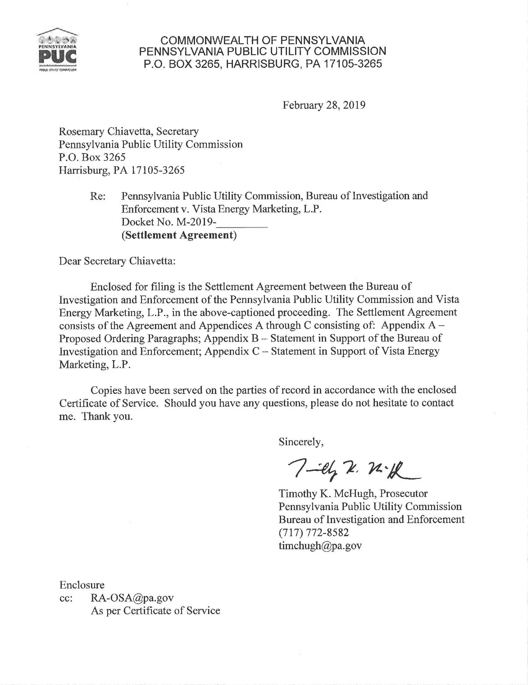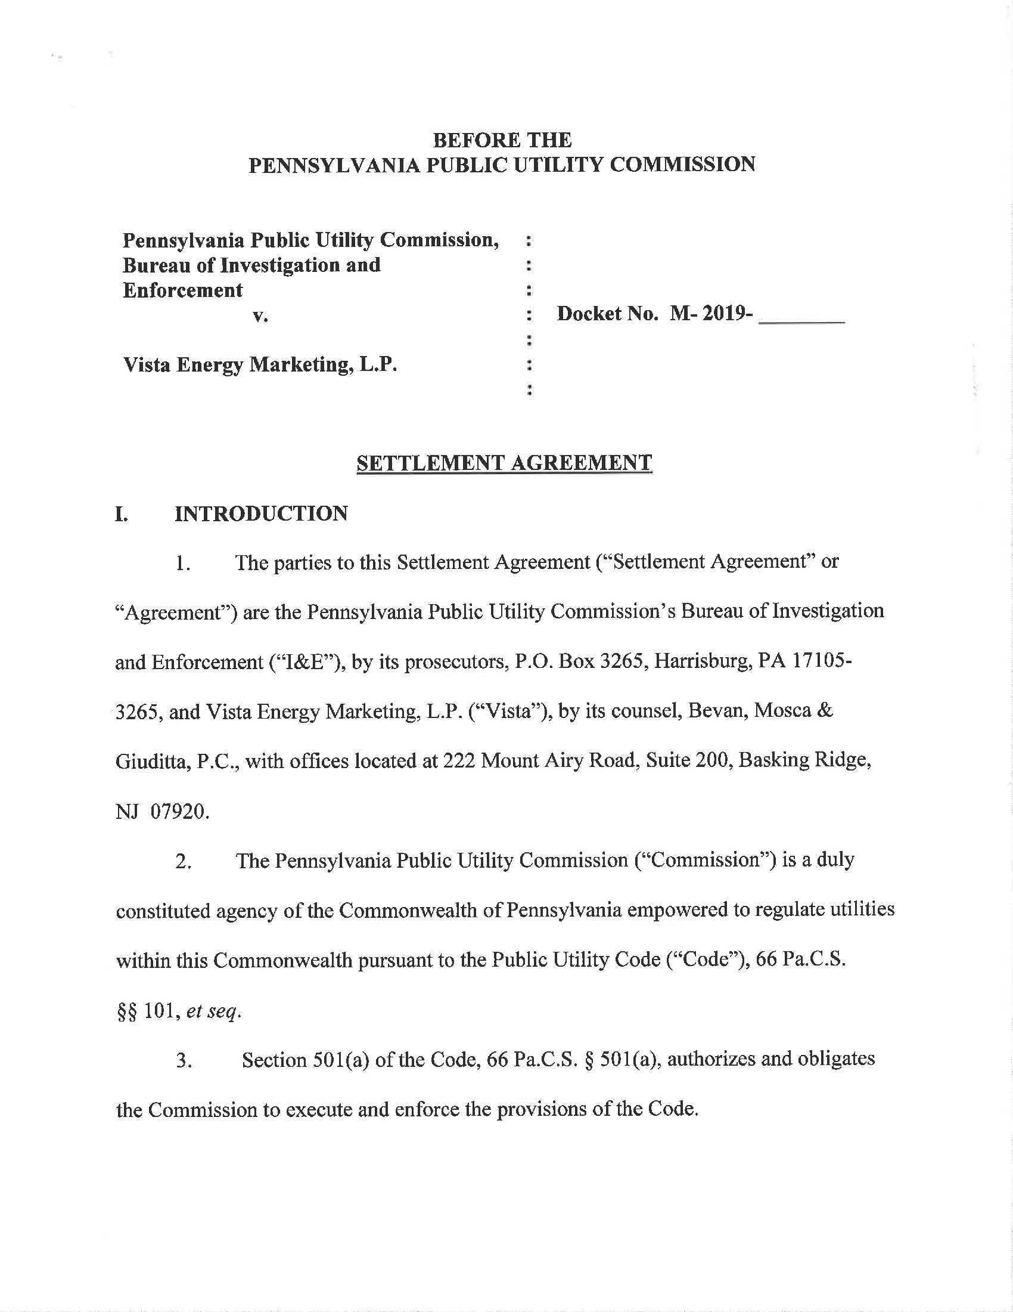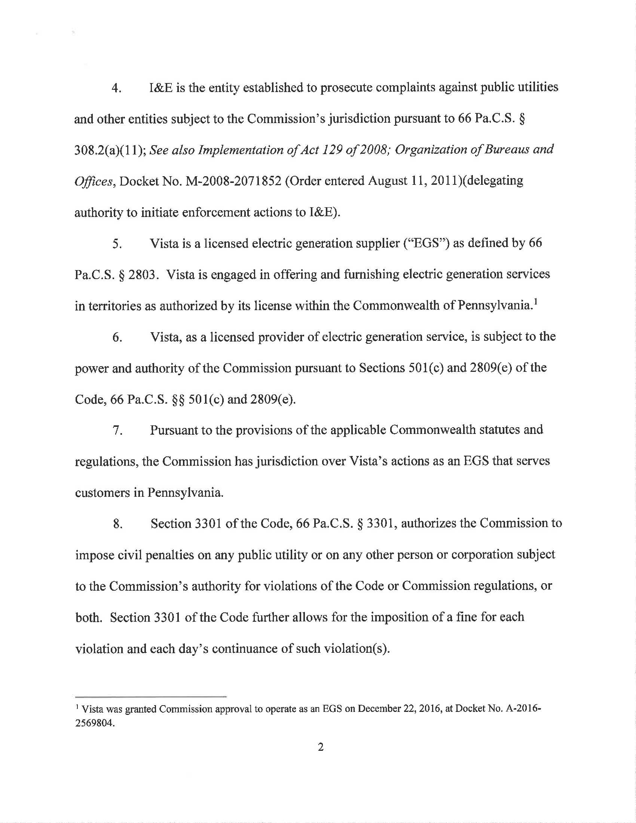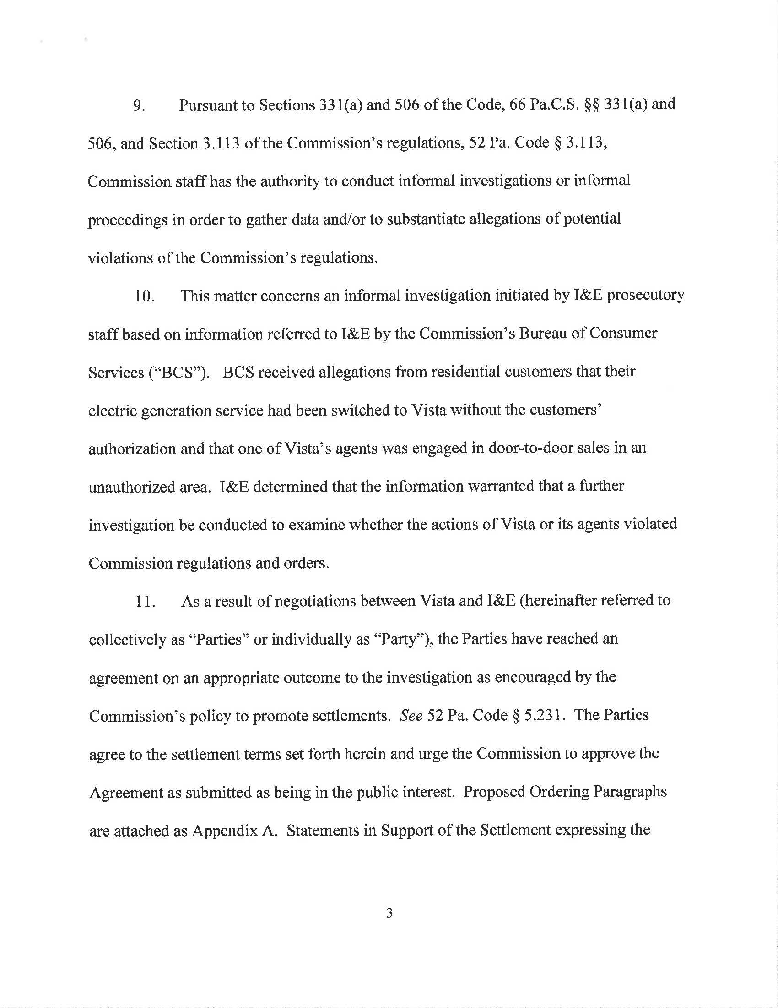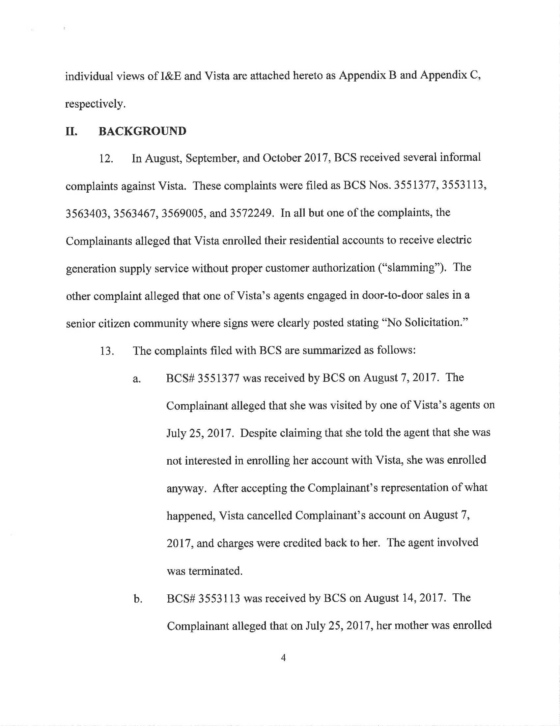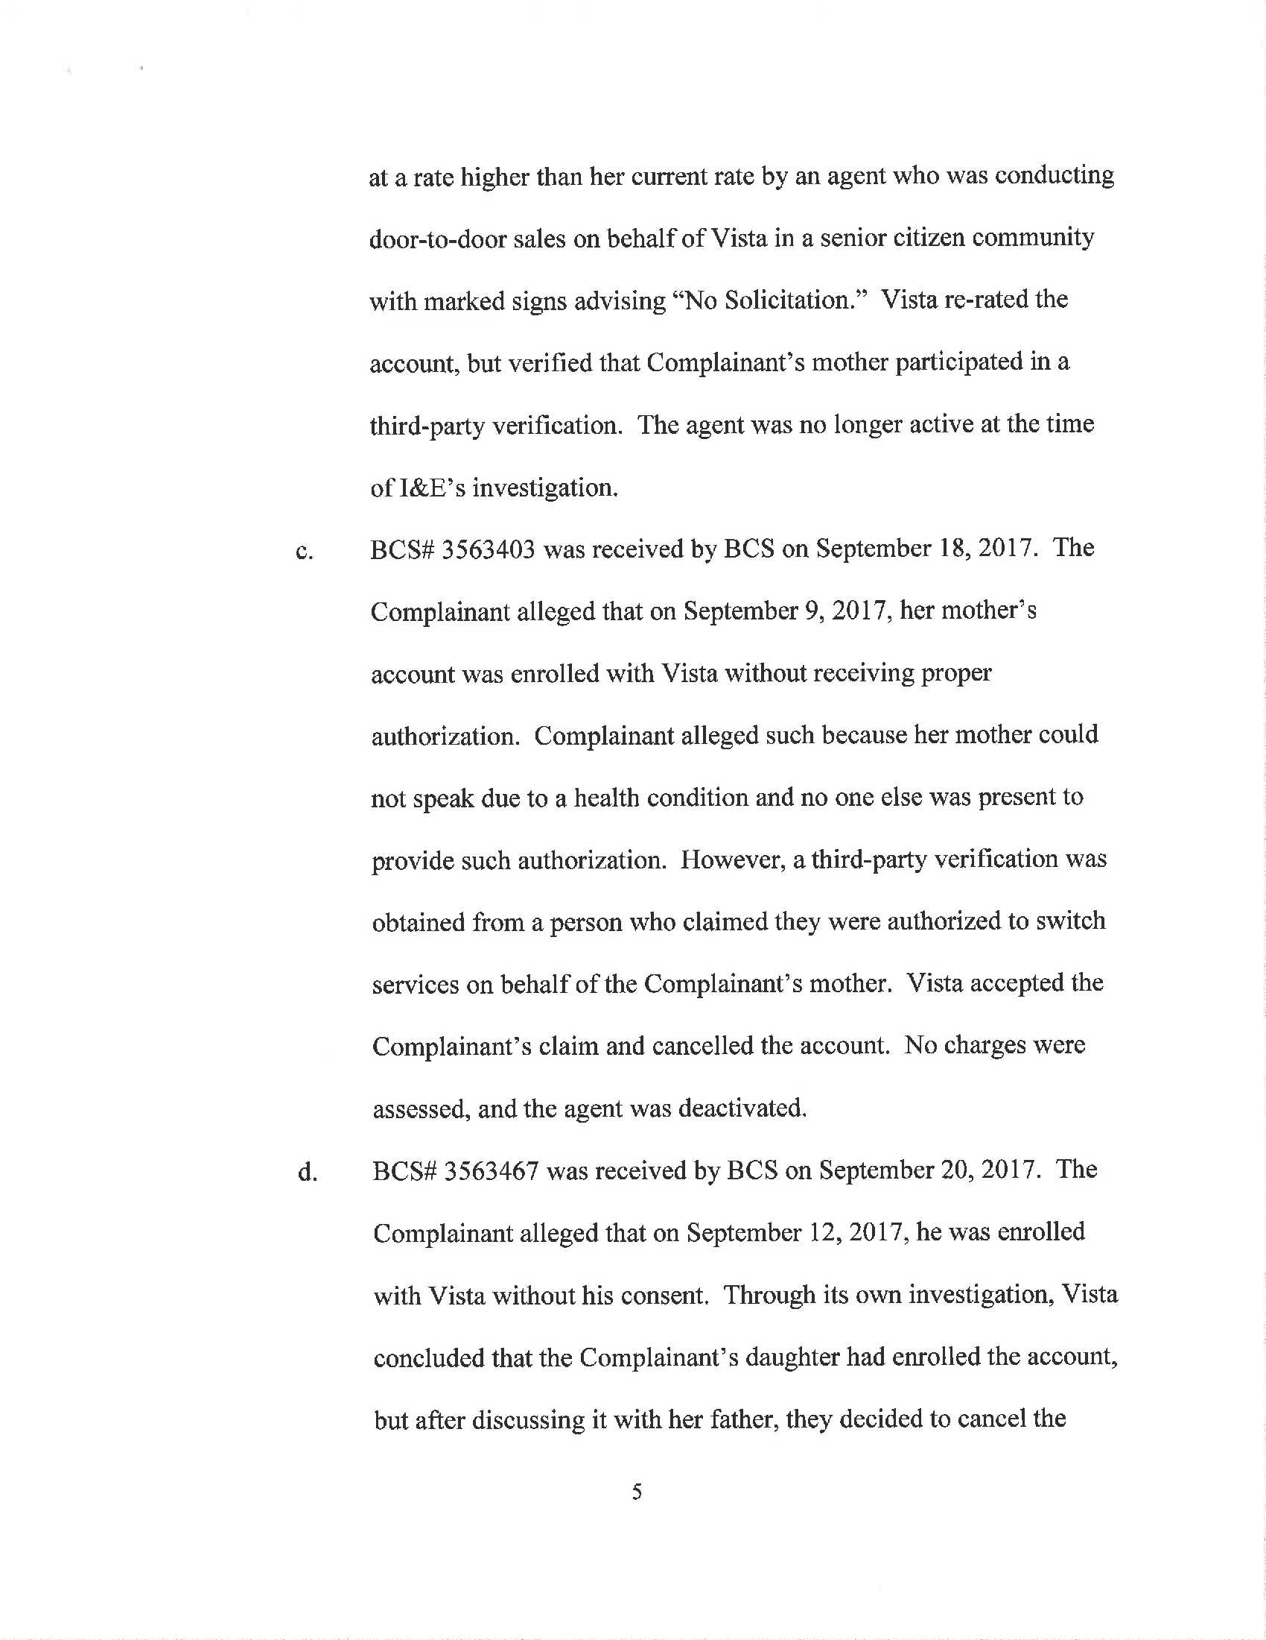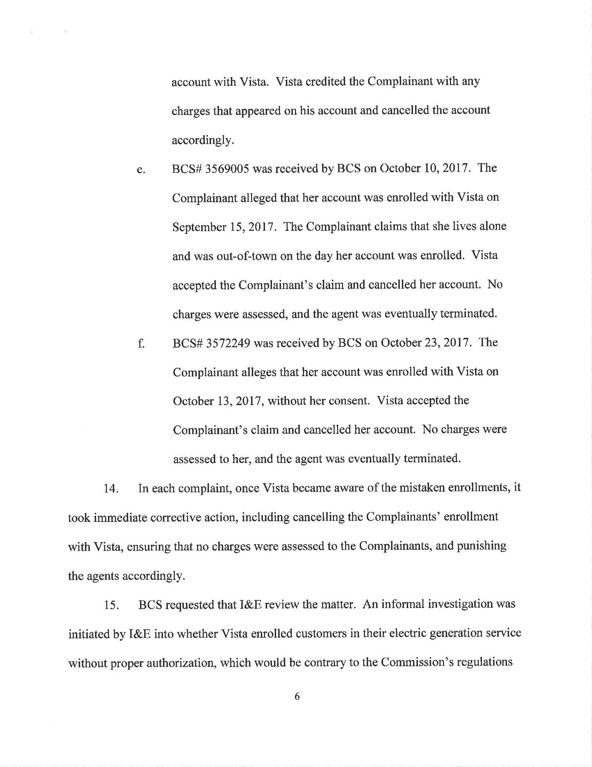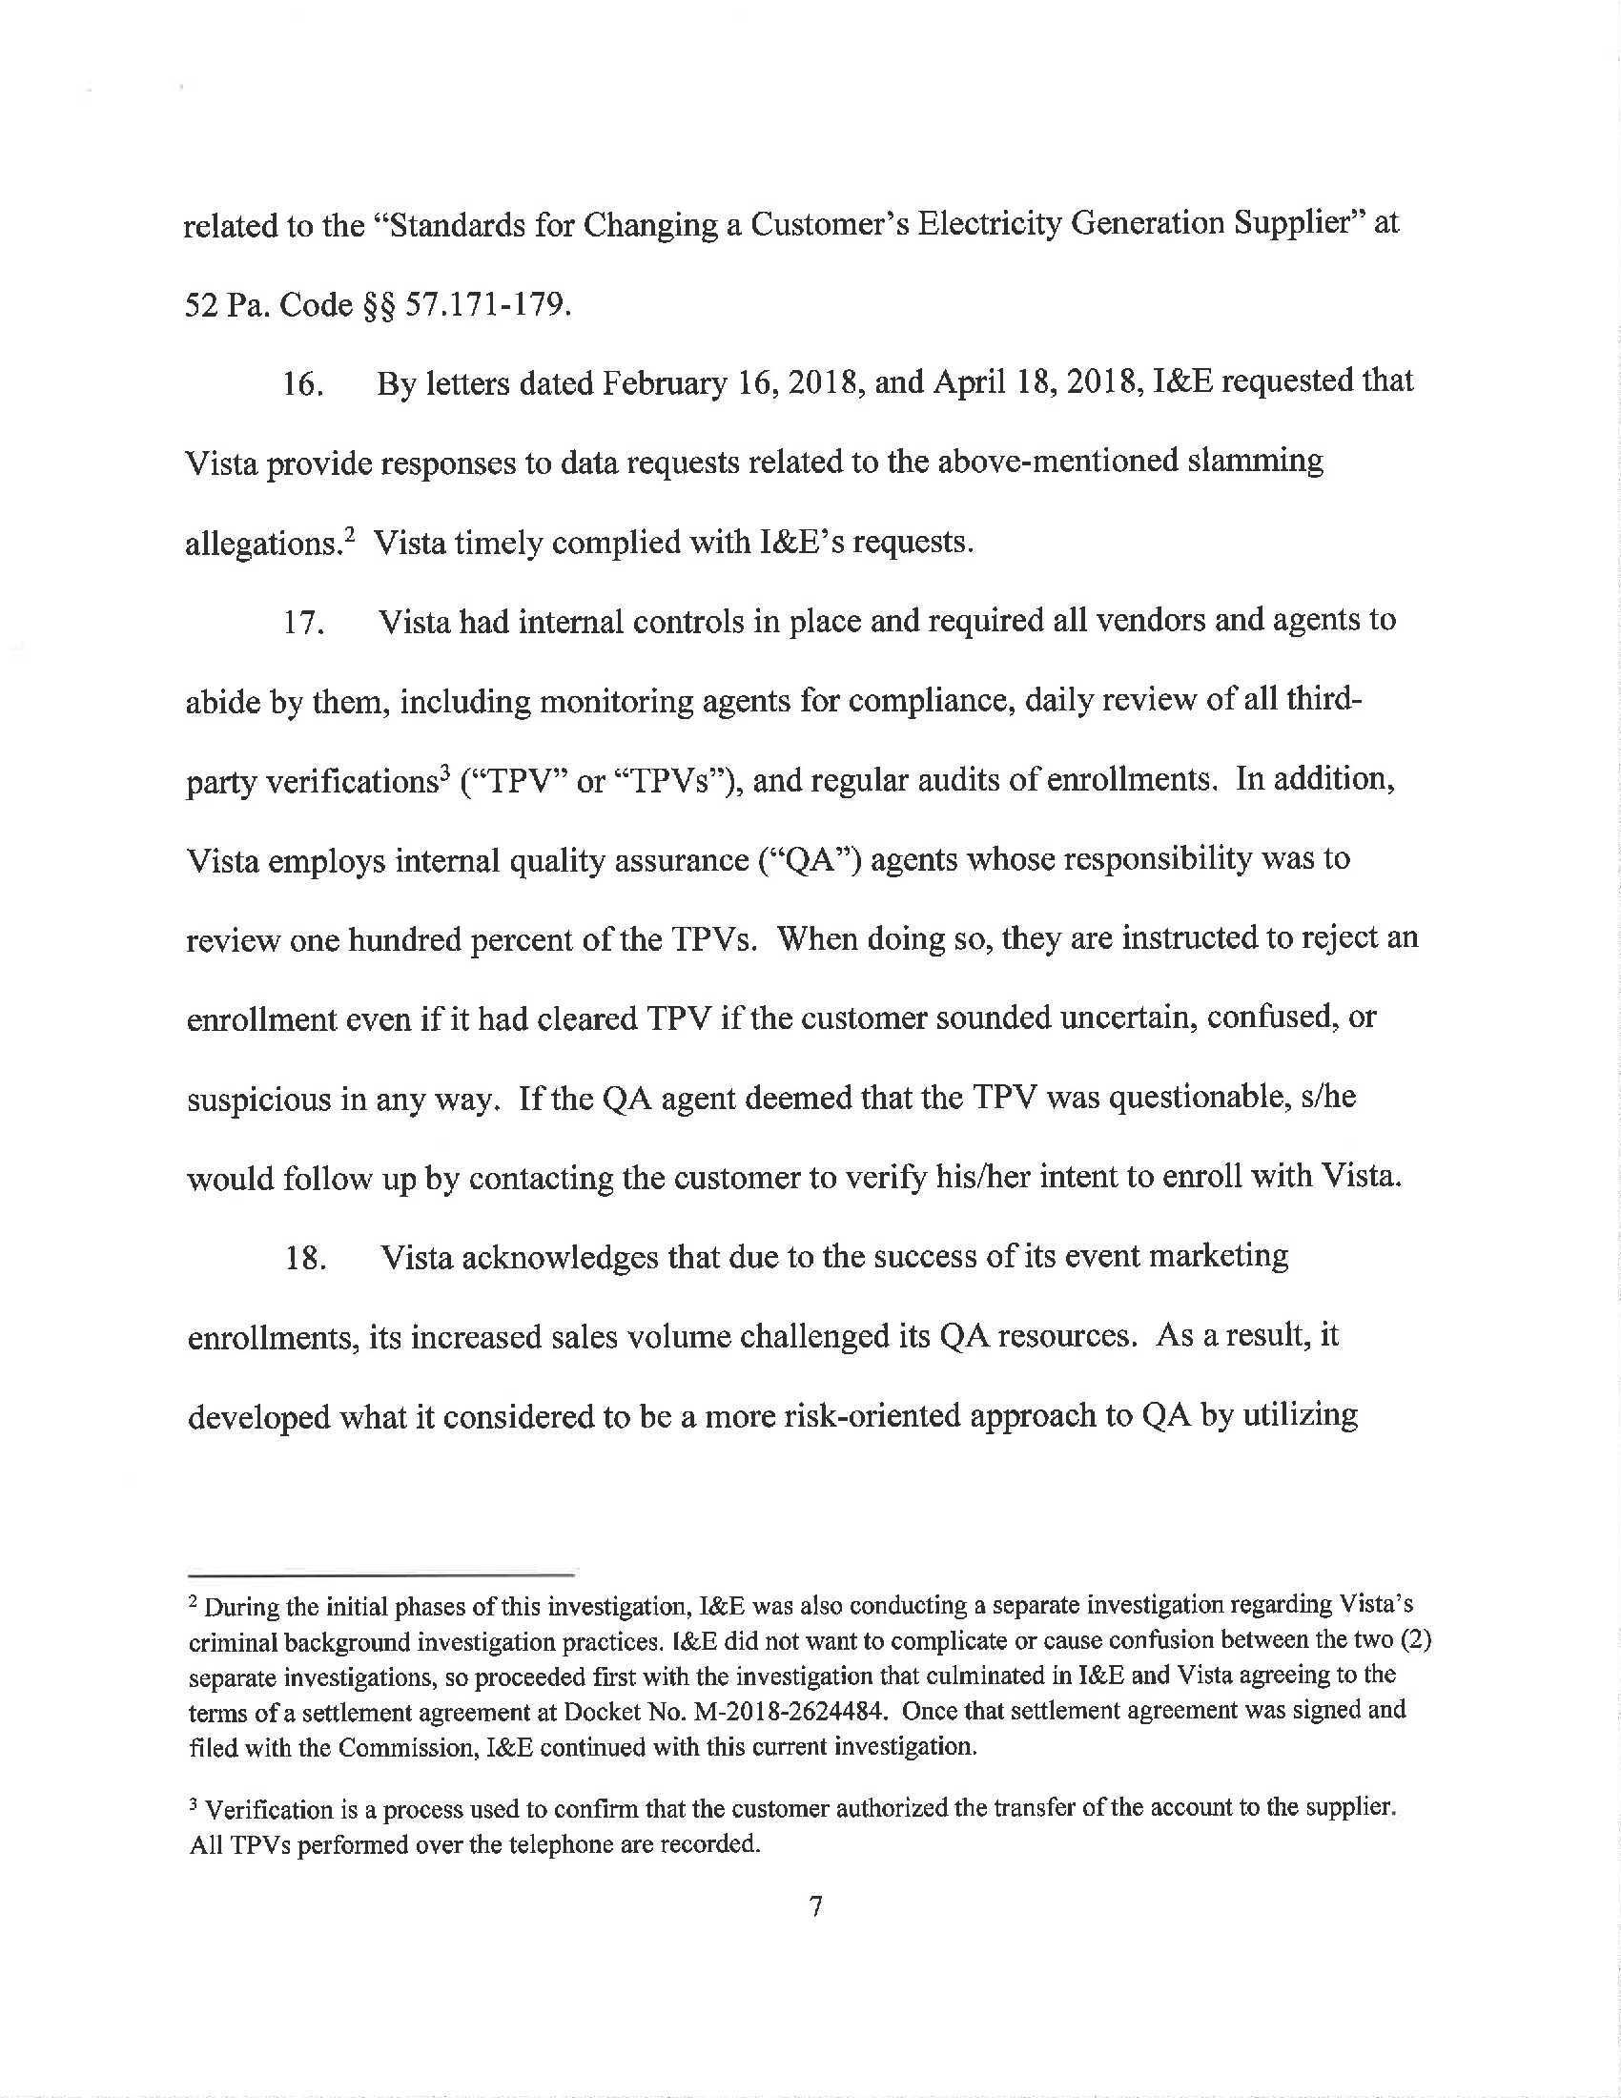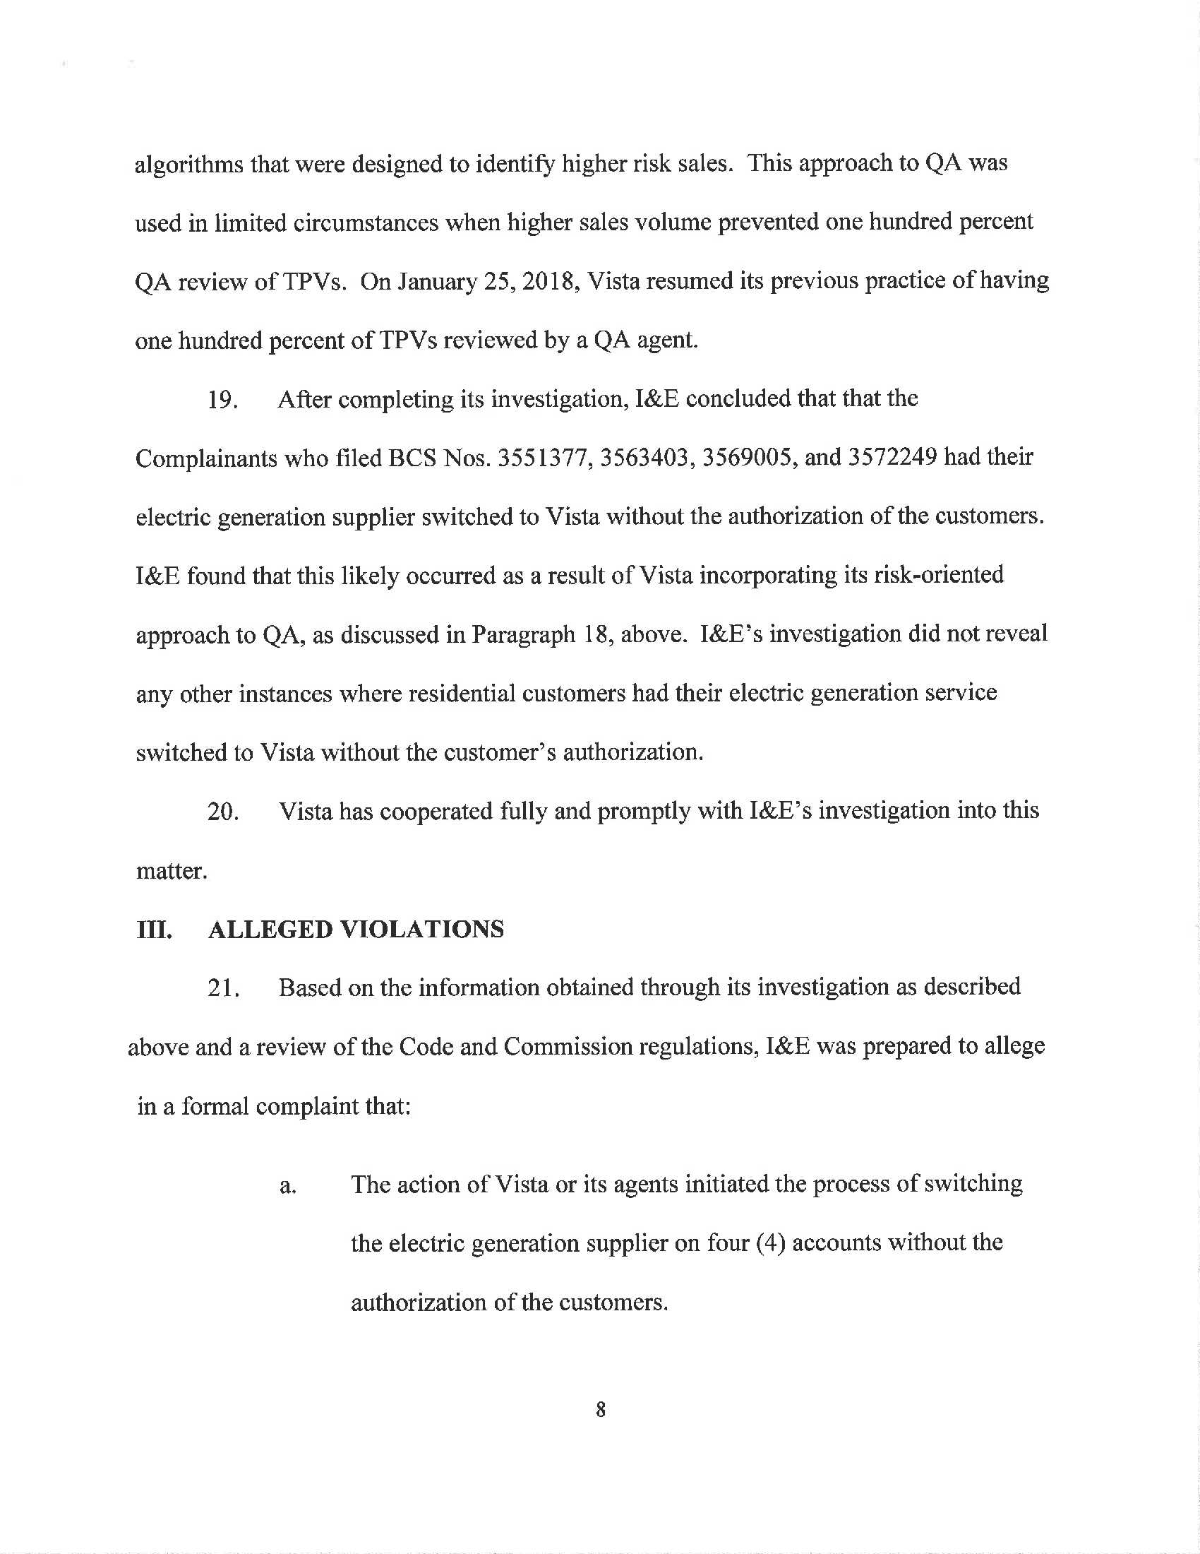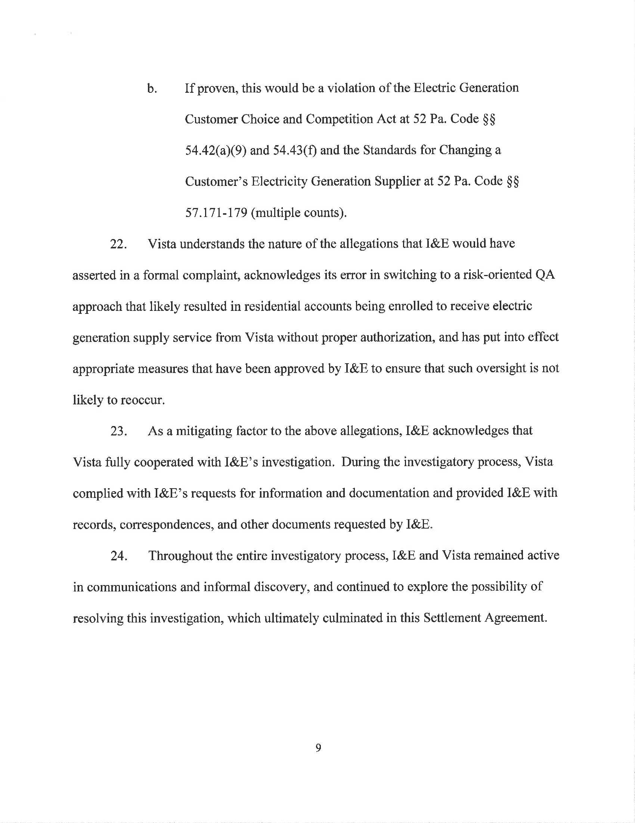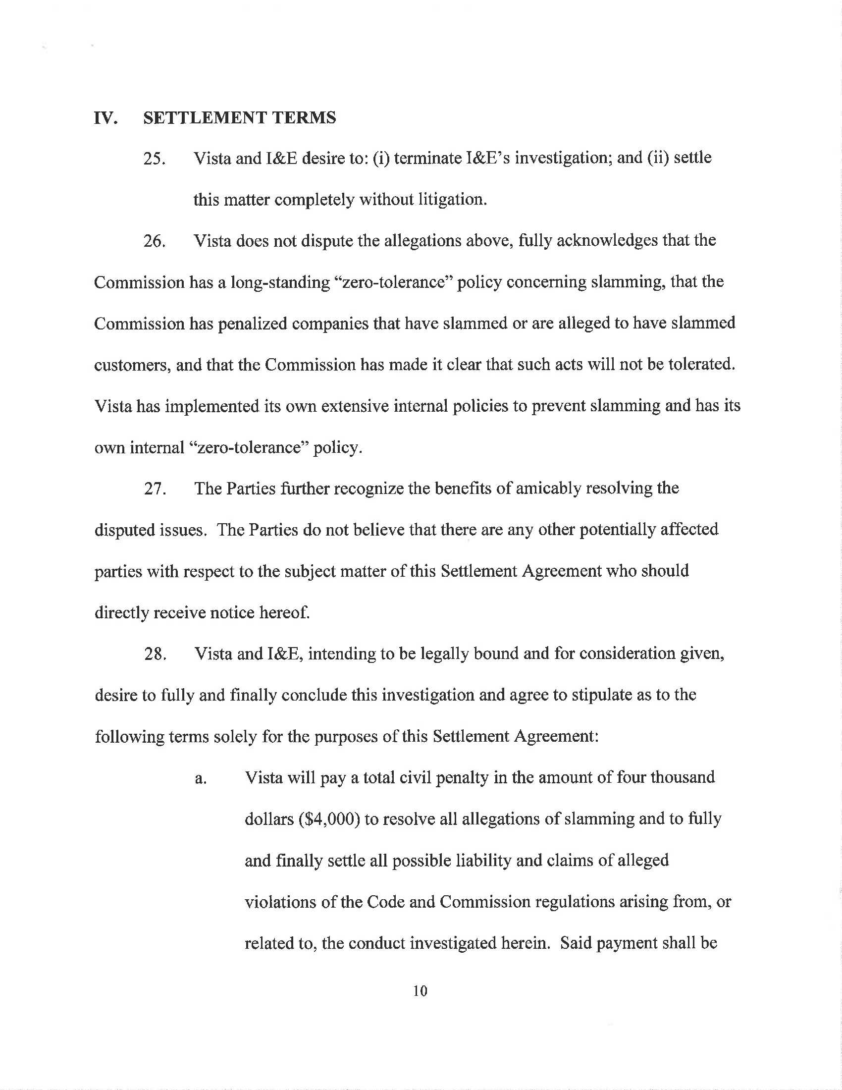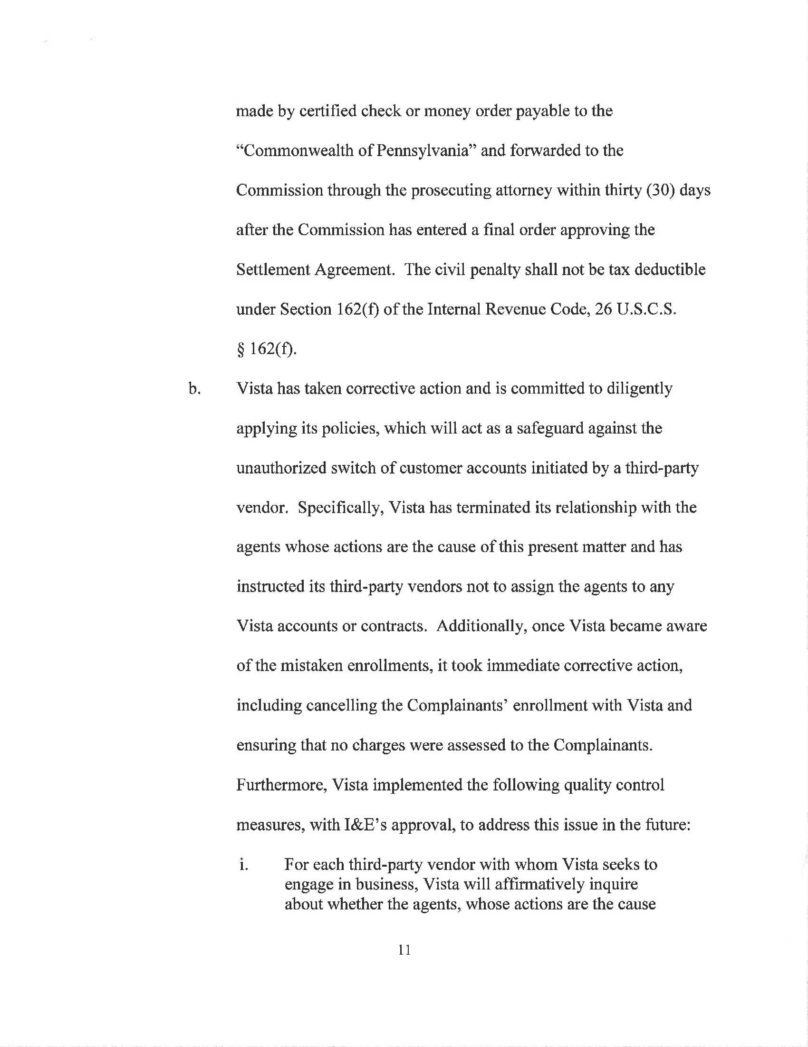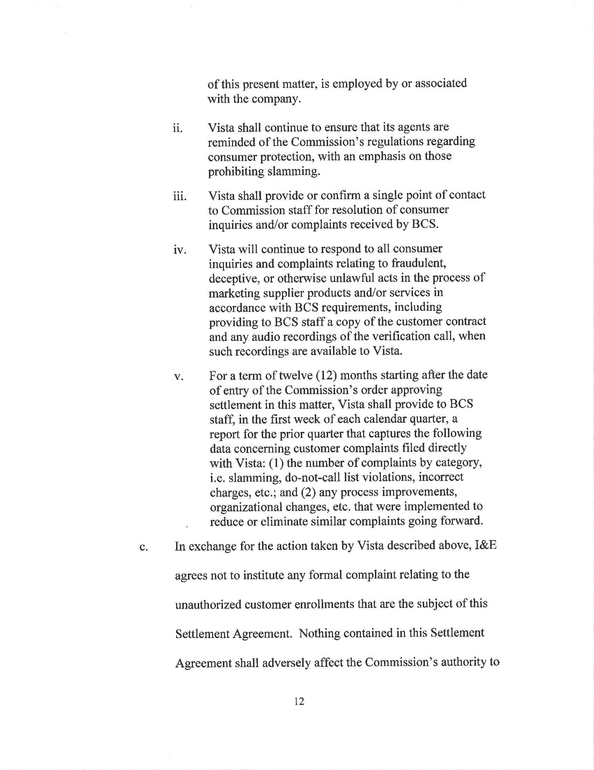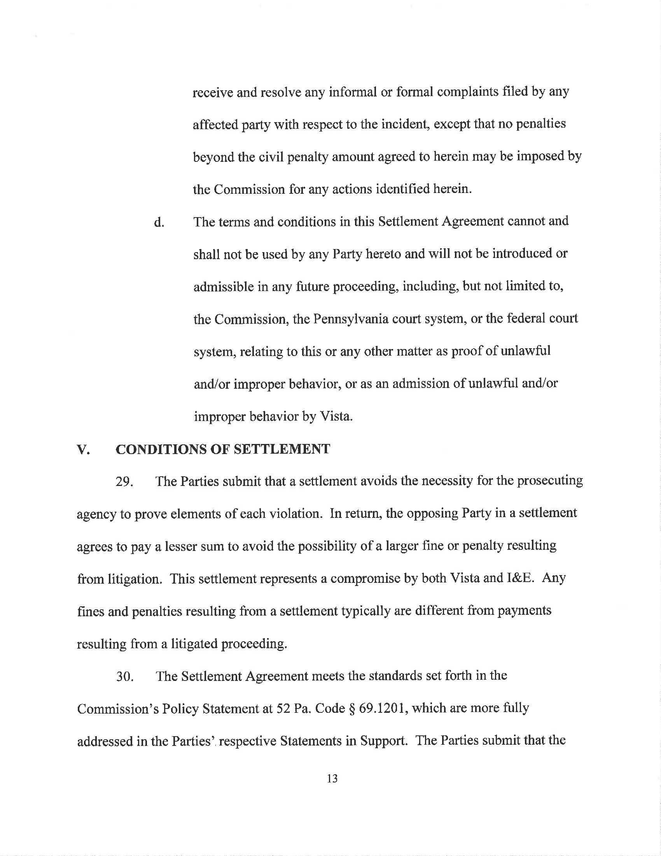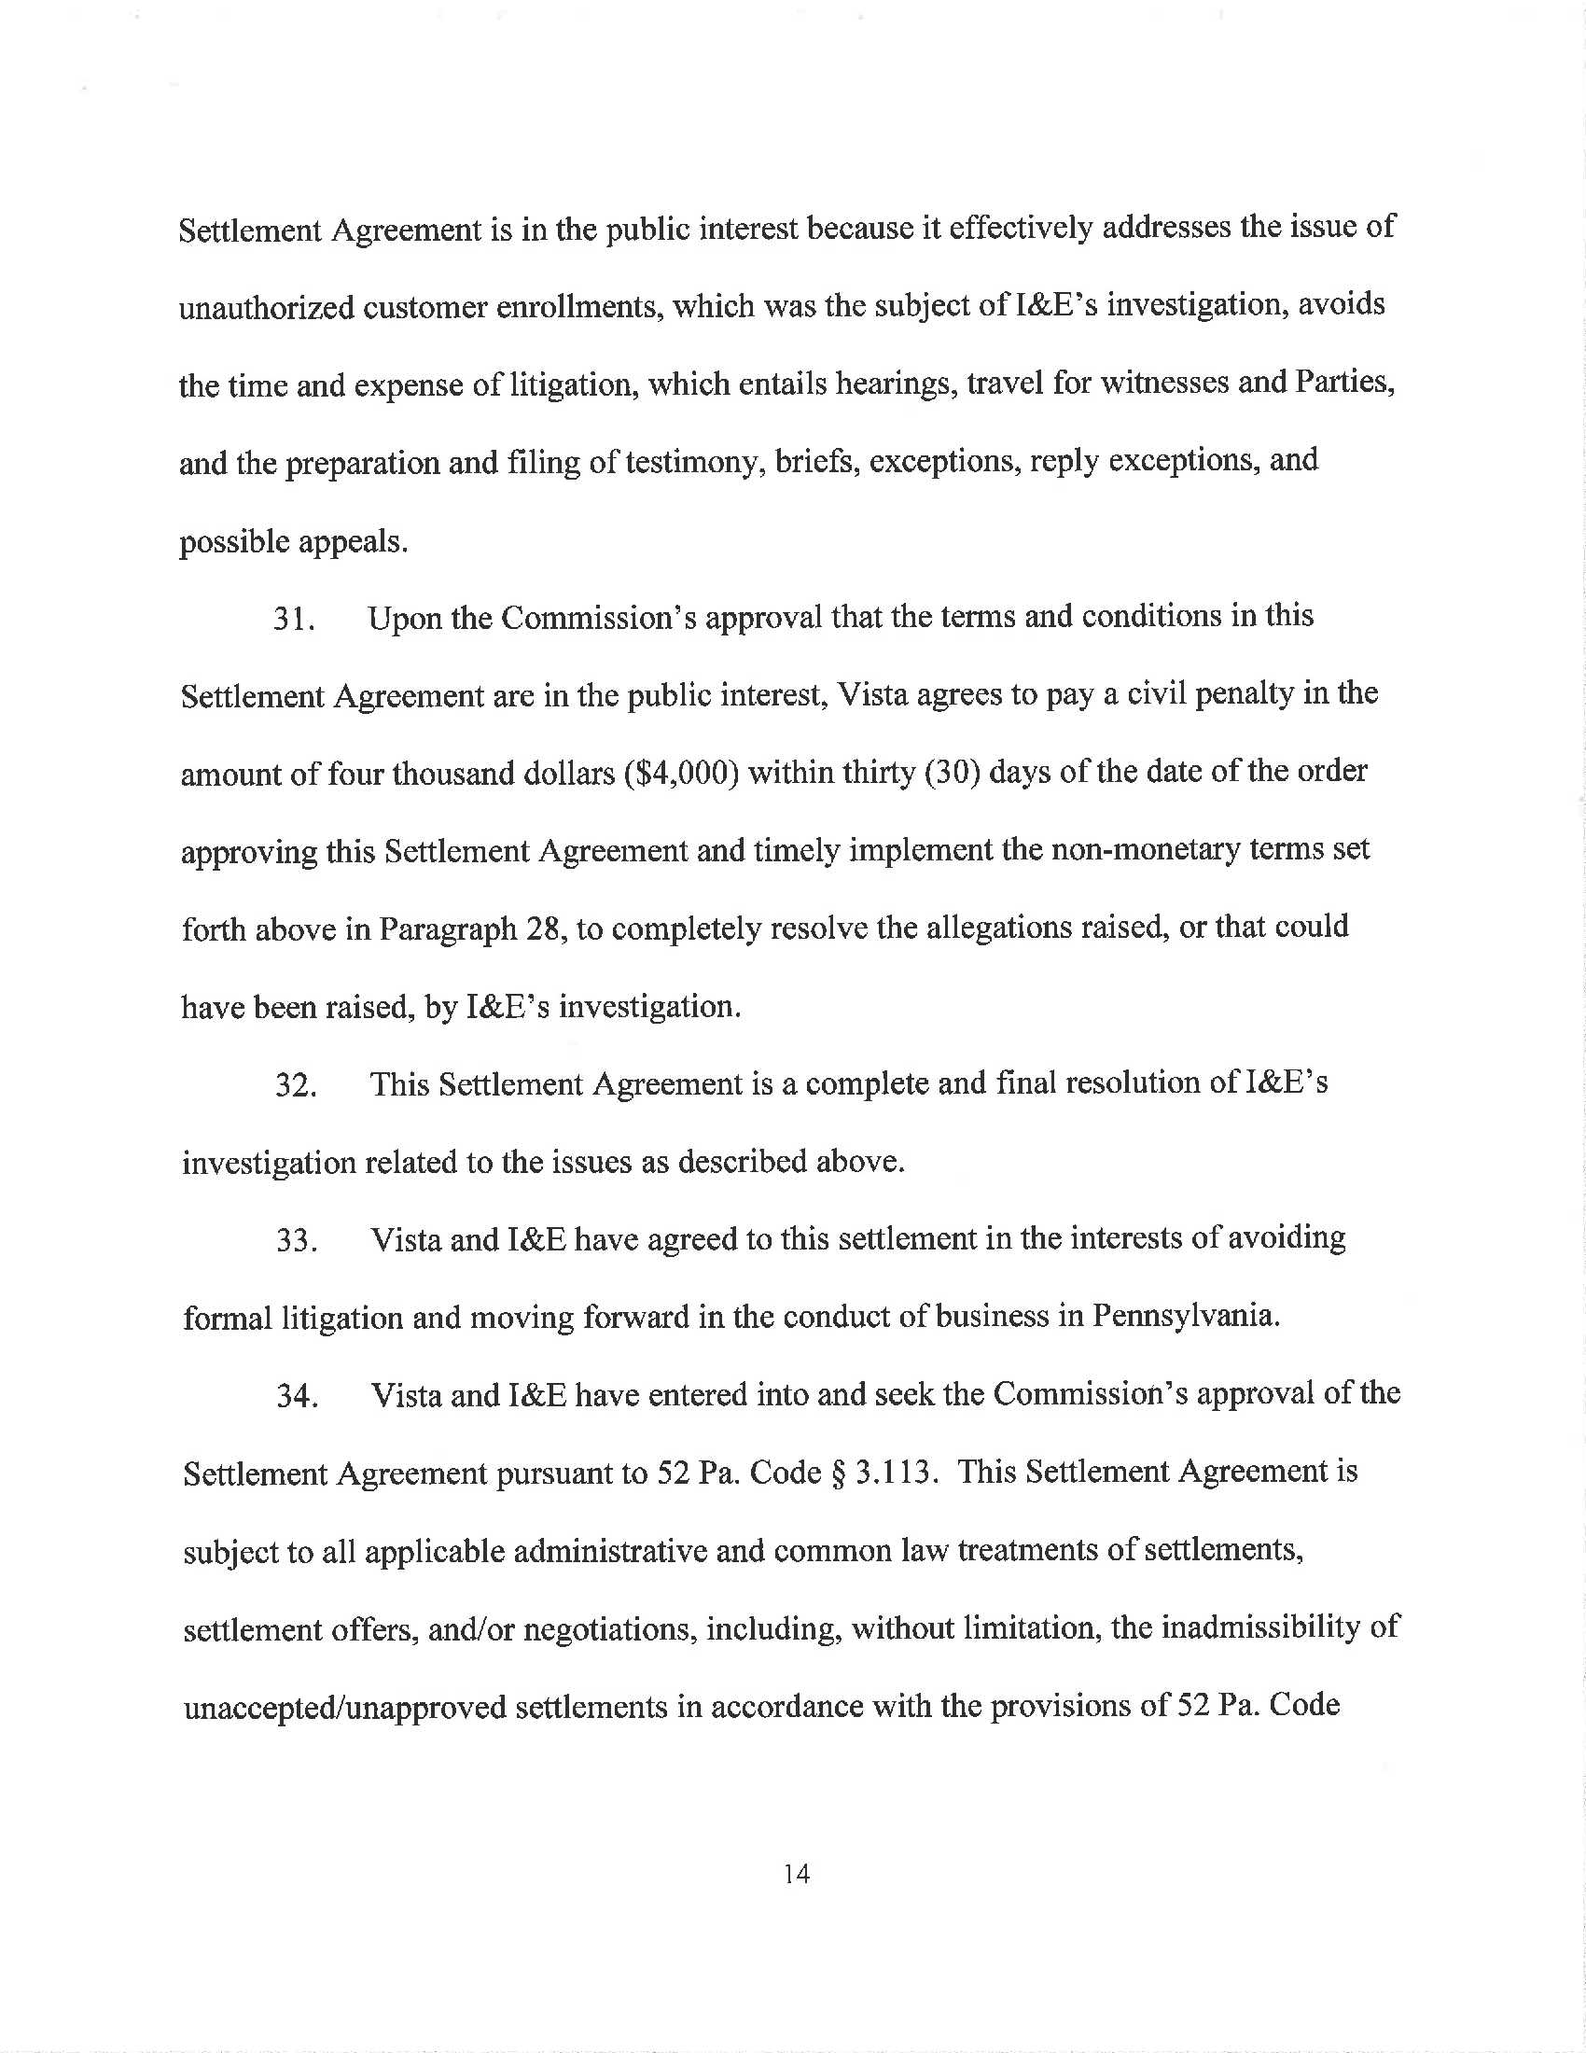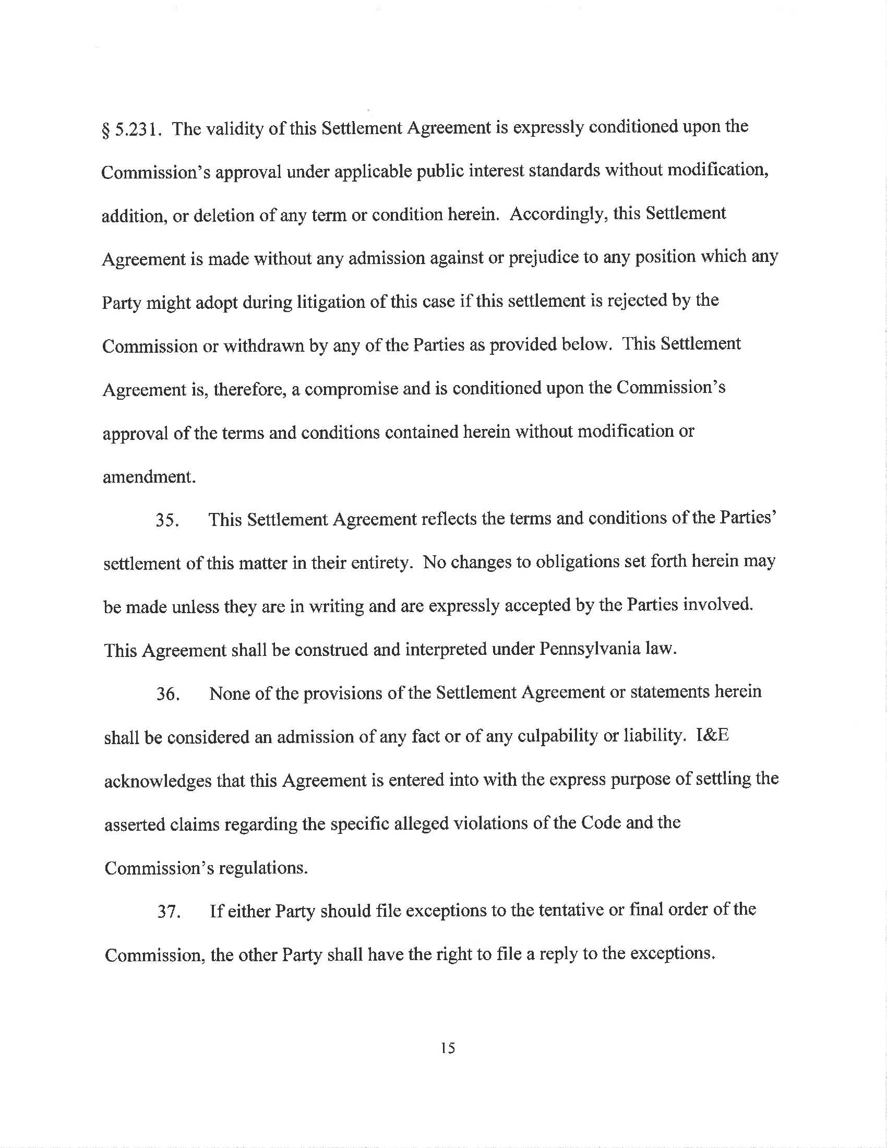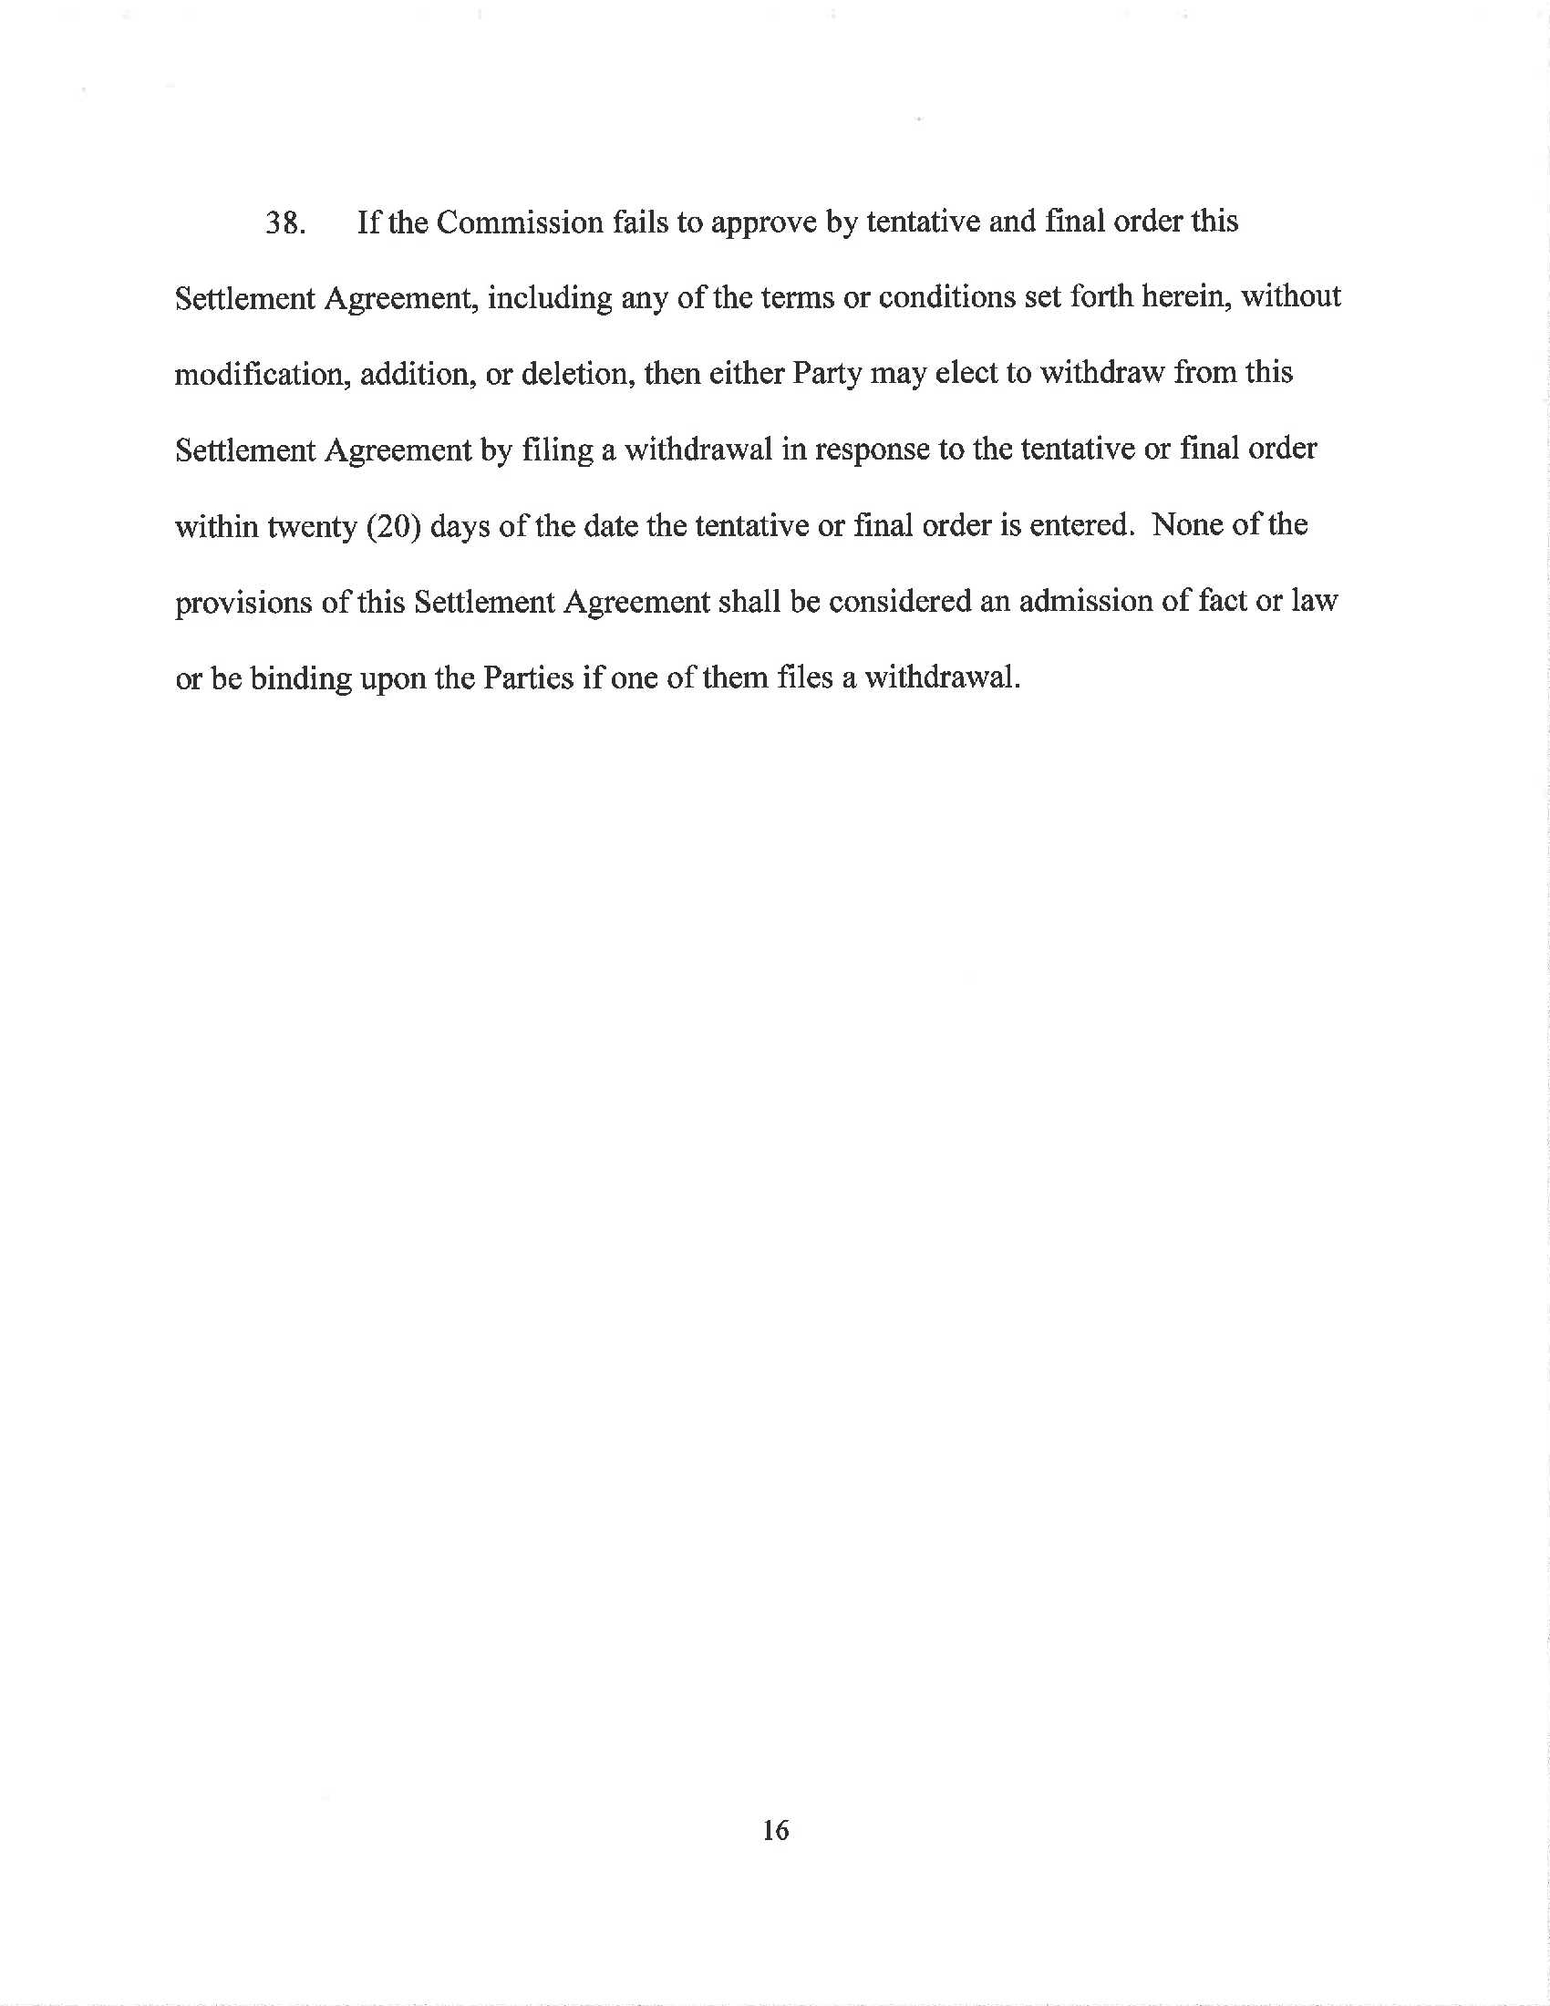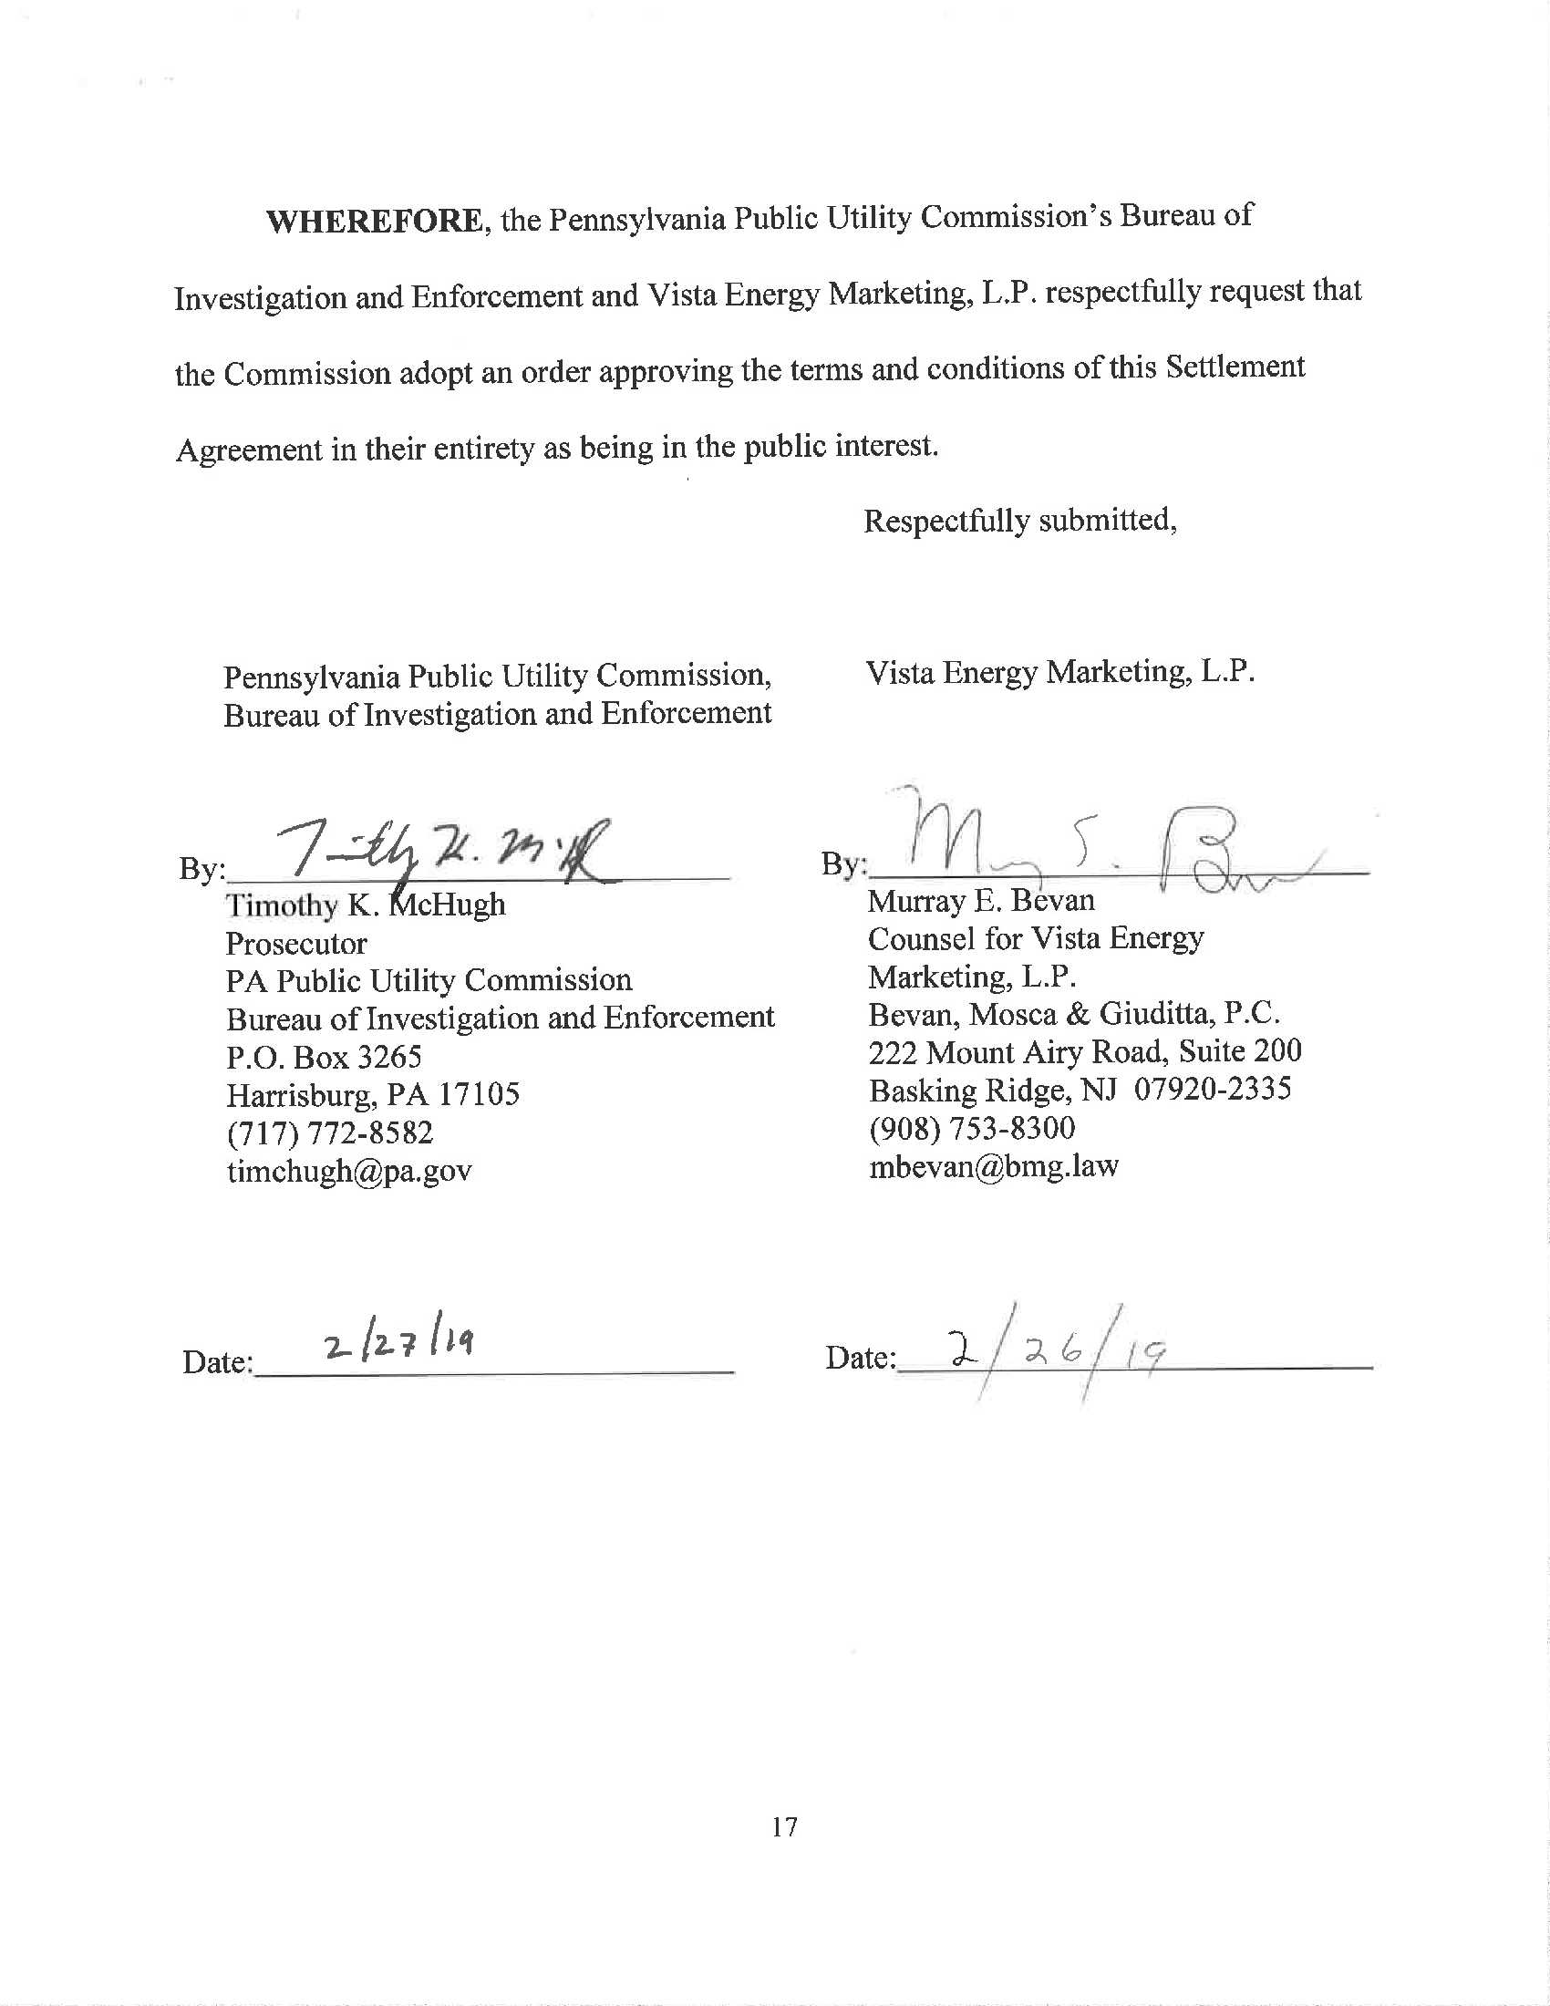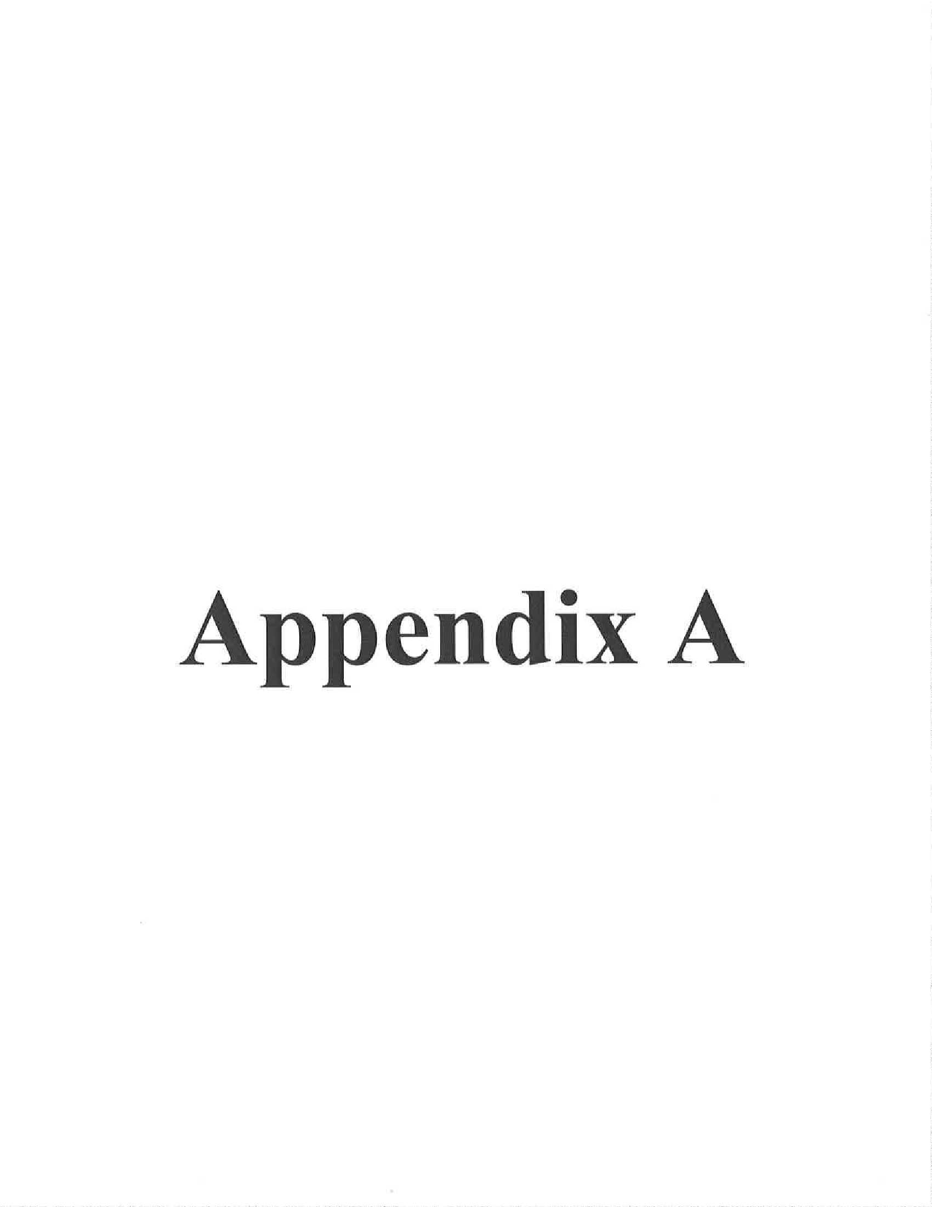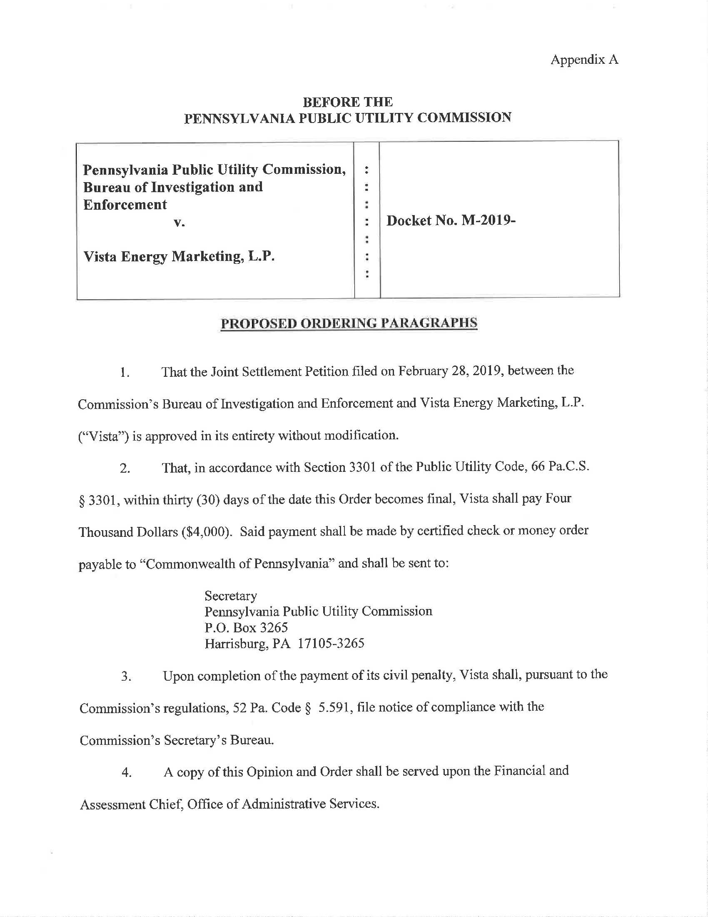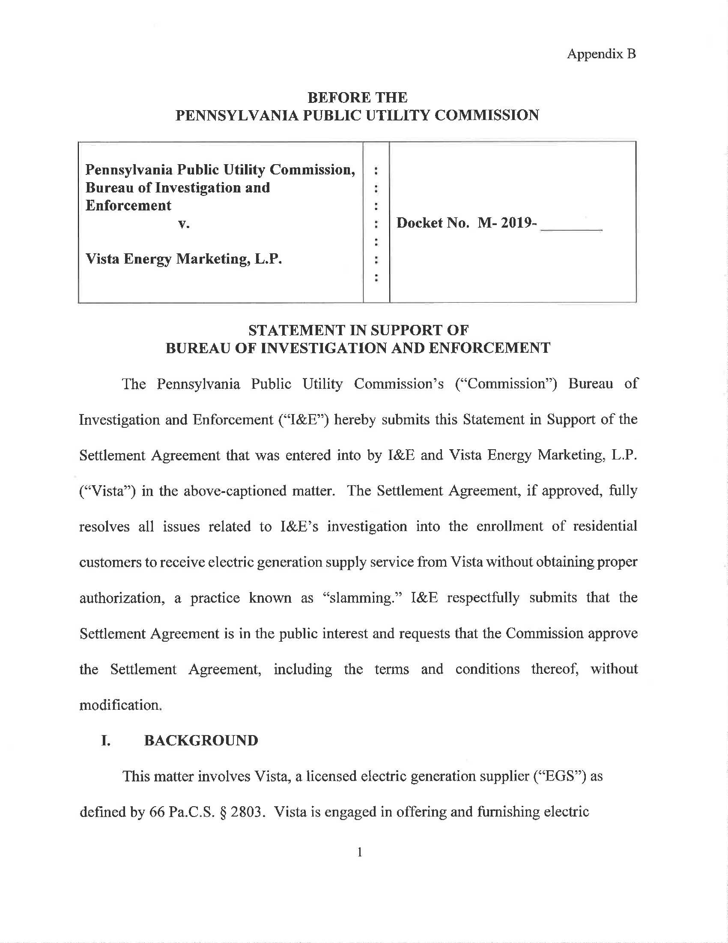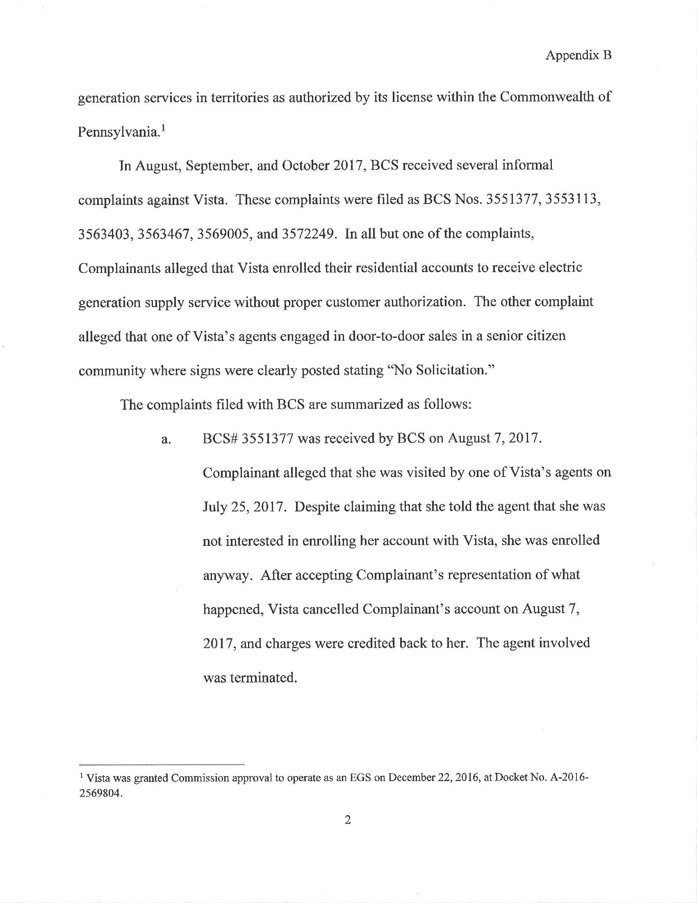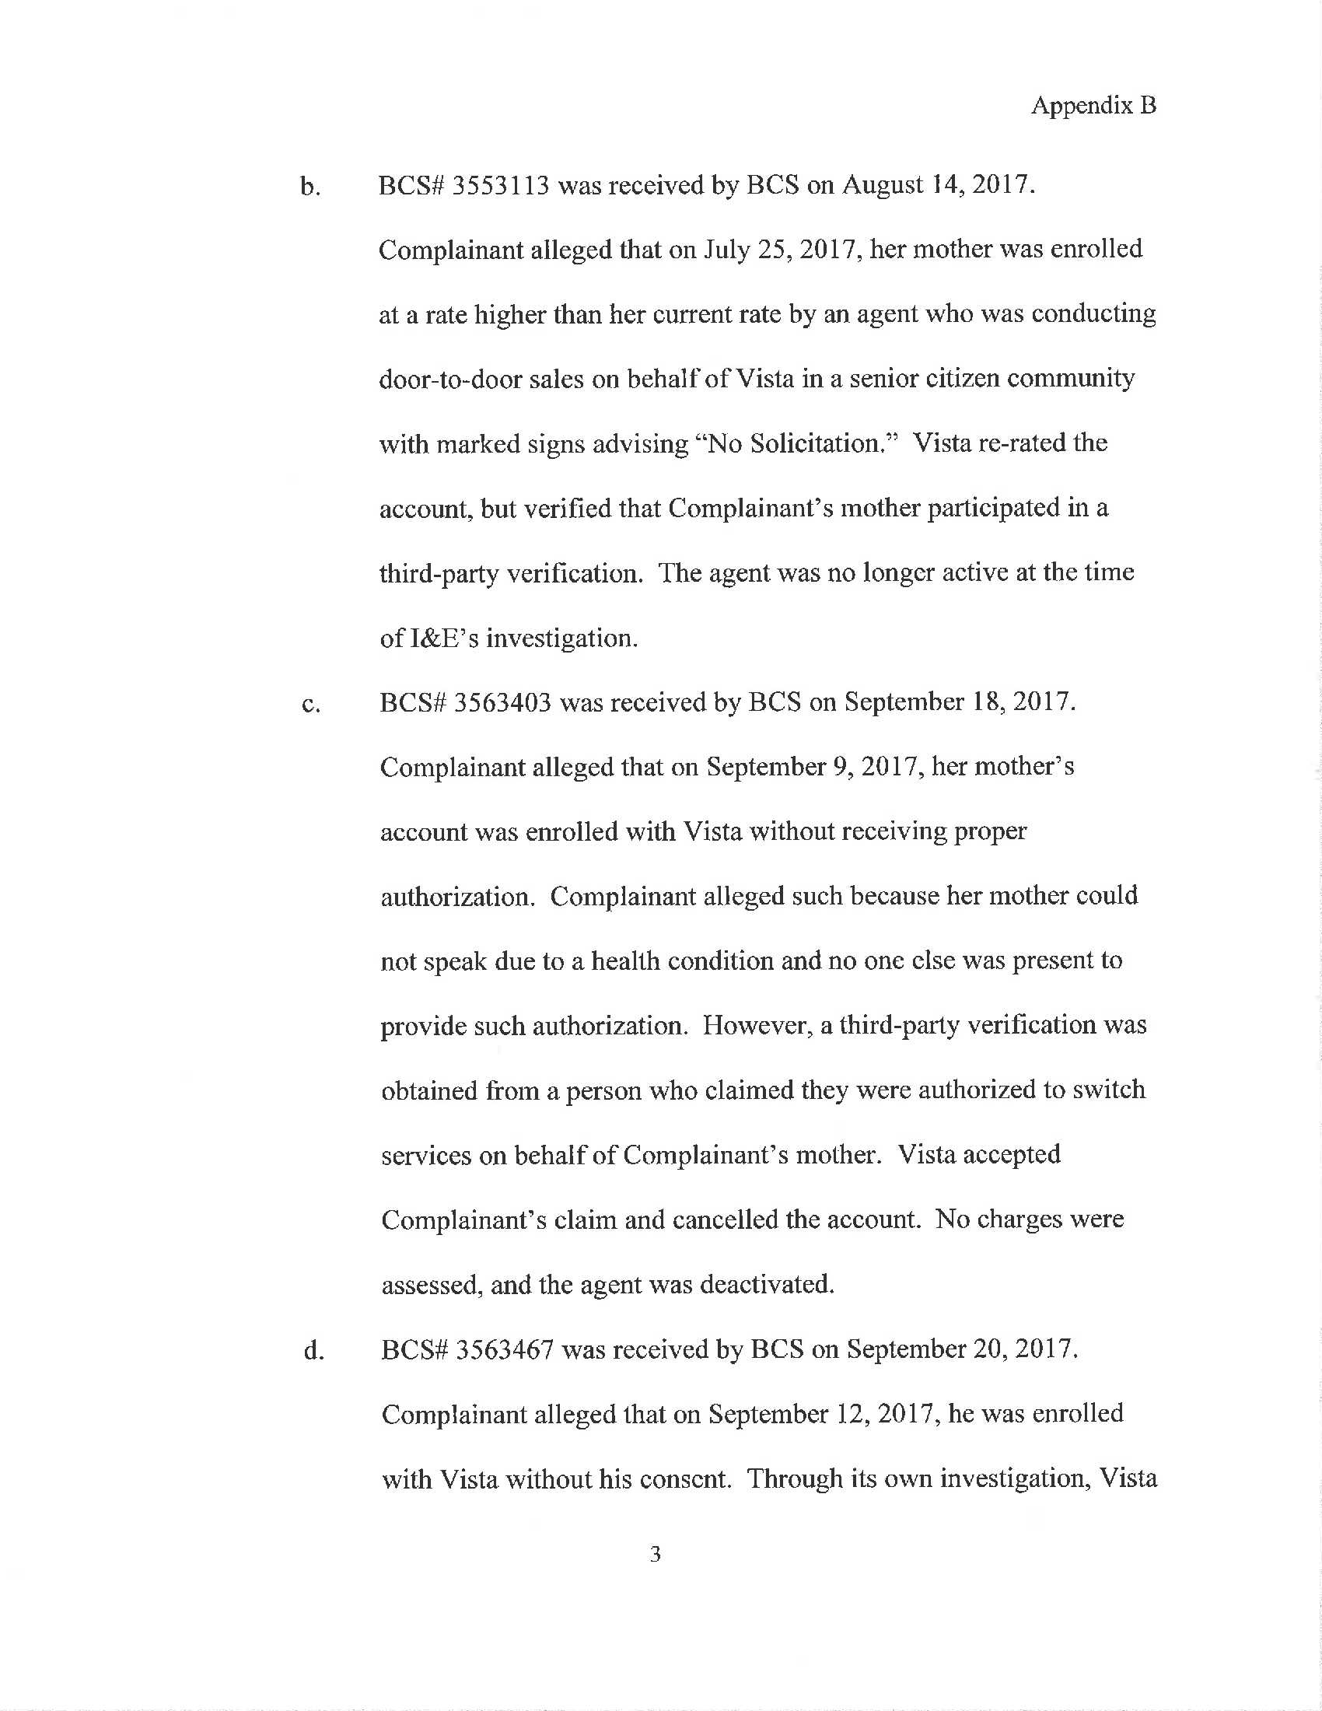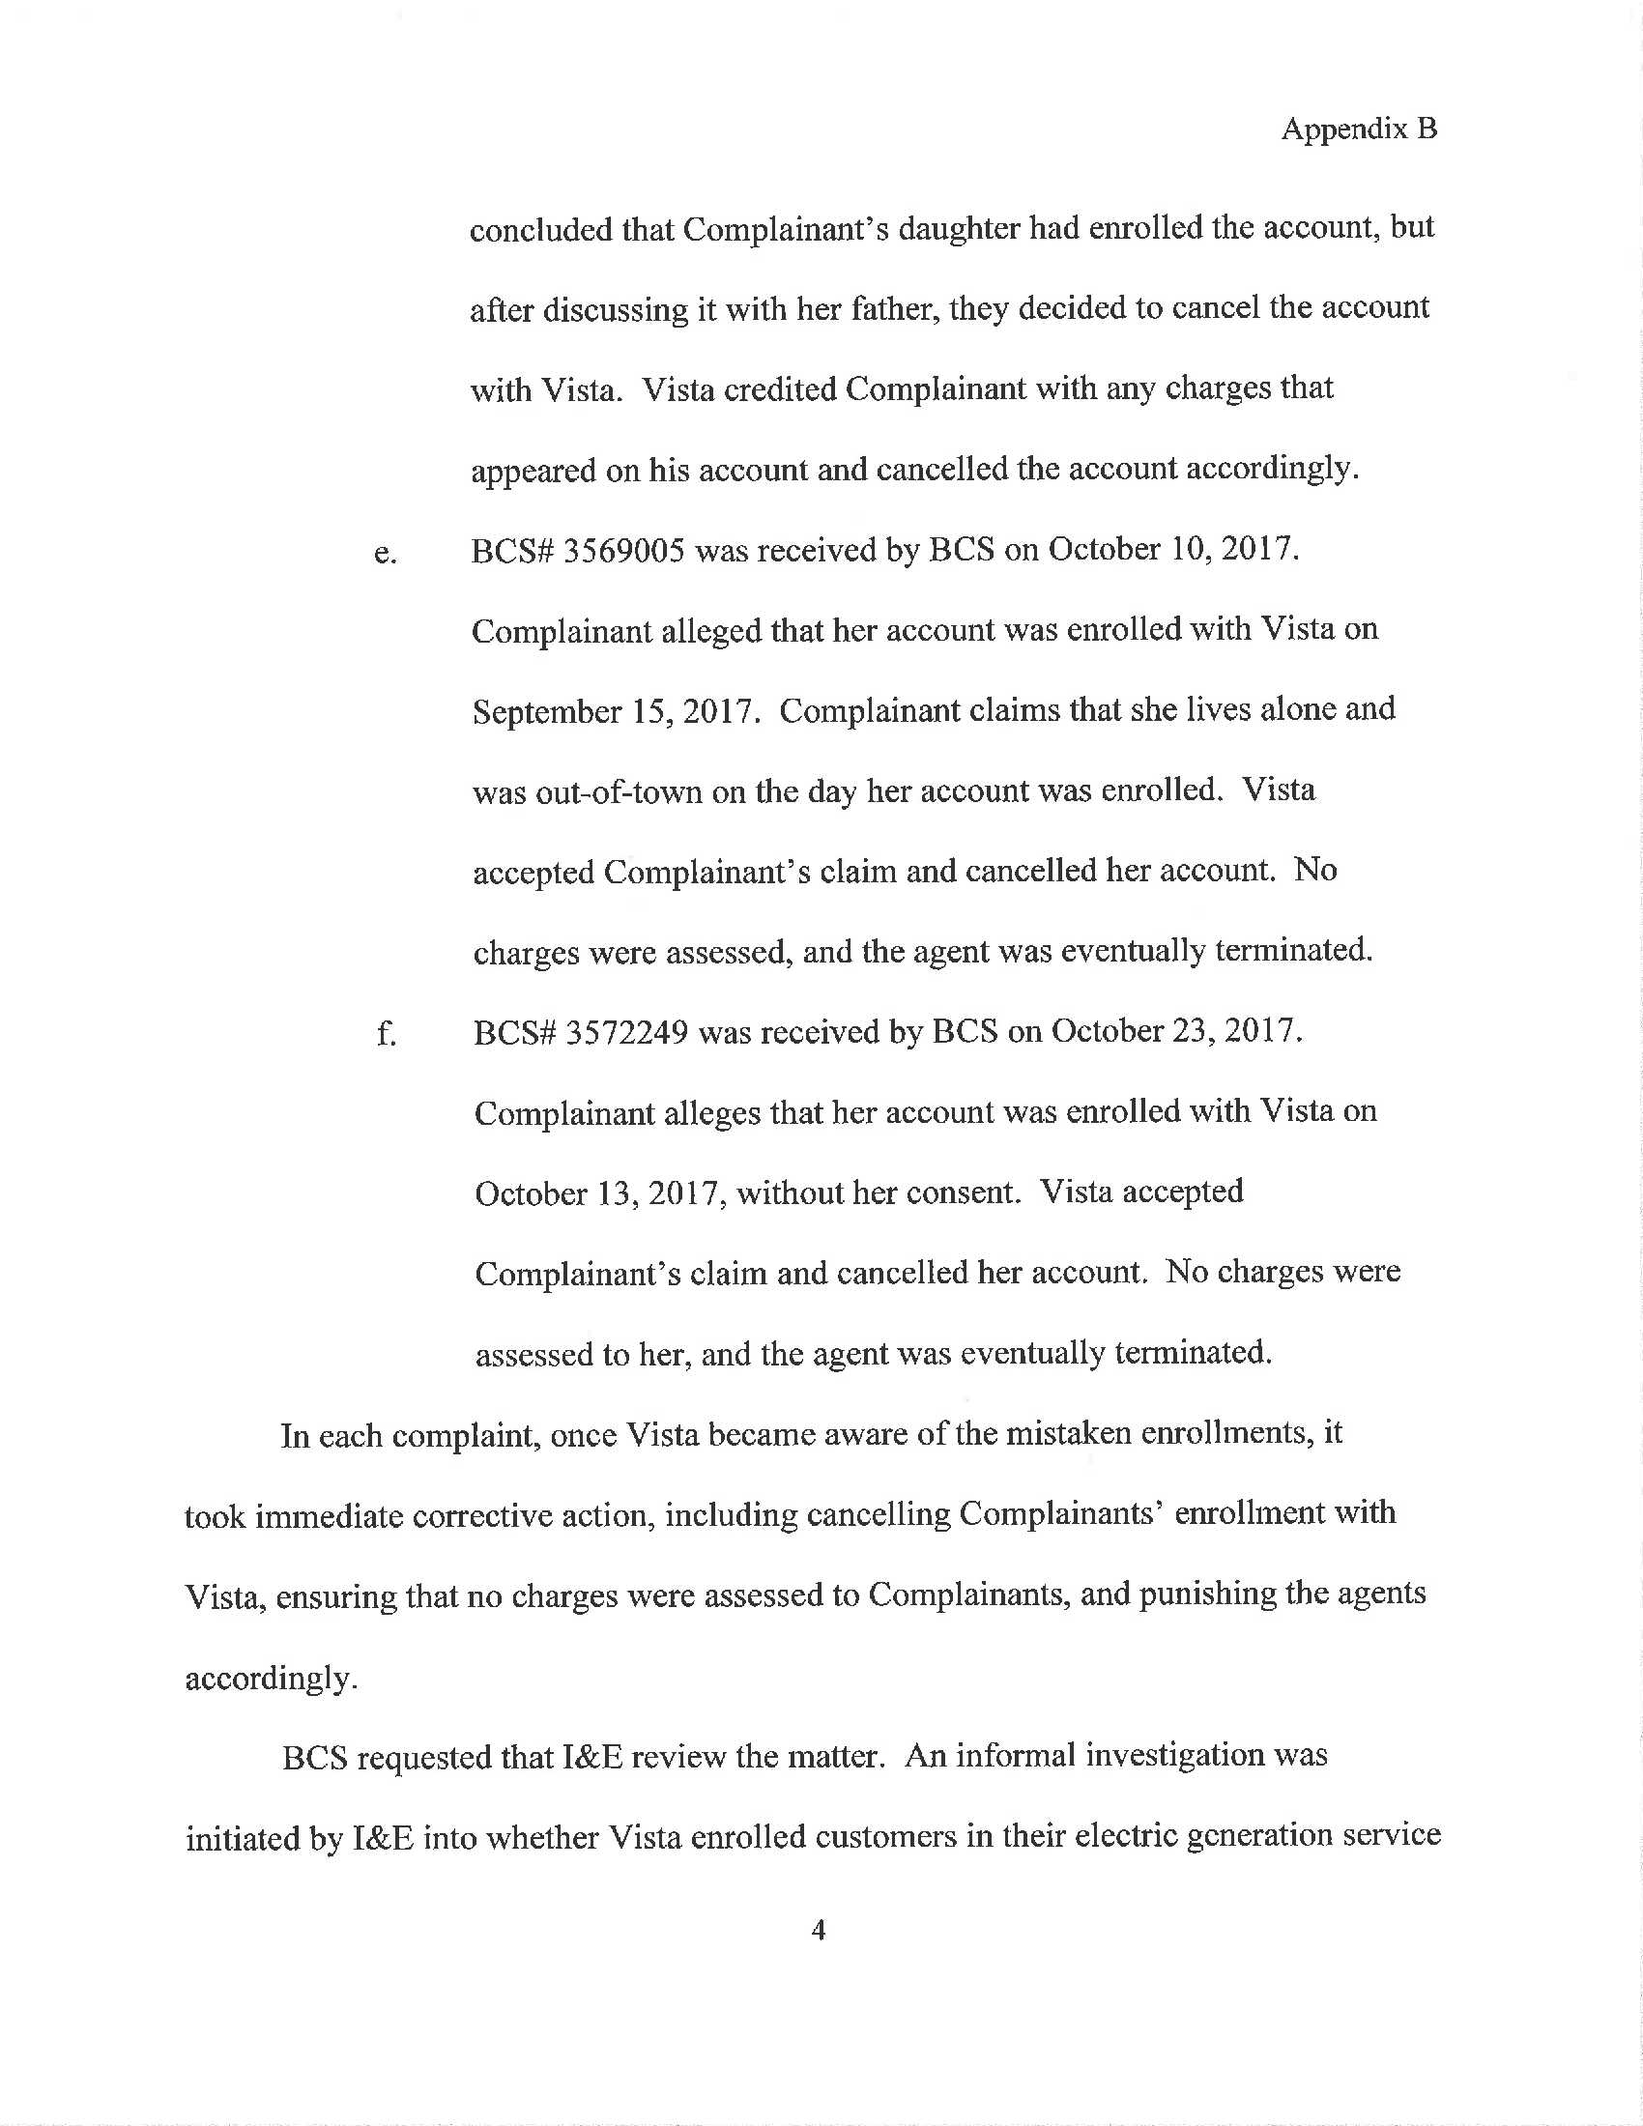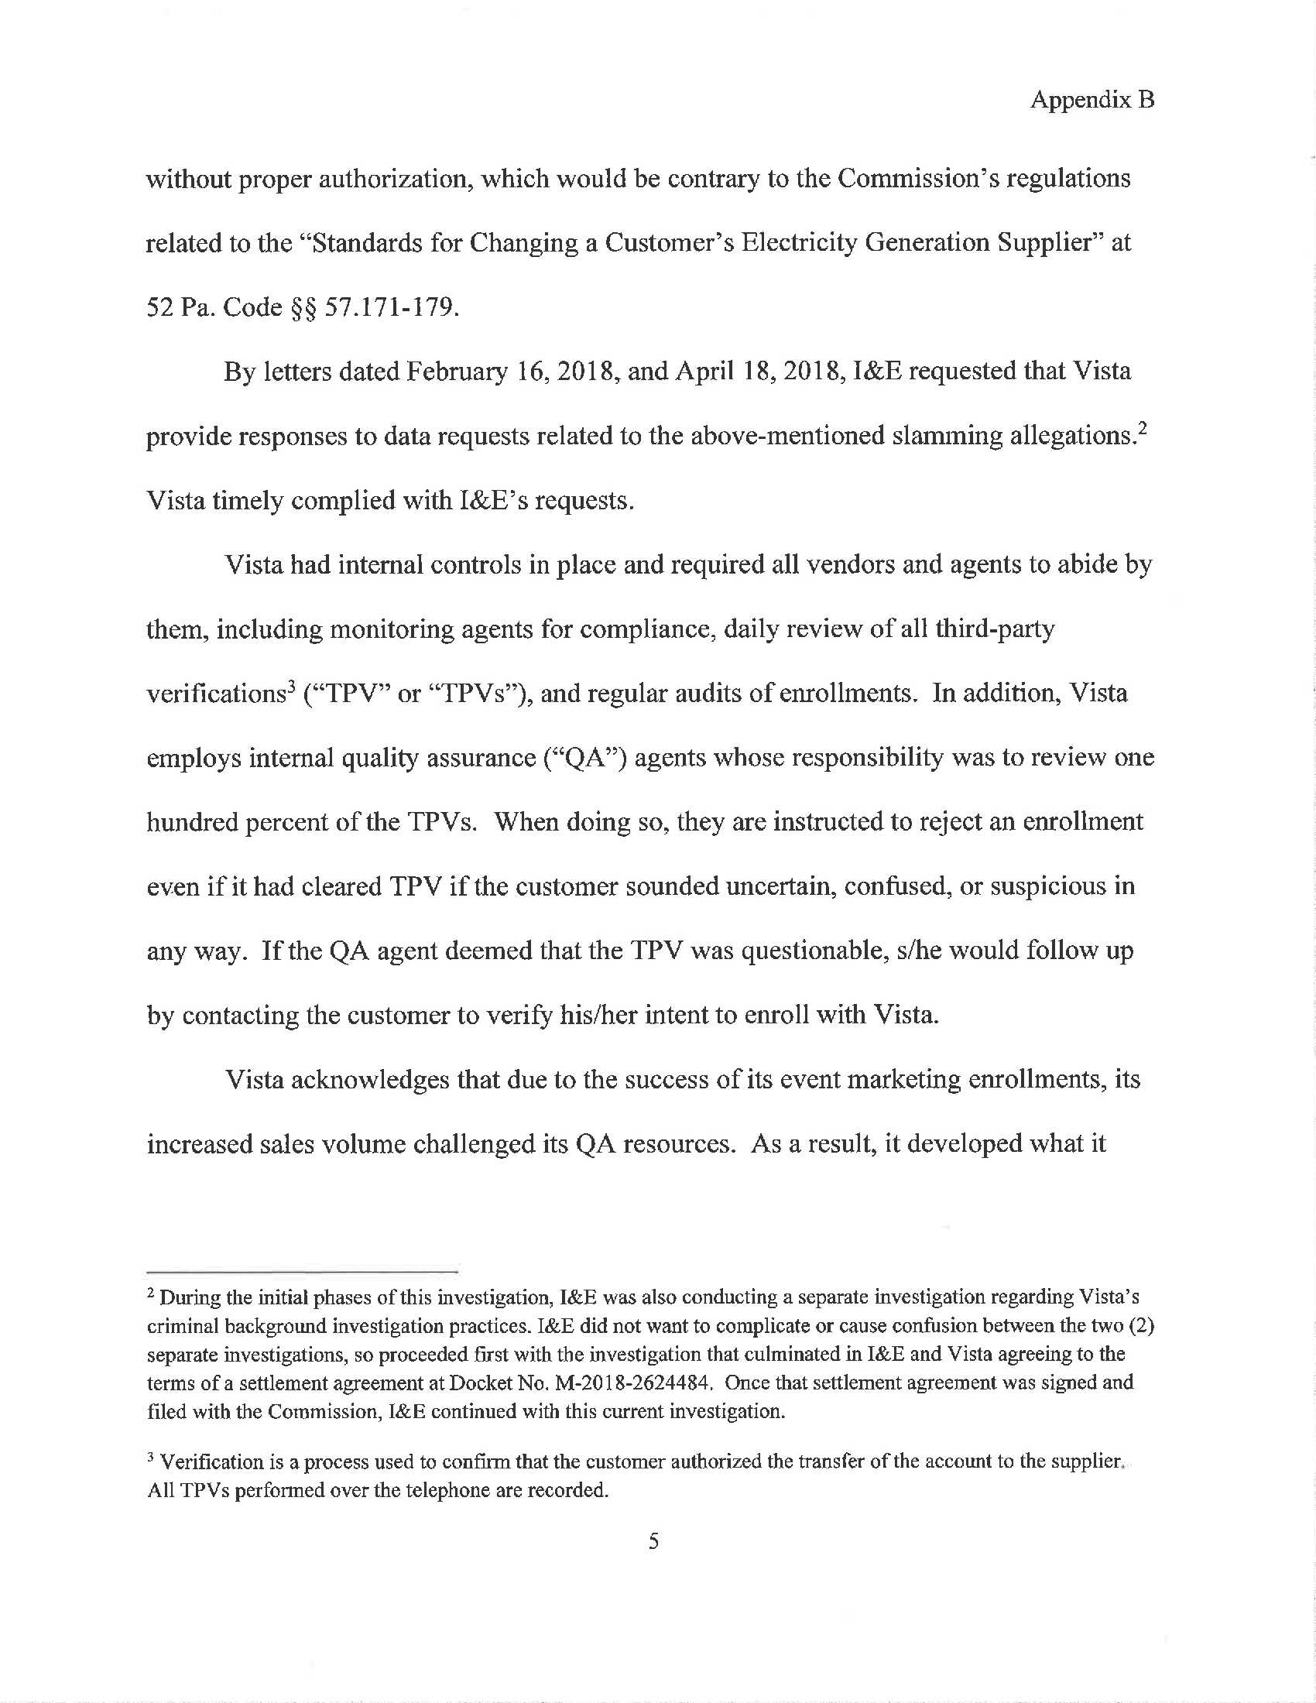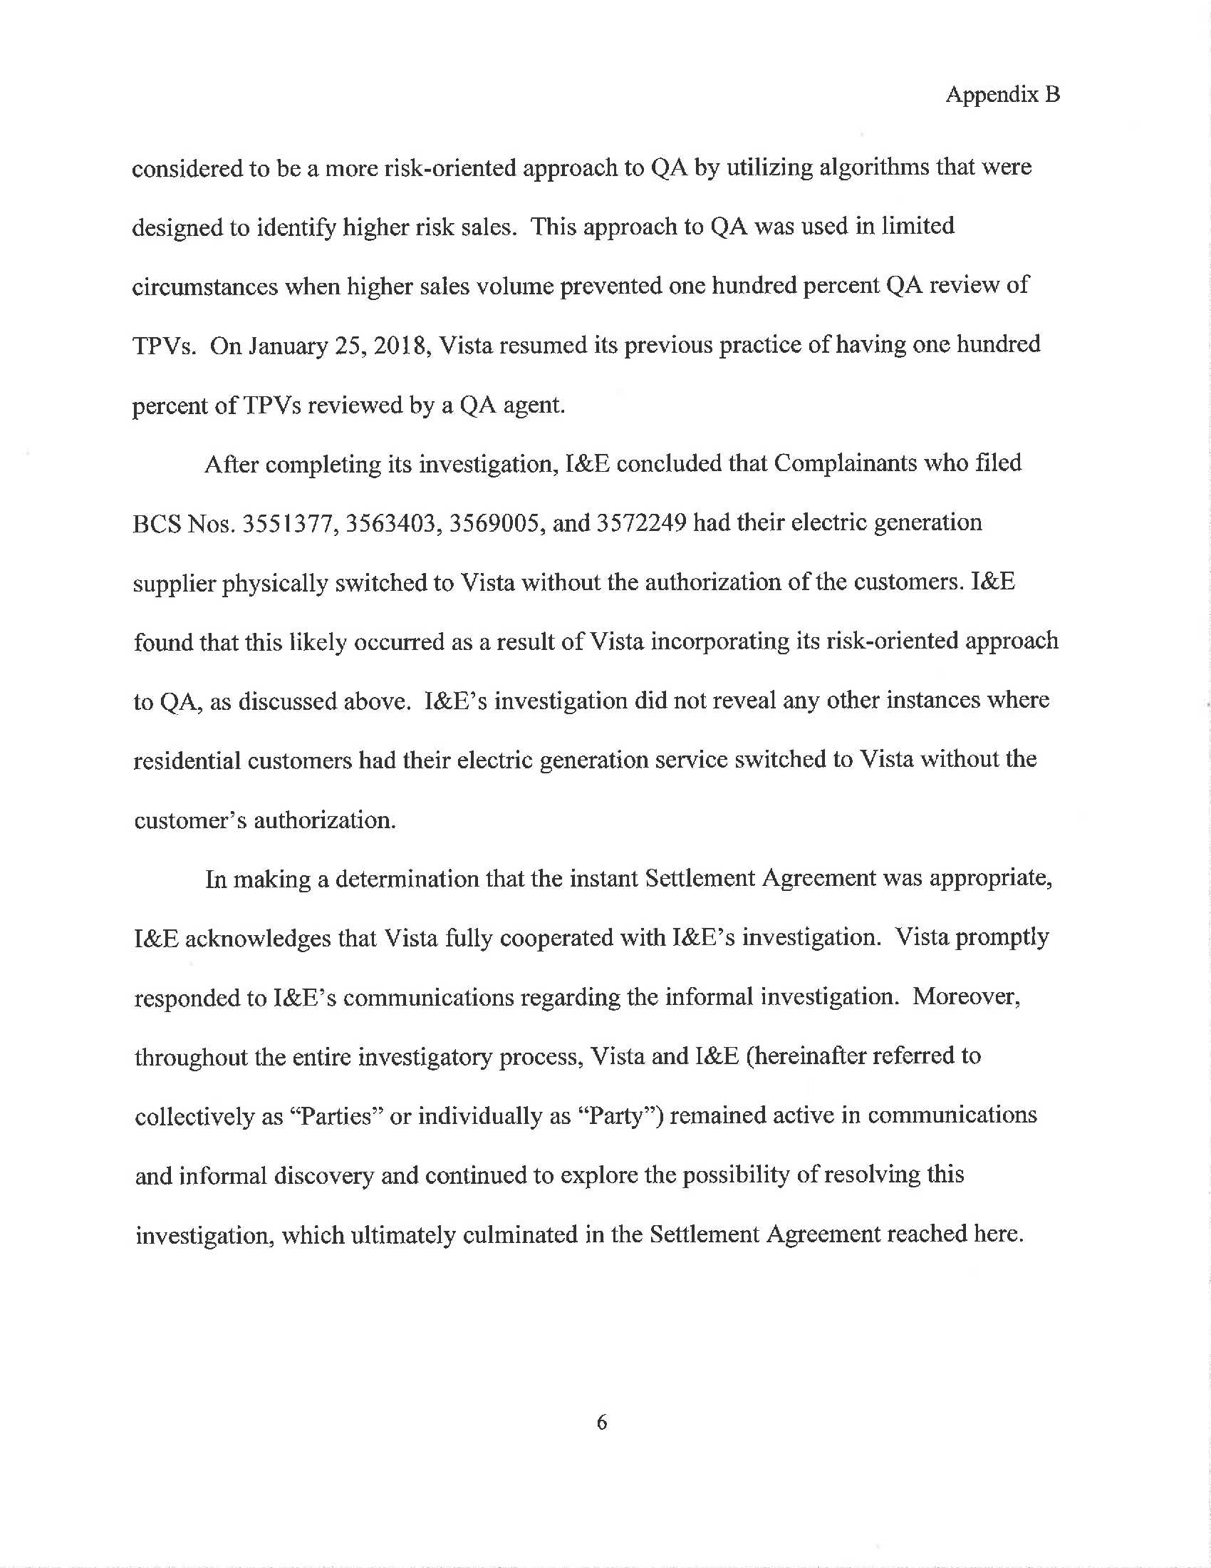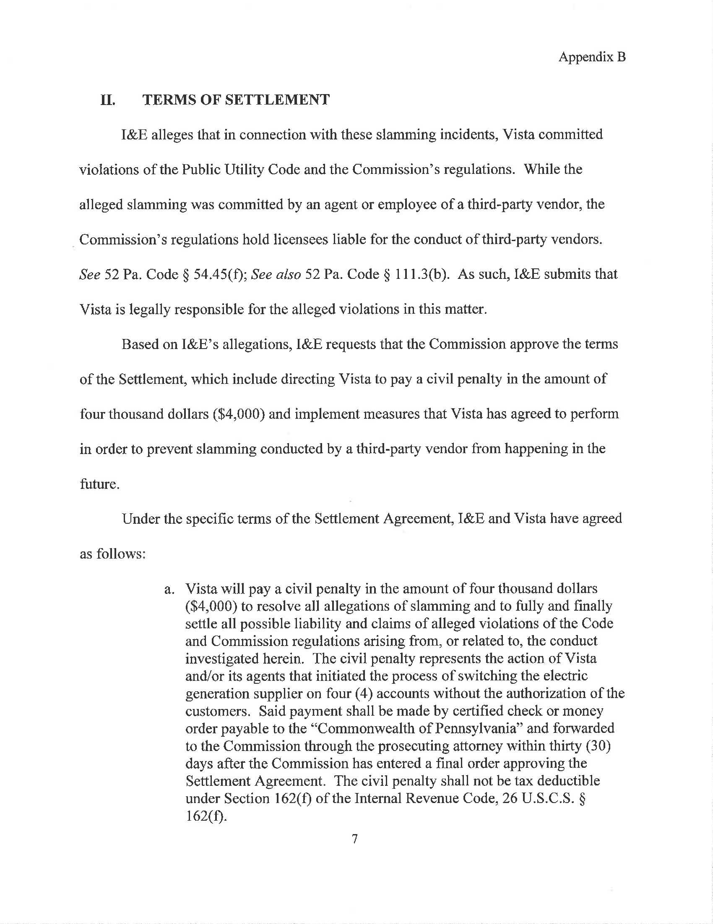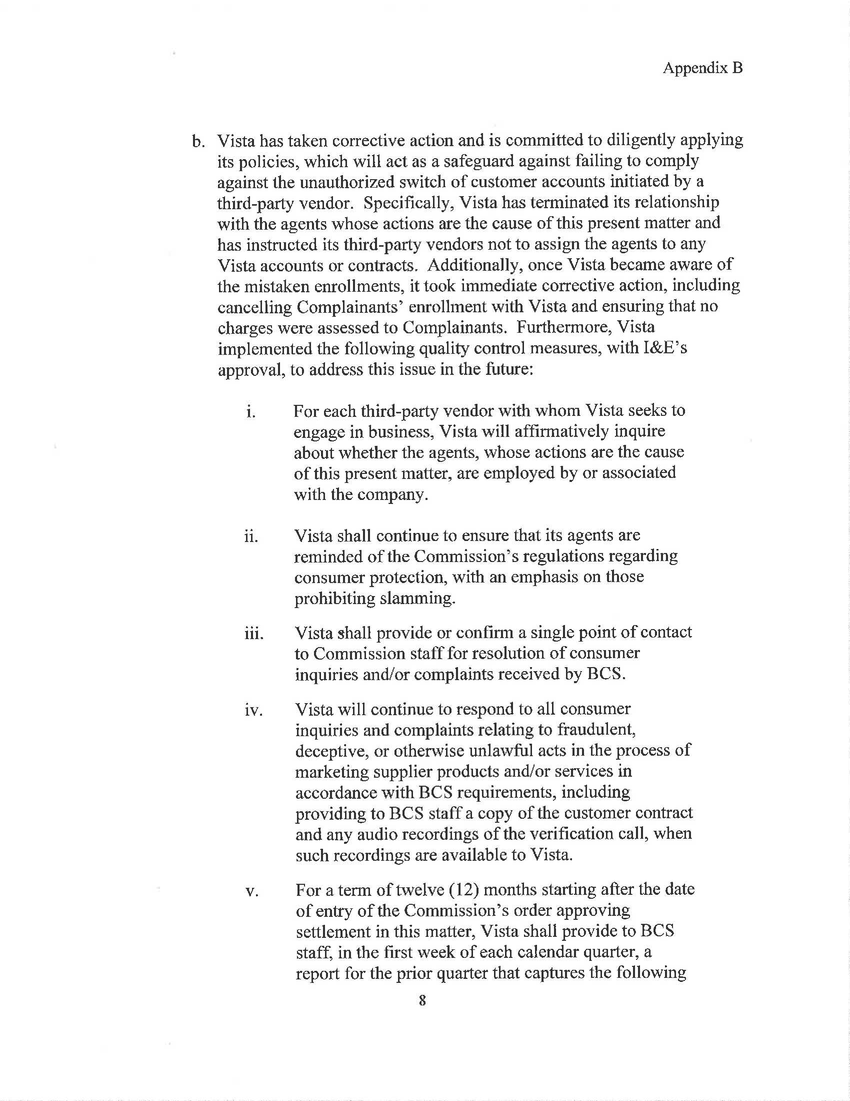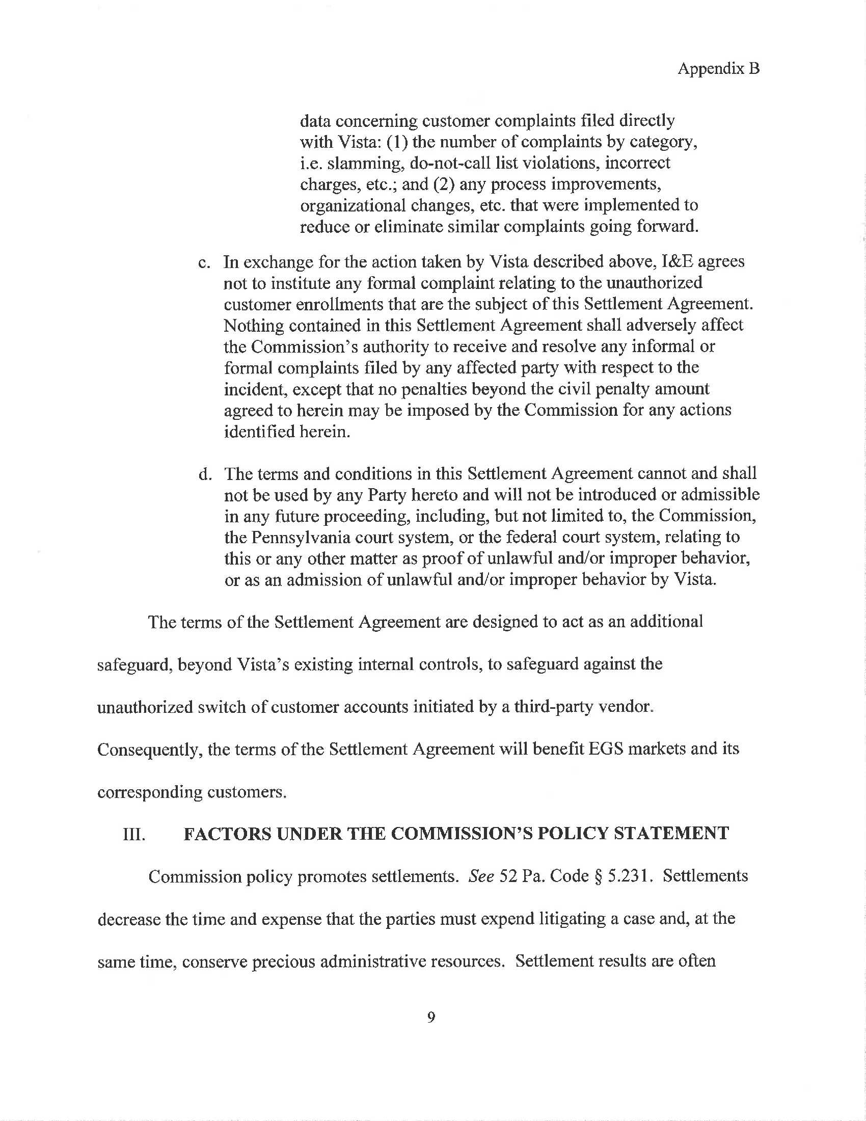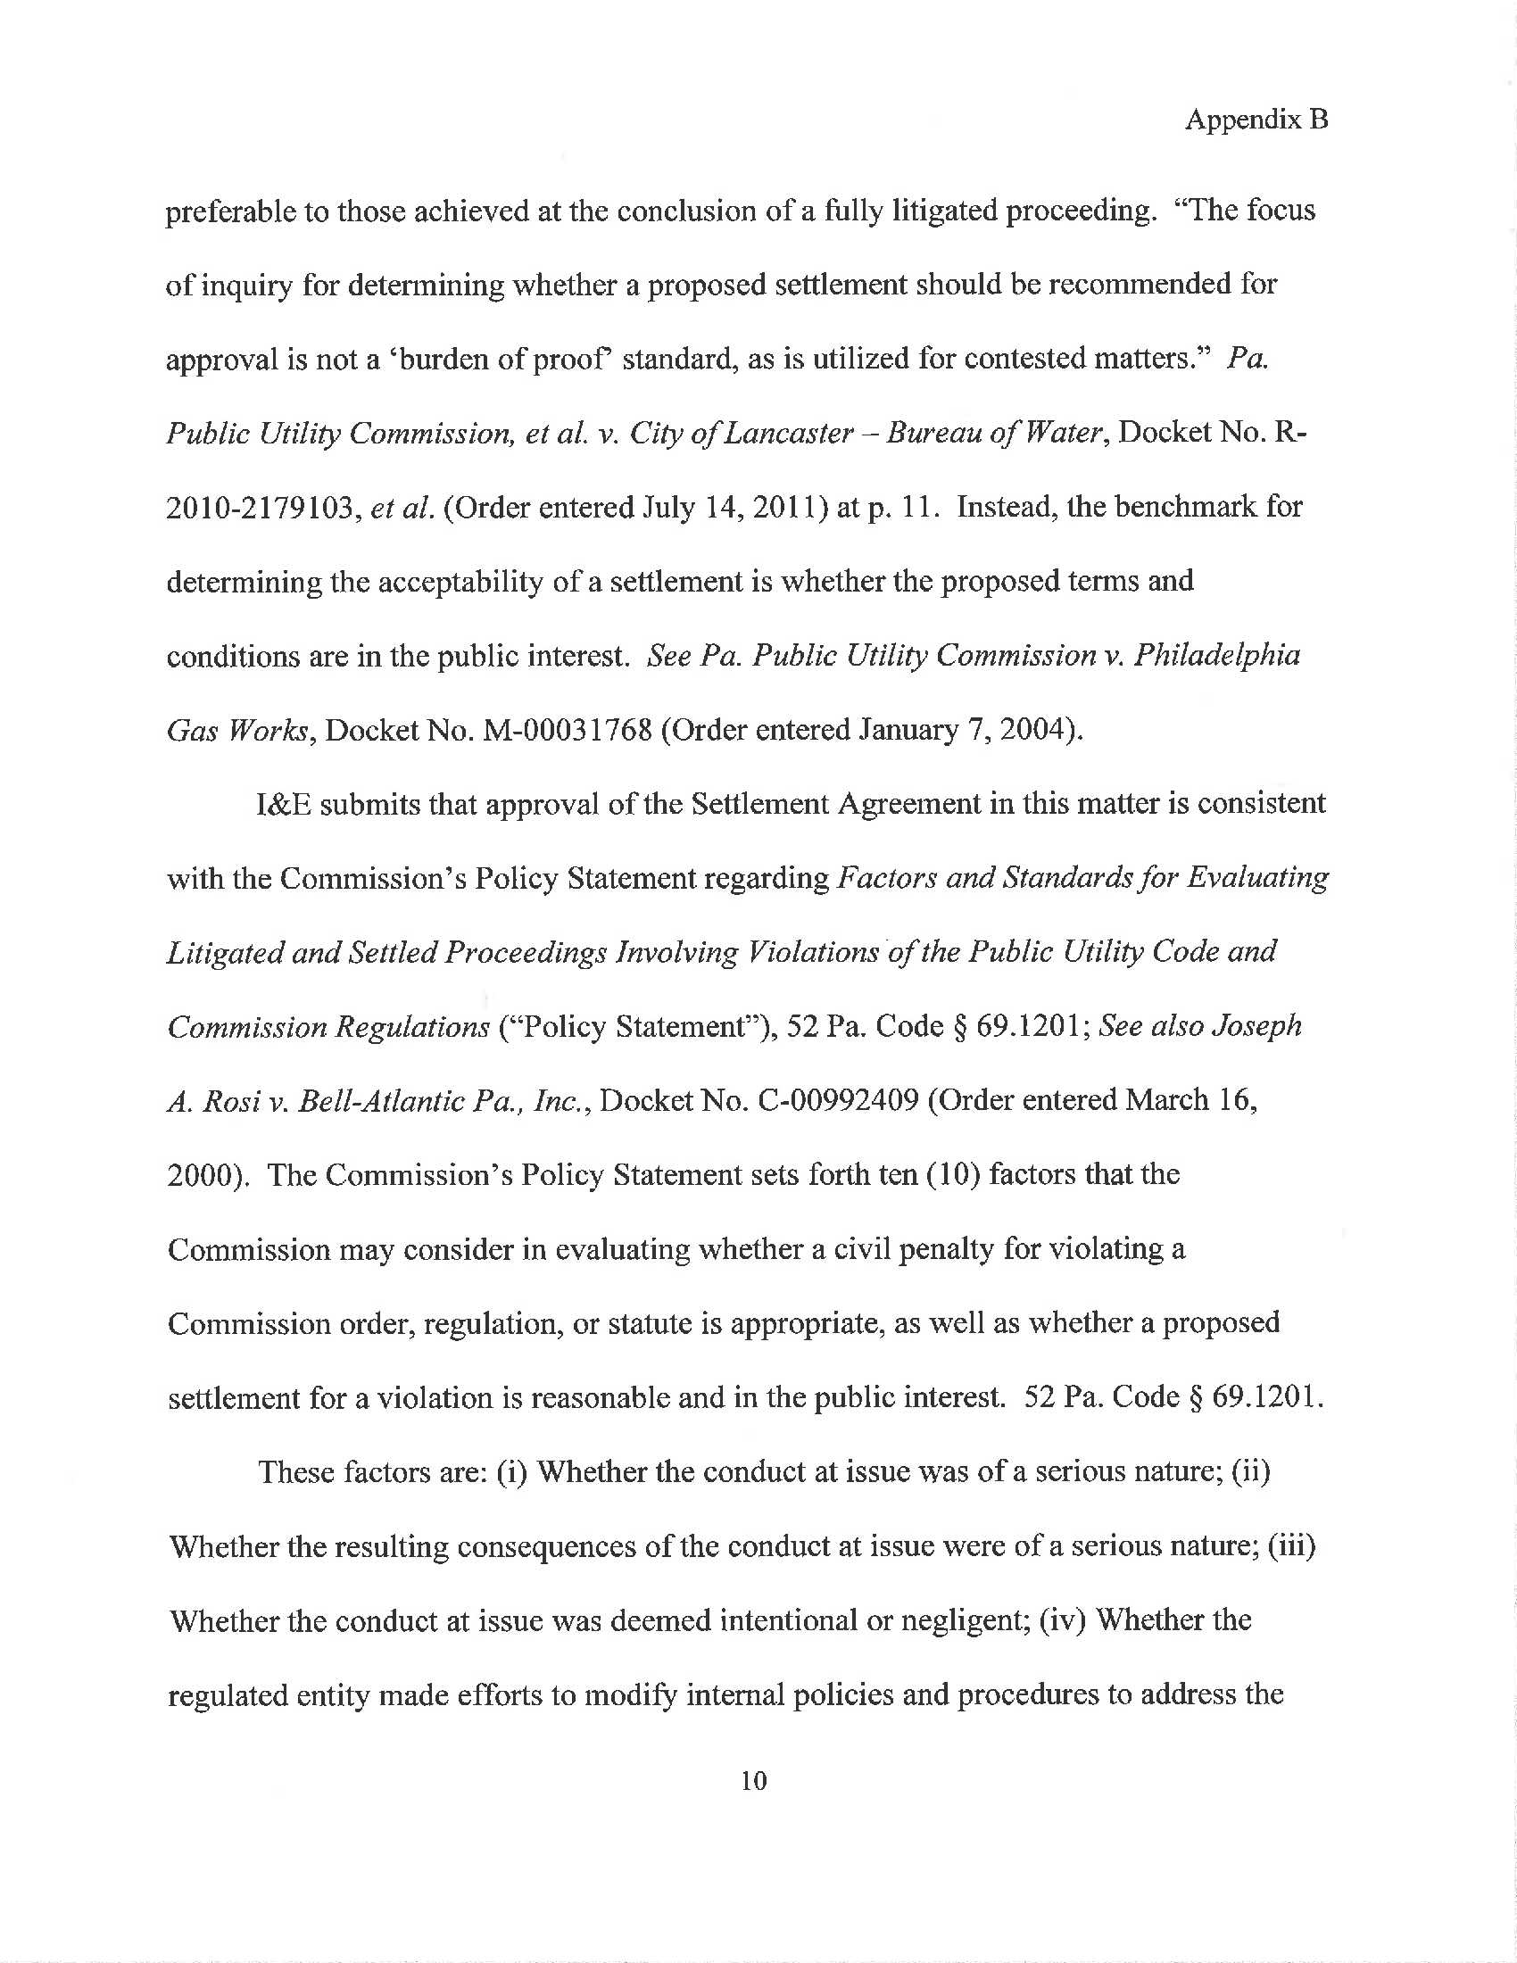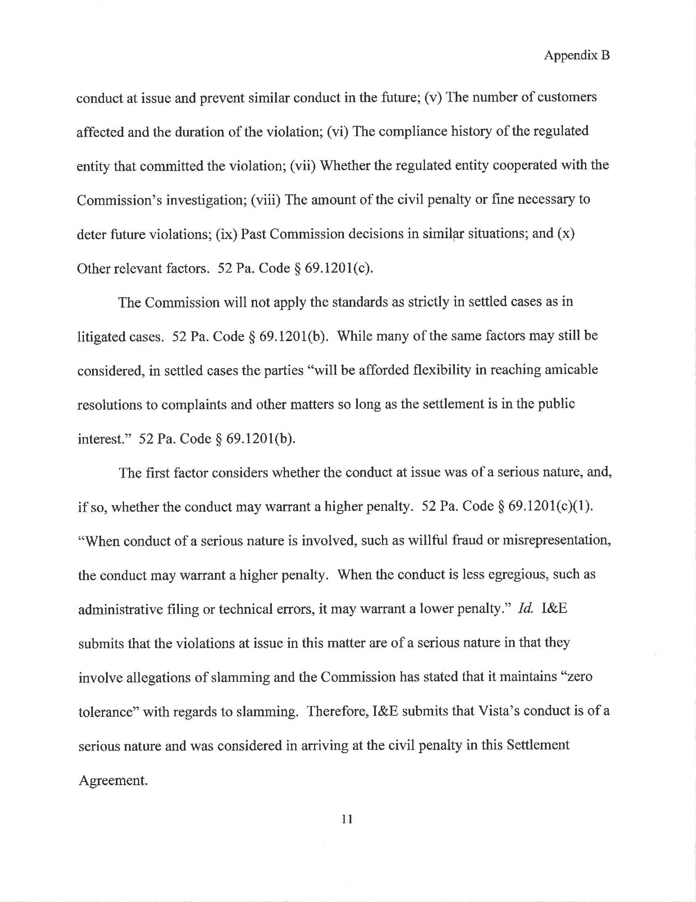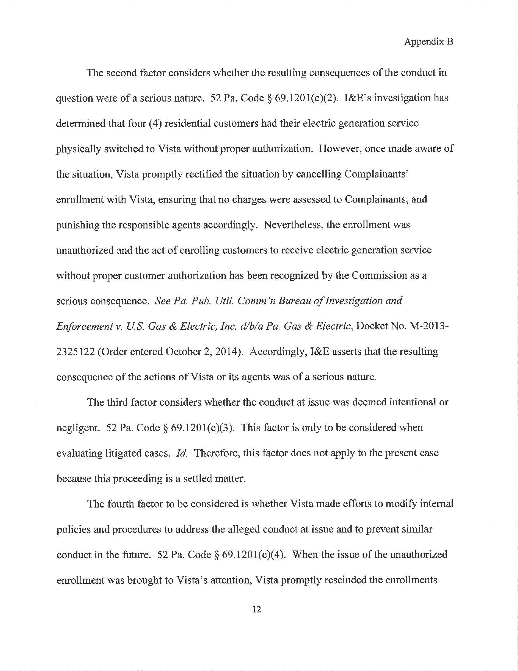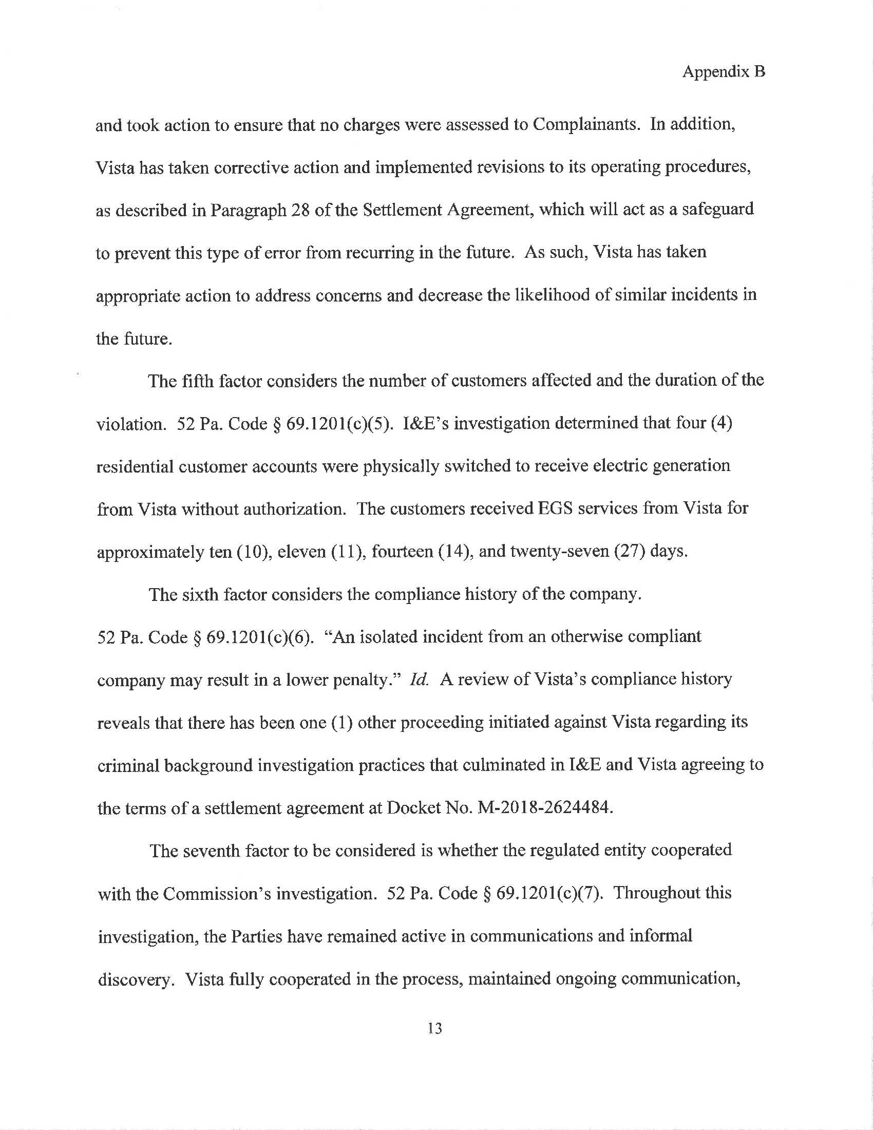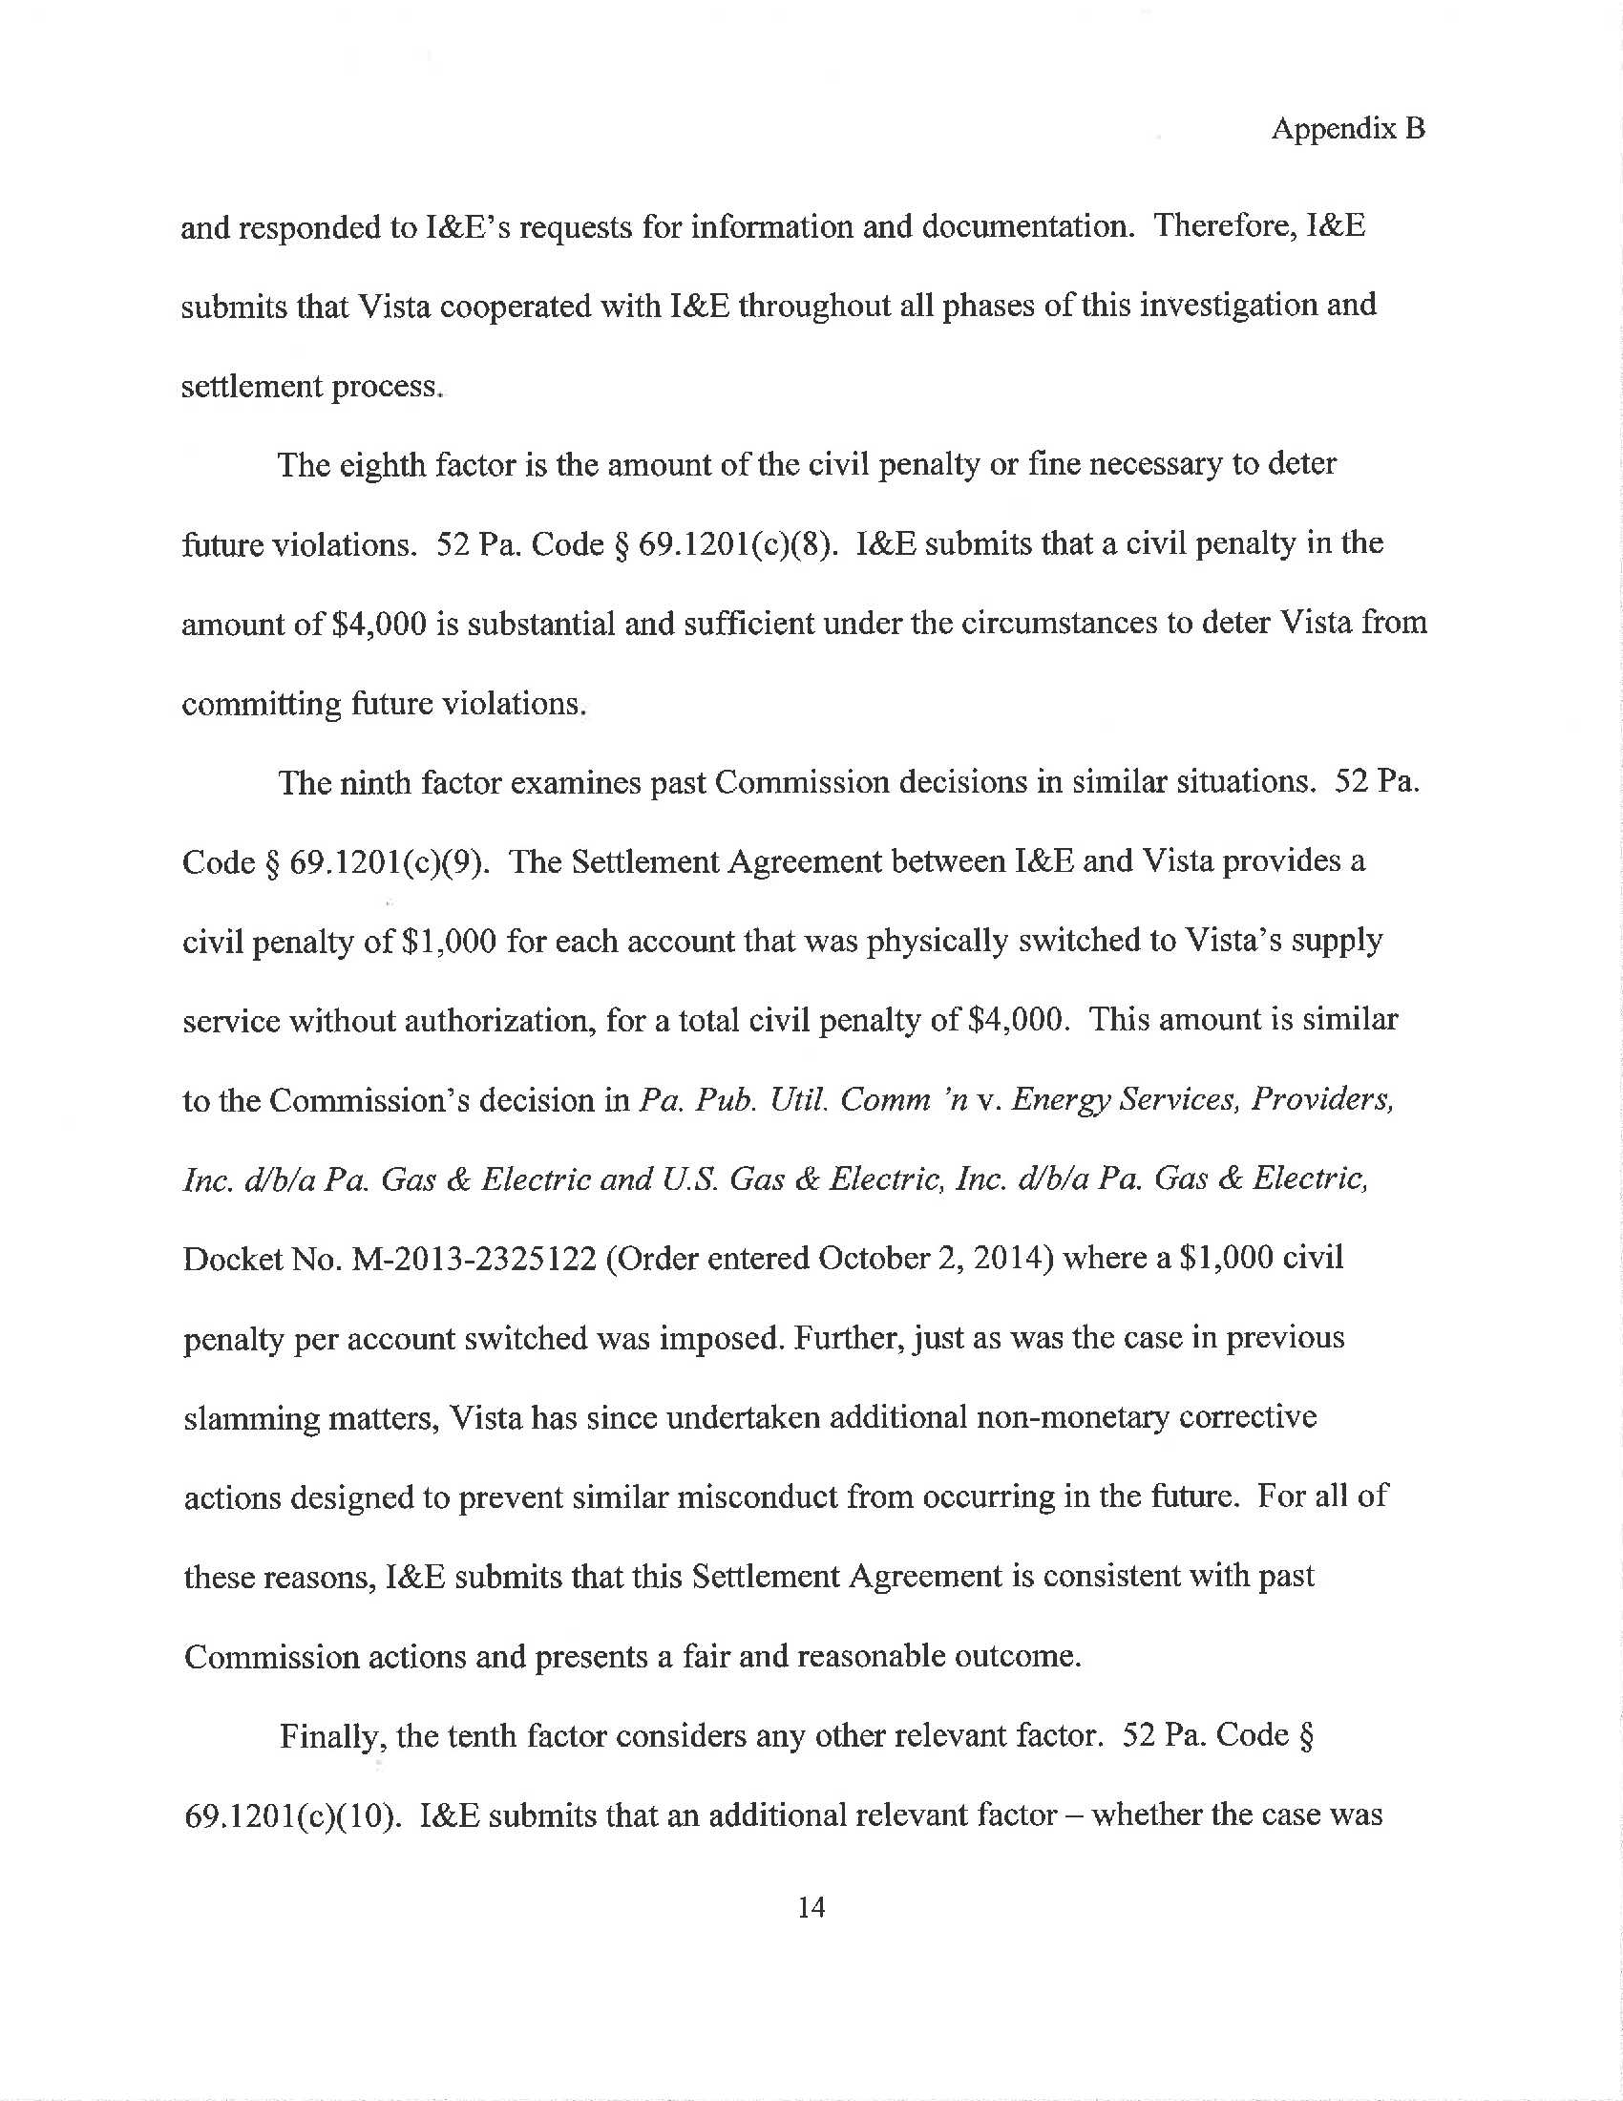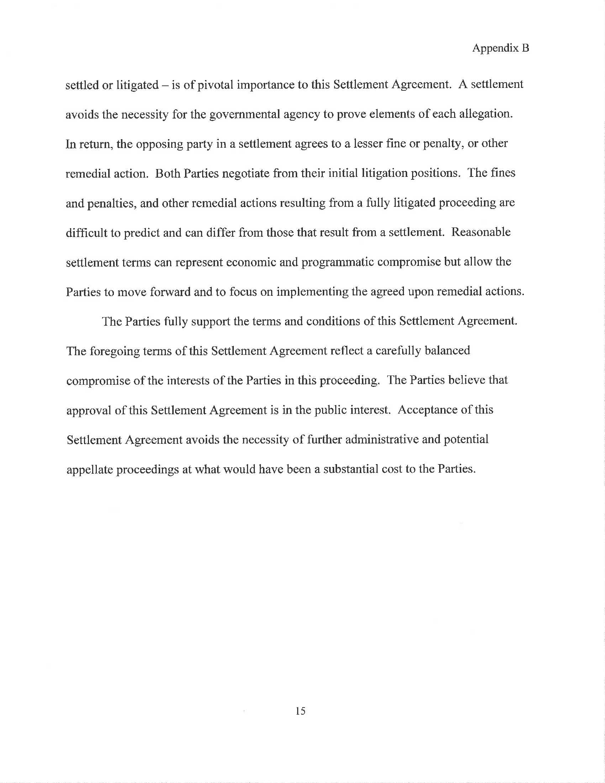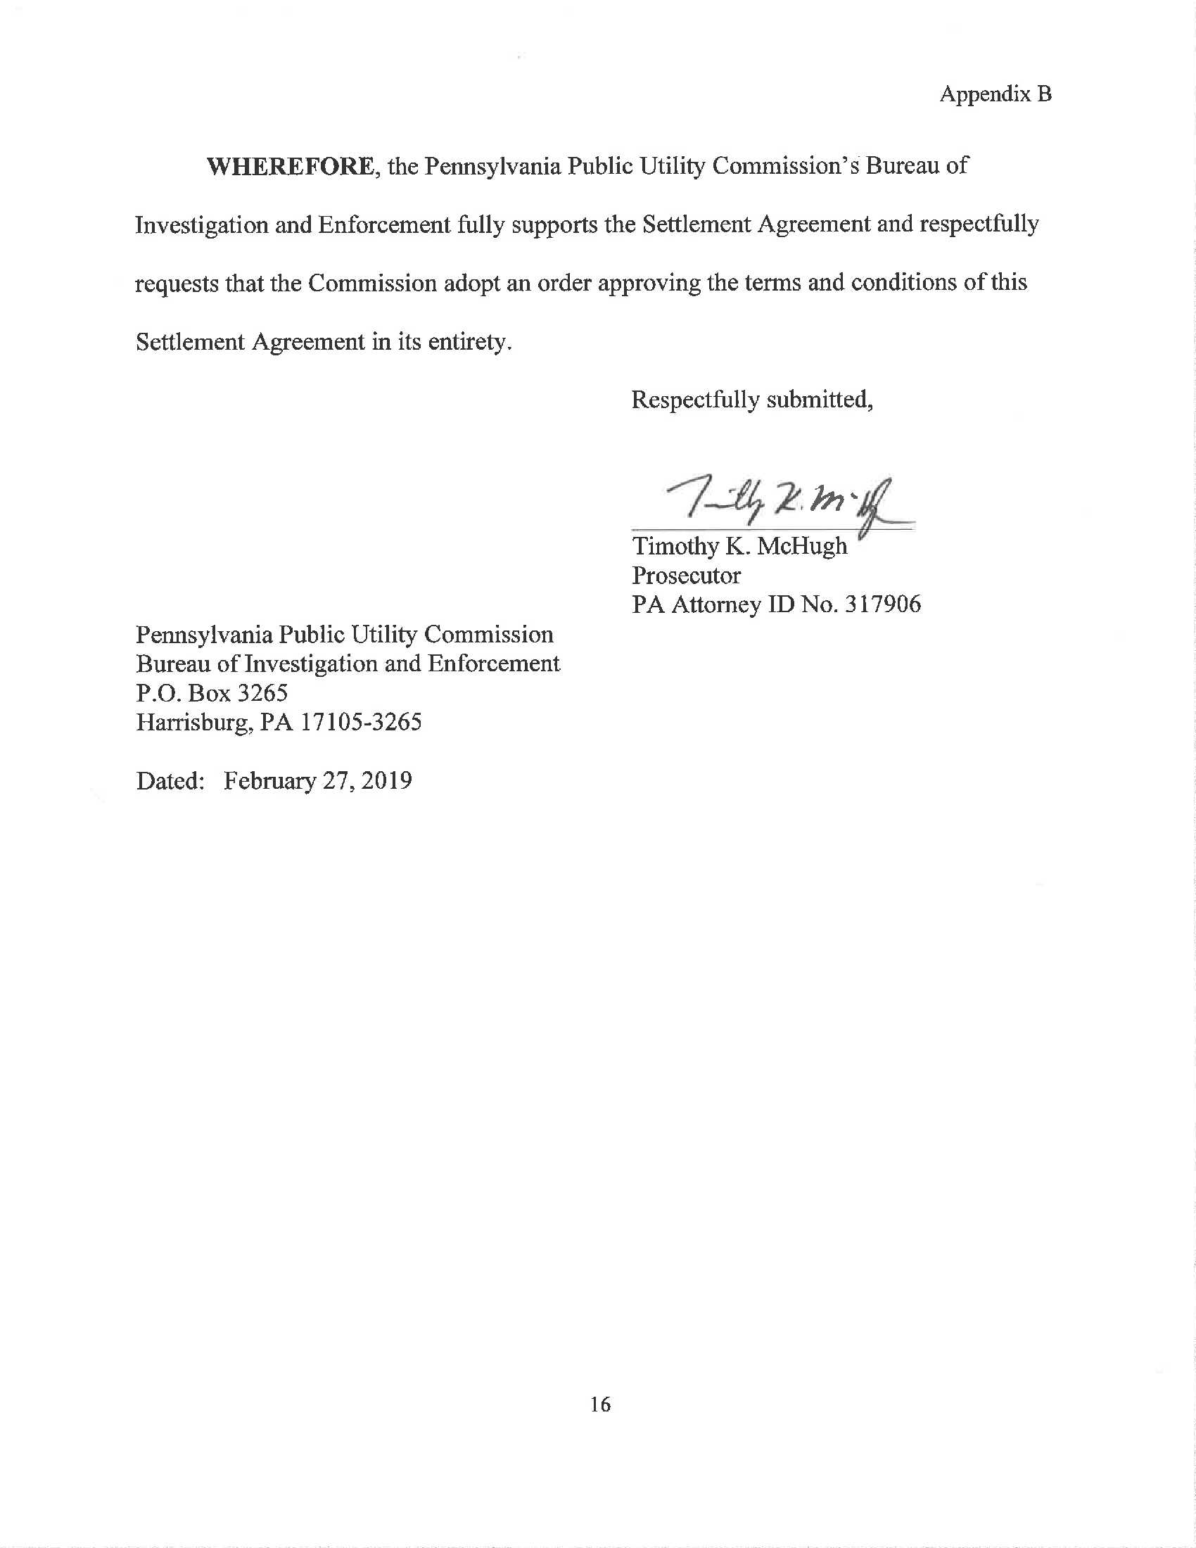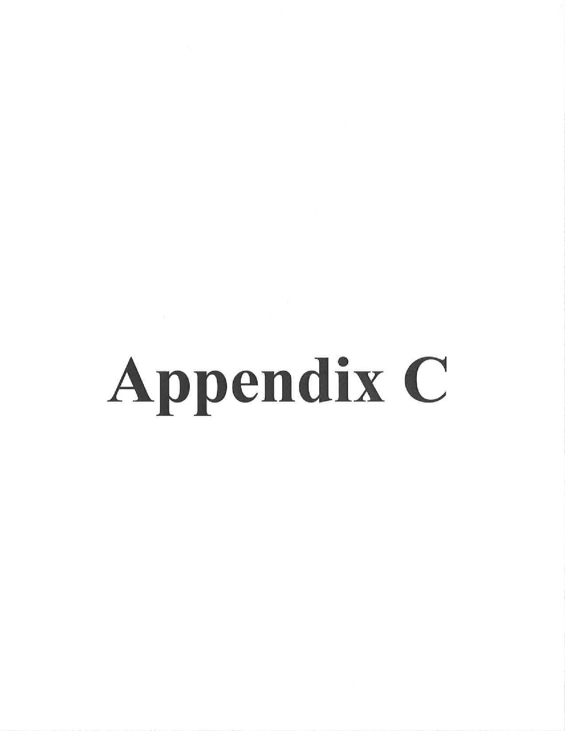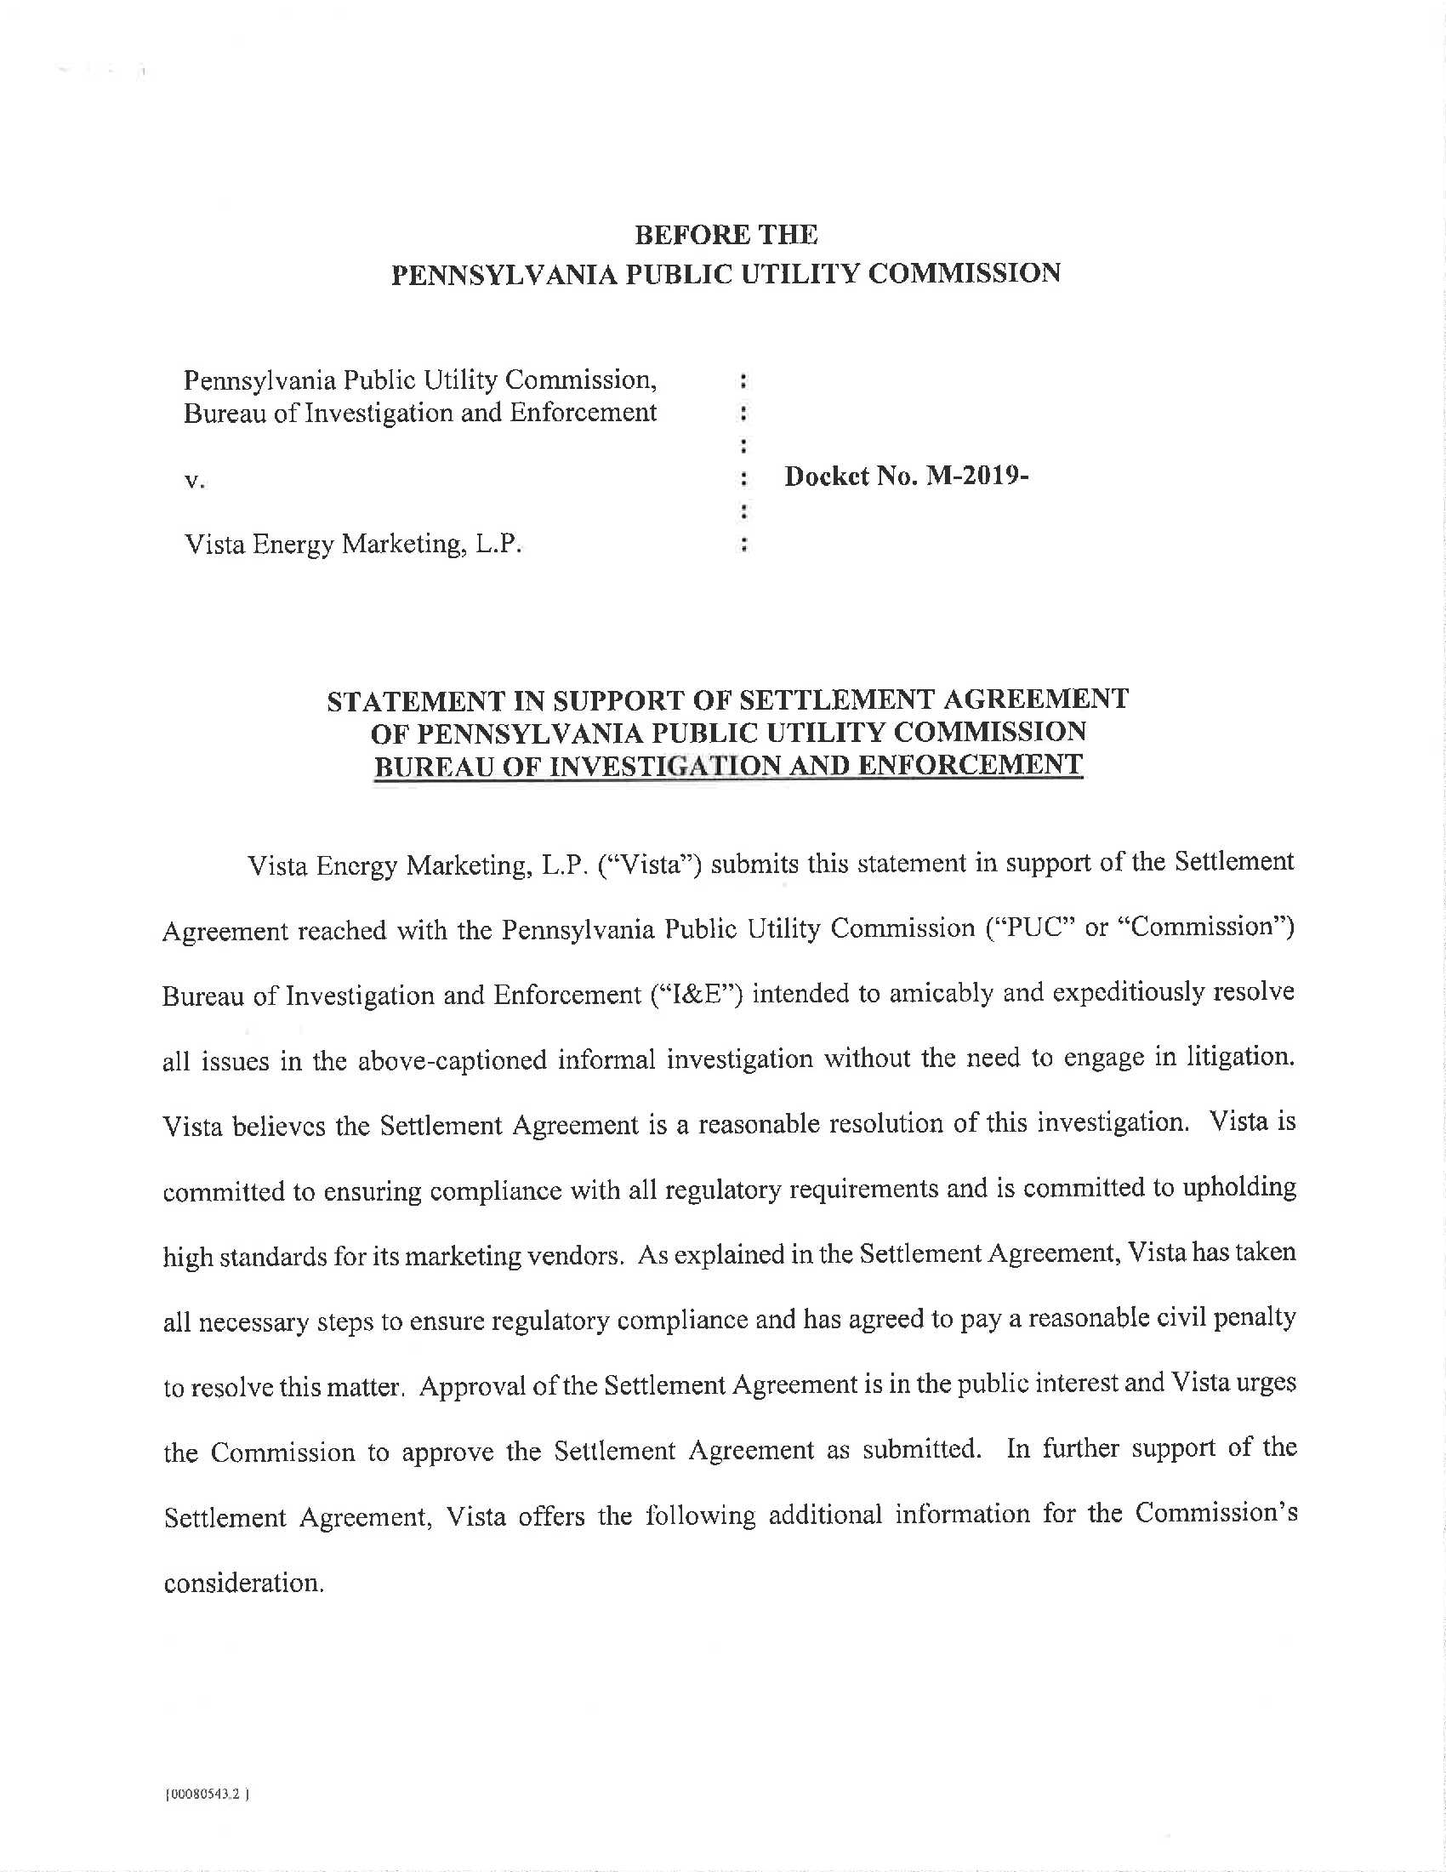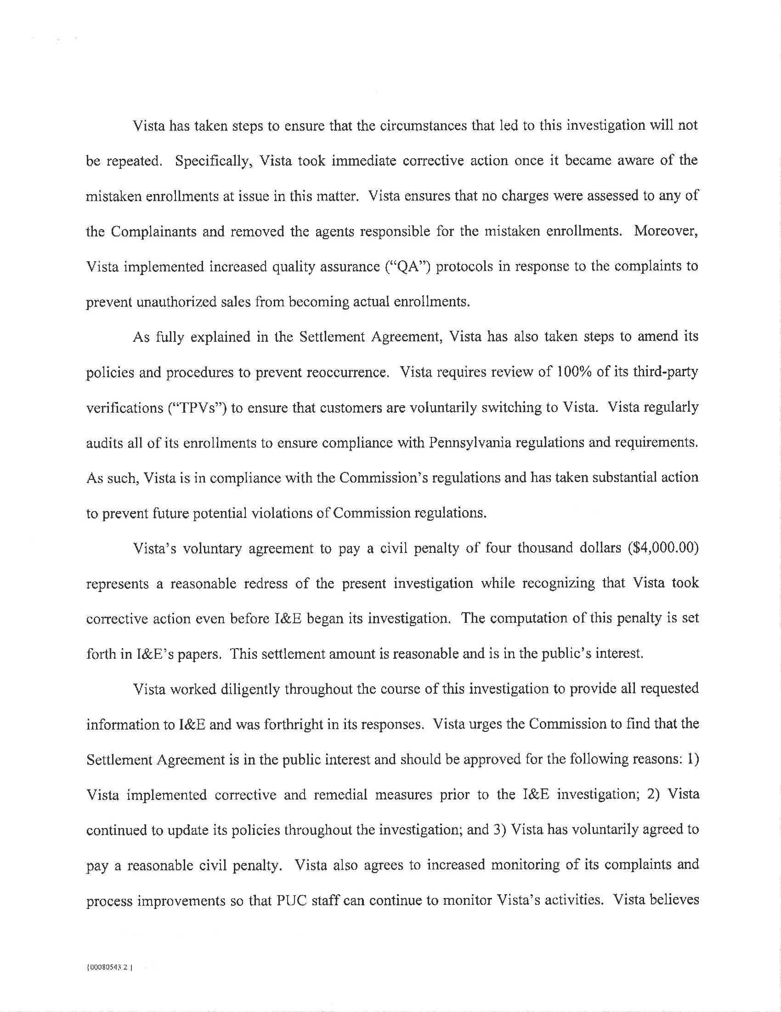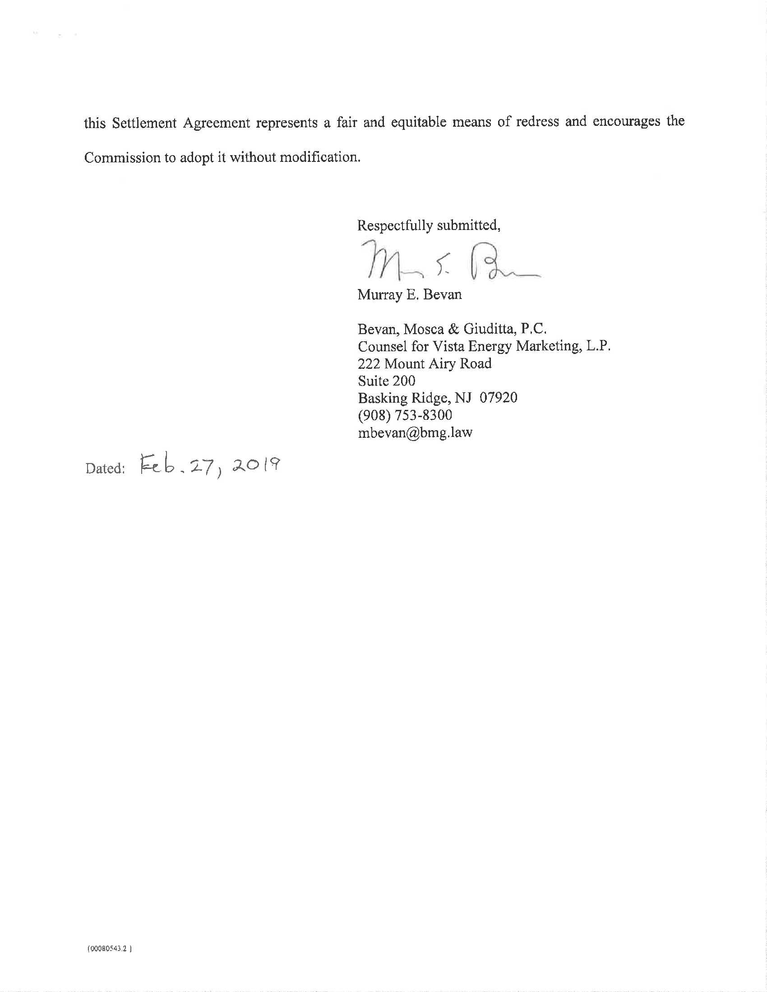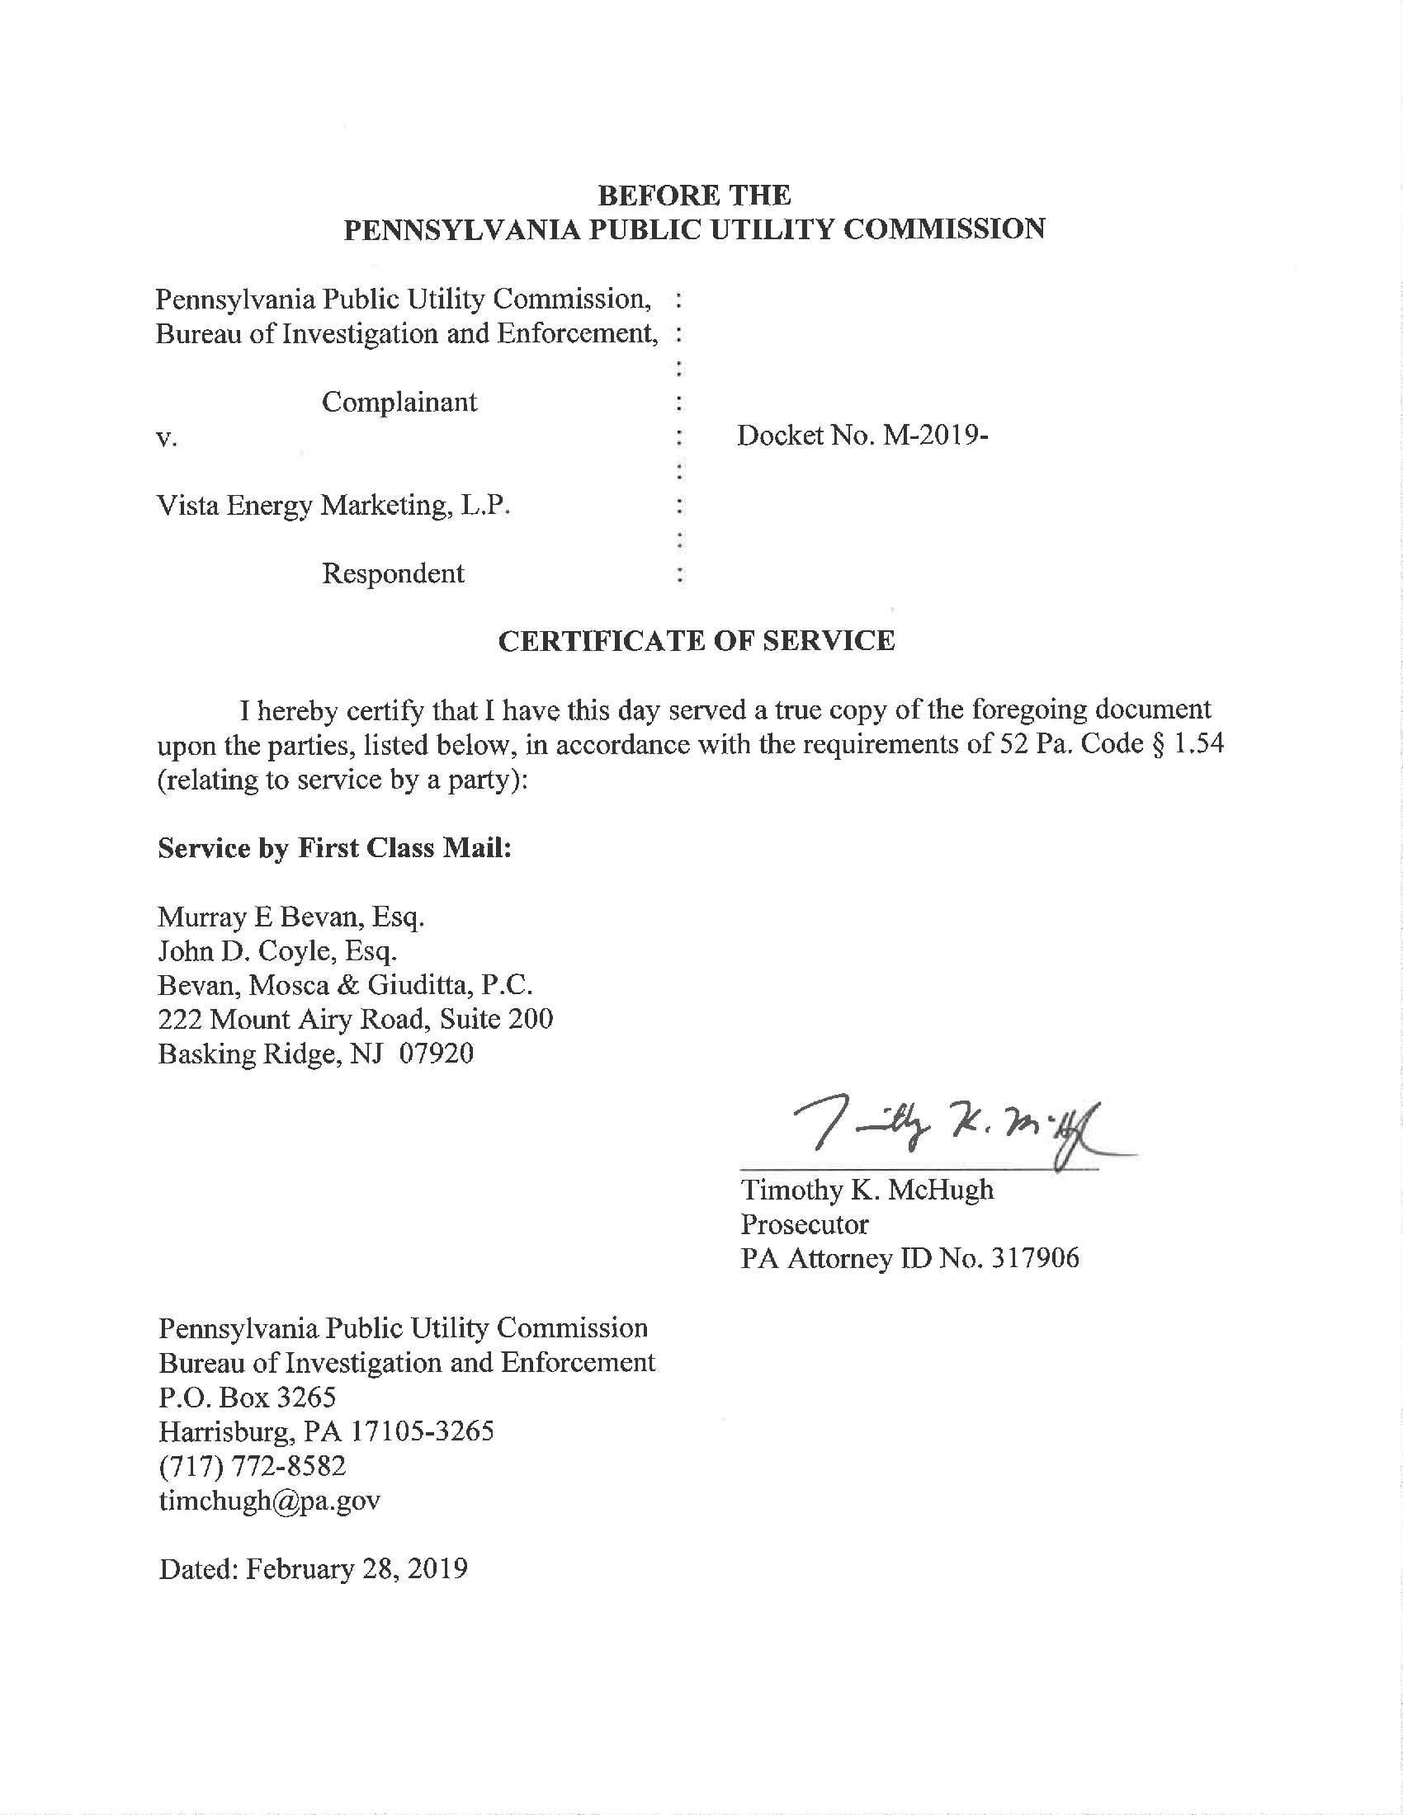

Vista received its Pennsylvania EGS license on December 22, 2016, at Docket No. A-2016-2569804.
“Slamming” is an unauthorized change made to a customer’s supply service. HIKO Energy LLC v Pa. Pub. Util. Comm’n, 163 A.3d 1079, 1090 (Pa. Cmwlth. 2017).
Verification is the process used to confirm that the customer authorized the transfer of the account to the supplier. All TPVs performed over the telephone are recorded. Statement in Support at 7.

