PENNSYLVANIA
PUBLIC UTILITY COMMISSION
Harrisburg, PA 17105-3265

Public Meeting held August 8, 2019

Commissioners Present:

Gladys Brown Dutrieuille, Chairman
David W. Sweet, Vice Chairman
Norman J. Kennard
Andrew G. Place
John F. Coleman, Jr.

Pennsylvania Public Utility M-2019-2568471
Commission, Bureau of
Investigation and Enforcement

v.

Liberty Power Holdings, LLC

OPINION AND ORDER

BY THE COMMISSION:

Before the Pennsylvania Public Utility Commission (Commission) for consideration and disposition is the Joint Petition for Approval of Settlement (Settlement) filed on June 6, 2019, by the Commission’s Bureau of Investigation and Enforcement
(I&E) and Liberty Power Holdings, LLC (Liberty Power or Company)
(collectively, the Parties). The Joint Petition contains terms and conditions representing a comprehensive settlement, along with Statements in Support, regarding an Informal Investigation that I&E conducted. The Parties submit that the proposed Settlement is in the public interest and is consistent with the Commission’s Policy Statement at 52 Pa. Code § 69.1201, Factors and standards for evaluating litigated and settled proceedings involving violations of the Public Utility Code and Commission regulations —statement of policy (Policy Statement). Settlement at 13. We will issue the Settlement for comment.

History of the Proceeding

Between May and June 2016, the Commission’s Bureau of Consumer Services (BCS) received approximately six informal complaints from customers alleging their electricity accounts had been switched to Liberty Power without their authorization. On July 18, 2016, after an internal investigation, Liberty Power reported the slamming incidents to the Commission’s Office of Competitive Market Oversight (OCMO).

On January 27, 2017, I&E initiated an informal investigation of the Company consistent with Sections 331(a) and 506 of the Public Utility Code (Code),
66 Pa. C.S. §§ 331(a) and 506, and Section 3.113 of the Commission’s Regulations,
52 Pa. Code § 3.113. I&E filed requests on May 18, 2017 and March 2, 2018 and Liberty Power filed its responses on June 7, 2017 and March 29, 2018. On June 6, 2019, the Parties filed the instant Joint Petition for Settlement.

Background

1. Allegations of Slamming

Liberty Power stated that it had contracted with an independent, third-party marketing company called Made in America Business Group (MIB) between February 2016 and June 2016. During this period, MIB contacted 921 potential residential customers and 533 of these customers were enrolled to receive electric generation supply from Liberty Power. When Liberty Power became aware of the possible issues with the customers enrolled by MIB, Liberty Power conducted an internal investigation and called 176 of the 533 customers enrolled. The five customers the Company reached requested cancellation. On June 14, 2016, Liberty Power verbally terminated its contract with MIB and suspended MIB’s ability to contact customers until July 26, 2016, when Liberty Power sent a formal letter of termination to MIB. Settlement at 6.

On July 18, 2016, Liberty Power voluntarily reported the incidents to OCMO as well as its internal actions and the corrective measures it planned to take. Id. at 7. Liberty Power mailed letters on August 26, 2016 to all accounts enrolled by MIB as of that date, which totaled 270 accounts, explaining its concerns and urging customers to contact Liberty Power to discuss account details. Following these communications, eighty-five customers requested to be dropped as customers or complained of being “slammed.” Id. In response, Liberty Power provided refunds of $27.64 to customers who filed formal complaints with the Commission. The refunds were based on a comparison of Liberty Power’s electric generation supply charge and the electric distribution company’s price-to-compare. Id. at 7-8. Upon review of Liberty Power’s data request responses, I&E concluded that it appeared that seven MIB agents were involved in a scheme to enroll customers with Liberty Power, without authorization, by fabricating documents and audio verifications to conceal that the customers did not consent to the switch to Liberty. Although MIB and not Liberty Power caused the unauthorized enrollments, Liberty Power bears responsibility for fraudulent, deceptive or other unlawful marketing acts performed by its agent pursuant to 52 Pa. Code §§ 54.43(f) and 111.3(b). Settlement at 8.

2. Allegations of Deficient Disclosure Statements and Marketing

Prior to February 10, 2017, Liberty Power’s residential disclosure statements presented two different prices to customers: 1) an Energy Only Rate which did not include distribution and delivery charges, applicable federal, state or local taxes, and charges, or the Pennsylvania Gross Tax Rate (GRT), and 2) a Price To Compare (PTC), which consisted of the Liberty Power Energy Only Rate plus the Pennsylvania GRT. The Liberty Power PTC was the rate that the Company billed to customers. It is unknown how many agents advertised the lower Energy Only Rate as opposed to Liberty Power’s PTC or how many customers received Liberty Power’s disclosure statements containing both rates. As a result of I&E’s investigation, Liberty Power eliminated references to the Energy Only Rate from their disclosures and advertisements, ensuring that Liberty Power’s enrollment and disclosure documents contained only one price that included the relevant components of the commodity price Liberty Power charged to include GRT. Id. at 9. As of now, no customers have complained to the BCS about the inclusion of the Energy Only Rate on Liberty Power’s disclosure statements and marketing materials. Id. at 10.

Through its investigation and data requests, I&E concluded that the Complainants who filed the BCS informal complaints, as well as several other consumers, had their electric generation supplier switched to Liberty Power without their authorization. I&E also determined that Liberty Power’s Energy Only Rate did not include GRT and therefore was not an all-inclusive price. Id.

Had this matter been litigated, I&E would have alleged that Liberty Power violated certain provisions of the Code, the Commission’s Regulations, and Commission Orders in that:

A. The action of Liberty Power’s agent initiated the process of switching the electric generation supplier on at least eighty-five (85) customer accounts and resulted in physically switching the electric generation supplier on fifty-six (56) of those accounts without the authorization of the customers.

If proven, I&E alleges that such conduct would have violated 52 Pa. Code § 54.42(a)(9) and the Standards for Changing a Customer’s Electricity Generation Supplier at 52 Pa. Code
§§ 57.171-180 (multiple counts).

B. The presentation of the “Energy Only Rate” on Liberty Power’s disclosure statements and marketing materials, which is a rate that did not include the GRT and, therefore, did not represent an all-inclusive price that consumers were able to compare to the PTC that is used for default service.

If proven, I&E alleges that such conduct would have violated 52 Pa. Code § 54.43(1) and the Commission’s Order regarding Guidelines for Use of Fixed Price Labels for Products with a Pass-Through Clause, Docket No. M-2013-2362961 (Order entered November 14, 2013) (multiple counts).

C. The presentation of the “Energy Only Rate” on Liberty Power’s disclosure statements and marketing materials, which is a rate that did not include the GRT, did not reflect the prices billed for Liberty Power’s electric generation supply.

If proven, I&E alleges that such conduct would have violated 52 Pa. Code §§ 54.4(a), 54.5(a) and 54.7(a).

Joint Petition at 10.

There has been no evidentiary hearing before any tribunal and no sworn testimony taken. Liberty Power would have contended that it did not violate the provisions of the Code, the Commission’s Regulations, or Commission Orders. Id. While Liberty Power disputes or disagrees with some or all of the alleged violations, the Company recognizes the need to prevent such alleged violations and the benefits of amicably resolving the investigation. Id. at 11.

In advance of the Settlement, Liberty Power began to take corrective action. Specifically, on July 14, 2016 Liberty Power verbally terminated its contract with MIB and formally issued a termination letter on July 26, 2016. Id. at 6. Moreover, on February 10, 2017, Liberty Power eliminated the inclusion of the Energy Only Rate on its disclosure materials and marketing. Id. at 5. The proposed Settlement, which is attached to this Opinion and Order, has been filed by the Parties in order to terminate I&E’s formal investigation and to resolve this matter completely and without litigation. The Parties urge the Commission to approve the Settlement as being in the public interest.

Terms of the Settlement

The Parties entered into the Settlement to resolve I&E’s informal investigation and to settle this matter without litigation in a formal proceeding. Pursuant to the proposed Settlement, Liberty Power agreed, inter alia, to do the following:

a. Liberty Power will pay a civil penalty in the amount of Eighty-Two Thousand Eight-Hundred Dollars ($82,800), pursuant to 66 Pa. C.S. § 3301, to resolve all allegations of slamming and unlawful marketing, and to fully and finally settle all possible liability and claims of alleged violations of the Commission’s Regulations and Orders arising from, or related to, the conduct investigated herein. The civil penalty represents the following: Fifty-Six Thousand Dollars ($56,000) for the fifty-six (56) customer accounts that were physically switched to and received electric generation supply from Liberty Power; Five Thousand Eight Hundred Dollars ($5,800) for the twenty-nine (29) customer accounts where the process of switching to Liberty Power had been initiated but not completed; One Thousand Dollars ($1,000) for the non-quantifiable and unknown number of customers who may have been potentially affected by the unauthorized switching conducted by Liberty Power’s agent; and Twenty Thousand Dollars ($20,000) for Liberty Power’s inclusion of an “Energy Only Rate” on Liberty Power’s disclosure statements and marketing materials. Said payment shall be made within sixty (60) days of the date of the Commission’s Final Order approving the Settlement Agreement and shall be made by certified check or money order payable to the “Commonwealth of Pennsylvania” and sent to:

Secretary
Pennsylvania Public Utility Commission
400 North Street
Harrisburg, PA 17120

The civil penalty shall not be tax deductible pursuant to Section 162(f) of the Internal Revenue Code, 26 U.S.C.
§ 162(f).

b. Liberty Power will provide to each of the customers, who had one or more of the fifty-six (56) accounts physically switched to Liberty Power, a refund for the entire electric generation supply portion on the customers’ bills for the first two (2) billing periods that the customers were switched to Liberty Power, pursuant to 52 Pa. Code § 57.177(b). Liberty Power will issue the customer refunds within thirty (30) days of the date of the Commission’s Final Order approving the Settlement Agreement. Pursuant to 52 Pa. Code § 5.591, following payment of the refunds, Liberty Power will file with the Commission a verification acknowledging that all refund payments have been disbursed, satisfying this settlement provision.

Settlement at 11. This payment shall not be claimed or included for recovery in future ratemaking proceedings, nor shall it be considered tax deductible. Id.

The Settlement is conditioned on the Commission’s approval of the Settlement’s terms and conditions, and if the Commission modifies the Settlement, any Party may withdraw from the Settlement and proceed with litigation. Id. at 13. Upon Commission approval of the Settlement without modification, I&E will not file any complaints or initiate other action against the Company at the Commission concerning unauthorized enrollments by MIB and deceptive and/or unlawful marketing practices during the time period in question. Id. at 12. The Settlement does not constitute a concession or an admission of fact or law by Liberty Power. The Settlement is presented without prejudice to any position the Parties have advanced or may advance in the future regarding the merits of the issues in future proceedings, except to the extent necessary to effectuate this Settlement. Id. at 14.

Discussion

Pursuant to Section 5.231 of our Regulations, 52 Pa. Code § 5.231, it is the Commission’s policy to promote settlements. The Commission must, however, review proposed settlements to determine whether the terms are in the public interest. Pa. PUC v. Philadelphia Gas Works, Docket No. M-00031768 (Order entered January 7, 2004).

Conclusion

Before issuing a decision on the merits of the proposed Settlement, consistent with the requirement of 52 Pa. Code § 3.113(b)(3), we are providing an opportunity for interested parties to file comments regarding the proposed Settlement that is included as an attachment to this Opinion and Order; THEREFORE,

IT IS ORDERED:

1. That this Opinion and Order, together with the attached Joint Petition for Approval of Settlement and the Statements in Support thereof, shall be issued for comments by any interested party.

2. That a copy of this Opinion and Order, together with the attached Joint Petition for Approval of Settlement and the Statements in Support thereof, shall be served on the Office of Consumer Advocate and the Office of Small Business Advocate.

3. That within twenty (20) days from the date of entry of this Opinion and Order, interested parties may file comments concerning the proposed Joint Petition for Approval of Settlement. Comments to the proposed Joint Petition for Approval of Settlement may be filed either through eFiling for those parties who have an eFiling user account with the Pennsylvania Public Utility Commission or by paper copy. Paper copies shall be filed with the Secretary’s Bureau at the following address:

Rosemary Chiavetta, Secretary
Pennsylvania Public Utility Commission
Commonwealth Keystone Building
400 North Street
Harrisburg, PA 17120

4. That subsequent to the Commission’s review of comments filed in this proceeding, a final Opinion and Order will be issued.

BY THE COMMISSION,

Rosemary Chiavetta
Secretary

(SEAL)

ORDER ADOPTED: August 8, 2019

ORDER ENTERED: August 8, 2019

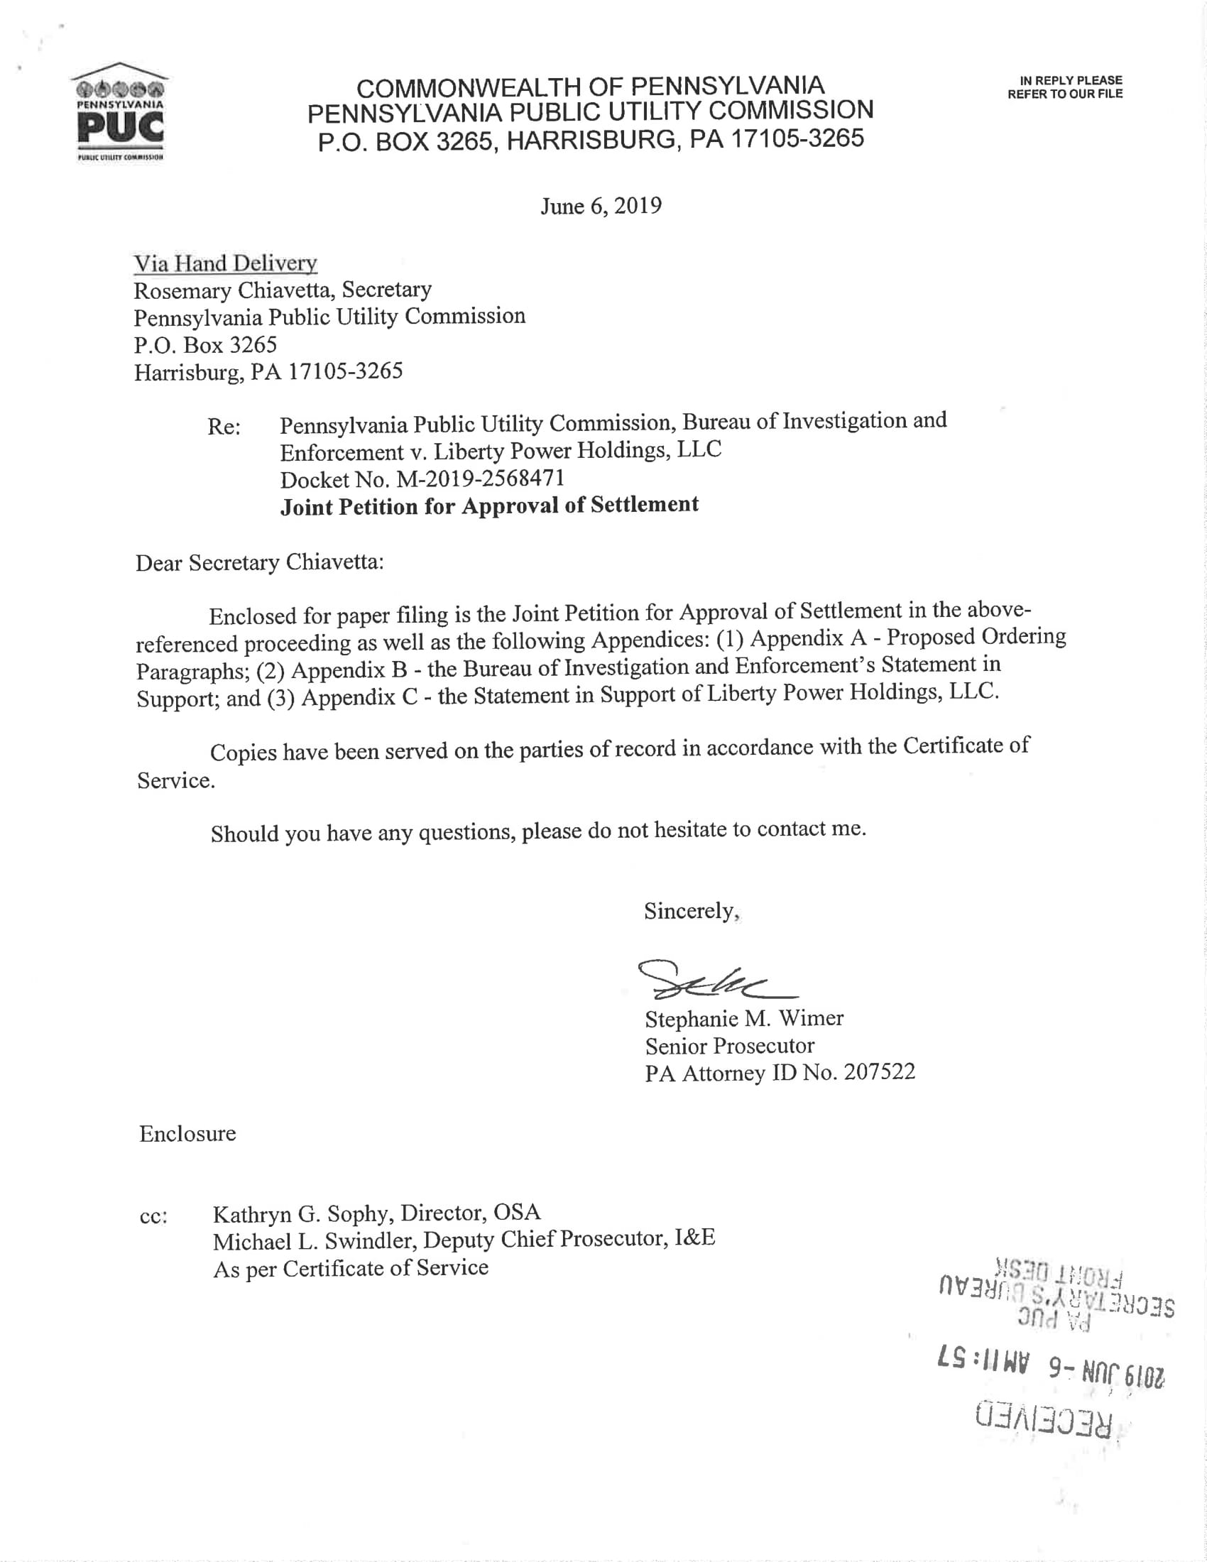
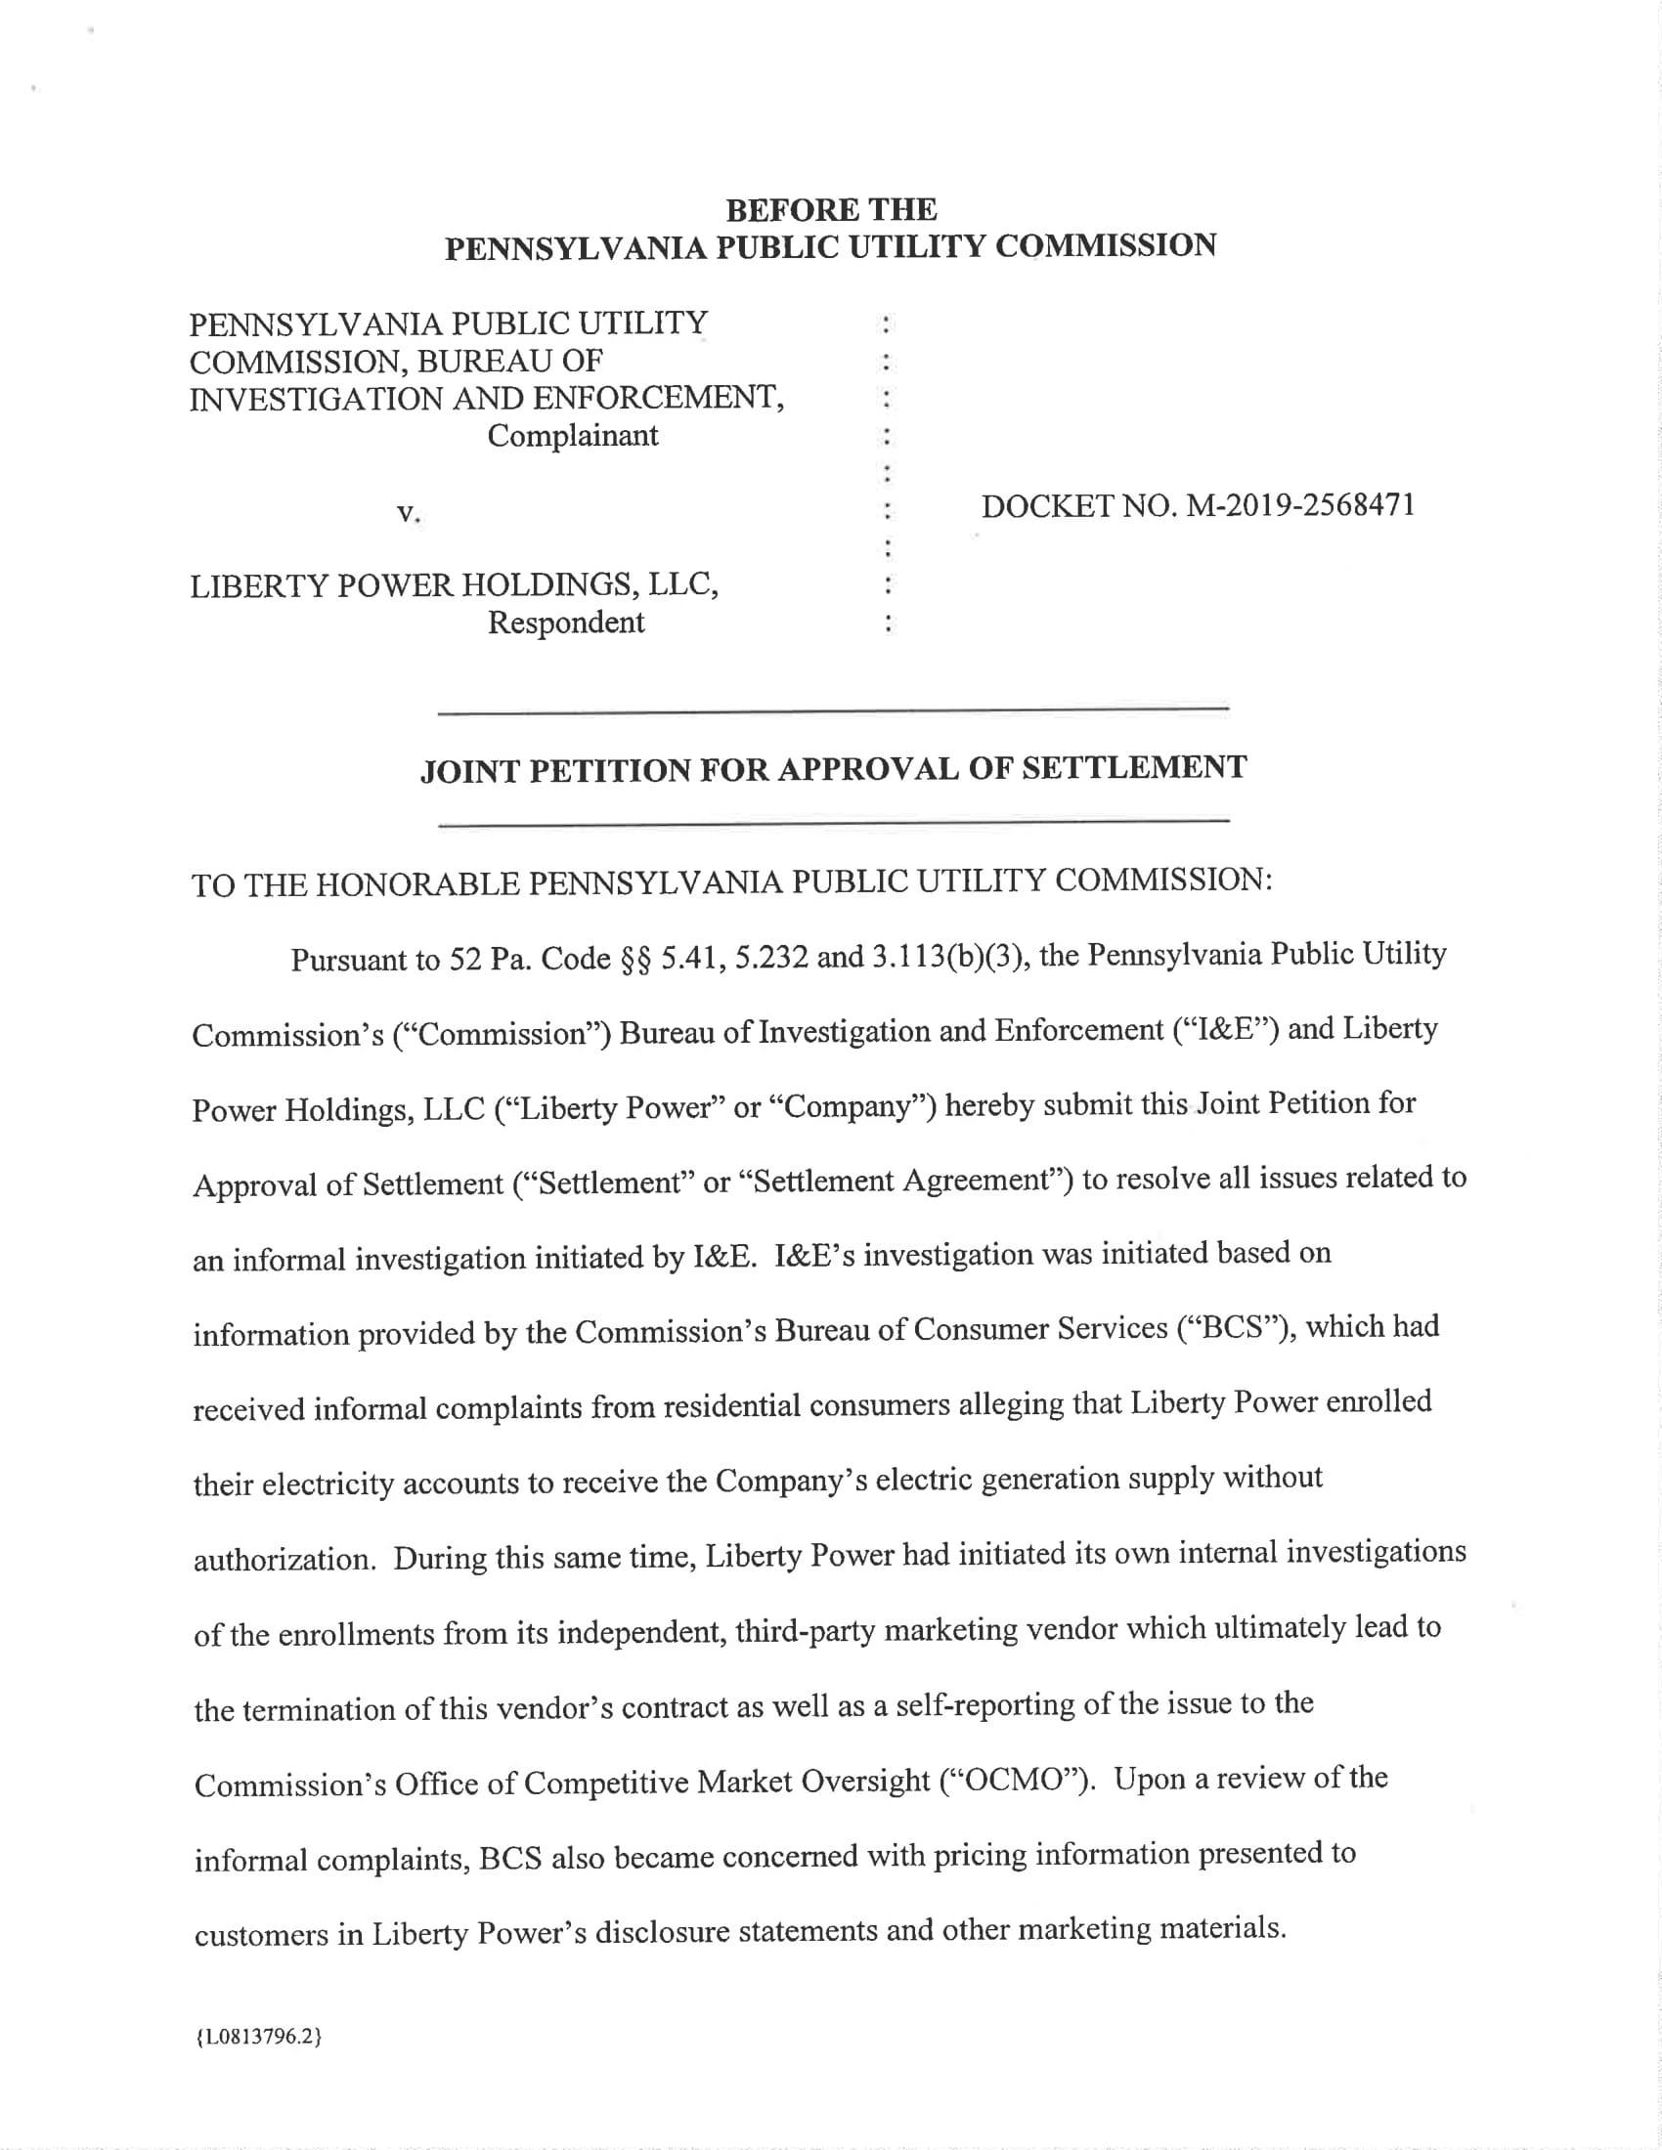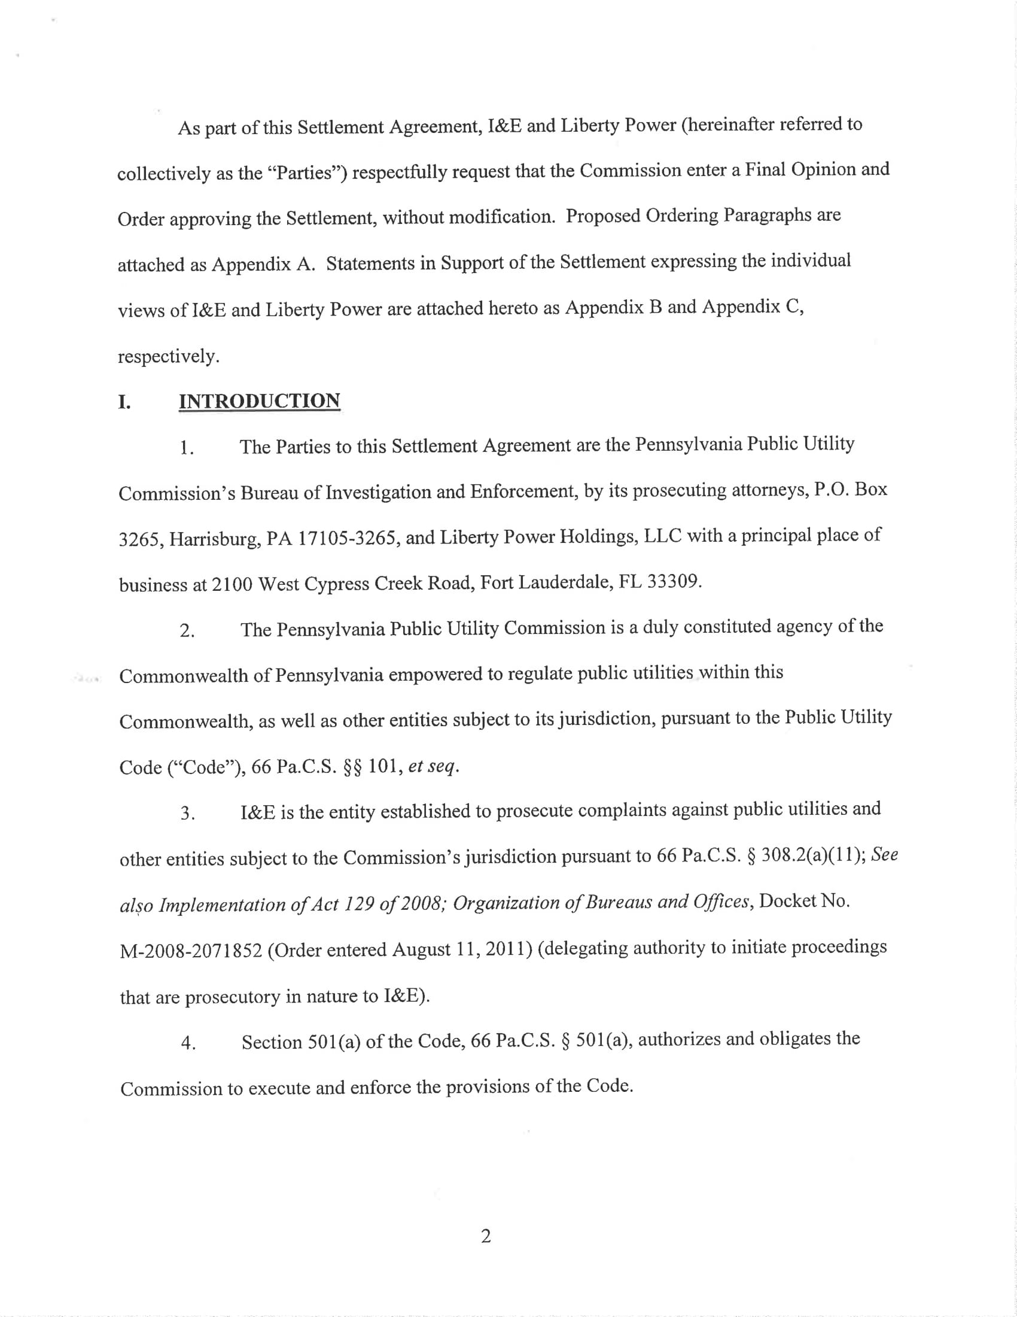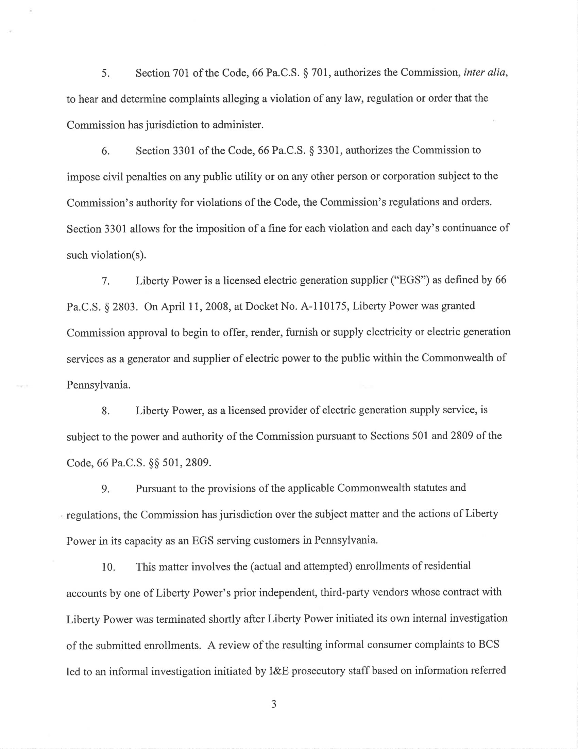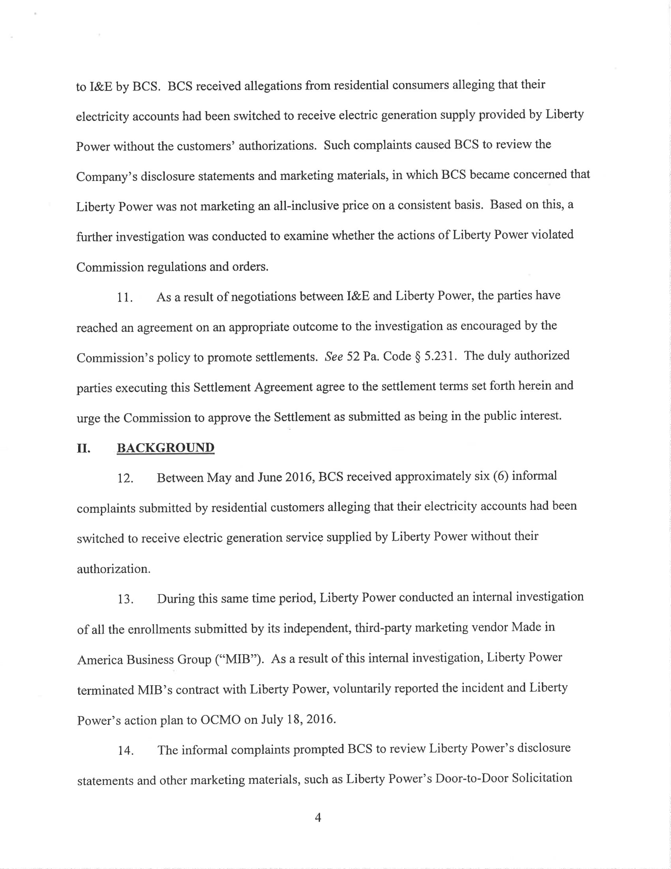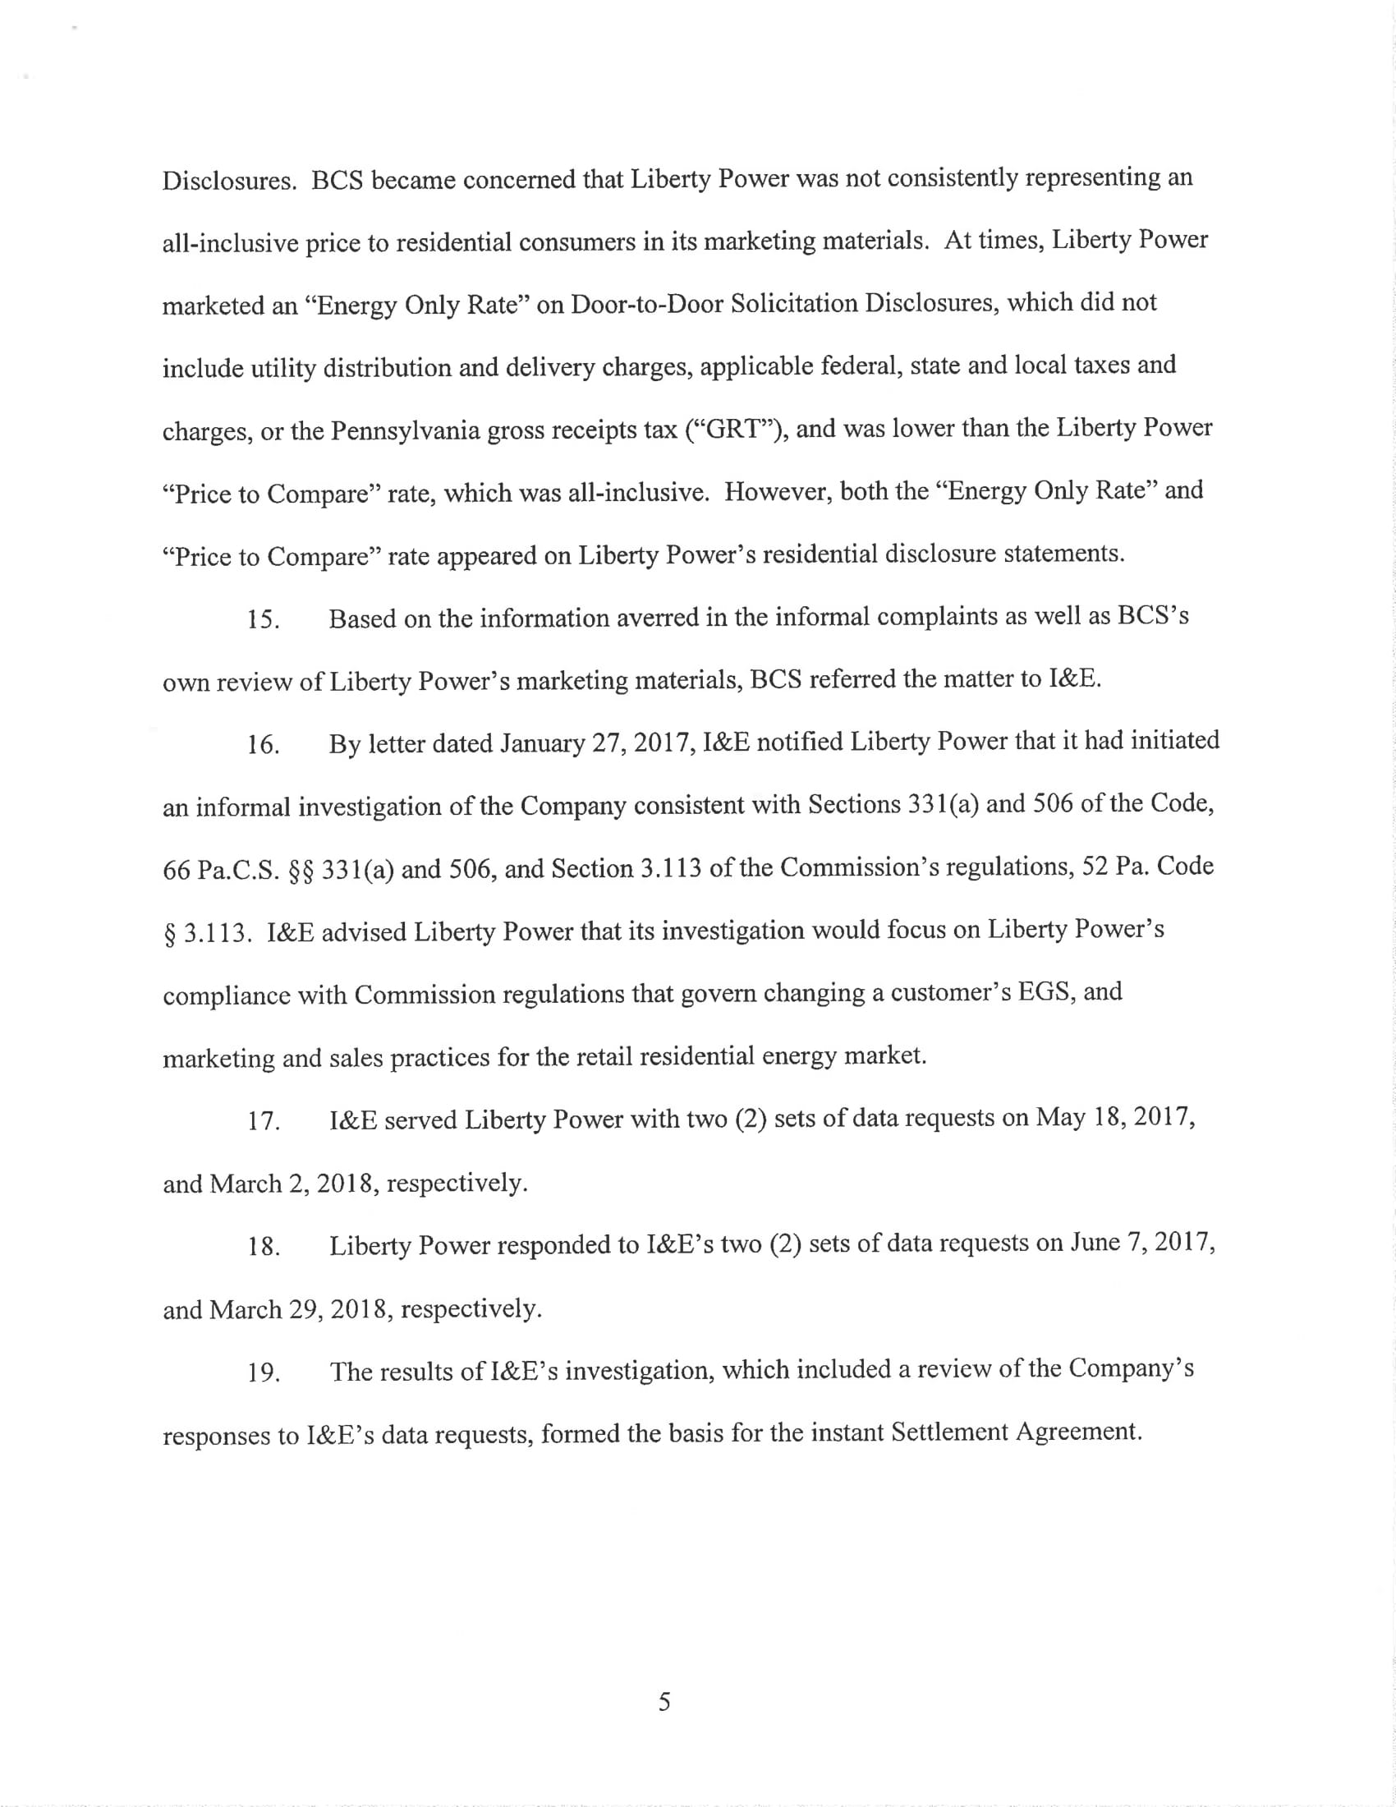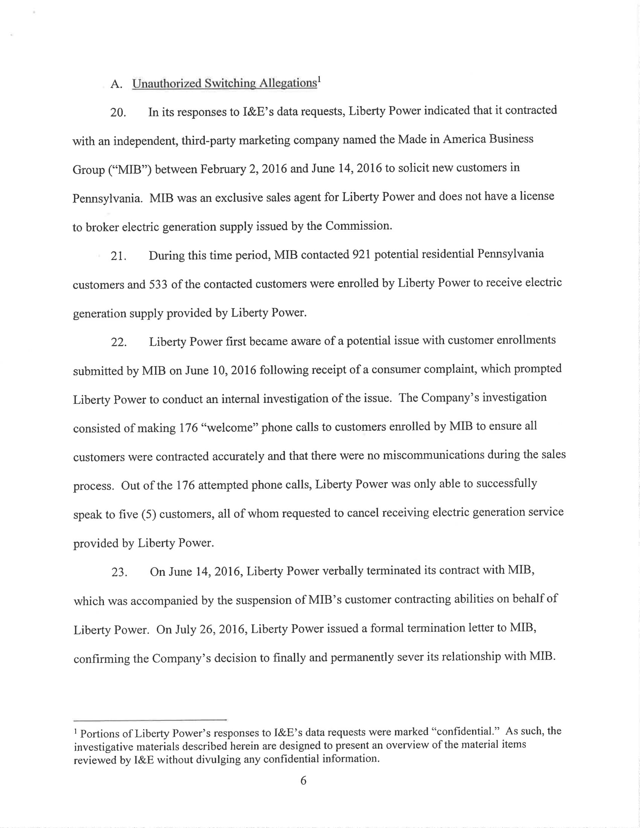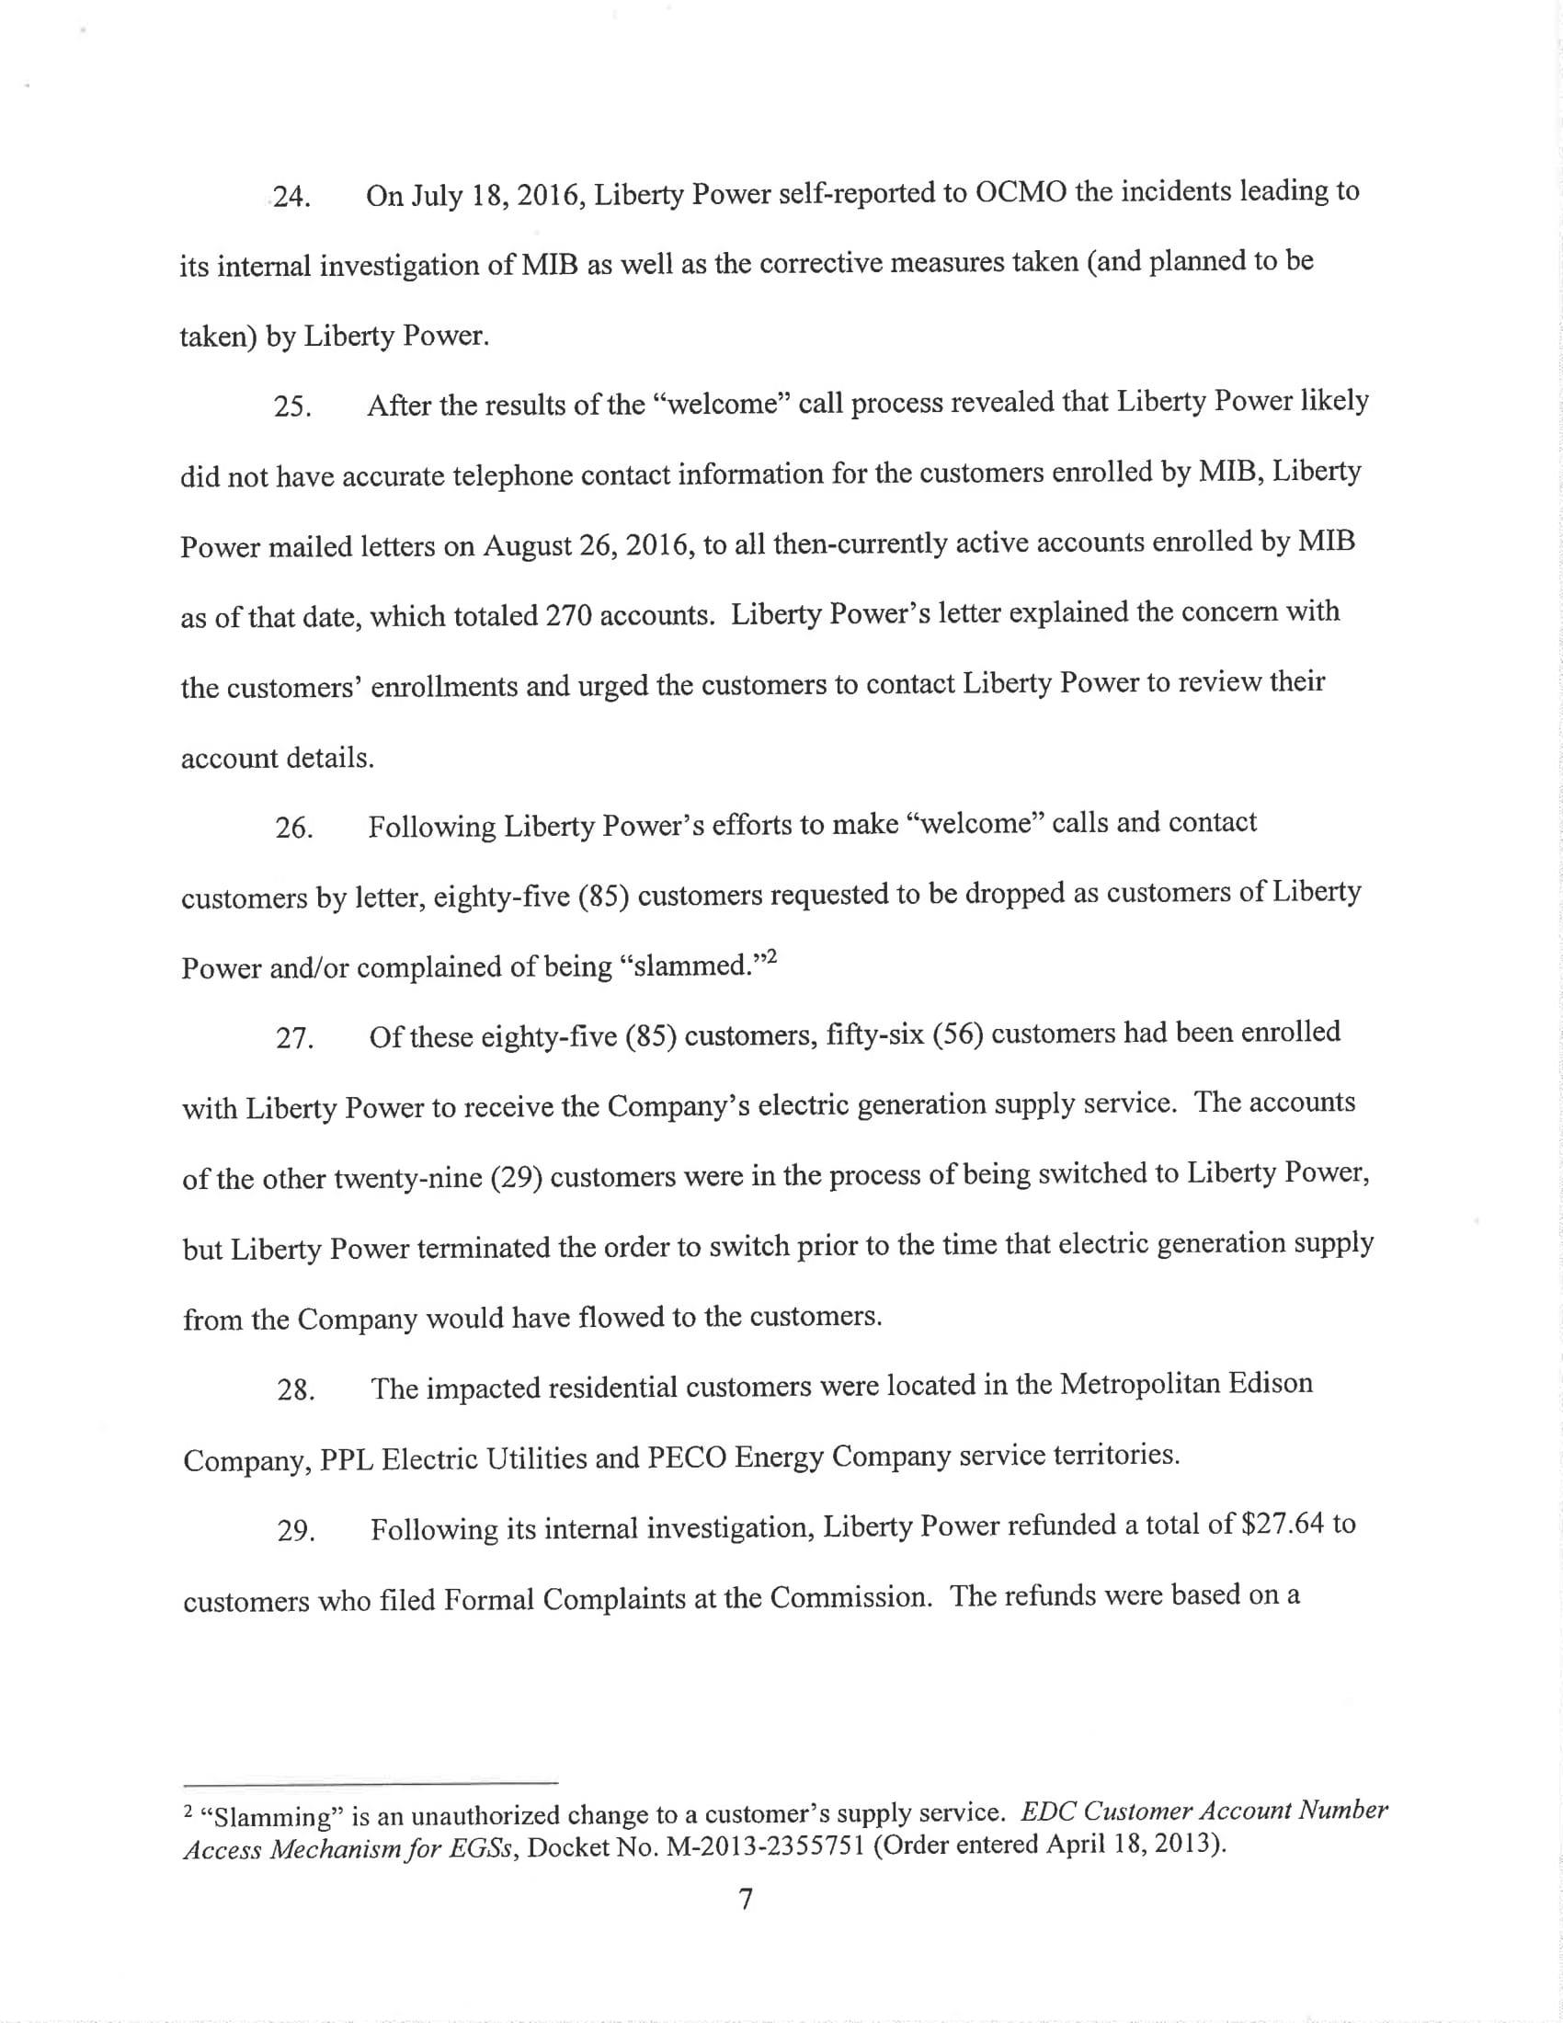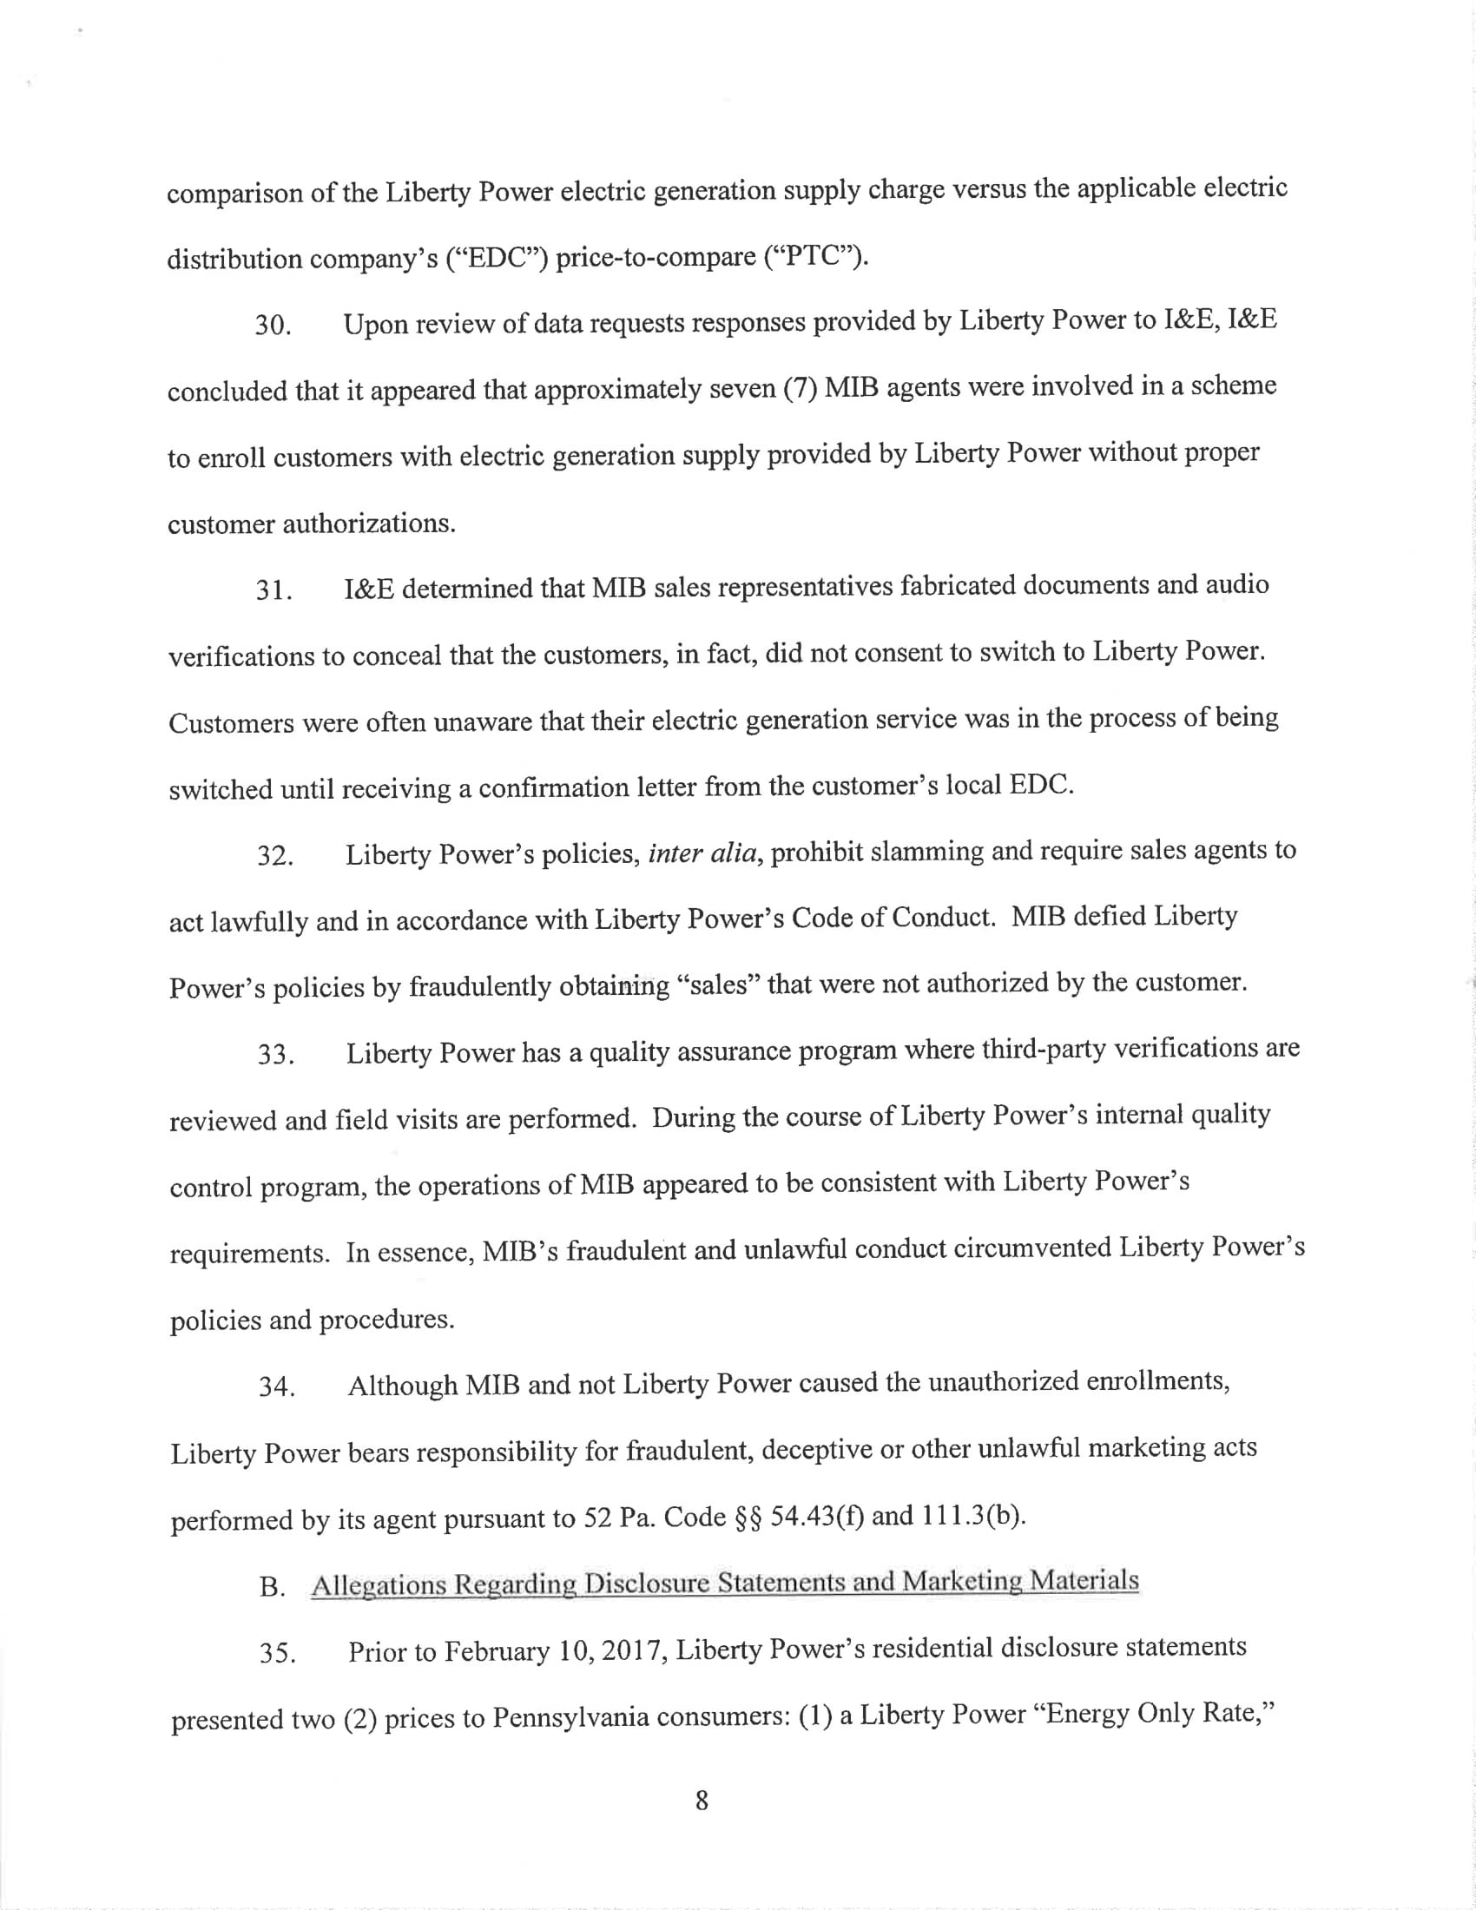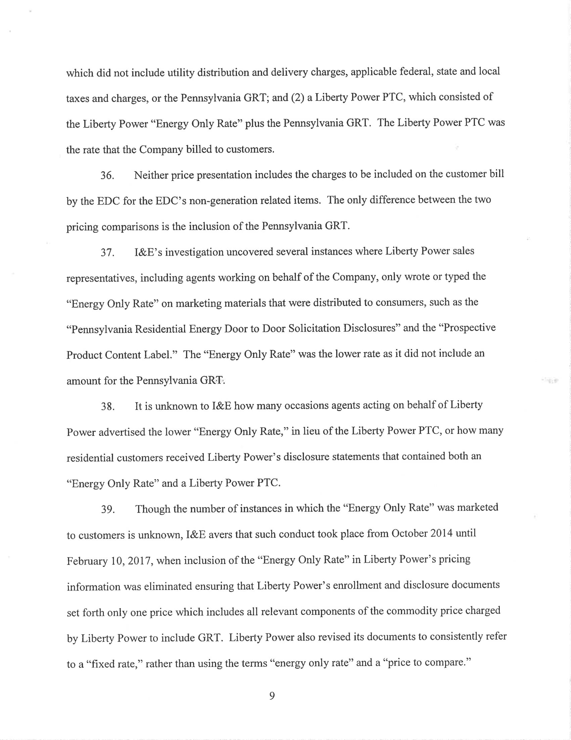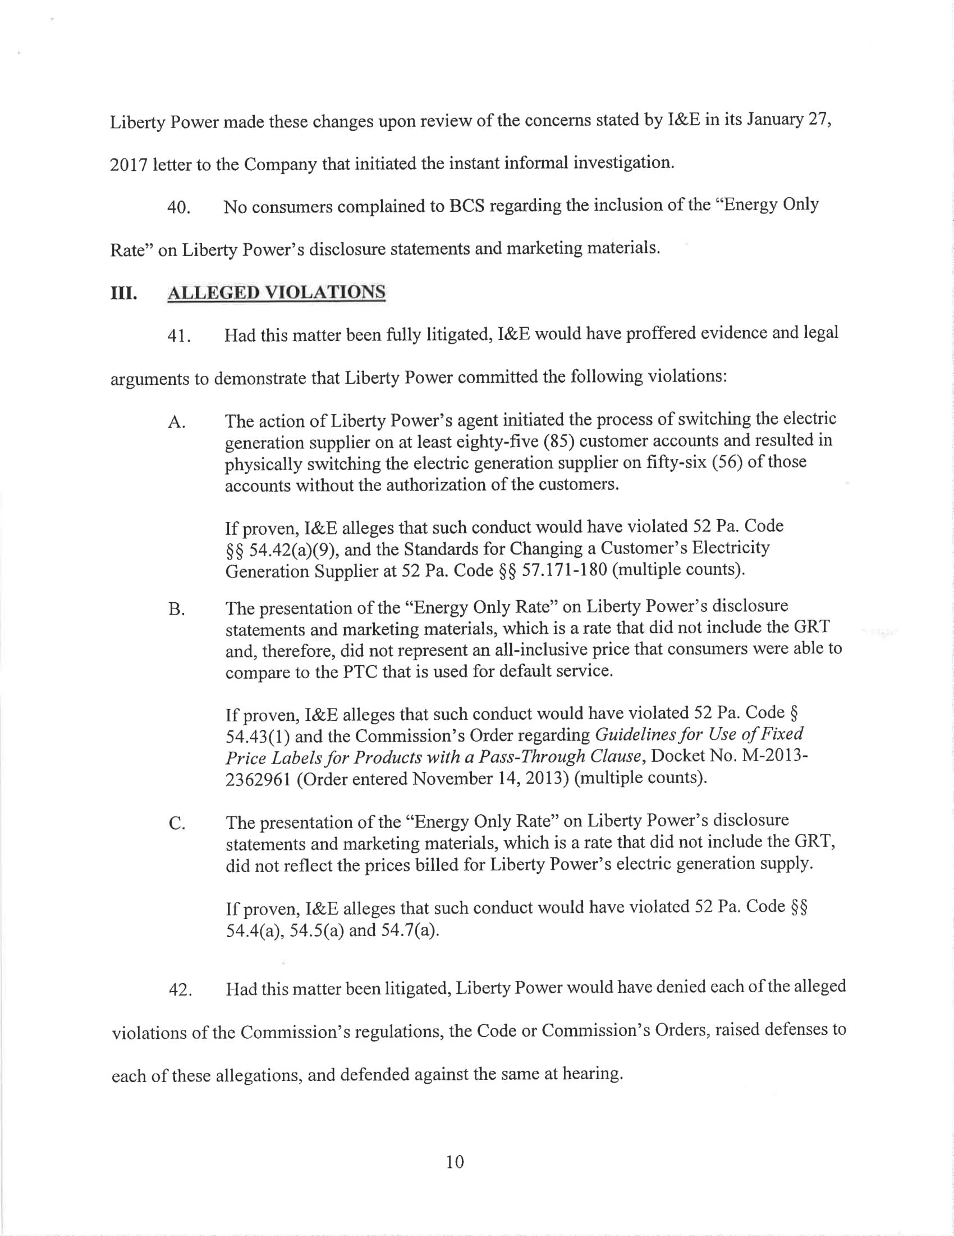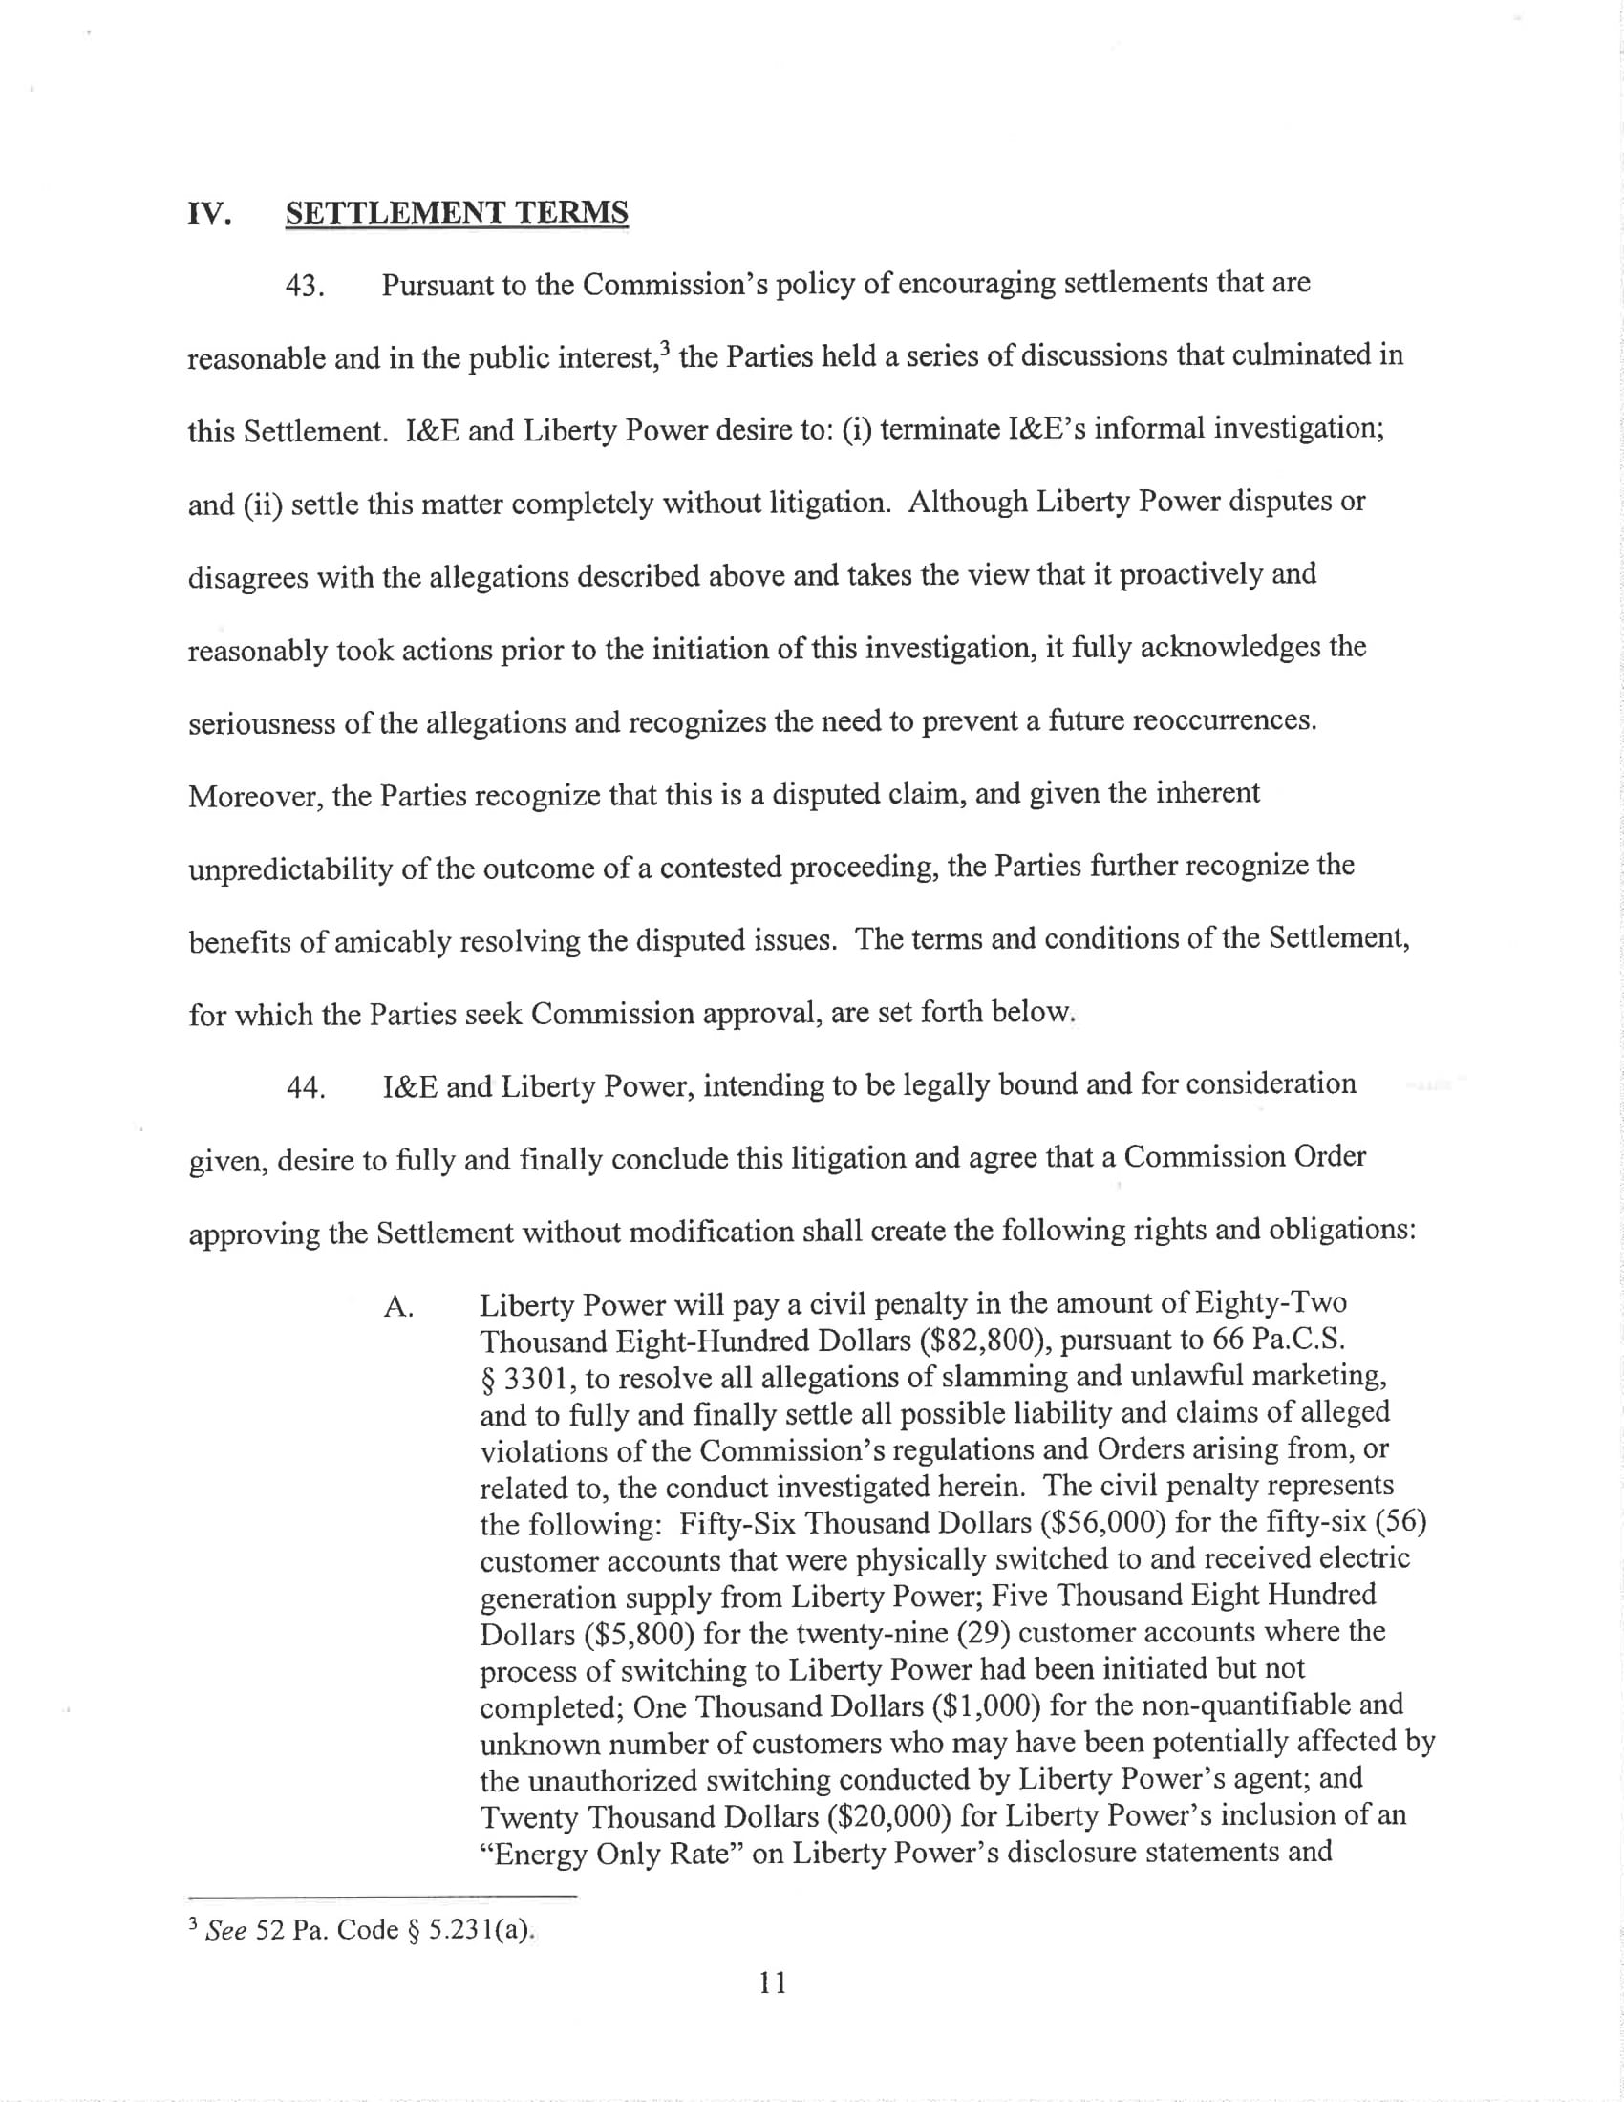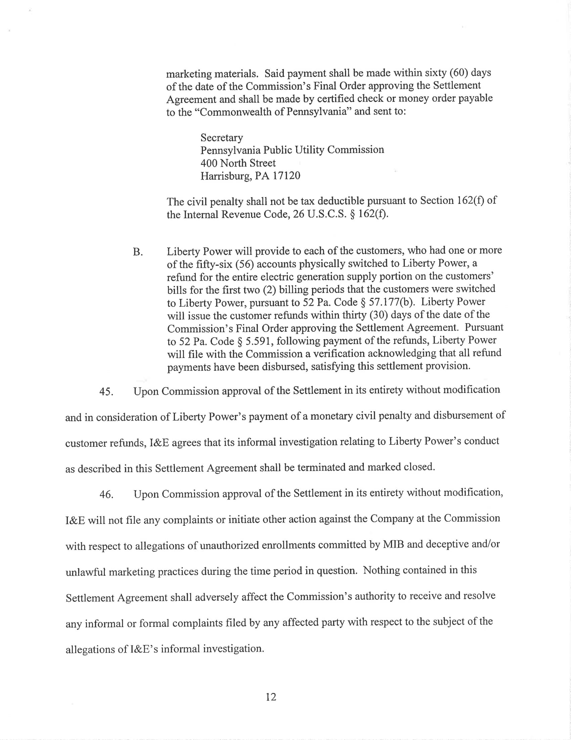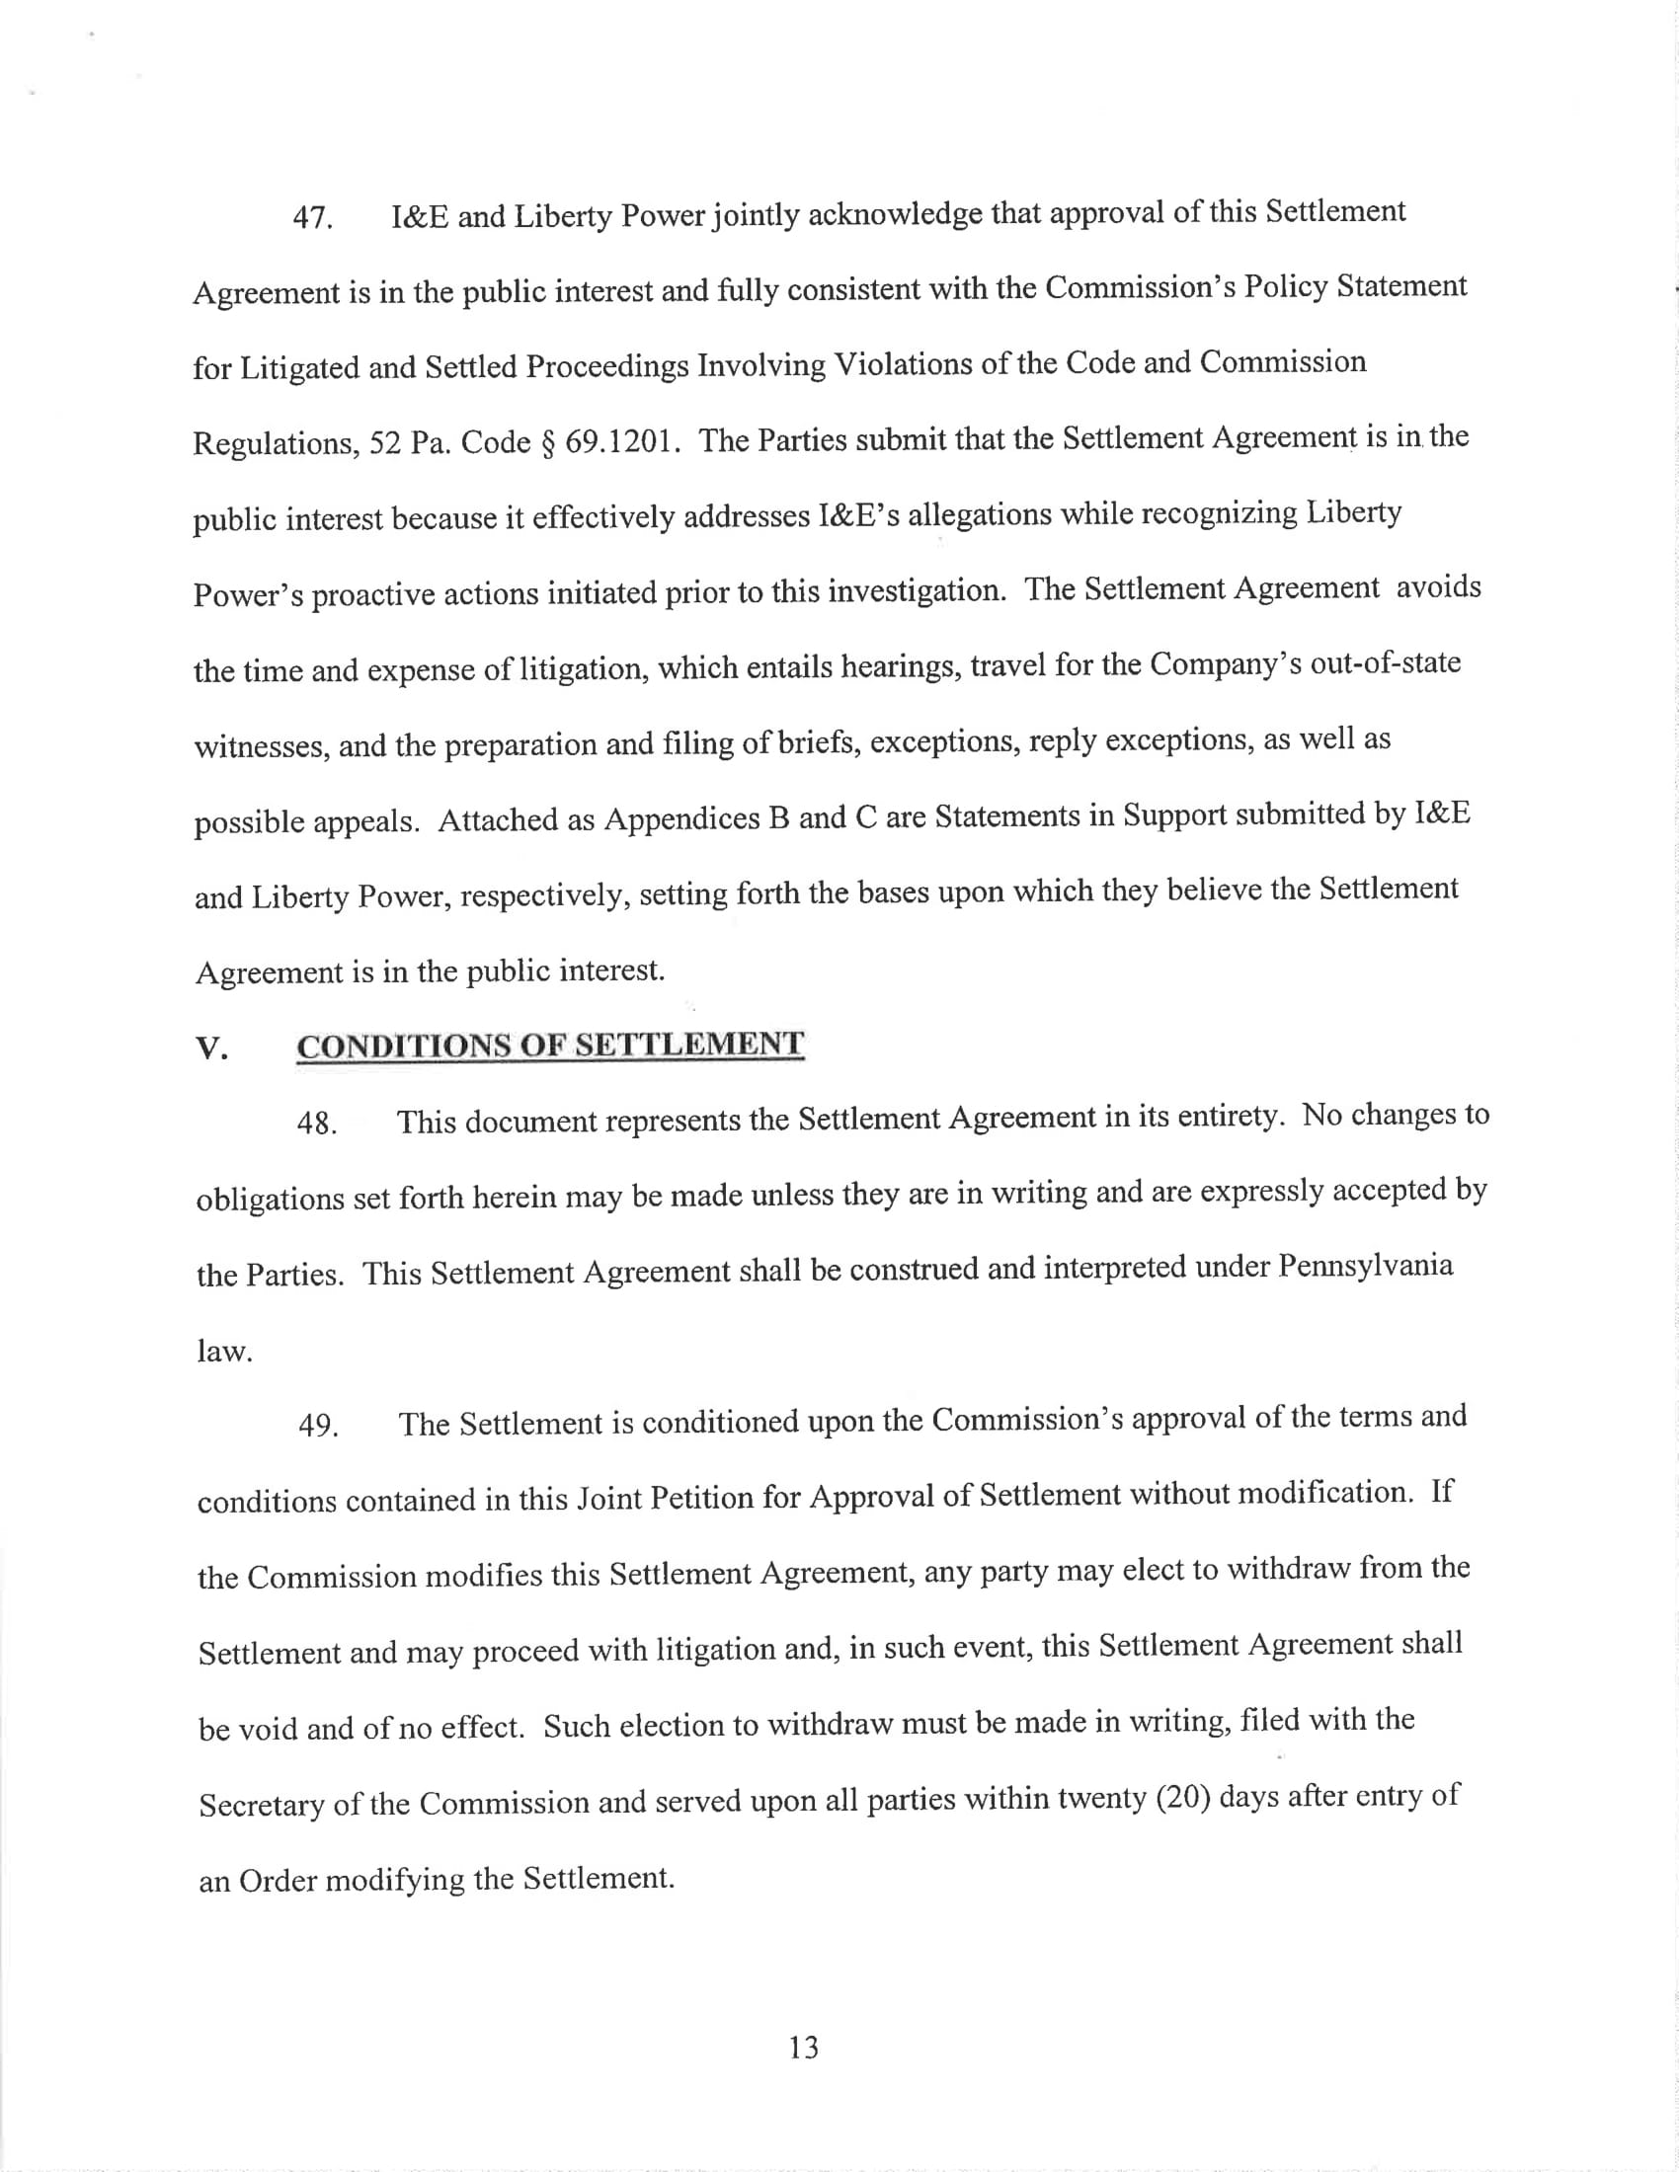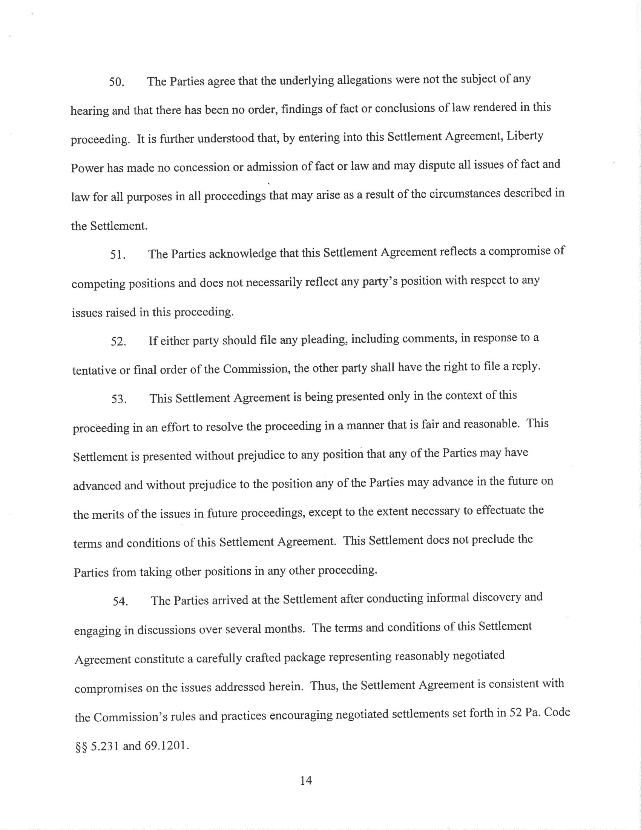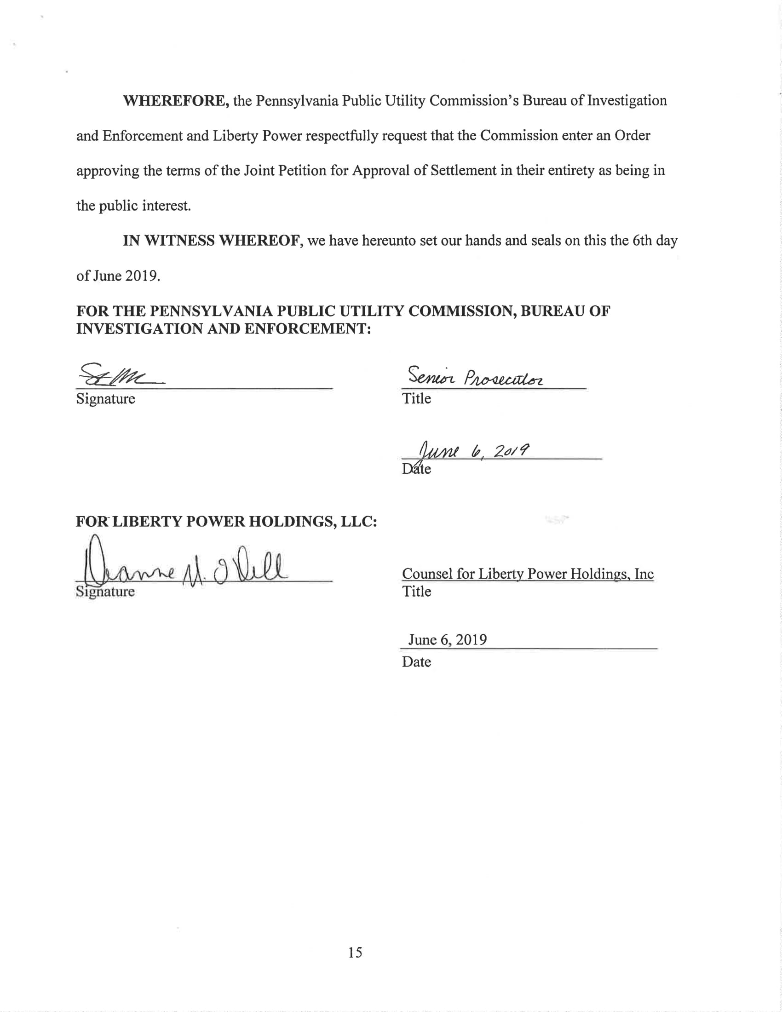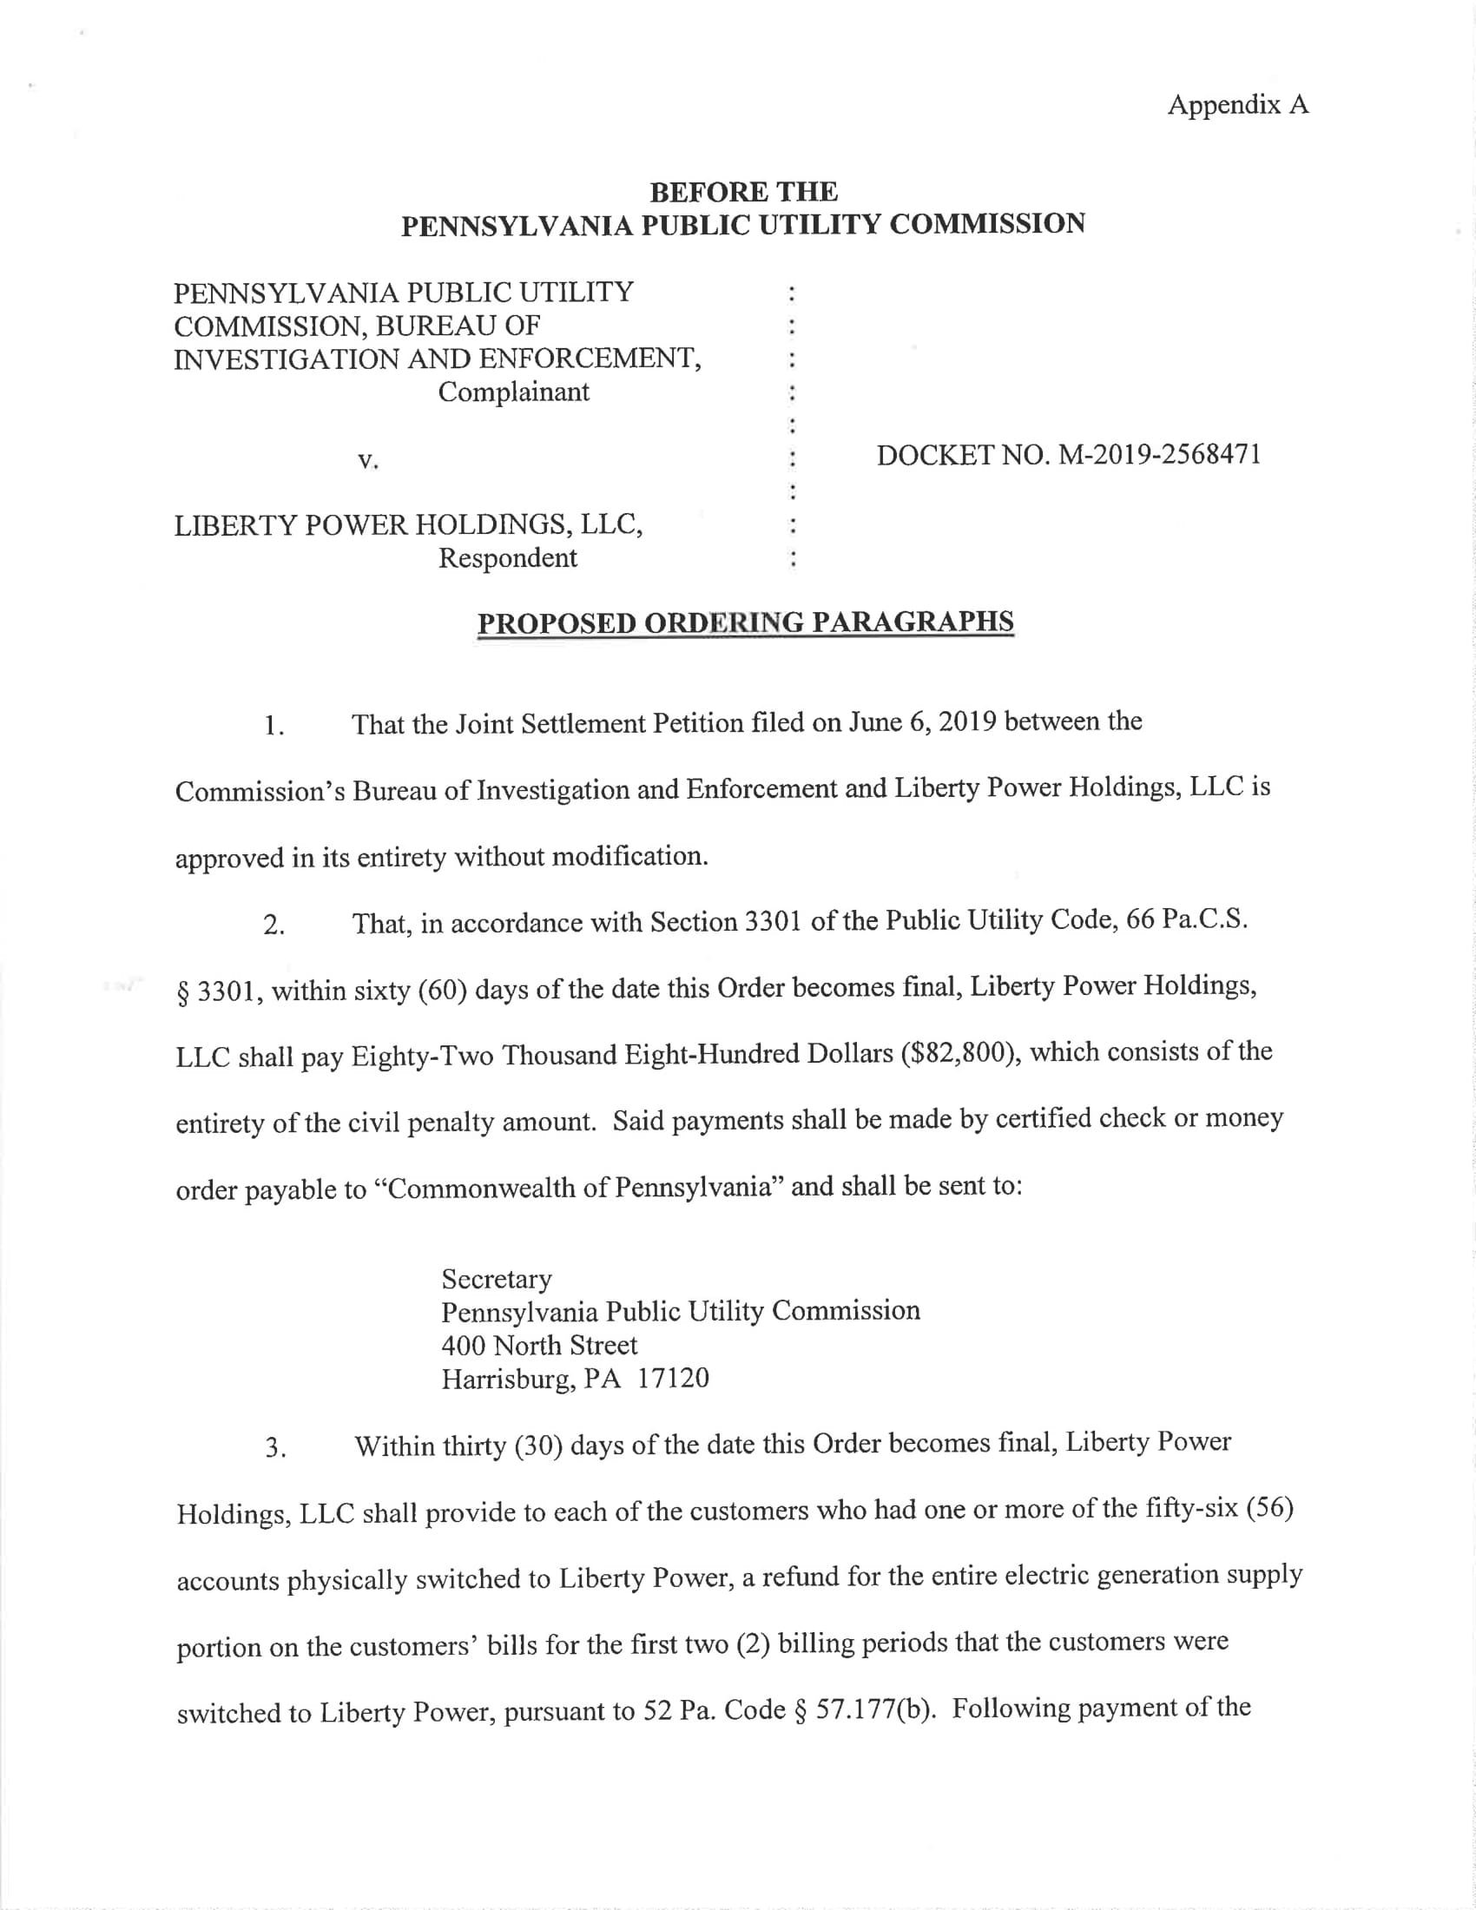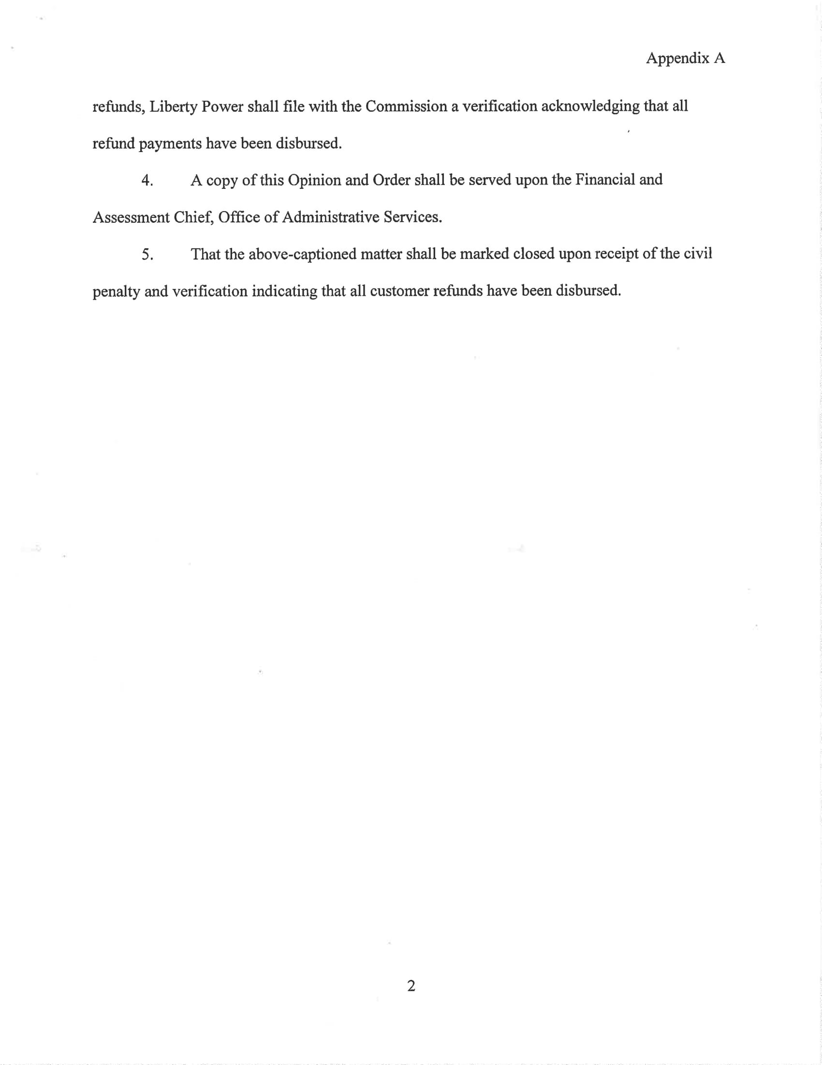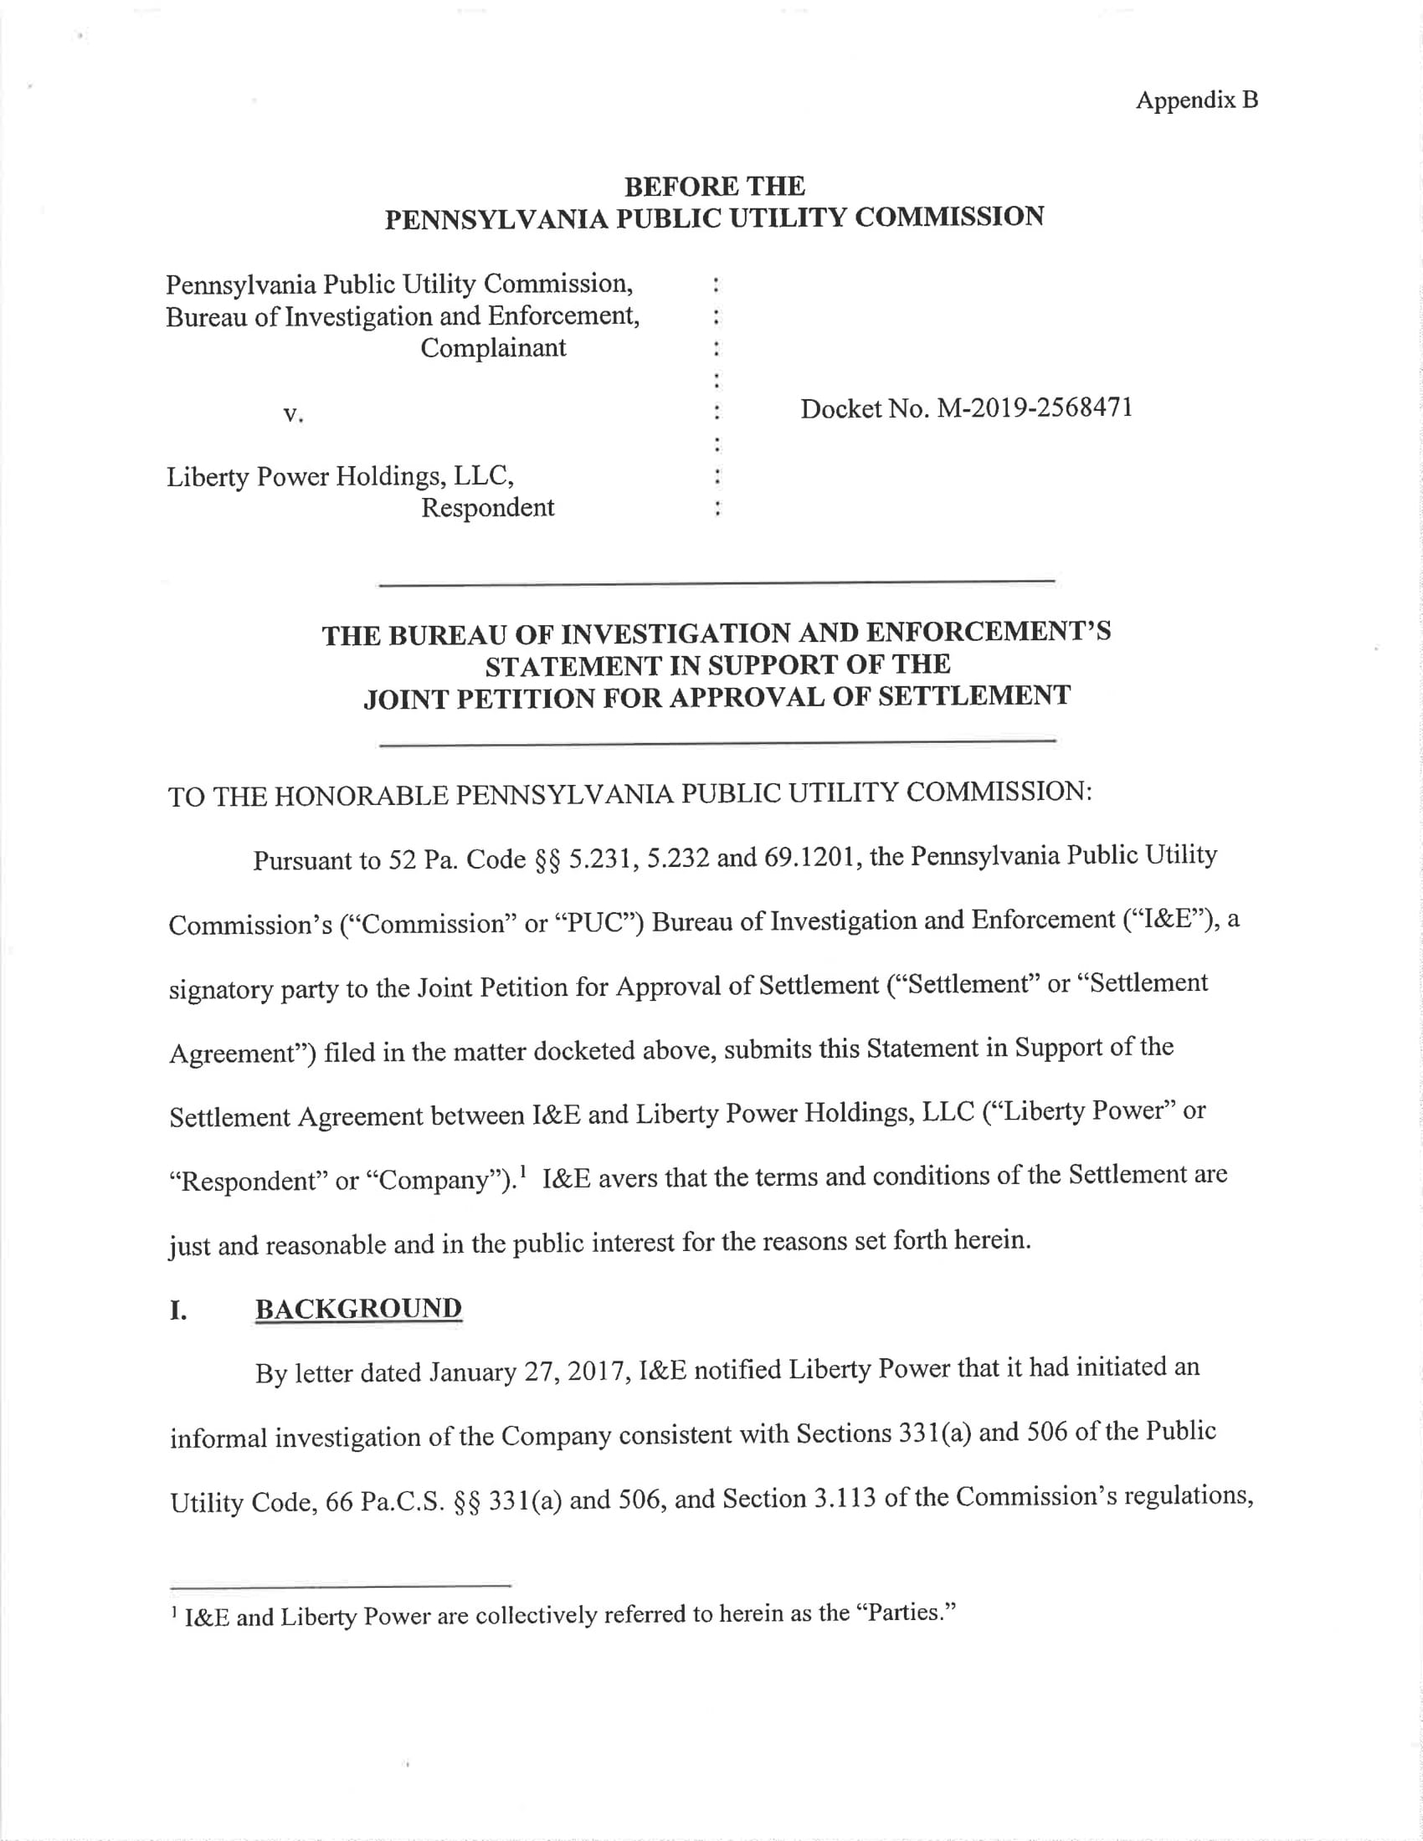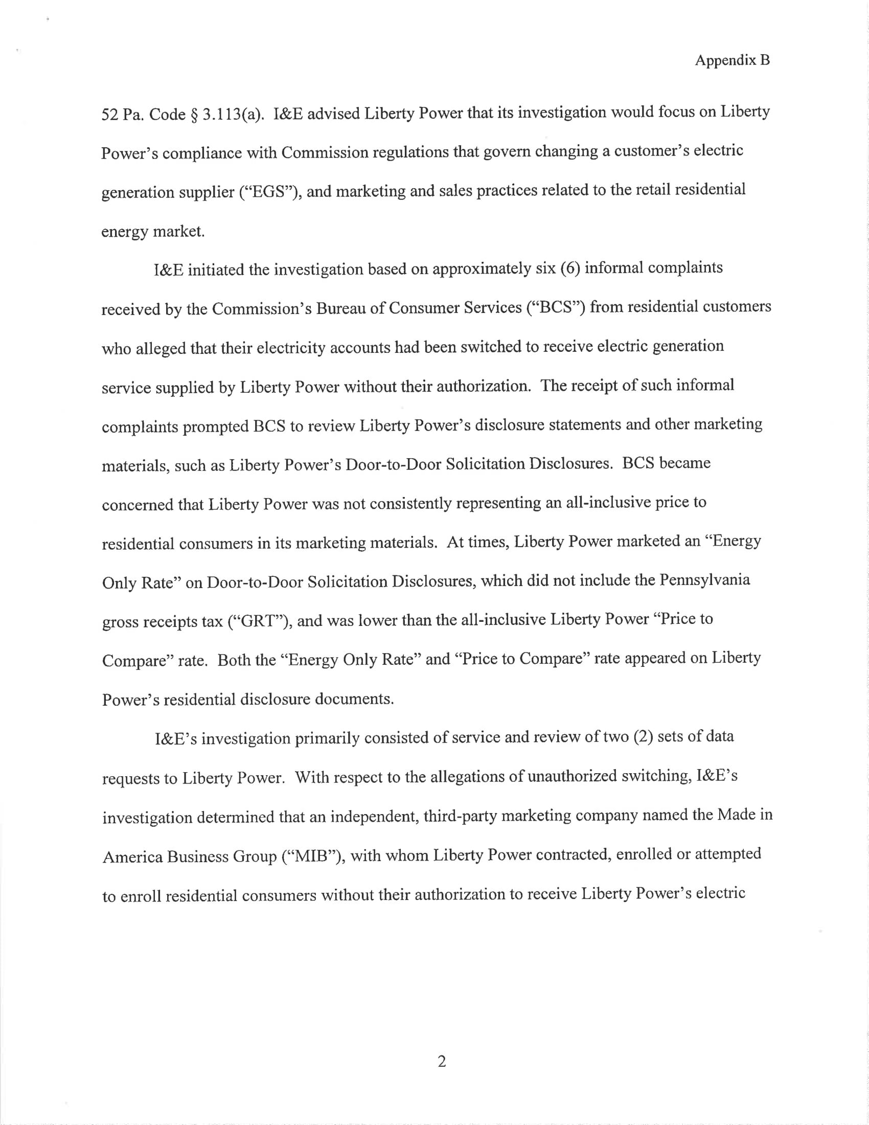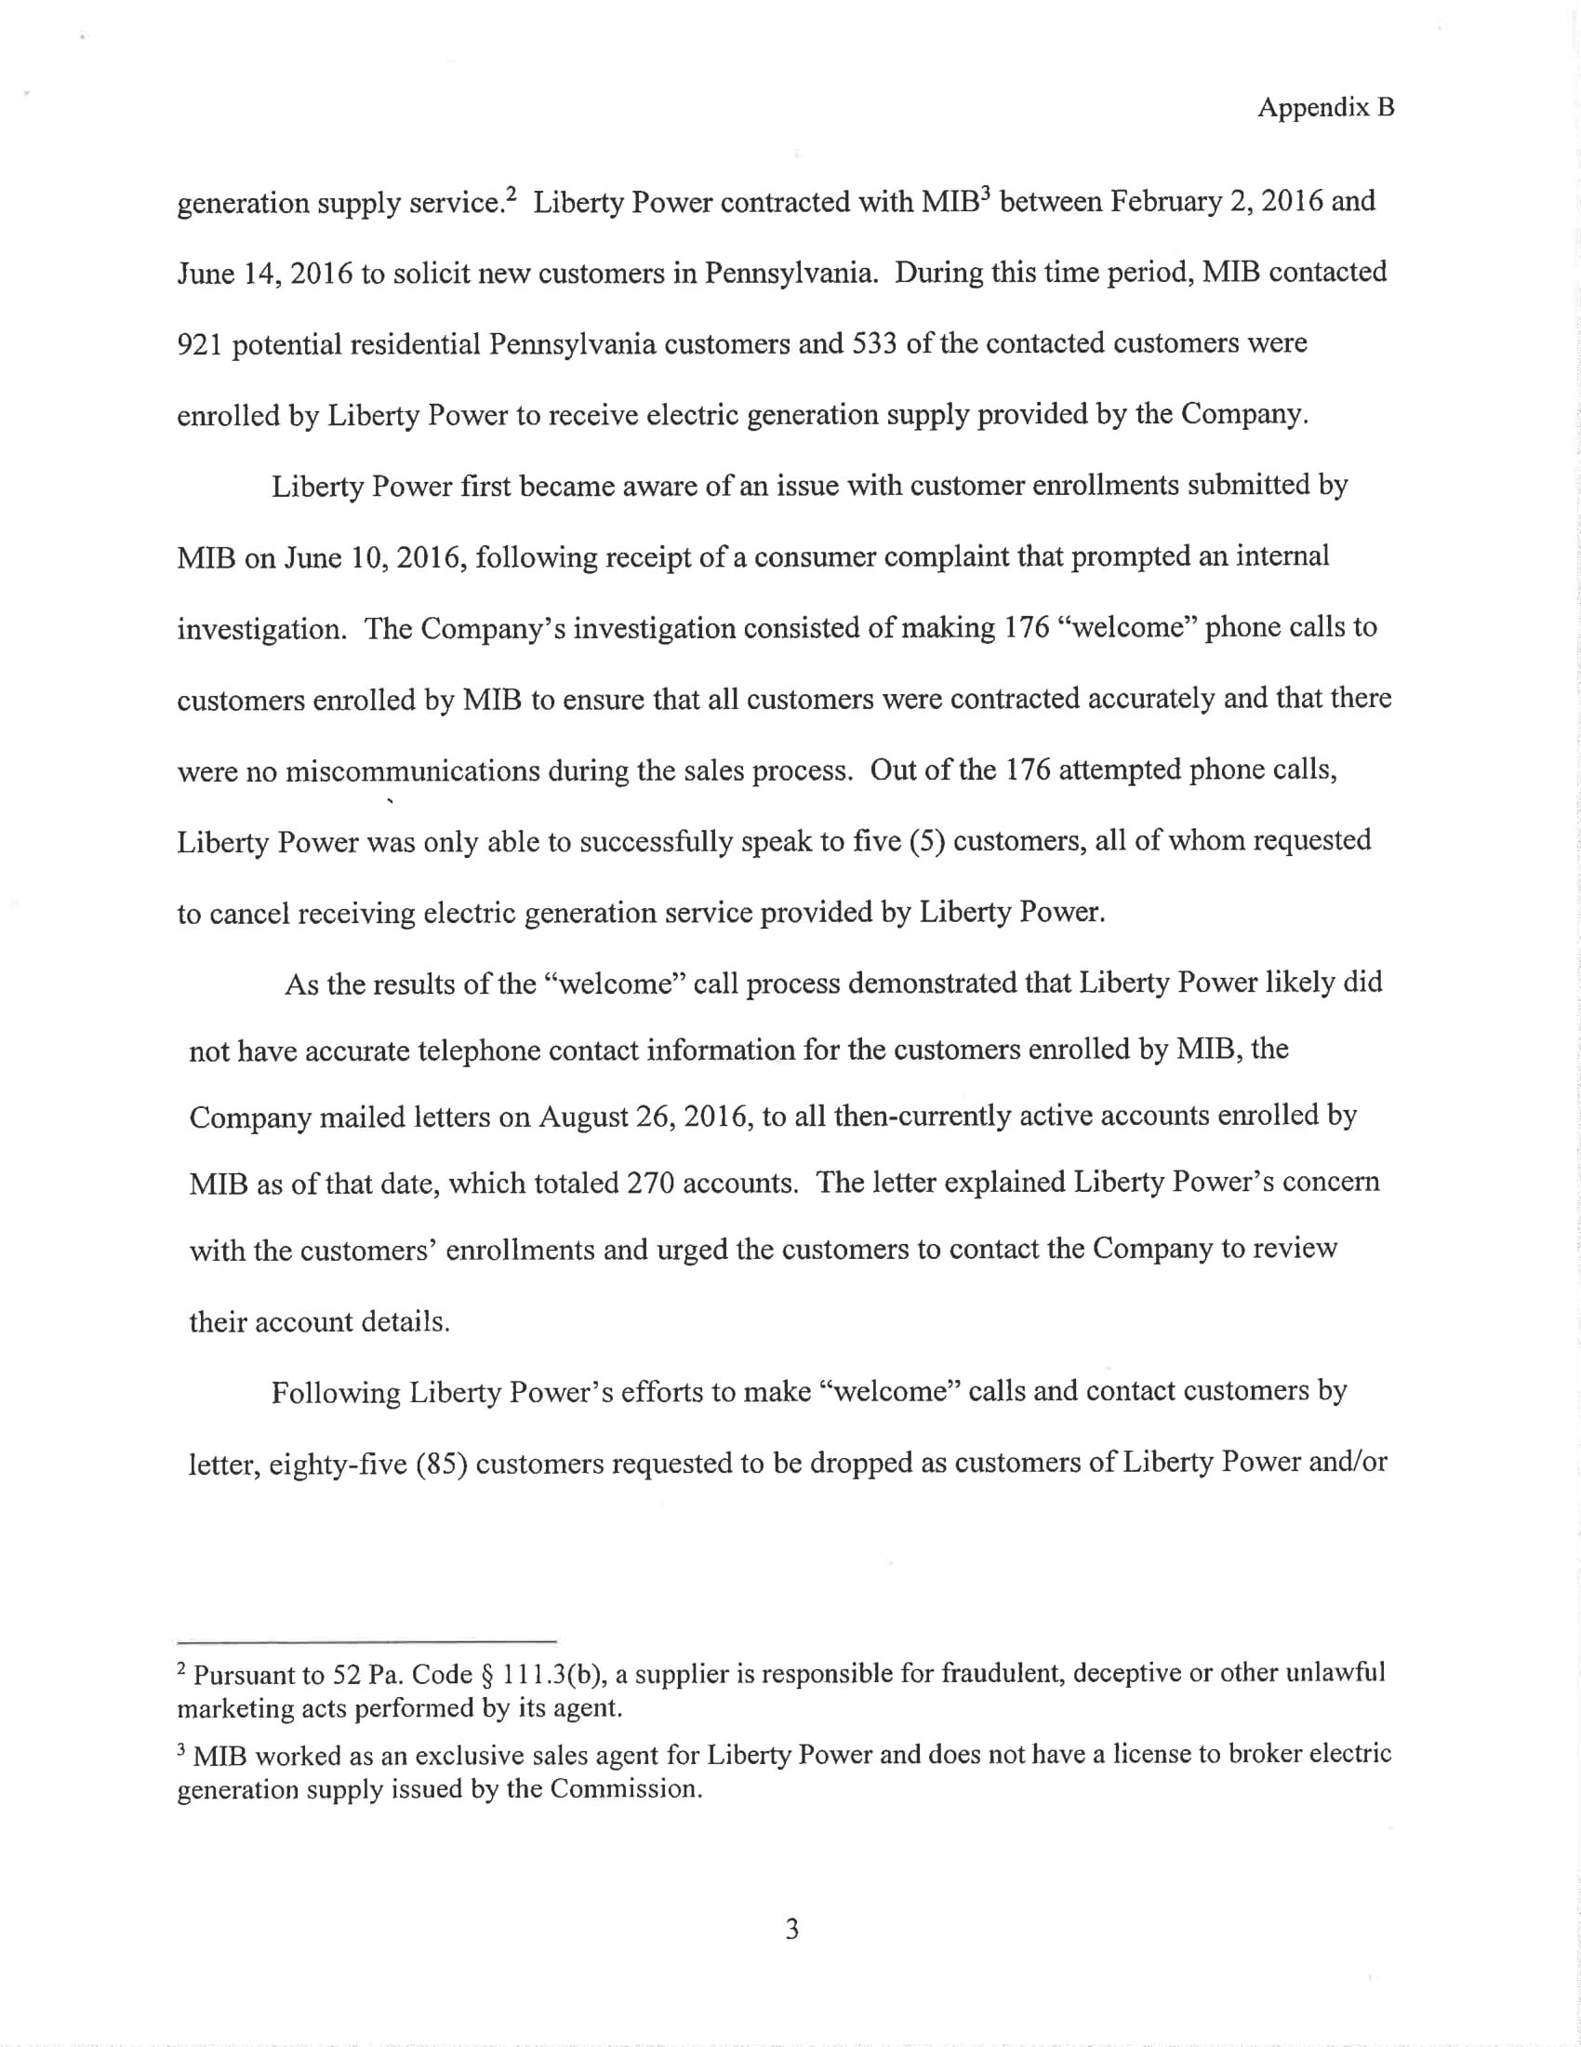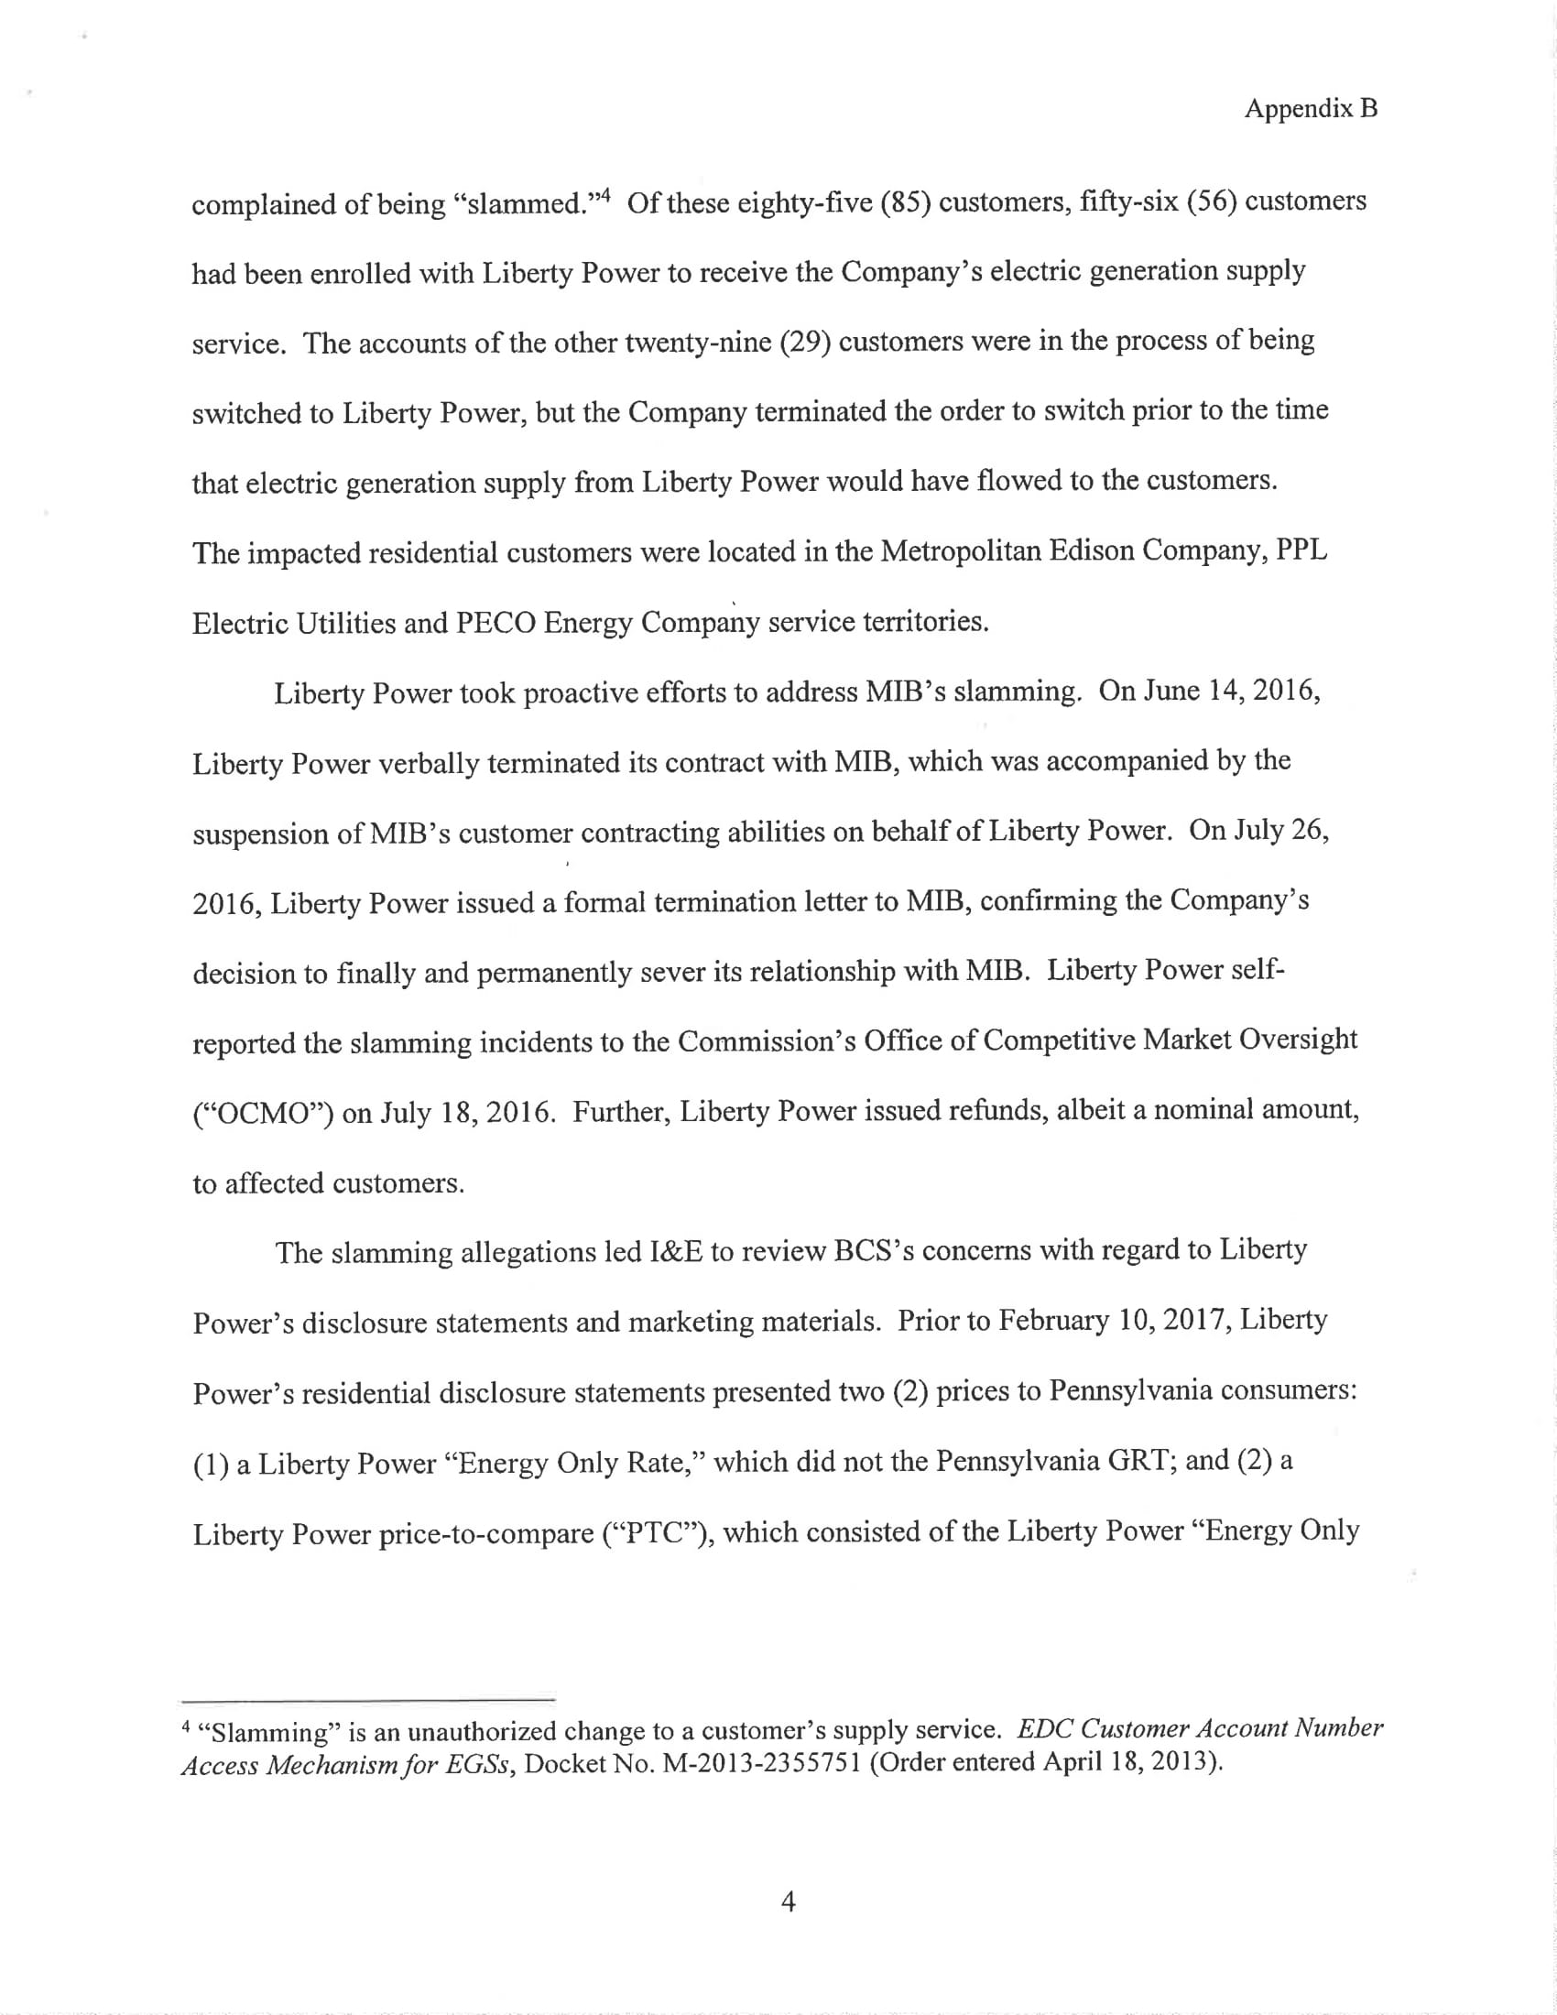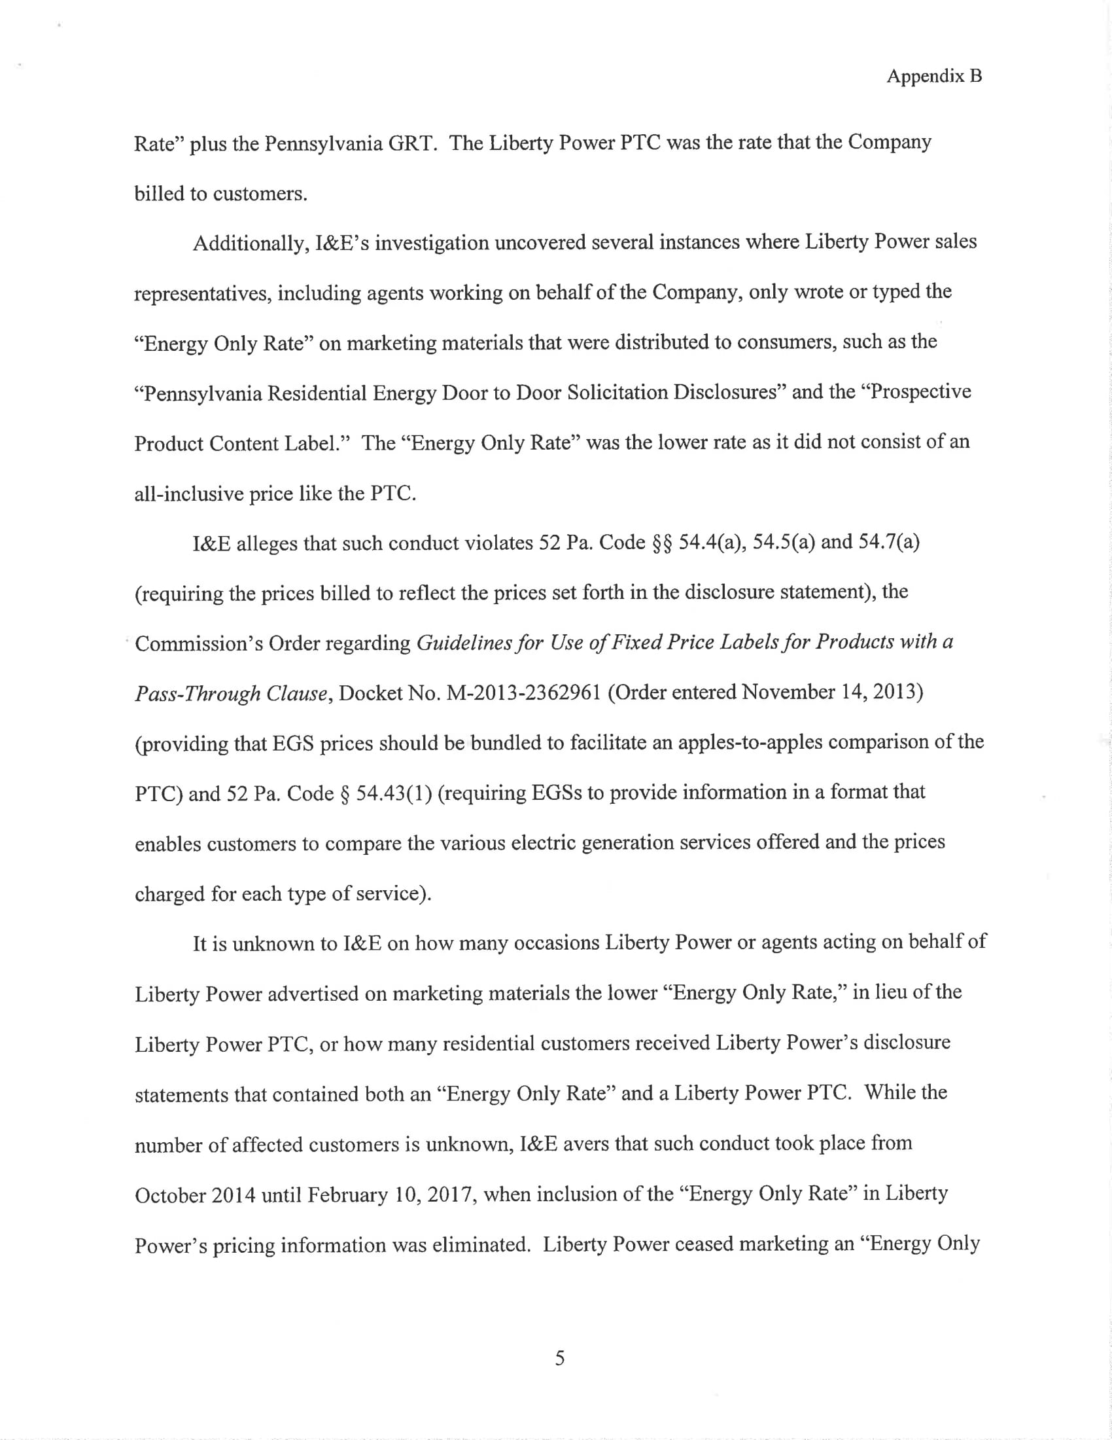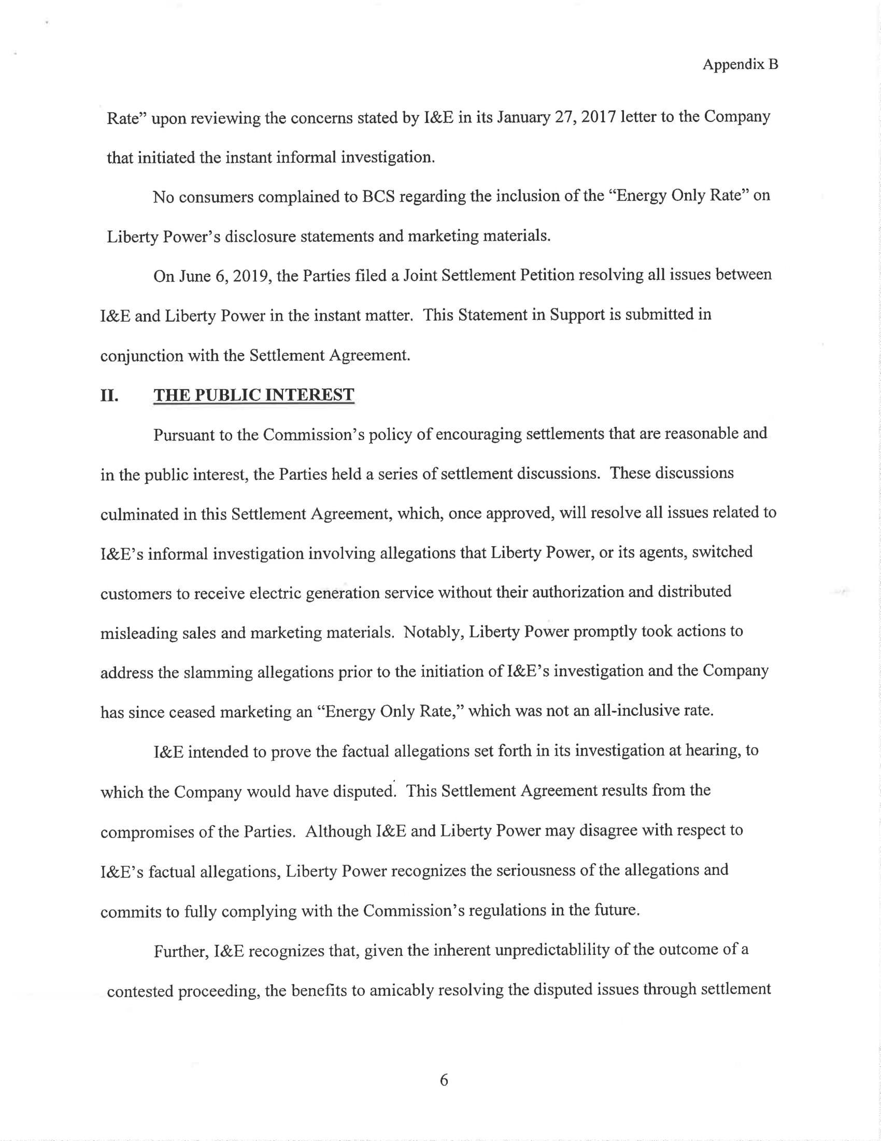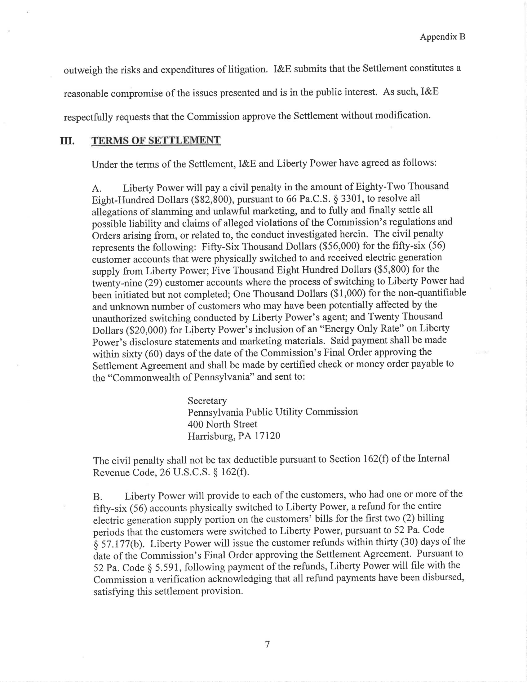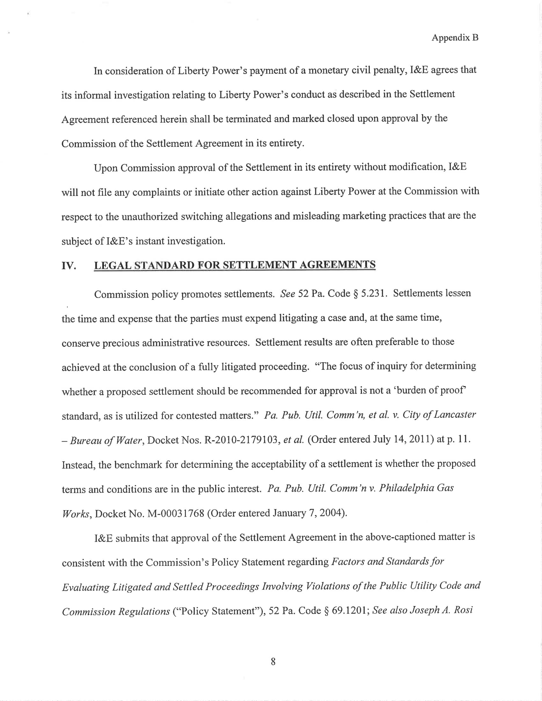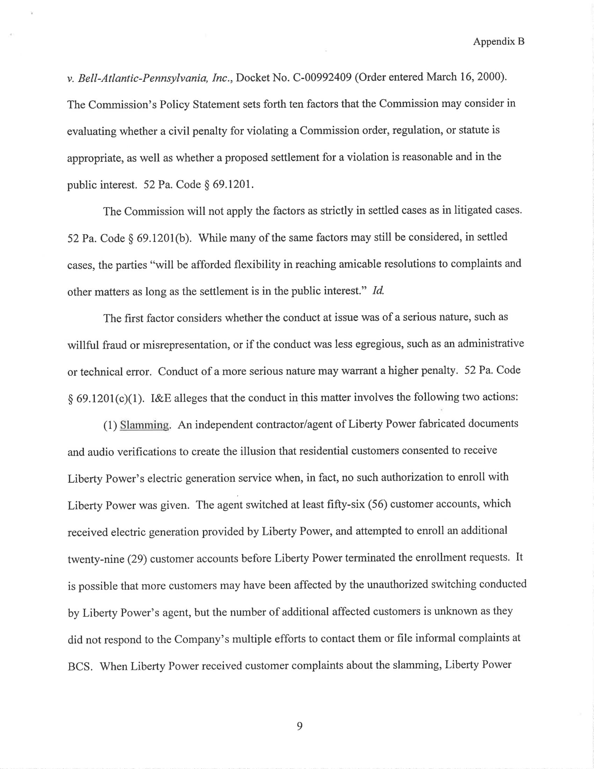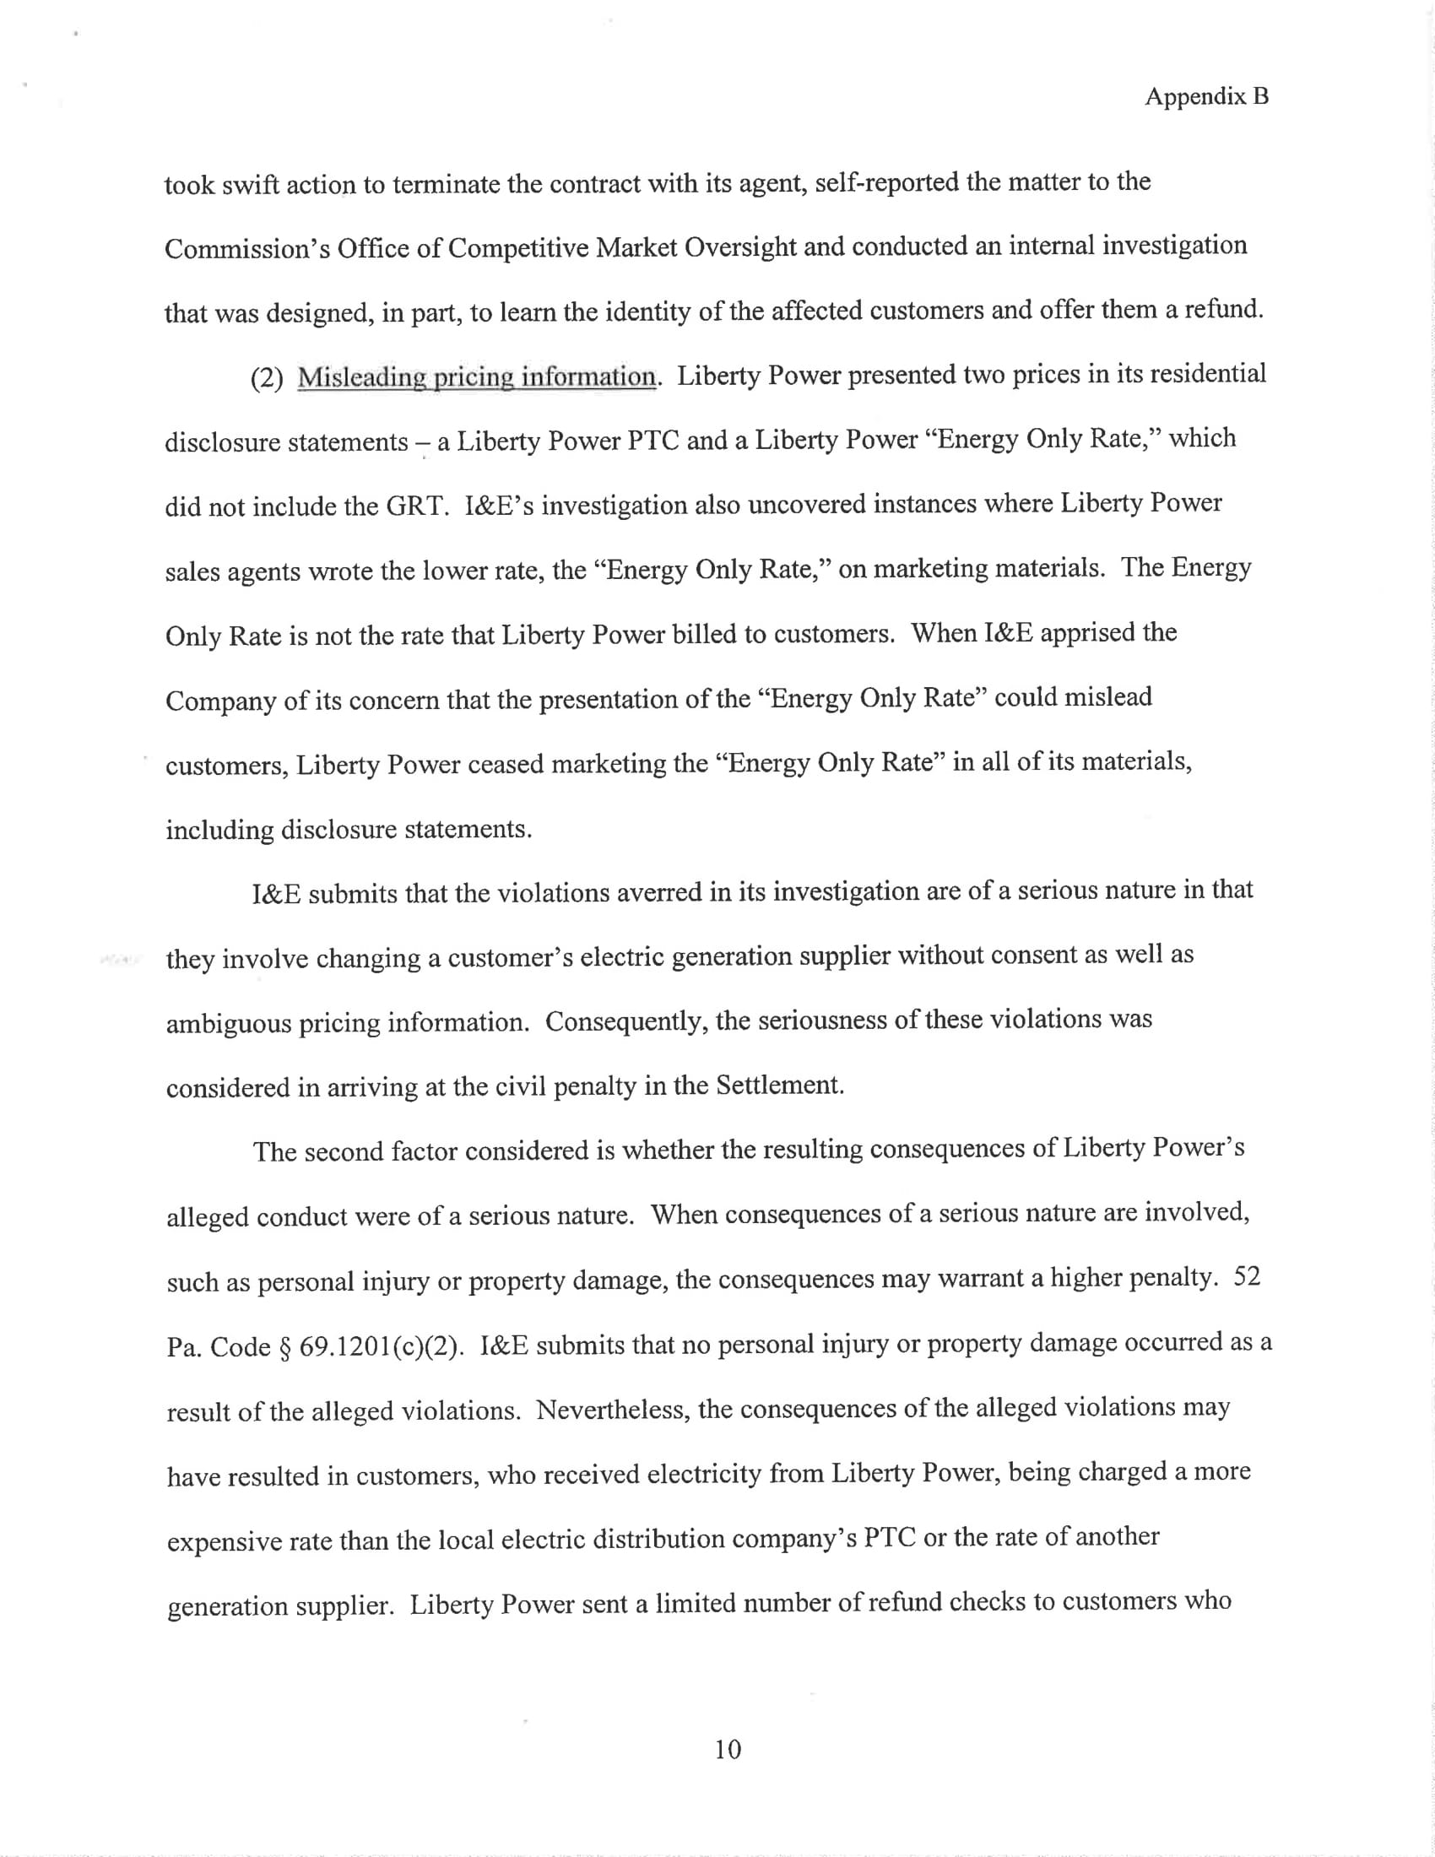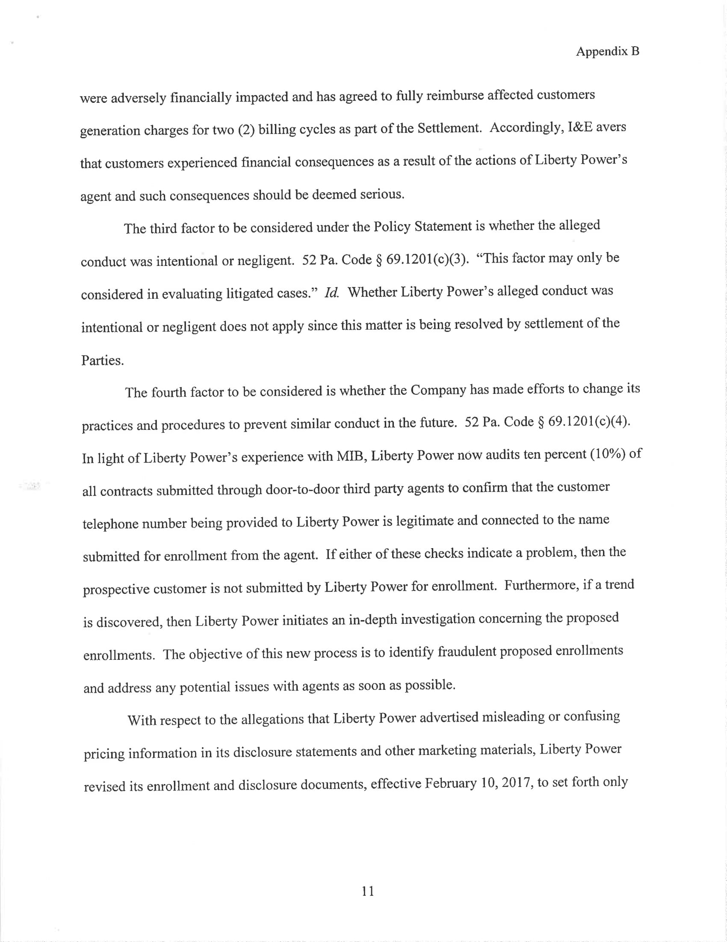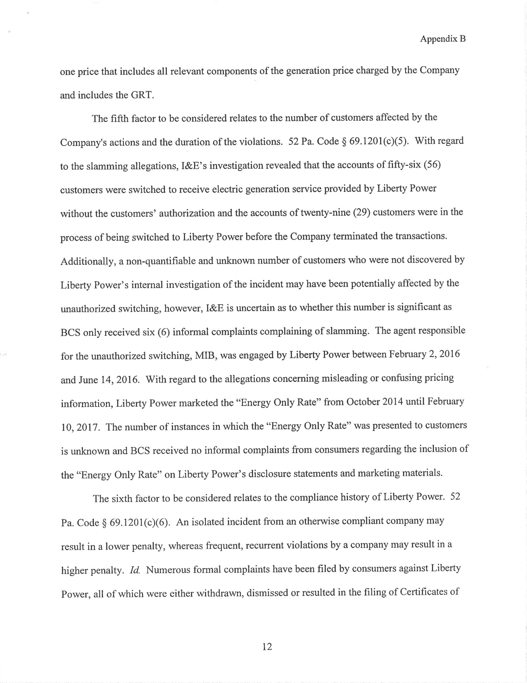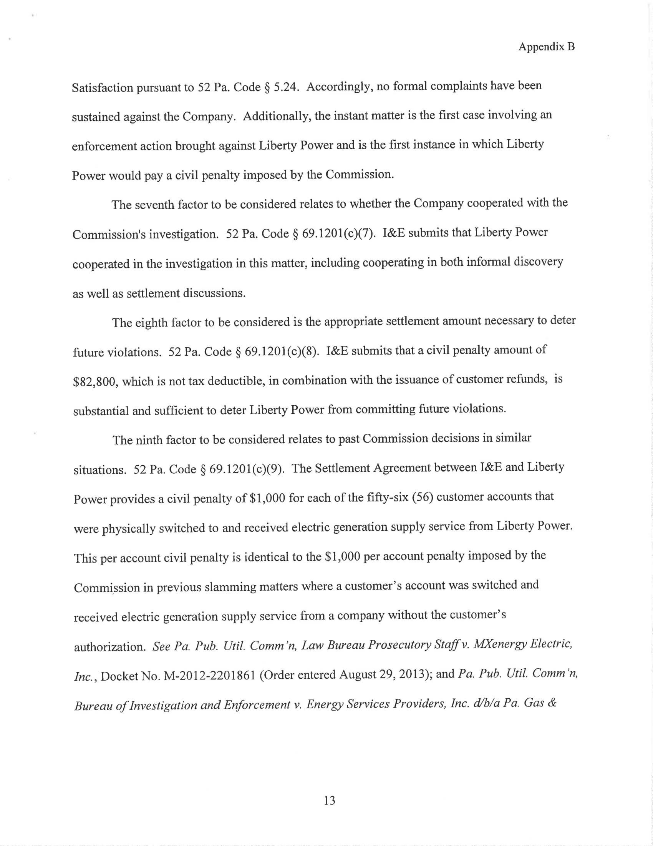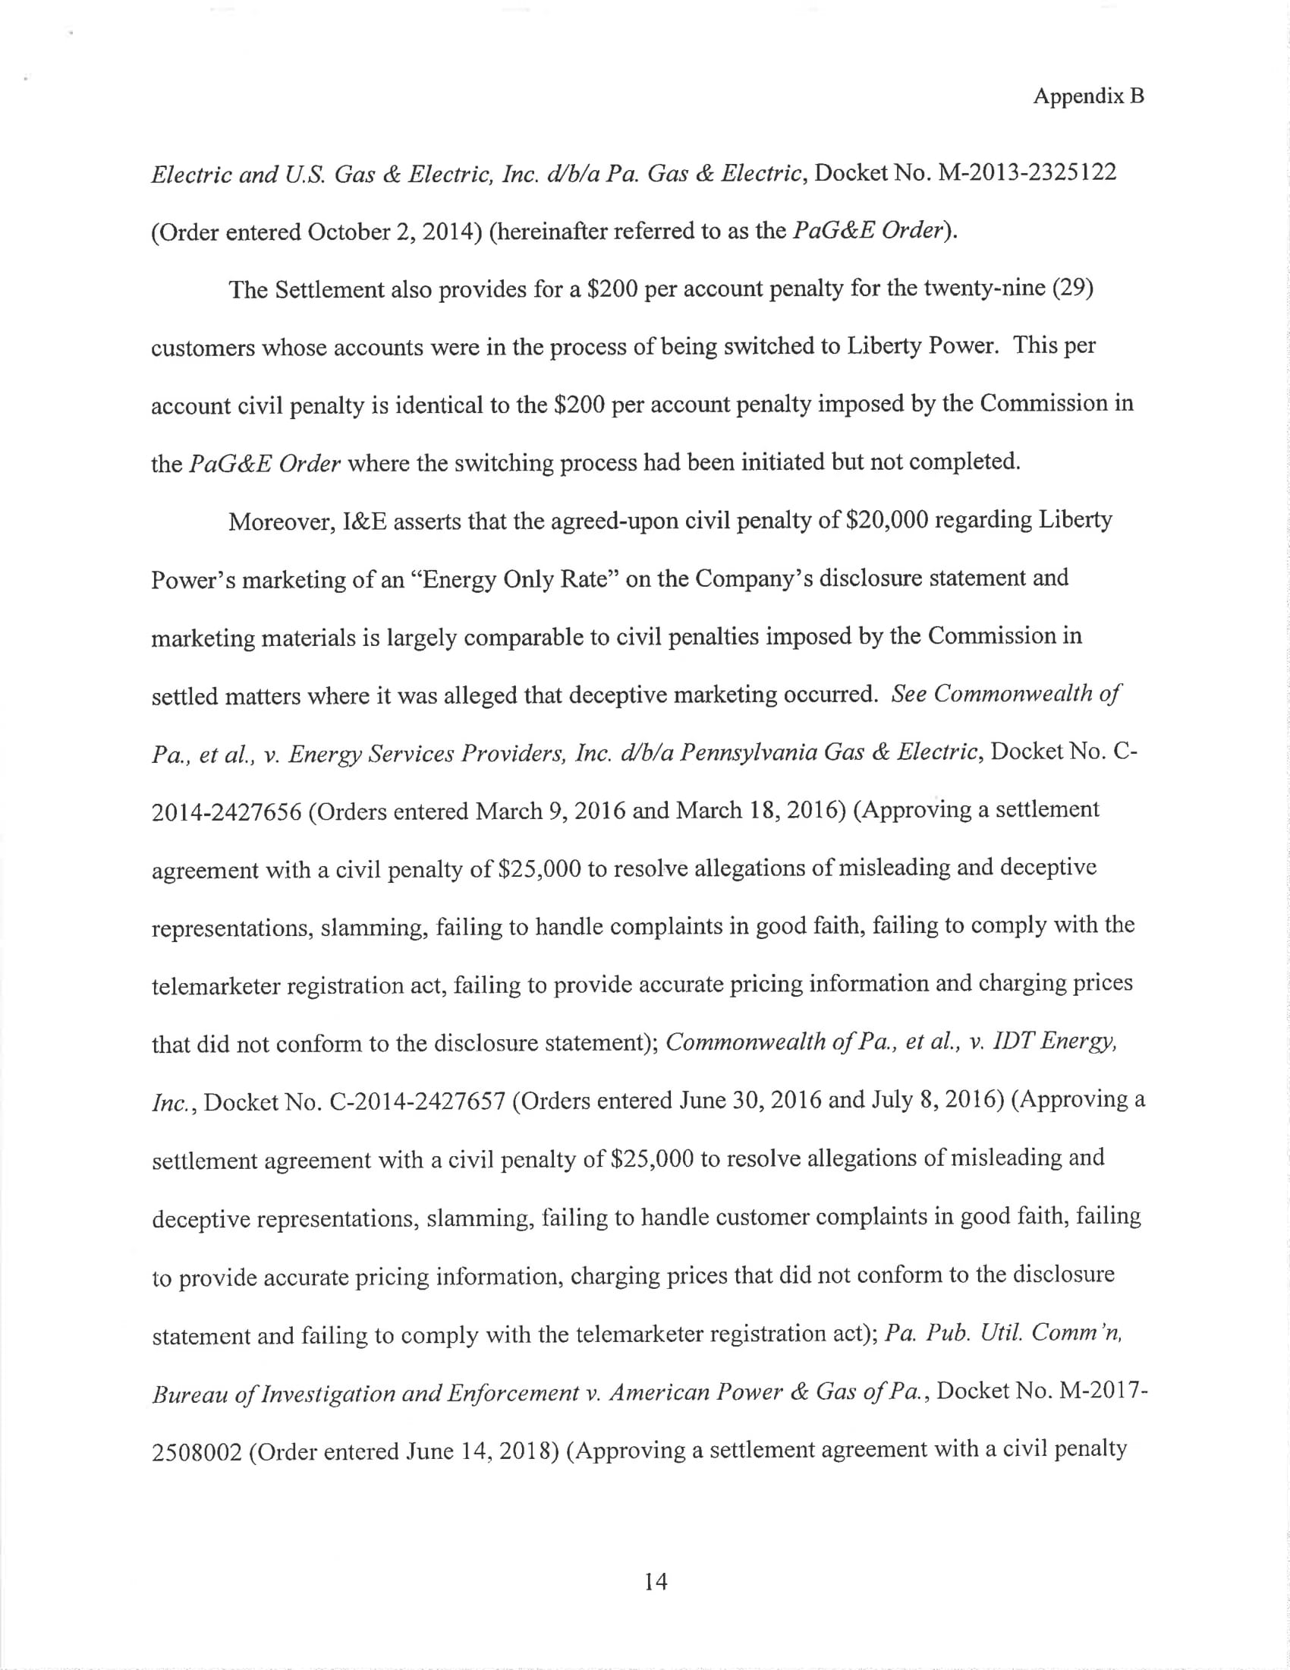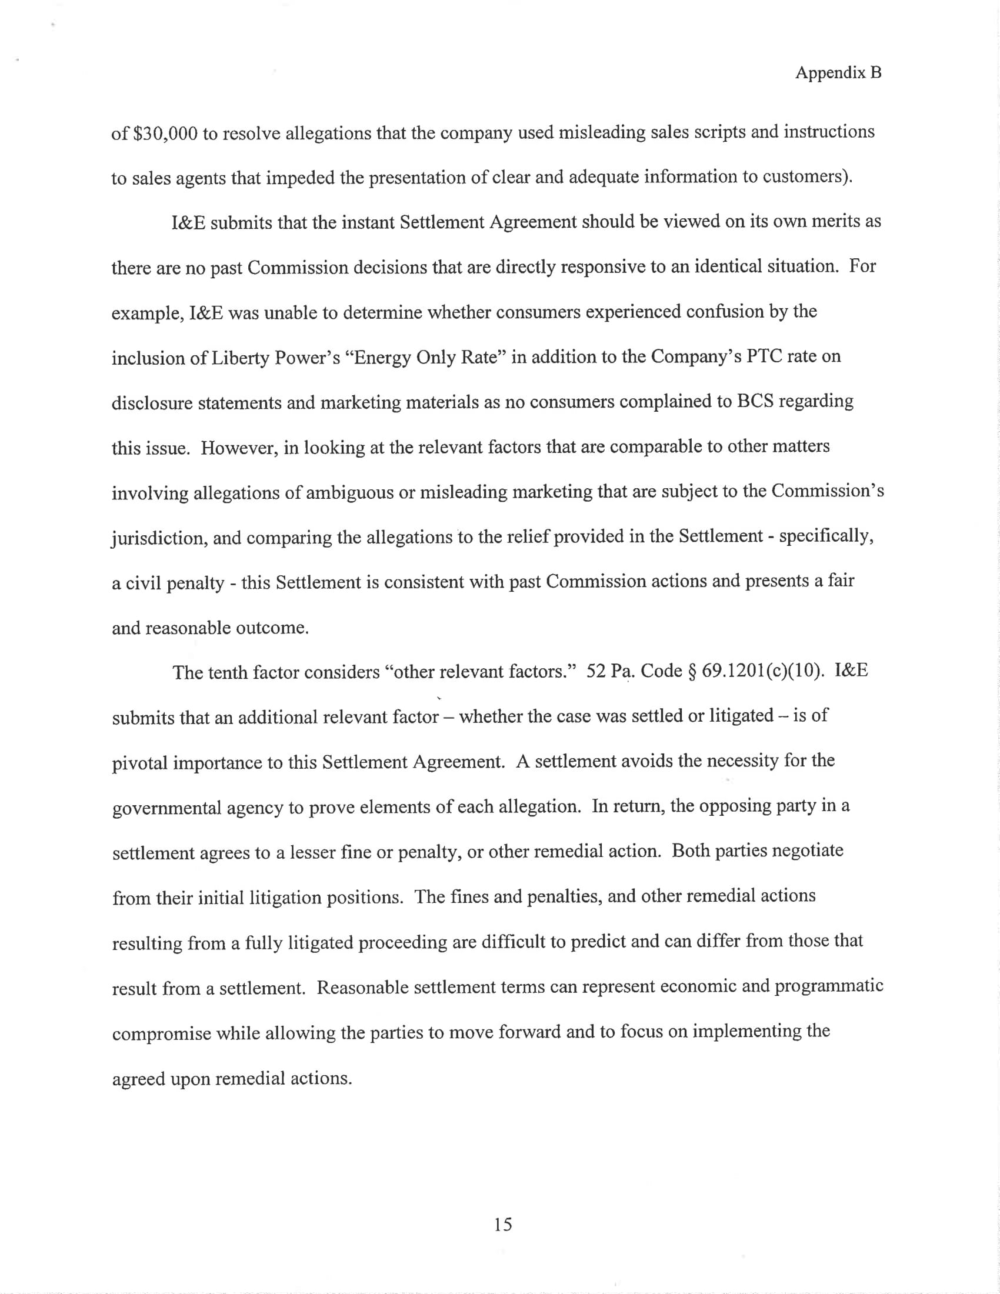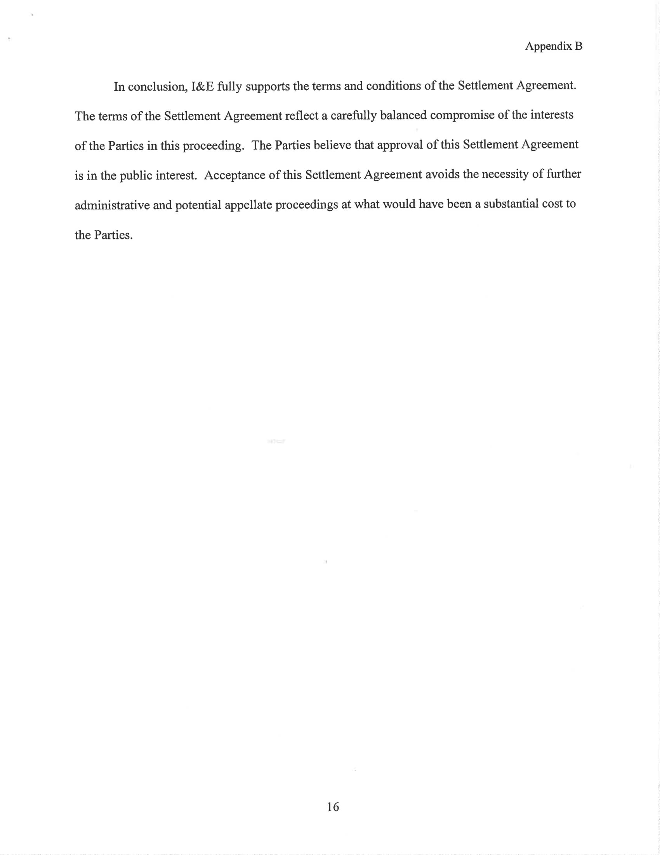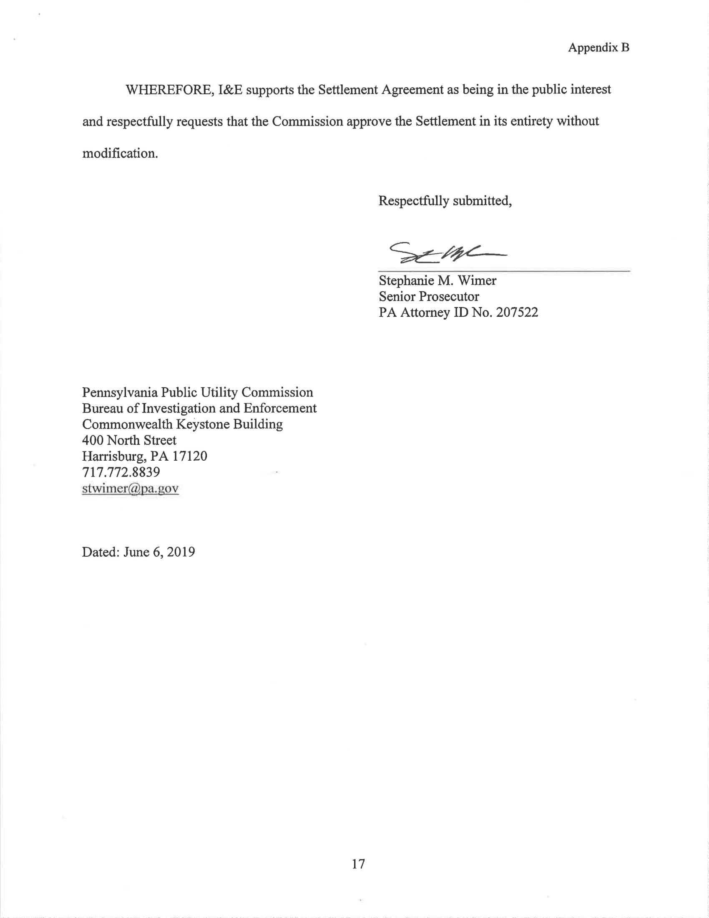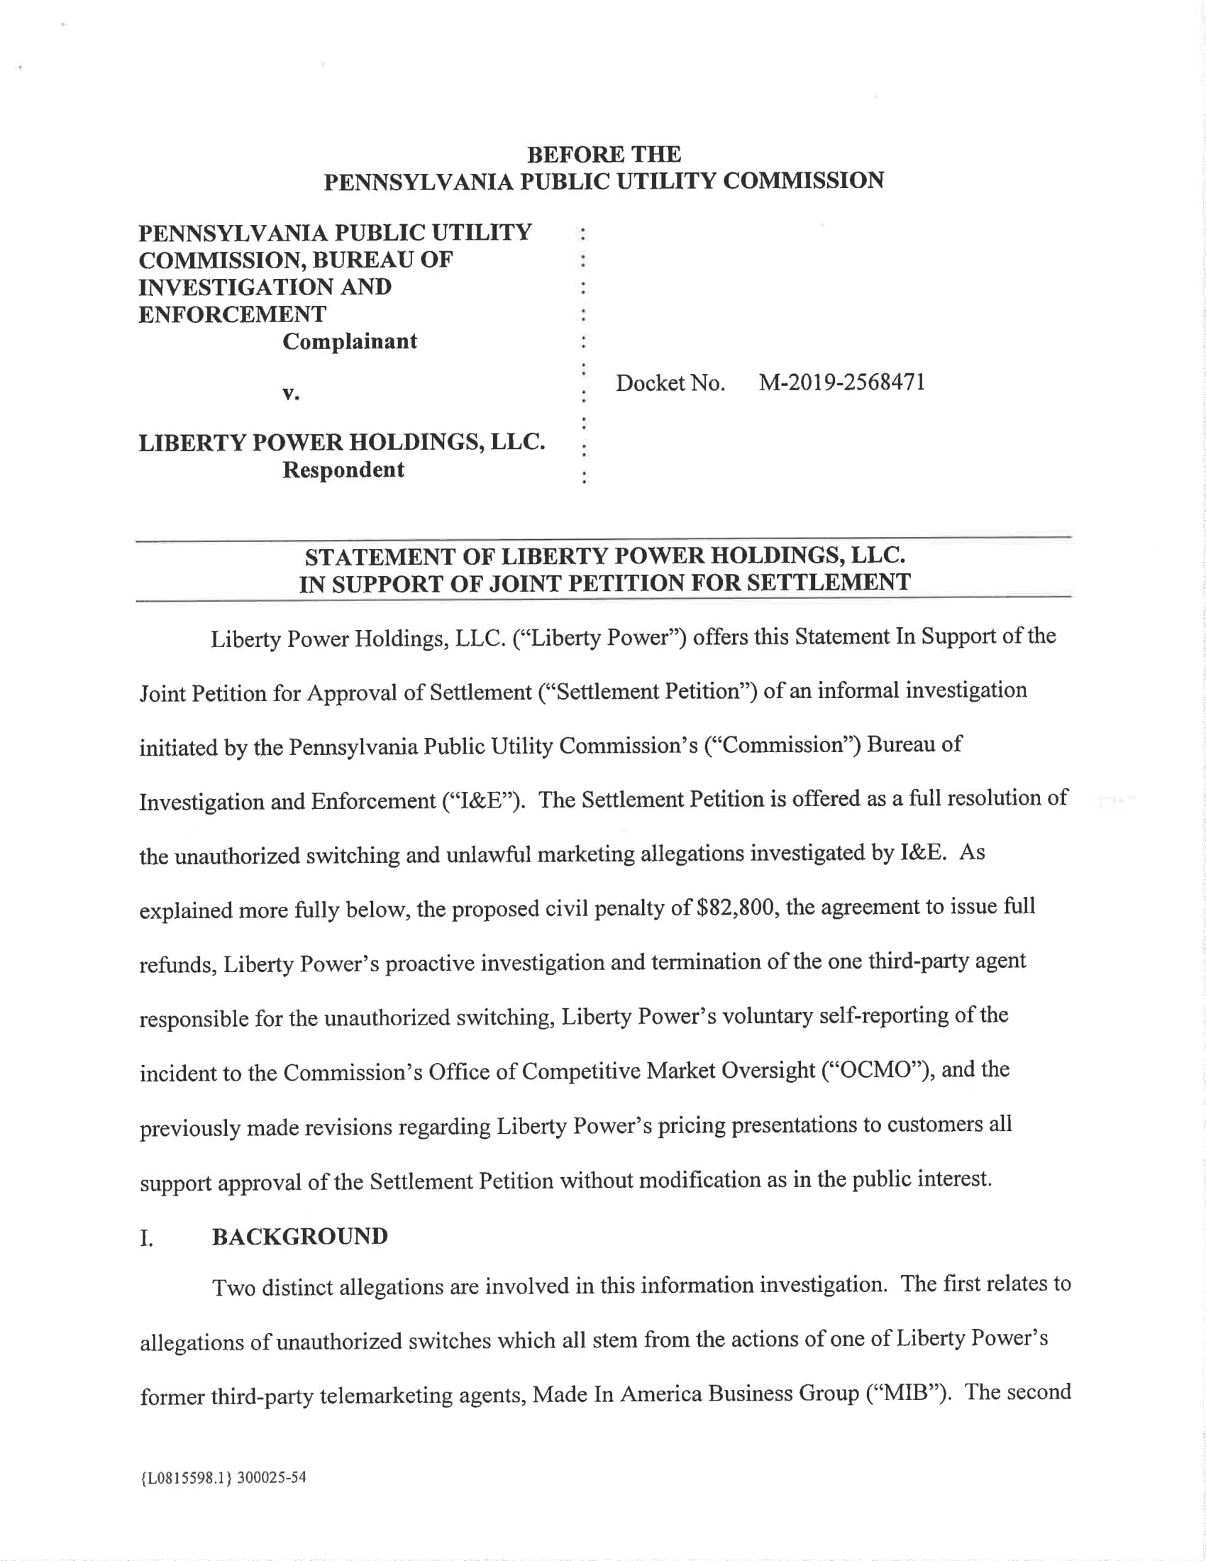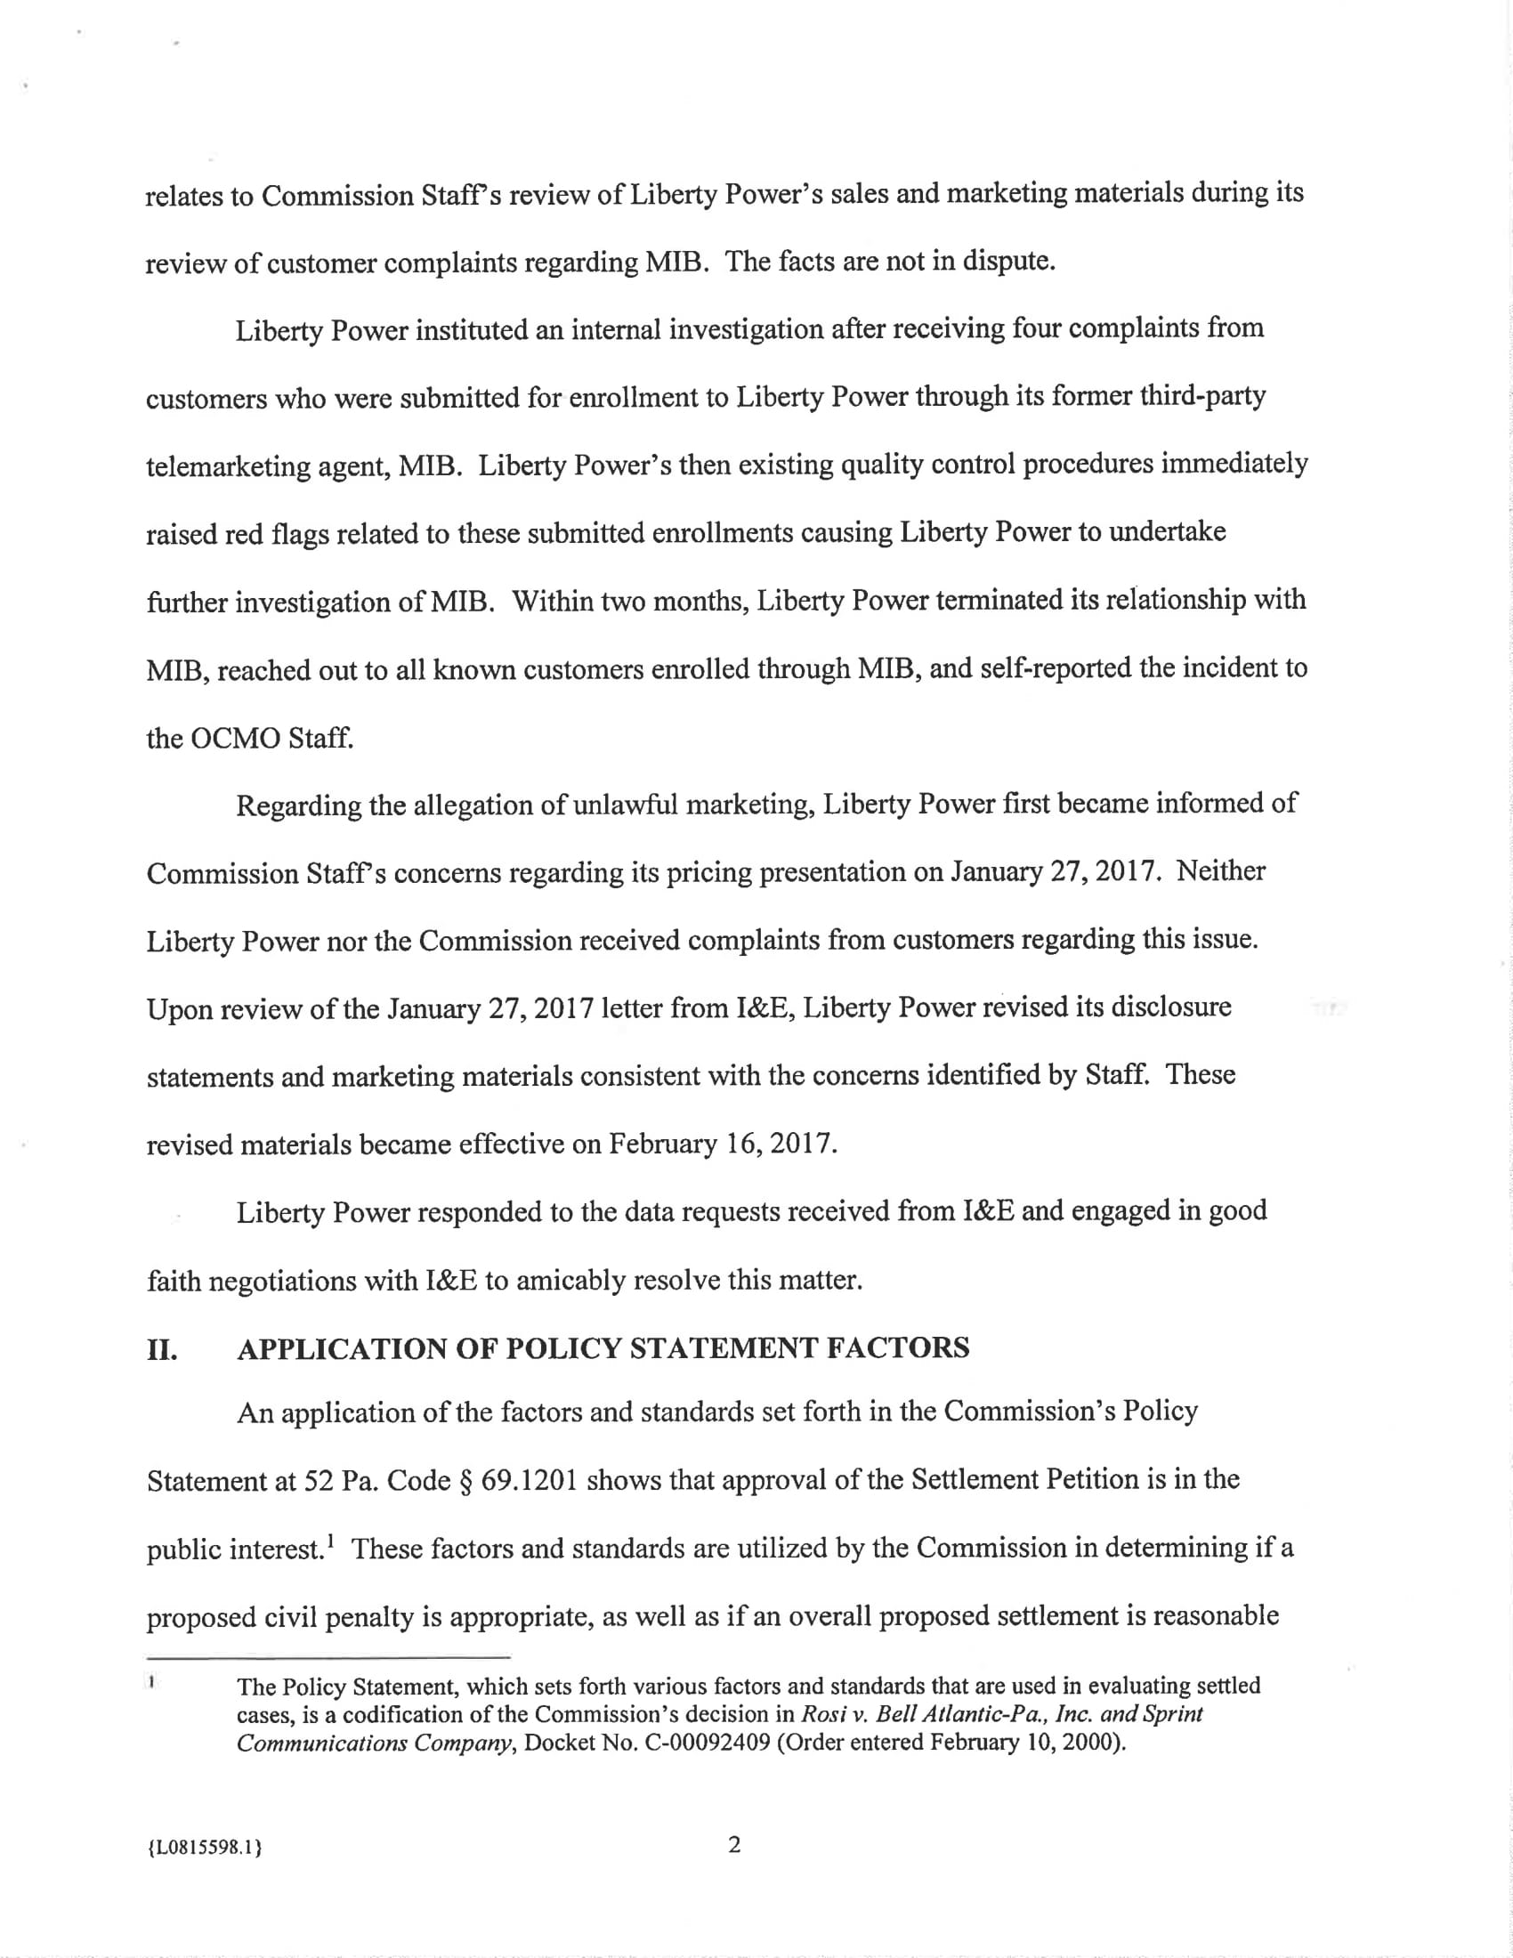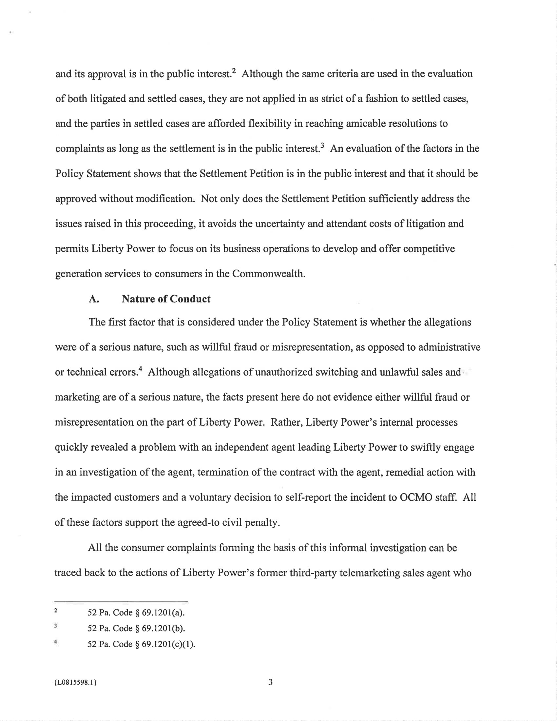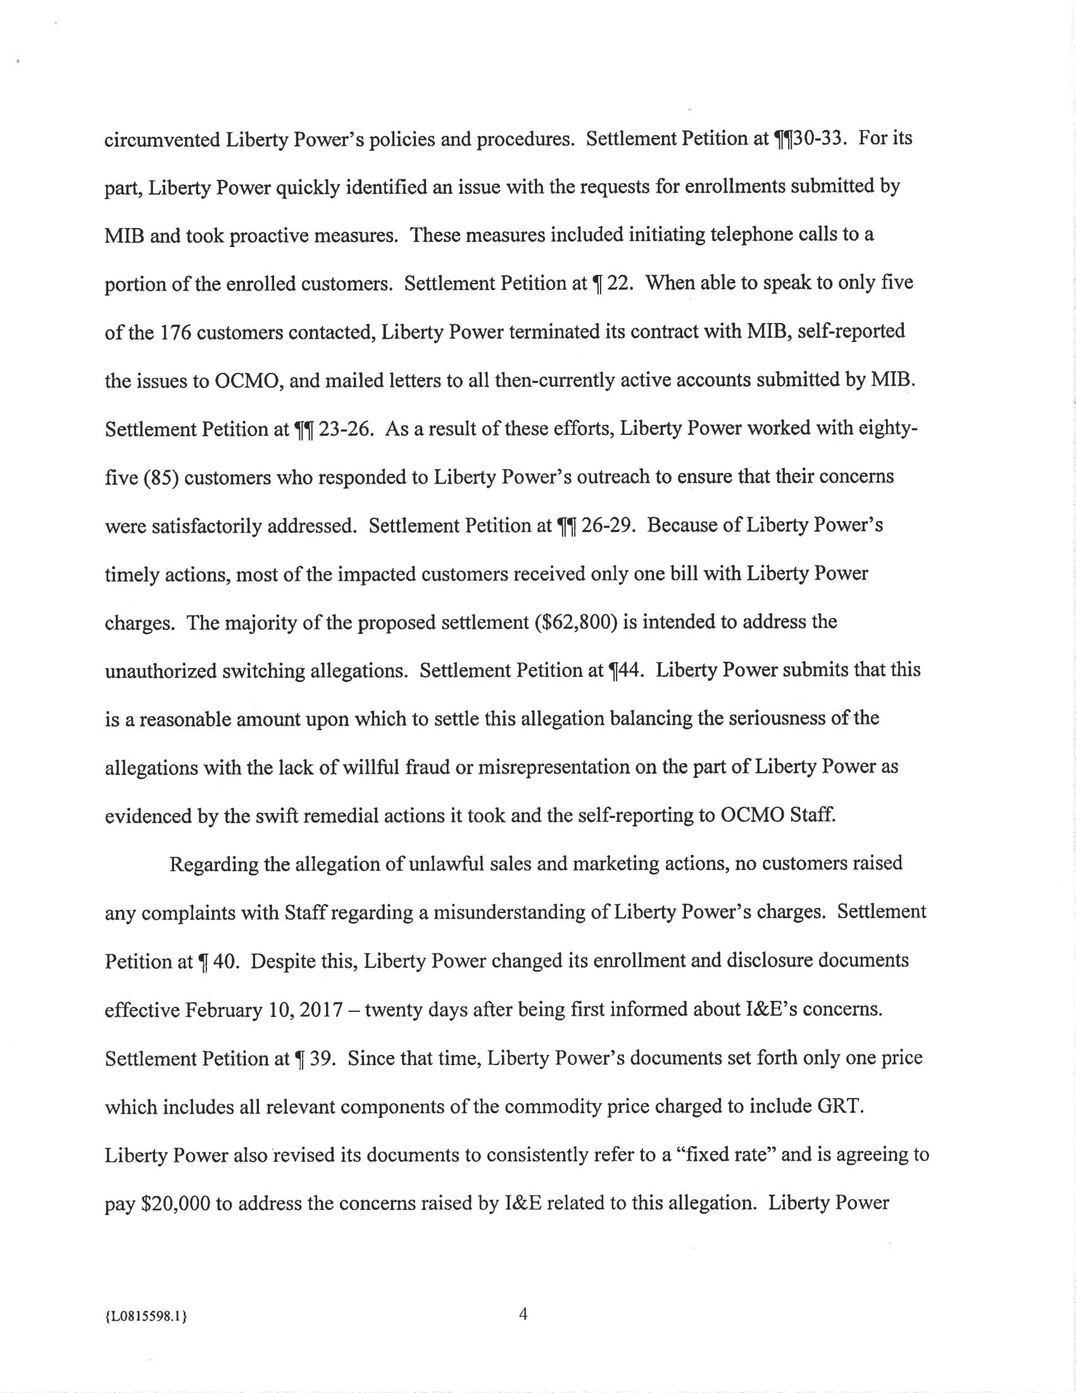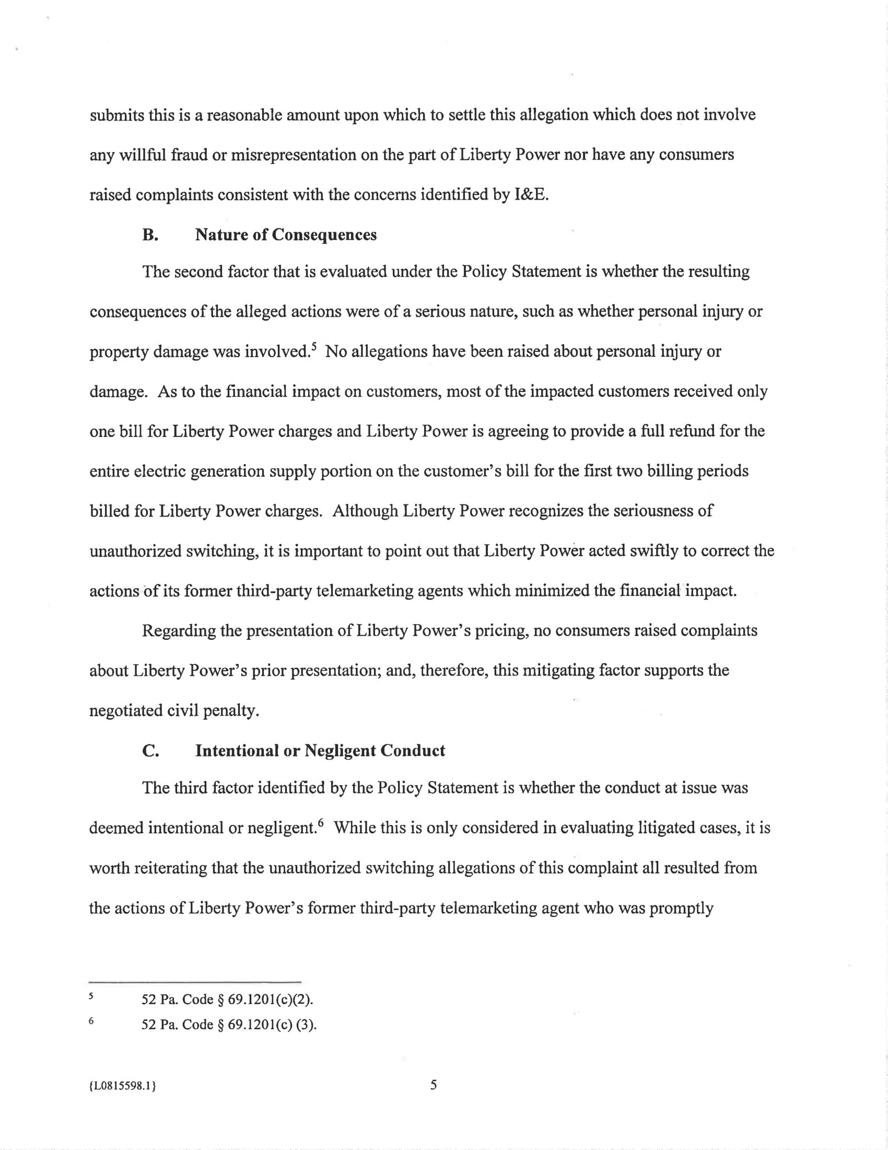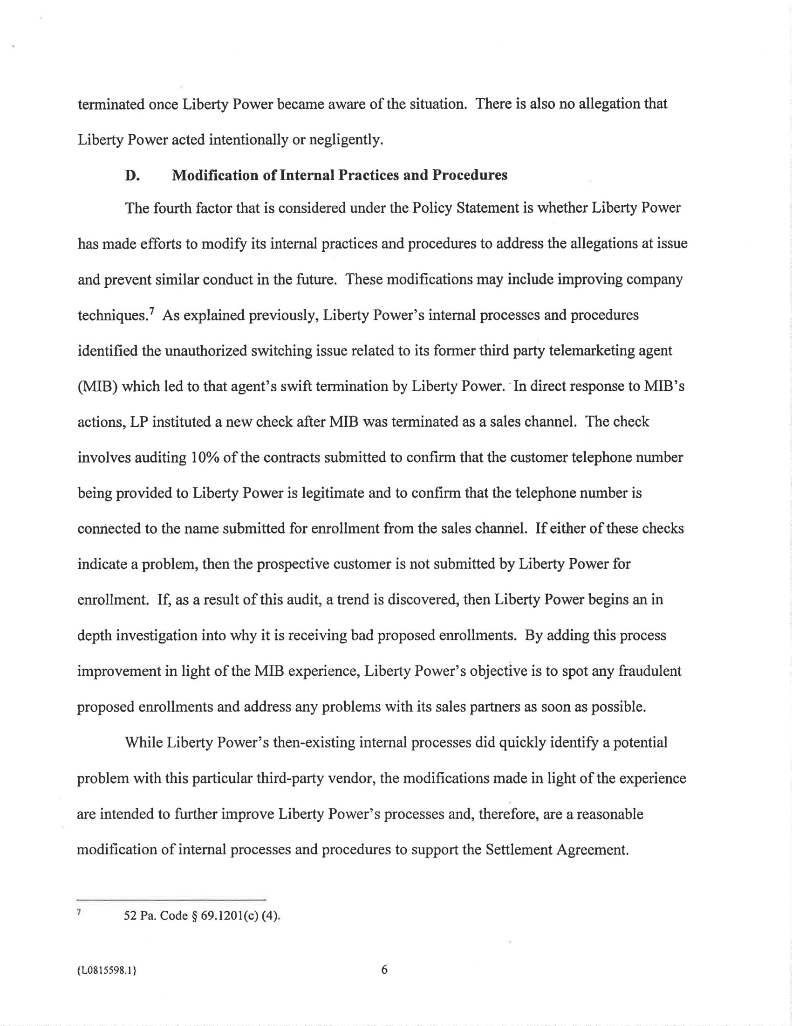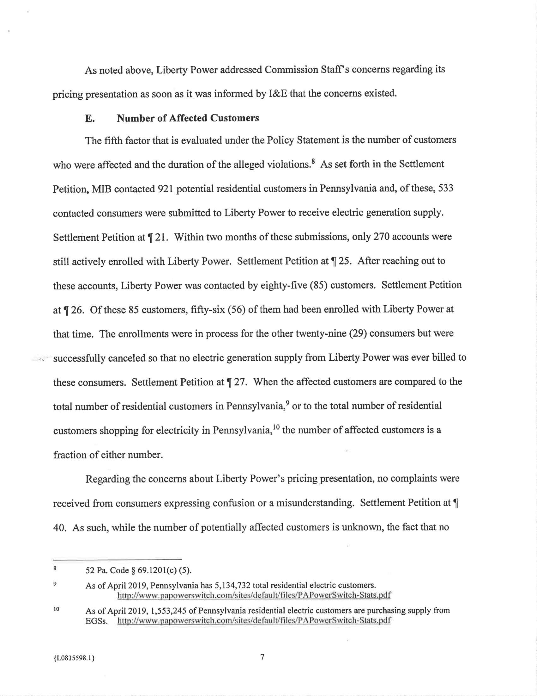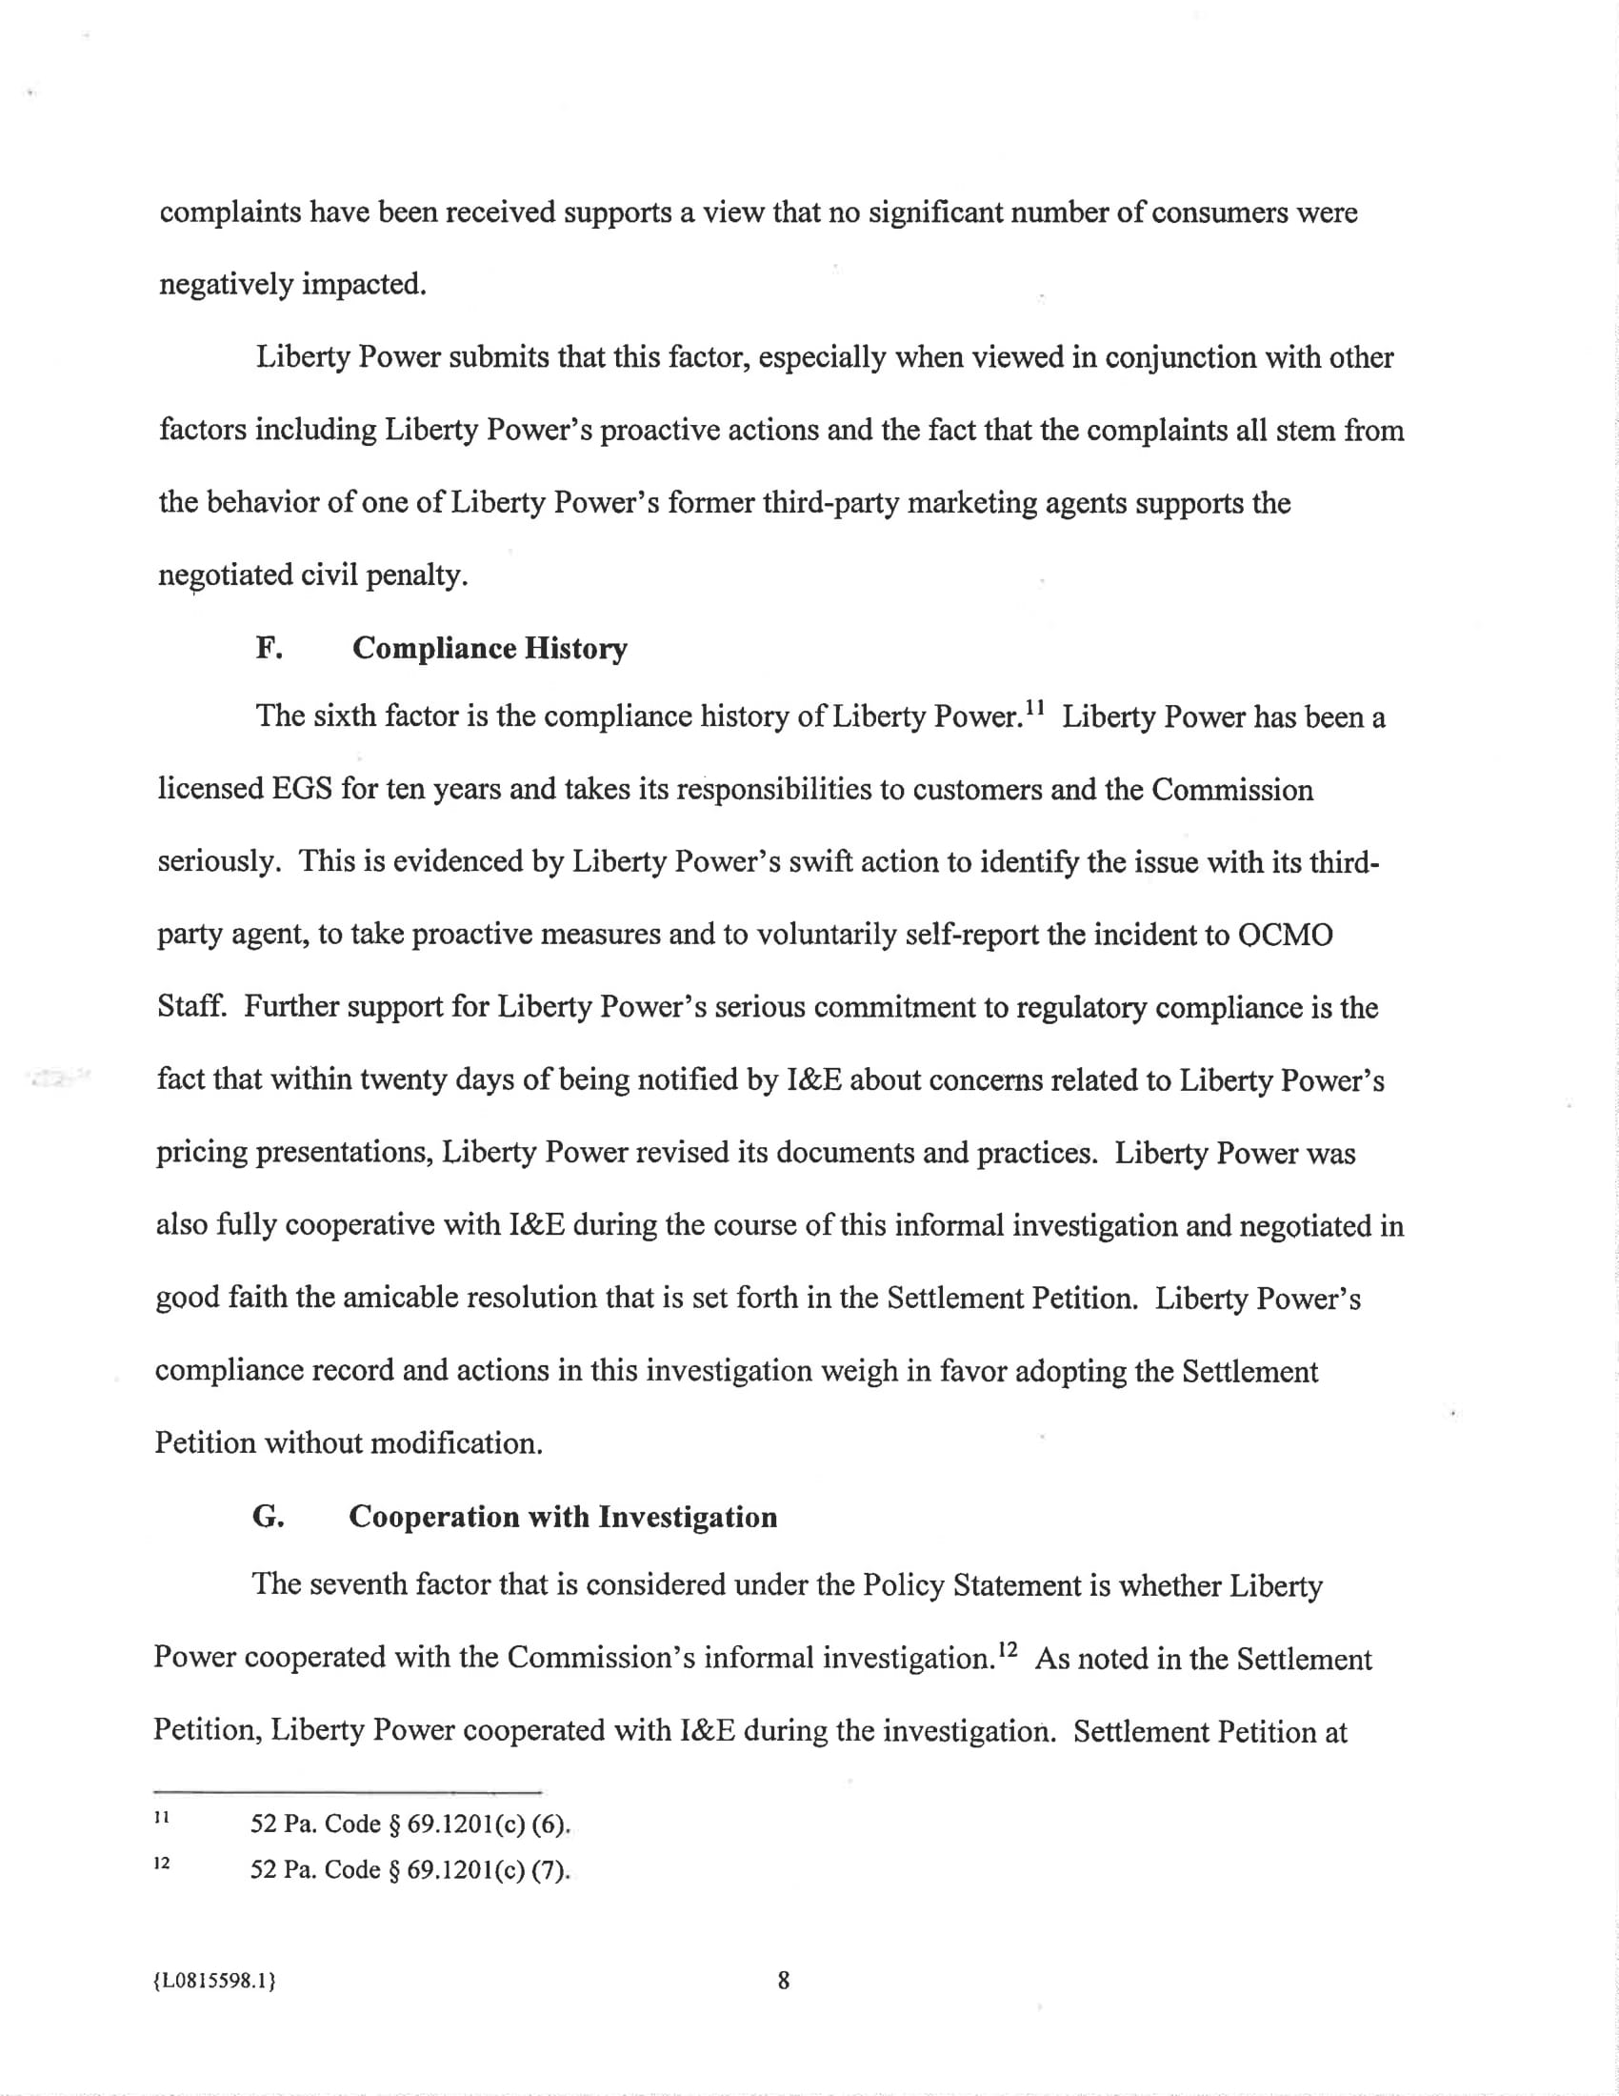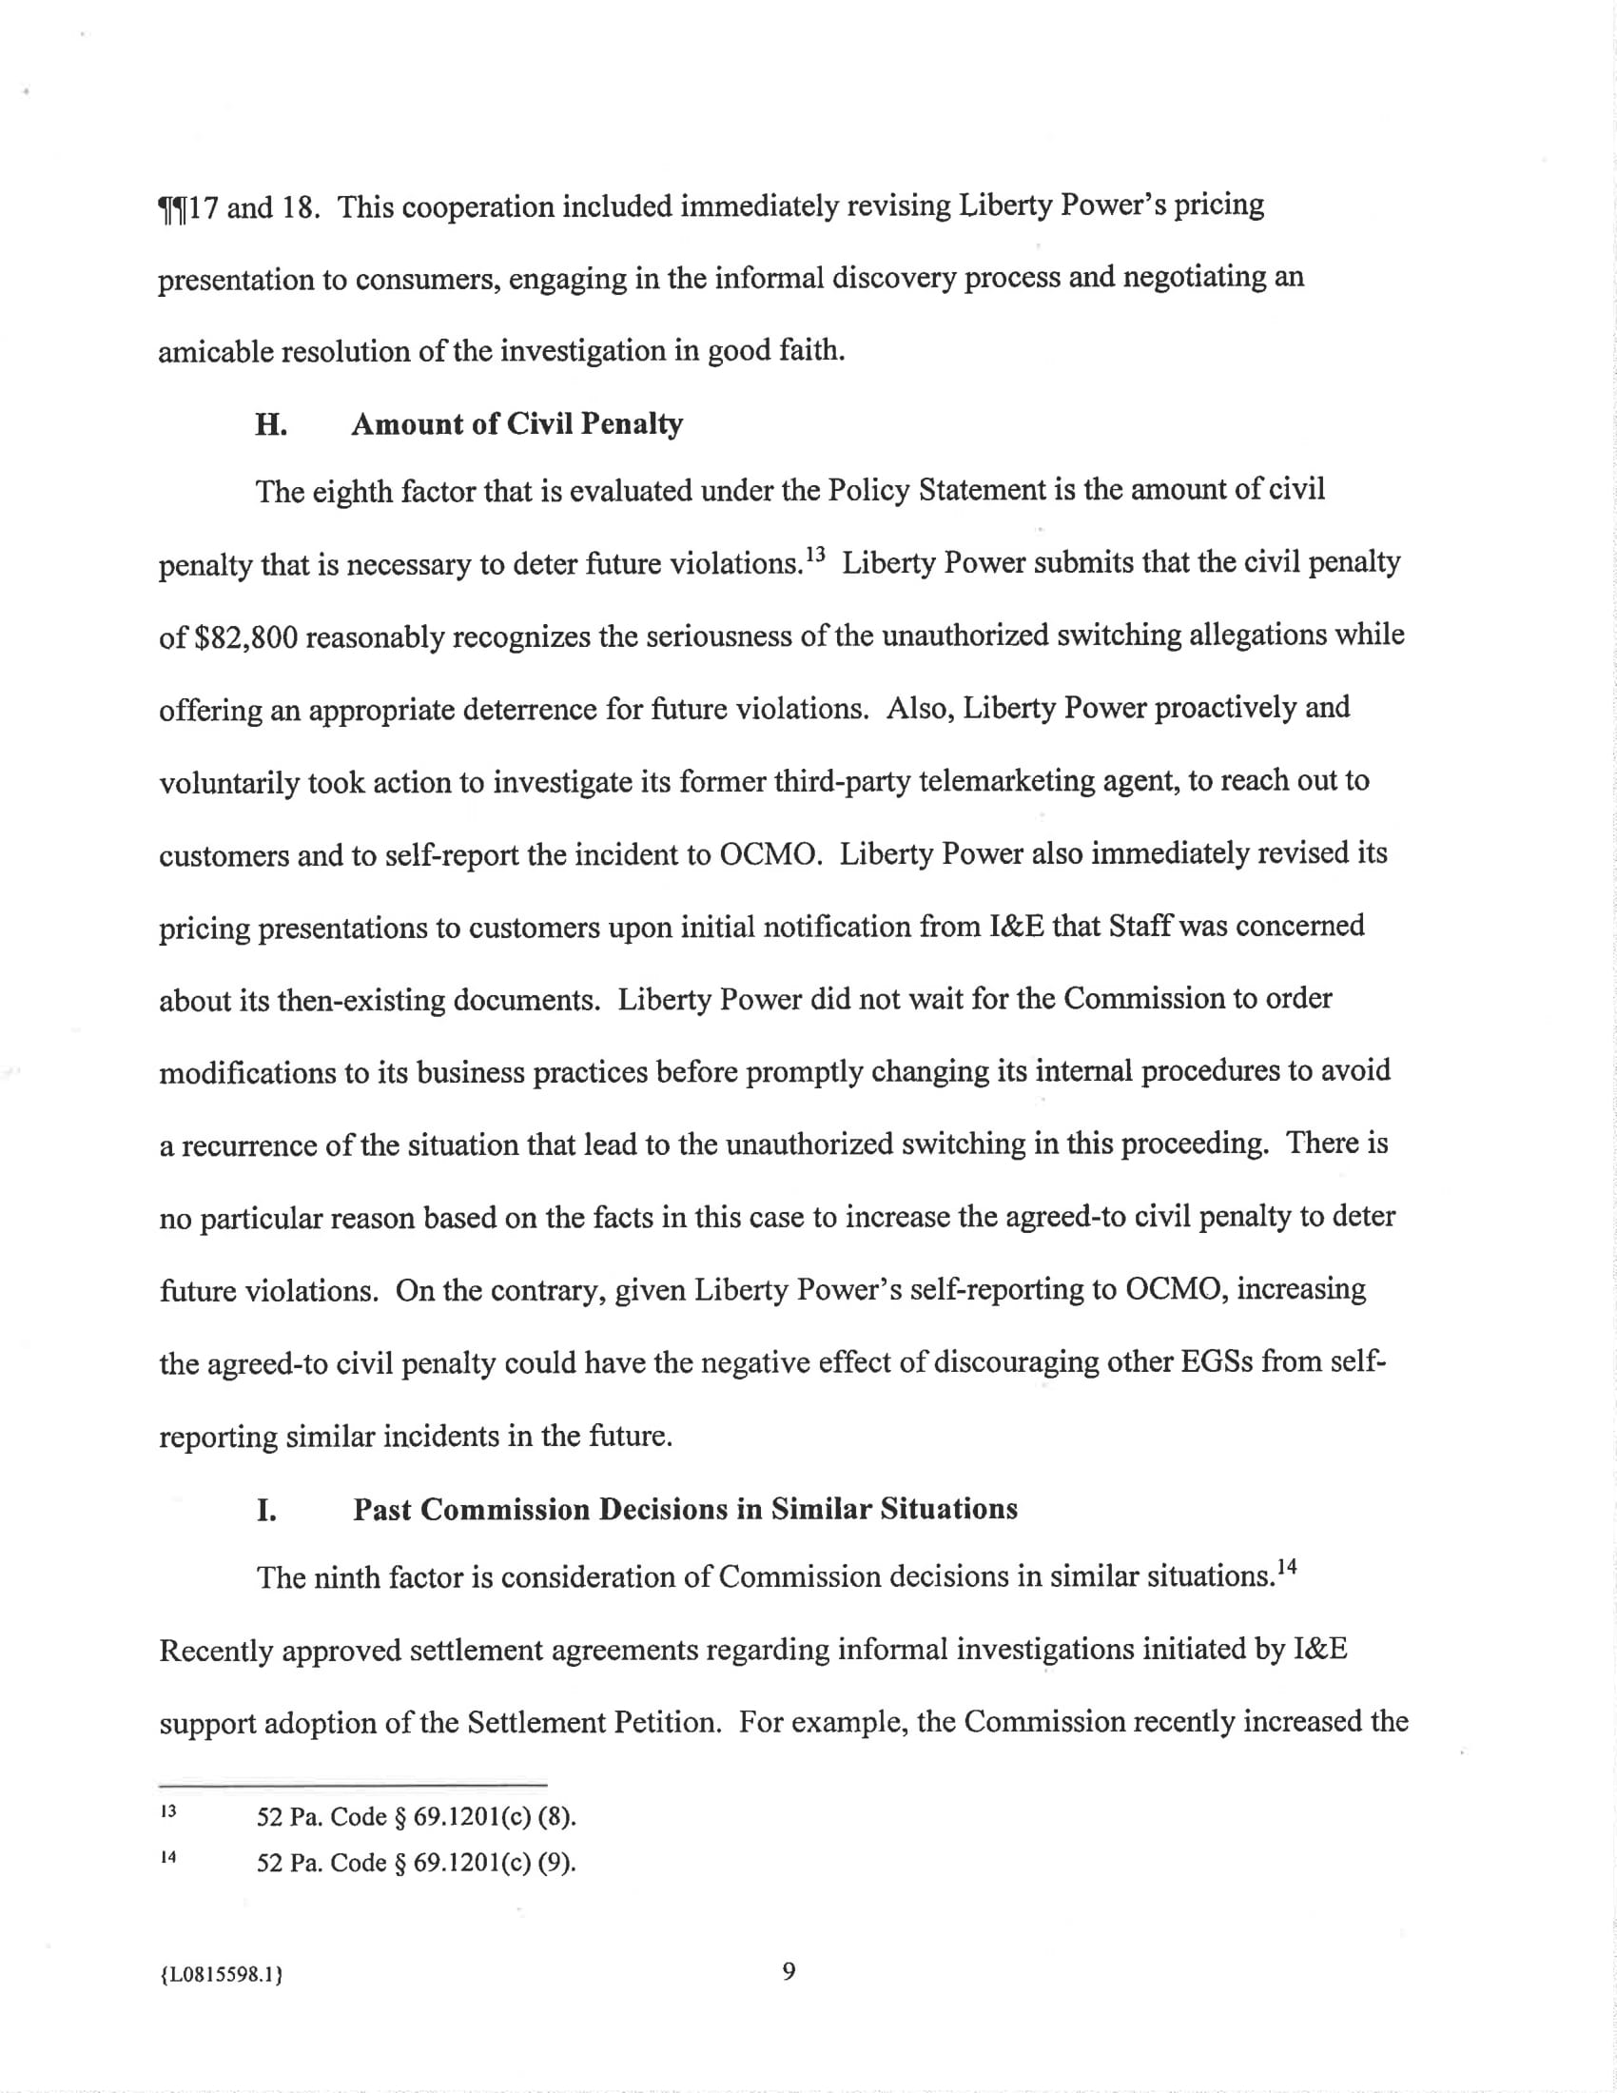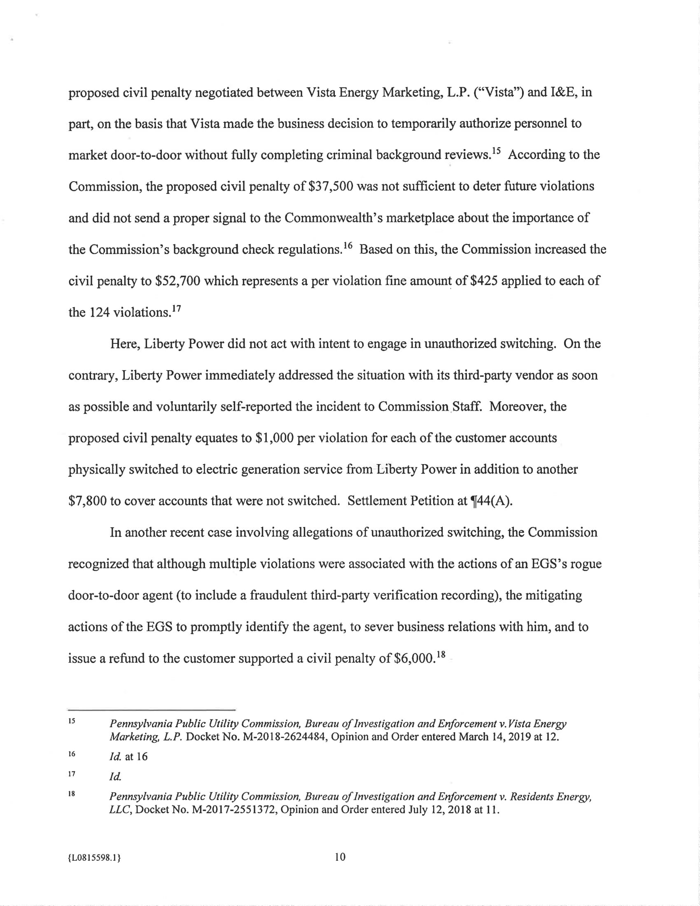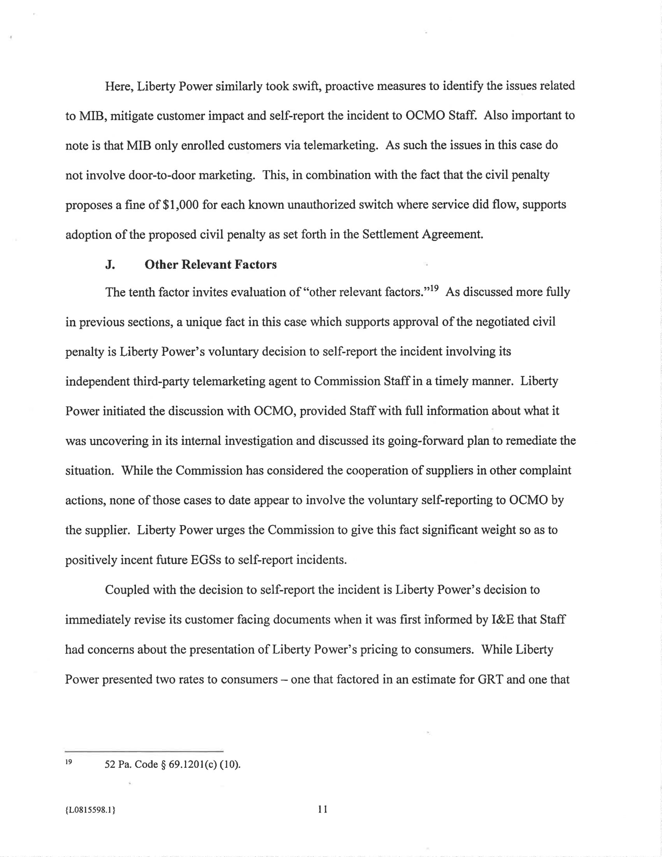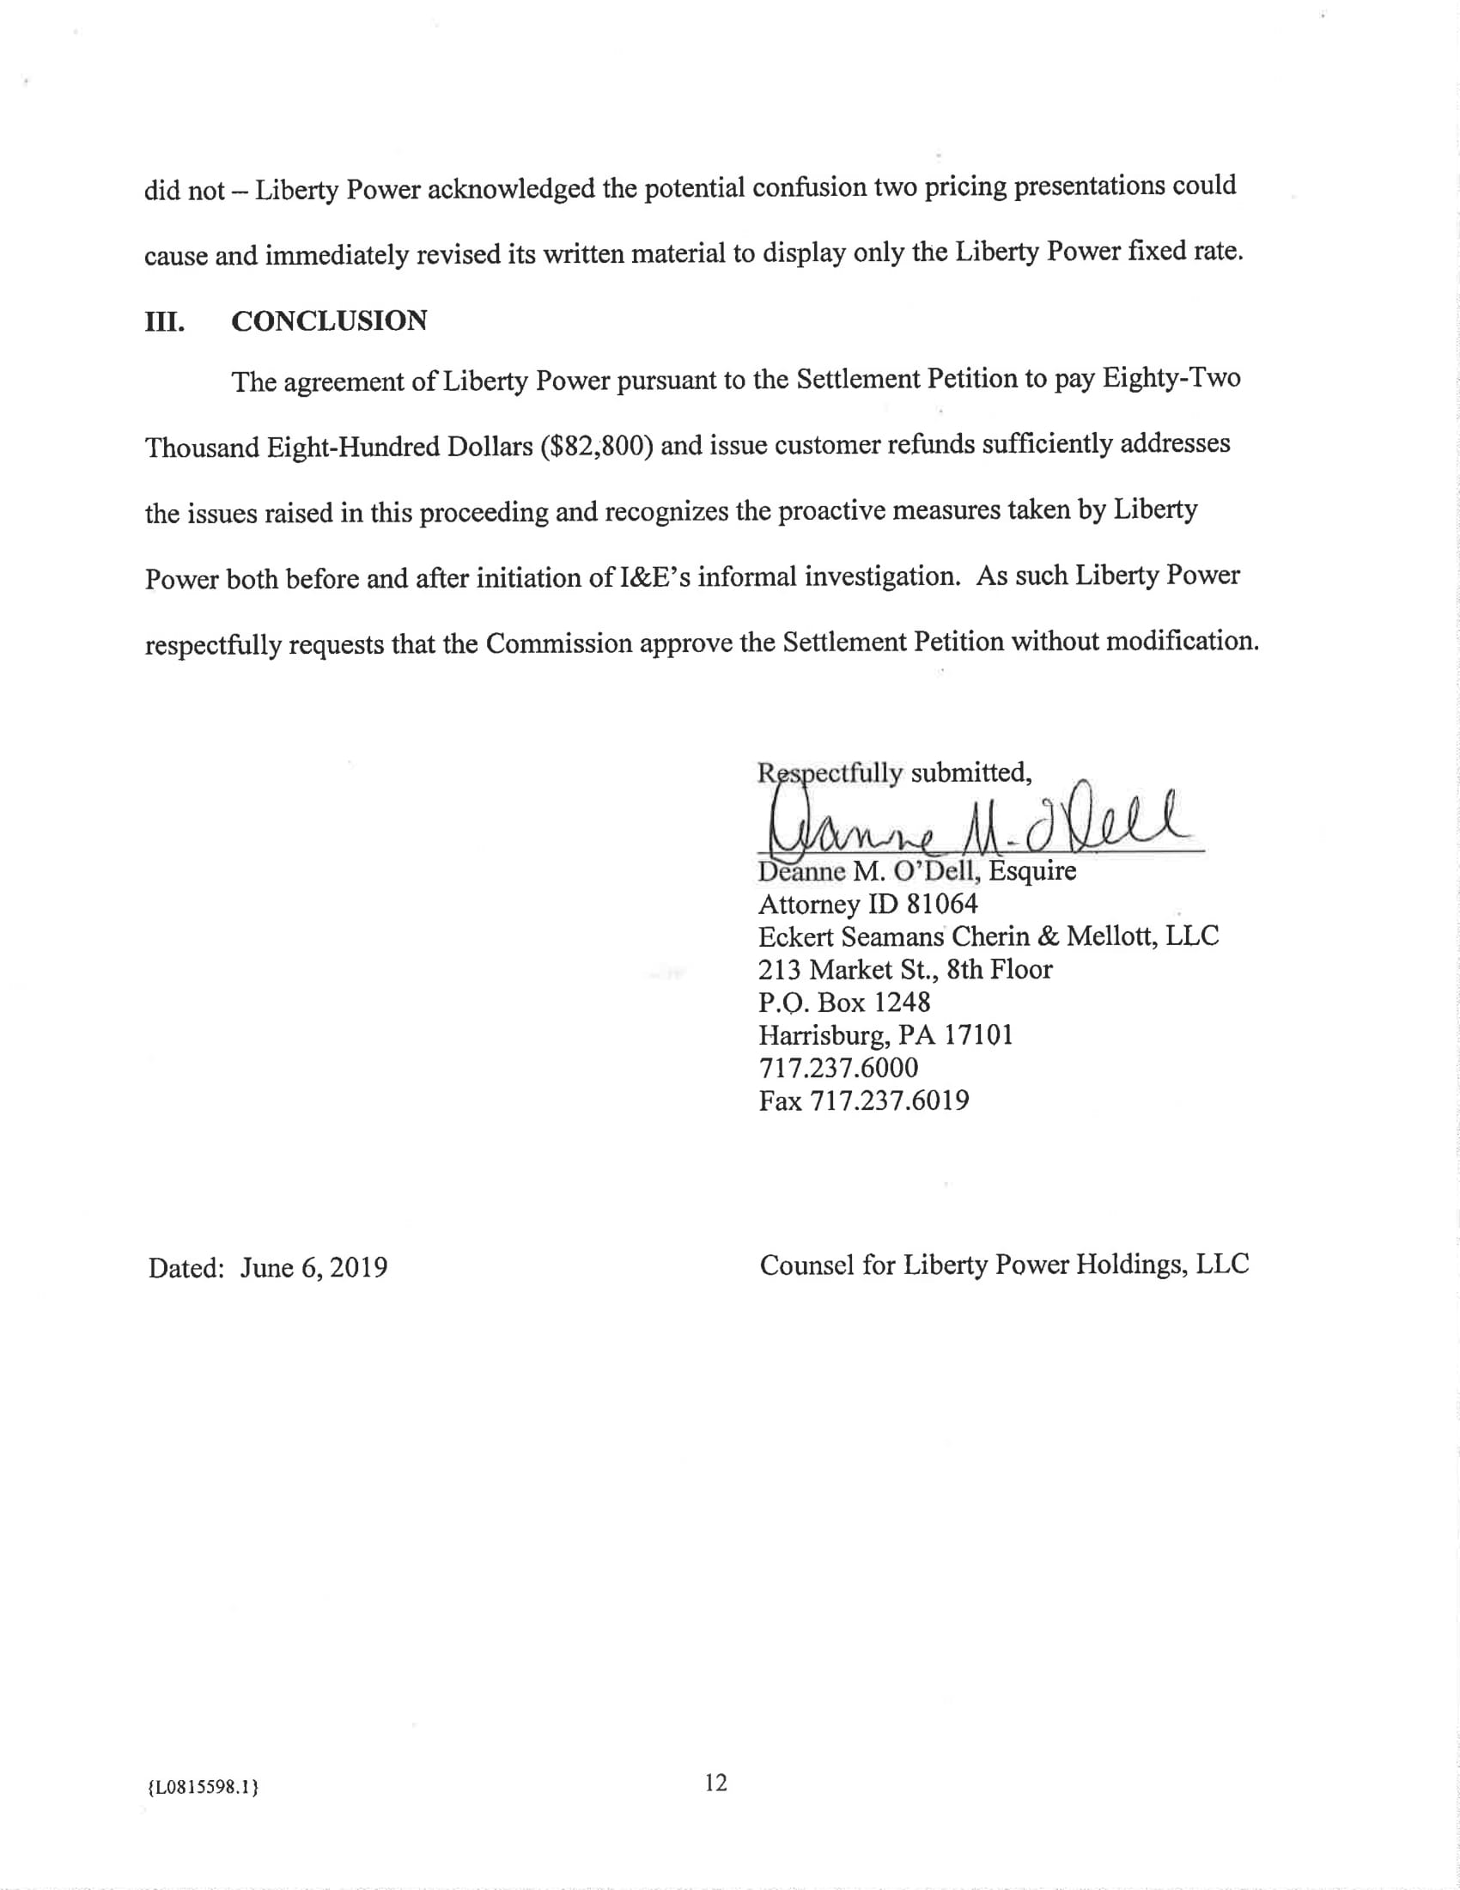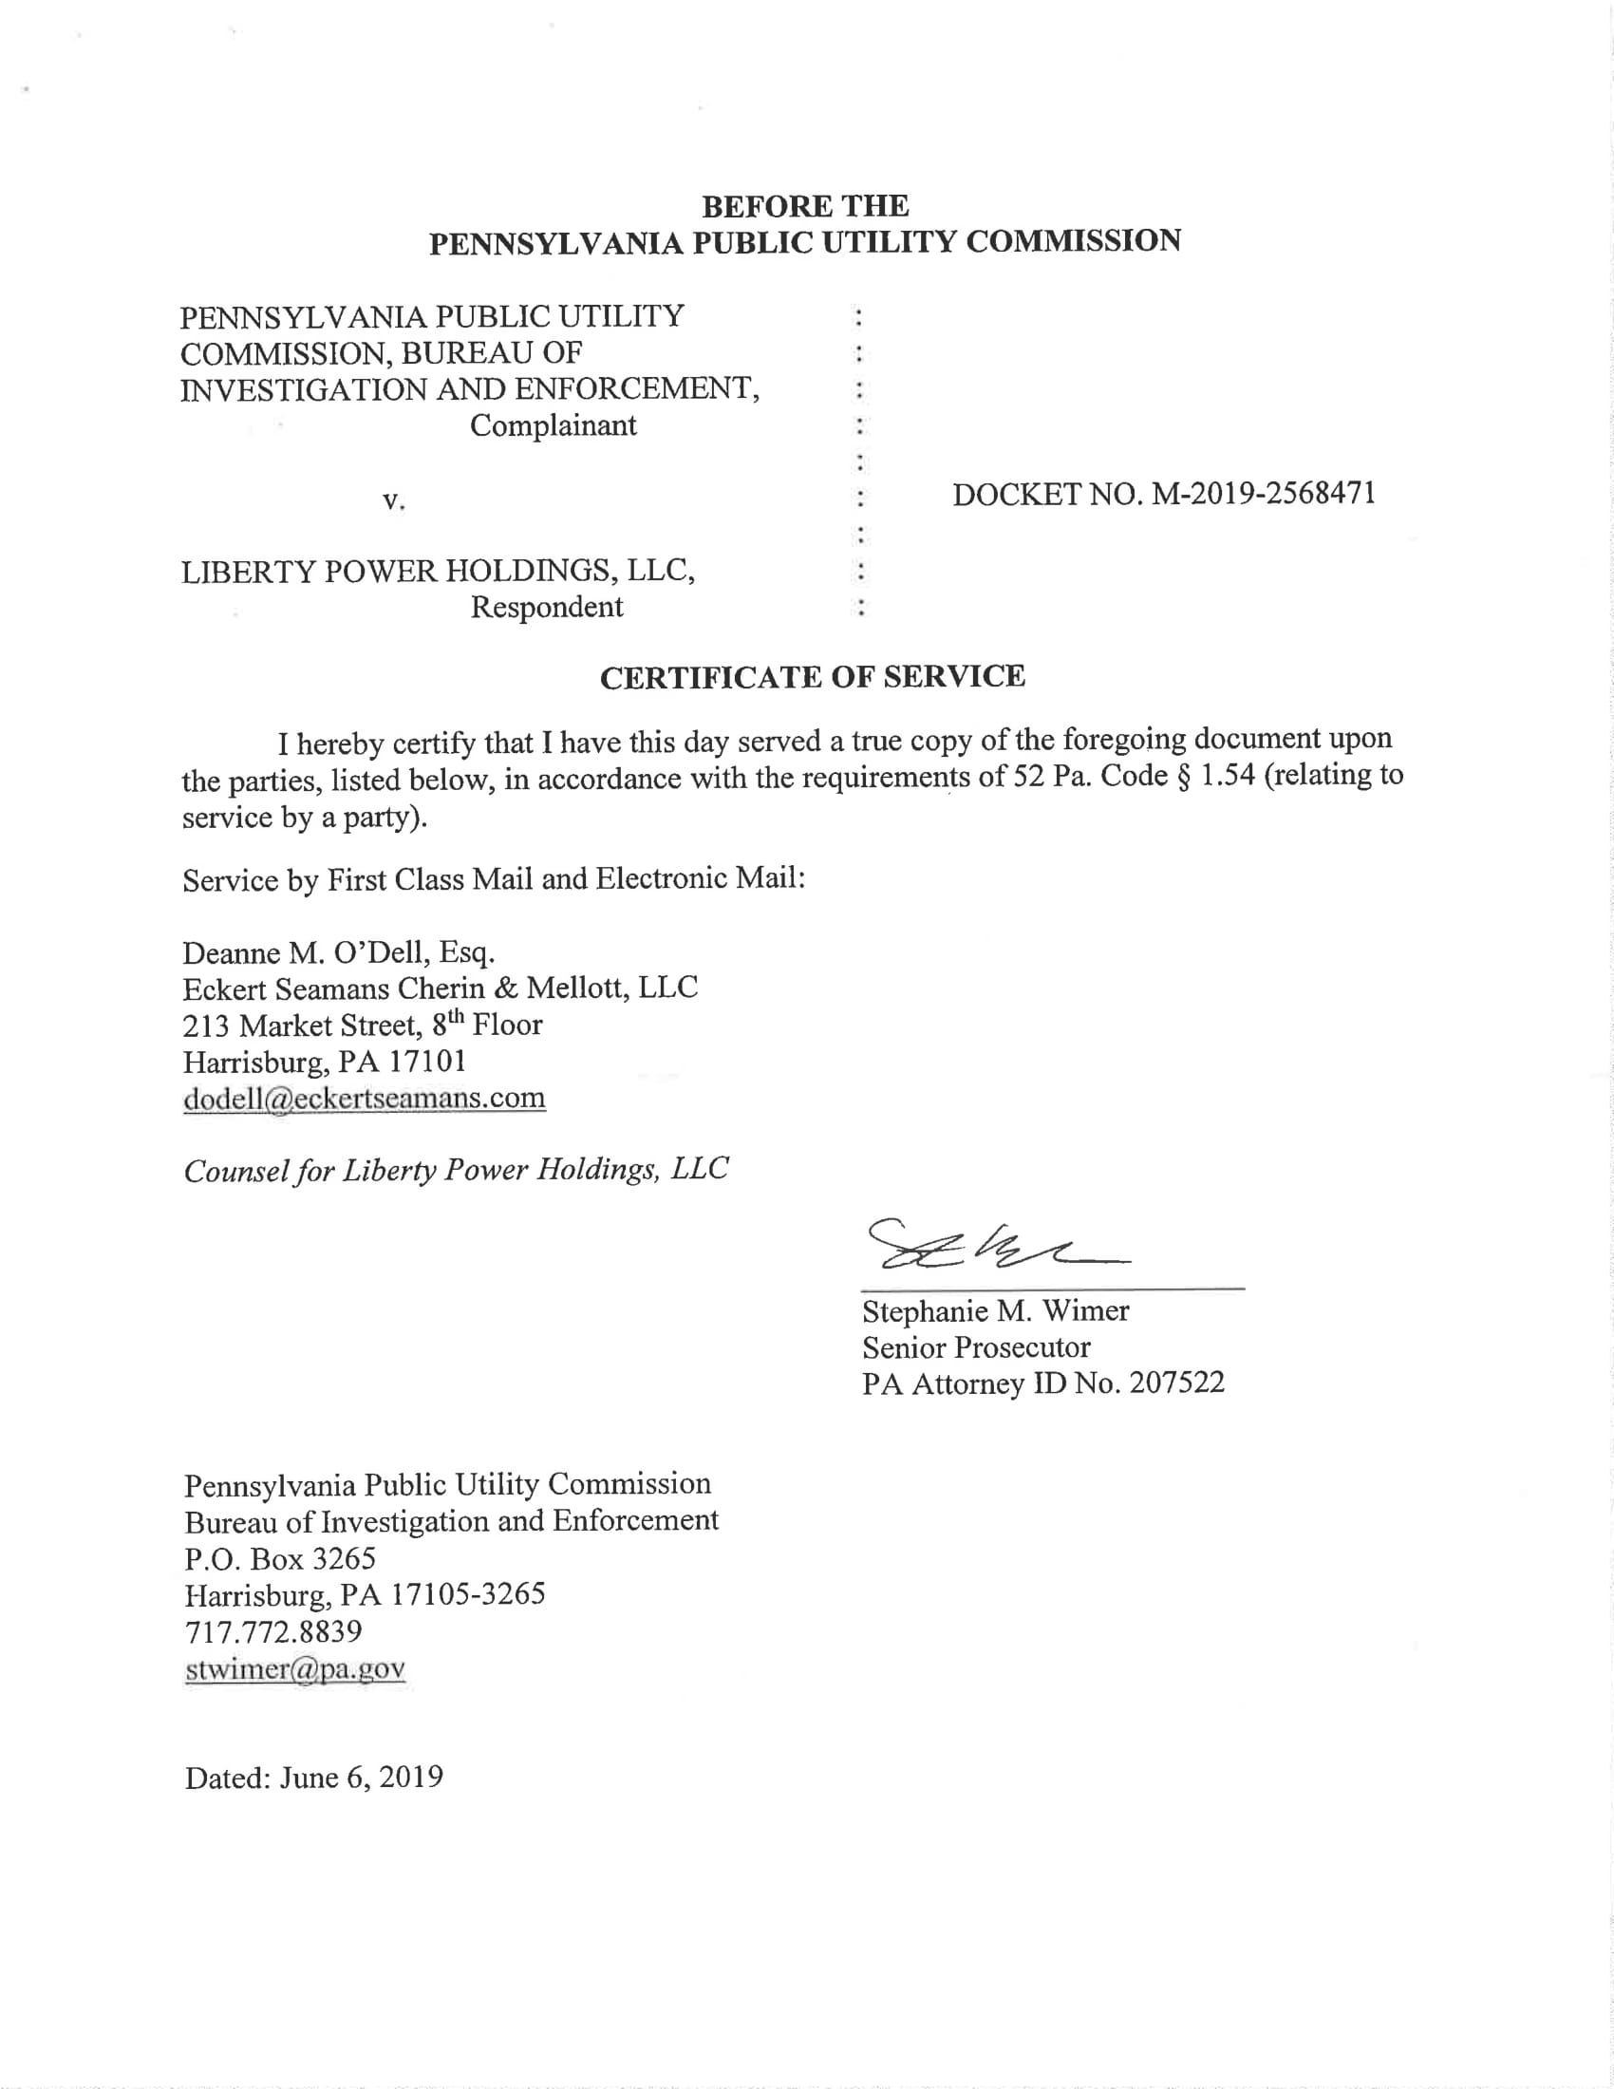

Liberty Power is a licensed electric generation supplier (EGS) as defined by 66 Pa. C.S. § 2803. On April 11, 2008, at Docket No. A-110175, the Commission granted Liberty Power approval to begin to offer, render, furnish or supply electricity or electric generation services as a generator and supplier of electric power to the public in Pennsylvania.
This practice is known as “slamming.” HIKO Energy LLC v. Pa. PUC, 163 A.3d 1079, 1090 (Pa. Cmwlth. 2017).

