PENNSYLVANIA

PUBLIC UTILITY COMMISSION

Harrisburg, PA 17105-3265

Public Meeting held April 30, 2020

Commissioners Present:

Gladys Brown Dutrieuille, Chairman
David W. Sweet, Vice Chairman
John F. Coleman, Jr.
Ralph V. Yanora

Pole Attachment Working Group M-2020-3019408
L-2018-3002672

OPINION AND ORDER

BY THE COMMISSION:

Pursuant to 52 Pa. Code § 77.7, the Commission has established a Pole Attachment Working Group to ensure that the Commission remains apprised of industry and public concerns, that changes to the federal pole attachments rules are properly vetted before they come into effect in Pennsylvania, and to provide feedback to the Commission on the functioning of its regulations and dispute resolution processes as they relate to pole attachments.

The Pennsylvania Department of General Services – Office of Enterprise Wireless Management was established to promote the co-location of wireless communications equipment on Commonwealth assets including monopoles, Commonwealth-owned utility poles, and other structures on Commonwealth property. Following the entry of our April 16, 2020 Order, the Office of Enterprise Wireless Management expressed interest in participating in the group to promote consistency in how the Commonwealth implements pole attachments. The Commission agrees that the Office of Enterprise Wireless Management will contribute value to the Pole Attachment Working Group by representing an interest that no other existing member currently represents. Therefore, adding the Office of Enterprise Wireless Management will supplement the existing expertise and representative experience of the Working Group.

Accordingly, the Commission finds it appropriate to appoint the Department of General Services – Office of Enterprise Wireless Management to the Pole Attachment Working Group, THEREFORE,

IT IS ORDERED:

1. That the appointment to the Pole Attachment Working Group of the Department of General Services – Office of Enterprise Wireless Management is approved.

2. The contact persons for the Pole Attachment Working Group are Colin W. Scott, Assistant Counsel, (717) 783-5949, and Christian A. McDewell, Assistant Counsel, (717) 787-7466.

BY THE COMMISSION,
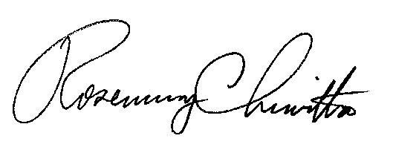

Rosemary Chiavetta
Secretary

(SEAL)

ORDER ADOPTED: April 30, 2020

ORDER ENTERED: April 30, 2020

