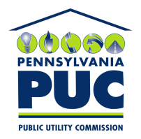 | COMMONWEALTH OF PENNSYLVANIA  PENNSYLVANIA PUBLIC UTILITY COMMISSION  400 NORTH STREET, HARRISBURG, PA 17120 | IN REPLY PLEASE REFER TO OUR FILE
May 6, 2020
Docket No. R-2019-3010955
Utility Code: 230220

Mr. John J. Gallagher
Attorney at Law
711 Forrest Road
Harrisburg, PA 17112

Re: Pennsylvania Public Utility Commission v. City of Lancaster (Wastewater)
Supplement No. 41 to Tariff Sewer-Pa. P.U.C. No. 7

Dear Mr. Gallagher:

By Order entered March 13, 2020, the Commission authorized City of Lancaster (the Company) to file a tariff supplement incorporating the terms of the settlement and changes to its rates, rules and regulations as set forth to the attachments of the Joint Settlement Petition for Rate Investigation filed in the above docketed rate investigation, designed to produce additional annual operating revenues of not more than $500,000. On March 13, 2020, the Company filed Supplement No. 41 to Tariff Sewer-Pa. P.U.C. No. 7 to become effective March 14, 2020.

Commission Staff has reviewed the tariff revisions and found that suspension or further investigation does not appear warranted at this time. Therefore, in accordance with 52 Pa. Code Chapter 53, Supplement No. 41 to Tariff Sewer - Pa. P.U.C. No. 7 is effective by operation of law as of the effective date contained on each page of the supplement. However, this is without prejudice to any formal complaints timely filed against said tariff revisions.

If you have any questions in this matter, please contact Marie Intrieri of the Bureau of Technical Utility Services at (717) 214-9114 or maintrieri@pa.gov.

Sincerely,
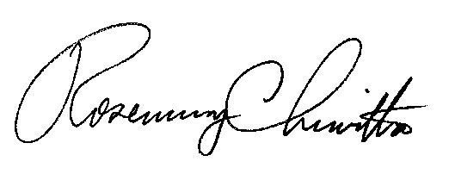

Rosemary Chiavetta

Secretary

