 | COMMONWEALTH OF PENNSYLVANIA  PENNSYLVANIA PUBLIC UTILITY COMMISSION  400 NORTH STREET, HARRISBURG, PA 17120 | IN REPLY PLEASE REFER TO OUR FILE

September 1, 2020
Docket No. M-2020-3019711
Utility Code: 125042

RAYMOND J. WELTE
PHILAPELPHIA GAS WORKS
800 W. MONTGOMERY AVENUE
PHILADELPHIA, PA 19122
RAYMOND.WELTE@PGWORKS.COM

Re: Periodic Review of Philadelphia Gas Works’ Long-Term Infrastructure Improvement Plan.

Dear Mr. Welte:

The Commission is required to review a utility’s Long-Term Infrastructure Improvement Plan (LTIIP) periodically, but at least once every five (5) years. Unless otherwise directed, the review shall begin at the midpoint of the term of the current LTIIP. Philadelphia Gas Works’ (PGW’s) current LTIIP began on September 1, 2017, and is in effect until August 31, 2022, and thus the midpoint is approximately March 1, 2020.

PGW is hereby notified that the Commission will begin the review of their LTIIP on September 1, 2020 at the docket number referenced above. The Commission’s review will determine:

- If PGW has adhered to its LTIIP
- If changes to the LTIIP are necessary to maintain and improve the efficiency, safety, adequacy and reliability of PGW’s existing distribution infrastructure.

Upon completion of the review, the Commission shall issue an Order with a determination of whether or not PGW has adhered to its LTIIP and if any changes to the LTIIP are necessary. The Commission will direct PGW to revise, update, or resubmit its LTIIP as appropriate if it determines PGW’s approved LTIIP is no longer adequate to ensure and maintain efficient, adequate, safe, reliable and reasonable service. Upon such a determination, PGW may elect to withdraw its LTIIP rather than comply with the Commission’s direction. PGW’s approved distribution system improvement surcharge (DSIC) mechanism would immediately terminate upon such a withdrawal.

To aid in its review the Commission is establishing a thirty (30) day comment period beginning from the date of this letter and a twenty (20) day reply comment period. A copy of this letter has been served upon the statutory advocates, the Bureau of Investigation & Enforcement, and the parties of record from PGW’s most recent base rate case proceeding, consistent with the LTIIP filing and review procedures.

If you have any questions regarding this matter, please contact Matthew Stewart in the Bureau of Technical Utility services at mattstewar@pa.gov.

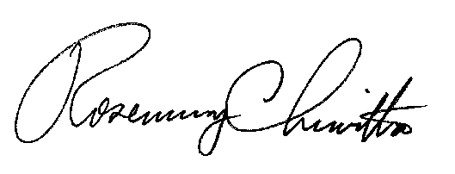
Sincerely,

Rosemary Chiavetta Secretary

Cc John Van Zant, TUS

Daniel Searfoorce, TUS

Kriss Brown, LAW

Richard Kanaskie, I&E

Robert Horensky, I&E

Tanya McCloskey, Office of Consumer Advocate, TMcCloskey@paoca.org

John Evans, Office of Small Business Advocate, jorevan@pa.gov

All Other Parties of Record for Docket No. R-2020-3017206

52 Pa. Code § 121.7(a).
Docket No. P-2017-2602315
52 Pa. Code § 121.7(c).
Docket No. R-2020-3017206
52 Pa. Code § 121.4(a).

