PENNSYLVANIA PUBLIC UTILITY COMMISSION
NOTICE TO BE PUBLISHED

Petition of Pike County Light & Power Company for Approval of Default Service Plan and Waiver of Commission Regulations and Nunc Pro Tunc Treatment for the Period June 1, 2021 through May 31, 2024
Docket Number: P-2020-3022988
___________________________________________________

Formal Protests, Petitions to Intervene and Answers must be filed in
Accordance with Title 52 of the Pennsylvania Code on or before December 29, 2020. All filings must be made with the Secretary of the
Pennsylvania Public Utility Commission, 400 North Street, Harrisburg,
PA 17120, with a copy served on the Petitioner and a copy
provided to the Administrative Law Judge. The documents filed in
support of the Petition are available for inspection and copying at the Office of the Secretary between the hours of 8:00 a.m. and 4:30 p.m., Monday through Friday, and at the Petitioner’s business address.

Applicants:
Pike County Light & Power Company
Through and by Counsel:
Whitney Snyder, Esquire
Hawke McKeon & Sniscak LLP
100 North Tenth Street
Harrisburg, PA 17101
wesnyder@hmslegal.com

Call-In Telephone Pre-Hearing Conference Notice

This is to inform you that an Initial Call-In Telephonic Prehearing Conference on the above-captioned case will be held as follows:

Type: Initial Call-In Telephonic Prehearing Conference
Date: Tuesday, January 5, 2021

Time: 10:00 AM

Presiding: Administrative Law Judge Eranda Vero

At the above date and time, you must call into the conference. You will not be called by the Administrative Law Judge.

To participate in the conference,

- You must dial the toll-free number listed below
- You must enter a PIN number when instructed to do so, also listed below
- You must speak your name when prompted
- The telephone system will connect you to the hearing

Toll-free Bridge Number: 1-866-560-8322
PIN Number: 36676820

If you require an interpreter to participate in the hearings, we will make every reasonable effort to have an interpreter present. Please call the scheduling office at the Public Utility Commission at least ten (10) business days prior to your hearing to submit your request.

- Scheduling Office: 717.787.1399
- AT&T Relay Service number for persons who are deaf or hearing-impaired: 1.800.654.5988

The Public Utility Commission offers a free eFiling Subscription Service, which allows users to automatically receive an email notification whenever a document is added, removed, or changed on the PUC website regarding a specific case. Instructions for subscribing to this service are on the PUC’s website at http://www.puc.pa.gov/Documentation/eFiling_Subscriptions.pdf

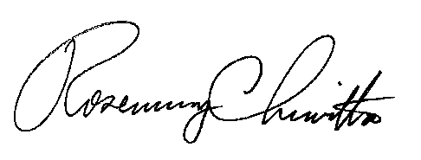
BY THE COMMISSION

Rosemary Chiavetta
Secretary

