 | COMMONWEALTH OF PENNSYLVANIA  PENNSYLVANIA PUBLIC UTILITY COMMISSION  400 North Street, Harrisburg, Pennsylvania 17120 | IN REPLY PLEASE REFER TO OUR FILE
November 30, 2020

TO: All Regulated Telecommunications Carrier

The Pennsylvania Public Utility Commission (Commission) has updated the instructions to its annual Assessment Report (Form GAO-20) to explain more explicitly how jurisdictional telecommunications public utilities are to report total gross intrastate operating revenues for Section 510 fiscal assessment purposes. The scope of the revenues to be reported for assessment purposes under that statutory provision has not changed.

However, the instructions have been revised to explain more explicitly that all utilities must report all gross intrastate operating revenues. This includes the following: (1) The reporting by incumbent and competitive local exchange carriers of revenues from all local network services and revenues from unbundled network elements as a part of their Local Network Services Revenues; (2) Explicit instructions to ILECs and CLECs to include special access services revenues, de facto intrastate revenues from special access services or other jurisdictionally mixed telecommunications services, and wholesale transmission or transport revenues in the monetary figure they report as Network Switched Access Services revenues, including revenues from the provision or exchange of traffic over any networks; and (3) Explicit direction to Competitive Access Providers and any other certificated telecommunications public utility providing a similar wholesale access service regardless of the network facilities used to include the following types of revenues when they report revenues:

1. Intrastate Special Access Services Revenues.

2. De Facto Intrastate Revenues from Special Access or Other Jurisdictionally Mixed Telecom Services (for additional guidance, see Commission Policy Statement adopted July 11, 2019, Docket No. M-2018-3004578, 49 Pa.B. 5003 (Aug. 31, 2019) 52 Pa. Code § 69.3701).

3. Intrastate wholesale transmission or transport services revenues not already included where such wholesale transmission or transport services involve the transmission of any traffic, including but not limited to intrastate voice.

To confirm compliance, the Commission is also requiring telecommunications public utilities to attach supporting documentation to verify the revenue data they submit.

Finally, in addition to providing more explicit instructions to assure complete and accurate reporting, the Commission has included new notices directly on Form GAO-20 advising that reports that are filed on other than Commission Form GAO-20, that do not comply with the revised instructions, and that fail to authorize release of state tax records will be rejected as noncompliant and subject to appropriate penalties.

All jurisdictional telecommunications public utilities will be required to use the updated Form GAO-20 for the 2020 revenue reporting period, which is due on March 31, 2021. Any questions regarding Assessment Reports should be directed to the Commission’s Assessment Section at (717) 265-7548.

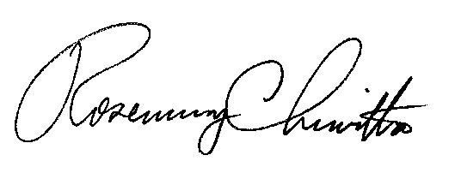
Sincerely,

Rosemary Chiavetta
Secretary

