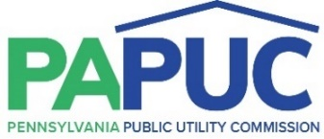 | COMMONWEALTH OF PENNSYLVANIA  PENNSYLVANIA PUBLIC UTILITY COMMISSION  COMMONWEALTH KEYSTONE BUILDING  400 NORTH STREET  HARRISBURG, PENNSYLVANIA 17120
December 23, 2021

Docket No. R-2020-3017206
Utility Code: 125042

Craig Berry
Philadelphia Gas Works
800 West Montgomery Avenue
Philadelphia, PA 19122

Re: Pennsylvania Public Utility Commission v. Philadelphia Gas Works

Dear Mr. Berry:

By Order entered November 19, 2020, the Commission authorized Philadelphia Gas Works (the Company) to file tariff supplements designed to increase annual distribution rate revenue as follows: (1) $10 million for service rendered on or after January 1, 2021; (2) additional $10 million for service rendered on or after July 1, 2021; and (3) $15 million for service rendered on or after January 1, 2022 in accordance with the Joint Petition for Partial Settlement filed in the above docketed rate investigation. On December 17, 2021, the Company filed Supplement No. 147 to Gas Service Tariff - Pa P.U.C. No. 2 to implement the third phase of the Company’s approved rate increase, effective January 1, 2022.

Commission Staff has reviewed the tariff revisions and found that suspension or further investigation does not appear warranted at this time. Therefore, in accordance with 52 Pa. Code Chapter 53, Supplement No. 147 to Gas Service Tariff - Pa P.U.C. No. 2 is effective by operation of law as of the effective dates contained on each page. However, this is without prejudice to any formal complaints timely filed against said tariff revisions.

If you have any questions in this matter, please contact Marissa Boyle, Bureau of Technical Utility Services at maboyle@pa.gov.

Sincerely,

Rosemary Chiavetta
Secretary

