ACT 13 – Public Utility Commission
PRODUCER’S USER GUIDE
Website address: https://www.act13-reporting.puc.pa.gov
The first screen will ask you for your User ID and Password. This information was mailed to your Company on August 3, 2012. Once the information is entered click “login.”
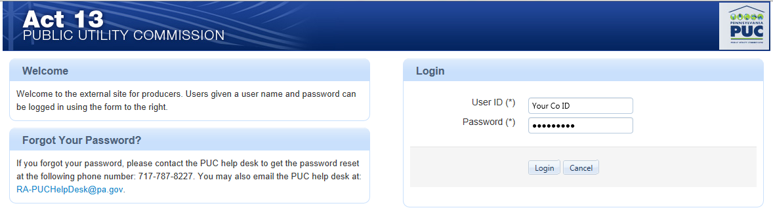
*********
When you initially login you will need to change the temporary password. Also you must select two security questions and provide the answers. This information will be used by the help desk in the event that you forget your password. Once finished click “Save.” 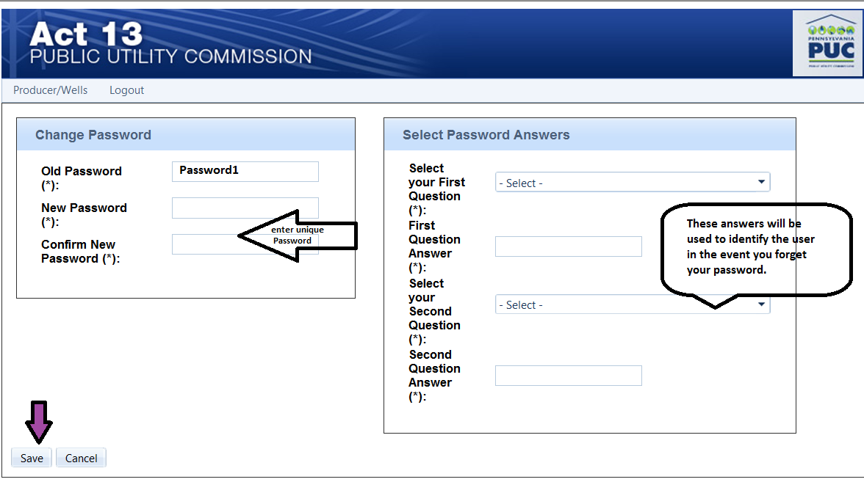
Once the password is changed you will enter the system and be able to access your Company’s currently available information. This first page is the producer page. 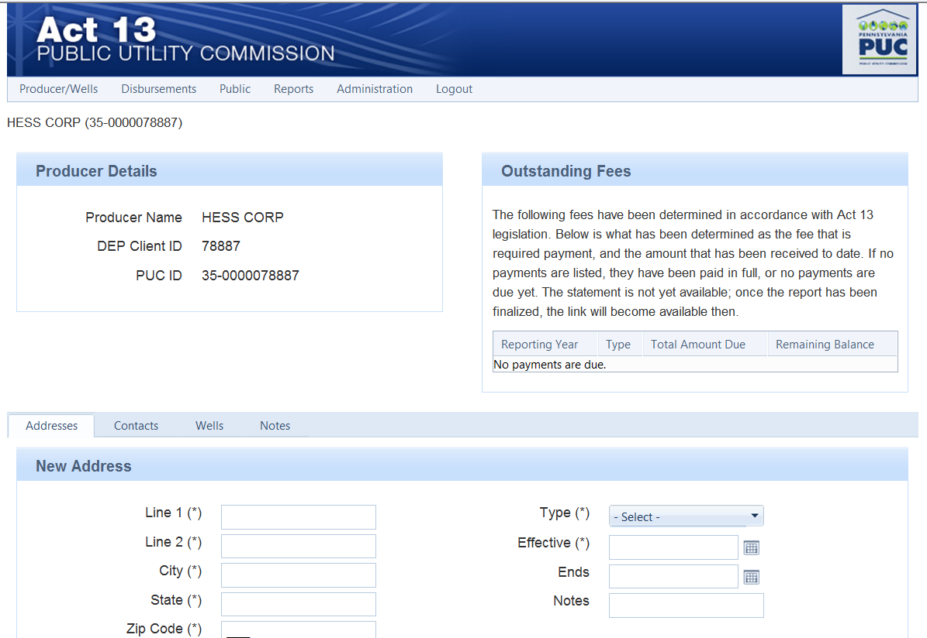
Company Name
Information as reported from DEP
Company Name
If you need to change, delete or add an Address/Contact/Notes please use this screen to input this information. In the notes section of this Producer Page is where you tell us of any change that is Company related. The well tab is informational only. After entering information into any tab please click “save.”
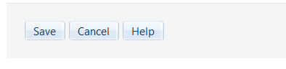
To begin reporting information regarding well data click on the Producer/Well Tab and select one of the following reports. (Producer Details is the first screen available upon entry into system).
Producer Details | This is the home page where Corporate changes are made.
Annual Report | This page is only available at year end to view well data/dispute wells/make notes. All well changes/additions must be done on the monthly reports
Monthly Report | This report will be used to make ALL well edits- changes to status, new wells, notes for the PUC regarding blocked change areas. When reviewing the annual report if well changes must be made you will use the monthly report to make the needed changes.
Well Transfer | This form needs completed by BOTH the Seller and the Buyer in order to complete the transfer.

Below is a screen shot of the opening page when selecting Monthly Report. You can add new wells, new notes or review existing notes including notes from the PUC. This will also notify you if the PUC has reviewed your notes. Save when finished entering data.
NOTE: please take extra care when entering Latitude and Longitude into the well record because this information is pertinent when the PUC calculates the applicable municipal disbursement regarding 5 linear miles from the well.
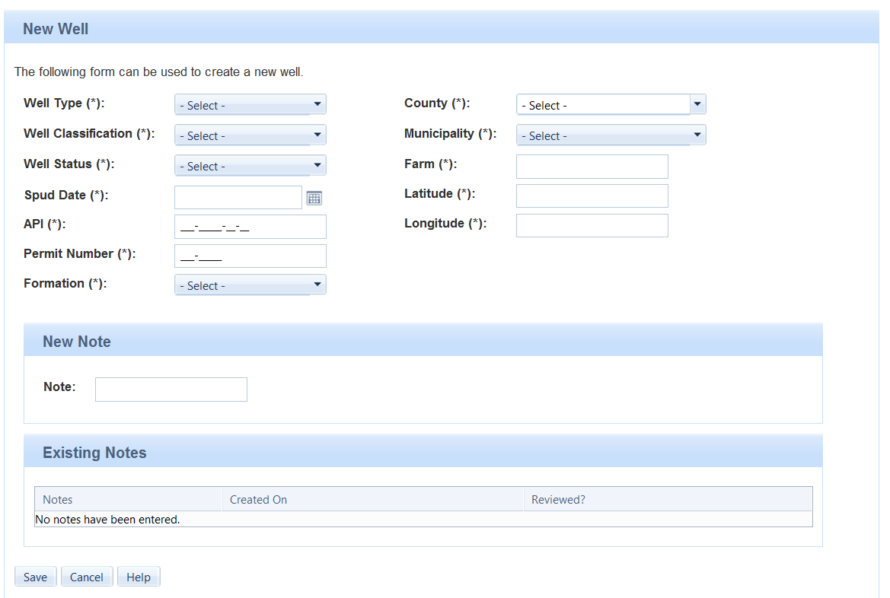
The bottom section of this screen has a listing of your Existing Wells. You can type in the API or Farm Name to go directly to that particular well. You can also click on each column heading in order to sort the listing by that category. If you click on a well in the listing the well information appears in the upper portion of the screen with the title “Edit Well.” Areas that you cannot change are greyed and if changes are necessary you must include that information in the “New Notes” section, PUC can only make these changes. When finished remember to save any input information.
The option to export this file to excel is available. You can then manipulate the data as necessary and just return to the monthly report to make necessary changes.
The last screen available under this heading is the “Transfer of a Well” and this is what will appear when you select this option:
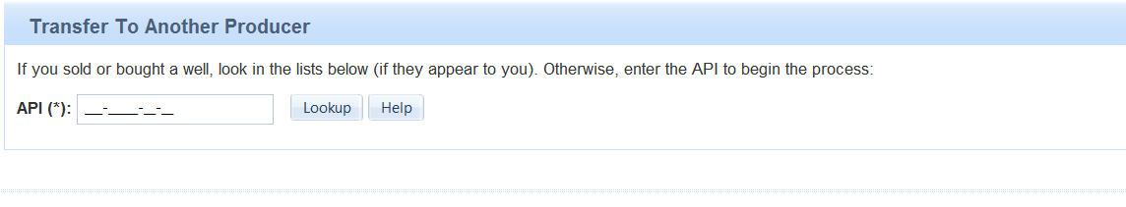
The last screen available under the Producer/Wells tab is the Annual Report. This report can only be accessed for a prior calendar year wells from approximately February 1, through April 1 in order to prepare a statement for that year’s impact fee payment. It is important to remember that you cannot edit any well data in this report. All well data must be edited in the Monthly reports. What you can do is write notes or dispute a well. All well status changes that reflect production levels applicable to stripper well or less must be made in the December Monthly report, along with any applicable notes. This information will be used in desk reviews or audits of production data if necessary.
After you have completed your review you must finalize the report by clicking on
Finalize Report
PLEASE NOTE: Once you finalize the report you cannot make any changes, if you need to make changes you must contact the PUC. (Numbers are listed below)
After the report is finalized the payment box on the Producer page will be completed (see below)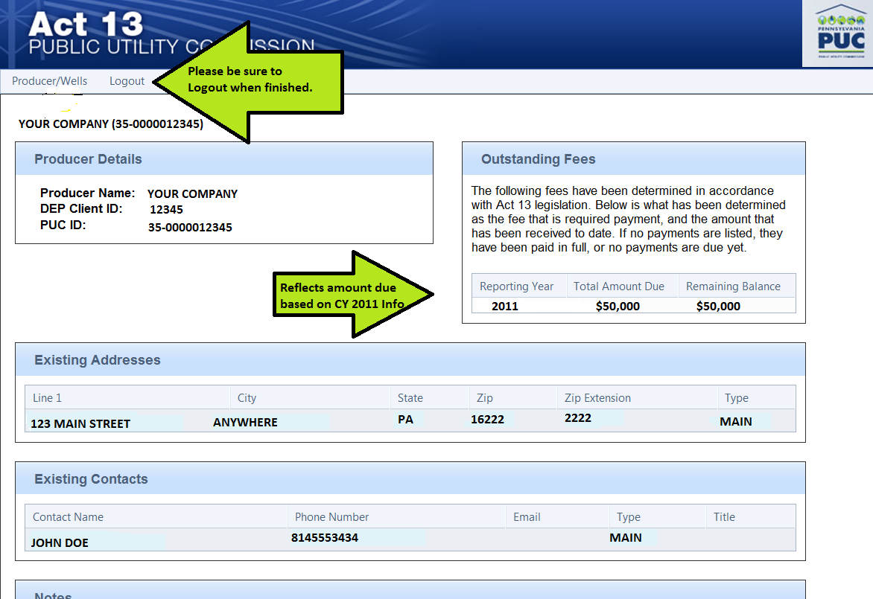
When finished please logout of the program.
If you have any questions regarding your login information, or encounter problems inputting data, please contact Amy Zuvich at 717-783-6806 or Yvonne Hess at 717-783-6190.

