EDEWG Change Request SU-MR #001

This EDEWG Change Request can be found on the PUC website at http://www.puc.pa.gov/electric/electric_edewg_download.aspx

Requester’s Name:  Joe Bisti | EDC/EGS Name:  PECO | Phone # :  215-841-5626
Date of Request:  11/11/2015 | Affected EDI Transaction Set #(s):  N/A – AMI SU-MR Portal Standard | E-Mail Address:  joseph.bisti@peco-energy.com
Requested Priority (emergency/high/low): Low | Requested Implementation Date:  ASAP | Status:  Approved / Pending update to documentation

Brief Explanation (This will be copied into the description in the Change Control Summary Spreadsheet):
PECO requests that EDEWG consider and implement a change to the SU-MR Solution Framework standard which incorporates interval increment length into the existing SU-MR account-level and meter-level downloadable file formats. This would also require adding “interval increment” data to the list of detailed usage items published within points 2.3.12 and 2.3.13 in the SU-MR portion of the Framework document.

Given that the SU-MR standard is now PUC-approved, PECO believes this should be the first SU-MR change control to be addressed via the normal EDEWG process, as opposed to the Web Portal Working Group discussions which require that focus remain on the system-to-system proposals.

Detail Explanation (Exactly what change is required? To which EDEWG Standards? Why?):
PECO is analyzing the effort required to implement the SU-MR web portal for sharing of usage data, in alignment with the approved SU-MR standards in the Solution Framework. The detail to be made available in the downloadable SU-MR file formats currently includes detailed interval usage with headers that simply identify the increments in sequence as shown below (NOTE: Image copied directly from the Solution Framework document).

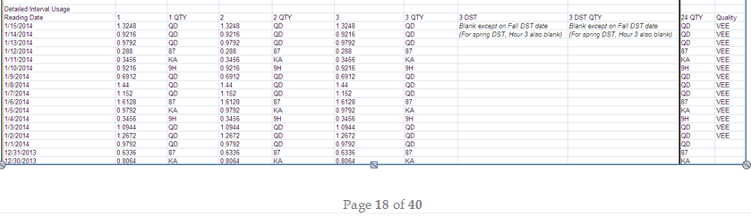

During PECO’s analysis, a question arose for a use case in which the interval increment provided within a given time period changes. This led to the discovery that neither the account-level nor meter-level downloadable file formats in the SU-MR standard currently provide interval increment data. The QTY field currently shown in the Framework example only shows the quantity qualifier (QD, KA, etc.) and not currently the increment of that interval.

EDEWG discussed on 12/3/2015 and agreed the change is to replace the sequential column headers (1, 2, 3) with the actual interval ending-time, as is currently being considered for the S2S Active EGS Rolling 10-Day as shown below (NOTE: image copied directly from the Solution Framework document). While this would create added consistency between the formats, it will require multiple SU-MR files be generated for the same account or meter – to prevent potential gaps in the data if/when the increment changes – or whether the gaps would be permissible.
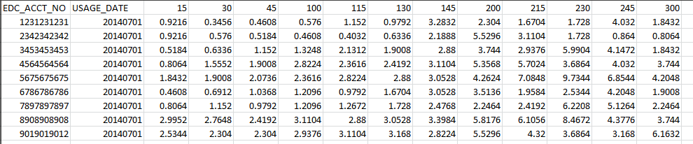

For Change Control Manager Use Only:
Date of EDEWG Discussion:  11/12/2015, 12/3/2015 | Expected Implementation Date:  TBD

EDEWG Discussion and Resolution:
11/12/2015 – Brandon Siegel: Received request, assigned SU-MR #001 and placed on 11/12/15 EDEWG meeting agenda.
12/3/2015 – Brandon Siegel: EDEWG discussed and agreed the first option provided in the original request will be used to resolve the issue. EDEWG approved SU-MR#001 based on the agreed changes. SU-MR#001has been updated to reflect the change.

Priority Classifications

Emergency Priority | Implemented within 10 days or otherwise directed by EDEWG
High Priority | Changes / Enhancements implemented with 30 days. The next release, or as otherwise directed by EDEWG
Low Priority | Changes / Enhancements implemented no earlier than 90 days, Future Release, or as otherwise directed by EDEWG

Please submit this form via e-mail to both jmccracken@pa.gov and lyalcin@pa.gov
at the PUC and to the
Change Control Manager, Brandon Siegel at brandon.siegel@intelometry.com

Your request will be evaluated and prioritized at an upcoming EDEWG meeting or conference call.

