EDEWG Change Request #147

This EDEWG Change Request can be found on the PUC website at http://www.puc.pa.gov/electric/electric_edewg_download.aspx

Requester’s Name:  Monica Neibert | EDC/EGS Name:  Energy Services Group | Phone # :  781-347-9039
Date of Request:  2/8/2018 | Affected EDI Transaction Set #(s):  867M, 867IU, 867HI | E-Mail Address:  mneibert@energyservicesgroup.net
Requested Priority (emergency/high/low): Low | Requested Implementation Date:  N/A – Admin Only | Status:  APPROVED / Implemented into IGs listed below in EDEWG D&R section.

Brief Explanation (This will be copied into the description in the Change Control Summary Spreadsheet):
Incorporate Citizens and Wellsboro into Regional IGs.

Detail Explanation (Exactly what change is required? To which EDEWG Standards? Why?):
Update 867MU Pennsylvania Notes pages 8-9 to add Citizens and Wellsoboro practices.
Update 867IU Pennsylvania Notes pages 10-11 to add Citizens and Wellsoboro practices.
Update 867HI Pennsylvania Notes pages 8-9 to add Citizens and Wellsoboro practices.
Update 867HI Pennsylvania Notes page 7 to add Citizens and Wellsoboro practices.

For Change Control Manager Use Only:
Date of EDEWG Discussion:  5/3/2018 | Expected Implementation Date:  N/A – Admin Only

EDEWG Discussion and Resolution:
2/15/2018: Brandon Siegel: Reviewed CC & placed into temporary hold pending completion of all C&W change requests
2/15/2018: Brandon Siegel: Incorporated into IG867MUv6-5D.docx, IG867IUv6-5D.docx, IG867HIv6-3D.docx, IG867HUv6-4D.docx
4/5//2018: Brandon Siegel: C&W change requests finalized, assigned #147 & placed on May meeting agenda.
5/3/2018: Brandon Siegel: EDEWG approved without revision, already implemented into IGs.

Priority Classifications

Emergency Priority | Implemented within 10 days or otherwise directed by EDEWG
High Priority | Changes / Enhancements implemented with 30 days. The next release, or as otherwise directed by EDEWG
Low Priority | Changes / Enhancements implemented no earlier than 90 days, Future Release, or as otherwise directed by EDEWG

Please submit this form via e-mail to both the PUC at jmccracken@pa.gov and lyalcin@pa.gov and to the
Change Control Manager, Brandon Siegel at brandon.siegel@intelometry.com
Your request will be evaluated and prioritized at an upcoming EDEWG meeting or conference call.
For 867MU
 |  | Pennsylvania Notes
What document is sent if supplier elects NOT to receive detail interval data? |  | If a supplier elects to receive only summary level information for an interval account, they will receive an 867MU document.  The 867IU document will be used when interval detail and summary level data is being sent.  Pennsylvania:  - Duquesne – Will provide detail interval data using 867IU with BB, SU, and BQ loops. If summary level is requested, will provide an 867MU with BB, SU, and PM loops (BPT04 will be “X5”).  - FIRST ENERGY – Will provide detail interval data using 867IU with BB, SU, and BQ loops. If summary level is requested, will provide an 867MU with BB, SU, and PM loops (BPT04 will be “X5”).  - PECO – If account-level interval detail is requested, will provide using 867IU with BB, SU, and BQ loops. If meter-level interval detail is requested, will provide using BB, BO, and PM loops. Else, will provide an 867MU with BB, SU, and PM loops (BPT04 in 867MU will be “DD” for AMR monthly metered accounts and “X5” for interval metered accounts).  - PPL EU – Will provide detail interval data using 867IU with BB, SU, and BQ loops. If summary level is requested, will provide an 867MU with BB and SU loops (BPT04 will be “DD”)  - UGI – No interval customers.  - Citizens and Wellsboro – will provide detail interval data using 867IU with BB, BO, PM loops. The default is summary and 867MU and is sent with BB, SU, PM (BPT04 will be “DD”).

For 867MU (Continued)
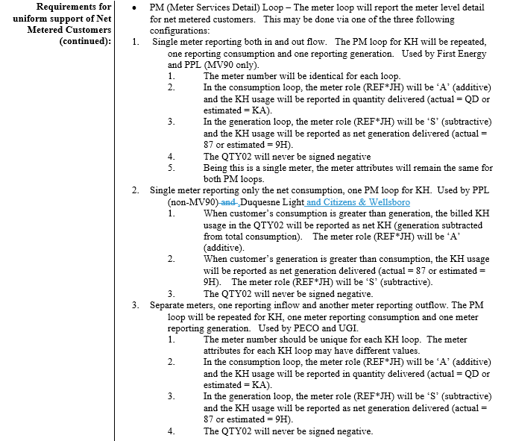
For 867IU

 |  | Pennsylvania Notes
What document is sent if supplier elects NOT to receive detail interval data? |  | If a supplier elects to receive only summary level information for an interval account, they will receive an 867MU document.  The 867IU document will be used when interval detail and summary level data is being sent. Listed below are the plans, by utility, of the information to be sent for summary and detail transaction. .  - Duquesne – Will provide detail interval data using 867IU with BB, BO and PM loops. If summary level is requested, will provide an 867MU with BB, SU, and PM loops (BPT04 will be “X5”).  - FIRST ENERGY – Will provide detail interval data using 867IU with BB, SU, and BQ loops. If summary level is requested, will provide an 867MU with BB, SU, and PM loops (BPT04 will be “X5”).  - PECO – If account-level interval detail is requested, will provide using 867IU with BB, SU, and BQ loops. If meter-level interval detail is requested, will provide using BB, BO, and PM loops. Else, will provide an 867MU with BB, SU, and PM loops (BPT04 in 867MU will be “DD” for AMR monthly metered accounts and “X5” for interval metered accounts).  - PPL EU – Will provide detail interval data using 867IU with BB, SU, and BQ loops. If summary level is requested, will provide an 867MU with BB and SU loops (BPT04 will be “DD”)  - UGI – No Interval Usage Customers  - Citizens and Wellsboro – will provide detail interval data using 867IU with BB, BO, PM loops. The default is summary and 867MU and is sent with BB, SU, PM (BPT04 will be “DD”).

For 867IU (Continued)
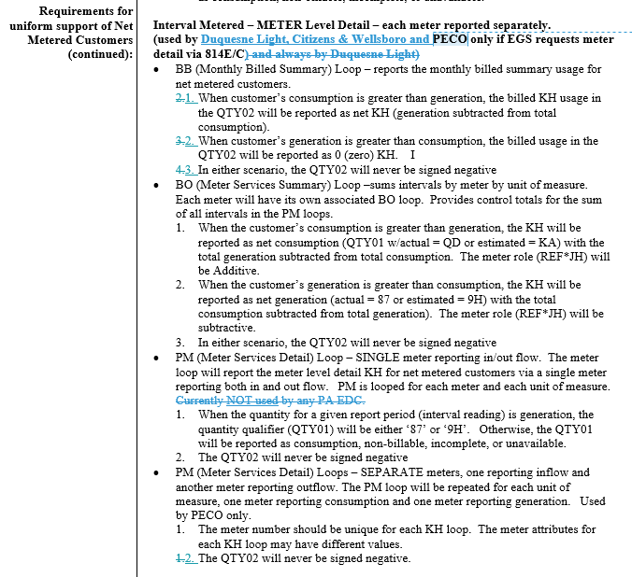
For 867HI

Use |  | Pennsylvania Notes  - Transaction is conditional in Pennsylvania. PUC order dated 12/5/2012, Docket # M-2009-2092655, Page 13 requires “all EDCs covered by the smart meter mandates to install the capability to share a minimum of 12 months of historical interval account level or meter level usage via EDI.”  - The EDC will provide interval detail at the lowest recorded level. The EGS will not be able to request a specific interval level.  - EDC support of 867HI:  - Duquesne – Supports; utilizes account summary loops (SU & BQ)  - First Energy (ME,PE,PP, & WPP)– Supports; utilizes account summary loops (SU & BQ)  - PECO – Supports; utilizes account summary loops (SU & BQ) for MV90 metered accounts and single rate AMI metered accounts. For AMI customers with more than one rate (service point), utilizes rate loops (RT & BQ).  - PPL EU – Supports; utilizes account summary loops (SU & BQ)  - UGI – Does not support  - Citizens & Wellsboro – supports; utilizes SU, BQ, FG loops

For 867HI (Continued)
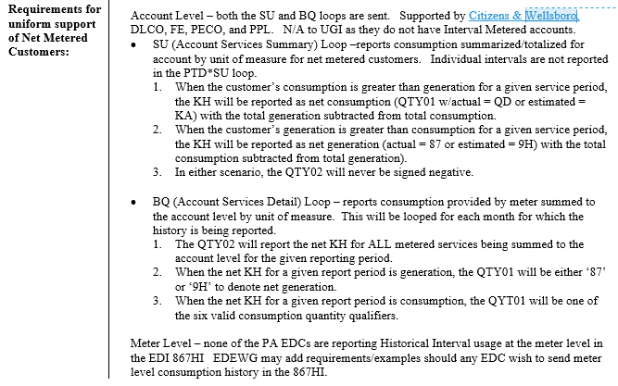

For 867HU
