EDEWG Change Request #166

This EDEWG Change Request can be found on the PUC website at http://www.puc.pa.gov/electric/electric_edewg_download.aspx

Requester’s Name:  Cheryl Oehler | EDC/EGS Name:  PPL Electric Utilities | Phone # :  610 984-5200
Date of Request:  1/5/2022 | Affected EDI Transaction Set #(s):  814 Change | E-Mail Address:  ctoehler@pplweb.com
Requested Priority (emergency/high/low): Low | Requested Implementation Date:  2022 | Status:  INCORPORATED in IG814Cv6-9.docx

Brief Explanation (This will be copied into the description in the Change Control Summary Spreadsheet):
On the 814 Change Response, add a new Rejection Reason Code (REF*7G) of B39 – “Unable to process request due to pending drop”.

Detail Explanation (Exactly what change is required? To which EDEWG Standards? Why?):
Add B39 – Invalid Rate Change Acct Has Pending Drop rejection response code in the 814C Implementation Guide for 814 Change Reject Response. This rejection code is used when rejecting EGS requested rate changes or bill method changes on accounts that already have a pending drop. PPL is sending a code in production on the 814 Change transaction that is not included in the 814C Implementation Guide for EDEWG. Note: the code is being used for the 814 Drop

ST*814*0013
BGN*11*20211207171206790623*20211104***213080008489675
N1*8S*PPL ELECTRIC UTILITIES*9*007909427AC**41
N1*SJ*xxxxxxxxxxx*1*080311127**40
N1*8R*xxxxxxxxxxxxxxxxxx
LIN*213080008489675*SH*EL*SH*CE
ASI*U*001
REF*7G*B39
REF*11*1684252
REF*12*xxxxxxxxxx
SE*11*0013

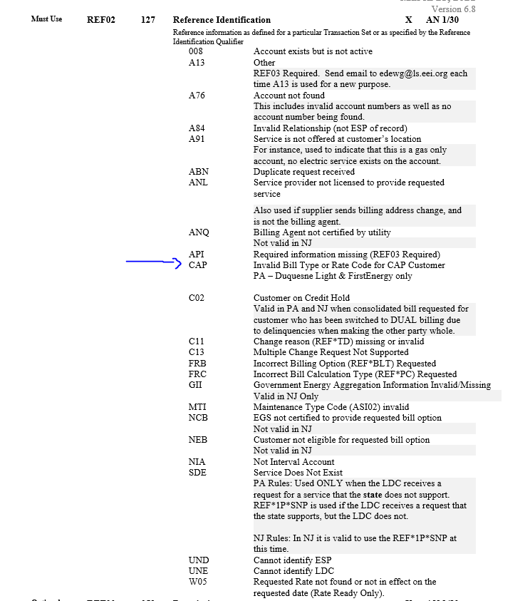

For Change Control Manager Use Only:
Date of EDEWG Discussion:  1/6/2022 | Expected Implementation Date:  TBD

EDEWG Discussion and Resolution:
1/6/2022 – Brandon Siegel: Received request, added to Change Control log, assigned #166 and placed on January 2022 meeting agenda.
1/6/2022 – Brandon Siegel: EDEWG reviewed and approved EDI CC #166 for incorporation into next IG version update.
1/27/2022 – Brandon Siegel: INCORPORATED in IG814Cv6-9.docx

Priority Classifications

Emergency Priority | Implemented within 10 days or otherwise directed by EDEWG
High Priority | Changes / Enhancements implemented with 30 days. The next release, or as otherwise directed by EDEWG
Low Priority | Changes / Enhancements implemented no earlier than 90 days, Future Release, or as otherwise directed by EDEWG

Please submit this form via e-mail to both the PUC at jmccracken@pa.gov and lyalcin@pa.gov and to the
Change Control Manager, Brandon Siegel at brandon.siegel@intelometry.com
Your request will be evaluated and prioritized at an upcoming EDEWG meeting or conference call.

