Act 13
Reporting
User Manual

Table of Contents
Login Instructions Page 3
Change Password Page 4
Details Tab Page 4
Accounts Tab* Page 5
Address Tab Page 6
Contacts Tab Page 7
Notes Tab Page 7
Impact Fee Spending** Page 8
Logout Page 11

*Entering your budget on the Accounts tab takes the place of submitting a Municipality Approved Budget Report.
**Entering your Impact Fee Spending takes the place of submitting an Unconventional Gas Well Fund Usage Report.

Login

Using the link below, go to the homepage of the Act 13 Reporting website. Click Login.
https://www.act13-reporting.puc.pa.gov/Modules/PublicReporting/Overview.aspx

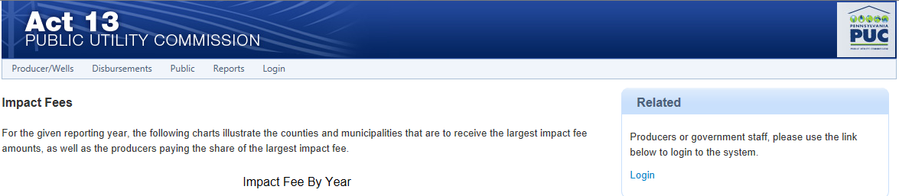
You may use either link. They will both take you to the login page.

Once you are on the login page, enter your 8 digit User ID and Password. Click Login.

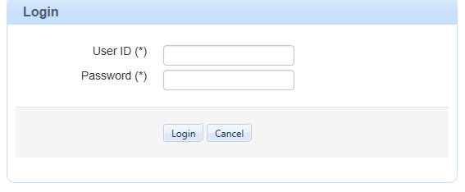
*********
12345678

Change Password

After you have logged in, hover your cursor over Administration. A drop down list will appear. Select Change Password.

Type in your Old Password. Once you have decided on a new password, enter it in the field for New Password and Confirm Password. Click Change Password.

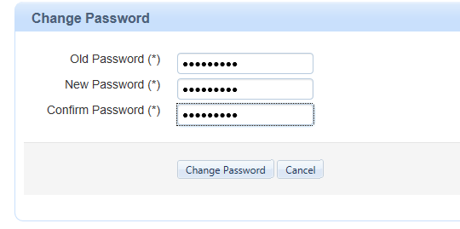

Details Tab

On this tab, you can view information about your county or municipality.

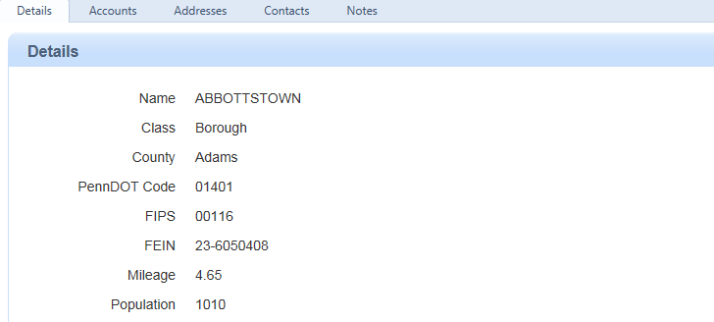

Accounts Tab

*This replaces the Municipality Approved Budget Report forms that you are required to submit by March 1st each year.*

After you have logged in, click on the Accounts tab. Under Update Budget, use the drop down box to select a Budget Year. Enter Budget Total in the next field. Click Save. (Your 2013 Budget is due by March 1, 2015.)

The figures found under Account Information are for informational purposes only. You do not have the ability to update your SAP Account via the Act 13 website. If you wish you update your SAP Account, please contact Commonwealth Vendor Management Unit (CVMU) at 877-435-7363 (then press 1) or
ra-psc_supplier_requests@pa.gov.

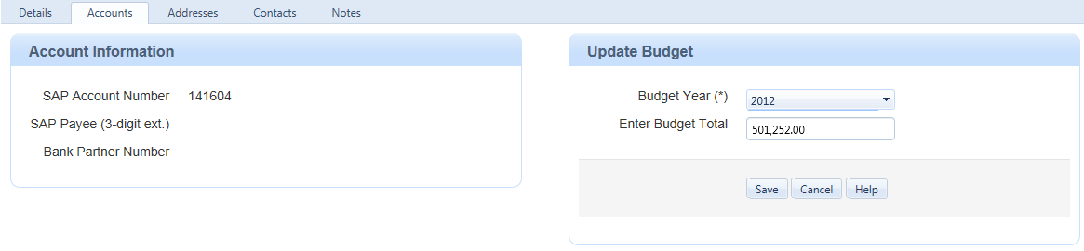
Click on the arrow for drop down box

Address Tab

If you wish to add or update your address, select the Address tab. You are required to fill in any fields that have an asterisk (*). Select Main as the address Type. Use the current date as the Effective date. Only put a date in Ends if the address should no longer be used. Click Save.

To update an address, click on the address under Existing Addresses. The address will populate the fields above. Make necessary changes and click Save.

Please note that the address you provide here does NOT affect where your impact fee payment will be sent. If you wish to change the address where your payment will be sent, you will need to update your SAP Account. To do so, please contact the Commonwealth Vendor Management Unit (CVMU) at
877-435-7363 (press 1) or ra-psc_supplier_requests@pa.gov.

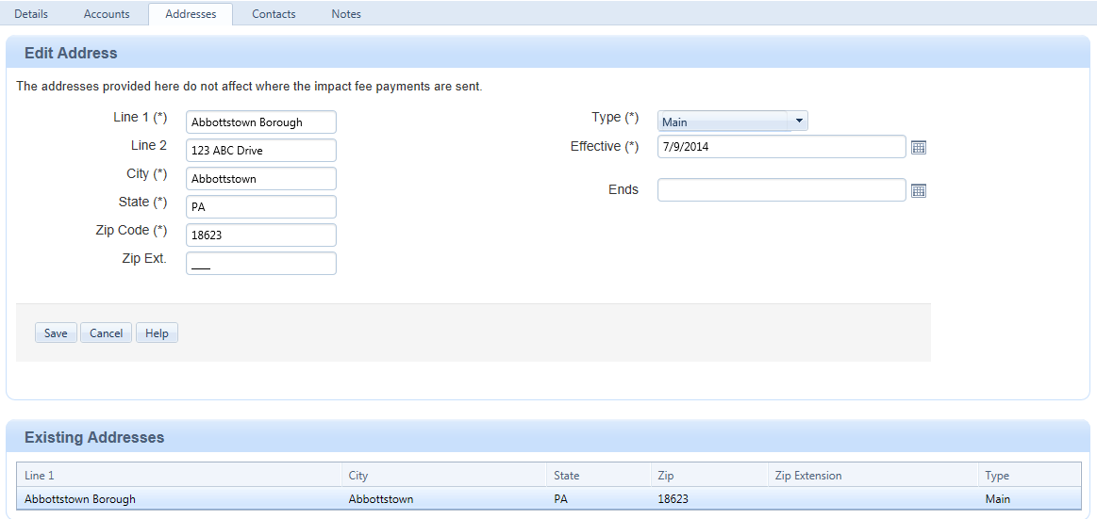
Select Main for Address Type

Use current date

Contacts Tab

If you wish to add or update your contacts, select the Contacts tab. You are required to fill in any fields that have an asterisk (*). Select Main as the contact Type. Use the current date as the Effective date. Only put an Ends date if the person listed is no longer the contact for Act 13 related issues. Click Save.

To update a contact, click on the name you wish to update under Existing Contacts. Their contact information will populate in the fields above. Make necessary changes. Click Save.

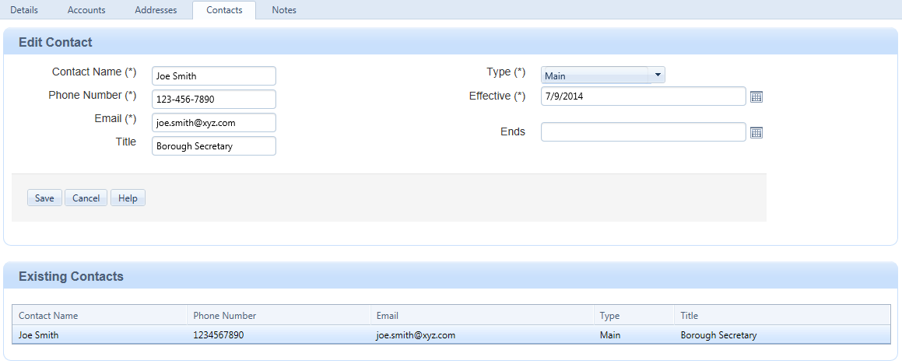
Use current date

Select Main for Contact Type

Notes Tab

Use the Notes tab to add any comments that you may have. Click Save.

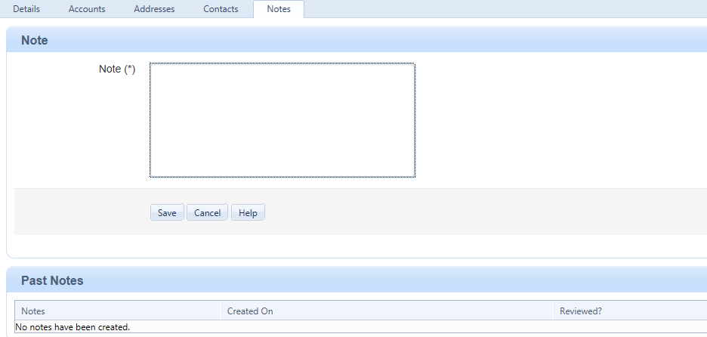

Impact Fee Spending

*This replaces the Unconventional Gas Well Fund Usage Report that you were required to submit by April 15th each year.*

After you have logged in, hover your cursor over Local Government. When the drop down list appears, select Impact Fee Spending.

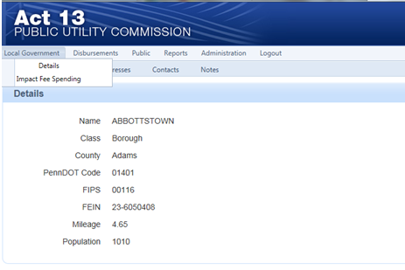

On this page, you will account for how you spent OR how you plan to spend the monies that your municipality received from the 2013 impact fee. You must account for the total dollar amount that you received. If you try to save your entries when they do not add up to the exact amount that you received, your entries will not save and you will get an error message at the top of the page.

Below is an example of an incorrect entry.

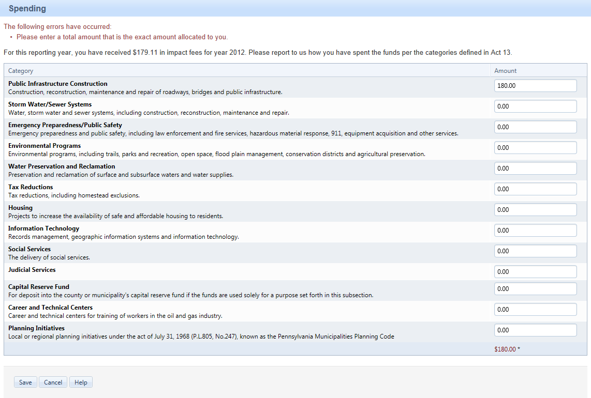
Amounts do not match

Enter dollar amounts in the categories that best describes your spending of the Act 13 funds. To move from one cell to the next, use the Tab key or use your mouse to place the cursor in the cell. DO NOT use the Enter key. If you use the Enter key, all the amounts that you entered will go back to 0.00 and you will have to re-enter them. Click Save at the bottom of the page. (Please note, after you hit Save, the whirlybird will appear and your figures will save even though the database does not give you any indication that they have been saved. If you wish to confirm that they have been saved, leave this page and then go back to it. If your figures are still there, they have been successfully saved.)

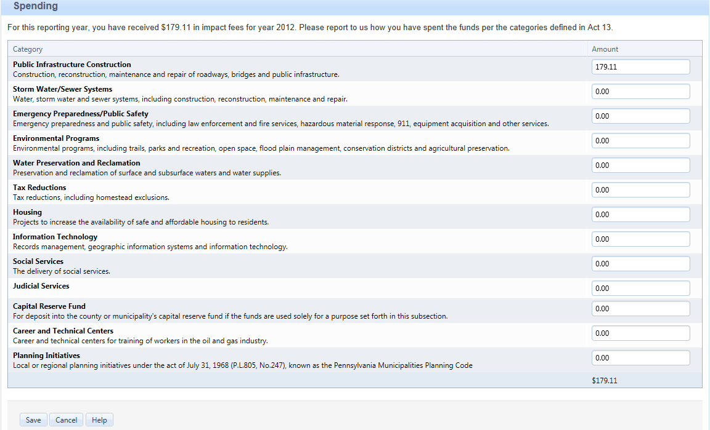
Amounts must match

To go back to your account details, hover your cursor over Local Government. When the drop down list appears, select Details.

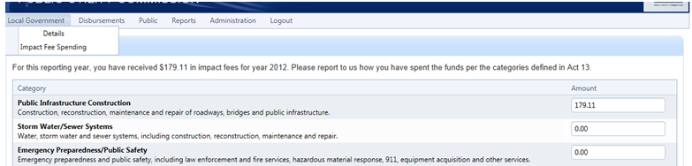

Logout

To logout of the Act 13 Reporting site, click Logout.

