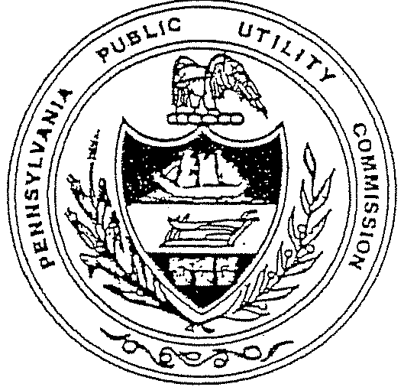
PENNSYLVANIA
PUBLIC
UTILITY
COMMISSION

2021-22 EXECUTIVE BUDGET REQUEST

BUDGET HEARING MATERIALS

FOR THE

HOUSE AND SENATE
APPROPRIATIONS COMMITTEES

DEPARTMENT: Public Utility Commission

DATE: March 1, 2021

TRANSMITTAL STATEMENT

TO THE CHAIRMAN, SENATE AND HOUSE APPROPRIATIONS COMMITTEES

The accompanying statements, schedules, and explanatory sheets represent the operating estimates of the Commission for all proposed expenditures for the 2021-22 Fiscal Year. The information contained herein supports a request for approval of an operating budget of $83,530,000, including $5,053,000 in anticipated Federal Funds.

Specifically, this request includes an increase in state funding in the amount of $416,000, or 0.53% above the current fiscal year’s approved budget. This increase is directly attributable to fund contractual obligations for salaries and benefits, continue all current programs. This budget request supports a complement of 526 total employees.

All statements and explanations contained in the estimates submitted herewith are true and correct to the best of my knowledge.

Signed: _________________________________

Gladys Brown Dutrieuille
Chairman

TABLE OF CONTENTS

SECTION PAGE

I. MISSION STATEMENT 1
II. PUC ORGANIZATION 2
III. 2021-22 BUDGET REQUEST 3
- Regulatory Priorities 3
- Complement Summary 3
- Personnel Costs 3
- Operating, Fixed Assets, Interagency Costs Summary 3
- Cost Reduction Proposals 3
- Budget Summary 4
- Commission Strategic Goals 4
H. Operational Objectives 5
IV. 2020-21 COMMISSION ACCOMPLISHMENTS 7
V. PROGRAM DESCRIPTIONS
A. Chairman, Commissioners, and
Commissioners’ Staffs 12
B. Executive Director 12
C. Office of Legislative Affairs 13
D. Office of Administrative Law Judge 13
E. Bureau of Investigation and Enforcement 13
F. Bureau of Technical Utility Services 14
G. The Secretary’s Bureau 14
H. Office of Special Assistants 14
I. Law Bureau 14
J. Bureau of Audits 15
K. Bureau of Consumer Services 15
L. Program Summary 15

SECTION PAGE
VI. COMMISSION BACKGROUND 16
VII. APPROPRIATION 16205, GENERAL
GOVERNMENT OPERATIONS
I-Summary Financial Data 20
II-Detail by Major Objective 21
III-History of Lapses 22
IV-Complement Information 22
V-Legislative Citations 22
VI-Explanation of Changes 23
VIII. LIST OF CONTRACTS 24
IX. SPECIAL FUNDS FINANCIAL STATEENTS 25
X. REQUEST FOR APPROPRIATION OF FEDERAL FUNDS 27

PENNSYLVANIA PUBLIC UTILITY COMMISSION
2021-22 BUDGET REQUEST
TO APPROPRIATIONS COMMITTEES OF
THE PENNSYLVANIA HOUSE AND SENATE

SECTION I

MISSION STATEMENT

DEPARTMENT: PUBLIC UTILITY COMMISSION

DATE: March 1, 2021

- MISSION STATEMENT

The Pennsylvania Public Utility Commission balances the needs of consumers and utilities; ensures safe and reliable utility service at reasonable rates; protects the public interest; educates consumers to make independent and informed utility choices; furthers economic development; and fosters new technologies and competitive markets in an environmentally sound manner.

PENNSYLVANIA PUBLIC UTILITY COMMISSION
2021-22 BUDGET REQUEST
TO APPROPRIATIONS COMMITTEES OF
THE PENNSYLVANIA HOUSE AND SENATE

SECTION II

PUC ORGANIZATION

The Pennsylvania Public Utility Commission (“Commission” or “PUC”) is an independent administrative commission established by the Legislature in 1937 to "supervise and regulate" all public utilities doing business in the Commonwealth.

The Commission is comprised of five full-time members nominated by the Governor, for staggered five-year terms, with the advice and consent of a majority of the members of the Senate.

Currently, under the Public Utility Code (Code), as codified in Title 66 of the Pennsylvania Consolidated Statutes Annotated, the Commission regulates more than
9,000 entities, including the following in-state services: electricity; natural gas; telecommunications and broadband (availability and speed in accordance with Pennsylvania statutory standards); water and wastewater collection and disposal; steam heat; transportation of passengers and property by motor coach, truck, taxicab and transportation network companies (TNCs); pipeline transmission of natural gas and hazardous materials; and public highway-railroad crossings.

The supervision and regulation of the public utilities includes establishing just and reasonable rates; providing for adequate, efficient, safe service and facilities; conducting audits, inspections, and investigations; developing energy forecasts, plans, and conservation guidelines; providing consumer services; and ensuring the enforcement of, and compliance with, public utility law and regulations.

In addition to staffing each Commissioner’s office, the Commission’s current complement of 526 employees is spread among 13 offices and bureaus reporting to an Executive Director: Regulatory Operations, Legislative Affairs, Secretary, Administration, Special Assistants, Technical Utility Services, Investigation and Enforcement, Audits, Law, Administrative Law Judge, Consumer Services, Cybersecurity and Communications.

The Commission is headquartered in Harrisburg with regional offices in Philadelphia, Pittsburgh and Scranton. Due to the COVID-19 emergency, the PUC office buildings are closed. The Commission remains fully operational, as personnel have been working remotely.

Generally, the regional offices serve as coordinating points for the Commission’s Bureaus of Investigation and Enforcement, Consumer Services, Audits and Administrative Law Judge. In addition to holding formal hearings, the regional offices field written and telephone inquiries and respond as necessary or forward the inquiries to Harrisburg for resolution.

PENNSYLVANIA PUBLIC UTILITY COMMISSION
2021-22 BUDGET REQUEST
TO APPROPRIATIONS COMMITTEES OF
THE PENNSYLVANIA HOUSE AND SENATE

SECTION III

2021-22 BUDGET REQUEST

The Commission receives its state funding from the assessments of jurisdictional public utilities based on their reported revenues from intrastate operations and the Commission's costs to regulate the various utility groups.

In addition, the PUC also assesses non-regulated natural gas pipeline operators under Act 127 of 2011, fees from Electric Generation Suppliers and Natural Gas Suppliers for the PUC’s oversight of these entities under Act 155 of 2014 and receives funding to administer Act 13 of 2012 - the unconventional gas well impact fee legislation. Also, a small portion of the funding is received based on various fees charged by the Commission.

REGULATORY PRIORITIES - This budget request reflects the PUC's regulatory priorities in the areas of (1) safe, adequate and reliable service at just and reasonable rates, (2) consumer services and education, (3) transportation safety and compliance, (4) competition, market-based pricing and incentive ratemaking and (5) fixed utility audits.

COMPLEMENT SUMMARY - This budget plan includes funding for a complement totaling 526. To control complement costs, vacancies are reallocated based on the operational needs of the PUC’s offices and bureaus. In this FY 2021-22 request we plan to review our need and ability to hire an additional (4) staff positions in gas safety inspections. If needed, this will be accomplished by reallocating vacant positions from elsewhere in the Commission. Also, the Commission will continue to use consultants, temporary hires and overtime as necessary and appropriate.

PERSONNEL COSTS - The total estimated personnel costs are $68,098,000 comprised of $64,152,000 in state funds, and $3,946,000 in federal funds. The increase requested in this budget reflects contractual obligations including bargaining unit contracts and increases for health care cost and retirement contributions for the complement we propose.

Operating, FIXED Assets, Interagency Costs Summary - The 2021-22 budget request for Operating, Fixed Assets, and Interagency costs is $15,432,000. This total is comprised of $14,325,000 in state funds and $1,107,000 in federal funds. The PUC has maintained a relatively flat budget over the past few years in operating costs.

COST REDUCTION PROPOSALS - The PUC’s ongoing cost reduction efforts address ways to increase individual productivity and operational efficiency within existing programs. Upgrades to InfoMAP continue improving both information flow to consumers and utilities as well as internal case tracking. It is expected that additional economies will be realized as utilities, practitioners and consumers more fully avail themselves of the ability to electronically file and access information.
GO-TIME projects have realized efficiencies in public hearings as well as conversion of decaying microfilm and microfiche to digital records. Also, a past reorganization has enhanced the overall structure of the PUC to increase efficiency and productivity in the regulation of the utilities and entities we oversee. Finally, the PUC has become a provider for offering continuing legal education credits required by the Pennsylvania Disciplinary Board and offers its attorneys the opportunity to acquire six of the twelve credits required each year at no cost to its attorneys and to those of the public advocates, which is a considerable savings for the Commission.

Budget Summary - The PUC is requesting $83,530,000 for budget year 2021-22, which includes $5,053,000 in potential Federal Funds, used to regulate motor carrier, rail safety and natural gas safety. Of the total amount requested, the State share of $78,477,000 will be obtained from assessments and fees paid by jurisdictional public utilities as well as assessments received for administration of Act 127 and Act 155. The $1,000,000 appropriation for the administration and oversight of Act 13 is a separate budget line item listed under “Other Funds”.

This budget request for $78,477,000 in State funding for the 2021-22 Fiscal Year represents a 0.53% increase over the current fiscal year state funding. The increase is to fund contractual salary and increased benefit obligations. In addition, we receive $1,000,000 for the duties assigned under Act 13 - The Unconventional Gas Well Impact Fee legislation.

COMMISSION’S STRATEGIC GOALS - The Commission has established the following strategic goals:

- To ensure that necessary utility service is reliably available to all Pennsylvania consumers at a reasonable cost.

- To foster development of competitive markets in the electric, telecommunications and natural gas industries.

- To promptly and effectively address anti-competitive activity by public utilities or licensed competitive suppliers.

- To promote greater public awareness and understanding of the public utility industry and related consumer protections and assistance programs.

- To establish policies that will encourage the public utilities to operate in the most environmentally compatible, safe, fair and cost-effective manner.
- To encourage and coordinate the upgrade of Pennsylvania’s electric, natural gas, water and wastewater systems.

- To implement and oversee new laws dealing with pipeline safety, unconventional gas well impact fees, and utility infrastructure improvements.

- To contribute to the economic development of Pennsylvania.

- To support Pennsylvania’s environmental initiatives, particularly with respect to alternative energy portfolio standards, and energy efficiency, conservation and demand side response programs.

- To continue improving internal efficiencies and enhancing public access to information maintained and produced by the Commission.

- To maintain policies and procedures for recruiting and retaining an efficient, diverse and well-trained Commission staff to enhance performance and promote timely, consistent, well-reasoned regulatory decisions.

- To provide the General Assembly and Congress with policy recommendations promoting the interest of consumers in state and federal regulatory forums.

- To provide affordability for low-income consumers by offering assistance programs to assist consumers in maintaining utility services.

Operational OBJECTIVES - The PUC strives to operate in the most cost-efficient manner possible and continues reviewing staffing levels in all bureaus.

The Commission continues to carry out the mission and duties assigned by the General Assembly. The PUC’s traditional responsibilities include ensuring the rates charged by public utilities are just and reasonable and that public utilities provide safe, adequate and reliable service.

During the development of this Executive Budget Request, the Commission reviewed its strategic goals, programs and priorities. The PUC continually faces new regulatory challenges to current and past practices, responding to known and anticipated changes in the regulatory environment. Initiatives to increase competition in the competitive markets are ongoing and continually require the PUC to reallocate staff resources and develop ways to enhance operational efficiency within existing programs.

All offices and bureaus have developed complementary and supporting goals and operational objectives for FY 2021-22. The objectives indicate: (1) what we intend to accomplish, (2) what the priorities are, (3) who is responsible for specific actions and (4) when they will be completed.

PENNSYLVANIA PUBLIC UTILITY COMMISSION
2021-22 BUDGET REQUEST
TO APPROPRIATIONS COMMITTEES OF
THE PENNSYLVANIA HOUSE AND SENATE

SECTION IV

2020-21 COMMISSION ACCOMPLISHMENTS

The Commission’s budget for the current fiscal year was approved by the General Assembly and the Governor in July of 2020. While most agencies were approved for a five-month budget, as an independent agency and funded by a restricted revenue account and no general funds dollars, the Commission had its entire fiscal year budget approved.

When presented with the ever-changing environment of the COVID-19 pandemic, the Commission not only began preparing ahead of time, but continues to deliver dedicated public service. In response to the Governor’s Emergency Disaster Declaration, the Commission issued three Emergency Orders declaring a moratorium on termination of service by all jurisdictional utilities; a suspension of door-to-door and in-person marketing by energy suppliers; and a suspension of regulatory and statutory deadlines. While the PUC office buildings are closed, the Commission remains fully operational with personnel working remotely.

Leading up to and during this time, the Commission has achieved many important successes, including taking major steps to address energy affordability to low-income customers; launching a proceeding to bring uniformity to lead water line replacement; continuing to help ensure that the Commonwealth’s regulated utilities protect themselves from cyber-attacks along with enhancing efforts between utilities and emergency response; holding educational train-the-trainer conferences across the state; removing barriers to the deployment of enhanced broadband and other services; adopting a policy to improve system efficiency; taking actions against underground facility owners, excavators and project owners as part of our PA One Call enforcement jurisdiction; distributing the largest distribution total in impact fees to communities across Pennsylvania; and handling an increase in filings and right-to-know requests.

The Commission processed 26,320 filings in 2020. Additionally, the Secretary’s Bureau served 9,738 documents including 848 Orders and Final Orders of the Commission; 452 Initial and Recommended Decisions from the Office of Administrative Law Judge; 7,621 Secretarial Letters and other documents; 817 consumer formal complaints; and 189 formal complaints initiated by the Bureau of Investigation & Enforcement.

THE COMMISSION’S WORK CONTINUES - While physical offices remained closed, the PUC continues to be fully operational with personnel working remotely during the COVID-19 pandemic.

In response to the growing COVID-19 pandemic abroad, the PUC began preparing its Continuity of Operations Plan (COOP) with full implementation on Feb. 20, 2020. During this time, Emergency Preparedness staff engaged the utilities to communicate that the Commission had begun planning and to apprise them to review their COOP plans as well.

In response to the Governor’s Emergency Disaster Declaration issued on March 6, 2020, the Commission transitioned to daily COOP conference calls and held utility conference calls to coordinate on issues that were pertinent to the implementation of the Governor’s Emergency Disaster Declaration requiring the shutdown of nonessential businesses. The Commission engaged with several state partners, including the Governor’s Office, the Office of Administration, the departments of Health and Homeland Security, and the Pennsylvania Emergency Management Agency (PEMA), and participated in the State Recovery Task Force Meetings beginning in April 2020. The Commission transitioned to teleworking on March 16, 2020. By April 2020, nearly all employees were teleworking to continue the operations of the Commission for both the regulated and consumer communities. Many of the Commission’s critical functions were immediately transitioned to the telework environment, including telephonic public meetings, telephonic evidentiary and public input hearings, a remote consumer services hotline, fiscal transactions, cybersecurity work, and eFiling of documents with the Commission.

PROTECTING THE PUBLIC - In March 2020, the Commission issued three Emergency Orders in response to the Governor’s Emergency Disaster Declaration. One Emergency Order established a moratorium on termination of service by all jurisdictional utilities. A second Emergency Order prohibited door-to-door and in-person marketing by energy suppliers (subsequently modified on June 3, 2020). An additional Emergency Order was issued regarding suspension of regulatory and statutory deadlines.

Two Secretarial Letters were issued requesting information from utilities on COVID-19 cost tracking and creation of a regulatory asset, and customer service billing and public outreach provisions. The Commission has maintained successful internal and external communications during the COVID-19 pandemic, with regular messages to employees, press releases on Commission actions shared publicly and consumer-education infographics and tips distributed electronically, along with updates made available on a special COVID-19 webpage. Past year accomplishments include:

Energy Affordability for Low-Income Customers - The PUC took major steps to address energy affordability for low-income customers by revising policy on Customer Assistance Programs (CAPs) and initiating a rulemaking for universal service programs. The changes are a result of a two-year holistic review of CAP and a thorough examination of energy burdens, as discussed in the PUC’s 2019 Energy Affordability Report.

Lead Water Line Replacement - The Commission launched a proceeding to bring uniformity to lead line replacement under Act 120 of 2018, with PUC staff convening a working group to discuss how the Commission may develop uniform procedures, consistent with Act 120, to address lead service pipes and damaged wastewater lateral replacement issues.

CYBERSECURITY - The PUC, through its Office of Cybersecurity Compliance and Oversight (OCCO), continued to work with federal and state stakeholders to conduct quarterly conference calls that disseminate cybersecurity information to regulated utilities – including connecting utilities with emergency response efforts. OCCO worked with the PUC Cybersecurity Committee to revise and update a cybersecurity best practice document for small and medium sized utilities, and to review and revise sections of the PA Code Title 52 dealing with cybersecurity incident reporting and public utility preparedness self-certification regulations.

CONSUMER EDUCATION – be utility wise - The PUC transitioned consumer education to largely virtual, with a heavier focus on online, videos, social media and infographics. In 2020 the Commission held its annual Be Utility Wise train-the-trainer conferences virtually for hundreds of front-line providers.

Rural Broadband - The PUC advanced the process to assume jurisdiction over pole attachments, creating a working group to remove barriers to the deployment of enhanced broadband and other services. While approving the first-ever Eligible Telecommunications Carrier (ETC) for a federal broadband deployment program in rural Pennsylvania, the PUC also supported the launch of the Pennsylvania Broadband Investment Incentive Program and pressed the Federal Communications Commission to secure federal funding.

Alternative Ratemaking - To provide incentives to improve system efficiency and ensure that utilities receive adequate revenue to maintain safe, secure and reliable service, the PUC adopted a Distribution Rates Policy Statement identifying factors the PUC will consider when utilities propose alternative ratemaking mechanisms and rate designs in distribution base rate proceedings.

PA One Call/Damage Prevention Committee - As part of the PUC’s jurisdiction over Pennsylvania One Call and its creation of a Damage Prevention Committee, in FY2020-21 the PUC held seven livestreamed or telephonic public meetings during the timeframe of this report. Overall, the PUC took more than 1,440 actions against underground facility owners, excavators and project owners. The actions resulted in administrative penalties totaling more than $854,630.

Impact Fees - The PUC distributed a total of $200,364,500 in impact fees. Over the past nine years, the PUC has collected and distributed almost $1.9 billion to communities across Pennsylvania.

Uber/Lyft Background Check REVIEWS - The PUC approved its first-ever review of Uber’s driver background check process in Pennsylvania and recommended improvements to further strengthen the process in the future. A similar review involving Lyft was completed in the second half of 2020.

Increase in Filings and Right-to-Know Requests – In calendar year 2020 the PUC’s Secretary’s Bureau received 26,320 filings, with 19,120 of them being eFiled due to the pandemic emergency when the PUC had limited access to mail delivery. Overall, the PUC served 9,738 documents and timely responded to approximately 151 right-to-know requests. During the pandemic, the Secretary’s Bureau, where practicable, transitioned filings from interested parties and service of PUC actions to electronic means to better serve those doing business with the PUC.
The Secretary’s Bureau implemented new innovations and procedures such as SharePoint files to receive large filings containing confidential material, new word searches to assist right-to-know requesters, new qualified document types available for eFiling, and the creation of employee teams to obtain email addresses of parties when eService was not feasible.
Historical documents continue to be placed on the PUC’s website for the public’s convenience. More than 4.8 million pages of historical records are now available online, and about 8,000 of the PUC’s 12,000 rolls of historical files on microfilm have been converted to digital and are now available for online review.

Amended Policy Statement on Diversity at Major Jurisdictional Utilities - In February 2020, the Commission approved amending its policy statement to further define diversity and other changes. The Commission also is directed to promulgate a rulemaking on diversity at the jurisdictional utilities by the end of the year 2020.

Wireless Pilot Program under Telecommunications Relay Service - The PUC issued an Order approving as a permanent feature the Wireless Expansion Initiative (WEI) program initially established as a pilot to augment the reach and effectiveness of Telecommunications Relay Service (TRS) in order to improve and modernize the Telecommunications Device and Distribution Program component of Pennsylvania’s TRS program. In addition, in June 2020, the PUC approved a pilot program to test the viability, cost and effectiveness of “Real Time Texting” among a limited number of eligible citizens.

Chapter 54 Final Rulemaking - This rulemaking amended the customer information disclosure regulations to enhance customer protections and the necessary information to make informed decisions when shopping in the state’s competitive retail electricity market.

PENNSYLVANIA PUBLIC UTILITY COMMISSION
2021-22 BUDGET REQUEST
TO APPROPRIATIONS COMMITTEES OF
THE PENNSYLVANIA HOUSE AND SENATE

SECTION V

PROGRAM DESCRIPTIONS

Appropriation 16205 (General Government Operations):

A. Office of the Chairman and Commissioners’ Staffs

By statute, the Office of Chairman and Commissioners consists of five members nominated by the Governor for staggered five-year terms. The nominations must be approved by a majority of the Members of the Senate.

Commissioners adjudicate matters coming before the PUC. They provide policy guidance and direction to Commission staff on matters affecting utility rate and services as well as on Commission staffing, budget and administrative matters.

Act 129 amended Chapter 3 of the Code to eliminate references to certain bureaus and offices, giving the PUC more flexibility to decide on an appropriate organizational structure. In response to that legislation, the PUC reorganized to better align the agency’s structure to meet current statutory responsibilities.

B. Executive Director

The Executive Director is responsible for the oversight of the day-to-day management of the Commission’s functions and staff. This position is responsible for the overall planning, direction, organization and operation of the Commission. The Executive Director develops, makes recommendations and implements the PUC’s strategic plans and policies. Also, within the Office of the Executive Director is OCMO, which calls upon a designated group of legal, technical and policy staff from various Commission bureaus and offices to carry out its mission.
The Executive Director also oversees OCOO, which advises the PUC on policy issues and procedural improvements involving cybersecurity oversight functions of regulated utilities; drafts proposed cyber-related regulations; and oversees document preparation related to cybersecurity policies and procedures.
- Director of Regulatory Affairs (vacant)

The Director of Regulatory Affairs oversees the PUC’s bureaus with regulatory functions, including the Bureau of Audits, the Bureau of Consumer Services, the Office of Special Assistants, the Bureau of Technical Utility Services and the Office of Administrative Law Judge. The Director of Regulatory Affairs also is responsible for planning, organizing, coordinating, directing and overseeing regulatory staff.

- The Director of Administration

The Director of Administration oversees administrative, fiscal and personnel functions. The Bureau of Administration is comprised of the Office of Human Resources; Management Information Systems overseeing technology; the Secretary’s Bureau; and the Office of Administrative Services, which is responsible for office services and the PUC’s Fiscal and Assessment section handling budget issues and the financial functions.

- The Director of Communications

The Director of Communications is charged with handling Commission media relations, external communications, internal communications and consumer education, in addition to acting as the lead staff for the Consumer Advisory Council. The Office also is responsible for issuing press releases, responding to media calls, special consumer-education campaigns, distributing educational materials, informing consumers about programs and rights, creating internal and external newsletters and other publications, and coordinating the PUC’s website.

C. Office of Legislative Affairs

The Office of Legislative Affairs acts as the liaison between the PUC and the Governor’s Office, the General Assembly and the Pennsylvania Congressional Delegation; identifies legislation that may affect the Commission or public utilities and obtains staff analysis; provides relevant information to the legislature; and promotes the PUC’s position on legislation and issues with the General Assembly.

D. The Bureau of Administrative Law Judge (ALJ)

ALJ fulfills a judicial role within the PUC by hearing cases, mediating cases through the alternative dispute resolution process, and issuing decisions. ALJ’s primary duty is to provide fair and prompt resolution of contested proceedings before the Commission. ALJs are attorneys with experience in administrative law, who preside over the hearings in cases, which can include consumer complaints, rate filings, investigations, ability to pay/billing disputes and applications. ALJ decisions are based upon record evidence, legal precedent and policy.

E. The Bureau of Investigation and Enforcement

The Bureau of Investigation and Enforcement serves as the prosecutory bureau for purposes of representing the public interest in ratemaking matters. The Bureau also prosecutes service matters before the Office of Administrative Law Judge and enforces regulatory compliance with the state and federal motor carrier safety, electric safety, and gas pipeline safety laws and regulations. The bureau handles rail safety enforcement proceedings and investigates referrals from other Bureaus. The Bureau also prepares administrative reports for the Commission.

F. The Bureau of Technical Utility Services (TUS)

TUS serves as the PUC’s technical advisory bureau regarding fixed and transportation utility regulatory matters, as well as an adviser on technical issues for electric, natural gas, water and wastewater, and telecommunications utilities. The Bureau also offers policy recommendations on rates, tariffs and regulatory matters, processes utility applications and coordinates emergency operations of utilities.

G. The Secretary’s Bureau

The Secretary’s Bureau is the PUC’s official point of contact with the public. The Secretary serves as the prothonotary of the Commission, and all documents and filings received by the Commission must be officially filed with the Secretary. The Bureau processes, dockets, and assigns all filings to the appropriate bureaus within the Commission for review and recommendation. All official Commission actions and decisions are issued over the Secretary’s signature. The Secretary’s Bureau coordinates the Commission’s Public Meeting agendas, records the minutes of each Public Meeting, and issues all Commission Orders, Decisions and Secretarial Letters. The Secretary also is the Commission’s official Right-to-Know Officer.

H. Office of Special Assistants

The Office of Special Assistants is the Commission’s advisory support bureau, provides legal and technical advice to the Commission primarily regarding challenges to Administrative Law Judge decisions, as well as policy issues; drafts proposed opinions and orders containing a review of the facts, the applicable law and a proposed resolution of the issues raised in contested proceedings; drafts opinions and orders pursuant to motions adopted at Public Meeting; and reviews petitions for relief following the issuance of Commission orders.

I. Law Bureau

The Law Bureau acts as the Commission’s in-house legal counsel in three main areas: advisory, representational and enforcement - providing legal advice to the PUC regarding electric, natural gas, telecommunications, water/wastewater and transportation matters, as well as proposed legislation, regulations and policy statements. The Bureau’s director serves as Chief Counsel to the Commission. The Bureau represents the PUC before state and federal courts and other state agencies, as well as before federal agencies such as the FCC and FERC.

J. Bureau of Audits (Audits)

Audits performs financial, management, operational and specialized audits on electric, natural gas, steam heat, water/wastewater and telecommunications utilities. It reviews certain adjustment clause rate filings and 1307(e) reconciliation statements. Recommendations on refunds of over-recovered costs and improved accounting/operational procedures often save utilities and consumers money.

K. Bureau of Consumer Services (BCS)

BCS investigates informal complaints from residential and small commercial customers and enforces customer service regulations. BCS serves as an intermediary between utilities and consumers, working to mediate complaints or make payment agreements, and is also responsible for implementing and monitoring universal service and energy conservation programs that help low income consumers. BCS prepares utility-related reports with assessments of complaint handling, customer service performance, universal service programs and collection performance.

L. PROGRAM SUMMARY

An agency priority is effectively implementing statutory and regulatory requirements with PA One Call oversight and regulation of PWSA, as well as all regulated utilities; while continuing to enhance competitive markets for electric, natural gas and telephone. The PUC strives to operate the agency in the most cost-efficient manner possible and continues to review staffing levels in all bureaus.

The requested budget provides funding to support 526 positions.

PENNSYLVANIA PUBLIC UTILITY COMMISSION
2021-22 BUDGET REQUEST
TO APPROPRIATIONS COMMITTEES OF
THE PENNSYLVANIA HOUSE AND SENATE

SECTION VI

COMMISSION BACKGROUND

In creating the PUC, the Pennsylvania Legislative Act of March 31, 1937 (and the Public Utility Law of May 28, 1937) abolished the Public Service Commission of the Commonwealth of Pennsylvania, which had been established by the Public Service Law of July 26, 1913 (effective Jan. 1, 1914). In 1914, the Public Service Commission had replaced the State Railroad Commission, which was created by the Act of May 31, 1907 (effective Jan. 1, 1908) to regulate, control and manage common carriers.

In the 1990s, the Public Utility Code was amended to provide for competition in electric and natural gas supply as well as local and intrastate telephone service, including broadband availability and deployment. These changes increased the PUC’s responsibilities with respect to reliability, market monitoring and quality of service.
Since 2004, the Code has been amended several times. In 2004, new obligations were placed on the PUC relating to alternative energy portfolio standards; the rules governing various consumer protections (which were further updated in 2014); and the continued availability and deployment of broadband throughout Pennsylvania with applicable deadlines and related broadband speed standards. In 2008, an amendment required the PUC to establish and oversee the implementation of an energy efficiency and conservation program as well as smart meter plans aimed at reducing energy demand and consumption. A 2011 amendment expanded the PUC’s authority to enforce federal pipeline safety laws as they relate to non-public utility gas and hazardous liquids pipeline equipment and facilities within the Commonwealth.

In 2012, the PUC was charged with collecting and distributing the state’s Unconventional Gas Well Impact Fee, which is used to mitigate the impacts of drilling as well as review ordinances at the request of a county or municipality and resolve complaints filed by those aggrieved by a local ordinance. Act 11 of 2012 (Act 11) allows jurisdictional water and wastewater utilities, natural gas distribution companies, city natural gas distribution operations, and electric distribution companies (EDCs) to petition for PUC approval of a distribution system improvement charge (DSIC) to more timely recover prudent costs to repair, improve or replace aging infrastructure. Just as it has in the water industry since 1991, a DSIC for electric, natural gas and wastewater reduces the frequency and associated costs of base rate cases while maintaining a high level of customer protections.

In 2014, Chapters 5, 14, 22 and 28 of the Code were amended to allow the PUC to establish annual fees to fund oversight of natural gas suppliers (NGSs) and electric generation suppliers (EGSs). The changes also allow the Commission to include the intrastate operating revenues of licensed entities in determining its budget cap, and to exclude from the budget cap funds received from the federal government and other sources to perform functions unrelated to the Commission’s jurisdictional regulation.

In 2016, the PUC was charged with implementing Act 12 of 2016 which added Section 1329 to the Code. This addresses the valuation of municipal and authority-owned water and wastewater systems acquired by water and wastewater utilities or entities regulated by the PUC through a streamlined process.

In 2017, the PUC implemented legislation providing for permanent statewide authority for Transportation Network Companies (TNCs), often described as ride-hailing services. Oversight of TNCs is intended to encourage innovation and competition, while ensuring that important public protections are in place – including regulations governing driver integrity, vehicle safety and insurance coverage.

In FY 2018-19, the PUC took on additional oversight responsibilities by virtue of legislation enacted in the Fall of 2017. Act 50 of 2017 shifted enforcement authority of the Underground Utility Line Protection Act – also known as the “One Call Law” - to the PUC, which is utilizing a dedicated enforcement team and “damage prevention program” modeled after other successful state efforts, to target a 50 percent reduction over five years in hits on underground utility infrastructure and better safeguard the public. A key element of enhanced efforts to safeguard underground utilities was the creation of a PUC Damage Prevention Committee (DPC) comprised of PUC Safety Division personnel, key stakeholders and concerned citizens, and supported by Commission staff. The DPC meets regularly to review alleged violations of the Act, and make determinations as to the appropriate response including, but not limited to, the issuance of warning letters or administrative penalties.

On Oct. 30, 2017, Governor Wolf signed into law Act 40 of 2017 (Act 40), amending the Administrative Code and including Section 11.1 that established geographical limits on solar photovoltaic (solar PV) systems that qualify for the solar PV share requirement of the AEPS. The Commission approved a Final Implementation Order on April 19, 2018 - an Order which affirmed the law’s provisions to close the borders for Tier 1 solar credit qualifications, thereby eliminating eligibility for certain out-of-state facilities.
On June 28, 2018, Gov. Tom Wolf signed into law Act 58 of 2018 (Act 58), which amended Chapter 13 of the Code – specifically, adding Section 1330, 66 Pa. C.S. §1330 (relating to alternative ratemaking for electric, natural gas, and water or wastewater utilities) that permits the Commission to approve an application by a utility to establish alternative rates and rate mechanisms, including, but not limited to: decoupling mechanisms, performance-based rates, formula rates, multiyear rate plans, or a combination of these alternatives.
On April 25, 2019, the PUC approved an Implementation Order for Act 58, putting forth procedures through which utilities may seek PUC approval of applications establishing alternative rates and rate mechanisms in future base rate proceedings under Chapter 13 of the Code. On July 11, 2019, the Commission then adopted a Distribution Rates Policy Statement establishing PUC guidelines on what factors to consider when investigating alternative ratemaking methodologies in a Section 1308 rate proceeding – including how the ratemaking mechanism and rate design will support improvements in utility reliability.
Additionally, Act 65 of 2017 (Act 65) gave the Commission oversight of water, wastewater and stormwater services by entities created by Pennsylvania cities of the second class – specifically the Pittsburgh Water and Sewer Authority (PWSA). In March 2020, the PUC approved plans to address a variety of compliance and infrastructure issues for PWSA – followed by Commission approval in January 2021 of an Opinion and Order resolving outstanding aspects of PWSA’s Stage 1 Compliance Plan filed with the PUC – specifically involving the remediation of lead service lines in PWSA’s system. Moving forward, a timetable has been set for PWSA “Stage 2” filings for compliance matters – including stormwater service, customer assistance programs, collections and other customer service issues.
In addition to the above duties and responsibilities, the Commission is required or empowered to:
    - Prescribe rates for common carriers of passengers and household goods by motor vehicle, and to establish accounting and service requirements for them.

    - Regulate the formation, merger, and consolidation of public utilities.

    - Determine whether a public utility should be permitted to discontinue service.

    - Regulate the crossing of public highways by the facilities of public utilities.
    - Inspect the properties, test the equipment, and examine the books and other records of utilities.

    - Prescribe systems of accounts for utilities; require restatement of plant accounts in their books of original cost; and require them to keep a continuing property record (perpetual inventory) of plants used or useful in the public service.

    - Determine whether the issuance of utility stocks and long-term debt by public utilities is necessary or proper for the present and probable future capital needs of the utilities.

    - Inquire into the reasonableness, from the point of view of the public interest, of contracts between public utilities and municipalities, and of contracts for services between public utilities and affiliates (affiliated interest agreements).
    - Assess all its expenses on utilities in accordance with Act 215 of Oct. 6, 1976.

    - Assess all expenses associated with Act 127 of 2011 (Act 127) on the affected pipeline operators.

    - Collect and distribute all applicable funds for Act 13 of 2012 (Act 13) - The Unconventional Gas Well Impact Fee.

  - Collect an annual registration fee and supplemental fee based on intrastate revenues where applicable for licensed EGSs and NGSs for the cost of Commission oversight in accordance with Act 155 of 2014 (Act 155).

PENNSYLVANIA PUBLIC UTILITY COMMISSION
2021-22 BUDGET REQUEST
TO APPROPRIATIONS COMMITTEES OF
THE PENNSYLVANIA HOUSE AND SENATE

SECTION VII

APPROPRIATION 16205
(GENERAL GOVERNMENT OPERATIONS)

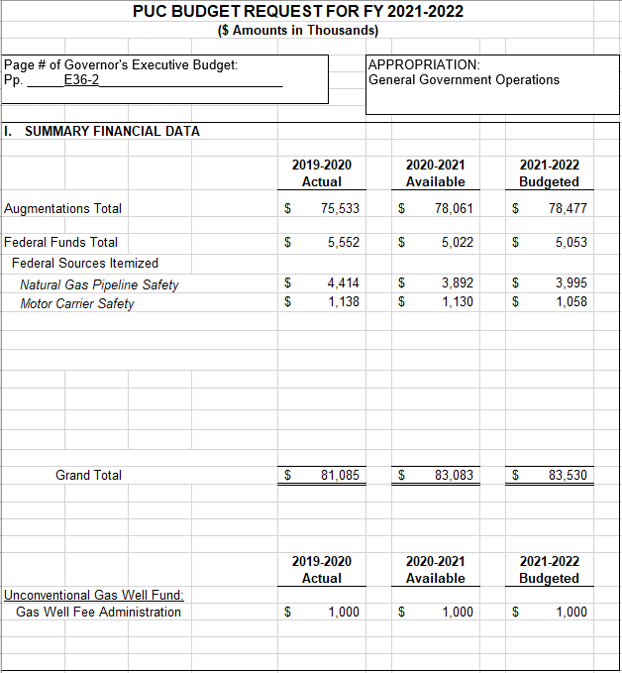

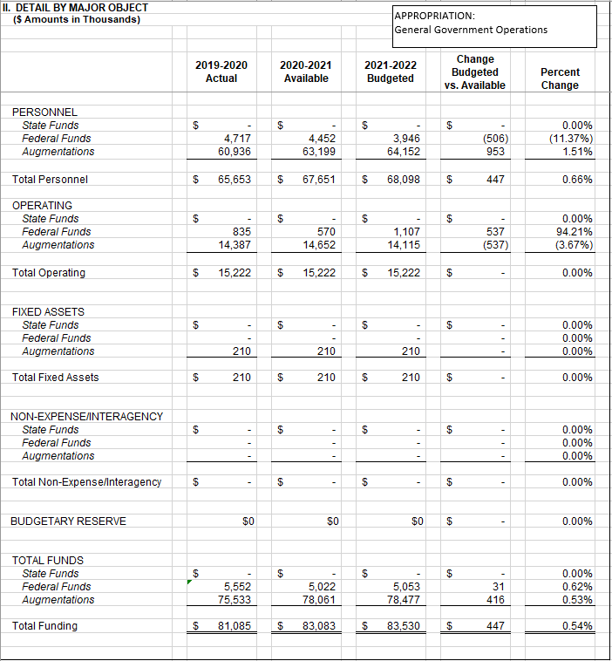

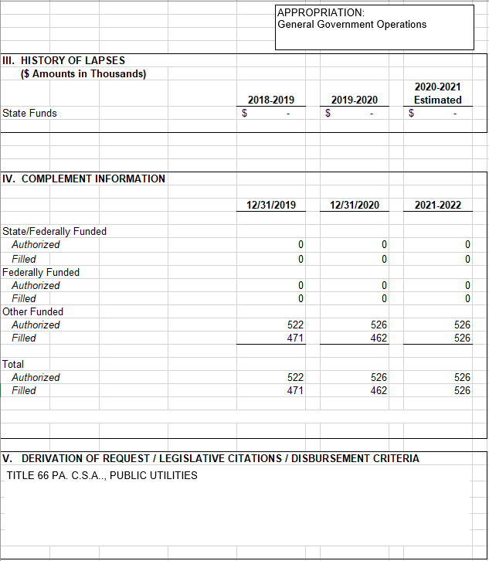

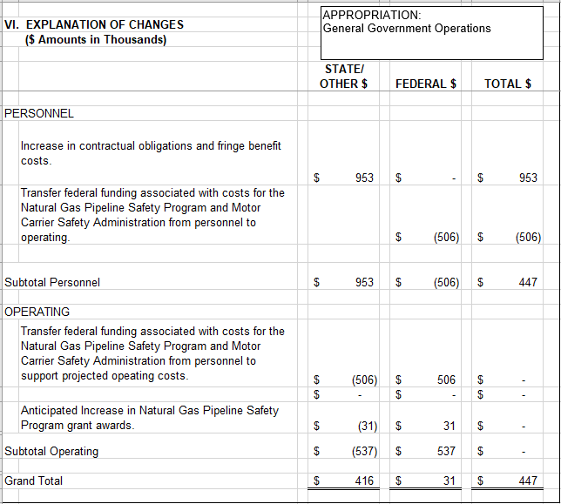

PENNSYLVANIA PUBLIC UTILITY COMMISSION
2021-22 BUDGET REQUEST
TO APPROPRIATIONS COMMITTEES OF
THE PENNSYLVANIA HOUSE AND SENATE

SECTION VIII

LIST OF CONTRACTS

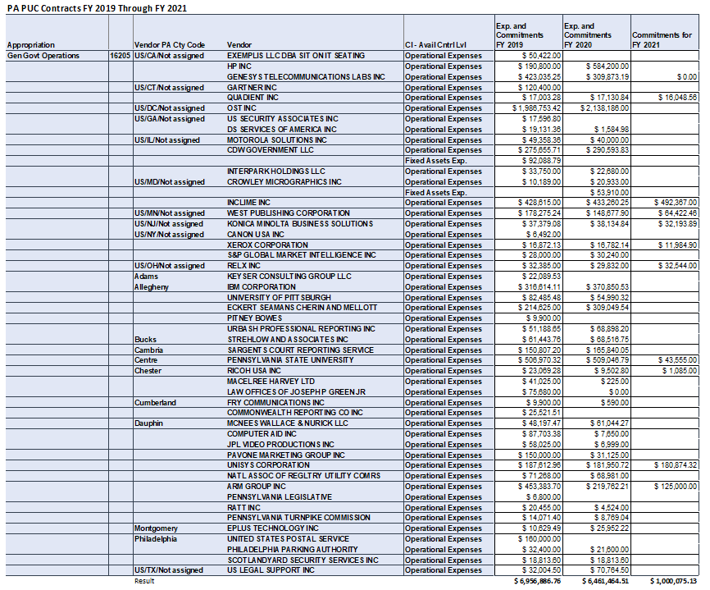

PENNSYLVANIA PUBLIC UTILITY COMMISSION
2021-22 BUDGET REQUEST
TO APPROPRIATIONS COMMITTEES OF
THE PENNSYLVANIA HOUSE AND SENATE

SECTION IX

SPECIAL FUND FINANCIAL STATEMENTS

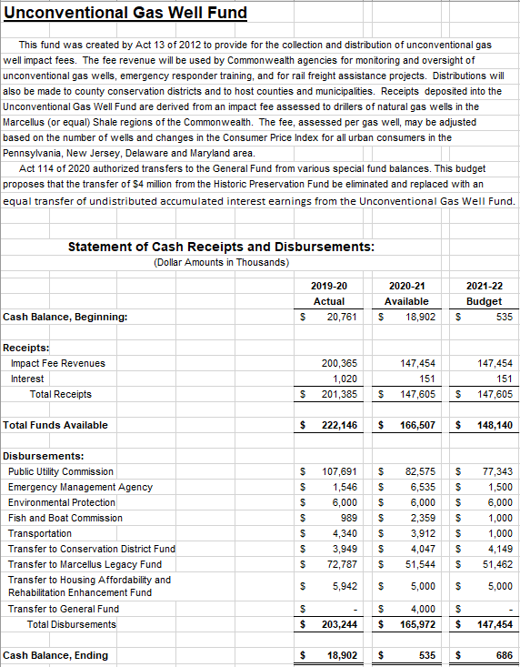

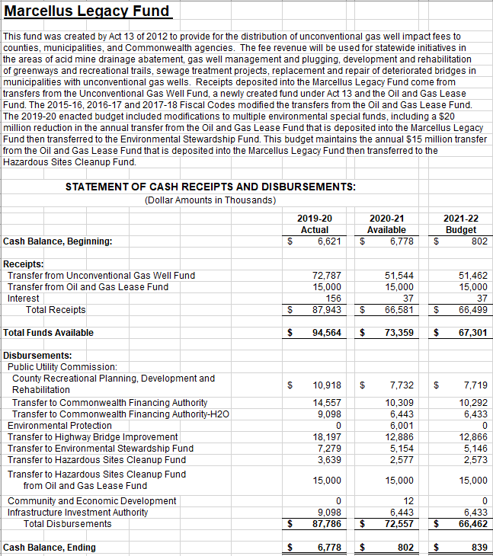

PENNSYLVANIA PUBLIC UTILITY COMMISSION
2021-22 BUDGET REQUEST
TO APPROPRIATIONS COMMITTEES OF
THE PENNSYLVANIA HOUSE AND SENATE

SECTION X

REQUEST FOR APPROPRIATION
OF FEDERAL FUNDS

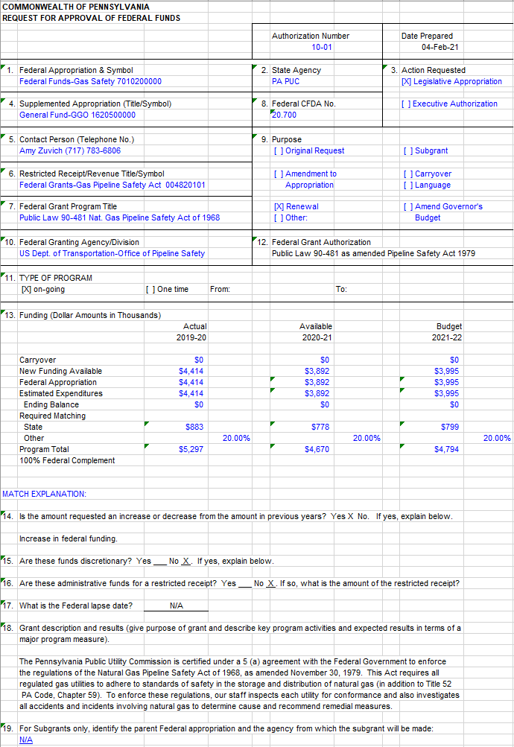
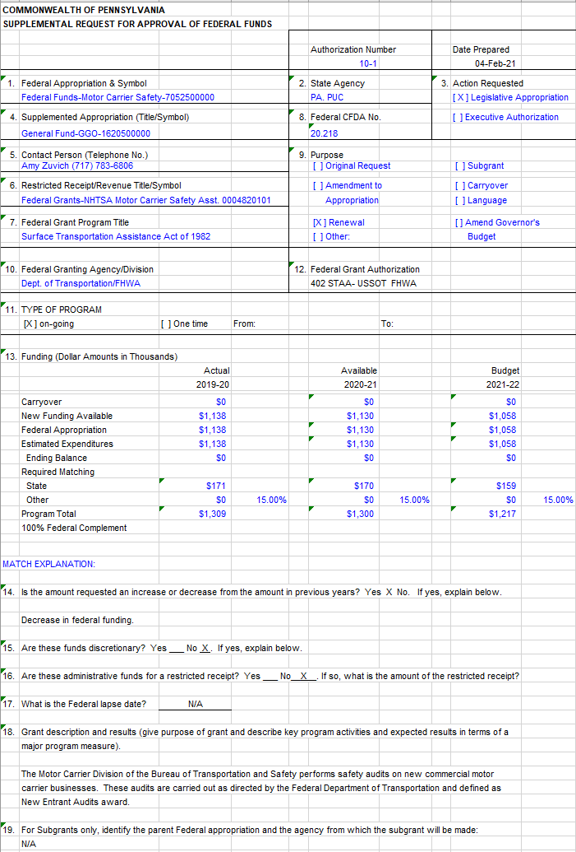

The FY 2021-22 Budget request amounts submitted to the Governor’s Office of the Budget on October 7, 2020 has been updated by the Office of the Budget to reflect a change in the employee benefit calculation. These amounts shown here reflect the adjusted amounts and are equal to those presented in the Governor’s Budget Book.

