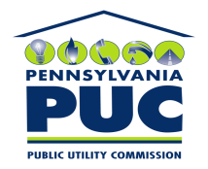 | COMMONWEALTH OF PENNSYLVANIA  PENNSYLVANIA PUBLIC UTILITY COMMISSION  P.O. BOX 3265, HARRISBURG, PA 17105-3265 | IN REPLY PLEASE REFER TO OUR FILE

June 3, 2009

U-2009-2105154

KIM G FLOWERS
AGENCY COORDINATOR
PPL ELECTRIC UTILITIES CORPORATION
TWO NORTH NINTH STREET
ALLENTOWN PA 18101-1179

Agreement Dated April 27, 2009 between PPL Electric Utilities Corporation and the County of Schuylkill, wherein the County of Schuylkill grants to PPL the right to construct, operate and maintain its electric line facilities in the Township of Cass, County of Schuylkill, Commonwealth of Pennsylvania.

__________

To Whom It May Concern:

We enclose herewith the original and one (1) copy of certificate of filing issued by this Commission in accordance with Section 507 of the Public Utility Code, 66 Pa. C.S. §507.

You should serve the enclosed copy of this certificate upon the County of Schuylkill.

Very truly yours,

James J. McNulty,
Secretary

mh
encls.
cert.mail

