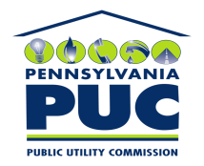 | COMMONWEALTH OF PENNSYLVANIA  PENNSYLVANIA PUBLIC UTILITY COMMISSION  P.O. BOX 3265, HARRISBURG, PA 17105-3265 | IN REPLY PLEASE REFER TO OUR FILE

August 13, 2009
U-2009-2118242

KIM G FLOWERS
AGENCY COORDINATOR
PPL ELECTRIC UTILITIES CORP
TWO NORTH NINTH STREET
ALLENTOWN PA 18101-1179

Agreement dated 6/1/2009 between PPL Electric Utilities Corporation and Christiana Borough relative with granting PPL the right to construct, operate, and maintain its electric line facilities in the Borough of Christiana, County of Lancaster.

To Whom It May Concern:

We enclose herewith the original and one (1) copy of certificate of filing issued by this Commission in accordance with Section 507 of the Public Utility Code, 66 Pa. C.S. §507.

You should serve the enclosed copy of this certificate upon the Borough of Christiana.

Very truly yours,

James J. McNulty,
Secretary

mh
encls.
cert.mail

