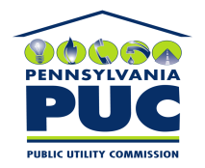 | COMMONWEALTH OF PENNSYLVANIA  PENNSYLVANIA PUBLIC UTILITY COMMISSION  P.O. BOX 3265, HARRISBURG, PA 17105-3265 | IN REPLY PLEASE REFER TO OUR FILE

November 5, 2009
U-2009-2134429

KIM G FLOWERS
AGENCY COORDINATOR
PPL ELECTRIC UTILITIES CORP
TWO NORTH NINTH STREET
ALLENTOWN PA 18101-1179

Agreement dated September 4, 2009 between PPL Electric Utilities Corporation and the Borough of Prompton, relative with the Borough of Prompton granting to PPL the right to construct, operate and maintain its electric line facilities in the Borough of Prompton, County of Wayne, Commonwealth of Pennsylvania.

__________

To Whom It May Concern:

We enclose herewith the original and one (1) copy of certificate of filing issued by this Commission in accordance with Section 507 of the Public Utility Code, 66 Pa. C.S. §507.

You should serve the enclosed copy of this certificate upon the Borough of Prompton.

Very truly yours,

James J. McNulty,
Secretary

mh
encls.
cert.mail

