PENNSYLVANIA
PUBLIC UTILITY COMMISSION
Harrisburg, PA 17105-3265

Public Meeting held November 19, 2009

Commissioners Present:

James H. Cawley, Chairman
Tyrone J. Christy, Vice Chairman, Statement
Kim Pizzingrilli
Wayne E. Gardner
Robert F. Powelson

Petition of PPL Utilities Corporation Docket No. P-2009-2129502
Requesting Approval of a Voluntary
Purchase of Accounts Receivables
Program and Merchant Function Charge

OPINION AND ORDER

BY THE COMMISSION:

Before the Commission for consideration and disposition is the Joint Petition for Settlement (Settlement) submitted by PPL Electric Utilities Corporation (PPL), the Office of Consumer Advocate (the OCA), the Office of Small Business Advocate (the OSBA), the Office of Trial Staff (the OTS), Constellation New Energy (Constellation), FirstEnergy Solutions, Inc. (FirstEnergy Solutions), the PP&L Industrial Consumer Alliance (PPLICA), Dominion Retail, Inc. (Dominion), Direct Energy Services, LLC (Direct Energy) and the Retail Energy Supply Association (RESA), collectively “the Parties,” in the above-captioned proceeding. Also submitted for consideration and resolution are two issues reserved by PPL and the Parties for litigation.

History of the Proceeding

On September 10, 2009, PPL filed a Petition Requesting Approval of a Voluntary Purchase of Accounts Receivables Program (POR Program) and Merchant Function Charge (MFC). On September 17, 2009, PPL filed a pro forma tariff supplement necessary for implementing the POR Program and MFC.

Pursuant to a Secretarial Letter issued on September 25, 2009, the Commission directed that this proceeding be assigned to the Office of Administrative Law Judge (OALJ) for hearing and certification of the record to the Commission for a Final Decision.

Petitions to Intervene in this proceeding were filed by: the OTS, the OCA, the OSBA, PPLICA, Constellation, FirstEnergy Solutions, Dominion, Direct Energy and RESA.

On October 22, 2009, an evidentiary hearing was held before Administrative Law Judge Louis G. Cocheres (ALJ).

On October 27, 2009, the ALJ certified the record in this proceeding for decision by the Commission given the compressed time-frame for implementation of the POR Program for 2010, if approved.

On October 30, 2009, the Parties to the proceeding filed a Joint Petition for Settlement (Settlement) which resolved all but two issues in the proceeding: (1) the termination/reconnection of residential customers for non-payment of Electric Generation Supplier (EGS) charges; and, (2) the definition of “basic supply services.”

On October 30, 2009, Main Briefs with respect to the two issues reserved for litigation were filed by PPL, the OCA, Dominion, FirstEnergy Solutions, and RESA.

On November 6, 2009, Reply Briefs were filed by PPL, the OCA, Dominion, and RESA. Also on November 6, 2009, Statements in support of the Settlement were filed by PPL, Constellation, FirstEnergy, and RESA. On November 6, 2009, PPLICA and the OTS filed letters of “non-opposition,” to the Settlement.

Discussion

Pursuant to our Regulations at 52 Pa. Code § 5.231, it is the Commission’s policy to promote settlements. However, the Commission must review proposed settlements to determine whether the terms are in the public interest. Pa. PUC v. Philadelphia Gas Works, M-00031768 (January 7, 2004); Pa. PUC v. C S Water and Sewer Assoc., 74 Pa. P.U.C. 767 (1991); Pa. PUC v. Philadelphia Electric Co., 60 Pa. P.U.C. 1 (1985).

Terms of the Settlement

While the full particulars of the Settlement are set forth in the Joint Petition for Settlement attached to this Opinion and Order, the following is a summary of a number of the essential points considered in reaching our decision in this case.

The Settlement is based on an agreement by the Parties that the PPL Plan, as revised, should be approved without modification. Settlement at ¶ 39. The Joint Petitioners agree that the Settlement is a reasonable resolution of the settled issues in this proceeding and is in the public interest. Therefore, the Joint Petitioners request that the Commission approve this proposed Settlement without modification and render a decision on the reserved issues. Settlement at ¶ 1. The two matters reserved for litigation are: (1) all issues regarding the termination/reconnection of residential customers for non-payment of EGS charges; and (2) all issues regarding the definition of “basic supply services.” However, the Parties maintain that decisions on these reserved issues will not alter the Settlement among the Parties on any other matters in the case.

Under the terms of the Settlement, PPL’s POR Program and MFC are approved for the year 2010. Settlement at ¶ 1. Under the POR Program, PPL will purchase EGS accounts receivables for residential shopping customers who take service under Rate Schedules RS, RTS(R) and RTD(R) at a discount of 1.37%. This discount rate reflects an uncollectible accounts expense percentage factor of 1.32% and a POR administrative factor of .05%. Settlement at ¶ 2. In order to be eligible for the residential POR Program, an EGS must choose consolidated Electric Distribution Company (EDC) billing for its residential customer accounts and must sell all of its residential customer accounts receivables to PPL. EGSs participating in the residential POR Program will agree not to reject for enrollment a new residential customer covered by the residential POR Program based on credit-related issues and agree not to require a deposit for providing service. Any customer who wishes to be served by an EGS participating in the residential POR Program will be accepted by that EGS, if that EGS is actively serving the residential customer class. Settlement at ¶¶ 3-4.

EGS customers on consolidated EDC billing will be able to select budget billing. PPL will pay EGSs based on actual billed supplier charges less the POR discount (versus budget amounts), and suppliers will not be impacted in any way by the budget billing program. PPL will inform customers that they can select a supplier and their budget payment plan will only be impacted to the extent necessary to assure that savings are reflected. Settlement at ¶ 7.

Under the POR Program, PPL will purchase EGS accounts receivables for small commercial and industrial (C&I) shopping customers who take service under Rate Schedules GS-1, GS-3, GH-1(R), GH-2(R), IS-1(R), BL, SA, SM(R), SHS, SE, TS(R) and SI-1(R), and standby service for the foregoing rate schedules at a discount of 0.17%. The discount rate reflects an uncollectible accounts expense percentage factor of 0.12% and a POR administrative factor of 0.05%. An EGS that chooses PPL’s consolidated EDC billing option for all or a portion of its small C&I accounts will be required to sell its accounts receivables to PPL Electric for those small C&I customers for whom PPL issues a consolidated bill. An EGS may continue to issue its own bills (dual billing) for all or a portion of its small C&I customers, but will not be eligible to participate in the POR Program for those small C&I customers that receive dual billing. Settlement at ¶ 8.

PPL will monitor individual EGS uncollectible percentages for small C&I customers pursuant to Section 12.9.2.6 of the tariff supplement provided in Appendix A and will adjust the discount rate for an individual EGS based upon the provisions contained therein. Section 12.9.2.6 shall not apply to EGSs that use EDC consolidated billing for all of their small C&I accounts and sell all of their small C&I accounts receivables to PPL. Settlement at ¶ 9.

EGSs are permitted to perform credit checks and require deposits for small C&I customers and are permitted to deny serving small C&I customers for credit-related reasons. Settlement at ¶ 10.

For 2010, PPL will be permitted to unbundle its generation related uncollectible accounts expense from distribution rates and collect it from default service customers through the MFC charges effective January 1, 2010. The MFC charge for residential customers will be 1.32%, and the MFC charge for small C&I customers will be 0.12%. The respective MFC charges will be added to the Price to Compare for residential and small C&I customers. Settlement at ¶ 11.

PPL will reduce its distribution rates by the amount of the bundled generation supply related uncollectible accounts expense included in PPL’s most recent distribution rate case at Docket No. R-00072155. Specifically, PPL will reduce residential distribution rates by $12,596,000 and small C&I distribution rates by $1,002,000. These reductions will be reflected in PPL’s compliance filing submitted upon Commission approval of this Settlement. Settlement at ¶ 12.

PPL has modified the 12-month minimum stay provision for the POR Program to coincide with the end of the term of the program on December 31, 2010, and has clarified that the minimum stay provision does not prohibit an EGS from enrolling a customer on a shorter-term product. PPL agrees to continue its existing POR Program for large C&I customers for 2010. EGSs will be permitted to perform credit checks and require deposits for large C&I customers and will be permitted to deny serving large C&I customers for credit related reasons. PPL agrees not to request recovery of the difference between the cost of purchased receivables and amounts actually collected for 2010 as part of its uncollectible accounts expense in its next base rate case. This provision is not intended to limit PPL from basing its future uncollectible accounts expense on actual experienced bad debt costs or to limit any party from objecting to such a claim. Settlement at ¶¶ 13-15.

This Settlement covers the terms of the POR Program and unbundling solely for 2010, and all Parties reserve their full rights as to all issues commencing January 1, 2011. Following Commission approval of the Settlement and up to December 31, 2009, PPL will hold bi-weekly conference calls with Parties to report on the status of PPL’s implementation of the POR Program. Settlement at ¶¶ 16-17.

Outstanding Issues

Although the proposed Settlement is unopposed, there are two outstanding matters that the Parties briefed: (1) the termination/reconnection of residential customers for non-payment of EGS charges; and (2) the definition of “basic supply services.”

Section 332(a) of the Pennsylvania Public Utility Code (Code), 66 Pa. C.S. § 332(a), provides that the party seeking a rule or order from the Commission has the burden of proof in that proceeding. It is axiomatic that “[a] litigant’s burden of proof before administrative tribunals as well as before most civil proceedings is satisfied by establishing a preponderance of evidence which is substantial and legally credible.” Samuel J. Lansberry, Inc. v. Pa. PUC, 578 A.2d 600, 602 (Pa. Cmwlth. 1990). The term “preponderance of the evidence” means that one party has presented evidence that is more convincing, by even the smallest amount, than the evidence presented by the other party. Se-ling Hosiery v. Margulies, 364 Pa. 45, 70 A.2d 854 (1950).

While the burden of persuasion may shift back and forth during a proceeding, the burden of proof never shifts. The burden of proof always remains on the party seeking affirmative relief from the Commission. Milkie v. Pa. PUC, 768 A.2d 1217 (Pa. Cmwlth. 2001).

Customer Service Termination Issues

Positions of the Parties

PPL’s Position

The first of the two issues reserved for litigation in this proceeding concerns the termination of service to residential customers who fail to pay PPL for purchased EGS receivables. PPL’s voluntary POR Program provides that PPL will have the right to terminate service for non-payment of all EGS generation charges purchased by PPL. PPL Electric St. 1 at 13. PPL further proposes that it should have the right to require full payment of all unpaid purchased receivables as a condition of reconnection. PPL Electric St. 1 at 13. Under PPL’s proposal, residential service terminations and reconnections associated with unpaid purchased receivables would be made in compliance with the provisions of Chapter 14 of the Code, 66 Pa. C.S. §§1401 et seq. and Chapter 56 of the Commission’s Regulations, 52 Pa. Code §§56.1 et seq. PPL Electric St. 1 at 13.

PPL states that, as a fundamental principle, it cannot accept a POR Program that does not give PPL the right to terminate service for non-payment of any portion of purchased receivables. PPL states that it filed its voluntary POR Program with the Commission in order to promote competition in its service territory. PPL believes that it would not be reasonable, fair or legal to require PPL to purchase an EGS’ accounts receivable, but deny PPL the right to collect from customers the entire amount purchased from the EGS.

Specifically, PPL contends that it voluntarily filed its POR Program with the Commission in response to the Retail Markets Order, and does not believe that the Commission has the authority to require it to purchase an EGS’ receivables. We agree. In PECO Energy Co. v. Pa. PUC, 568 Pa. 39, 791 A.2d 1155 (2002), the Supreme Court of Pennsylvania stated as follows:

The power of the Commission is statutory, arising either from words contained in the enabling statutes or by a strong and necessary implication from those words, and the legislative grant of power in any particular case must be clear.

No provision of the Code either expressly or by “strong and necessary implication” provides the Commission with the authority to require EDCs to purchase accounts receivable from EGSs. On the contrary, the Code specifically provides that the Commission cannot require EDCs to purchase EGS’ accounts receivables. Section 2807(c)(3) of the Code provides as follows:

The electric distribution company shall not be required to forward payment to entities providing services to customers, and on whose behalf the electric distribution company is billing those customers, before the electric distribution company has received payment for those services from customers.

Under PPL’s voluntary POR Program, PPL is required to forward payment to an EGS for service provided by the EGS to customers before the EDC has received payment, even if the customer does not pay the EDC. If imposed as a mandatory requirement by the Commission, such a provision would violate Section 2807(c)(3) of the Code and, therefore, any POR Program adopted by an EDC must be voluntarily adopted by that EDC. Nevertheless, PPL has offered to pay EGSs before it receives payment provided that the terms of its POR Program and MFC are accepted.

Additionally, PPL states that, depending upon the circumstances, requiring PPL to purchase an EGS’ receivables without the ability to terminate electric service to a customer for failure to pay those receivables could result in a taking in violation of the United States Constitution. PPL Electric MB at 16. Therefore, PPL believes that it cannot be required to accept a decision in this case that would prevent it from terminating service to customers for failure to pay EGS charges purchased by PPL or prevent it from requiring full payment of purchased EGS charges before reconnecting electric service to a customer, subject to Chapter 14 of the Code and Chapter 56 of the Commission’s Regulations. PPL Electric MB at 16.

The OCA’s Position

The OCA’s primary position is that PPL’s right to termination for non-payment of a purchased receivable should be limited to an amount no greater than what the customer would have been billed if the customer had received default service during the non-payment period. OCA St. 1 at 13. Associated with this proposal is the OCA’s position that a customer whose service was terminated for non-payment should be reconnected upon payment of the lesser of unpaid distribution charges plus: (1) unpaid EGS charges, or (2) the amount the customer would have been billed if the customer had received default service. OCA St. 1, at 13. The OCA also contends that a customer’s service should not be terminated based upon charges that have not been found by the Commission to be just and reasonable. OCA St. 1 at 10.

The OCA offers an alternative proposal under which EGSs would be required to certify that their charges are at or below PPL’s default service price as a condition of participating in the POR. This alternative proposal would be in effect for the one-year term of PPL’s Competitive Bridge Plan (CSP), which establishes default service rates for the one-year period beginning January 1, 2010. OCA St. 1 at 14.

The OCA notes that PPL’s current POR Program will continue in 2010 for large C&I. Tr. at 55-56. The OCA explains that under PPL’s existing program, PPL pays a participating EGS the entire amount for undisputed charges for large C&I customers’ EGS charges regardless of whether full payment was received from the customer for 90 days. After 90 days of not receiving payment for a customer’s purchased receivables, PPL cannot terminate the customer’s electric service but can revert to dual billing requiring the EGS to bill and collect its own generation charges or, if the EGS so elects, the EGS can cancel its contract with the customer, which would revert the customer back to default generation service with PPL. PPL St. 2 at 4; Tr. at 54-55.

The OCA points out that if termination for failure to pay EGS charges is permitted in PPL’s 2010 POR Program, residential customers in the POR Program could have their essential electric service terminated for failure to pay unregulated EGS charges. Yet, large C&I customers could not be terminated from electric service in the same scenario. Rather, those customers would have their EGS contract cancelled and would be returned to PPL’s default service upon a failure to pay.

In conclusion, the OCA states that the Commission must not eliminate essential consumer protections for residential customers in PPL’s 2010 POR Program. The necessary consumer protections are contained in both the OCA’s proposal to implement the Duquesne model’s termination/reconnection provisions and the OCA’s alternate proposal requiring EGS certification that its prices are at or below the default service rate. OCA MB at 12-14; RB at 14-16. OCA contends that the EGSs’ arguments that consumer protections are not necessary within the POR are without merit and should be dismissed.

Dominion

Dominion believes that PPL’s proposal to terminate customers for the total past due balance for purchased receivables is necessary and reasonable and should be approved. DR St. No. 1 at 13, 22. Dominion states that PPL’s proposed disconnection policy promotes equity and fairness as between shopping and non-shopping customers and helps PPL reduce costs. Dominion St. No. 1 at 9-12. That is, by treating all customers the same, all customers will have equal access to PPL’s distribution system and billing system on the same terms. 66 Pa. C.S. § 2804(6).

Dominion further notes that the rates PPL will charge in 2010 are market based rates subject to the same market forces as EGS rates and are disciplined by the same markets that discipline EGS offers. Dominion Retail refers to the Electricity Generation Customer Choice and Competition Act, 66 Pa. C.S. § 2802(14), which provides that:

The generation of electricity will no longer be regulated as a public utility function except as otherwise provided for in this chapter.

66 Pa. C.S. § 2802(14).

Dominion, therefore, asserts that the regulatory concept of “just and reasonable” rates that continues to govern base rates under 66 Pa. C.S. § 1301, et seq., is no longer relevant to the rates for the sales of electric generation supply. Dominion MB at 8. Dominion concludes by stating that there is no legal basis for the distinctions proposed by the OCA in this case, that somehow default service rates from an electric utility have a higher status than those of electric generation suppliers when it comes to seeking termination for supplier charges. Rather, as a matter of policy, and for the benefit of all interested parties (except those few EGS customers who choose not to or refuse to pay the full amount of their electricity bill), the best approach is to treat all customers the same when it comes to collection and terminations, particularly in the instance where the utility has implemented a voluntary purchase of receivables program. Dominion Retail MB at 13.

FirstEnergy Solutions

In its Reply Brief, FirstEnergy Solutions states that the OCA has incorrectly concluded that the statute and regulations developed to regulate monopolistic utilities should regulate EGSs simply because they use a POR Program. In the view of FirstEnergy Solutions, the OCA’s attempt to bring unregulated entities under the regulation of the Commission under the guise of consumer protection goes against everything that the Commission is trying to accomplish with the restructuring of the electric industry. The conclusion that somehow a free marketplace cannot generate fair and reasonable rates not only contradicts the General Assembly’s conclusion, but it is unsupported by any evidence in the record. FirstEnergy Solutions RB at 6, 7. Accordingly, FirstEnergy Solutions requests that the Commission reject the OCA proposal to limit residential reconnection fees. OCA MB at 13-14; FirstEnergy Solutions RB at 6.

FirstEnergy Solutions also contends that it is not necessary to implement the OCA’s proposal because in addition to market forces keeping energy prices competitive and fair, the Commission already has appropriate protections in place for the electric choice customer. FirstEnergy Solutions RB
at 7.

Retail Energy Supply Association

RESA’s position on the termination issue is that since PPL would be purchasing an EGS’s accounts receivable, PPL would own those accounts and should have all of the suspension and termination tools available for those customers as it has for its default service customers. RESA St. No. 1, at 24. RESA notes that the OCA cites three statutory sections, one regulation and the 1997 Consumer Guidelines Order of the Commission to claim that the Commission is legally required to adopt the restrictions advocated by the OCA. RESA asserts that a complete review of all this authority makes it clear that there is no authority that mandates or suggests adoption of the OCA’s proposal to restrict the ability of EDCs to terminate service to POR customers based upon non-payment of an amount equal to the customer’s default service rates. RESA RB at 10.

Regarding the OCA’s position that EGS prices are not Commission made rates and, therefore, may not be deemed ‘just and reasonable’ RESA states in its Reply Brief that EGS prices which are derived from the same competitive market that produces the default service rates fall within the zone of reasonableness. As discussed in the Main Brief of RESA, there are many legal and legitimate situations where the price per kilowatt hour from an EGS may be higher than the price per kilowatt hour for default service. RESA points out that the Commission has already determined that such a variance between an EGS generation charge and an EDC generation charge is permissible and, in fact, may be desirable for some customers. Therefore, an EGS’s generation charge that exceeds the EDC’s default service rate does not mean that the EGS charges automatically fall outside the “zone of reasonableness” that may have been established by the Commission pursuant to Section 1301 of the Code. RESA maintains that only if EGSs were shown to regularly charge rates that are clearly inconsistent with competitive market forces would there be a concern that EGS charges would somehow fall outside this “zone of reasonableness.” If such a concern arose, the Commission has an array of procedures, including license revocation and individual consumer complaint adjudication, to address the issue. RESA MB at 21-23. Accordingly, RESA believes that there is no reason to restrict service termination and reconnection procedures to the default service rate. RESA RB at 13.

Disposition

First, we stress that the POR Program offered by PPL is voluntary and contains provisions that, if directed by the Commission, would be inconsistent with our regulations and the Code in a manner that might impact PPL negatively. We agree with PPL that authority does not exist for the Commission to compel any of our jurisdictional EDCs to create and offer such a POR Program in the competitive electric generation marketplace.

Based upon our review of the record created in this proceeding and the arguments of the Parties, we cannot support the recommendations of the OCA. We do not consider EGS rates to be Commission-made rates though such rates may be akin to the default service rates of our EDCs. Both EGS rates and default service rates are derived from an EDC and EGS solicitations in the wholesale market for contract requirements. Neither rate is Commission approved; however, the process used by the EDCs to solicit and accept wholesale bids was approved and is monitored by the Commission. In our view, and for the limited purpose of resolving this particular issue, it would be unreasonable to consider an EGS developed rate to be any different in character from an EDC developed rate.

The OCA pointed to the Duquesne Settlement POR Program as being instructive and advocated including service termination and reconnection standards from that Program into PPL’s POR Program. None of the other Parties to this proceeding support this recommendation. We note that the Duquesne POR Program was the product of a Settlement and was not litigated. Additionally, we believe that except for a small number of shopping customers, all EGS customers’ rates will be below the EDC’s price to compare rendering this OCA recommendation moot.

We consider PPL’s customers to be adequately protected under the PPL Plan, as submitted, from unjust termination of service for non-payment of EGS charges. PPL has stated that it will continue to follow Chapter 14 and Chapter 56 requirements to determine when service termination would be appropriate and in proceeding with such an action, thus providing shopping customers with the same protections as default service customers.

Based upon the record established in this proceeding, the voluntary and short term nature of PPL’s POR Program and the reasonableness of PPL’s service termination policies to be followed and applied to shopping customers, we shall adopt PPL’s proposal. Accordingly, PPL may commence service termination actions with respect to any shopping customer whose account has been purchased by PPL, if PPL is not paid by the shopping customer, in the same manner as is permissible under current Commission regulations.

The Definition of “Basic Supply Services”

Positions of the Parties

PPL

PPL’s proposed tariff supplement states:

PPL Electric will purchase only those receivables that are associated with basic electric supply services and not receivables associated with charges for other products or services. Participating EGSs will be required to certify that purchased receivables are associated with only basic electric supply service.

Proposed tariff supplement Section 12.9. PPL interprets “basic supply service” to mean actual generation supply excluding attribute based products such as voluntary Renewable Energy Credit (REC) programs. PPL MB at 24, 25.

As a basic matter, PPL does not believe that it should be required to purchase receivables for special products, such as green programs, offered by EGSs. Under its POR Program, the Company is assuming the risk of purchasing an EGS’ receivables and does not want to add to that risk by including receivables for anything other than basic supply service. PPL MB at 25.

PPL’s interpretation of “Basic Supply Service” is guided by the Commission’s Tentative Retail Markets Order (TRM Order), wherein the Commission stated as follows:

Finally, an EGS can bill only for basic supply service via POR. However, there are no limitations on the provision of other billing options if the EGS is participating in the POR program. EGSs have unique programs, such as green power for example, which require billing needs the utility cannot supply. Thus, EGSs may still need to separately bill for complex supply pricing options or environmental/renewable products.

TRM Order at 15. PPL believes that it is clear from this excerpt that the Commission does not consider green programs to be “basic supply service.”

For example, PPL does not consider the Green Power Option to be basic supply service, and in fact, does not include amounts paid by customers under the Green Power Option as charges for which the customer can be terminated. (PPL Exhibit No. 6).

Retail Energy Supply Association

RESA recommends that the PPL POR Program be available for value-added products based on the underlying attributes of the energy. RESA St. 1 at 20-21. This would include physical renewable and REC-based or other attribute-based products. RESA MB at 27. RESA agrees, however, that a POR Program should not be available for non-electric generation services such as the sale of appliances consistent with the Commission’s definition of non-basic service as found in 52 Pa. Code § 56.13. RESA St. No. 1 at 22.

During cross examination, PPL’s witness explained the basic dividing line the Company envisioned between “acceptable” and “unacceptable” green products that could be billed through POR as follows:
Our concern in my testimony for basic supply service is that it be a generation product. I accept that there are what you might call attribute products that come from specific types of generation that may have a higher price, but it’s fundamentally a generation service.
If it’s a payment to the Environmental Defense Fund that’s collected on a cent per kilowatt-hour basis for like our green program, which is really a kind of donation to a window that is promised somewhere else, it’s not the generation supply that the customer receives.
You could refer to them both as attribute products, but we don’t think that that second type is really something the customer should be subject to termination over.
Tr. 107 (emphasis added).

RESA agrees with PPL’s explanation of what would be an “acceptable” or an “unacceptable” attribute-based product for POR billing purposes.

RESA’s proposal is that POR should be available to bill a customer for an attribute-type product when the customer is receiving generation service from that EGS. RESA St. 1 at 20-21. Therefore, in all instances, the product would be connected to the sale of generation. RESA MB at 29. RESA further asserts that the failure to permit such products in the POR Program will result in EGSs not participating in Pennsylvania’s energy market. RESA MB at 29. RESA believes that a failure to permit such products would deny Pennsylvania consumers green products and that such a restriction would create an unlevel playing field between the EDC and EGSs because PPL (and other PA EDCs) are currently providing attribute-type green products which are billed with default and distribution service. RESA MB at 29.

OCA
During cross examination, the OCA’s witness testified as follows:

. . . the collection activities on the bill, all of that ought to be limited to the basic commodity charge, the basic generation service. So I’m right there with that.
Now, there are renewable resource providers and they charge 100 percent wind or whatever, and obviously, whatever that charge is would also be a basic generation service charge. I gather there are some complexities with the way some EGS suppliers try to add a particular dollar amount on top of the utility’s default service charge for, you know, for some donation to a green product, and I can see that there may be some need for further thinking about that detail. I must confess, I was not aware of that method of billing. But the bottom line is, we are talking about basic commodity charges. We are not talking about termination fees; we’re not talking about smart thermostat installations; we’re not talking about refrigerator repairs, you know; we’re not talking about anything other than what the Commission has already said needs to appear on the bill, which is the basic generation supply charge.

Tr. 123, 124 (emphasis added).

RESA agrees with the OCA regarding the above definition of what is to appear on the customer’s combined bill, that being, commodity charges.
Based upon the above cited testimony, the Parties have developed an interpretation of the Commission’s Tentative Order (which states “EGSs have unique programs, such as green power for example, which require unique billing needs the utility cannot supply”) as follows:

‘REC-based or other attribute-based renewable products’ bundled with physical energy which RESA/Direct Energy, PPL and the OCA agree should be included in POR - are clearly not the type of ‘unique programs’ requiring ‘complex supply pricing options’ the Commission was describing in the Tentative Order. Rather, the Commission was referring to products or programs such as PPL’s Green Power Option.

RESA RB at 26.

Accordingly, RESA believes that the Commission should make clear that EGS offerings of generation supply services bundled with value-added green products based on the underlying attributes of the energy source be included in the POR Program. RESA RB at 26.

Disposition

No other Party has expressed a concern about this issue. The commenting Parties’ consensus on this issue is consistent with obligations imposed on EDCs and EGSs by the Alternative Energy Portfolio Standards Act (AEPS Act), which requires EGSs to include energy from green resources in their energy supply to their customers in PPL’s service territory in 2010.

We concur with the Parties’ consensus agreement on the definition of basic supply service as being tied to the provision of generation and not an ancillary program, without generation attributes, which may be purchased by customers. Accordingly, we believe that REC-based or other attribute-based renewable products bundled with physical energy should be included in a POR Program

Conclusion

Based upon our review of the record in this proceeding and the supporting statements of the Parties, we find that the Joint Petition for Settlement, the Settlement itself, and the rates, terms and conditions contained in the Settlement Agreement are just, reasonable and within the public interest and are in accord with the rules and regulations of the Commission and with the provisions of the Pennsylvania Public Utility Code; THEREFORE,

IT IS ORDERED:

1. That the Joint Petition for Settlement is granted and the Settlement is approved without modification.

2. That the Purchase of Receivables Program and Merchant Function Charge established by this Opinion and Order shall remain in effect until December 31, 2010.

3. That PPL Electric Utilities Corporation’s proposed policy to allow service termination to customers, subject to the provisions of the Public Utility Code and the Regulations of the Commission, for non-payment of all EGS generation charges purchased by the Company, is granted.

4. That the basic supply service charges, for which non-payment thereof may result in service termination, includes REC-based or other “attribute-based renewable products” bundled with physical energy and excludes any ancillary service provided by an EGS such as PPL Electric Utilities Corporation’s Green Power Option and/or termination fees, smart thermostat installations, refrigerator repairs or other non-regulated offerings.

5. That this Opinion and Order is dispositive of PPL Electric Utilities Corporation’s Purchase of Receivables Program and Merchant Function Charge for 2010 only, and it shall have no precedential effect in the context of the Commission’s collaborative to be held in 2010 to develop a permanent Purchase of Receivables Program.

6. That PPL Electric Utilities Corporation shall timely implement all proposals, programs and filings required in the Settlement, consistent with that agreement and with this Opinion and Order.

7. That the record at Docket No. P-2009-2120502 be marked closed.

BY THE COMMISSION,

James J. McNulty
Secretary

(SEAL)

ORDER ADOPTED: November 19, 2009

ORDER ENTERED: November 19, 2009
ATTACHMENT
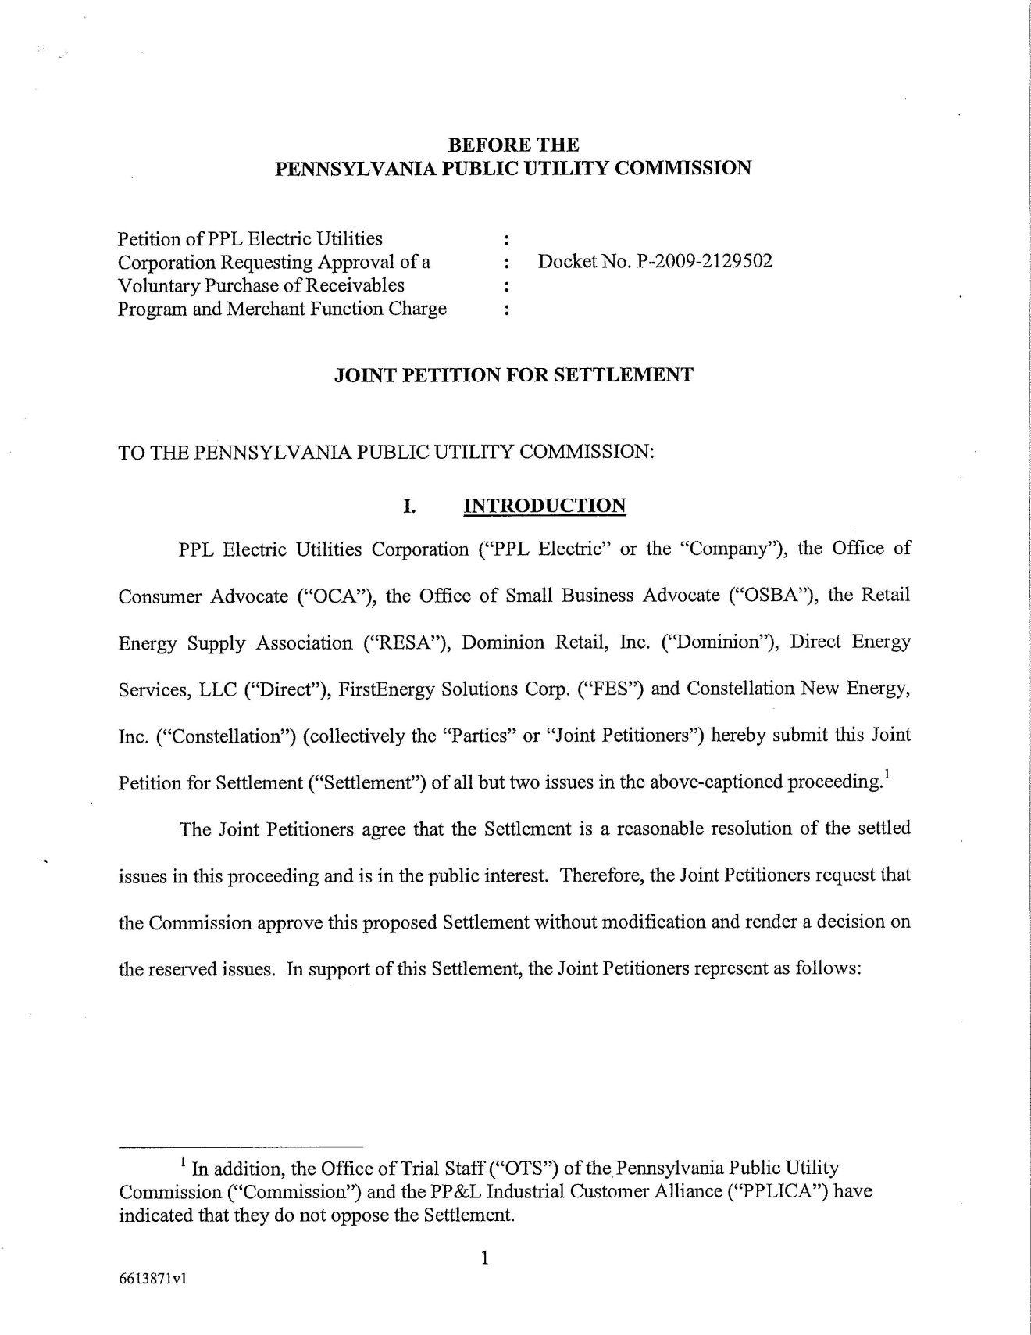

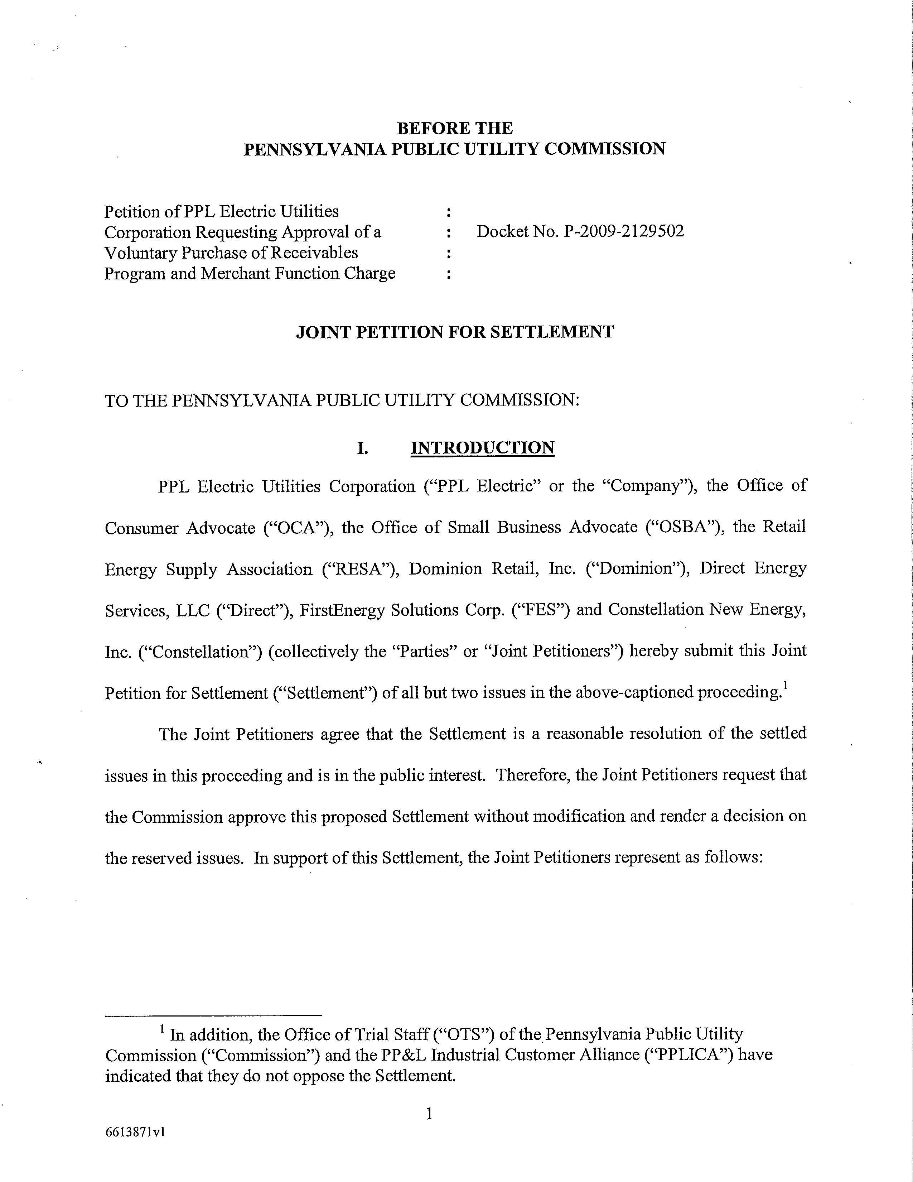

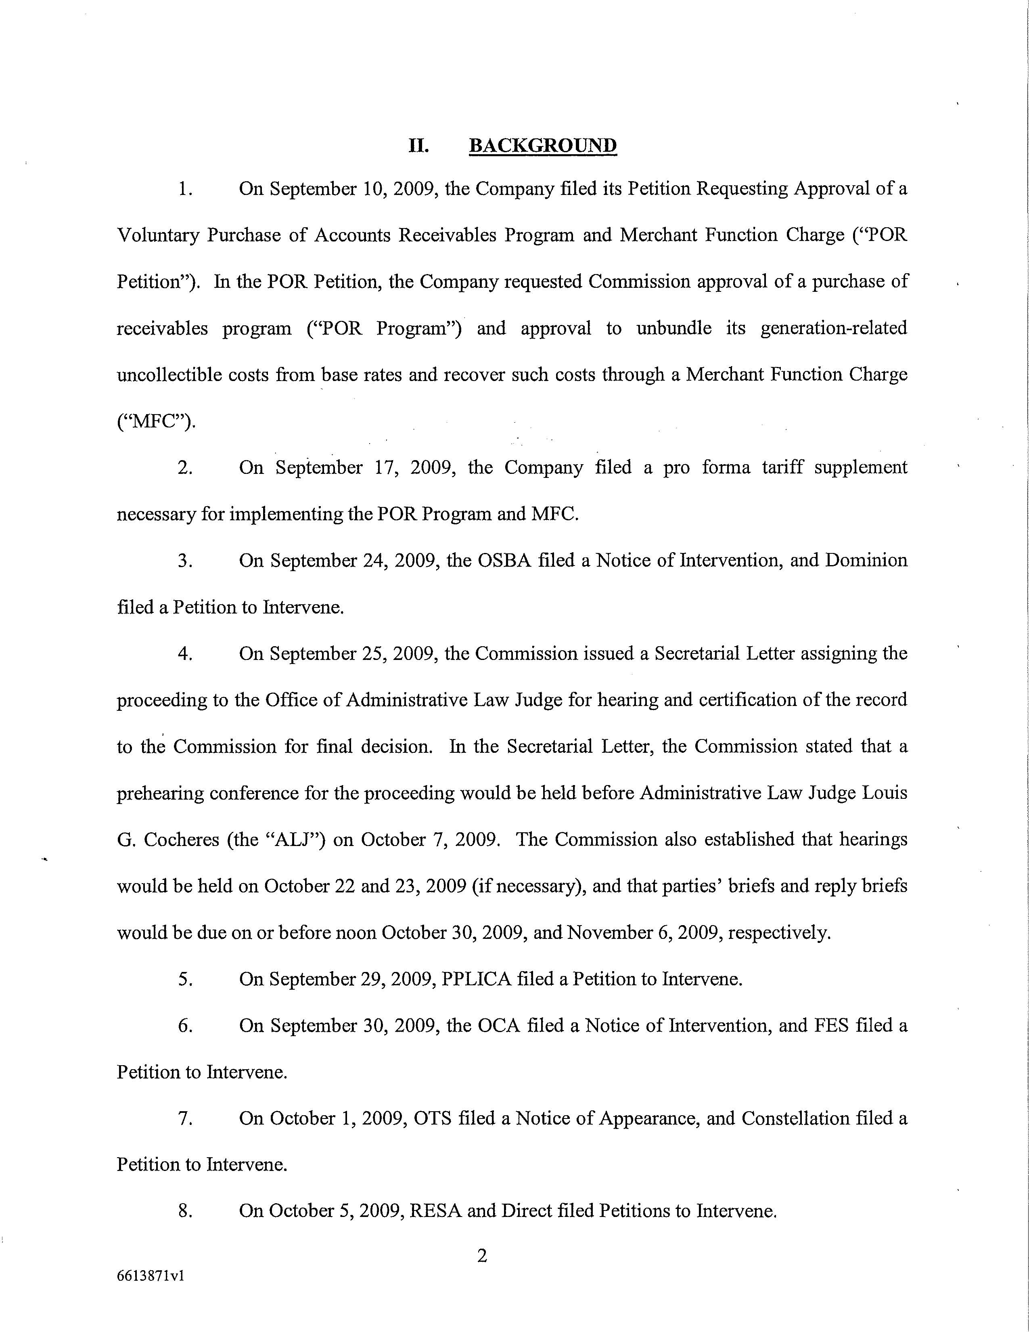

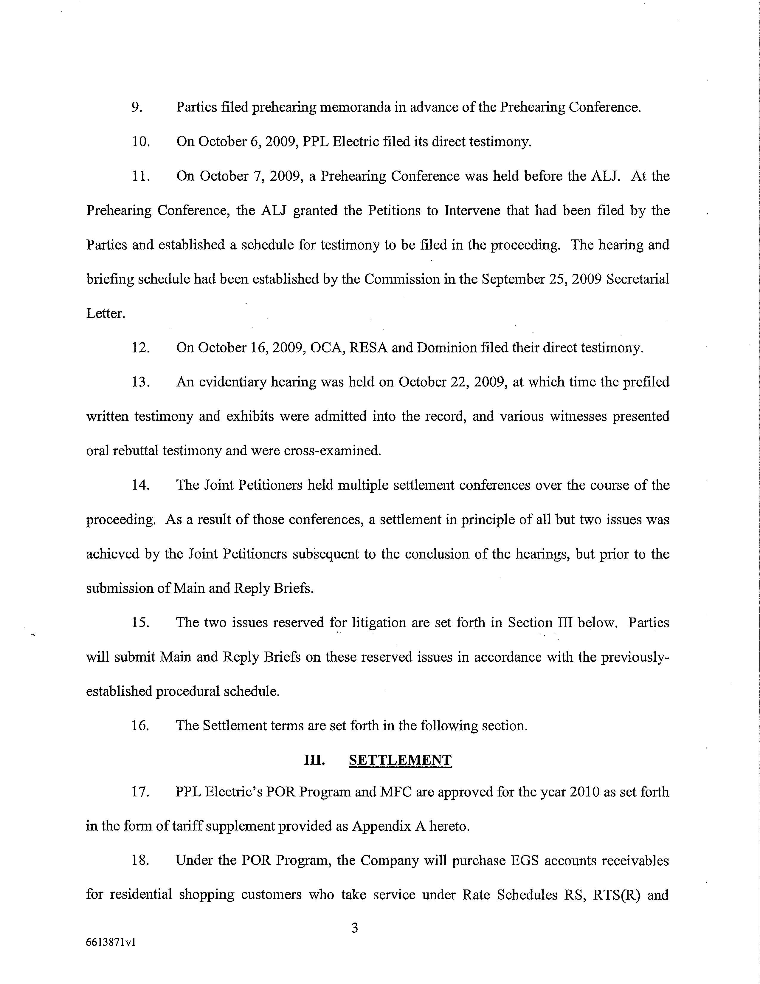

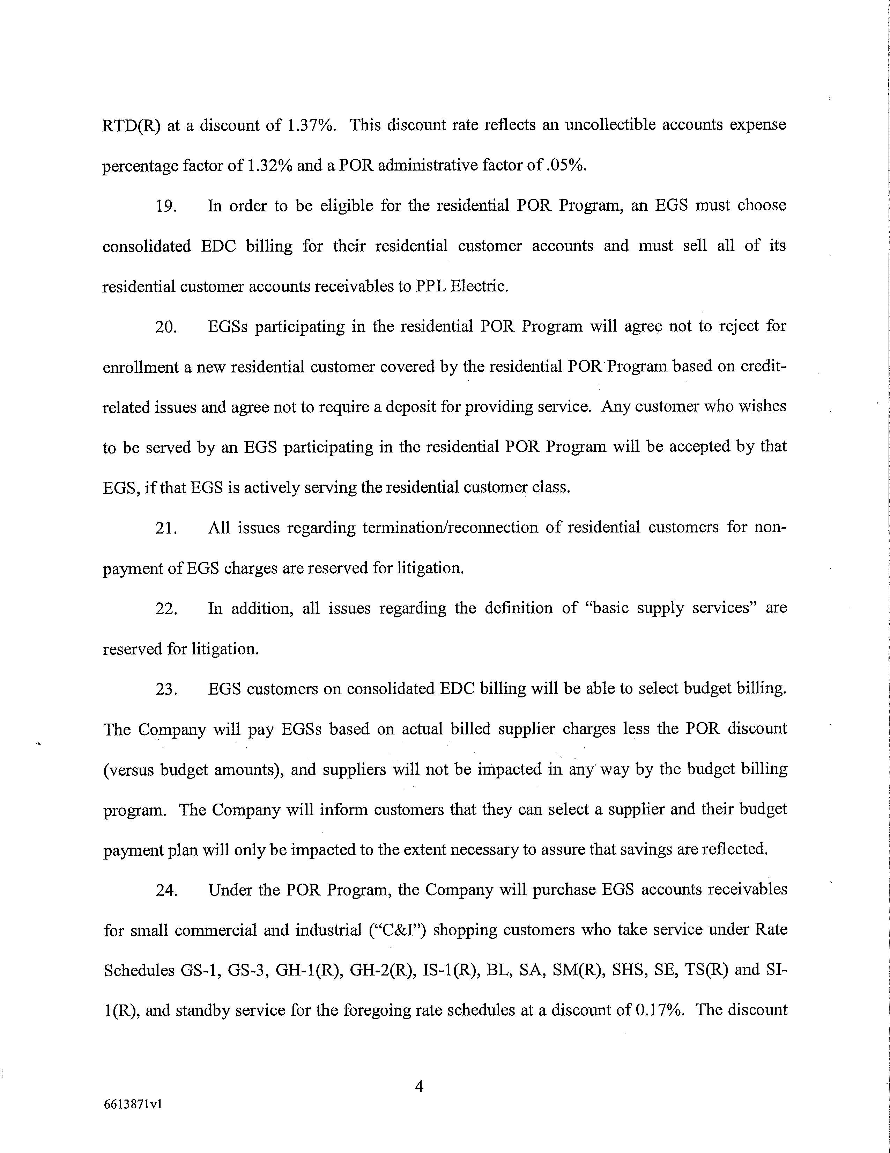

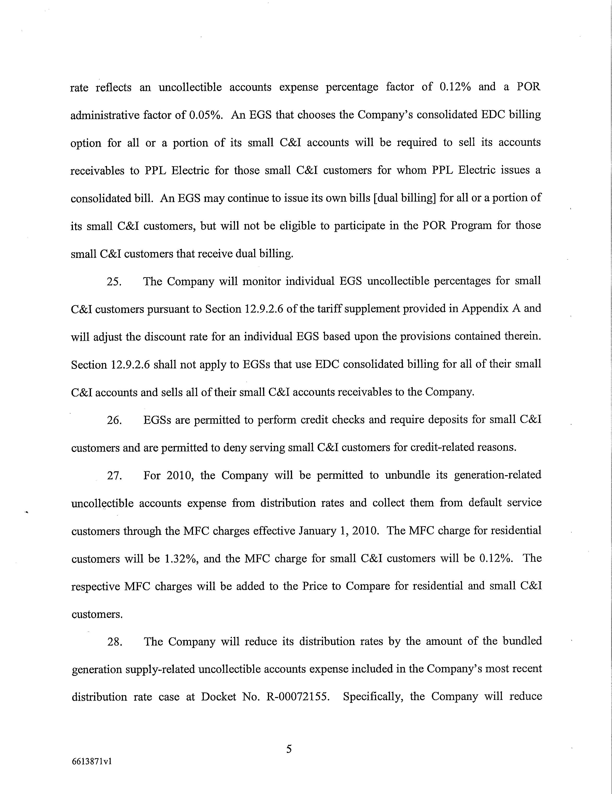

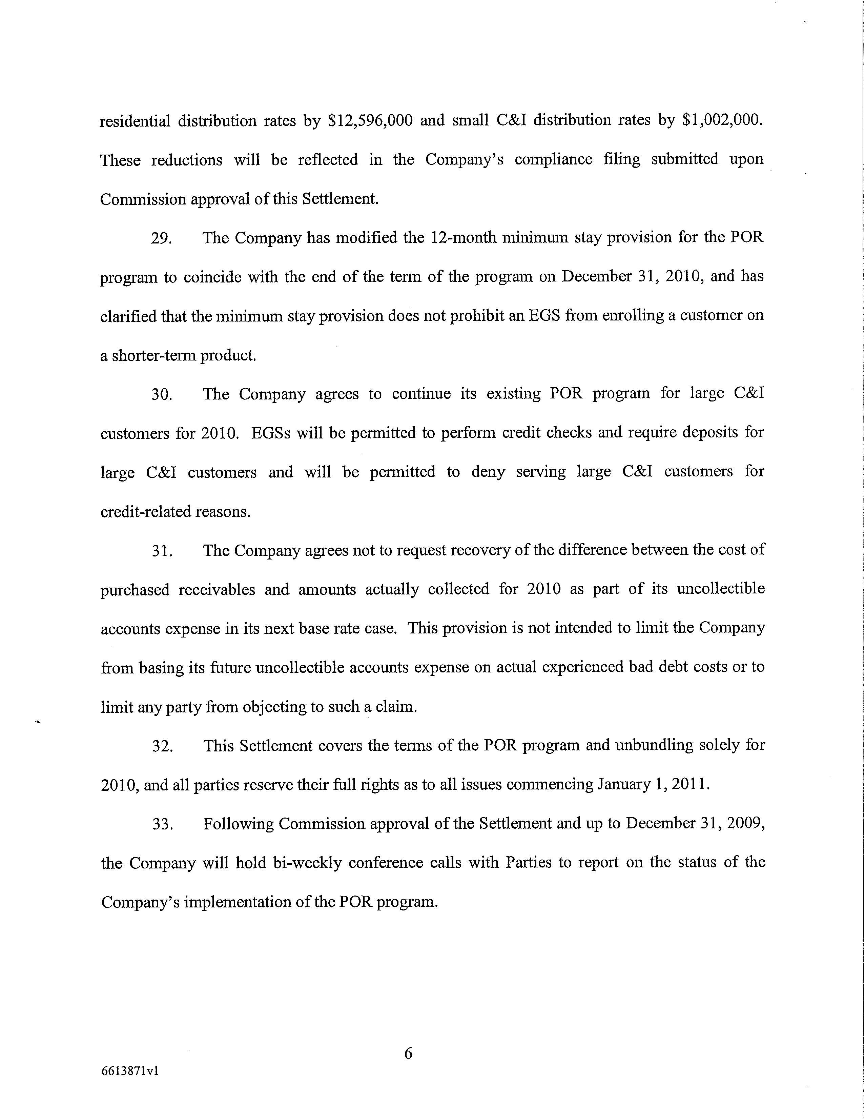

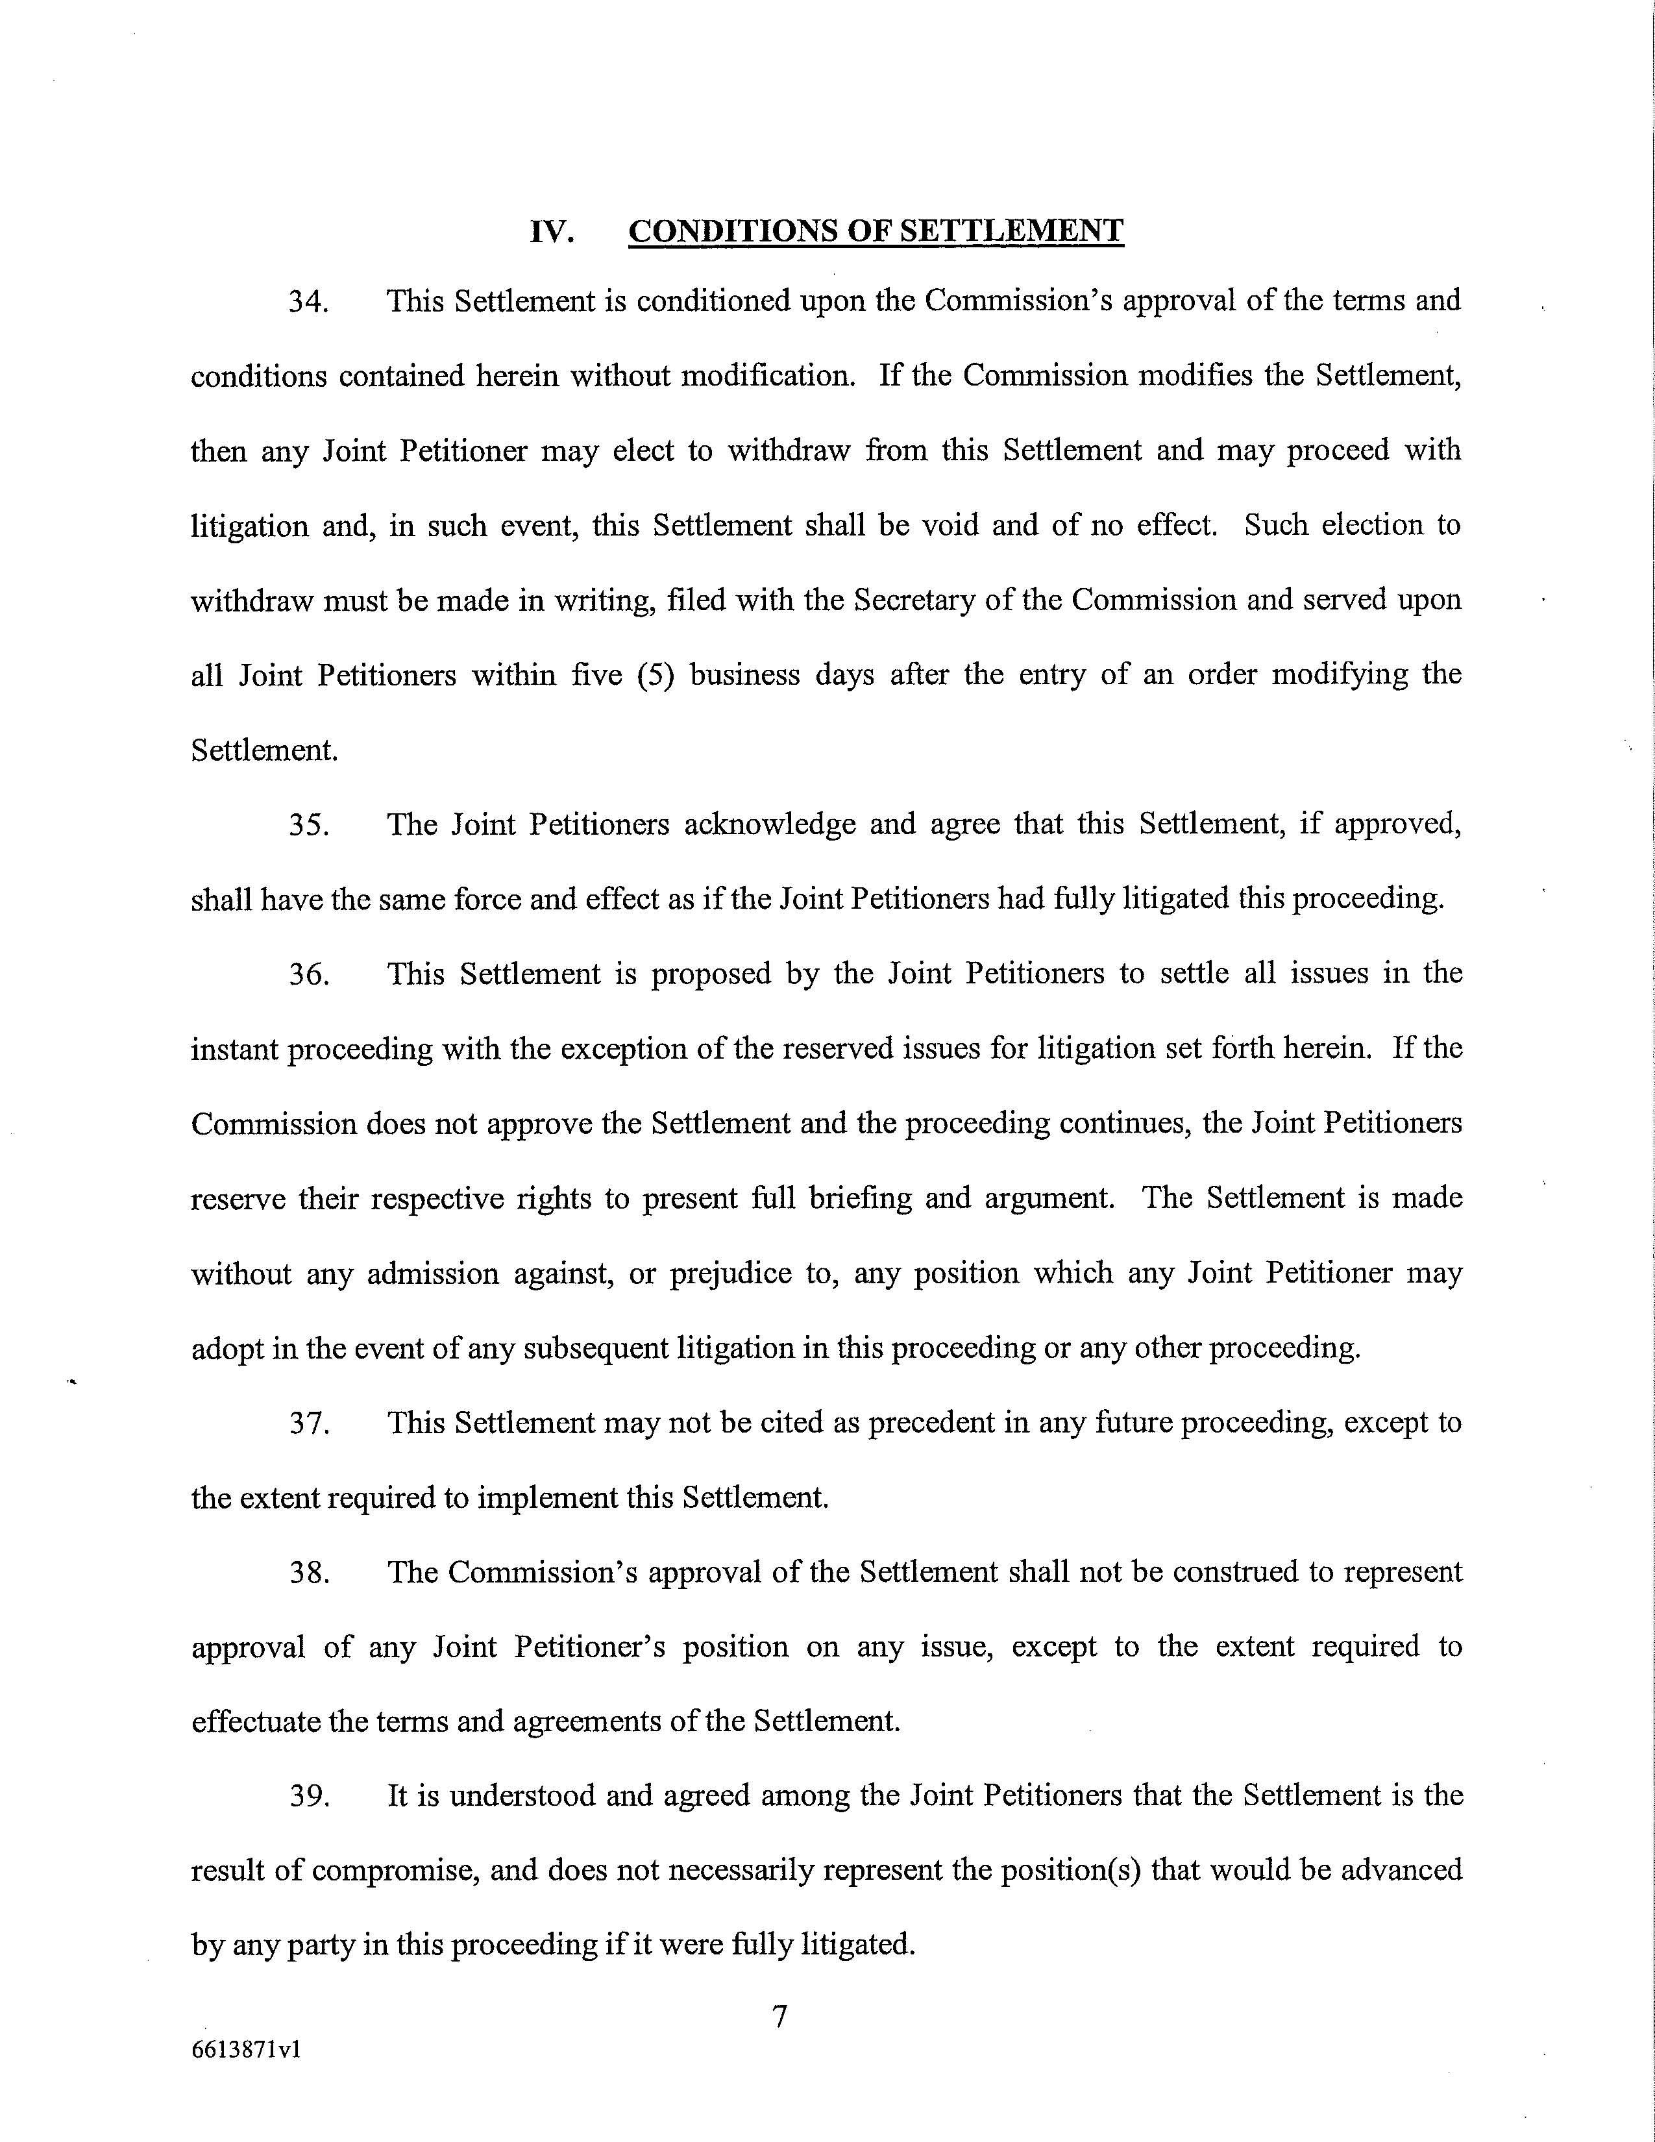

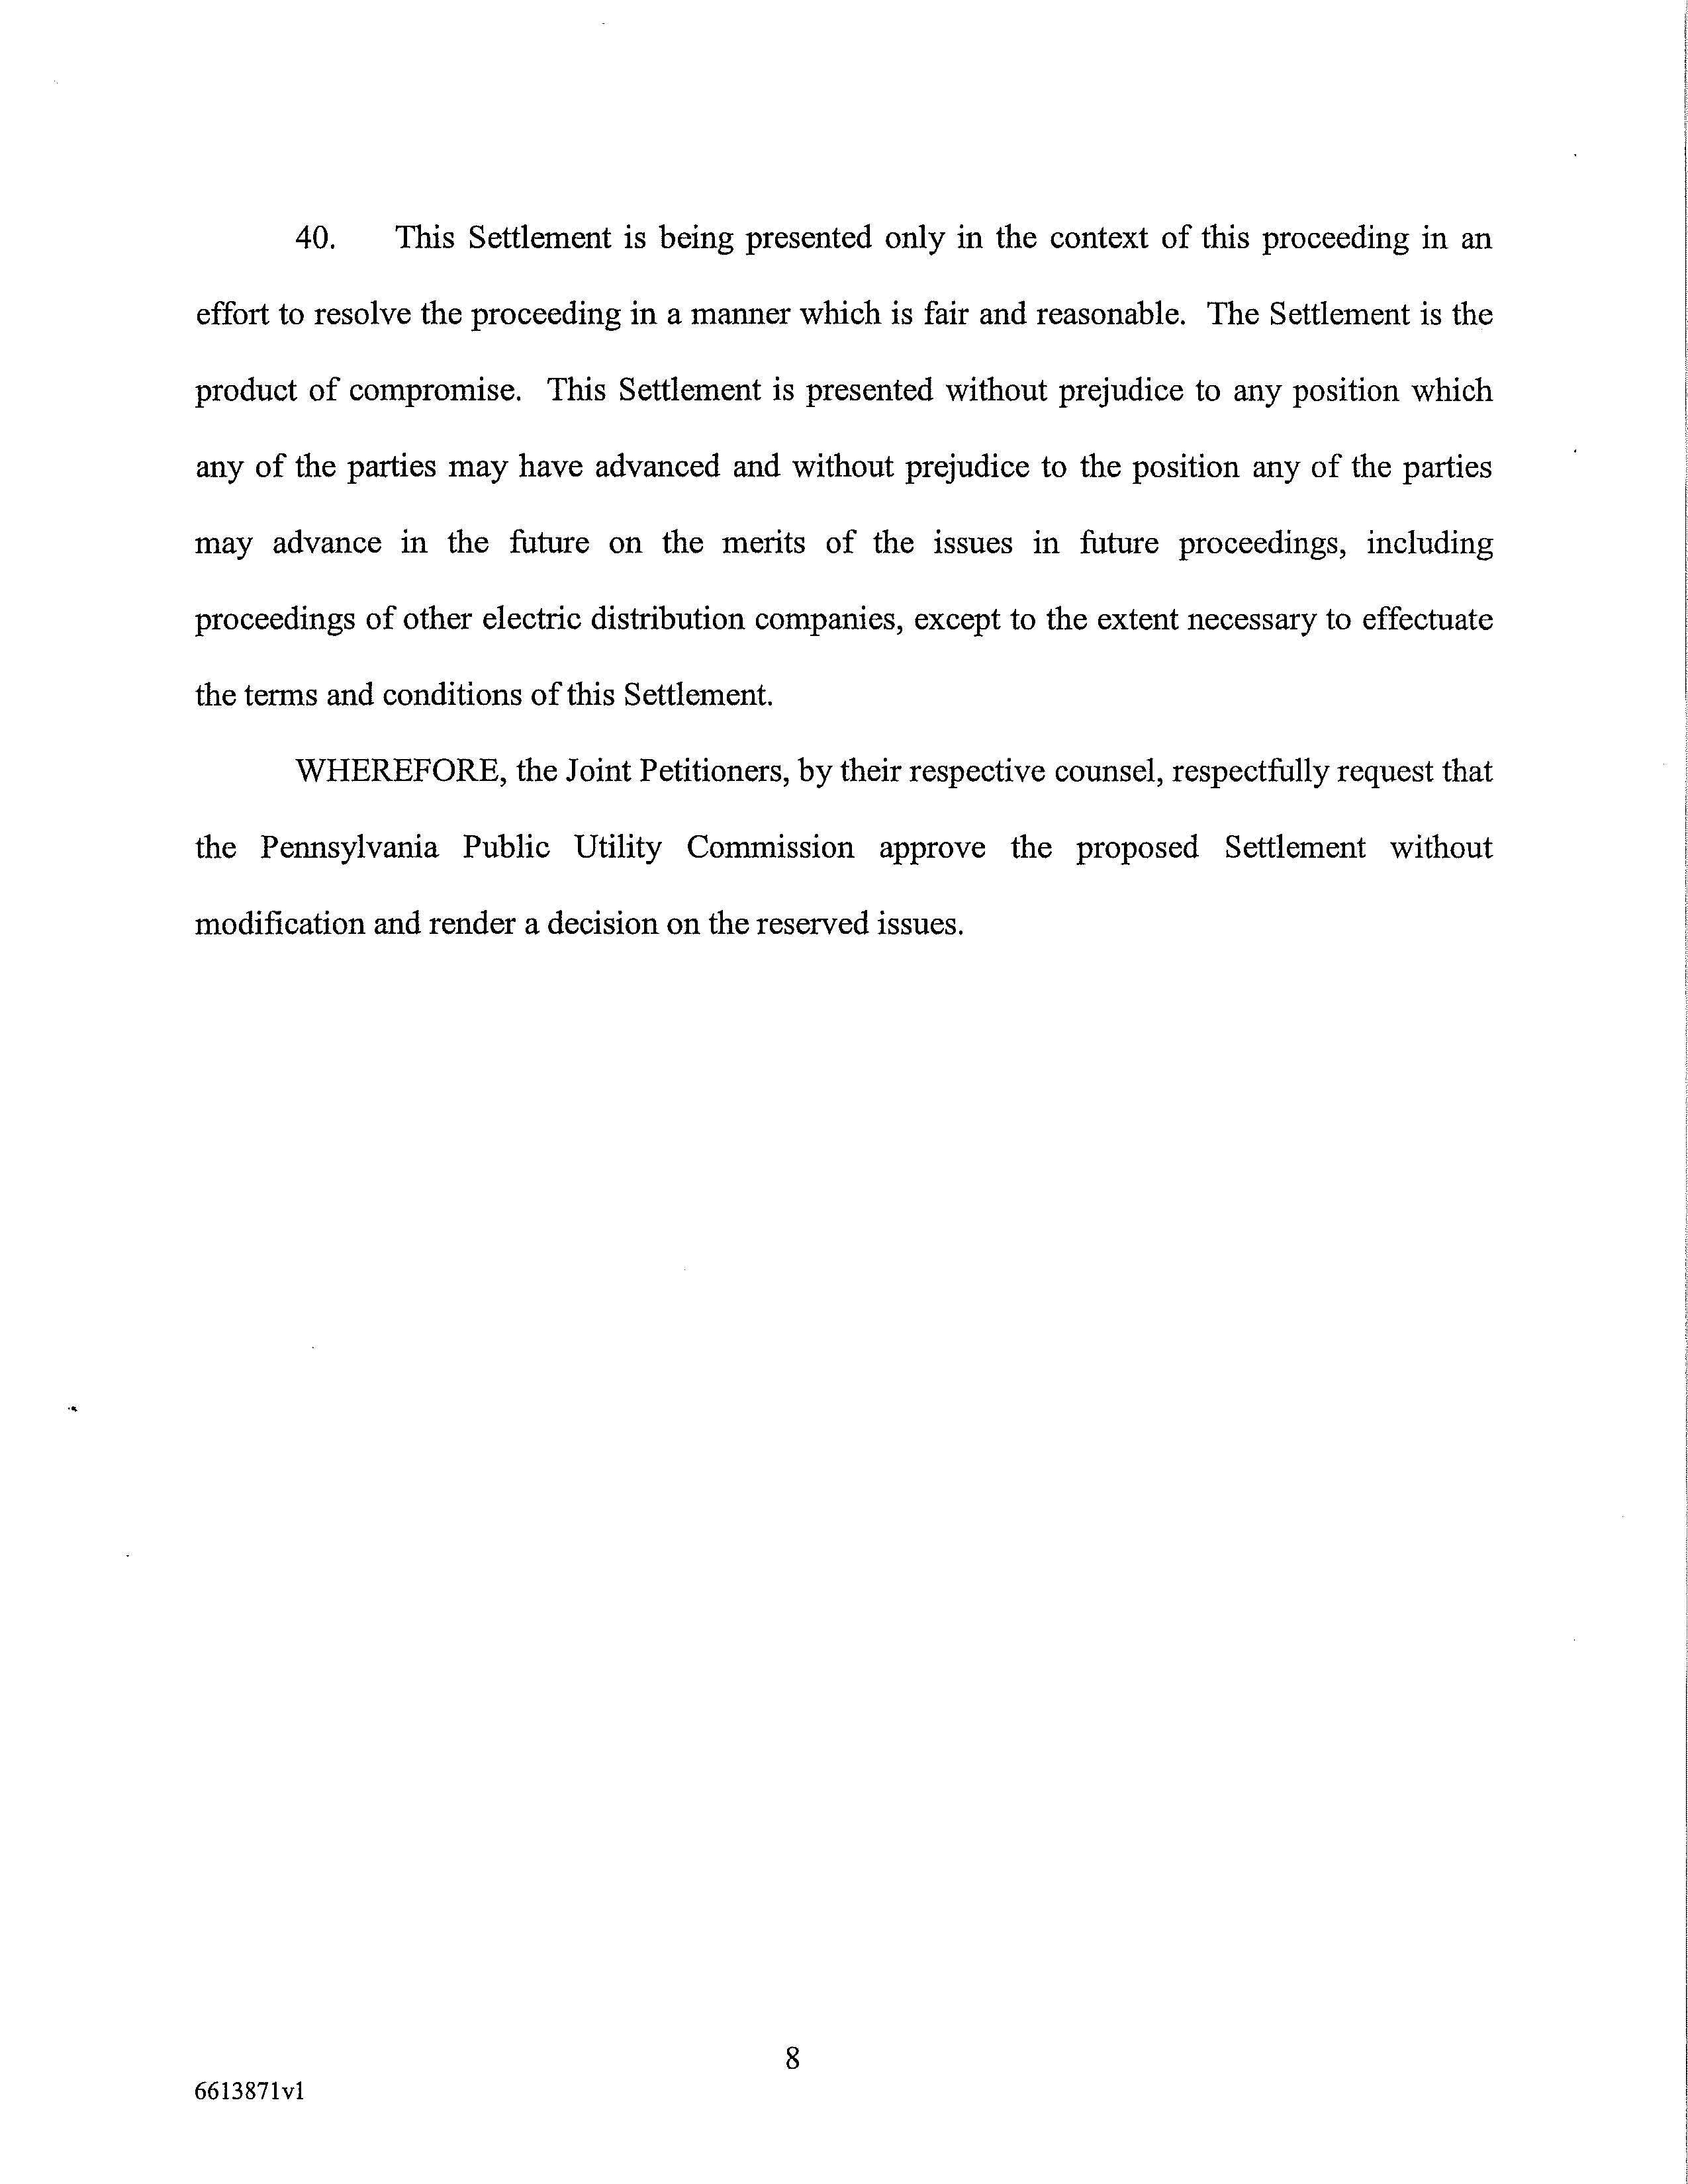

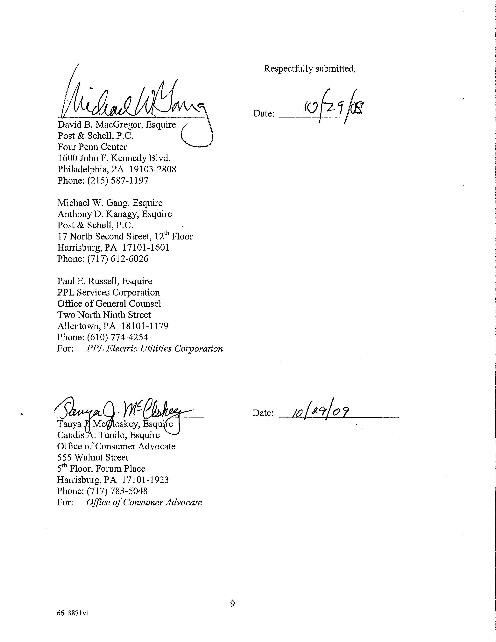

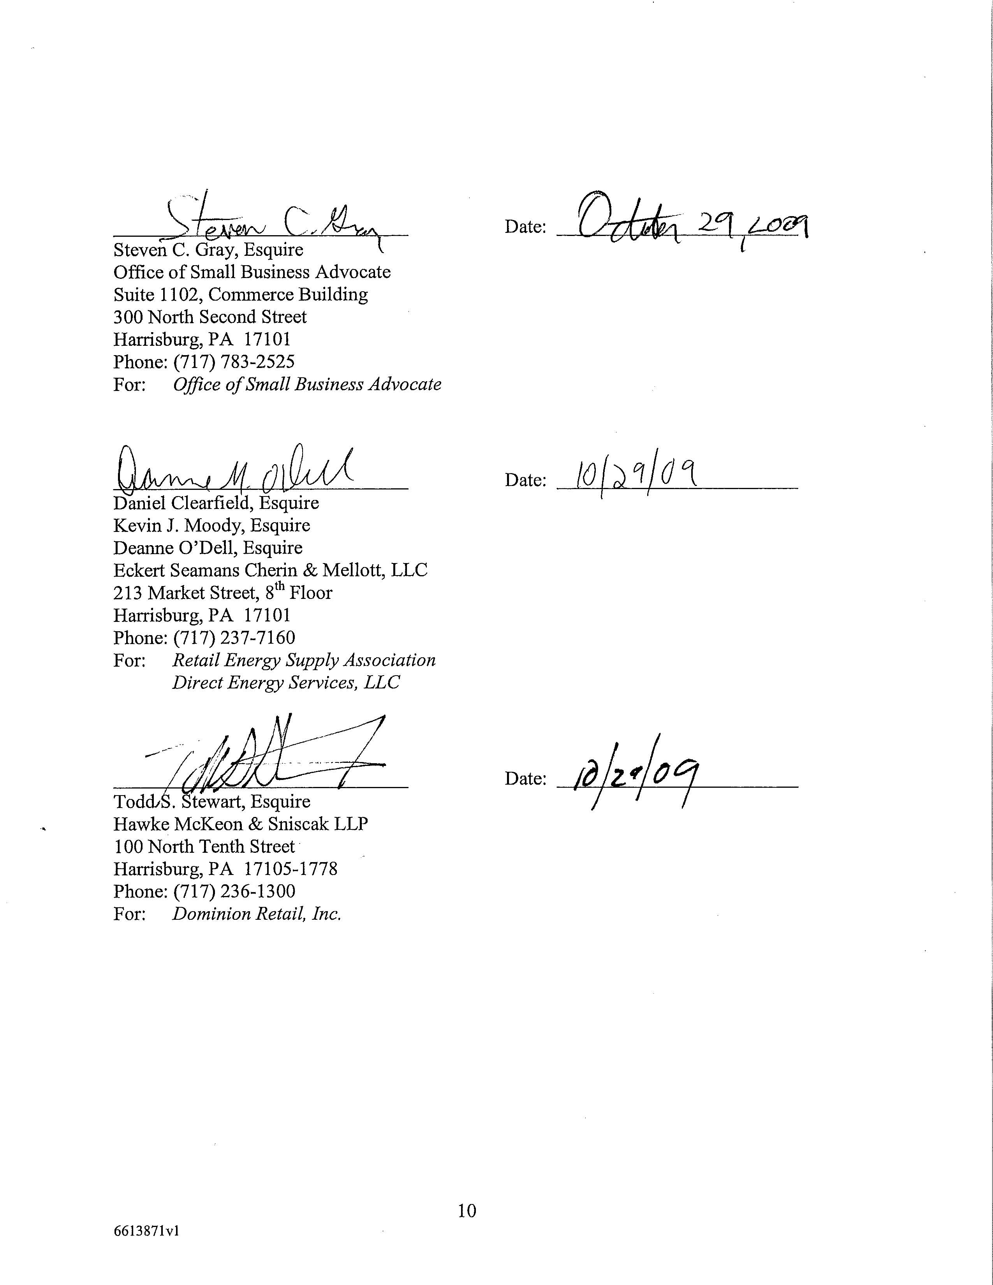

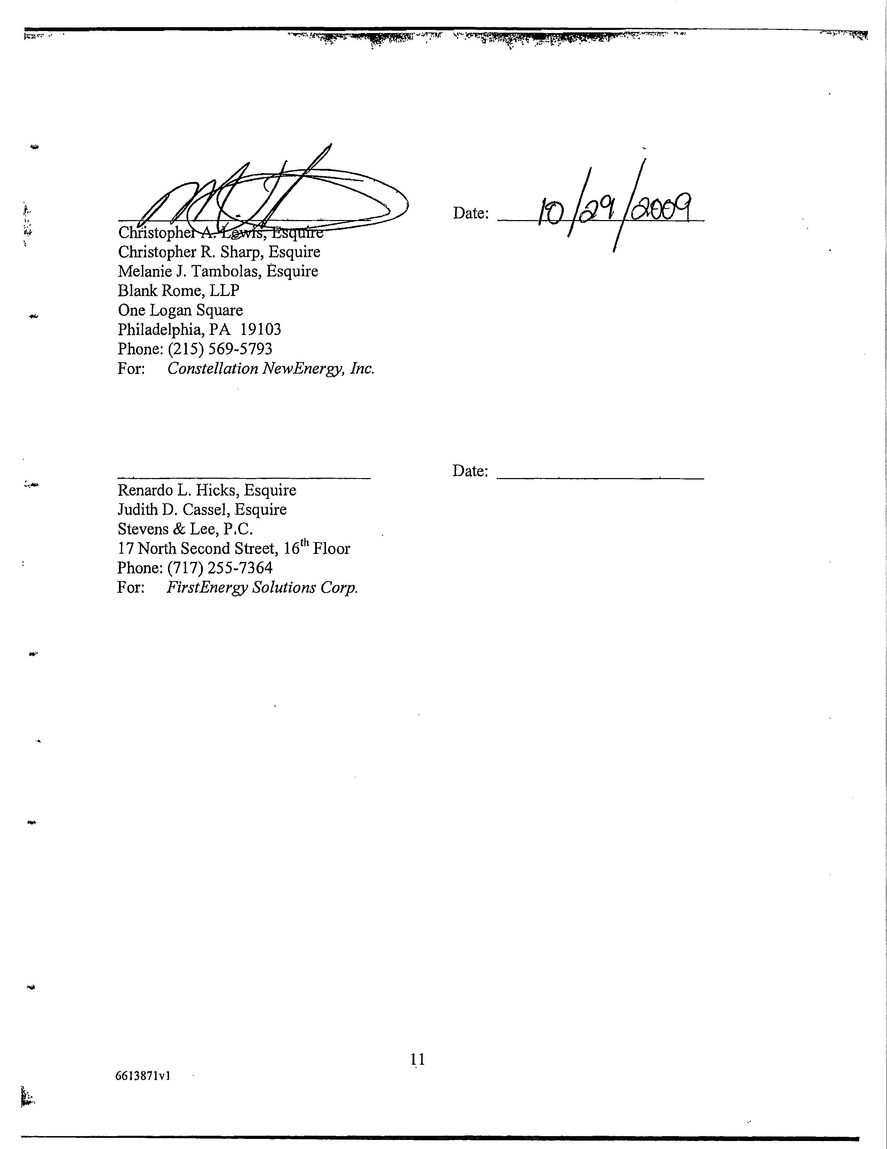

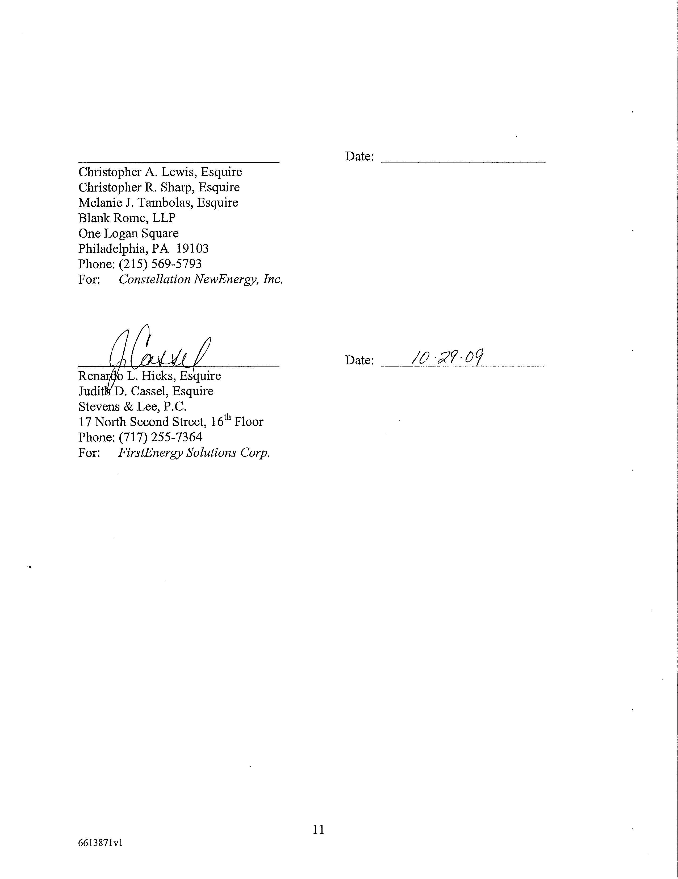



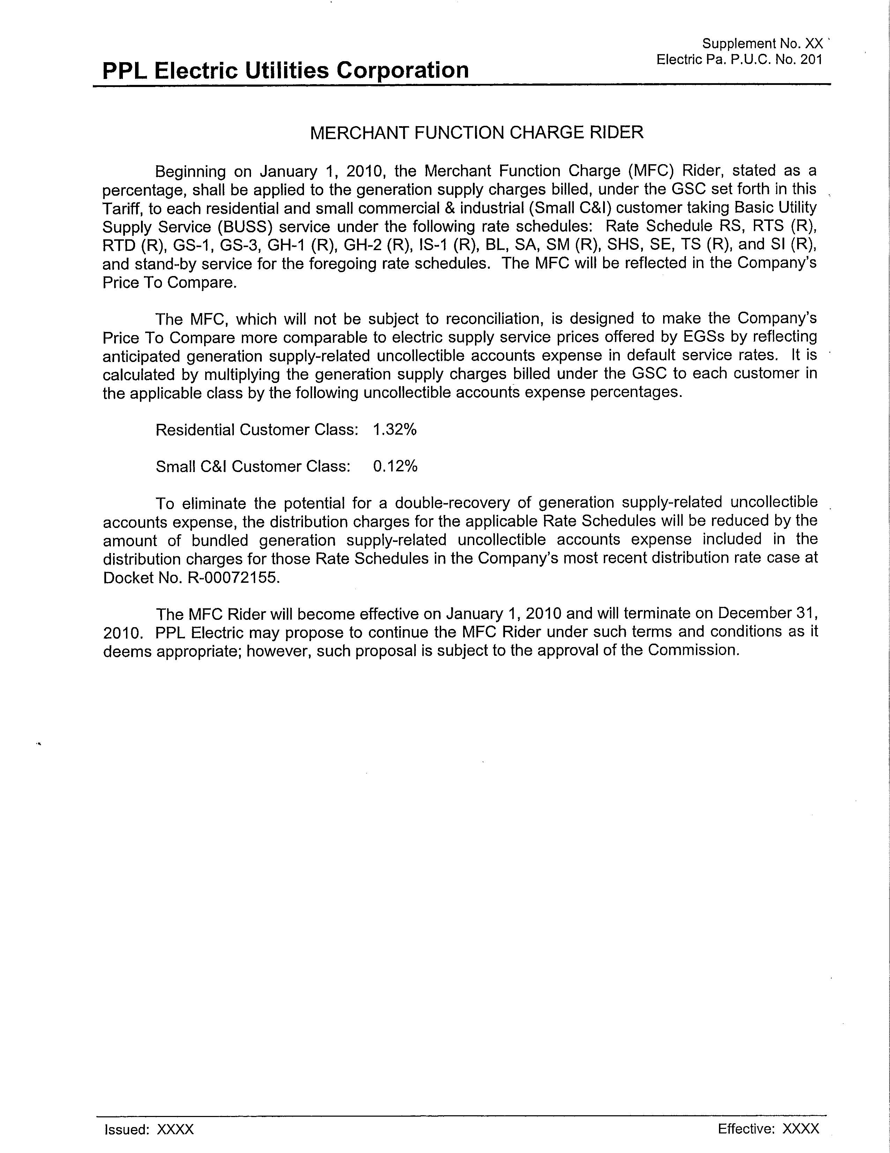

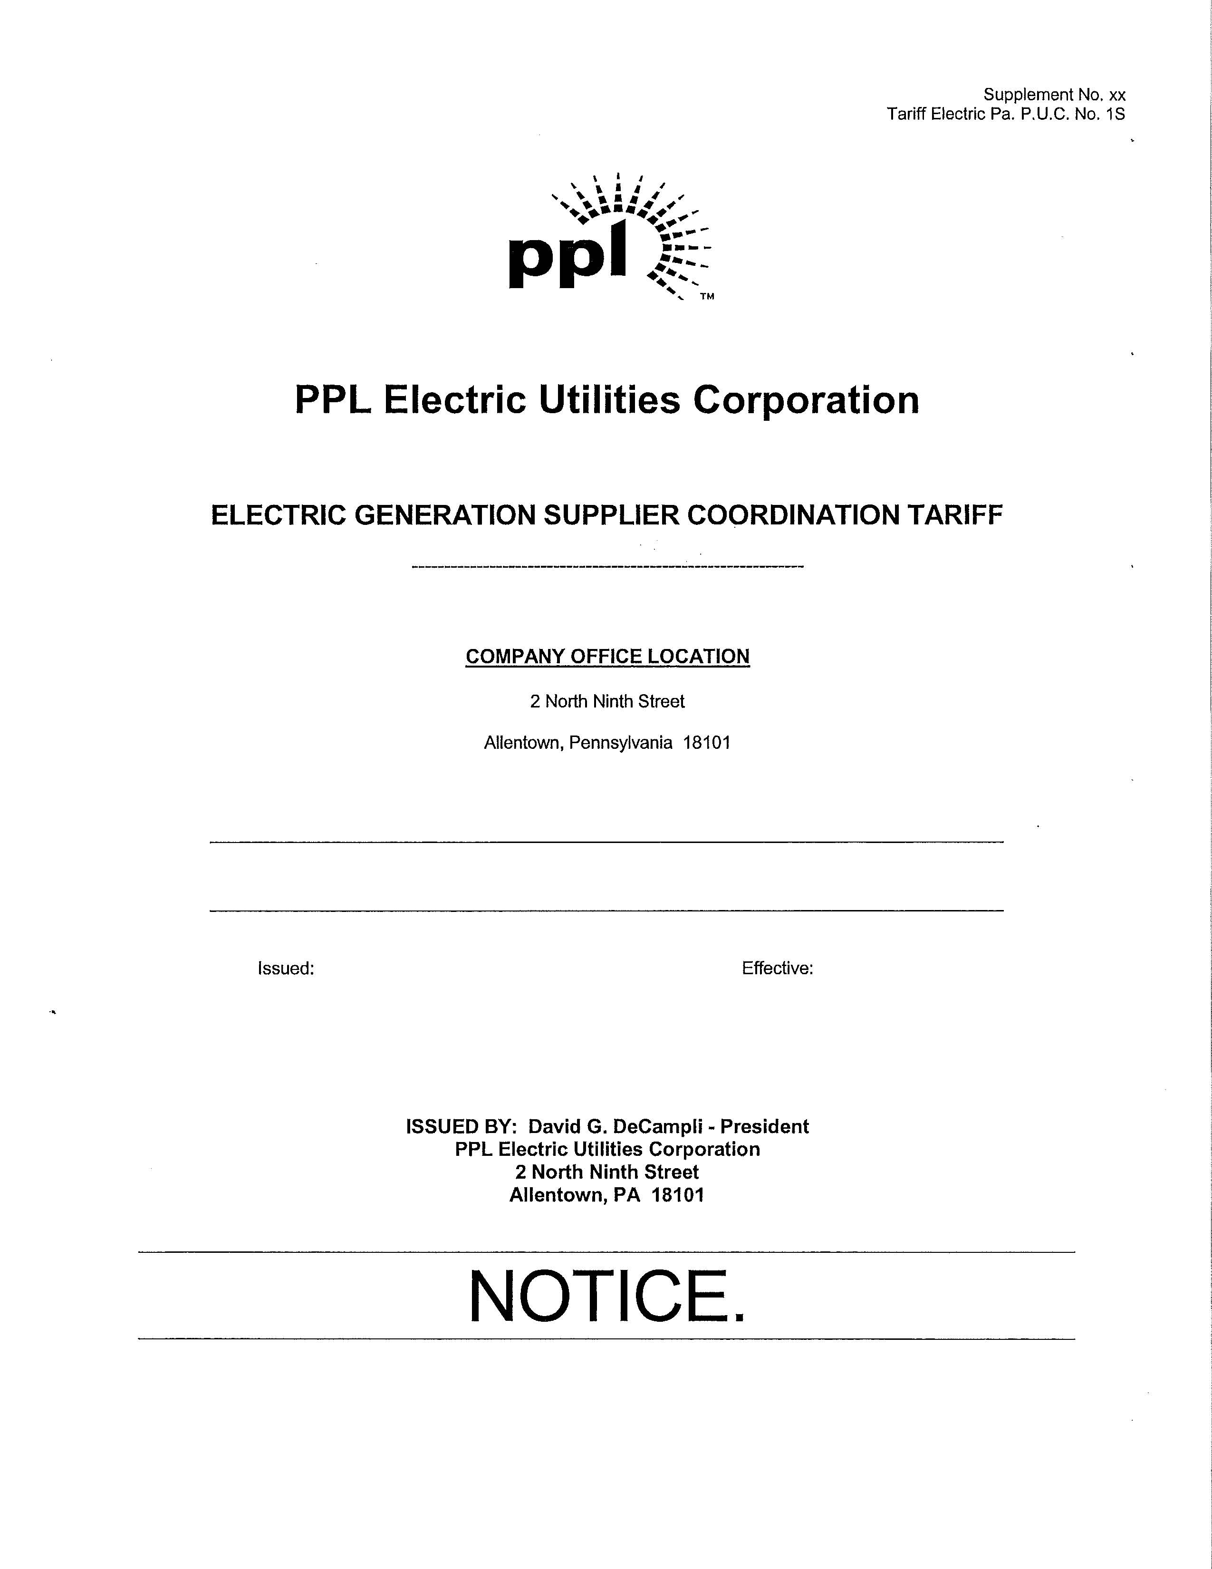

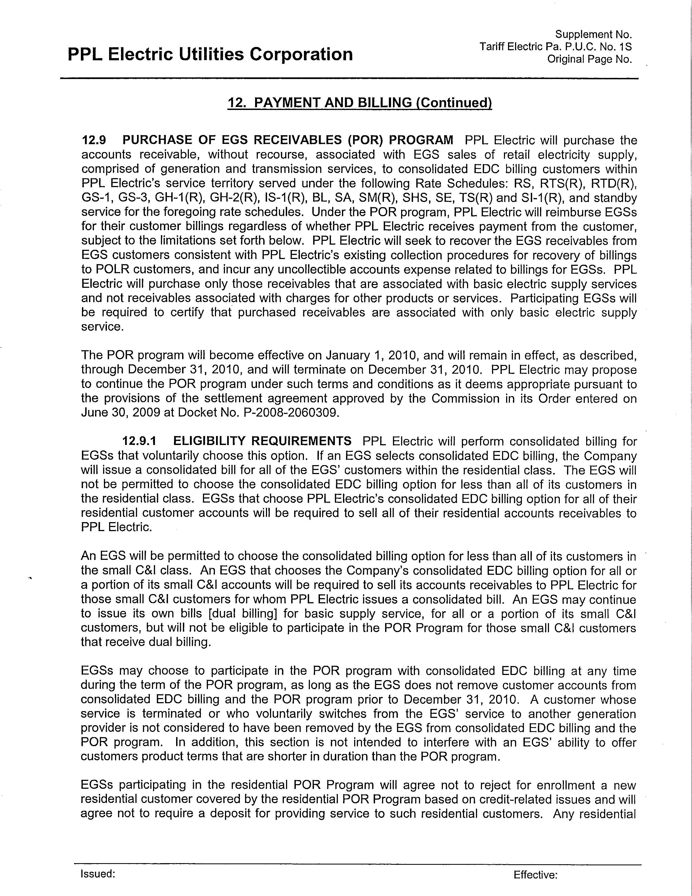

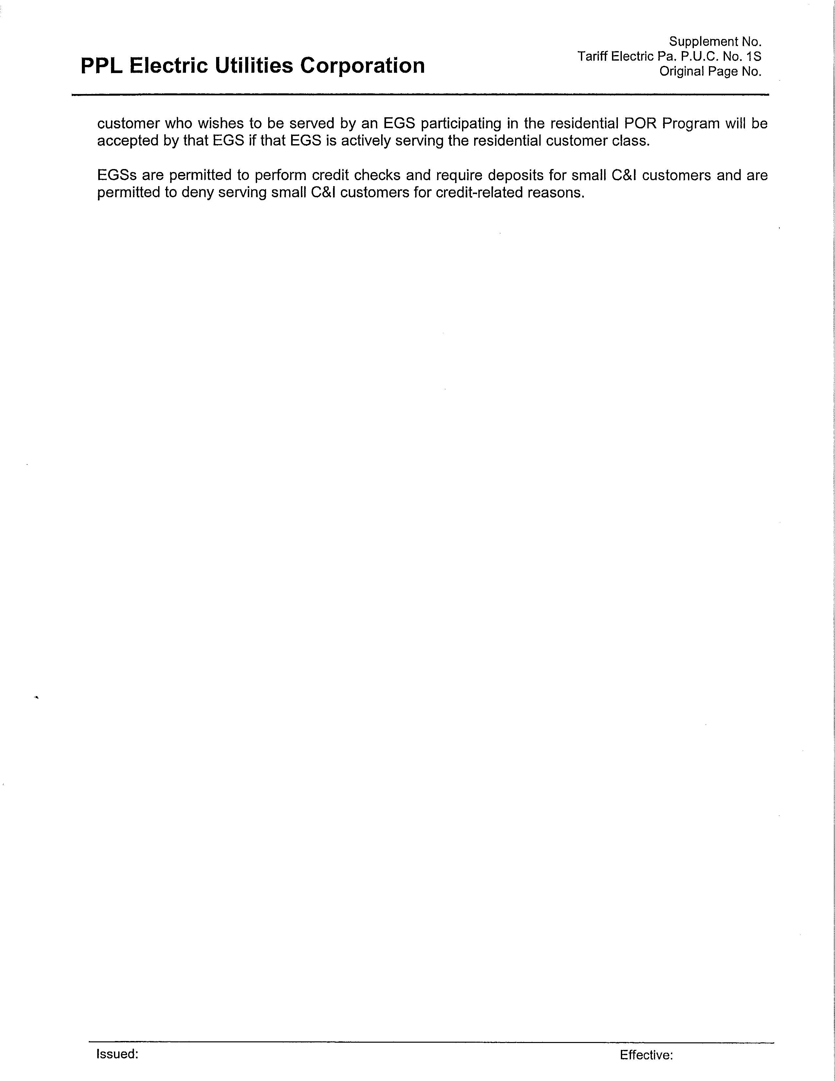

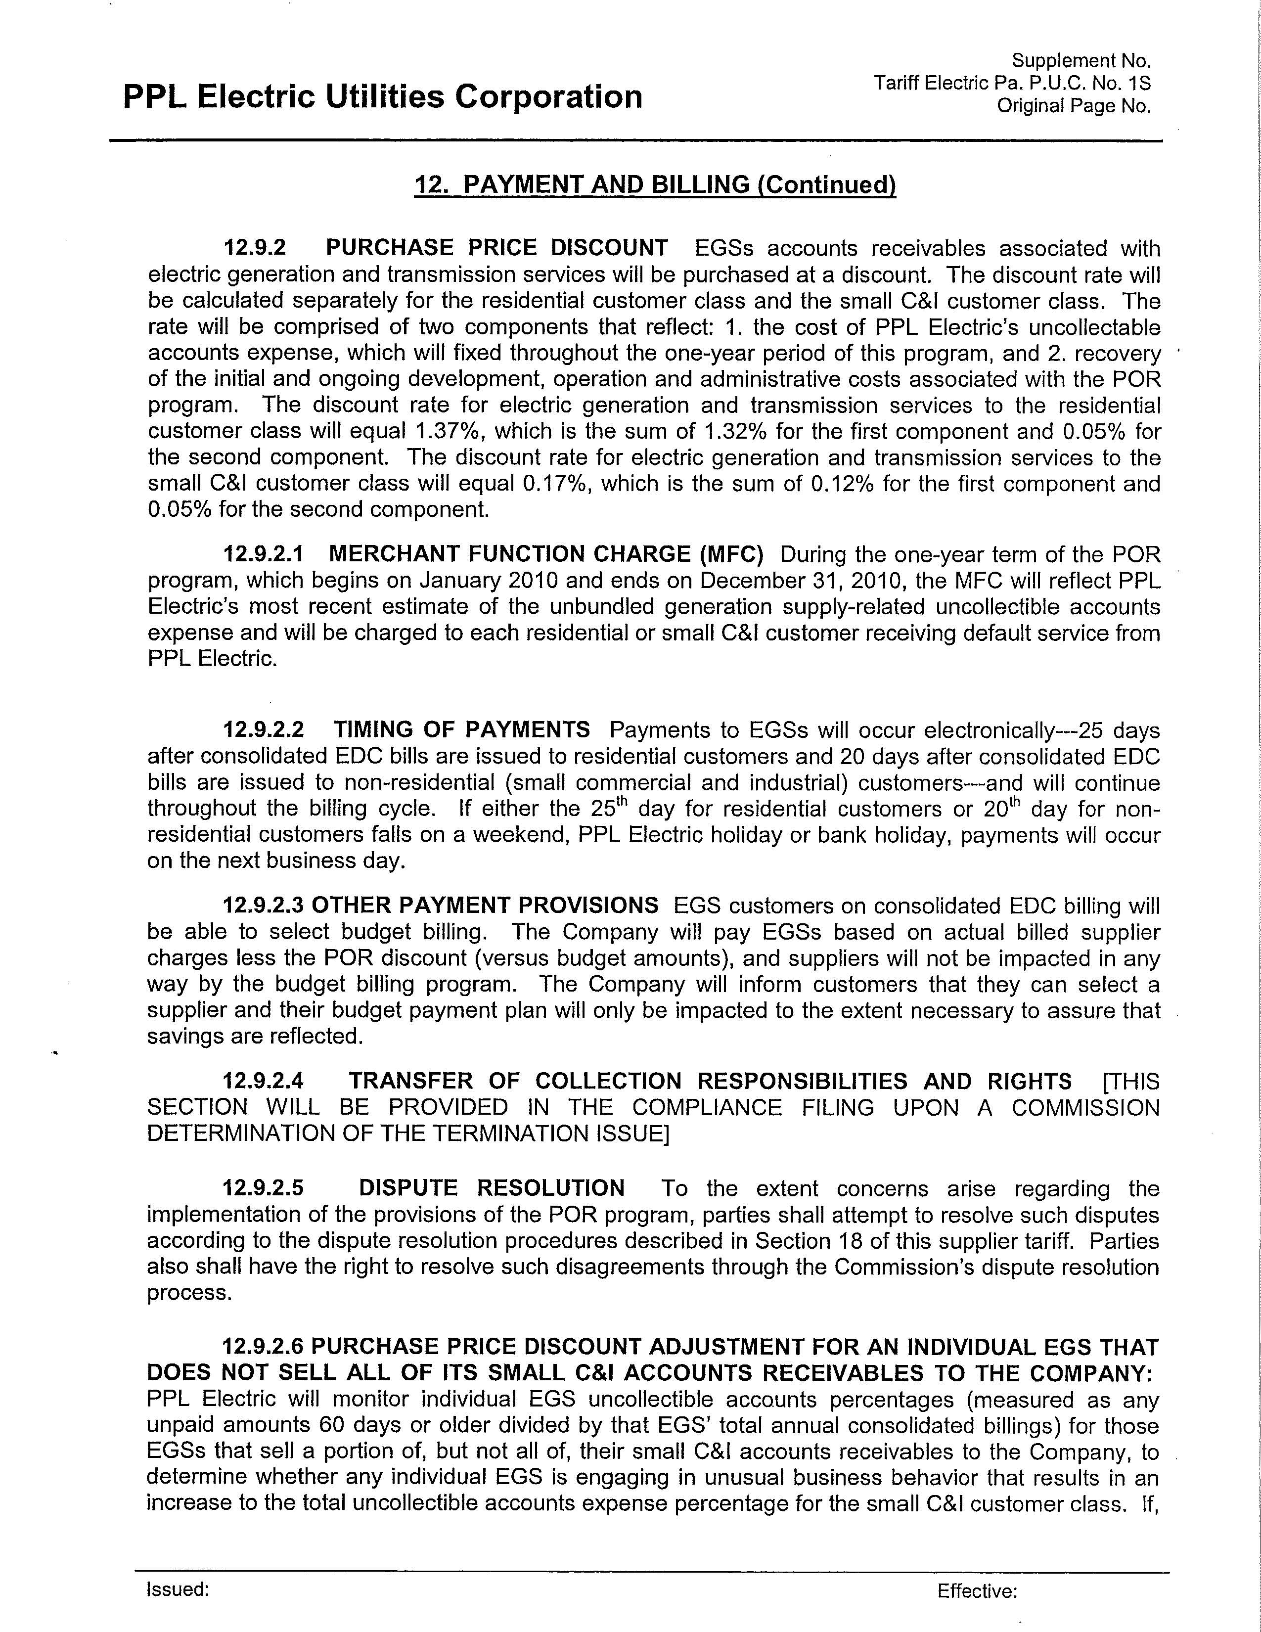

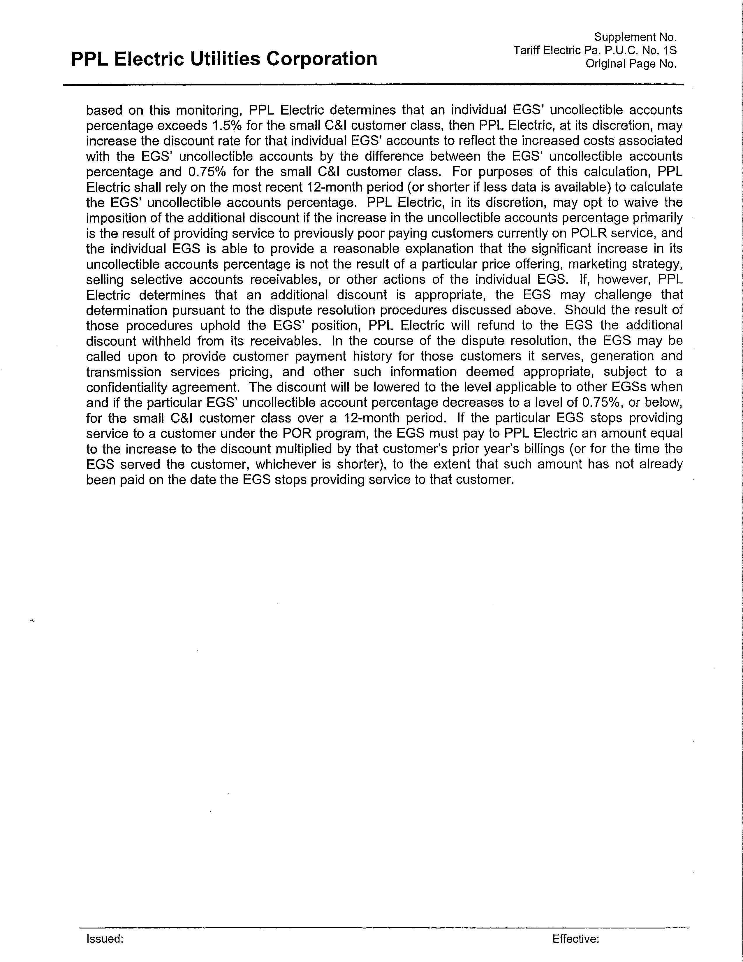

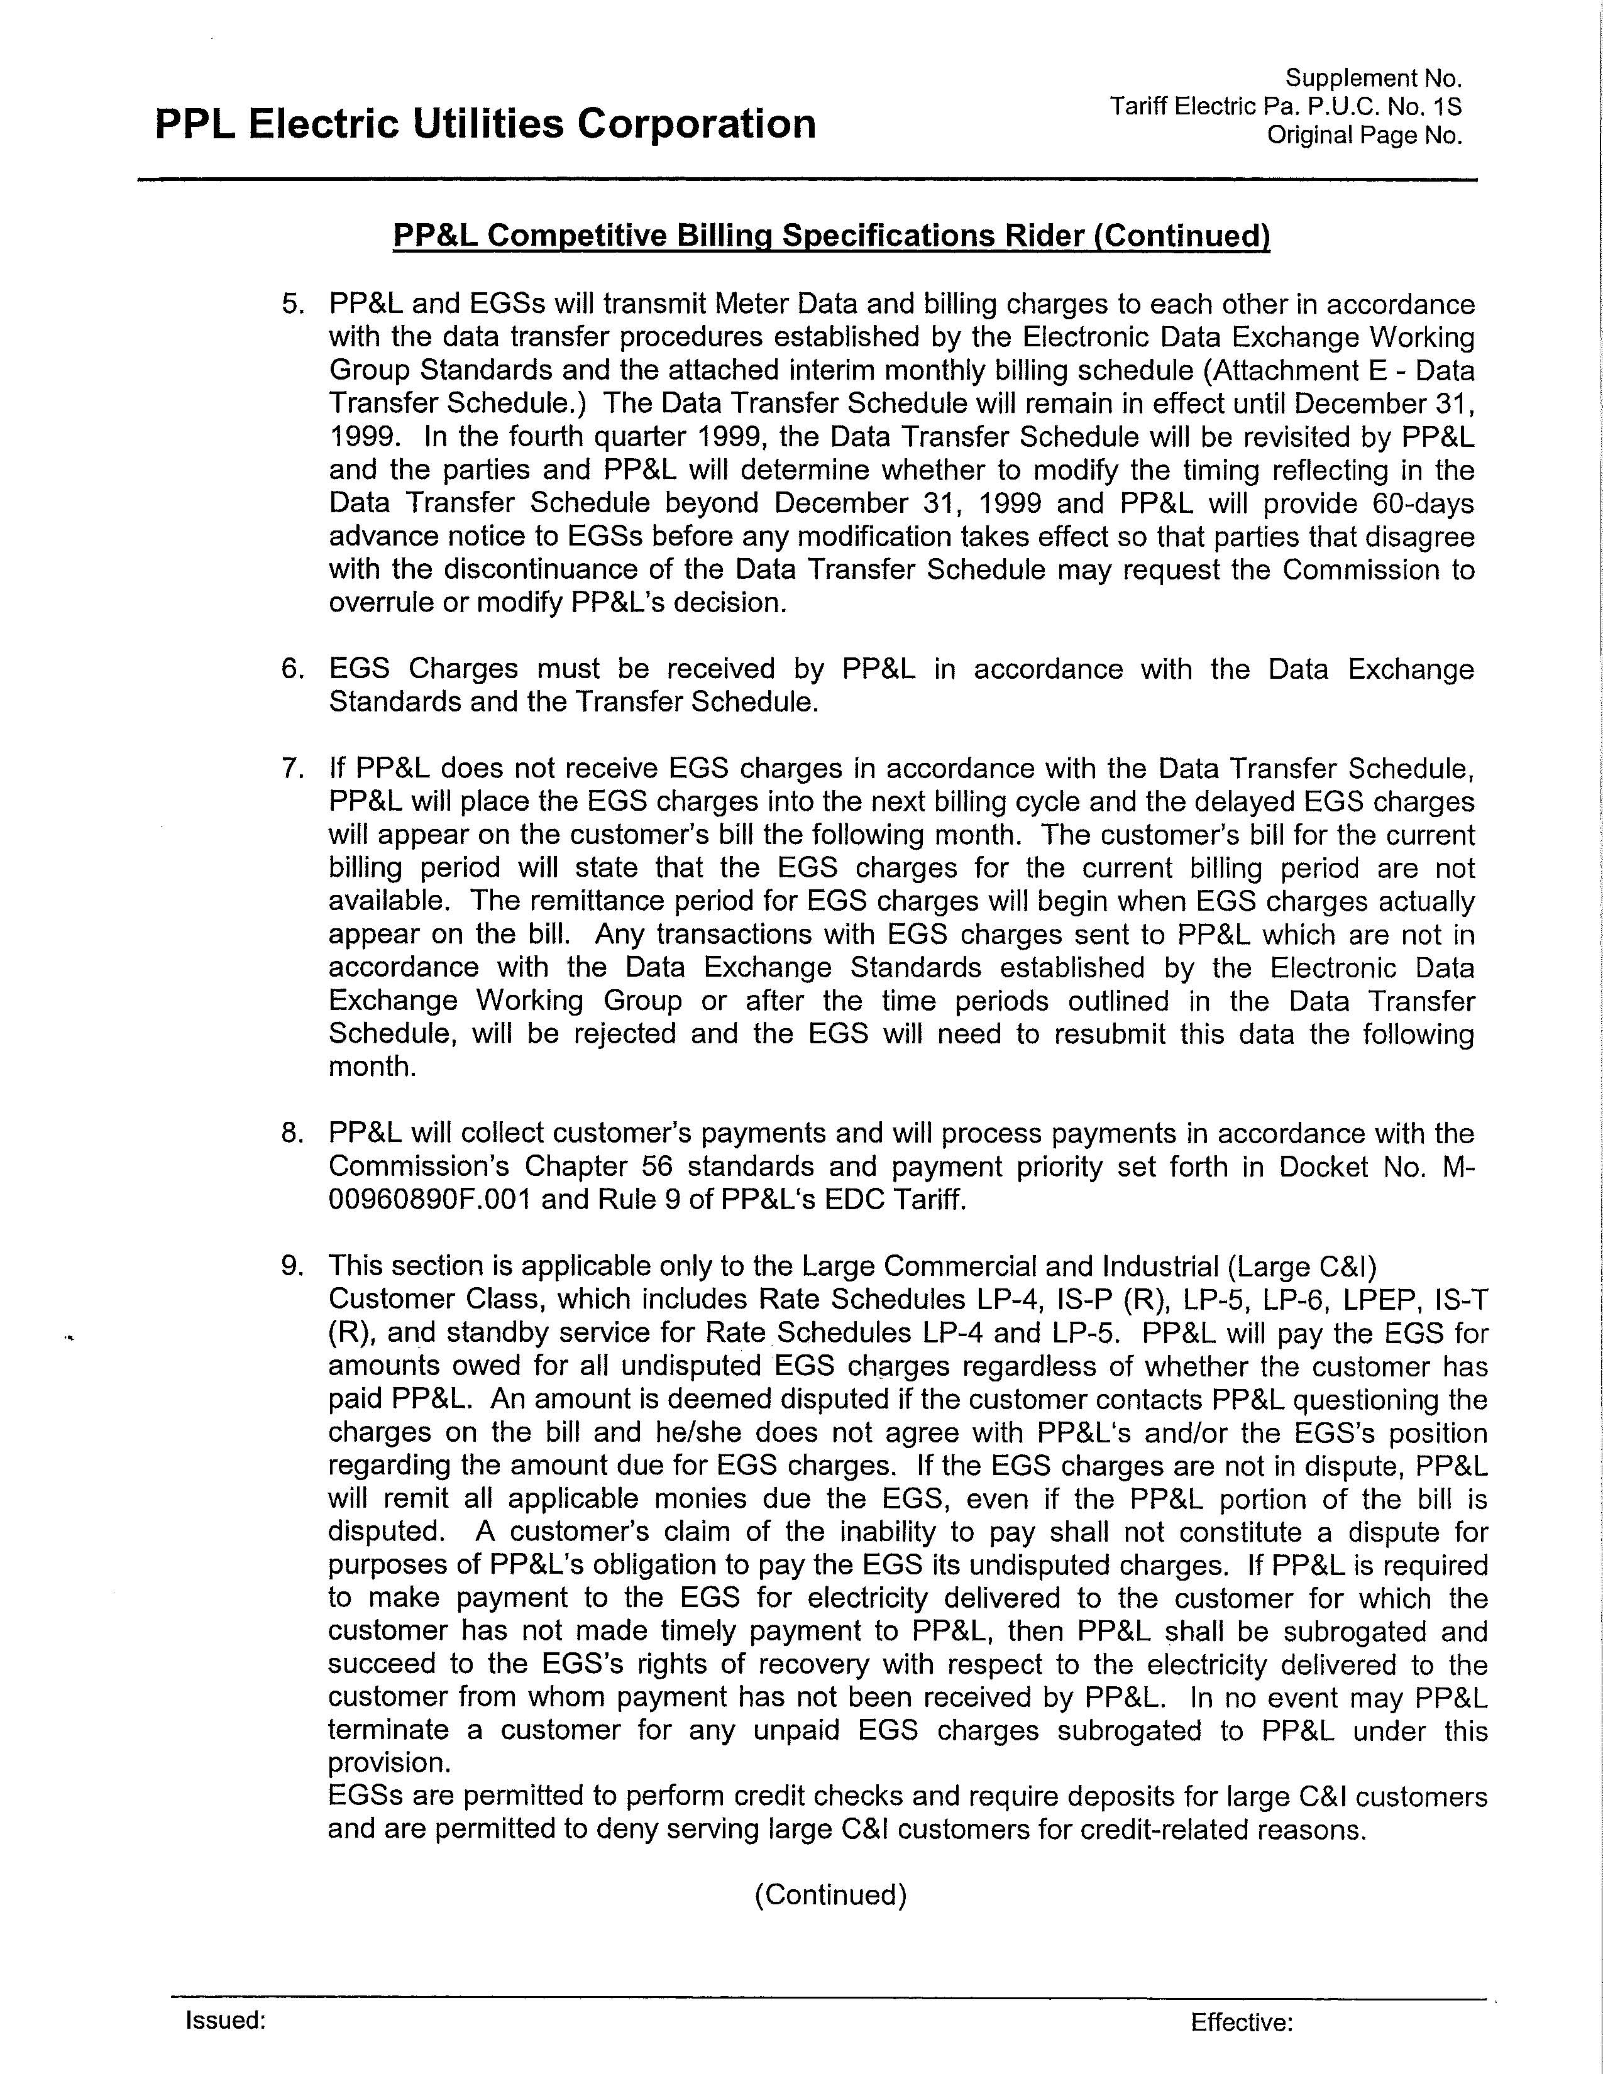

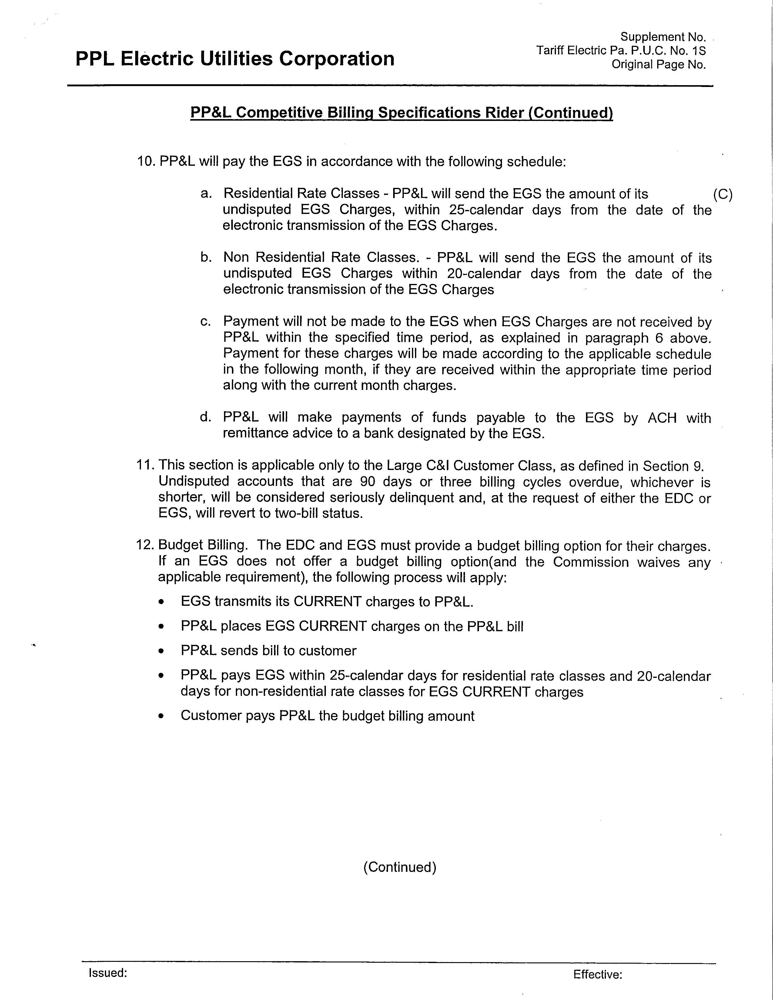

The EGSs that are Parties in this proceeding have argued that PPL Electric should be required to purchase, and terminate service for failure to pay, certain other charges that PPL Electric does not consider to be generation charges. PPL Electric opposes this proposal. This issue is addressed in our consideration and resolution of what constitutes “basic supply service,” below.
We note that 66 Pa. C.S. § 2807(e)(3) provides that PPL acquire the energy at “prevailing market prices.”
RESA/Direct Energy MB at 12.
Petition of Pike County Light & Power Company For Expedited Approval of its Default Service Implementation Plan, Docket No. P-00072245, (Order entered August 16, 2007) at 36 (“While it is true that, at some point, the monthly spot market based POLR price could fall below the [EGS] aggregation price, that is a characteristic of a competitive market based approach and does not mean that the [EGS] aggregation price is unreasonable. Some customers may very well choose to accept the higher priced [EGS] aggregation price in some months in exchange for the stability inherent in that fixed price.”)
Docket No. M-00051865 (Order entered October 3, 2005).
PPL Exhibit No. 6 was filed as a response to an on-the-record data request from RESA. In the ALJ’s Order certifying the Record in this proceeding, the ALJ stated that objections to this Exhibit were due with Main Briefs.
PPL Electric Utility Corporation Retail Markets, Docket No. M-2009-2104271, (Tentative Order entered May 15, 2009) at 15.
Alternative Energy Portfolio Standards Act, 73 P.S. §§ 1648.1 – 1648.8

