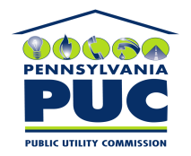 | COMMONWEALTH OF PENNSYLVANIA  PENNSYLVANIA PUBLIC UTILITY COMMISSION  P.O. BOX 3265, HARRISBURG, PA 17105-3265 | IN REPLY PLEASE REFER TO OUR FILE

April 16, 2010
U-2010-2164441

KIM G FLOWERS
AGENCY COORDINATOR
PPL ELECTRIC UTILITIES CORP
TWO NORTH NINTH STREET
ALLENTOWN PA 18101-1179

Agreement dated November 10, 2009, between PPL Electric Utilities Corporation and the Borough of Lehighton relative with the right to construct, operate, and maintain its electric line facilities in Franklin Township, County of Carbon.
__________

To Whom It May Concern:

We enclose herewith the original and one (1) copy of certificate of filing issued by this Commission in accordance with Section 507 of the Public Utility Code, 66 Pa. C.S. §507.

You should serve the enclosed copy of this certificate upon the Borough of Lehighton.

Very truly yours,

James J. McNulty,
Secretary

mh
encls.
cert.mail

