PENNSYLVANIA
PUBLIC UTILITY COMMISSION
Harrisburg, PA 17105-3265

Public Meeting held May 20, 2010

Commissioners Present:

James H. Cawley, Chairman; Statement
Tyrone J. Christy, Vice Chairman; Statement
Wayne E. Gardner; Dissenting Statement
Robert F. Powelson

Petition of Duquesne Light Company for  Approval of Default Service Plan for the  Period January 1, 2011 Through May 31, 2013 | P-2009-2135500

OPINION AND ORDER

BY THE COMMISSION:

Before the Pennsylvania Public Utility Commission (Commission) for consideration and disposition is the Recommended Decision of Administrative Law Judge (ALJ) John H. Corbett, Jr., issued on March 17, 2010, wherein he recommended that the Commission approve, without modification, the Joint Petition For Settlement Of All Issues (Settlement Petition) that was filed on February 24, 2010. Duquesne Light Company (Duquesne Light or Company), the Office of Trial Staff (OTS), the Office of Consumer Advocate (OCA), the Office of Small Business Advocate (OSBA), Citizen Power, Inc. (Citizen Power), Constellation Energy Commodities Group, Inc. and Constellation NewEnergy, Inc. (collectively Constellation), Dominion Retail, Inc. (Dominion), First Energy Solutions Corporation (FES), and Retail Energy Supply Association (RESA) (hereinafter collectively referred to as the “Joint Petitioners”) either join in or do not oppose the Settlement Petition.

History of the Proceeding

On October 9, 2009, Duquesne Light filed a Petition with the Commission seeking approval of a Default Service Plan (Petition). In the Petition, Duquesne Light requests approval of its proposed plan to provide default service to its customers from January 1, 2011 through May 31, 2013. Duquesne Light’s current default service plan (the POLR IV Plan) expires on December 31, 2010. Notice of the Default Service Plan was published in the Pennsylvania Bulletin on October 24, 2009.

The OTS entered its appearance in this proceeding, while the OCA and the OSBA filed notices of intervention. The following entities filed petitions to intervene: Citizen Power, Constellation, Dominion, Duquesne Industrial Intervenors (DII), FES, and RESA.

An initial prehearing conference was held on November 12, 2009. The Parties filed prehearing memoranda identifying potential issues and witnesses. At the prehearing conference, the ALJ granted the petitions to intervene of Citizen Power, Constellation, DII, Dominion, and FES. The ALJ deferred ruling on RESA’s petition to intervene pending admission of counsel pro hac vice. A procedural schedule was established at the prehearing conference. On November 20, 2009, the hearing dates were changed from February 9-10, 2010 to February 11-12, 2010, due to the impending move of the Commission’s Pittsburgh offices. Also on November 20, 2009, the ALJ issued a Second Interim Order granting RESA’s motion for admission of counsel pro hac vice, and RESA’s petition to intervene.

The OCA, OSBA, Constellation, Dominion, FES, and RESA served direct testimony on December 21, 2009. On January 19, 2010, rebuttal testimony was served by Duquesne Light, the OCA, OSBA, Constellation, Dominion, and RESA. On January 29, 2010, surrebuttal testimony was served by Duquesne Light, the OCA, OSBA, Constellation, Dominion, and RESA. In addition, Duquesne Light served rejoinder outlines on February 5, 2010. Due to inclement weather conditions, the hearing dates scheduled for February 11-12, 2010, were postponed to February 24-25, 2010.

The Parties undertook formal and informal discovery in this proceeding. They held several settlement conferences. As a result of these conferences and their efforts to examine the issues raised by the various Parties, a settlement in principle of all issues was achieved prior to the date set for evidentiary hearings. On February 19, 2010, Duquesne Light advised the ALJ of the settlement in principle and the hearings scheduled for February 24-25, 2010, were canceled.

The Joint Petitioners either join in or do not oppose the Settlement Petition that was filed on February 24, 2010. The Settlement Petition, which is incorporated herein by reference, provides for a default service plan for the period from January 1, 2011, through May 31, 2013. Attached as Appendix “A” to the Settlement are pro forma tariff sheets to implement the default service plan. Appendix “B” to the Settlement contains an Interrogatory Response clarifying the limited circumstances under which Duquesne Light may propose to modify the fixed price offering for residential and lighting customers. Appendix “C” to the Settlement contains a default supply procurement schedule for the Company’s Small Commercial and Industrial (“C&I”) and Medium C&I customers. Appendix “D” to the Settlement is the Supply Master Agreement for Small and Medium C&I default supply procurements. The Joint Petitioners also submit statements in support of the Settlement attached thereto as Appendices “E” through “L.” The Joint Petitioners represent that this Settlement is a reasonable resolution of this proceeding and is in the public interest and, therefore, request that the ALJ and Commission approve the proposed Settlement without modification.

Discussion

Pursuant to our Regulations at 52 Pa. Code § 5.231, it is the Commission’s policy to promote settlements. Settlements eliminate the time, effort and expense of litigating a matter to its ultimate conclusion, which may entail review of the Commission’s decision by the appellate courts of Pennsylvania. Such savings benefit not only the individual parties, but also the Commission and all ratepayers of a utility, who otherwise may have to bear the financial burden such litigation necessarily entails.

We commend all the Parties for coming together to present the Commission with a well-reasoned and thorough settlement. We believe approval of this Settlement Petition is in the public interest and that all default service customers will be well-served by the programs put in place. However, and as will be discussed below, while we will approve the Settlement, we also wish to solicit comments with respect to two matters.

Pursuant to the Settlement, Duquesne Light shall provide Commission-licensed Electric Generation Suppliers (EGSs) monthly updates to its customer list on its EGS website, subject to the Commission’s customer privacy and protection rules. The Settlement further provides for the right of small and medium commercial and industrial customers to opt out of the release of customer information in its new customer packet.

At the Commission’s Public Meeting on October 22, 2009, the Commission clarified its interpretation of the customer privacy and protection rules in the electric choice regulations at 52 Pa. Code § 54.8, which allow a customer to restrict the release of their telephone number and/or historical billing data. The Commission further directed PPL as follows:

Customers may restrict the release of all historical billing data consistent with 52 Pa. Code § 54.8(a)(2). The Company may make any changes to its proposed letter to customers it believes are necessary in light of these requirements. Any other information, with the exception of customer telephone numbers which is addressed below, not restricted by customers shall be made available to EGSs not later than December 31, 2009.

The Commission further directed PPL to update its customer database immediately and to release, for each customer account, the following information not less than thirty days before the rate cap expired:

- Customer name;
- Account number;
- Rate class and sub-class;
- Service address; and
- Billing address.

In the interest of ensuring effective competition statewide, improving customer access to competitive offers, and consistent with the Commission’s orders regarding consumer privacy and customer lists, we wish to explore whether Duquesne Light should be required to provide a customer list as noted above. If such a requirement is adopted, it is our contemplation that Duquesne Light shall permit customers to opt out of providing historical billing data and telephone numbers, consistent with our customer privacy and protection rules. Comments with respect to this issue may be filed by any Parties to this proceeding who wish to comment within ten days of the entry date of this Opinion and Order. It is our contemplation, based upon those comments, that we may consider further action with respect to this inquiry at a future Public Meeting. Parties should also address in their Comments whether residential customers should be able to restrict the release of their service addresses, as opposed to billing addresses, for privacy reasons.

The Settlement Petition puts into place various continued Company customer-education programs. Consistent with our prior Orders concerning customer education programs, we direct that all draft materials shall be provided to the Commission’s Office of Communications, as well as the Office of Consumer Advocate for consumer education programs and the Office of Small Business Advocate for small business education programs, for review and comment prior to being used.

Conclusion

For the reasons set forth above, we conclude that the Settlement Petition is in the public interest and should be adopted, consistent with this Opinion and Order. We also ask that the Parties provide Comments, if any, with respect to whether Duquesne Light Company should be required to provide a customer list such as was required in our October 22, 2009 PPL Order. Parties should also address in their Comments whether residential customers should be able to restrict the release of their service, as opposed to billing, addresses for privacy reasons; THEREFORE,

IT IS ORDERED:

- That the Recommended Decision of Administrative Law Judge John H. Corbett, Jr., issued on March 17, 2010, recommending that the Commission approve the Joint Petition For Settlement Of All Issues, which was filed by the Parties on February 24, 2010, is adopted.

- That a copy of this Opinion and Order together with the attached Settlement Agreement shall be served on all Parties to this proceeding.

- That Comments with respect to whether Duquesne Light Company should be required to provide a customer list such as was required in our October 22, 2009 Opinion and Order in PPL Electric Utilities Corporation Retail Markets, Docket No. M-2009-2104271 may be filed by the Parties within ten (10) days of the date of entry of this Opinion and Order. The Commission reserves the right to issue a subsequent Order addressing this topic following receipt and consideration of these comments.

- That, consistent with the terms of the Settlement Agreement, Duquesne Light Company shall file appropriate tariff supplements, to be effective on one day’s notice, with the Secretary of the Commission.

5. That consistent with our prior Orders concerning customer-education programs, we direct that all draft materials be provided to the Commission’s Office of Communications, as well as the Office of Consumer Advocate (for consumer education programs) and the Office of Small Business Advocate (for small business education programs) for review and comment prior to use.


BY THE COMMISSION,

Rosemary Chiavetta
Secretary

(SEAL)
ORDER ADOPTED: May 20, 2010
ORDER ENTERED: June 21, 2010

ATTACHMENT
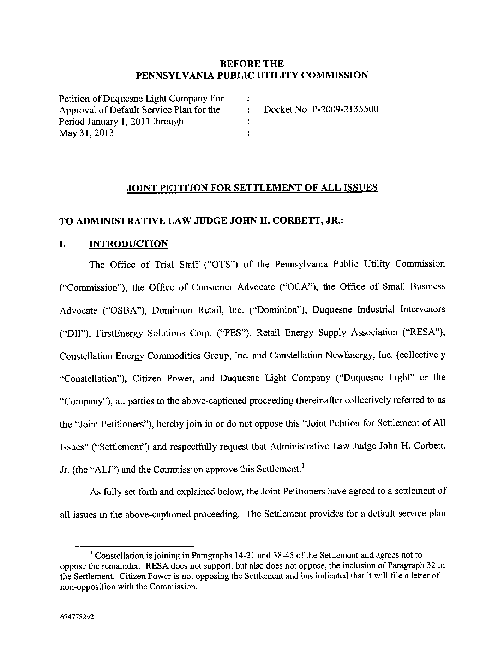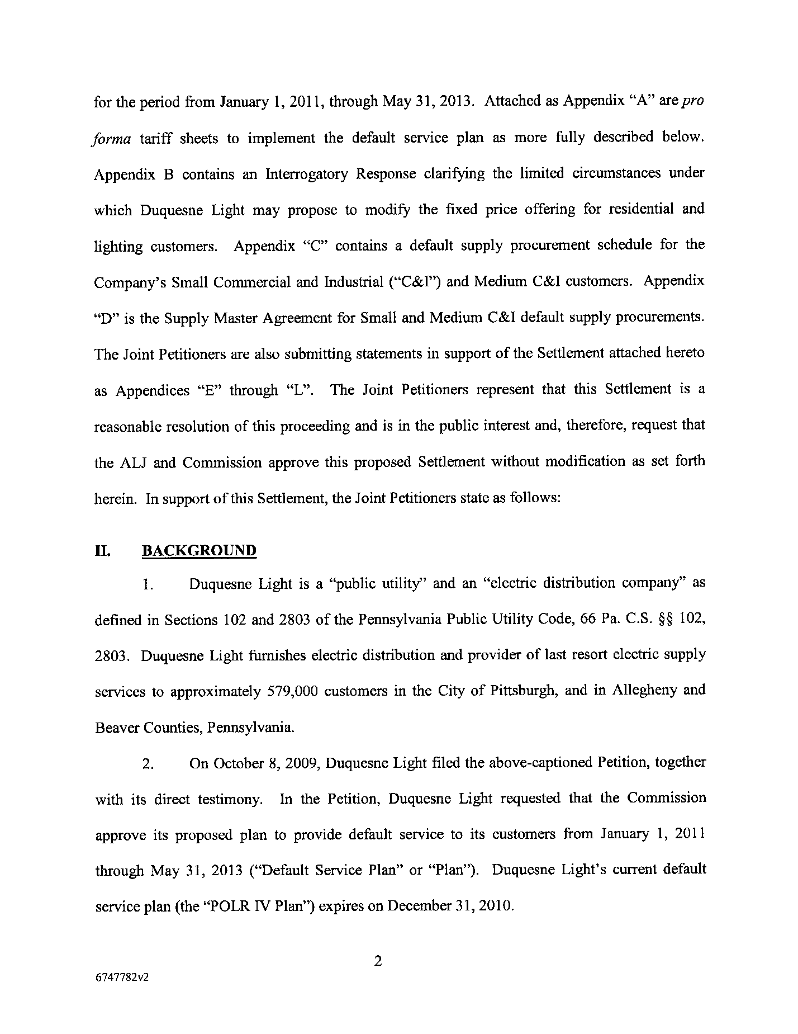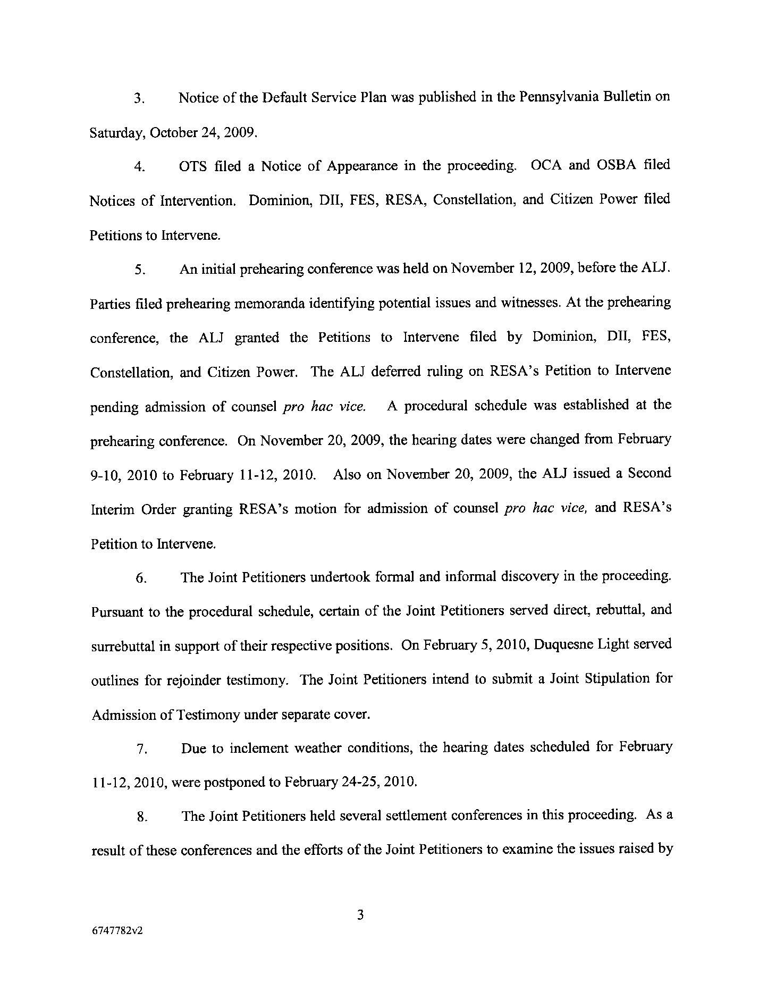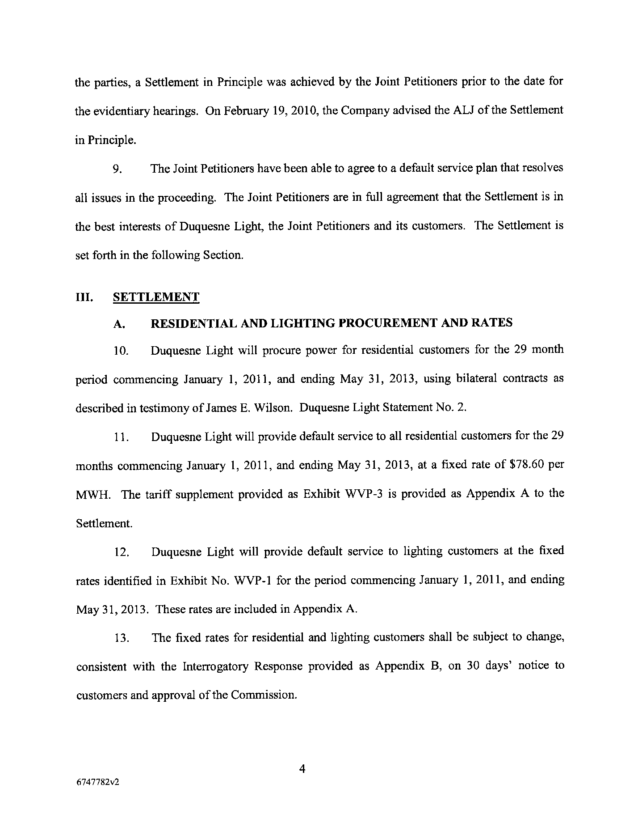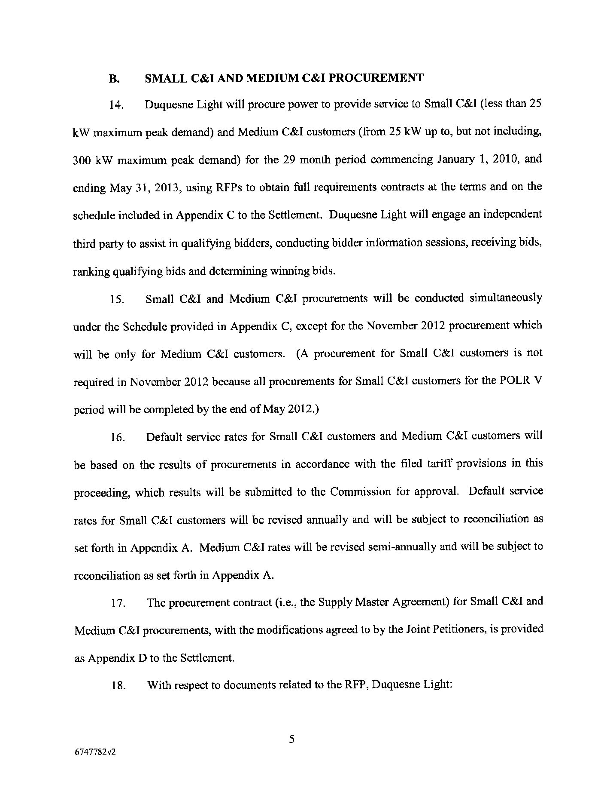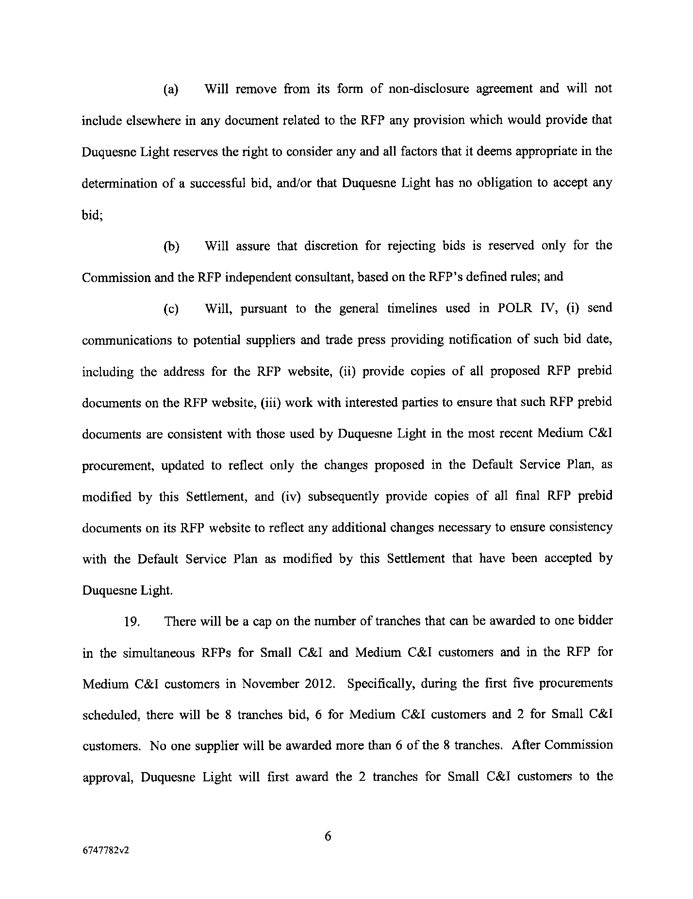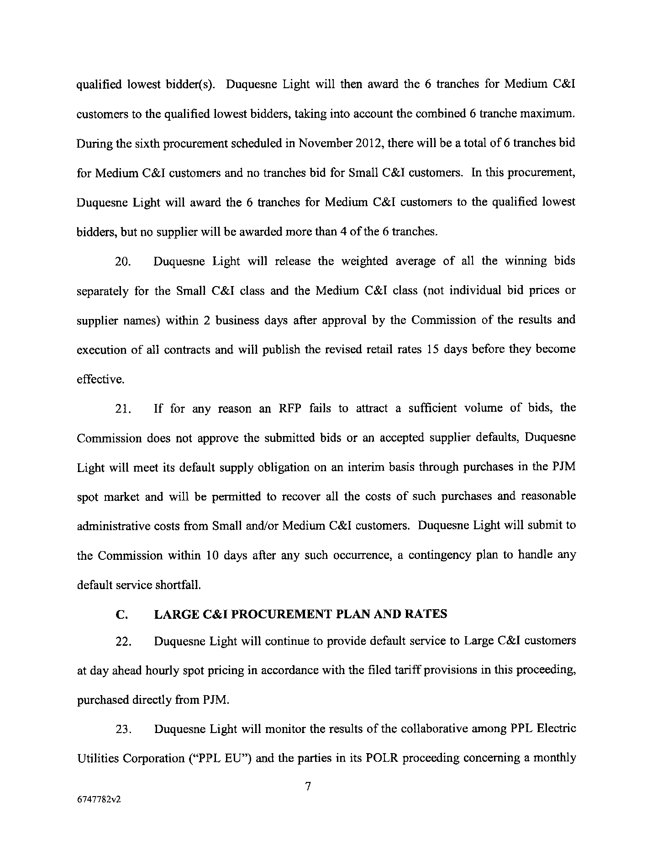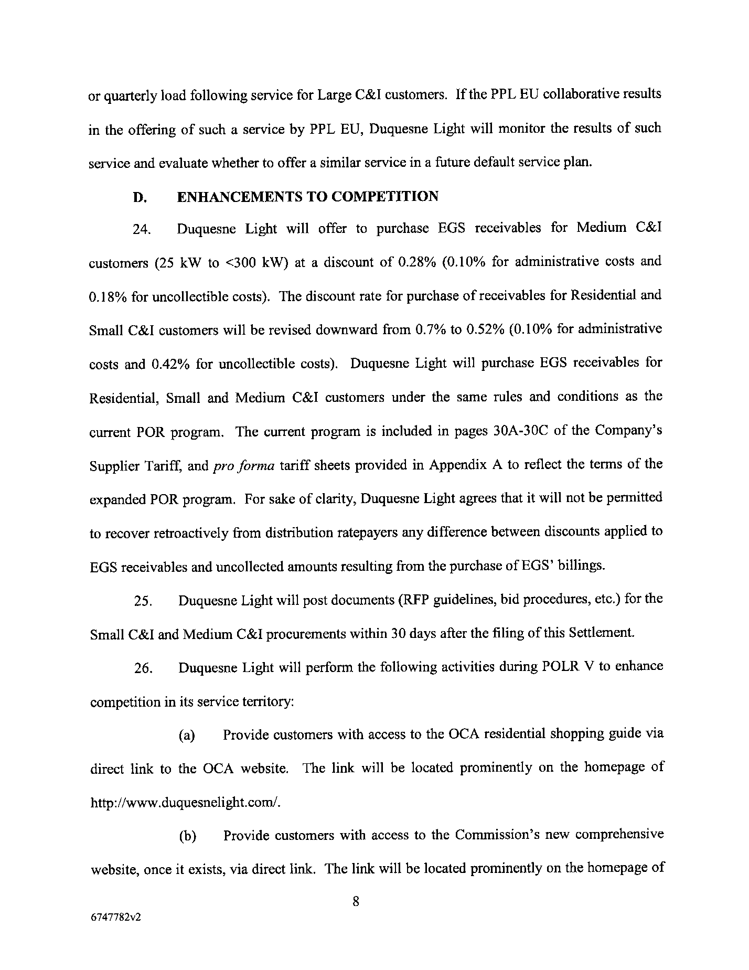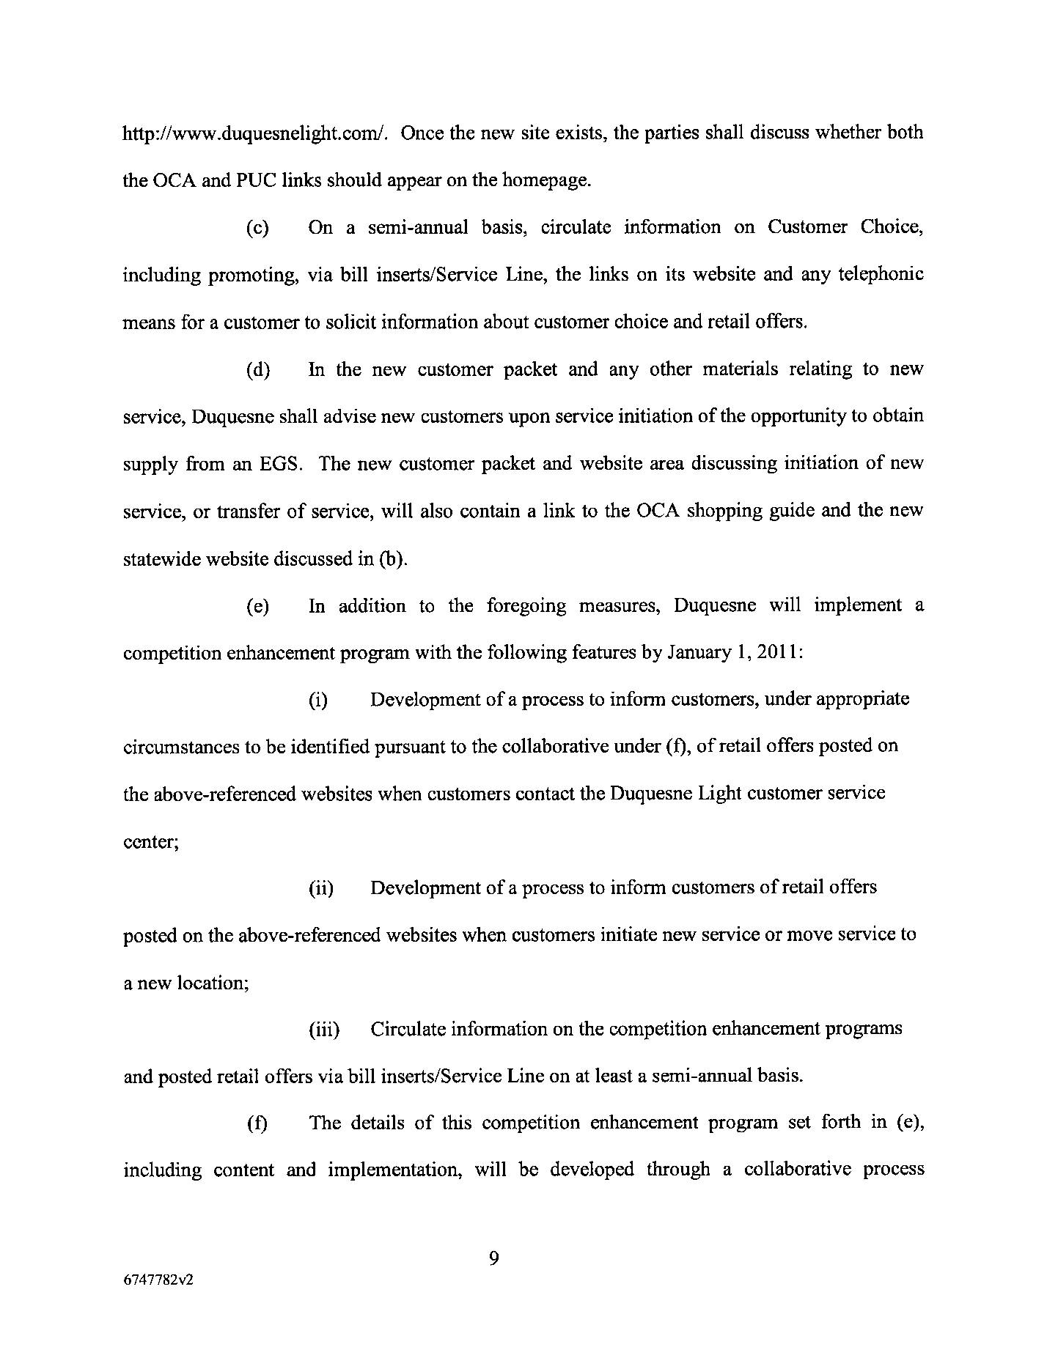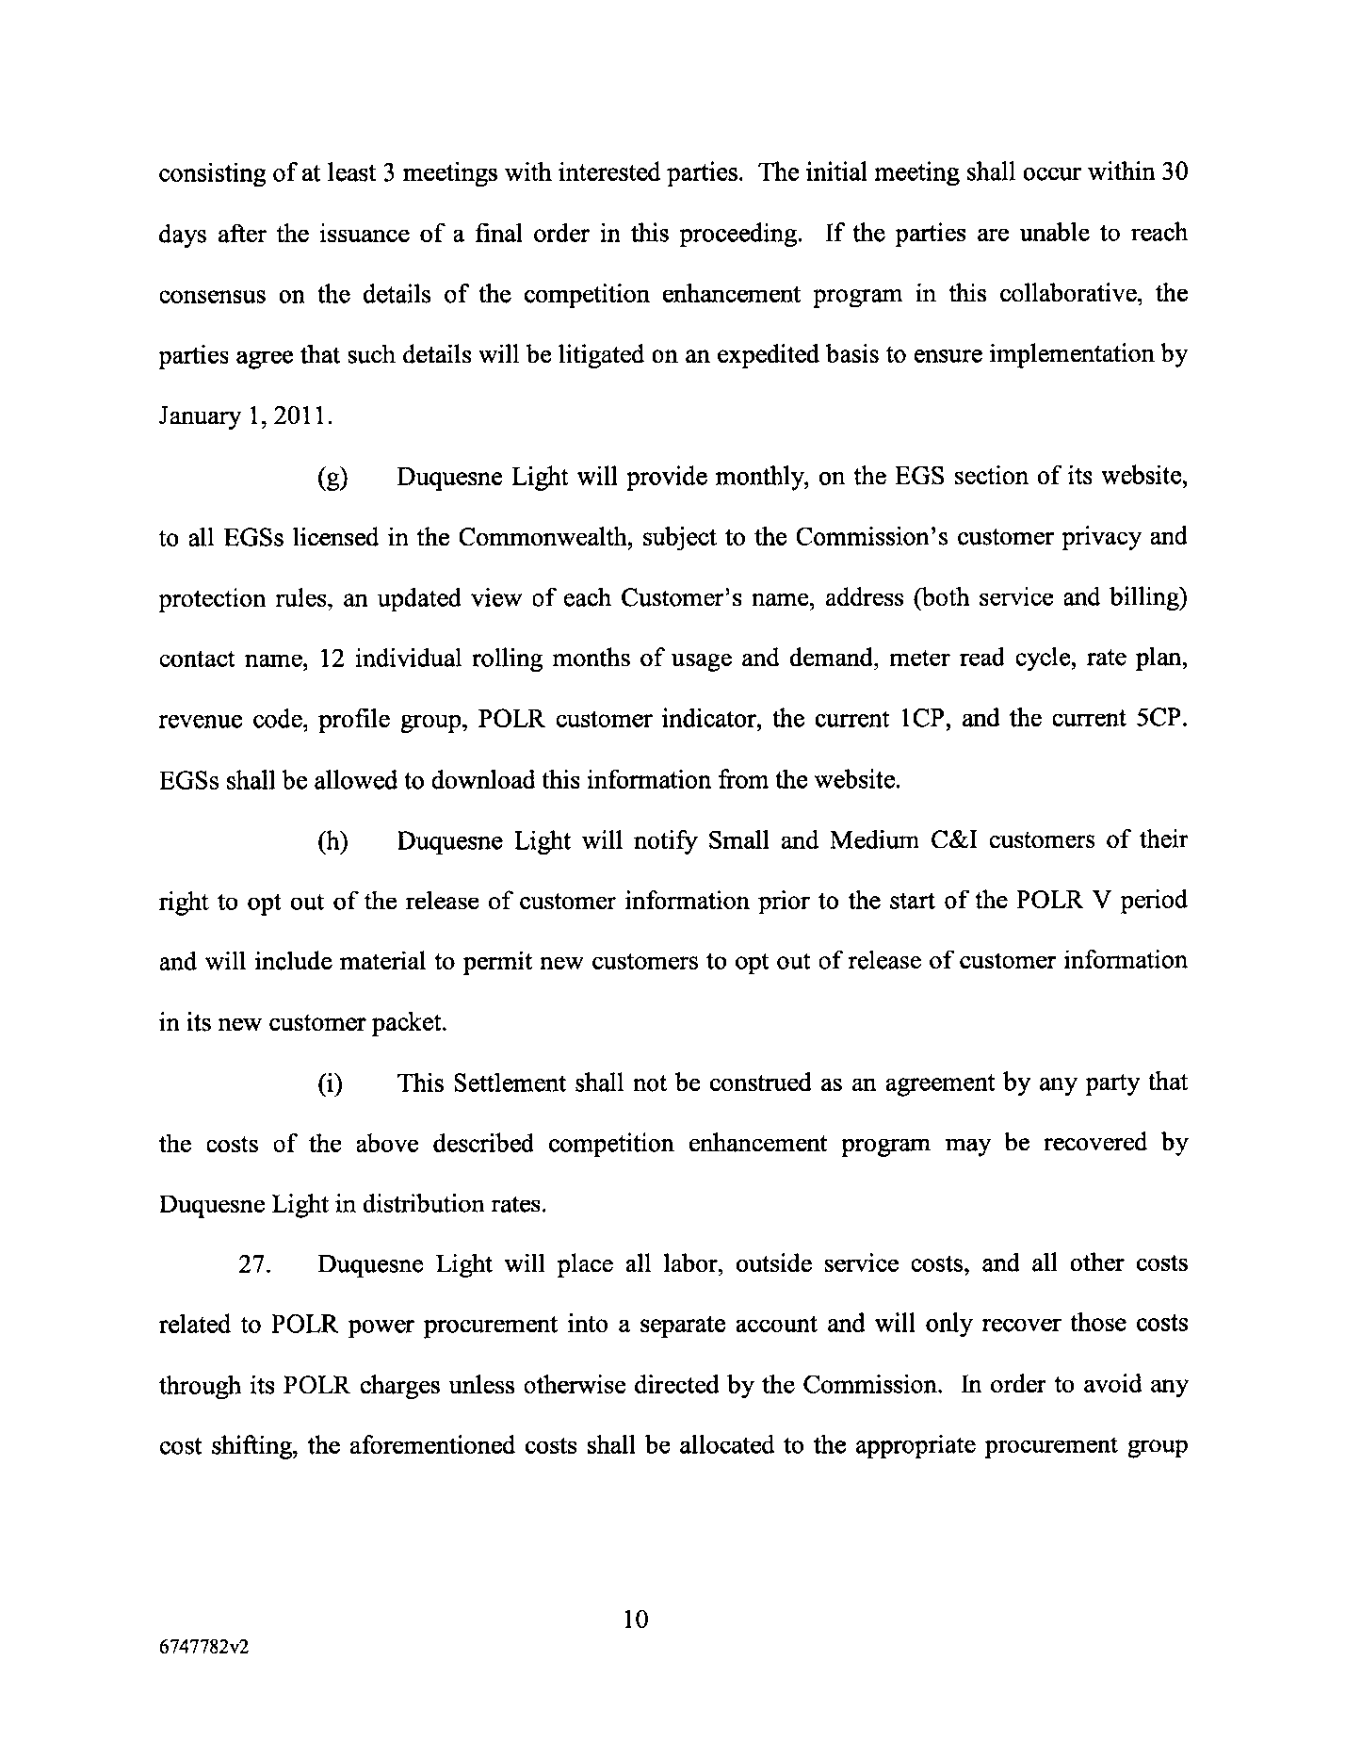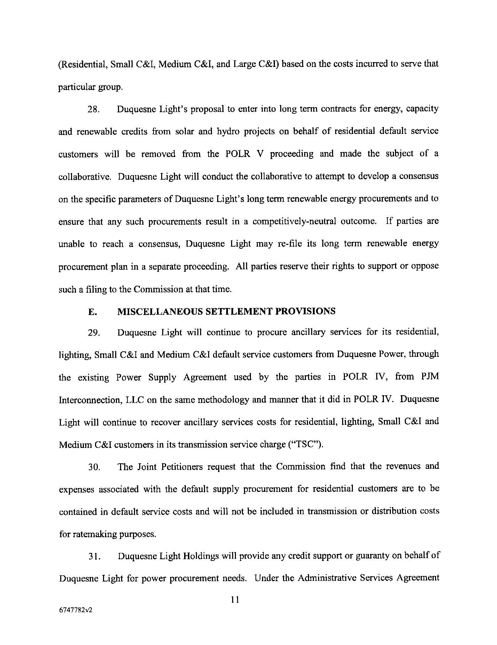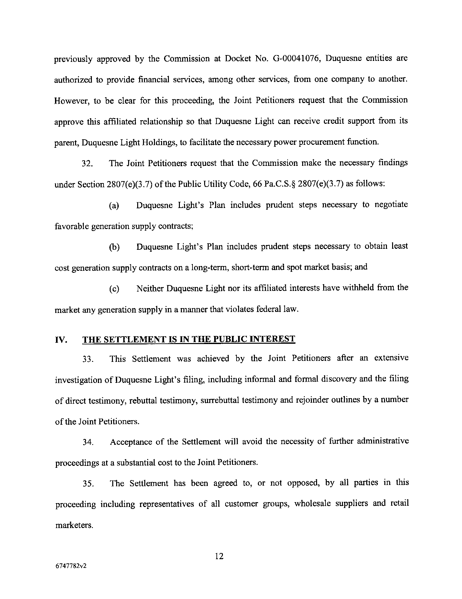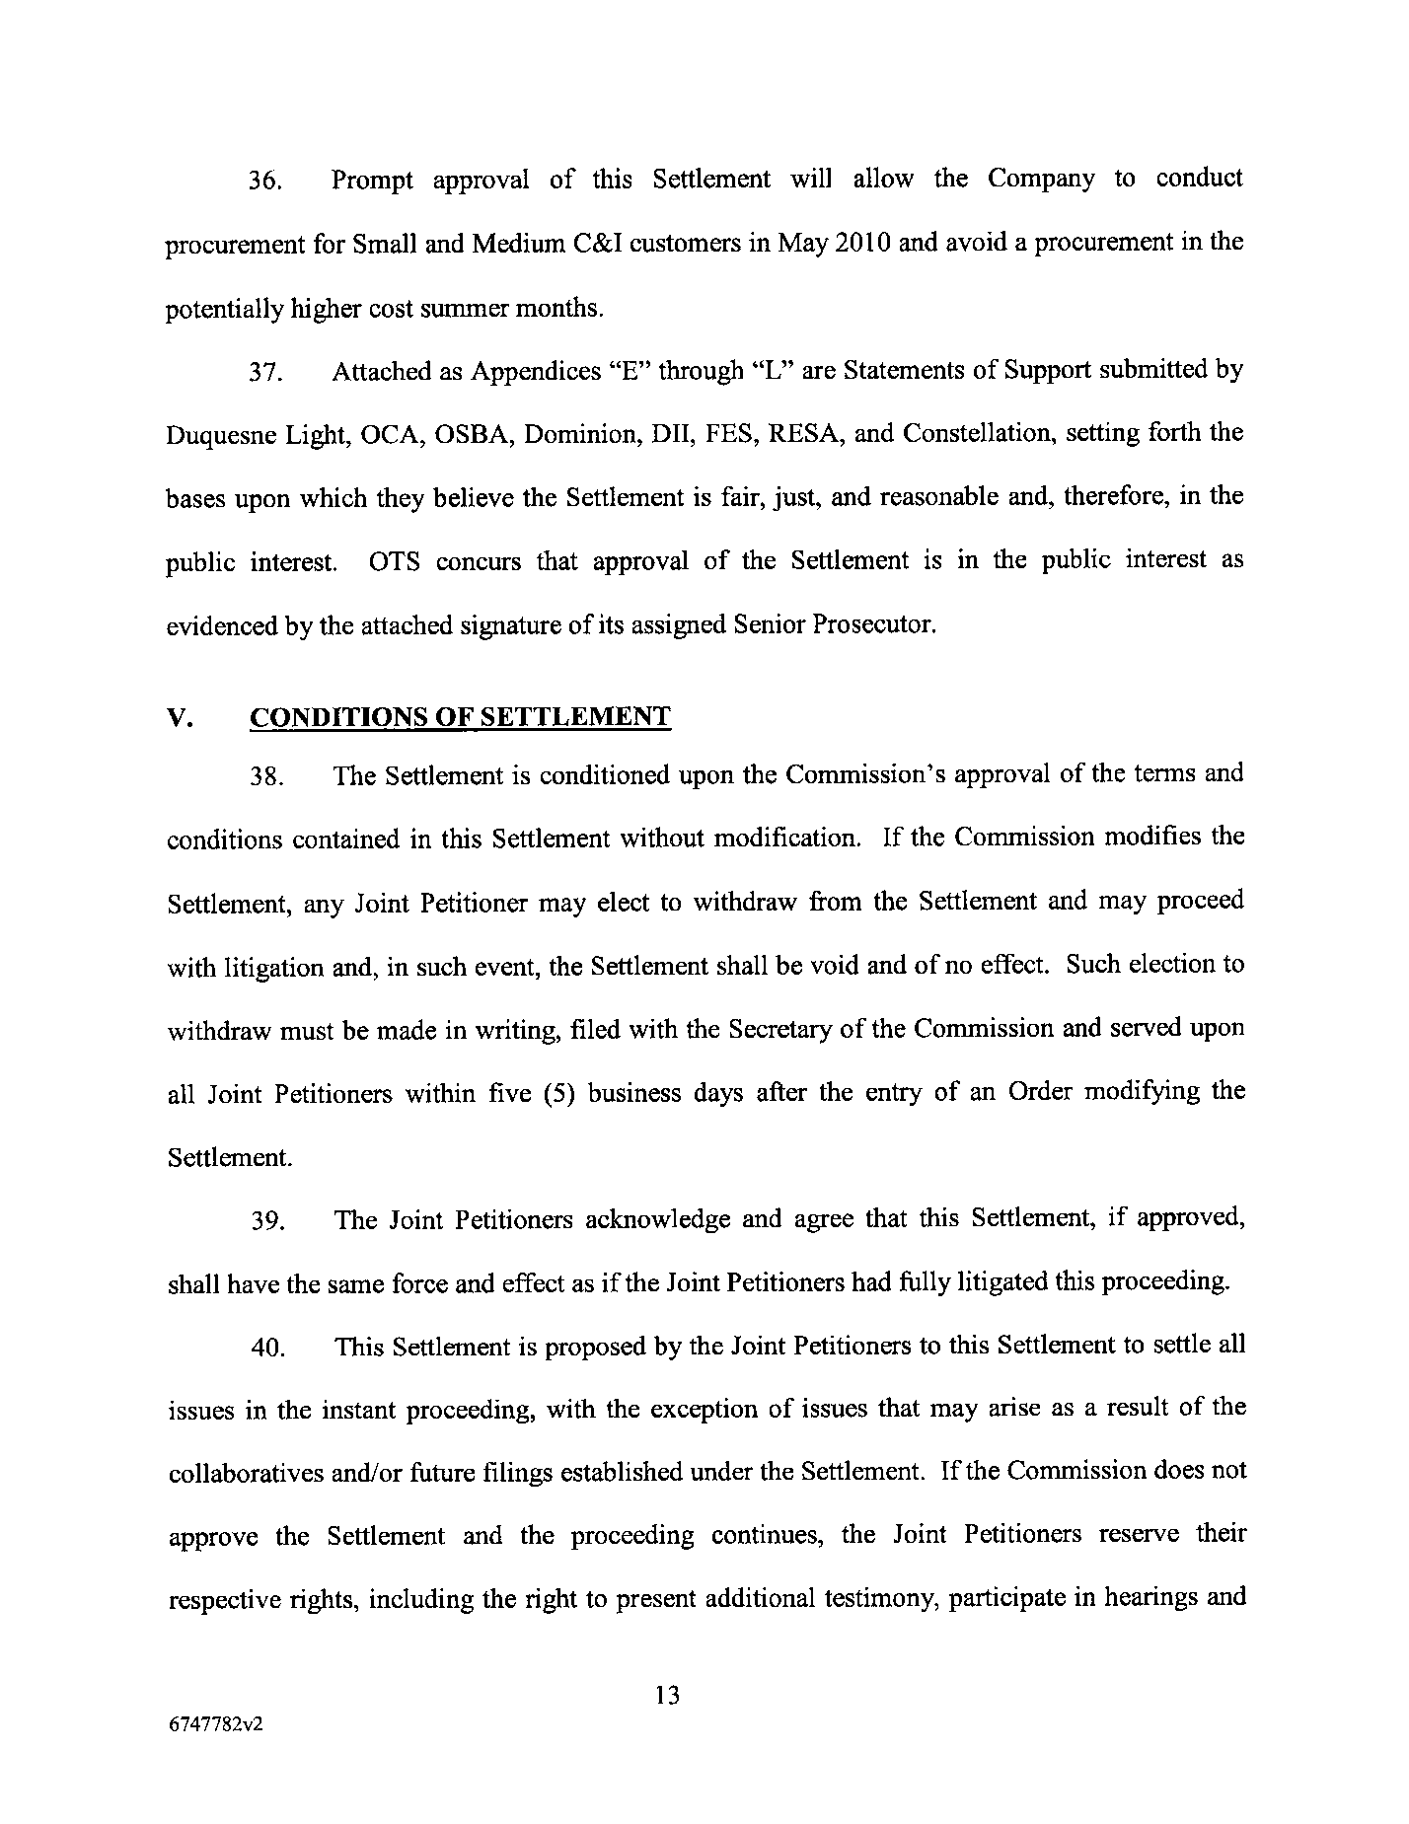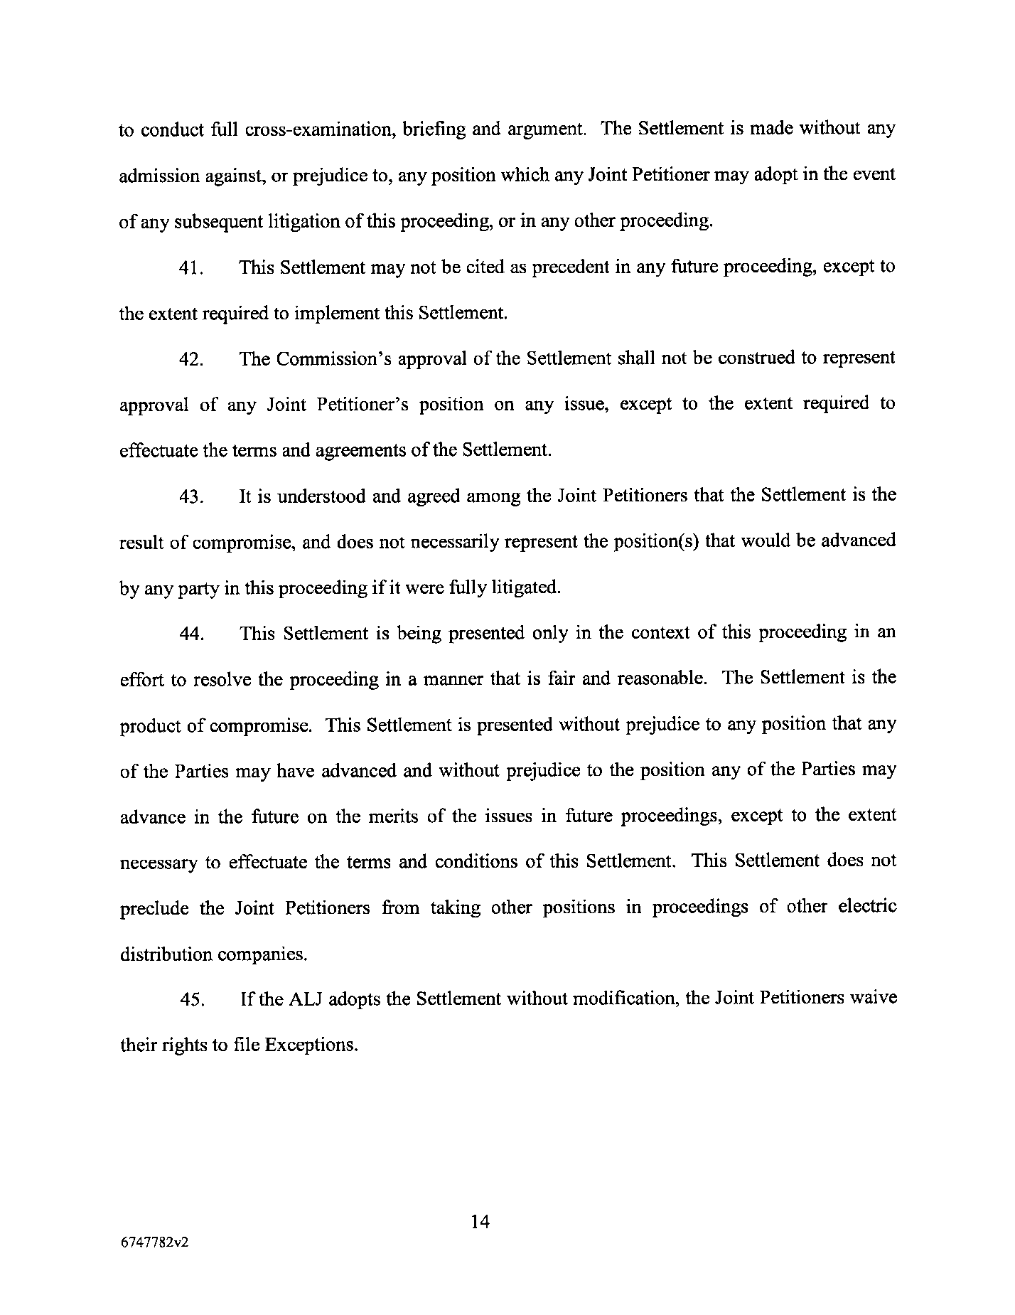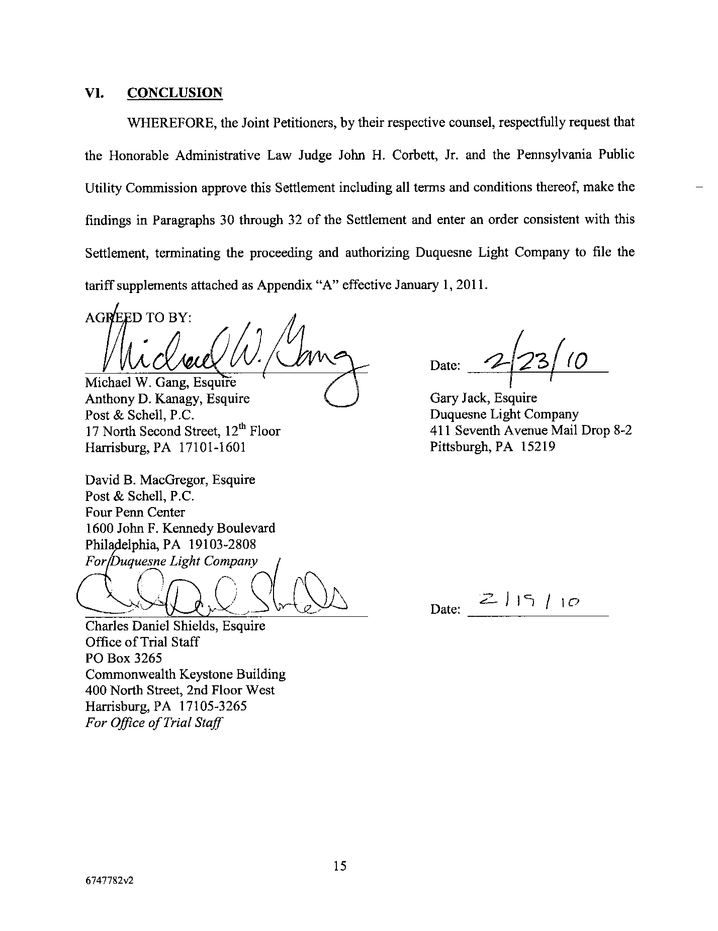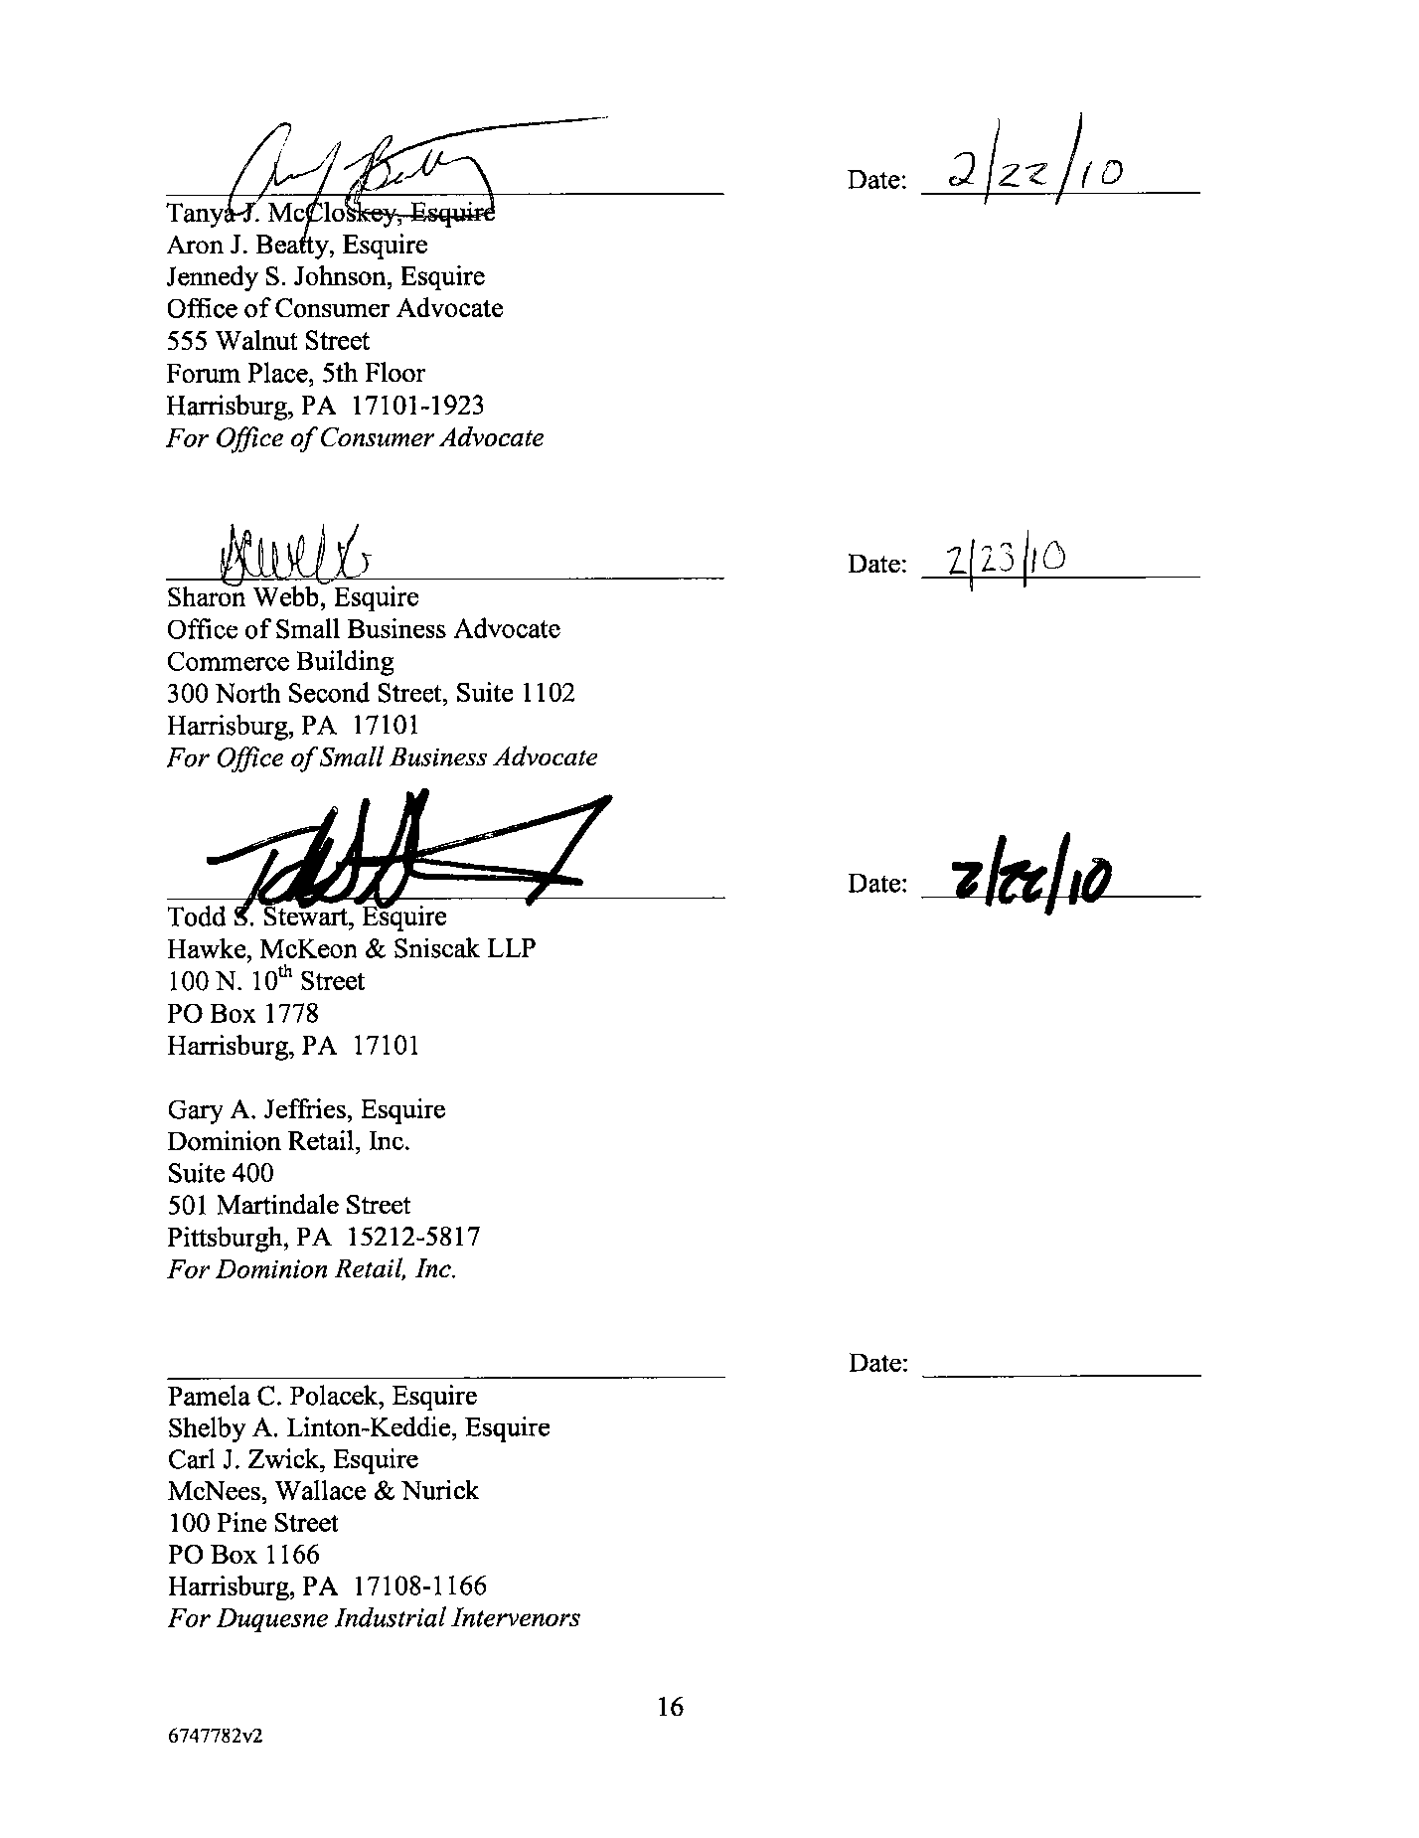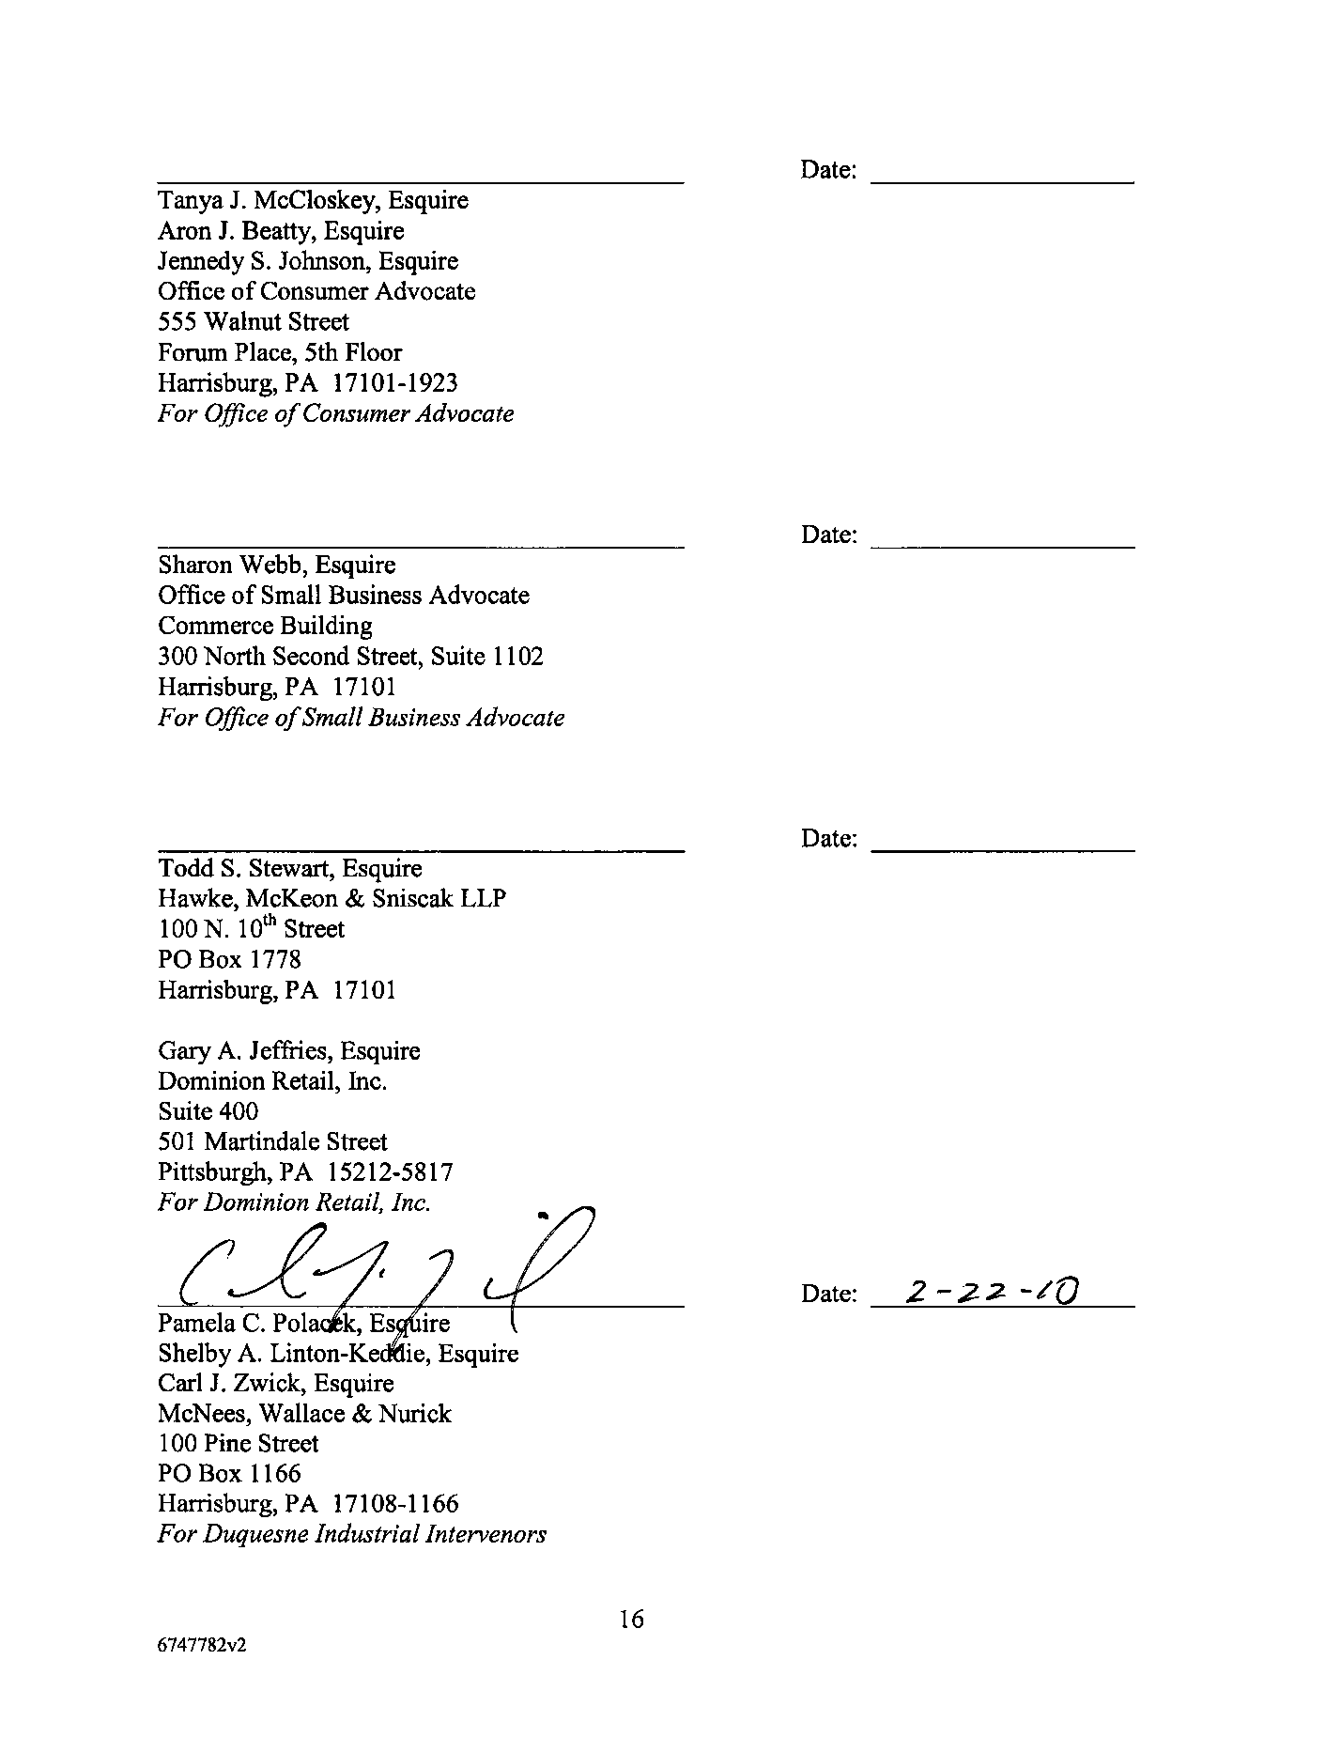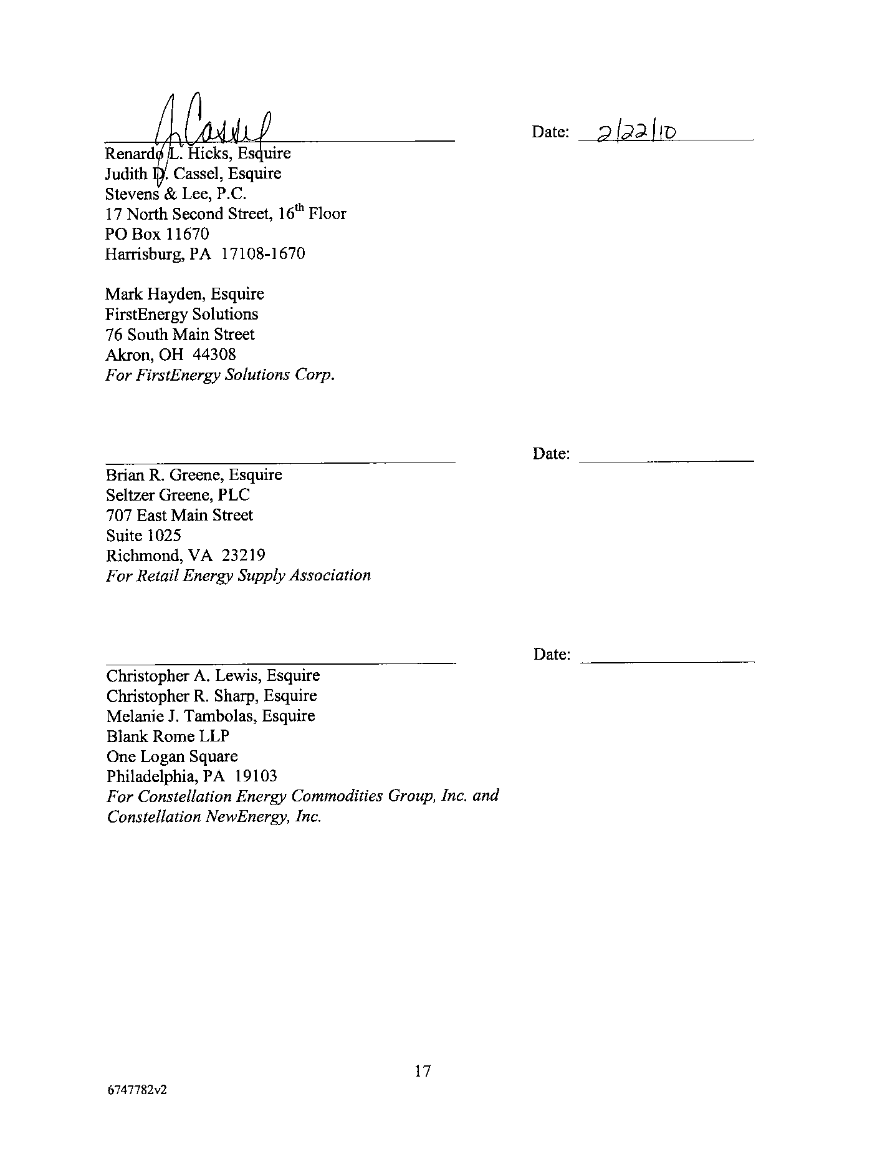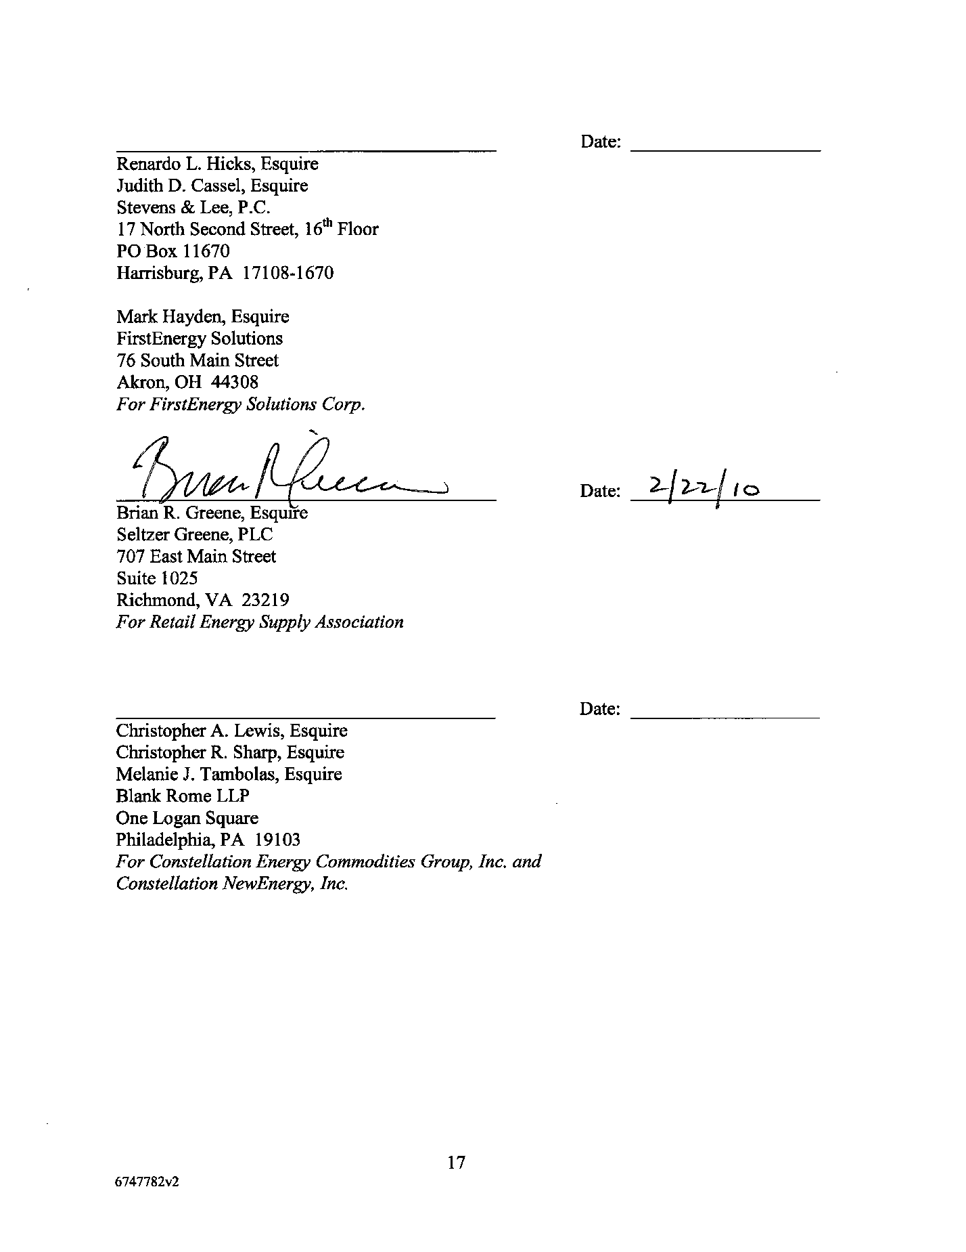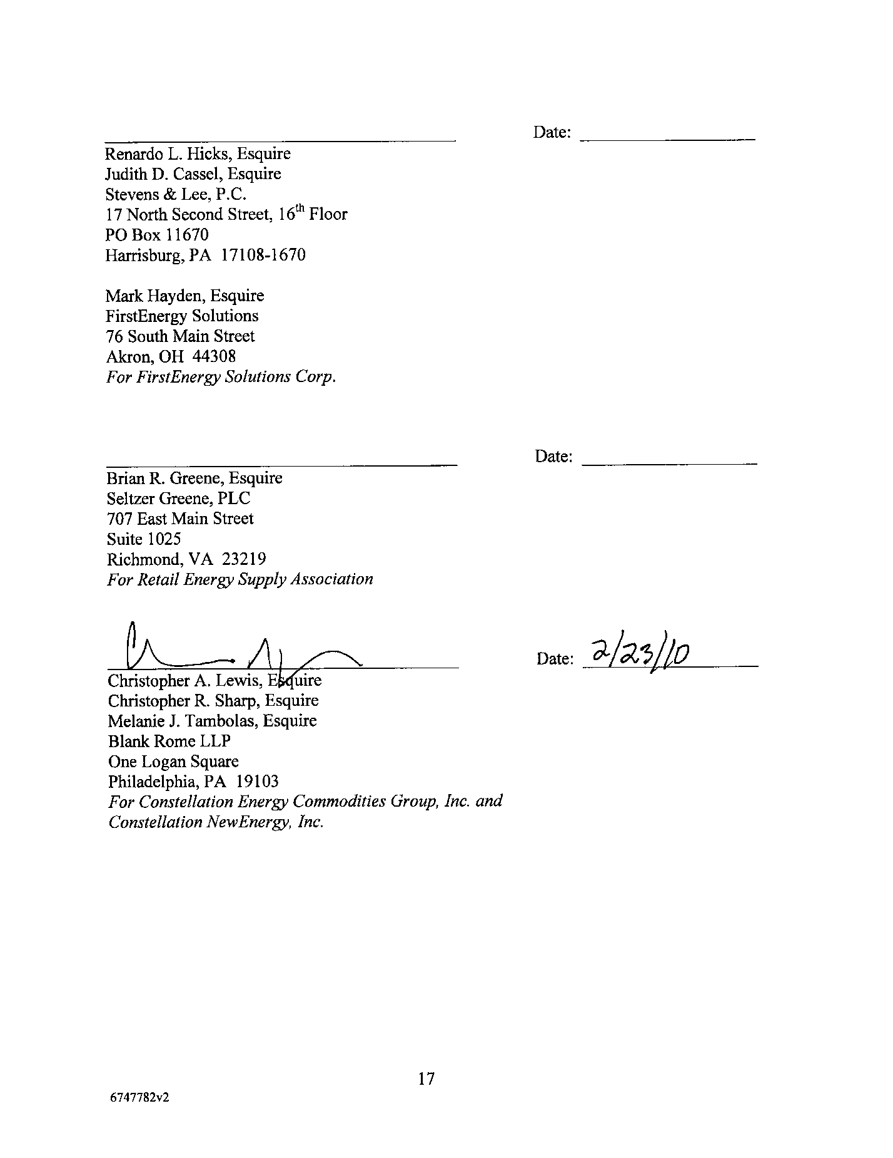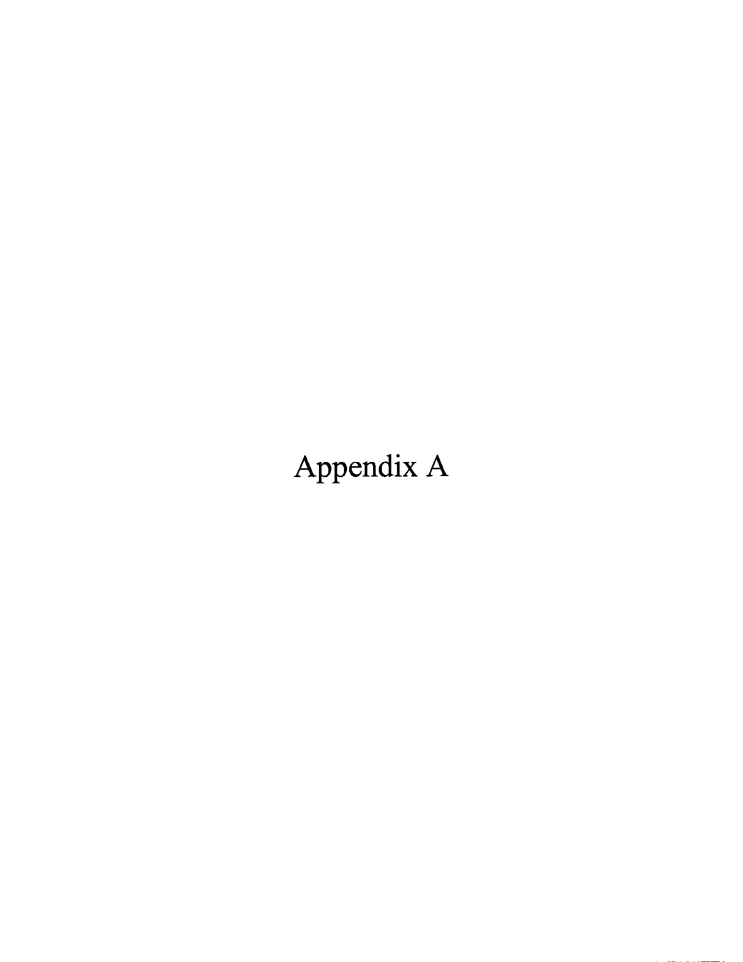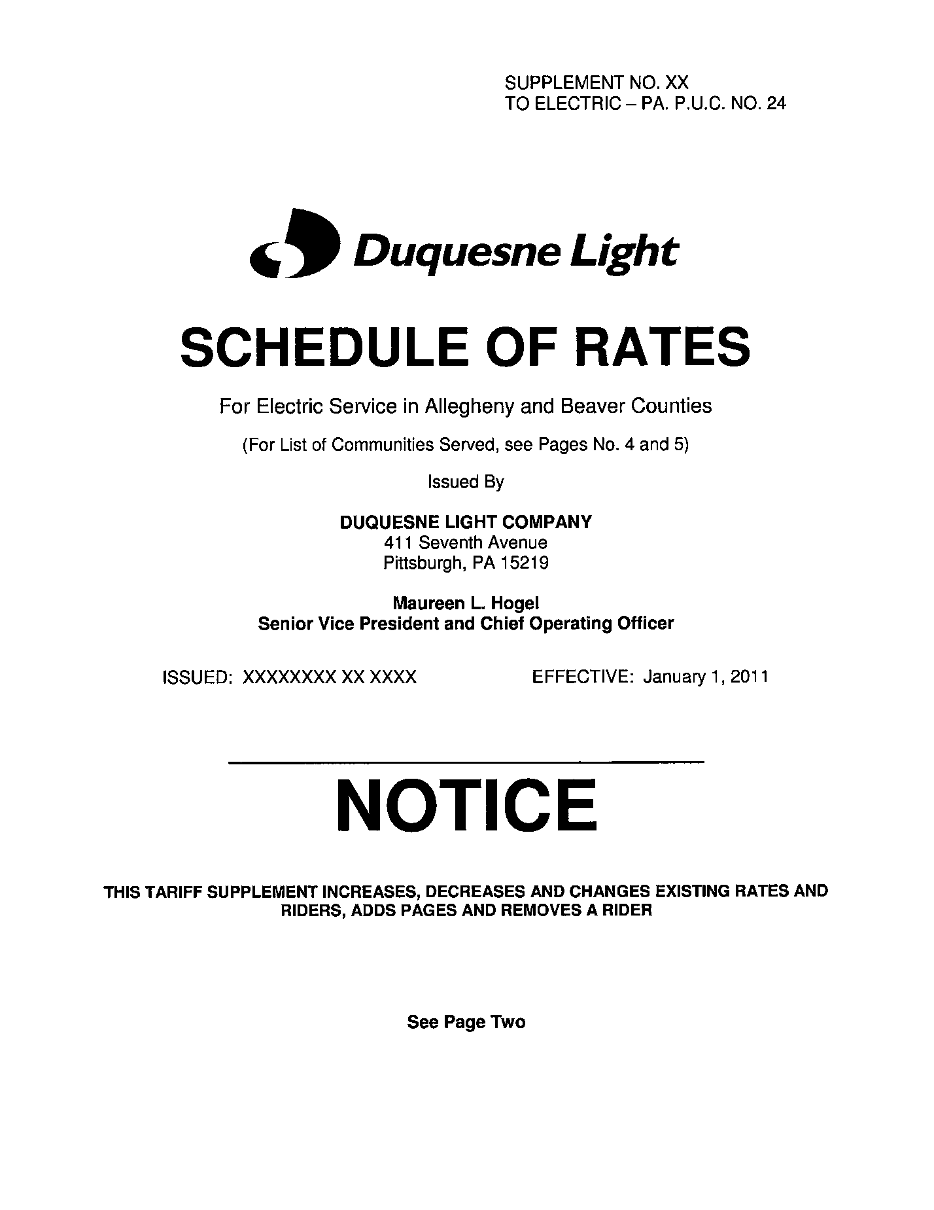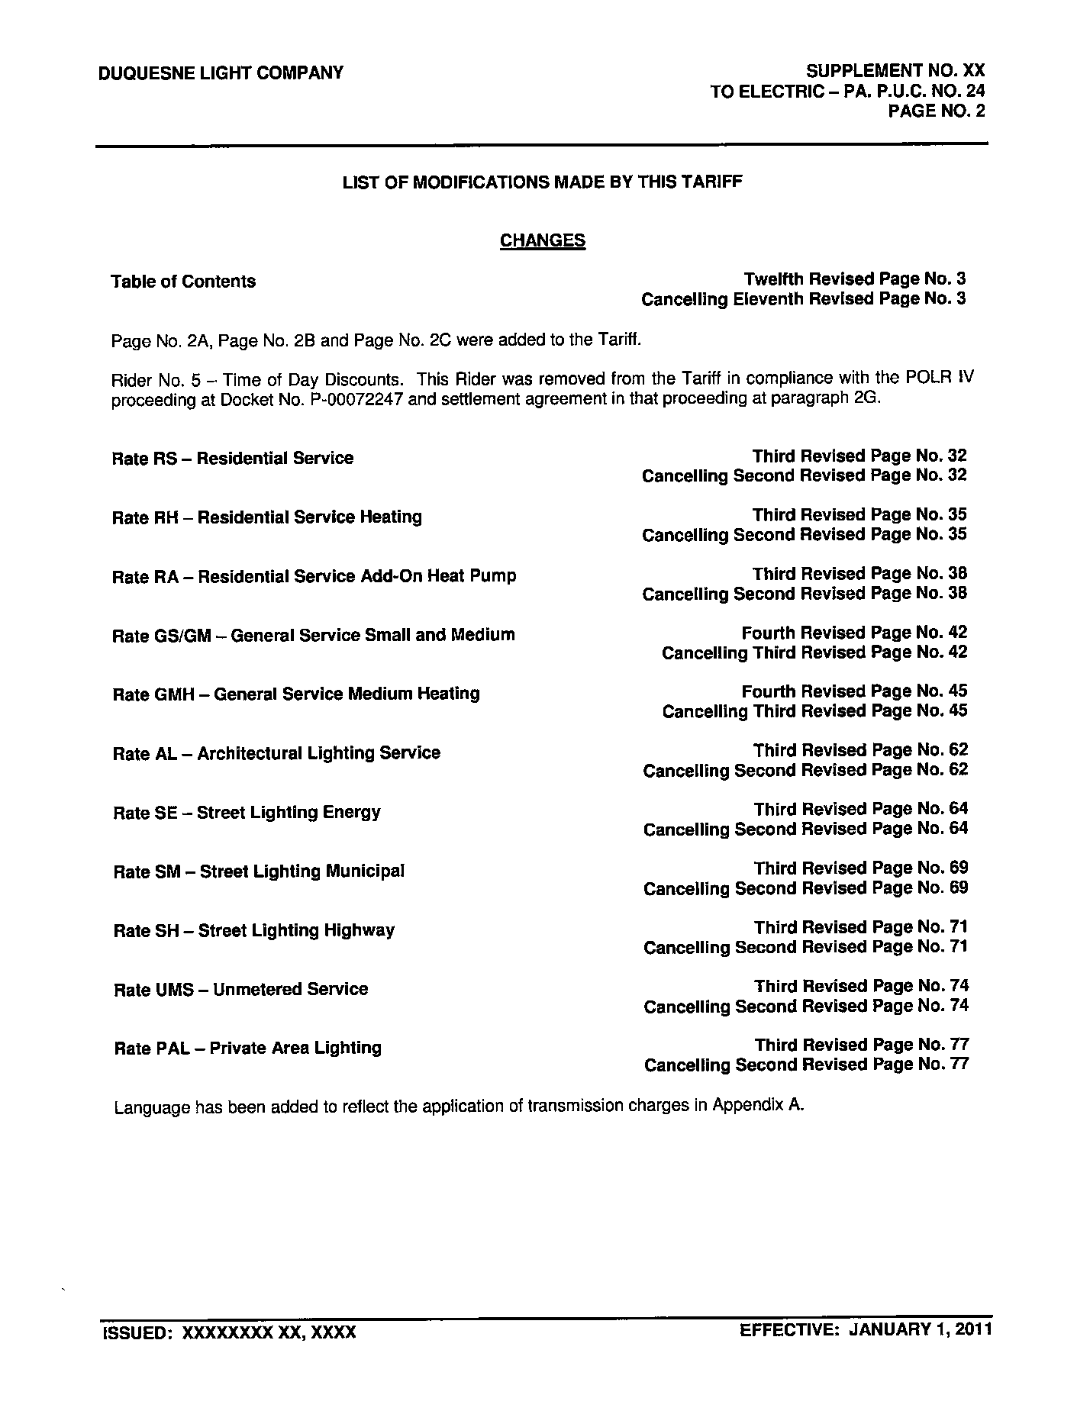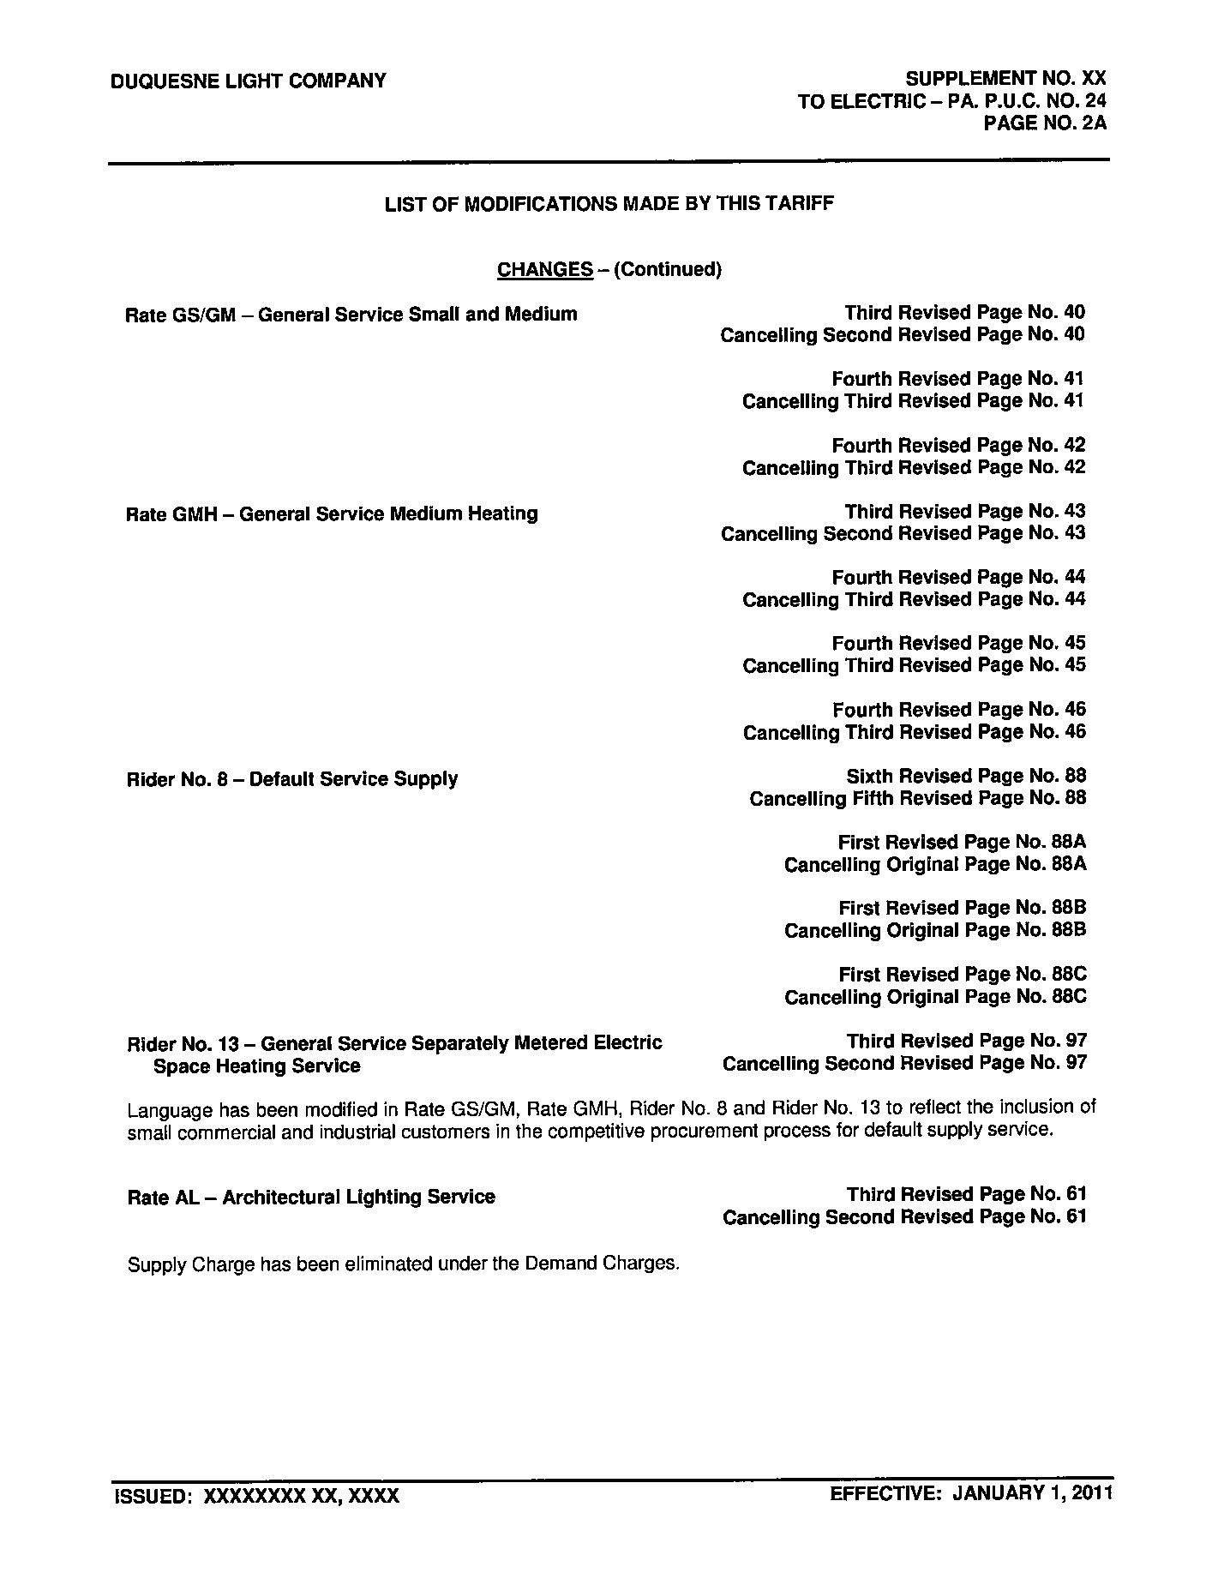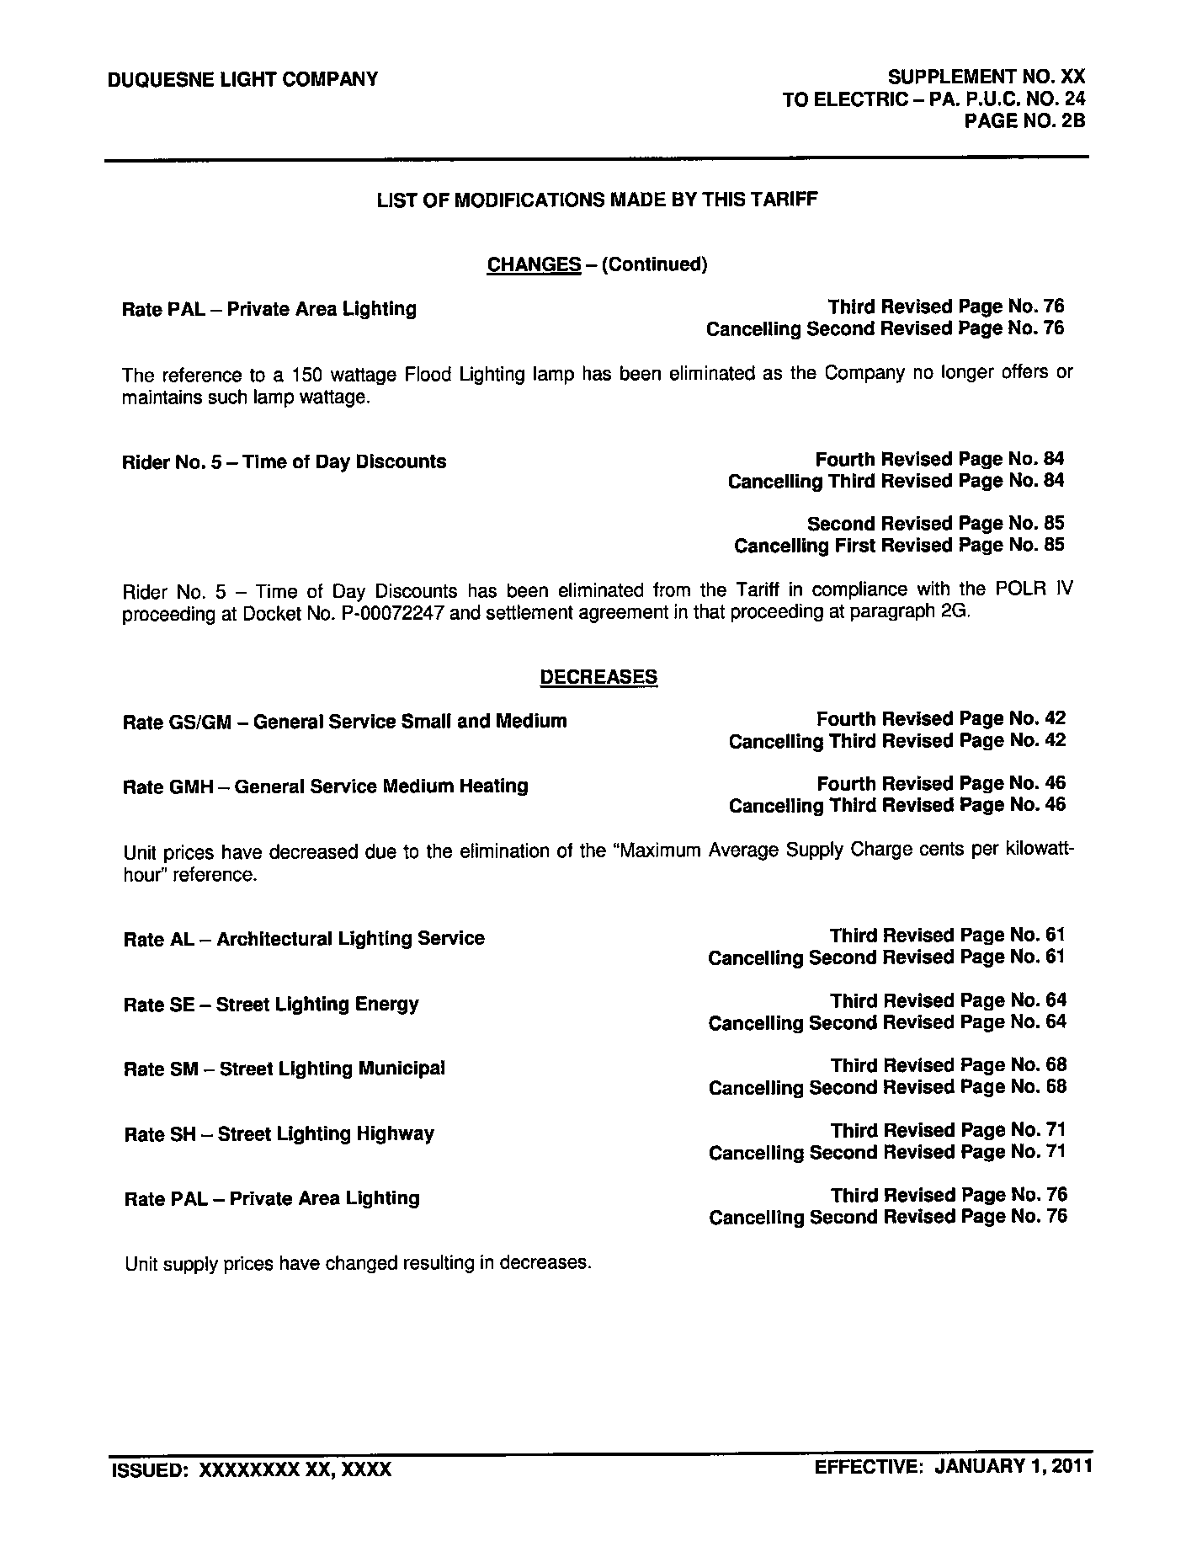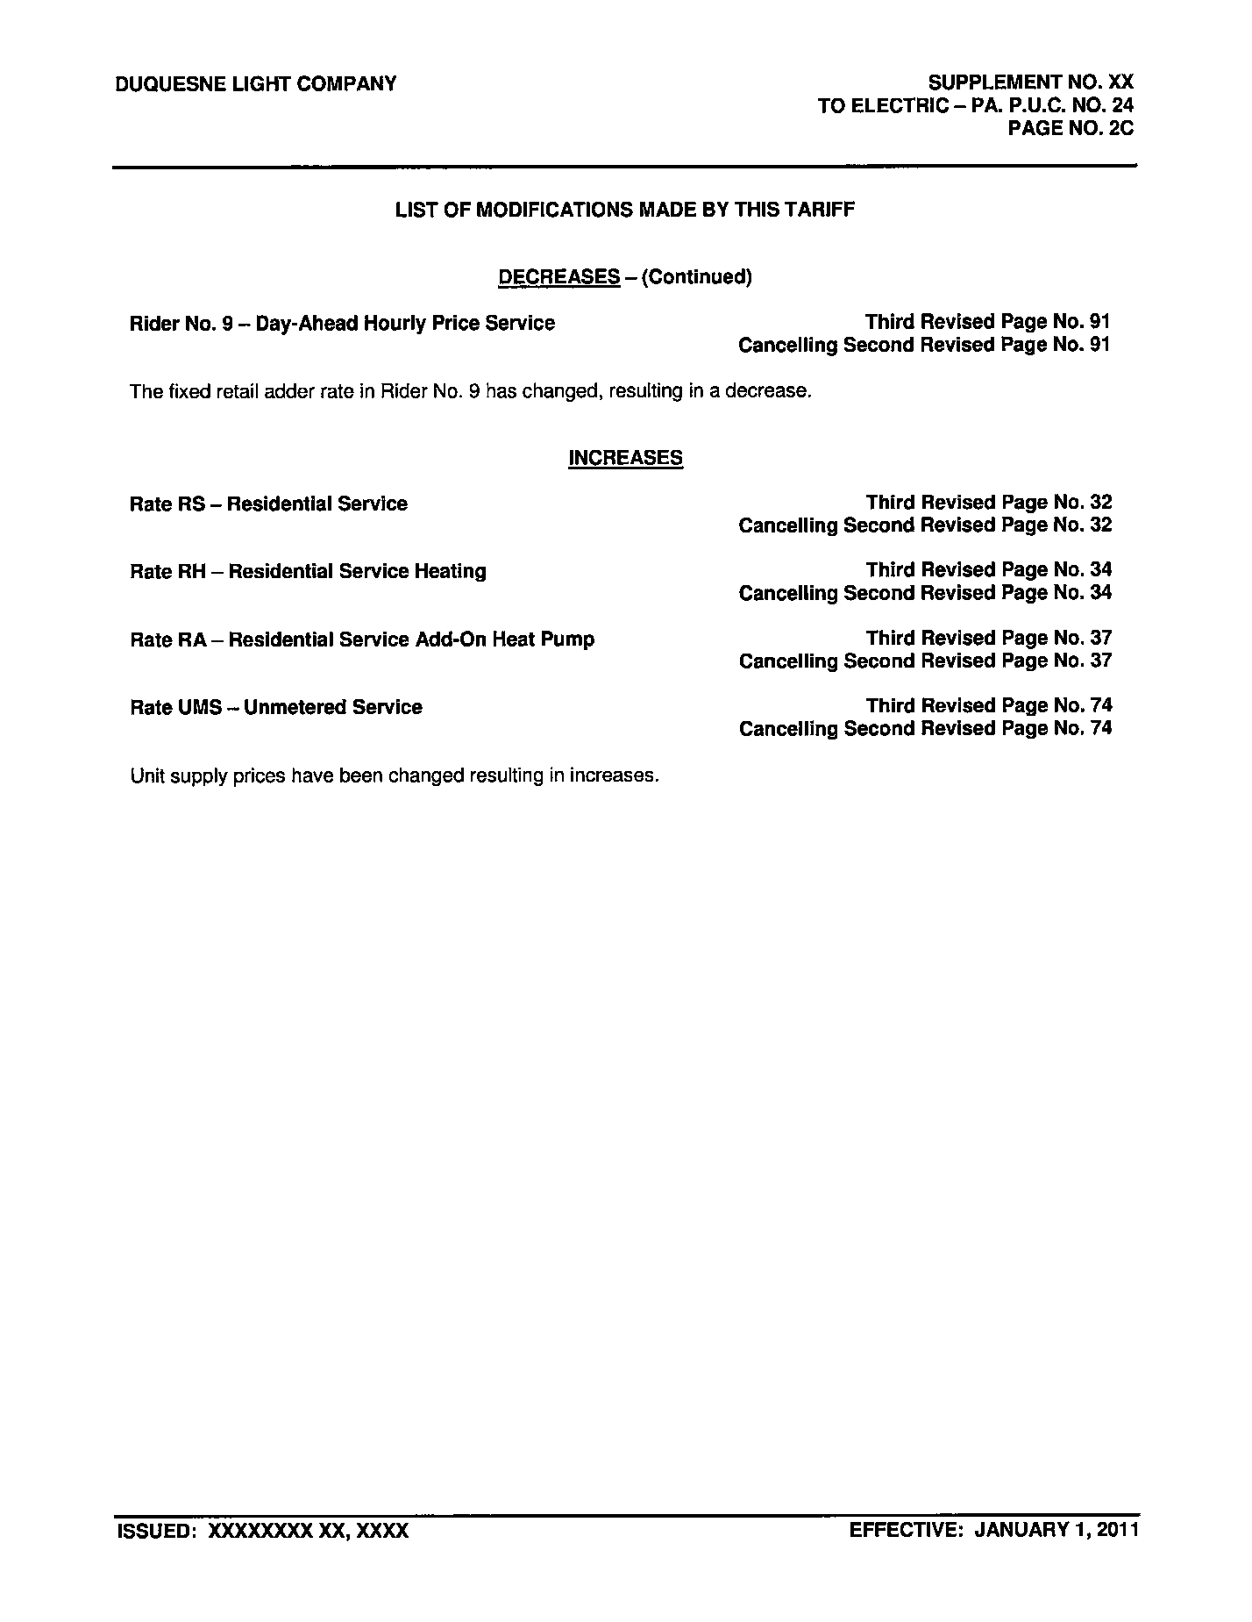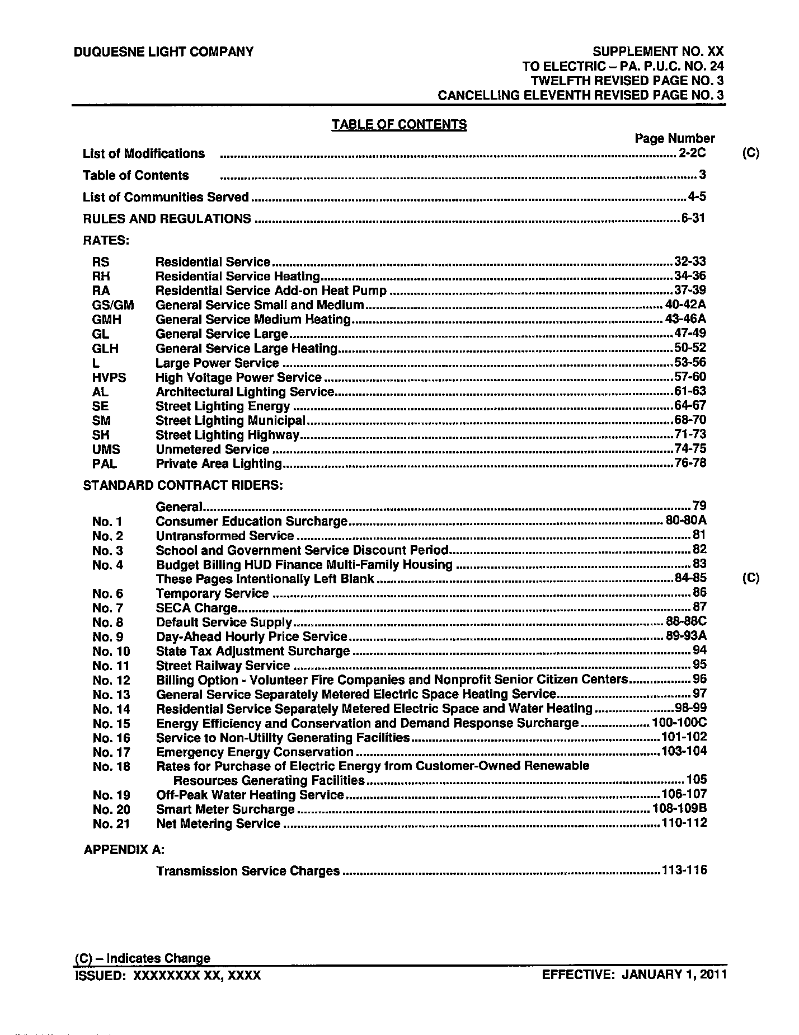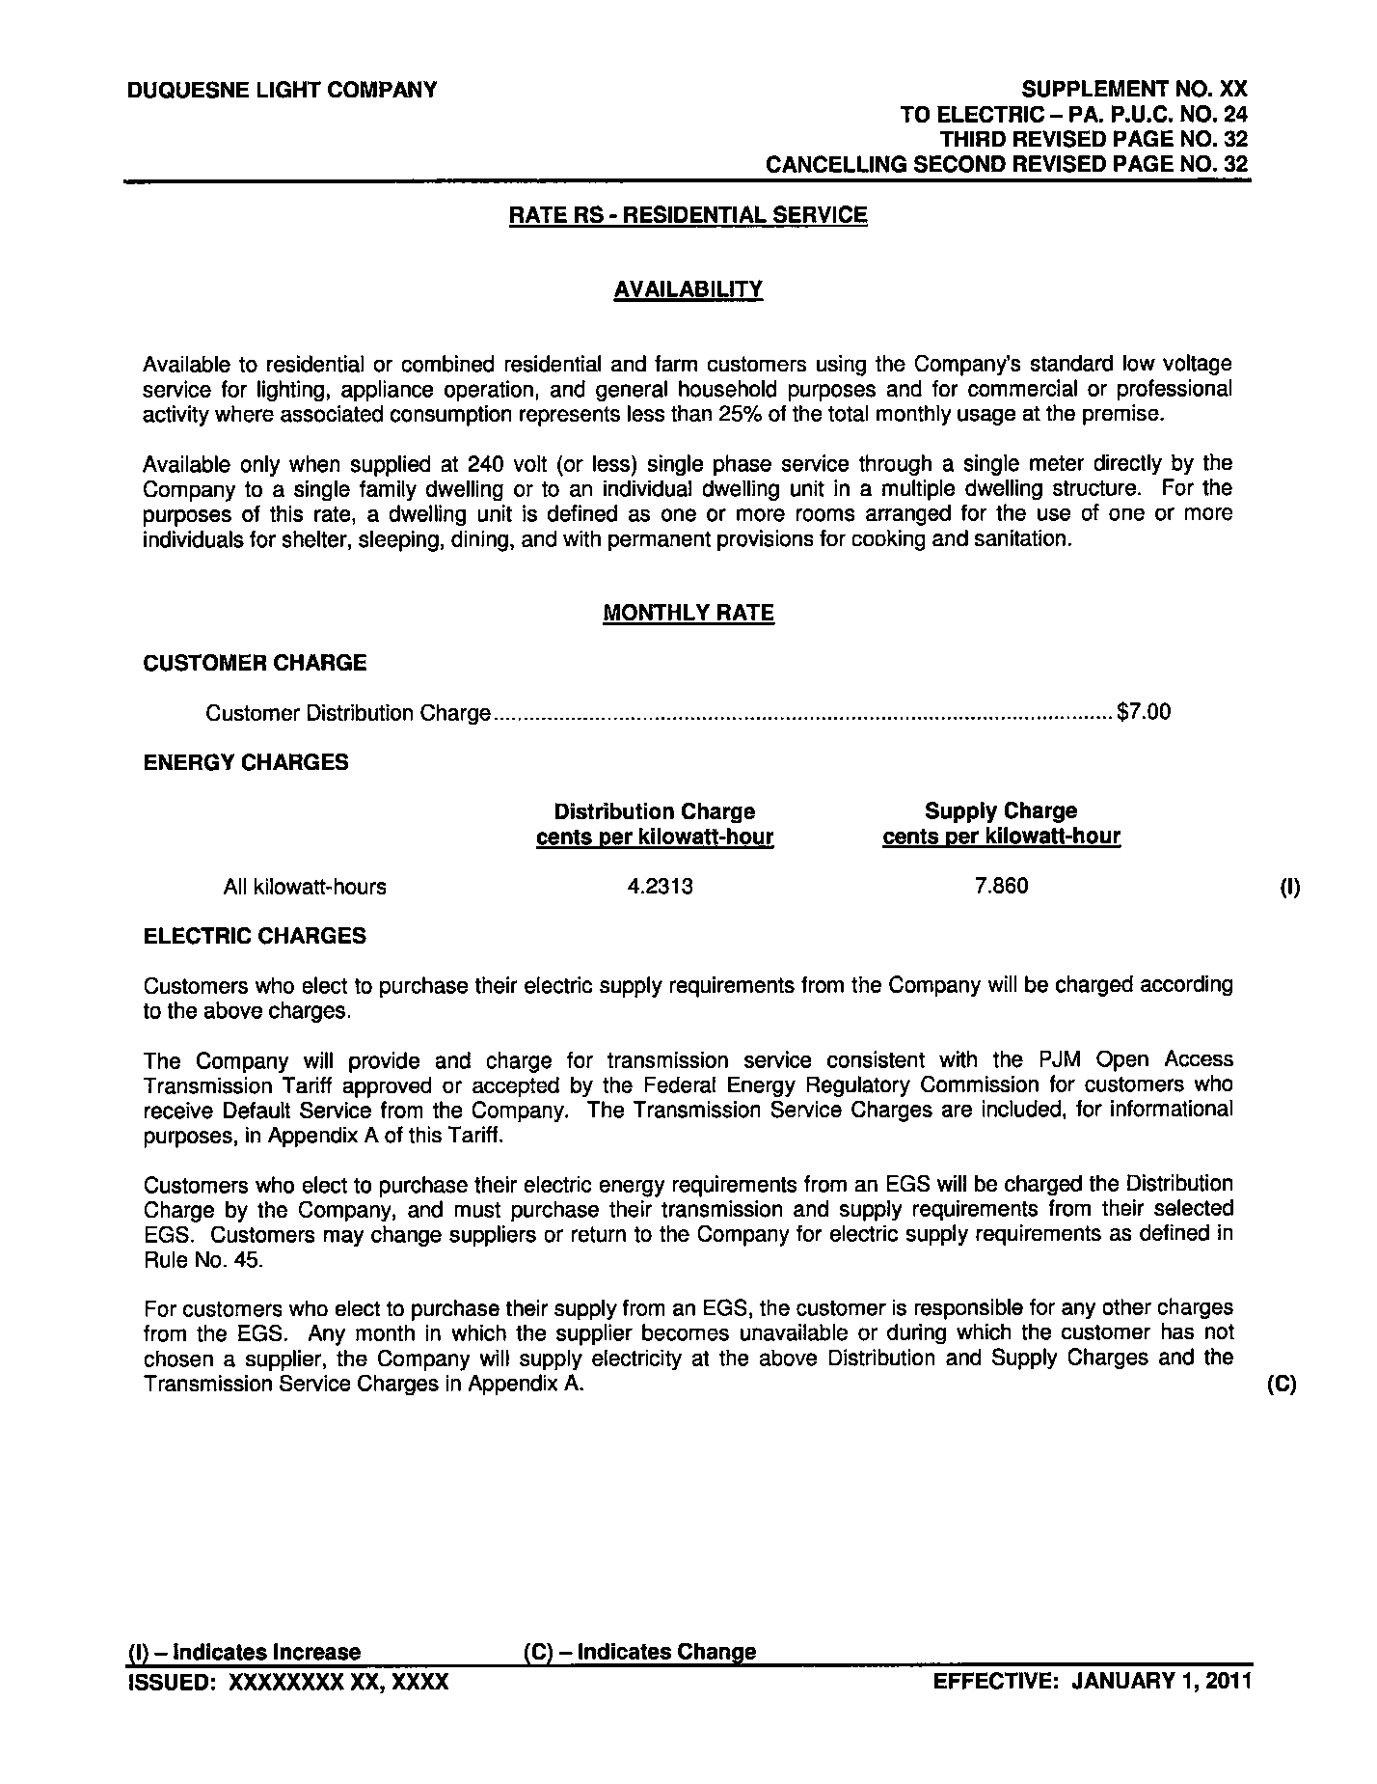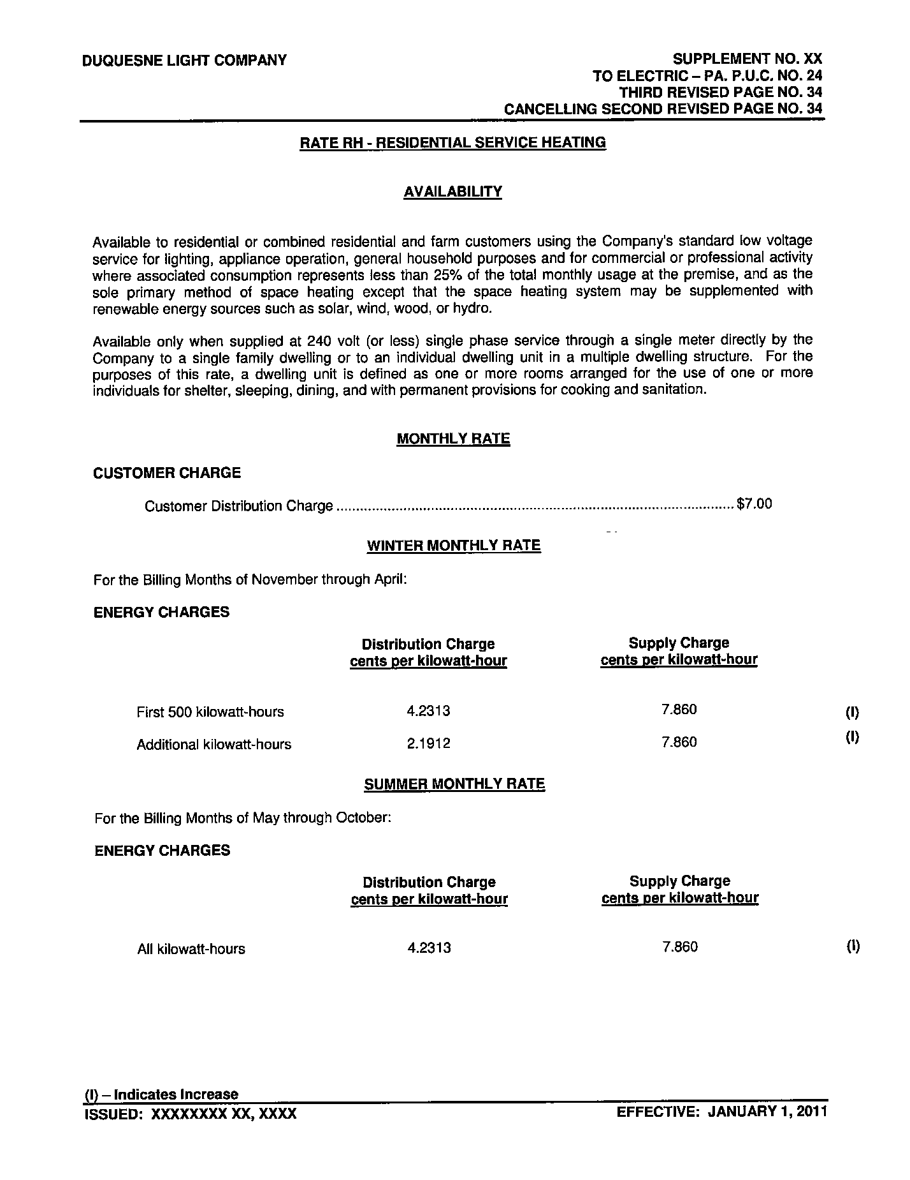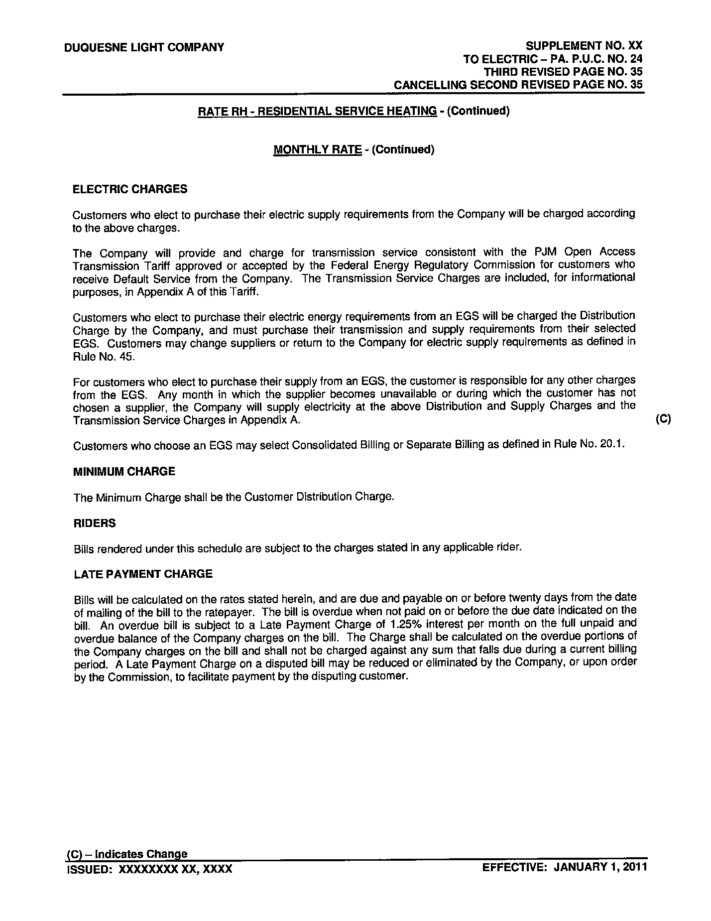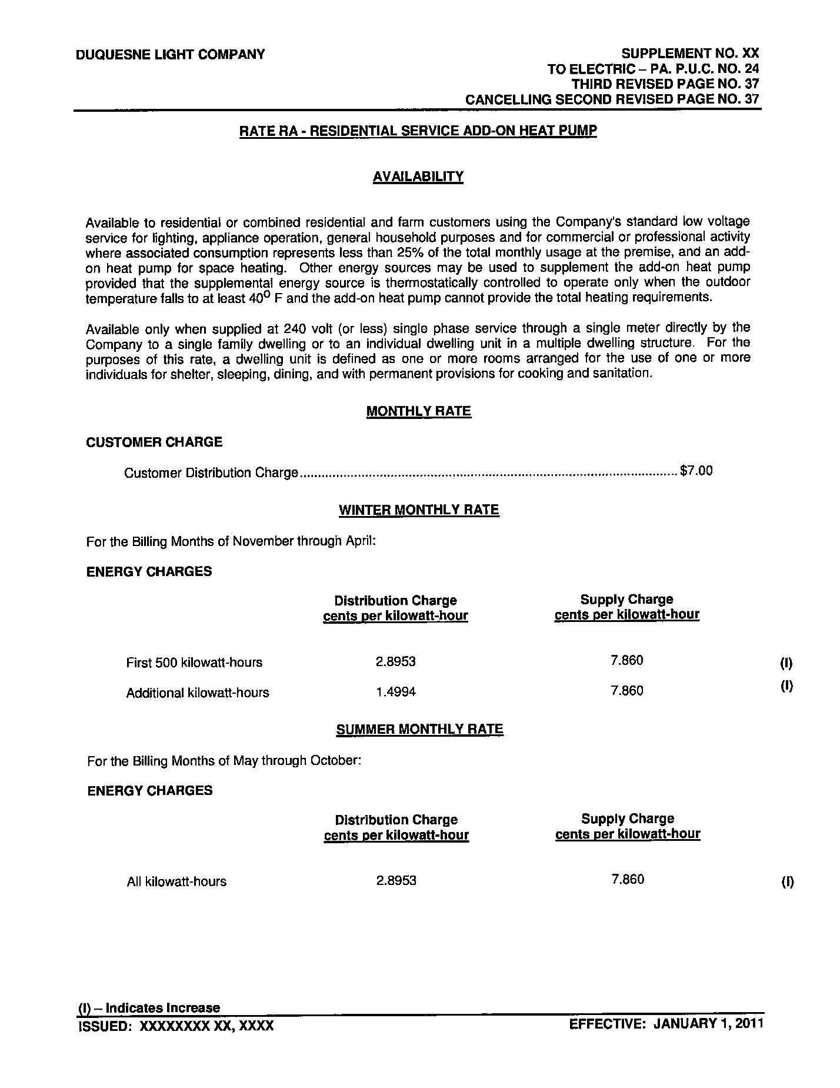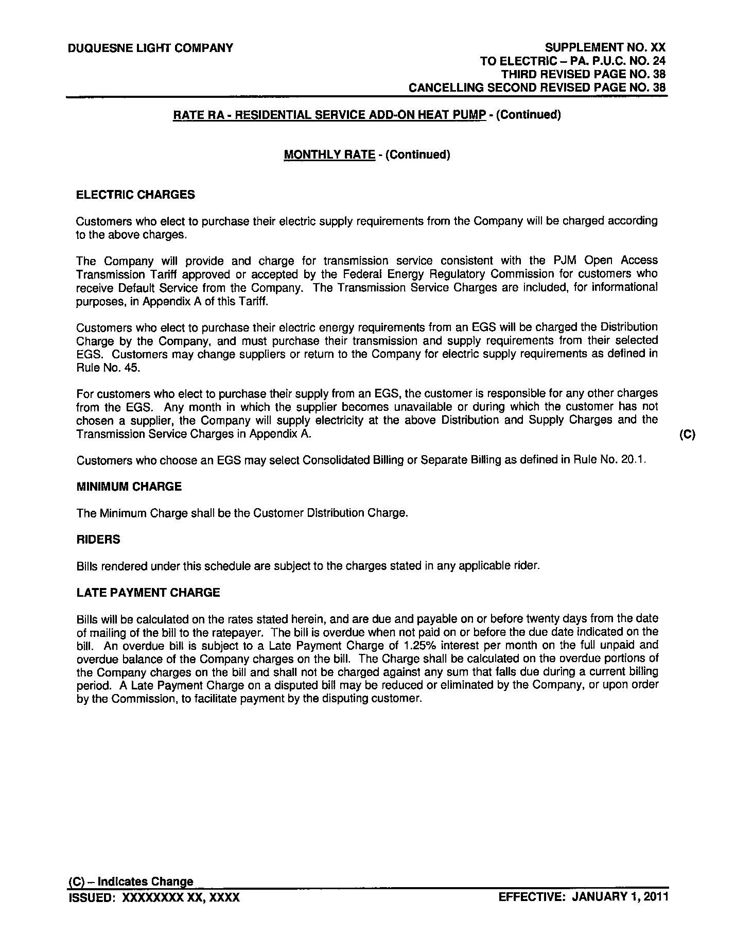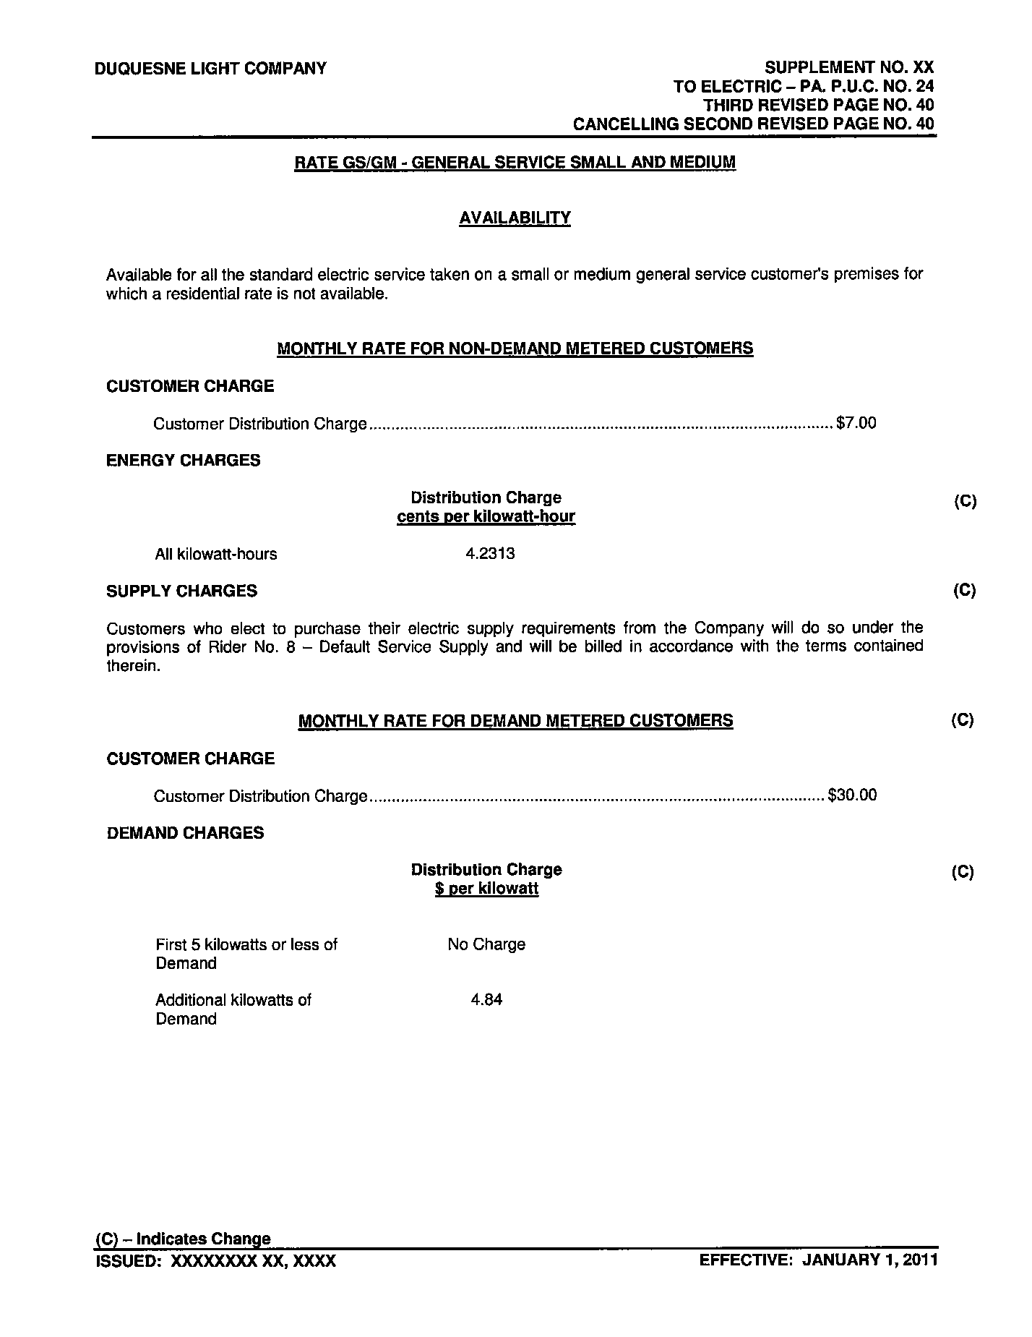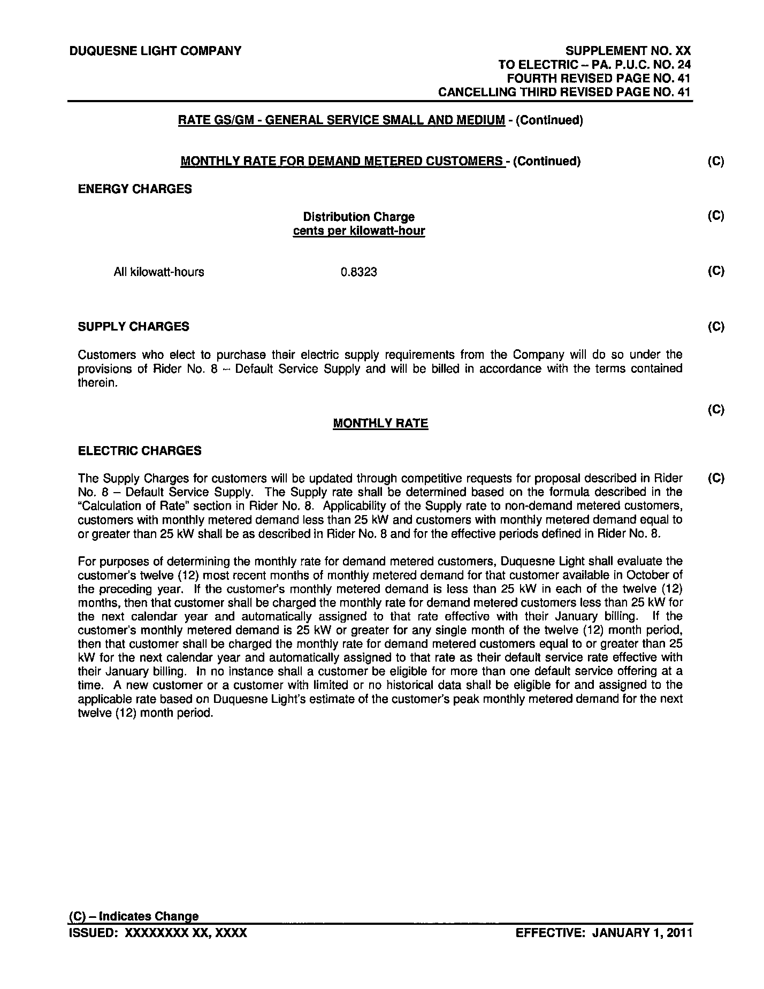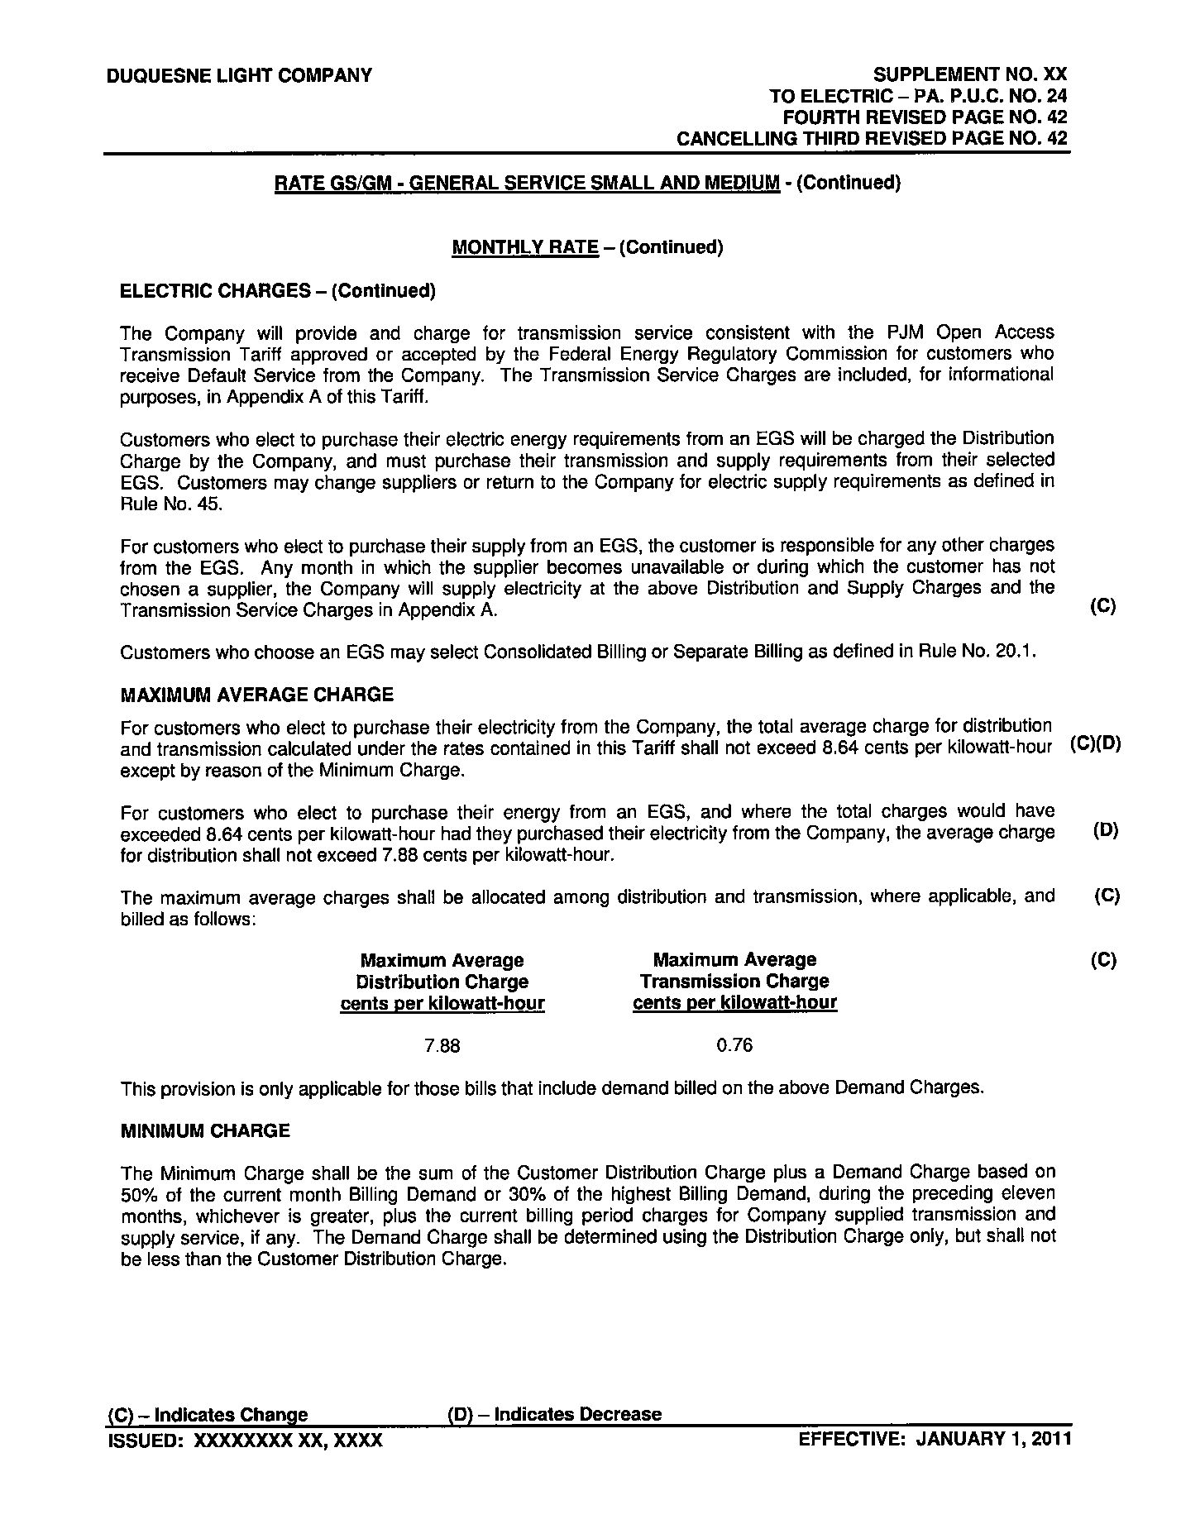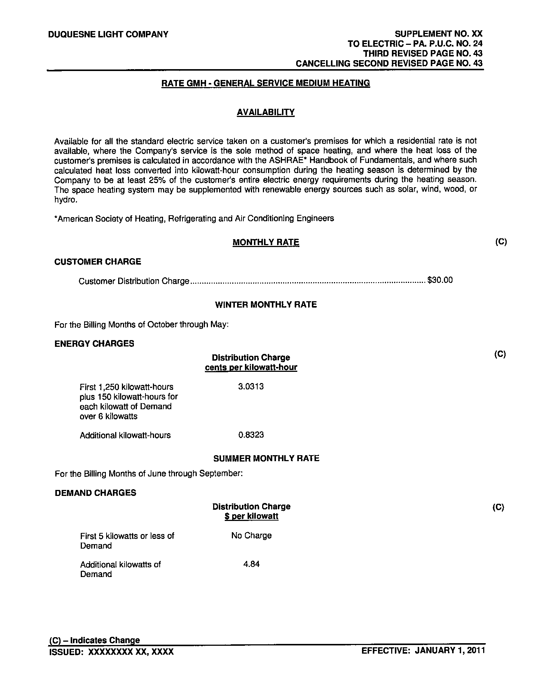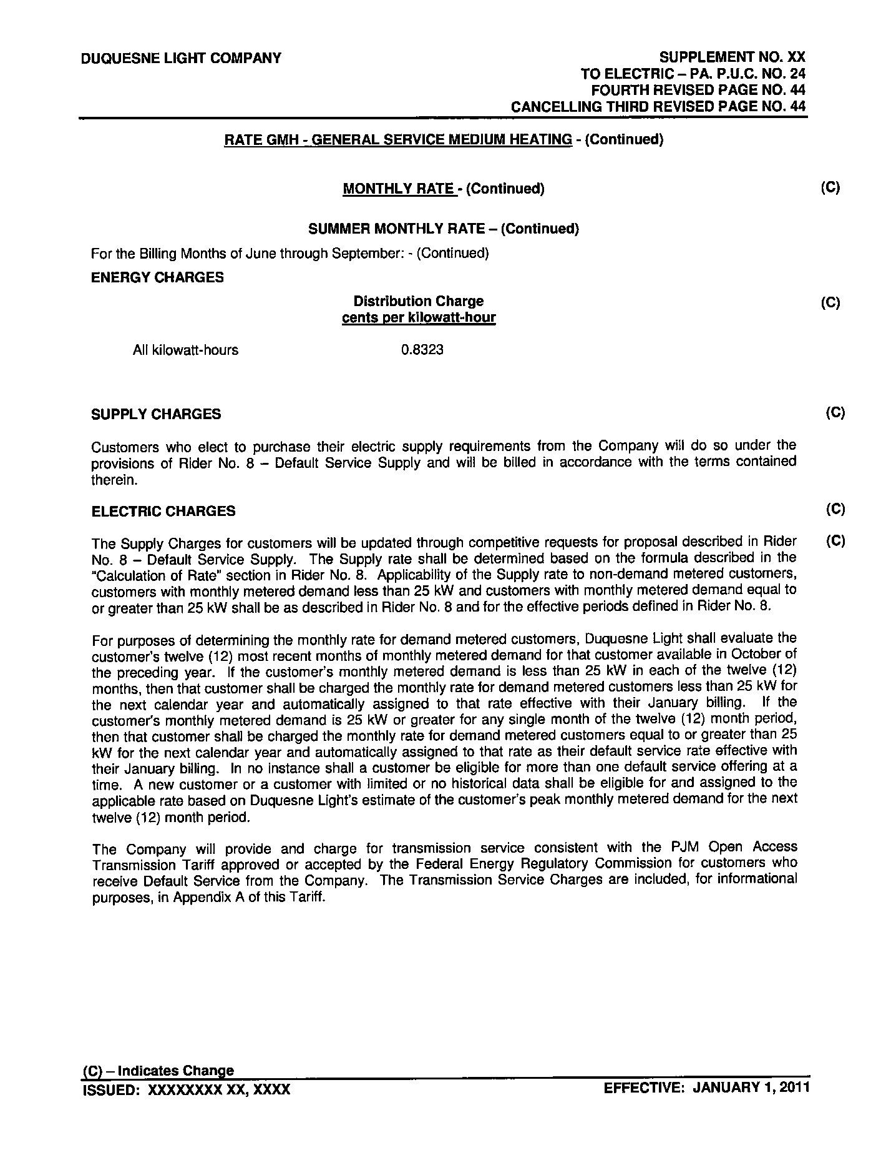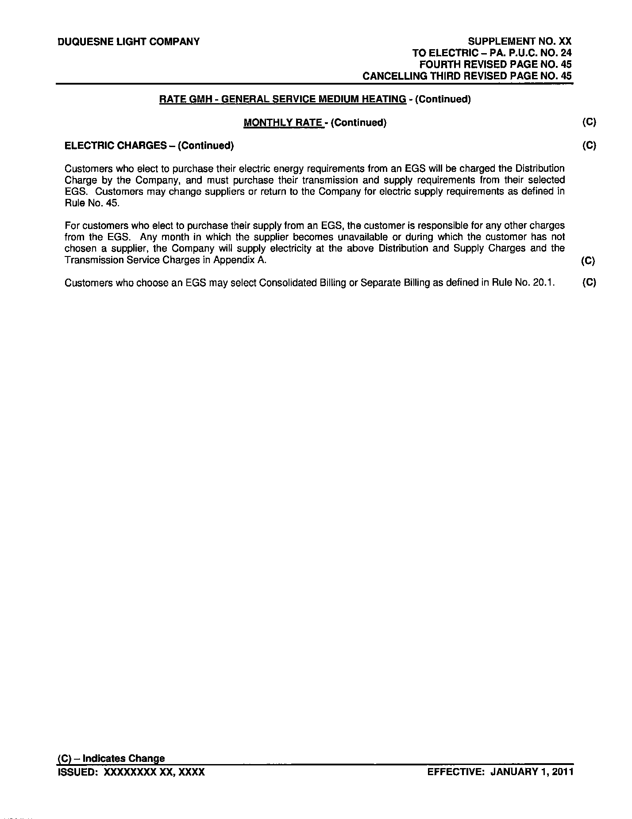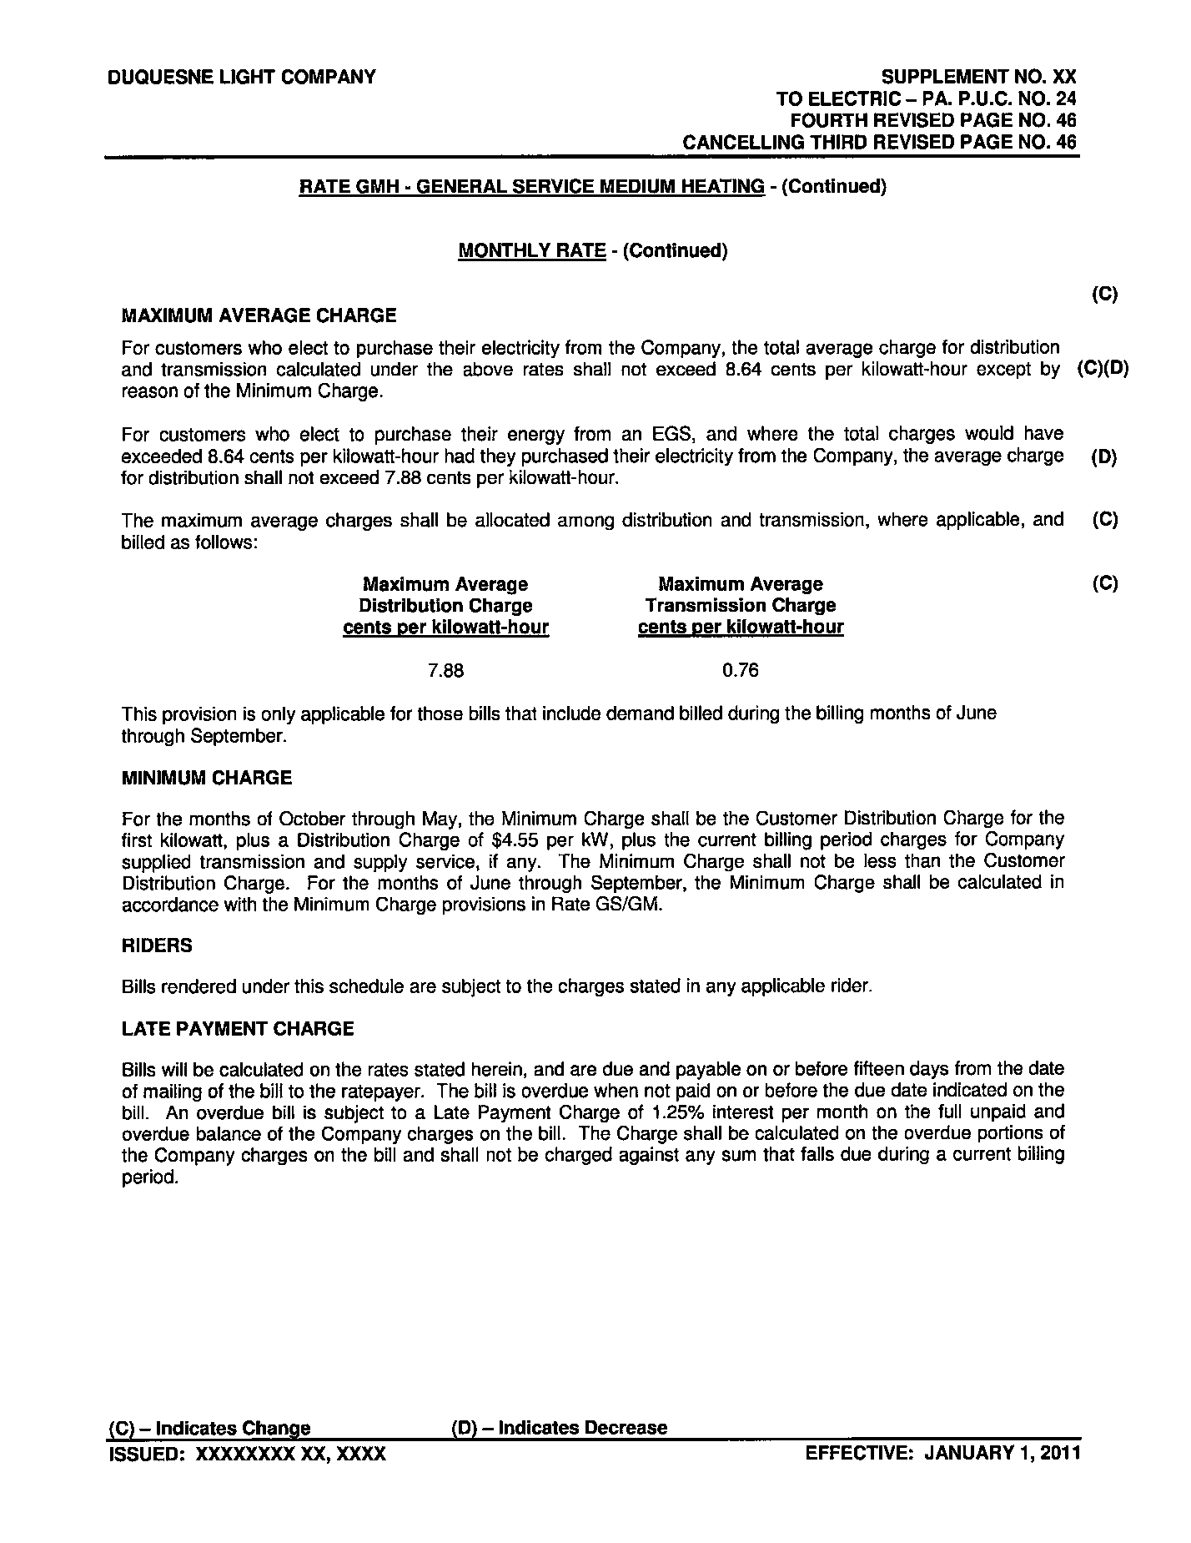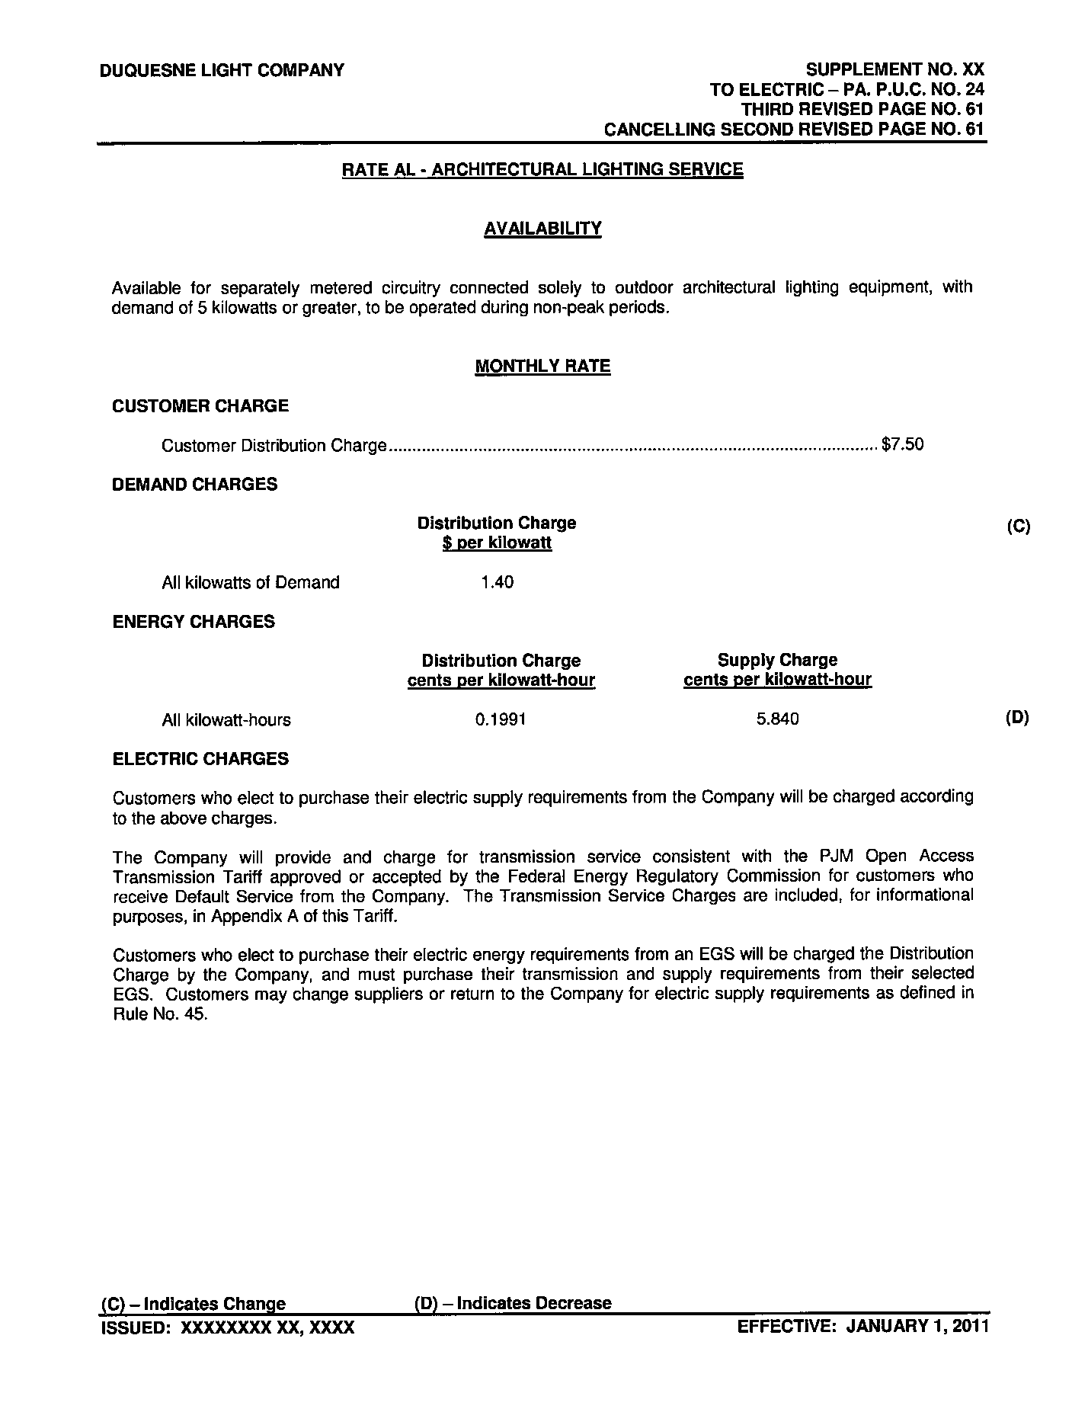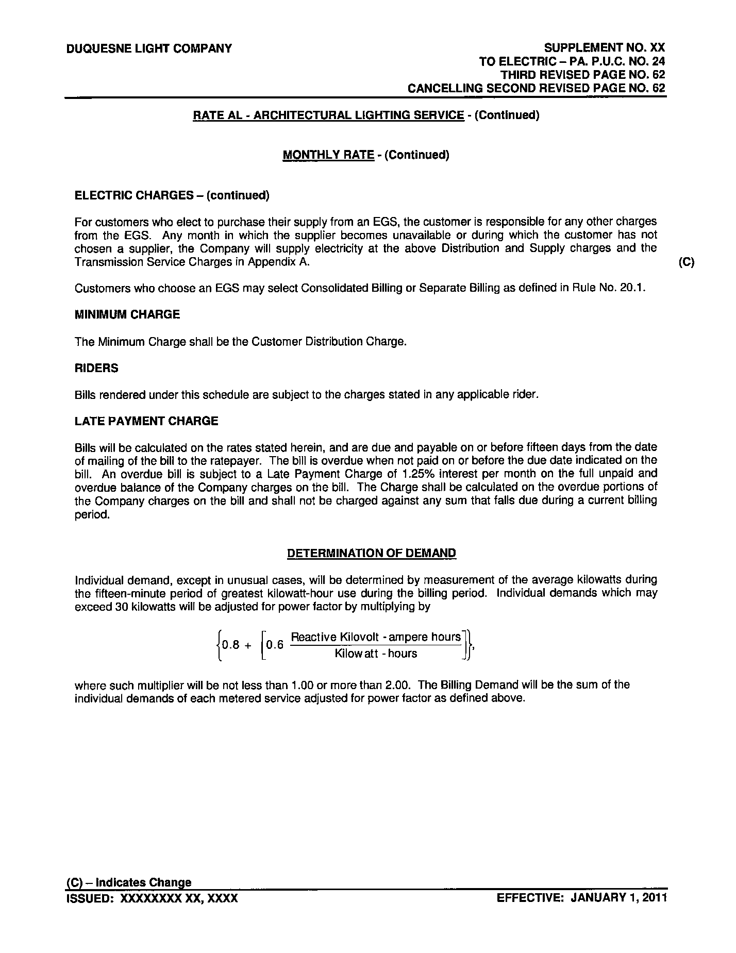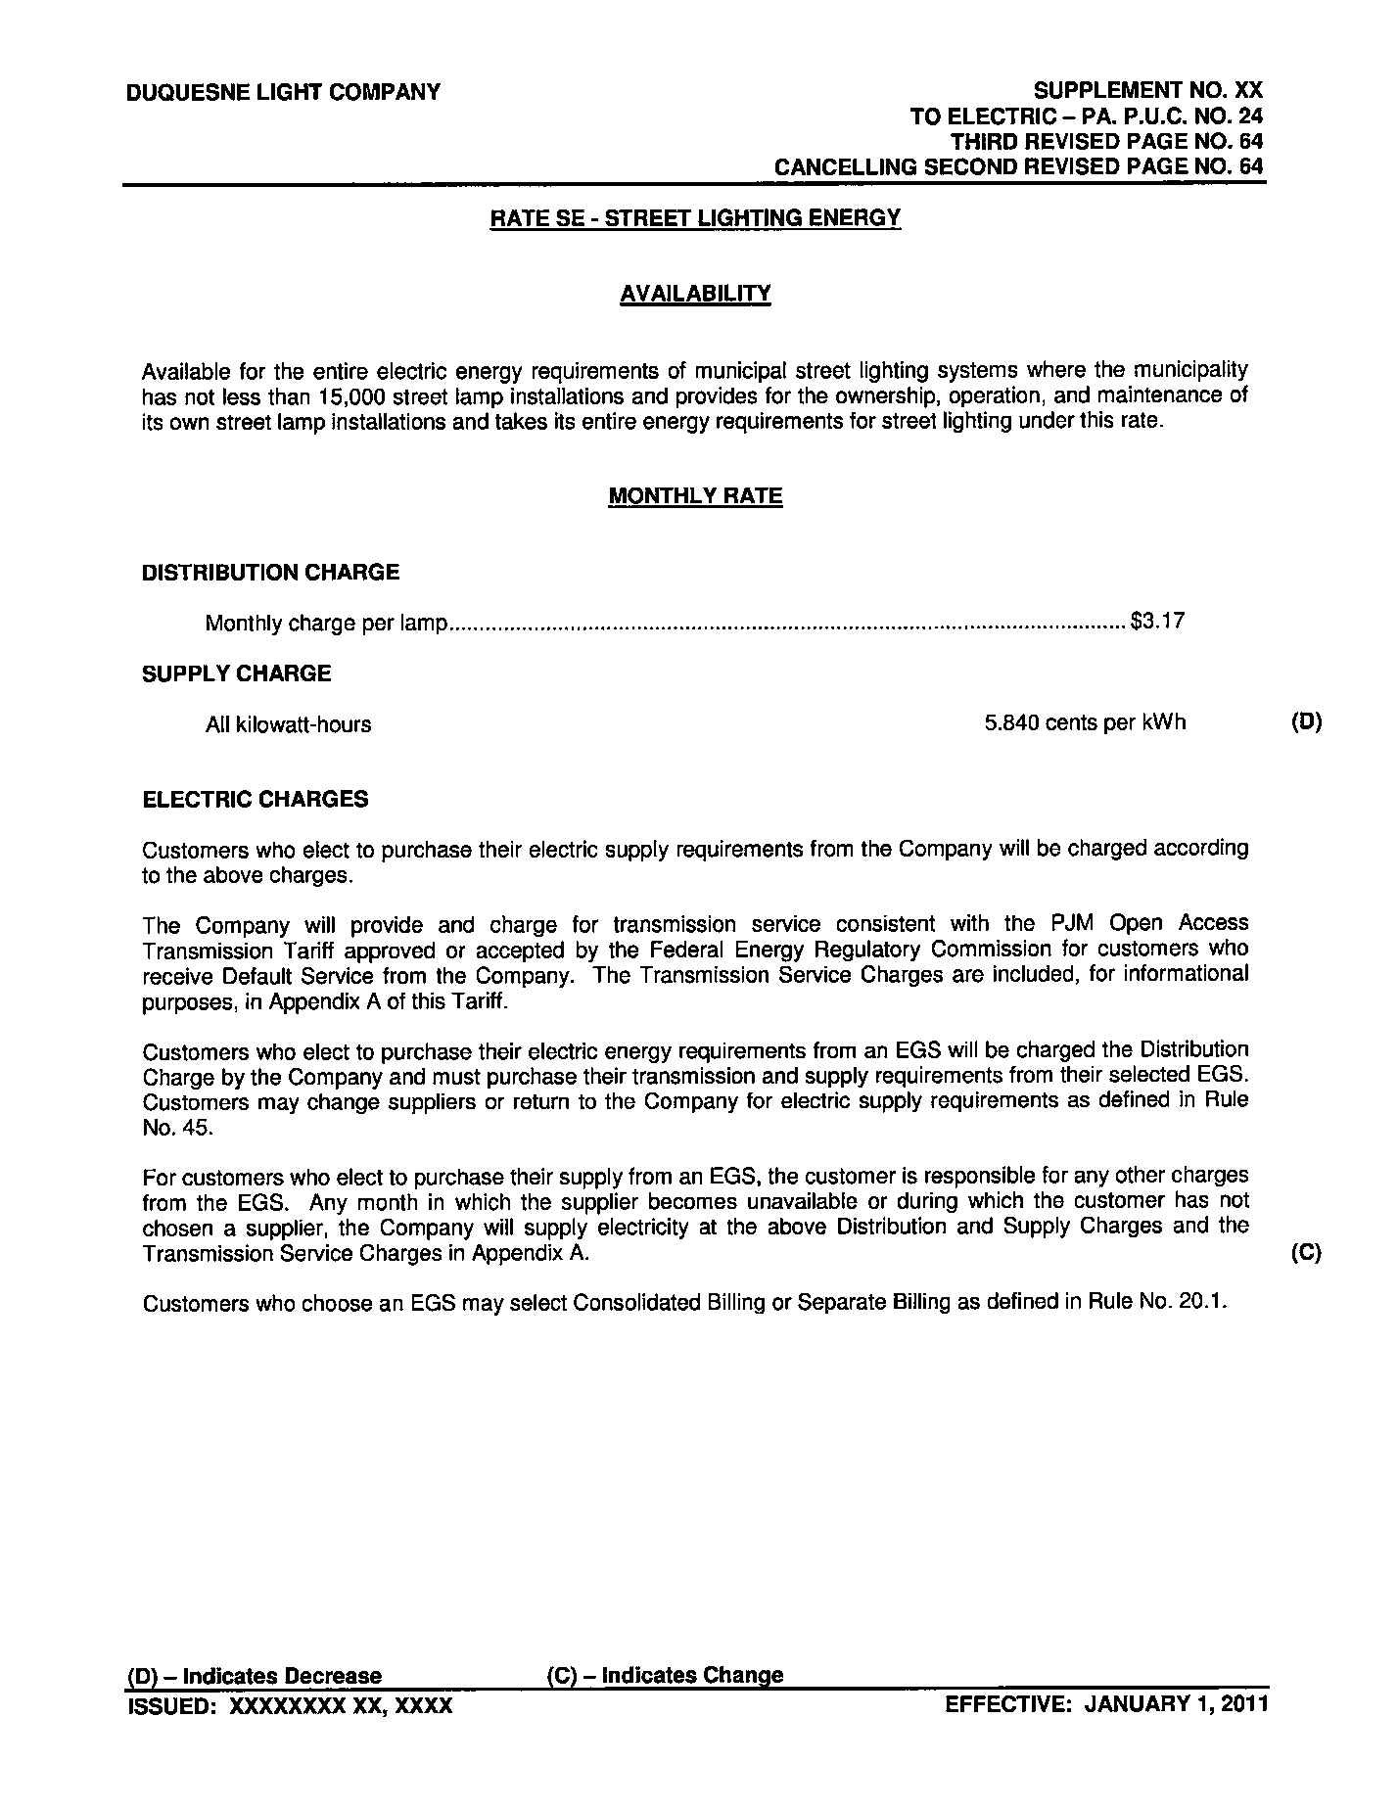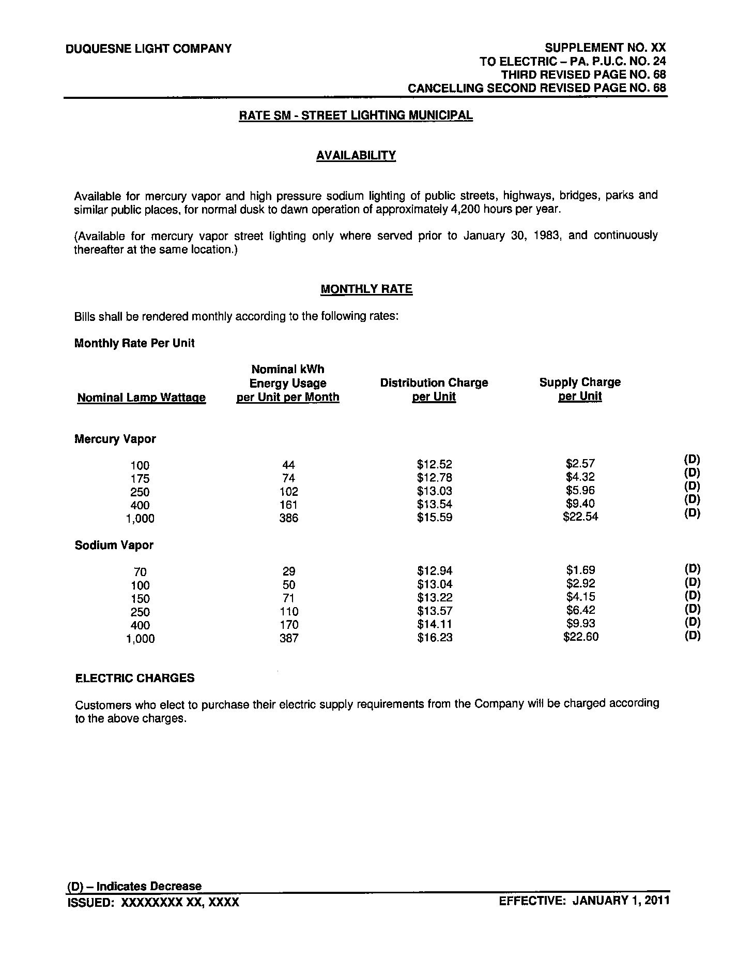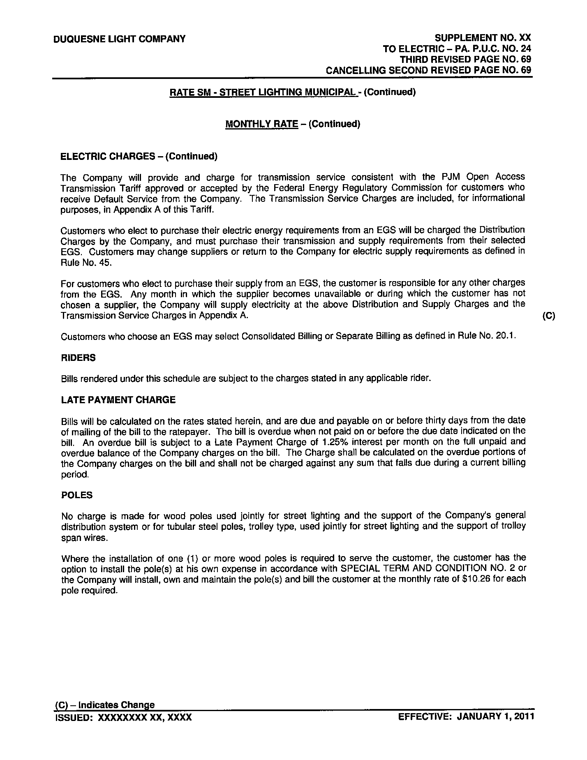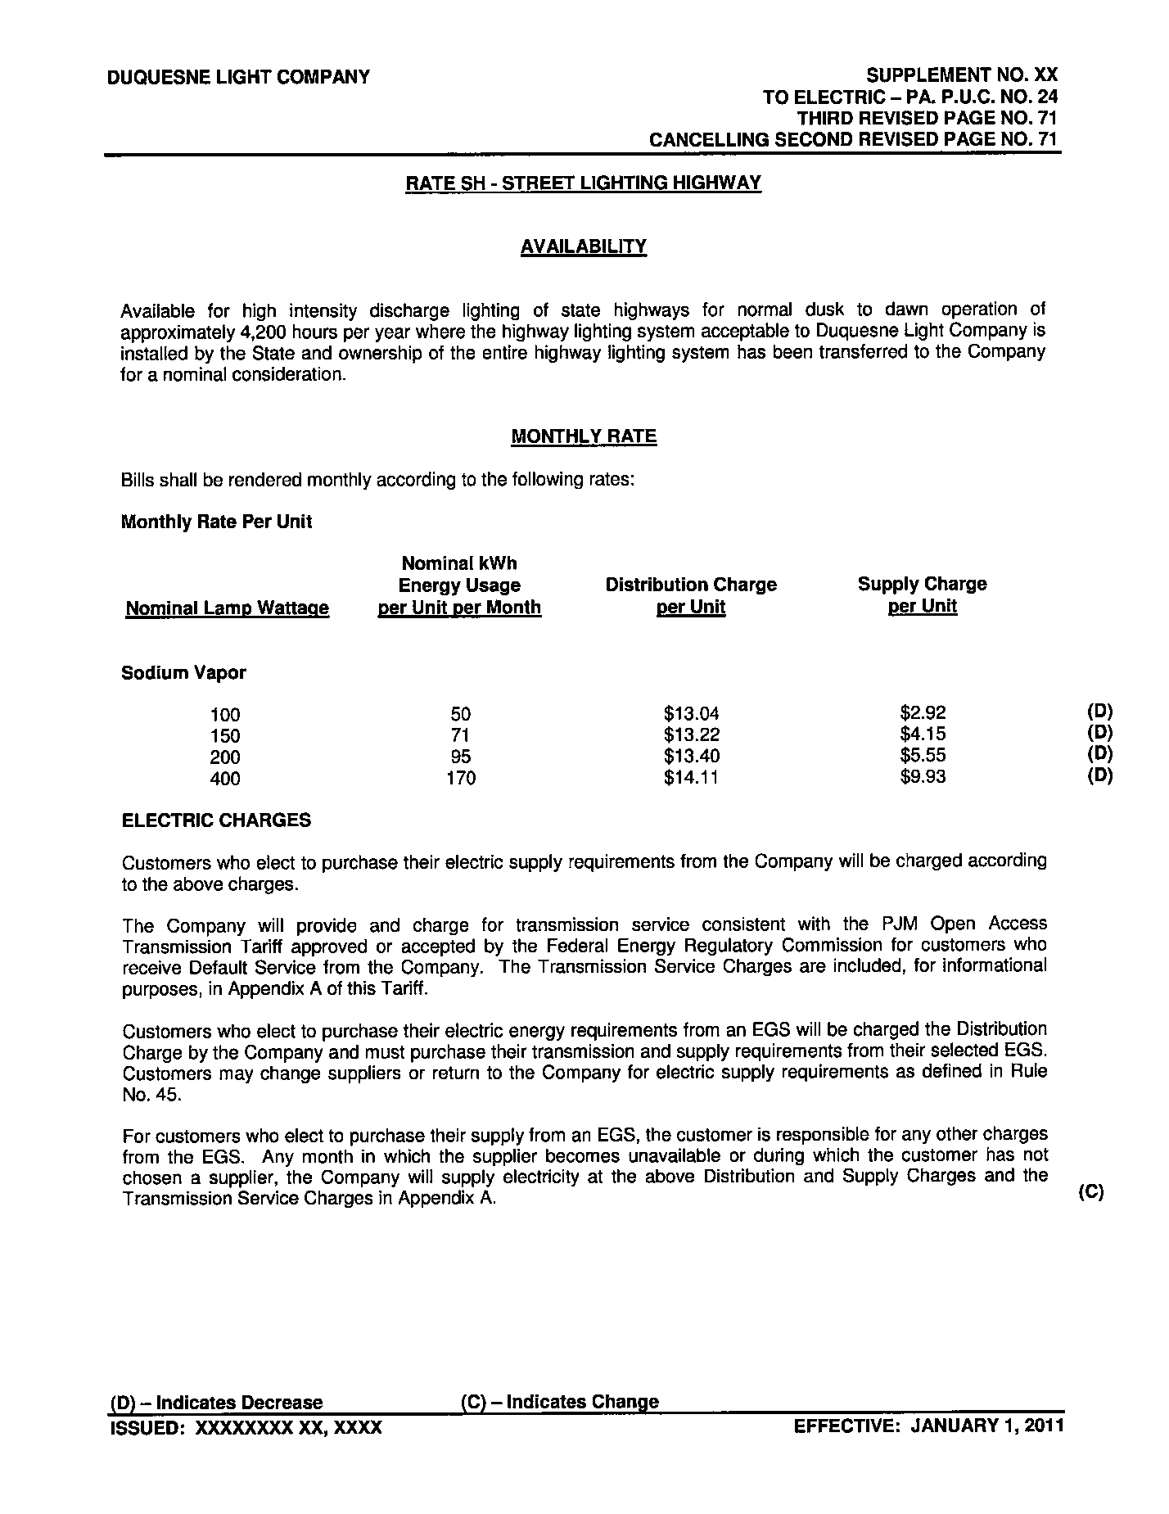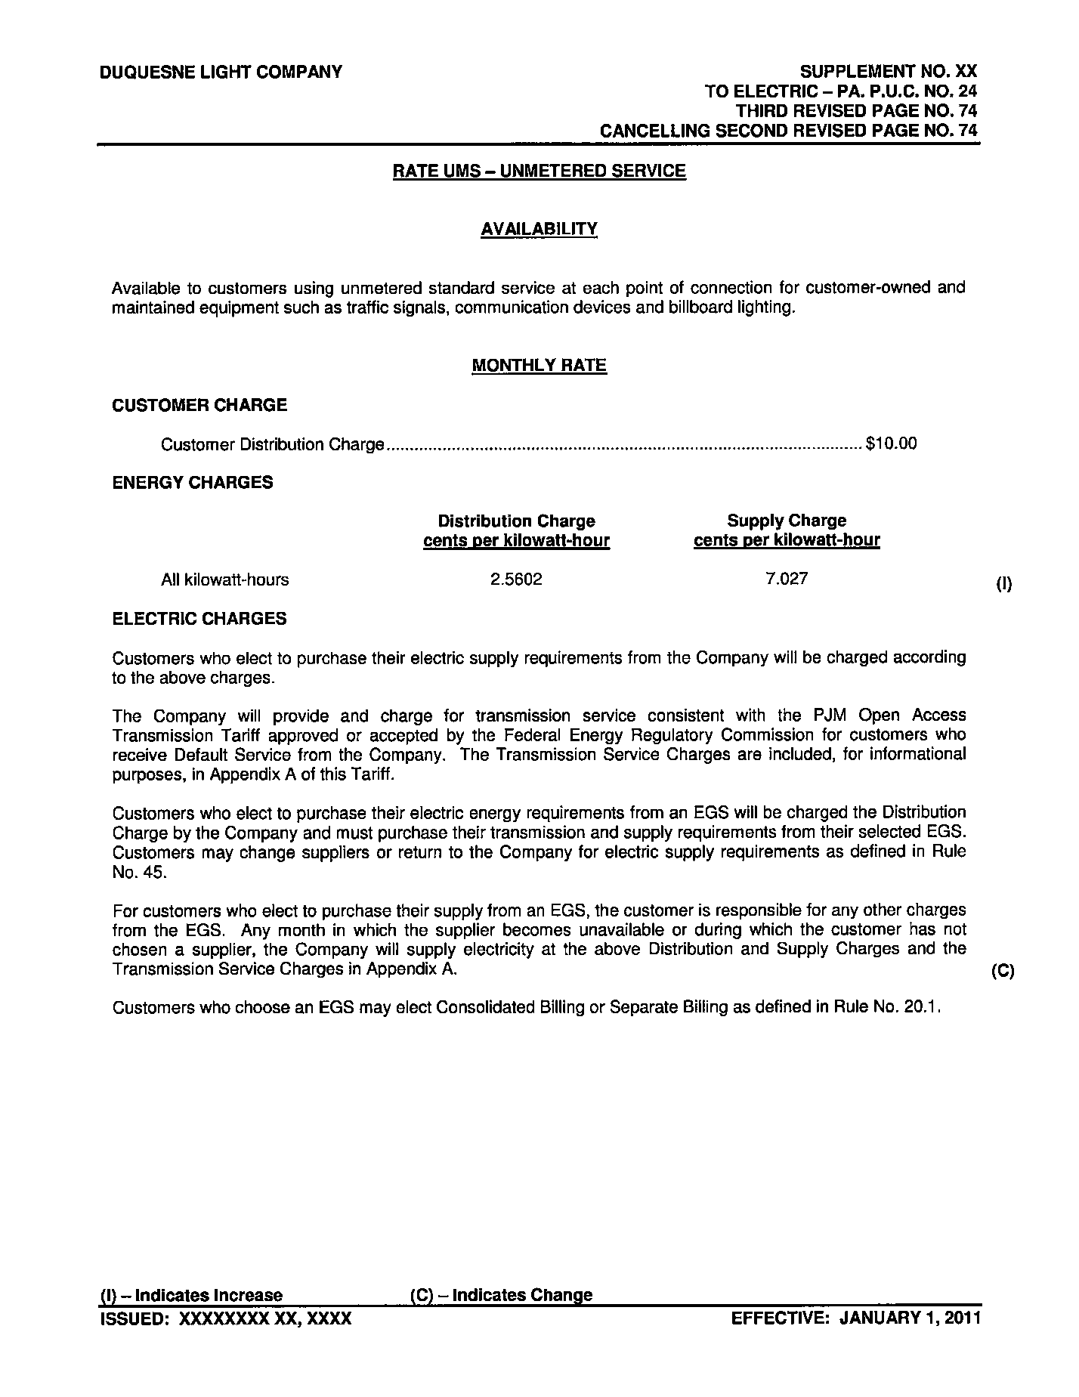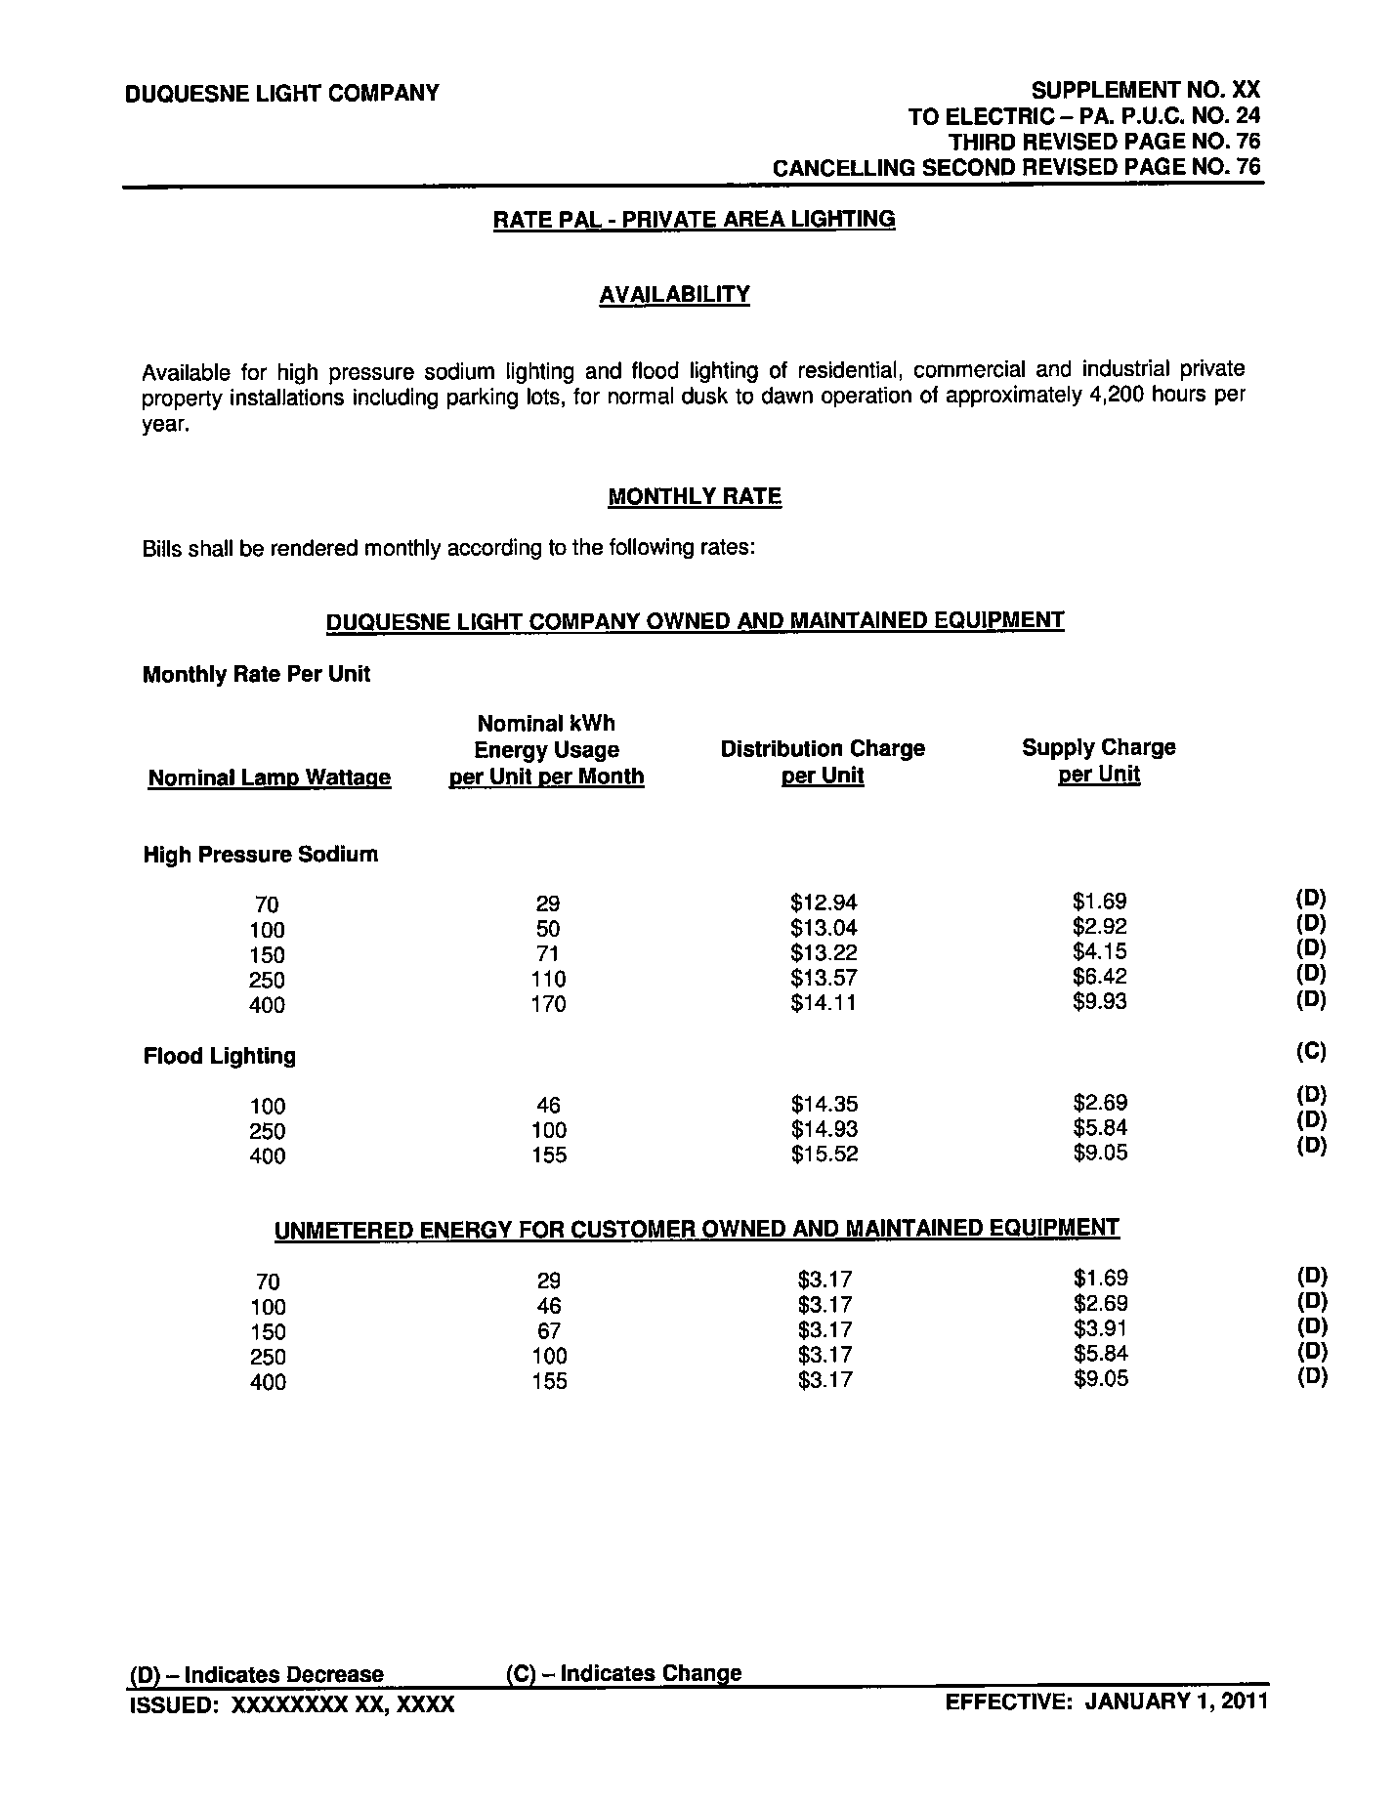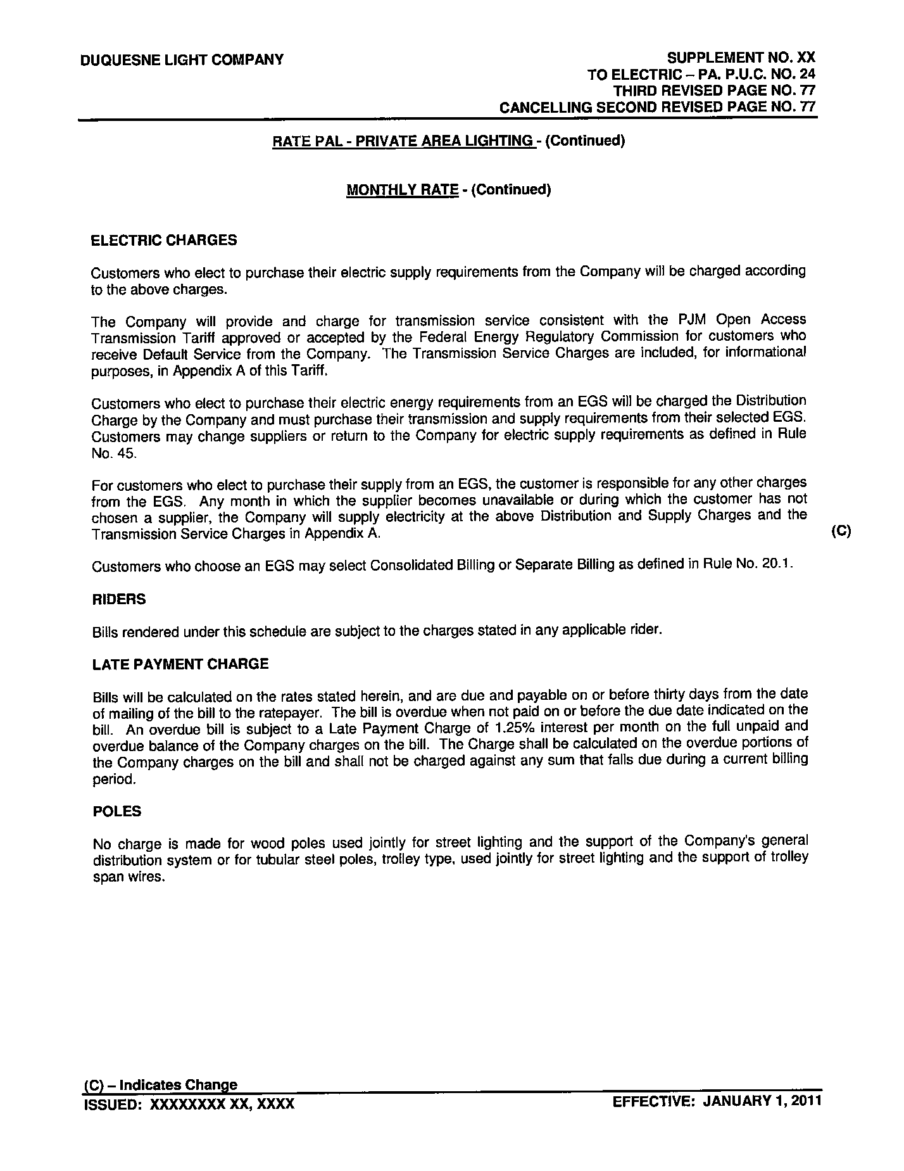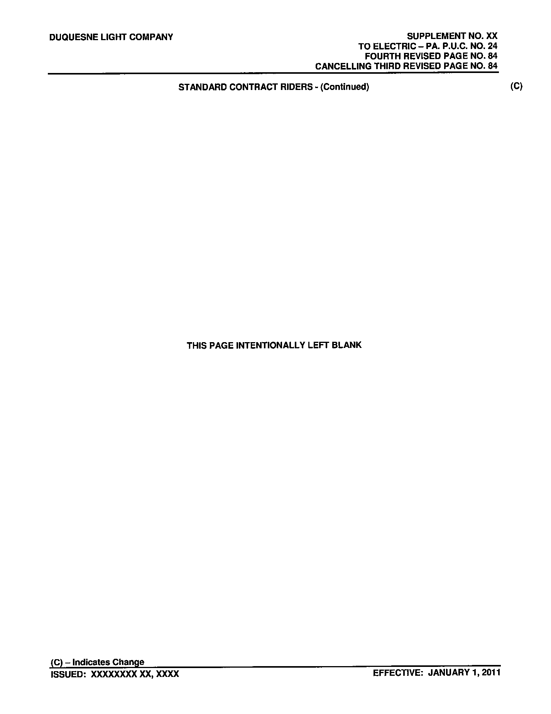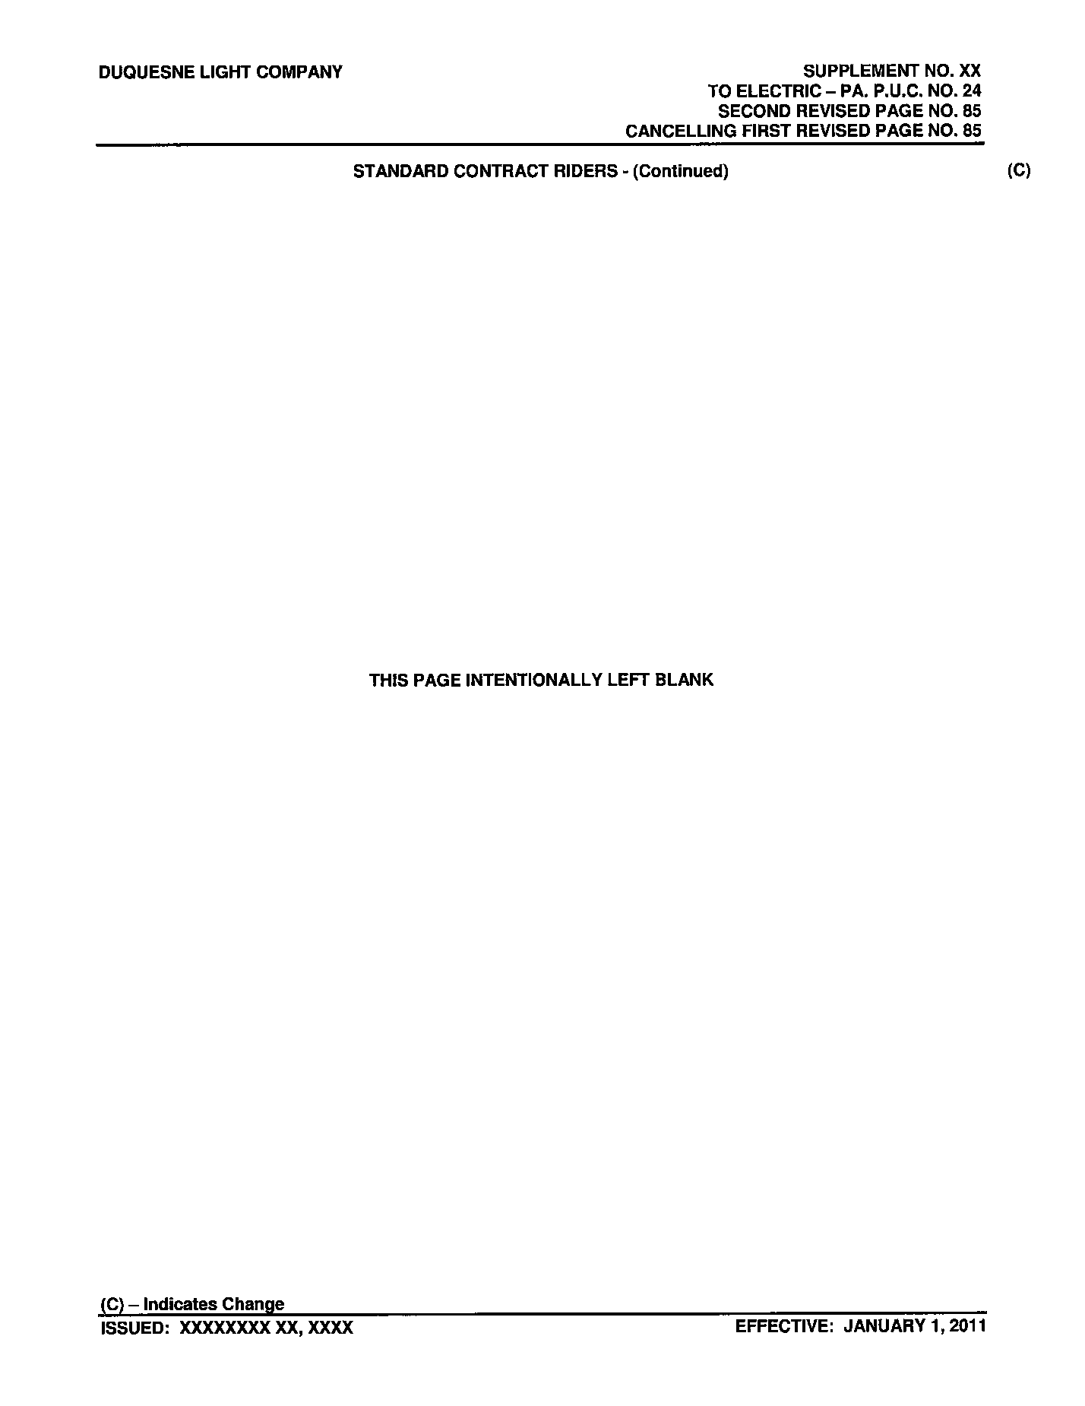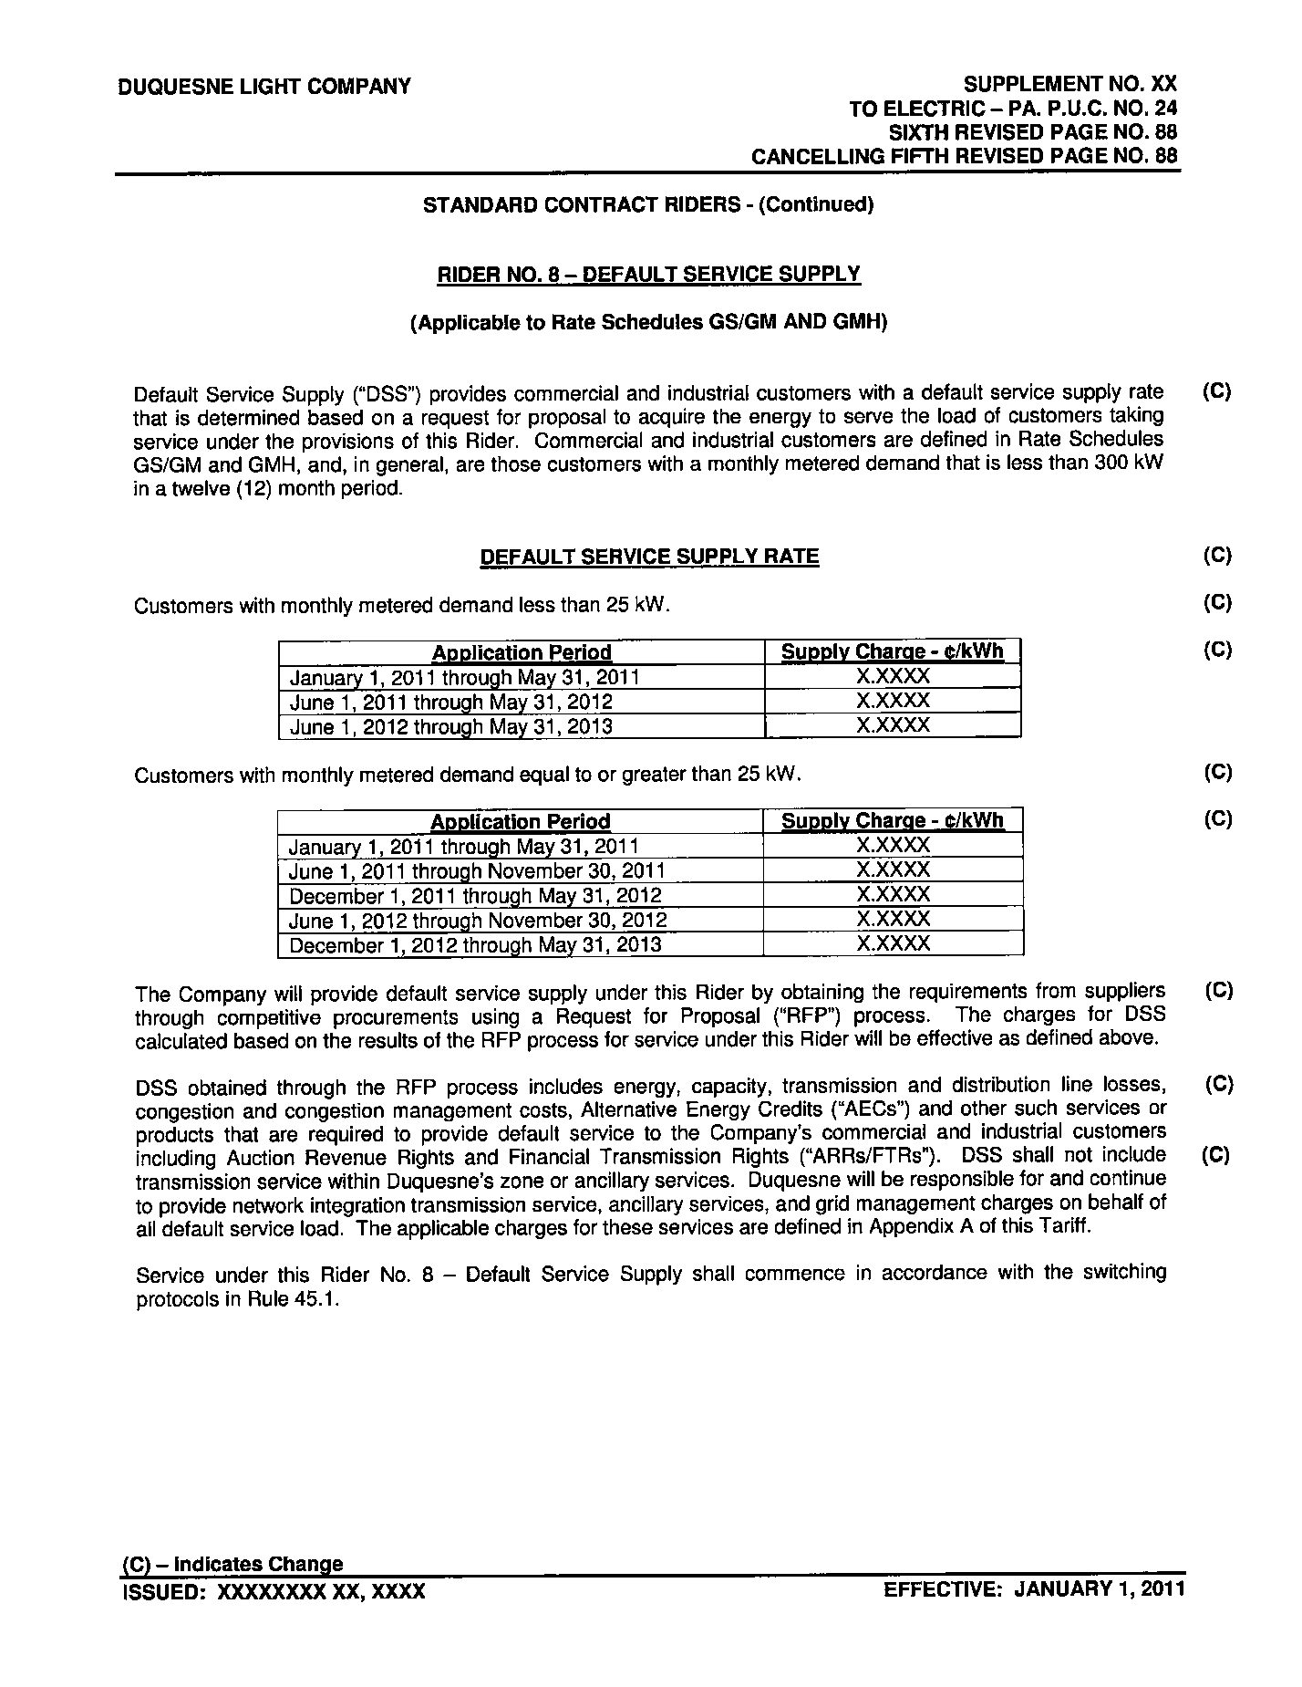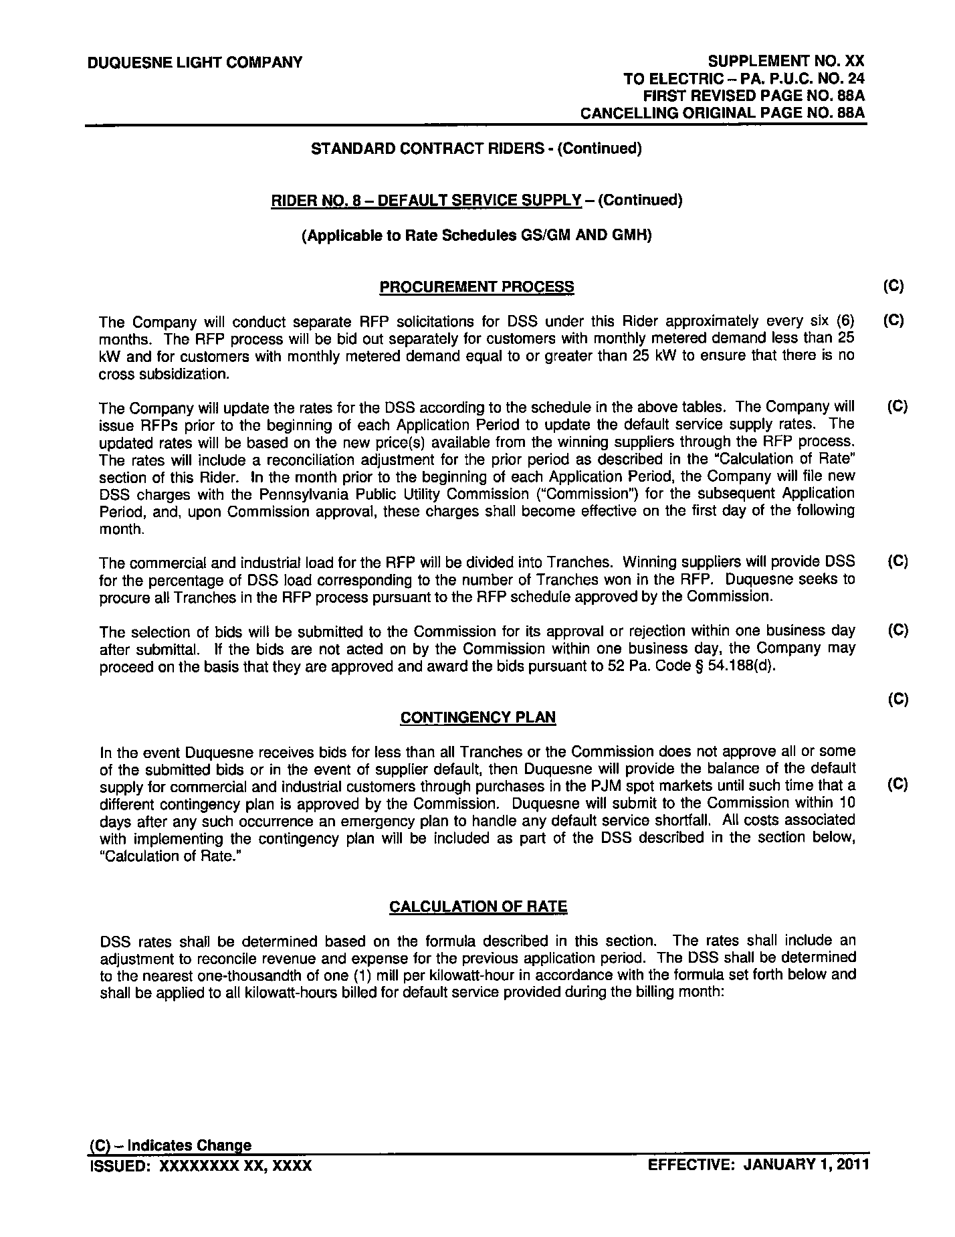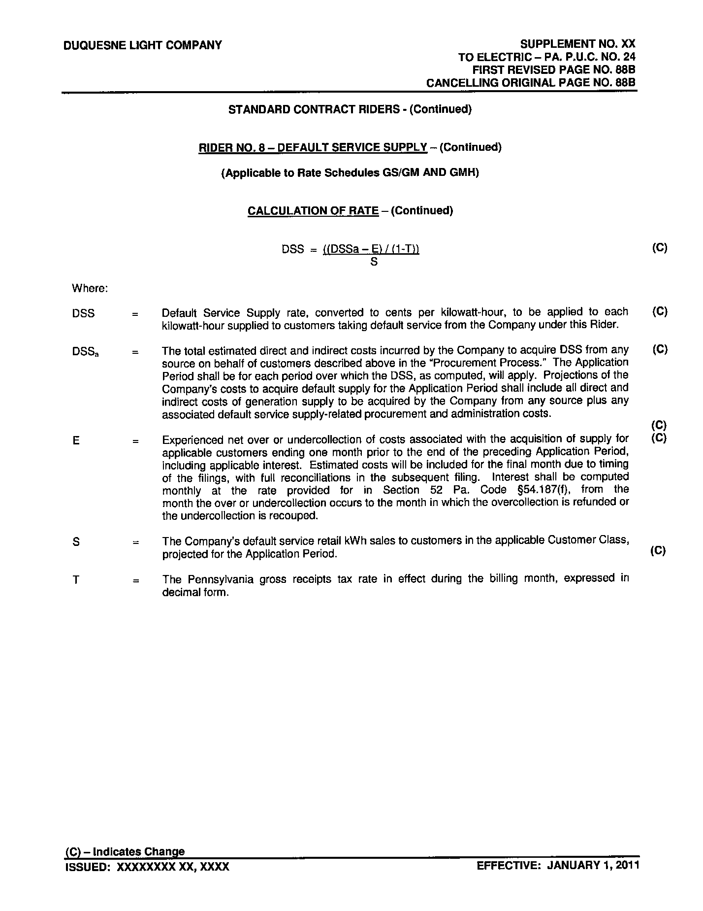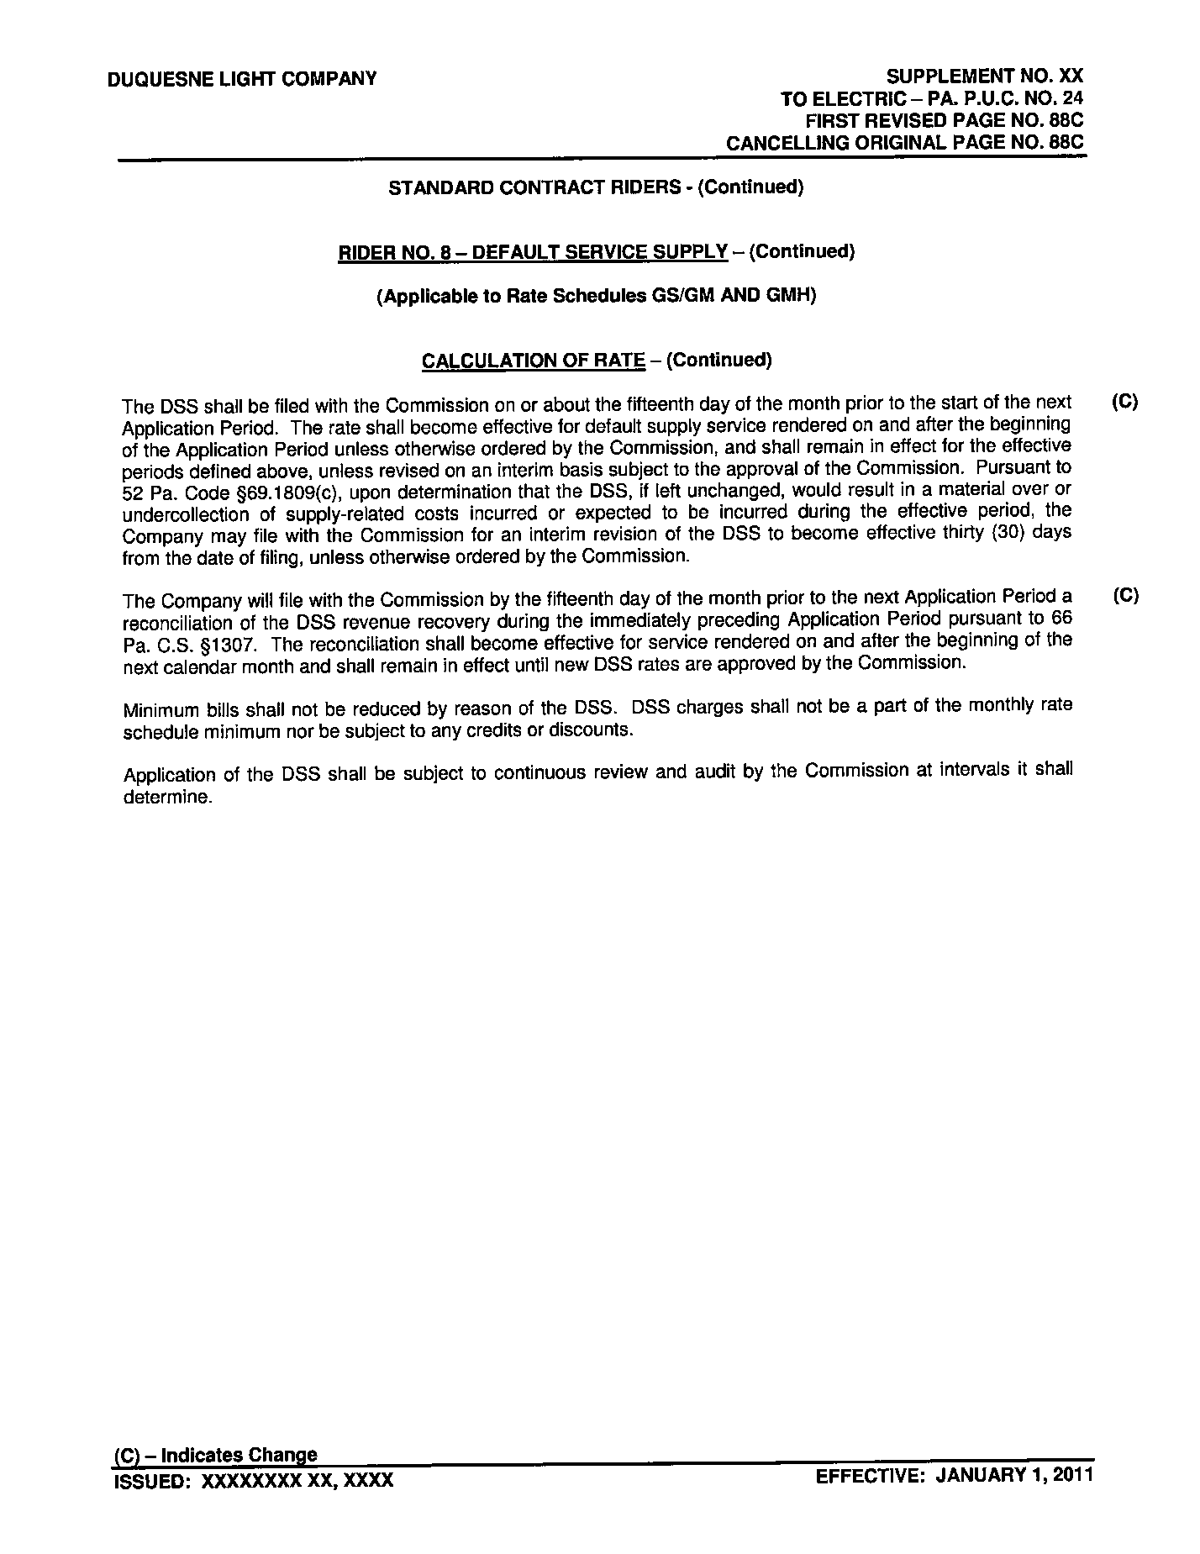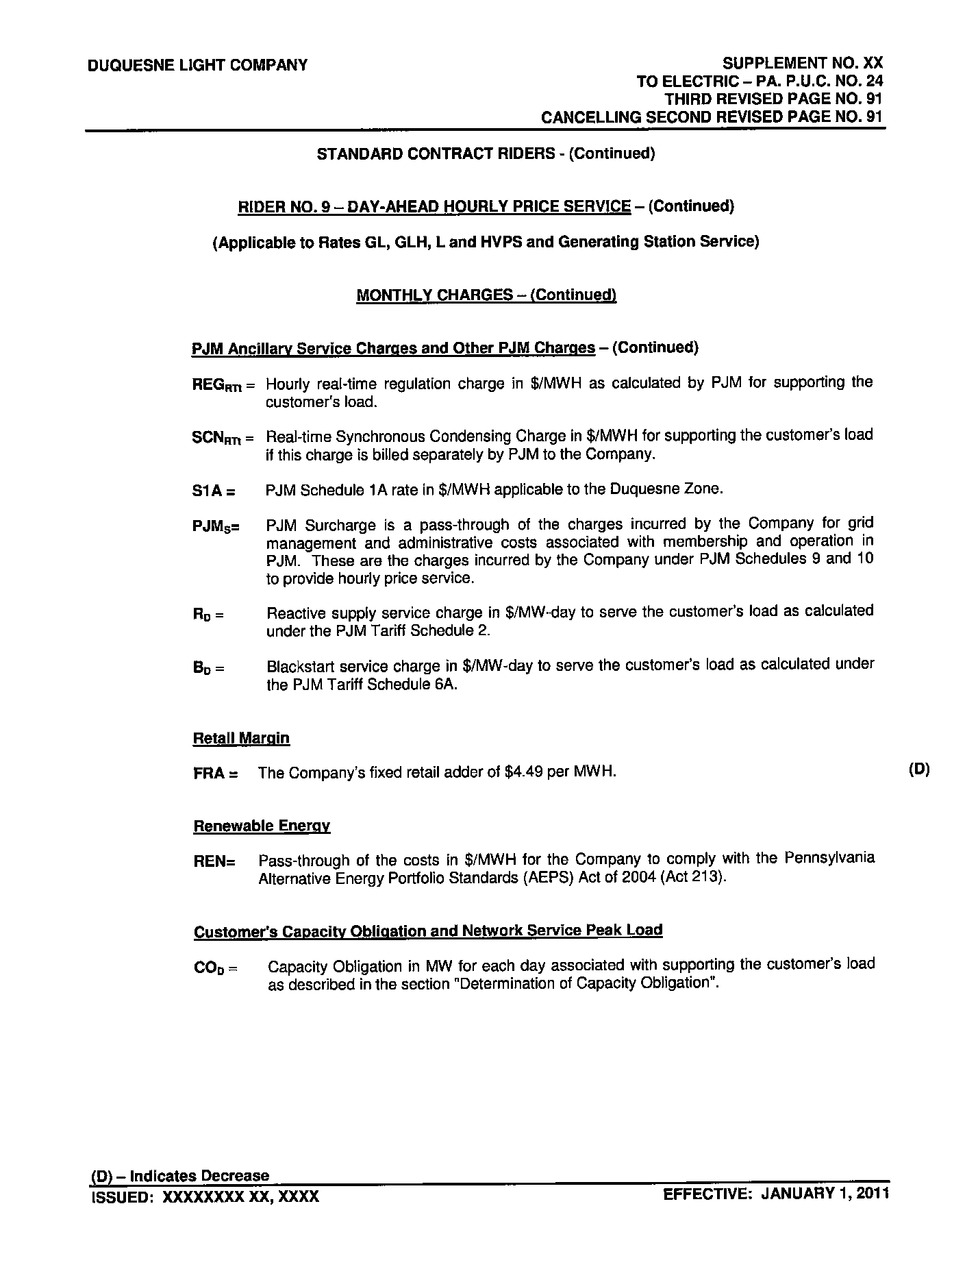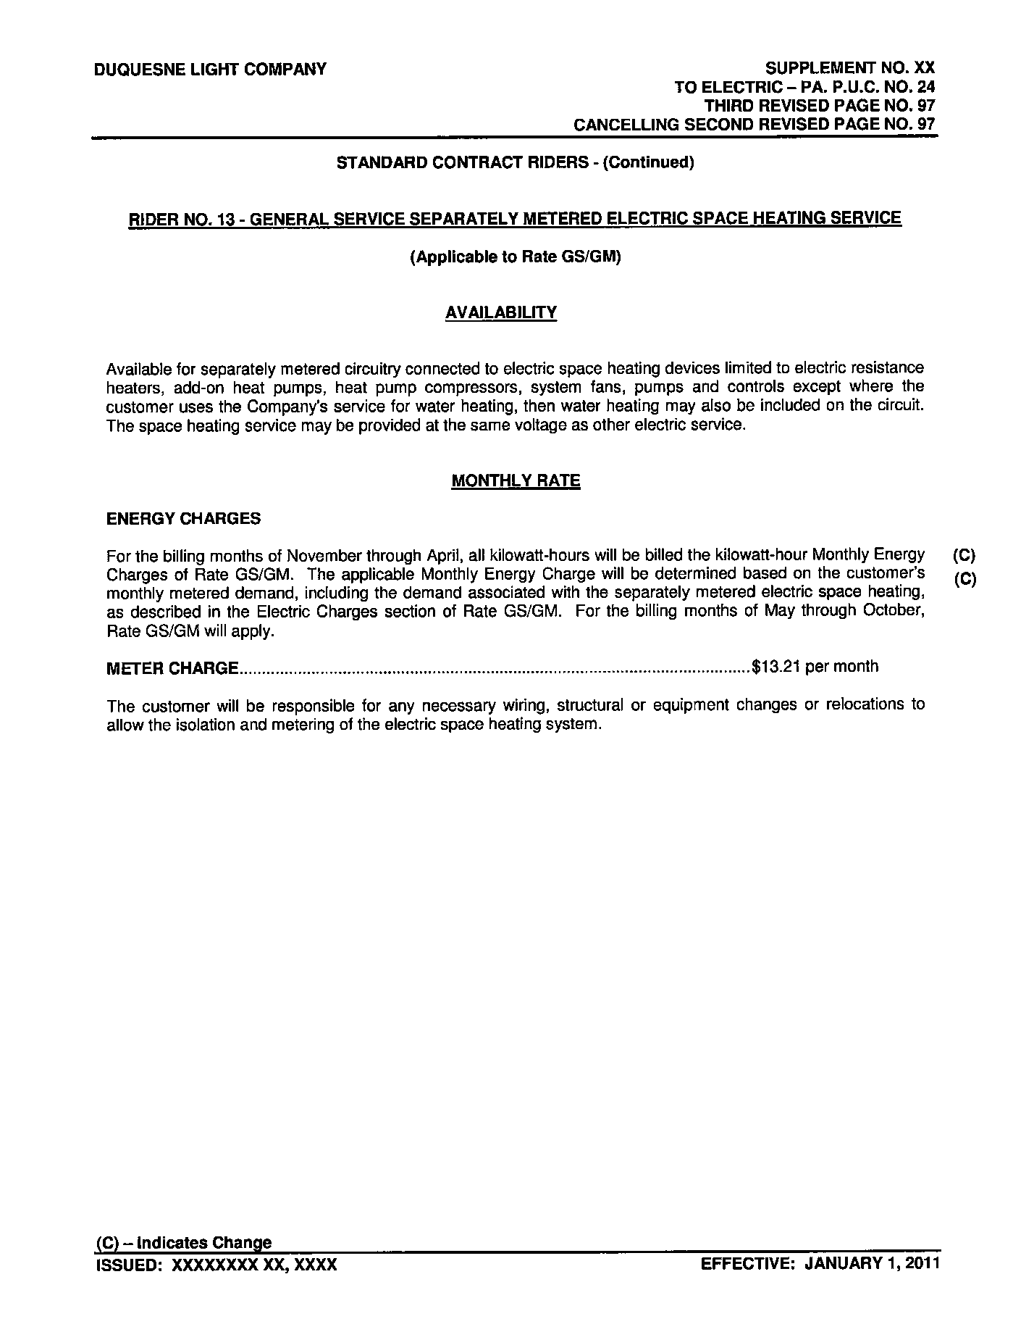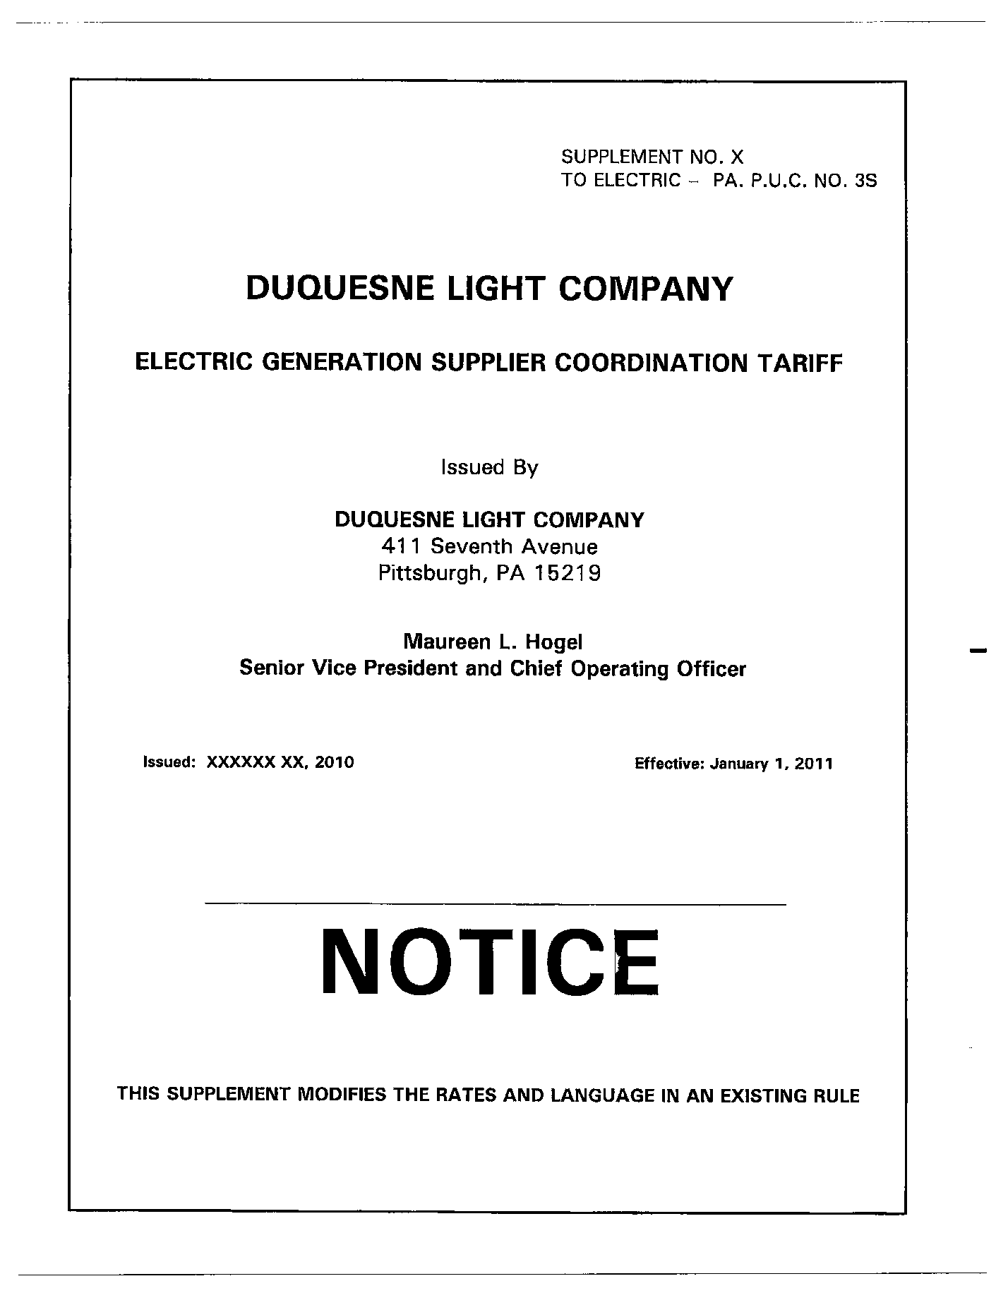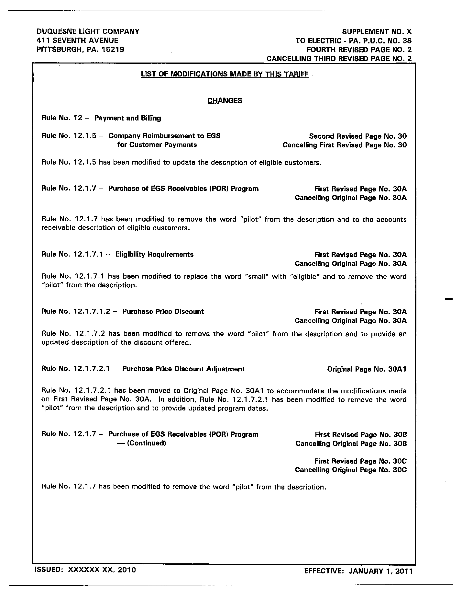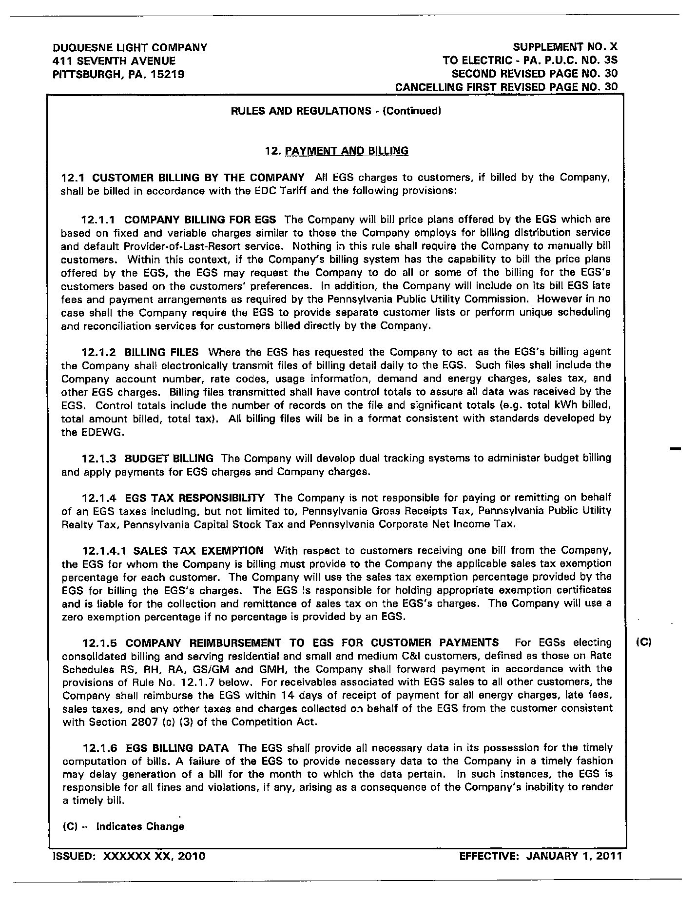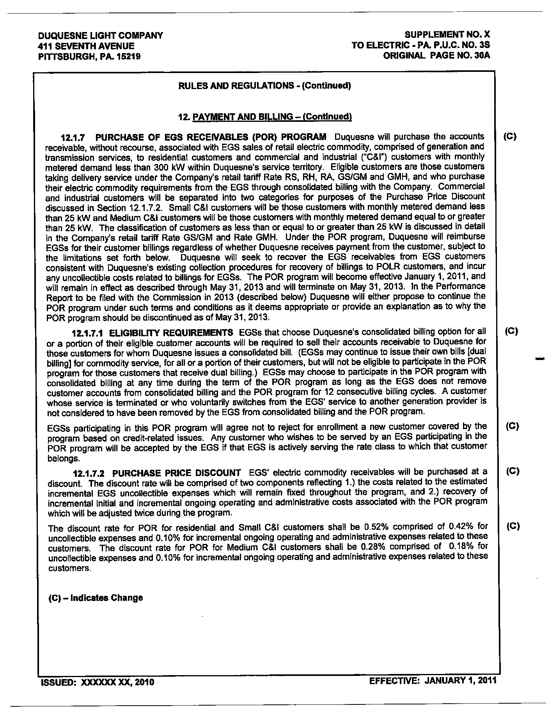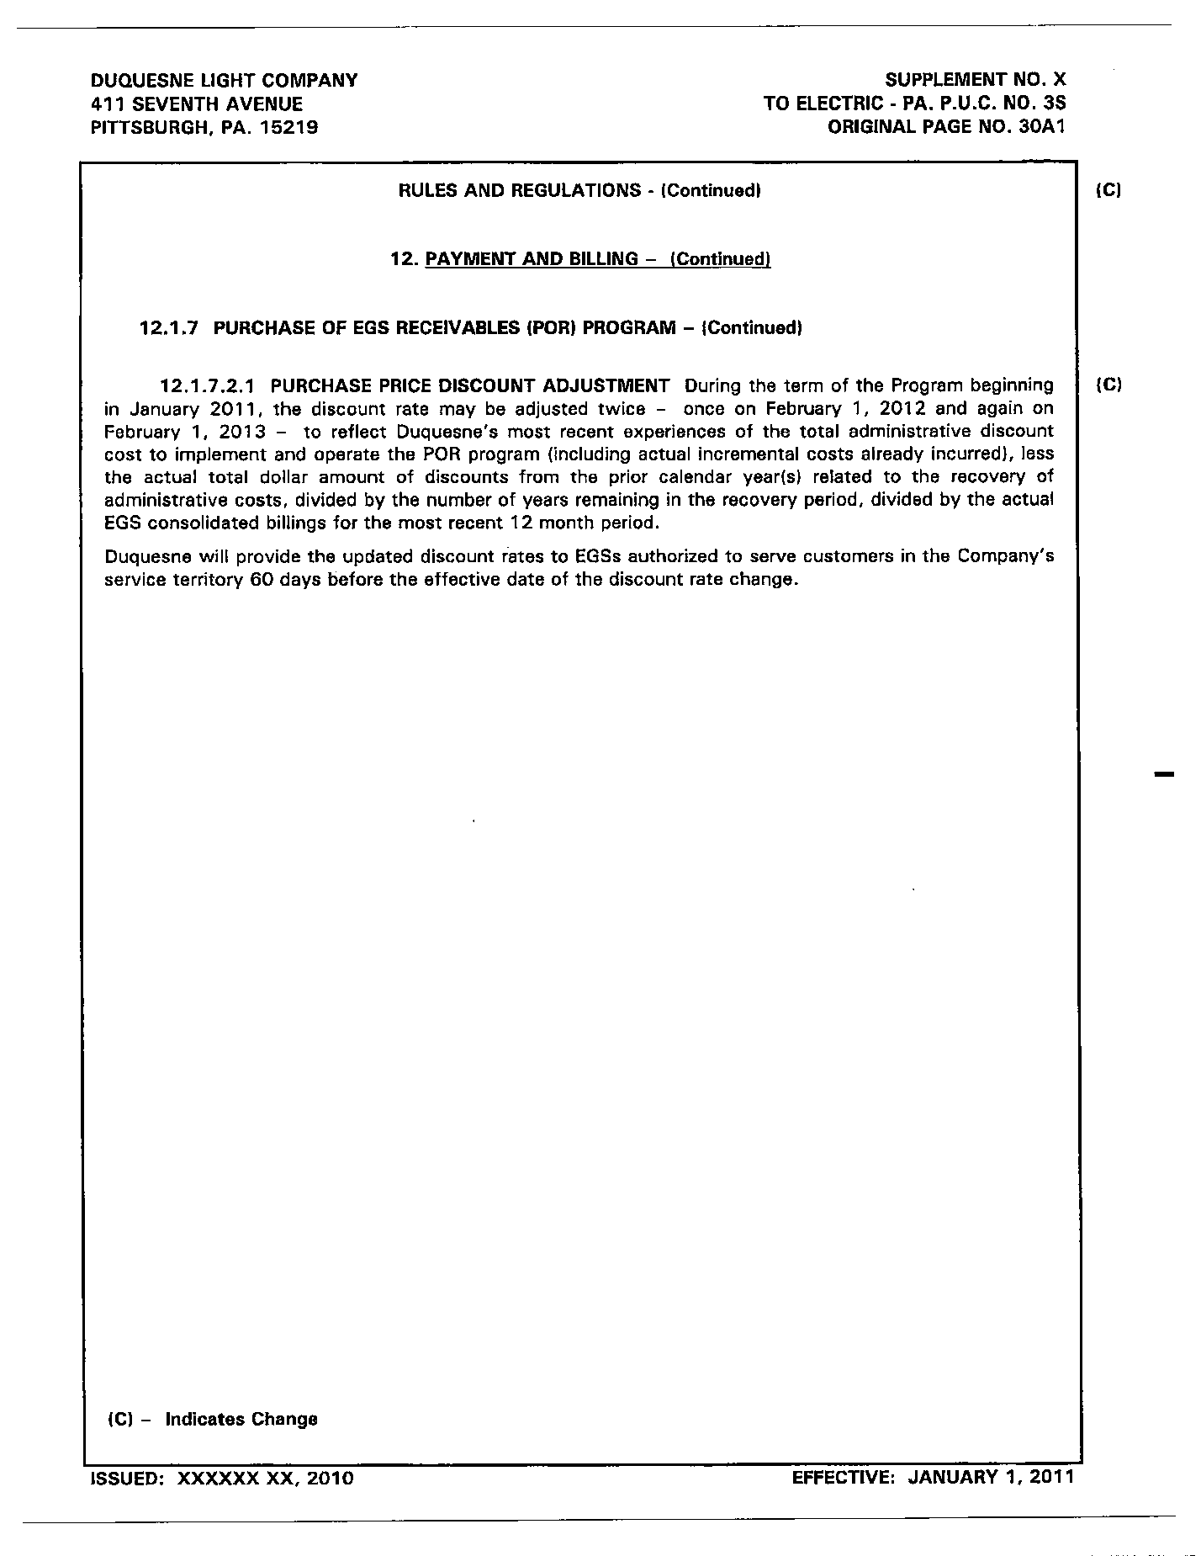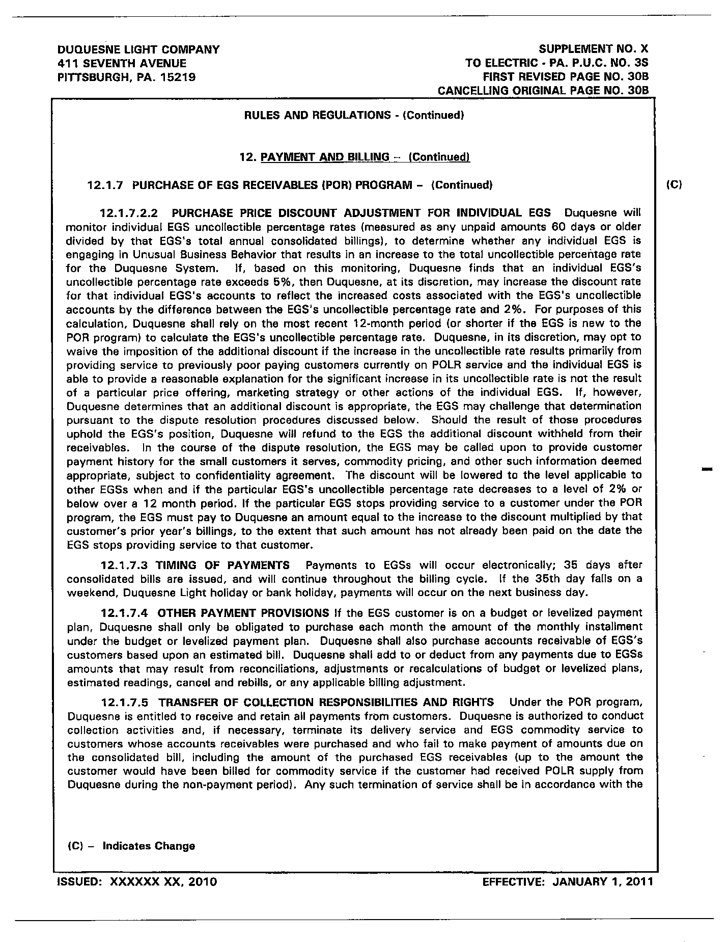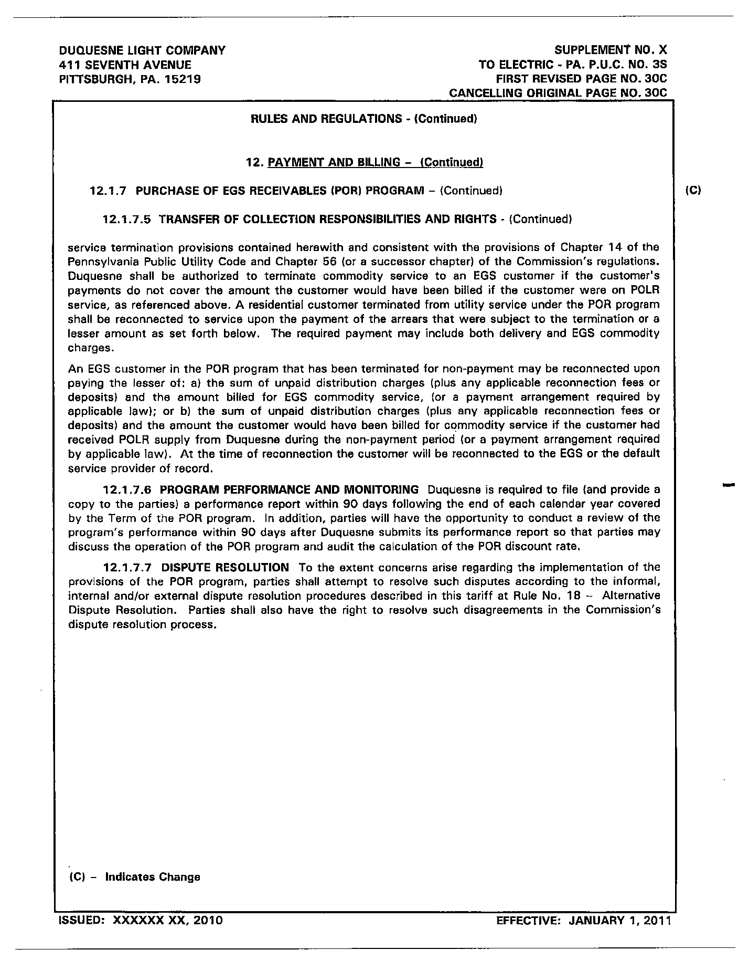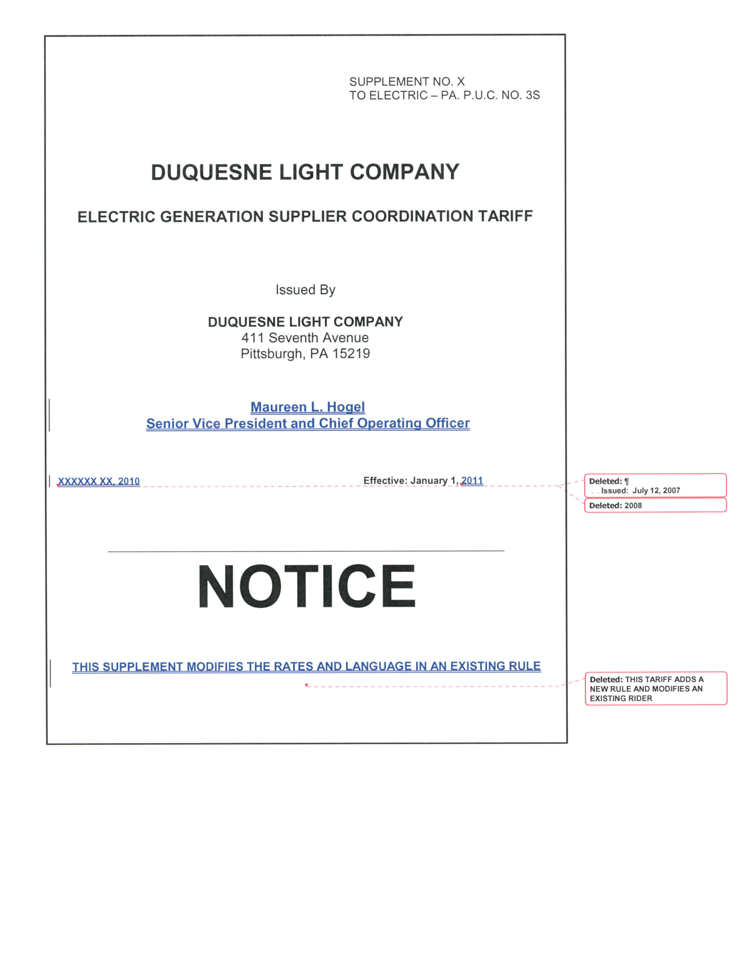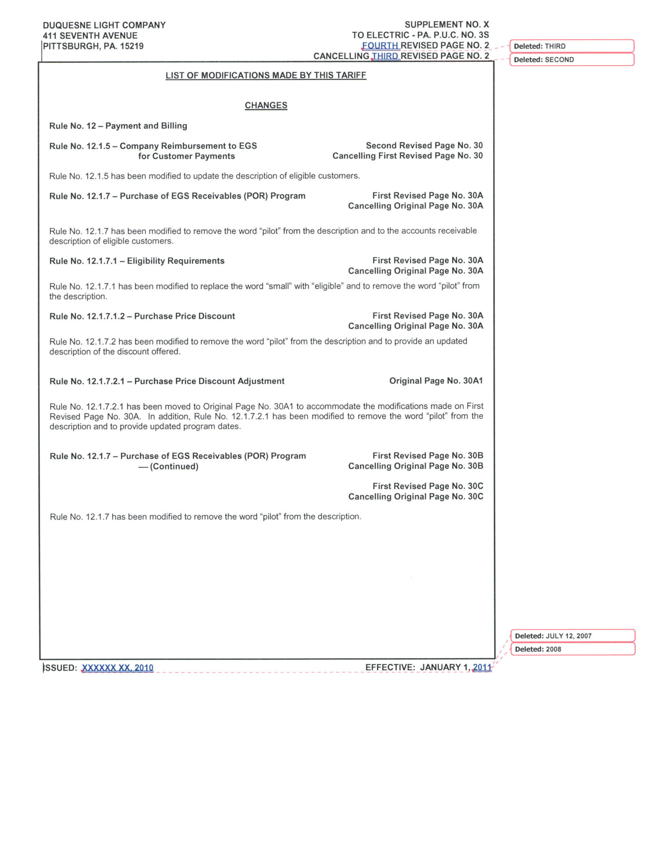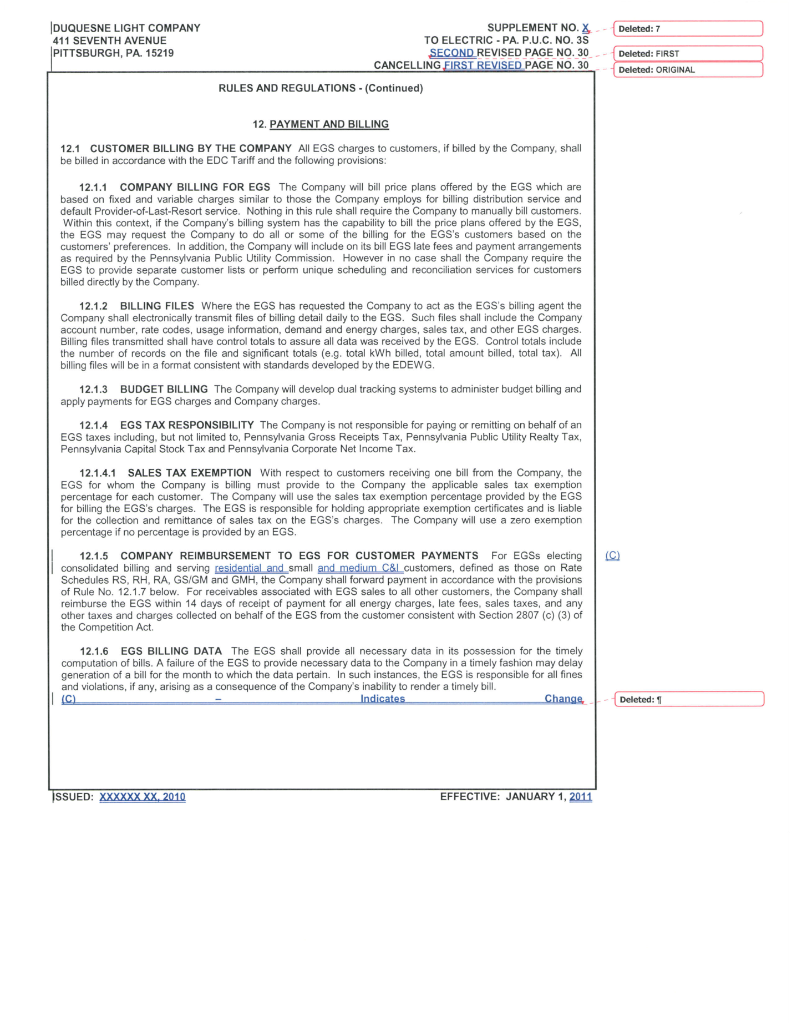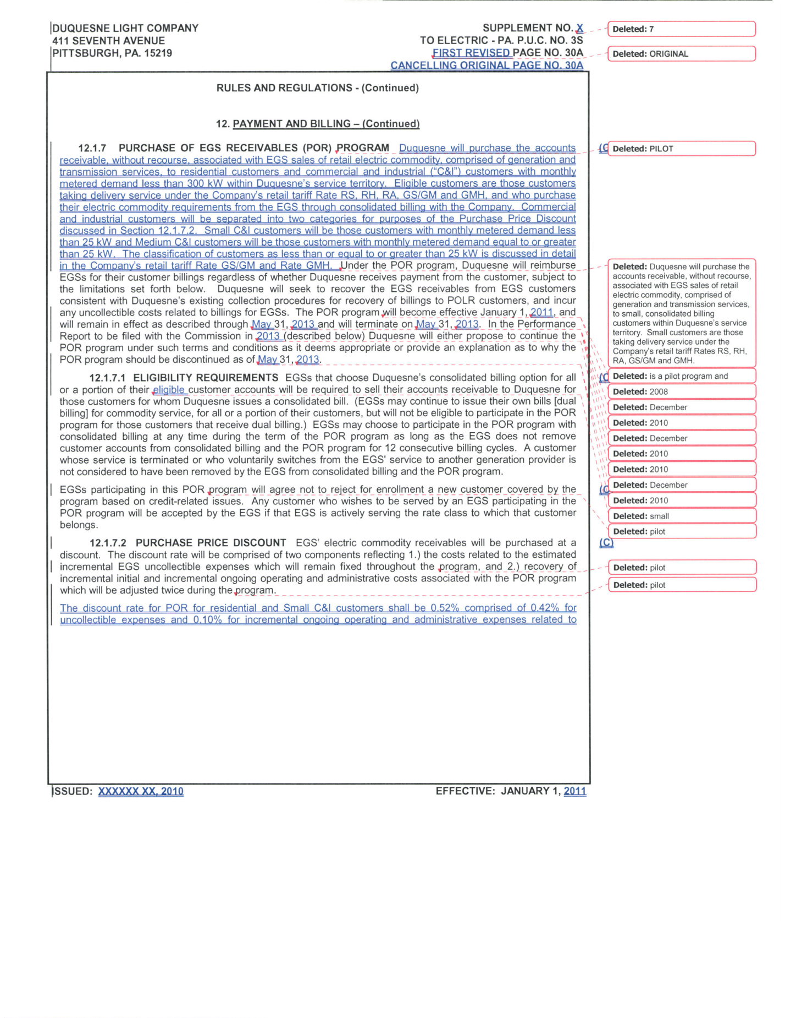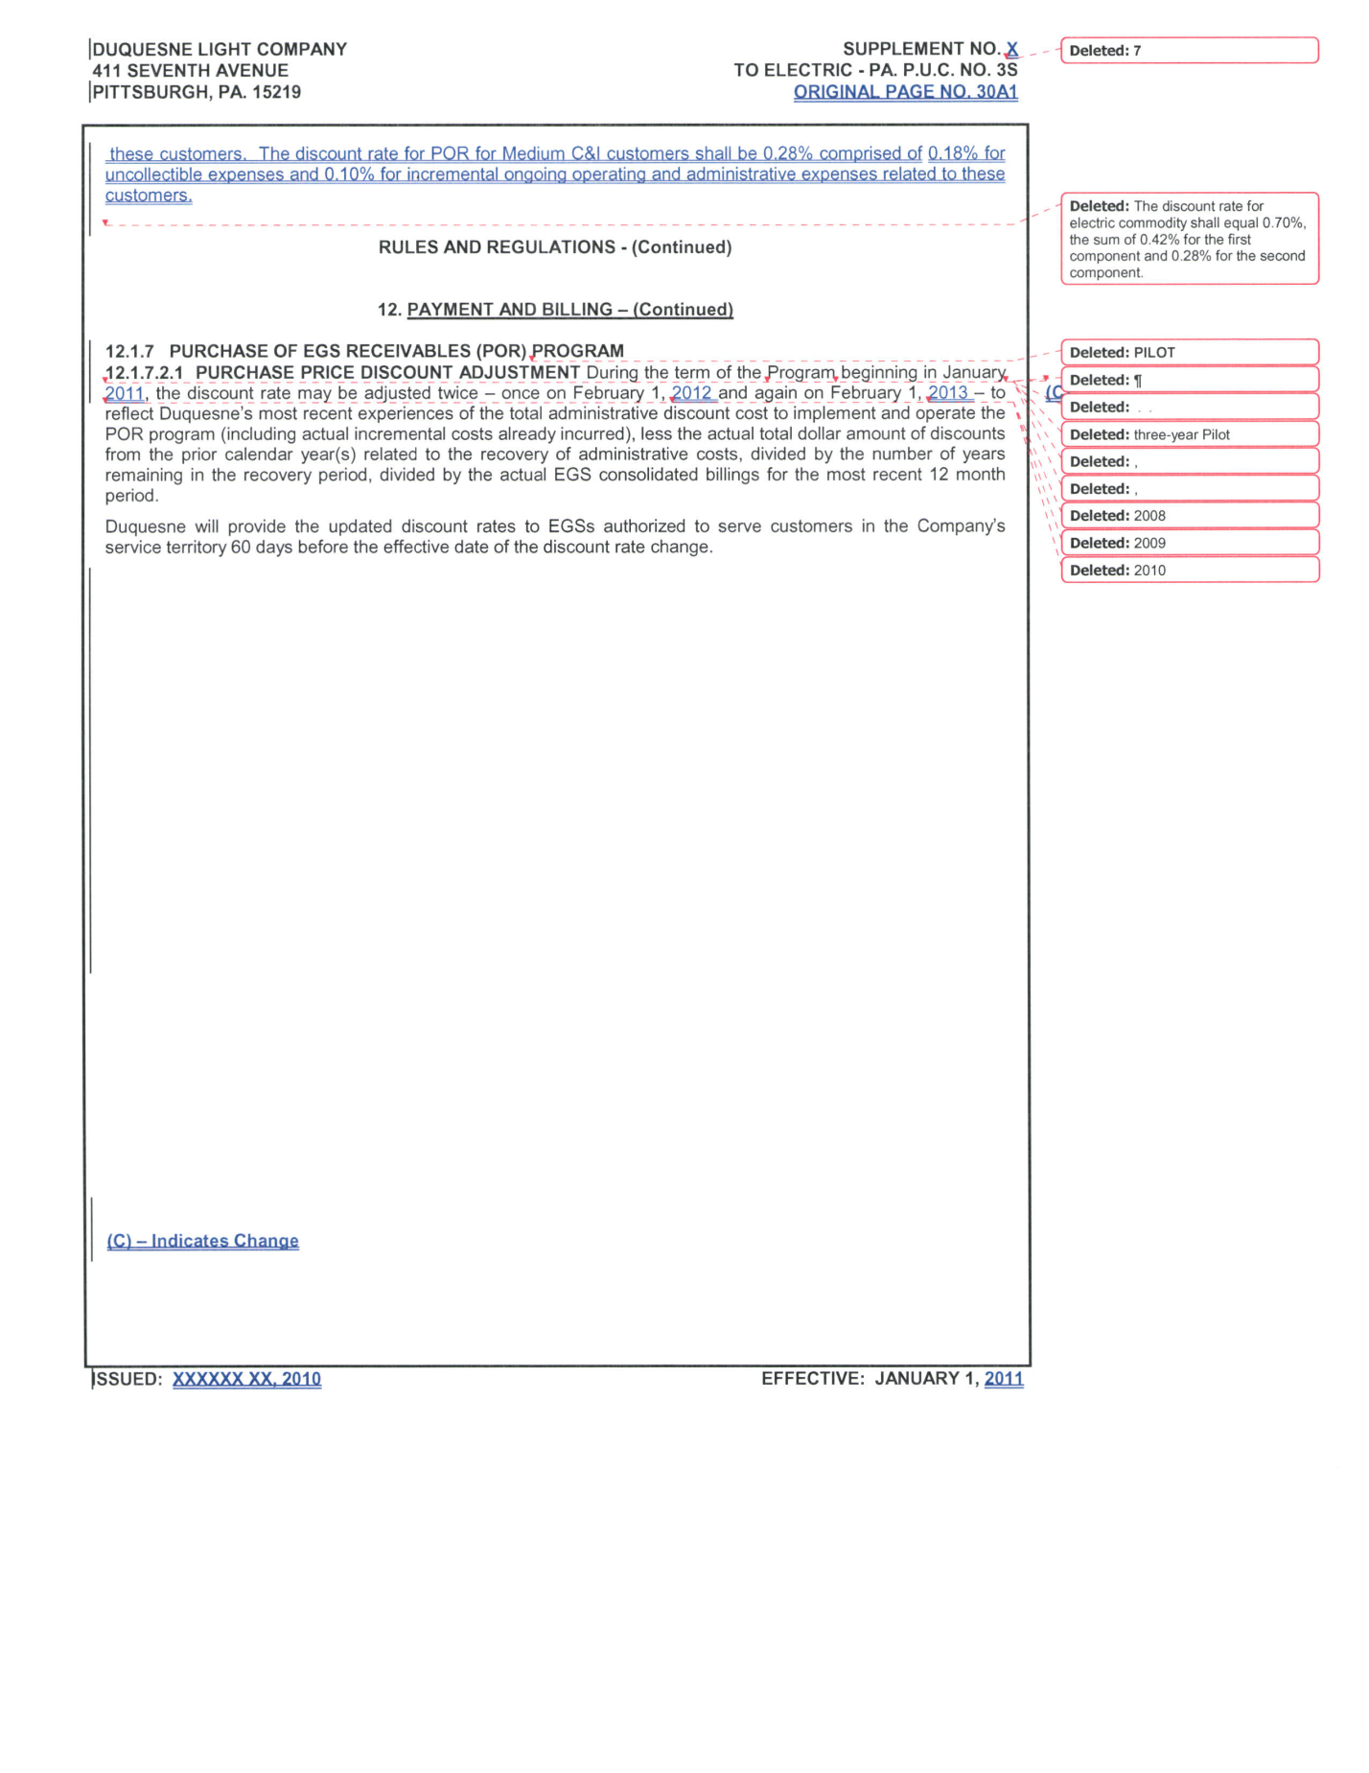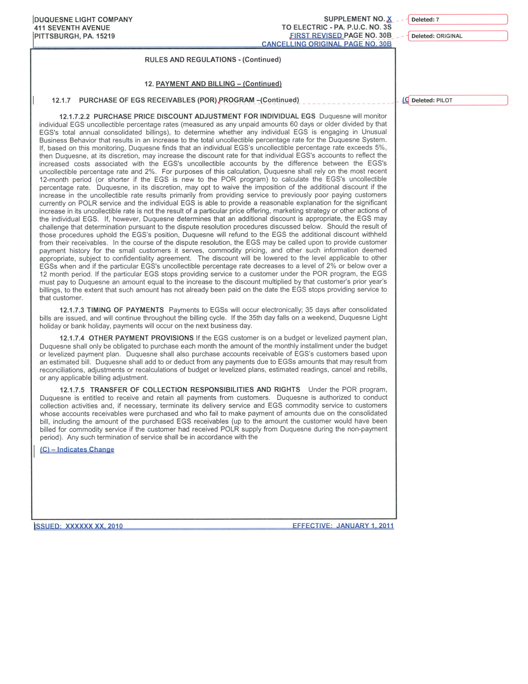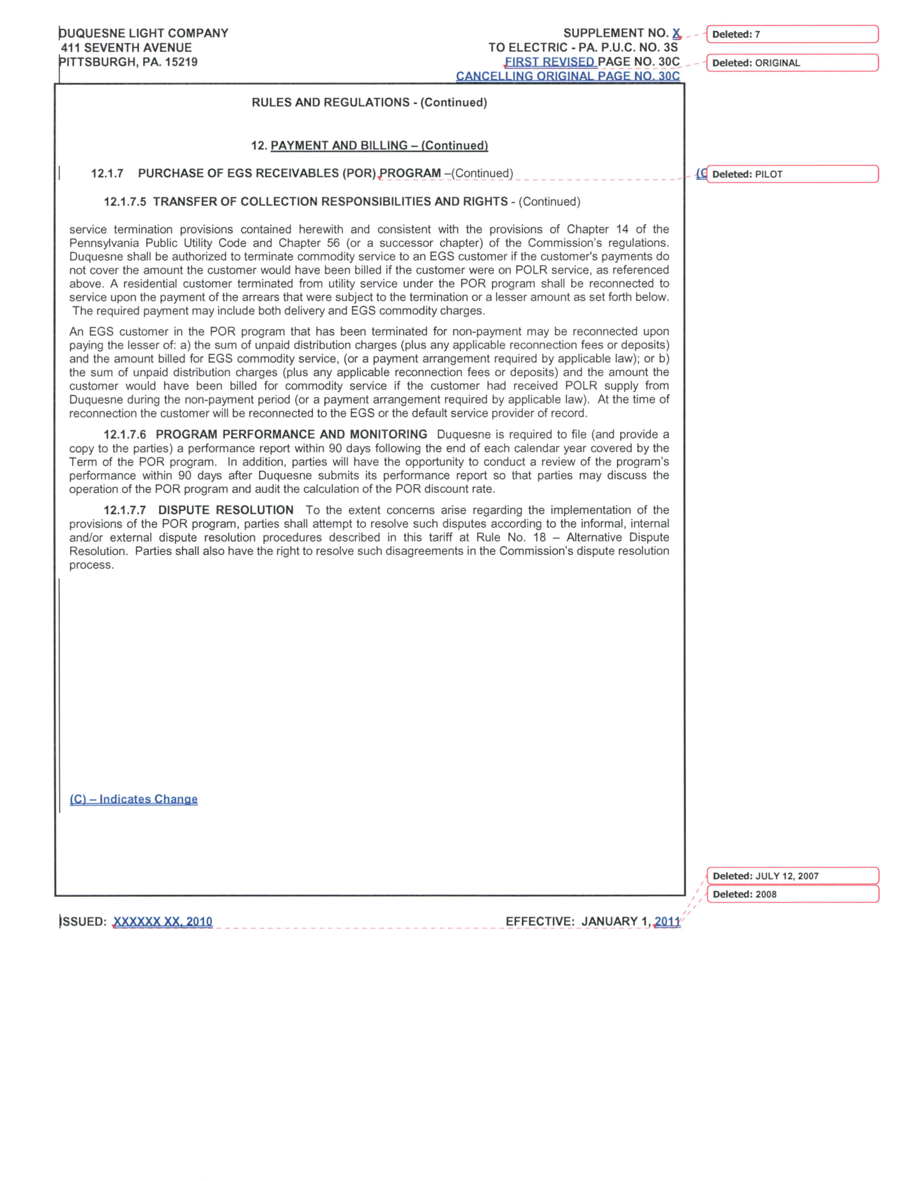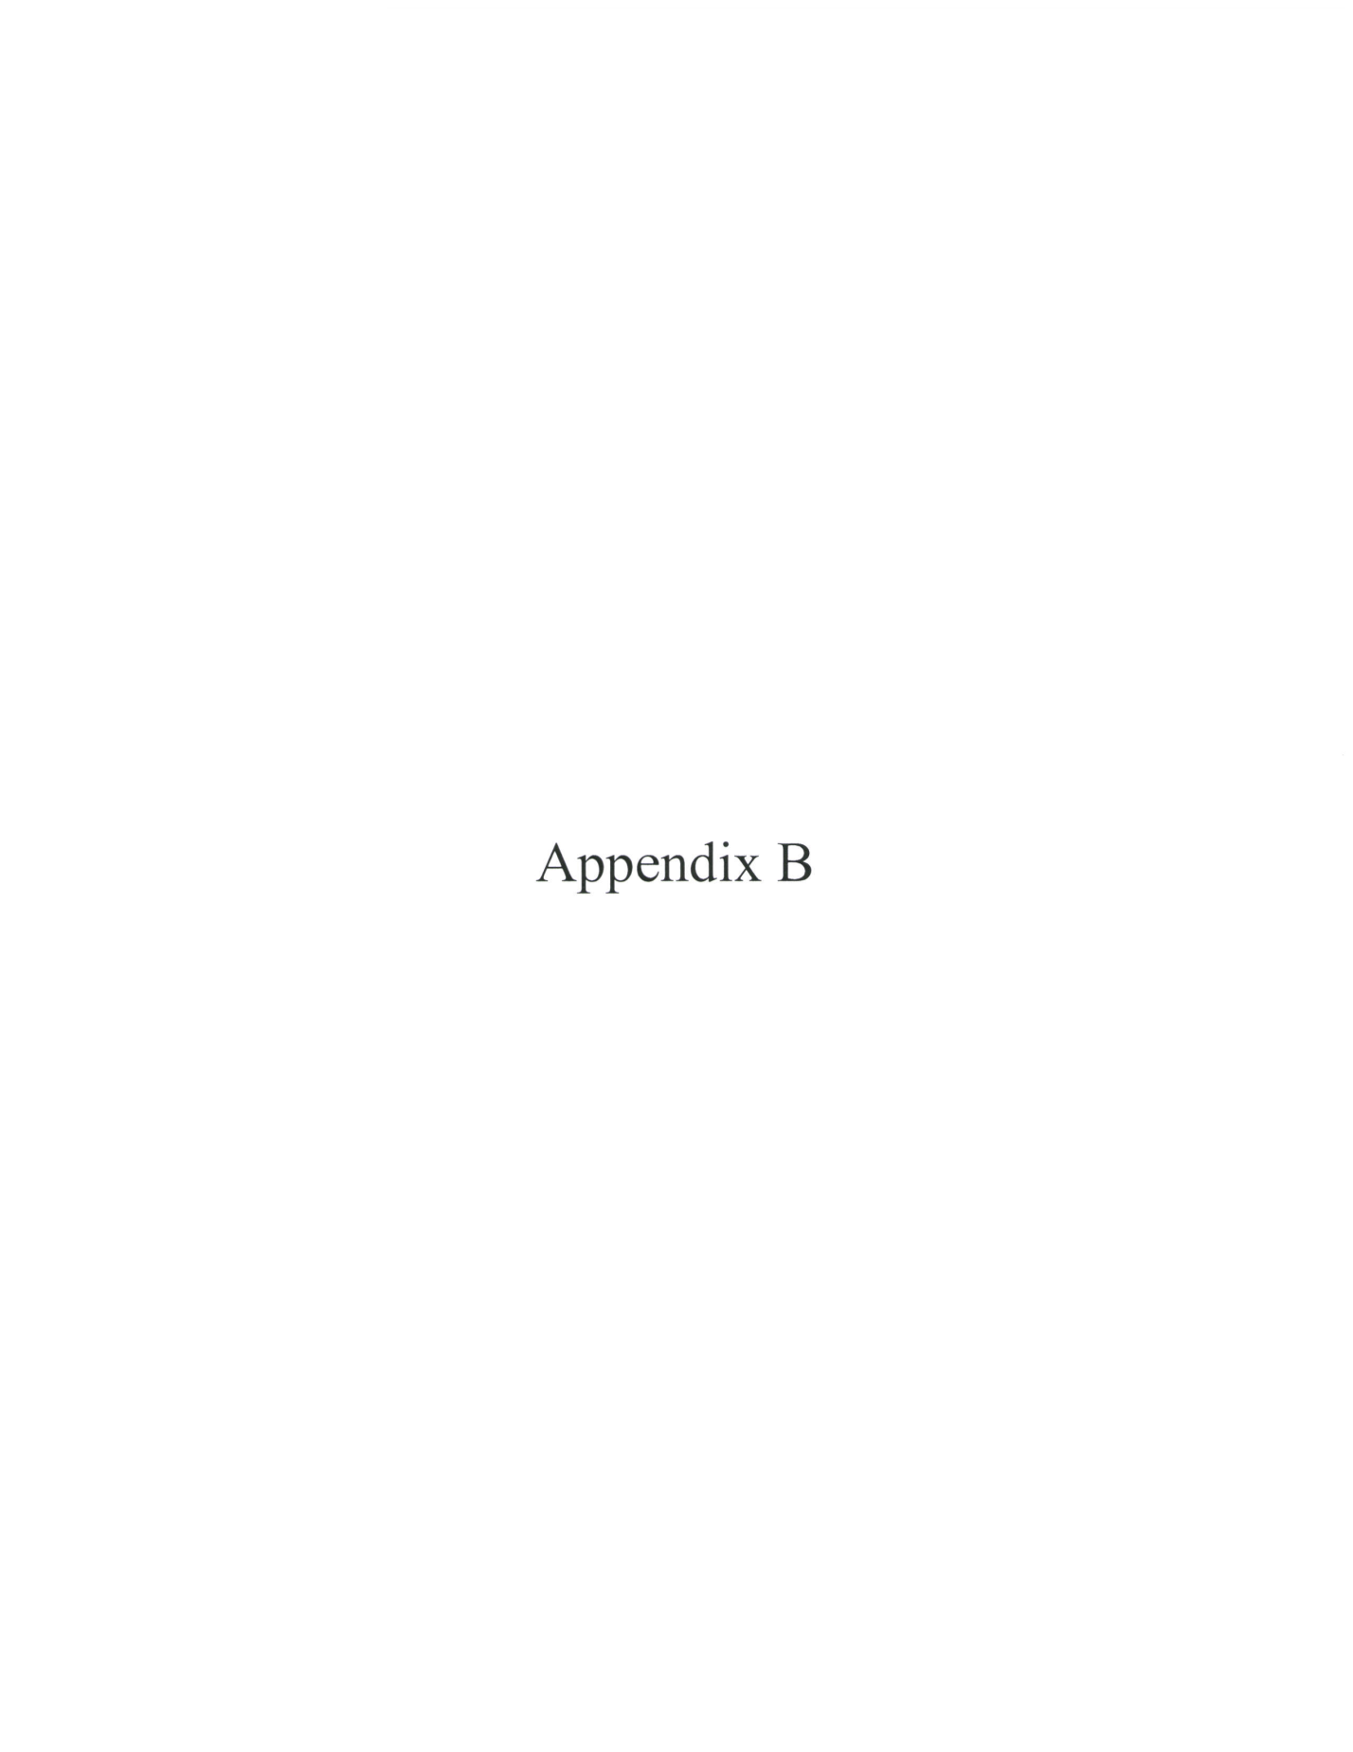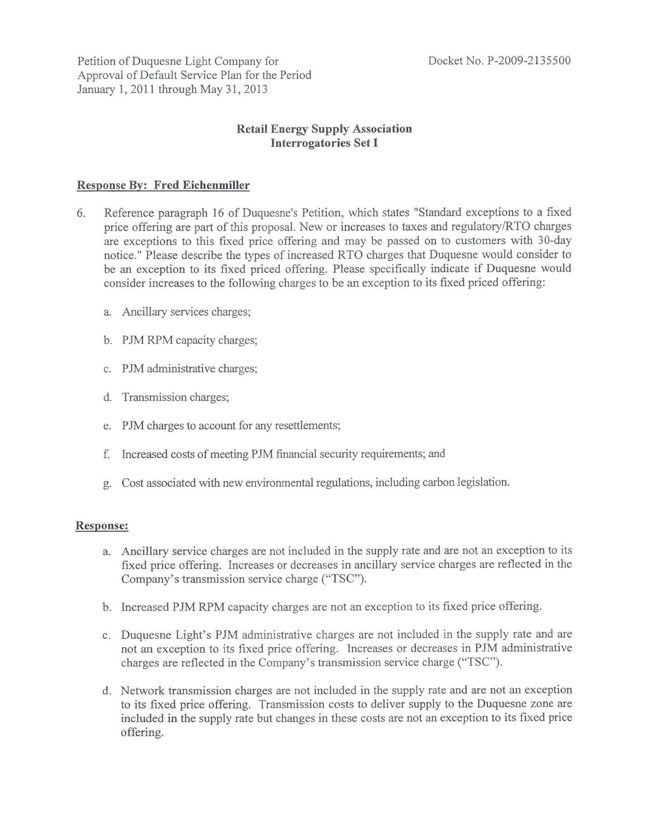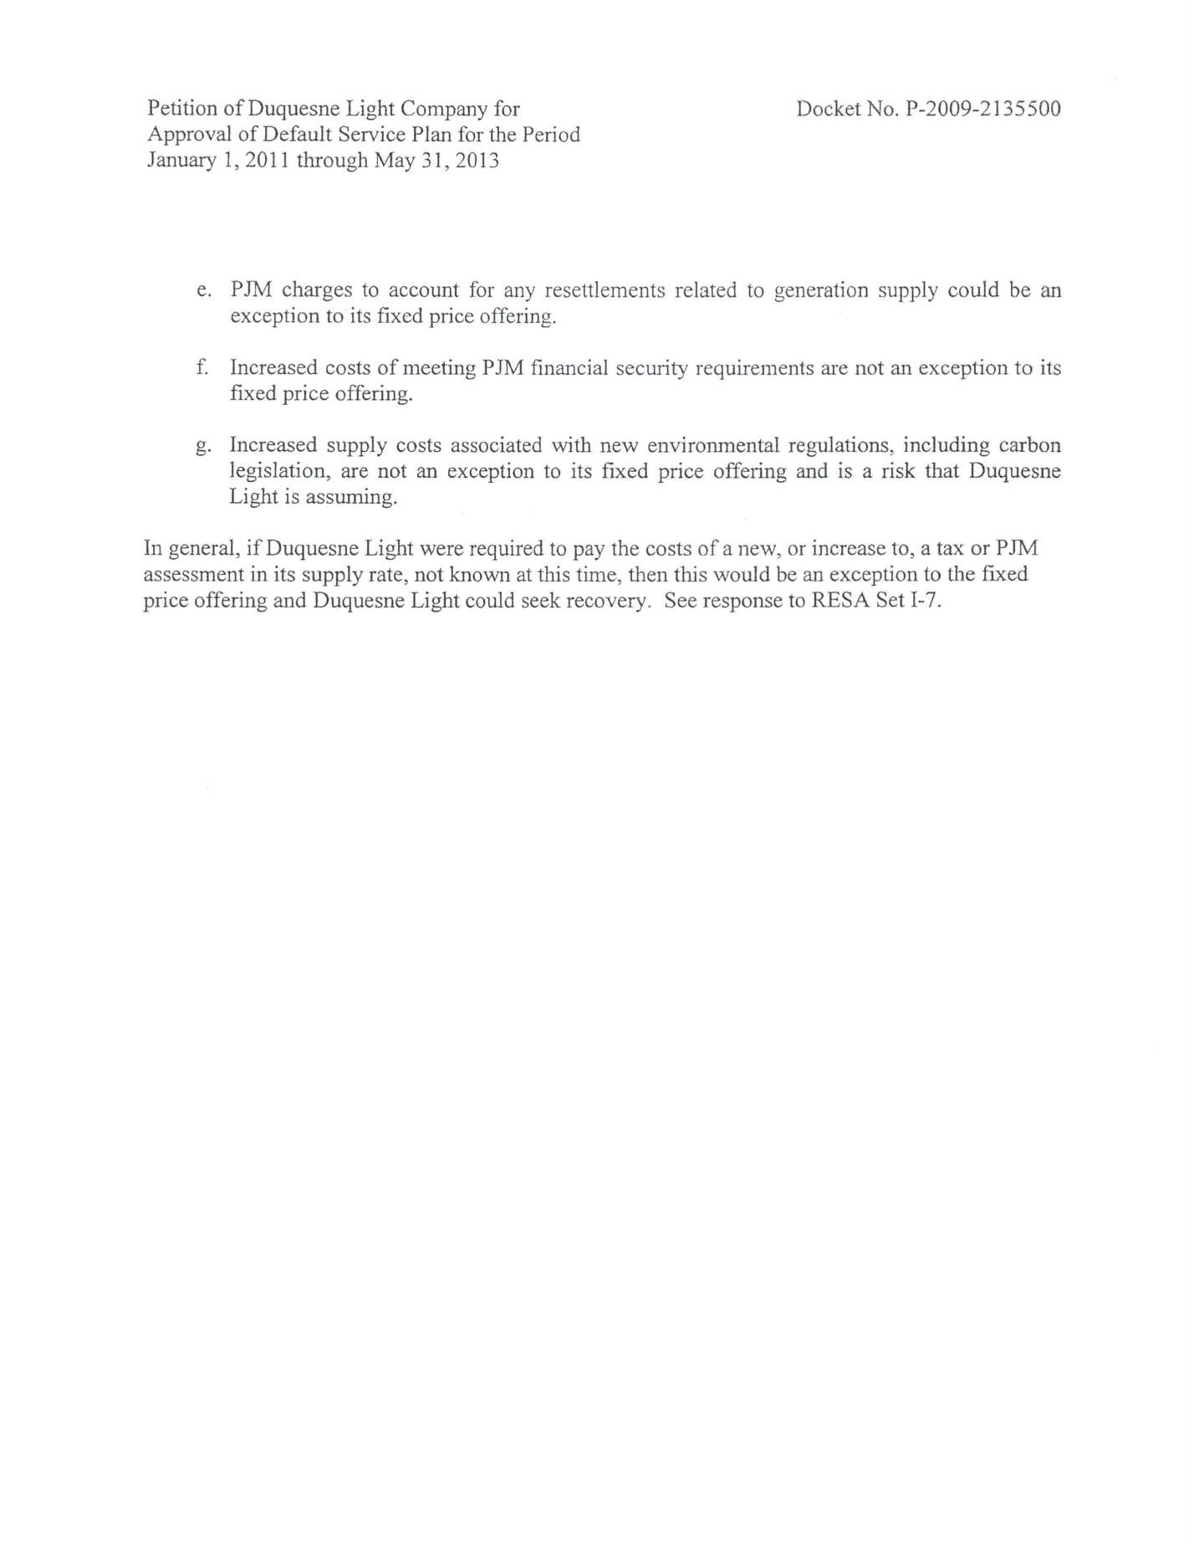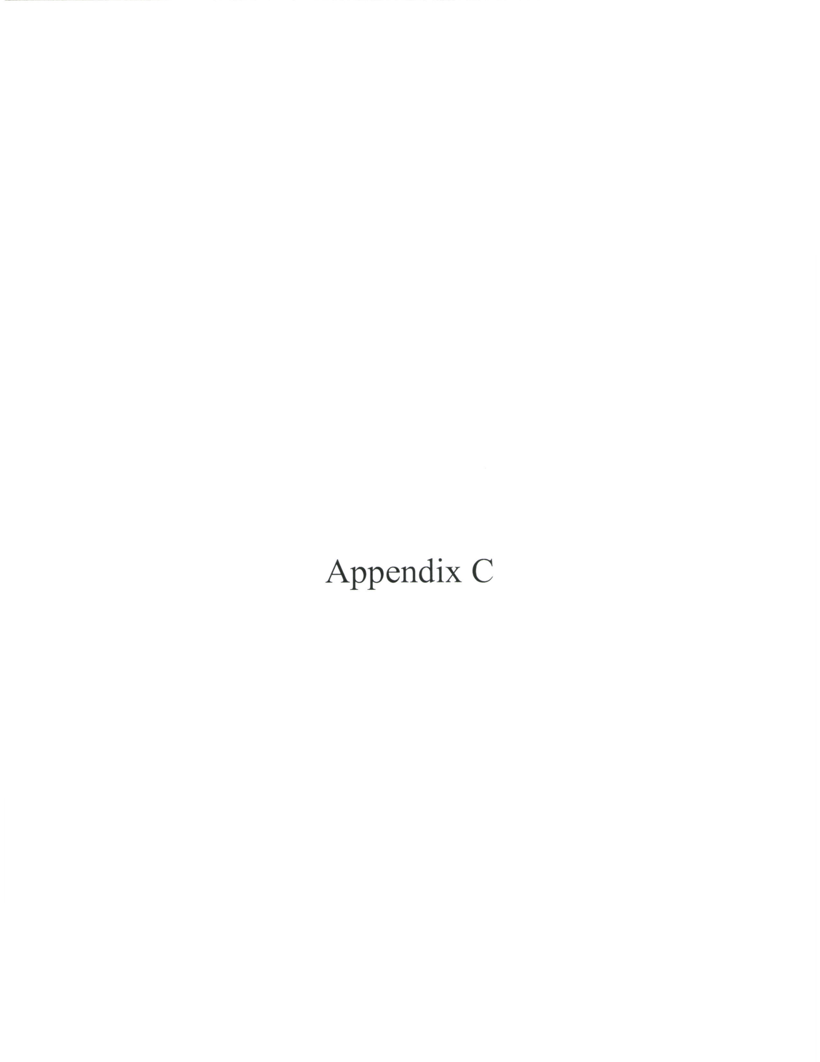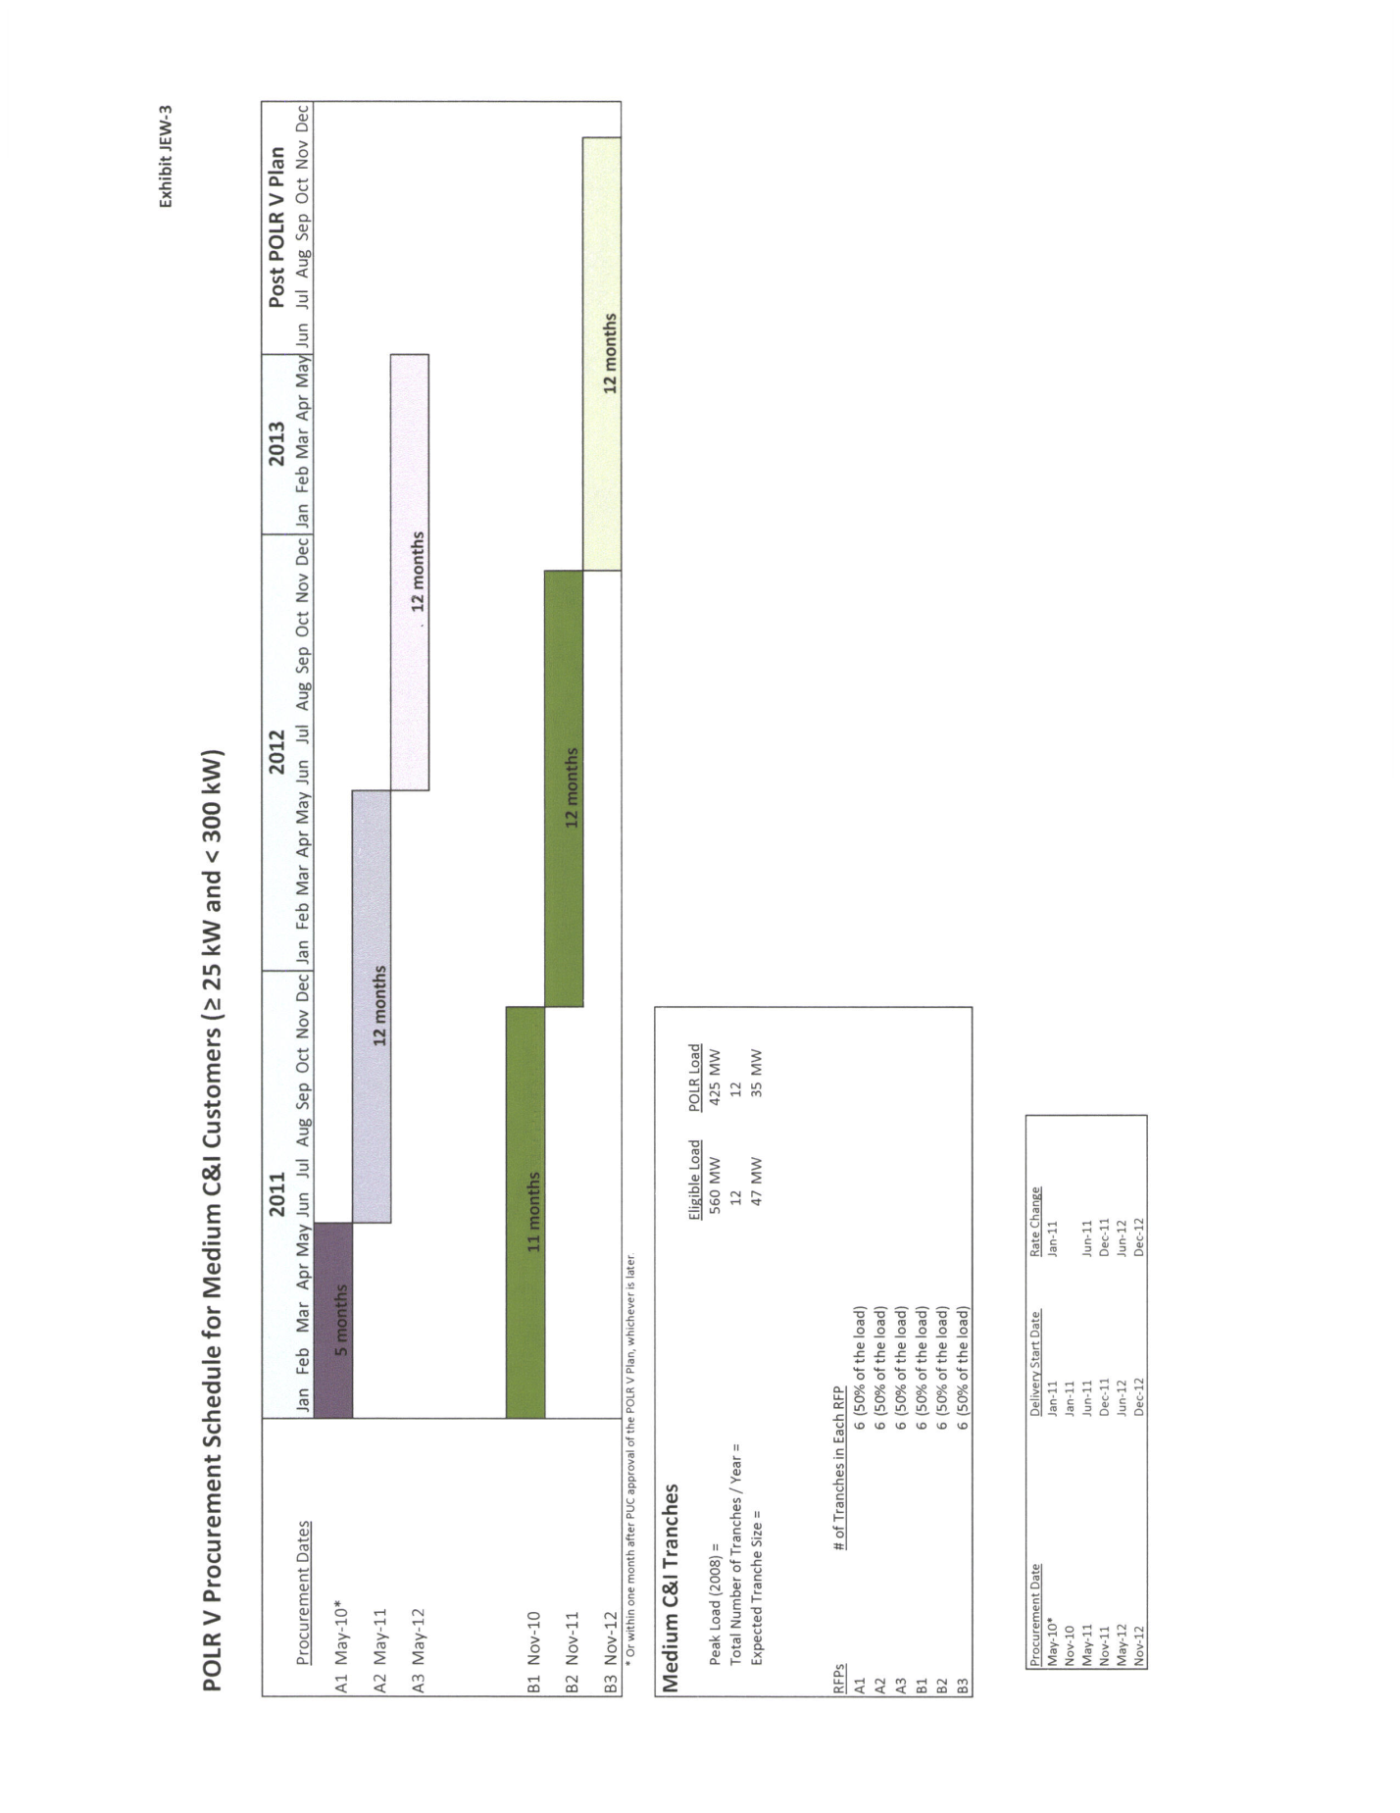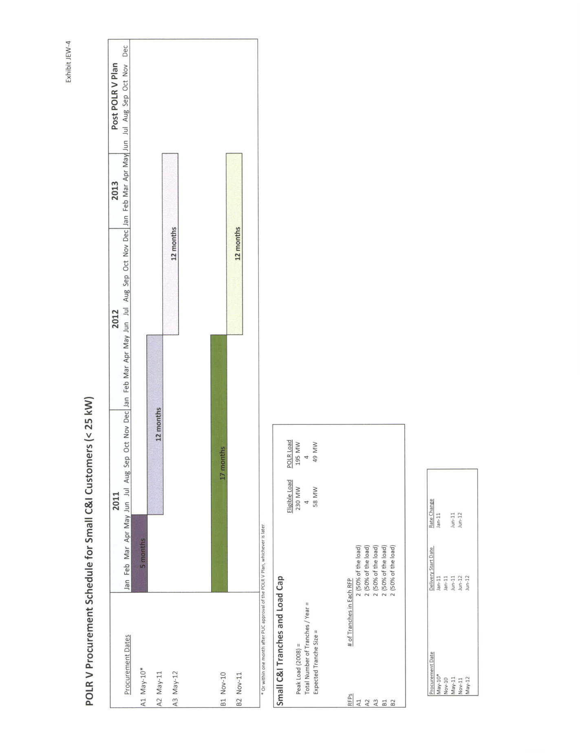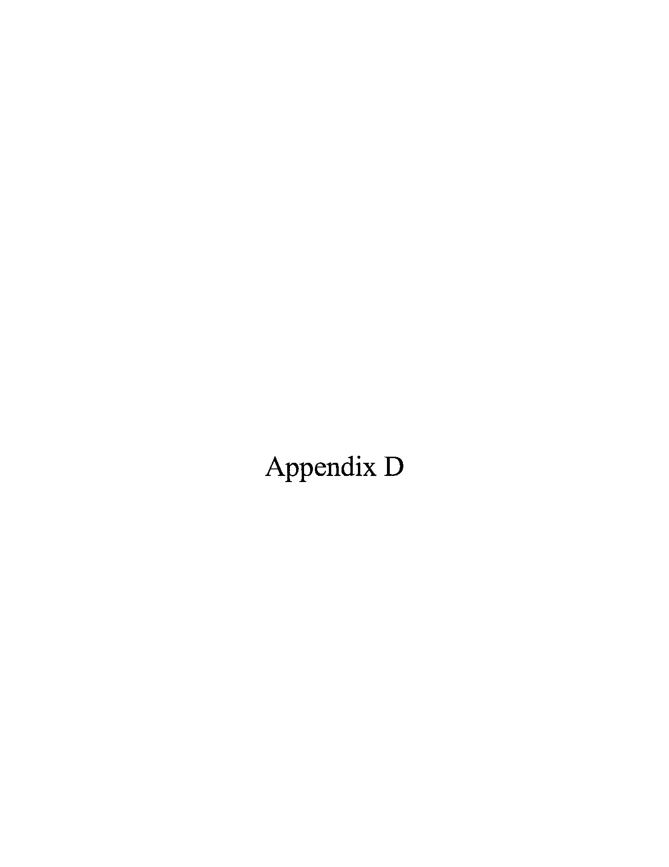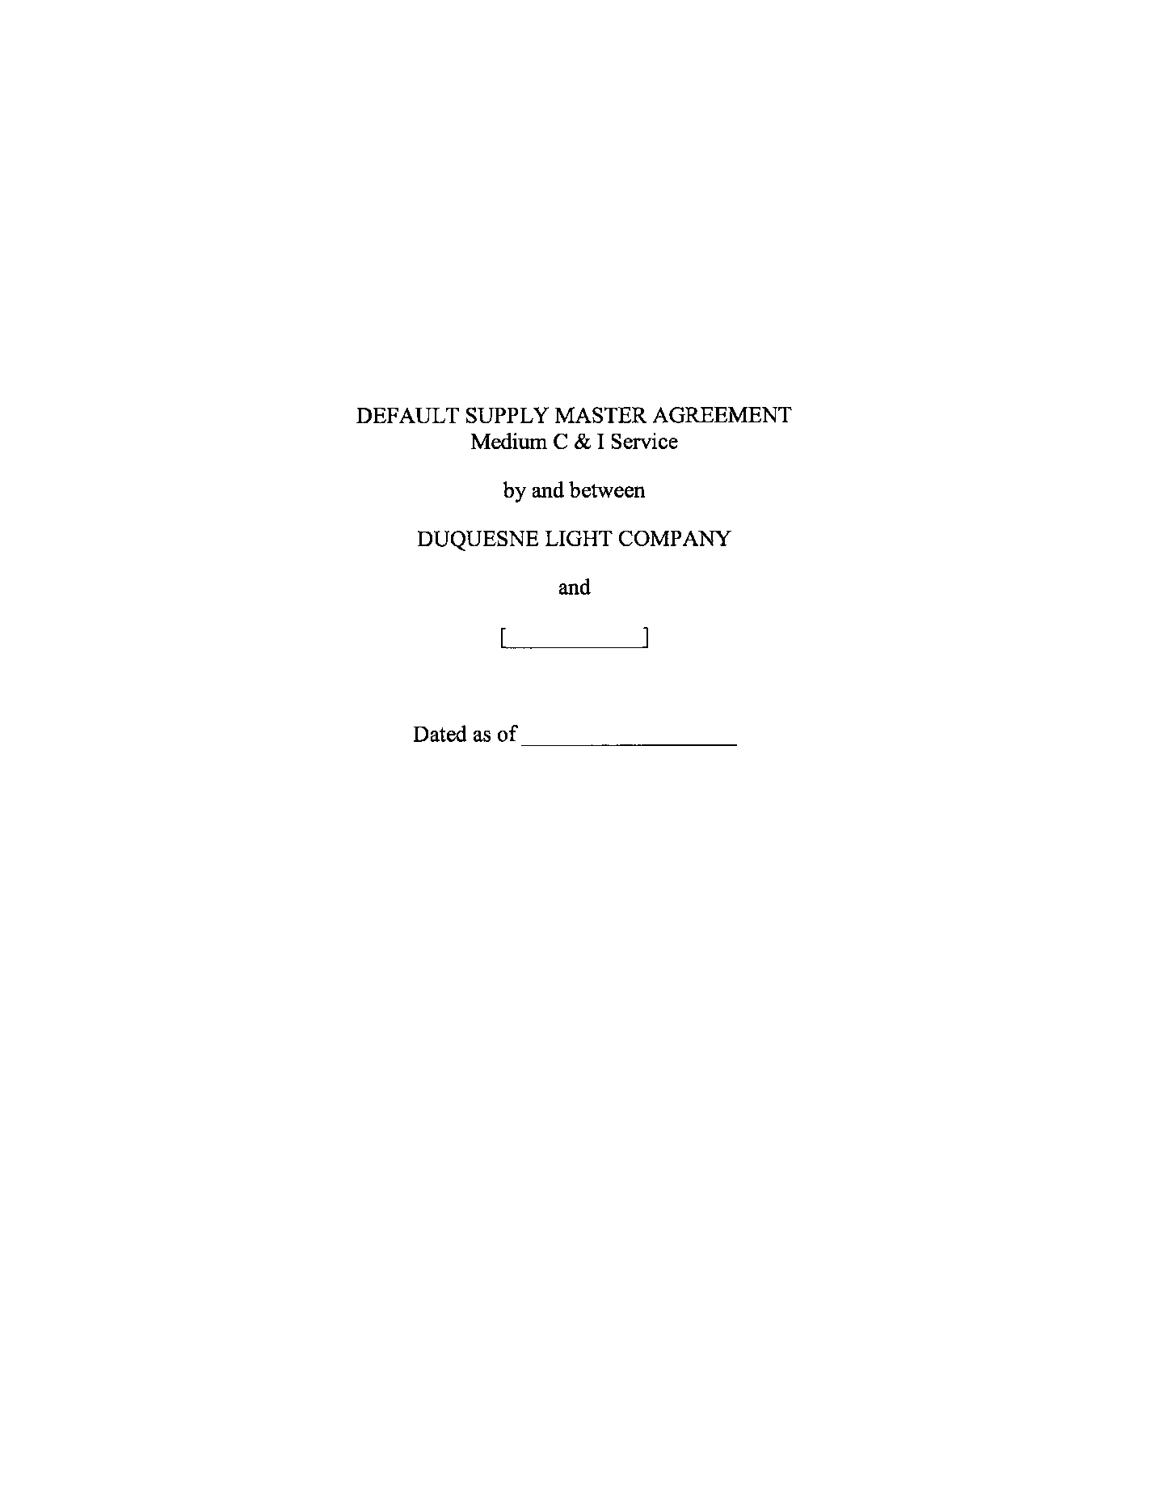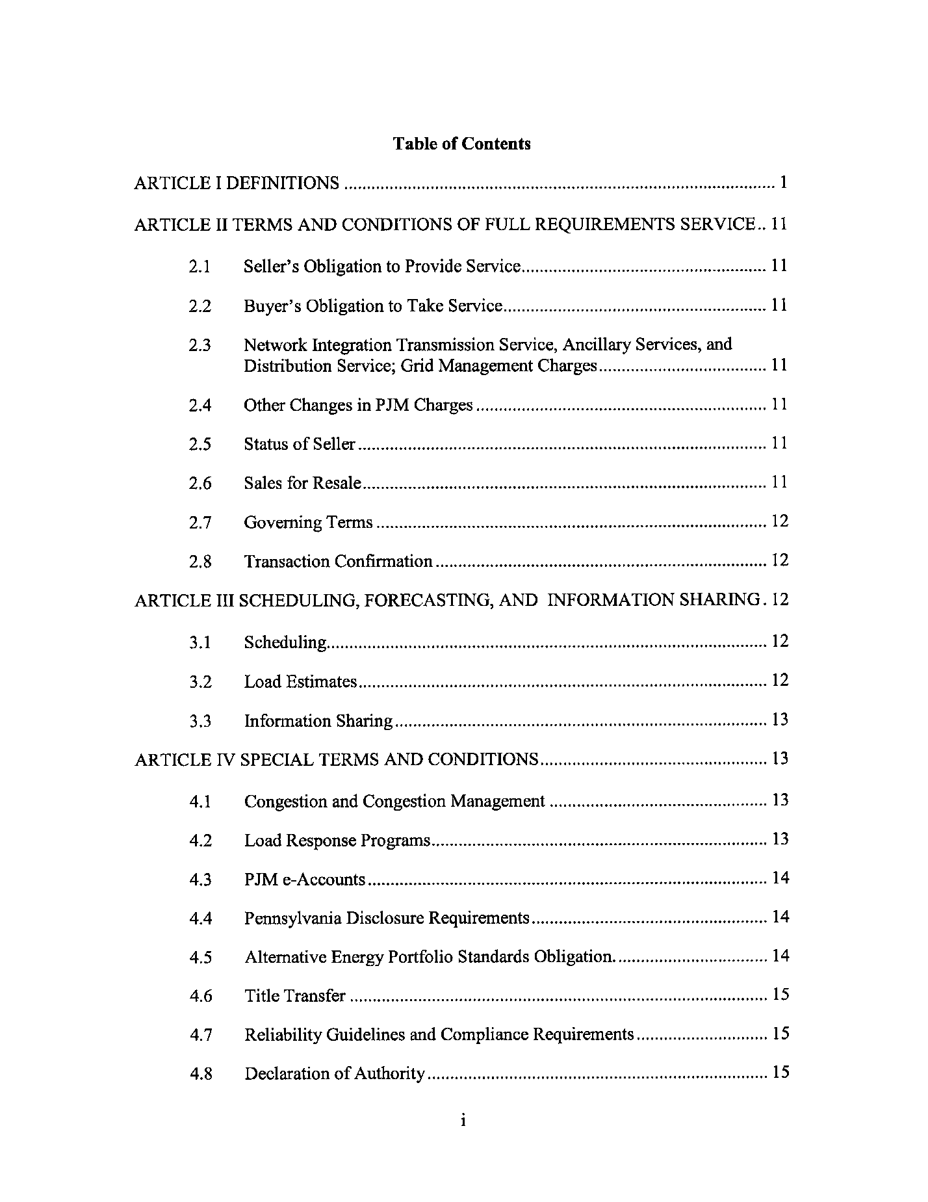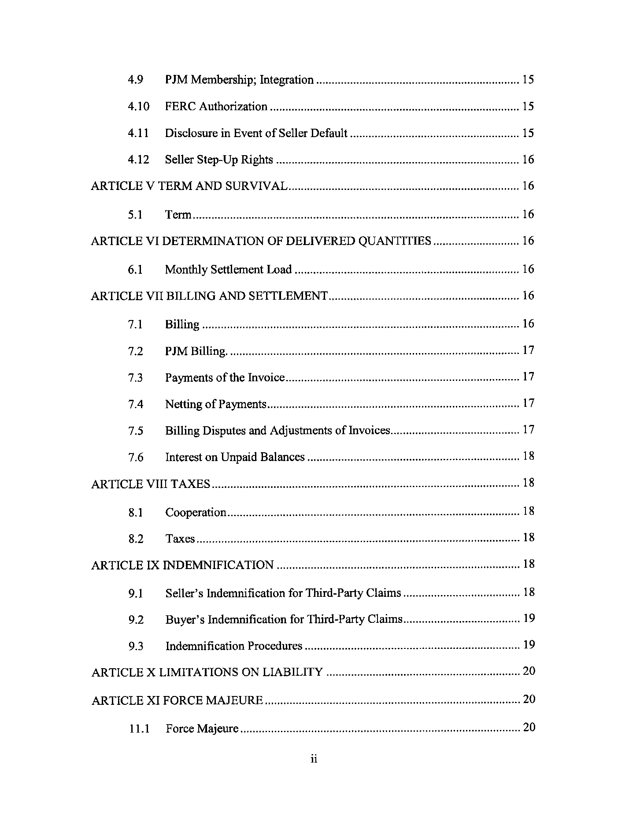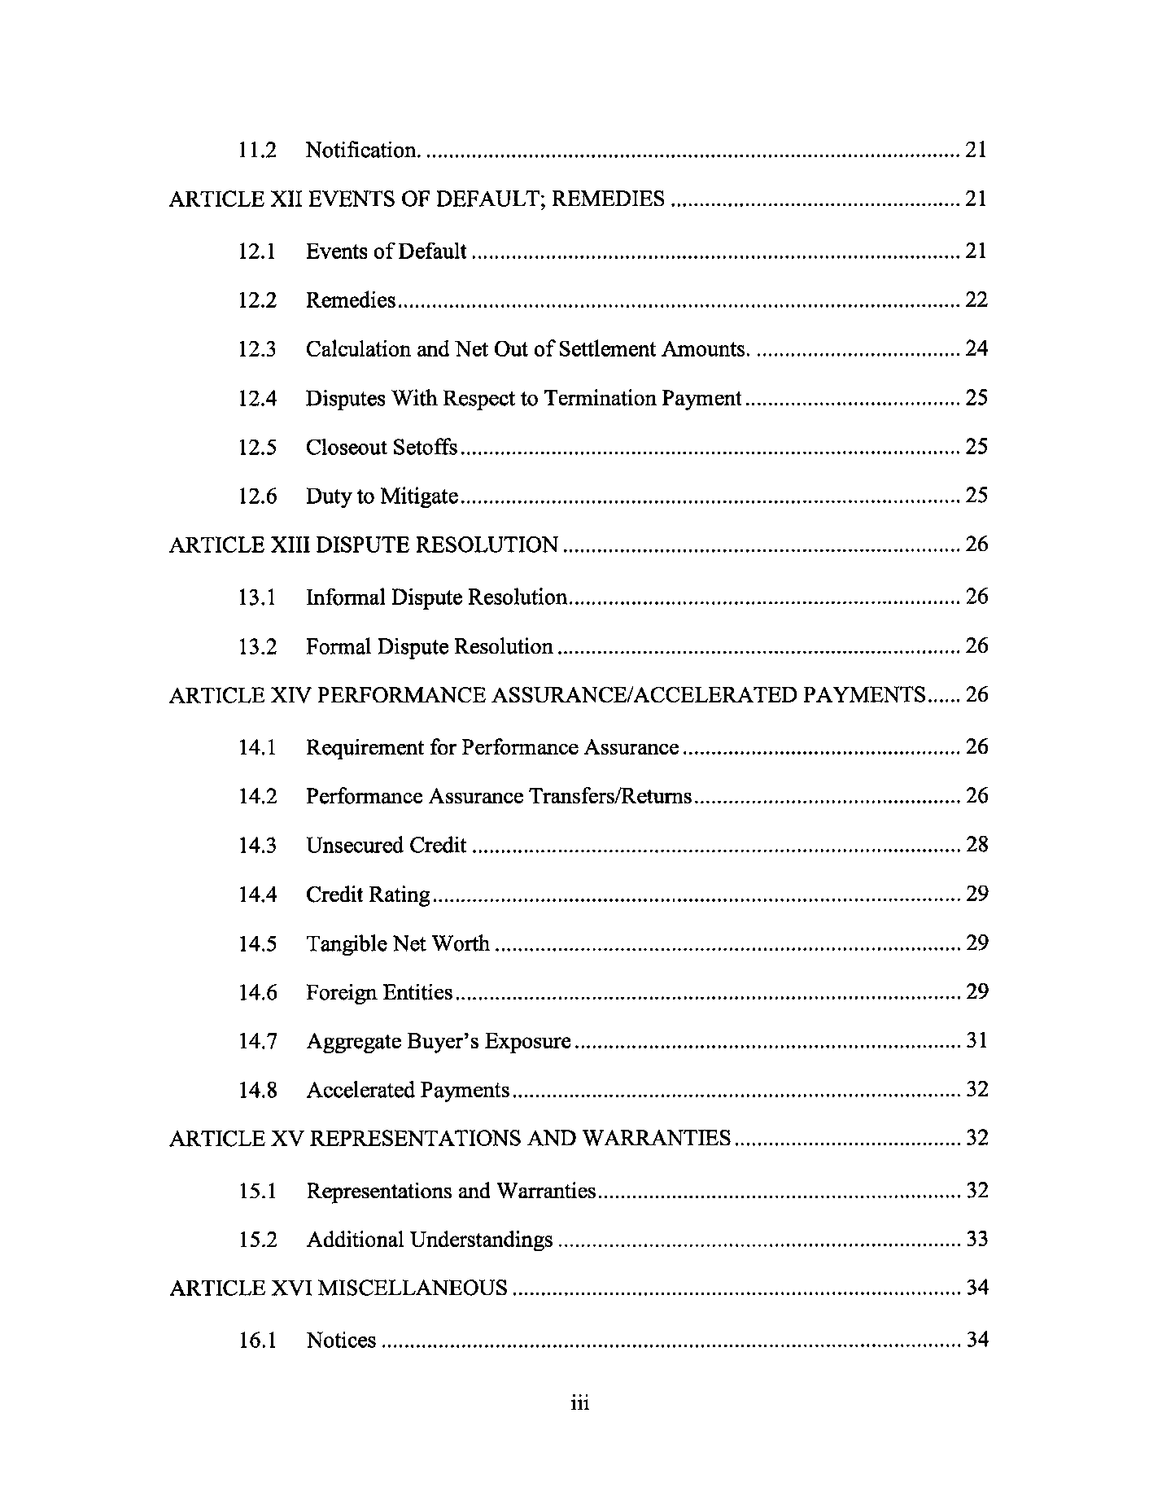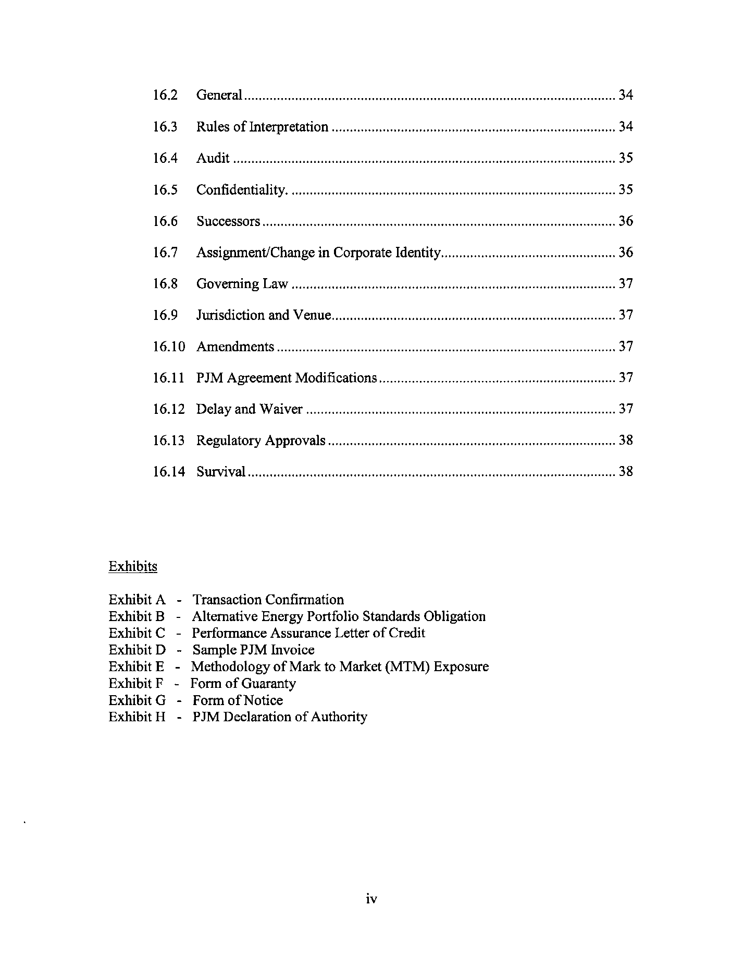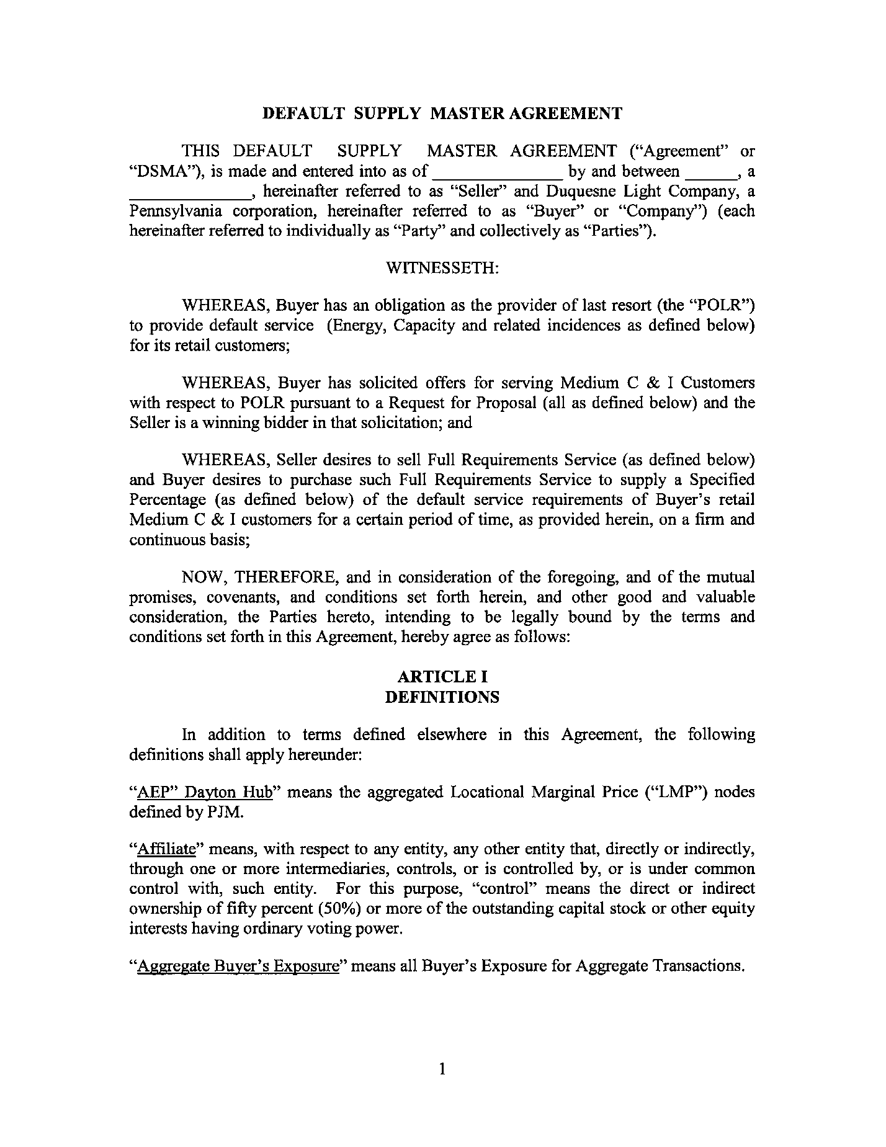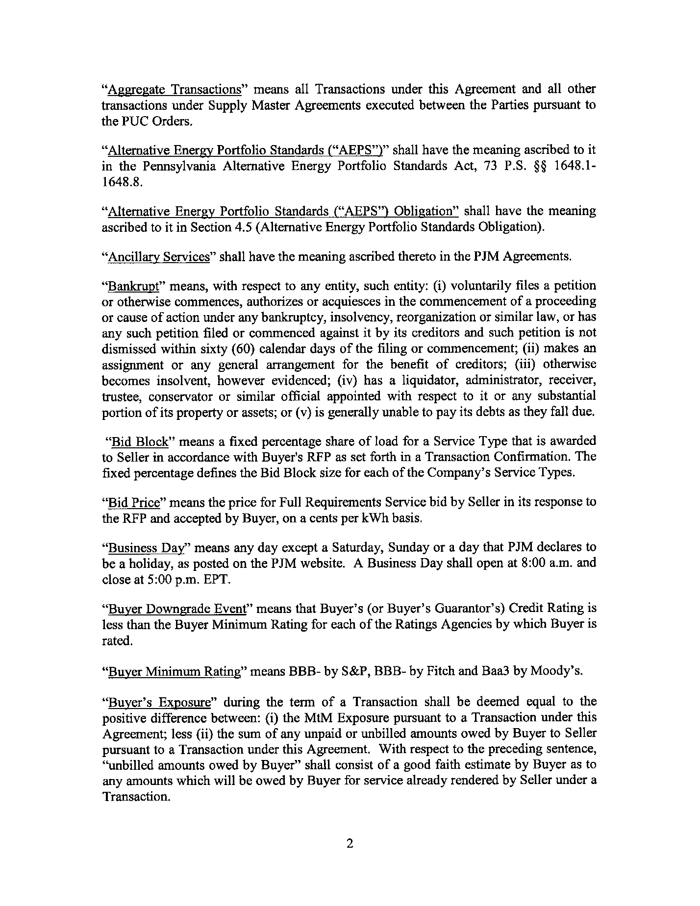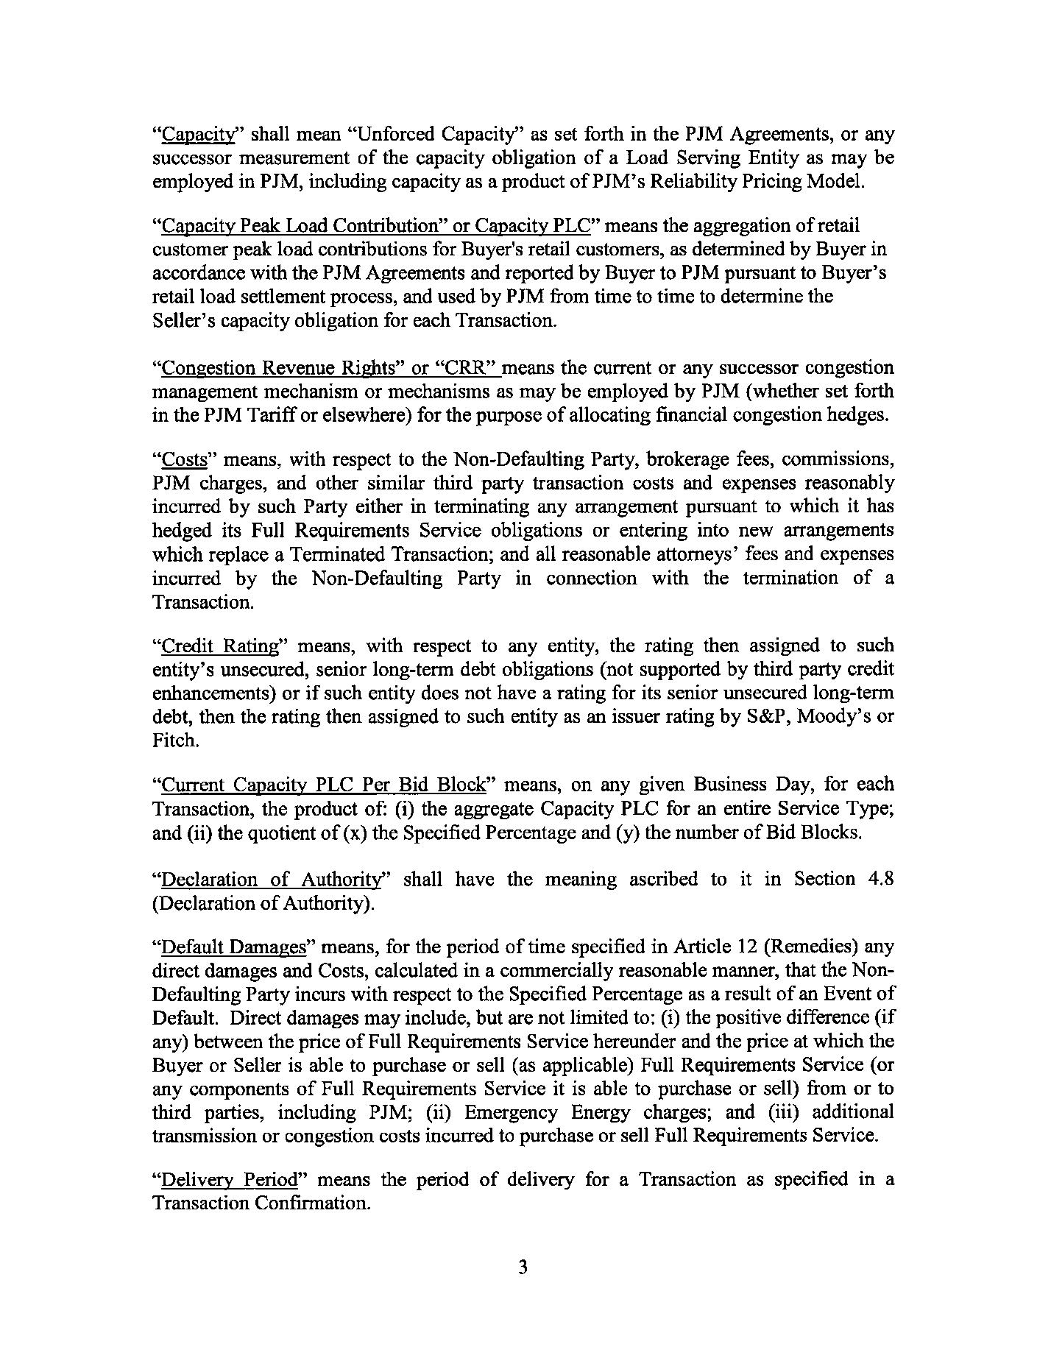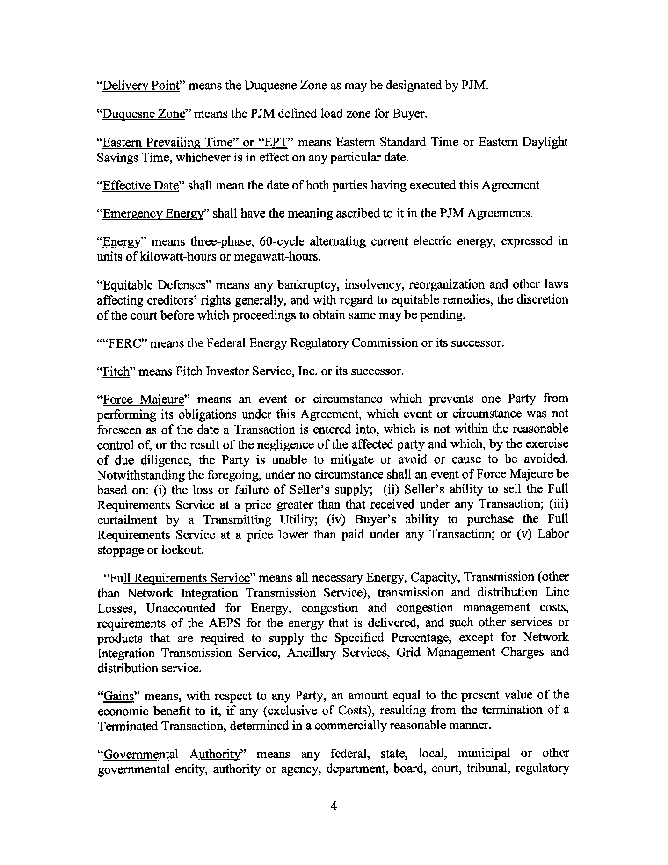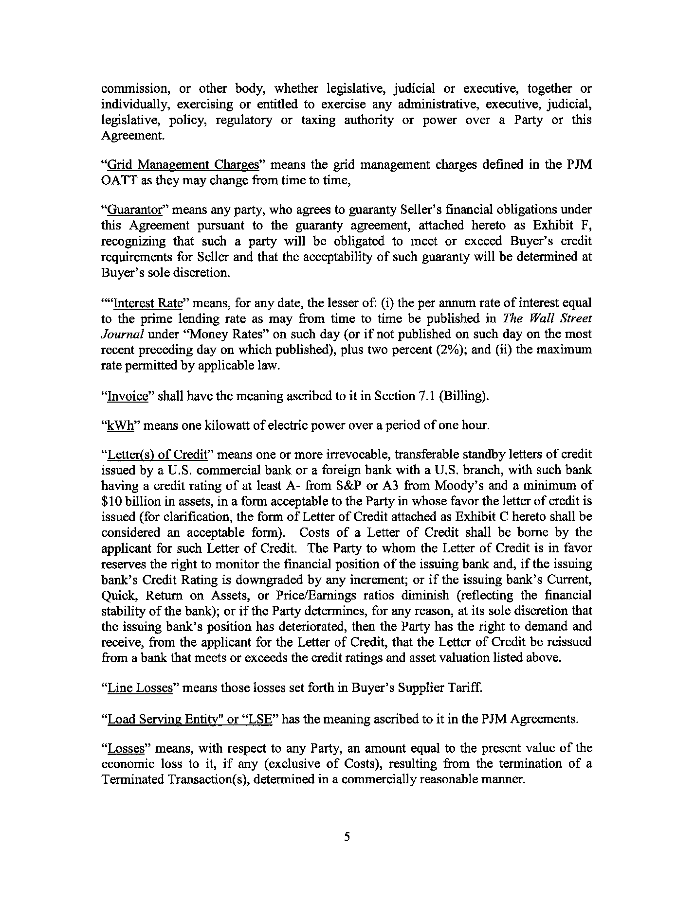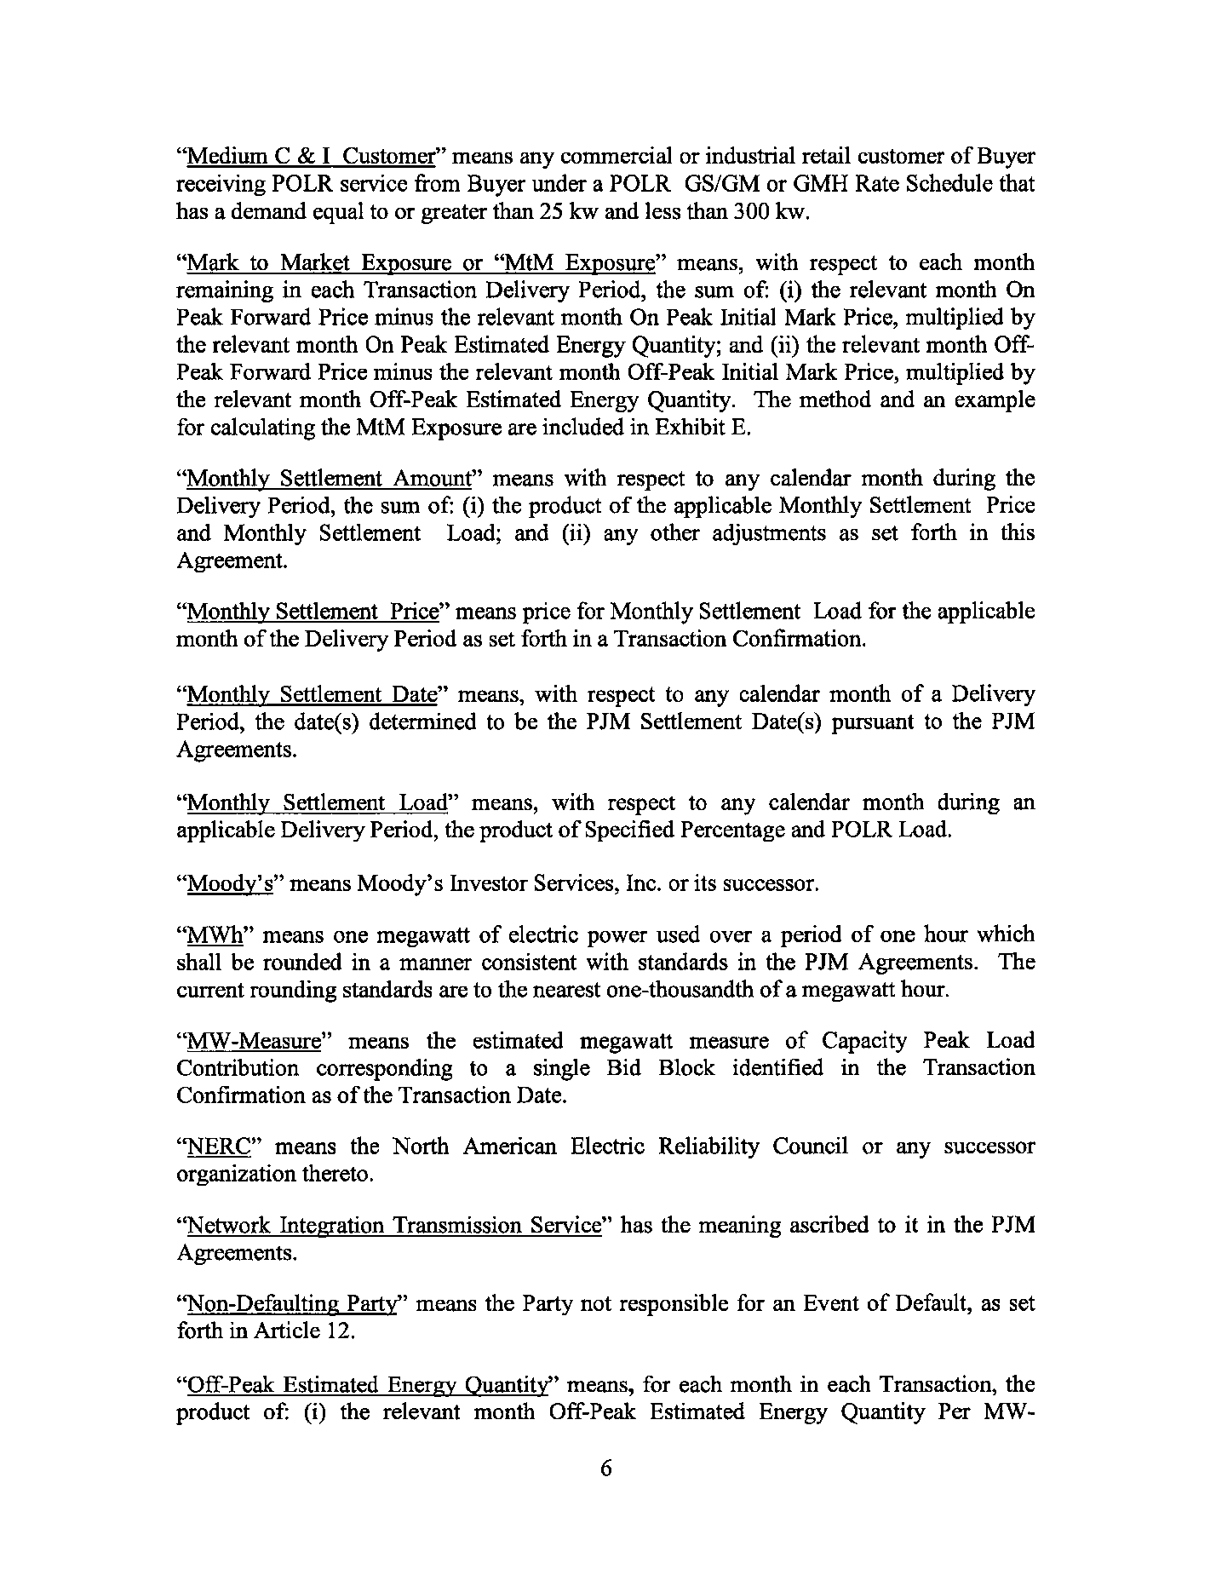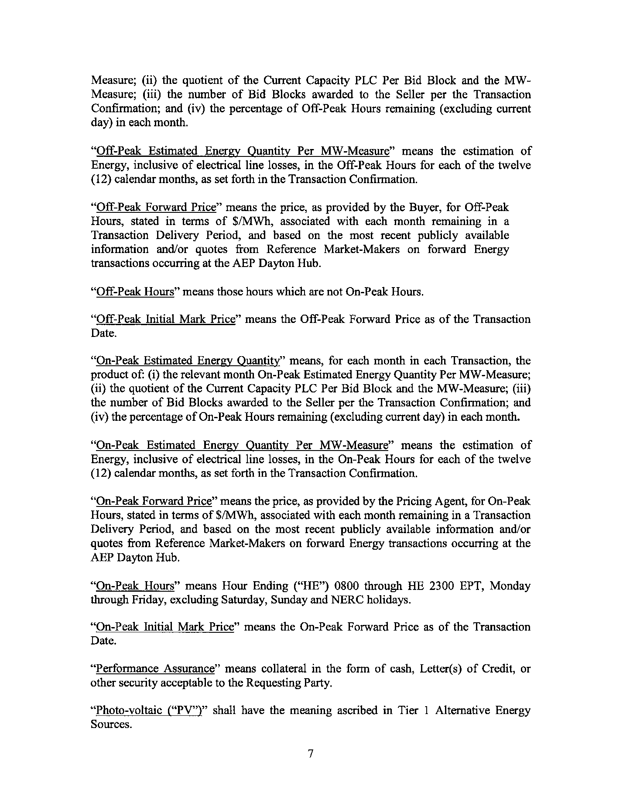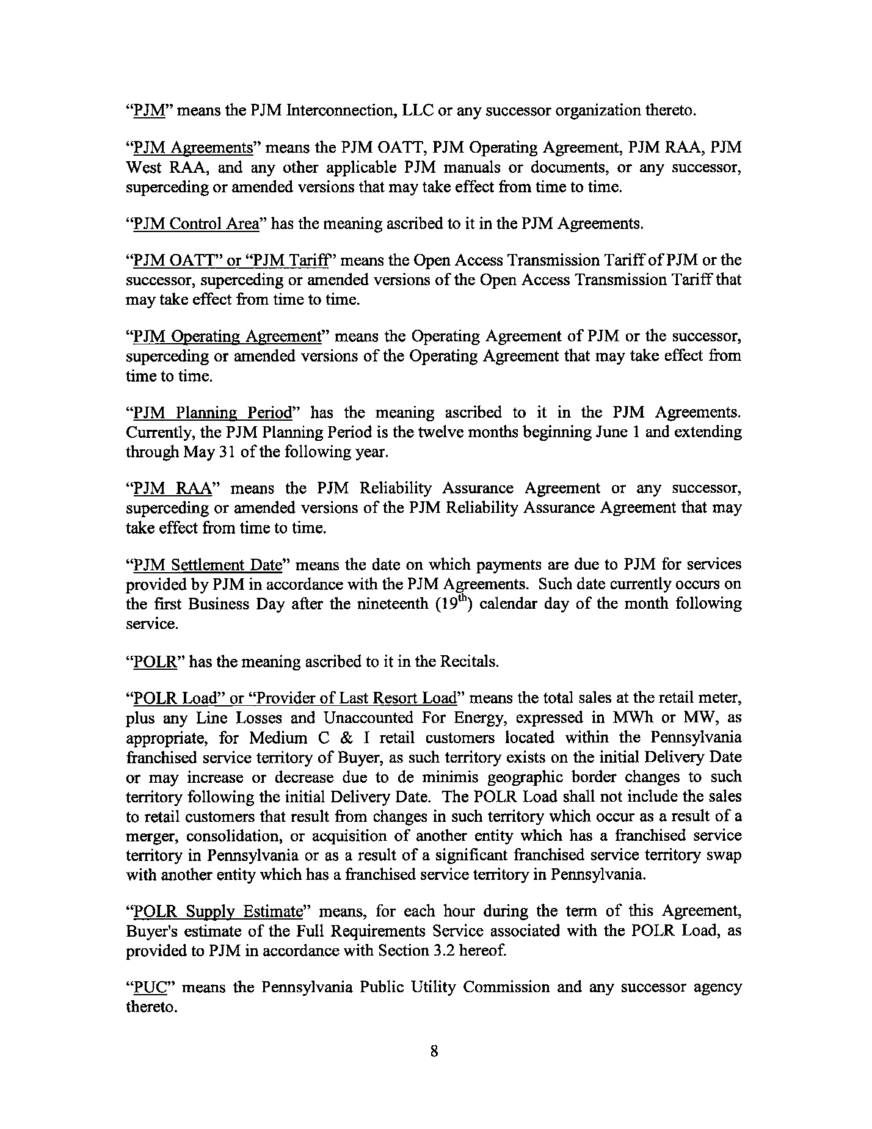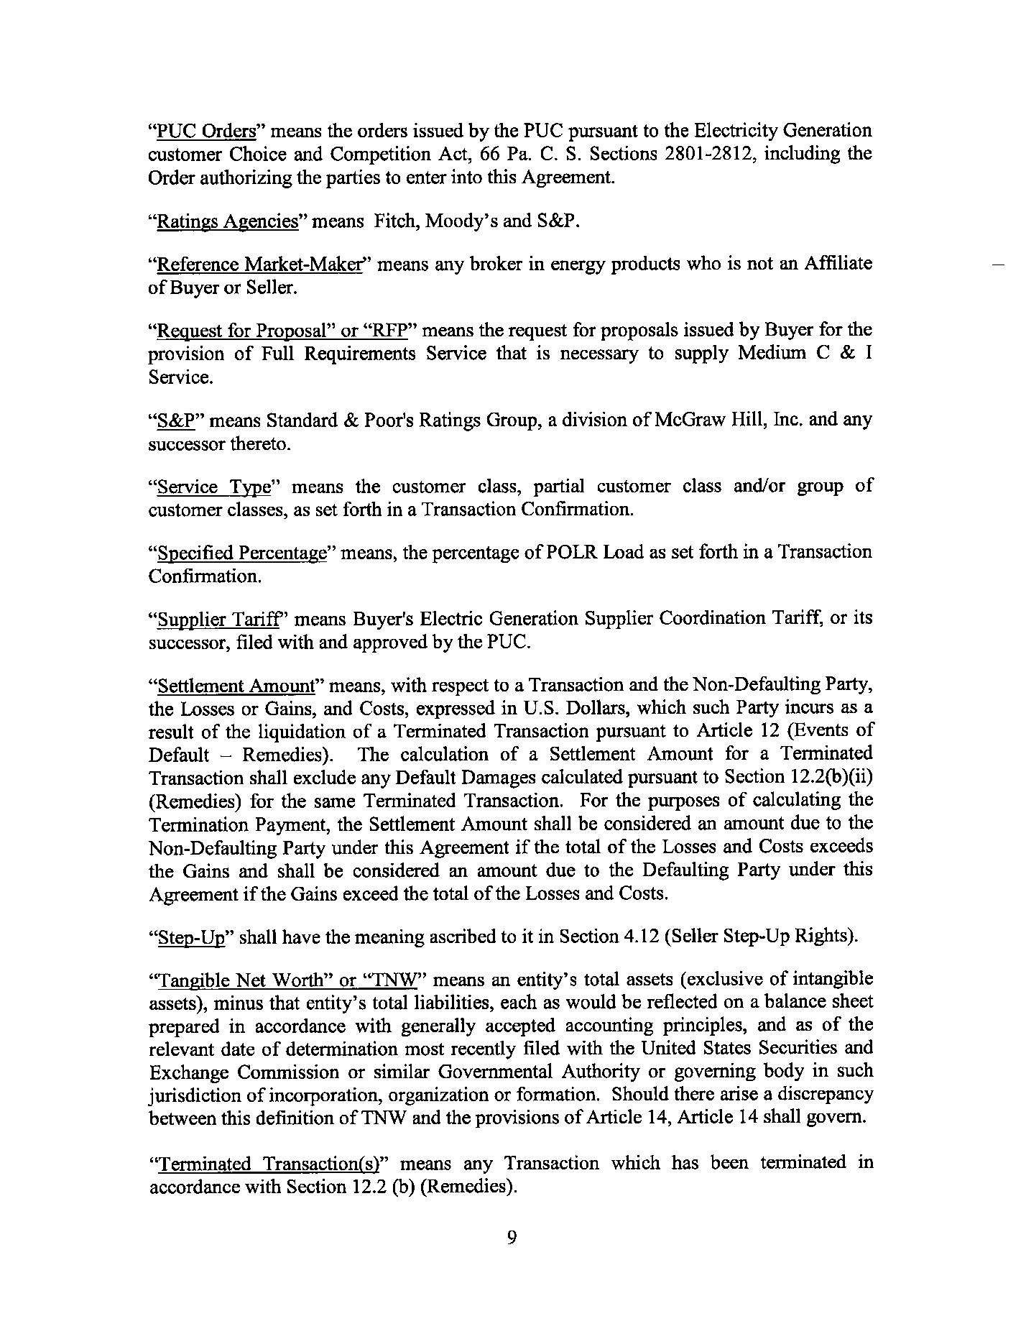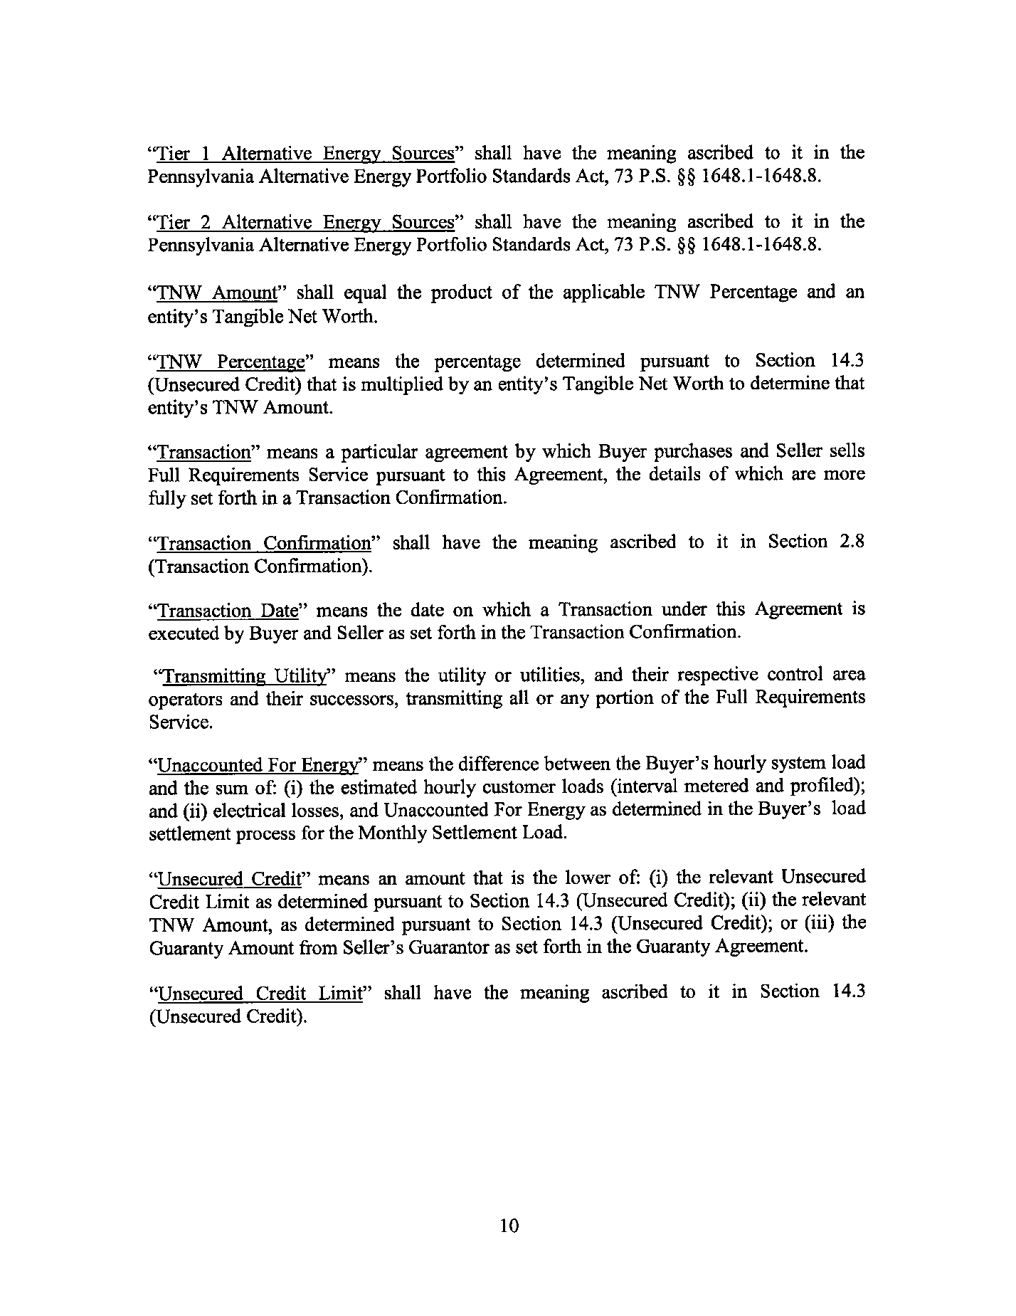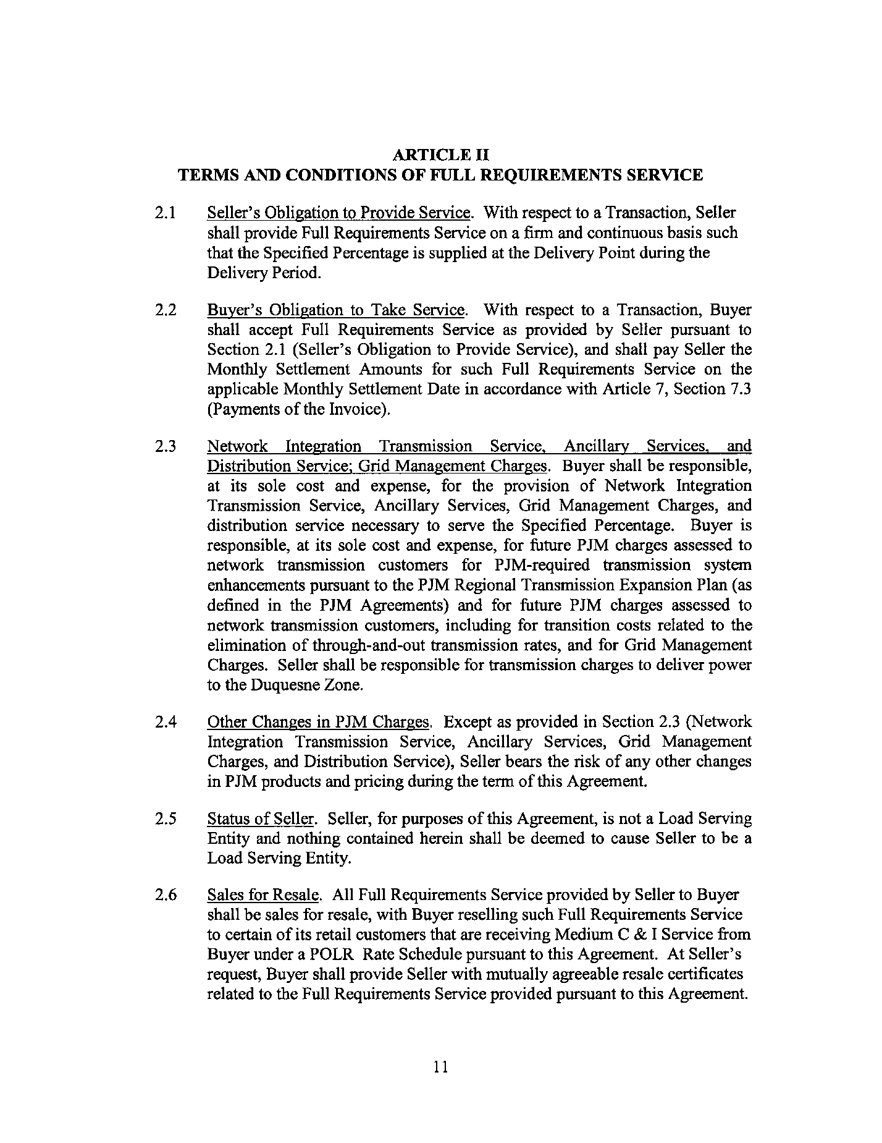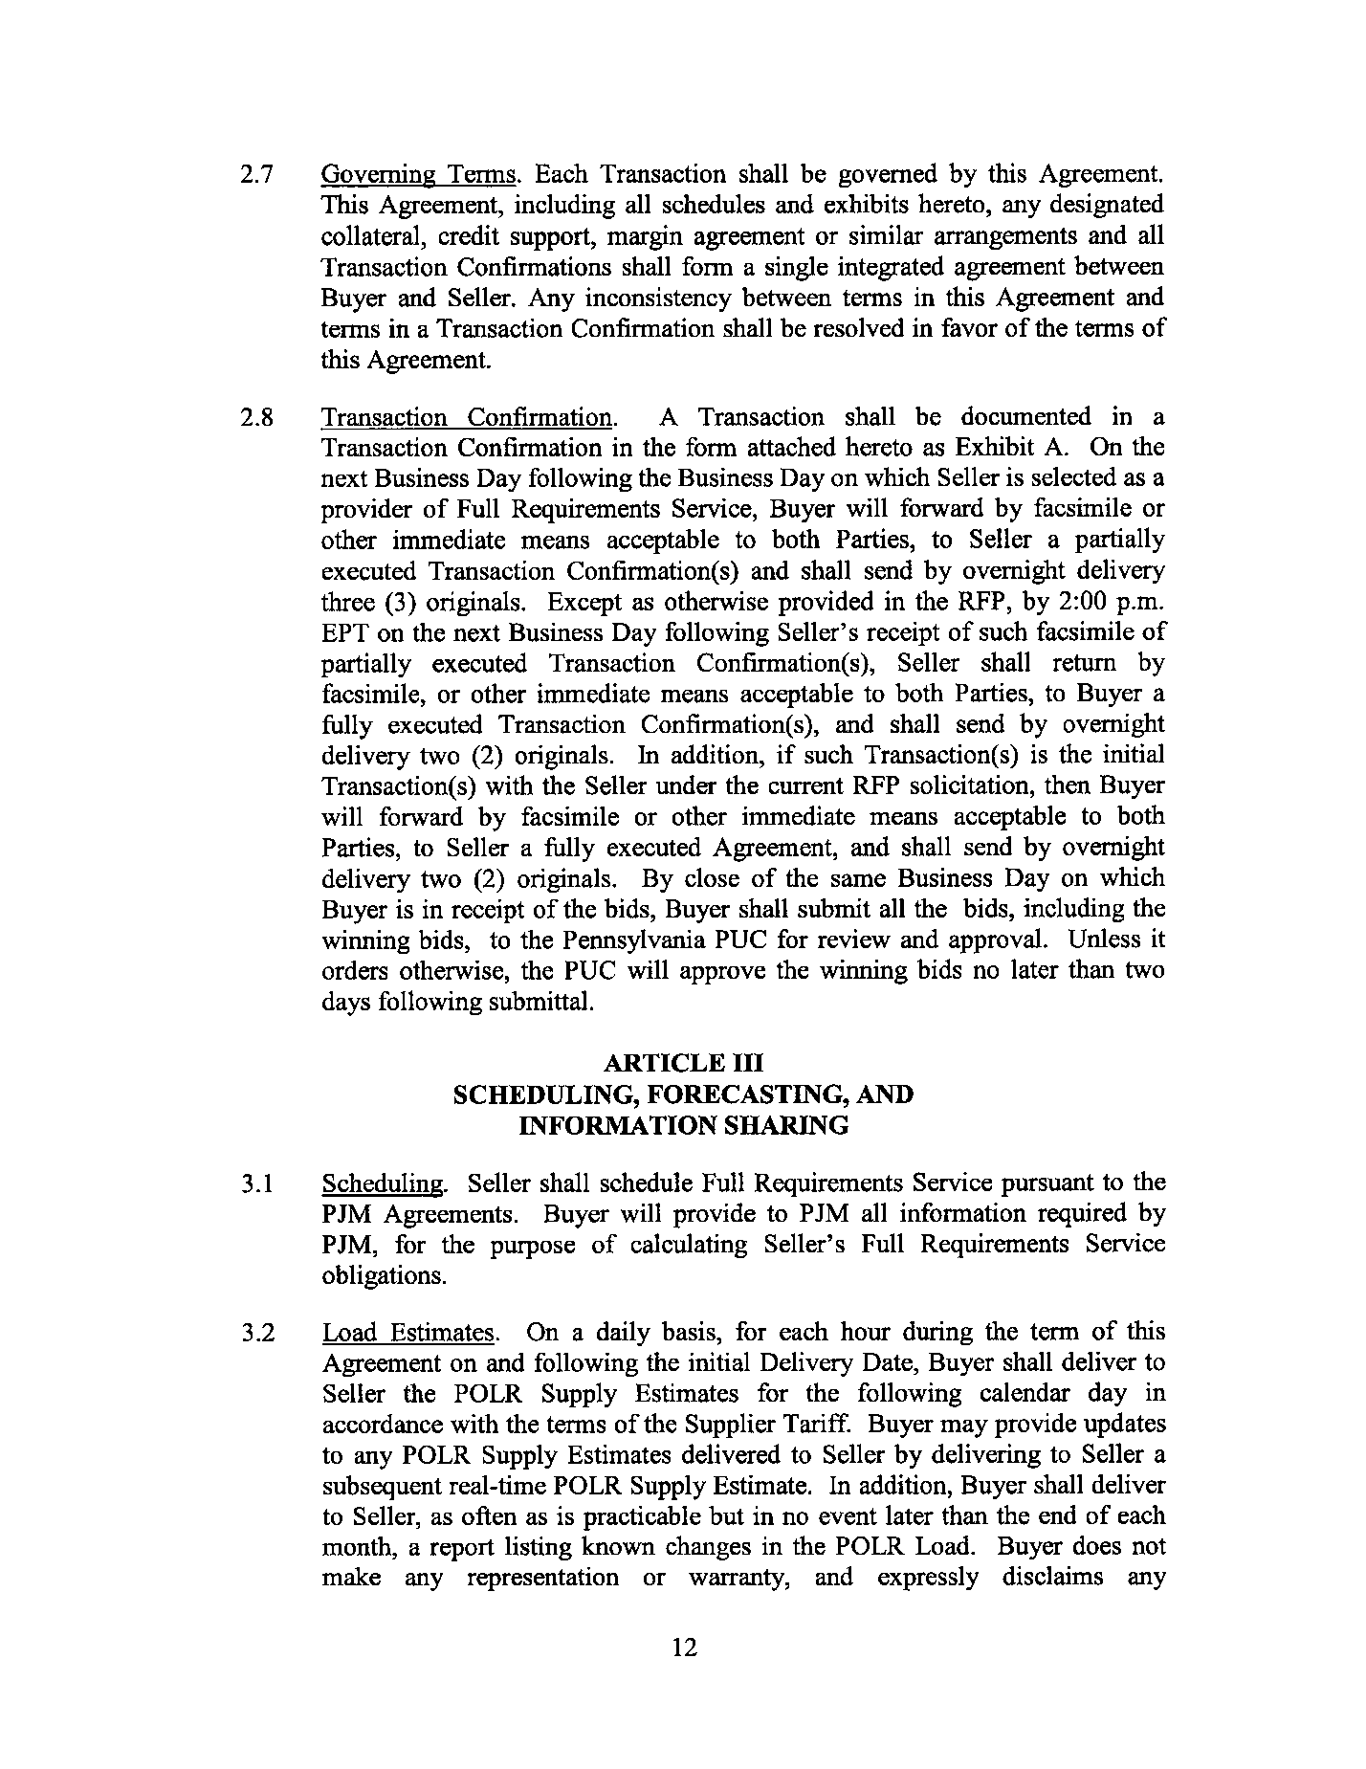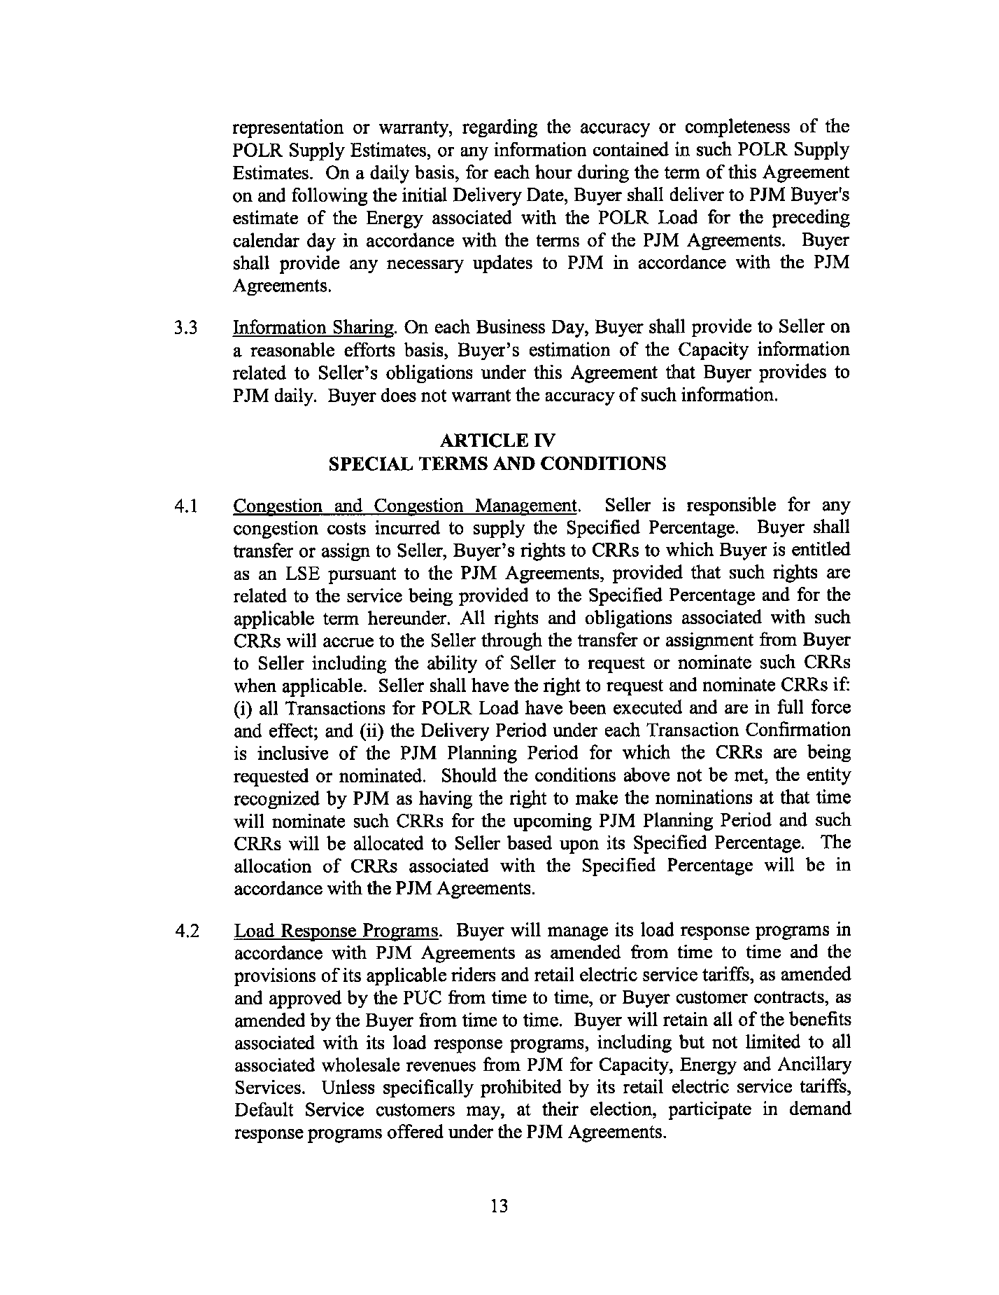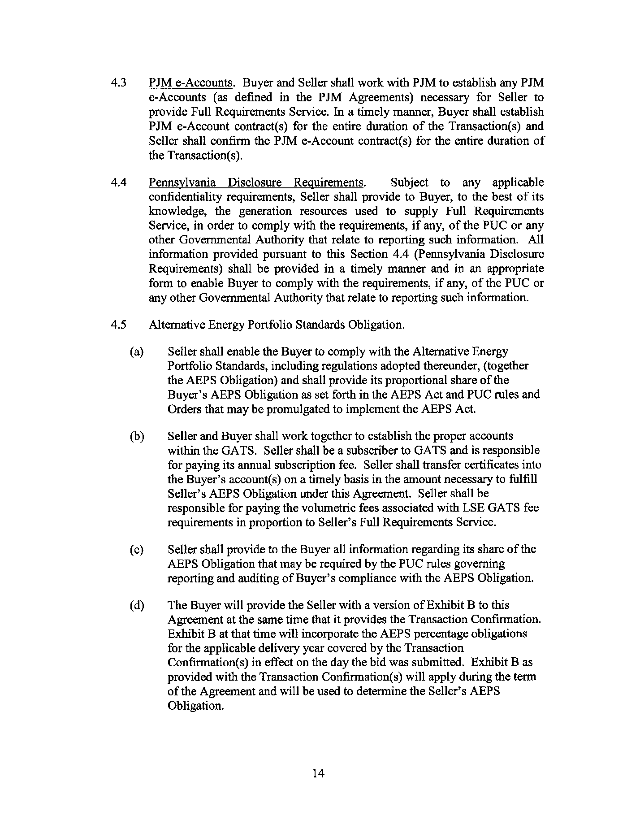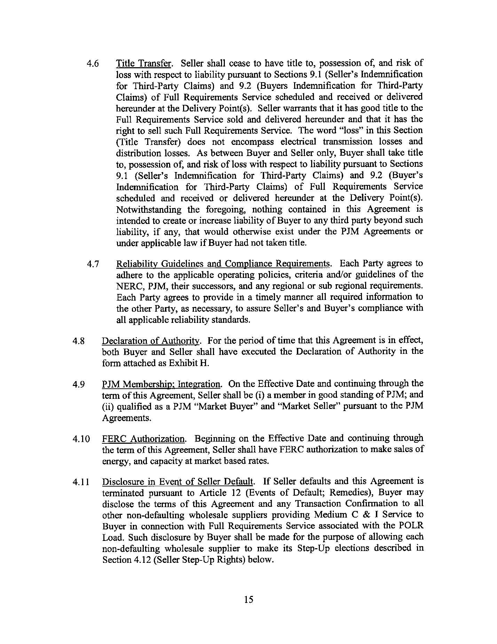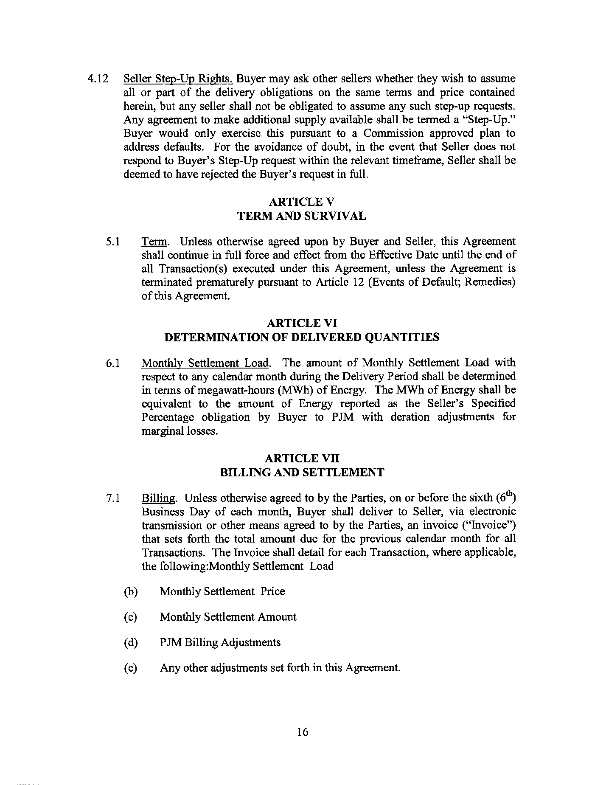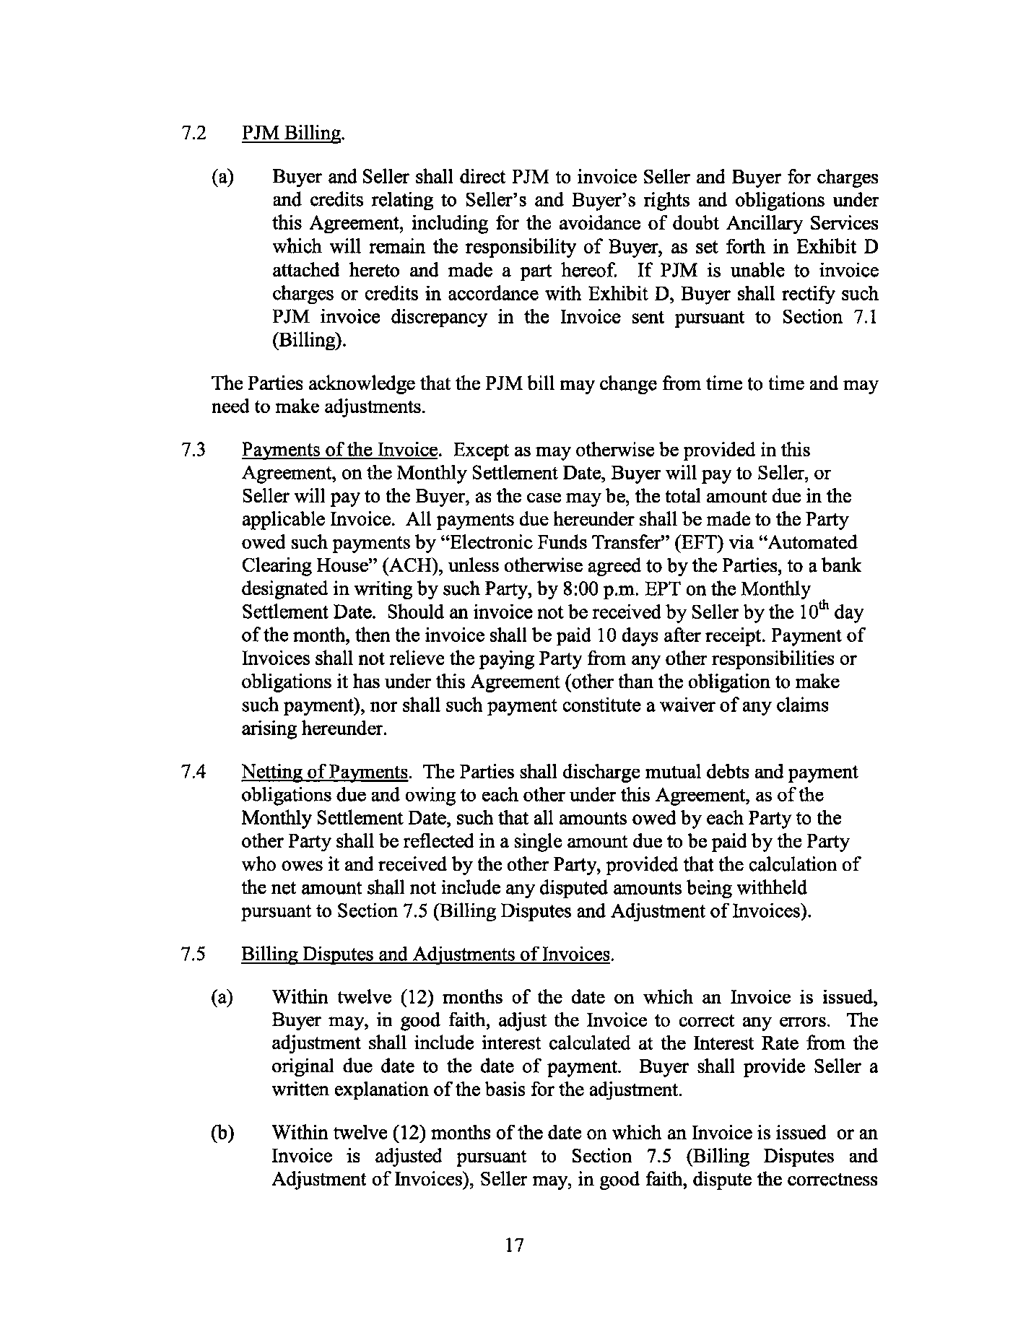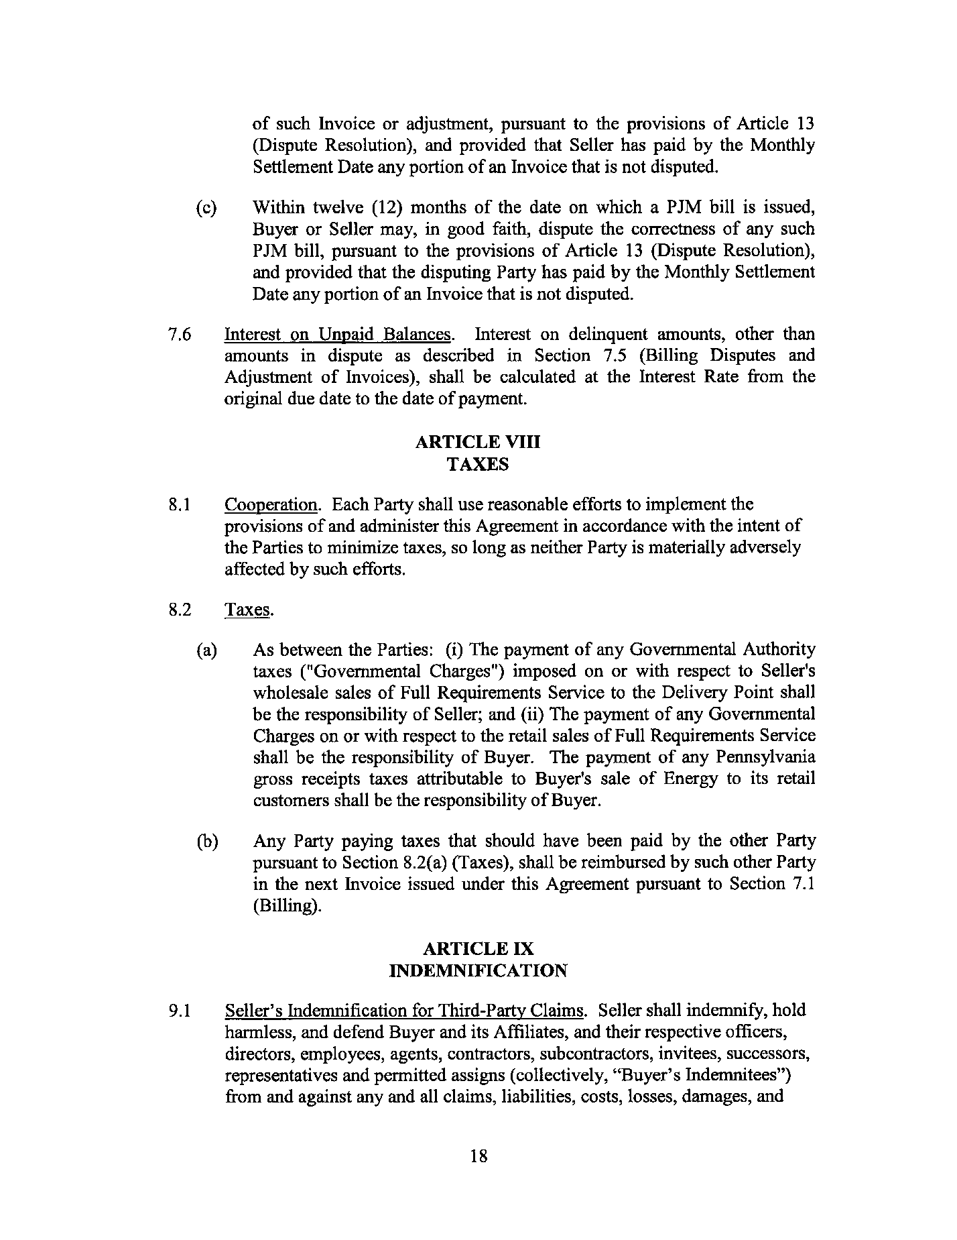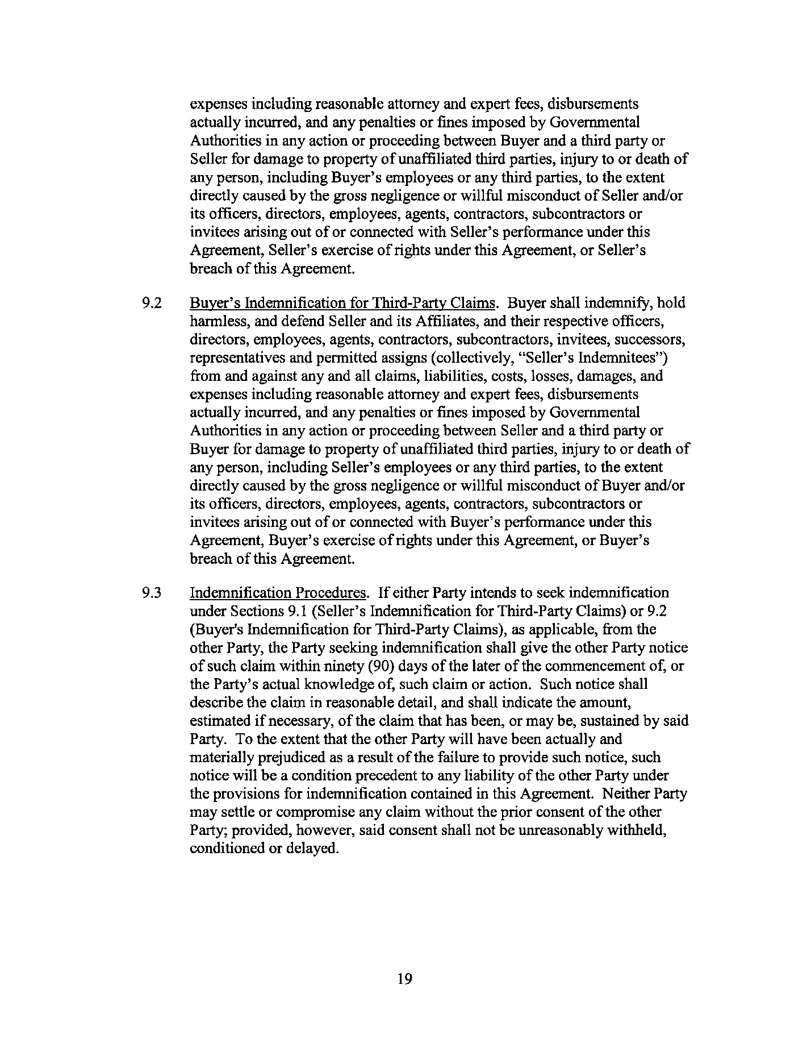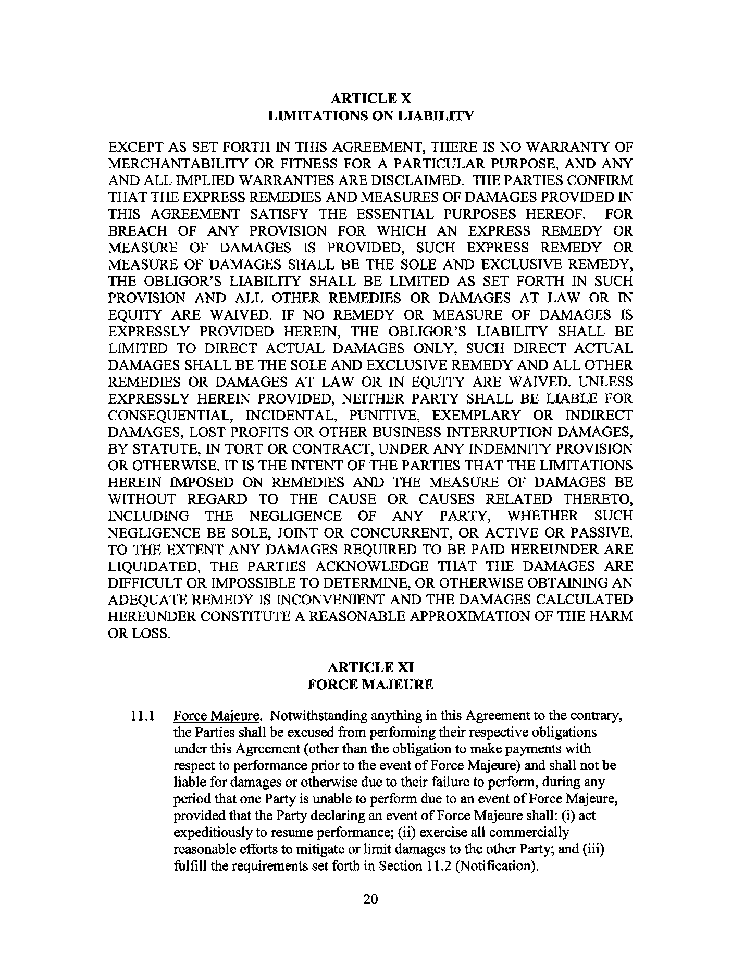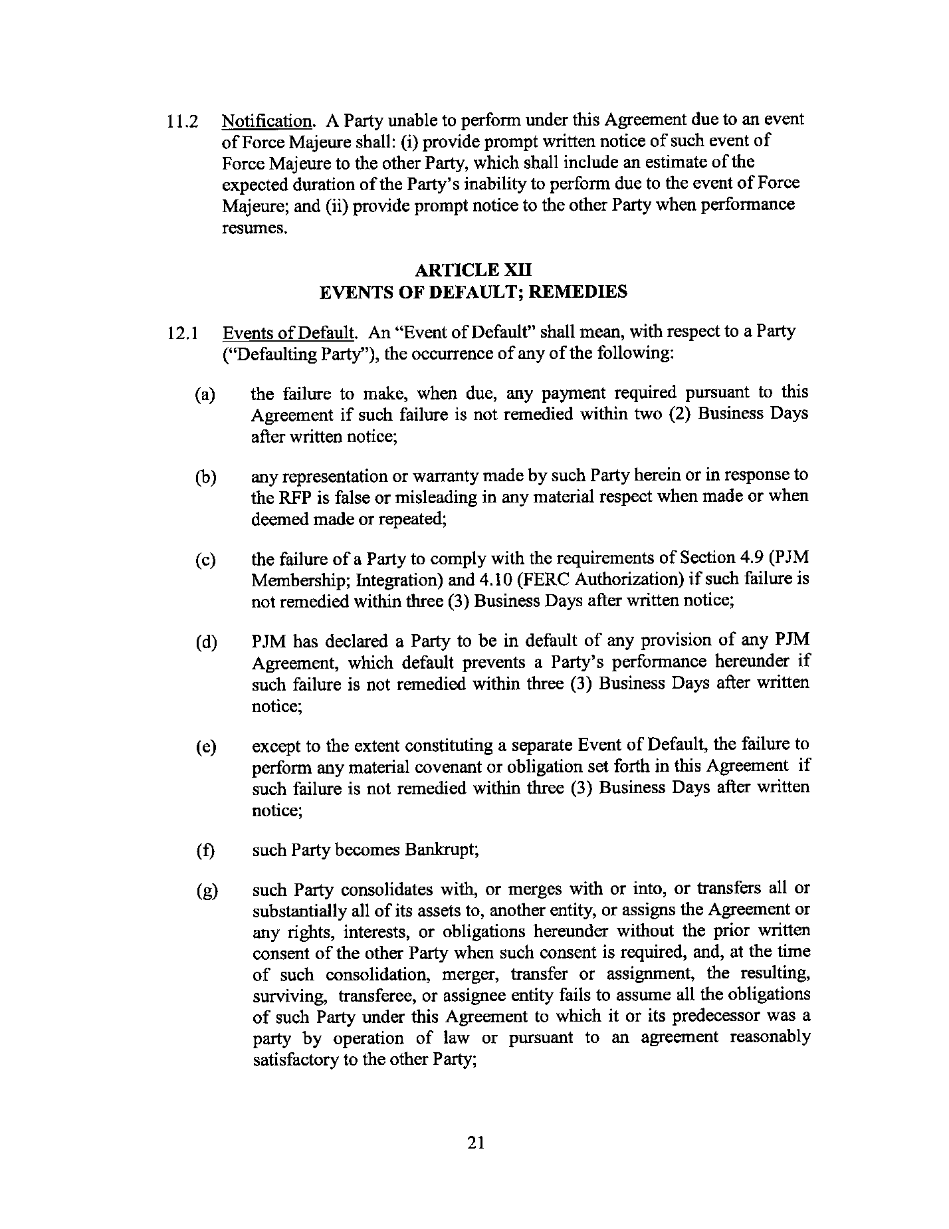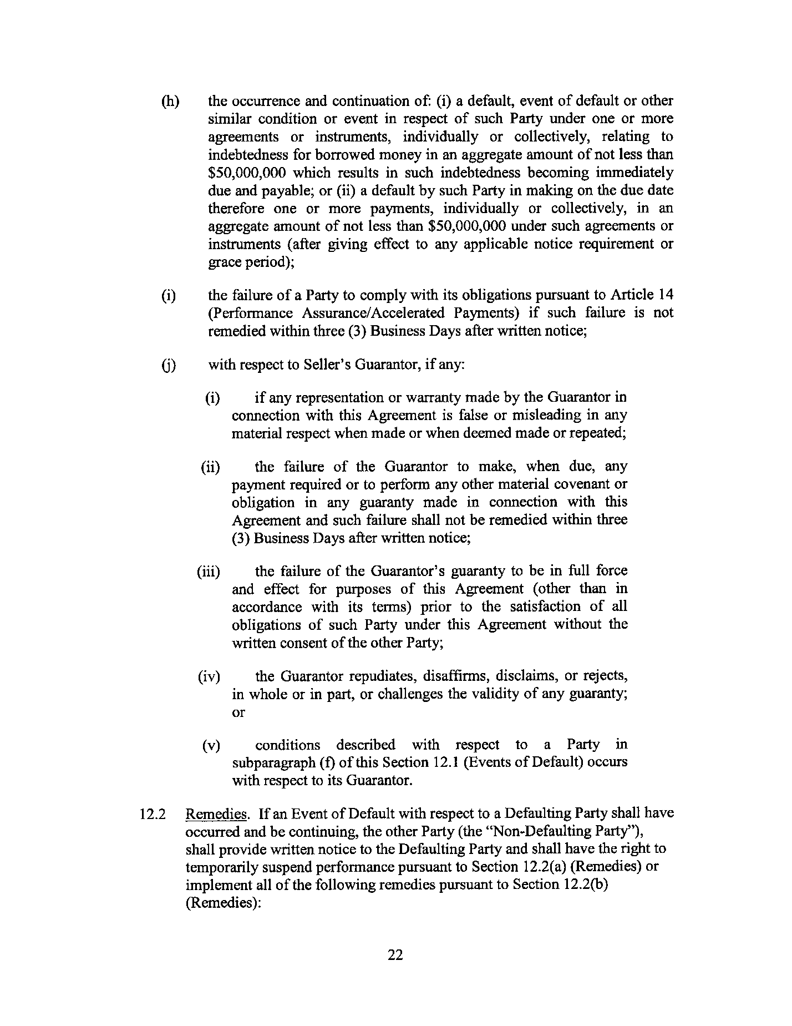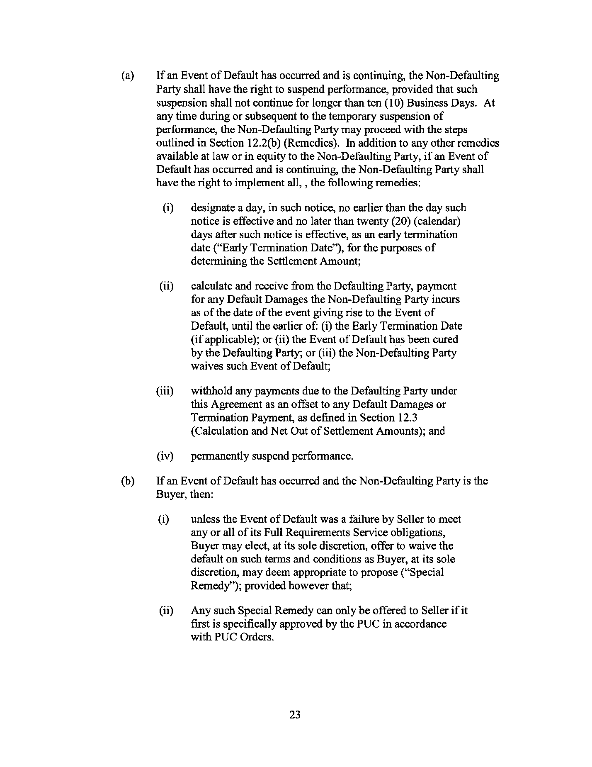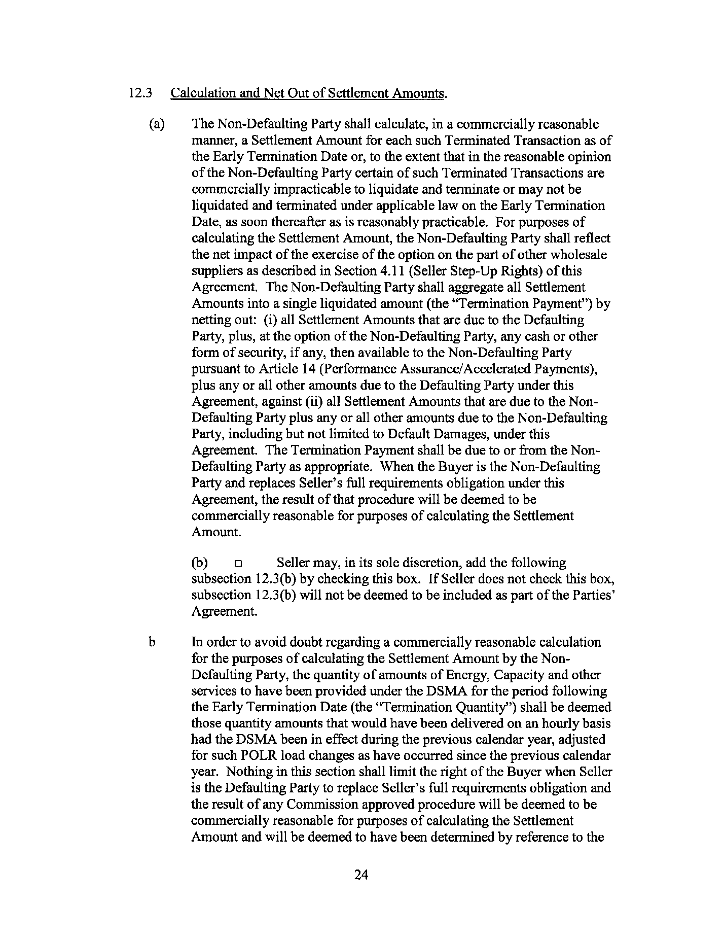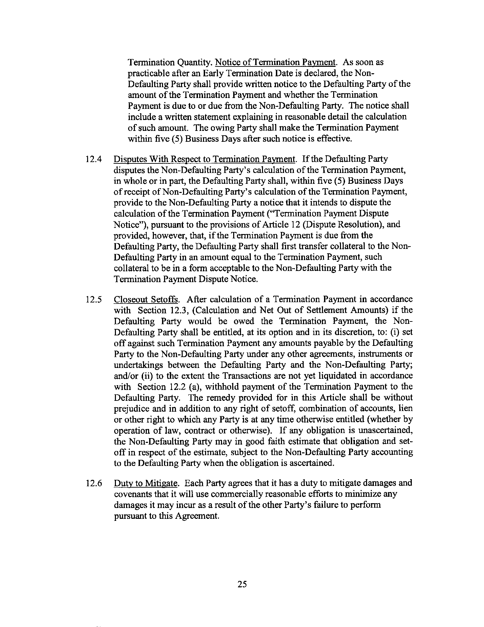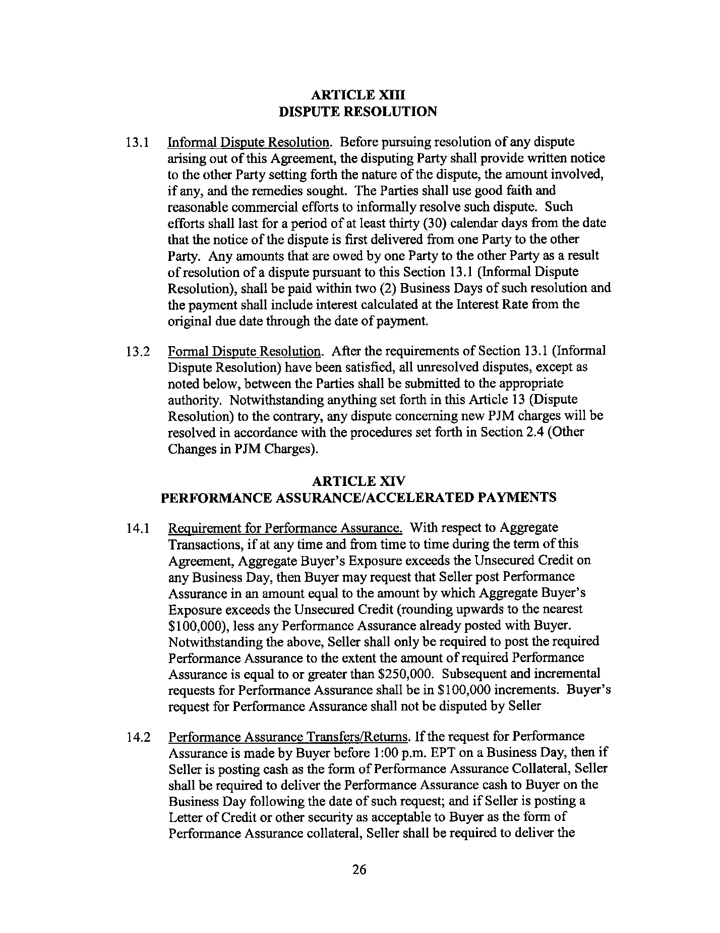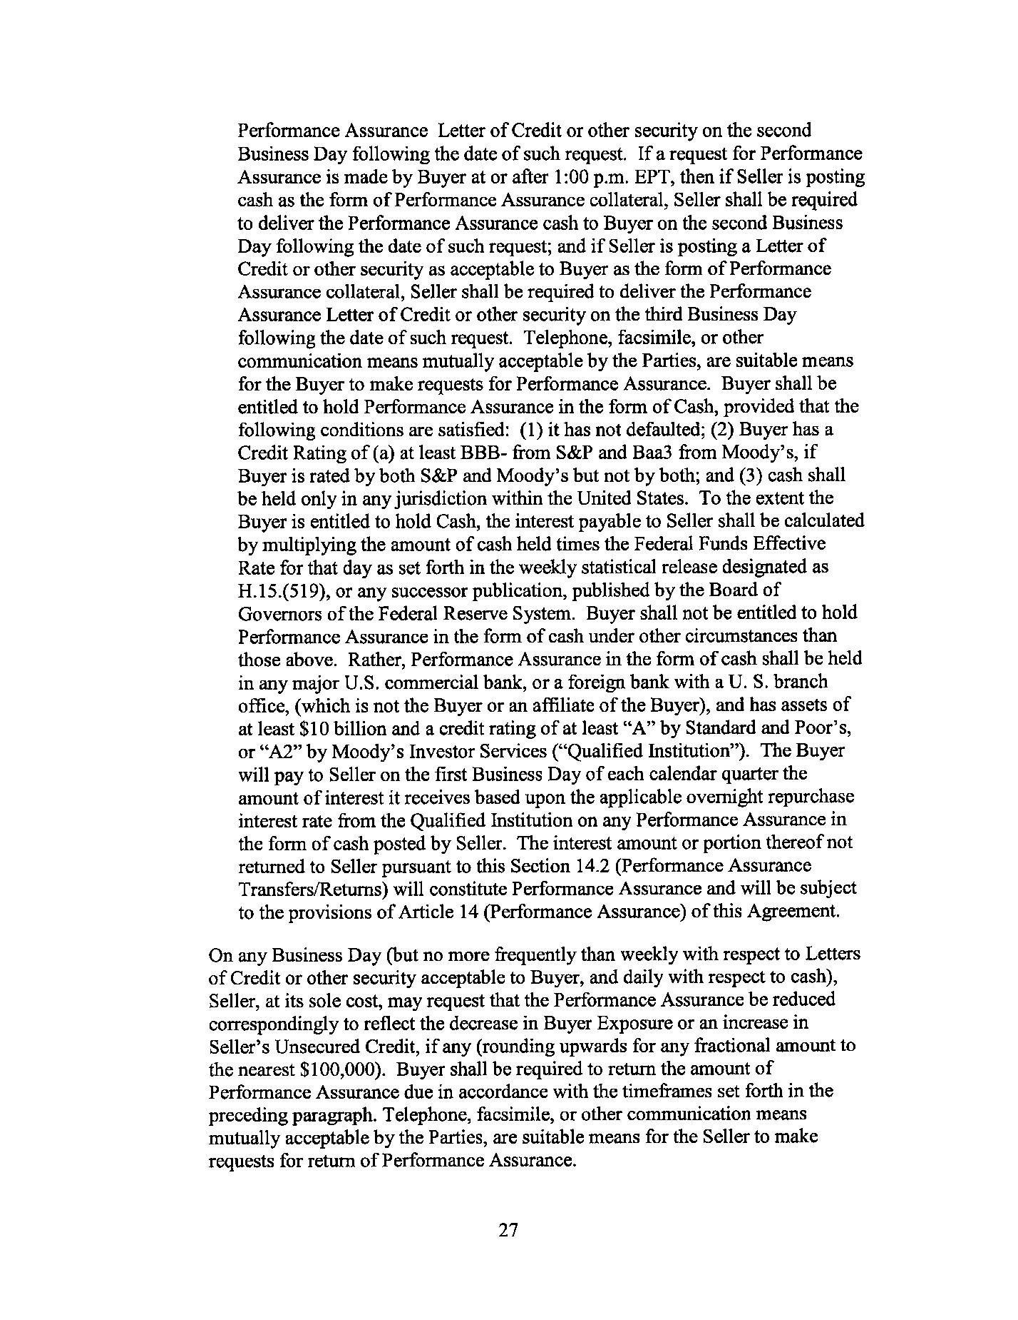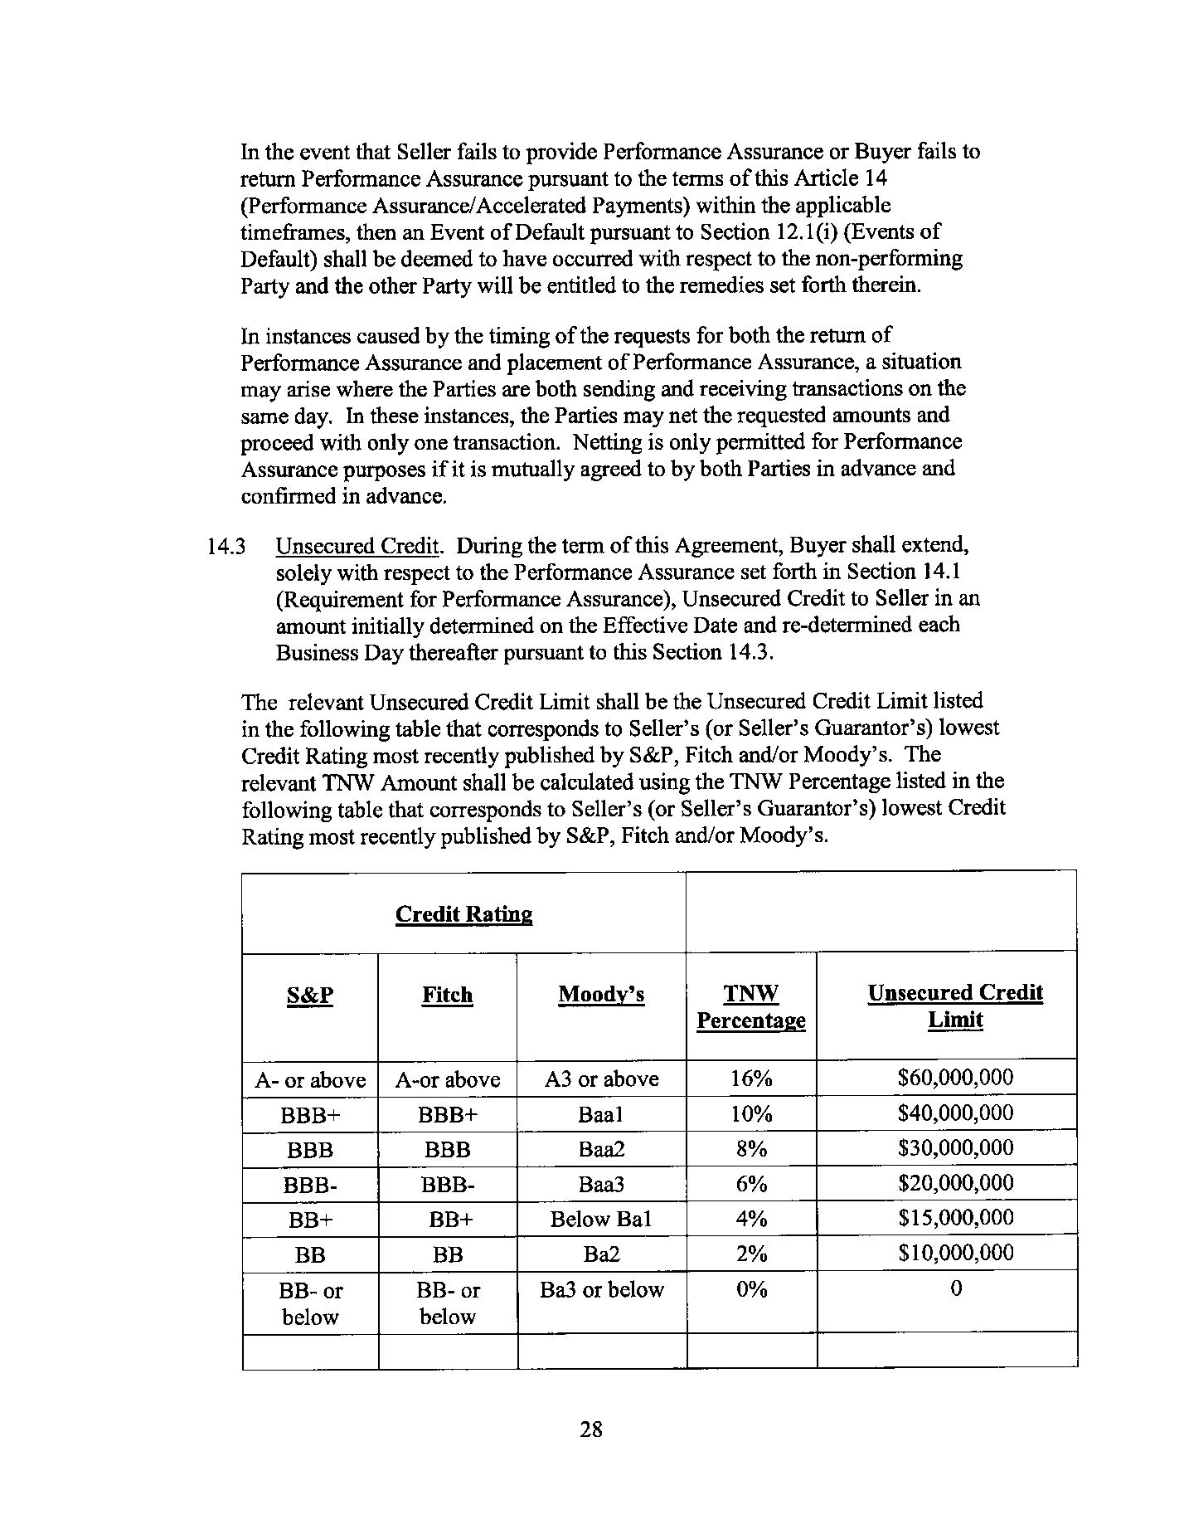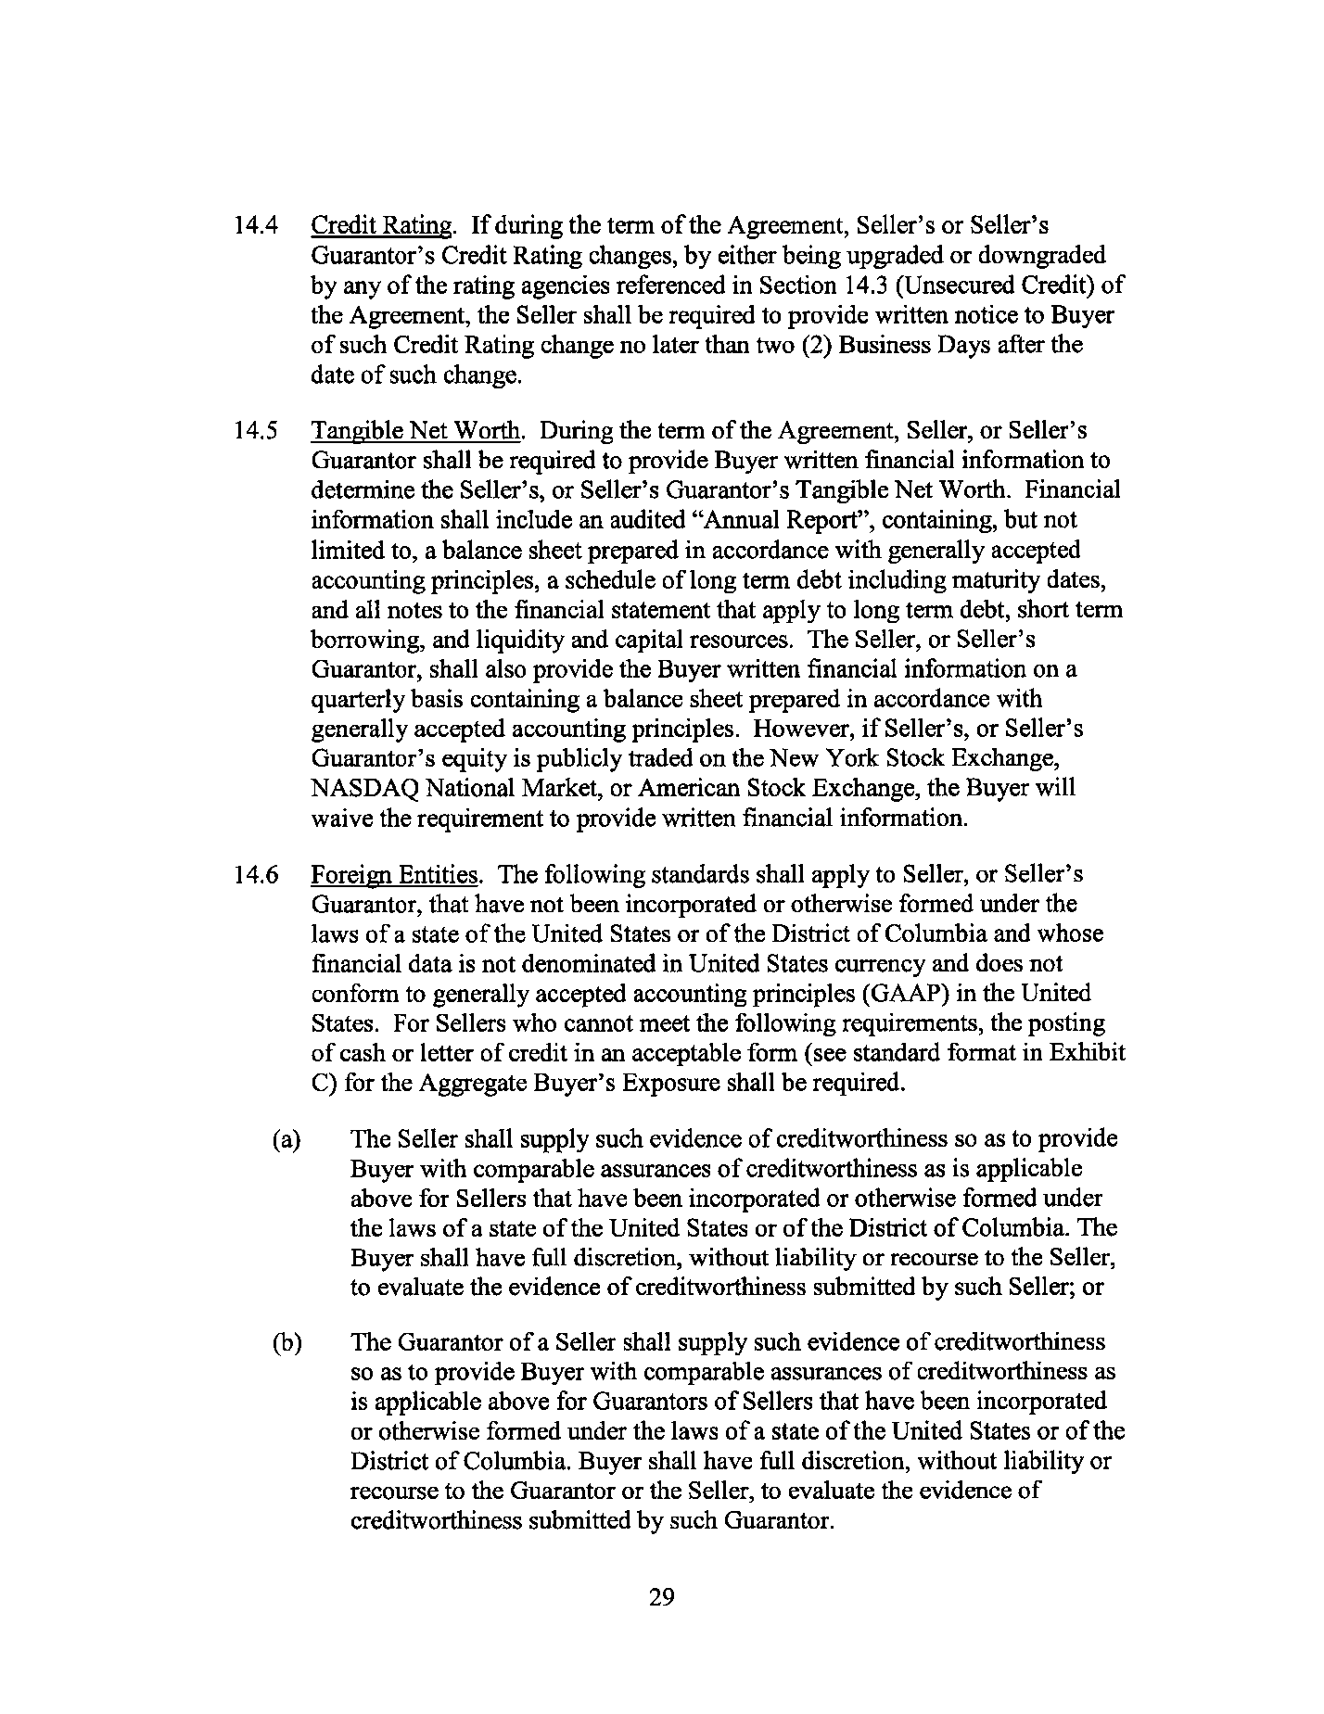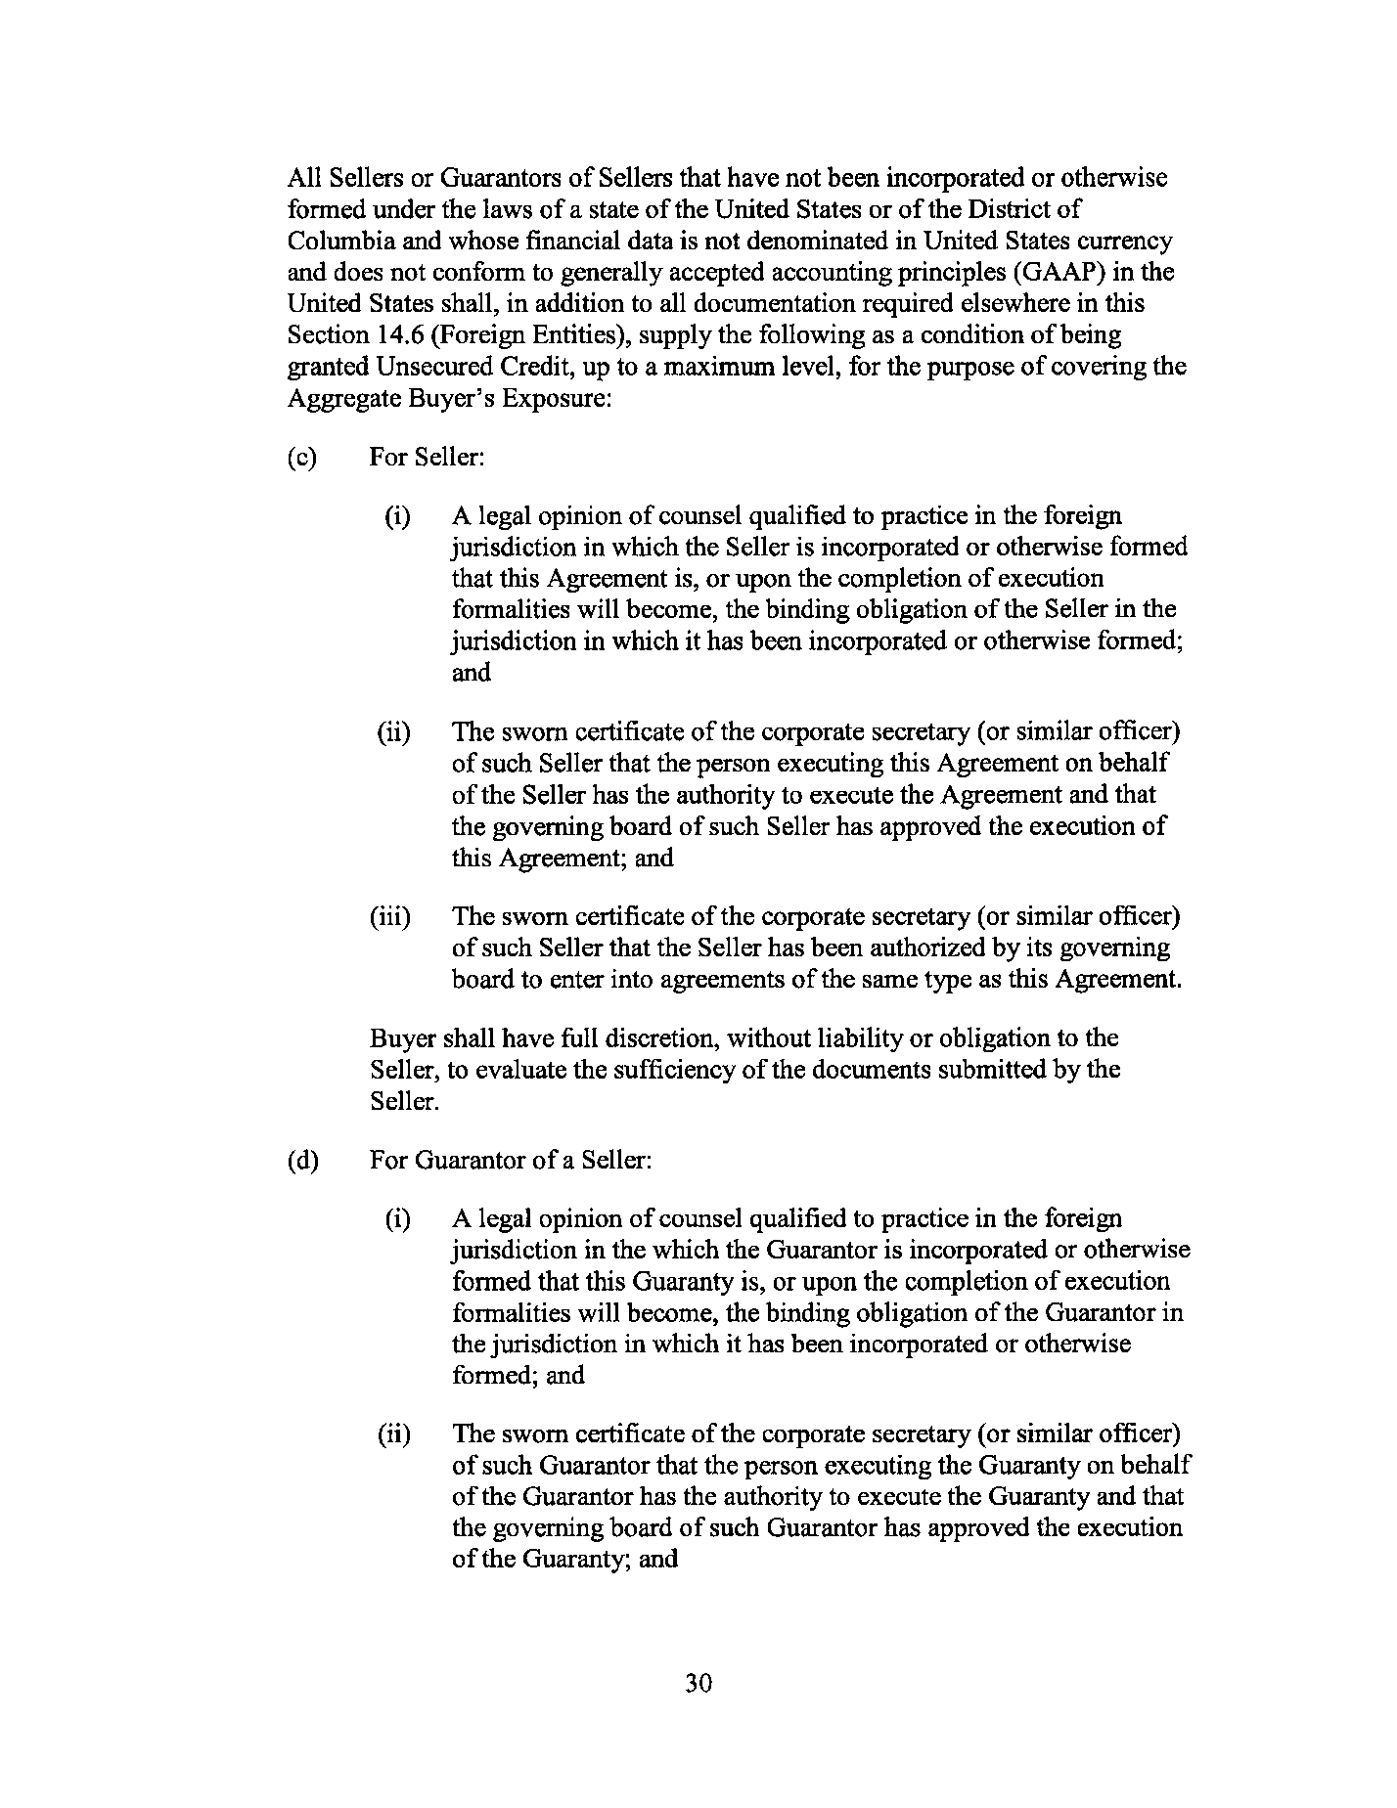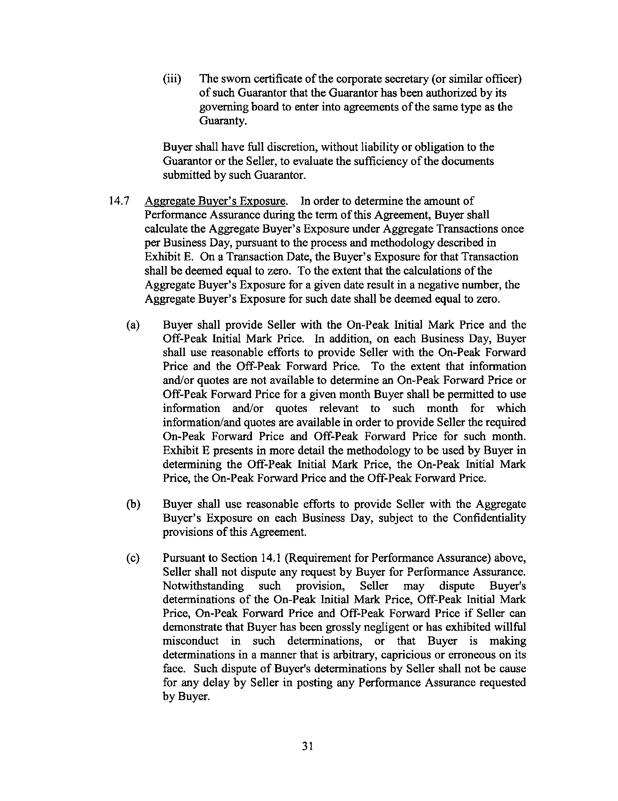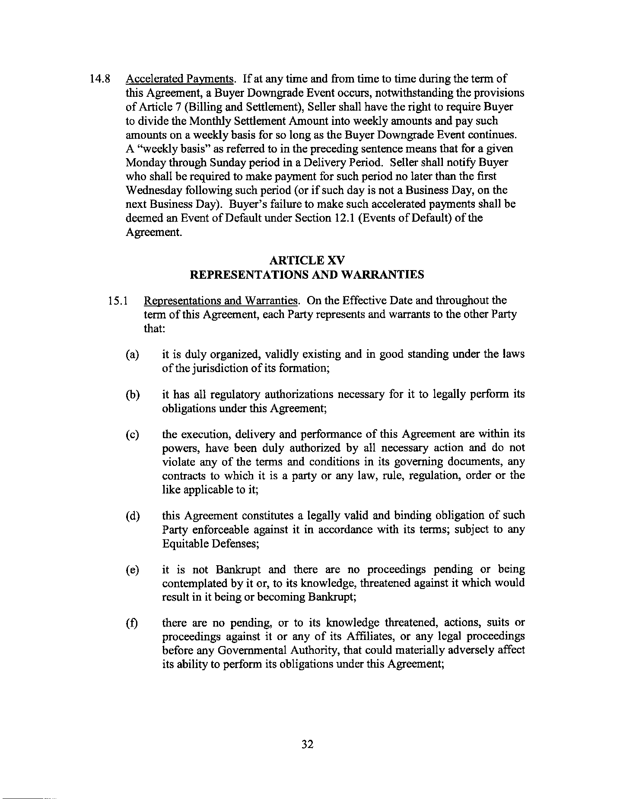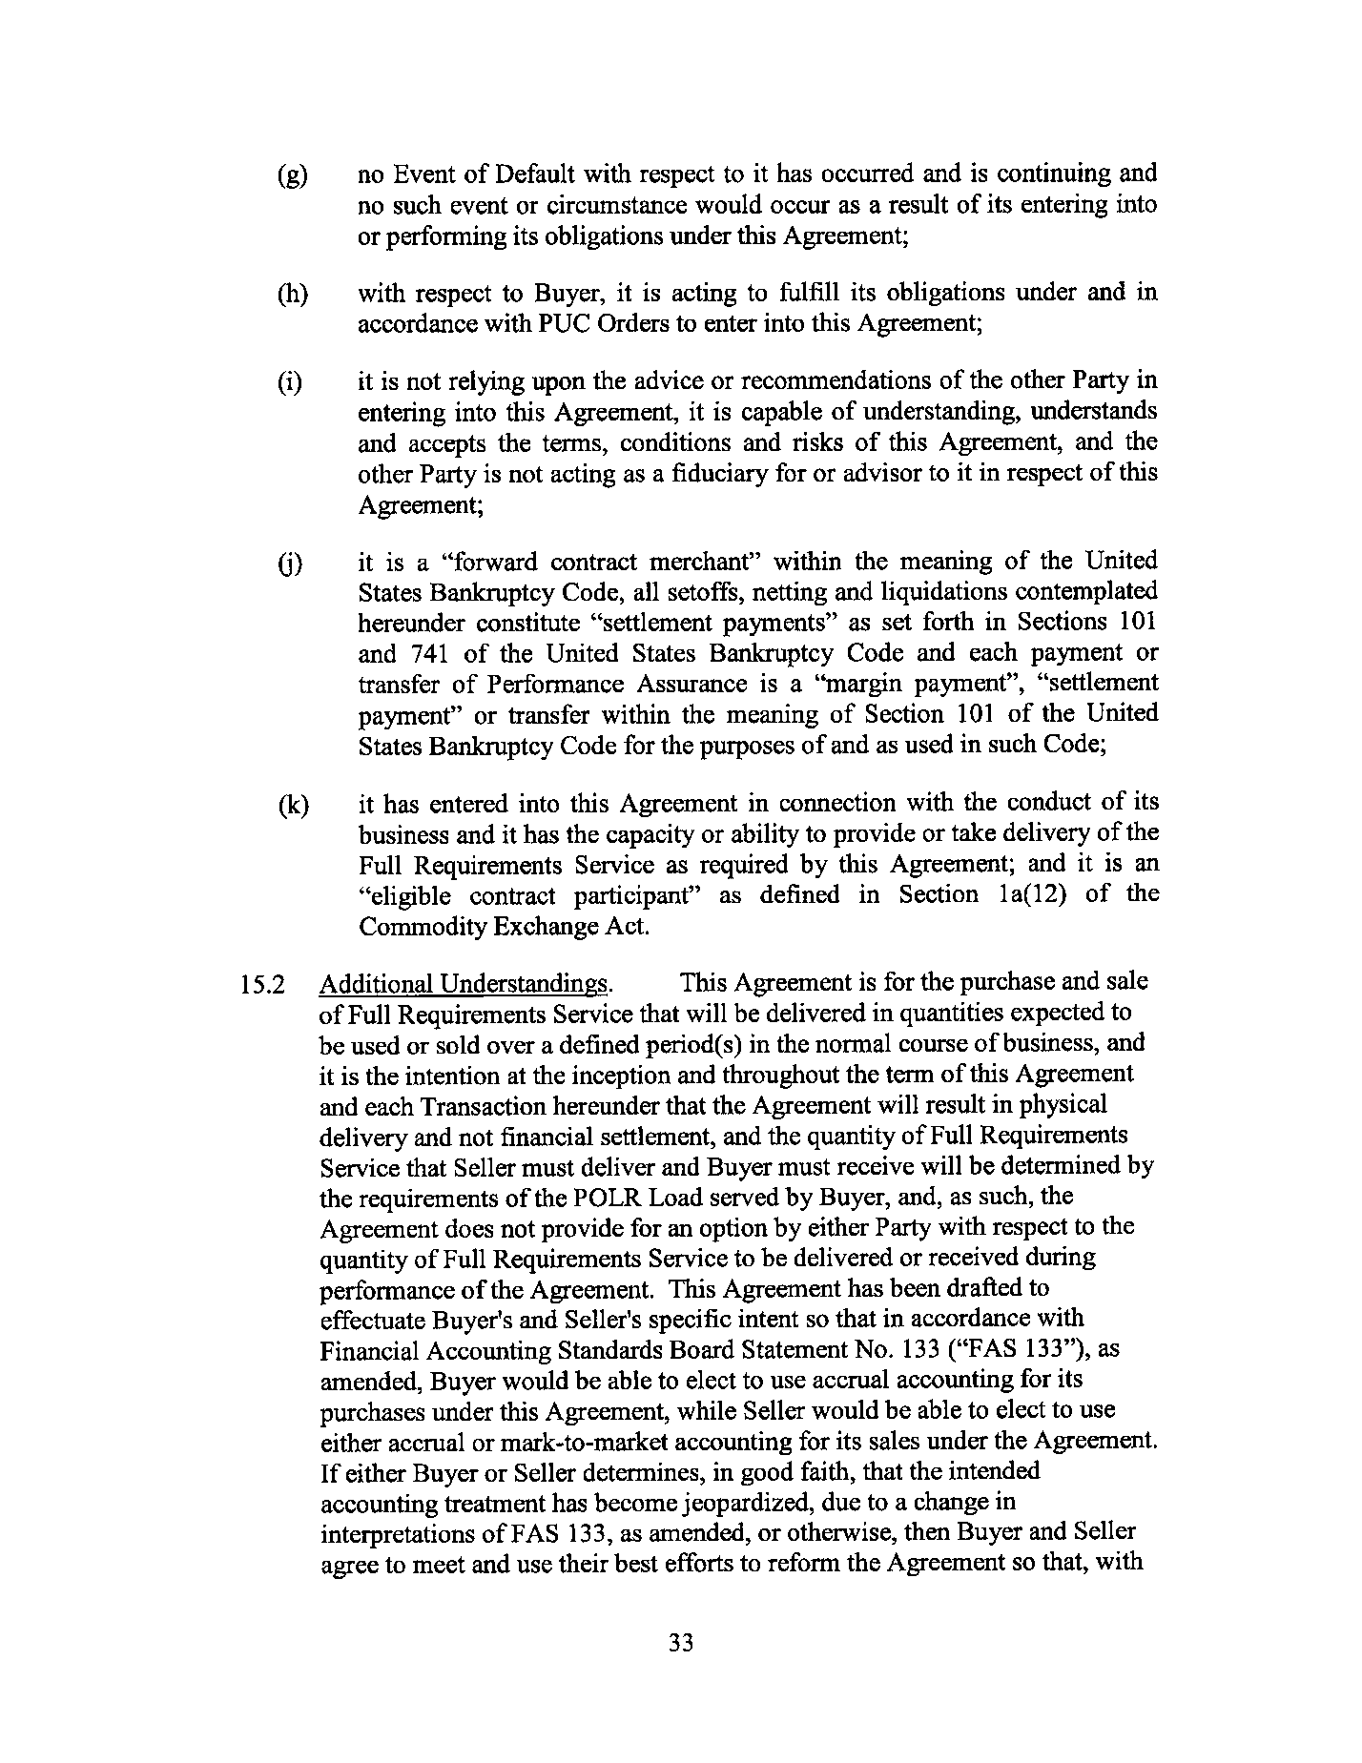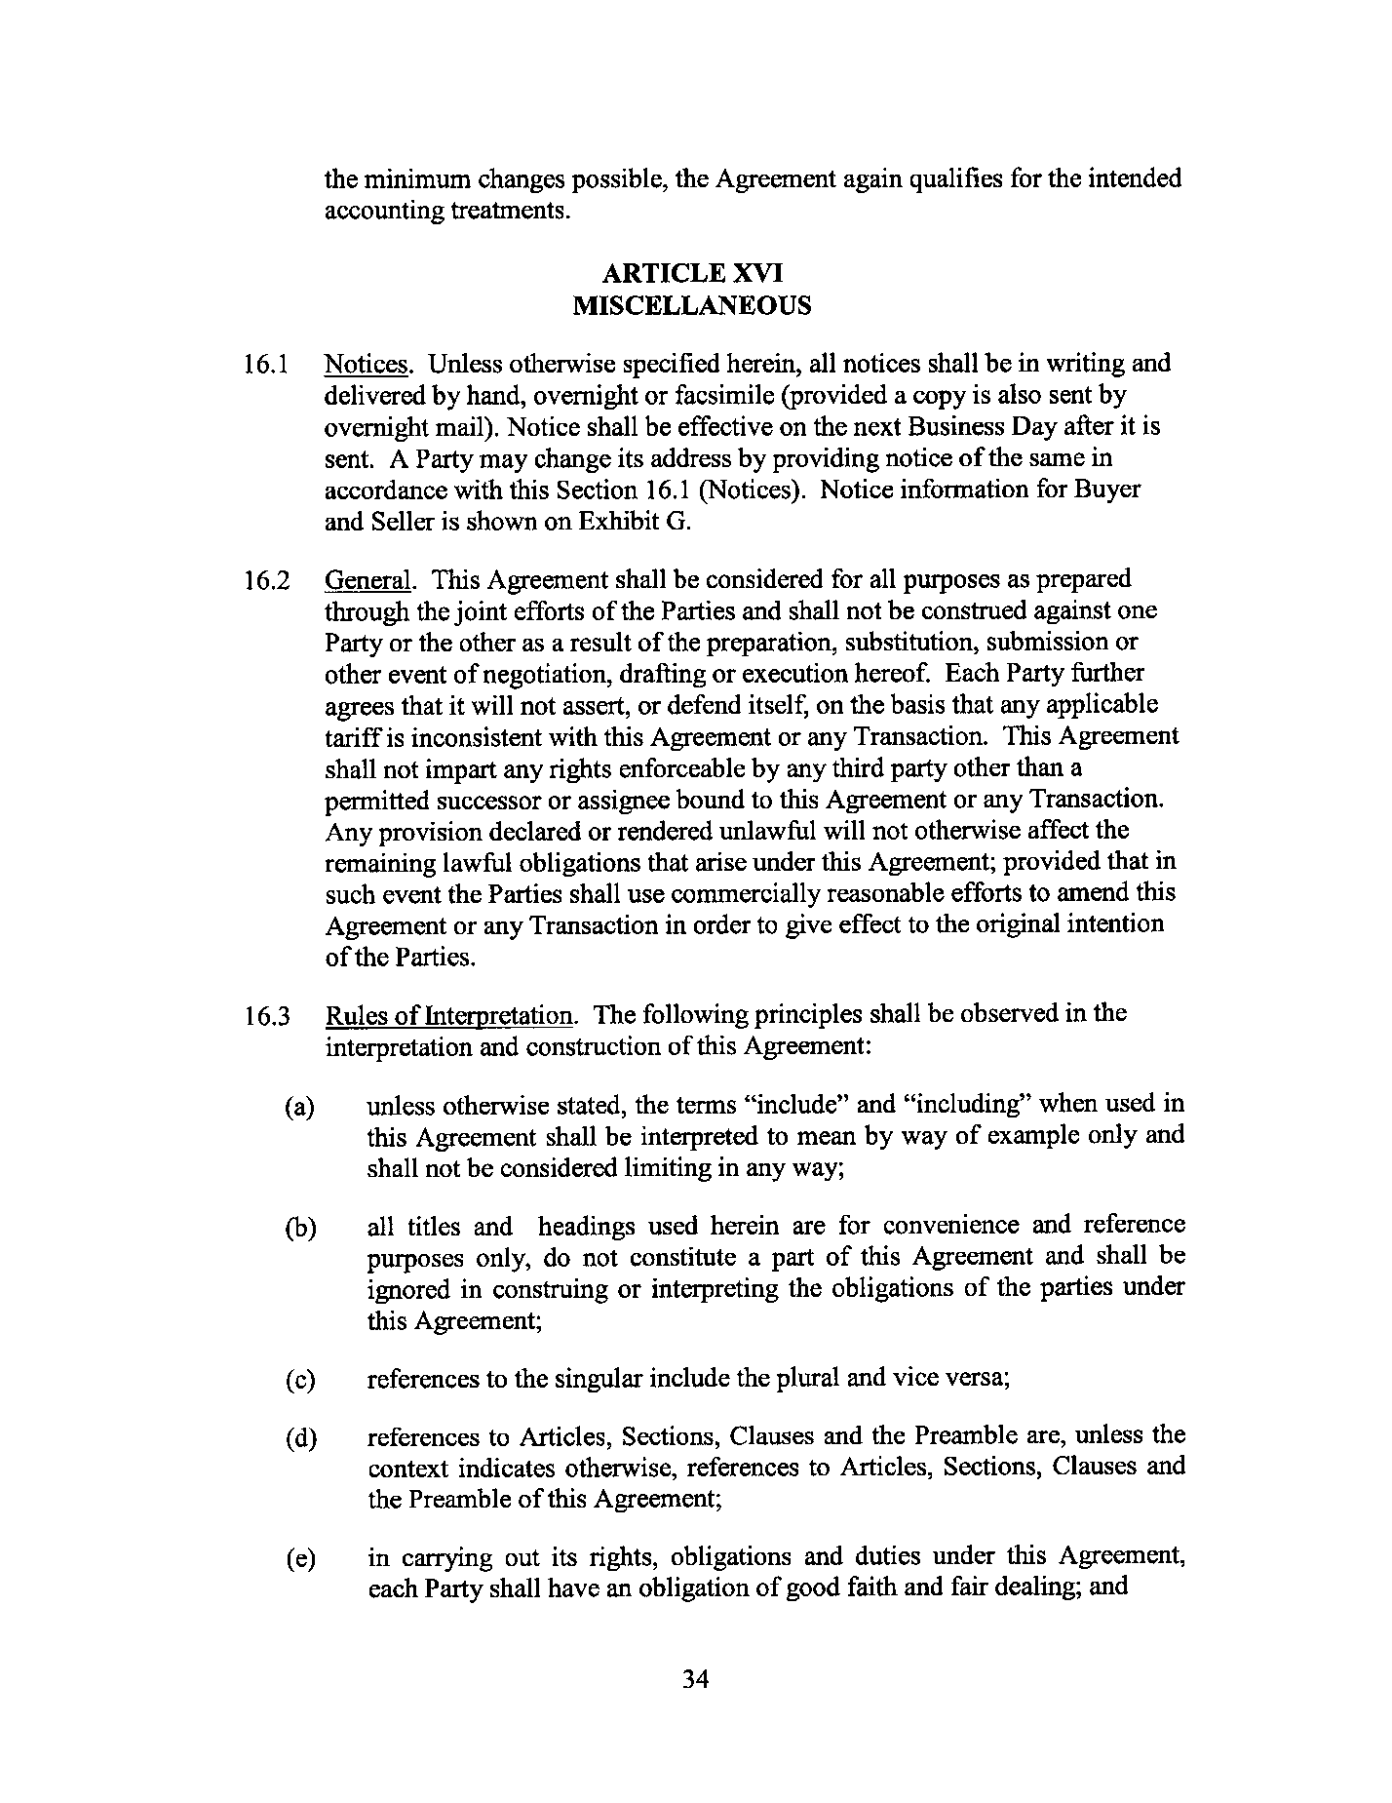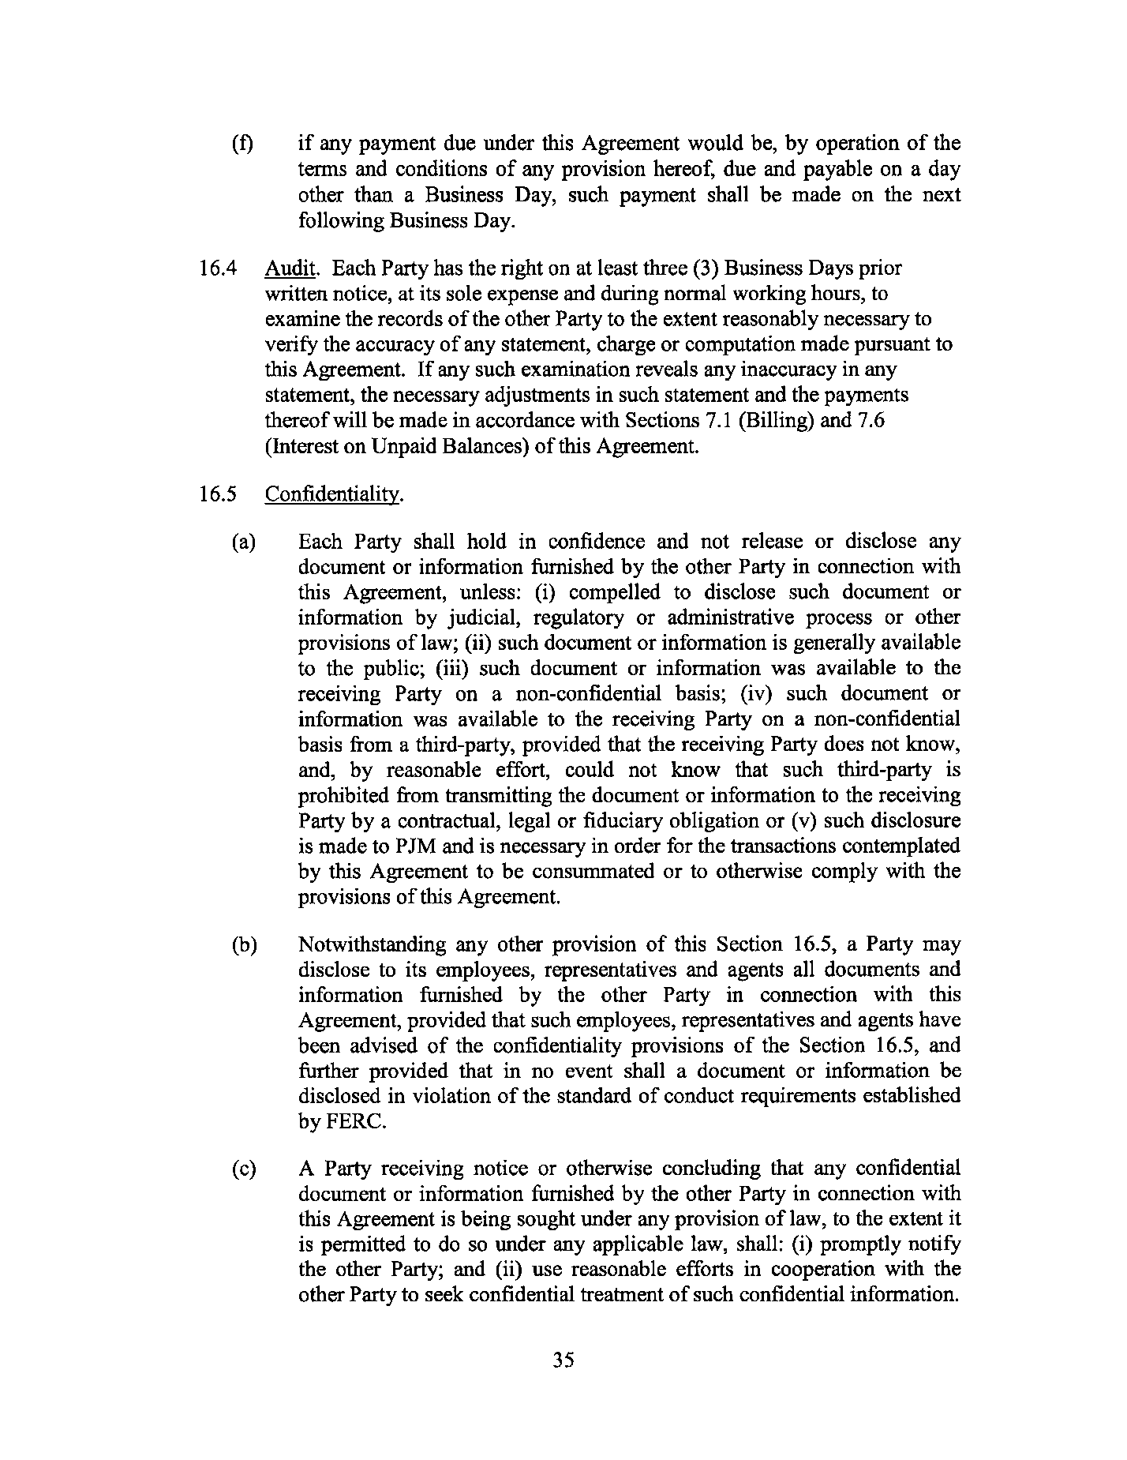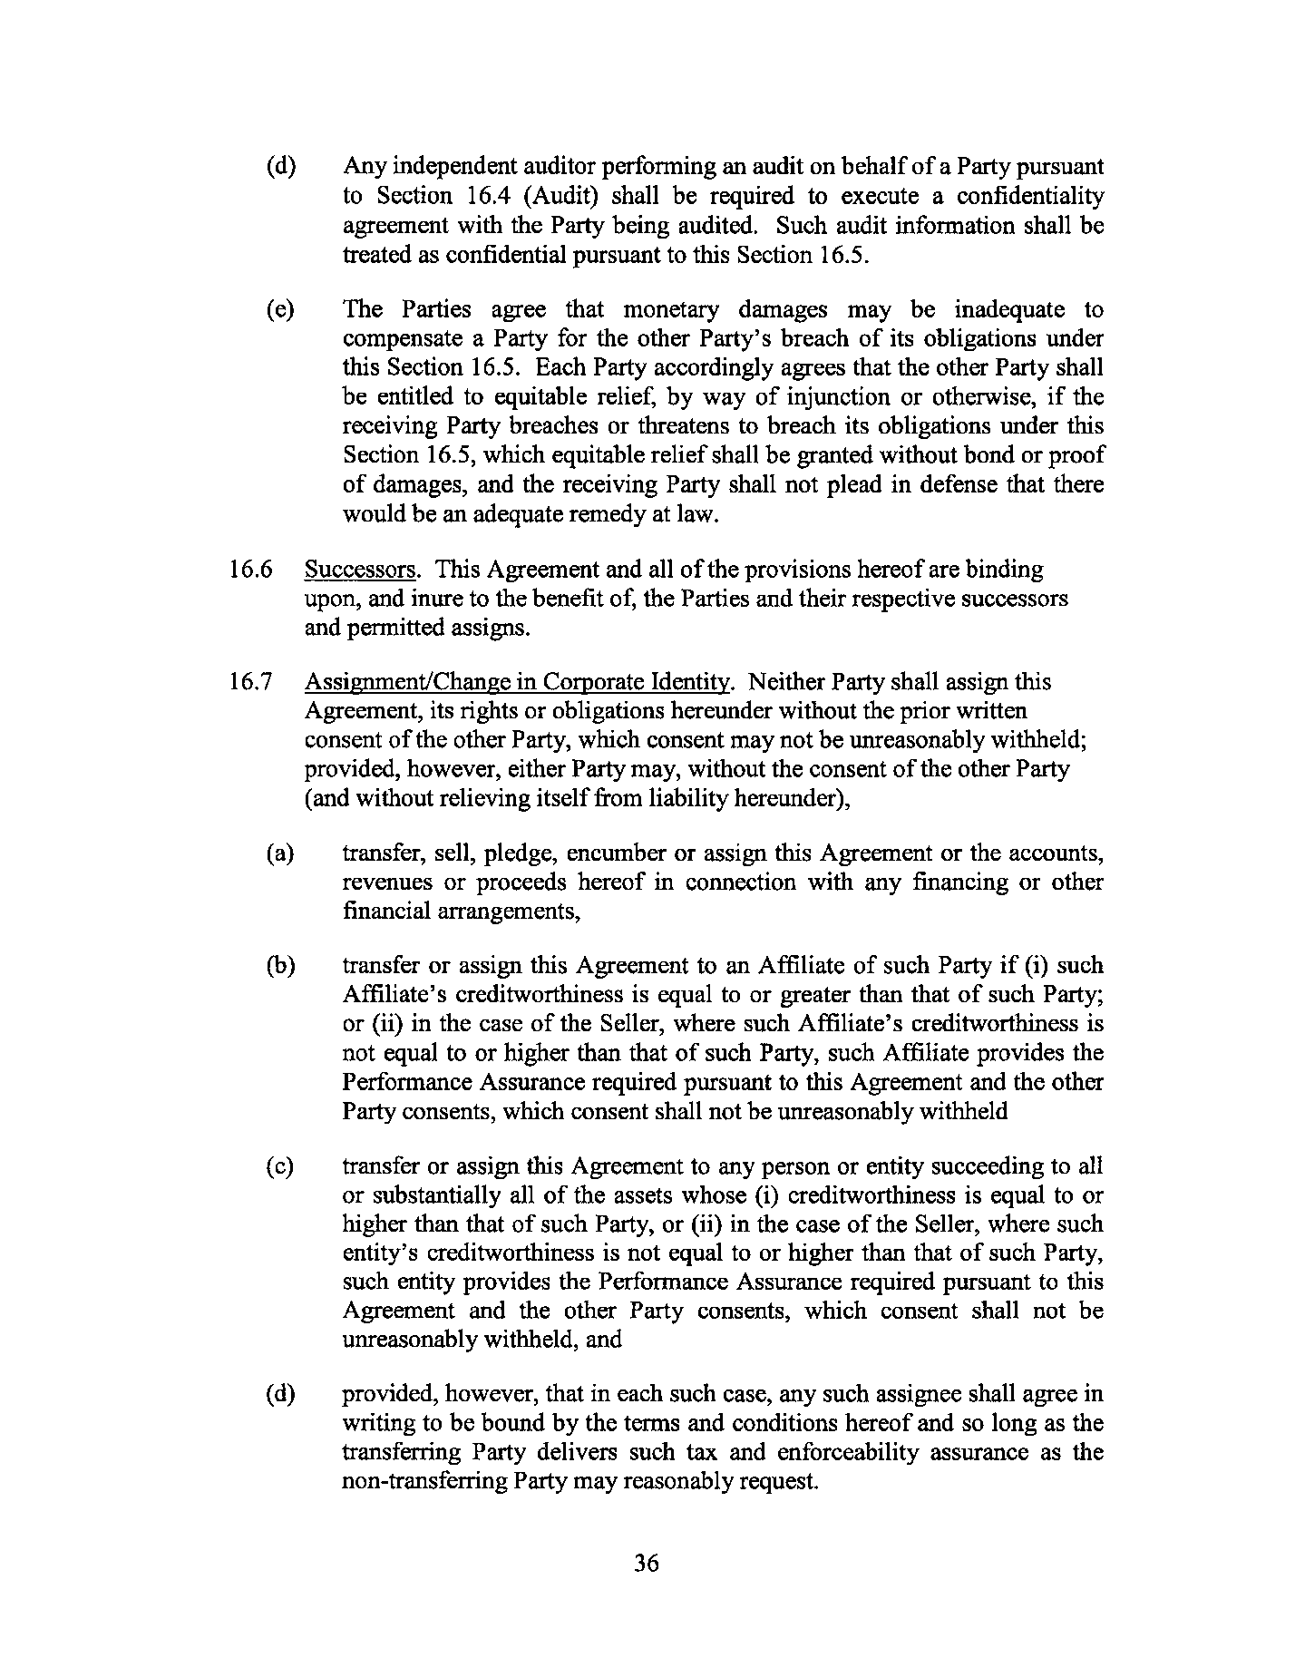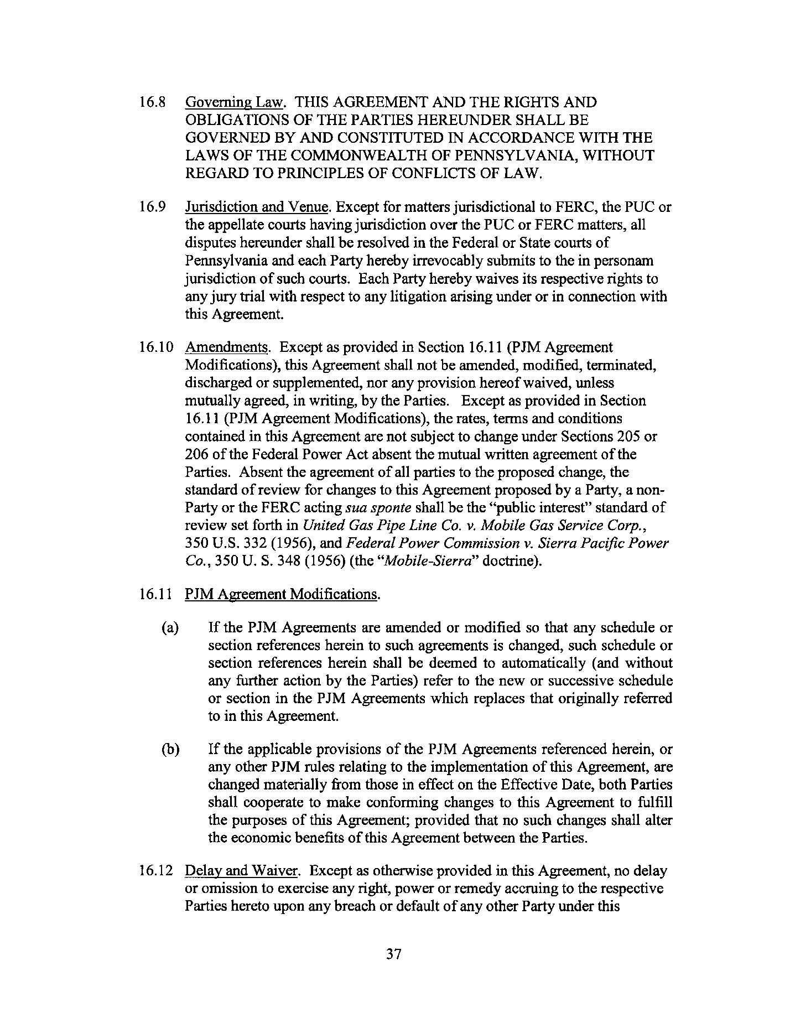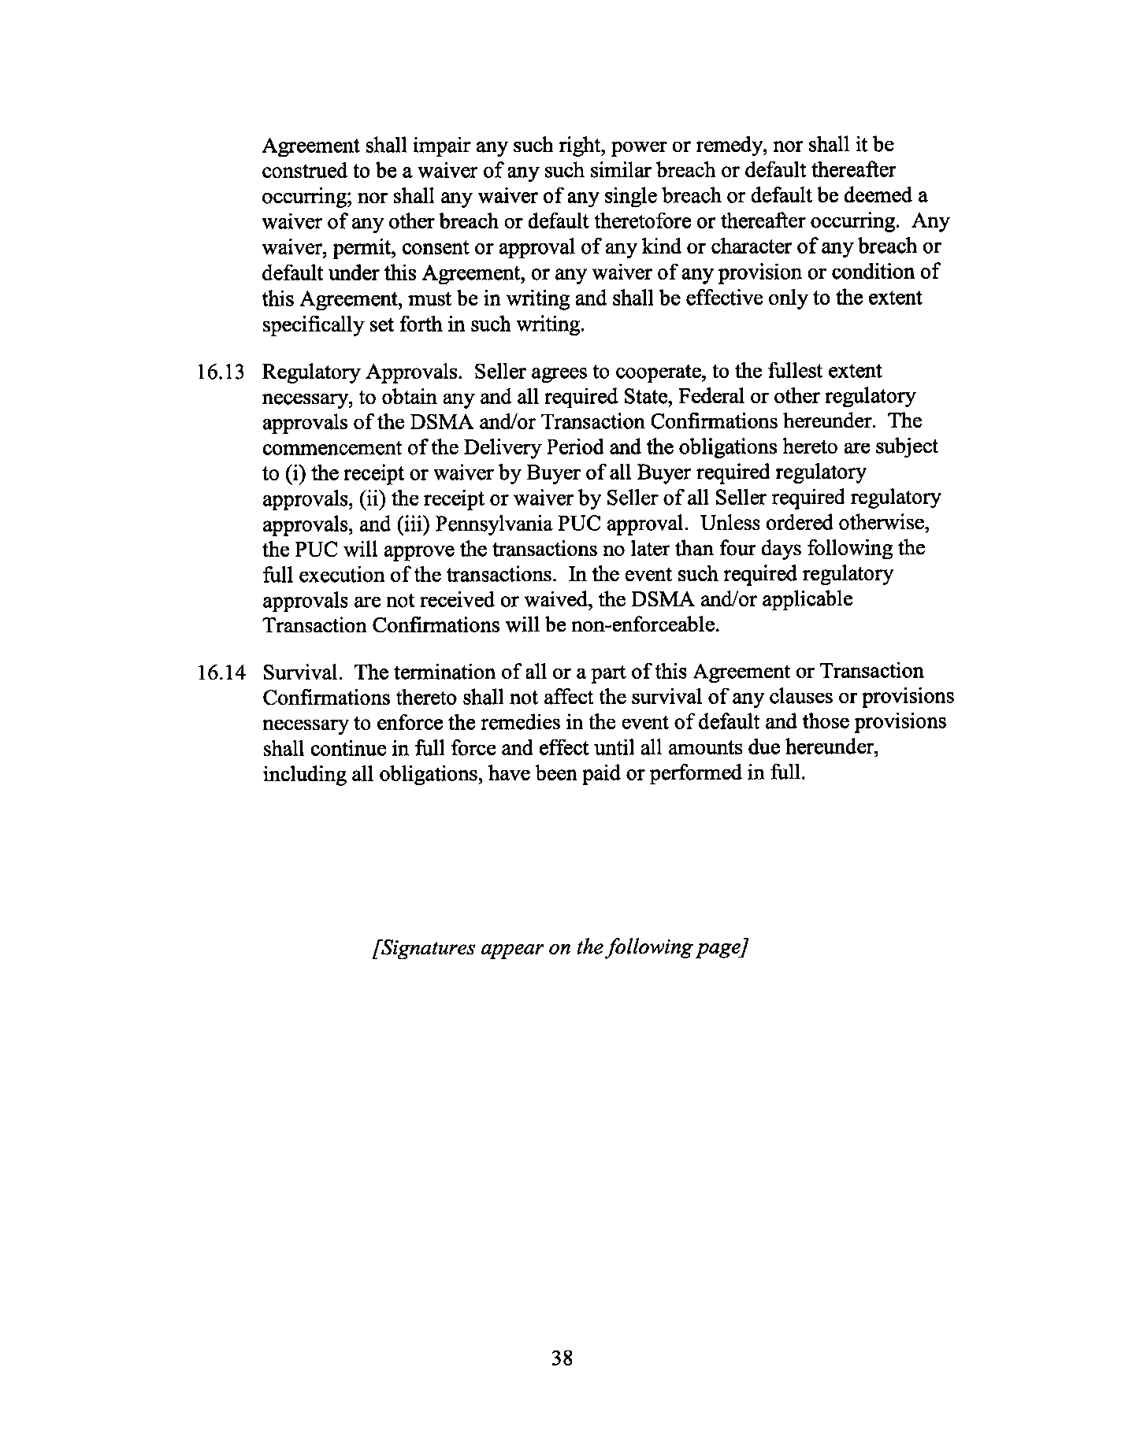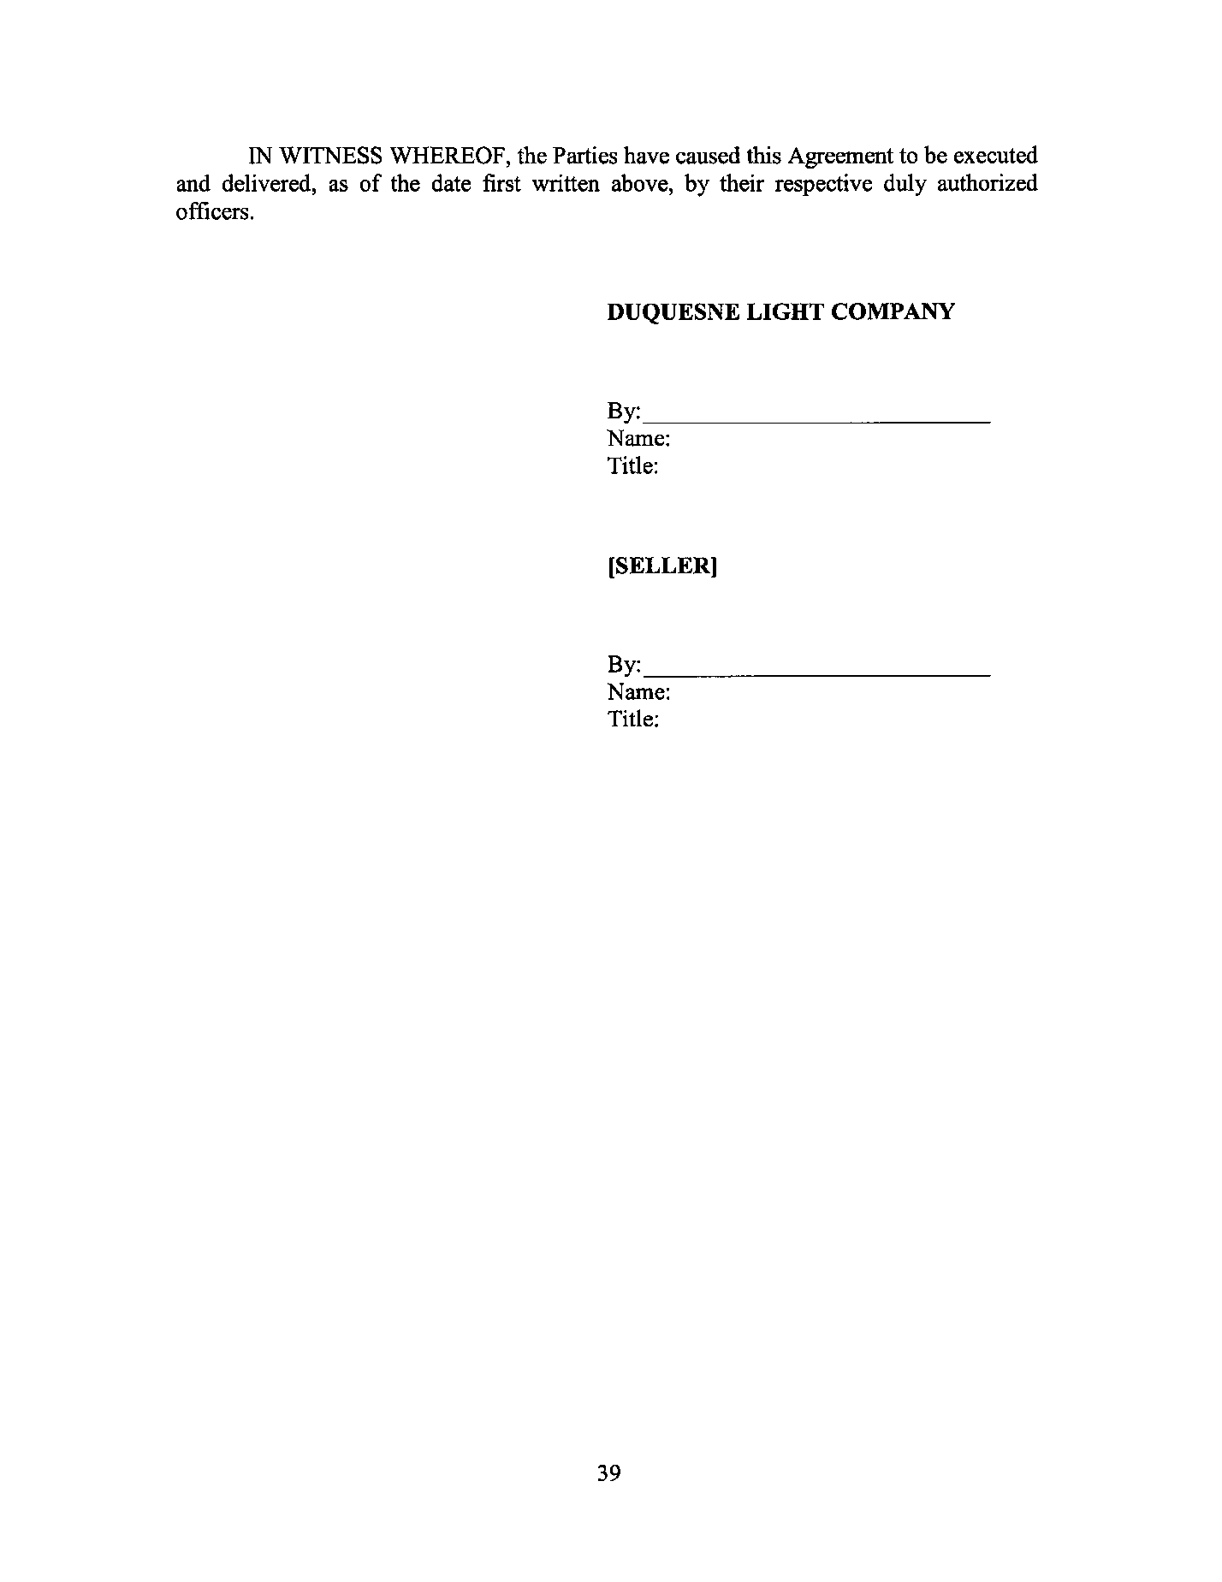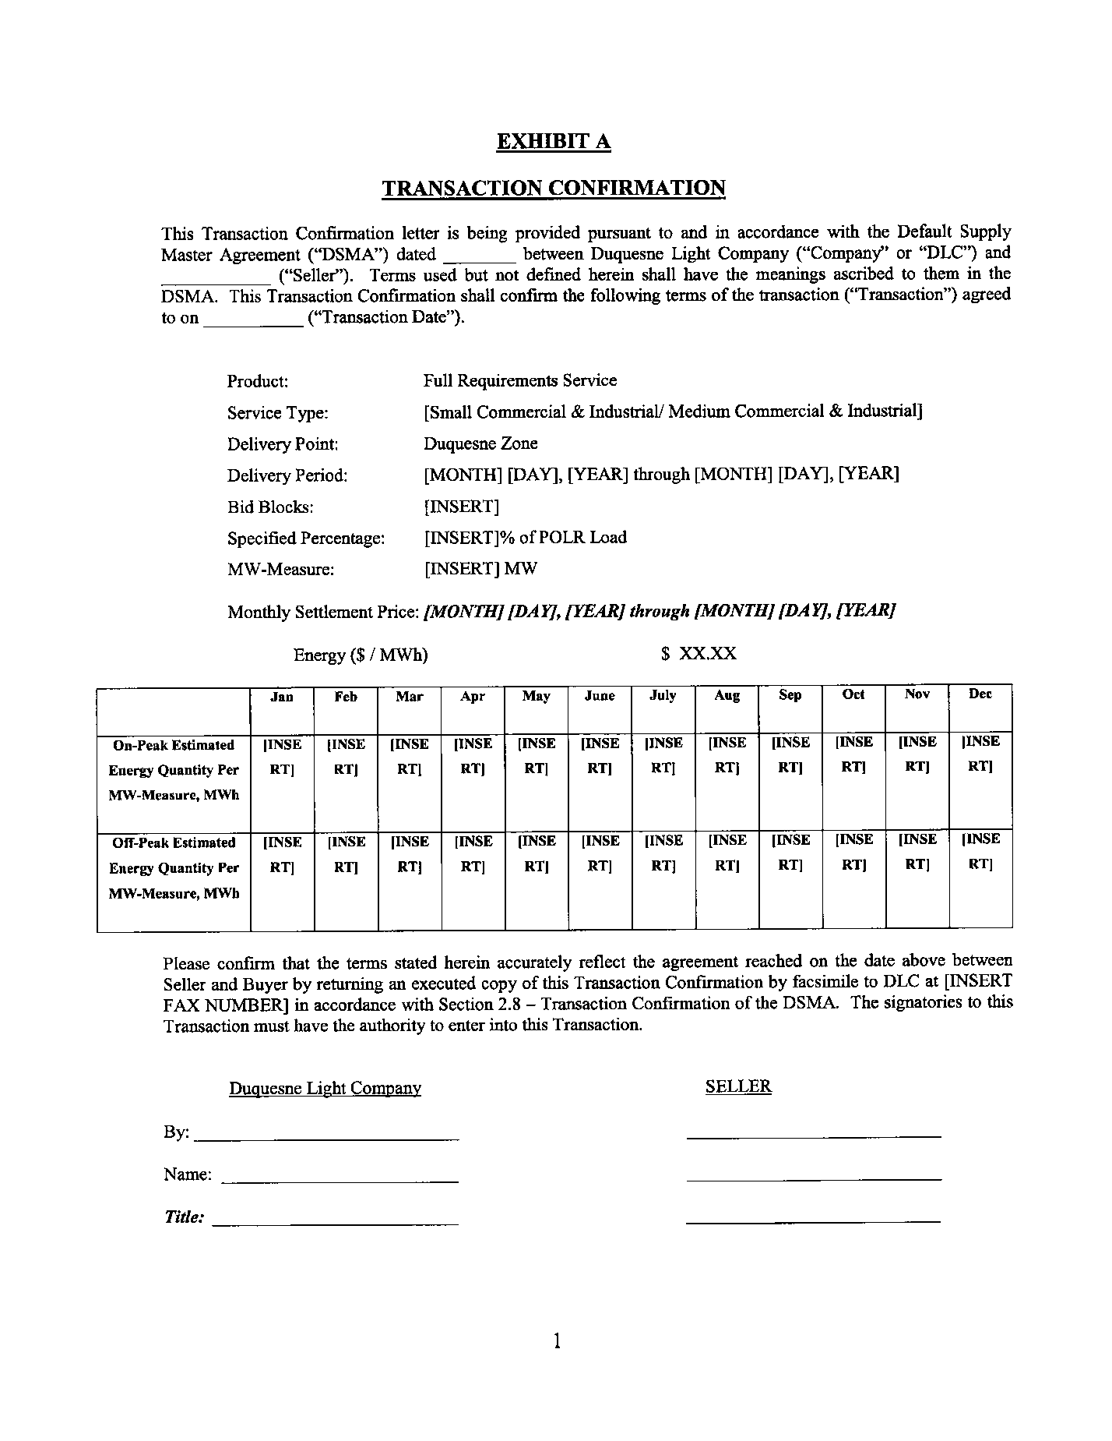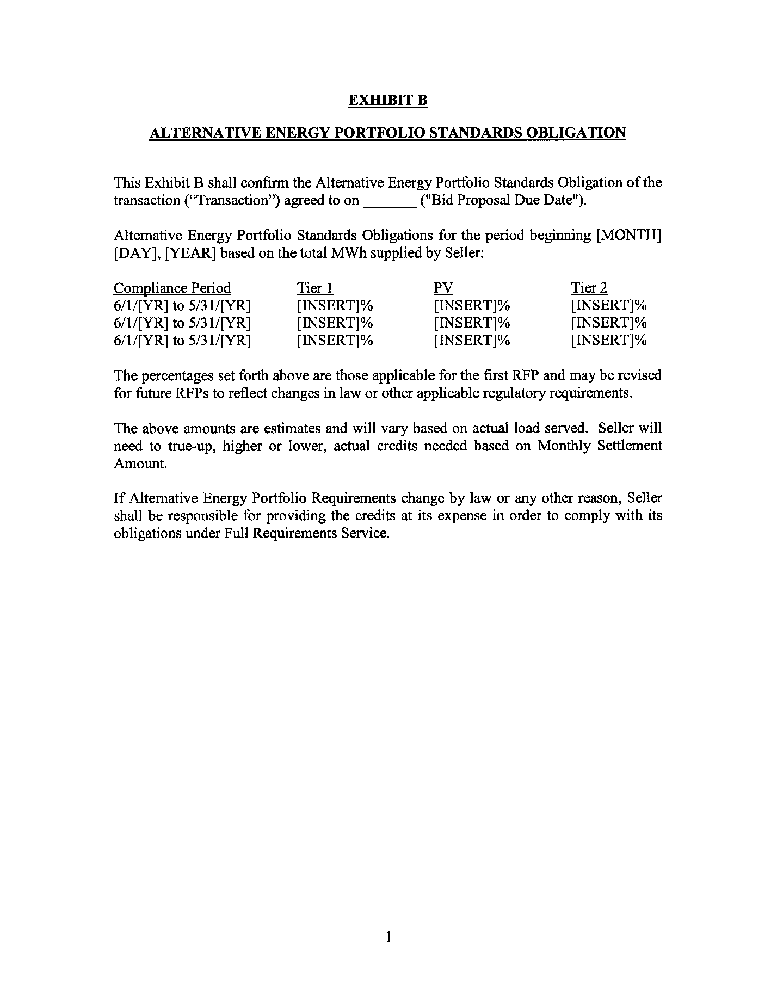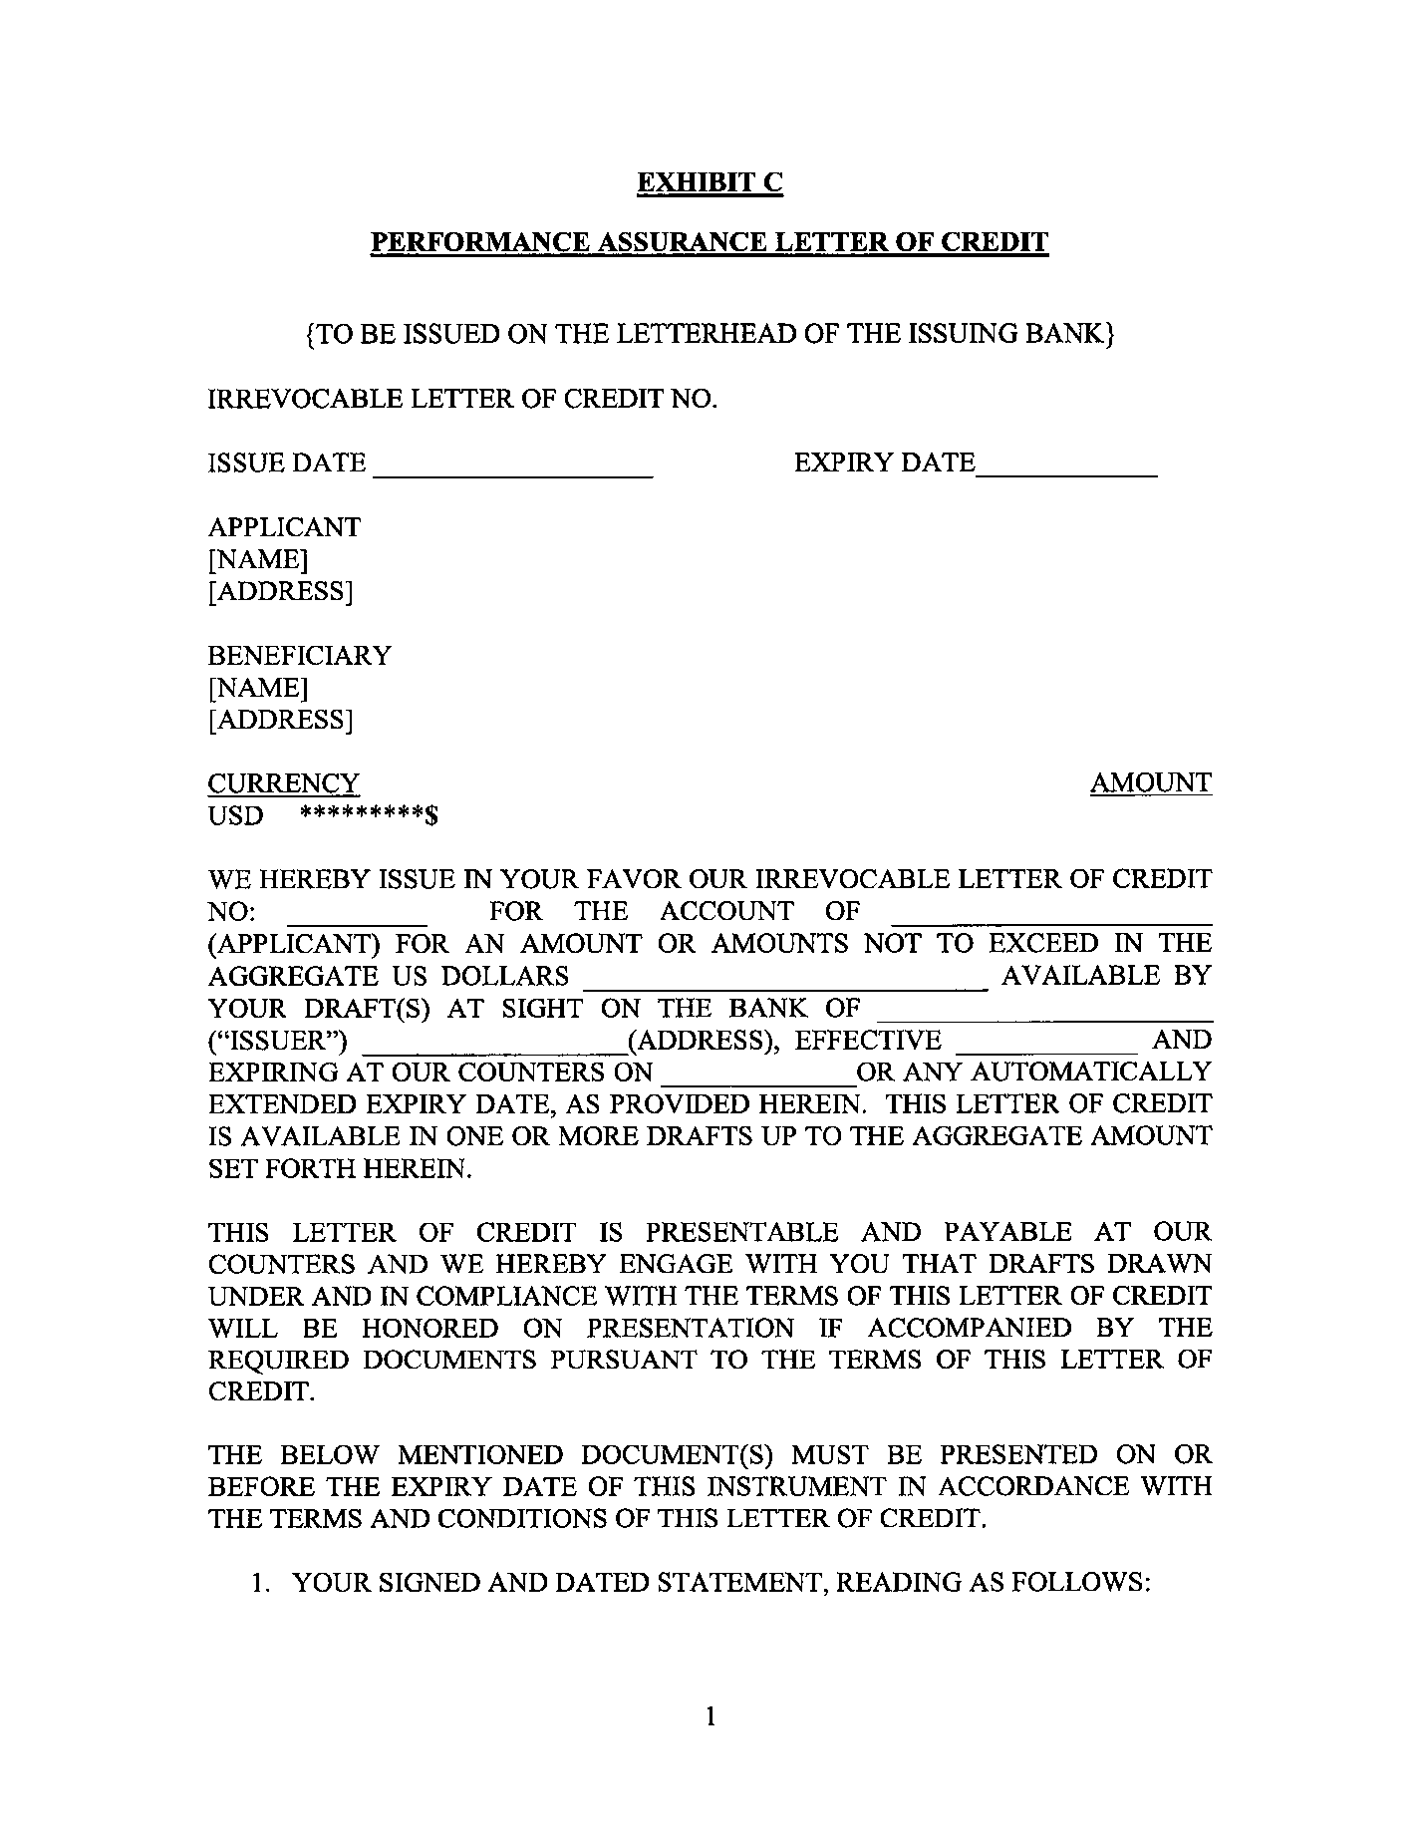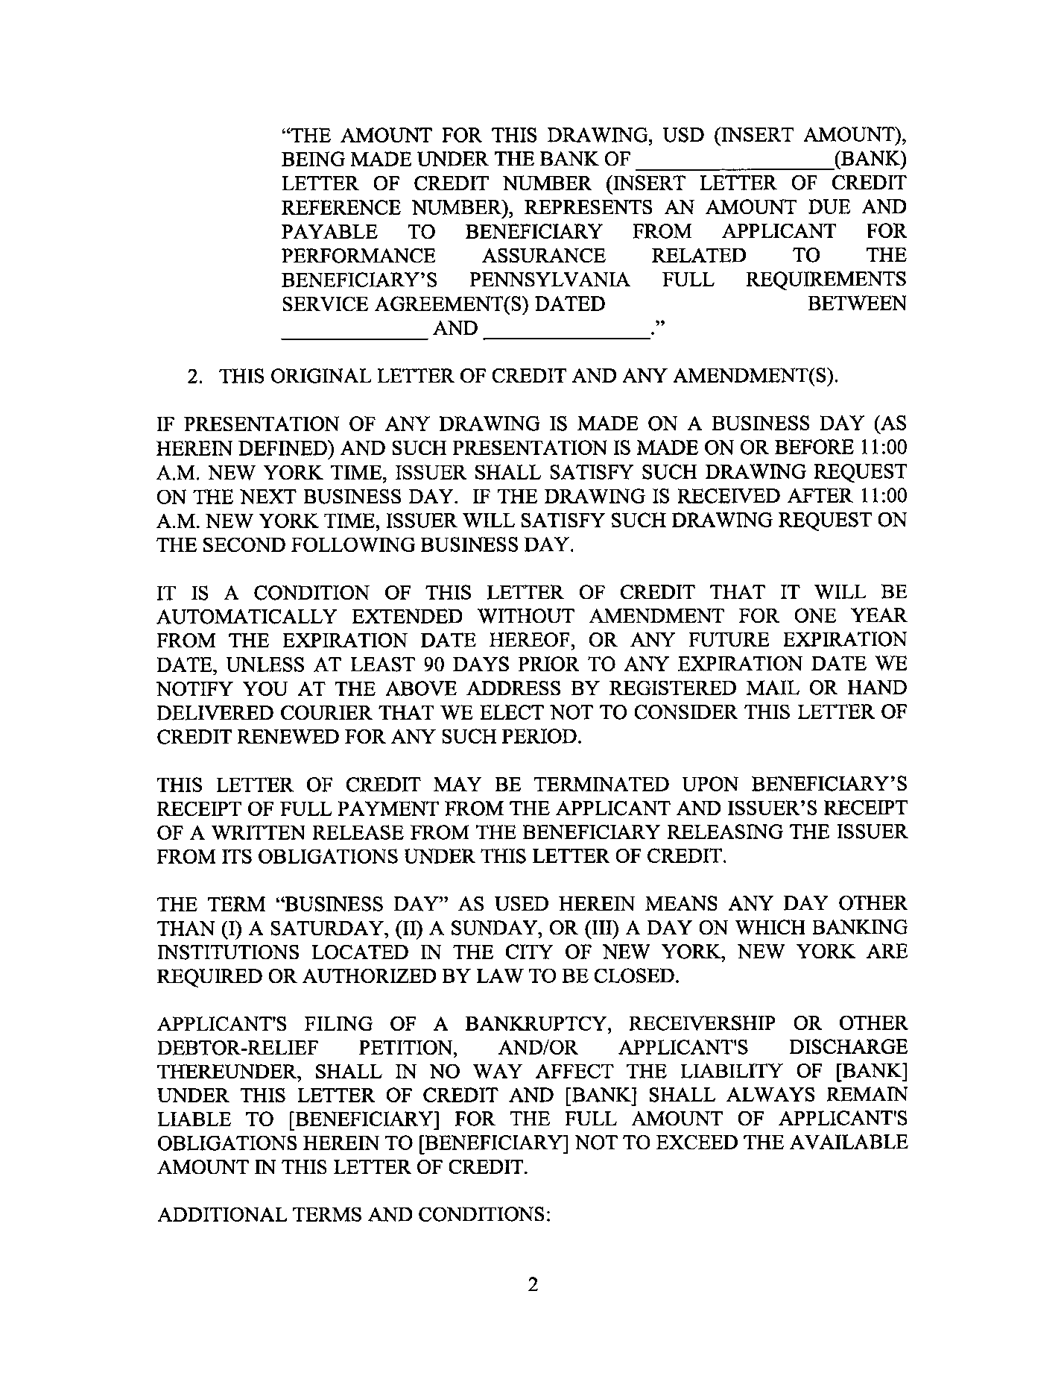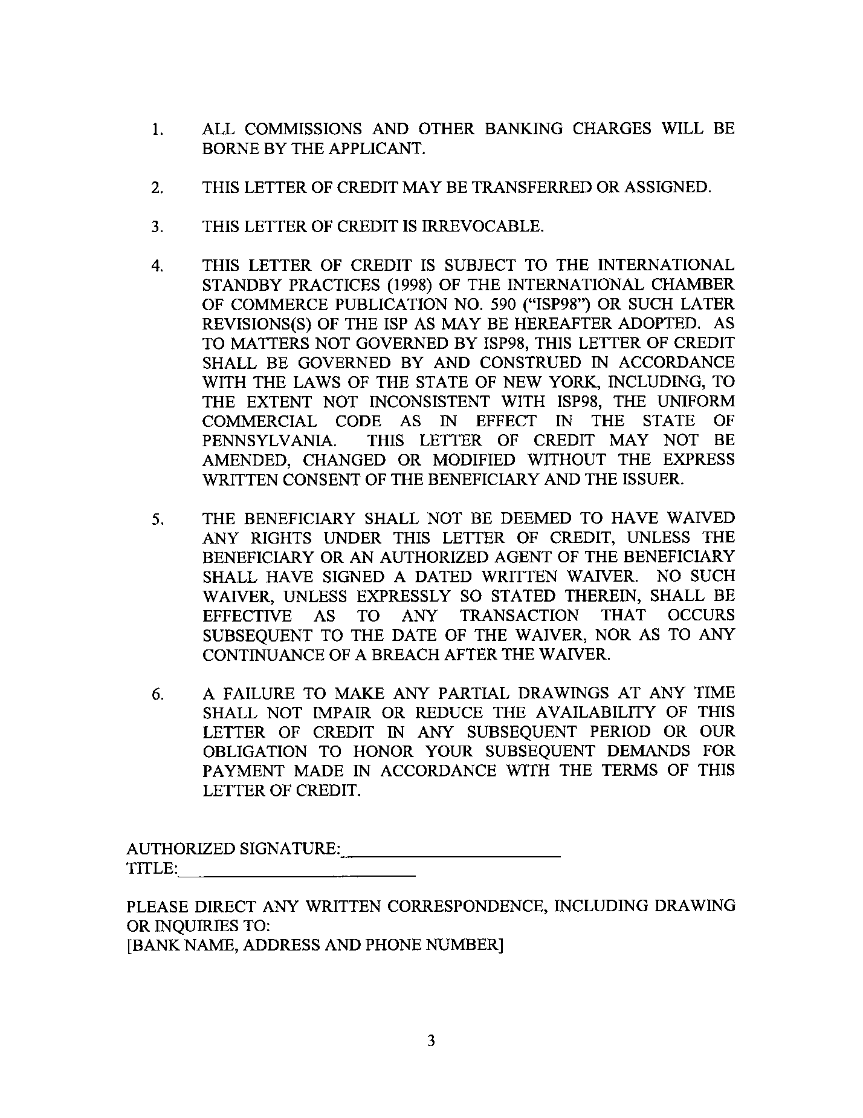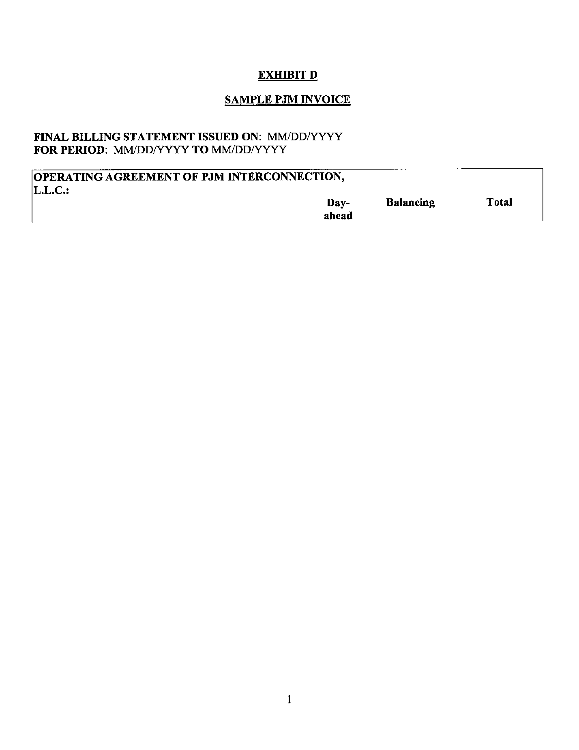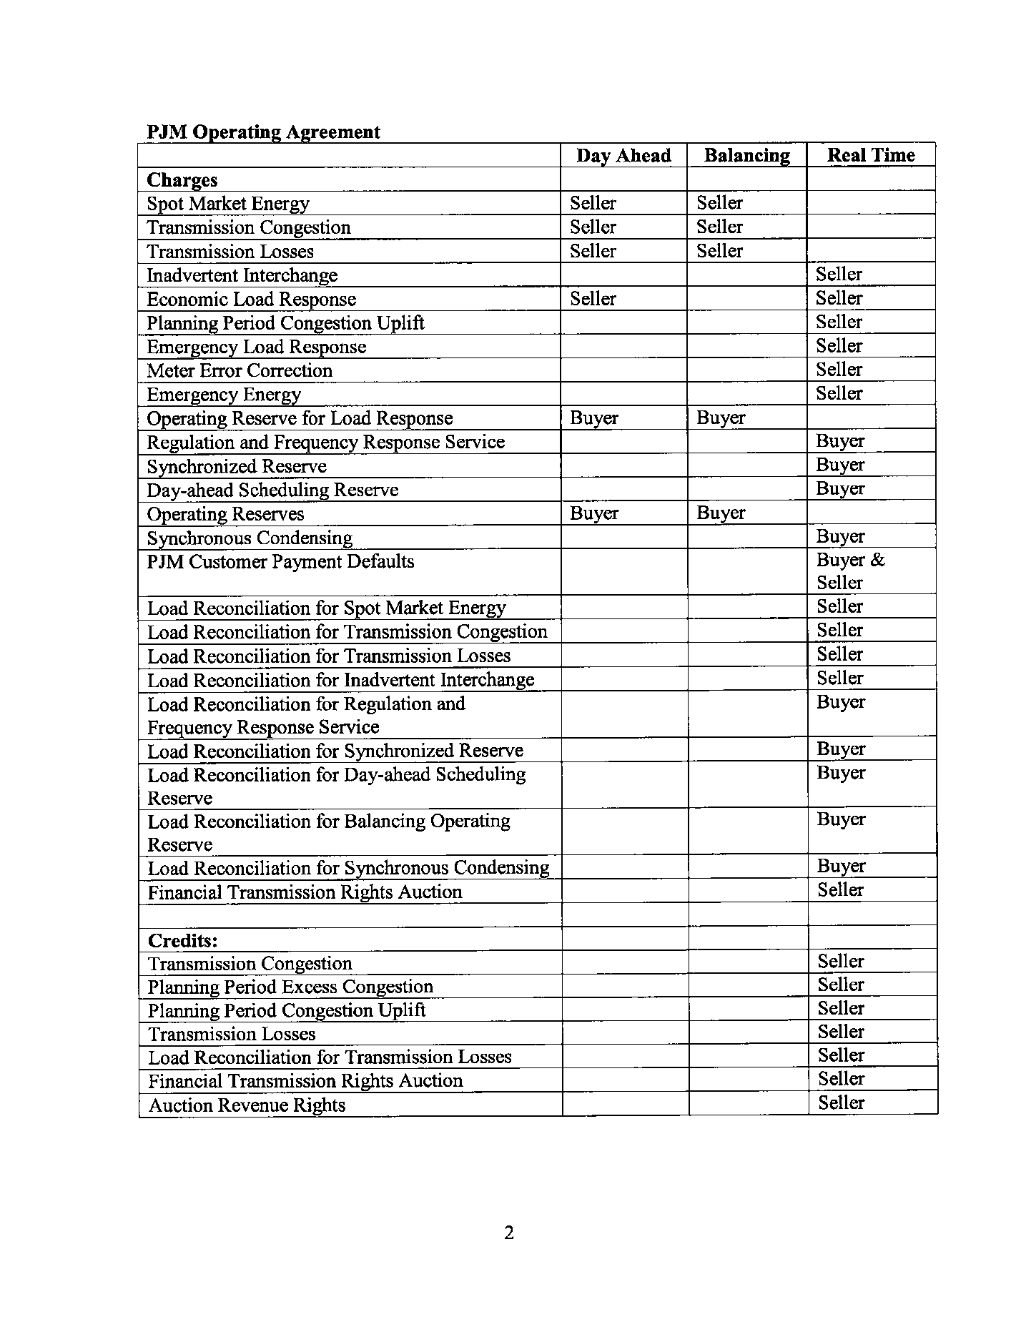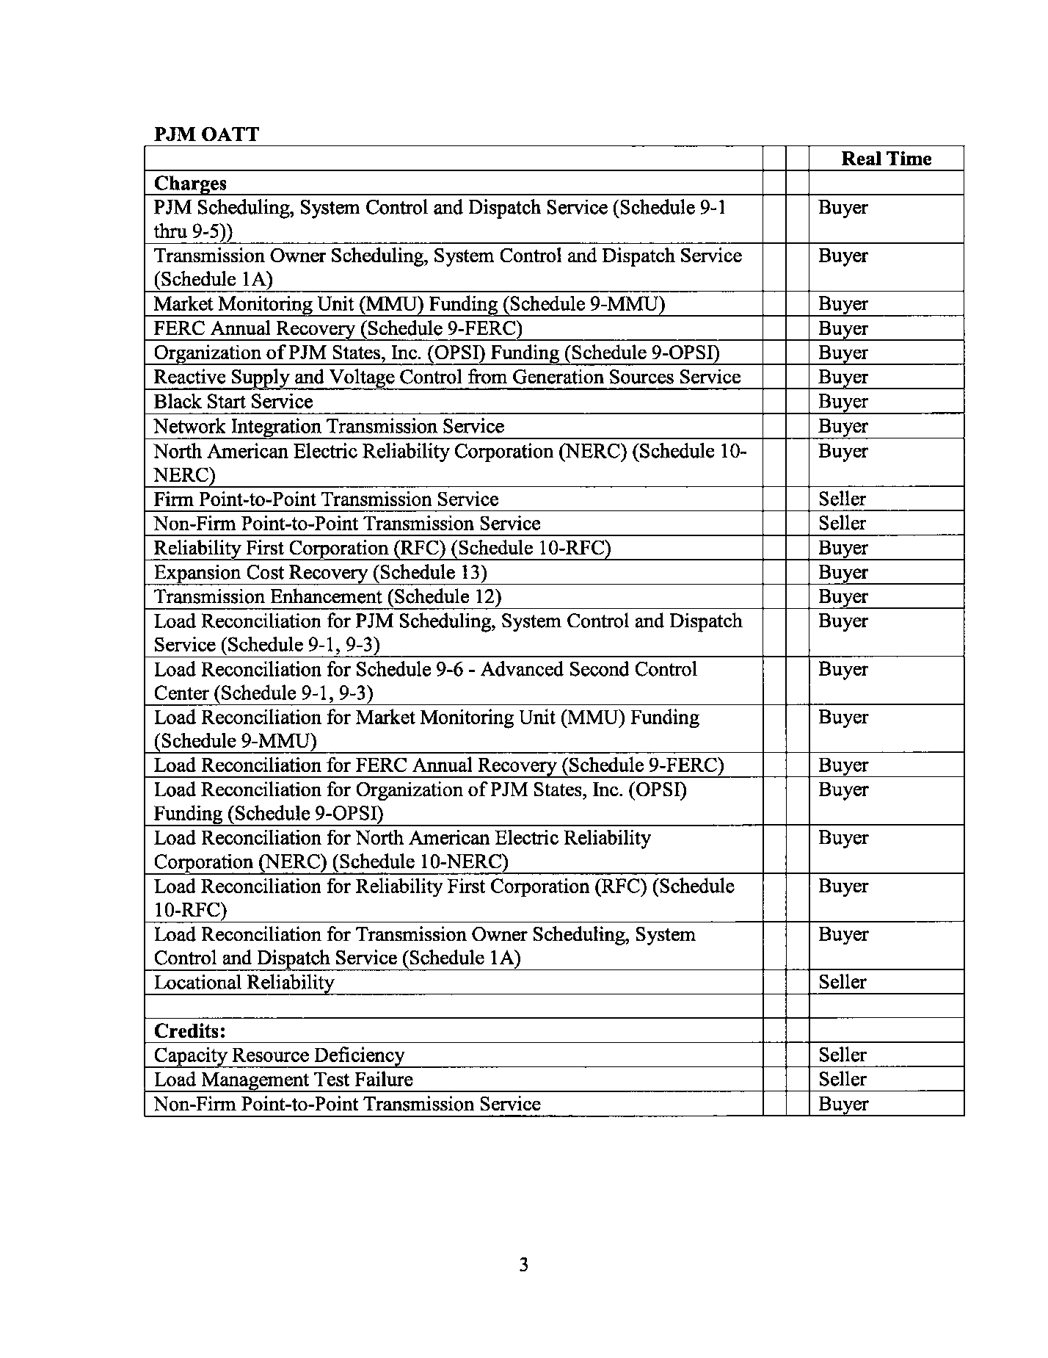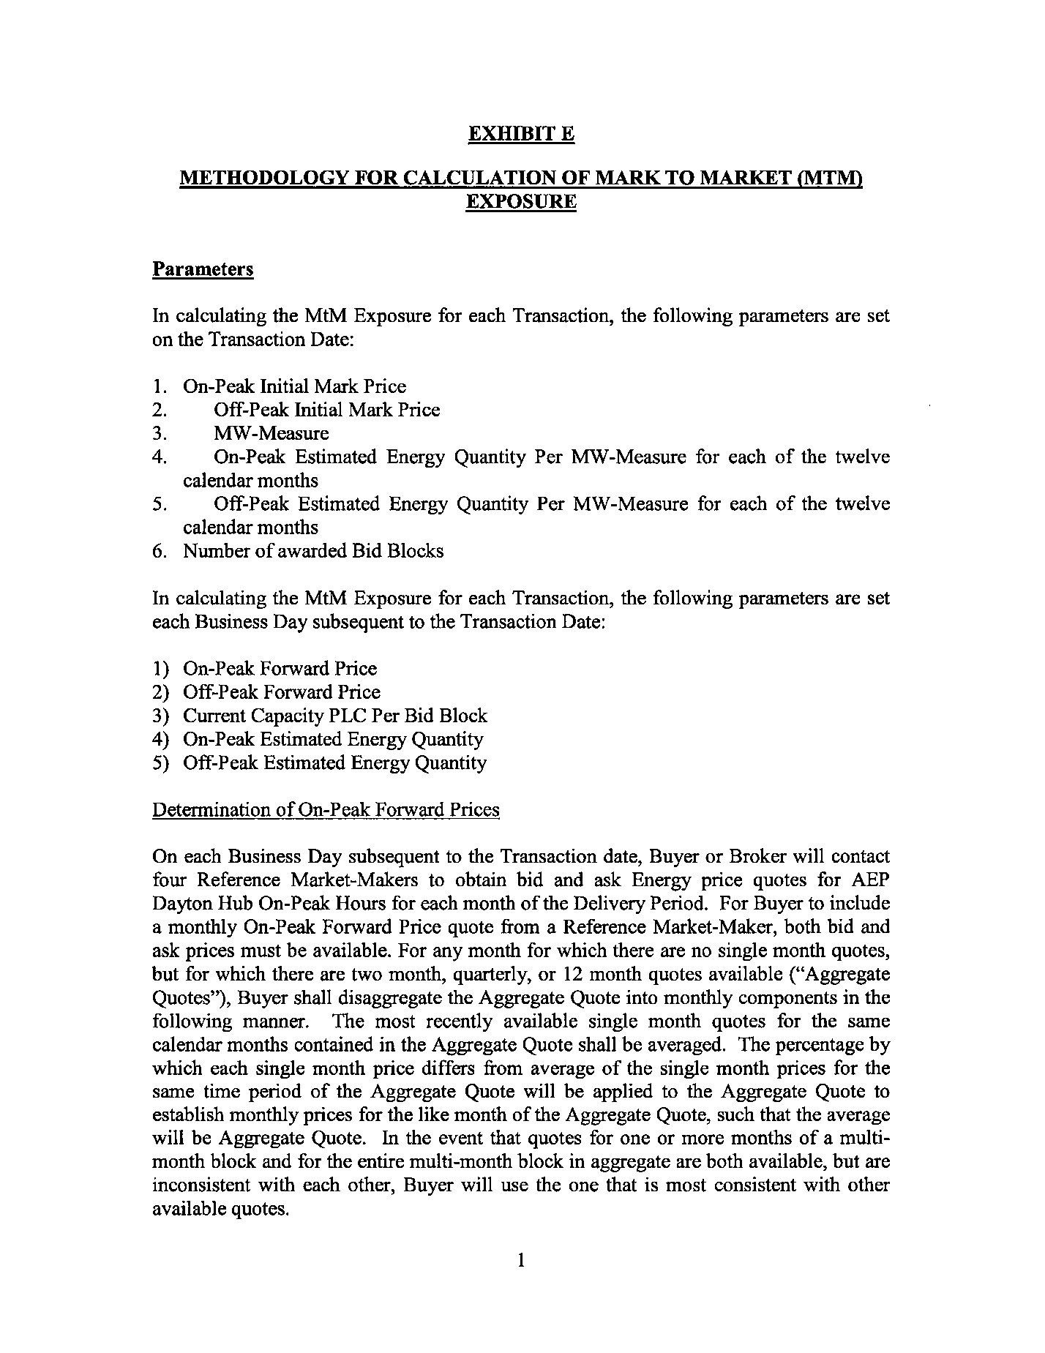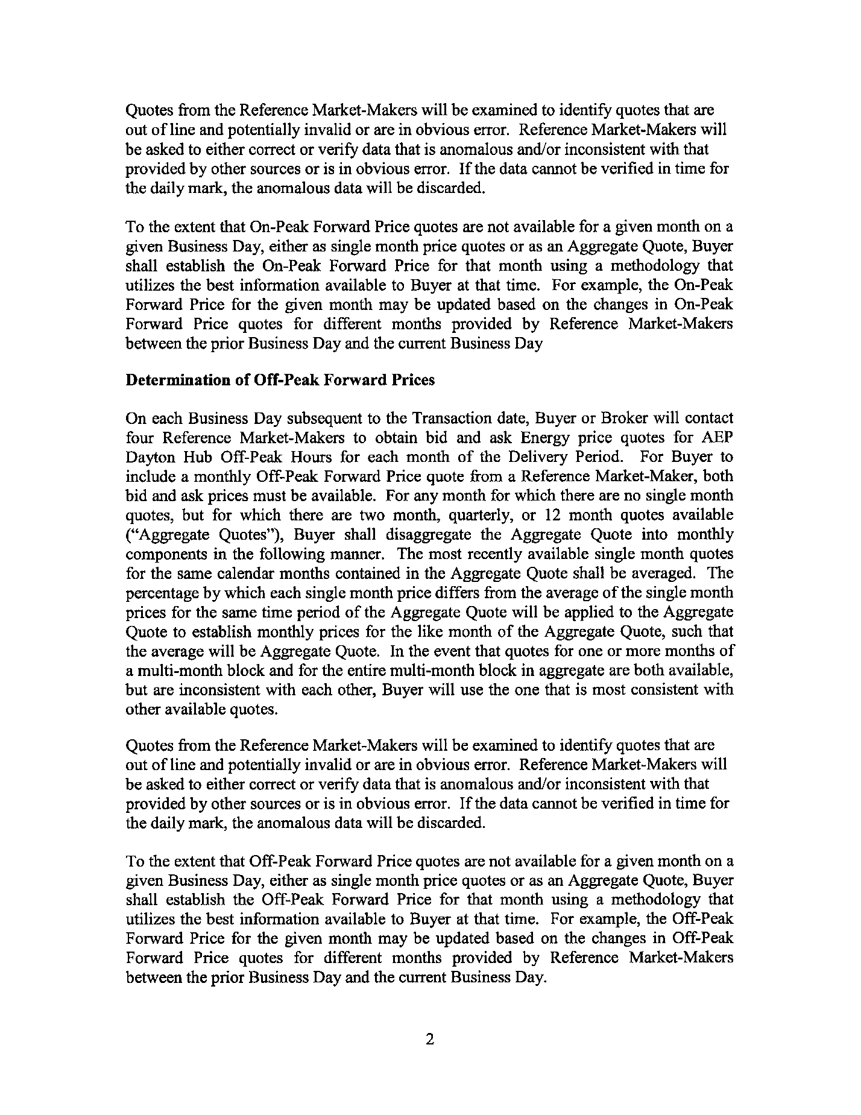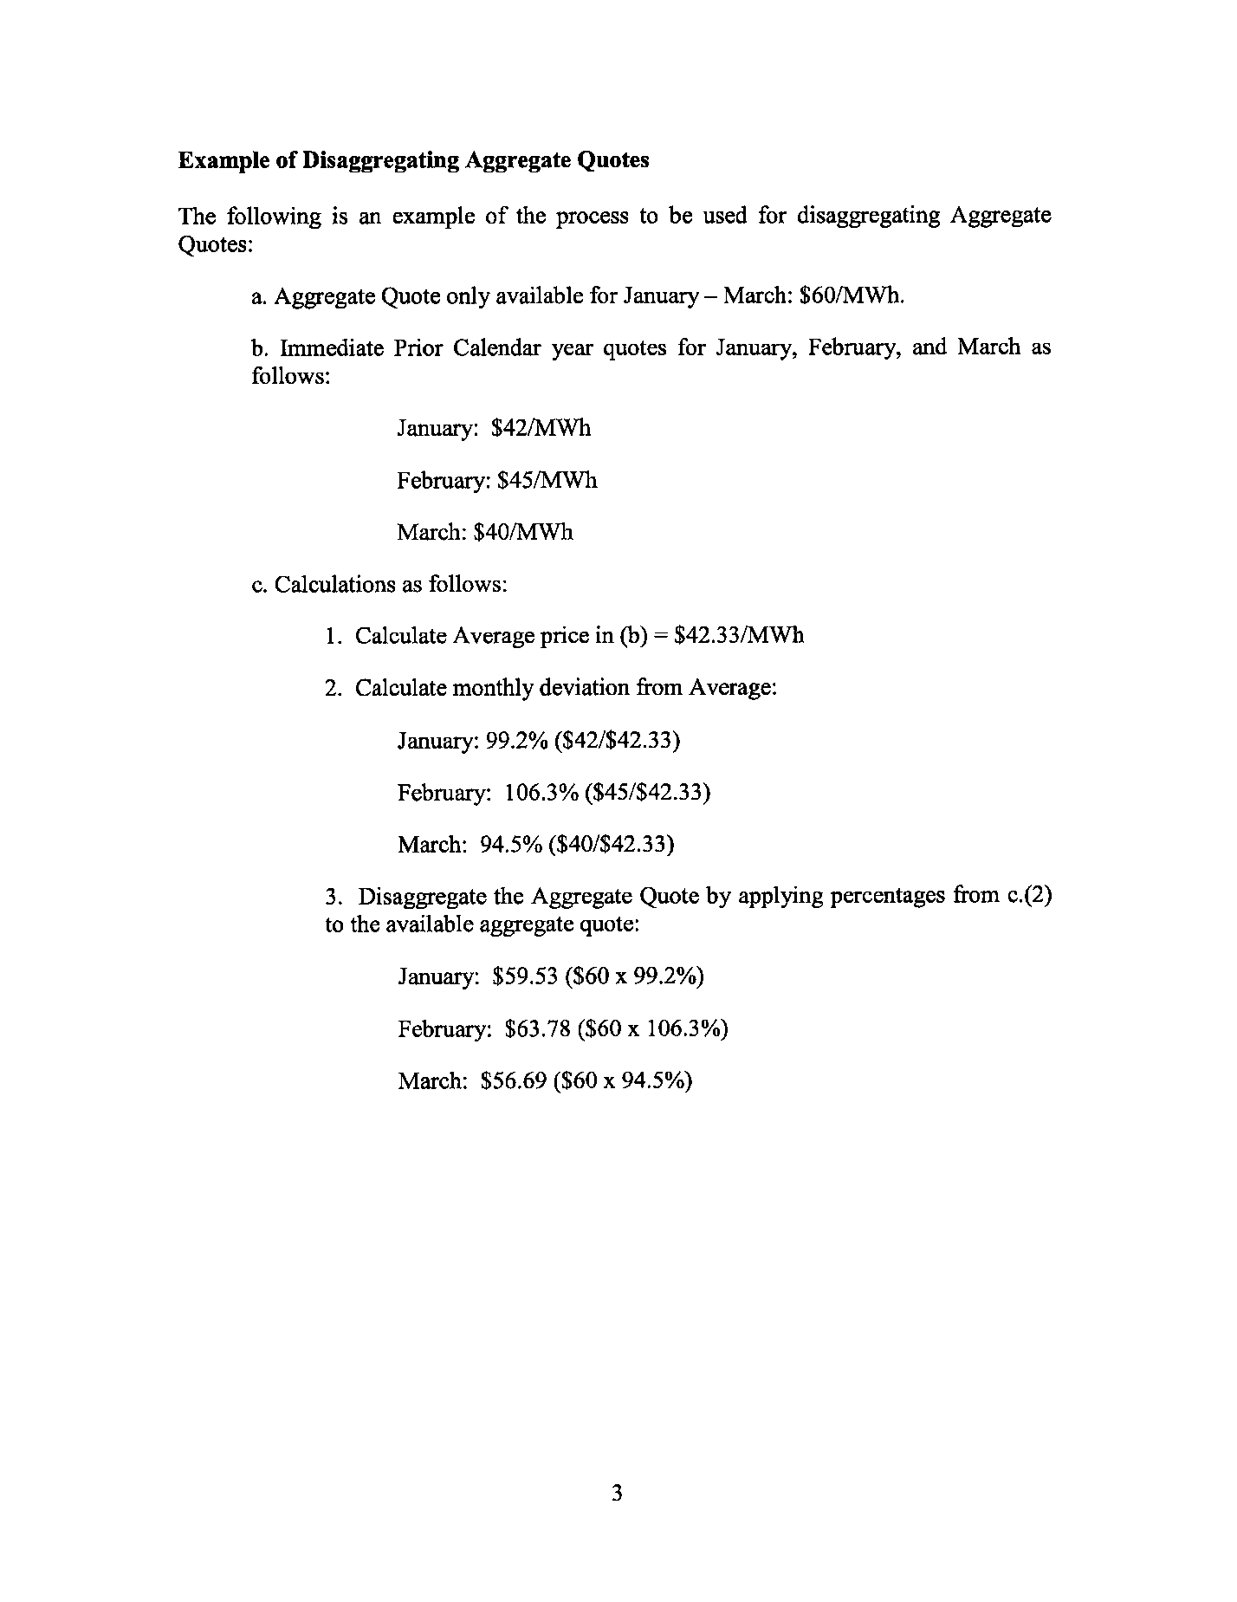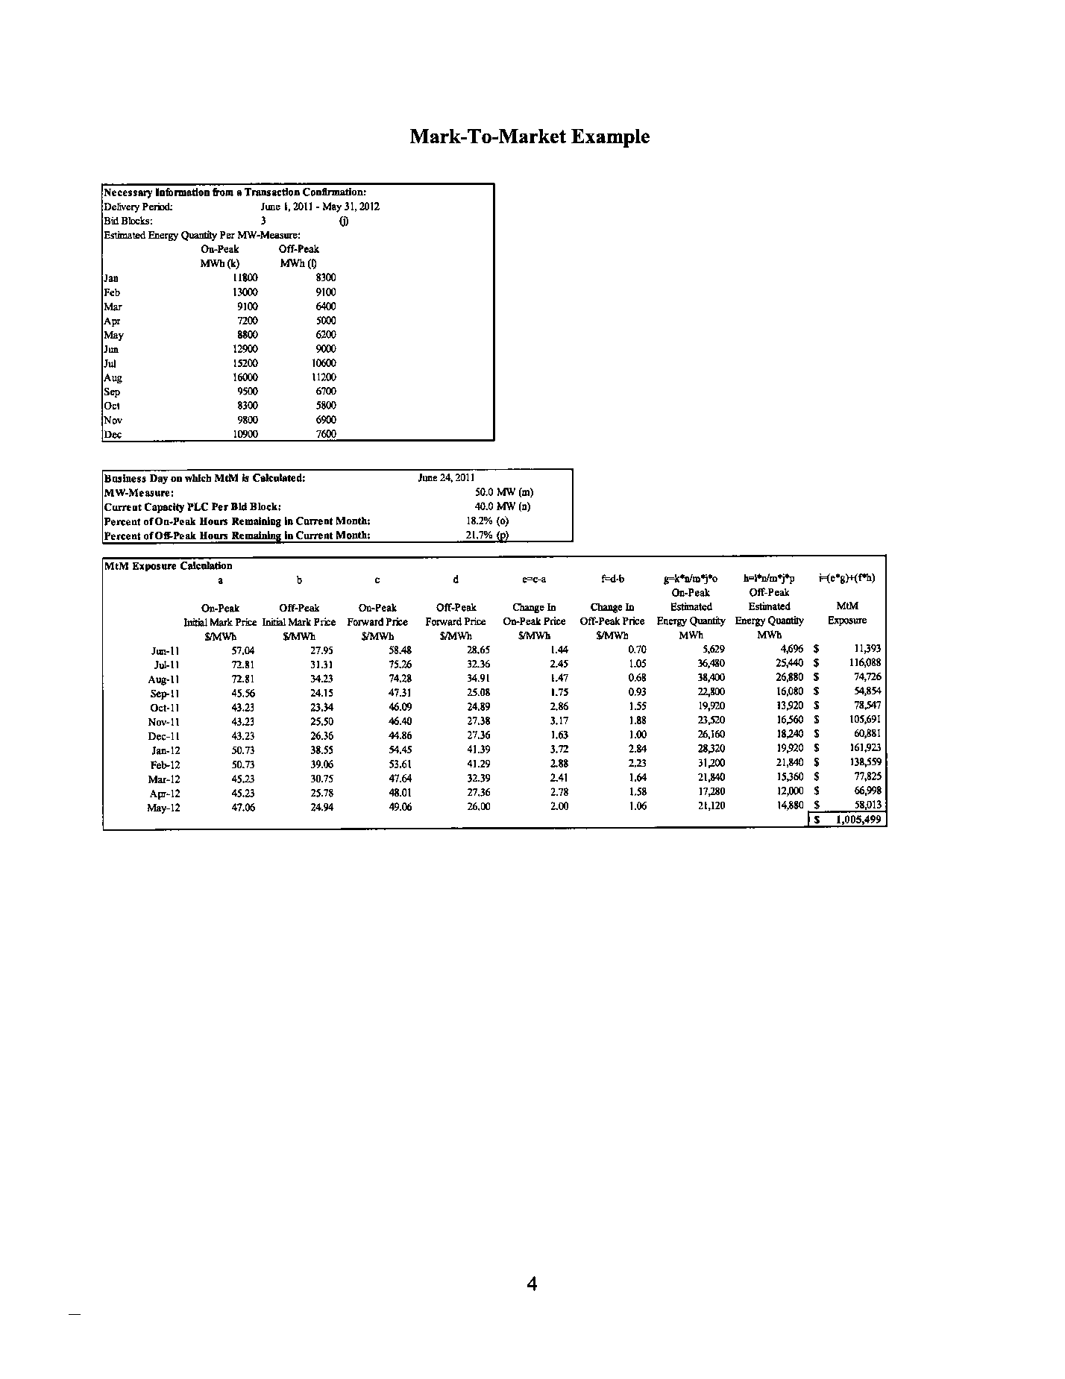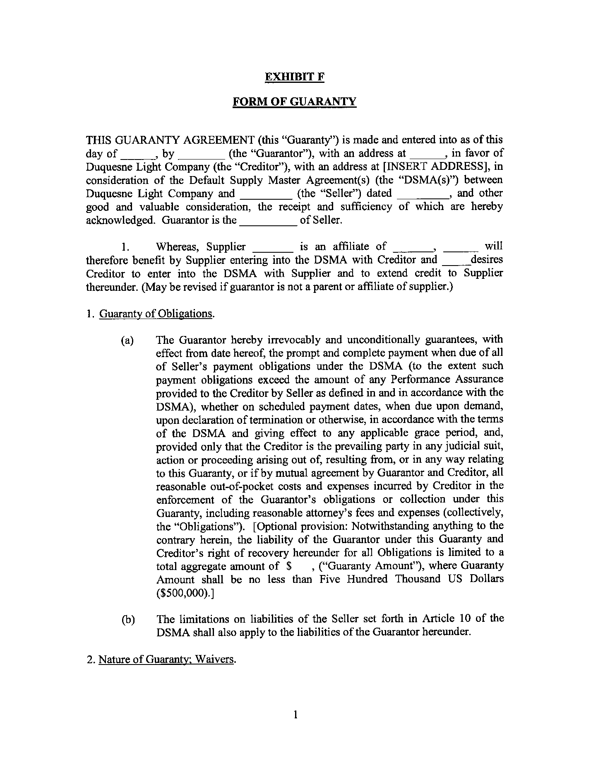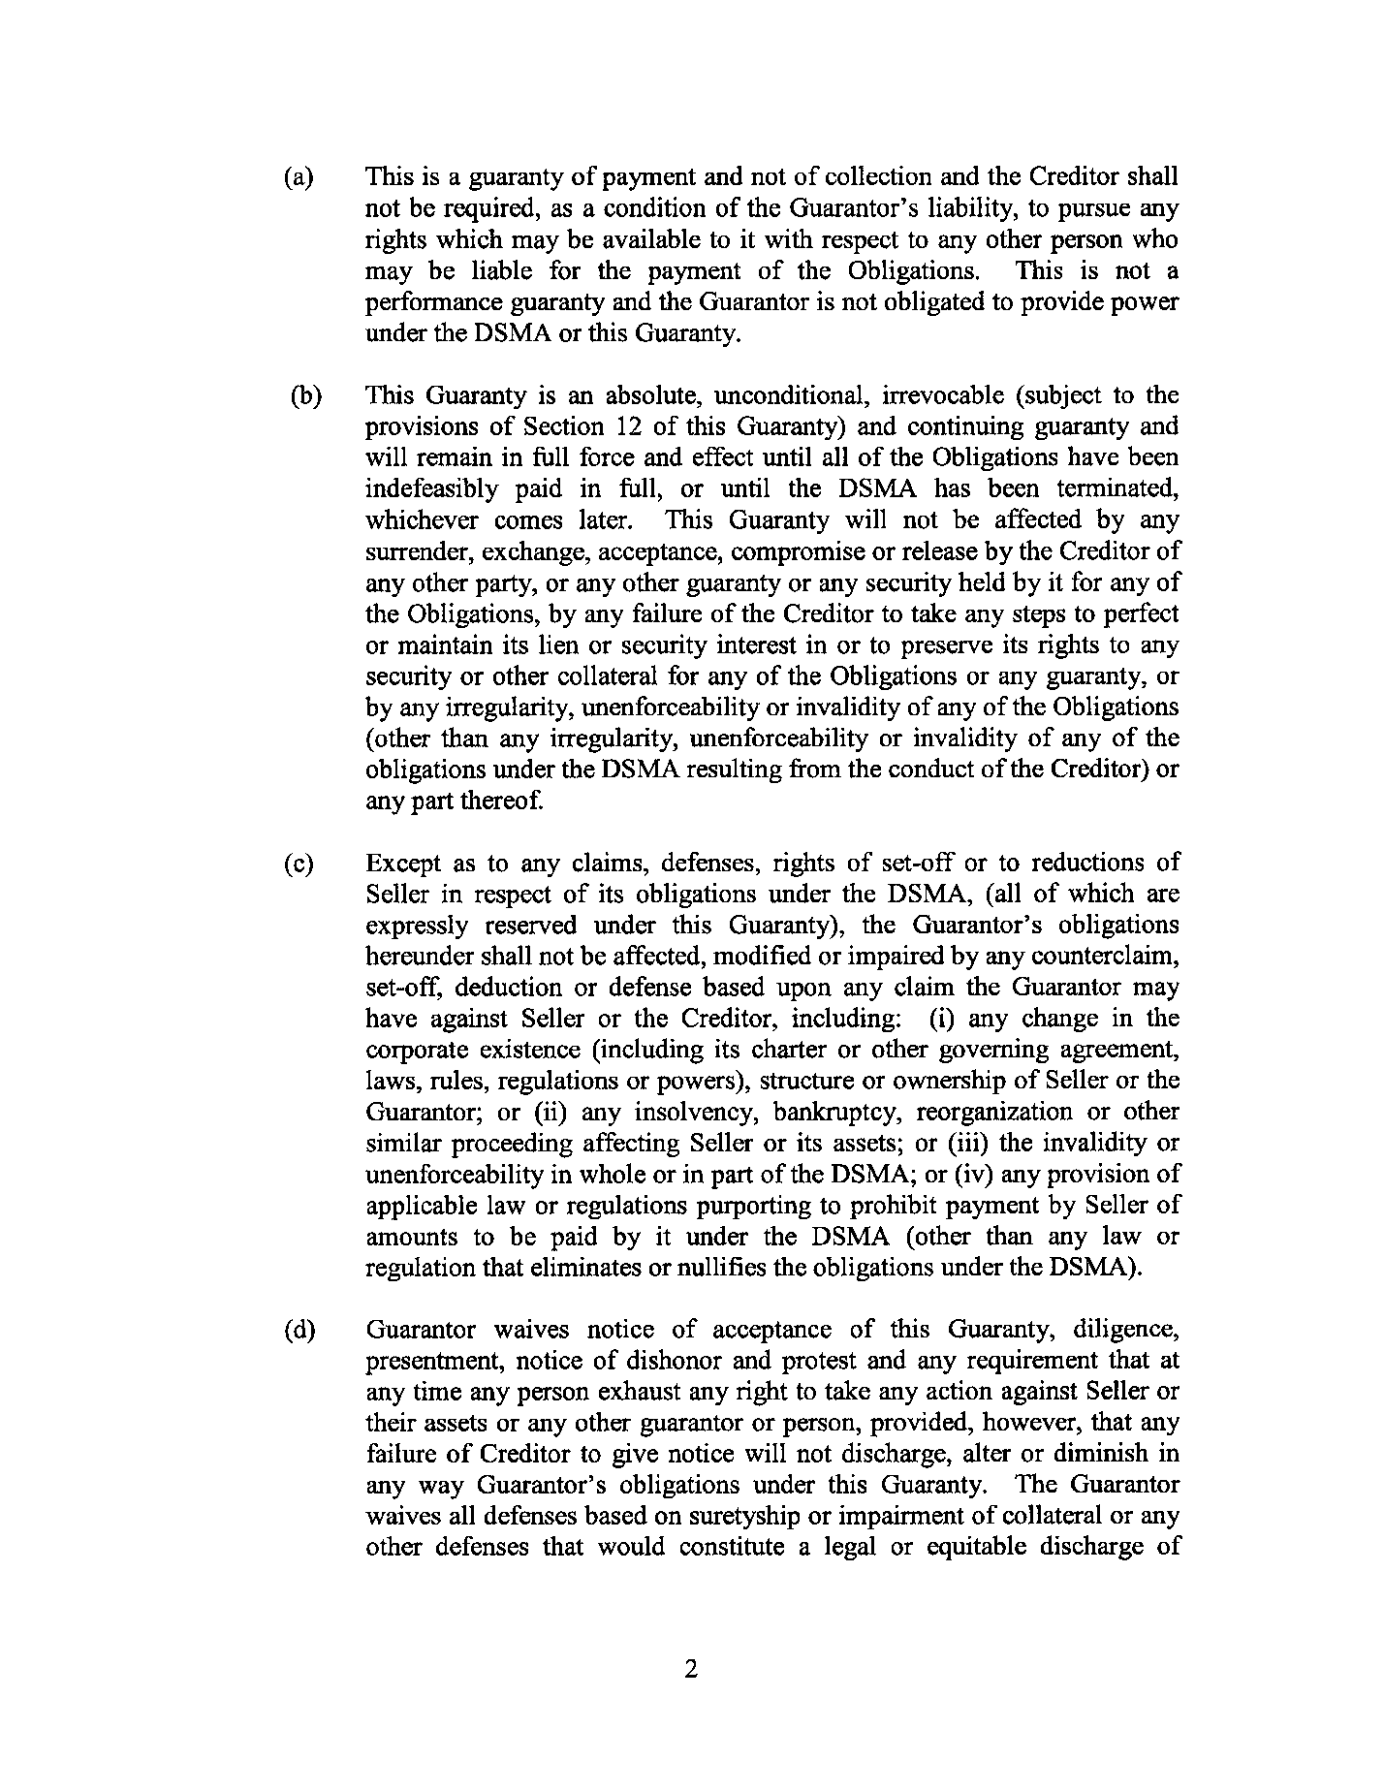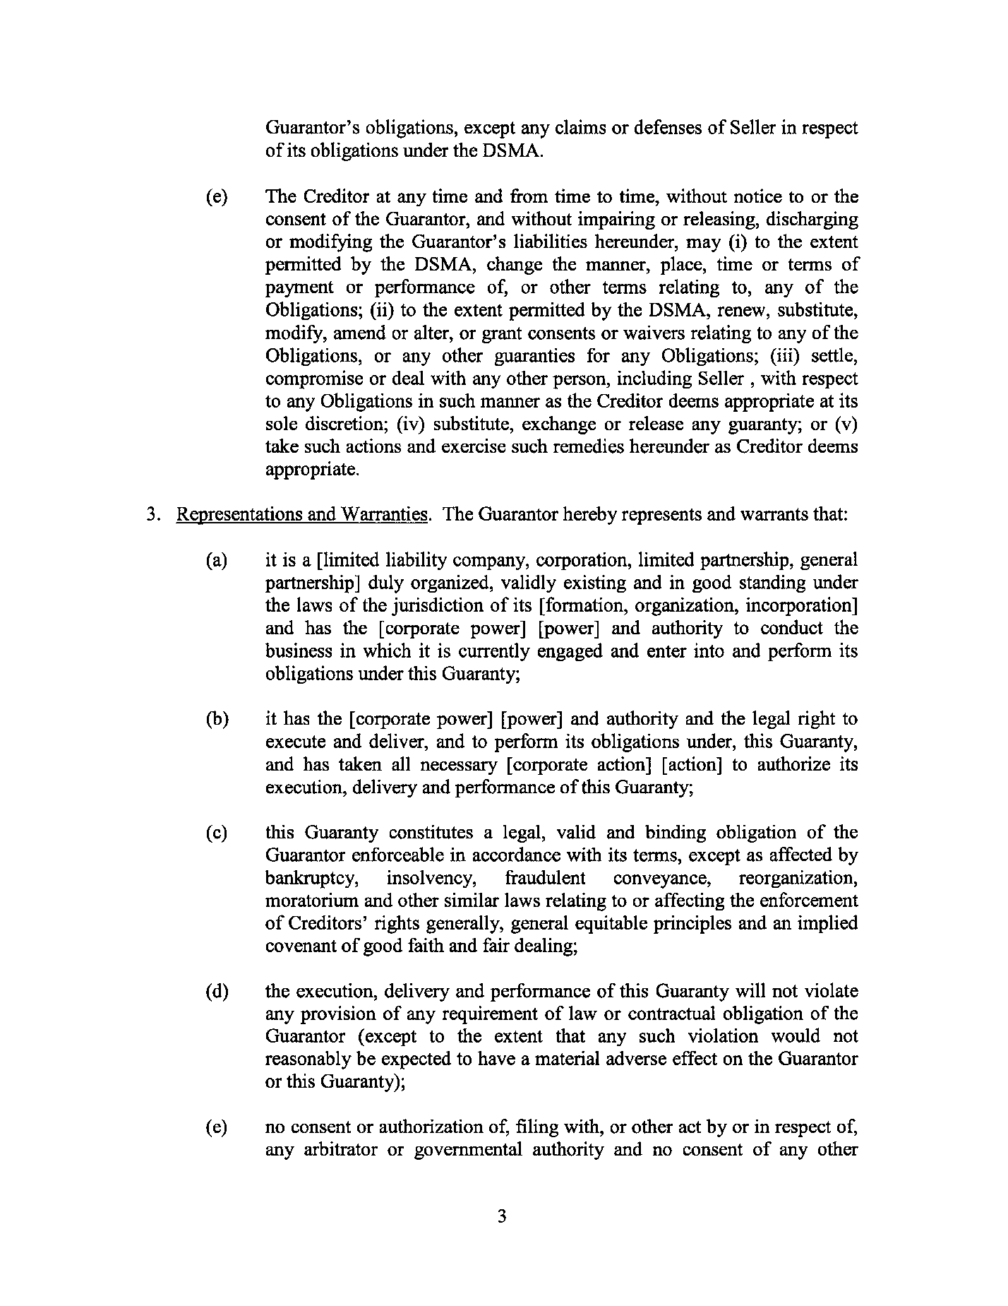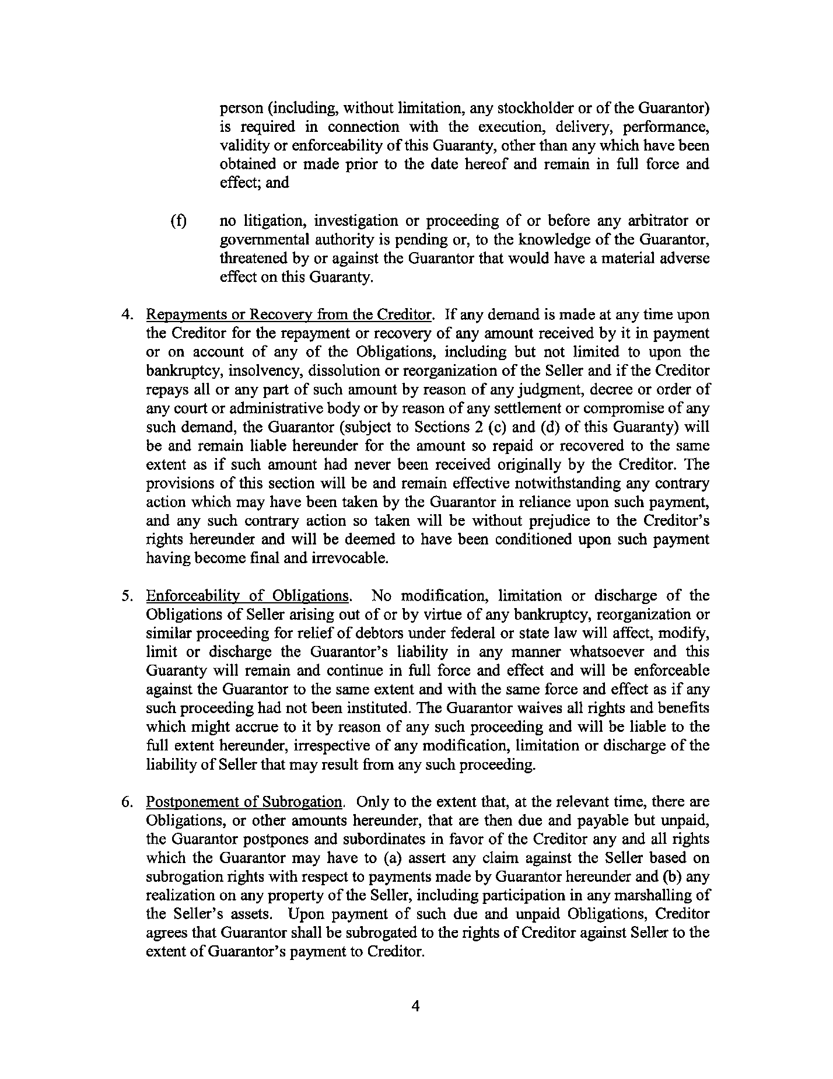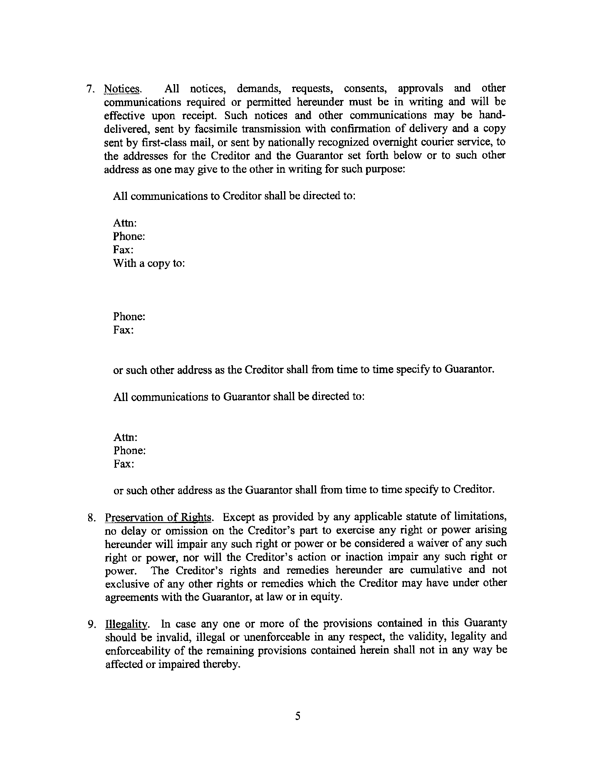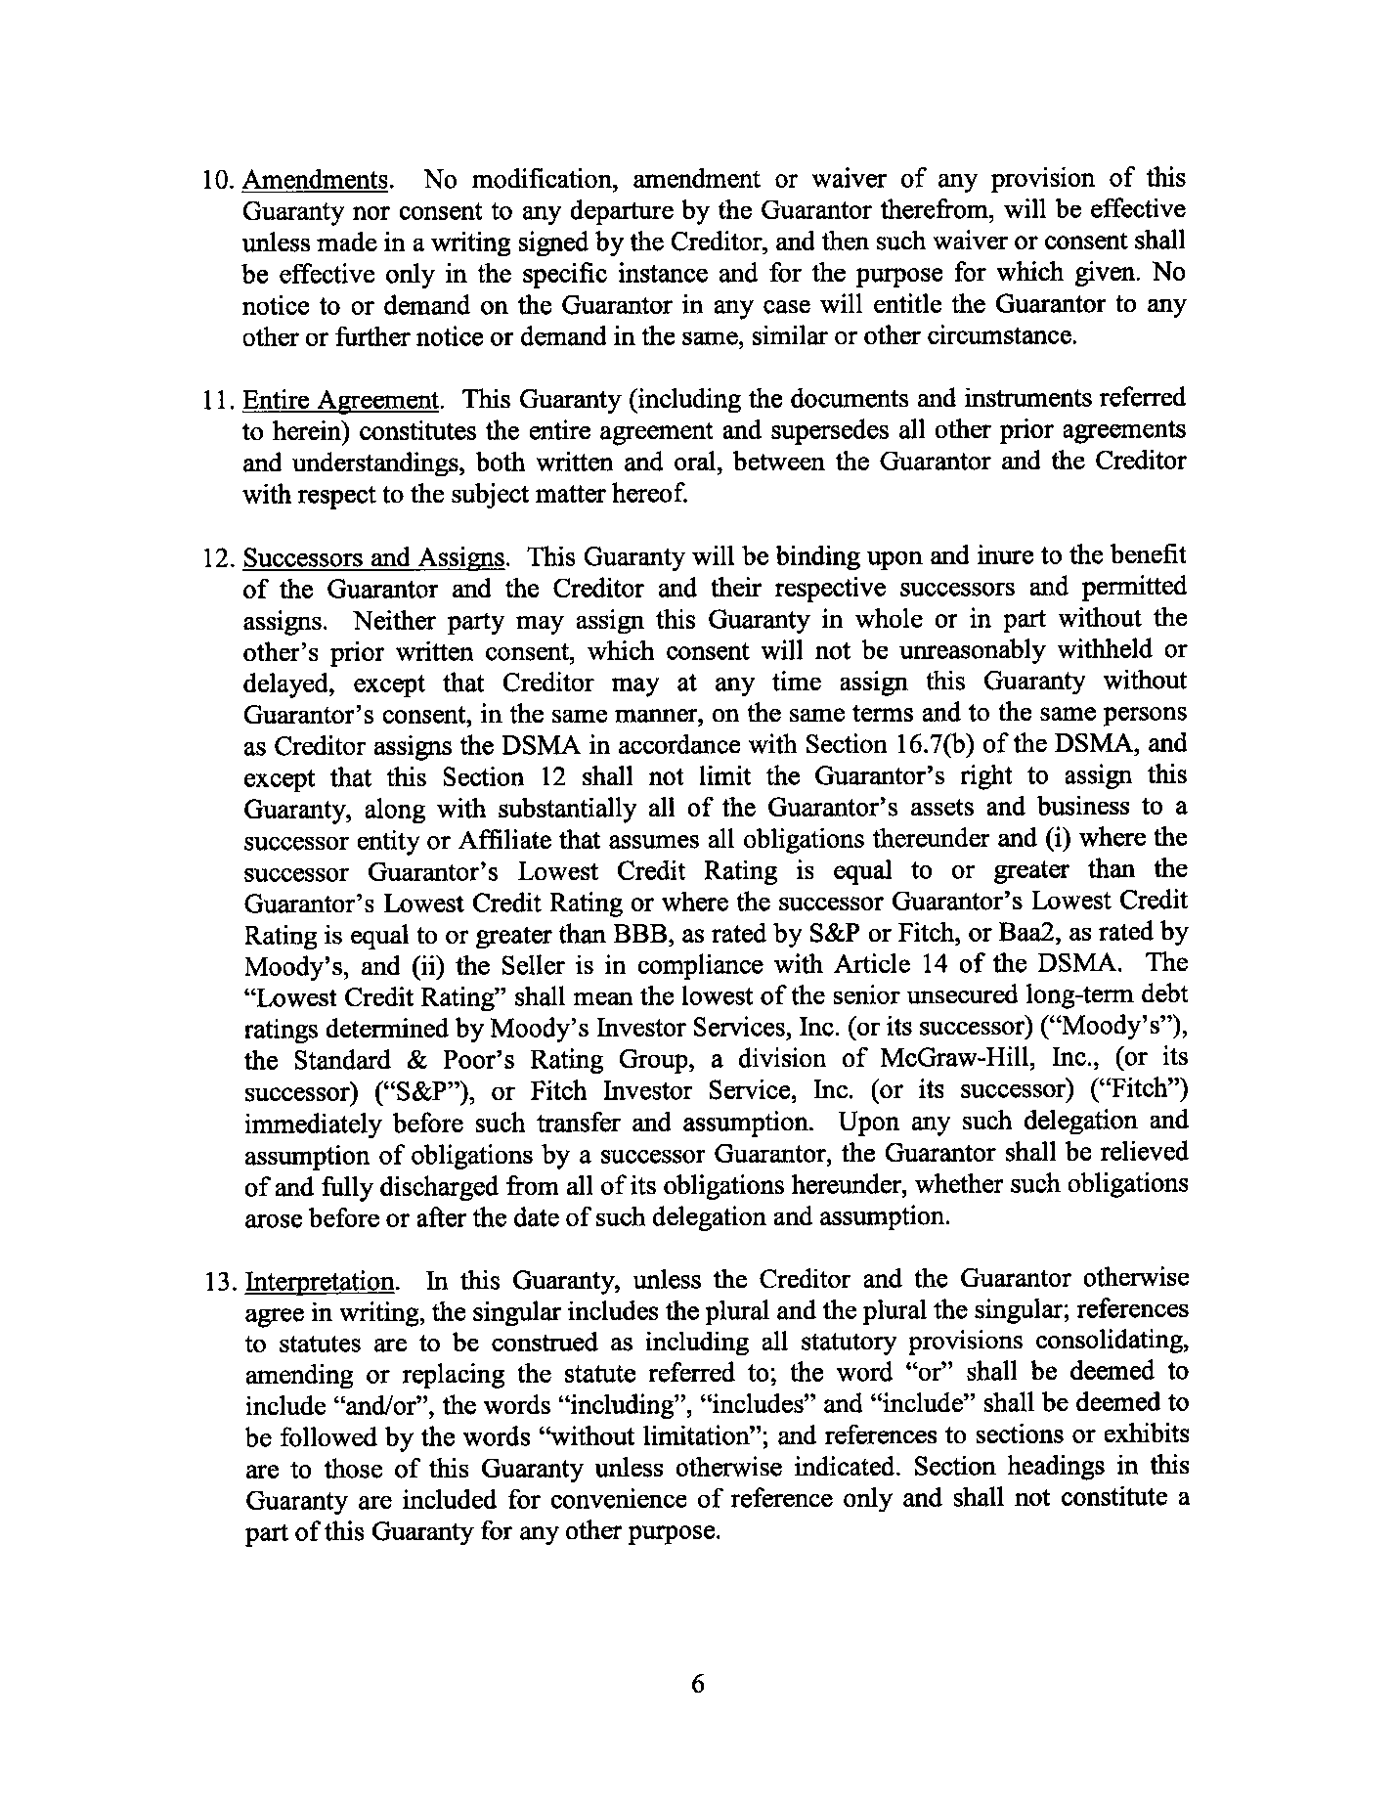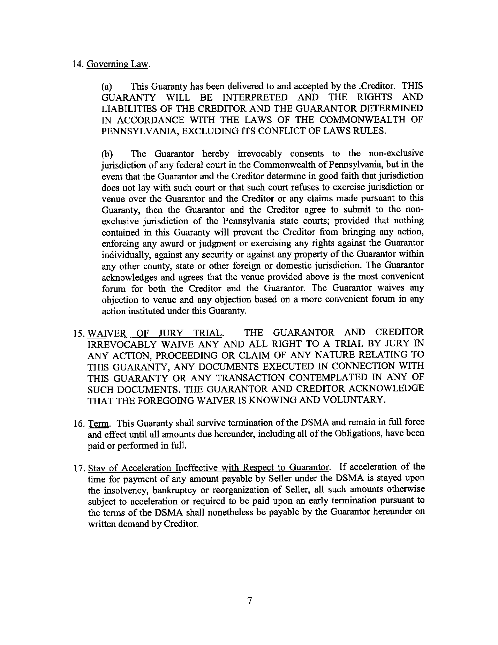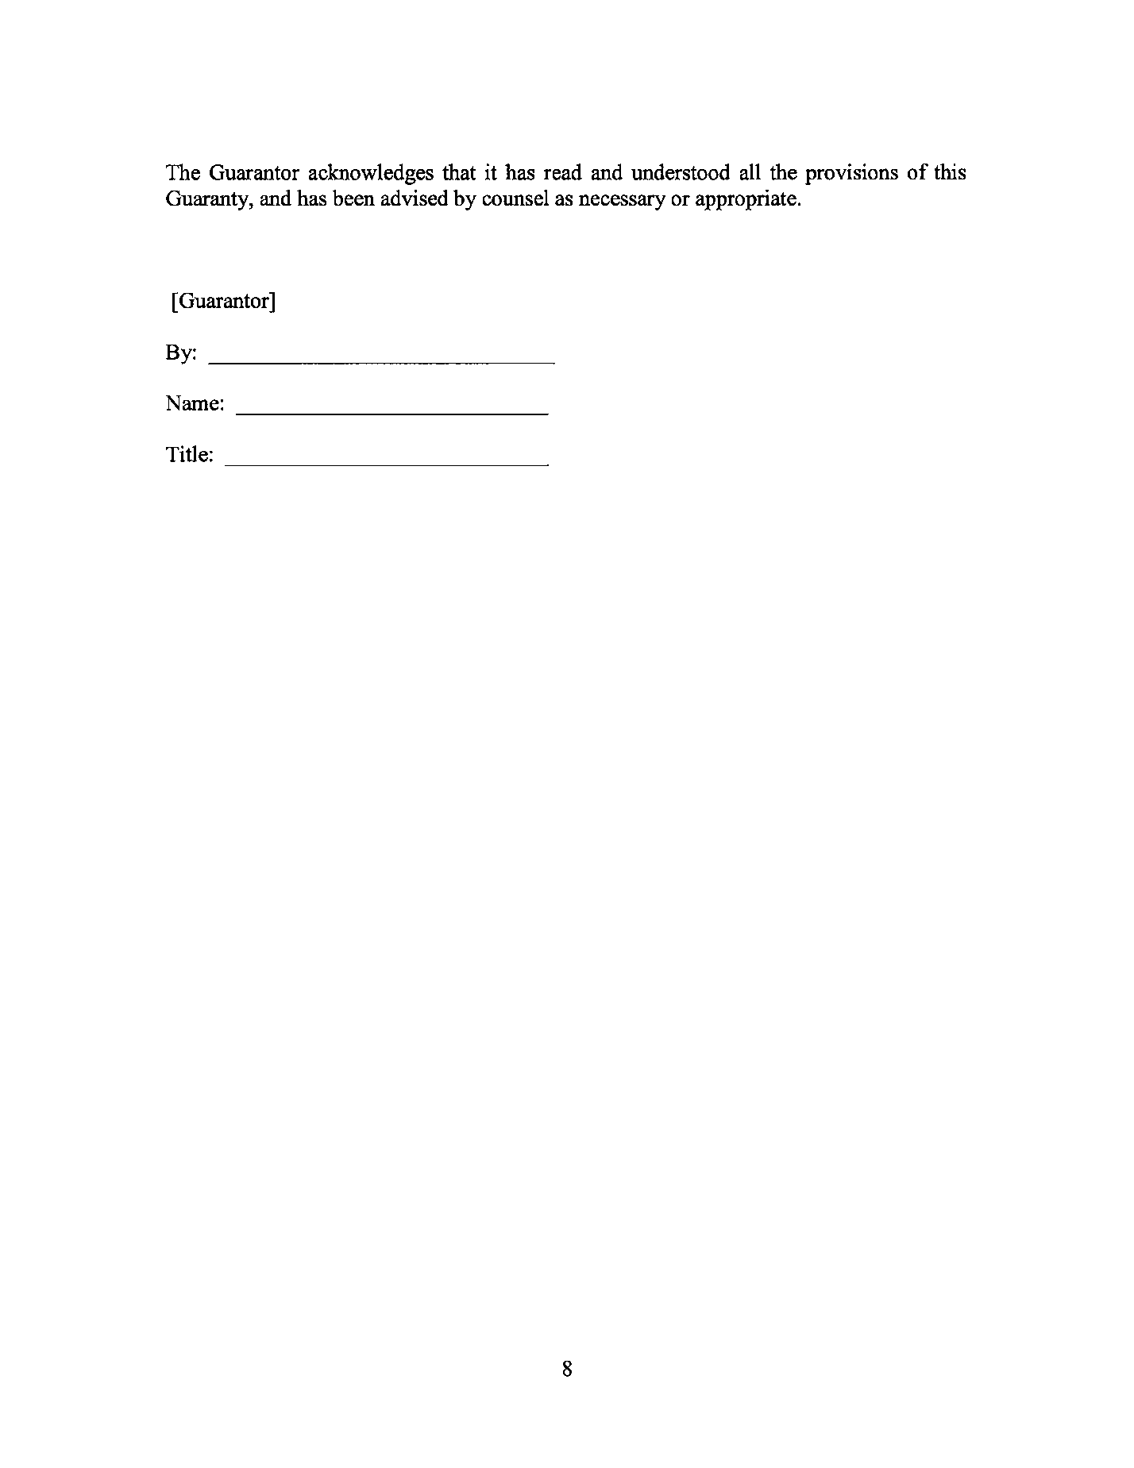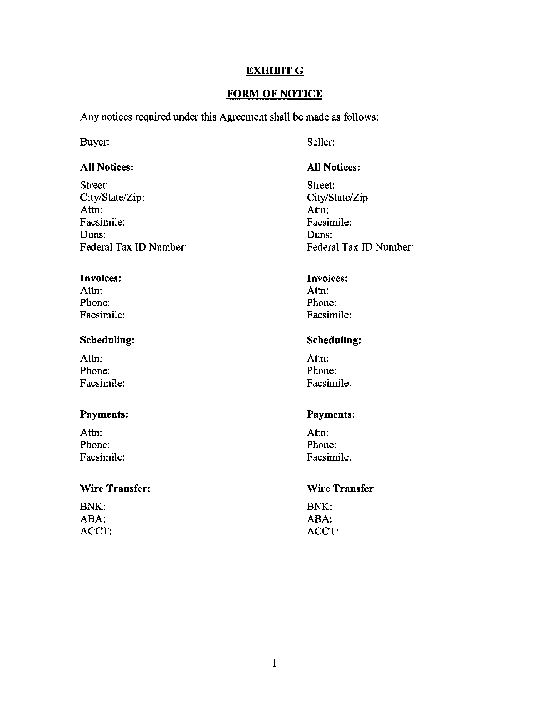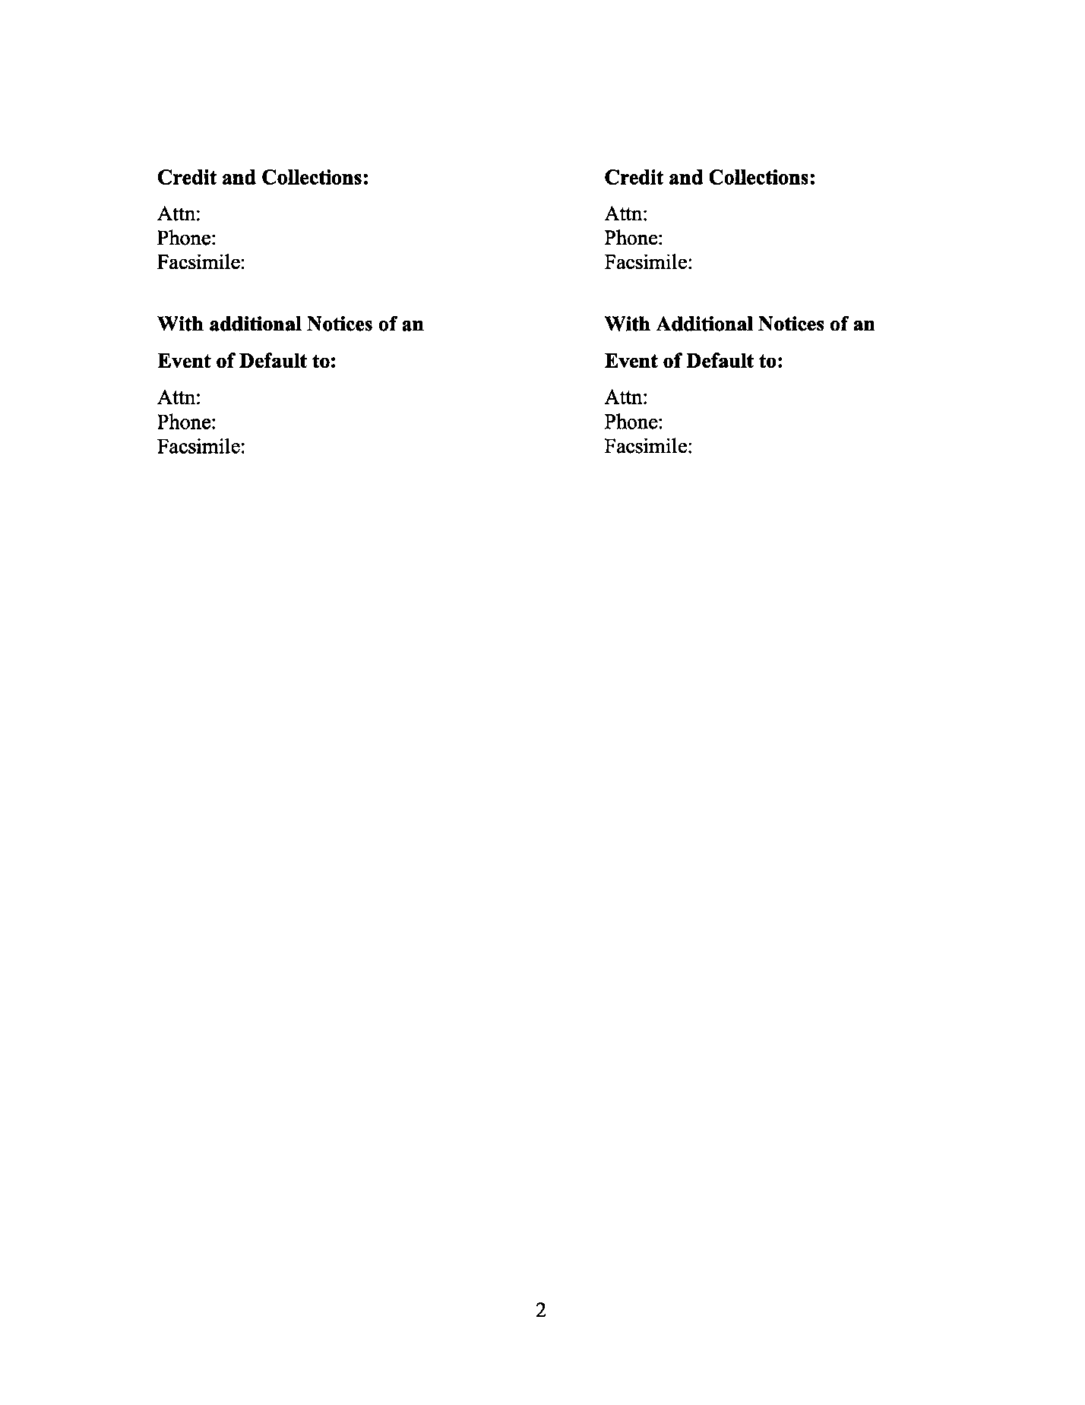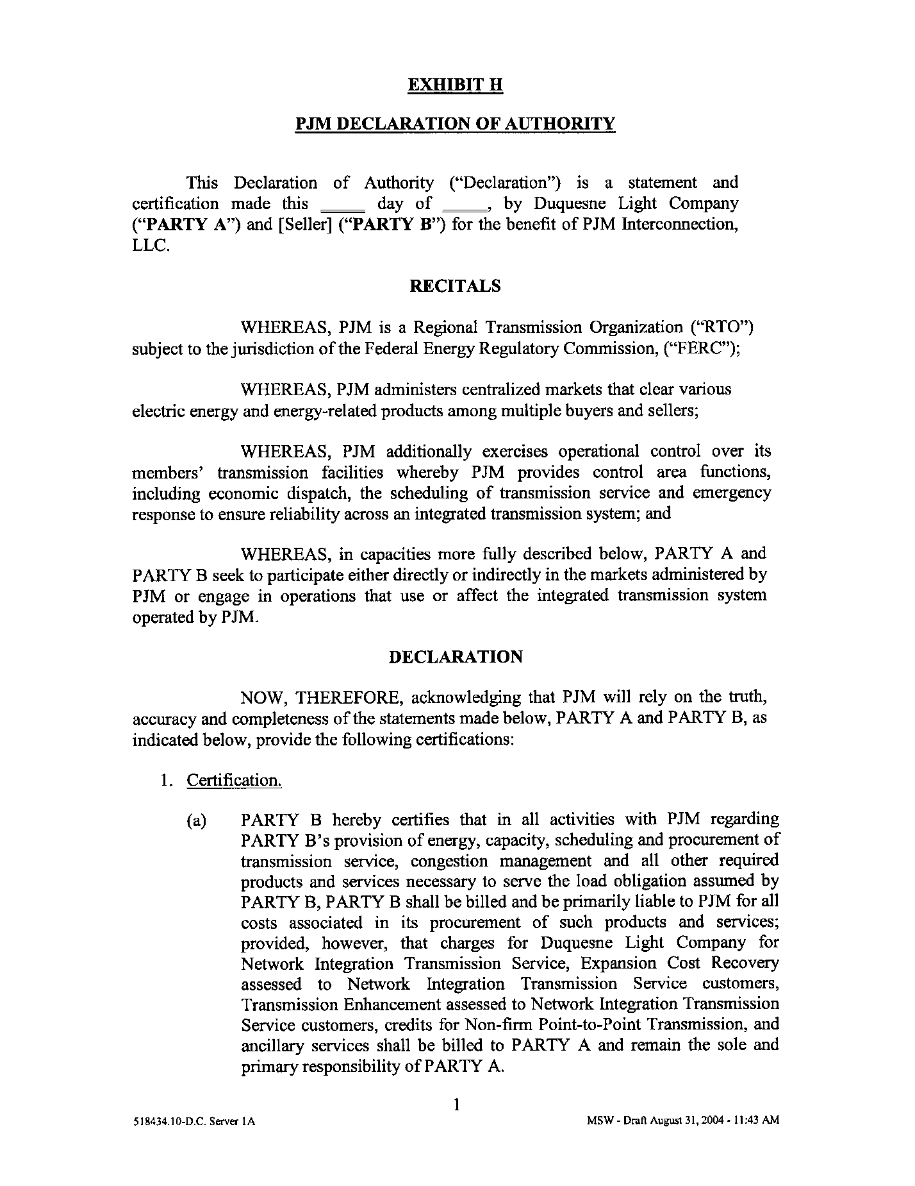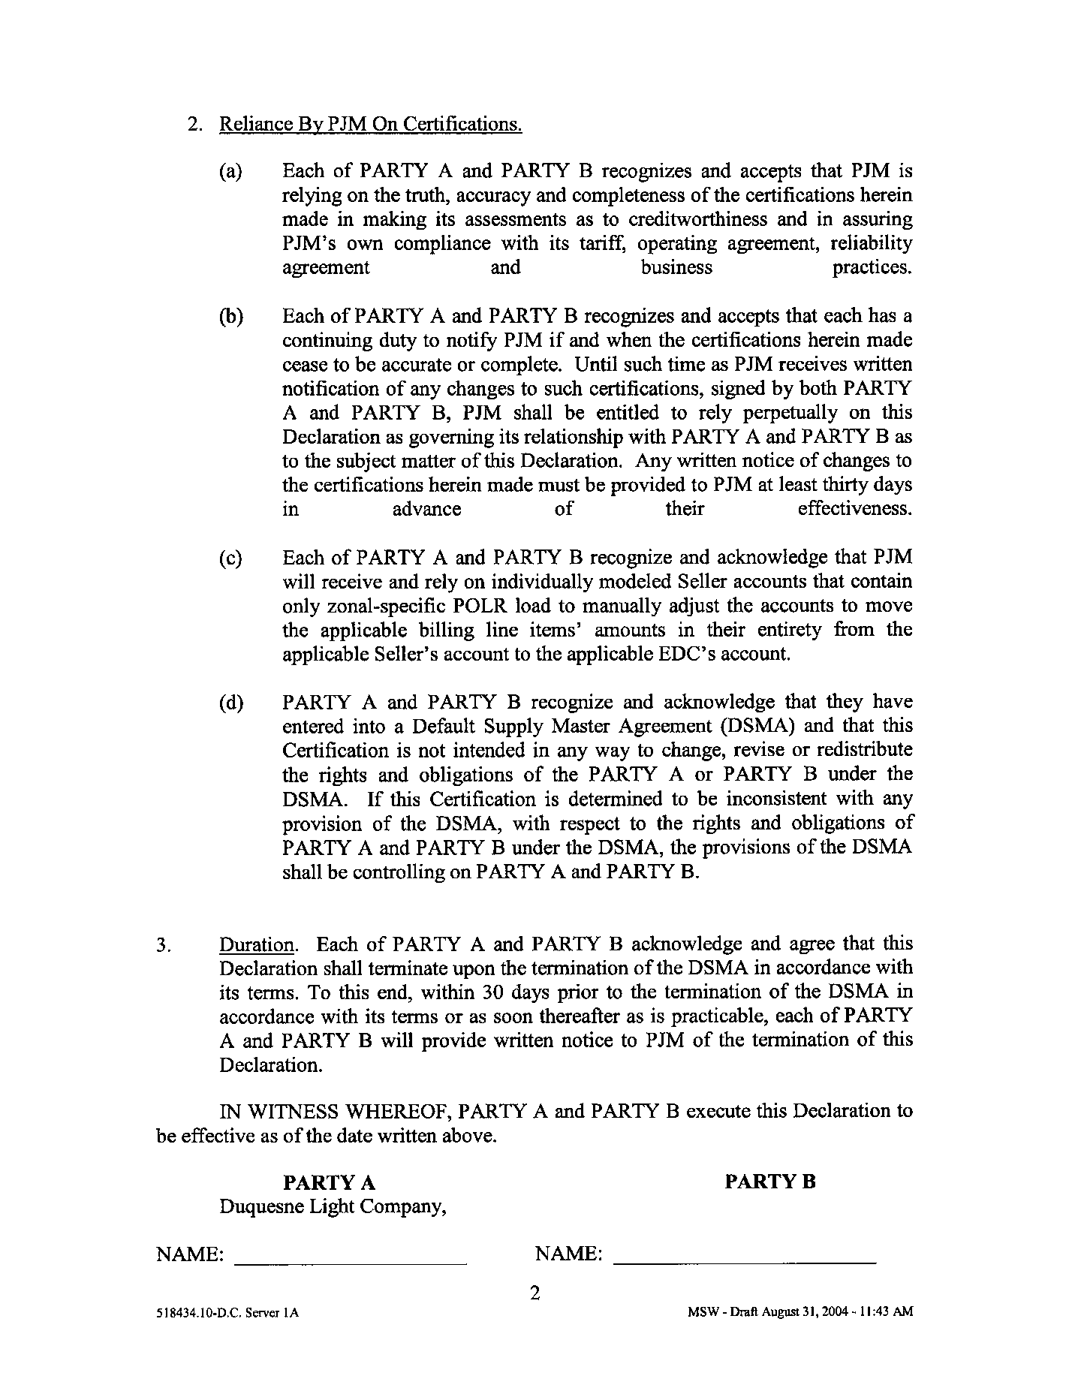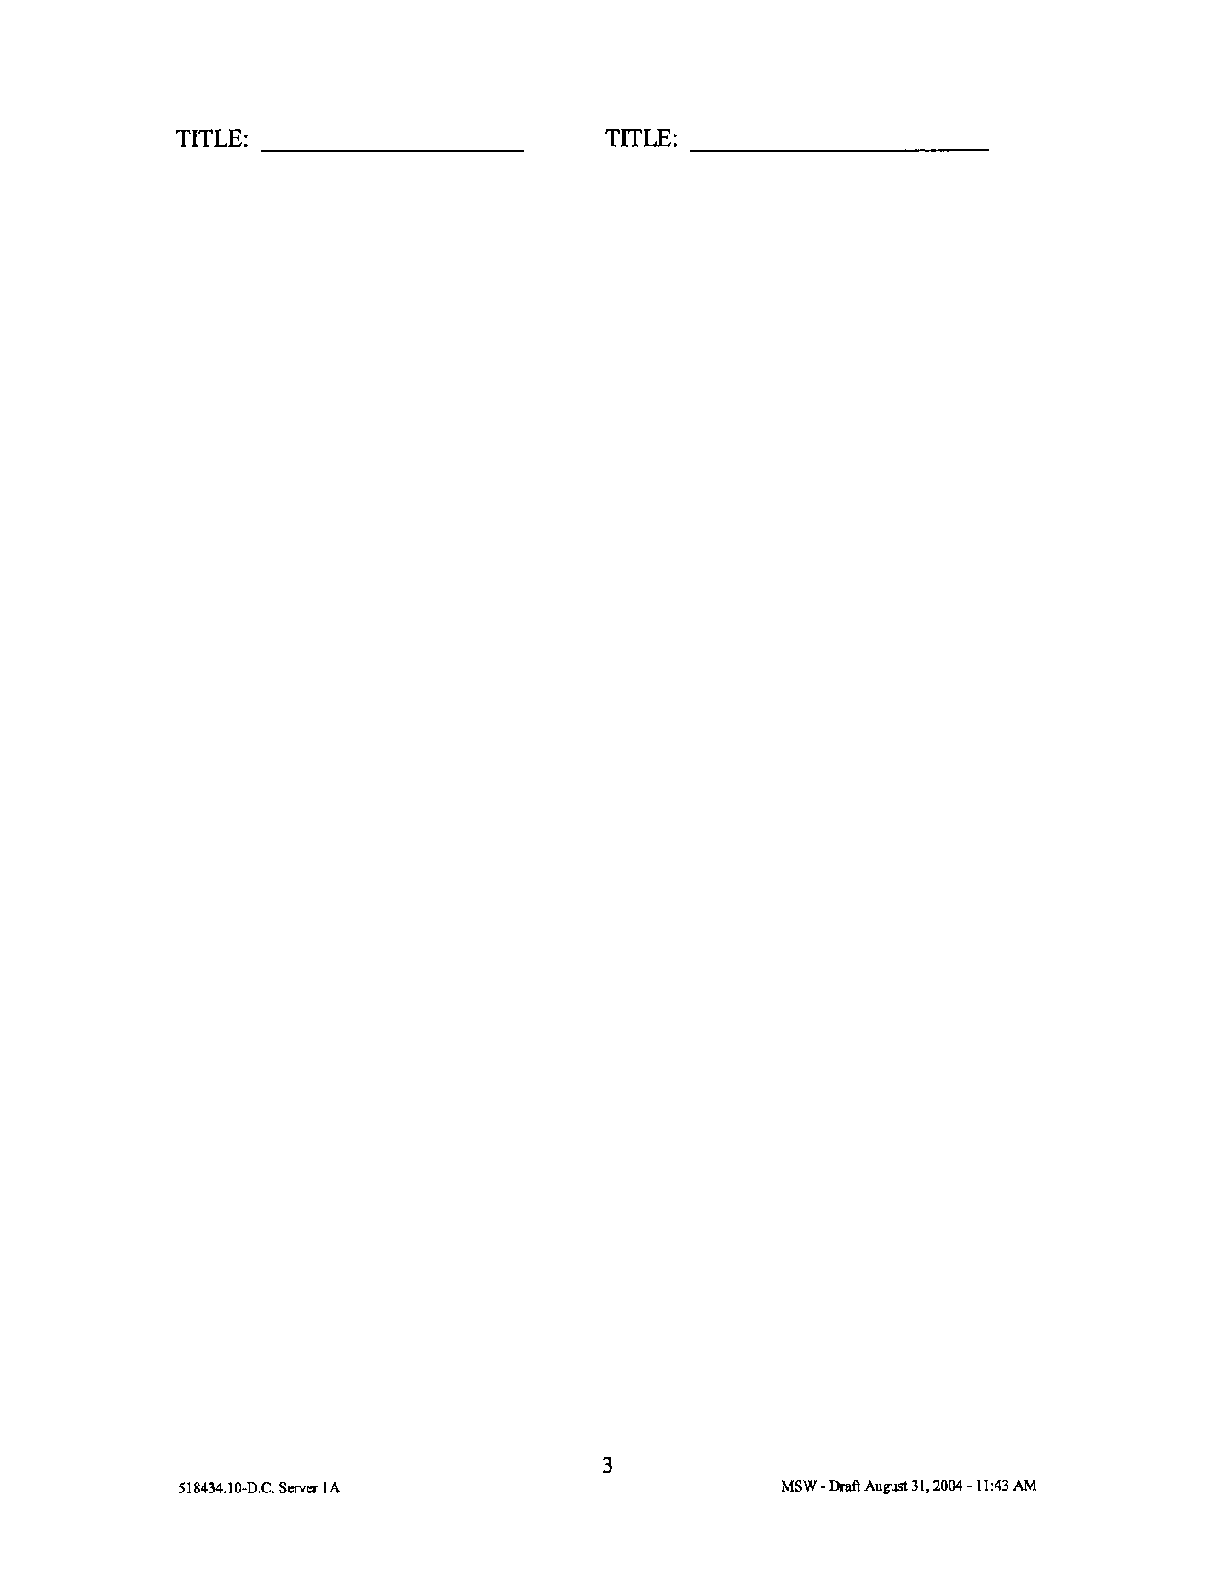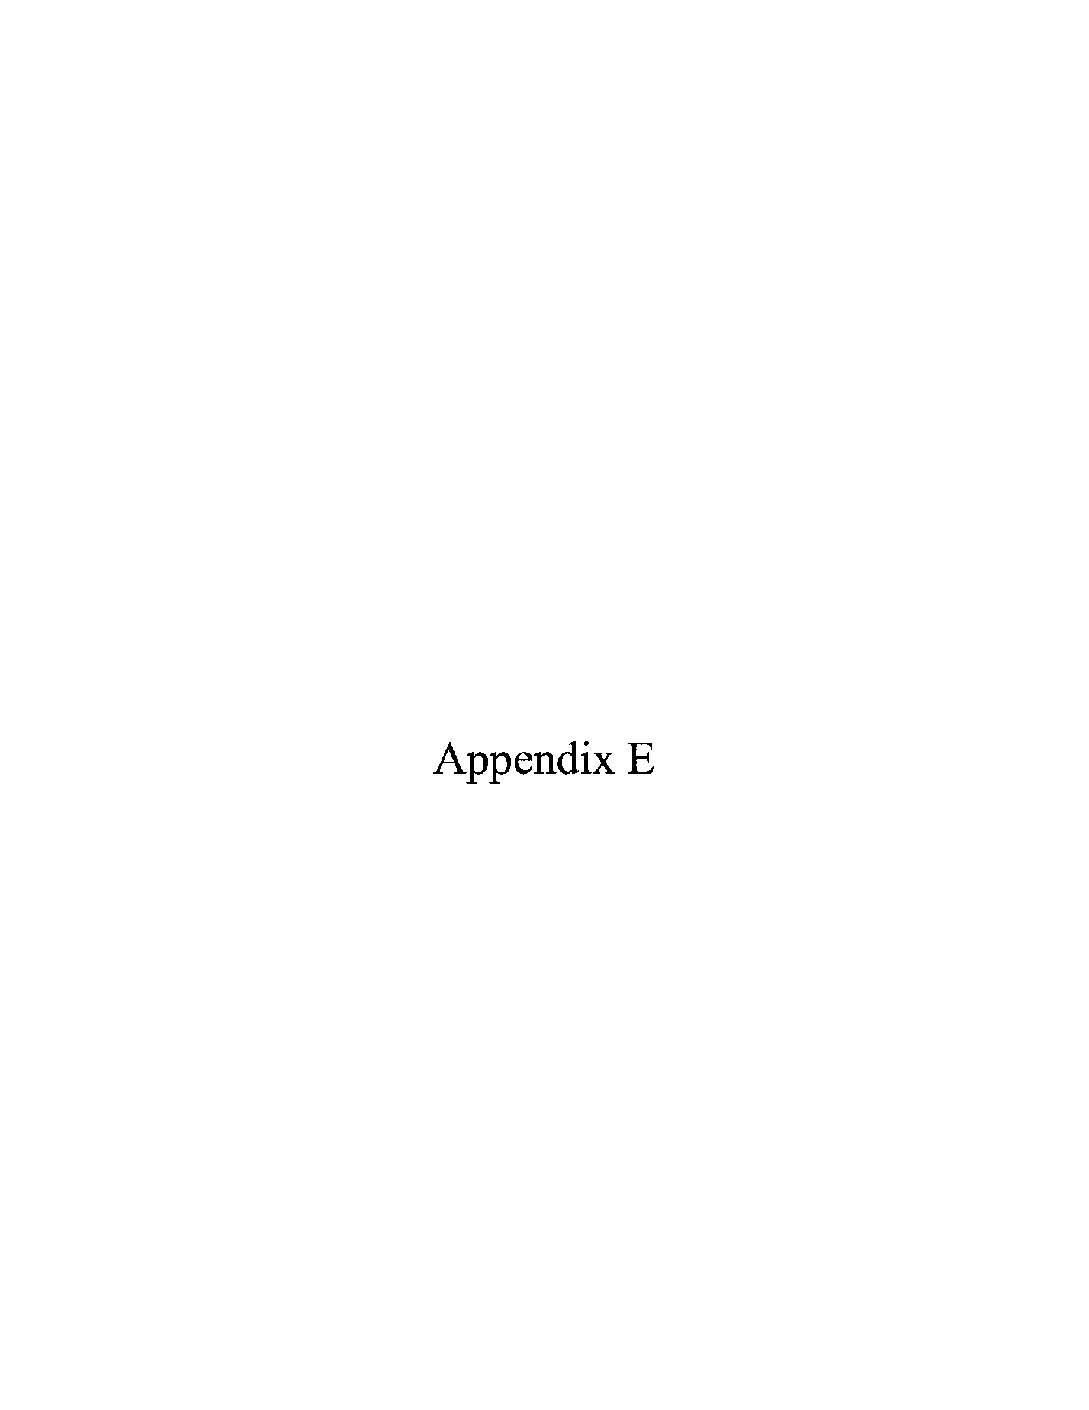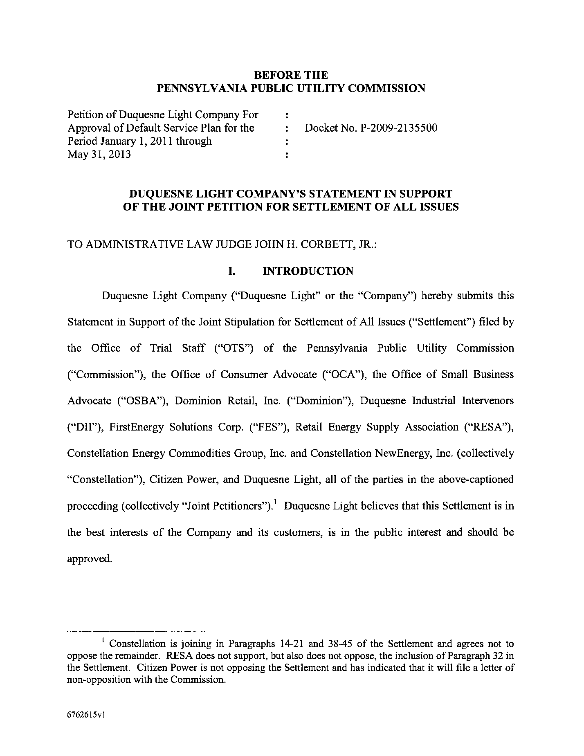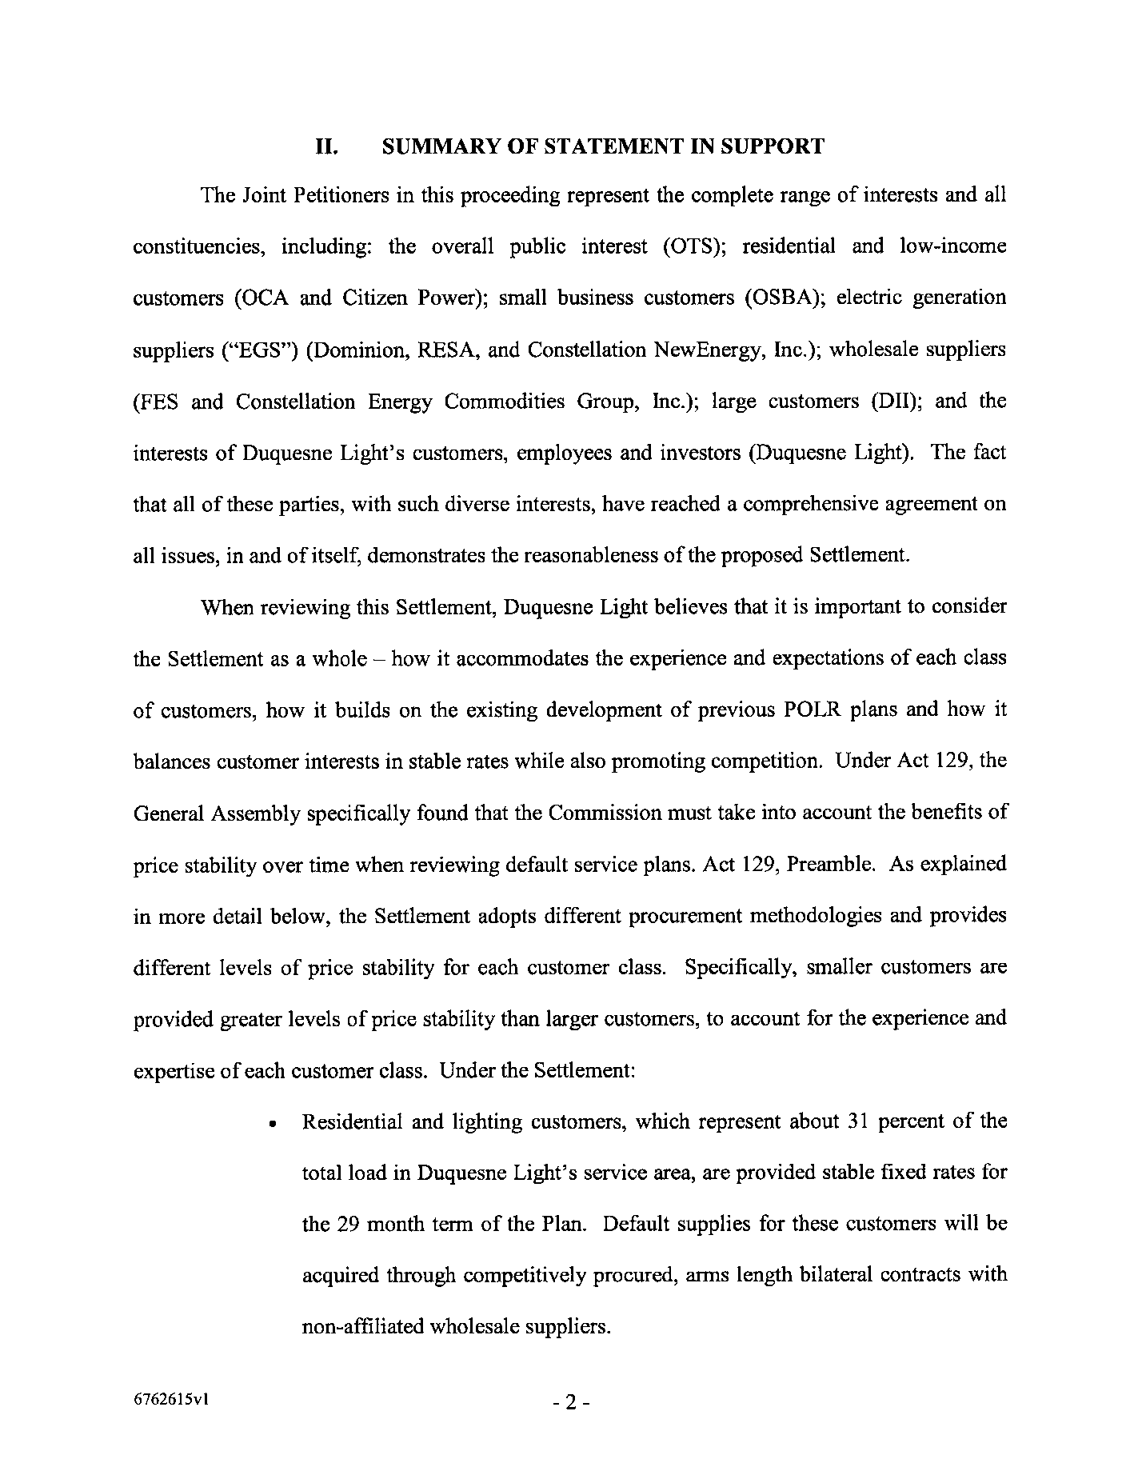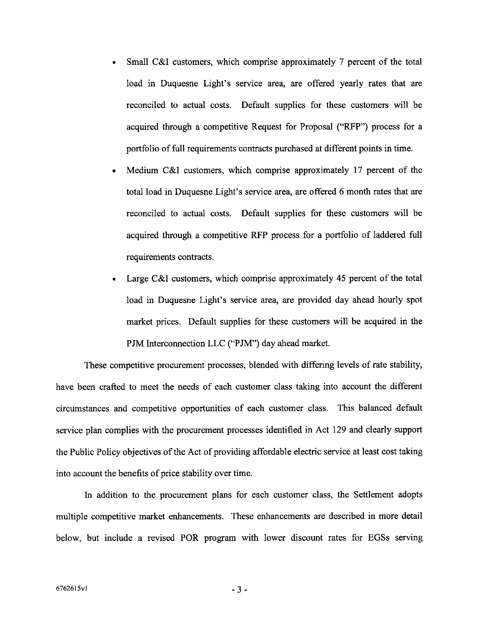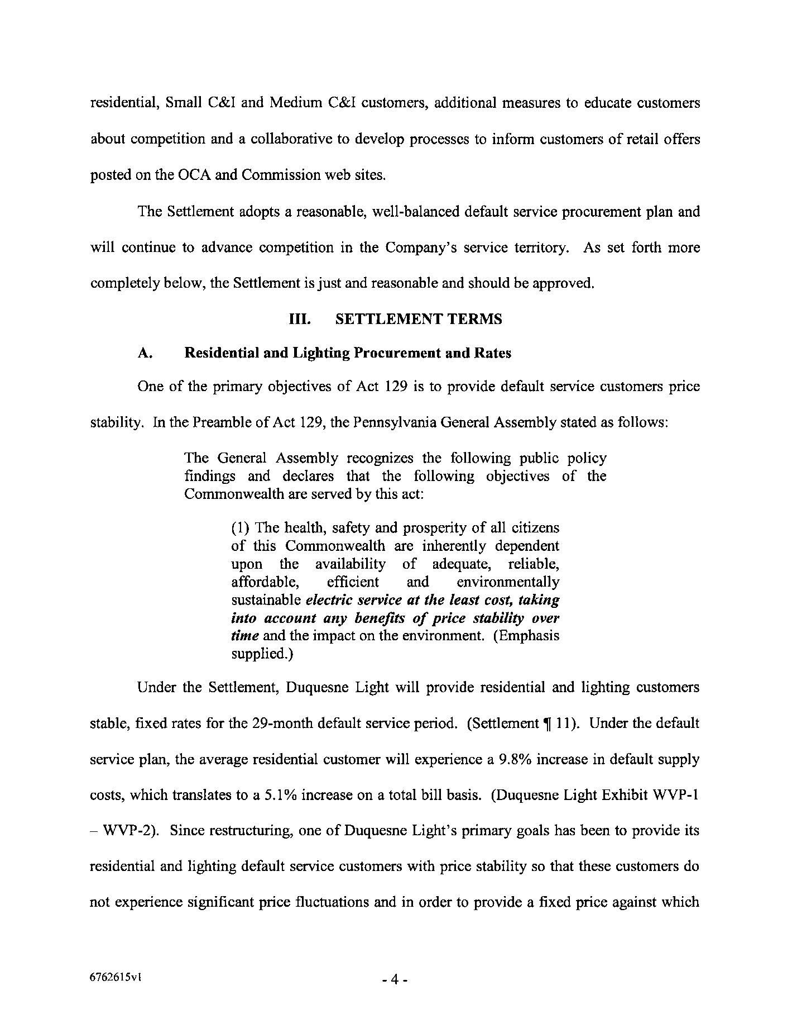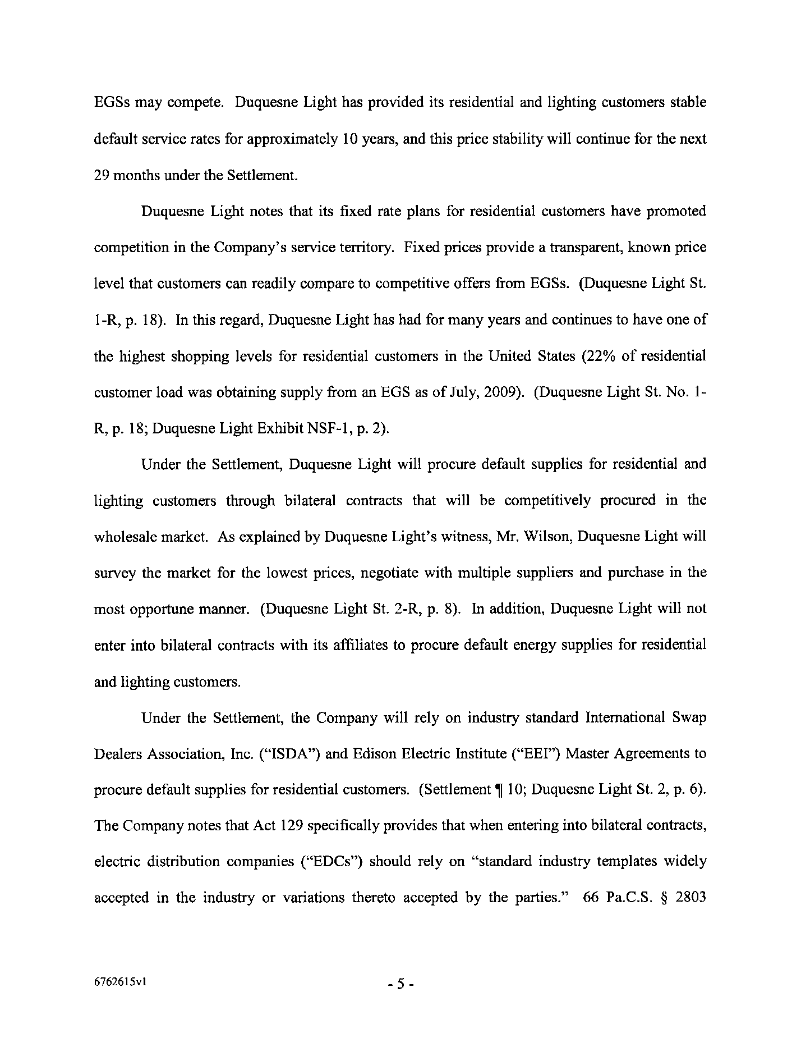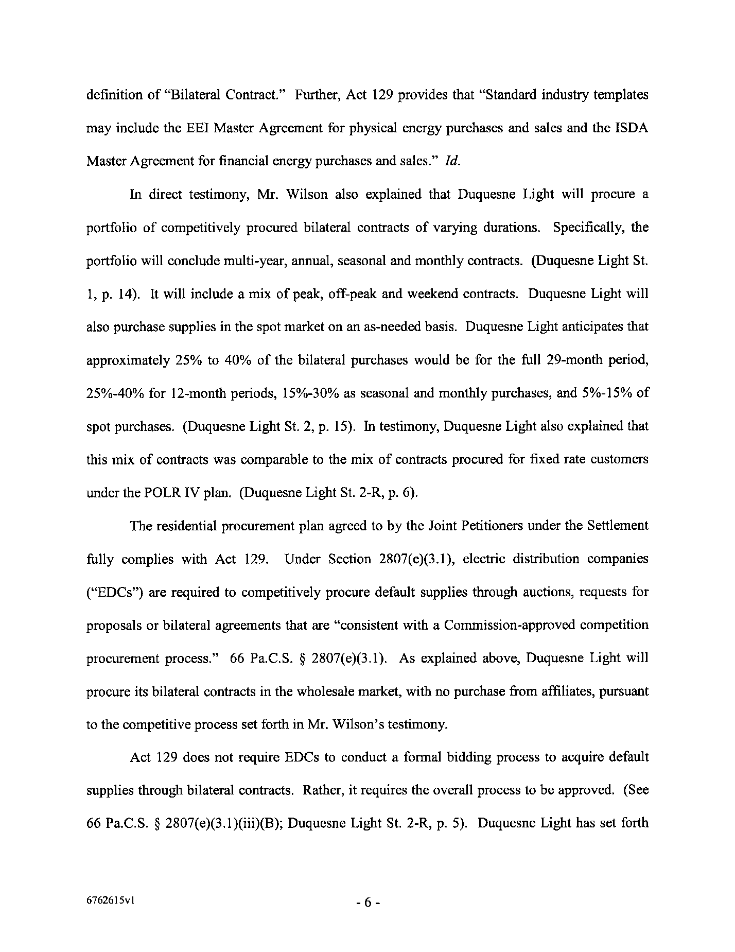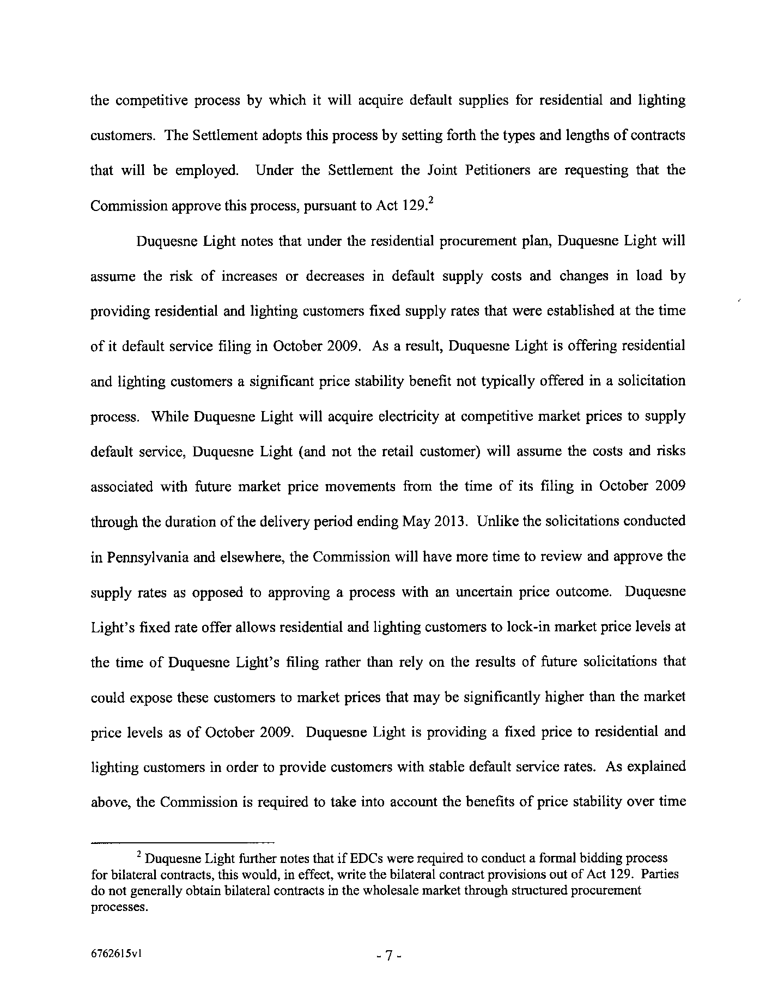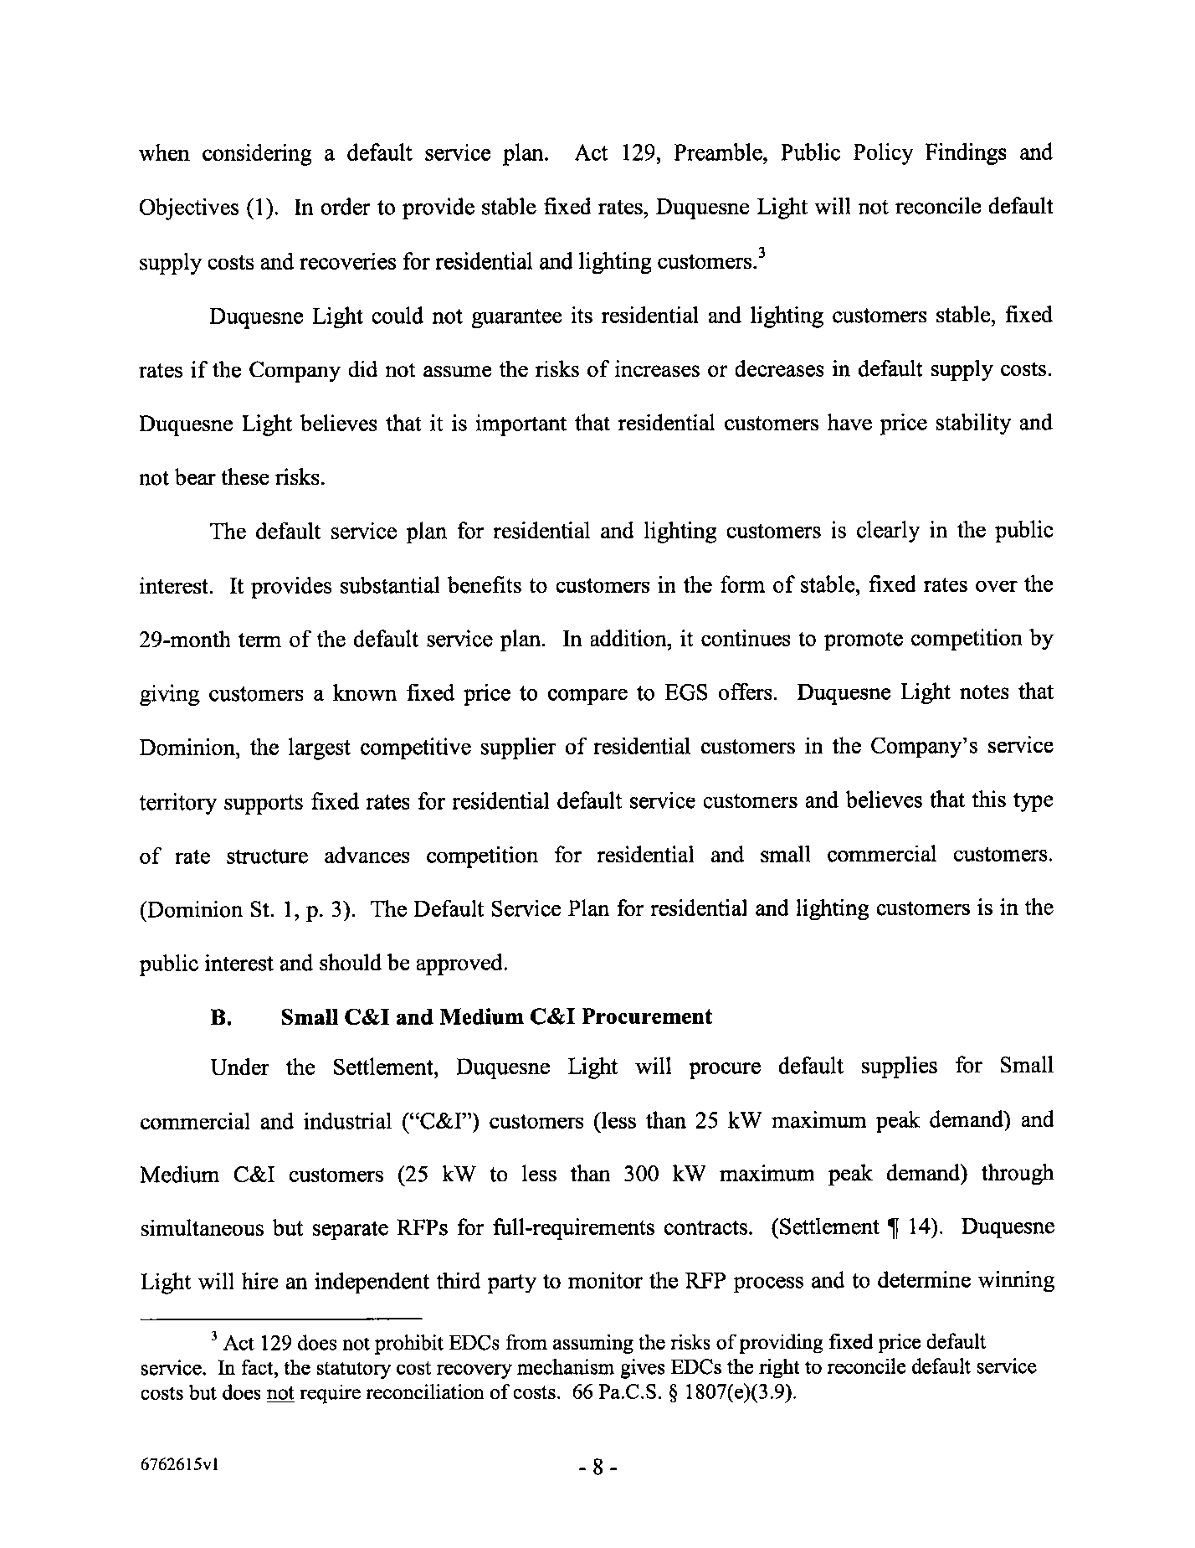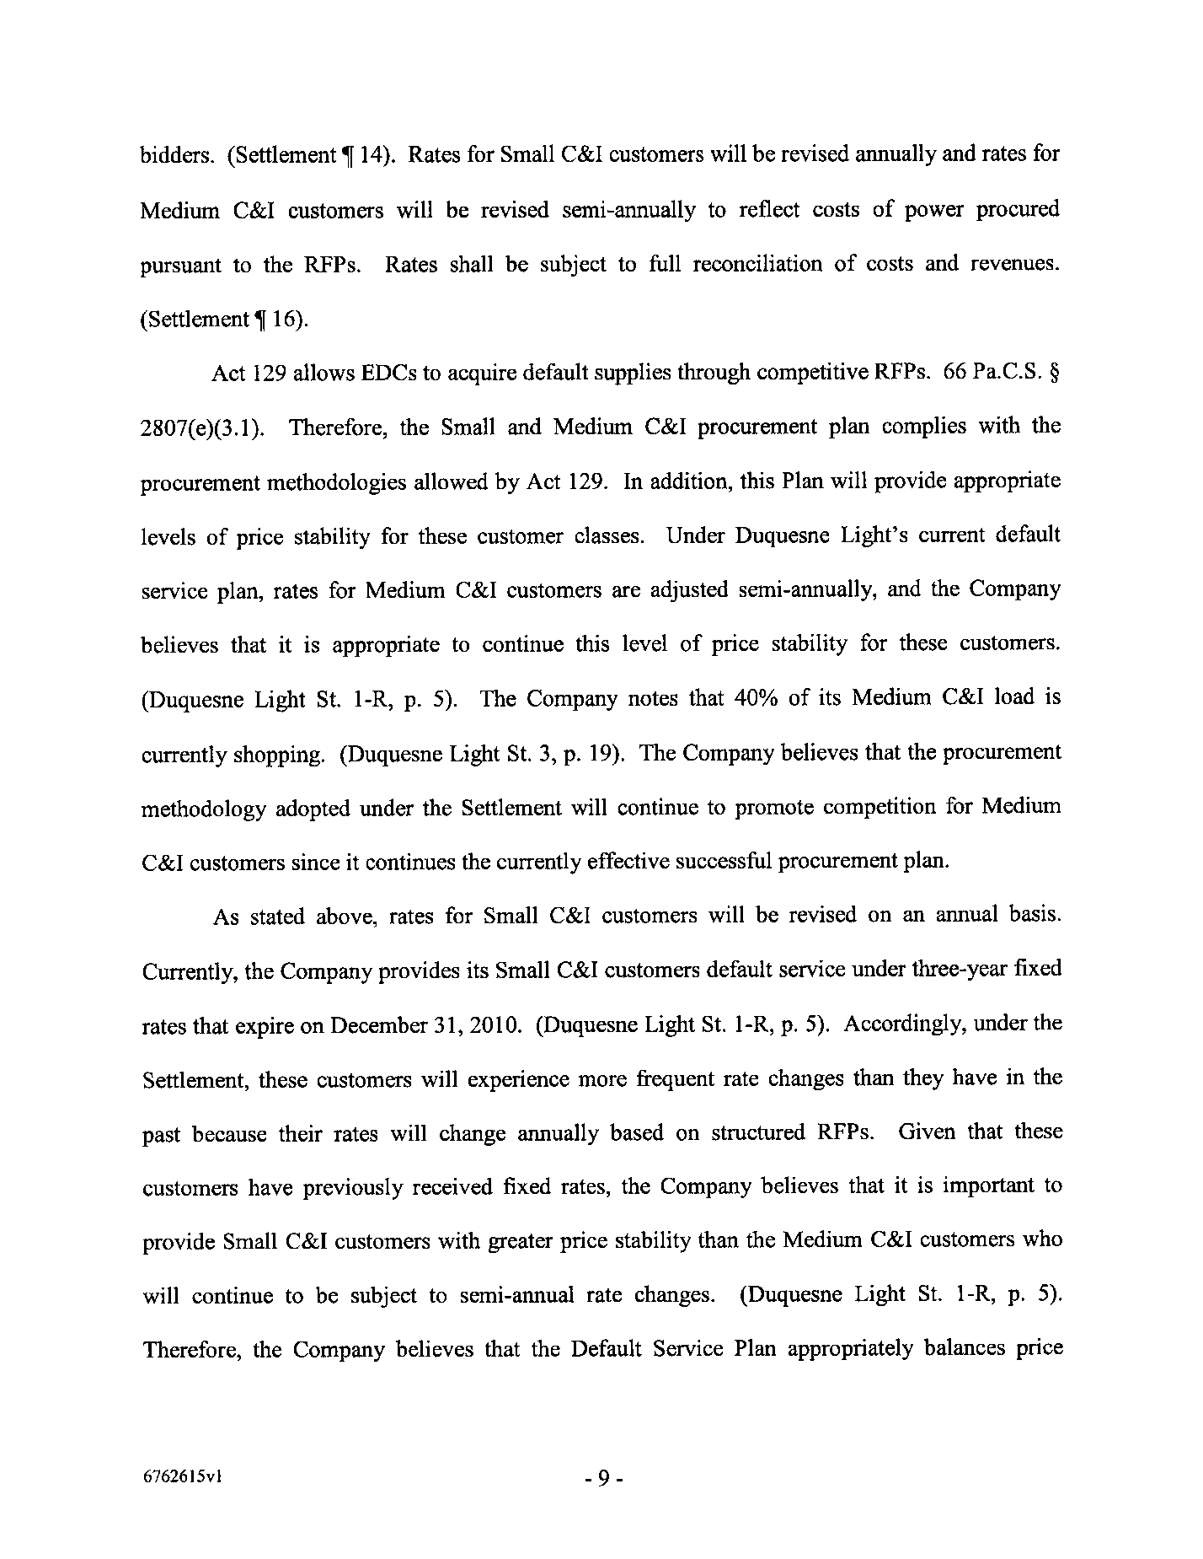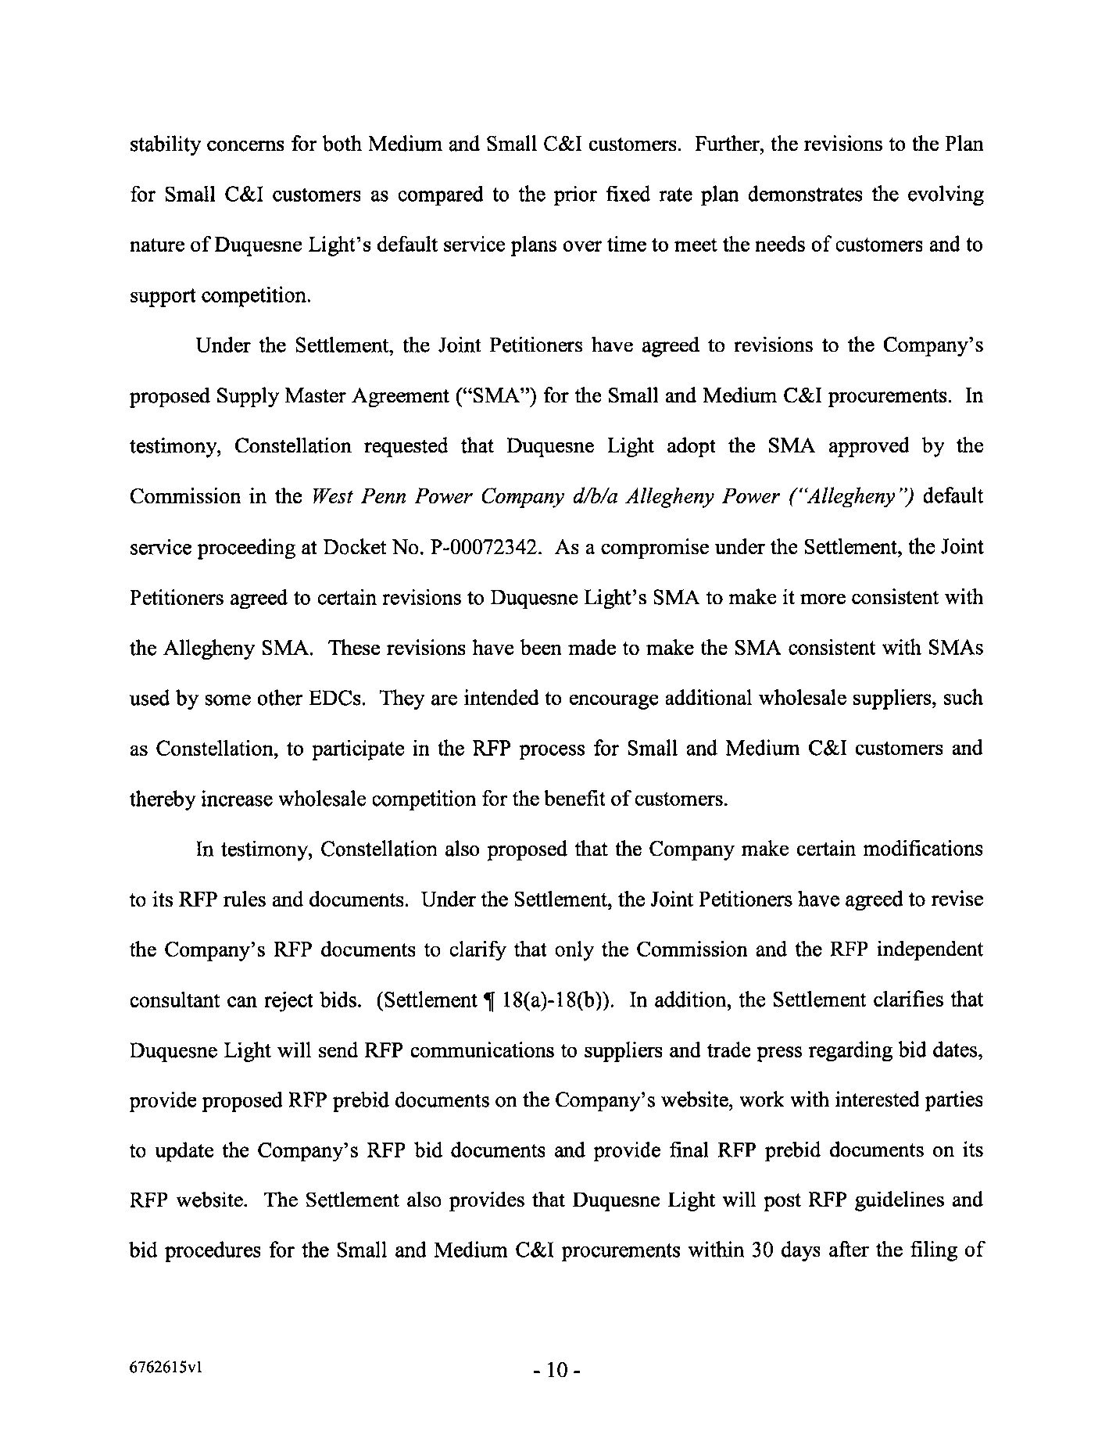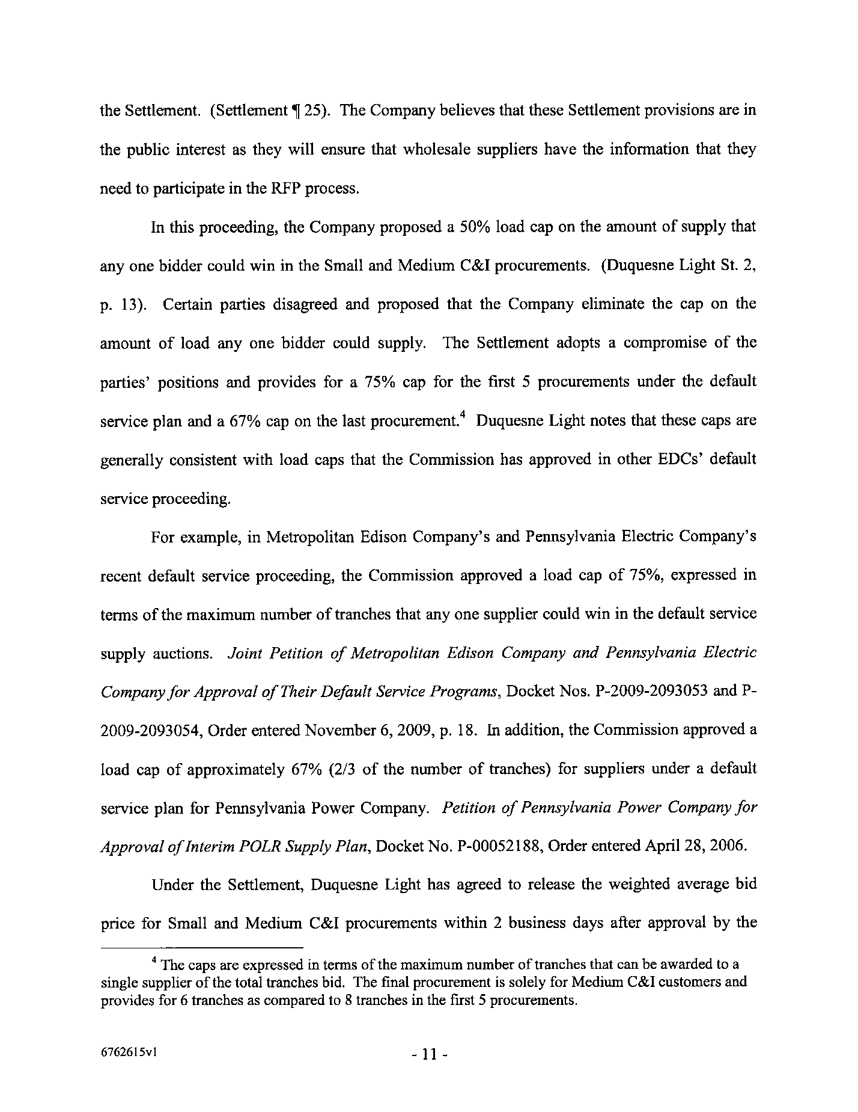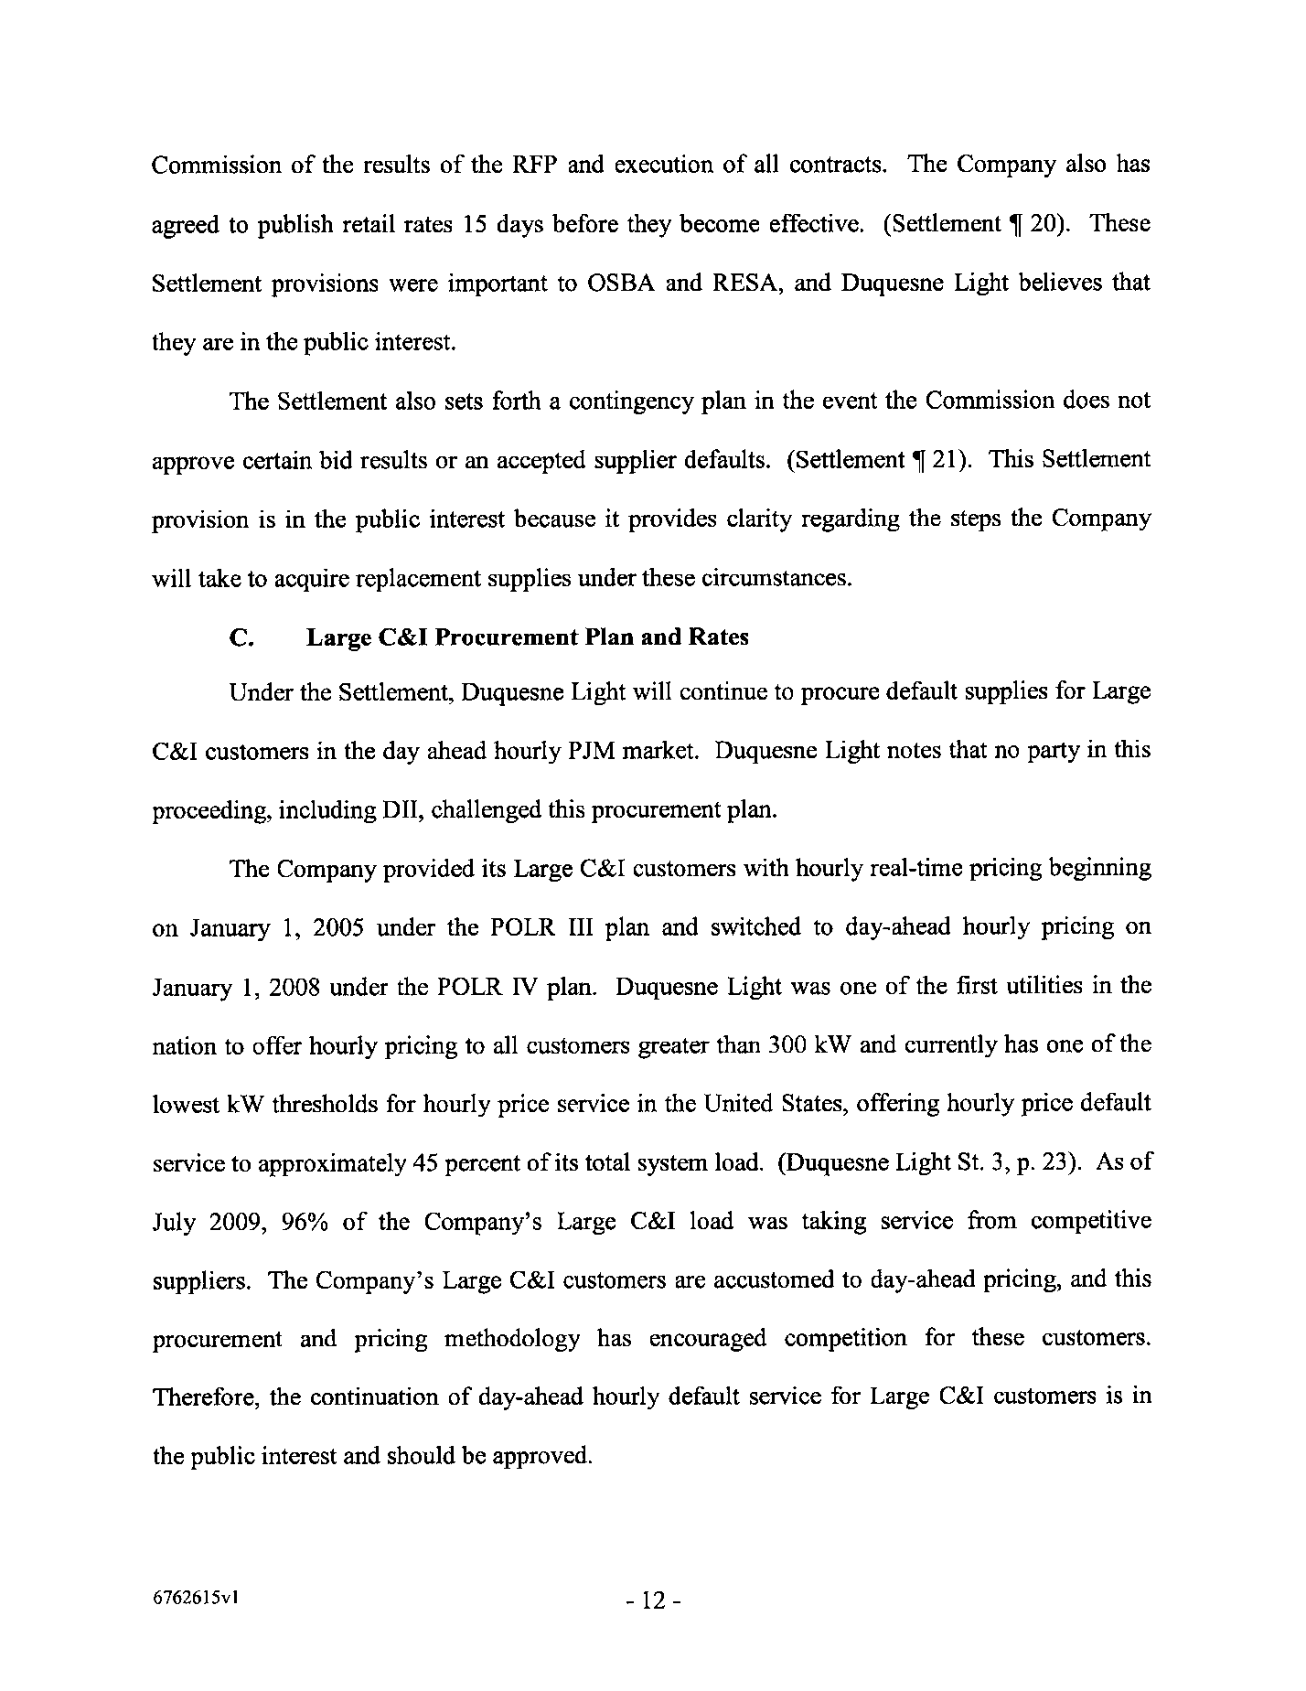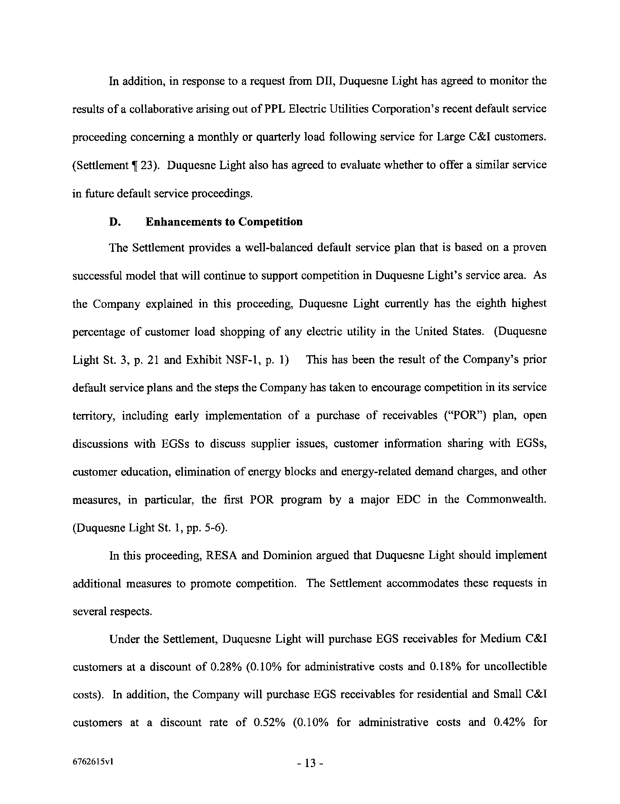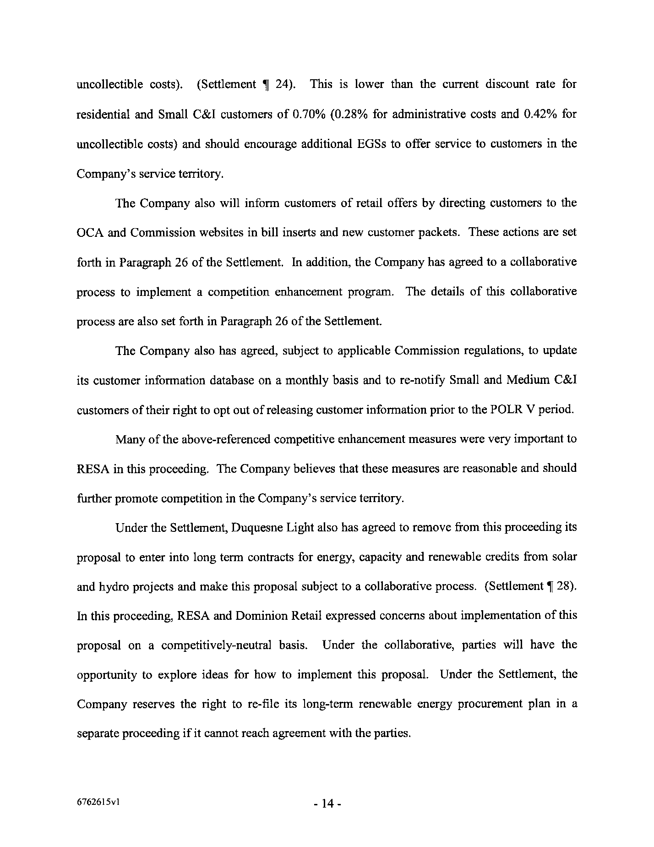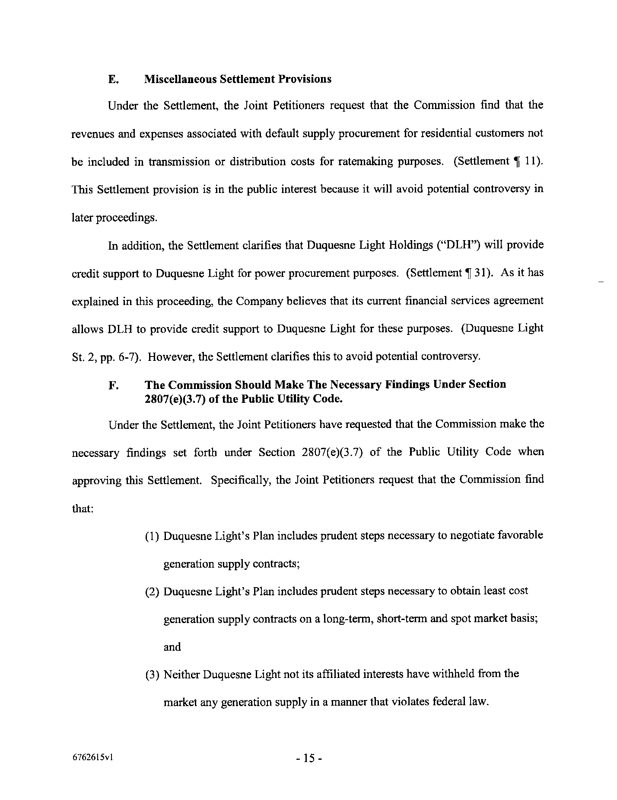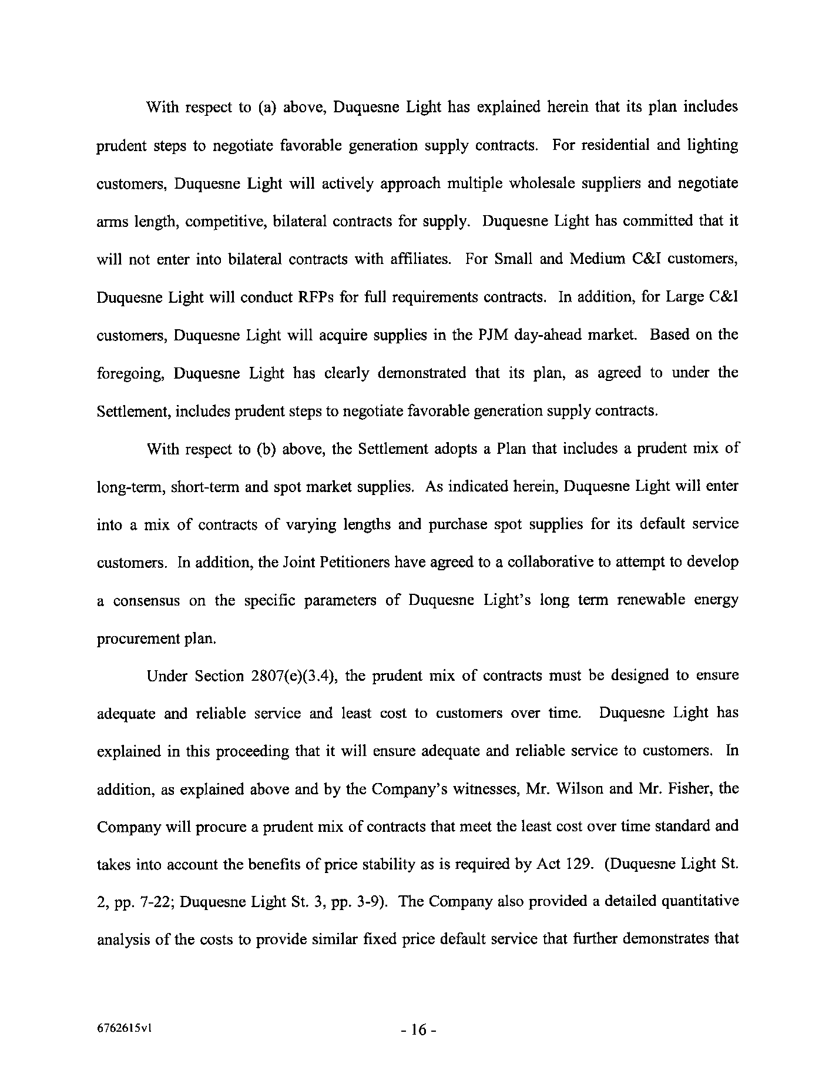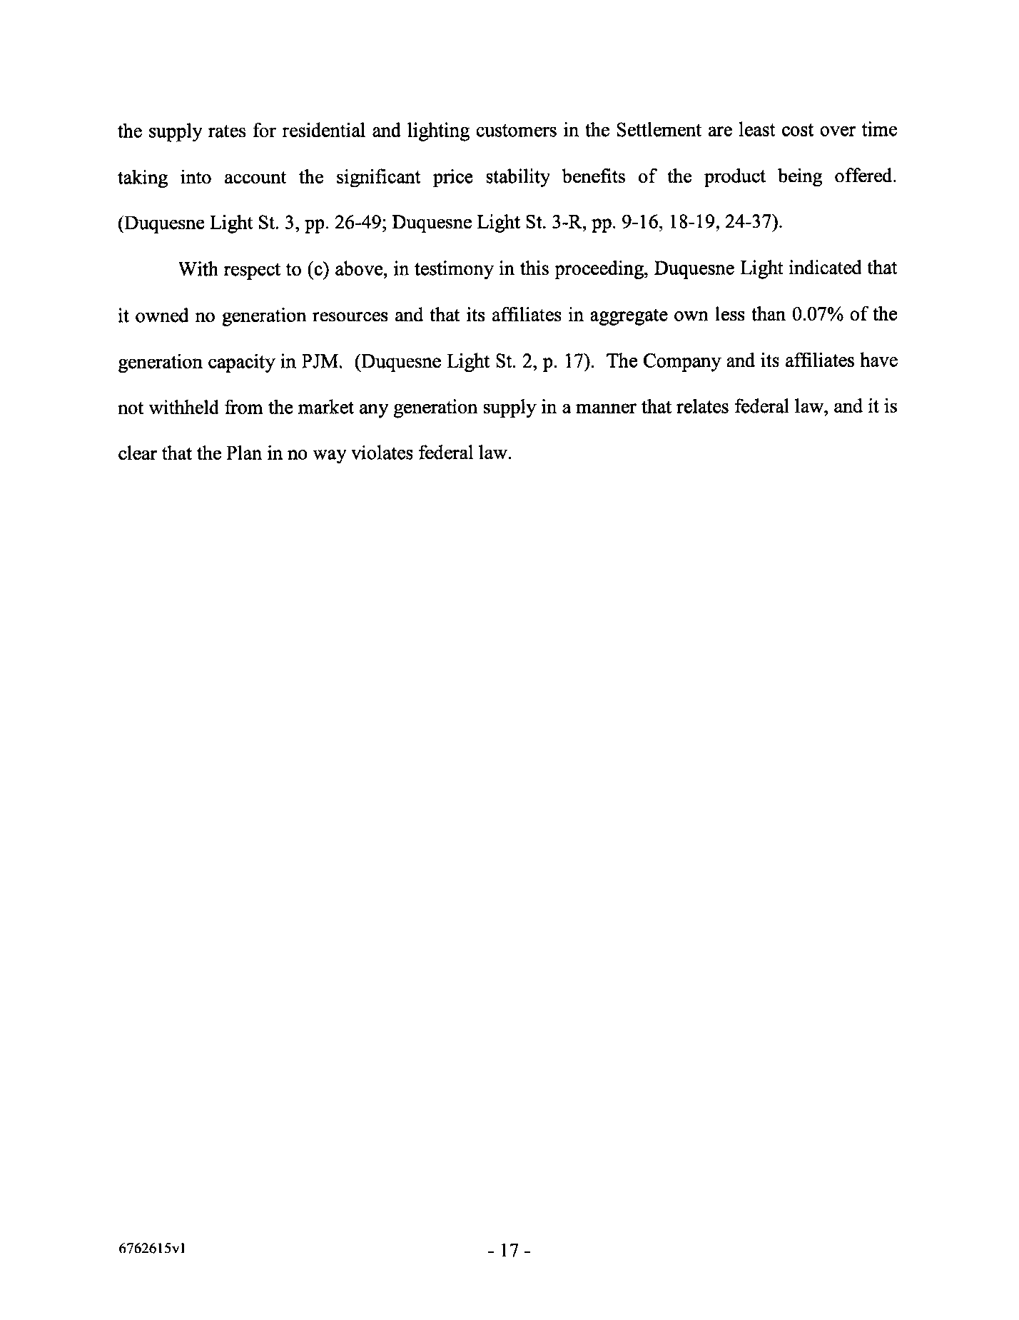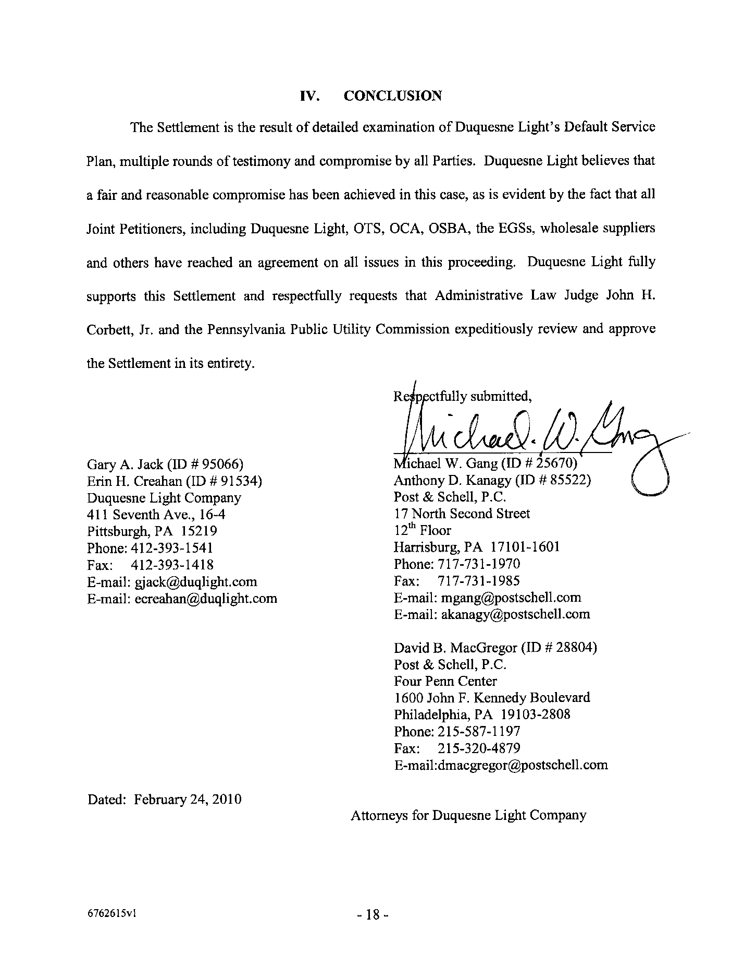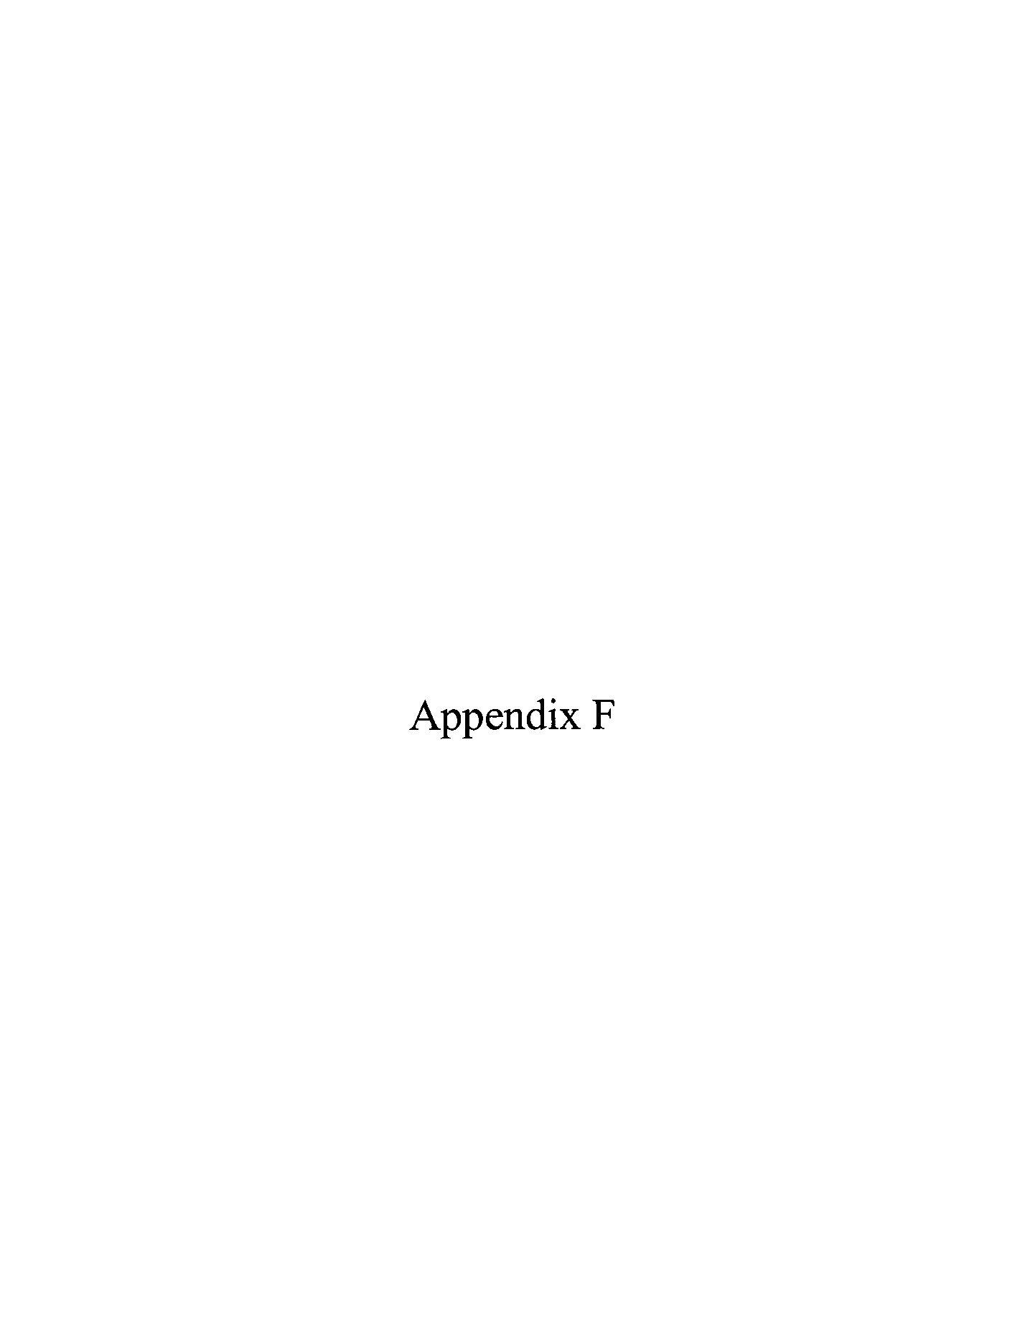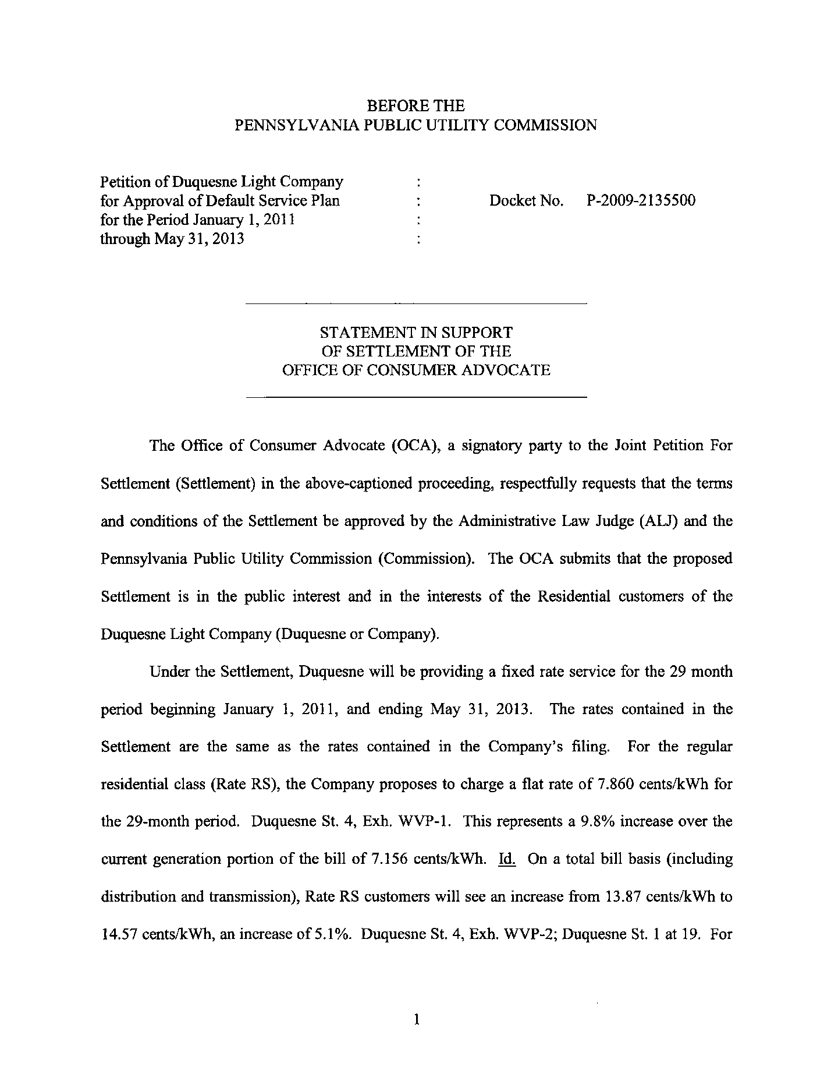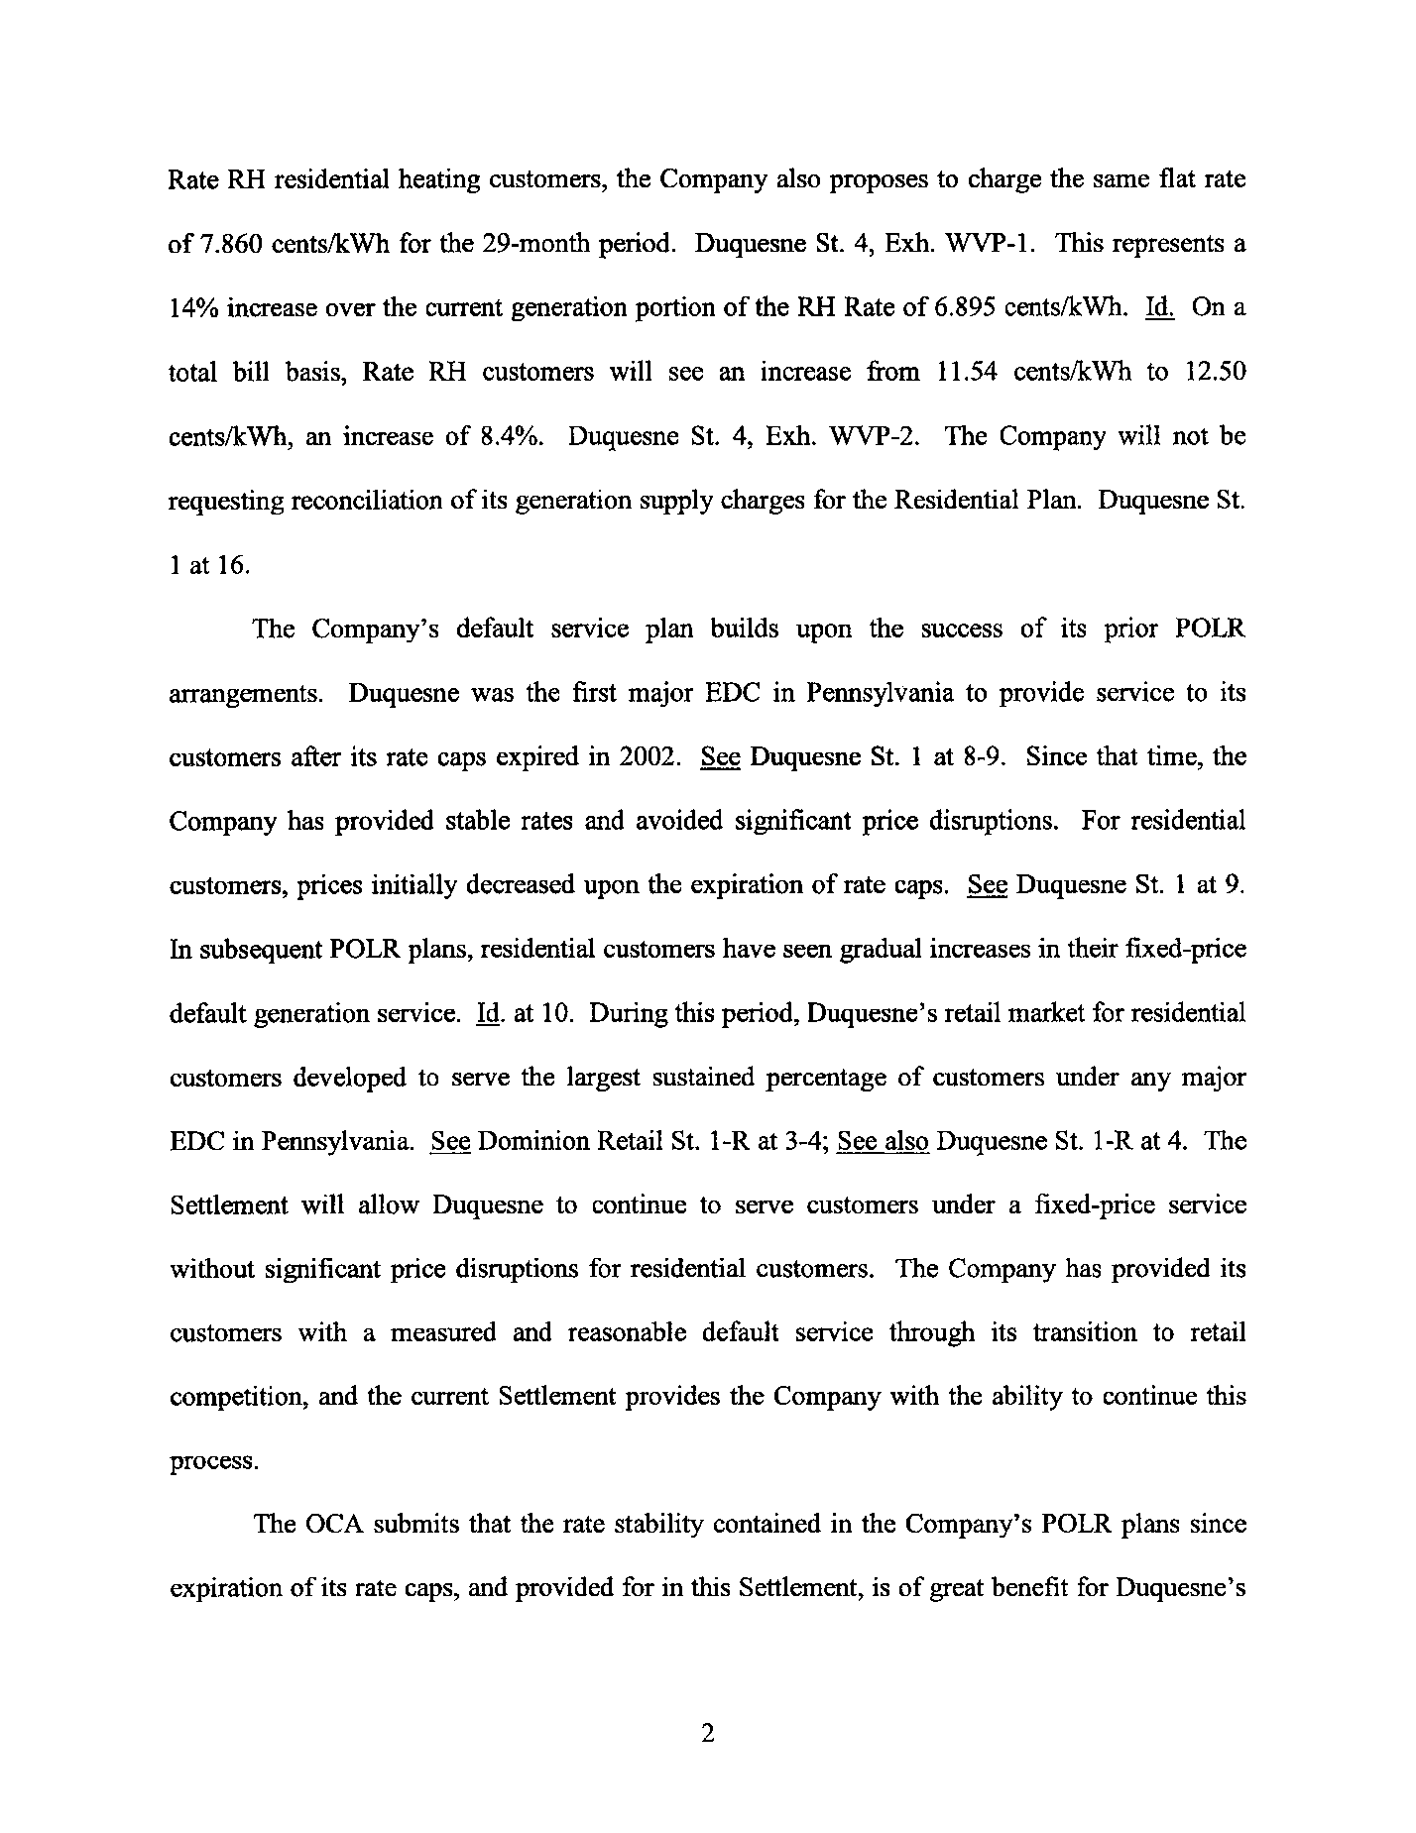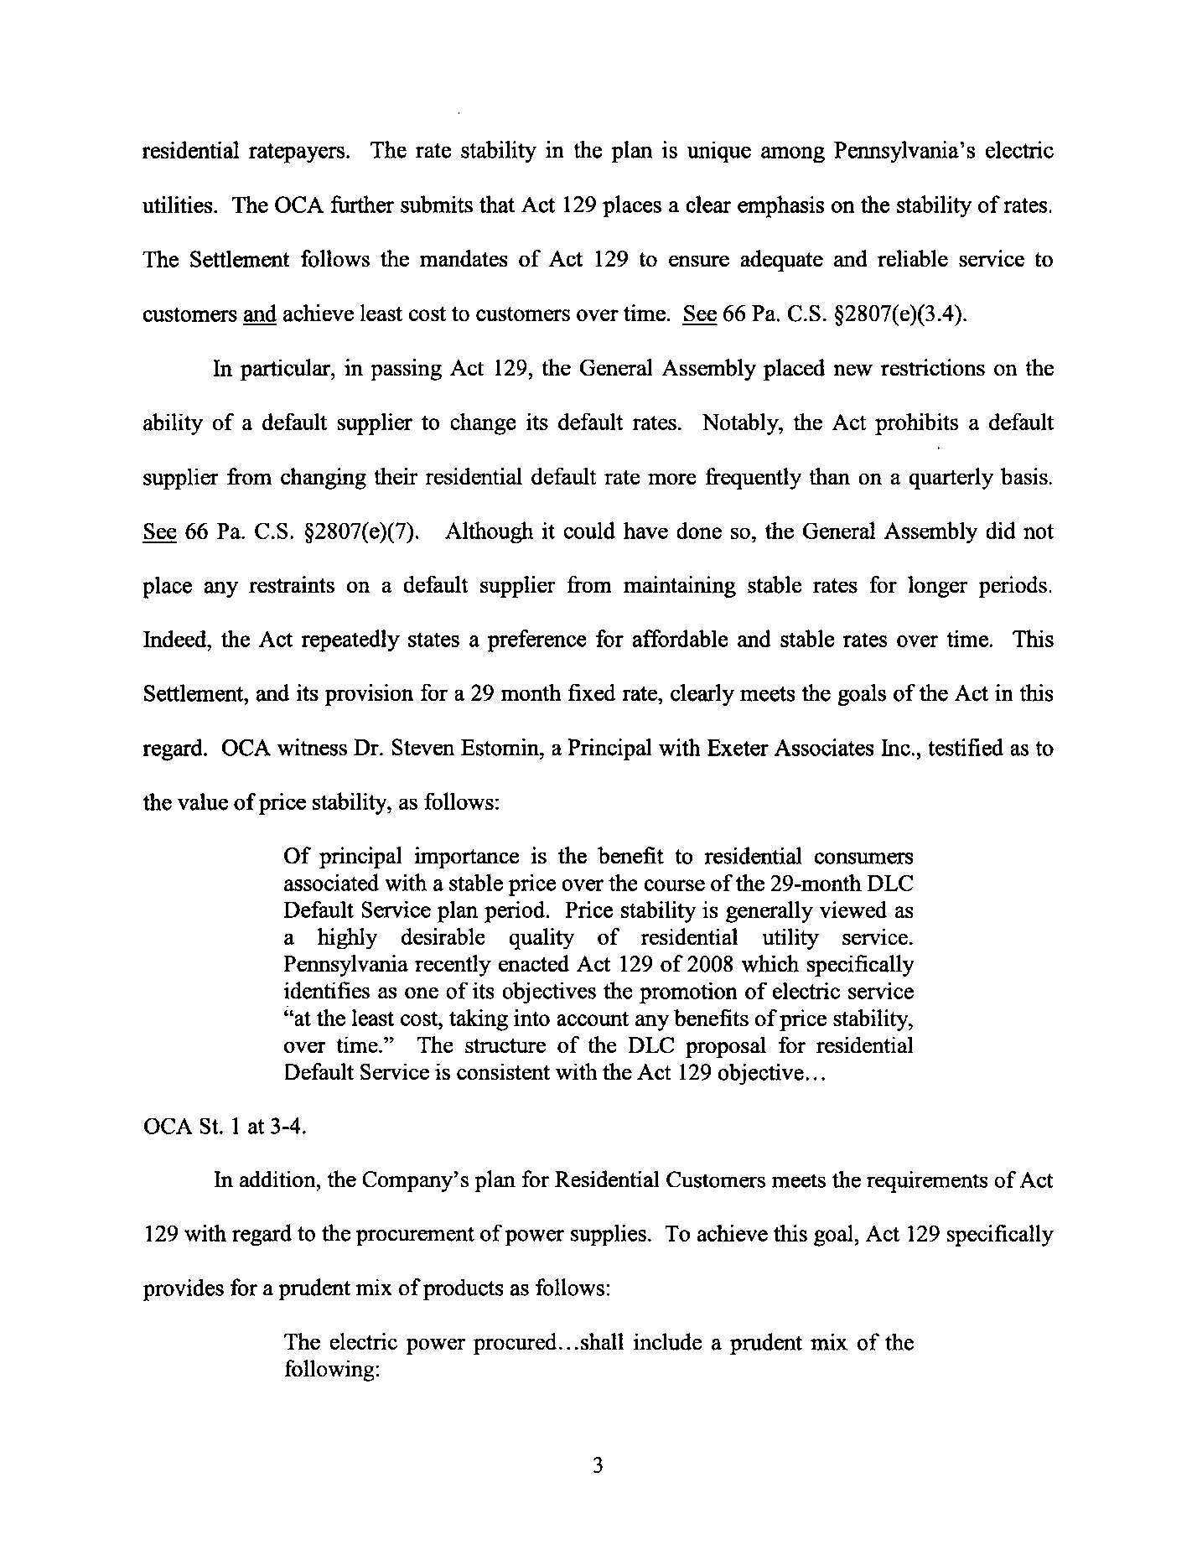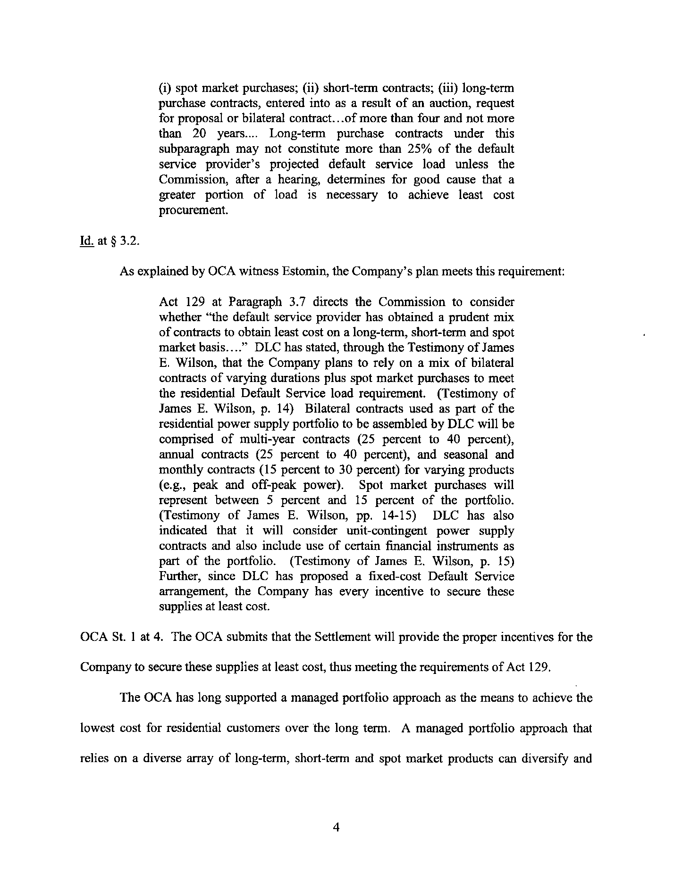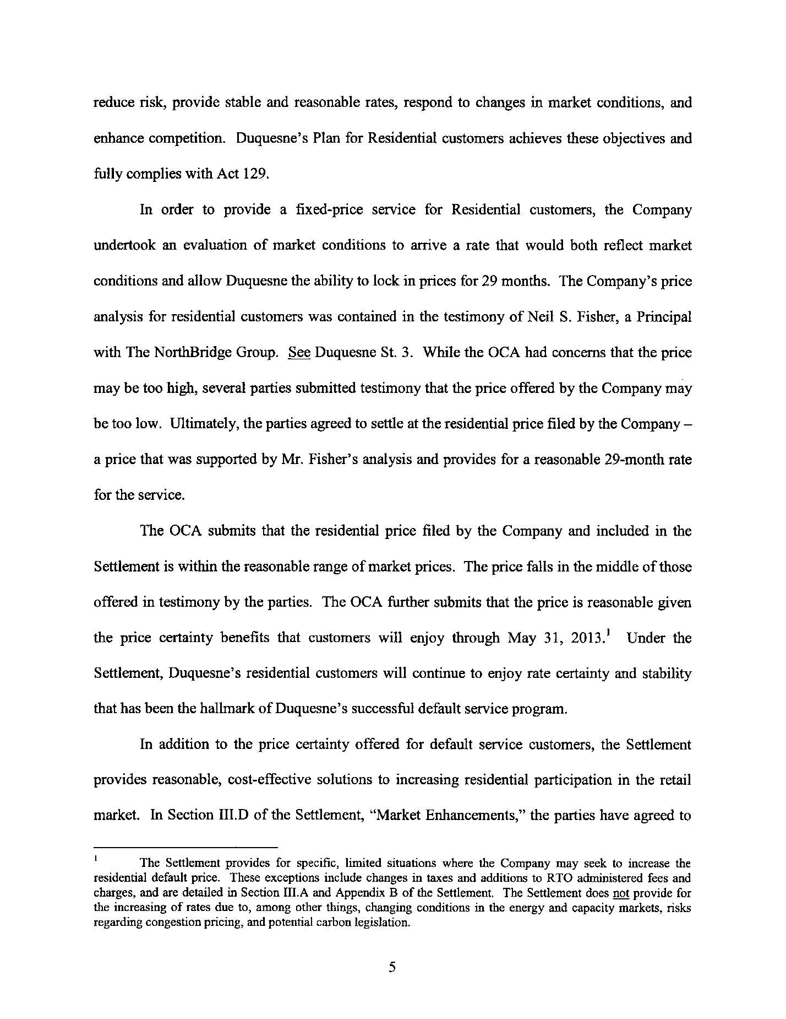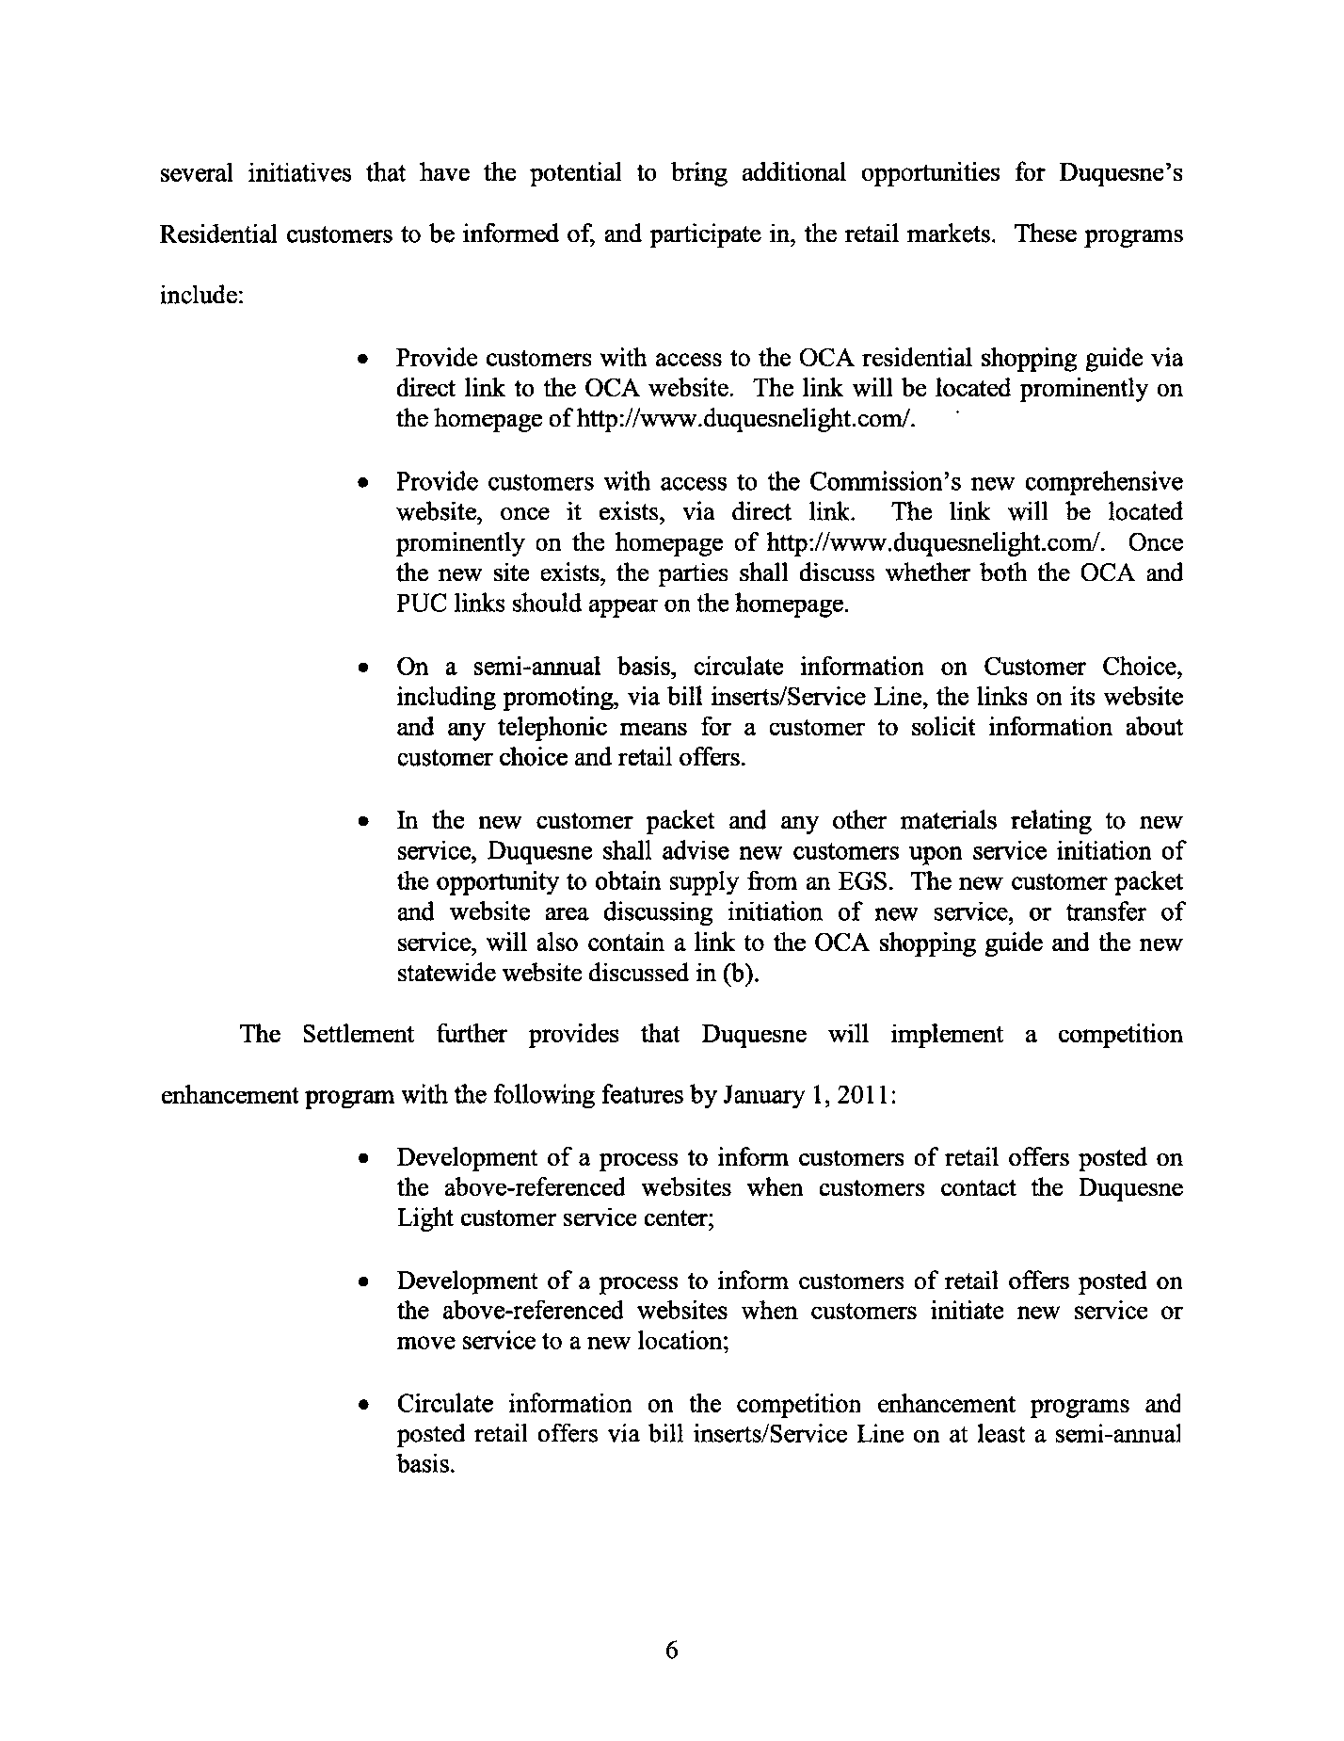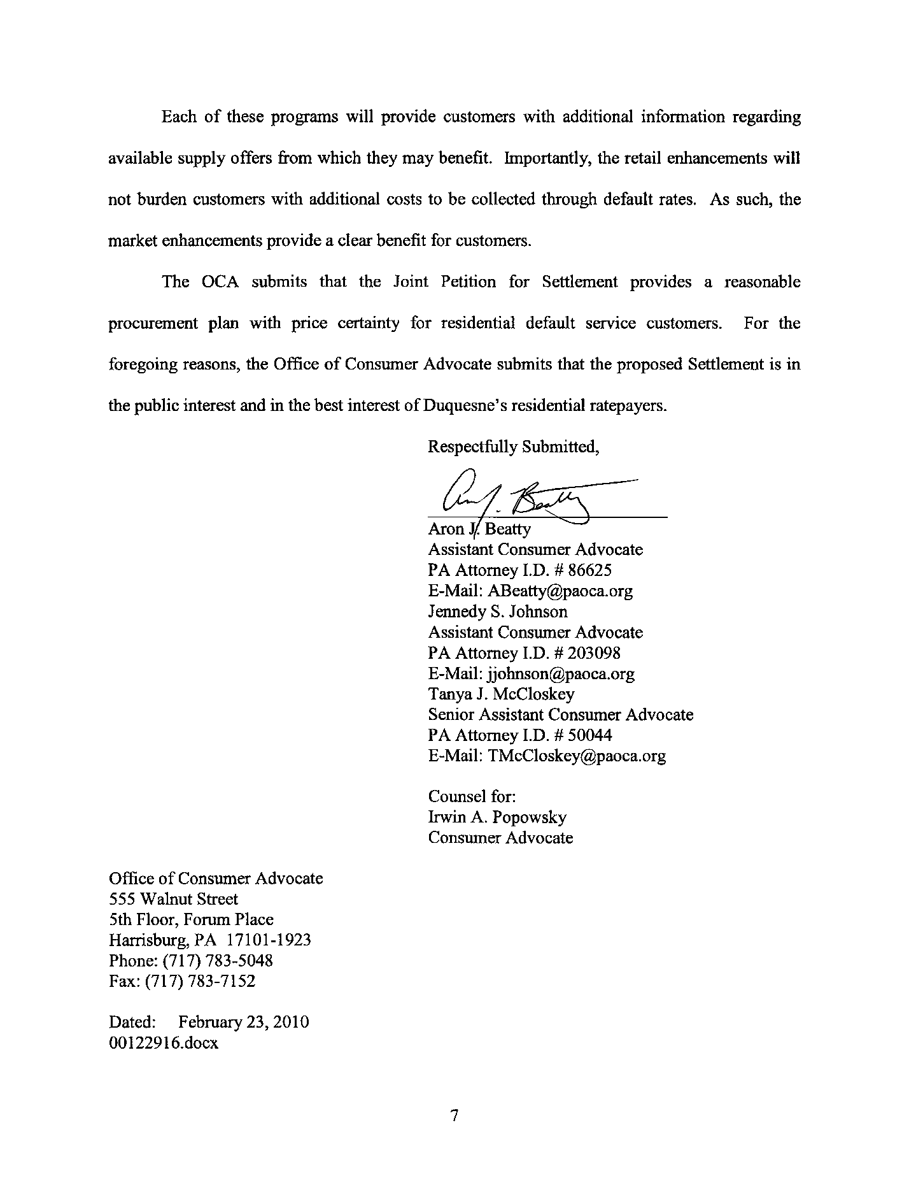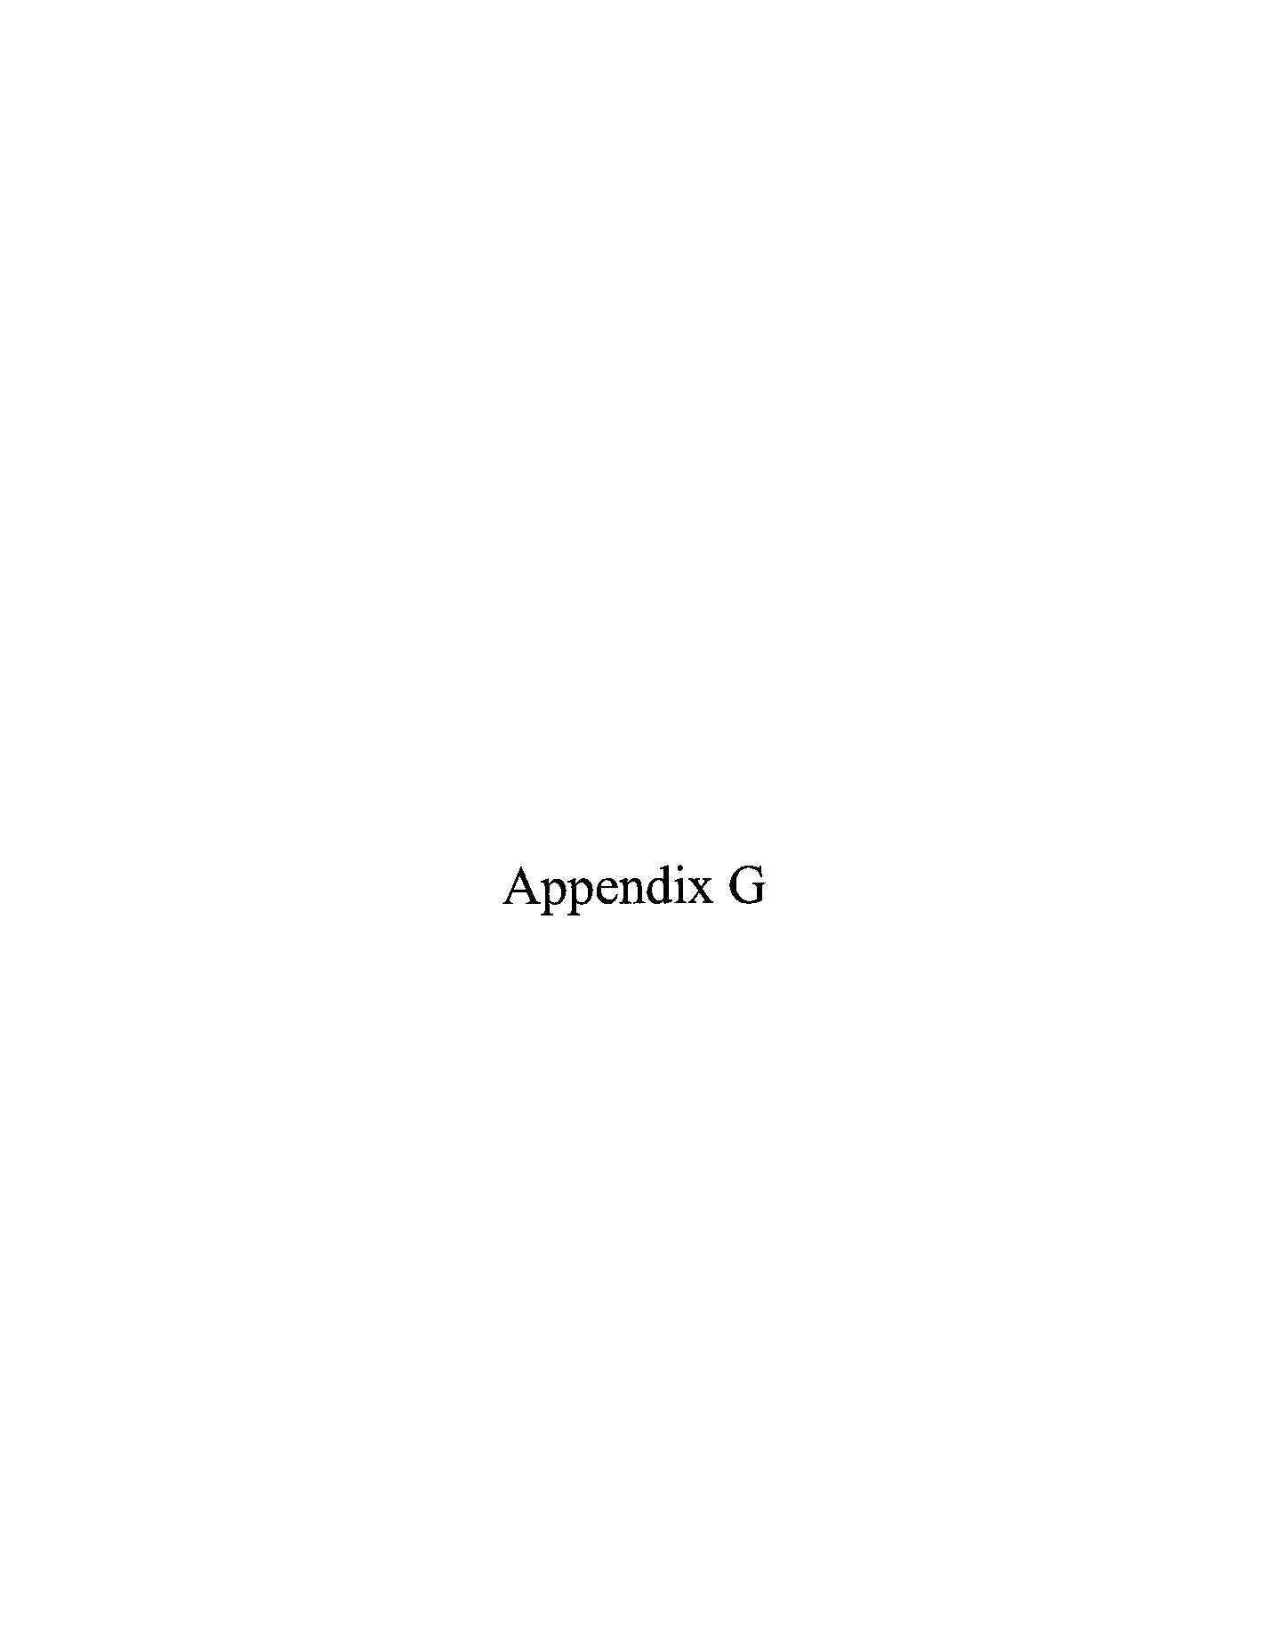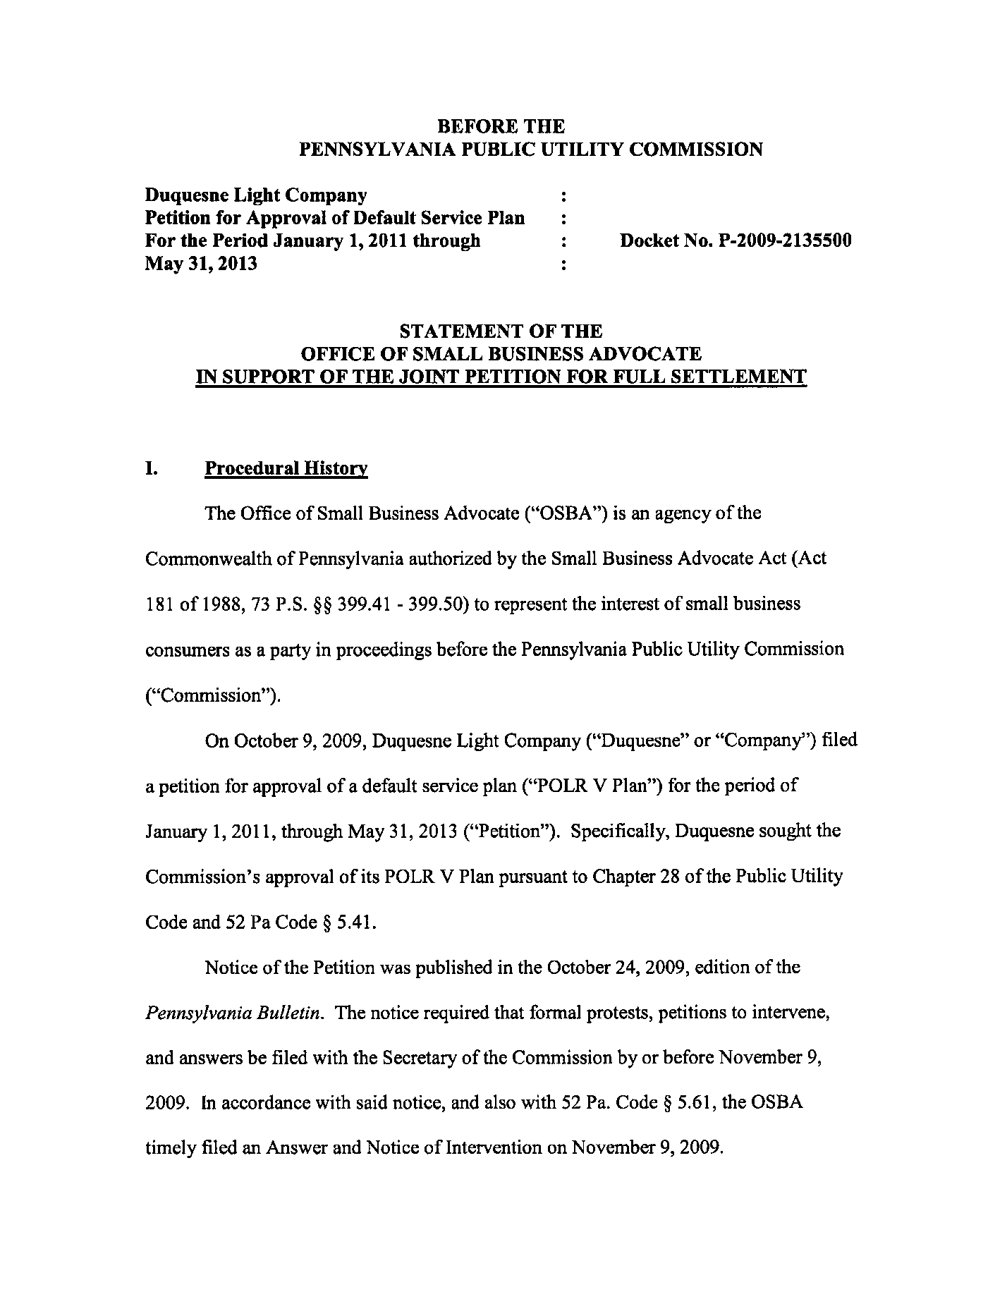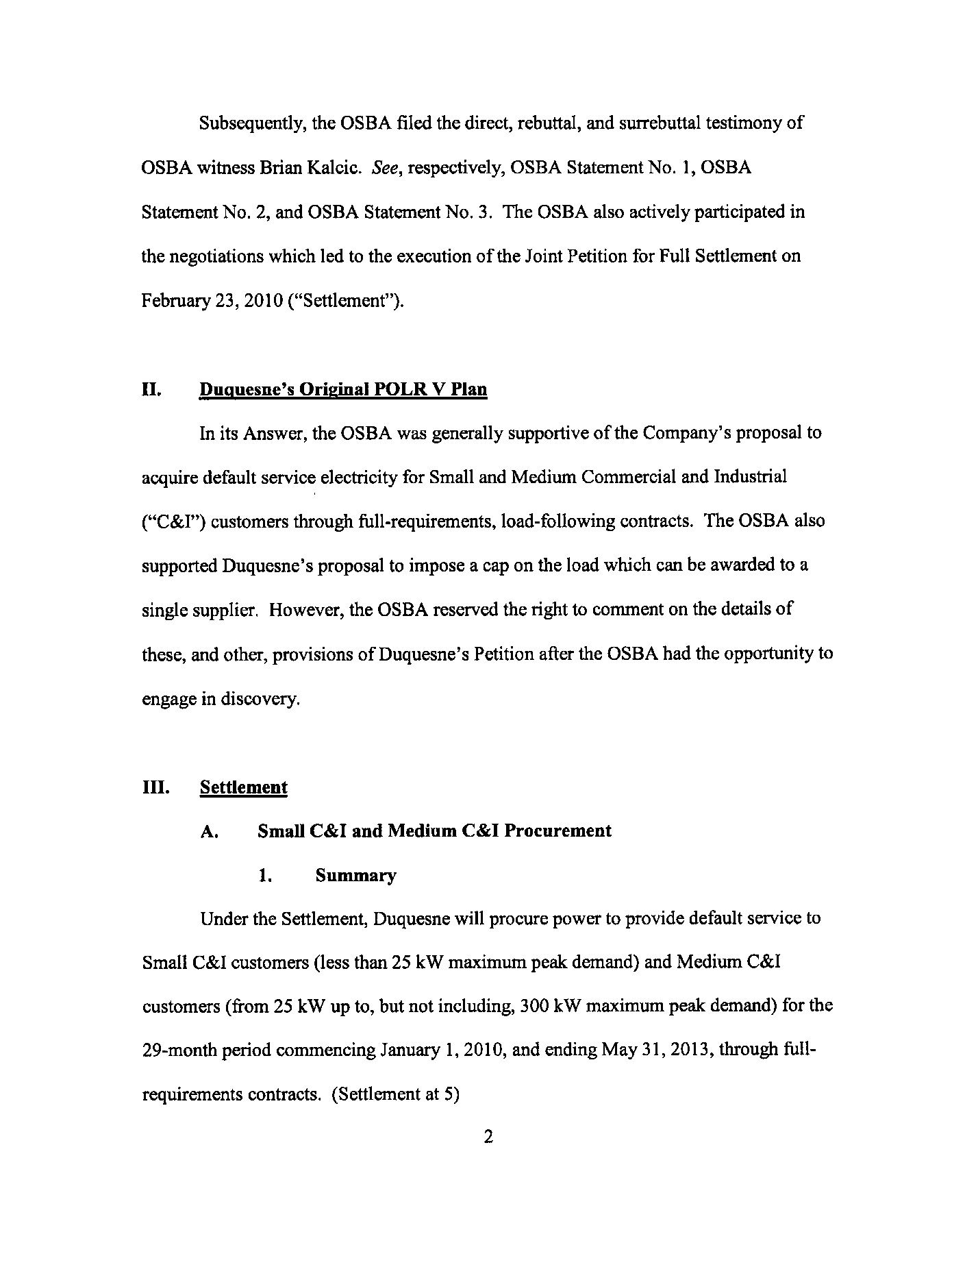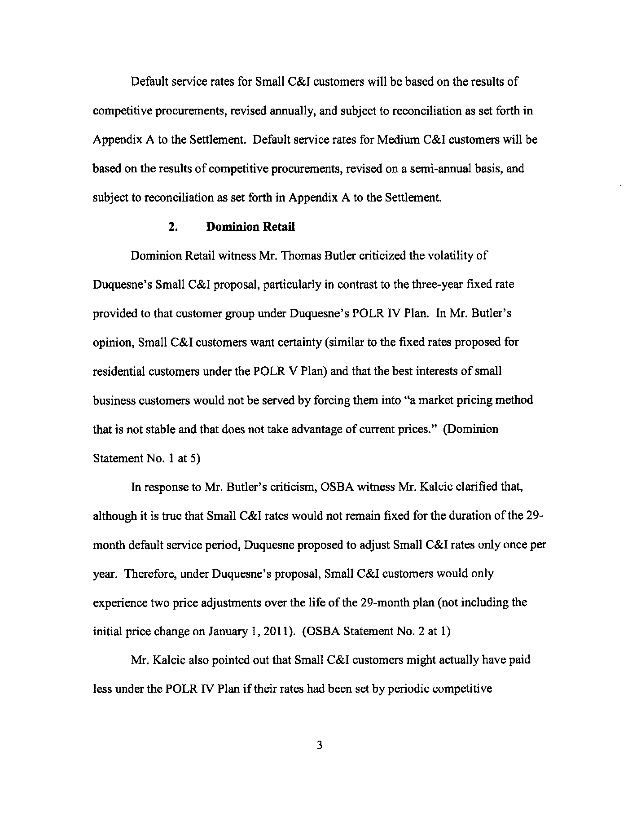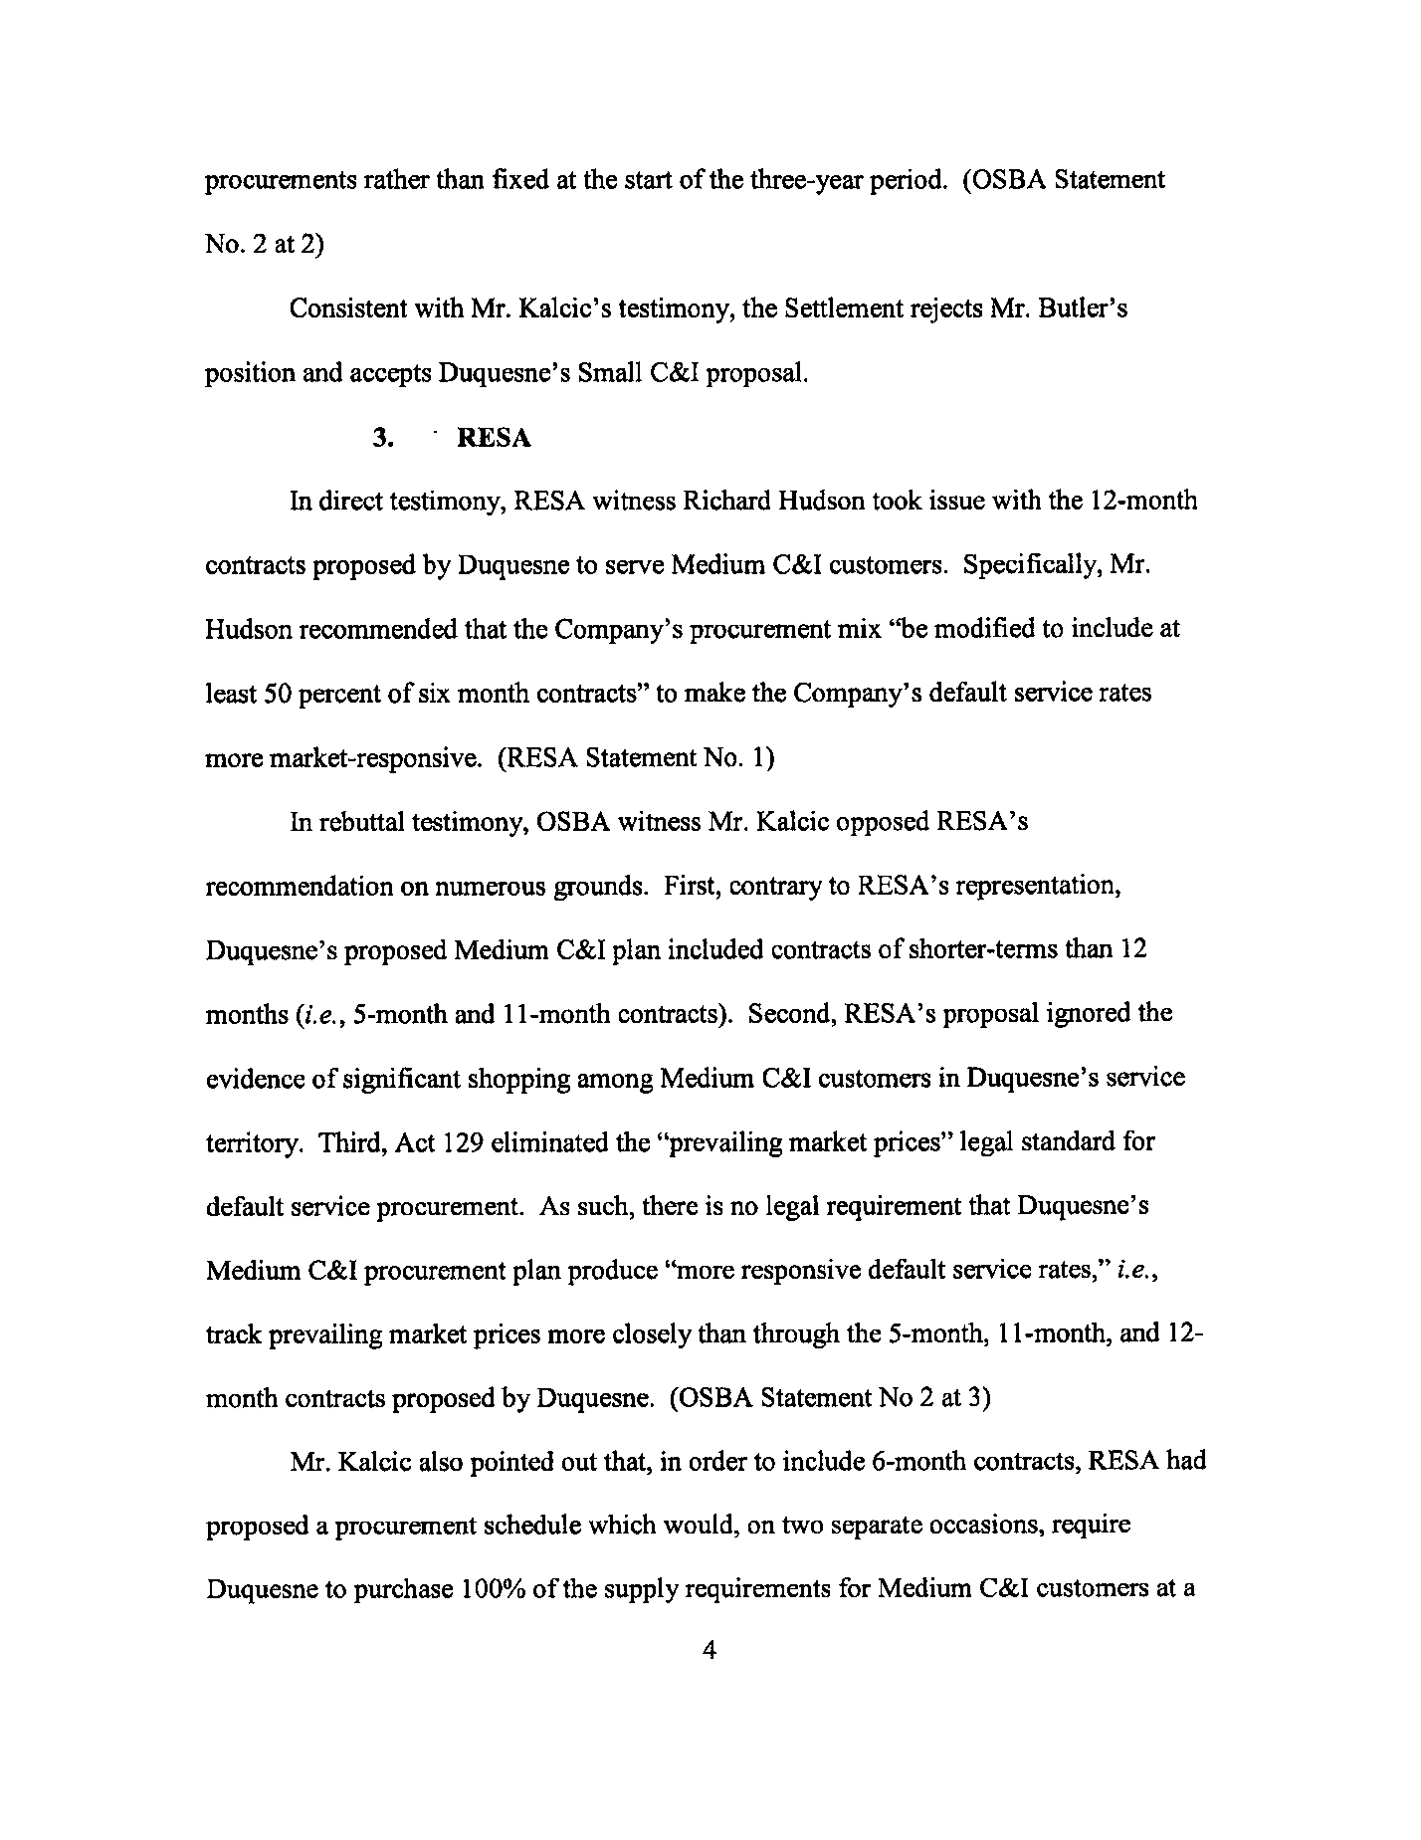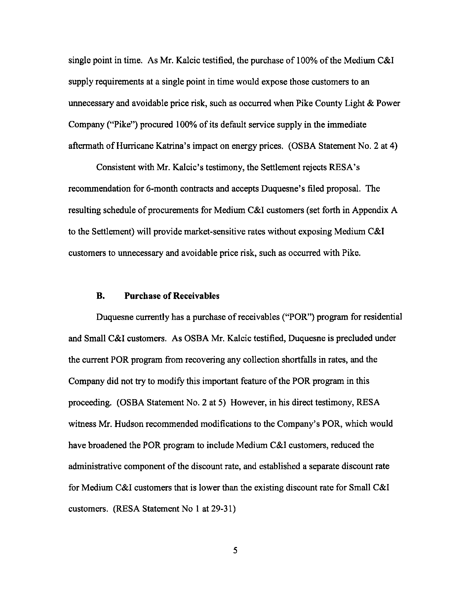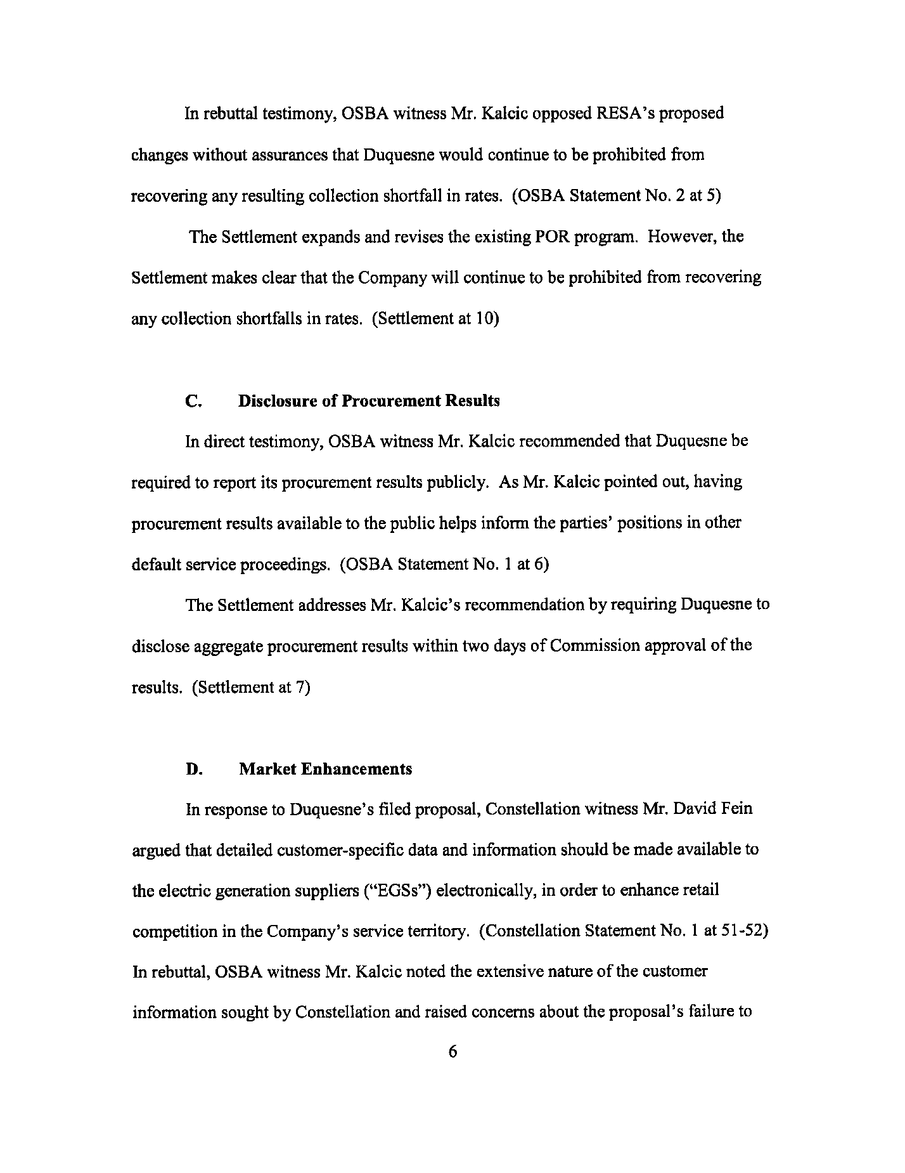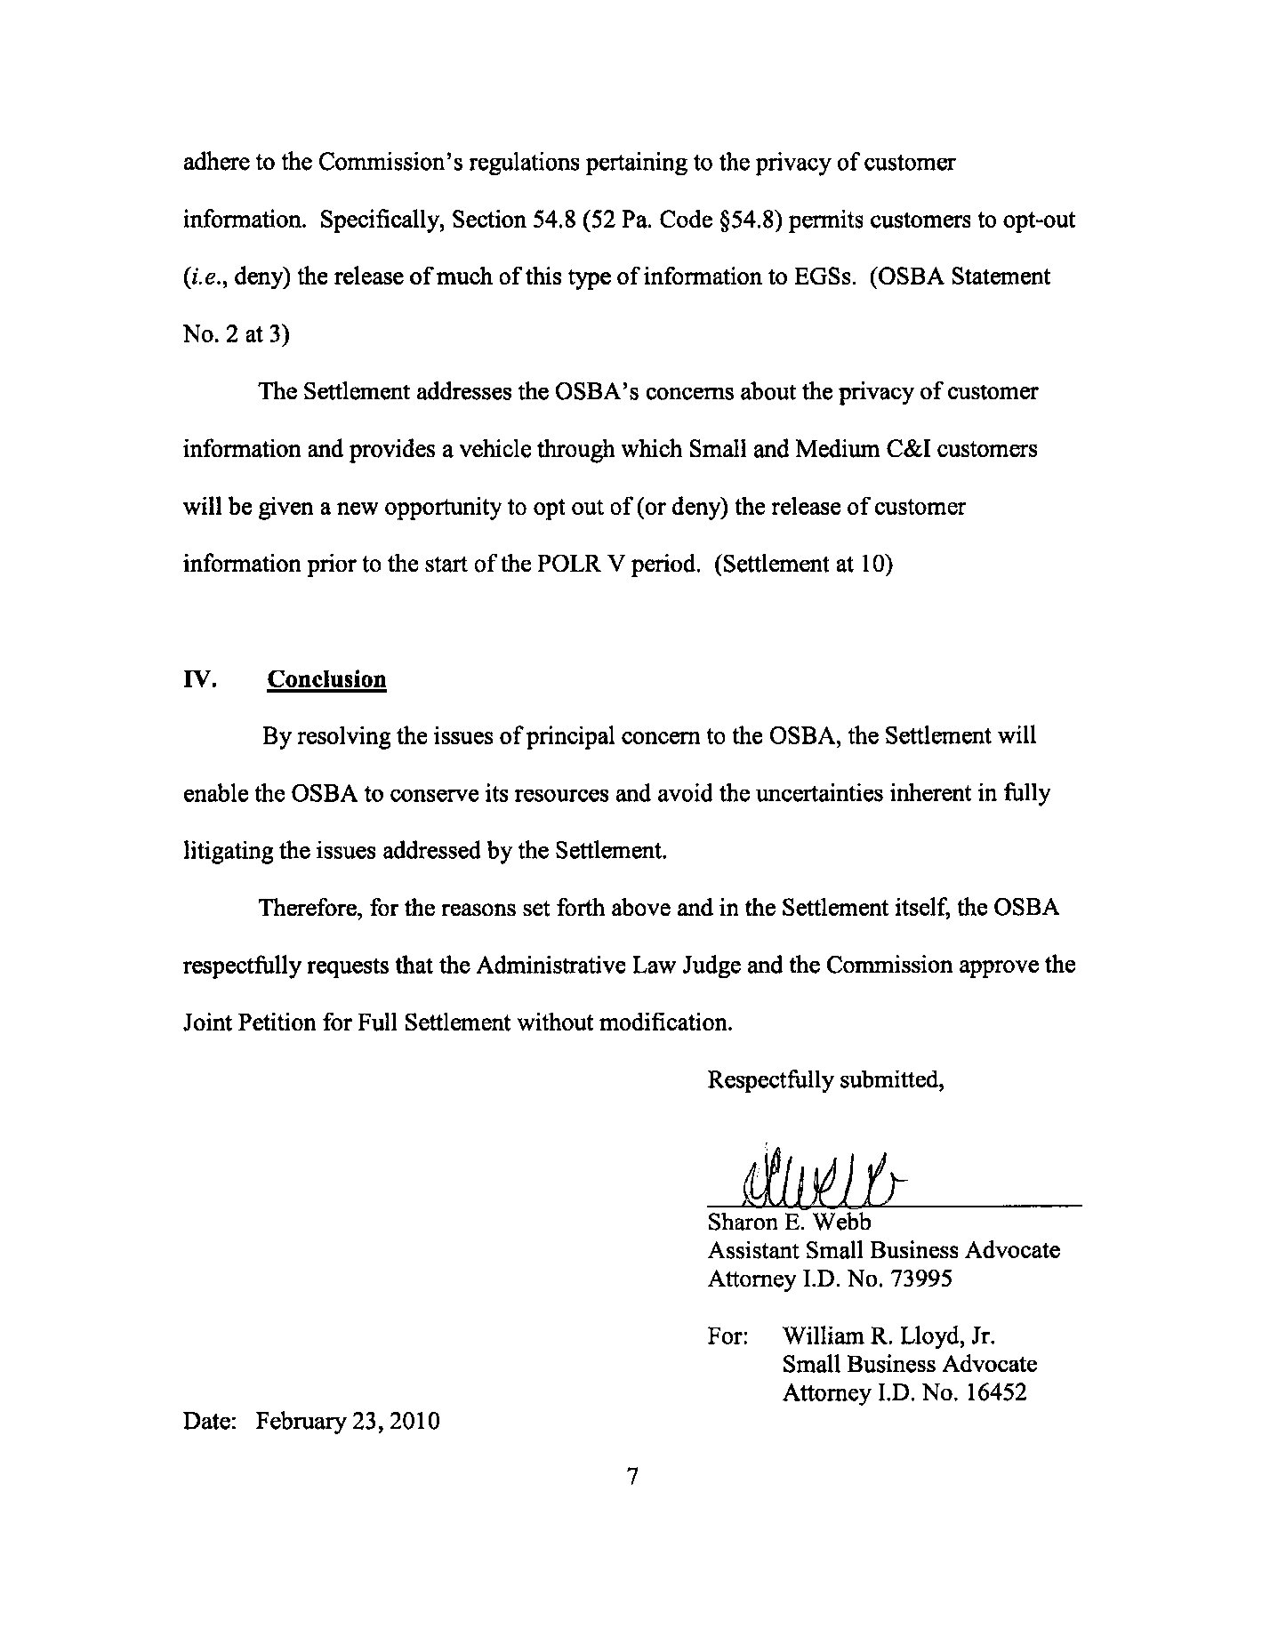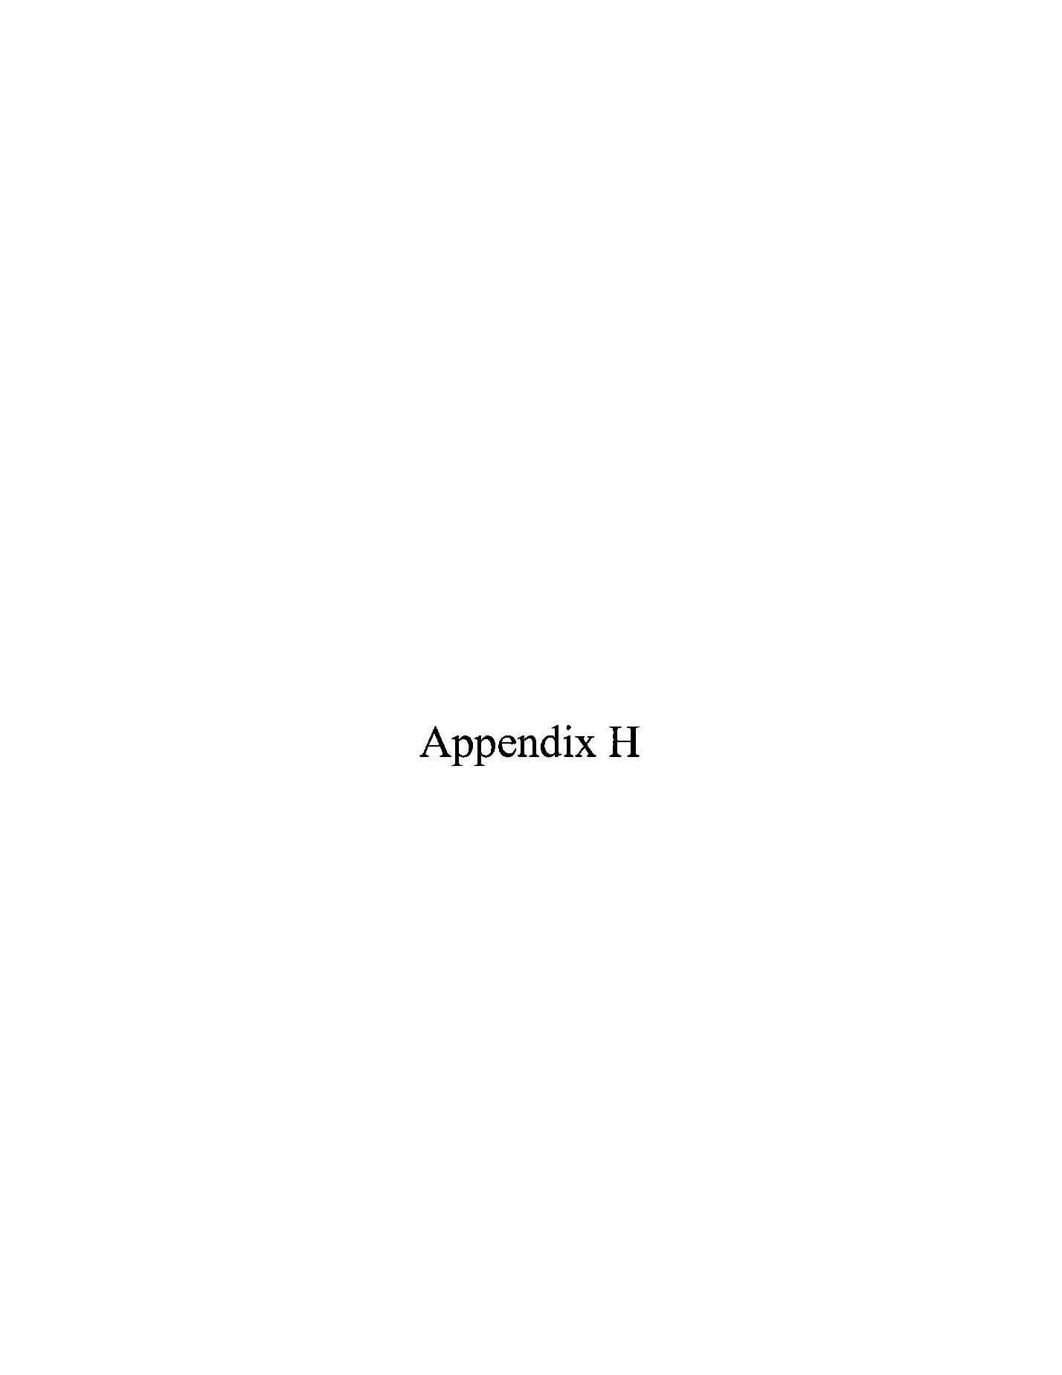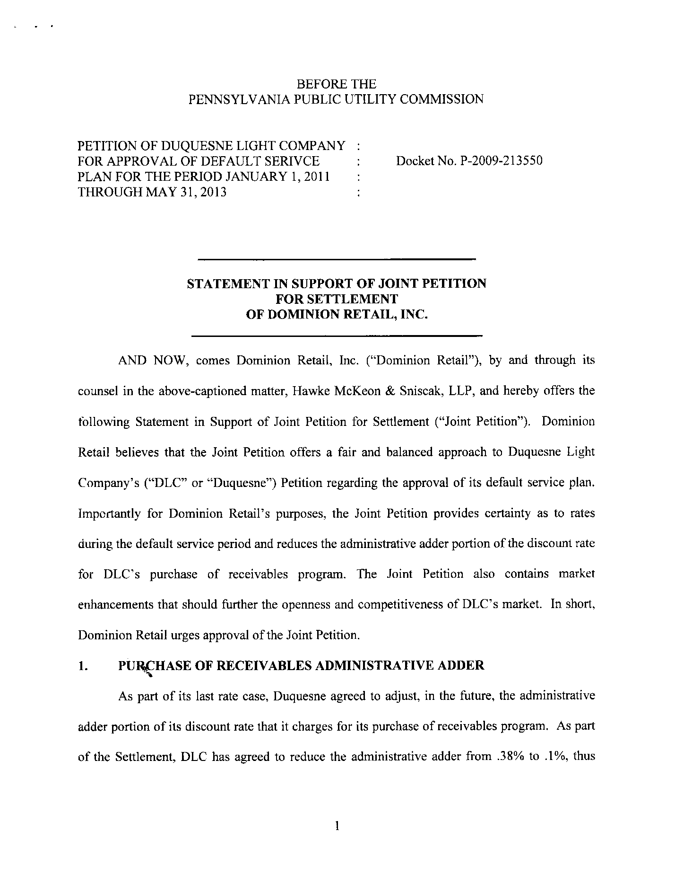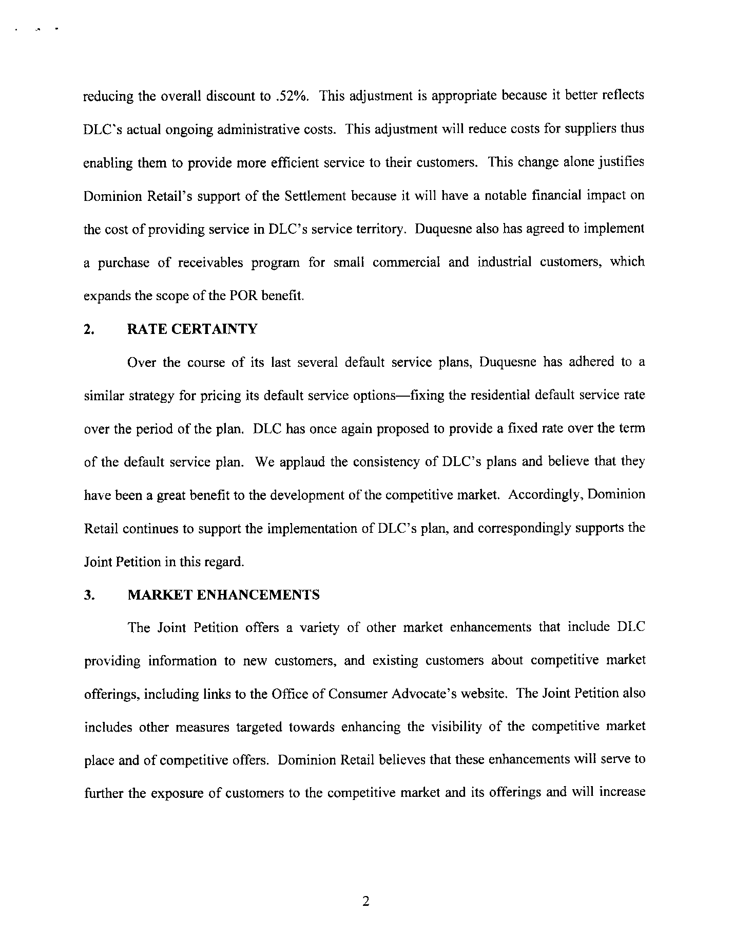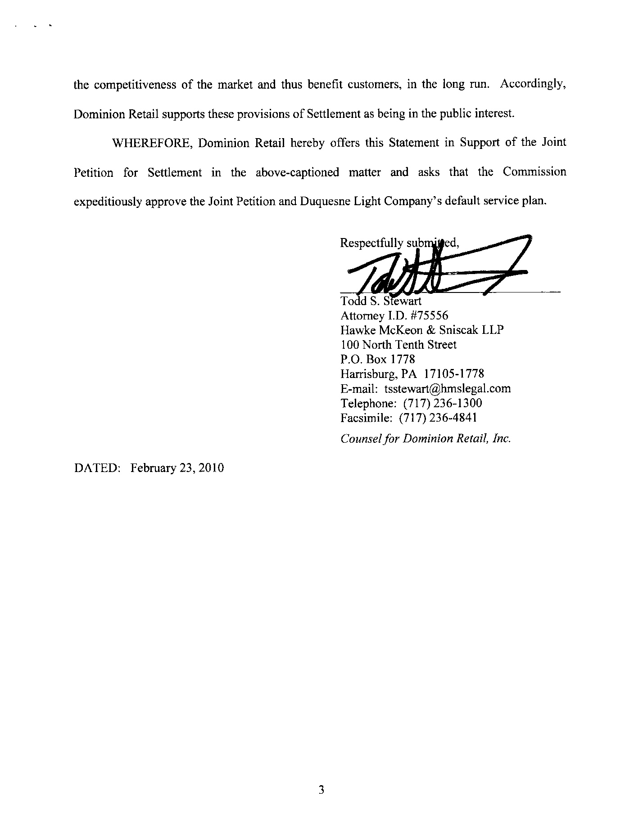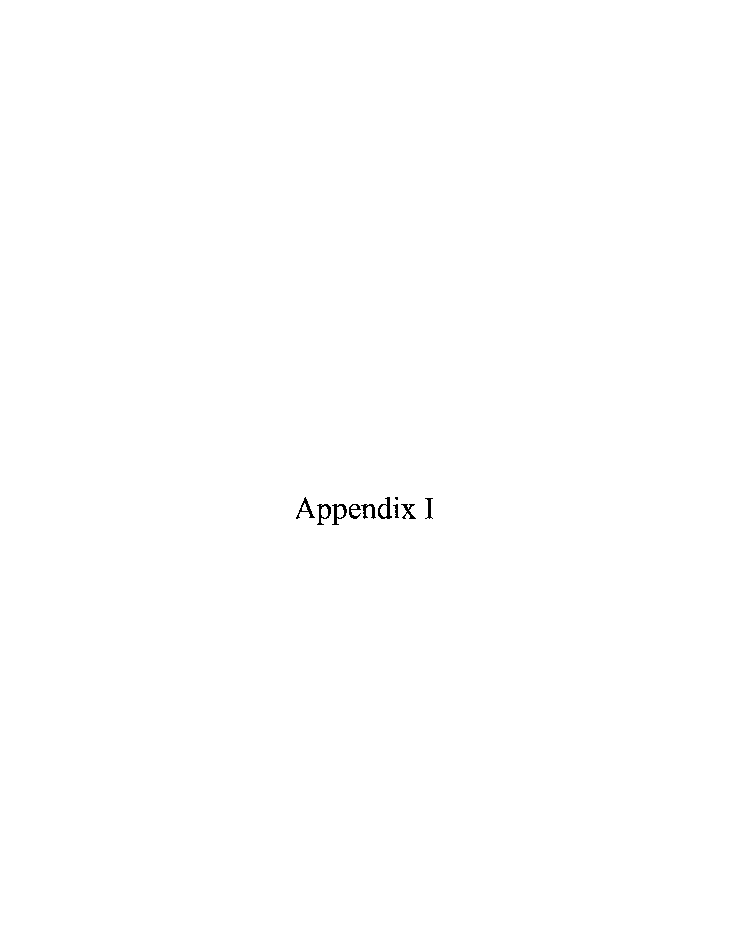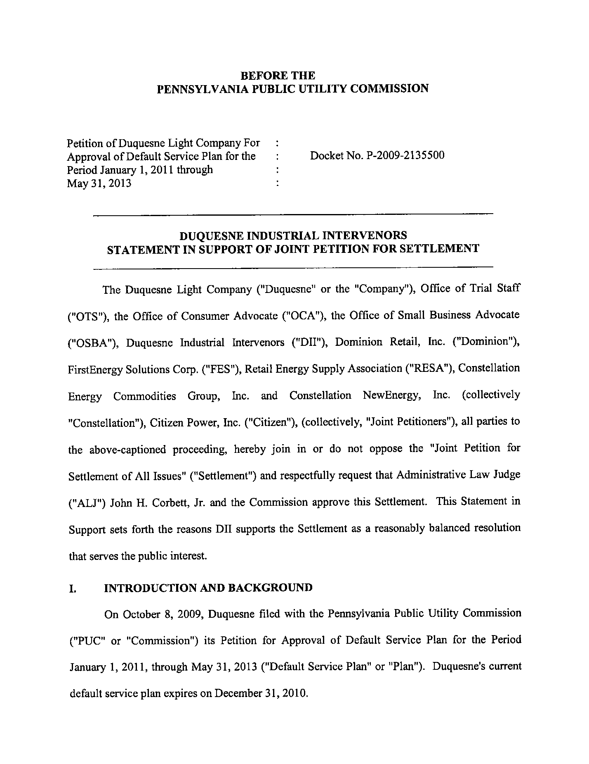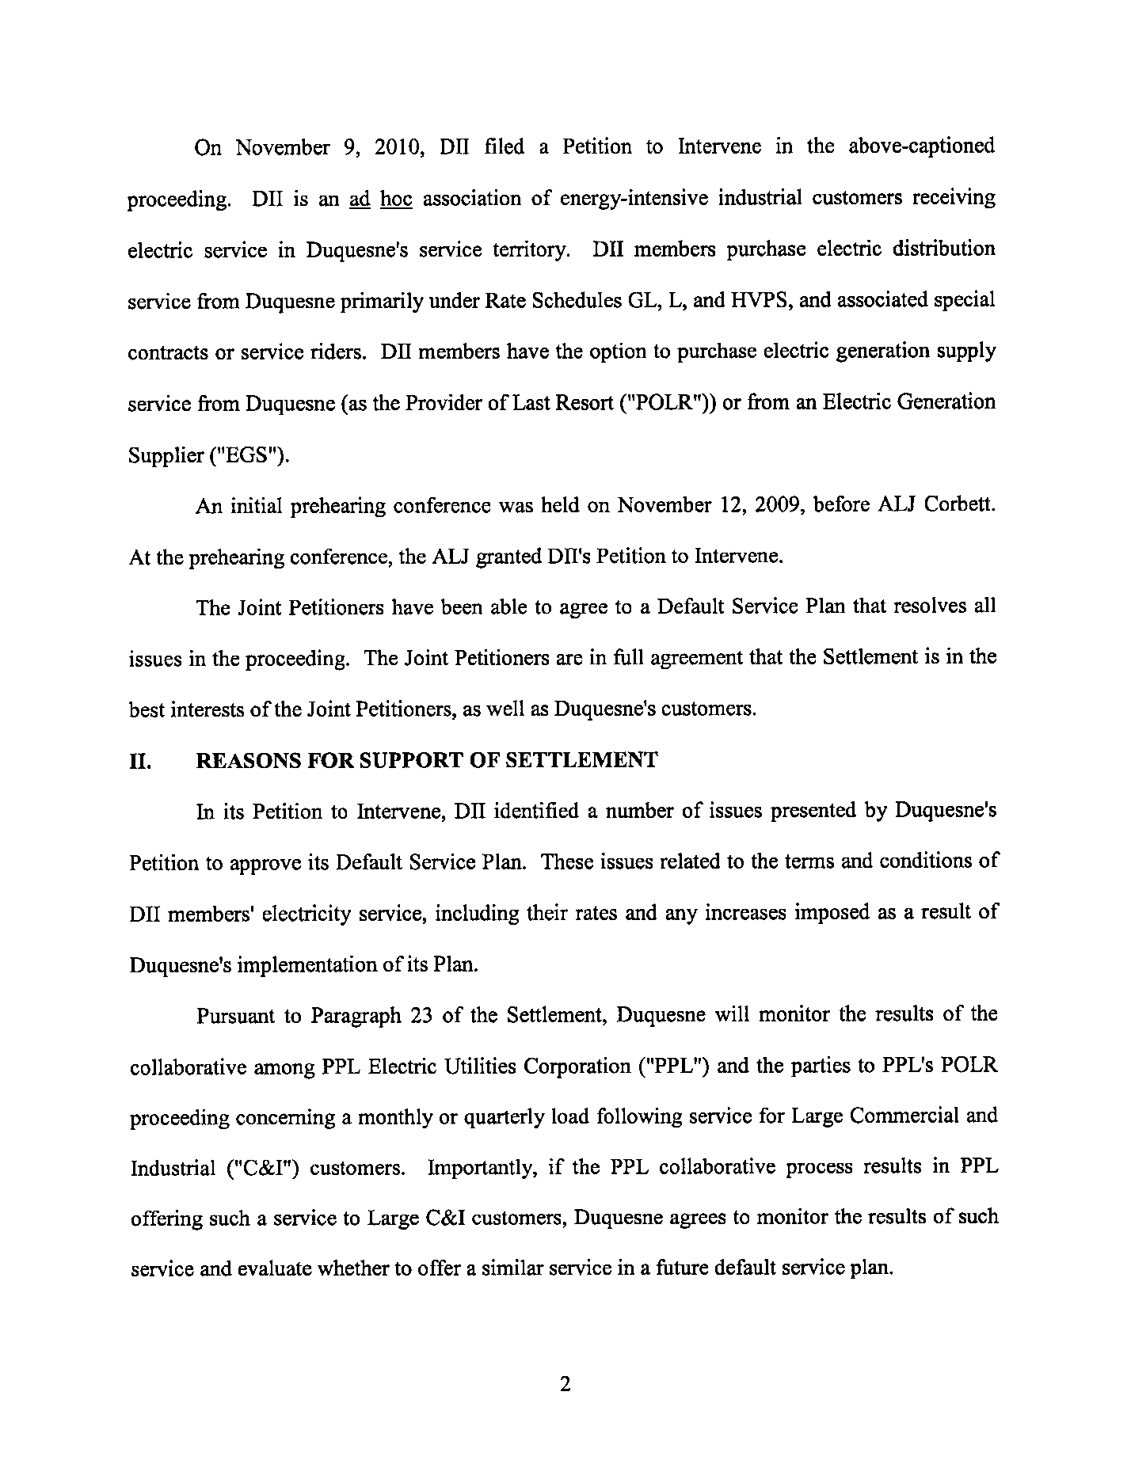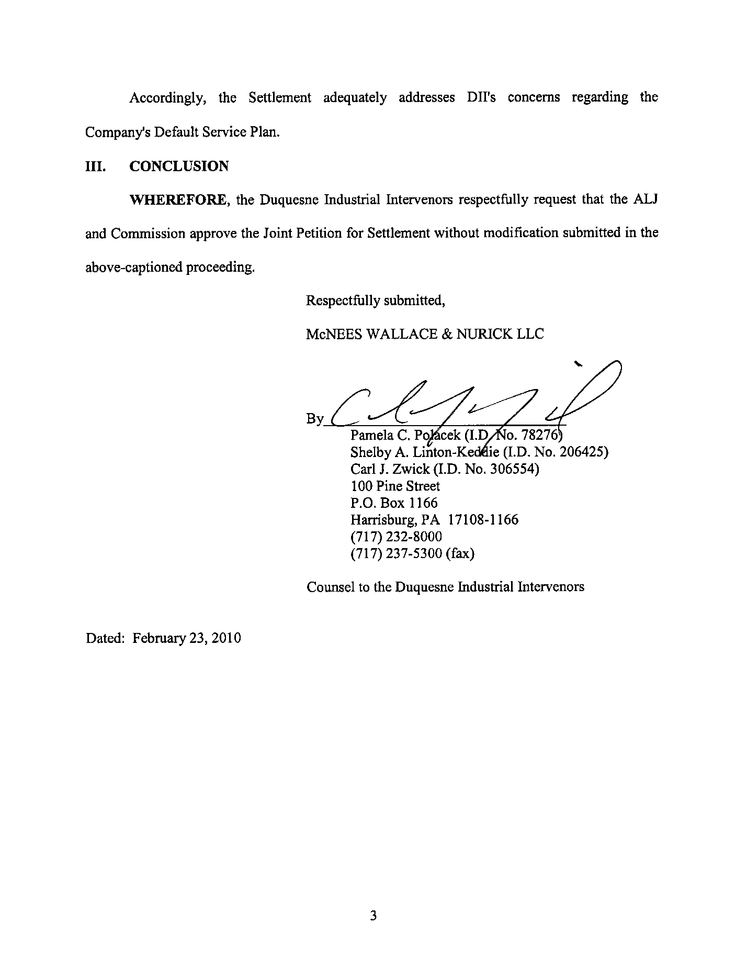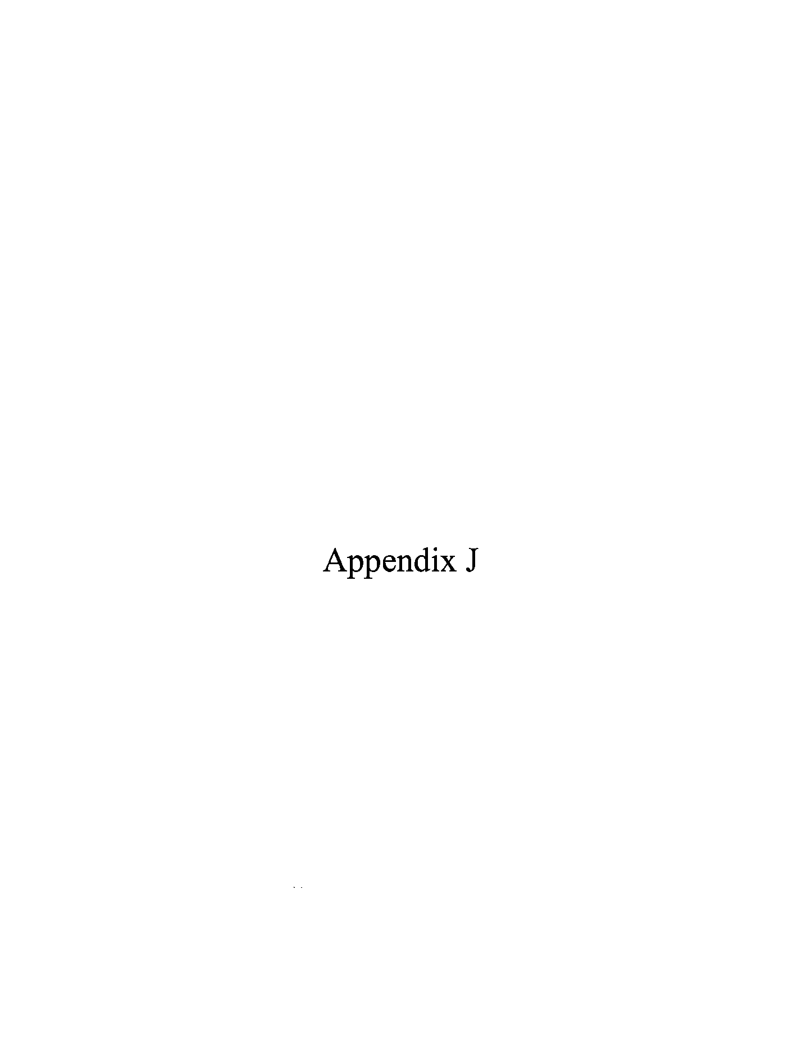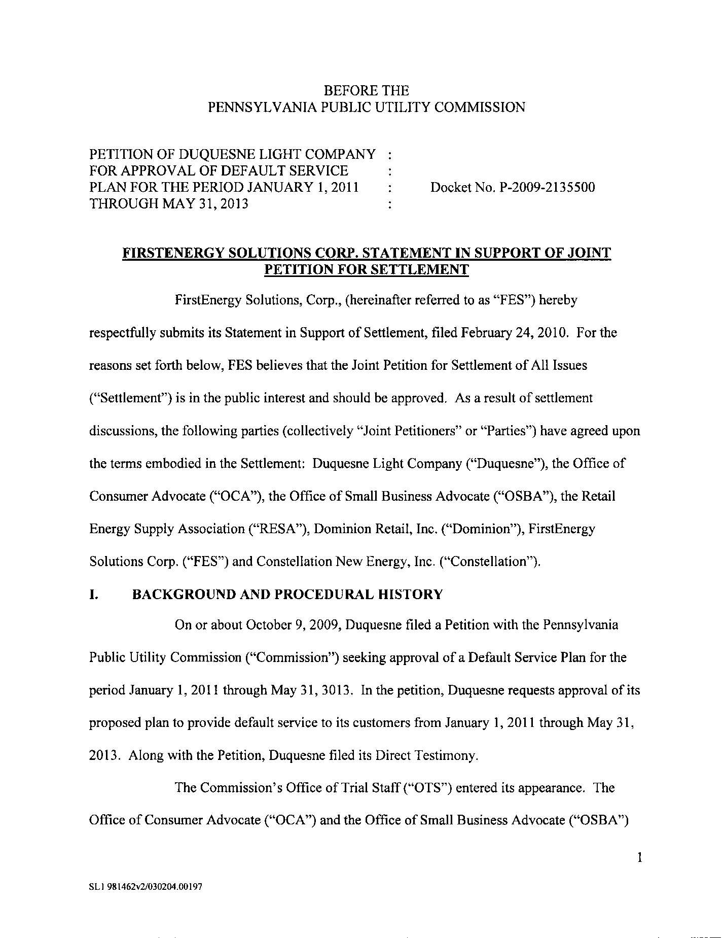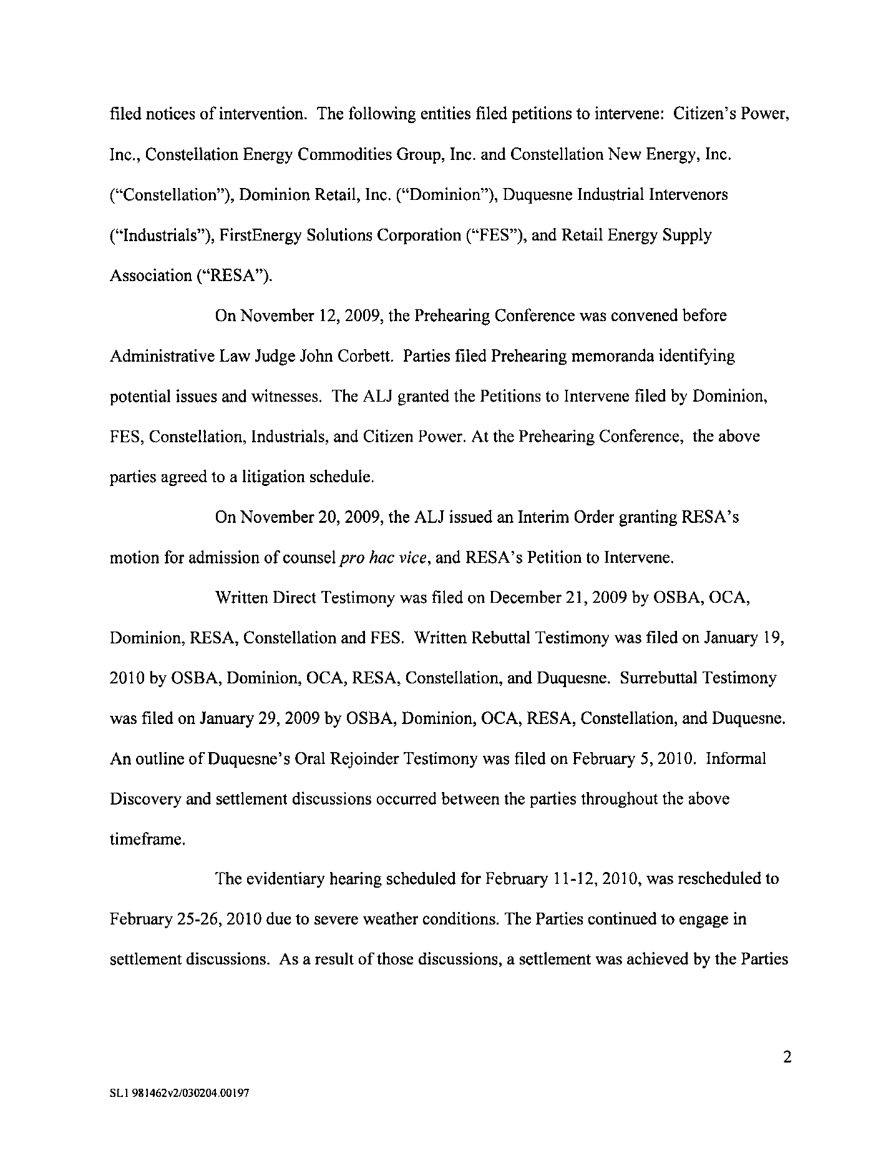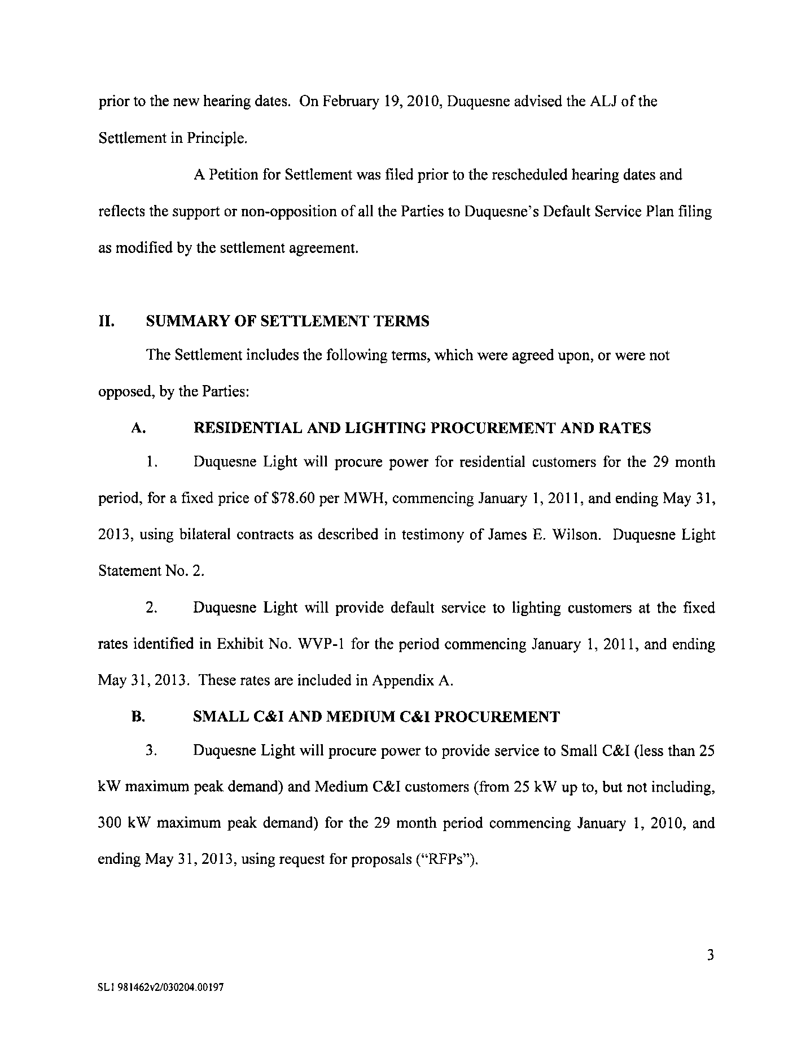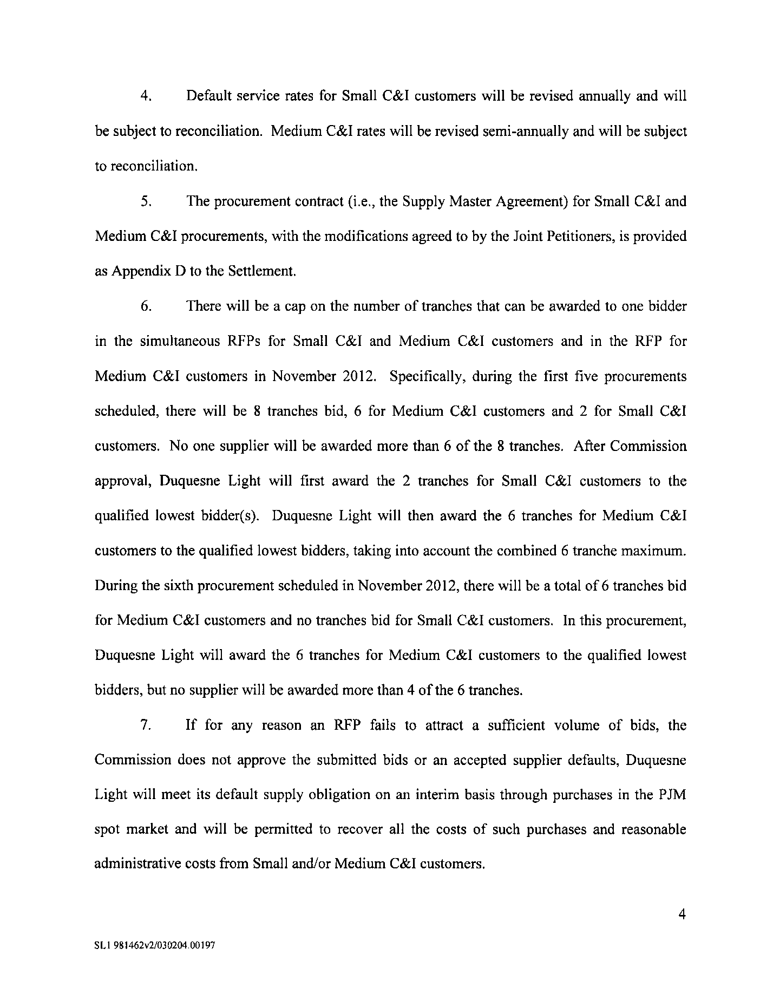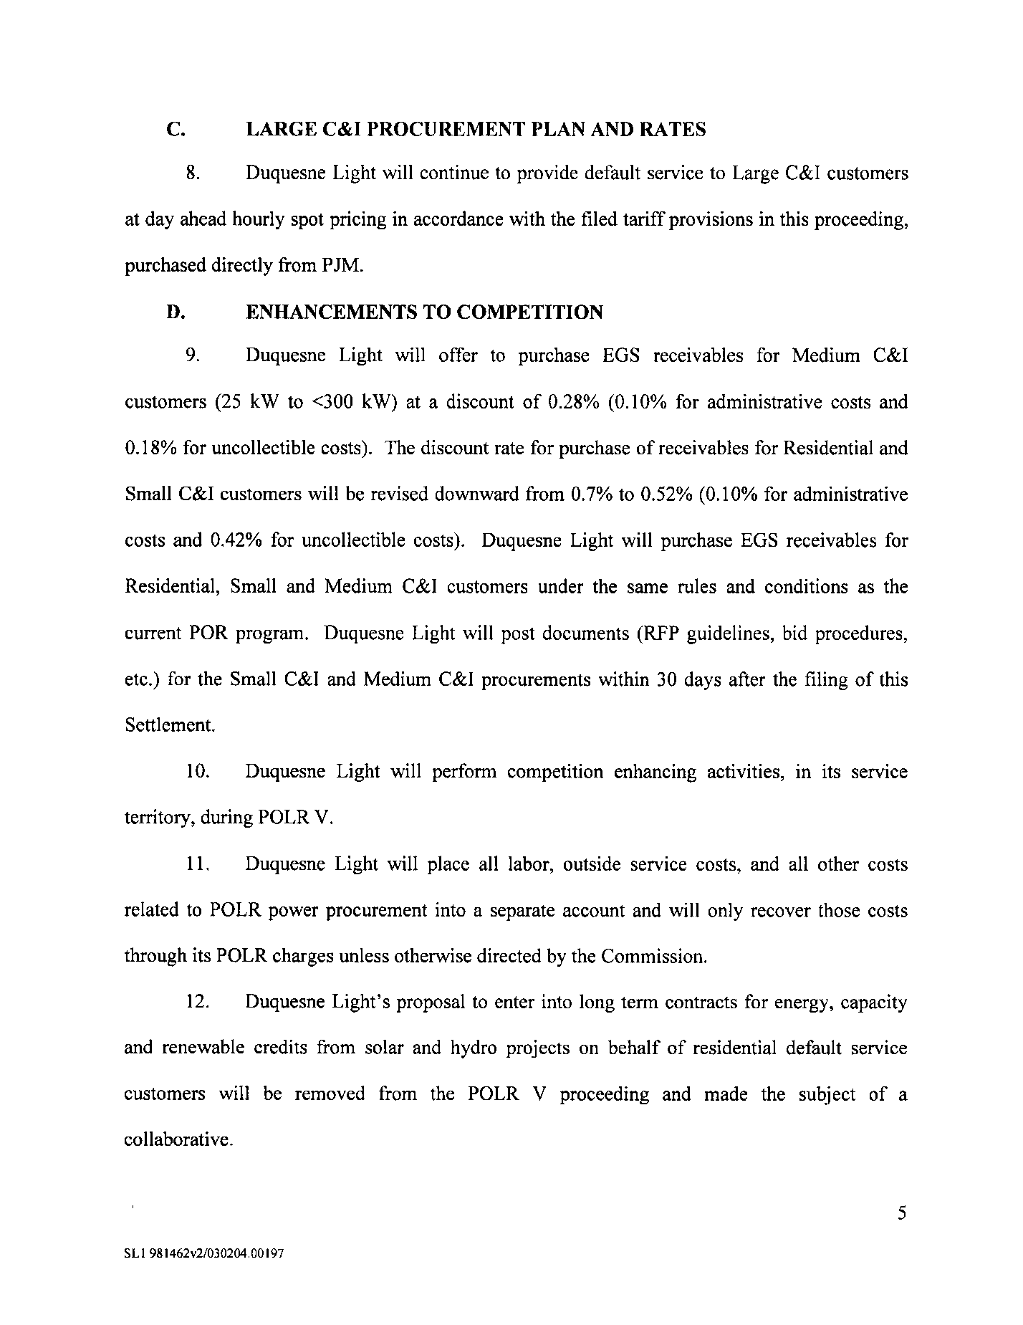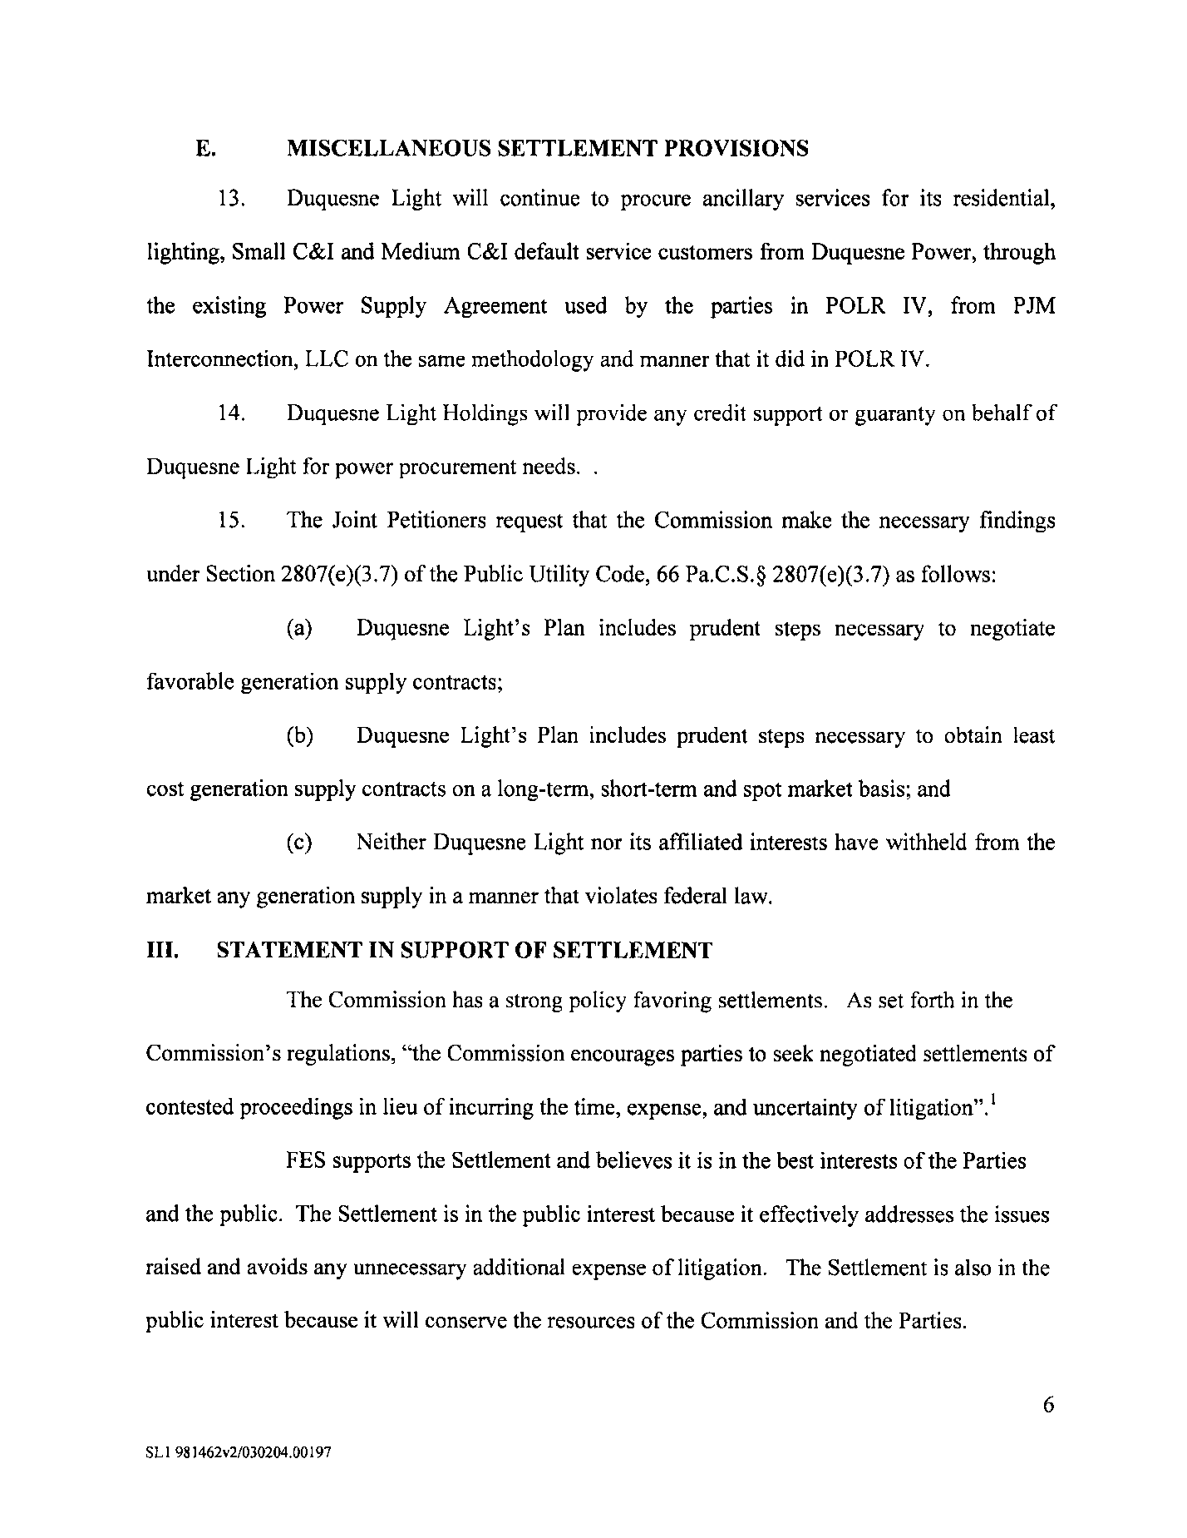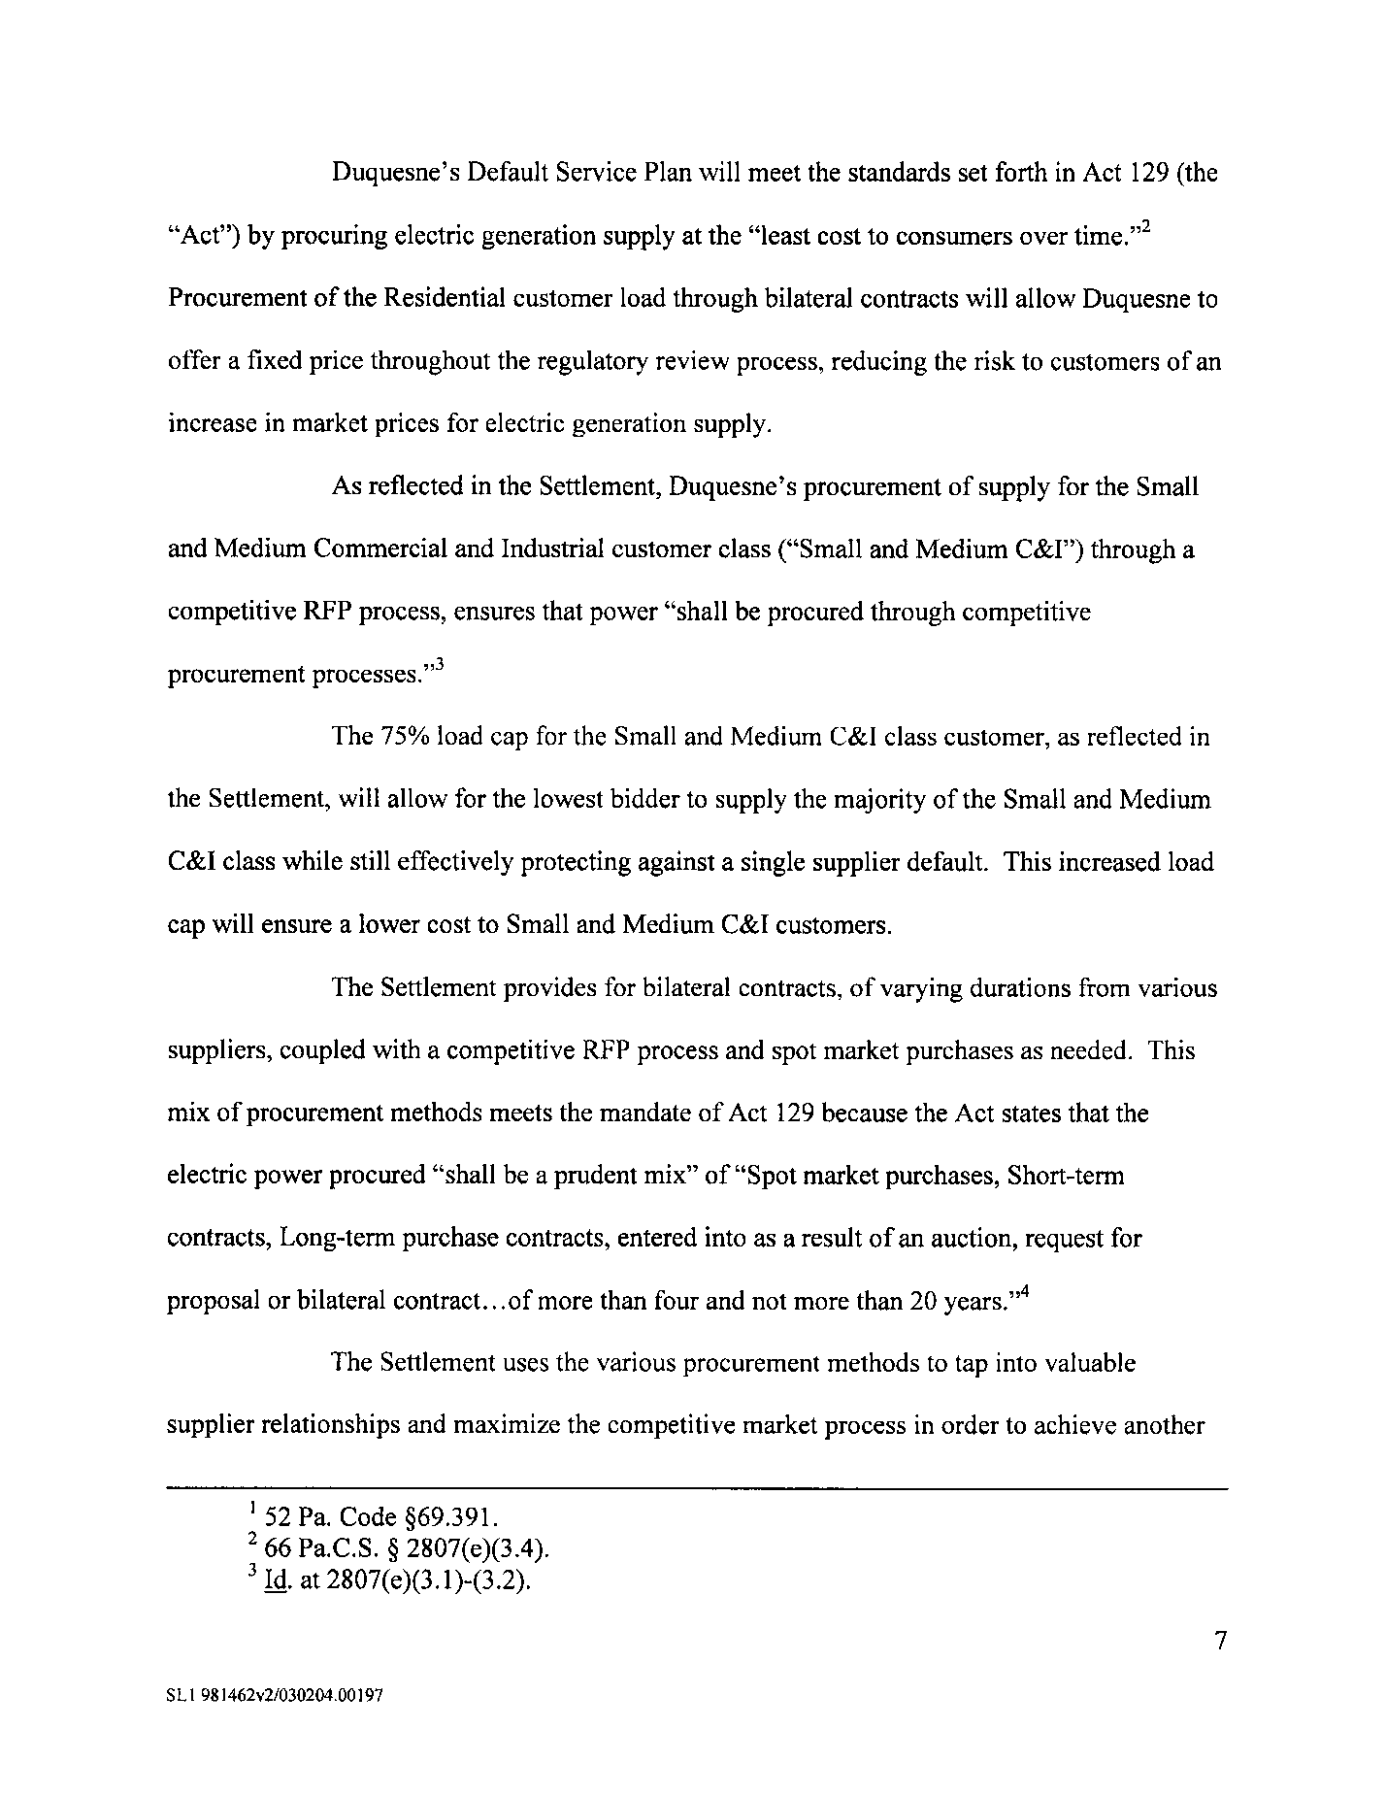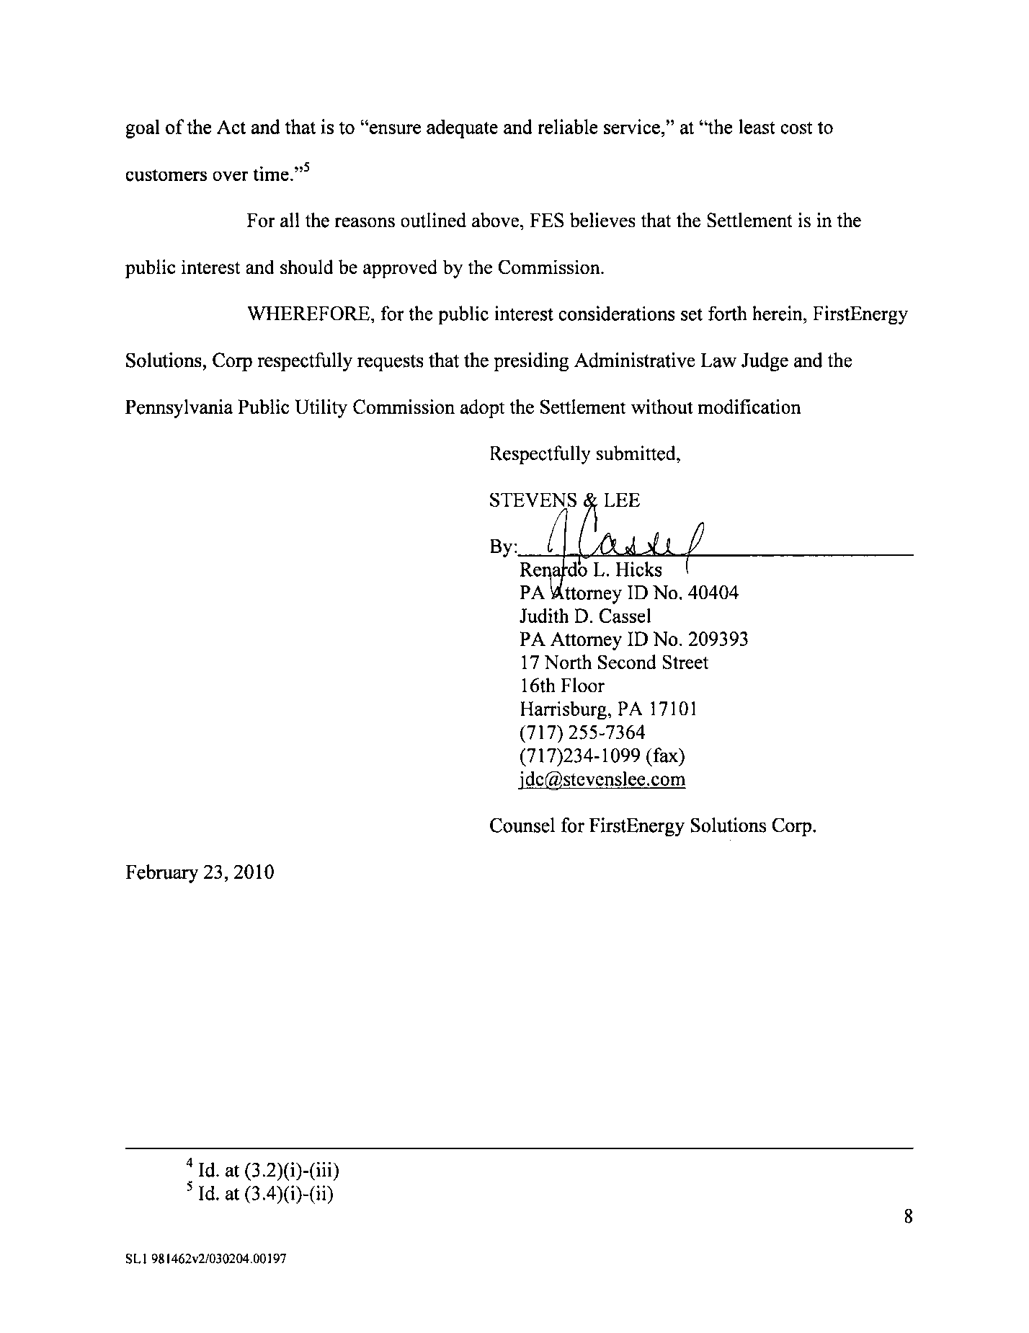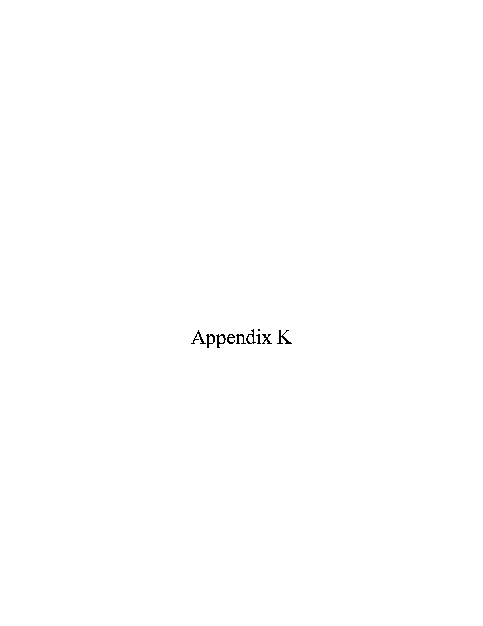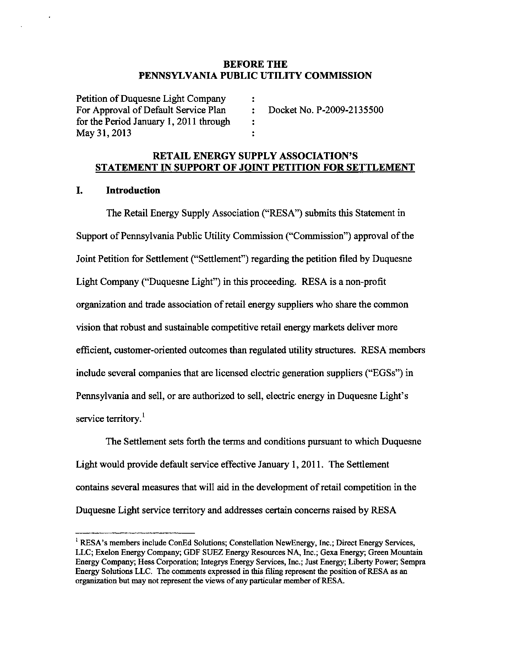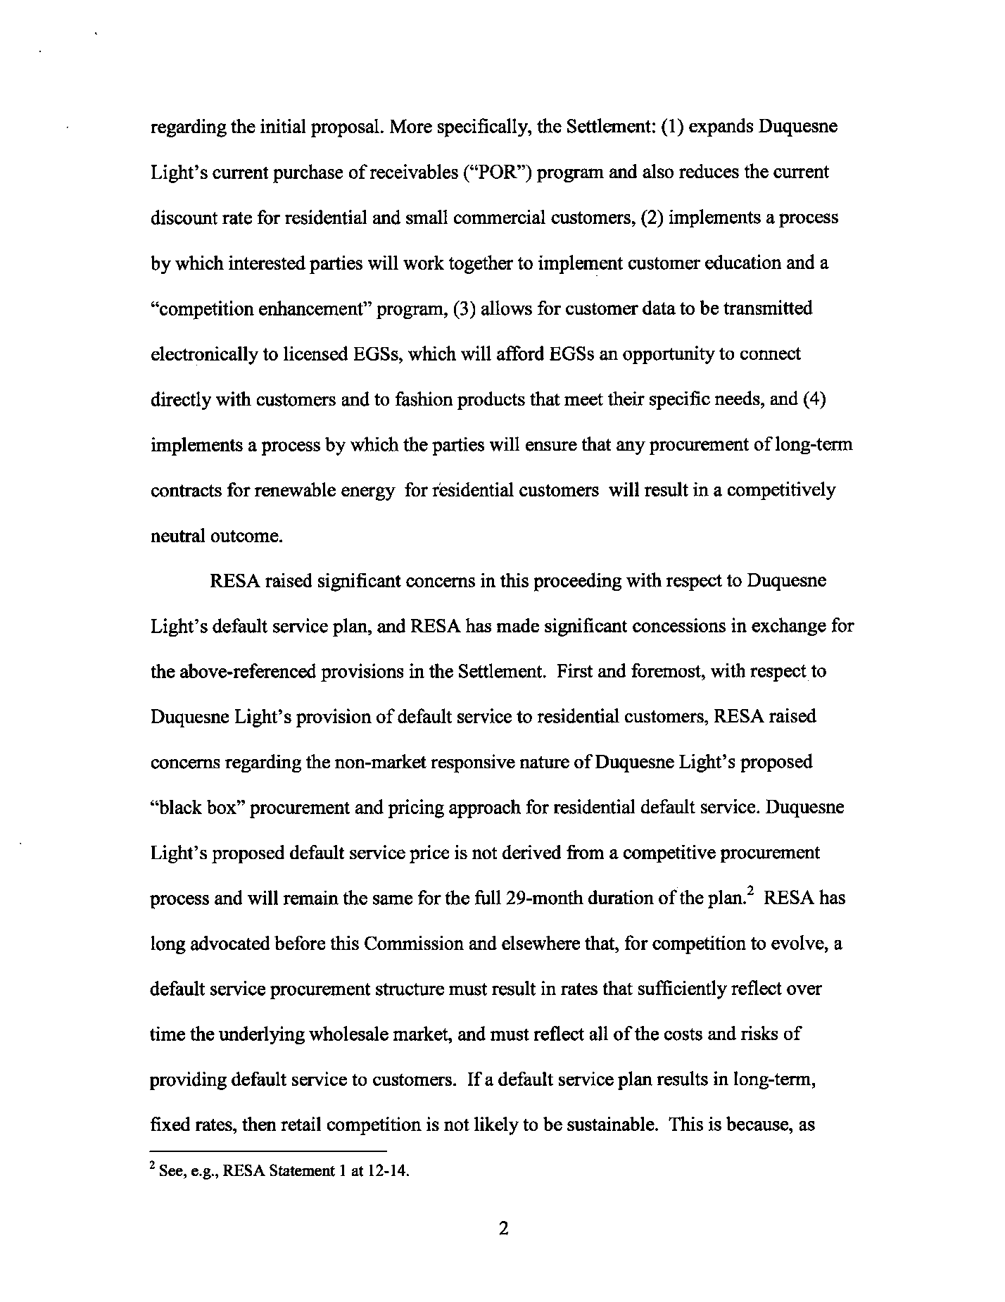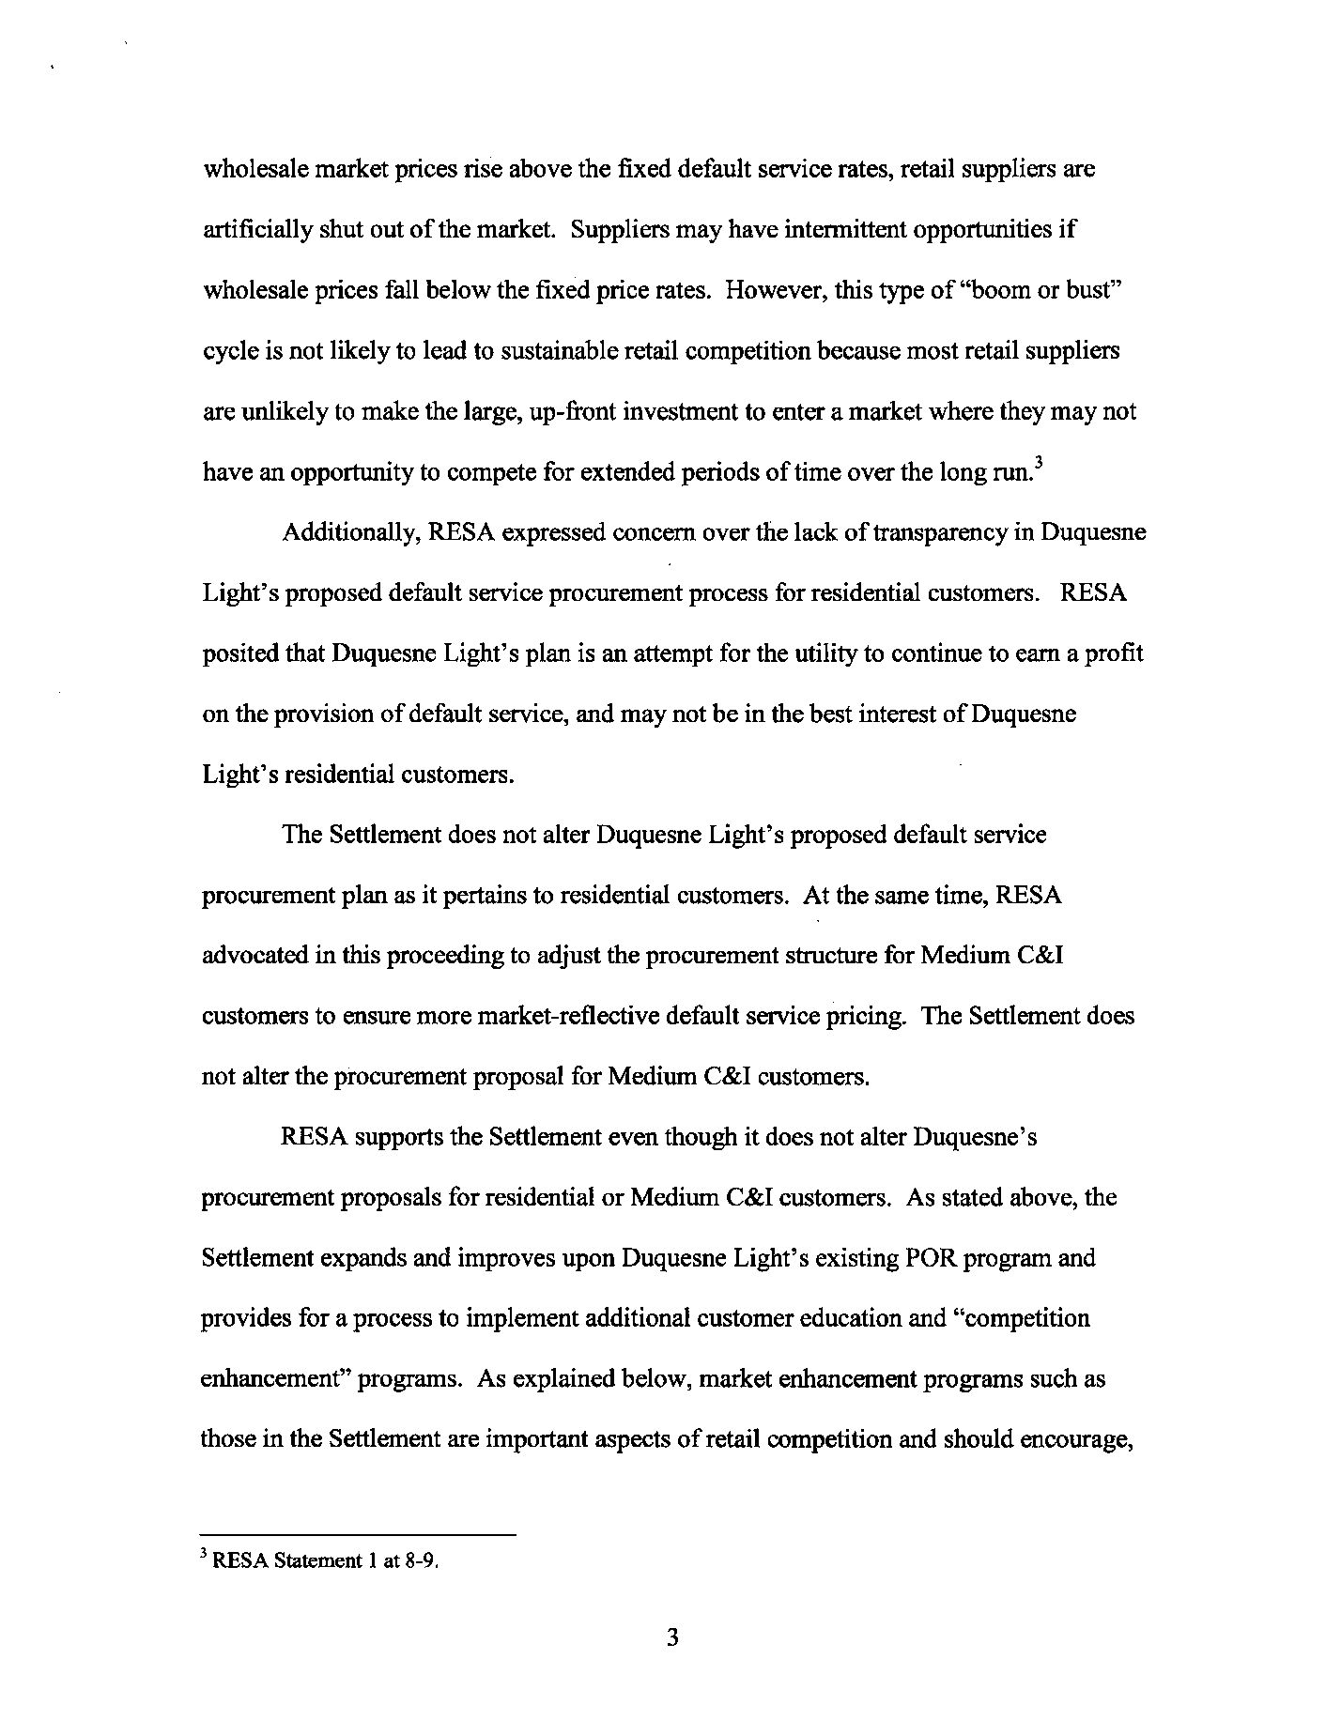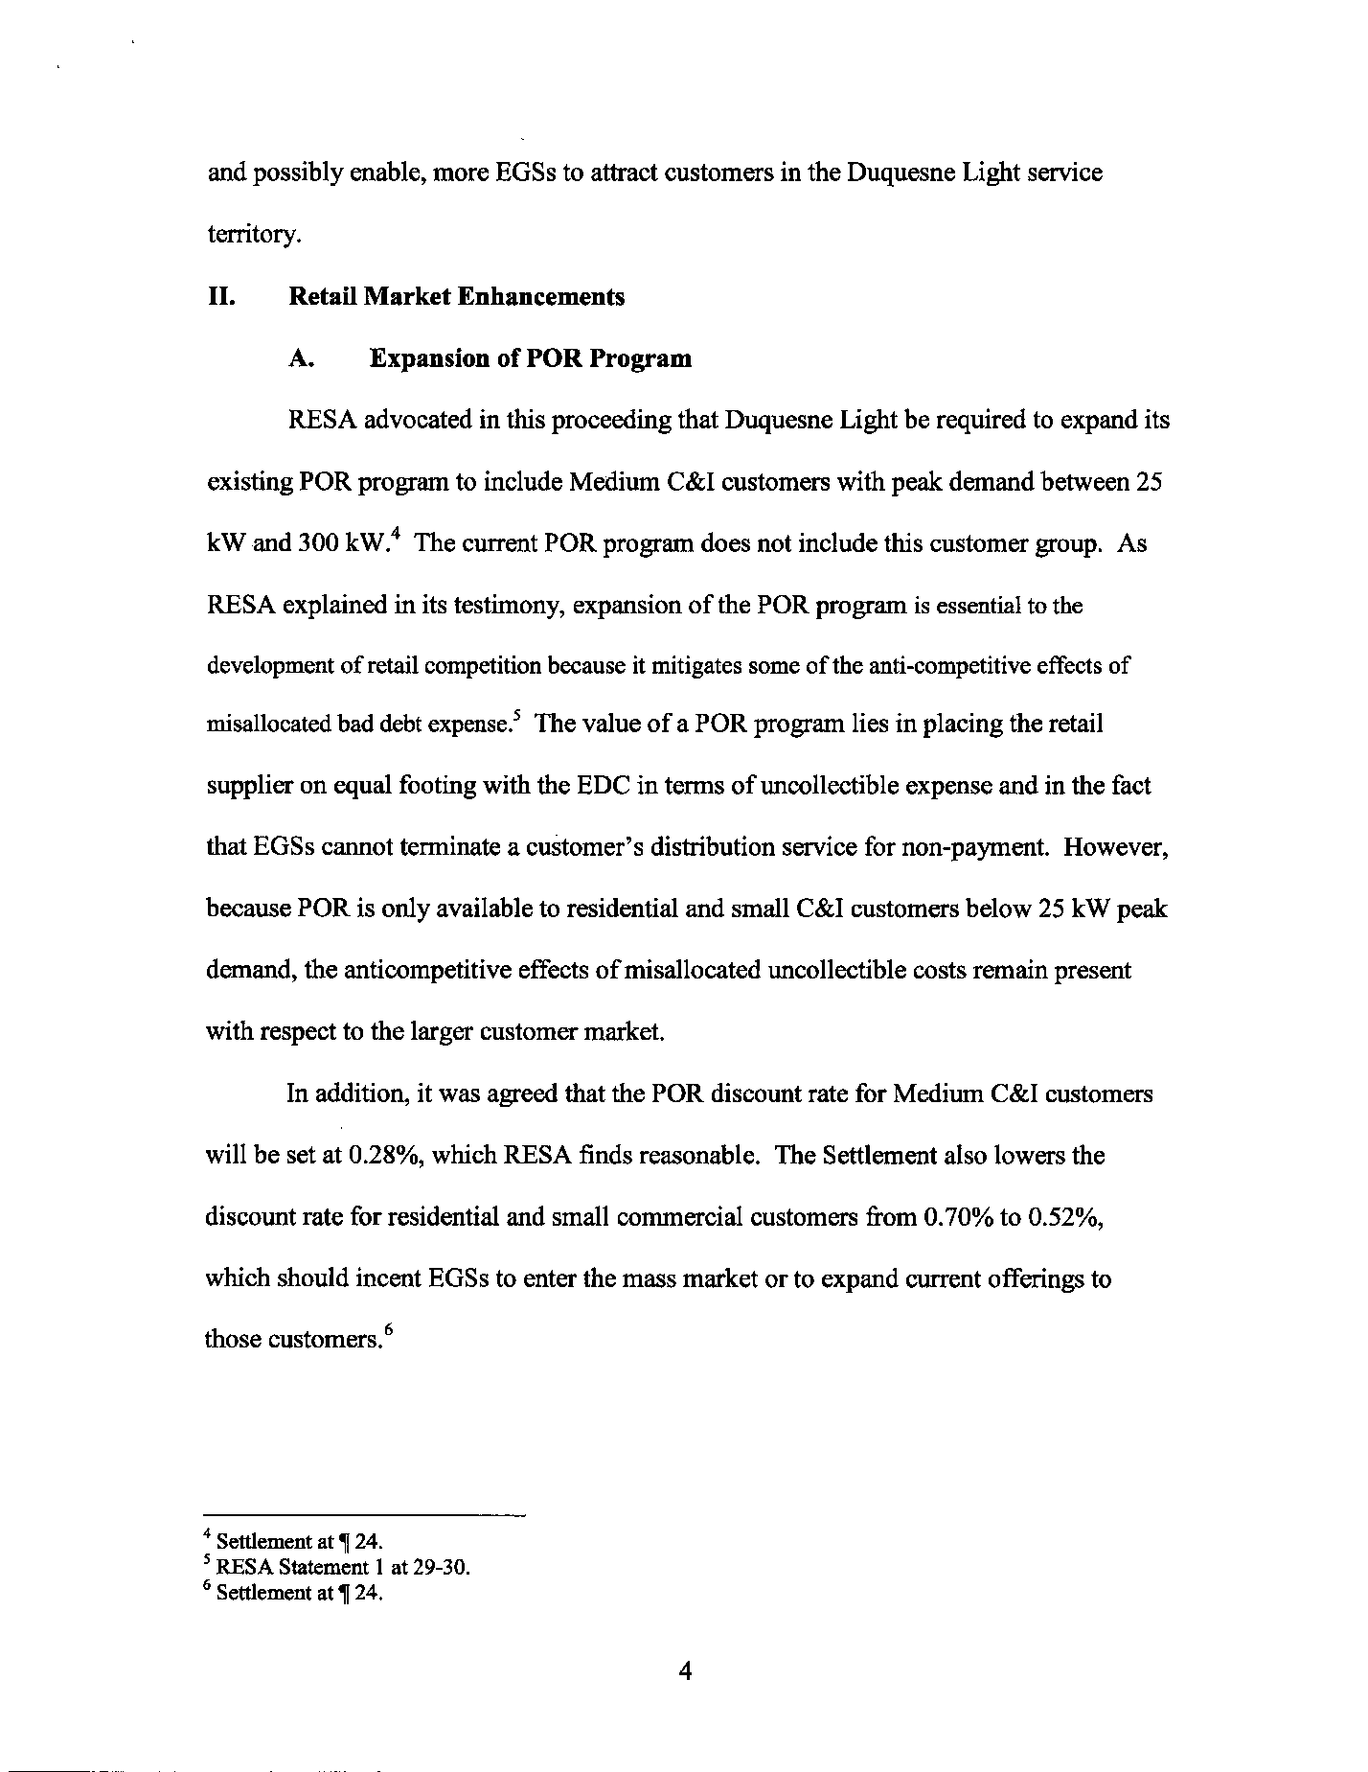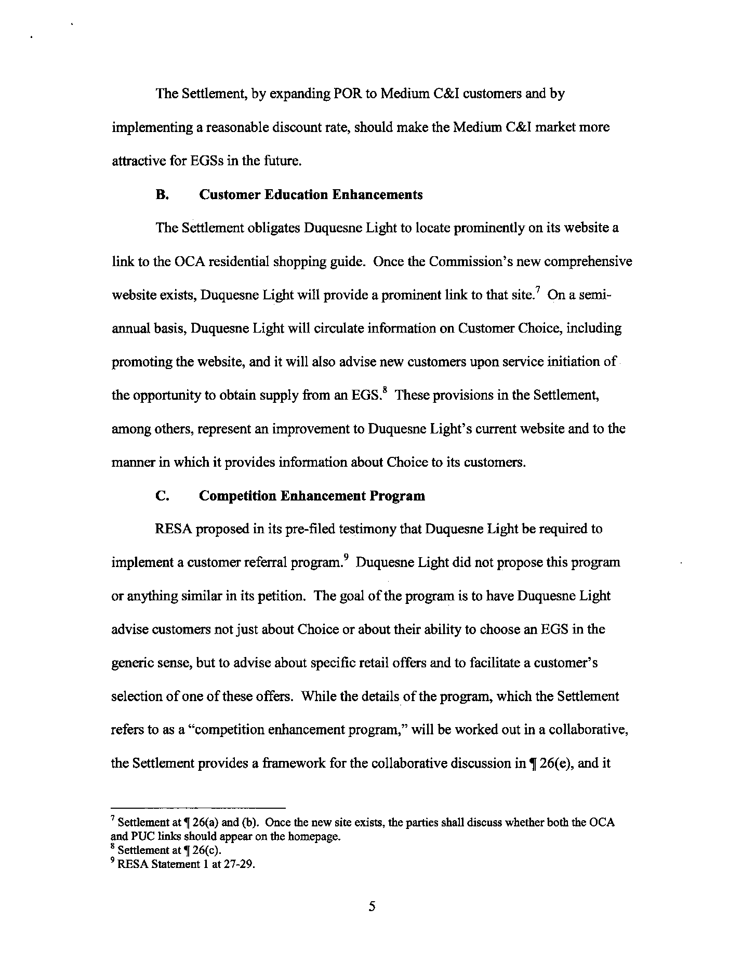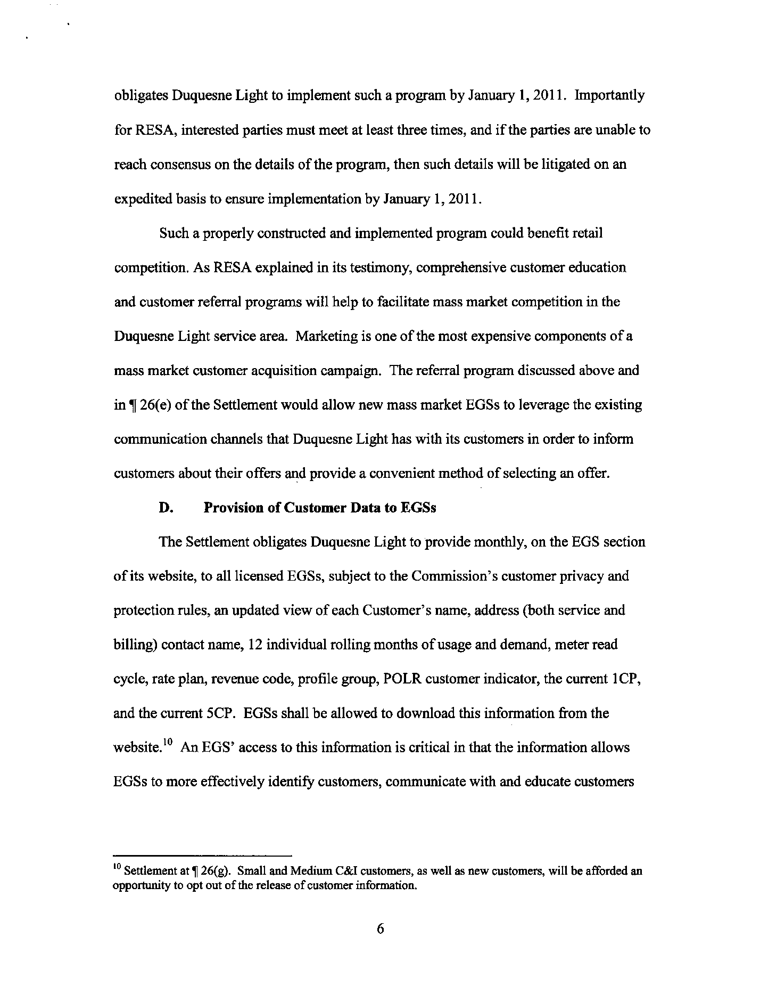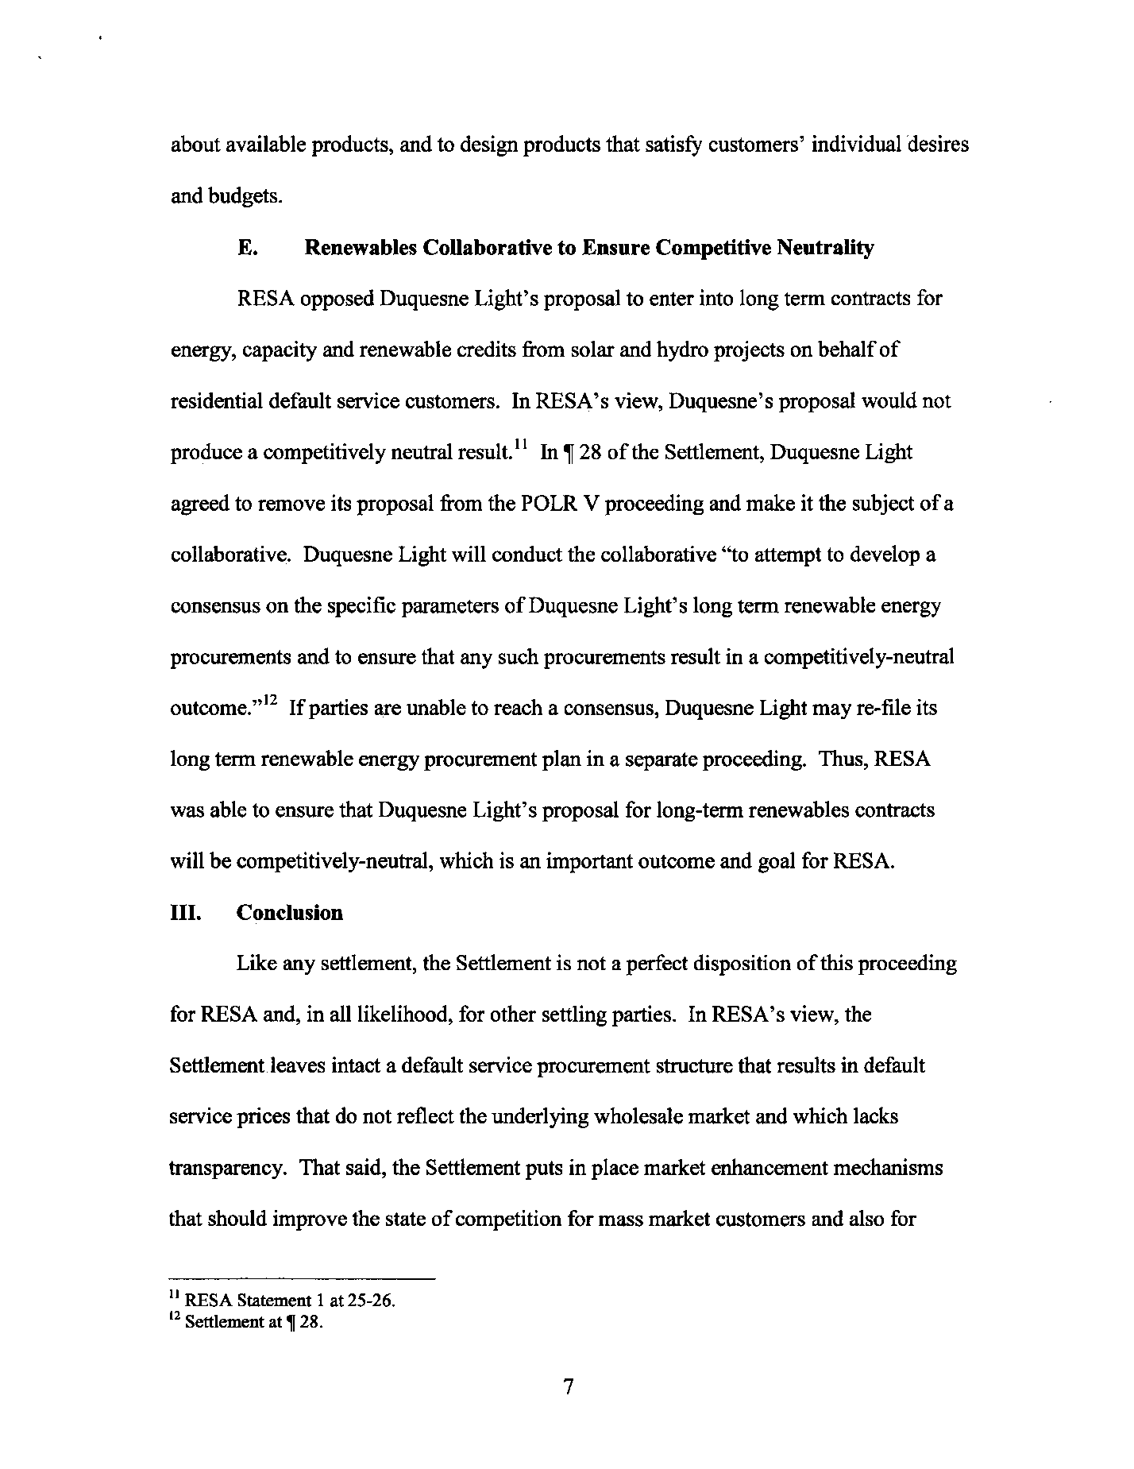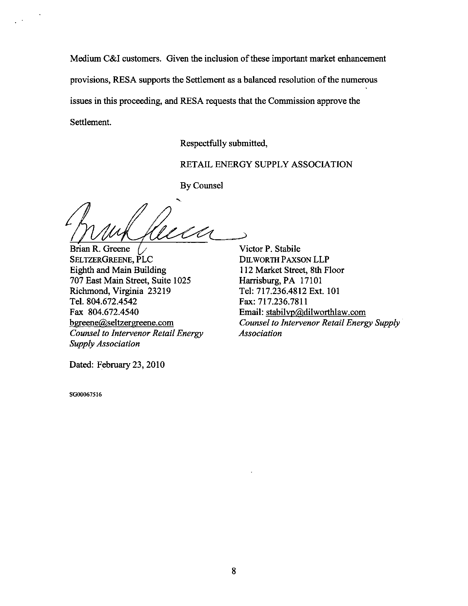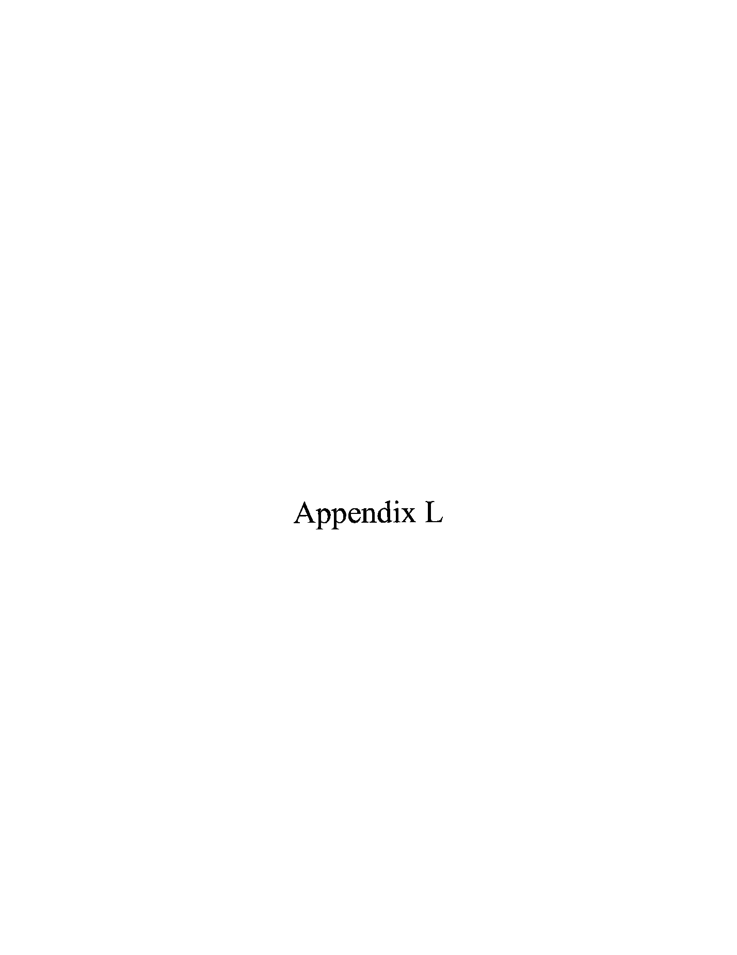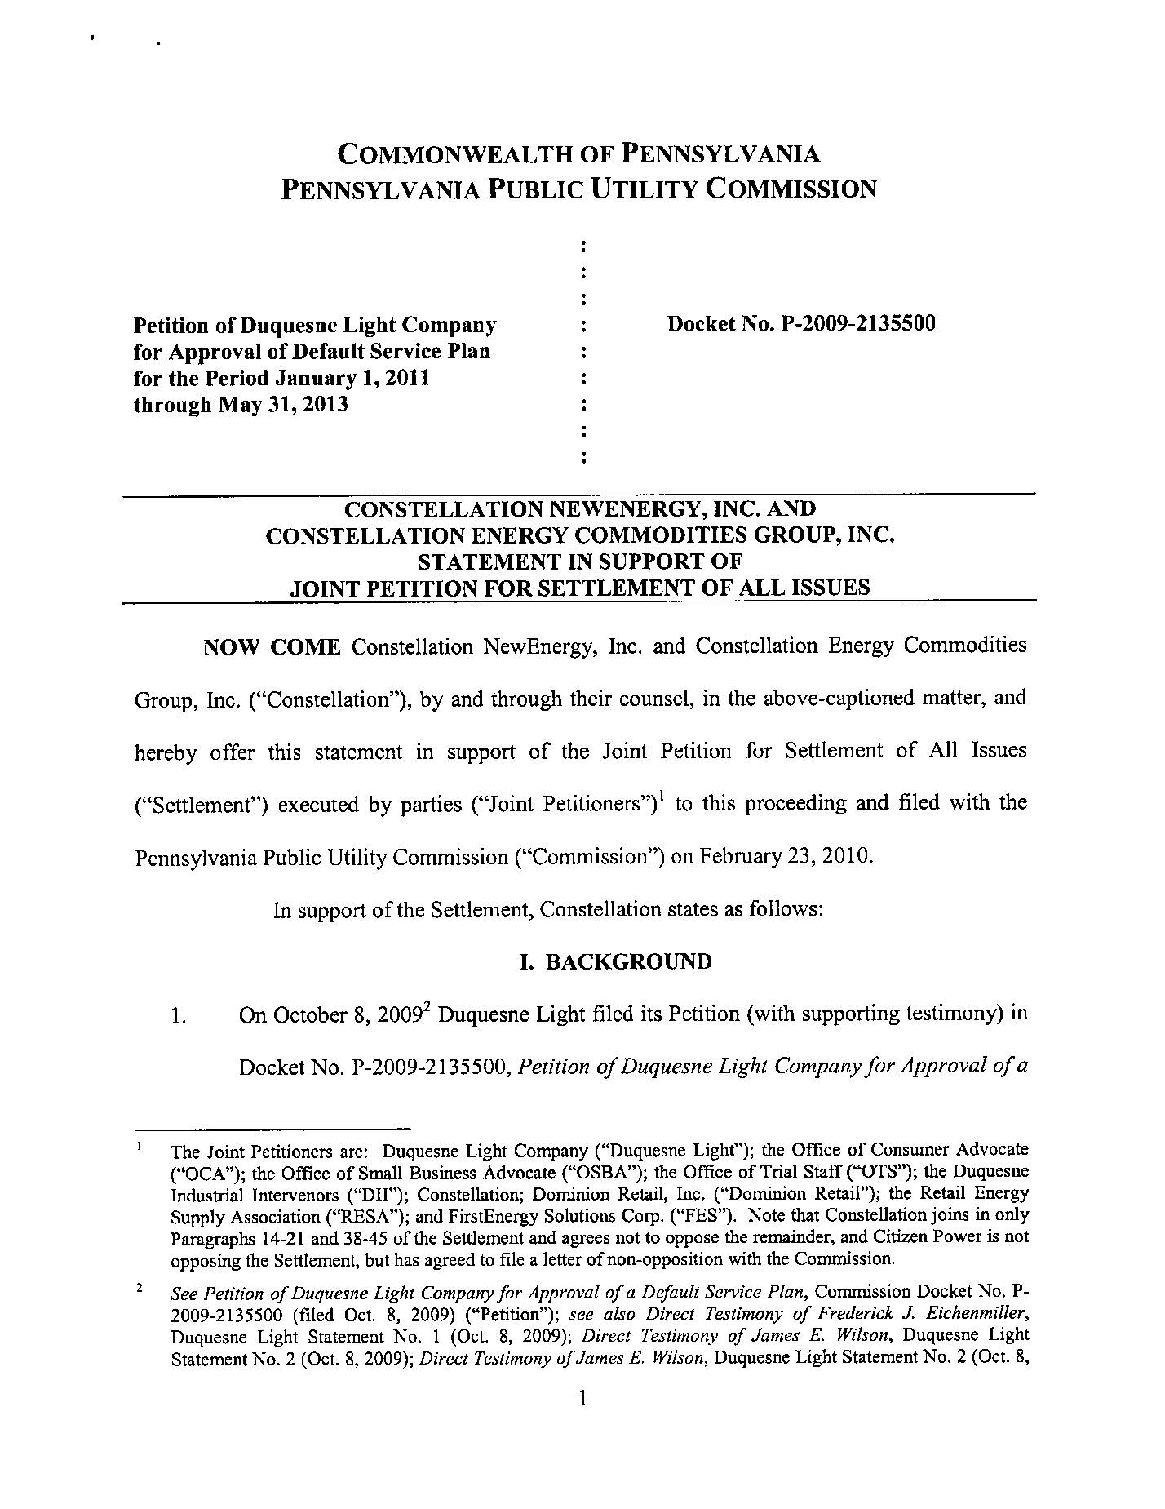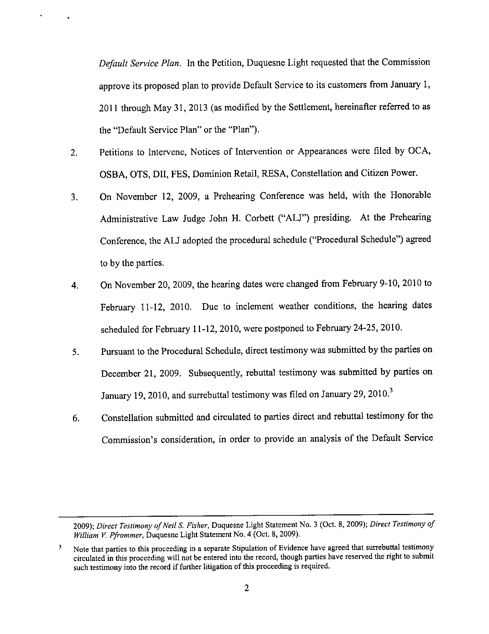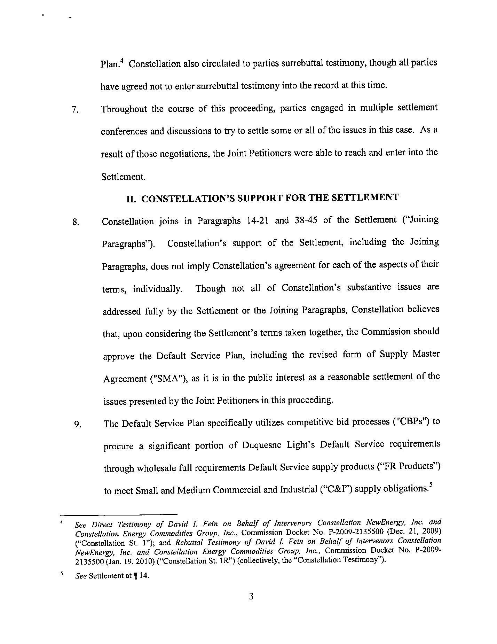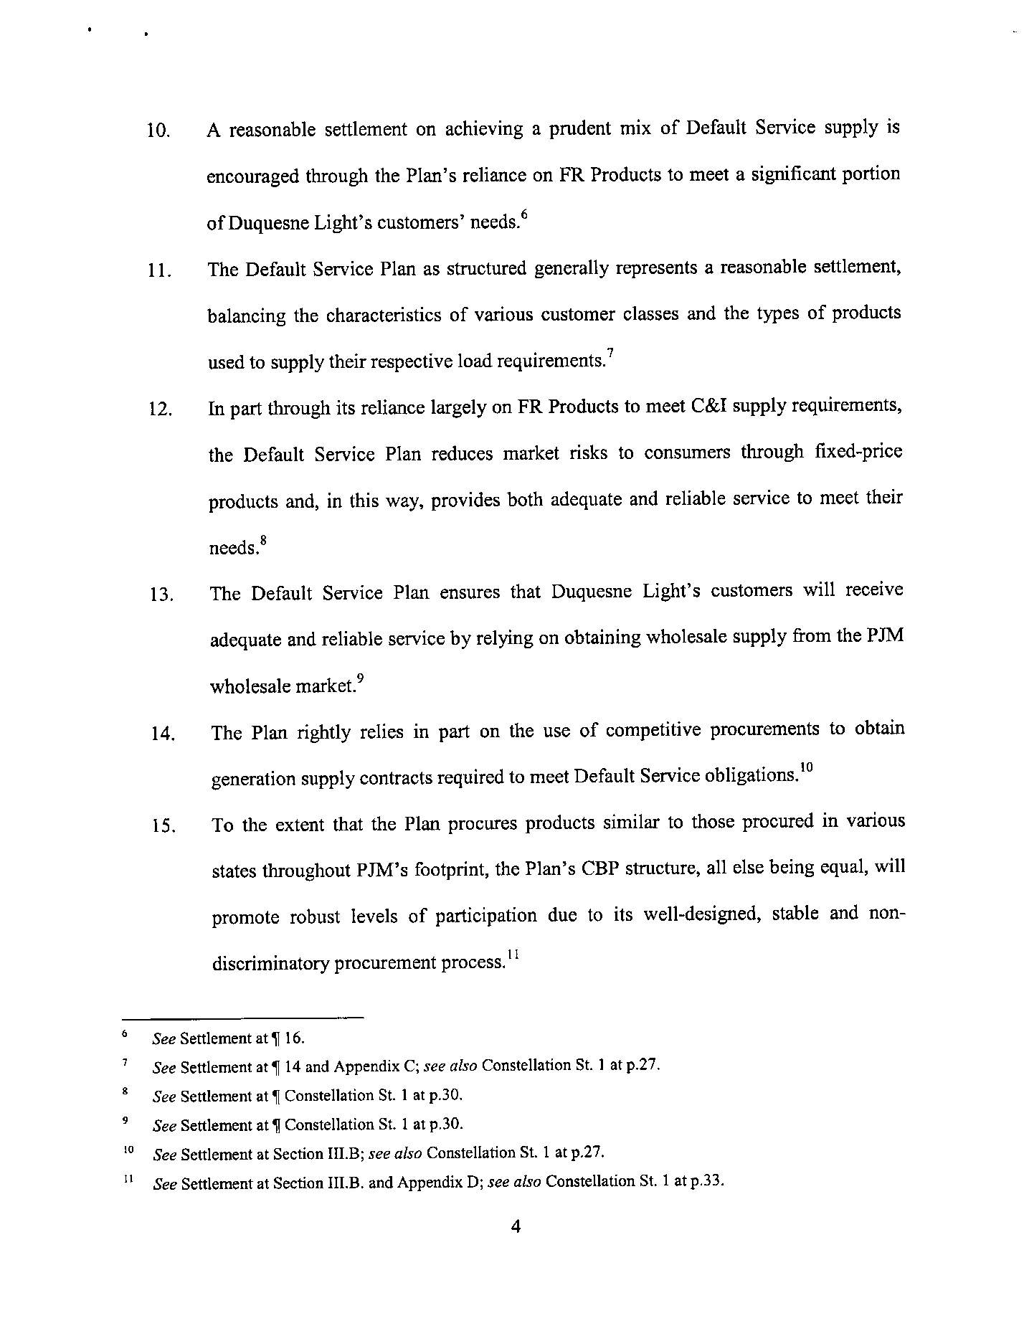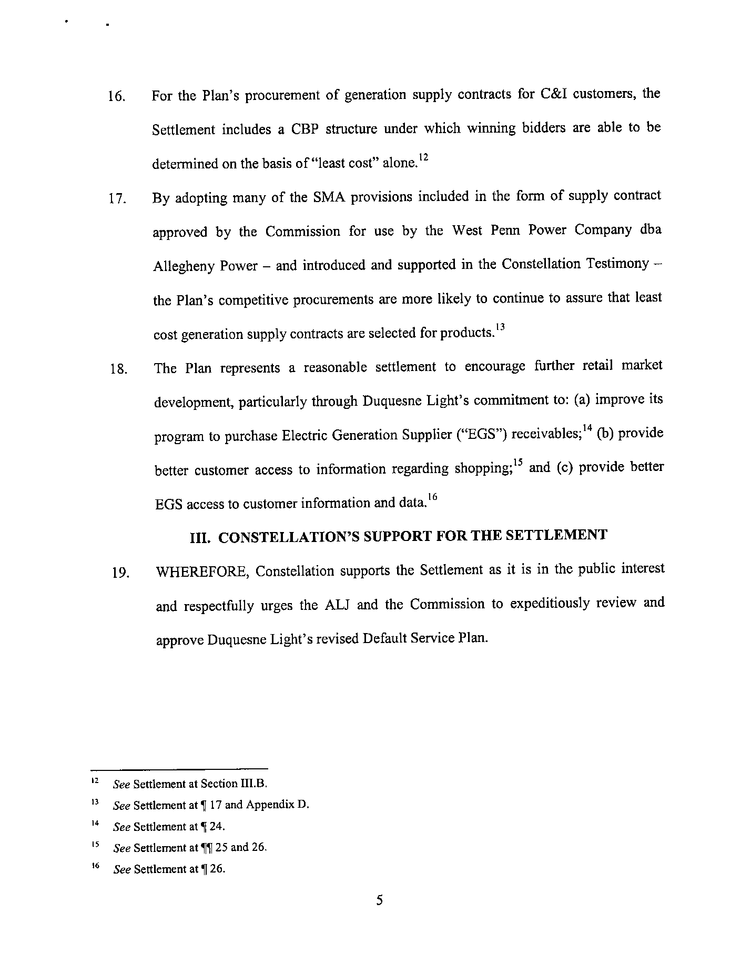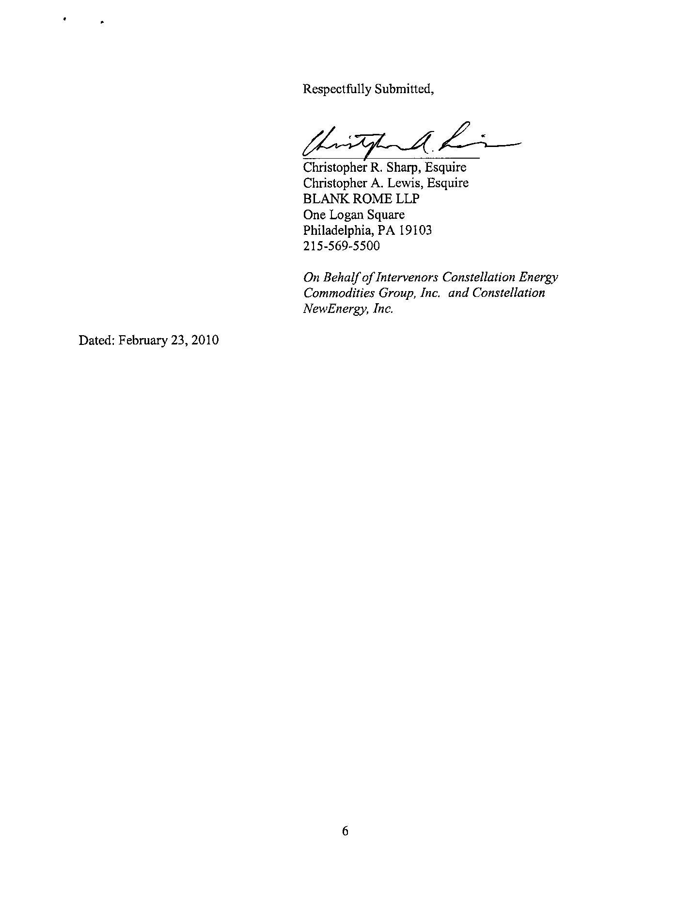

Duquesne Light is a “public utility” and an “electric distribution company” as defined in Sections 102 and 2803 of the Pennsylvania Public Utility Code (the “Code”), 66 Pa. C.S. §§102, 2803. Duquesne Light furnishes electric distribution and provider of last resort electric supply services to approximately 579,000 customers in the City of Pittsburgh, and in Allegheny and Beaver Counties, Pennsylvania.
The OTS, DII, and Citizen Power, Inc. did not serve testimony in this proceeding.
By Fifth and Sixth Interim Orders issued on March 1 and March 11, 2010 respectively, the parties’ prepared written testimony was admitted into the record by stipulation.
Constellation is joining in Paragraphs 14-21 and 38-45 of the Settlement and agrees not to oppose the remainder. RESA does not support, but also does not oppose, the inclusion of Paragraph 32 in the Settlement. Citizen Power is not opposing the Settlement and has filed a letter of non-opposition with the Commission.
Joint Petition for Settlement at 10.
PPL Electric Utilities Corporation Retail Markets, Docket No. M-2009-2104271 (Order entered October 22, 2009) (PPL Order).

