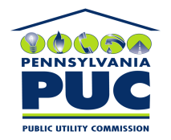 | COMMONWEALTH OF PENNSYLVANIA  PENNSYLVANIA PUBLIC UTILITY COMMISSION  P.O. BOX 3265, HARRISBURG, PA 17105-3265 | IN REPLY PLEASE REFER TO OUR FILE

August 25, 2010
U-2010-2189981

KIM G FLOWERS
AGENCY COORDINATOR
PPL ELECTRIC UTILITIES CORP
TWO NORTH NINTH STREET
ALLENTOWN PA 18101-1179

Agreement dated July 12, 2010, between PPL Electric Utilities Corporation and the City of Allentown relative with the right to construct, operate, and maintain its electric line facilities located along Martin Luther King Jr. Drive, situate in the City of Allentown, County of Lehigh, Commonwealth of Pennsylvania.

To Whom It May Concern:

We enclose herewith the original and one (1) copy of certificate of filing issued by this Commission in accordance with Section 507 of the Public Utility Code, 66 Pa. C.S. §507.

You should serve the enclosed copy of this certificate upon the City of Allentown.

Very truly yours,


Rosemary Chiavetta
Secretary

mh
encls.
cert.mail

