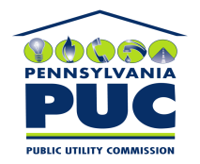 | COMMONWEALTH OF PENNSYLVANIA  PENNSYLVANIA PUBLIC UTILITY COMMISSION  P.O. BOX 3265, HARRISBURG, PA 17105-3265 | IN REPLY PLEASE REFER TO OUR FILE

September 7, 2010
U-2010-2192347

PAUL E RUSSELL ESQUIRE
PPL
TWO NORTH NINTH STREET
ALLENTOWN PA 18101-1179

Agreement dated July 20, 2010 between PPL Electric Utilities Corp and Dauphin County whereby the County desires to acquire a Waterline Easement Agreement between PPL Electric Utilities Corporation and the County of Dauphin.

To Whom It May Concern:

We enclose herewith the original and one (1) copy of certificate of filing issued by this Commission in accordance with Section 507 of the Public Utility Code, 66 Pa. C.S. §507.

You should serve the enclosed copy of this certificate upon the County of Dauphin.

Very truly yours,


Rosemary Chiavetta
Secretary

mh
encls.
cert.mail

