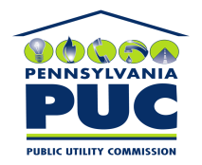 | COMMONWEALTH OF PENNSYLVANIA  PENNSYLVANIA PUBLIC UTILITY COMMISSION  P.O. BOX 3265, HARRISBURG, PA 17105-3265 | IN REPLY PLEASE REFER TO OUR FILE

November 19, 2010
U-2010-2205116

PAUL E RUSSELL ESQUIRE
PPL
TWO NORTH NINTH STREET
ALLENTOWN PA 18101-1179

Agreement dated August 25, 2010 between PPL and Milton Regional Sewer Authority relative with the right and privilege to use a portion of PPL Electric’s Milton-Lycoming line right of way.

To Whom It May Concern:

We enclose herewith the original and one (1) copy of certificate of filing issued by this Commission in accordance with Section 507 of the Public Utility Code, 66 Pa. C.S. §507.

You should serve the enclosed copy of this certificate upon the Township of Chillisquaque.

Very truly yours,


Rosemary Chiavetta
Secretary

mh
encls.
cert.mail

