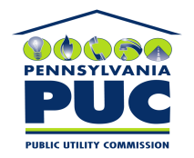 | COMMONWEALTH OF PENNSYLVANIA  PENNSYLVANIA PUBLIC UTILITY COMMISSION  P.O. BOX 3265, HARRISBURG, PA 17105-3265 | IN REPLY PLEASE REFER TO OUR FILE

November 19, 2010
U-2010-2205476

PAUL E RUSSELL ESQUIRE
PPL
TWO NORTH NINTH STREET
ALLENTOWN PA 18101-1179

Agreement dated August 25, 2010 between PPL Electric Utilities and Milton Regional Sewer Authority relative to Relinquishment of Portion of Right of Way, therefore both parties intending to be legally bound hereby, the party of the first part irrevocably relinquishes unto the party of the second part, their successors and assigns, all of its right, title and interest in and to a portion of the right of way.

To Whom It May Concern:

We enclose herewith the original and one (1) copy of certificate of filing issued by this Commission in accordance with Section 507 of the Public Utility Code, 66 Pa. C.S. §507.

You should serve the enclosed copy of this certificate upon the Borough of Milton.

Very truly yours,


Rosemary Chiavetta
Secretary

mh
encls.
cert.mail

