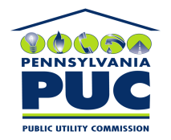 | COMMONWEALTH OF PENNSYLVANIA  PENNSYLVANIA PUBLIC UTILITY COMMISSION  P.O. BOX 3265, HARRISBURG, PA 17105-3265 | IN REPLY PLEASE REFER TO OUR FILE

November 22, 2010
U-00024796

SUSAN SIMMS MARSH ESQUIRE
PENNSYLVANIA AMERICAN WATER CO
800 HERSHEY PARK DRIVE
HERSHEY PA 17033

Amended Agreement dated October 18, 2010 between the Tatamy Borough Sewer Authority and Pennsylvania-American Water Company, whereby the Company agrees to terminate water service to any premises for failure to pay current sewage bills.

To Whom It May Concern:

We enclose herewith the original and one (1) copy of certificate of filing issued by this Commission in accordance with Section 507 of the Public Utility Code, 66 Pa. C.S. §507.

You should serve the enclosed copy of this certificate upon the Borough of Tatamy.

Very truly yours,


Rosemary Chiavetta
Secretary

mh
encls.
cert.mail

