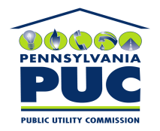 | COMMONWEALTH OF PENNSYLVANIA  PENNSYLVANIA PUBLIC UTILITY COMMISSION  P.O. BOX 3265, HARRISBURG, PA 17105-3265 | IN REPLY PLEASE REFER TO OUR FILE

January 10, 2011
U-2010-2210225

JOHN J KELHART
PPL ELECTRIC UTILITIES
TWO NORTH NINTH STREET
ALLENTOWN PA 18101-1179

Agreement dated October 26, 2010 between PPL Electric Utilities and Lehigh-Northampton Airport Authority, Township of Hanover, County of Northampton relative Right of Way that grants PPL the right to construct, operate and maintain and from time to time to reconstruct its overhead and underground electric transmission, distribution, and communication lines, including but not limited to such poles, towers, guys, cables, wires, fiber optics, fixtures and apparatus above and below ground.

To Whom It May Concern:

We enclose herewith the original and one (1) copy of certificate of filing issued by this Commission in accordance with Section 507 of the Public Utility Code, 66 Pa. C.S. §507.

You should serve the enclosed copy of this certificate upon the Township of Hanover.

Very truly yours,


Rosemary Chiavetta
Secretary

mh
encls.
cert.mail

