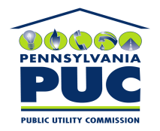 | COMMONWEALTH OF PENNSYLVANIA  PENNSYLVANIA PUBLIC UTILITY COMMISSION  P.O. BOX 3265, HARRISBURG, PA 17105-3265 | IN REPLY PLEASE REFER TO OUR FILE
(Corrected Certificate)
February 11, 2011
U-2010-2218012

JOHN C HALDERMAN ESQUIRE
EXELON BUSINESS SERVICES CO
2301 MARKET STREET/S23-1
PO BOX 8699
PHILADELPHIA PA 19101-8699

Agreement dated December 9, 2010 between PECO Energy Company and Upper Merion Township relative to the consideration of one dollar and other valuable considerations, receipt and sufficiency of which is acknowledged, grantor grants and conveys a permanent, public right-of-way over, under and through the described real estate lying and situated in the County of Montgomery, Commonwealth of Pennsylvania.

To Whom It May Concern:

We enclose herewith the original and one (1) copy of certificate of filing issued by this Commission in accordance with Section 507 of the Public Utility Code, 66 Pa. C.S. §507.

You should serve the enclosed copy of this certificate upon the Township of Upper Merion.

Very truly yours,


Rosemary Chiavetta
Secretary

sjmw
encls.
cert.mail

