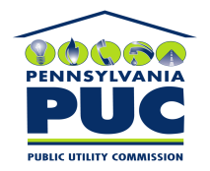 | COMMONWEALTH OF PENNSYLVANIA  PENNSYLVANIA PUBLIC UTILITY COMMISSION  P.O. BOX 3265, HARRISBURG, PA 17105-3265 | IN REPLY PLEASE REFER TO OUR FILE

April 7, 2011
U-2011-2229607

KIM G FLOWERS
AGENCY COORDINATOR
PPL ELECTRIC UTILITIES CORP
TWO NORTH NINTH STREET
ALLENTOWN PA 18101-1179

Agreement dated December 16, 2010 between PPL Electric Utilities Corporation & Borough of Flemington relative with the Borough of Flemington grants PPL the right to construct, operate, & maintain its electric line facilities in the Borough of Flemington, County of Clinton.

To Whom It May Concern:

We enclose herewith the original and one (1) copy of certificate of filing issued by this Commission in accordance with Section 507 of the Public Utility Code, 66 Pa. C.S. §507.

You should serve the enclosed copy of this certificate upon the Borough of Flemington.

Very truly yours,


Rosemary Chiavetta
Secretary

mh
encls.
cert.mail

