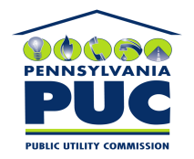 | COMMONWEALTH OF PENNSYLVANIA  PENNSYLVANIA PUBLIC UTILITY COMMISSION  P.O. BOX 3265, HARRISBURG, PA 17105-3265 | IN REPLY PLEASE REFER TO OUR FILE

April 21, 2011
U-2011-2231875

KIM G FLOWERS
AGENCY COORDINATOR
PPL ELECTRIC UTILITIES CORP
TWO NORTH NINTH STREET
ALLENTOWN PA 18101-1179

Agreement dated March 11, 2011 between PPL Electric Utilities Corporation AND Hellertown Borough Authority relative with Hellertown Borough Authority grants PPL the right to construct, operate and maintain its electric line facilities in the Township of Lower Saucon, County of Northampton.

To Whom It May Concern:

We enclose herewith the original and one (1) copy of certificate of filing issued by this Commission in accordance with Section 507 of the Public Utility Code, 66 Pa. C.S. §507.

You should serve the enclosed copy of this certificate upon the Township of Lower Saucon.

Very truly yours,


Rosemary Chiavetta
Secretary

mh
encls.
cert.mail

