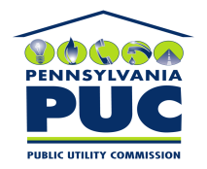 | COMMONWEALTH OF PENNSYLVANIA  PENNSYLVANIA PUBLIC UTILITY COMMISSION  P.O. BOX 3265, HARRISBURG, PA 17105-3265 | IN REPLY PLEASE REFER TO OUR FILE

May 19, 2011
U-2011-2234906

LESLEY C GANNON ESQUIRE
DUQUESNE LIGHT COMPANY
411 SEVENTH AVENUE 16-1
PITTSBURGH PA 15219

Agreement dated March 22, 2011 between Duquesne Light Company and the Borough of West Mifflin relative with Duquesne Light Company granted to Borough of West Mifflin the right to attach traffic signal facilities to Duquesne Light Company utility poles in the Borough of West Mifflin, Allegheny County.

To Whom It May Concern:

We enclose herewith the original and one (1) copy of certificate of filing issued by this Commission in accordance with Section 507 of the Public Utility Code, 66 Pa. C.S. §507.

You should serve the enclosed copy of this certificate upon the Borough of West Mifflin.

Very truly yours,


Rosemary Chiavetta
Secretary

mh
encls.
cert.mail

