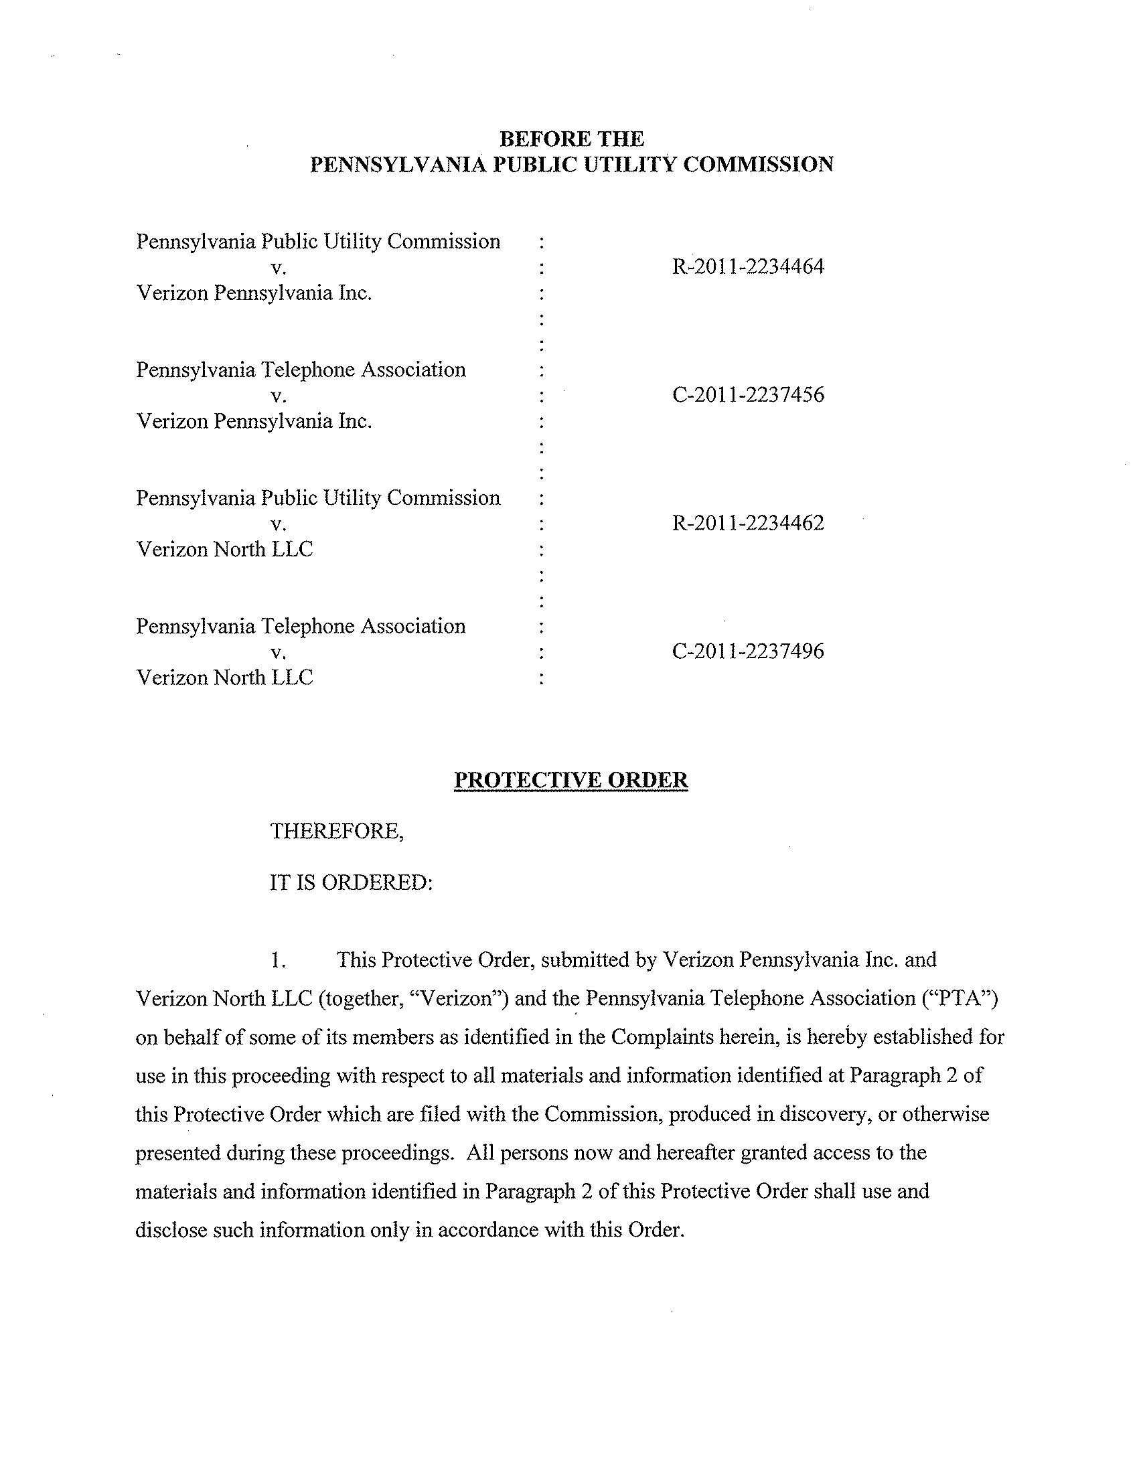
R-2011-2234462; C-2011-2237496 – PENNSYLVANIA PUBLIC UTILITY COMMISSION & PENNSYLVANIA TELEPHONE ASSOCIATION v. VERIZON NORTH LLC
R-2011-2234464; C-2011-2237456 – PENNSYLVANIA PUBLIC UTILITY COMMISSION & PENNSYLVANIA TELEPHONE ASSOCIATION v. VERIZON PENNSYLVANIA INC.

NORMAN J KENNARD ESQUIRE
THOMAS LONG NIESEN & KENNARD
212 LOCUST STREET SUITE 500
PO BOX 9500
HARRISBURG PA 17108-9500
(717) 255-7627

SUZAN D PAIVA ESQUIRE
VERIZON PENNSYLVANIA INC
1717 ARCH STREET
FLOOR 3 SE
PHILADELPHIA PA 19103
(215) 466-4755

